**Document Type: Detail Design**

**Document Name:**

**ADSP EQUALIZER PLUGIN**

Renesas Design Vietnam Co. Ltd

R-Car Software Solution 2 Group

Middleware 1 Team

Renesas Electronics Corporation

Table of Contents

1. Overview 4

1.1 Configuration 4

2. Function list 5

2.1 API specifications 5

2.2 Internal functions 6

3. Detail information 7

3.1 Data type, macro definition and variable 7

3.2 Function definition 9

3.2.1 Supported functions 9

3.2.1.1 xa_rel_eqz_reset_bqbuff 9

3.2.1.2 xa_rel_eqz_init_params 10

3.2.1.3 xa_rel_eqz_set_coef 11

3.2.1.4 xa_rel_eqz_set_gcoef 12

3.2.1.5 xa_rel_eqz_do_execute 13

3.2.2 Command processing 14

3.2.2.1 xa_releqz_get_api_lib_id_string 14

3.2.2.2 xa_releqz_get_api_size 15

3.2.2.3 xa_releqz_init 16

3.2.2.4 xa_releqz_get_memtabs_size 21

3.2.2.5 xa_releqz_set_memtabs_ptr 22

3.2.2.6 xa_releqz_get_n_memtabs 24

3.2.2.7 xa_releqz_get_mem_info_size 25

3.2.2.8 xa_releqz_get_mem_info_alignment 27

3.2.2.9 xa_releqz_get_mem_info_type 29

3.2.2.10 xa_releqz_set_mem_ptr 31

3.2.2.11 xa_releqz_input_over 33

3.2.2.12 xa_releqz_set_input_bytes 34

3.2.2.13 xa_releqz_get_curidx_input_buf 35

3.2.2.14 xa_releqz_execute 36

3.2.2.15 xa_releqz_get_output_bytes 37

3.2.2.16 xa_releqz_set_config_param 38

3.2.2.17 xa_releqz_get_config_param 45

4. Revision history 47

List of Figures

Figure 1‑1 The software architecture 4

Figure 2‑1 xa_rel_eqz flowchart 5

Figure 3‑1 xa_rel_eqz_reset_bqbuff flowchart 9

Figure 3‑2 xa_rel_eqz_init_params flowchart 10

Figure 3‑3 xa_rel_eqz_set_coef flowchart 11

Figure 3‑4 xa_rel_eqz_set_gcoef flowchart 12

Figure 3‑5 xa_rel_eqz_do_execute flowchart 13

Figure 3‑6 xa_releqz_get_api_lib_id_string flowchart 14

Figure 3‑7 xa_releqz_get_api_size flowchart 15

Figure 3‑8 xa_releqz_init flowchart 17

Figure 3‑9 xa_releqz_init (A) flowchart 18

Figure 3‑10 xa_releqz_init (B) flowchart 18

Figure 3‑11 xa_releqz_init (C) flowchart 19

Figure 3‑12 xa_releqz_init (D) flowchart 20

Figure 3‑13 xa_releqz_get_memtabs_size flowchart 21

Figure 3‑14 xa_releqz_set_memtabs_ptr flowchart 23

Figure 3‑15 xa_releqz_get_n_memtabs flowchart 24

Figure 3‑16 xa_releqz_get_mem_info_size flowchart 26

Figure 3‑17 xa_releqz_get_mem_info_alignment flowchart 28

Figure 3‑18 xa_releqz_get_mem_info_type flowchart 30

Figure 3‑19 xa_releqz_set_mem_ptr flowchart 32

Figure 3‑23 xa_releqz_input_over flowchart 33

Figure 3‑24 xa_releqz_set_input_bytes flowchart 34

Figure 3‑25 xa_releqz_get_curidx_input_buf flowchart 35

Figure 3‑26 xa_releqz_execute flowchart 36

Figure 3‑27 xa_releqz_get_output_bytes flowchart 37

Figure 3‑28 xa_releqz_set_config_param flowchart 39

Figure 3‑29 xa_releqz_set_config_param (A) flowchart 40

Figure 3‑30 xa_releqz_set_config_param (B) flowchart 40

Figure 3‑31 xa_releqz_set_config_param (C) flowchart 41

Figure 3‑32 xa_releqz_set_config_param (D) flowchart 41

Figure 3‑33 xa_releqz_set_config_param (E) flowchart 42

Figure 3‑34 xa_releqz_set_config_param (F) flowchart 42

Figure 3‑35 xa_releqz_set_config_param (G) flowchart 43

Figure 3‑36 xa_releqz_set_config_param (H) flowchart 43

Figure 3‑37 xa_releqz_set_config_param (I) flowchart 44

Figure 3‑38 xa_releqz_set_config_param (J) flowchart 44

Figure 3‑42 xa_releqz_get_config_param flowchart 46

List of Table

Table 2‑1 API Functions of Equalizer 6

Table 2‑2 Function list 7

Table 3‑1 releqz_Memtabs type structure information 8

Table 3‑2 Macro definitions 8

Table 3‑3 Global variable xa_releqz_api 9

# Overview

In this chapter, overview of ADSP Equalizer plugin is explained.

## Configuration

User Application

ADSP Interface

Kernel Space

User Space

ADSP Driver

ARM

Audio HW

**ADSP Framework**

TDM class

Equalizer class

Capture class

Renderer class

ADSP

Plugin

Equalizer Plugin*

TDM Plugin

Capture Plugin

Renderer Plugin

SRC/ DMA/ SSI/

DMA

This document’s target is in side of red square

* Not connect to SCU/SSI DMA block

DAC/

ADC

Figure 1‑1 ****The software architecture****

The architecture of ADSP Equalizer is shown in Figure 1-1. ADSP Equalizer is an ADSP plugin, which is controlled by ADSP Framework.

# Function list

## API specifications

Because one interface function accesses the procedure that was appointed by a command in equalizer, it is used

Table 2‑1 API Functions of Equalizer

|  |  |
| --- | --- |
| xa_rel_eqz | |
| Description | This API is the only access function to the equalizer plugin. |
| Syntax | XA_ERRORCODE xa_rel_eqz(xa_codec_handle_t p_xa_module_obj,  WORD32 i_cmd,  WORD32 i_idx,  pVOID pv_value); |
| Parameters | p_xa_module_obj: Pointer to opaque API structure.  i_cmd: Command. (defined in the supplied header files).  i_idx: Command subtype or index. (defined in the supplied header files).  pv_value: Pointer to the variable used to pass in, or get out properties, from state structure. |
| Returns | Error Code based on the success or failure of API command (defined in the supplied header files). |

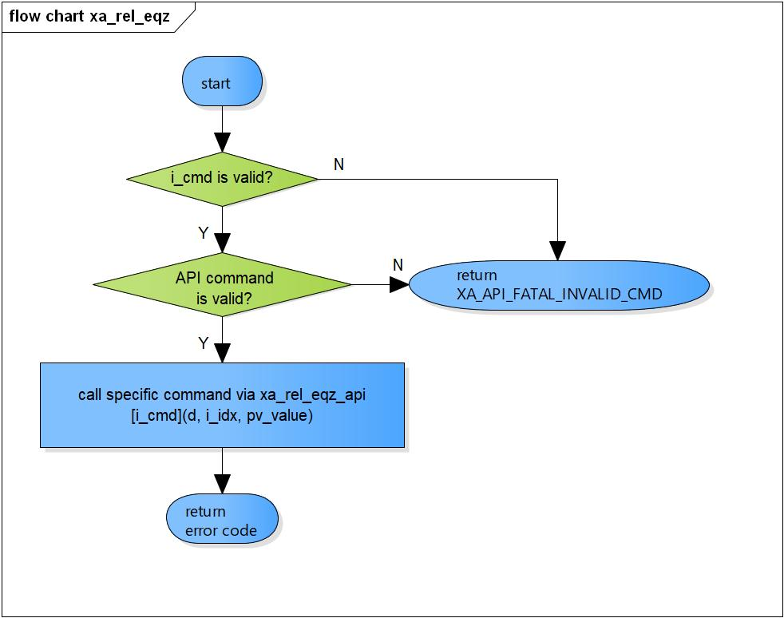

Figure 2‑1 xa_rel_eqz flowchart

## Internal functions

The following is list of functions:

Table 2‑2 Function list

|  |  |  |
| --- | --- | --- |
| **No.** | **Function Name** | **Outline** |
| 1 | xa_rel_eqz_reset_bqbuff | Initial parameters for equalizer, reset Biquad Filters. |
| 2 | xa_rel_eqz_init_params | Set default parameters for equalizer. |
| 3 | xa_rel_eqz_set_coef | Set coefficients for parametric equalizer. |
| 4 | xa_rel_eqz_set_gcoef | Set coefficients for graphic equalizer. |
| 5 | xa_rel_eqz_do_execute | Execute processing of equalizer: transfer data from input buffer to output buffer. |
| 6 | xa_releqz_get_api_lib_id_string | Get the version of the API, library, it is called by XA_API_CMD_GET_LIB_ID_STRINGS command. |
| 7 | xa_releqz_get_api_size | Get the size of the API structure; it is called by XA_API_CMD_GET_API_SIZE command. |
| 8 | xa_releqz_init | Equalizer initialization, it is called by XA_API_CMD_INIT command. |
| 9 | xa_releqz_set_mem_ptr | Set memory pointer, XA_API_CMD_SET_MEM_PTR command. |
| 10 | xa_releqz_set_memtabs_ptr | Set memory tables pointer, it is called by XA_API_CMD_SET_MEMTABS_PTR command. |
| 11 | xa_releqz_get_memtabs_size | Get the size of the memory structures to be allocated for the memory tables, it is called by XA_API_CMD_GET_MEMTABS_SIZE command. |
| 12 | xa_releqz_get_n_memtabs | Get total amount of memory buffers, it is called by XA_API_CMD_GET_N_MEMTABS command. |
| 13 | xa_releqz_get_mem_info_size | Get memory buffer size, it is called by XA_API_CMD_GET_MEM_INFO_SIZE command. |
| 14 | xa_releqz_get_mem_info_alignment | Get alignment information of the memory-type, it is called by XA_API_CMD_GET_MEM_INFO_ALIGNMENT command. |
| 15 | xa_releqz_get_mem_info_type | Get the type of memory being referred to by the index, it is called by XA_API_CMD_GET_MEM_INFO_TYPE command. |
| 16 | xa_releqz_set_input_bytes | Set number of input bytes, it is called by XA_API_CMD_SET_INPUT_BYTES command. |
| 17 | xa_releqz_get_curidx_input_buf | Get the number of input buffer bytes consumed, it is called by XA_API_CMD_GET_CURIDX_INPUT_BUF command. |
| 18 | xa_releqz_input_over | Stop equalizer, it is called by XA_API_CMD_INPUT_OVER command. |
| 19 | xa_releqz_get_output_bytes | Get the number of bytes output, it is called by XA_API_CMD_GET_OUTPUT_BYTES command. |
| 20 | xa_releqz_set_config_param | Set equalizer configuration parameters, it is called by XA_API_CMD_SET_CONFIG_PARAM command. |
| 21 | xa_releqz_get_config_param | Get equalizer configuration parameters, it is called by XA_API_CMD_GET_CONFIG_PARAM command. |
| 22 | xa_releqz_execute | Execute Equalizer plugin; it is called by XA_API_CMD_EXECUTE command. |

# Detail information

This section describes detail information of data types, macro definitions, implemented APIs, and internal function units, global variable.

## Data type, macro definition and variable

Refer to 2.6.1 API structure, 2.6.2 Persistent structure into function design of equalizer document [ADSP Reference Equalizer Plugin]

Table 3‑1 releqz_Memtabs type structure information

|  |  |
| --- | --- |
| Member name | Outline |
| WORD32 iPersist_size | Persistent buffer size. |
| pVOID pPersistent | Persistent buffer pointer. |
| WORD32 iInput_size | Input buffer size |
| pVOID pInput | Input buffer pointer. |
| WORD32 iOutput_size | Output buffer size. |
| pVOID pOutput | Output buffer pointer. |
| pVOID pScratch | Scratch memory use to temporary store information when transfer data from input to output buffer. |

Table 3‑2 Macro definitions

|  |  |  |
| --- | --- | --- |
| Macro | Value | Outline |
| XA_REL_REN_LIB_VERSION | "1.0.0" | Equalizer library version. |
| XA_REL_REN_API_VERSION | "1.0.0" | Equalizer api version. |
| XA_REL_EQZ_FLAG_START | 0 | Equalizer start flag. |
| XA_REL_EQZ_FLAG_PREINIT_DONE | 1 << 0 | Pre-initialize done flag. |
| XA_REL_EQZ_FLAG_MEMTABS_DONE | 1 << 1 | Set memory table pointer done flag. |
| XA_REL_EQZ_FLAG_POSTINIT_DONE | 1 << 2 | Post-initialize done flag. |
| XA_REL_EQZ_FLAG_RUNNING | 1 << 3 | Equalizer running flag. |
| XA_REL_EQZ_FLAG_EOS | 1 << 4 | Input end of stream flag. |
| XA_REL_EQZ_FLAG_COMPLETE | 1 << 5 | Equalizer execute done flag. |
| XA_REL_EQZ_ALIGN_4BYTE | 4 | 4-byte alignment. |
| XA_REL_EQZ_BUFFER_SIZE | 1024 | Equalizer buffer size. |
| XA_CHK_ALIGN(d, n) | (((UWORD32)(d)) & ((n)-1)) | Check d is alignment with n bytes. |
| GET_IDX(IDX) | ((IDX) & 0x0F) | Get index of sub-command. |
| XA_REL_EQZ_API_COMMANDS_NUM | (sizeof(xa_releqz_api) / sizeof(xa_releqz_api[0])) | Total number of commands supported. |

Table 3‑3 Global variable xa_releqz_api

|  |  |
| --- | --- |
| static XA_ERRORCODE (* const xa_releqz_api[])(XARelEqz*, WORD32, pVOID) | |
| Description: variable stores function pointers according to API command index to run in runtime operation. | |
| Array API command index | Value (function pointer) |
| XA_API_CMD_GET_LIB_ID_STRINGS | xa_releqz_get_api_lib_id_string |
| XA_API_CMD_GET_API_SIZE | xa_releqz_get_api_size |
| XA_API_CMD_INIT | xa_releqz_init |
| XA_API_CMD_GET_MEMTABS_SIZE | xa_releqz_get_memtabs_size |
| XA_API_CMD_SET_MEMTABS_PTR | xa_releqz_set_memtabs_ptr |
| XA_API_CMD_GET_N_MEMTABS | xa_releqz_get_n_memtabs |
| XA_API_CMD_GET_MEM_INFO_SIZE | xa_releqz_get_mem_info_size |
| XA_API_CMD_GET_MEM_INFO_ALIGNMENT | xa_releqz_get_mem_info_alignment |
| XA_API_CMD_GET_MEM_INFO_TYPE | xa_releqz_get_mem_info_type |
| XA_API_CMD_SET_MEM_PTR | xa_releqz_set_mem_ptr |
| XA_API_CMD_INPUT_OVER | xa_releqz_input_over |
| XA_API_CMD_SET_INPUT_BYTES | xa_releqz_set_input_bytes |
| XA_API_CMD_GET_CURIDX_INPUT_BUF | xa_releqz_get_curidx_input_buf |
| XA_API_CMD_GET_OUTPUT_BYTES | xa_releqz_get_output_bytes |
| XA_API_CMD_EXECUTE | xa_releqz_execute |
| XA_API_CMD_SET_CONFIG_PARAM | xa_releqz_set_config_param |
| XA_API_CMD_GET_CONFIG_PARAM | xa_releqz_get_config_param |

Note: All API command index macro is definded in xa_apicmd_standards.h.

## Function definition

### Supported functions

#### xa_rel_eqz_reset_bqbuff

DD_PLG_EQZ_01_001

|  |  |  |  |  |
| --- | --- | --- | --- | --- |
| **Syntax** | static void xa_rel_eqz_reset_bqbuff(XARelEqz *d) | | | |
| **Function** | Initial parameters for equalizer, reset Biquad Filters. | | | |
| **Arguments** | Type | Name | I/O | Description |
| XARelEqz* | d | I | Pointer to plugin API structure  (struct XAReleqz). |
| **Return value** | None. | | | |
| **Description** | * xa_rel_eqz_reset_bqbuff command processing:   - Reset biquad filters for all channels. | | | |

[Covers: FD_PLG_EQZ_005]

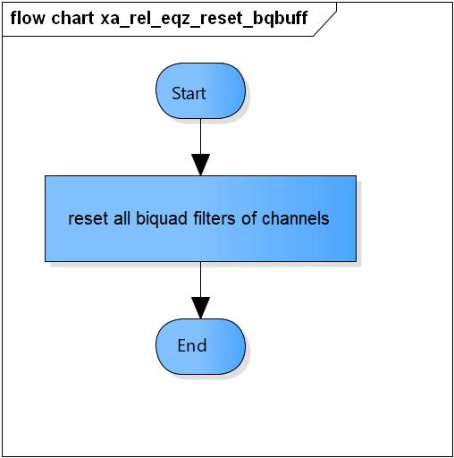

Figure 3‑1 xa_rel_eqz_reset_bqbuff flowchart

#### xa_rel_eqz_init_params

DD_PLG_EQZ_01_002

|  |  |  |  |  |
| --- | --- | --- | --- | --- |
| **Syntax** | static void xa_rel_eqz_init_params(XARelEqz *d) | | | |
| **Function** | Set default parameters for equalizer. | | | |
| **Arguments** | Type | Name | I/O | Description |
| XARelEqz* | d | I | Pointer to plugin API structure  (struct XAReleqz). |
| **Return value** | None. | | | |
| **Description** | * xa_rel_eqz_init_params command processing:   - Set default equalizer type is parametric.  - Set default gain for each graphic equalizer band.  - Set default value for buffer size control. | | | |

[Covers: FD_PLG_EQZ_003]

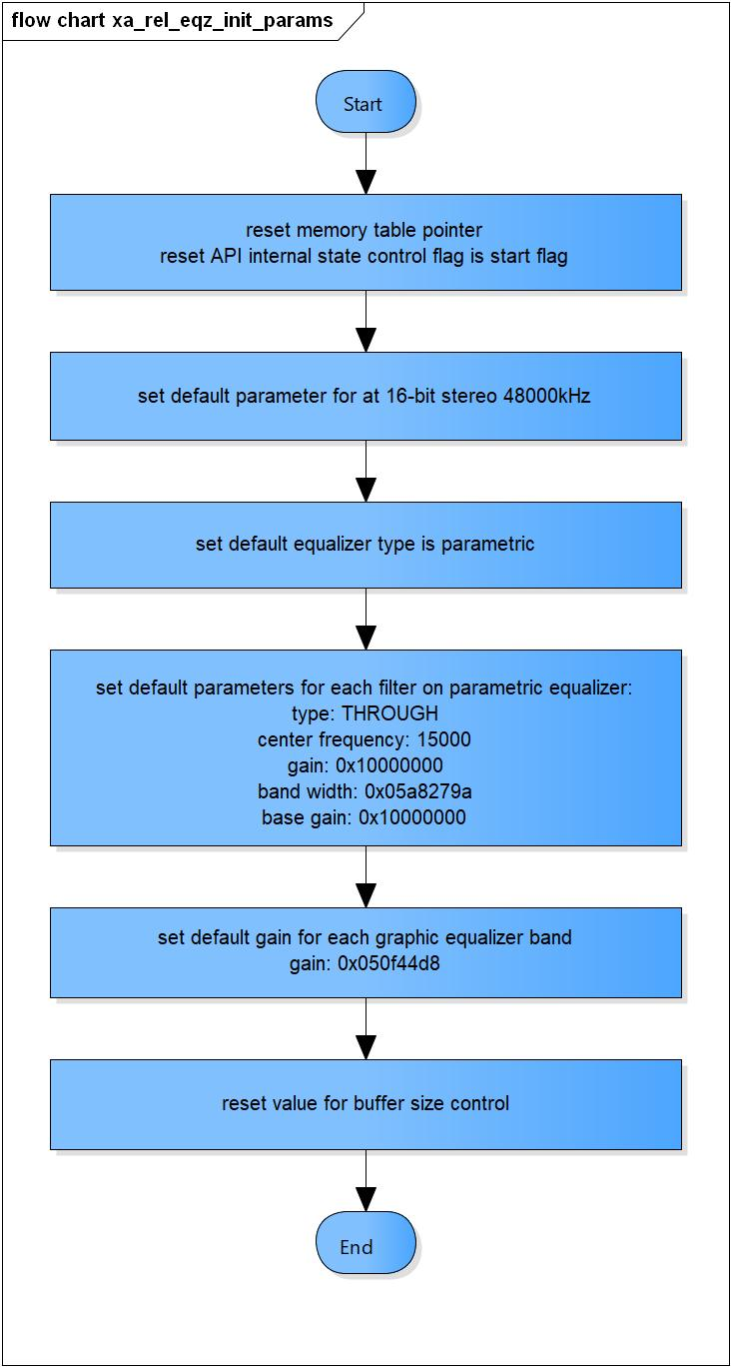

Figure 3‑2 xa_rel_eqz_init_params flowchart

#### xa_rel_eqz_set_coef

DD_PLG_EQZ_01_003

|  |  |  |  |  |
| --- | --- | --- | --- | --- |
| **Syntax** | static void xa_rel_eqz_set_coef(XARelEqz *d) | | | |
| **Function** | Set coefficients for parametric equalizer. | | | |
| **Arguments** | Type | Name | I/O | Description |
| XARelEqz* | d | I | Pointer to plugin API structure  (struct XAReleqz). |
| **Return value** | None. | | | |
| **Description** | * xa_rel_eqz_set_coef command processing:   - Set coefficients of parametric equalizer for all channels. | | | |

[Covers: FD_PLG_EQZ_005]

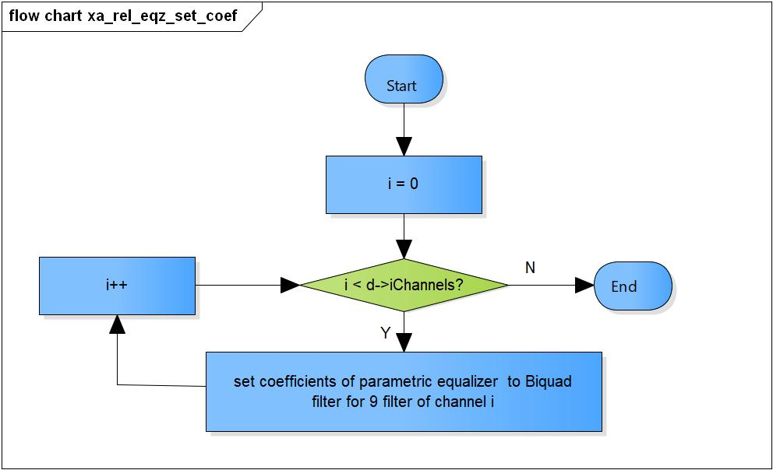

Figure 3‑3 xa_rel_eqz_set_coef flowchart

#### xa_rel_eqz_set_gcoef

DD_PLG_EQZ_01_004

|  |  |  |  |  |
| --- | --- | --- | --- | --- |
| **Syntax** | static void xa_rel_eqz_set_gcoef(XARelEqz *d) | | | |
| **Function** | Set coefficients for graphic equalizer. | | | |
| **Arguments** | Type | Name | I/O | Description |
| XARelEqz* | d | I | Pointer to plugin API structure  (struct XAReleqz). |
| **Return value** | None. | | | |
| **Description** | * xa_rel_eqz_set_gcoef command processing:   - Set coefficients of graphic equalizer for all channels. | | | |

[Covers: FD_PLG_EQZ_005]

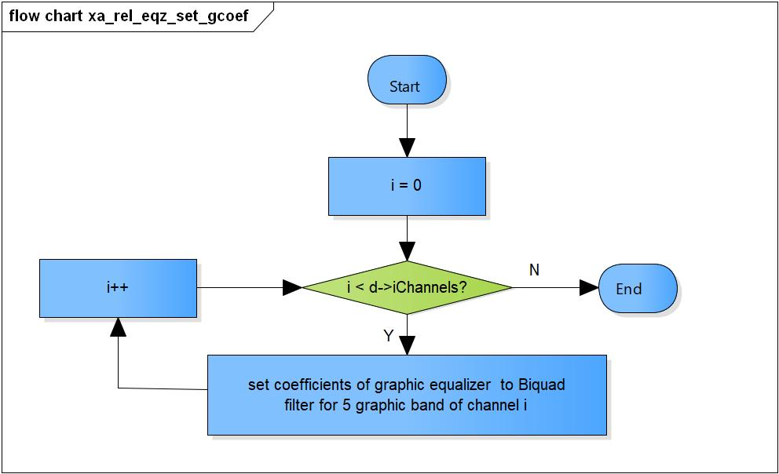

Figure 3‑4 xa_rel_eqz_set_gcoef flowchart

#### xa_rel_eqz_do_execute

DD_PLG_EQZ_01_005

|  |  |  |  |  |
| --- | --- | --- | --- | --- |
| **Syntax** | static void xa_rel_eqz_do_execute(XARelEqz *d) | | | |
| **Function** | Transfer data from input buffer to output buffer. | | | |
| **Arguments** | Type | Name | I/O | Description |
| XARelEqz* | d | I | Pointer to plugin API structure  (struct XAReleqz). |
| **Return value** | None. | | | |
| **Description** | * xa_rel_eqz_do_execute command processing:   - Reset all value in scratch memory.  - Get the number of filter need to process based on equalizer type.  - Transfer data from input memory to output memory for each channel.  - Calculate number of byte consumed, number of output byte. | | | |

[Covers: FD_PLG_EQZ_036]

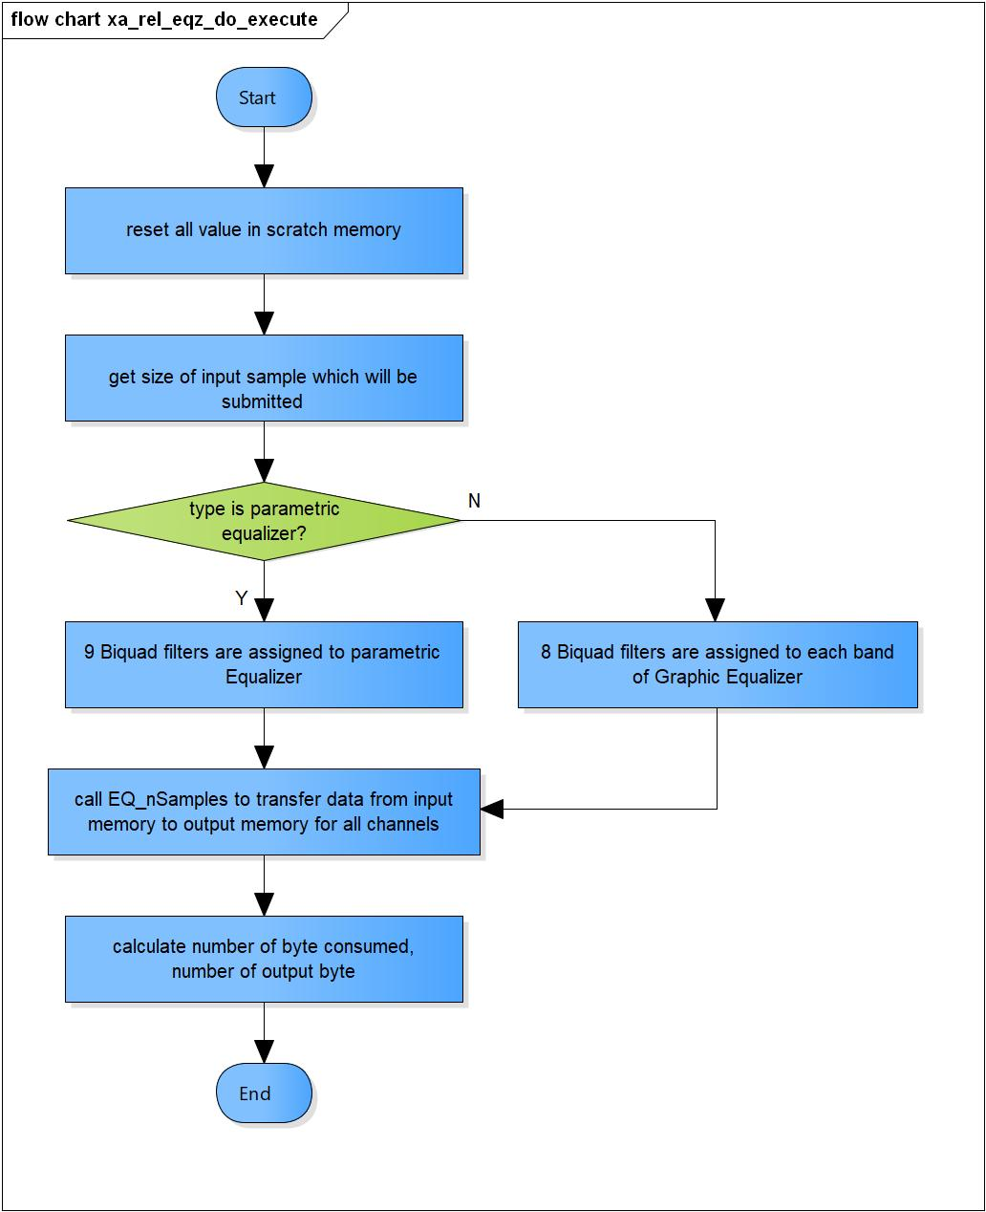

Figure 3‑5 xa_rel_eqz_do_execute flowchart

### Command processing

#### xa_releqz_get_api_lib_id_string

DD_PLG_EQZ_01_006

|  |  |  |  |  |
| --- | --- | --- | --- | --- |
| **Syntax** | static XA_ERRORCODE xa_releqz_get_api_lib_id_string(XARelEqz *d,  WORD32 i_idx,  pVOID pv_value) | | | |
| **Function** | This function obtains the version of the library in the form of a string. The maximum length of the string that the library will provide is 30 bytes. Therefore, the application shall pass a pointer to a buffer of a minimum size of 30 bytes. | | | |
| **Arguments** | Type | Name | I/O | Description |
| XARelEqz* | d | I | Pointer to plugin API structure  (struct XAReleqz). |
| WORD32 | i_idx | I | Index of sub-command.  Valid values:  XA_CMD_TYPE_LIB_VERSION  XA_CMD_TYPE_API_VERSION |
| pVOID | pv_value | O | Pointer to API version or library version. |
| **Return value** | XA_NO_ERROR | | Normal return. | |
| XA_API_FATAL_MEM_ALLOC | | pv_value is NULL. | |
| XA_API_FATAL_INVALID_CMD_TYPE | | i_idx is invalid. | |
| **Description** | * xa_releqz_get_api_lib_id_string command processing:   - Check pv_value is valid.  - Get the version of the API, library. | | | |

[Covers: FD_PLG_EQZ_001]

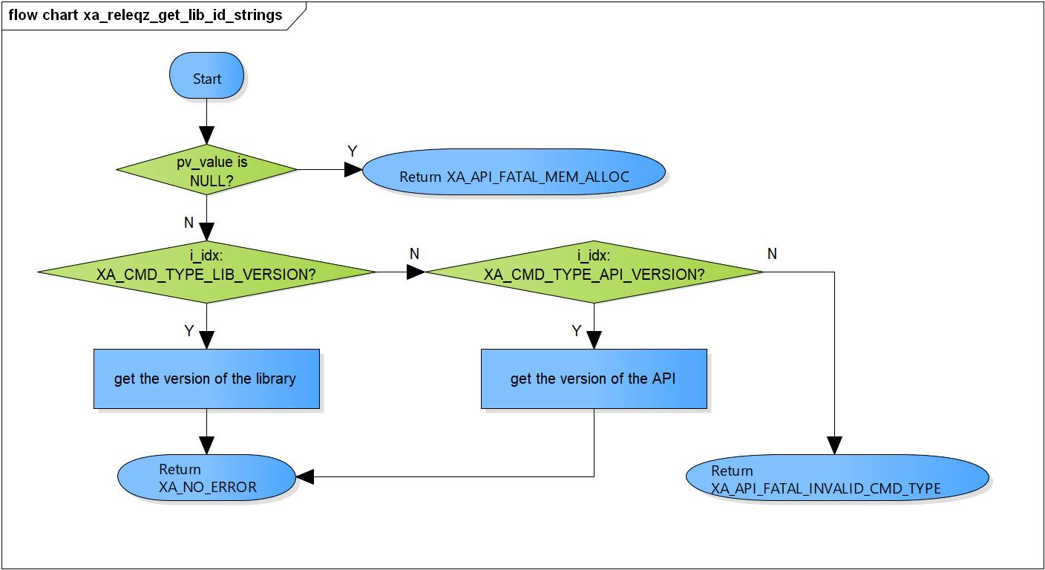

Figure 3‑6 xa_releqz_get_api_lib_id_string flowchart

#### xa_releqz_get_api_size

DD_PLG_EQZ_01_007

|  |  |  |  |  |
| --- | --- | --- | --- | --- |
| **Syntax** | static XA_ERRORCODE xa_releqz_get_api_size(XARelEqz *d,  WORD32 i_idx,  pVOID pv_value) | | | |
| **Function** | This function is used to obtain the size of the API structure, in order to allocate memory for the API structure. | | | |
| **Arguments** | Type | Name | I/O | Description |
| XARelEqz* | d | I | Pointer to plugin API structure  (struct XAReleqz). |
| WORD32 | i_idx | X | Index of sub-command. |
| pVOID | pv_value | O | Pointer to plugin API structure size variable (struct XAReleqz). |
| **Return value** | XA_NO_ERROR | | Normal return. | |
| XA_API_FATAL_MEM_ALLOC | | pv_value is NULL. | |
| **Description** | * xa_releqz_get_api_size command processing:   - Check pv_value is valid.  - Get API structure size. | | | |

[Covers: FD_PLG_EQZ_002]

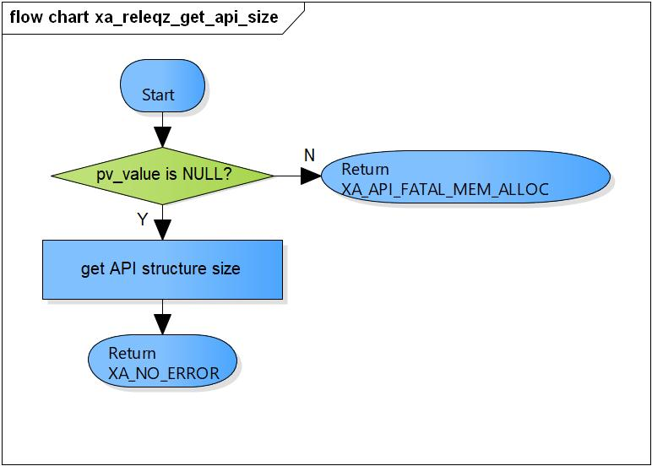

Figure 3‑7 xa_releqz_get_api_size flowchart

#### xa_releqz_init

DD_PLG_EQZ_01_008

|  |  |  |  |  |
| --- | --- | --- | --- | --- |
| **Syntax** | static XA_ERRORCODE xa_releqz_init(XARelEqz *d,  WORD32 i_idx,  pVOID pv_value) | | | |
| **Function** | This function is used to set the default value of the configuration parameters in pre-configuration process, calculate all memory in post-configuration process, calculate coefficients of equalizer base on equalizer type in initialization process and initialization done query process. | | | |
| **Arguments** | Type | Name | I/O | Description |
| XARelEqz* | d | I/O | Pointer to plugin API structure (struct XAReleqz). |
| WORD32 | i_idx | I | Index of sub-command.  Valid values:  XA_CMD_TYPE_INIT_API_PRE_CONFIG_PARAMS  XA_CMD_TYPE_INIT_API_POST_CONFIG_PARAMS  XA_CMD_TYPE_INIT_PROCESS  XA_CMD_TYPE_INIT_DONE_QUERY |
| pVOID | pv_value | x | NULL. |
| **Return value** | XA_NO_ERROR | | Normal return. | |
| XA_API_FATAL_MEM_ALLOC | | API object is NULL. | |
| XA_API_FATAL_MEM_ALIGN | | API object is not aligned to 4 bytes. | |
| XA_EQZ_CONFIG_FATAL_STATE | | Incorrect sequence call.  Memory table is invalid in post init processing. | |
| XA_API_FATAL_INVALID_CMD_TYPE | | Invalid index. | |
| XA_EQZ_EXEC_FATAL_STATE | | Scratch, persistent, input, output memory are invalid in init process. | |
| **Description** | * xa_releqz_init command processing: * Check API structure is valid. * Check API structure is aligned to 4 bytes. * Process particular type (pre config params, init API post config params, init process, init done query). | | | |

[Covers: FD_PLG_EQZ_003, FD_PLG_EQZ_004, FD_PLG_EQZ_005, FD_PLG_EQZ_006]

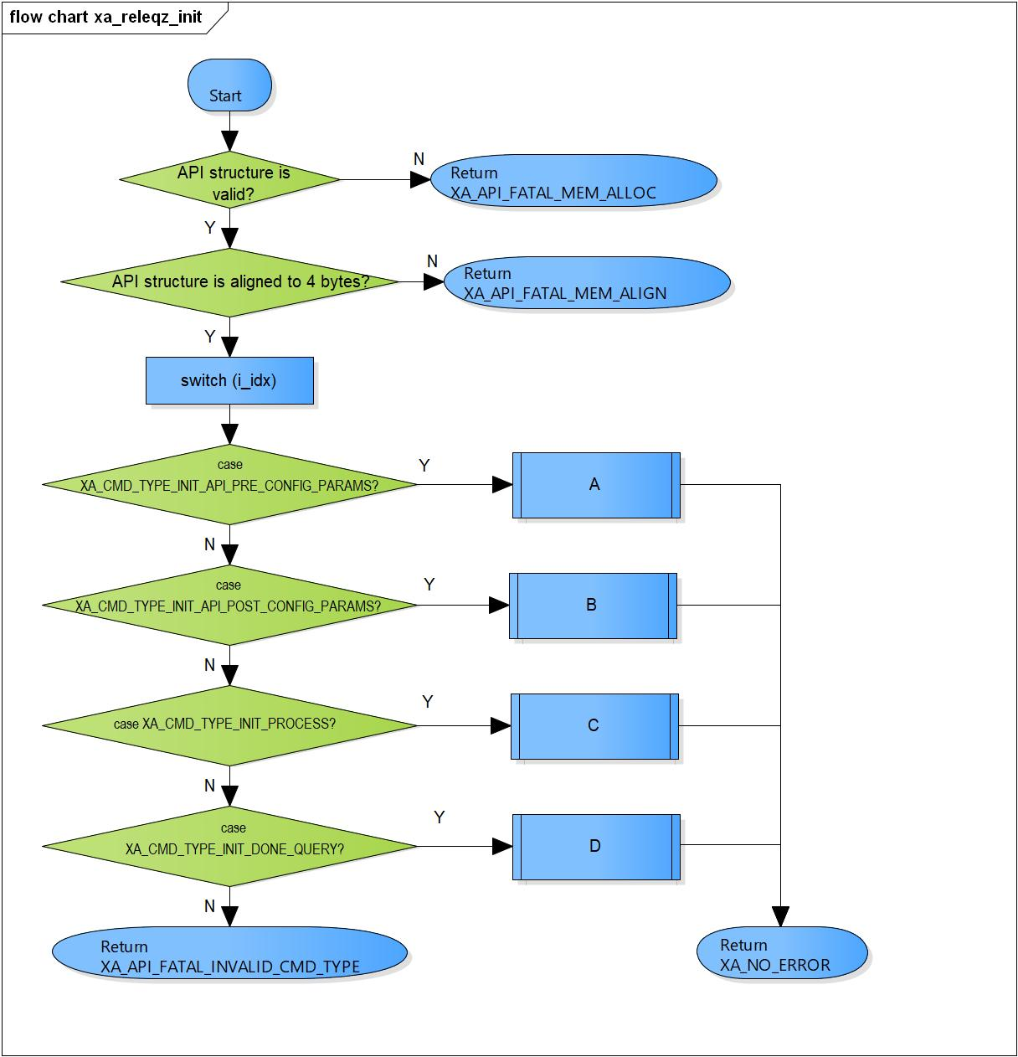

Figure 3‑8 xa_releqz_init flowchart

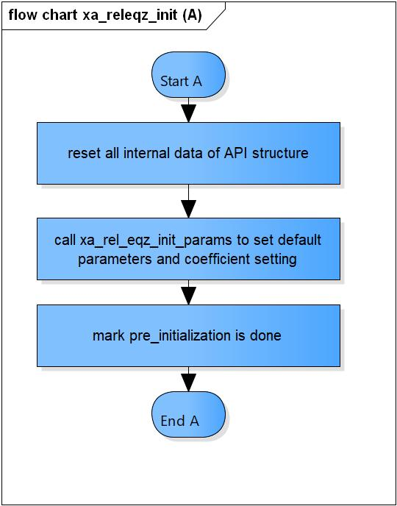

Figure 3‑9 xa_releqz_init (A) flowchart

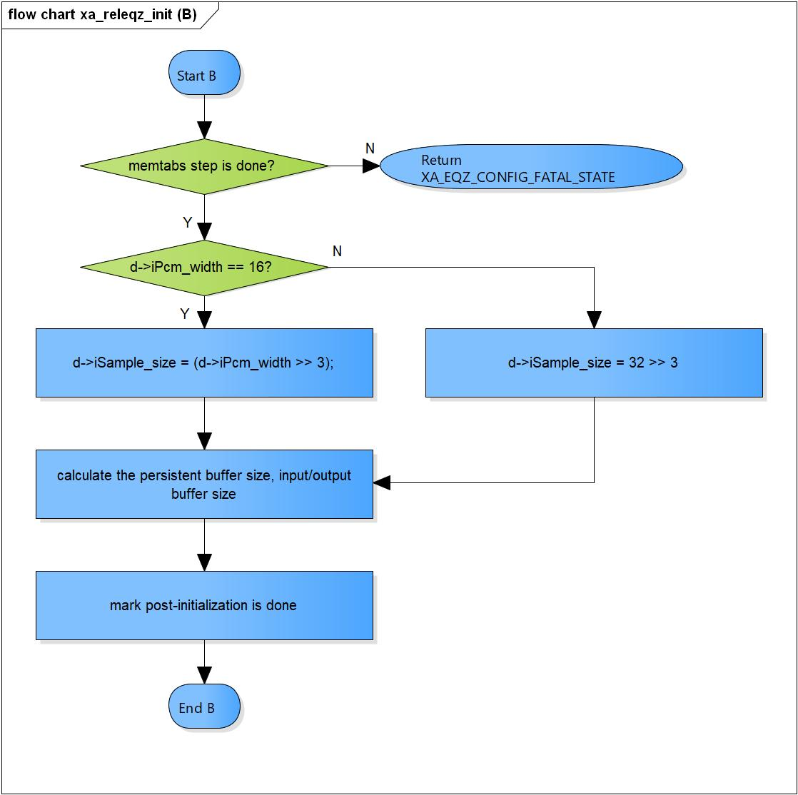

Figure 3‑10 xa_releqz_init (B) flowchart

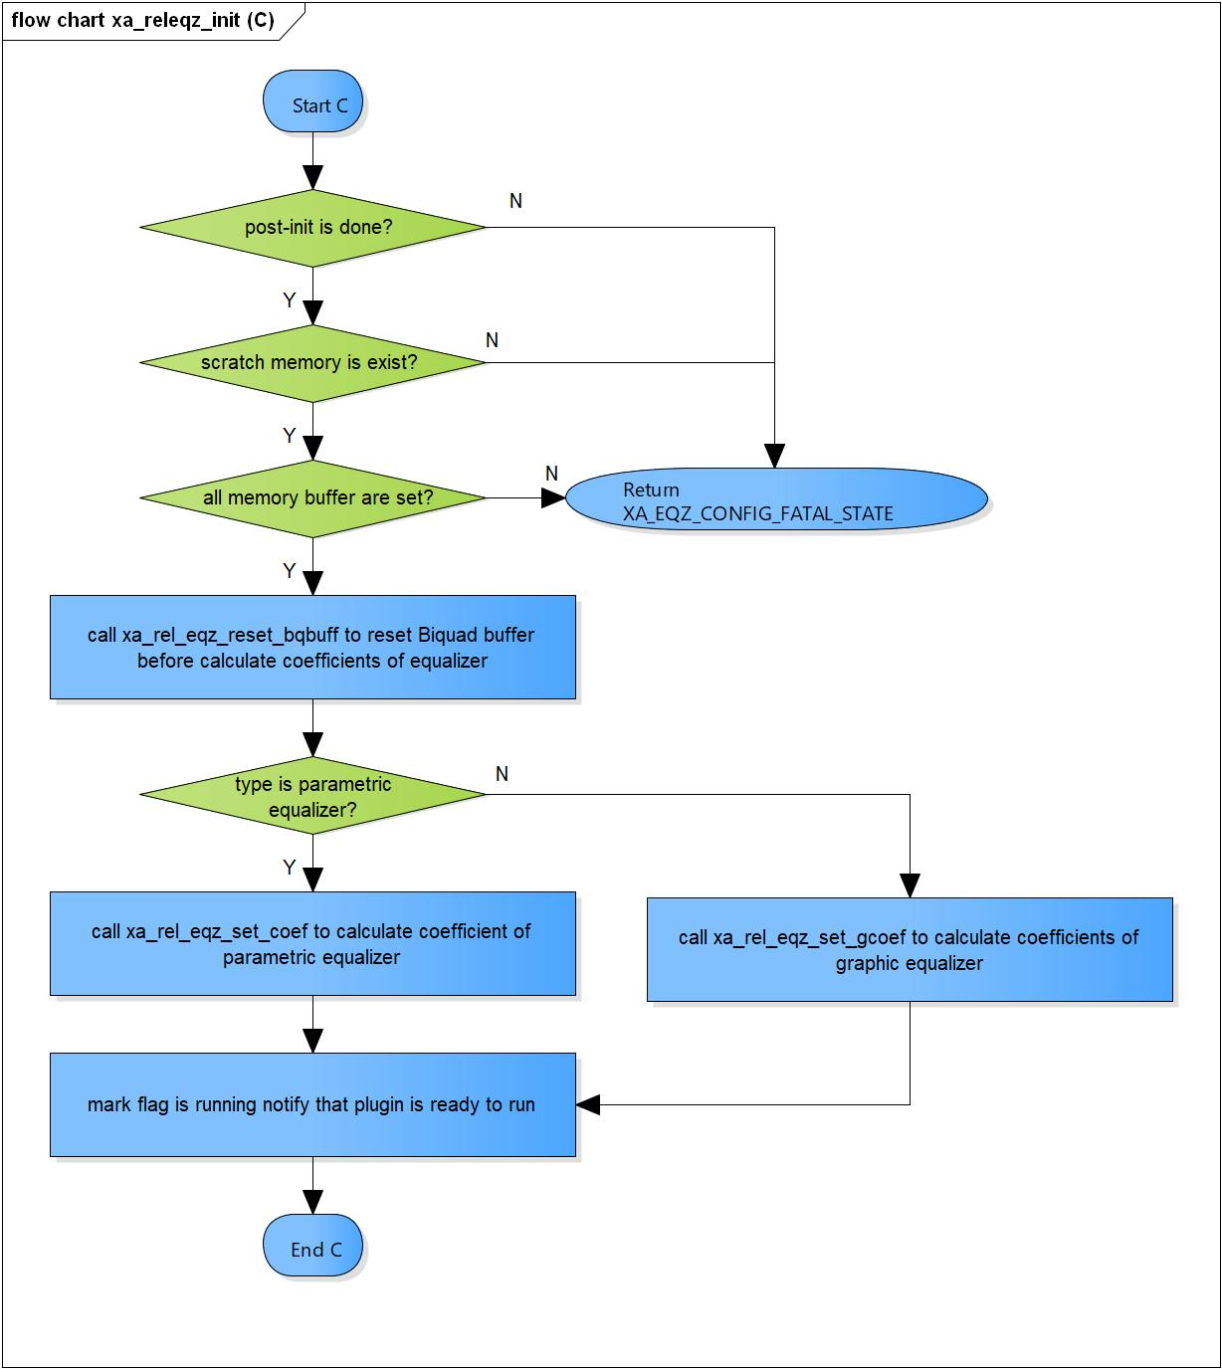

Figure 3‑11 xa_releqz_init (C) flowchart

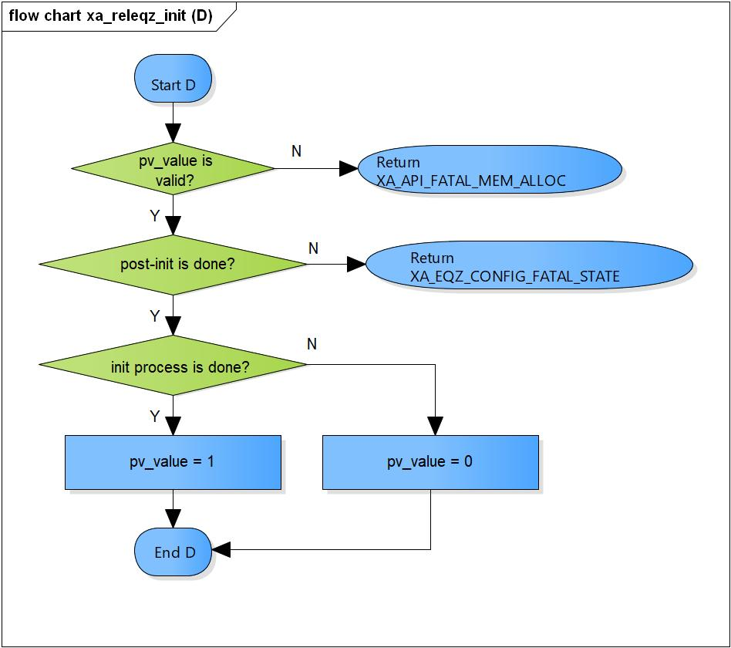

Figure 3‑12 xa_releqz_init (D) flowchart

#### xa_releqz_get_memtabs_size

DD_PLG_EQZ_01_009

|  |  |  |  |  |
| --- | --- | --- | --- | --- |
| **Syntax** | static XA_ERRORCODE xa_releqz_get_memtabs_size(XARelEqz *d,  WORD32 i_idx,  pVOID pv_value) | | | |
| **Function** | This function is used to obtain the size of the table used to hold memory blocks. These blocks required for the equalizer operation. The API returns the total size of the required table. | | | |
| **Arguments** | Type | Name | I/O | Description |
| XARelEqz* | d | I | Pointer to plugin API structure (struct XAReleqz). |
| WORD32 | i_idx | X | Index of sub-command. |
| pVOID | pv_value | O | Pointer to memory size variable. |
| **Return value** | XA_NO_ERROR | | Normal return. | |
| XA_API_FATAL_MEM_ALLOC | | API object is NULL.  pv_value is NULL. | |
| XA_API_FATAL_MEM_ALIGN | | API object is not aligned to 4 bytes. | |
| XA_EQZ_CONFIG_FATAL_STATE | | Equalizer has not pre-init yet. | |
| **Description** | * xa_releqz_get_memtabs_size command processing: * Check API structure is valid. * Check API structure is aligned to 4 bytes. * Check equalizer is pre-initialized. * Get size of the memory table of plugin. | | | |

[Covers: FD_PLG_EQZ_017]

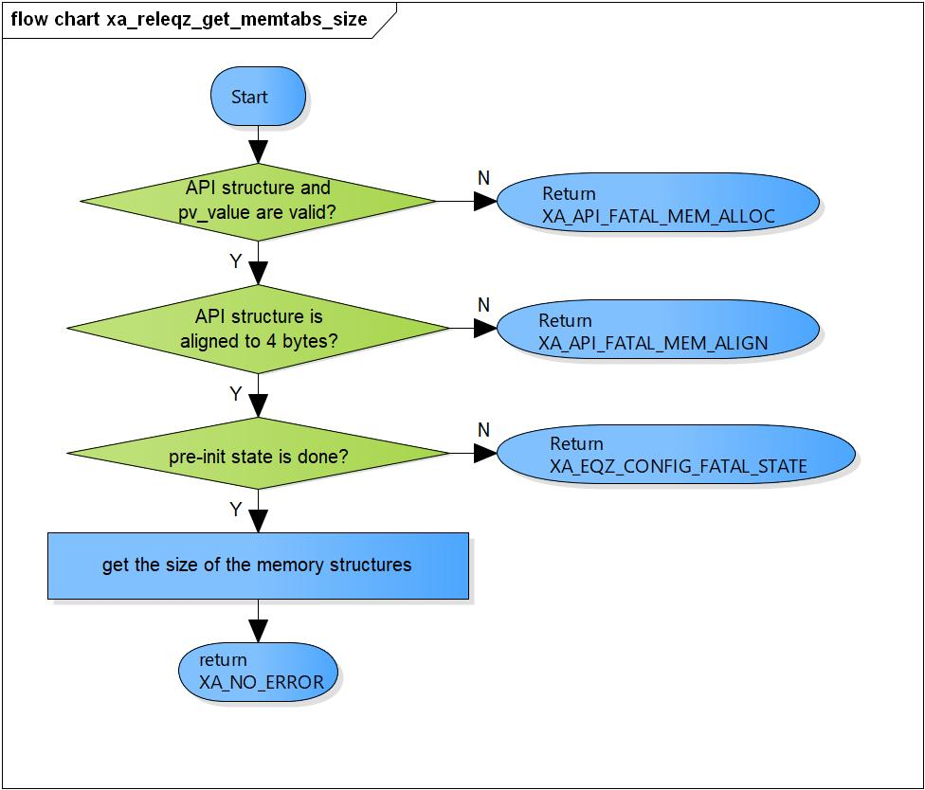

Figure 3‑13 xa_releqz_get_memtabs_size flowchart

#### xa_releqz_set_memtabs_ptr

DD_PLG_EQZ_01_010

|  |  |  |  |  |
| --- | --- | --- | --- | --- |
| **Syntax** | static XA_ERRORCODE xa_releqz_set_memtabs_ptr(XARelEqz *d,  WORD32 i_idx,  pVOID pv_value) | | | |
| **Function** | This function is used to set the memory structure pointer to the allocated value. | | | |
| **Arguments** | Type | Name | I/O | Description |
| XARelEqz* | d | I | Pointer to plugin API structure (struct XAReleqz). |
| WORD32 | i_idx | X | Index of sub-command. |
| pVOID | pv_value | I | Memory table pointer. |
| **Return value** | XA_NO_ERROR | | Normal return. | |
| XA_API_FATAL_MEM_ALLOC | | API object is NULL.  pv_value is NULL. | |
| XA_API_FATAL_MEM_ALIGN | | API object or pv_value are not aligned to 4 bytes. | |
| XA_EQZ_CONFIG_FATAL_STATE | | Equalizer has not pre-init yet. | |
| **Description** | * xa_releqz_set_memtabs_ptr command processing: * Check API structure and pv_value are valid. * Check API structure and pv_value are aligned to 4 bytes. * Check equalizer is pre-initialized. * Set memory tables pointer. * Mark memtabs step is done. | | | |

[Covers: FD_PLG_EQZ_018]

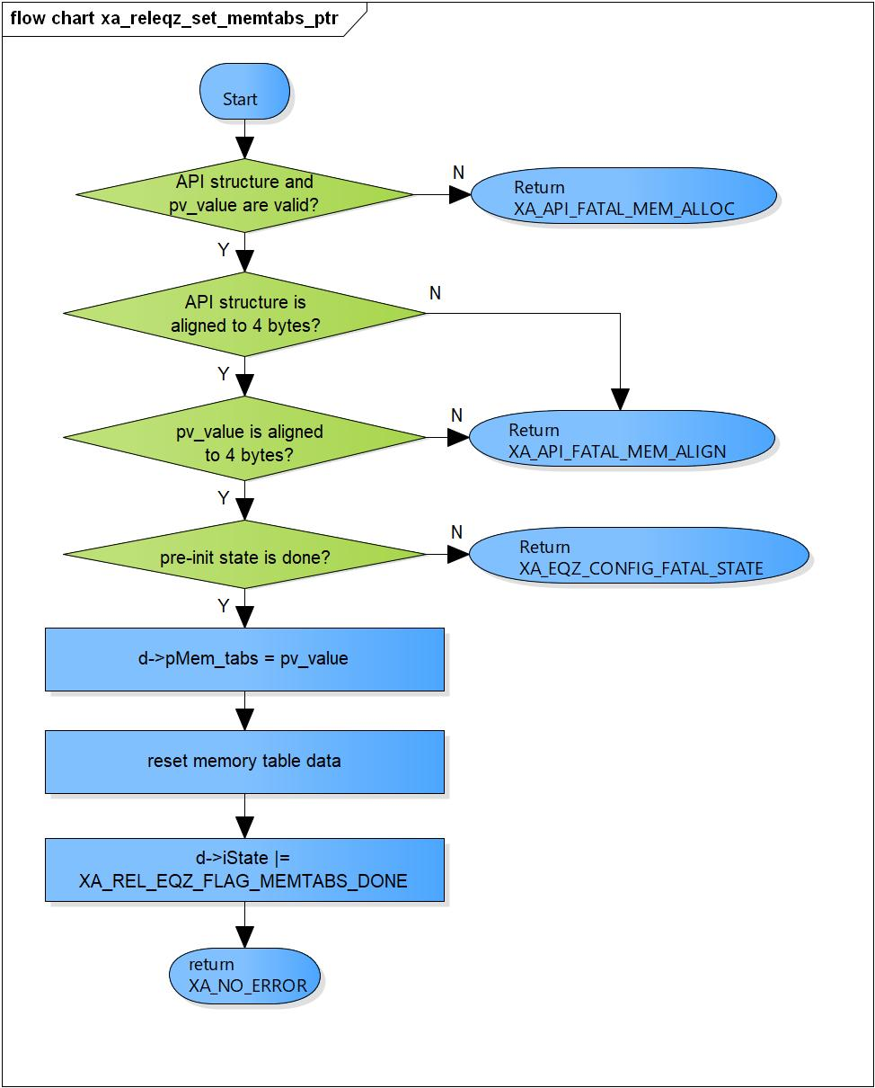

Figure 3‑14 xa_releqz_set_memtabs_ptr flowchart

#### xa_releqz_get_n_memtabs

DD_PLG_EQZ_01_011

|  |  |  |  |  |
| --- | --- | --- | --- | --- |
| **Syntax** | static XA_ERRORCODE xa_releqz_get_n_memtabs(XARelEqz *d,  WORD32 i_idx,  pVOID pv_value) | | | |
| **Function** | This function is used to obtain the number of memory blocks the equalizer needs. This value is used as the iteration counter for the allocation of the memory blocks. A pointer to each memory block will be placed in the previously allocated memory tables. | | | |
| **Arguments** | Type | Name | I/O | Description |
| XARelEqz* | d | I | Pointer to plugin API structure (struct XAReleqz). |
| WORD32 | i_idx | X | Index of sub-command. |
| pVOID | pv_value | O | Pointer to variable of number of memory buffers required to be allocated. |
| **Return value** | XA_NO_ERROR | | Normal return. | |
| XA_API_FATAL_MEM_ALLOC | | API object is NULL.  pv_value is NULL. | |
| XA_API_FATAL_MEM_ALIGN | | API object is not aligned to 4 bytes. | |
| **Description** | * xa_releqz_get_n_memtabs command processing: * Check API structure and pv_value are valid. * Check API structure is aligned to 4 bytes. * Get number of memory in plugin. | | | |

[Covers: FD_PLG_EQZ_019]

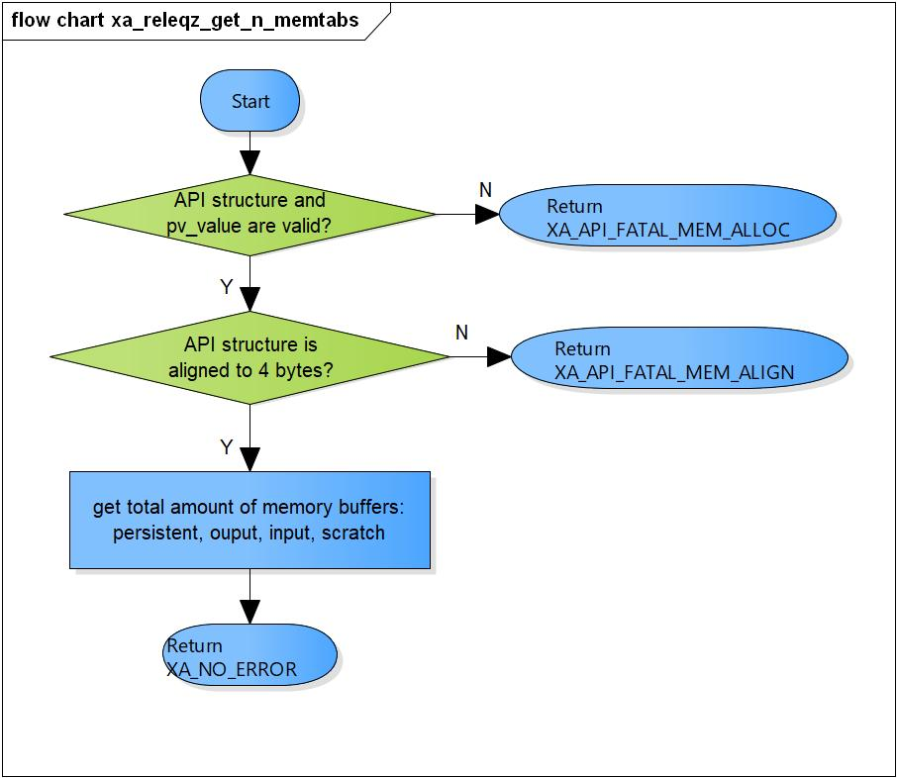

Figure 3‑15 xa_releqz_get_n_memtabs flowchart

#### xa_releqz_get_mem_info_size

DD_PLG_EQZ_01_012

|  |  |  |  |  |
| --- | --- | --- | --- | --- |
| **Syntax** | static XA_ERRORCODE xa_releqz_get_mem_info_size(XARelEqz *d,  WORD32 i_idx,  pVOID pv_value) | | | |
| **Function** | This function obtains the size of the memory type being referred to by the index. The size in bytes is returned in the variable pointed to by the final argument. | | | |
| **Arguments** | Type | Name | I/O | Description |
| XARelEqz* | d | I | Pointer to plugin API structure (struct XAReleqz). |
| WORD32 | i_idx | I | Index of the memory  0 - Persistent Area  1 - Input Buffer  2 - Output Buffer  3 – Scratch Area |
| pVOID | pv_value | O | Pointer to memory size. |
| **Return value** | XA_NO_ERROR | | Normal return. | |
| XA_API_FATAL_MEM_ALLOC | | API object is NULL.  pv_value is NULL. | |
| XA_API_FATAL_MEM_ALIGN | | API object is not aligned to 4 bytes. | |
| XA_API_FATAL_INVALID_CMD_TYPE | | Invalid index. | |
| XA_EQZ_CONFIG_FATAL_STATE | | Equalizer has not post-init yet. | |
| **Description** | * xa_releqz_get_mem_info_size command processing: * Check API structure is valid. * Check API structure is aligned to 4 bytes. * Check equalizer is post-initialized. * Get memory buffer size base on i_idx. | | | |

[Covers: FD_PLG_EQZ_020]

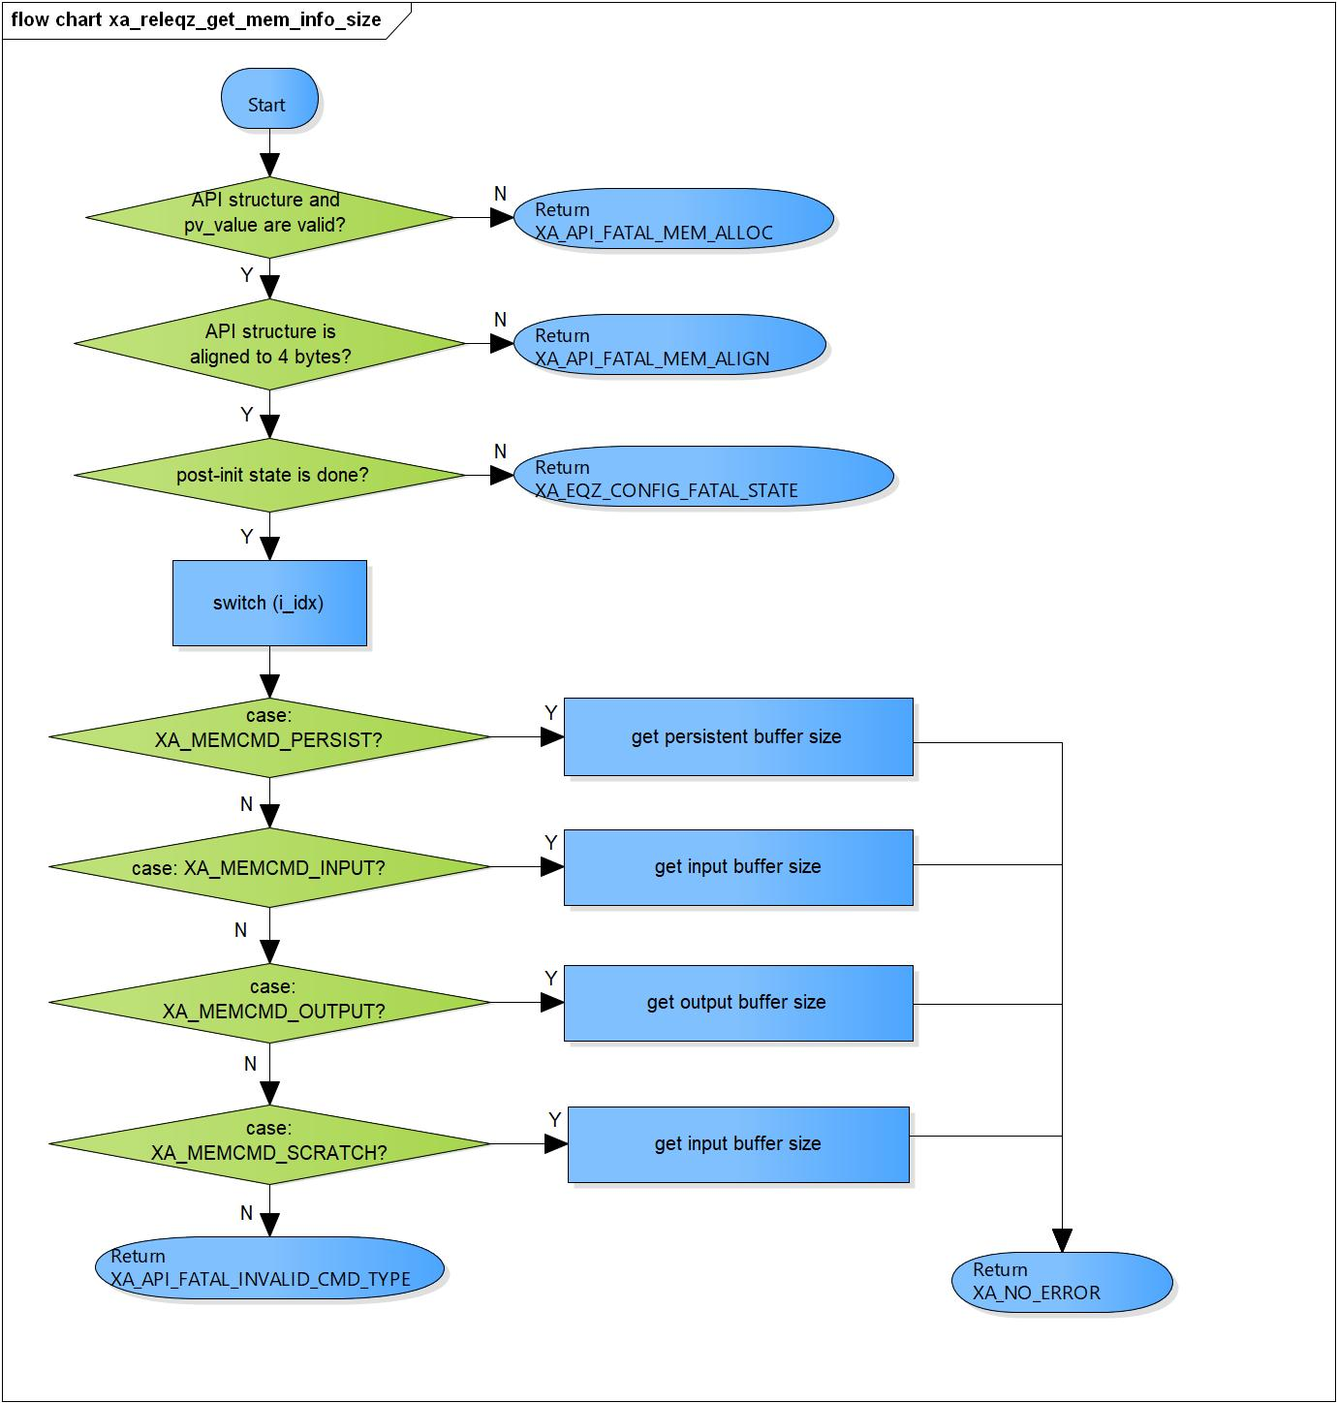

Figure 3‑16 xa_releqz_get_mem_info_size flowchart

#### xa_releqz_get_mem_info_alignment

DD_PLG_EQZ_01_013

|  |  |  |  |  |
| --- | --- | --- | --- | --- |
| **Syntax** | static XA_ERRORCODE xa_releqz_get_mem_info_alignment(XARelEqz *d,  WORD32 i_idx,  pVOID pv_value) | | | |
| **Function** | This function gets the alignment information of the memory-type referred to by the index. The alignment required in bytes is returned to the application. | | | |
| **Arguments** | Type | Name | I/O | Description |
| XARelEqz* | d | I | Pointer to plugin API structure (struct XAReleqz). |
| WORD32 | i_idx | I | Index of the memory  0 - Persistent Area  1 - Input Buffer  2 - Output Buffer  3 – Scratch Area |
| pVOID | pv_value | O | Pointer to the alignment info variable. |
| **Return value** | XA_NO_ERROR | | Normal return. | |
| XA_API_FATAL_MEM_ALLOC | | API object is NULL.  pv_value is NULL. | |
| XA_API_FATAL_MEM_ALIGN | | API object is not aligned to 4 bytes. | |
| XA_API_FATAL_INVALID_CMD_TYPE | | Invalid index. | |
| XA_EQZ_CONFIG_FATAL_STATE | | Equalizer has not post-init yet. | |
| **Description** | * xa_releqz_get_mem_info_alignment command processing: * Check API structure is valid. * Check API structure is aligned to 4 bytes. * Check equalizer is post-initialized. * Get alignment information of the memory base on i_idx. | | | |

[Covers: FD_PLG_EQZ_022]

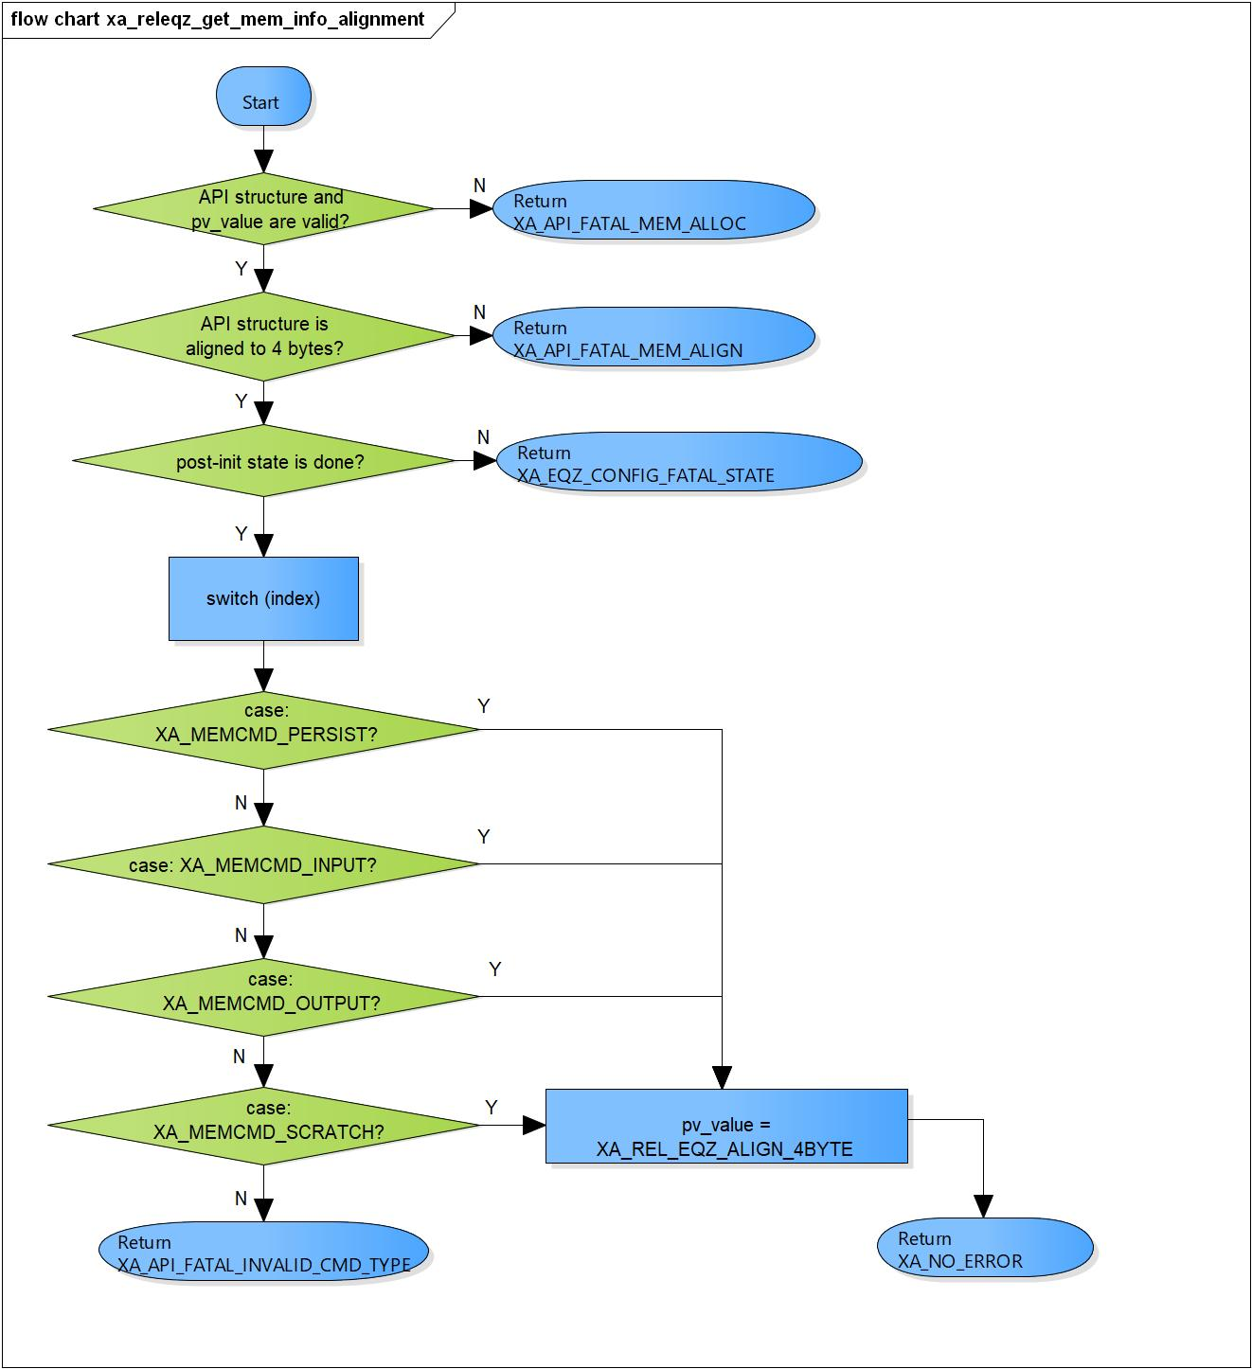

Figure 3‑17 xa_releqz_get_mem_info_alignment flowchart

#### xa_releqz_get_mem_info_type

DD_PLG_EQZ_01_014

|  |  |  |  |  |
| --- | --- | --- | --- | --- |
| **Syntax** | static XA_ERRORCODE xa_releqz_get_mem_info_type(XARelEqz *d,  WORD32 i_idx,  pVOID pv_value) | | | |
| **Function** | This function gets the type of memory being referred to by the index. | | | |
| **Arguments** | Type | Name | I/O | Description |
| XARelEqz* | d | I | Pointer to plugin API structure (struct XAReleqz). |
| WORD32 | i_idx | I | Index of the memory  0 - Persistent Area  1 - Input Buffer  2 - Output Buffer  3 – Scratch Area |
| pVOID | pv_value | O | Pointer to memory type variable. |
| **Return value** | XA_NO_ERROR | | Normal return. | |
| XA_API_FATAL_MEM_ALLOC | | API object is NULL.  pv_value is NULL. | |
| XA_API_FATAL_MEM_ALIGN | | API object is not aligned to 4 bytes. | |
| XA_API_FATAL_INVALID_CMD_TYPE | | Invalid index. | |
| **Description** | * xa_releqz_get_mem_info_type command processing: * Check API structure is valid. * Check API structure is aligned to 4 bytes. * Check equalizer is post-initialized. * Get type information of the memory base on i_idx. | | | |

[Covers: FD_PLG_EQZ_021]

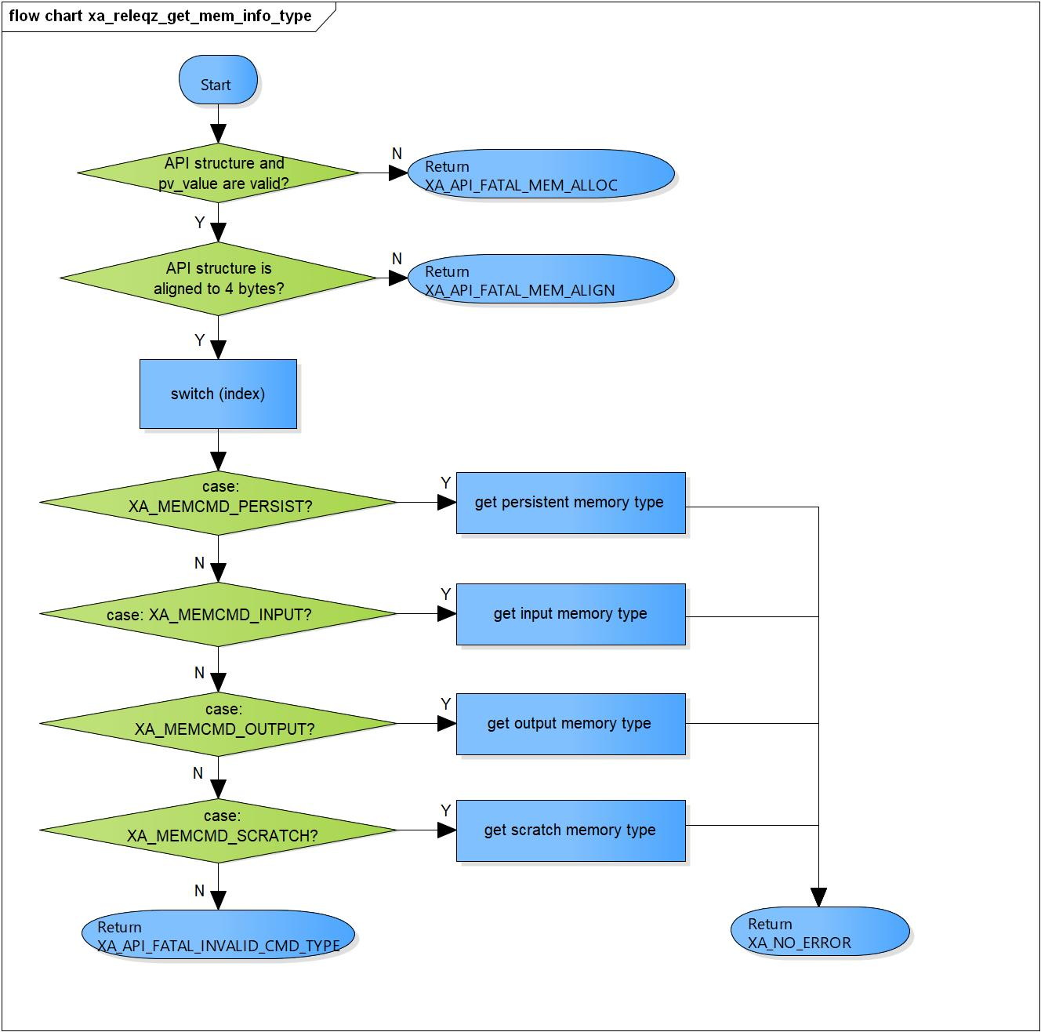

Figure 3‑18 xa_releqz_get_mem_info_type flowchart

#### xa_releqz_set_mem_ptr

DD_PLG_EQZ_01_015

|  |  |  |  |  |
| --- | --- | --- | --- | --- |
| **Syntax** | static XA_ERRORCODE xa_releqz_set_mem_ptr(XARelEqz *d,  WORD32 i_idx,  pVOID pv_value) | | | |
| **Function** | This function passes to the equalizer the pointer to the allocated memory. | | | |
| **Arguments** | Type | Name | I/O | Description |
| XARelEqz* | d | I | Pointer to plugin API structure (struct XAReleqz). |
| WORD32 | i_idx | I | Index of the memory  0 - Persistent Area  1 - Input Buffer  2 - Output Buffer  3 – Scratch Area |
| pVOID | pv_value | I | Pointer to memory buffer allocated. |
| **Return value** | XA_NO_ERROR | | Normal return. | |
| XA_API_FATAL_MEM_ALLOC | | API object is NULL.  pv_value is NULL. | |
| XA_API_FATAL_MEM_ALIGN | | API object are not aligned to 4 bytes. | |
| XA_API_FATAL_INVALID_CMD_TYPE | | Invalid index. | |
| XA_EQZ_CONFIG_FATAL_STATE | | Equalizer has not post-init yet. | |
| **Description** | * xa_releqz_set_mem_ptr command processing: * Check API structure is valid. * Check API structure is aligned to 4 bytes. * Check Equalizer is post-initialized. * Set memory pointer base on i_idx. | | | |

[Covers: FD_PLG_EQZ_023]

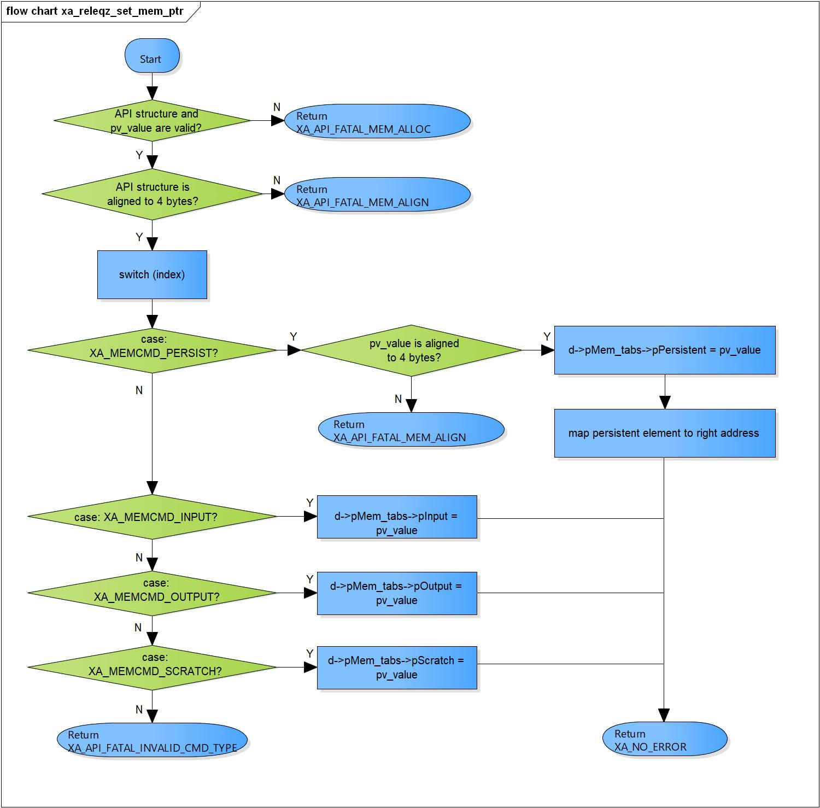

Figure 3‑19 xa_releqz_set_mem_ptr flowchart

#### xa_releqz_input_over

DD_PLG_EQZ_01_016

|  |  |  |  |  |
| --- | --- | --- | --- | --- |
| **Syntax** | static XA_ERRORCODE xa_releqz_input_over(XARelEqz *d,  WORD32 i_idx,  pVOID pv_value) | | | |
| **Function** | This command is used to notify the equalizer that the end of the input data has been reached. This situation can arise both in the initialization loop and the execute loop. | | | |
| **Arguments** | Type | Name | I/O | Description |
| XARelEqz* | d | I/O | Pointer to plugin API structure (struct XAReleqz). |
| WORD32 | i_idx | x | Not necessary. |
| pVOID | pv_value | x | Not necessary. |
| **Return value** | XA_NO_ERROR | | Normal return. | |
| XA_API_FATAL_MEM_ALLOC | | API object is NULL. | |
| XA_API_FATAL_MEM_ALIGN | | API object is not aligned to 4 bytes. | |
| **Description** | * xa_releqz_input_over command processing: * Check API structure is valid. * Check API structure is aligned to 4 bytes. * Mark end-of-stream flag. | | | |

[Covers: FD_PLG_EQZ_035]

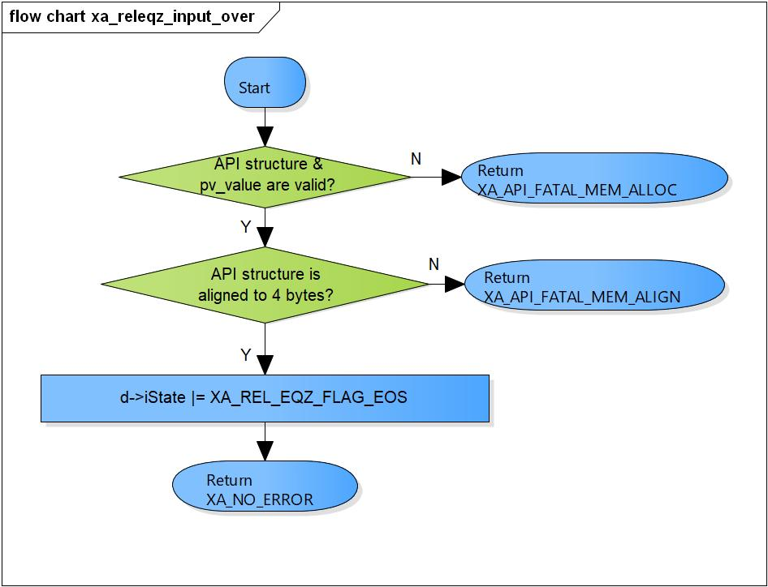

Figure 3‑20 xa_releqz_input_over flowchart

#### xa_releqz_set_input_bytes

DD_PLG_EQZ_01_017

|  |  |  |  |  |
| --- | --- | --- | --- | --- |
| **Syntax** | static XA_ERRORCODE xa_releqz_set_input_bytes(XARelEqz *d,  WORD32 i_idx,  pVOID pv_value) | | | |
| **Function** | This command is used to set the number of bytes available in the input buffer for the execution. | | | |
| **Arguments** | Type | Name | I/O | Description |
| XARelEqz* | d | I/O | Pointer to plugin API structure (struct XAReleqz). |
| WORD32 | i_idx | x | Not necessary. |
| pVOID | pv_value | I | Number of input bytes. |
| **Return value** | XA_NO_ERROR | | Normal return. | |
| XA_API_FATAL_MEM_ALLOC | | API object is NULL. | |
| XA_API_FATAL_MEM_ALIGN | | API object is not aligned to 4 bytes. | |
| XA_EQZ_EXEC_FATAL_STATE | | Equalizer is not post init. | |
| XA_EQZ_EXEC_FATAL_INPUT | | Input buffer pointer is invalid. | |
| **Description** | * xa_releqz_set_input_bytes command processing: * Check API structure is valid. * Check API structure is aligned to 4 bytes. * Set input buffer size. | | | |

[Covers: FD_PLG_EQZ_034]

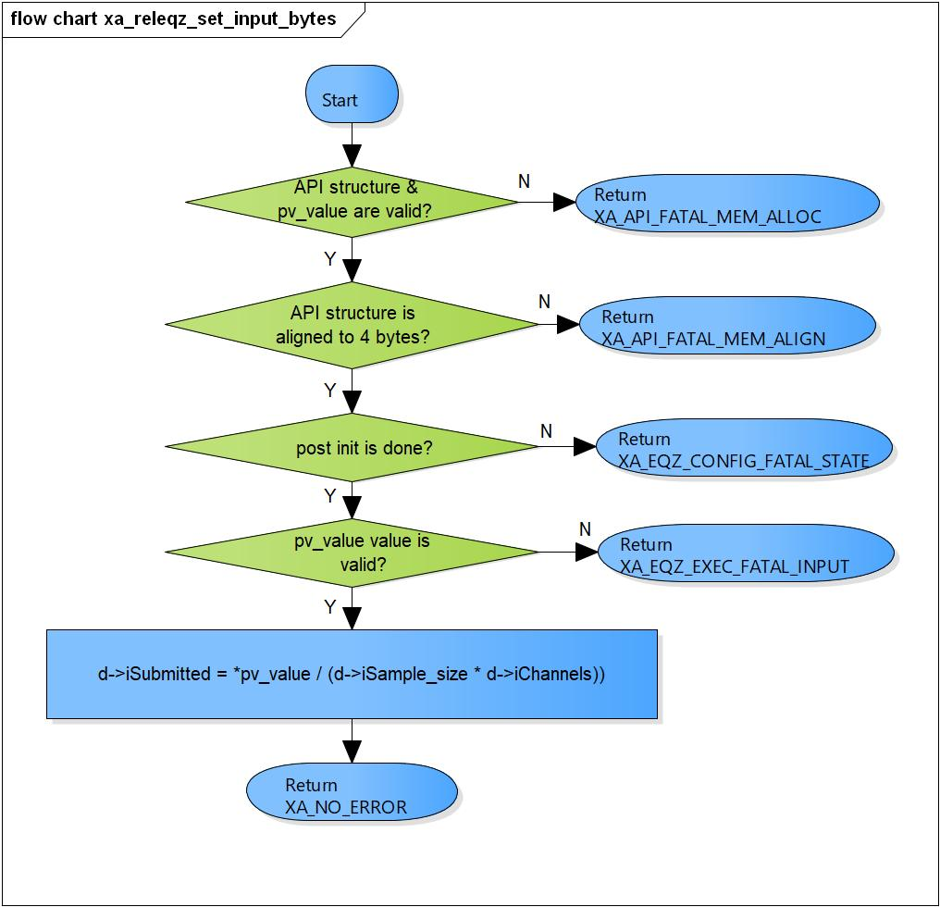

Figure 3‑21 xa_releqz_set_input_bytes flowchart

#### xa_releqz_get_curidx_input_buf

DD_PLG_EQZ_01_018

|  |  |  |  |  |
| --- | --- | --- | --- | --- |
| **Syntax** | static XA_ERRORCODE xa_releqz_get_curidx_input_buf(XARelEqz *d,  WORD32 i_idx,  pVOID pv_value) | | | |
| **Function** | This function gets the number of input buffer bytes consumed by the equalizer. | | | |
| **Arguments** | Type | Name | I/O | Description |
| XARelEqz* | d | I | Pointer to plugin API structure (struct XAReleqz). |
| WORD32 | i_idx | x | Not necessary. |
| pVOID | pv_value | x | Pointer to bytes consumed variable. |
| **Return value** | XA_NO_ERROR | | Normal return. | |
| XA_API_FATAL_MEM_ALLOC | | API object or pv_value are NULL.  Input buffer is invalid. | |
| XA_API_FATAL_MEM_ALIGN | | API object is not aligned to 4 bytes. | |
| **Description** | * xa_releqz_get_curidx_input_buf command processing: * Check API structure and pv_value is valid. * Check API structure is aligned to 4 bytes. * Return number of bytes consumed. | | | |

[Covers: FD_PLG_EQZ_039]

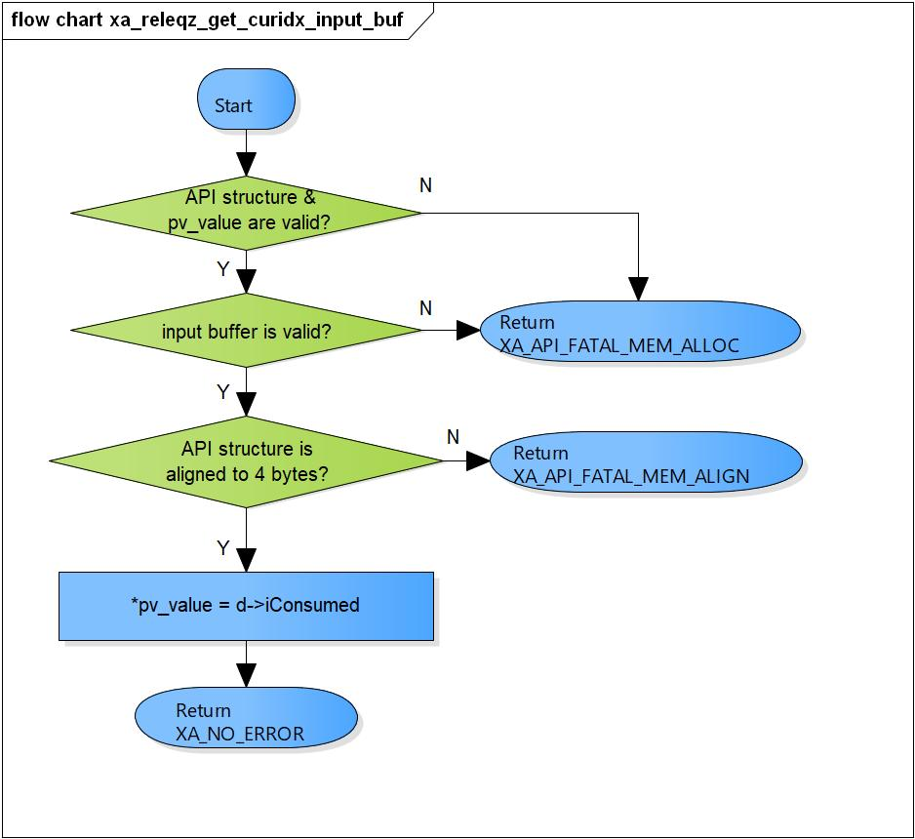

Figure 3‑22 xa_releqz_get_curidx_input_buf flowchart

#### xa_releqz_execute

DD_PLG_EQZ_01_019

|  |  |  |  |  |
| --- | --- | --- | --- | --- |
| **Syntax** | static XA_ERRORCODE xa_releqz_execute(XARelEqz *d,  WORD32 i_idx,  pVOID pv_value) | | | |
| **Function** | This function executes the Equalizer plugin in do execute process and completion status of processing in done process. | | | |
| **Arguments** | Type | Name | I/O | Description |
| XARelEqz* | d | I/O | Pointer to plugin API structure (struct XAReleqz). |
| WORD32 | i_idx | I | Index sub commands.  Valid values:  XA_CMD_TYPE_DO_EXECUTE  XA_CMD_TYPE_DONE_QUERY  XA_CMD_TYPE_DO_RUNTIME_INIT |
| pVOID | pv_value | I | Depend on every sub commands |
| **Return value** | XA_NO_ERROR | | Normal return. | |
| XA_API_FATAL_MEM_ALLOC | | API object is NULL. | |
| XA_API_FATAL_MEM_ALIGN | | API object is not aligned to 4 bytes. | |
| XA_API_FATAL_INVALID_CMD_TYPE | | Invalid index. | |
| XA_EQZ_EXEC_FATAL_STATE | | Equalizer is not running yet | |
| **Description** | * xa_releqz_execute command processing: * Check API structure is valid. * Check API structure is aligned to 4 bytes. * Process individual command type base on i_idx. | | | |

[Covers: FD_PLG_EQZ_036, FD_PLG_EQZ_037]

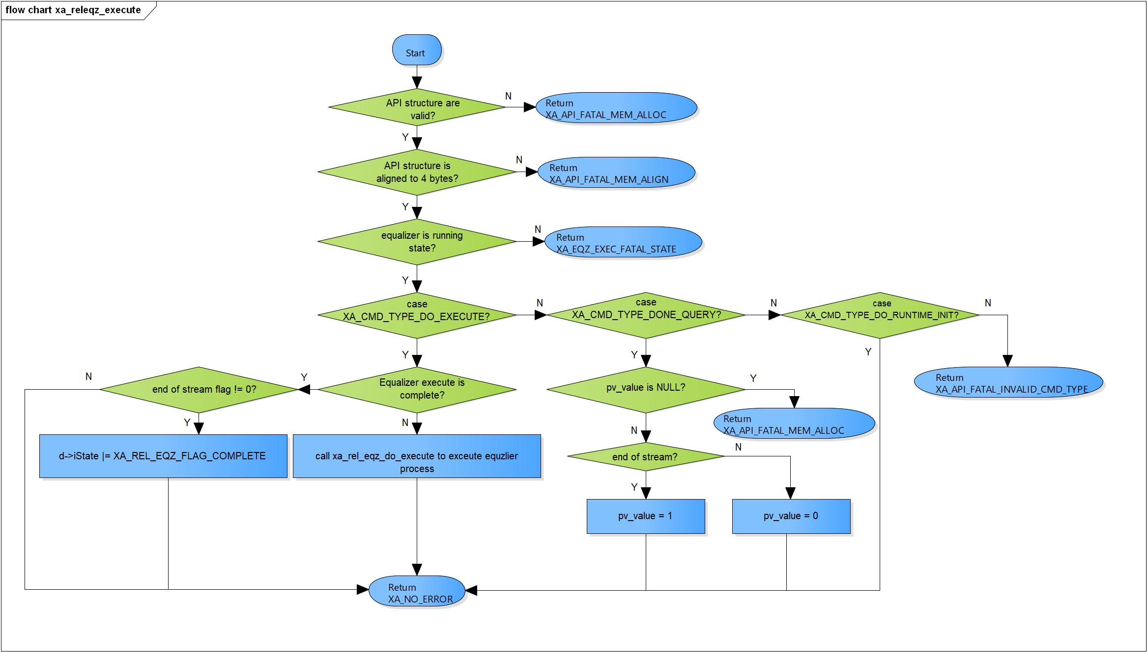

Figure 3‑23 xa_releqz_execute flowchart

#### xa_releqz_get_output_bytes

DD_PLG_EQZ_01_020

|  |  |  |  |  |
| --- | --- | --- | --- | --- |
| **Syntax** | static XA_ERRORCODE xa_releqz_get_output_bytes(XARelEqz *d,  WORD32 i_idx,  pVOID pv_value) | | | |
| **Function** | This function obtains the number of bytes output by the equalizer during the last execution. | | | |
| **Arguments** | Type | Name | I/O | Description |
| XARelEqz* | d | I | Pointer to plugin API structure (struct XAReleqz). |
| WORD32 | i_idx | X | Not necessary. |
| pVOID | pv_value | I | Pointer to output bytes variable. |
| **Return value** | XA_NO_ERROR | | Normal return. | |
| XA_API_FATAL_MEM_ALLOC | | API object is NULL.  pv_value is NULL. | |
| XA_EQZ_EXEC_FATAL_STATE | | Equalizer plugin is not running. | |
| XA_API_FATAL_MEM_ALIGN | | API object is not aligned to 4 bytes. | |
| **Description** | * xa_releqz_get_output_bytes command processing: * Get output index memory. * Check API structure is valid. * Check API structure is aligned to 4 bytes. * Get produced output samples. | | | |

[Covers: FD_PLG_EQZ_038]

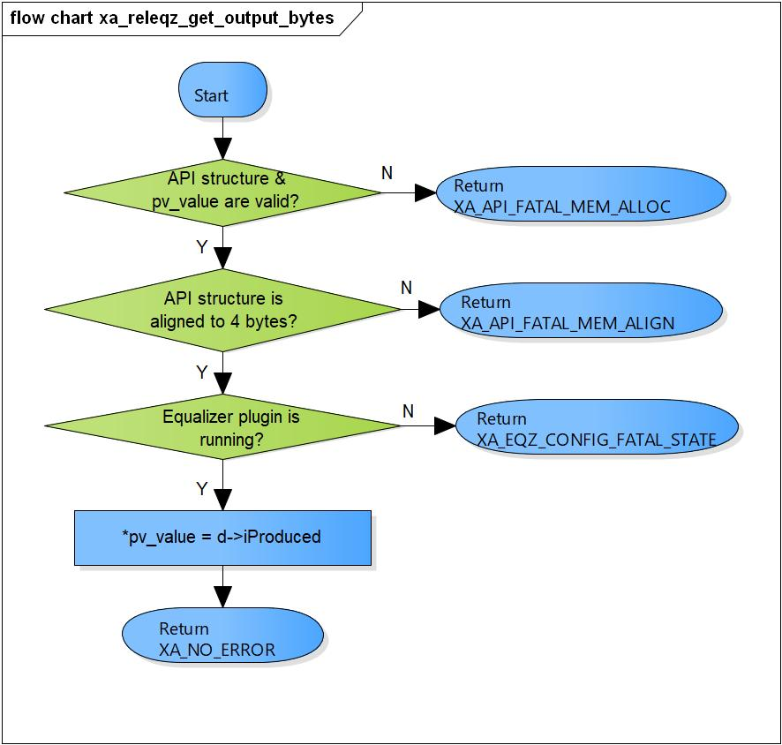

Figure 3‑24 xa_releqz_get_output_bytes flowchart

#### xa_releqz_set_config_param

DD_PLG_EQZ_01_021

|  |  |  |  |  |
| --- | --- | --- | --- | --- |
| **Syntax** | static XA_ERRORCODE xa_releqz_set_config_param(XARelEqz *d,  WORD32 i_idx,  pVOID pv_value) | | | |
| **Function** | This command is used to set the center frequency of a peaking filter or transition frequency of a Bass/Treble filter for filter n. | | | |
| **Arguments** | Type | Name | I/O | Description |
| XARelEqz* | d | I/O | Pointer to plugin API structure  (struct XAReleqz). |
| WORD32 | i_idx | I | Index of sub commands.  Valid values:  XA_EQZ_CONFIG_PARAM_FILTER_<n>_COEF_FC  XA_EQZ_CONFIG_PARAM_FILTER_<n>_COEF_TYPE  XA_EQZ_CONFIG_PARAM_FILTER_<n>_COEF_BW  XA_EQZ_CONFIG_PARAM_FILTER_<n>_COEF_GA  XA_EQZ_CONFIG_PARAM_FILTER_<n>_COEF_BA  XA_EQZ_CONFIG_PARAM_BAND_<m>_GCOEF_GA  XA_EQZ_CONFIG_PARAM_PCM_WIDTH  XA_EQZ_CONFIG_PARAM_CH  XA_EQZ_CONFIG_PARAM_EQZ_TYPE  (n = [0: 8], m = [0: 4] |
| pVOID | pv_value | I | Address that stored center/ transition frequency.  Value range:  - Peaking filter: 20-20kHz (or less than Nyquist frequency)  - Bass filter: 50-500Hz  - Treble filter: 5k - 11kHz |
| **Return value** | XA_NO_ERROR | | Normal return. | |
| XA_API_FATAL_MEM_ALLOC | | API object or pv_value is NULL. | |
| XA_API_FATAL_MEM_ALIGN | | API object is not aligned to 4 bytes. | |
| XA_API_FATAL_INVALID_CMD_TYPE | | Invalid index. | |
| XA_EQZ_CONFIG_FATAL_STATE | | Pre-initialization is not done.  Post-init is done. | |
| XA_EQZ_CONFIG_NONFATAL_ERR_FC | | FC’s value is out range (from 20 – 20000). | |
| XA_EQZ_CONFIG_NONFATAL_ERR_TYPE | | Type of equalizer is neither through, peak, bass nor treble. | |
| XA_EQZ_CONFIG_FATAL_ERR_CH | | Channel is neither stereo nor mono. | |
| XA_EQZ_CONFIG_FATAL_ERR_FS | | Sample rate is neither 32kHz, 44,1kHz nor 48kHz. | |
| XA_EQZ_CONFIG_NONFATAL_ERR_BW | | BW’s value is out range  (from 26843545 – 2013265920). | |
| XA_EQZ_CONFIG_NONFATAL_ERR_GA | | GA’s value for parametric is invalid  (from 47735324 – 1509523500).  GA’s value for graphic is invalid  (from 84886744 – 848867445). | |
| XA_EQZ_CONFIG_NONFATAL_ERR_BA | | BA’s value is invalid  (from 84886744 – 848867445). | |
| XA_EQZ_CONFIG_FATAL_ERR_PCM_WIDTH | | PCM width is neither 16 nor 24. | |
| XA_EQZ_CONFIG_NONFATAL_ERR_SELECT_EQZ_TYPE | | Type of equalizer is neither parametric nor graphic. | |
| **Description** | * xa_releqz_set_config_param command processing: * Check API structure and pv_vlue is valid. * Check API structure is aligned to 4 bytes. * Check pre-initialization is done. * Process individual configuration parameter base on i_idx. | | | |

[Covers: FD_PLG_EQZ_007, FD_PLG_EQZ_008, FD_PLG_EQZ_009, FD_PLG_EQZ_010, FD_PLG_EQZ_011, FD_PLG_EQZ_012, FD_PLG_EQZ_013, FD_PLG_EQZ_014, FD_PLG_EQZ_015, FD_PLG_EQZ_016]

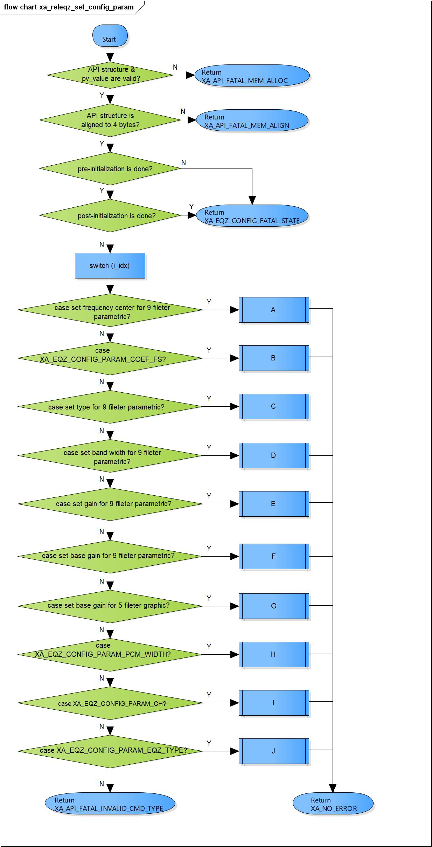

Figure 3‑25 xa_releqz_set_config_param flowchart

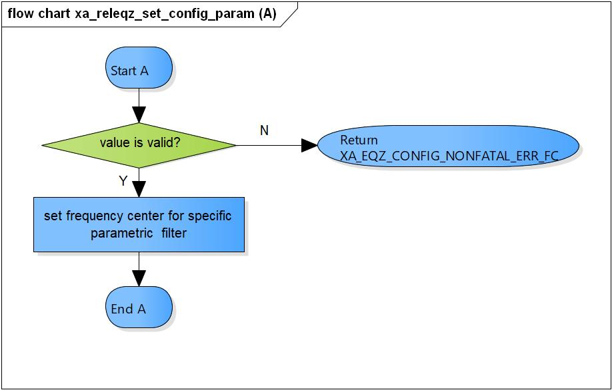

Figure 3‑26 xa_releqz_set_config_param (A) flowchart

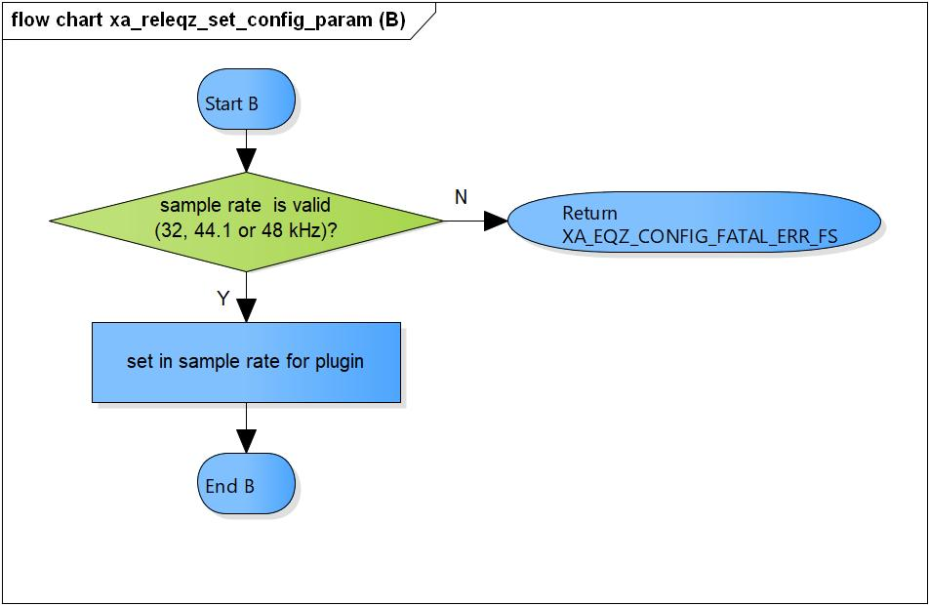

Figure 3‑27 xa_releqz_set_config_param (B) flowchart

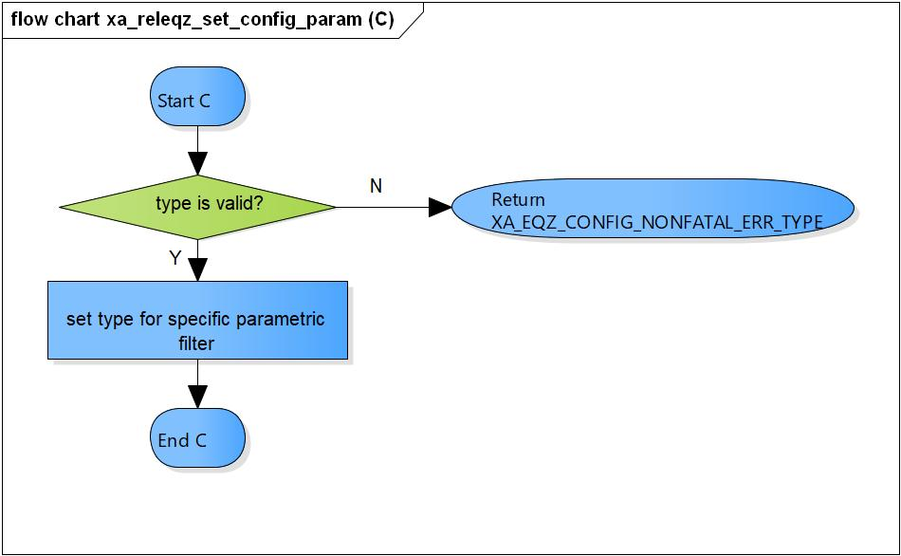

Figure 3‑28 xa_releqz_set_config_param (C) flowchart

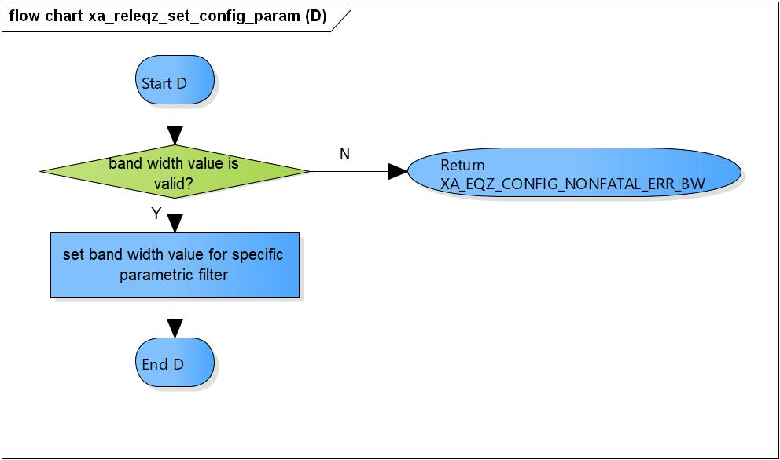

Figure 3‑29 xa_releqz_set_config_param (D) flowchart

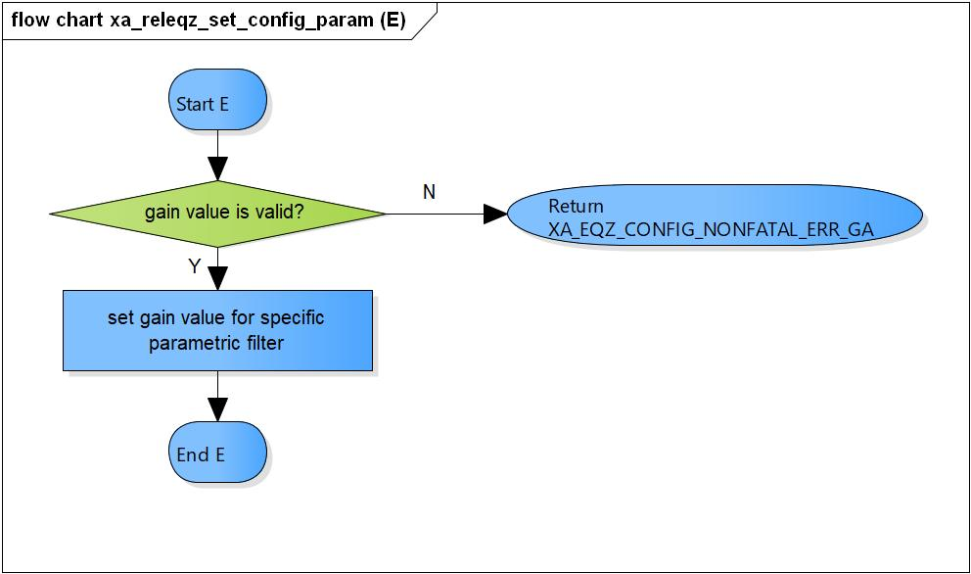

Figure 3‑30 xa_releqz_set_config_param (E) flowchart

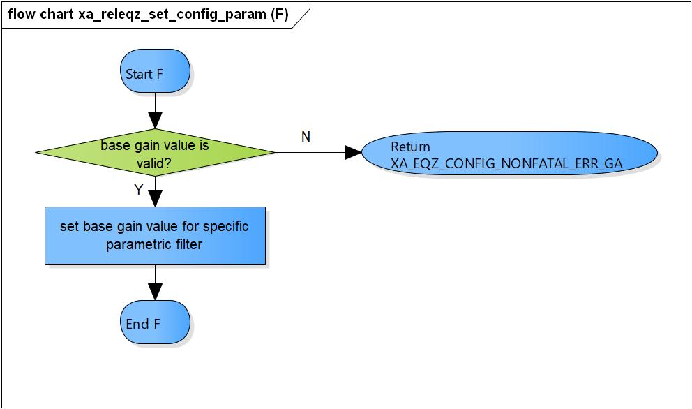

Figure 3‑31 xa_releqz_set_config_param (F) flowchart

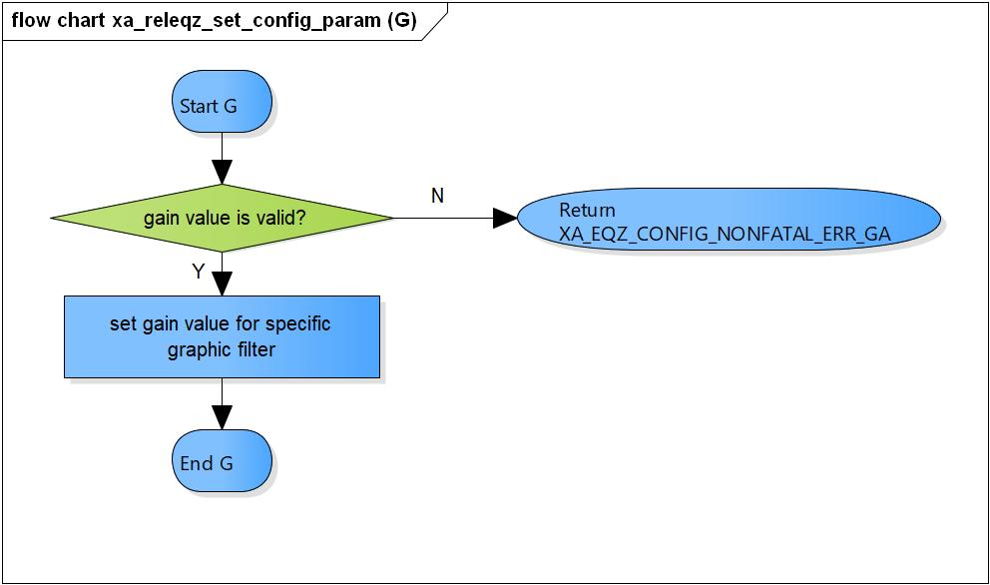

Figure 3‑32 xa_releqz_set_config_param (G) flowchart

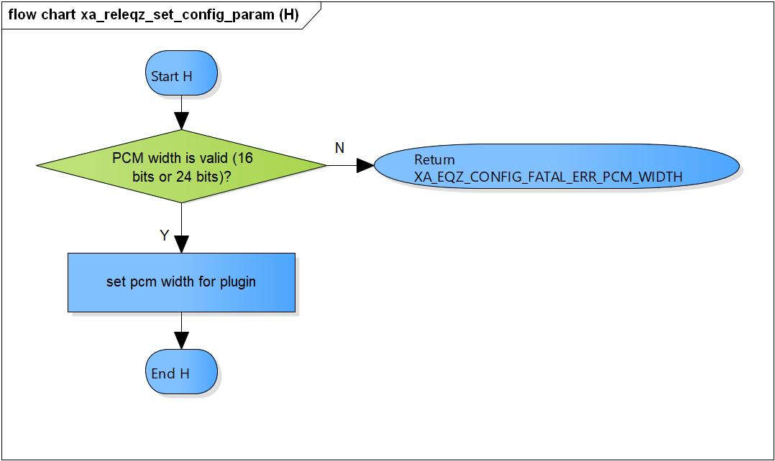

Figure 3‑33 xa_releqz_set_config_param (H) flowchart

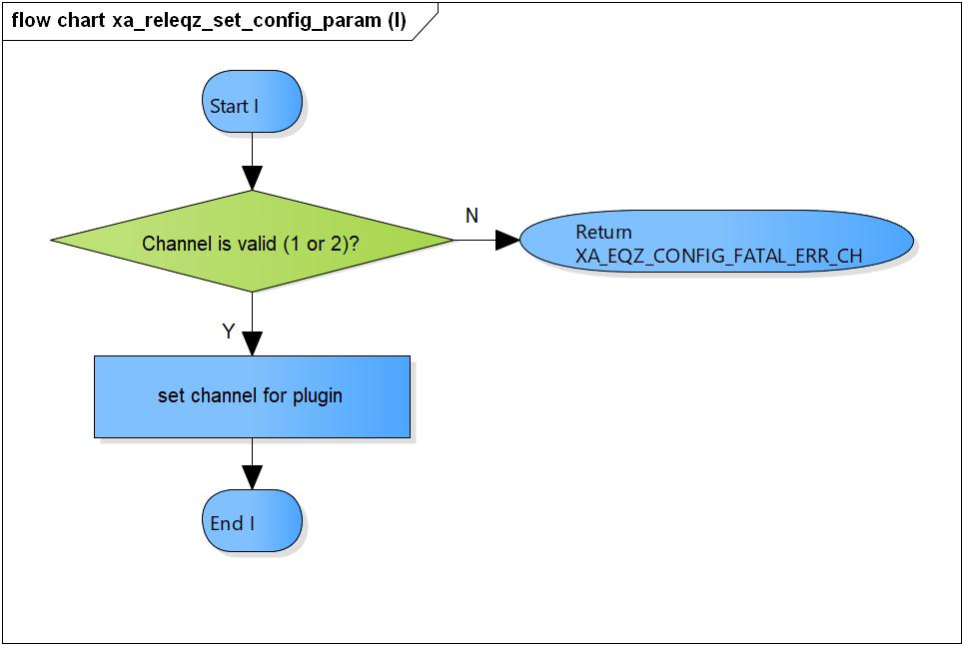

Figure 3‑34 xa_releqz_set_config_param (I) flowchart

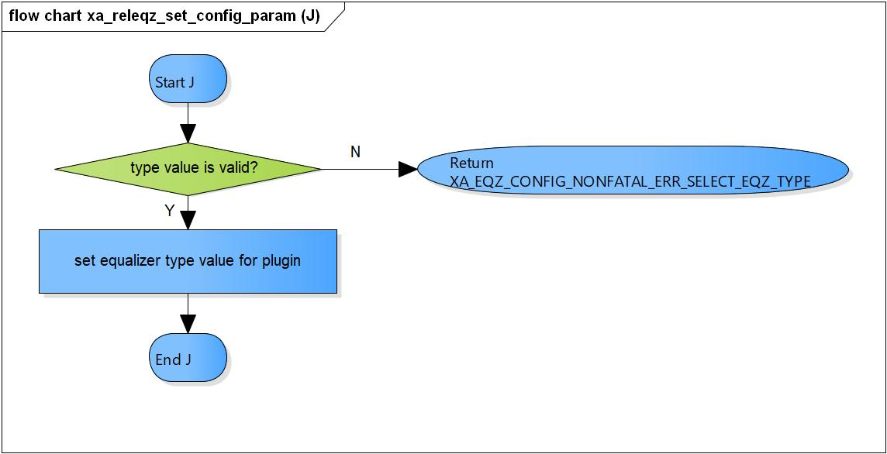

Figure 3‑35 xa_releqz_set_config_param (J) flowchart

#### xa_releqz_get_config_param

DD_PLG_EQZ_01_022

|  |  |  |  |  |
| --- | --- | --- | --- | --- |
| **Syntax** | static XA_ERRORCODE xa_releqz_get_config_param(XARelEqz *d,  WORD32 i_idx,  pVOID pv_value) | | | |
| **Function** | Get equalizer configuration parameters. | | | |
| **Arguments** | Type | Name | I/O | Description |
| XARelEqz* | d | I | Pointer to plugin API structure (struct XAReleqz). |
| WORD32 | i_idx | I | Index sub commands.  Valid values:  XA_EQZ_CONFIG_PARAM_FILTER_<n>_COEF_FC  XA_EQZ_CONFIG_PARAM_FILTER_<n>_COEF_TYPE  XA_EQZ_CONFIG_PARAM_FILTER_<n>_COEF_BW  XA_EQZ_CONFIG_PARAM_FILTER_<n>_COEF_GA  XA_EQZ_CONFIG_PARAM_FILTER_<n>_COEF_BA  XA_EQZ_CONFIG_PARAM_BAND_<m>_GCOEF_GA  XA_EQZ_CONFIG_PARAM_PCM_WIDTH  XA_EQZ_CONFIG_PARAM_CH  XA_EQZ_CONFIG_PARAM_EQZ_TYPE  (n = [0: 8], m = [0: 4] |
| pVOID | pv_value | O | Pointer to parameters variable. |
| **Return value** | XA_NO_ERROR | | Normal return. | |
| XA_API_FATAL_MEM_ALLOC | | API object or pv_value is NULL. | |
| XA_API_FATAL_MEM_ALIGN | | API object is not aligned to 4 bytes. | |
| XA_API_FATAL_INVALID_CMD_TYPE | | Invalid index. | |
| XA_EQZ_EXEC_FATAL_STATE | | Plugin has not pre-init yet. | |
| **Description** | * xa_releqz_get_config_param command processing: * Check API structure is valid. * Check API structure is aligned to 4 bytes. * Check pre-initialization is completed. * Process individual configuration parameter base on i_idx. | | | |

[Covers: FD_PLG_EQZ_024, FD_PLG_EQZ_025, FD_PLG_EQZ_026, FD_PLG_EQZ_027, FD_PLG_EQZ_028, FD_PLG_EQZ_029, FD_PLG_EQZ_030, FD_PLG_EQZ_031, FD_PLG_EQZ_032, FD_PLG_EQZ_033]

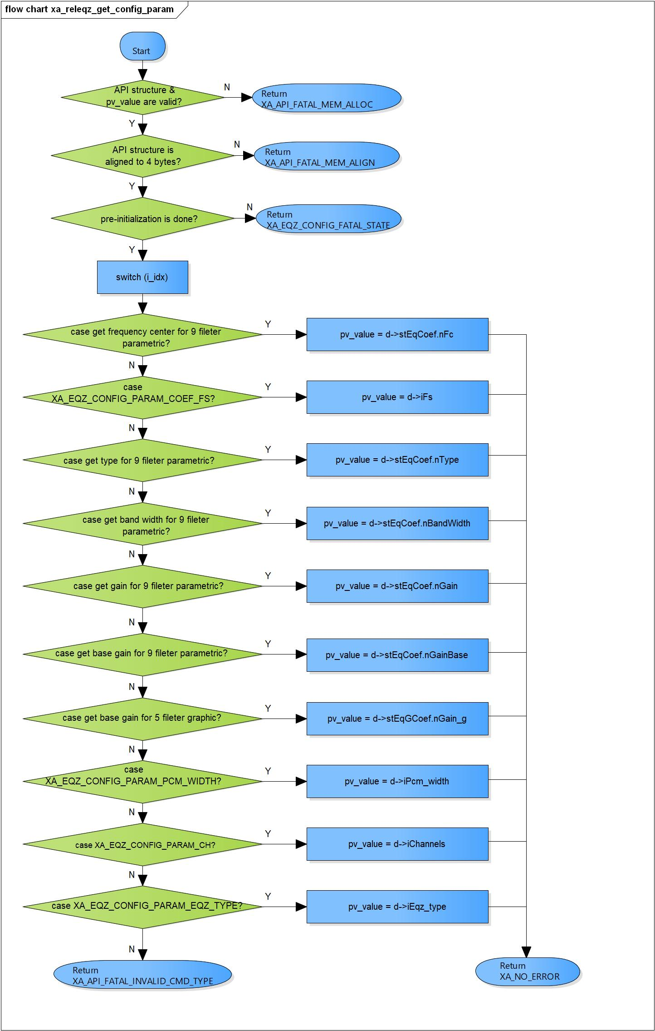

Figure 3‑36 xa_releqz_get_config_param flowchart

# Revision history

|  |  |  |  |  |  |
| --- | --- | --- | --- | --- | --- |
| **Version** | **Date** | **Page** | **Content** | **Approved** | **Changed** |
| 1.0.0 | Nov 14 2018 | - | First Edition issued | Vu Phan | Ngu Pham |
| 1.1.0 | Dec 10 2018 | - | Add traceability ID | Vu Phan | Ngu Pham |
| 1.2.0 | Jan 03, 2019 | - | Add range for input parameters | Vu Phan | Tien Tran |