**Document Type: Detail Design**

**Document Name:**

**ADSP FRAMEWORK: PDMA DRIVER**

Renesas Electronics Corporation

Renesas Design Vietnam Co. Ltd

R-Car Software Solution 2 Group

Middleware 1 Team

Table of Contents

1. Overview 3

2. Function list 4

3. Detail information 5

3.1 Data type definition 5

3.1.1 PDMA_CHN 5

3.1.2 PDMA_ERROR_CODE 6

3.1.3 PDMA_SRC_DST 6

3.1.4 PDMA_REG_SETTING 10

3.2 Macro definition 11

3.3 Global variable definition 12

3.4 Function definition 16

3.4.1 get_pdma_regs 16

3.4.2 set_pdma_regs 17

3.4.3 xa_set_pdma_extend 18

3.4.4 xa_clear_pdma_extend 20

3.4.5 xa_enable_pdma_extend 21

3.4.6 xa_disable_pdma_extend 22

3.4.7 xa_check_available_pdma_channel 23

4. Revision history 26

List of Figures

Figure 1‑1 The software architecture 3

Figure 3‑1 get_pdma_regs flowchart 16

Figure 3‑2 set_pdma_regs flowchart 17

Figure 3‑3 xa_set_pdma_extend flowchart 19

Figure 3‑4 xa_clear_pdma_extend flowchart 20

Figure 3‑5 xa_enable_pdma_extend flowchart 21

Figure 3‑6 xa_disable_pdma_extend flowchart 22

Figure 3‑7 xa_check_available_pdma_channel flowchart 24

List of Table

Table 2‑1 Function list 4

Table 3‑1 PDMA_CHN type information 5

Table 3‑2 PDMA_ERROR_CODE type information 6

Table 3‑3 PDMA_SRC_DST type information 6

Table 3‑4 PDMA_REG_SETTING type information 10

Table 2‑1 Function list 4

Table 3‑1 PDMA_CHN type information 5

Table 3‑2 PDMA_ERROR_CODE type information 6

Table 3‑3 PDMA_SRC_DST type information 6

Table 3‑4 PDMA_REG_SETTING type information 10

# Overview

This section provides an overview of software architecture.

User Application

ADSP Interface

Kernel Space

User Space

ADSP Driver

ARM

Audio HW

**ADSP Framework**

TDM class

Renderer class

Equalizer class

Capture class

TDM Plugin

ADSP

Plugin

Equalizer Plugin*

Capture Plugin

Renderer Plugin

This document’s target is in side of red square

* not connect to hardware modules

DAC/

ADC

PDMA

FIFO

SCU

SSI

SSIU

PDMA

Figure 1‑1 ****The software architecture****

# Function list

The following is list of functions:

Table 2‑1 Function list

|  |  |  |
| --- | --- | --- |
| **Type** | **Function Name** | **Outline** |
| API | xa_set_pdma_extend | This API is to set the registers for PDMA |
| xa_clear_pdma_extend | This API is to clear the registers for PDMA |
| xa_enable_pdma_extend | This API is to enable PDMA |
| xa_disable_pdma_extend | This API is to disable PDMA |
| xa_check_available_pdma_channel | This API is to check availability of a PDMA channel and choose an available one |
| Internal function | get_pdma_regs | This function is to get a PDMA register’s value |
| set_pdma_regs | This function is to set a PDMA register |

# Detail information

This section describes detail information of data types, macro definitions, implemented APIs and internal function units, global variable.

## Data type definition

### PDMA_CHN

The data type PDMA_CHN is a type-defined enumeration that lists all supported PDMA channels.

Table 3‑1 PDMA_CHN type information

|  |  |  |
| --- | --- | --- |
| **Member name** | **Value** | **Outline** |
| PDMA_CH00 | 0 | PDMA channel 0 |
| PDMA_CH01 | 1 | PDMA channel 1 |
| PDMA_CH02 | 2 | PDMA channel 2 |
| PDMA_CH03 | 3 | PDMA channel 3 |
| PDMA_CH04 | 4 | PDMA channel 4 |
| PDMA_CH05 | 5 | PDMA channel 5 |
| PDMA_CH06 | 6 | PDMA channel 6 |
| PDMA_CH07 | 7 | PDMA channel 7 |
| PDMA_CH08 | 8 | PDMA channel 8 |
| PDMA_CH09 | 9 | PDMA channel 9 |
| PDMA_CH10 | 10 | PDMA channel 10 |
| PDMA_CH11 | 11 | PDMA channel 11 |
| PDMA_CH12 | 12 | PDMA channel 12 |
| PDMA_CH13 | 13 | PDMA channel 13 |
| PDMA_CH14 | 14 | PDMA channel 14 |
| PDMA_CH15 | 15 | PDMA channel 15 |
| PDMA_CH16 | 16 | PDMA channel 16 |
| PDMA_CH17 | 17 | PDMA channel 17 |
| PDMA_CH18 | 18 | PDMA channel 18 |
| PDMA_CH19 | 19 | PDMA channel 19 |
| PDMA_CH20 | 20 | PDMA channel 20 |
| PDMA_CH21 | 21 | PDMA channel 21 |
| PDMA_CH22 | 22 | PDMA channel 22 |
| PDMA_CH23 | 23 | PDMA channel 23 |
| PDMA_CH24 | 24 | PDMA channel 24 |
| PDMA_CH25 | 25 | PDMA channel 25 |
| PDMA_CH26 | 26 | PDMA channel 26 |
| PDMA_CH27 | 27 | PDMA channel 27 |
| PDMA_CH28 | 28 | PDMA channel 28 |
| PDMA_CHMAX | 29 | Total number of PDMA channels |

### PDMA_ERROR_CODE

The data type PDMA_ERROR_CODE is a type-defined enumeration that lists all error codes for PDMA.

Table 3‑2 PDMA_ERROR_CODE type information

|  |  |
| --- | --- |
| **Member name** | **Value** |
| PDMA_ERROR_NONE | 0 |
| PDMA_ERROR_INVALID_CHANNEL | -1 |
| PDMA_ERROR_INVALID_SOURCE | -2 |
| PDMA_ERROR_INVALID_DESTINATION | -3 |
| PDMA_ERROR_BUSY_CHANNEL | -4 |

### PDMA_SRC_DST

The data type PDMA_SRC_DST is a type-defined enumeration that shows connections between PDMA and other devices.

Table 3‑3 PDMA_SRC_DST type information

|  |  |
| --- | --- |
| **Member name** | **Value** |
| PDMA_SSI00 | SSI_MODULE_MIN |
| PDMA_SSI01 | 1 |
| PDMA_SSI02 | 2 |
| PDMA_SSI03 | 3 |
| PDMA_SSI04 | 4 |
| PDMA_SSI05 | 5 |
| PDMA_SSI06 | 6 |
| PDMA_SSI07 | 7 |
| PDMA_SSI10 | 10 |
| PDMA_SSI11 | 11 |
| PDMA_SSI12 | 12 |
| PDMA_SSI13 | 13 |
| PDMA_SSI14 | 14 |
| PDMA_SSI15 | 15 |
| PDMA_SSI16 | 16 |
| PDMA_SSI17 | 17 |
| PDMA_SSI20 | 20 |
| PDMA_SSI21 | 21 |
| PDMA_SSI22 | 22 |
| PDMA_SSI23 | 23 |
| PDMA_SSI24 | 24 |
| PDMA_SSI25 | 25 |
| PDMA_SSI26 | 26 |
| PDMA_SSI27 | 27 |
| PDMA_SSI30 | 30 |
| PDMA_SSI31 | 31 |
| PDMA_SSI32 | 32 |
| PDMA_SSI33 | 33 |
| PDMA_SSI34 | 34 |
| PDMA_SSI35 | 35 |
| PDMA_SSI36 | 36 |
| PDMA_SSI37 | 37 |
| PDMA_SSI40 | 40 |
| PDMA_SSI41 | 41 |
| PDMA_SSI42 | 42 |
| PDMA_SSI43 | 43 |
| PDMA_SSI44 | 44 |
| PDMA_SSI45 | 45 |
| PDMA_SSI46 | 46 |
| PDMA_SSI47 | 47 |
| PDMA_SSI5 | 50 |
| PDMA_SSI6 | 60 |
| PDMA_SSI7 | 70 |
| PDMA_SSI8 | 80 |
| PDMA_SSI90 | 90 |
| PDMA_SSI91 | 91 |
| PDMA_SSI92 | 92 |
| PDMA_SSI93 | 93 |
| PDMA_SSI94 | 94 |
| PDMA_SSI95 | 95 |
| PDMA_SSI96 | 96 |
| PDMA_SSI97 | SSI_MODULE_MAX |
| PDMA_DTCPPP0 | 98 |
| PDMA_DTCPPP1 | 99 |
| PDMA_DTCPCP0 | 100 |
| PDMA_DTCPCP1 | 101 |
| PDMA_ADSPO0 | 102 |
| PDMA_ADSPI0 | 103 |
| PDMA_ADSPO1 | 104 |
| PDMA_ADSPI1 | 105 |
| PDMA_ADSPO2 | 106 |
| PDMA_ADSPI2 | 107 |
| PDMA_ADSPO3 | 108 |
| PDMA_ADSPI3 | 109 |
| PDMA_SCU_SRCI0 | SCU_SRC_INPUT_MODULE_MIN |
| PDMA_SCU_SRCI1 | 111 |
| PDMA_SCU_SRCI2 | 112 |
| PDMA_SCU_SRCI3 | 113 |
| PDMA_SCU_SRCI4 | 114 |
| PDMA_SCU_SRCI5 | 115 |
| PDMA_SCU_SRCI6 | 116 |
| PDMA_SCU_SRCI7 | 117 |
| PDMA_SCU_SRCI8 | 118 |
| PDMA_SCU_SRCI9 | SCU_SRC_INPUT_MODULE_MAX |
| PDMA_SCU_SRCO0 | SCU_SRC_OUTPUT_MODULE_MIN |
| PDMA_SCU_SRCO1 | 121 |
| PDMA_SCU_SRCO2 | 122 |
| PDMA_SCU_SRCO3 | 123 |
| PDMA_SCU_SRCO4 | 124 |
| PDMA_SCU_SRCO5 | 125 |
| PDMA_SCU_SRCO6 | 126 |
| PDMA_SCU_SRCO7 | 127 |
| PDMA_SCU_SRCO8 | 128 |
| PDMA_SCU_SRCO9 | SCU_SRC_OUTPUT_MODULE_MAX |
| PDMA_SCU_CMD0 | SCU_CMD_MODULE_MIN |
| PDMA_SCU_CMD1 | SCU_CMD_MODULE_MAX |
| PDMA_MLM0 | 132 |
| PDMA_MLM1 | 133 |
| PDMA_MLM2 | 134 |
| PDMA_MLM3 | 135 |
| PDMA_MLM4 | 136 |
| PDMA_MLM5 | 137 |
| PDMA_MLM6 | 138 |
| PDMA_MLM7 | 139 |
| PDMA_NONCONTROL | 140 |
| PDMA_MAX | 141 |

### PDMA_REG_SETTING

The data type PDMA_REG_SETTING is a type-defined structure that possesses necessary parameters for PDMA module.

Table 3‑4 PDMA_REG_SETTING type information

|  |  |  |
| --- | --- | --- |
| **Member name** | **Data type** | **Outline** |
| SARE | UWORD32 | SARE register value |
| CHCRESRS | UWORD32 | CHCRESRS register SRS bit value |
| DARE | UWORD32 | DARE register value |
| CHCREDRS | UWORD32 | CHCREDRS register DRS bit value |

## Macro definition

|  |  |  |
| --- | --- | --- |
| **Macros** | **Value** | **Outline** |
| SSI_MODULE_MIN | 0 | SSI module min index |
| SSI_MODULE_MAX | 97 | SSI module max index |
| SCU_SRC_INPUT_MODULE_MIN | 110 | SCU input module min index |
| SCU_SRC_INPUT_MODULE_MAX | 119 | SCU input module max index |
| SCU_SRC_OUTPUT_MODULE_MIN | 120 | SCU output module min index |
| SCU_SRC_OUTPUT_MODULE_MAX | 129 | SCU output module max index |
| SCU_CMD_MODULE_MIN | 130 | CMD module min index |
| SCU_CMD_MODULE_MAX | 131 | CMD module max index |
| PDMASARE(n) | XF_RCAR_REG_PDMASARE(n) | PDMASARE Address Calculation: XF_RCAR_REG_PDMASARE(n) in xf-registers.h |
| PDMADARE(n) | XF_RCAR_REG_PDMADARE(n) | PDMADARE Address Calculation: XF_RCAR_REG_PDMADARE(n) in xf-registers.h |
| PPDMAHCRE(n) | XF_RCAR_REG_PPDMAHCRE(n) | PPDMAHCRE Address Calculation: XF_RCAR_REG_PPDMAHCRE(n) in xf-registers.h |

## Global variable definition

Below is the array of struct PDMA_REG_SETTING-datatype pdma_set_value holds 141 (PDMA_MAX) elements representing settings for PDMA data transfer

|  |  |  |  |  |
| --- | --- | --- | --- | --- |
| static PDMA_REG_SETTING pdma_set_value[PDMA_MAX] | | | | |
| Array’s index | SARE | CHCRESRS | DARE | CHCREDRS |
| PDMA_SSI00 | 0xEC400000 | 0x00 | 0xEC400000 | 0x00 |
| PDMA_SSI01 | 0xEC400400 | 0x01 | 0xEC400400 | 0x01 |
| PDMA_SSI02 | 0xEC400800 | 0x02 | 0xEC400800 | 0x02 |
| PDMA_SSI03 | 0xEC400C00 | 0x03 | 0xEC400C00 | 0x03 |
| PDMA_SSI04 | 0xEC40A000 | 0x39 | 0xEC40A000 | 0x39 |
| PDMA_SSI05 | 0xEC40A400 | 0x3A | 0xEC40A400 | 0x3A |
| PDMA_SSI06 | 0xEC40A800 | 0x3B | 0xEC40A800 | 0x3B |
| PDMA_SSI07 | 0xEC40AC00 | 0x3C | 0xEC40AC00 | 0x3C |
| PDMA_SSI10 | 0xEC401000 | 0x04 | 0xEC401000 | 0x04 |
| PDMA_SSI11 | 0xEC401400 | 0x05 | 0xEC401400 | 0x05 |
| PDMA_SSI12 | 0xEC401800 | 0x06 | 0xEC401800 | 0x06 |
| PDMA_SSI13 | 0xEC401C00 | 0x07 | 0xEC401C00 | 0x07 |
| PDMA_SSI14 | 0xEC40B000 | 0x3D | 0xEC40B000 | 0x3D |
| PDMA_SSI15 | 0xEC40B400 | 0x3E | 0xEC40B400 | 0x3E |
| PDMA_SSI16 | 0xEC40B800 | 0x3F | 0xEC40B800 | 0x3F |
| PDMA_SSI17 | 0xEC40BC00 | 0x40 | 0xEC40BC00 | 0x40 |
| PDMA_SSI20 | 0xEC402000 | 0x08 | 0xEC402000 | 0x08 |
| PDMA_SSI21 | 0xEC402400 | 0x09 | 0xEC402400 | 0x09 |
| PDMA_SSI22 | 0xEC402800 | 0x0A | 0xEC402800 | 0x0A |
| PDMA_SSI23 | 0xEC402C00 | 0x0B | 0xEC402C00 | 0x0B |
| PDMA_SSI24 | 0xEC40C000 | 0x41 | 0xEC40C000 | 0x41 |
| PDMA_SSI25 | 0xEC40C400 | 0x42 | 0xEC40C400 | 0x42 |
| PDMA_SSI26 | 0xEC40C800 | 0x43 | 0xEC40C800 | 0x43 |
| PDMA_SSI27 | 0xEC40CC00 | 0x44 | 0xEC40CC00 | 0x44 |
| PDMA_SSI30 | 0xEC403000 | 0x0C | 0xEC403000 | 0x0C |
| PDMA_SSI31 | 0xEC403400 | 0x45 | 0xEC403400 | 0x45 |
| PDMA_SSI32 | 0xEC403800 | 0x46 | 0xEC403800 | 0x46 |
| PDMA_SSI33 | 0xEC403C00 | 0x47 | 0xEC403C00 | 0x47 |
| PDMA_SSI34 | 0xEC40D000 | 0x48 | 0xEC40D000 | 0x48 |
| PDMA_SSI35 | 0xEC40D400 | 0x49 | 0xEC40D400 | 0x49 |
| PDMA_SSI36 | 0xEC40D800 | 0x4A | 0xEC40D800 | 0x4A |
| PDMA_SSI37 | 0xEC40DC00 | 0x4B | 0xEC40DC00 | 0x4B |
| PDMA_SSI40 | 0xEC404000 | 0x0D | 0xEC404000 | 0x0D |
| PDMA_SSI41 | 0xEC404400 | 0x4C | 0xEC404400 | 0x4C |
| PDMA_SSI42 | 0xEC404800 | 0x4D | 0xEC404800 | 0x4D |
| PDMA_SSI43 | 0xEC404C00 | 0x4E | 0xEC404C00 | 0x4E |
| PDMA_SSI44 | 0xEC40E000 | 0x4F | 0xEC40E000 | 0x4F |
| PDMA_SSI45 | 0xEC40E400 | 0x50 | 0xEC40E400 | 0x50 |
| PDMA_SSI46 | 0xEC40E800 | 0x51 | 0xEC40E800 | 0x51 |
| PDMA_SSI47 | 0xEC40EC00 | 0x52 | 0xEC40EC00 | 0x52 |
| PDMA_SSI5 | 0xEC405000 | 0x0E | 0xEC405000 | 0x0E |
| PDMA_SSI6 | 0xEC406000 | 0x0F | 0xEC406000 | 0x0F |
| PDMA_SSI7 | 0xEC407000 | 0x10 | 0xEC407000 | 0x10 |
| PDMA_SSI8 | 0xEC408000 | 0x11 | 0xEC408000 | 0x11 |
| PDMA_SSI90 | 0xEC409000 | 0x12 | 0xEC409000 | 0x12 |
| PDMA_SSI91 | 0xEC409400 | 0x13 | 0xEC409400 | 0x13 |
| PDMA_SSI92 | 0xEC409800 | 0x14 | 0xEC409800 | 0x14 |
| PDMA_SSI93 | 0xEC409C00 | 0x15 | 0xEC409C00 | 0x15 |
| PDMA_SSI94 | 0xEC40F000 | 0x53 | 0xEC40F000 | 0x53 |
| PDMA_SSI95 | 0xEC40F400 | 0x54 | 0xEC40F400 | 0x54 |
| PDMA_SSI96 | 0xEC40F800 | 0x55 | 0xEC40F800 | 0x55 |
| PDMA_SSI97 | 0xEC40FC00 | 0x56 | 0xEC40FC00 | 0x56 |
| PDMA_DTCPPP0 | 0xEC420000 | 0x16 | 0xEC420000 | 0x16 |
| PDMA_DTCPPP1 | 0xEC420400 | 0x17 | 0xEC420400 | 0x17 |
| PDMA_DTCPCP0 | 0xEC420800 | 0x18 | 0xEC420800 | 0x18 |
| PDMA_DTCPCP1 | 0xEC420C00 | 0x19 | 0xEC420C00 | 0x19 |
| PDMA_ADSPO0 | 0xEC460000 | 0x23 | 0xff | 0xff |
| PDMA_ADSPI0 | 0xff | 0xff | 0xEC460400 | 0x24 |
| PDMA_ADSPO1 | 0xEC460800 | 0x57 | 0xff | 0xff |
| PDMA_ADSPI1 | 0xff | 0xff | 0xEC460C00 | 0x58 |
| PDMA_ADSPO2 | 0xEC461000 | 0x59 | 0xff | 0xff |
| PDMA_ADSPI2 | 0xff | 0xff | 0xEC461400 | 0x5A |
| PDMA_ADSPO3 | 0xEC461800 | 0x5B | 0xff | 0xff |
| PDMA_ADSPI3 | 0xff | 0xff | 0xEC461C00 | 0x5C |
| PDMA_SCU_SRCI0 | 0xff | 0xff | 0xEC300000 | 0x2D |
| PDMA_SCU_SRCI1 | 0xff | 0xff | 0xEC300400 | 0x2E |
| PDMA_SCU_SRCI2 | 0xff | 0xff | 0xEC300800 | 0x2F |
| PDMA_SCU_SRCI3 | 0xff | 0xff | 0xEC300C00 | 0x30 |
| PDMA_SCU_SRCI4 | 0xff | 0xff | 0xEC301000 | 0x31 |
| PDMA_SCU_SRCI5 | 0xff | 0xff | 0xEC301400 | 0x32 |
| PDMA_SCU_SRCI6 | 0xff | 0xff | 0xEC301800 | 0x33 |
| PDMA_SCU_SRCI7 | 0xff | 0xff | 0xEC301C00 | 0x34 |
| PDMA_SCU_SRCI8 | 0xff | 0xff | 0xEC302000 | 0x35 |
| PDMA_SCU_SRCI9 | 0xff | 0xff | 0xEC302400 | 0x36 |
| PDMA_SCU_SRCO0 | 0xEC304000 | 0x2D | 0xff | 0xff |
| PDMA_SCU_SRCO1 | 0xEC304400 | 0x2E | 0xff | 0xff |
| PDMA_SCU_SRCO2 | 0xEC304800 | 0x2F | 0xff | 0xff |
| PDMA_SCU_SRCO3 | 0xEC304C00 | 0x30 | 0xff | 0xff |
| PDMA_SCU_SRCO4 | 0xEC305000 | 0x31 | 0xff | 0xff |
| PDMA_SCU_SRCO5 | 0xEC305400 | 0x32 | 0xff | 0xff |
| PDMA_SCU_SRCO6 | 0xEC305800 | 0x33 | 0xff | 0xff |
| PDMA_SCU_SRCO7 | 0xEC305C00 | 0x34 | 0xff | 0xff |
| PDMA_SCU_SRCO8 | 0xEC306000 | 0x35 | 0xff | 0xff |
| PDMA_SCU_SRCO9 | 0xEC306400 | 0x36 | 0xff | 0xff |
| PDMA_SCU_CMD0 | 0xEC308000 | 0x37 | 0xff | 0xff |
| PDMA_SCU_CMD1 | 0xEC308400 | 0x38 | 0xff | 0xff |
| PDMA_MLM0 | 0xEC320000 | 0x25 | 0xEC320000 | 0x25 |
| PDMA_MLM1 | 0xEC320400 | 0x26 | 0xEC320400 | 0x26 |
| PDMA_MLM2 | 0xEC320800 | 0x27 | 0xEC320800 | 0x27 |
| PDMA_MLM3 | 0xEC320C00 | 0x28 | 0xEC320C00 | 0x28 |
| PDMA_MLM4 | 0xEC321000 | 0x29 | 0xEC321000 | 0x29 |
| PDMA_MLM5 | 0xEC321400 | 0x2A | 0xEC321400 | 0x2A |
| PDMA_MLM6 | 0xEC321800 | 0x2B | 0xEC321800 | 0x2B |
| PDMA_MLM7 | 0xEC321C00 | 0x2C | 0xEC321C00 | 0x2C |

## Function definition

### get_pdma_regs

DD_PLG_TDM_05_001

|  |  |  |  |  |
| --- | --- | --- | --- | --- |
| **Syntax** | static inline UWORD32 get_pdma_regs(UWORD32 reg_addr) | | | |
| **Function** | This function is to get a PDMA register’s value. | | | |
| **Arguments** | Type | Name | I/O | Description |
| UWORD32 | reg_addr | I | Address of a PDMA register whose value needs taking |
| **Return value** | The value of register whose address is reg_addr | | | |
| **Description** | * pdma_get_regs command processing:   - Get a PDMA register’s value | | | |

[Covers: FD_PLG_TDM_005, FD_PLG_TDM_017]

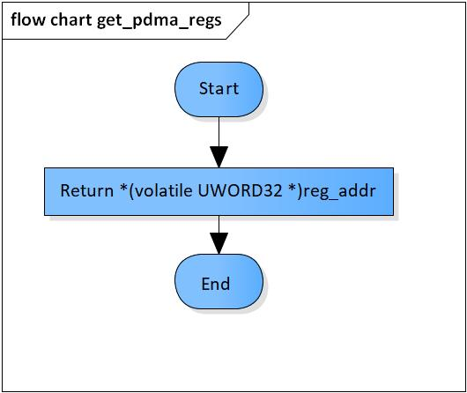

Figure 3‑1 get_pdma_regs flowchart

### set_pdma_regs

DD_PLG_TDM_05_002

|  |  |  |  |  |
| --- | --- | --- | --- | --- |
| **Syntax** | static inline VOID set_pdma_regs(UWORD32 reg_addr, UWORD32 value) | | | |
| **Function** | This function is to set value for register of address reg_addr. | | | |
| **Arguments** | Type | Name | I/O | Description |
| UWORD32 | reg_addr | I | Address of the register that needs setting |
| UWORD32 | value | I | Value to set |
| **Return value** | None | | | |
| **Description** | * pdma_set_stage_number command processing:   - Set value for register whose address is reg_addr | | | |

[Covers: FD_PLG_TDM_005, FD_PLG_TDM_017]

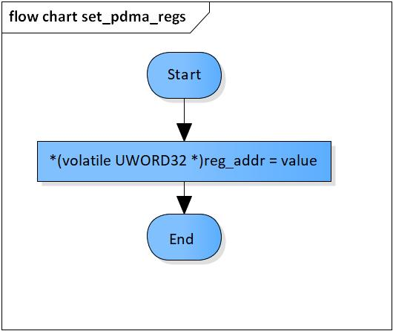

Figure 3‑2 set_pdma_regs flowchart

### xa_set_pdma_extend

DD_PLG_TDM_05_003

|  |  |  |  |  |
| --- | --- | --- | --- | --- |
| **Syntax** | PDMA_ERROR_CODE xa_set_pdma_extend(PDMA_CHN ch, PDMA_SRC_DST src, PDMA_SRC_DST dst) | | | |
| **Function** | This function is to set PDMA registers. | | | |
| **Arguments** | Type | Name | I/O | Description |
| PDMA_CHN | ch | I | PDMA channel  Valid value: [0: 28] |
| PDMA_SRC_DST | src | I | Source module |
| PDMA_SRC_DST | dst | I | Destination module |
| **Return value** | PDMA_ERROR_INVALID_CHANNEL | | Channel is invalid  Source module is invalid  Destination module is invalid | |
| PDMA_ERROR_INVALID_SOURCE | | Register SARE’s value is invalid | |
| PDMA_ERROR_INVALID_DESTINATION | | Register DARE’s value is invalid | |
| PDMA_ERROR_BUSY_CHANNEL | | Current PDMA channel is busy | |
| PDMA_ERROR_NONE | | Normal end | |
| **Description** | * xa_set_pdma_extend command processing:   - Set PDMA registers | | | |

[Covers: FD_PLG_TDM_005]

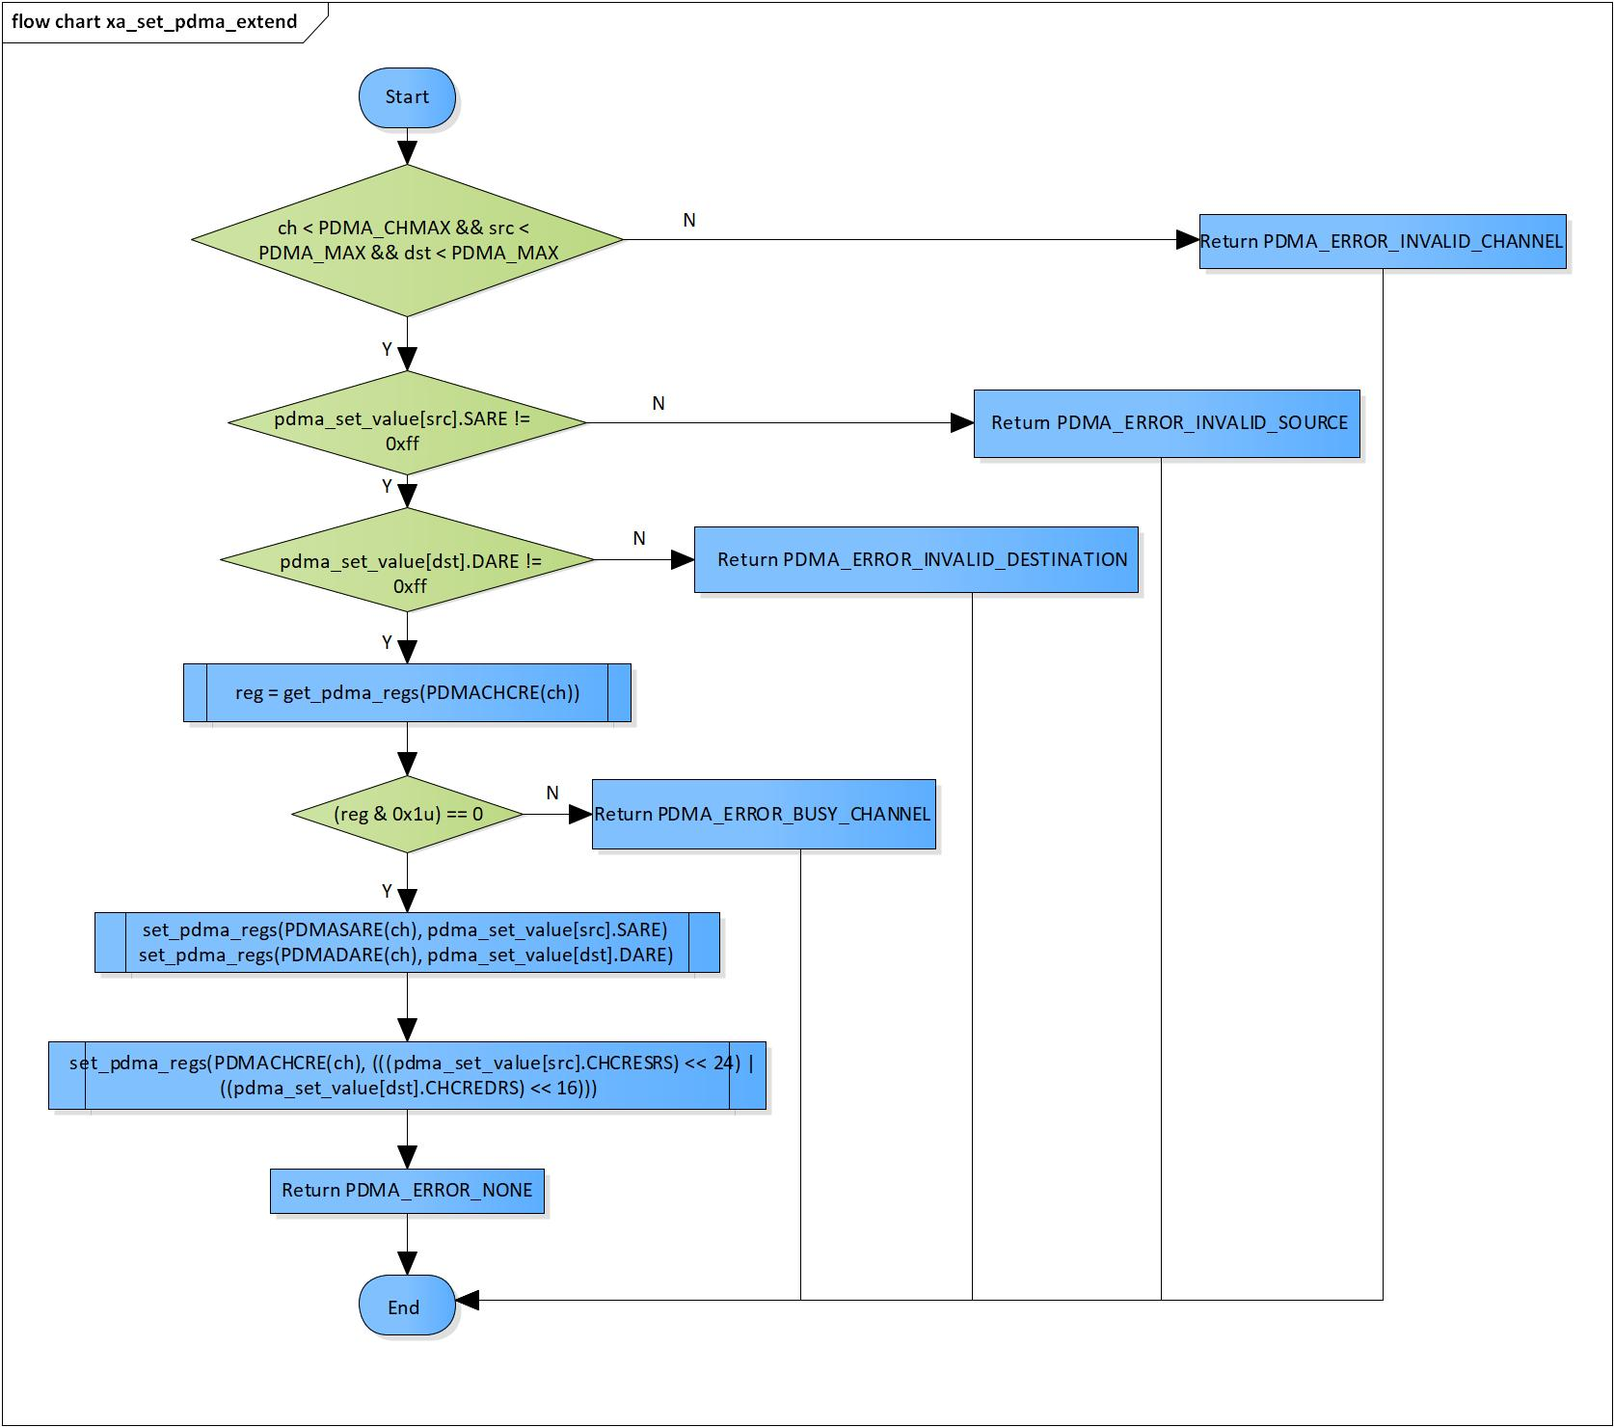

Figure 3‑3 xa_set_pdma_extend flowchart

### xa_clear_pdma_extend

DD_PLG_TDM_05_004

|  |  |  |  |  |
| --- | --- | --- | --- | --- |
| **Syntax** | PDMA_ERROR_CODE xa_clear_pdma_extend(PDMA_CHN ch) | | | |
| **Function** | This function is to clear PDMA channel ch’s registers | | | |
| **Arguments** | Type | Name | I/O | Description |
| PDMA_CHN | ch | I | PDMA channel  Valid value: [0: 28] |
| **Return value** | PDMA_ERROR_BUSY_CHANNEL | | Current PDMA channel is busy | |
| PDMA_ERROR_NONE | | Normal end | |
| **Description** | * xa_clear_pdma_extend command processing:   - Clear PDMA registers | | | |

[Covers: FD_PLG_TDM_017]

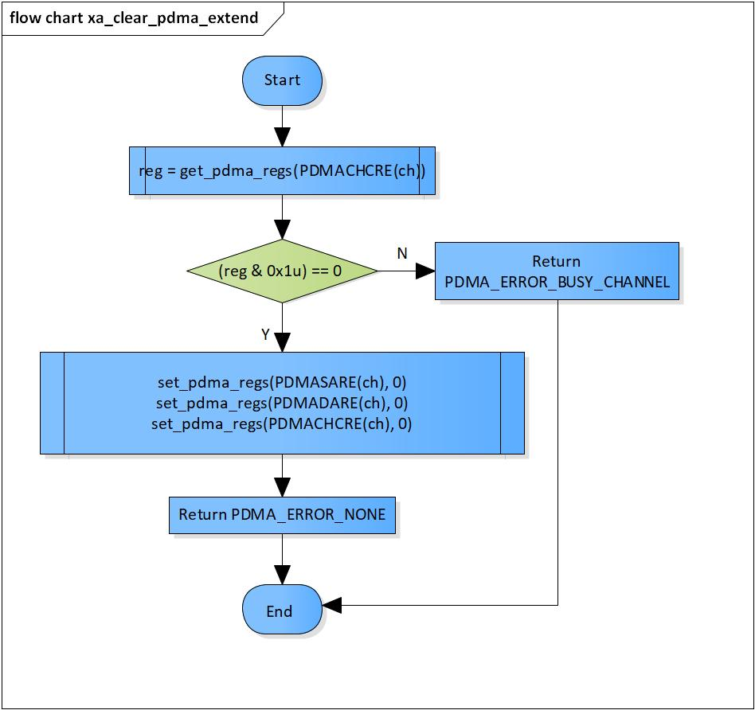

Figure 3‑4 xa_clear_pdma_extend flowchart

### xa_enable_pdma_extend

DD_PLG_TDM_05_005

|  |  |  |  |  |
| --- | --- | --- | --- | --- |
| **Syntax** | PDMA_ERROR_CODE xa_enable_pdma_extend(PDMA_CHN ch) | | | |
| **Function** | This function is to enable PDMA channel ch. | | | |
| **Arguments** | Type | Name | I/O | Description |
| PDMA_CHN | ch | I | PDMA channel  Valid value: [0: 28] |
| **Return value** | PDMA_ERROR_BUSY_CHANNEL | | Current PDMA channel is busy | |
| PDMA_ERROR_NONE | | Normal end | |
| **Description** | * xa_enable_pdma_extend command processing:   - Enable PDMA | | | |

[Covers: FD_PLG_TDM_005]

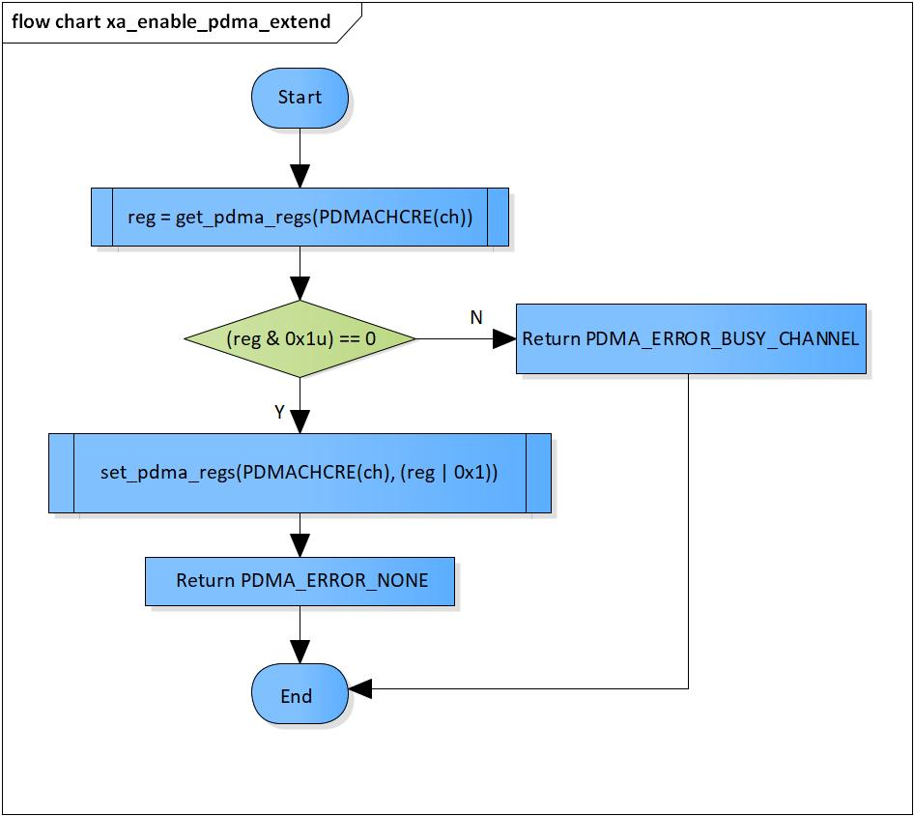

Figure 3‑5 xa_enable_pdma_extend flowchart

### xa_disable_pdma_extend

DD_PLG_TDM_05_006

|  |  |  |  |  |
| --- | --- | --- | --- | --- |
| **Syntax** | PDMA_ERROR_CODE xa_disable_pdma_extend(PDMA_CHN ch) | | | |
| **Function** | This function is to enable PDMA channel ch. | | | |
| **Arguments** | Type | Name | I/O | Description |
| PDMA_CHN | ch | I | PDMA channel  Valid value: [0: 28] |
| **Return value** | PDMA_ERROR_INVALID_CHANNEL | | Channel is invalid | |
| PDMA_ERROR_NONE | | Normal end | |
| **Description** | * xa_disable_pdma_extend command processing:   - Disable PDMA | | | |

[Covers: FD_PLG_TDM_017]

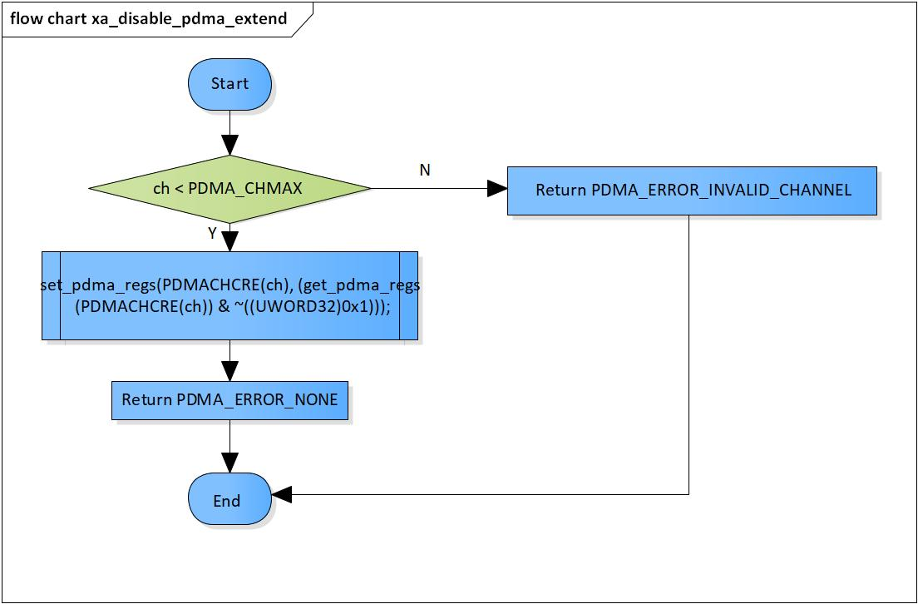

Figure 3‑6 xa_disable_pdma_extend flowchart

### xa_check_available_pdma_channel

DD_PLG_TDM_05_007

|  |  |  |  |  |
| --- | --- | --- | --- | --- |
| **Syntax** | PDMA_ERROR_CODE xa_check_available_pdma_channel(pVOID pch) | | | |
| **Function** | This function is to check availability of PDMAs and choose an available one for operation. | | | |
| **Arguments** | Type | Name | I/O | Description |
| pVOID | pch | I/O | Pointer to channel of PDMA  Valid value: [0: 28] |
| **Return value** | PDMA_ERROR_INVALID_CHANNEL | | Current PDMA channel is invalid | |
| PDMA_ERROR_BUSY_CHANNEL | | No available PDMA module | |
| PDMA_ERROR_NONE | | Normal end | |
| **Description** | * xa_check_available_pdma_channel command processing:   - Check availability of PDMAs  - Choose an available one for operation | | | |

[Covers: FD_PLG_TDM_005]

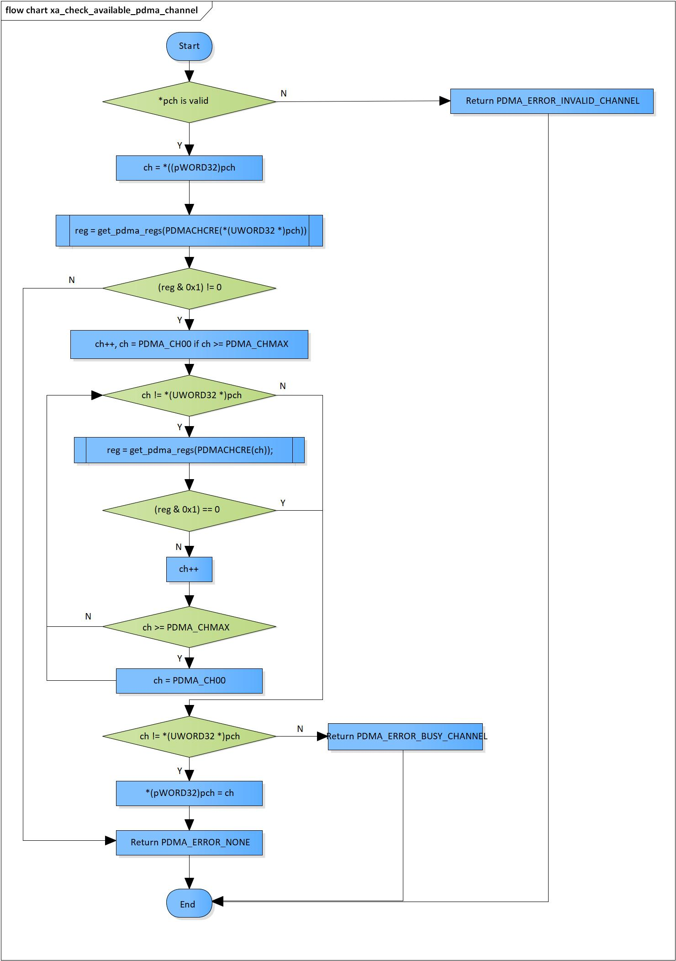

Figure 3‑7 xa_check_available_pdma_channel flowchart

# Revision history

|  |  |  |  |  |  |
| --- | --- | --- | --- | --- | --- |
| **Version** | **Date** | **Page** | **Content** | **Approved** | **Changed** |
| 1.0.0 | Nov 14 2018 | - | First Edition issued | Vu Phan | Nguyen Dang |
| 1.1.0 | Dec 10 2018 | - | Add traceability ID | Vu Phan | Nguyen Dang |
| 1.2.0 | Jan 03, 2019 | - | Add range for input parameters | Vu Phan | Tien Tran |