**Document Type: Detail Design**

**Document Name:**

**ADSP FRAMEWORK: SCU DRIVER**

Renesas Electronics Corporation

Renesas Design Vietnam Co. Ltd

R-Car Software Solution 2 Group

Middleware 1 Team

Table of Cotents

1. Overview 3

2. Function list 4

3. Detail information 5

3.1 Data type definition 5

3.1.1 SRC_MODULE 5

3.1.2 SRC_DATA_LENGTH 5

3.1.3 SRC_CH_NUM 6

3.1.4 SRC_SYNC_MODE 6

3.1.5 SRC_UF_MODE 6

3.1.6 SRC_START_MODE 7

3.1.7 SRC_ERROR_CODE 7

3.1.8 SRC_FLAG 7

3.1.9 DVC_CH_NUM 8

3.1.10 DVC_MODES 8

3.1.11 DVC_ERROR_CODE 8

3.1.12 DVC_FLAG 9

3.1.13 CMD_MODULES 9

3.1.14 SRC_CONFIG 9

3.1.15 SRC_CTRL 10

3.1.16 SRC_REG 10

3.2 Macro definition 11

3.3 Global variable definition 12

3.4 Function definition 13

3.4.1 xa_src_check_module_index 13

3.4.2 xa_src_config 14

3.4.3 xa_src_start 18

3.4.4 xa_src_stop 19

3.4.5 xa_src_check_available_module 20

3.4.6 xa_dvc_dig_setting 21

3.4.7 xa_dvc_config 22

3.4.8 xa_dvc_start 24

3.4.9 xa_dvc_stop 25

3.4.10 xa_dvc_reset 26

3.4.11 xa_dvc_check_available 27

3.4.12 xa_src_get_config 28

3.4.13 xa_src_get_control 29

4. Revision history 30

List of Figures

Figure 1‑1 The software architecture 3

Figure 3‑1 xa_src_check_module_index flowchart 13

Figure 3‑2 xa_src_config flowchart 17

Figure 3‑3 xa_src_start flowchart 18

Figure 3‑4 start_stop flowchart 19

Figure 3‑5 xa_src_check_available_module flowchart 20

Figure 3‑6 xa_dvc_dig_setting flowchart 21

Figure 3‑7 xa_dvc_config flowchart 23

Figure 3‑8 xa_dvc_start flowchart 24

Figure 3‑9 xa_dvc_stop flowchart 25

Figure 3‑10 xa_dvc_reset flowchart 26

Figure 3‑11 xa_dvc_check_available flowchart 27

Figure 3‑12 xa_src_get_config flowchart 28

Figure 3‑13 xa_src_get_control flowchart 29

List of Table

Table 2‑1 Function list 4

Table 3‑1 SRC_MODULE type information 5

Table 3‑2 SRC_DATA_LENGTH type information 5

Table 3‑3 SRC_DATA_MODE type information 6

Table 3‑4 SRC_SYNC_MODE type information 6

Table 3‑5 SRC_UF_MODE type information 6

Table 3‑6 SRC_START_MODE type information 7

Table 3‑7 SRC_ERROR_CODE type information 7

Table 3‑8 SRC_FLAG type information 7

Table 3‑9 DVC_CH_NUM type information 8

Table 3‑10 DVC_MODES type information 8

Table 3‑11 DVC_ERROR_CODE type information 8

Table 3‑12 DVC_FLAG type information 9

Table 3‑13 CMD_MODULES type information 9

Table 3‑14 SRC_CONFIG type information 9

Table 3‑15 SRC_CTRL type information 10

Table 3‑16 SRC_REG type information 10

Table 3‑17 Setting SRC Input Timing Select registers based on input sampling rate 14

Table 3‑18 Setting SRC Output Timing Select registers based on output sampling rate 14

Table 3‑19 Setting XF_RCAR_REG_CMDOUT_TIMSEL for CMD execution 22

Table 3‑20 Setting for CMD_ROUTE_SELECT register 22

Table 2‑1 Function list 5

Table 3‑1 SRC_MODULE type information 6

Table 3‑2 SRC_DATA_LENGTH type information 6

Table 3‑3 SRC_DATA_MODE type information 7

Table 3‑4 SRC_SYNC_MODE type information 7

Table 3‑5 SRC_UF_MODE type information 7

Table 3‑6 SRC_START_MODE type information 8

Table 3‑7 SRC_ERROR_CODE type information 8

Table 3‑8 SRC_FLAG type information 8

Table 3‑9 DVC_CH_NUM type information 9

Table 3‑10 DVC_MODES type information 9

Table 3‑11 DVC_ERROR_CODE type information 9

Table 3‑12 DVC_FLAG type information 10

Table 3‑13 CMD_MODULES type information 10

Table 3‑14 SRC_CONFIG type information 10

Table 3‑15 SRC_CTRL type information 11

Table 3‑16 SRC_REG type information 11

Table 3‑17 Setting SRC Input Timing Select registers based on input sampling rate 15

Table 3‑18 Setting SRC Output Timing Select registers based on output sampling rate 15

Table 3‑19 Setting XF_RCAR_REG_CMDOUT_TIMSEL for CMD execution 23

Table 3‑20 Setting for CMD_ROUTE_SELECT register 23

# Overview

This section provides an overview of software architecture.

User Application

ADSP Interface

Kernel Space

User Space

ADSP Driver

ARM

Audio HW

**ADSP Framework**

TDM class

Renderer class

Equalizer class

Capture class

TDM Plugin

ADSP

Plugin

Equalizer Plugin*

Capture Plugin

Renderer Plugin

This document’s target is in side of red square

* not connect to hardware modules

DAC/

ADC

SCU

PDMA

FIFO

SSI

SSIU

ADMA

Figure 1‑1 ****The software architecture****

# Function list

The following is list of functions:

Table 2‑1 Function list

|  |  |  |
| --- | --- | --- |
| **Type** | **Function Name** | **Outline** |
| APIs | xa_src_check_module_index | This API is to check if current SRC supports multichannel stream |
| xa_src_config | This API is to set up SRC configuration |
| xa_src_start | This API is to start SRC module |
| xa_src_stop | This API is to stop SRC module |
| xa_src_check_available_module | This API is to check availability of SRC modules and choose an available one |
| xa_dvc_dig_setting | This API is to set up DVC digital mode |
| xa_dvc_config | This API is to set up DVC module |
| xa_dvc_start | This API is to start DVC module |
| xa_dvc_stop | This API is to stop DVC module |
| xa_dvc_reset | This API is to reset DVC module |
| xa_dvc_check_available | This API is to check availability and select free DVC module |
| Internal functions | xa_src_get_config | This function is to get SRC Config base register |
| xa_src_get_control | This function is to get SRC Control base register |

# Detail information

This section describes detail information of data types, macro definitions, implemented APIs and internal function units, global variable.

## Data type definition

### SRC_MODULE

The data type SRC_MODULE is a type-defined enumeration that lists all supported SRC modules. It starts with SRC0 to SRCMAX.

Table 3‑1 SRC_MODULE type information

|  |  |  |
| --- | --- | --- |
| **Member name** | **Value** | **Outline** |
| SRC0 | 0 | SRC0 |
| SRC1 | 1 | SRC1 |
| SRC2 | 2 | SRC2 |
| SRC3 | 3 | SRC3 |
| SRC4 | 4 | SRC4 |
| SRC5 | 5 | SRC5 |
| SRC6 | 6 | SRC6 |
| SRC7 | 7 | SRC7 |
| SRC8 | 8 | SRC8 |
| SRC9 | 9 | SRC9 |
| SRCMAX | 10 | Number of SRC modules |

### SRC_DATA_LENGTH

The data type SRC_DATA_LENGTH is a type-defined enumeration that lists all supported SRC module’s data bit length.

Table 3‑2 SRC_DATA_LENGTH type information

|  |  |  |
| --- | --- | --- |
| **Member name** | **Value** | **Outline** |
| SRC_24BIT | 0 | Data 24-bit width |
| SRC_22BIT | 2 | Data 22-bit width |
| SRC_20BIT | 4 | Data 20-bit width |
| SRC_18BIT | 6 | Data 18-bit width |
| SRC_16BIT | 8 | Data 16-bit width |
| SRC_8BIT | 16 | Data 8-bit width |

### SRC_CH_NUM

The data type SRC_CH_NUM is a type-defined enumeration that lists all supported number of channels for SRC module.

Table 3‑3 SRC_DATA_MODE type information

|  |  |  |
| --- | --- | --- |
| **Member name** | **Value** | **Outline** |
| SRC_NONE | 0 | No channels |
| SRC_1CH | 1 | 1 channel |
| SRC_2CH | 2 | 2 channels |
| SRC_4CH | 4 | 4 channels |
| SRC_6CH | 6 | 6 channels |
| SRC_8CH | 8 | 8 channels |

### SRC_SYNC_MODE

The data type SRC_SYNC_MODE is a type-defined enumeration that lists all supported SRC synchronization mode.

Table 3‑4 SRC_SYNC_MODE type information

|  |  |  |
| --- | --- | --- |
| **Member name** | **Value** | **Outline** |
| SRC_ASYNC | 0 | Asynchronous |
| SRC_SYNC | 1 | Synchronous |
| SRC_SYNC_MAX | 2 | Maximum number of synchronization types |

### SRC_UF_MODE

The data type SRC_UF_MODE is a type-defined enumeration that lists all supported SRC underflow data treatment modes.

Table 3‑5 SRC_UF_MODE type information

|  |  |  |
| --- | --- | --- |
| **Member name** | **Value** | **Outline** |
| SRC_REPEAT | 0 | Data before underflow occurs is output |
| SRC_ZERO | 1 | All 0s are output when underflow occurs |

### SRC_START_MODE

The data type SRC_START_MODE is a type-defined enumeration that lists all supported SRC start mode.

Table 3‑6 SRC_START_MODE type information

|  |  |  |
| --- | --- | --- |
| **Member name** | **Value** | **Outline** |
| SRC_INPUT | 0 | SRC only receives input data from out of SCU module and output within SCU module |
| SRC_OUTPUT | 1 | SRC only produces output data to modules of of SCU |
| SRC_BOTH | 2 | SRC receives input data from modules out of SCU and produces output data out of SCU |

### SRC_ERROR_CODE

The data type SRC_ERROR_CODE is a type-defined enumeration that lists all error-codes used for SRC.

Table 3‑7 SRC_ERROR_CODE type information

|  |  |
| --- | --- |
| **Member name** | **Value** |
| SRC_ERROR_NONE | 0 |
| SRC_ERROR_INVALID | -1 |
| SRC_ERROR_INTERNAL | -2 |
| SRC_ERROR_BUSY | -3 |
| SRC_ERROR_OUT_RANGE | -4 |

### SRC_FLAG

The data type SRC_FLAG is a type-defined structure that possesses necessary parameters for SRC module.

Table 3‑8 SRC_FLAG type information

|  |  |  |
| --- | --- | --- |
| **Member name** | **Data type** | **Outline** |
| pcm_wdsz | SRC_DATA_LENGTH | PCM width of the data input to and output from SRC |
| ch | SRC_CH_NUM | The number of channels input to and output from SRC |
| inp_sync_mode | SRC_SYNC_MODE | Input synchronization mode of SRC |
| out_sync_mode | SRC_SYNC_MODE | Output synchronization mode of SRC |
| uf_mode | SRC_UF_MODE | Underflow mode |
| fs_in | WORD32 | Input frequency sampling |
| fs_out | WORD32 | Output frequency sampling |

### DVC_CH_NUM

The data type DVC_CH_NUM is a type-defined enumeration that lists all supported number of channels for DVC module.

Table 3‑9 DVC_CH_NUM type information

|  |  |  |
| --- | --- | --- |
| **Member name** | **Value** | **Outline** |
| DVC_NONE | 0 | No channels |
| DVC_1CH | 1 | 1 channel |
| DVC_2CH | 2 | 2 channels |
| DVC_4CH | 4 | 4 channels |
| DVC_6CH | 6 | 6 channels |
| DVC_8CH | 8 | 8 channels |
| DVC_CHMAX | 9 | Maximum number of DVC output channels |

### DVC_MODES

The data type DVC_MODES is a type-defined enumeration that lists all supported DVC modes.

Table 3‑10 DVC_MODES type information

|  |  |  |
| --- | --- | --- |
| **Member name** | **Value** | **Outline** |
| DVC_DIG | 0 | Digital volume mode |
| DVC_RAMP | 1 | Ramp volume mode |
| DVC_MUTE | 2 | Zero cross mute mode |
| DVC_DIG_RAM | 3 | Digital and ramp volume mode |

### DVC_ERROR_CODE

The data type DVC_ERROR_CODE is a type-defined enumeration that lists all error-codes used for DVC.

Table 3‑11 DVC_ERROR_CODE type information

|  |  |
| --- | --- |
| **Member name** | **Value** |
| DVC_ERROR_NONE | 0 |
| DVC_ERROR_INVALID | -1 |
| DVC_ERROR_INTERNAL | -2 |
| DVC_ERROR_BUSY | -3 |
| DVC_ERROR_OUT_RANGE | -4 |

### DVC_FLAG

The data type DVC_FLAG is a type-defined structure that possesses necessary parameters for DVC module.

Table 3‑12 DVC_FLAG type information

|  |  |  |
| --- | --- | --- |
| **Member name** | **Data type** | **Outline** |
| CMD_module | CMD_MODULES | CMD module |
| fs | UWORD32 | Sampling rate for DVC |
| sync_mode | SRC_SYNC_MODE | SRC synchronization mode |
| SRC_module | SRC_MODULE | SRC module |
| dvc_mode | DVC_MODES | DVC operation mode |
| pcm_width | UWORD32 | PCM width |
| data_ch | UWORD32 | Channel data |
| volume[DVC_CHMAX -1] | WORD32 | volume of channels |

### CMD_MODULES

The data type CMD_MODULES is a type-defined enumeration that lists all supported CMD modules.

Table 3‑13 CMD_MODULES type information

|  |  |  |
| --- | --- | --- |
| **Member name** | **Value** | **Outline** |
| CMD0 | 0 | CMD0 module |
| CMD1 | 1 | CMD1 module |
| CMDMAX | 2 | Maximum number of CMD modules |

### SRC_CONFIG

The data type SRC_CONFIG is a type-defined structure of config registers of SRC module.

Table 3‑14 SRC_CONFIG type information

|  |  |
| --- | --- |
| **Member name** | **Data type** |
| SRC_IN_BUSIF_MODE | UWORD32 |
| SRC_OUT_BUSIF_MODE | UWORD32 |
| SRC_BUSIF_DALIGN | UWORD32 |
| SRC_MODE | UWORD32 |
| SRC_CONTROL | UWORD32 |
| SRC_STATUS | UWORD32 |
| SRC_INT_ENABLE0 | UWORD32 |

### SRC_CTRL

The data type SRC_CTRL is a type-defined structure of control registers of SRC module.

Table 3‑15 SRC_CTRL type information

|  |  |
| --- | --- |
| **Member name** | **Data type** |
| SRC_SWRSR | UWORD32 |
| SRC_SRCIR | UWORD32 |
| dummy1[12] | UWORD8 |
| SRC_ADINR | UWORD32 |
| dummy2[4] | UWORD8 |
| SRC_IFSCR | UWORD32 |
| SRC_IFSVR | UWORD32 |
| SRC_SRCCR | UWORD32 |
| dummy3[4] | UWORD8 |
| SRC_BSDSR | UWORD32 |
| dummy4[8] | UWORD8 |
| SRC_BSISR | UWORD32 |

### SRC_REG

The data type SRC_REG is a type-defined structure of control registers of SRC module.

Table 3‑16 SRC_REG type information

|  |  |
| --- | --- |
| **Member name** | **Data type** |
| SRC_CONFIG_BASE | UWORD32 |
| SRC_CONTROL_BASE | UWORD32 |

## Macro definition

|  |  |  |
| --- | --- | --- |
| **Macros** | **Value** | **Outline** |
| VOLUME_MAX | 0x7FFFFF | Max volume DVC can support |
| VOLUME_NONUSE | 0xFFFFFFFF | DVC is not used |
| FALSE | 0 | Checked condition is false |
| TRUE | 1 | Checked condition is true |
| SRC_SUPPORT_MULTICHANNEL_NUM | 4 | Number of SRC modules which support multi-channel |
| SRC_ONLY_SUPPORT_2CHANNEL_NUM | 6 | Number of SRC modules which only support mono, stereo |
| SRC_CMD_SUPPORT_ONLY_2CHANNEL_NUM | 4 | Number of SRC modules which only support mono, stereo and can route CMD modules |
| SRC_CMD_NUM | SRC_SUPPORT_MULTICHANNEL_NUM + SRC_CMD_SUPPORT_ONLY_2CHANNEL_NUM | Number of SRCs that can route CMD modules |
| SRC_SUPPORT_2CHANNEL_NUM | SRC_ONLY_SUPPORT_2CHANNEL_NUM + SRC_CMD_SUPPORT_ONLY_2CHANNEL_NUM | Number of SRC modules which support 2 channels |
| SRC_FSO | 1 << 22 | SRC FSO value |
| VOL_SCALE | 1000 | Volume scale |

## Global variable definition

|  |  |
| --- | --- |
| static const WORD32 xa_dvc_register_base[CMDMAX] | |
| Array’s index | Value |
| CMD0 | XF_RCAR_REG_DVC0_BASE |
| CMD1 | XF_RCAR_REG_DVC1_BASE |

|  |  |
| --- | --- |
| static const WORD32 cmd_register_base[CMDMAX] | |
| Array’s index | Value |
| CMD0 | XF_RCAR_REG_CMD0OUT_BUSIF_MODE |
| CMD1 | XF_RCAR_REG_CMD1OUT_BUSIF_MODE |

|  |  |  |
| --- | --- | --- |
| static const SRC_REG xa_src_register_base[SRCMAX] | | |
| Array’s index | SRC_CONFIG_BASE | SRC_CONTROL_BASE |
| SRC0 | XF_RCAR_REG_SRC0IN_BUSIF_MODE | XF_RCAR_REG_SRC_SWRSR(0) |
| SRC1 | XF_RCAR_REG_SRC1IN_BUSIF_MODE | XF_RCAR_REG_SRC_SWRSR(1) |
| SRC2 | XF_RCAR_REG_SRC2IN_BUSIF_MODE | XF_RCAR_REG_SRC_SWRSR(2) |
| SRC3 | XF_RCAR_REG_SRC3IN_BUSIF_MODE | XF_RCAR_REG_SRC_SWRSR(3) |
| SRC4 | XF_RCAR_REG_SRC4IN_BUSIF_MODE | XF_RCAR_REG_SRC_SWRSR(4) |
| SRC5 | XF_RCAR_REG_SRC5IN_BUSIF_MODE | XF_RCAR_REG_SRC_SWRSR(5) |
| SRC6 | XF_RCAR_REG_SRC6IN_BUSIF_MODE | XF_RCAR_REG_SRC_SWRSR(6) |
| SRC7 | XF_RCAR_REG_SRC7IN_BUSIF_MODE | XF_RCAR_REG_SRC_SWRSR(7) |
| SRC8 | XF_RCAR_REG_SRC8IN_BUSIF_MODE | XF_RCAR_REG_SRC_SWRSR(8) |
| SRC9 | XF_RCAR_REG_SRC9IN_BUSIF_MODE | XF_RCAR_REG_SRC_SWRSR(9) |

|  |  |
| --- | --- |
| static SRC_MODULE module_support_multichannel[SRC_SUPPORT_MULTICHANNEL_NUM] | |
| Array’s index | Value |
| 0 | SRC0 |
| 1 | SRC1 |
| 2 | SRC3 |
| 3 | SRC4 |

## Function definition

### xa_src_check_module_index

DD_PLG_TDM_06_001

|  |  |  |  |  |
| --- | --- | --- | --- | --- |
| **Syntax** | SRC_ERROR_CODE xa_src_check_module_index(SRC_MODULE module) | | | |
| **Function** | This API is used to check if current SRC supports multichannel stream. | | | |
| **Arguments** | Type | Name | I/O | Description |
| SRC_MODULE | module | I | SRC module  Valid value: [0: 9] |
| **Return value** | SRC_ERROR_OUT_RAGE | | Current SRC does not support multichannel stream | |
| SRC_ERROR_NONE | | Current SRC supports multichannel stream | |
| **Description** | * xa_src_check_module_index command processing:   - Check if current SRC supports multichannel stream | | | |

[Covers: FD_PLG_TDM_005, FD_PLG_TDM_024, FD_PLG_TDM_026, FD_PLG_TDM_034, FD_PLG_TDM_036]

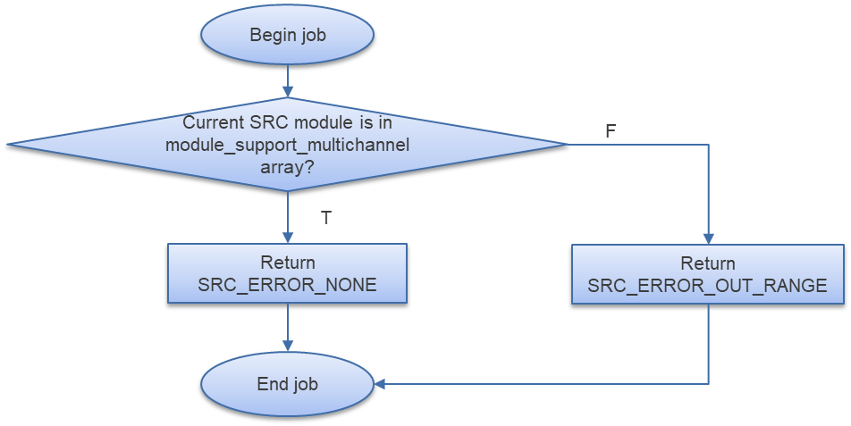

Figure 3‑1 xa_src_check_module_index flowchart

### xa_src_config

DD_PLG_TDM_06_002

|  |  |  |  |  |
| --- | --- | --- | --- | --- |
| **Syntax** | SRC_ERROR_CODE xa_src_config(SRC_MODULE module, const SRC_FLAG *flag, SRC_START_MODE start) | | | |
| **Function** | This function is to set up SRC configuration. | | | |
| **Arguments** | Type | Name | I/O | Description |
| SRC_MODULE | module | I | SRC module  Valid value: [0: 9] |
| const SRC_FLAG * | flag | I | Pointer to SRC module configuration setting structure |
| SRC_START_MODE | start | I | SRC operation mode  Valid values: 0/1/2 |
| **Return value** | SRC_ERROR_INVALID | | Channel is invalid  SRC module does not support multichannel stream | |
| SRC_ERROR_NONE | | Normal end | |
| **Description** | * xa_src_config command processing:   - Set registers for SRC execution | | | |

[Covers: FD_PLG_TDM_005]

Table 3‑17 Setting SRC Input Timing Select registers based on input sampling rate

|  |  |  |  |
| --- | --- | --- | --- |
| **flag->fs_in** | **module** | **register** | **value** |
| 32000 | SRC0 | XF_RCAR_REG_SRCIN_TIMSEL0[15:0] | 0x110 |
| SRC1 | XF_RCAR_REG_SRCIN_TIMSEL0[31:16] | 0x110 |
| SRC3 | XF_RCAR_REG_SRCIN_TIMSEL1[31:16] | 0x110 |
| SRC4 | XF_RCAR_REG_SRCIN_TIMSEL2[15:0] | 0x110 |
| 44100 | SRC0 | XF_RCAR_REG_SRCIN_TIMSEL0[15:0] | 0xF |
| SRC1 | XF_RCAR_REG_SRCIN_TIMSEL0[31:16] | 0xF |
| SRC3 | XF_RCAR_REG_SRCIN_TIMSEL1[31:16] | 0xF |
| SRC4 | XF_RCAR_REG_SRCIN_TIMSEL2[15:0] | 0xF |
| 48000 | SRC0 | XF_RCAR_REG_SRCIN_TIMSEL0[15:0] | 0x10F |
| SRC1 | XF_RCAR_REG_SRCIN_TIMSEL0[31:16] | 0x10F |
| SRC3 | XF_RCAR_REG_SRCIN_TIMSEL1[31:16] | 0x10F |
| SRC4 | XF_RCAR_REG_SRCIN_TIMSEL2[15:0] | 0x10F |

Table 3‑18 Setting SRC Output Timing Select registers based on output sampling rate

|  |  |  |  |
| --- | --- | --- | --- |
| **flag->fs_out** | **module** | **register** | **value** |
| 32000 | SRC0 | XF_RCAR_REG_SRCOUT_TIMSEL0[15:0] | 0x110 |
| SRC1 | XF_RCAR_REG_SRCOUT_TIMSEL0[31:16] | 0x110 |
| SRC3 | XF_RCAR_REG_SRCOUT_TIMSEL1[31:16] | 0x110 |
| SRC4 | XF_RCAR_REG_SRCOUT_TIMSEL2[15:0] | 0x110 |
| 44100 | SRC0 | XF_RCAR_REG_SRCOUT_TIMSEL0[15:0] | 0xF |
| SRC1 | XF_RCAR_REG_SRCOUT_TIMSEL0[31:16] | 0xF |
| SRC3 | XF_RCAR_REG_SRCOUT_TIMSEL1[31:16] | 0xF |
| SRC4 | XF_RCAR_REG_SRCOUT_TIMSEL2[15:0] | 0xF |
| 48000 | SRC0 | XF_RCAR_REG_SRCOUT_TIMSEL0[15:0] | 0x10F |
| SRC1 | XF_RCAR_REG_SRCOUT_TIMSEL0[31:16] | 0x10F |
| SRC3 | XF_RCAR_REG_SRCOUT_TIMSEL1[31:16] | 0x10F |
| SRC4 | XF_RCAR_REG_SRCOUT_TIMSEL2[15:0] | 0x10F |

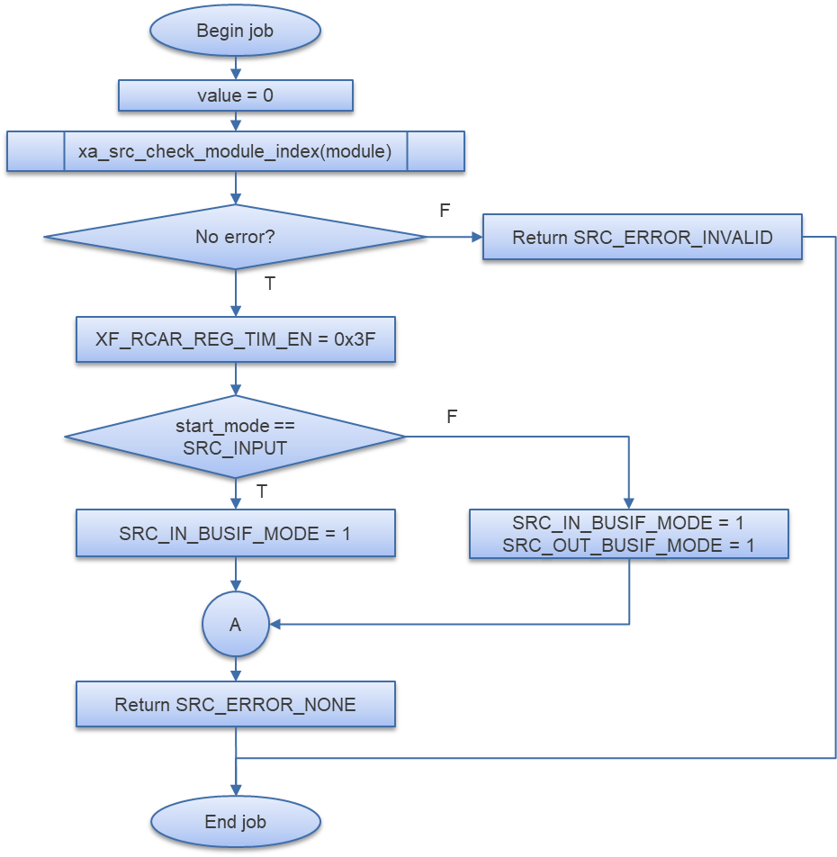

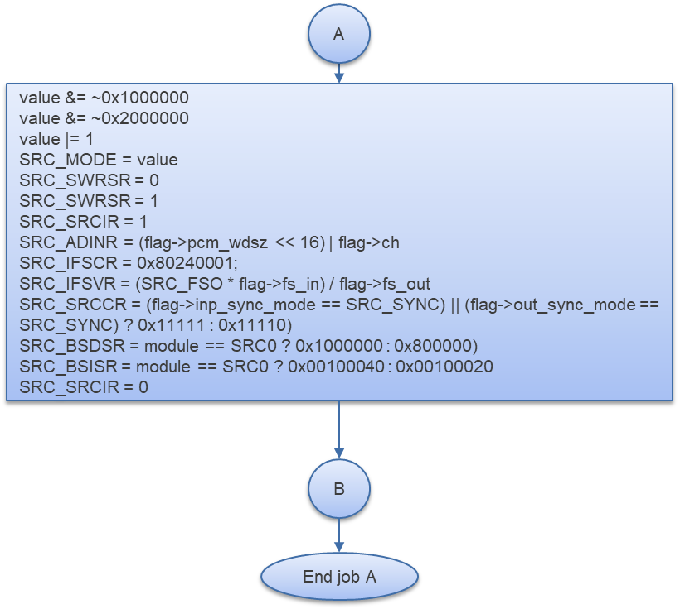

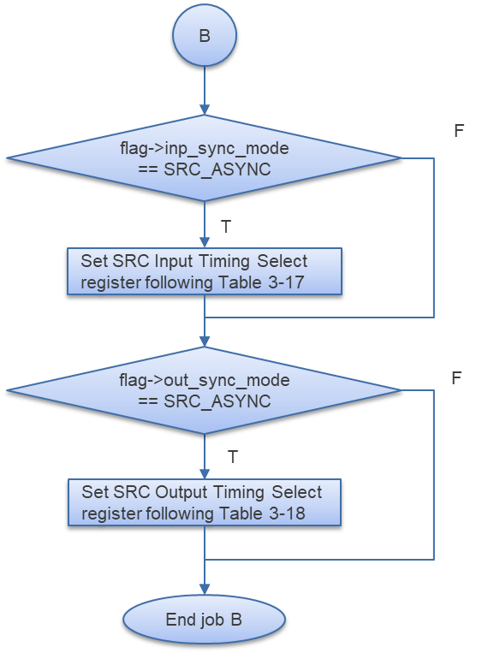

Figure 3‑2 xa_src_config flowchart

### xa_src_start

DD_PLG_TDM_06_003

|  |  |  |  |  |
| --- | --- | --- | --- | --- |
| **Syntax** | SRC_ERROR_CODE xa_src_start(SRC_MODULE module, SRC_START_MODE start) | | | |
| **Function** | This function is to start SRC module. | | | |
| **Arguments** | Type | Name | I/O | Description |
| SRC_MODULE | module | I | SRC module  Valid value: [0: 9] |
| SRC_START_MODE | start | I | SRC operation mode  Valid values: 0/1/2 |
| **Return value** | SRC_ERROR_BUSY | | SRC module is running | |
| SRC_ERROR_NONE | | Normal end | |
| **Description** | * xa_src_start command processing:   - Start SRC execution | | | |

[Covers: FD_PLG_TDM_005]

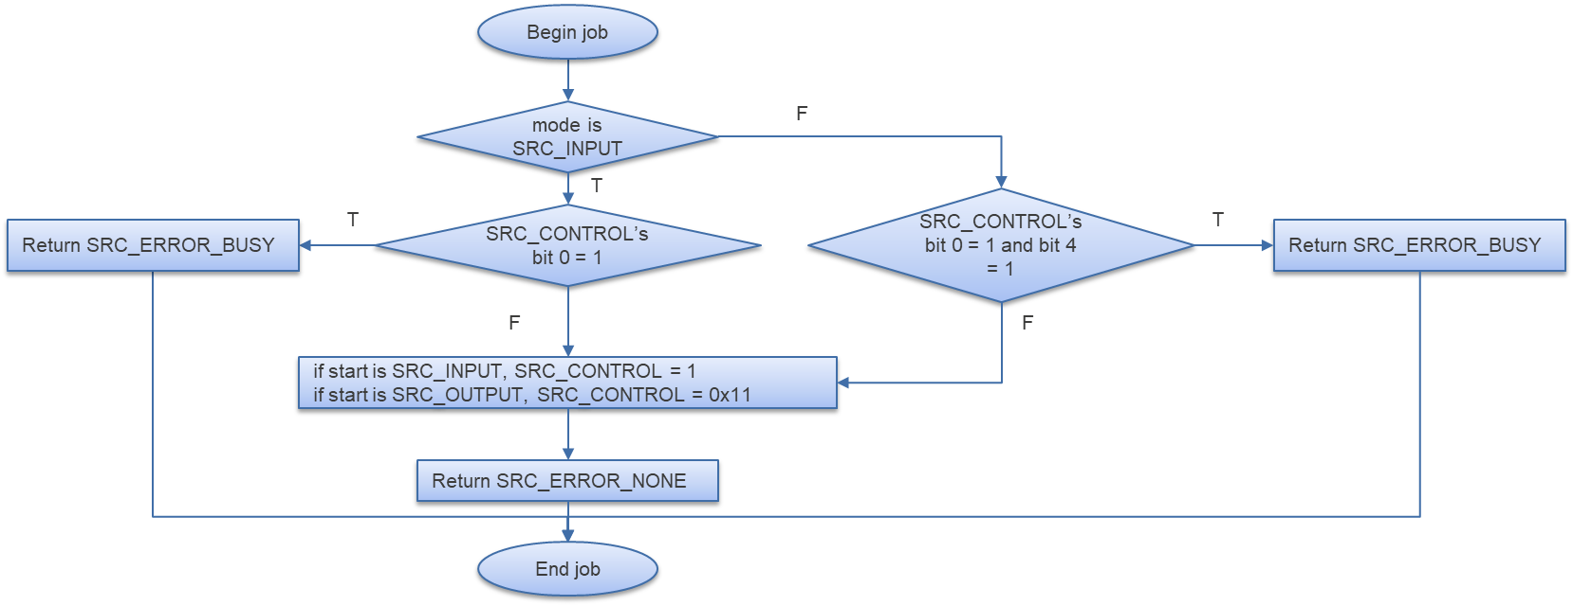

Figure 3‑3 xa_src_start flowchart

### xa_src_stop

DD_PLG_TDM_06_004

|  |  |  |  |  |
| --- | --- | --- | --- | --- |
| **Syntax** | SRC_ERROR_CODE xa_src_stop(SRC_MODULE module) | | | |
| **Function** | This function is to stop SRC module. | | | |
| **Arguments** | Type | Name | I/O | Description |
| SRC_MODULE | module | I | SRC module  Valid value: [0: 9] |
| **Return value** | SRC_ERROR_OUT_RANGE | | SRC module is invalid | |
| SRC_ERROR_NONE | | Normal end | |
| **Description** | * xa_src_stop command processing:   - Stop SRC execution | | | |

[Covers: FD_PLG_TDM_017]

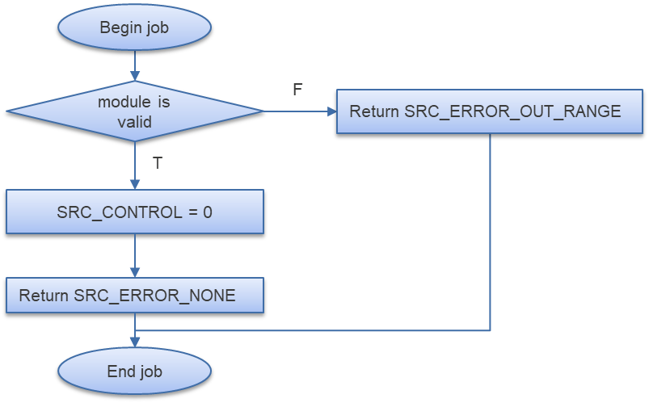

Figure 3‑4 start_stop flowchart

### xa_src_check_available_module

DD_PLG_TDM_06_005

|  |  |  |  |  |
| --- | --- | --- | --- | --- |
| **Syntax** | SRC_ERROR_CODE xa_src_check_available_module(UWORD32 *pmodule, SRC_CH_NUM ch_num) | | | |
| **Function** | This function is to check availability of SRC modules and choose an available one. | | | |
| **Arguments** | Type | Name | I/O | Description |
| UWORD32 * | pmodule | I/O | Pointer to selected SRC module  Valid value: [0: 9] |
| SRC_CH_NUM | ch_num | I | Channel number |
| **Return value** | SRC_ERROR_OUT_RANGE | | SRC module is invalid | |
| SRC_ERROR_BUSY | | No free SRC modules | |
| SRC_ERROR_NONE | | Normal end | |
| **Description** | * xa_src_check_available_module command processing:   - Check availability of SRC module and select an available one | | | |

[Covers: FD_PLG_TDM_005]

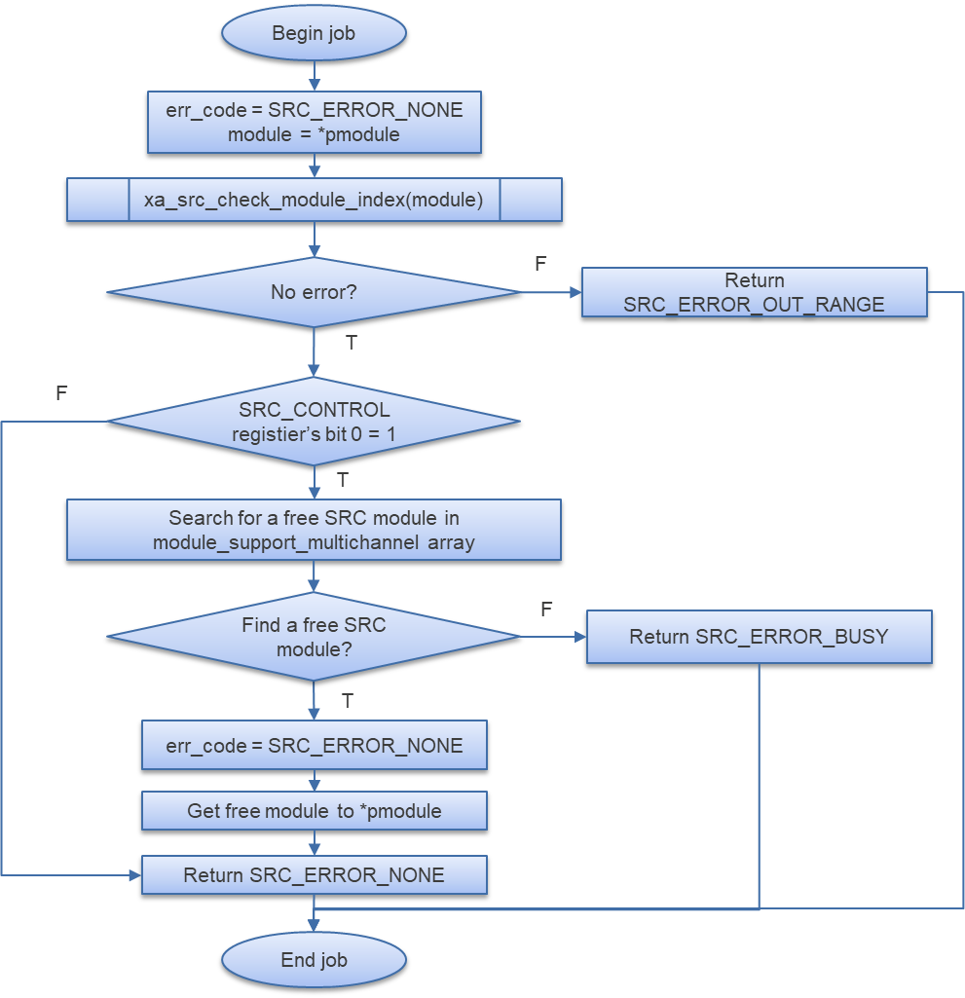

Figure 3‑5 xa_src_check_available_module flowchart

### xa_dvc_dig_setting

DD_PLG_TDM_06_006

|  |  |  |  |  |
| --- | --- | --- | --- | --- |
| **Syntax** | static DVC_ERROR_CODE xa_dvc_dig_setting(DVC_CH_NUM ch, WORD32 vol[], volatile DVC_CONFIG *dvcConf) | | | |
| **Function** | This function is to set up DVC module in digital mode. | | | |
| **Arguments** | Type | Name | I/O | Description |
| DVC_CH_NUM | ch | I | Number of channels  Valid value: 0/1/2/4/6/8 |
| WORD32 | vol[] | I | Array of volume values to set |
| volatile DVC_CONFIG * | dvcConf | I | Pointer to DVC Config registers’ structure |
| **Return value** | DVC_ERROR_INVALID | | Channel is invalid | |
| DVC_ERROR_NONE | | Normal end | |
| **Description** | * xa_dvc_dig_setting command processing:   - Set up DVC registers in digital mode | | | |

[Covers: FD_PLG_TDM_005]

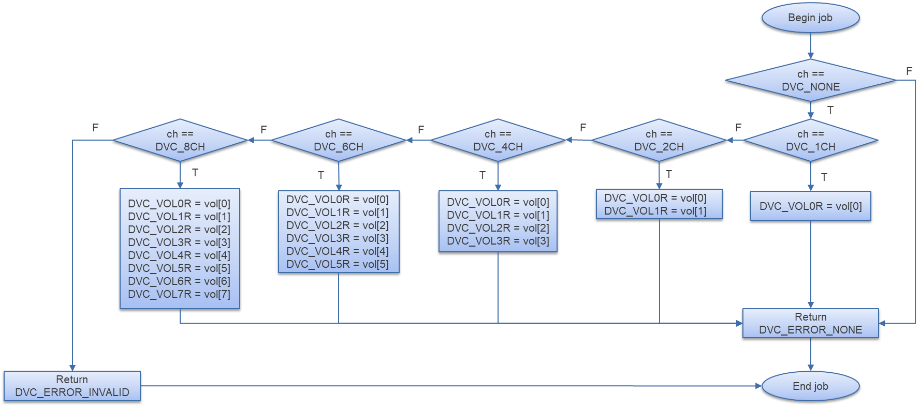

Figure 3‑6 xa_dvc_dig_setting flowchart

### xa_dvc_config

DD_PLG_TDM_06_007

|  |  |  |  |  |
| --- | --- | --- | --- | --- |
| **Syntax** | DVC_ERROR_CODE dvc_config(CMD_FLAG *flag) | | | |
| **Function** | This function is to set up for DVC module. | | | |
| **Arguments** | Type | Name | I/O | Description |
| CMD_FLAG * | flag | I/O | Pointer to CMD’s parameter structure |
| **Return value** | DVC_ERROR_INVALID | | SRC module is invalid  DVC mode is invalid  Cannot set up DVC digital mode | |
| DVC_ERROR_NONE | | Normal end | |
| **Description** | * xa_dvc_config command processing:   - Set up registers for DVC execution | | | |

[Covers: FD_PLG_TDM_005]

Table 3‑19 Setting XF_RCAR_REG_CMDOUT_TIMSEL for CMD execution

|  |  |  |  |
| --- | --- | --- | --- |
| **flag->fs** | **module** | **register** | **value** |
| 32000 | CMD0 | XF_RCAR_REG_CMDOUT_TIMSEL[15:0] | 0x110 |
| CMD1 | XF_RCAR_REG_CMDOUT_TIMSEL[31:16] | 0x110 |
| 44100 | CMD0 | XF_RCAR_REG_CMDOUT_TIMSEL[15:0] | 0xF |
| CMD1 | XF_RCAR_REG_CMDOUT_TIMSEL[31:16] | 0xF |
| 48000 | CMD0 | XF_RCAR_REG_CMDOUT_TIMSEL[15:0] | 0x10F |
| CMD1 | XF_RCAR_REG_CMDOUT_TIMSEL[31:16] | 0x10F |

Table 3‑20 Setting for CMD_ROUTE_SELECT register

|  |  |
| --- | --- |
| **flag->SRC_module** | **value to set CMD_ROUTE_SELECT register** |
| SRC0 | 0x30000 |
| SRC1 | 0x30001 |
| SRC3 | 0x10000 |
| SRC4 | 0x20000 |

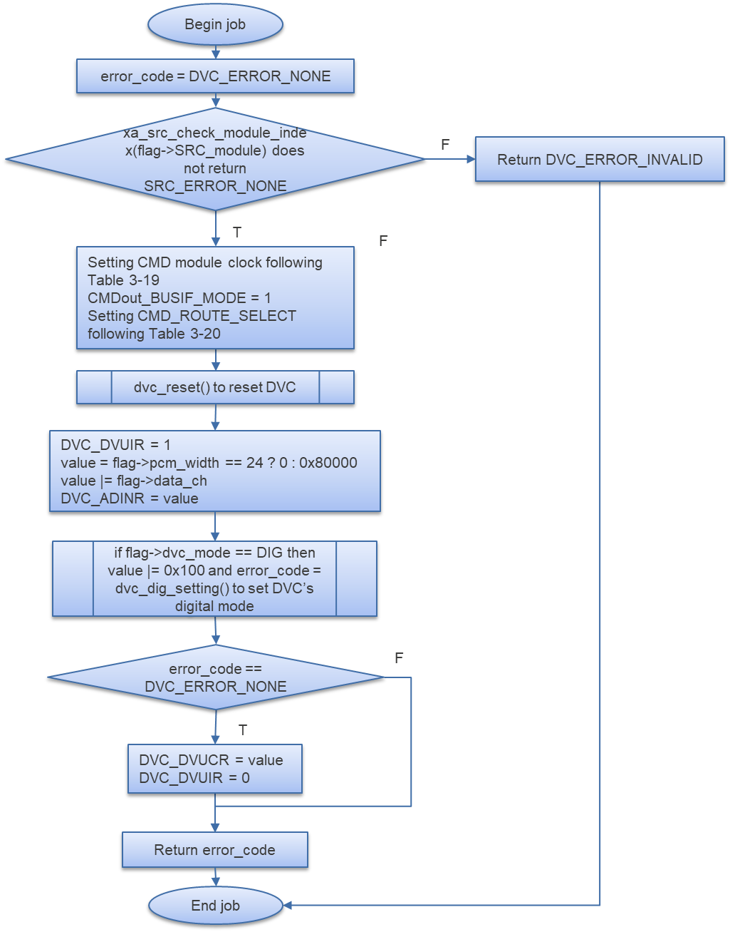

Figure 3‑7 xa_dvc_config flowchart

### xa_dvc_start

DD_PLG_TDM_06_008

|  |  |  |  |  |
| --- | --- | --- | --- | --- |
| **Syntax** | DVC_ERROR_CODE xa_dvc_start(CMD_MODULES modules) | | | |
| **Function** | This function is to start CMD module. | | | |
| **Arguments** | Type | Name | I/O | Description |
| CMD_MODULES | modules | I | CMD module  Valid value: [0: 1] |
| **Return value** | DVC_ERROR_BUSY | | CMD module is running | |
| DVC_ERROR_NONE | | Normal end | |
| **Description** | * xa_dvc_start command processing:   - Start DVC module by set ‘1’ to bit 4 of CMD_CONTROL register | | | |

[Covers: FD_PLG_TDM_005]

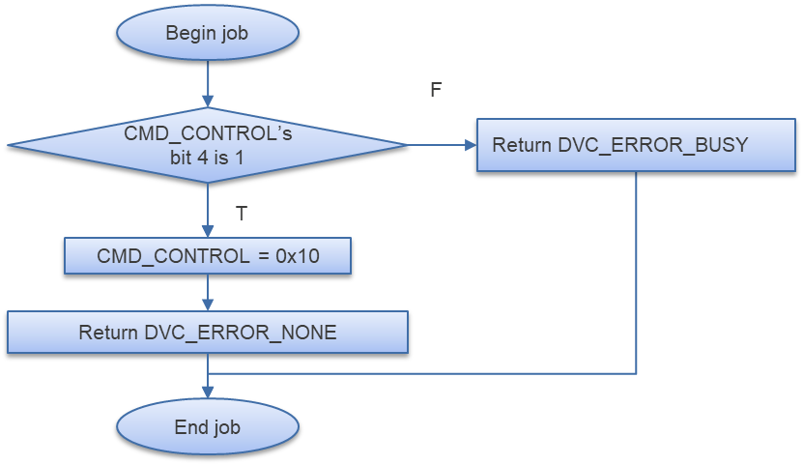

Figure 3‑8 xa_dvc_start flowchart

### xa_dvc_stop

DD_PLG_TDM_06_009

|  |  |  |  |  |
| --- | --- | --- | --- | --- |
| **Syntax** | DVC_ERROR_CODE xa_dvc_stop(CMD_MODULES modules) | | | |
| **Function** | This function is to stop CMD module. | | | |
| **Arguments** | Type | Name | I/O | Description |
| CMD_MODULES | modules | I | CMD module  Valid value: [0: 1] |
| **Return value** | DVC_ERROR_INVALID | | CMD module is invalid | |
| DVC_ERROR_NONE | | Normal end | |
| **Description** | * xa_dvc_stop command processing:   - Stop DVC module by set ‘0’ to CMD_CONTROL register | | | |

[Covers: FD_PLG_TDM_017]

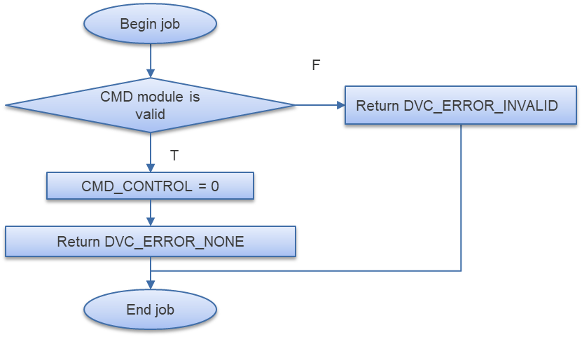

Figure 3‑9 xa_dvc_stop flowchart

### xa_dvc_reset

DD_PLG_TDM_06_010

|  |  |  |  |  |
| --- | --- | --- | --- | --- |
| **Syntax** | static VOID xa_dvc_reset(CMD_MODULES modules) | | | |
| **Function** | This function is to reset DVC module. | | | |
| **Arguments** | Type | Name | I/O | Description |
| CMD_MODULES | modules | I | CMD module  Valid value: [0: 1] |
| **Return value** | None | | | |
| **Description** | * xa_dvc_reset command processing:   - Set DVC_SWRSR to reset DVC module | | | |

[Covers: FD_PLG_TDM_005]

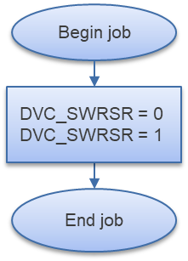

Figure 3‑10 xa_dvc_reset flowchart

### xa_dvc_check_available

DD_PLG_TDM_06_011

|  |  |  |  |  |
| --- | --- | --- | --- | --- |
| **Syntax** | DVC_ERROR_CODE xa_dvc_check_available(UWORD32 *pcmd_num) | | | |
| **Function** | This function is to check availability of DVC module and select an available one. | | | |
| **Arguments** | Type | Name | I/O | Description |
| UWORD32 * | pcmd_num | I/O | Pointer to DVC module selected  Valid value: [0: 1] |
| **Return value** | DVC_ERROR_BUSY | | DVC modules are busy | |
| DVC_ERROR_INVALID | | DVC module is invalid | |
| DVC_ERROR_NONE | | Normal end | |
| **Description** | * xa_dvc_check_available command processing:   - Check availability of DVC module and select a free one | | | |

[Covers: FD_PLG_TDM_005]

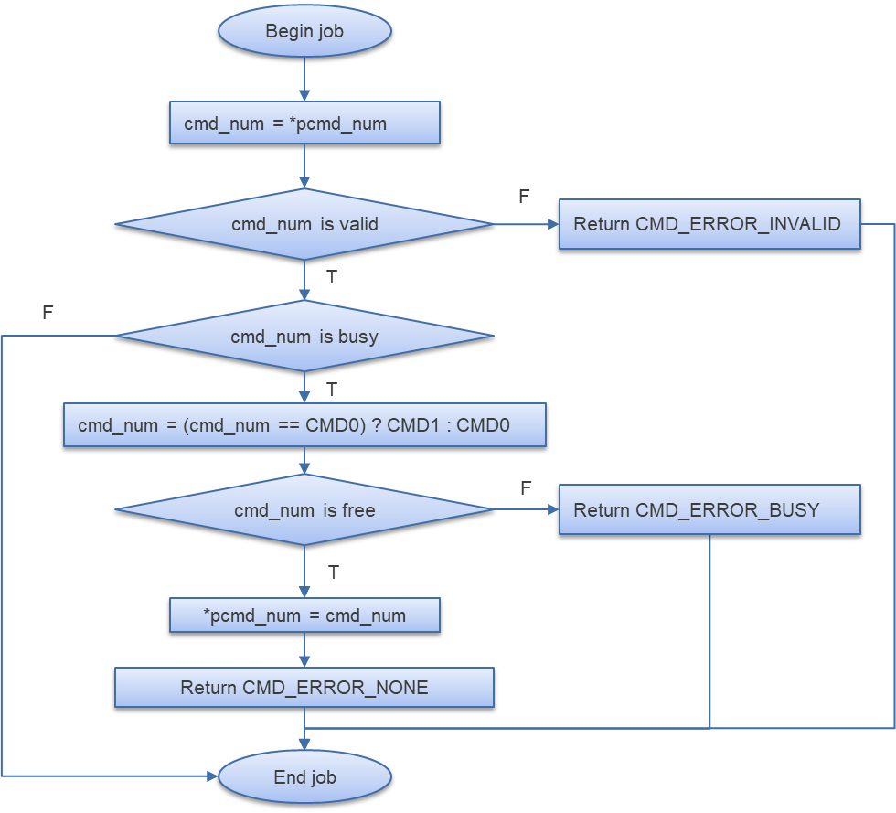

Figure 3‑11 xa_dvc_check_available flowchart

### xa_src_get_config

DD_PLG_TDM_06_012

|  |  |  |  |  |
| --- | --- | --- | --- | --- |
| **Syntax** | static volatile inline SRC_CONFIG *xa_src_get_config(SRC_MODULE module) | | | |
| **Function** | This function is to get base address of Config registers of SRC module. | | | |
| **Arguments** | Type | Name | I/O | Description |
| SRC_MODULE | module | I | SRC module  Valid value: [0: 9] |
| **Return value** | 0 | | SRC module is invalid | |
| Base address of Config registers of SRC module | | | |
| **Description** | * xa_src_get_config command processing:   - Get base address of Config registers of SRC module | | | |

[Covers: FD_PLG_TDM_005, FD_PLG_TDM_017]

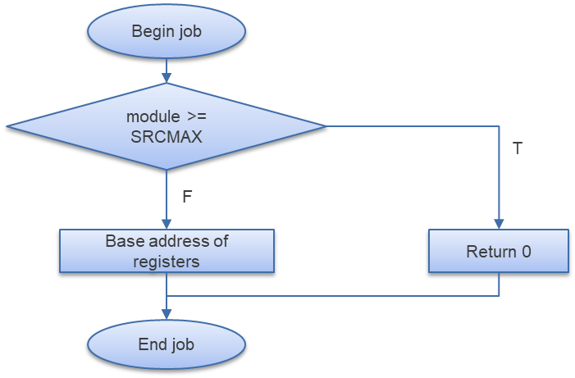

Figure 3‑12 xa_src_get_config flowchart

### xa_src_get_control

DD_PLG_TDM_06_013

|  |  |  |  |  |
| --- | --- | --- | --- | --- |
| **Syntax** | static volatile inline SRC_CTRL *xa_src_get_control(SRC_MODULE module) | | | |
| **Function** | This function is to get base address of Control registers of SRC module. | | | |
| **Arguments** | Type | Name | I/O | Description |
| SRC_MODULE | module | I | SRC module  Valid value: [0: 9] |
| **Return value** | Base address of Control registers of SRC module | | | |
| **Description** | * xa_src_get_control command processing:   - Get base address of Control registers of SRC module | | | |

[Covers: FD_PLG_TDM_005]

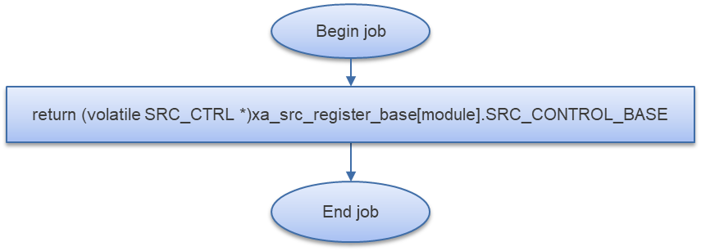

Figure 3‑13 xa_src_get_control flowchart

# Revision history

|  |  |  |  |  |  |
| --- | --- | --- | --- | --- | --- |
| **Version** | **Date** | **Page** | **Content** | **Approved** | **Changed** |
| 1.0.0 | Nov 14 2018 | - | First Edition issued | Vu Phan | Nguyen Dang |
| 1.1.0 | Dec 10 2018 | - | Add traceability ID | Vu Phan | Nguyen Dang |
| 1.2.0 | Jan 03, 2019 | - | Add range for input parameters | Vu Phan | Tien Tran |