**Document Type: Detail Design**

**Document Name:**

**ADSP FRAMEWORK: SSI DRIVER**

Renesas Electronics Corporation

Renesas Design Vietnam Co. Ltd

R-Car Software Solution 2 Group

Middleware 1 Team

Table of Contents

1. Overview 3

2. Function list 4

3. Detail information 5

3.1 Data type definition 5

3.1.1 SSI_MODULE 5

3.1.2 ADG_CLK 5

3.1.3 SSI_DATA_MODE 6

3.1.4 SSI_CLK_MODE 6

3.1.5 SSI_CLK_MODE 6

3.1.6 SSI_ERR_CODE 6

3.1.7 SSI_PARAMS 7

3.2 Global variable definition 8

3.3 Function definition 9

3.3.1 xa_ssi_get_register_base 9

3.3.2 xa_ssi_get_module_master 10

3.3.3 xa_ssi_check_valid_module 11

3.3.4 xa_ssi_setup 12

3.3.5 ssi_start 14

3.3.6 xa_ssi_stop 15

3.3.7 xa_ssi_check_available_module 16

4. Revision history 17

List of Figures

Figure 1‑1 The software architecture 3

Figure 3‑1 xa_ssi_get_register_base flowchart 9

Figure 3‑2 xa_ssi_get_module_master flowchart 10

Figure 3‑3 xa_ssi_check_valid_module flowchart 11

Figure 3‑4 xa_ssi_setup flowchart 13

Figure 3‑5 xa_ssi_start flowchart 14

Figure 3‑6 xa_ssi_stop flowchart 15

Figure 3‑7 xa_ssi_check_available_module flowchart 16

List of Table

Table 2‑1 Function list 4

Table 3‑1 SSI_MODULE type information 5

Table 3‑2 ADG_CLK type information 5

Table 3‑3 SSI_DATA_MODE type information 6

Table 3‑4 SSI_CLK_MODE type information 6

Table 3‑5 SSI_CLK_MODE type information 6

Table 3‑6 SSI_ERR_CODE type information 6

Table 3‑7 SSI_PARAMS type information 7

Table 3‑8 Setting of clock supplier for SSI 12

Table 2‑1 Function list 4

Table 3‑1 SSI_MODULE type information 5

Table 3‑2 ADG_CLK type information 5

Table 3‑3 SSI_DATA_MODE type information 6

Table 3‑4 SSI_CLK_MODE type information 6

Table 3‑5 SSI_CLK_MODE type information 6

Table 3‑6 SSI_ERR_CODE type information 6

Table 3‑7 SSI_PARAMS type information 7

Table 3‑8 Setting of clock supplier for SSI 12

# Overview

This section provides an overview of software architecture.

User Application

ADSP Interface

Kernel Space

User Space

ADSP Driver

ARM

Audio HW

**ADSP Framework**

TDM class

Renderer class

Equalizer class

Capture class

TDM Plugin

ADSP

Plugin

Equalizer Plugin*

Capture Plugin

Renderer Plugin

This document’s target is in side of red square

* not connect to hardware modules

DAC/

ADC

SCU

PDMA

FIFO

SSI

SSIU

ADMA

Figure 1‑1 ****The software architecture****

# Function list

The following is list of functions:

Table 2‑1 Function list

|  |  |  |
| --- | --- | --- |
| **Type** | **Function Name** | **Outline** |
| API | xa_ssi_get_module_master | This API is to get the master module of SSI module |
| xa_ssi_check_valid_module | This API is to check validity of SSI module |
| xa_ssi_setup | This API is to set up registers necessary for SSI module execution |
| xa_ssi_start | This API is to start SSI module |
| xa_ssi_stop | This API is to stop SSI module |
| xa_ssi_check_available_module | This API is to check availability of SSI module |
| Internal functions | xa_ssi_get_register_base | This function is to get the address of the base register of SSI module |

# Detail information

This section describes detail information of data types, macro definitions, implemented APIs and internal function units, global variable.

## Data type definition

### SSI_MODULE

The data type SSI_MODULE is a type-defined enumeration that lists all supported SSI modules. It starts with SSI0 to SSIMAX.

Table 3‑1 SSI_MODULE type information

|  |  |  |
| --- | --- | --- |
| **Member name** | **Value** | **Outline** |
| SSI0 | 0 | SSI0 |
| SSI1 | 1 | SSI1 |
| SSI2 | 2 | SSI2 |
| SSI3 | 3 | SSI3 |
| SSI4 | 4 | SSI4 |
| SSI5 | 5 | SSI5 |
| SSI6 | 6 | SSI6 |
| SSI7 | 7 | SSI7 |
| SSI8 | 8 | SSI8 |
| SSI9 | 9 | SSI9 |
| SSIMAX | 10 | Number of SSI modules |

### ADG_CLK

The data type ADG_CLK is a type-defined enumeration that lists all supported ADG Clocks.

Table 3‑2 ADG_CLK type information

|  |  |  |
| --- | --- | --- |
| **Member name** | **Value** | **Outline** |
| ADG_CLKA | 0 | ADG Clock A, frequency is 22.5792MHz |
| ADG_CLKB | 1 | ADG Clock B, frequency is 24.576MHz |
| ADG_CLKC | 2 | ADG Clock C, frequency is 14.7456MHz |

### SSI_DATA_MODE

The data type SSI_DATA_MODE is a type-defined enumeration that lists all supported SSI modes: Transfer mode/Receive mode.

Table 3‑3 SSI_DATA_MODE type information

|  |  |  |
| --- | --- | --- |
| **Member name** | **Value** | **Outline** |
| SSI_RCV_MODE | 0 | SSI’s Receive mode |
| SSI_TR_MODE | 1 | SSI’s Transfer mode |

### SSI_CLK_MODE

The data type SSI_CLK_MODE is a type-defined enumeration that lists all supported SSI clock modes: Master/Slave.

Table 3‑4 SSI_CLK_MODE type information

|  |  |  |
| --- | --- | --- |
| **Member name** | **Value** | **Outline** |
| SSI_MASTER_MODE | 0 | SSI clock mode Master |
| SSI_SLAVE_MODE | 1 | SSI clock mode Slave |

### SSI_CLK_MODE

The data type SSI_CLK_MODE is a type-defined enumeration that lists all supported SSI clock modes: Master/Slave.

Table 3‑5 SSI_CLK_MODE type information

|  |  |  |
| --- | --- | --- |
| **Member name** | **Value** | **Outline** |
| SSI_MASTER_MODE | 0 | SSI clock mode Master |
| SSI_SLAVE_MODE | 1 | SSI clock mode Slave |

### SSI_ERR_CODE

The data type SSI_ERR_CODE is a type-defined enumeration that lists all error-codes used for SSI.

Table 3‑6 SSI_ERR_CODE type information

|  |  |  |
| --- | --- | --- |
| **Member name** | **Value** | **Outline** |
| SSI_ERR_NONE | 0 | No errors |
| SSI_ERR_OUT_RANGE | -1 | SSI module is out of range |
| SSI_ERR_BUSY | -2 | SSI module is busy |

### SSI_PARAMS

The data type SSI_PARAMS is a type-defined structure that possesses necessary parameters for SSI module.

Table 3‑7 SSI_PARAMS type information

|  |  |  |
| --- | --- | --- |
| **Member name** | **Data type** | **Outline** |
| channels | UWORD32 | channel of data used for SSI module |
| pcm_wdth | UWORD32 | PCM width of data used for SSI module |
| fs | UWORD32 | Sampling rate of data used for SSI moduel |
| clock_type | ADG_CLK_MODE | Clock type (Clock A, B, C) |
| data_mode | SSI_DATA_MODE | SSI data mode |
| clock_mode | SSI_CLK_MODE | SSI clock mode |
| ssi_format | SSI_FORMAT | SSI format |

## Global variable definition

|  |  |
| --- | --- |
| static const UWORD32 xa_ssi_register_base[SSIMAX] | |
| Array’s index | Value |
| SSI0 | XF_RCAR_REG_SSICR0 |
| SSI1 | XF_RCAR_REG_SSICR1 |
| SSI2 | XF_RCAR_REG_SSICR2 |
| SSI3 | XF_RCAR_REG_SSICR3, |
| SSI4 | XF_RCAR_REG_SSICR4 |
| SSI5 | XF_RCAR_REG_SSICR5 |
| SSI6 | XF_RCAR_REG_SSICR6 |
| SSI7 | XF_RCAR_REG_SSICR7 |
| SSI8 | XF_RCAR_REG_SSICR8 |
| SSI9 | XF_RCAR_REG_SSICR9 |

## Function definition

### xa_ssi_get_register_base

DD_PLG_TDM_07_001

|  |  |  |  |  |
| --- | --- | --- | --- | --- |
| **Syntax** | static inline SSI_CONTROL *xa_ssi_get_register_base(SSI_MODULE module) | | | |
| **Function** | This function is to get the address of the base register of SSI module. | | | |
| **Arguments** | Type | Name | I/O | Description |
| SSI_MODULE | module | I | SSI module  Valid value: [0: 9] |
| **Return value** | 0 | | SSI module is invalid | |
| Address of base register | | | |
| **Description** | * xa_ssi_get_register_base command processing:   - Get address of base register from xa_ssi_register_base array. | | | |

[Covers: FD_PLG_TDM_005, FD_PLG_TDM_017]

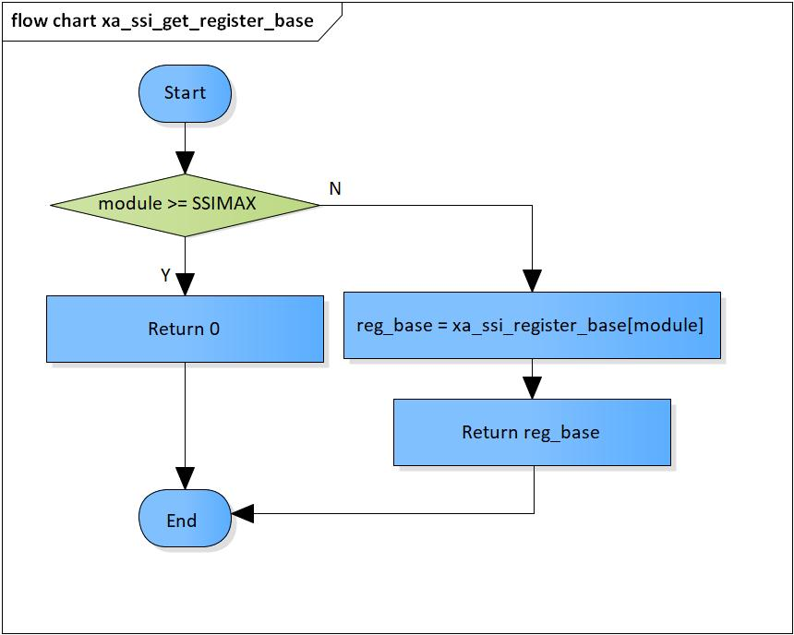

Figure 3‑1 xa_ssi_get_register_base flowchart

### xa_ssi_get_module_master

DD_PLG_TDM_07_002

|  |  |  |  |  |
| --- | --- | --- | --- | --- |
| **Syntax** | SSI_MODULE xa_ssi_get_module_master(SSI_MODULE module) | | | |
| **Function** | This function is to get master module based on current SSI module. | | | |
| **Arguments** | Type | Name | I/O | Description |
| SSI_MODULE | module | I | SSI module  Valid value: [0: 9] |
| **Return value** | master_module | | Master module of current SSI module | |
| **Description** | * xa_ssi_get_module_master command processing:   - Get master module based on current SSI module | | | |

[Covers: FD_PLG_TDM_005]

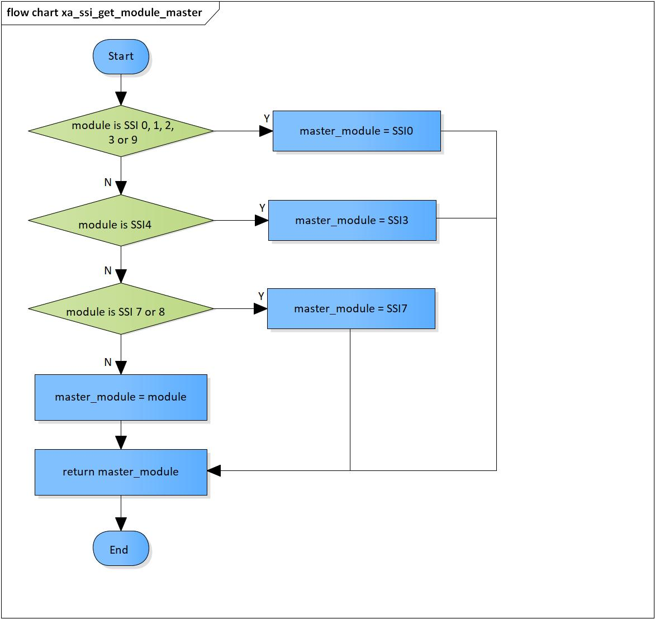

Figure 3‑2 xa_ssi_get_module_master flowchart

### xa_ssi_check_valid_module

DD_PLG_TDM_07_003

|  |  |  |  |  |
| --- | --- | --- | --- | --- |
| **Syntax** | SSI_ERROR_CODE xa_ssi_check_valid_module(SSI_MODULE module, SSI_FORMAT format) | | | |
| **Function** | This function is to check validity of SSI module | | | |
| **Arguments** | Type | Name | I/O | Description |
| SSI_MODULE | module | I | SSI module  Valid value: [0: 9] |
| SSI_FORMAT | format | I | Format of the SSI module  Valid value: 0/1/2/3 |
| **Return value** | SSI_ERR_OUT_RANGE | | SSI module is invalid | |
| SSI_ERR_NONE | | Normal end | |
| **Description** | * xa_ssi_check_valid_module command processing:   - Check validity of SSI module | | | |

[Covers: FD_PLG_TDM_024, FD_PLG_TDM_026, FD_PLG_TDM_034, FD_PLG_TDM_036]

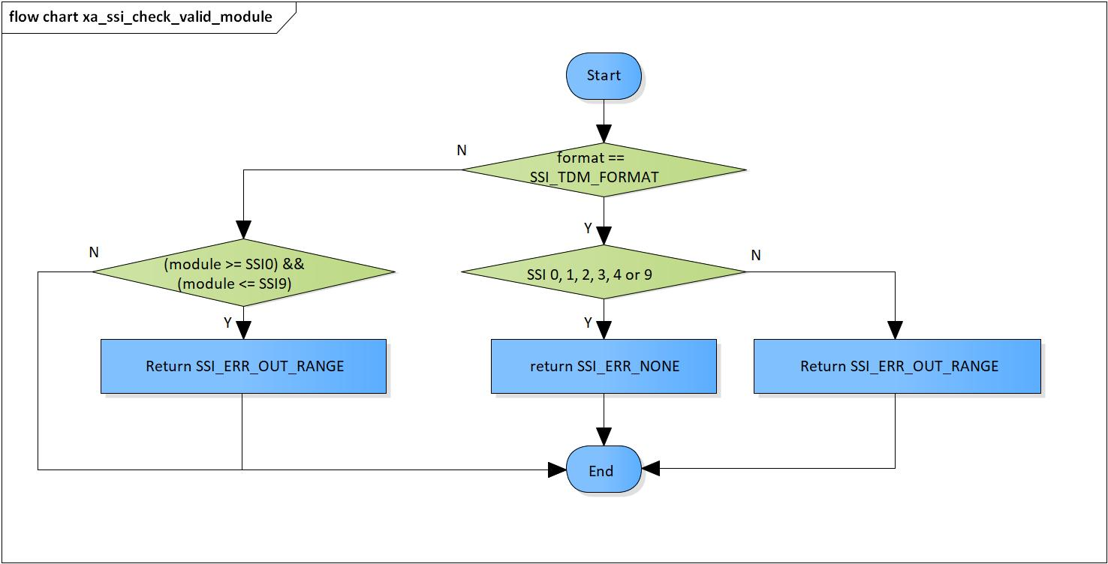

Figure 3‑3 xa_ssi_check_valid_module flowchart

### xa_ssi_setup

DD_PLG_TDM_07_004

|  |  |  |  |  |
| --- | --- | --- | --- | --- |
| **Syntax** | SSI_ERROR_CODE xa_ssi_setup(SSI_MODULE module, SSI_PARAMS params) | | | |
| **Function** | This function is to set up registers necessary for SSI module execution. | | | |
| **Arguments** | Type | Name | I/O | Description |
| SSI_MODULE | module | I | SSI module  Valid value: [0: 9] |
| SSI_PARAMS | params | I | Struct of parameters to set |
| **Return value** | SSI_ERR_OUT_RANGE | | SSI module is invalid  SSI format is invalid  Clock type is invalid  Channel is invalid  Clock ratio is invalid  Sampling rate is invalid  PCM width is invalid | |
| SSI_ERR_NONE | | Normal end | |
| **Description** | * xa_ssi_setup command processing:   - Set registers for SSI operation | | | |

[Covers: FD_PLG_TDM_005]

Table 3‑8 Setting of clock supplier for SSI

|  |  |  |  |  |
| --- | --- | --- | --- | --- |
| **SSI module** | **Sampling rate** | **Register** | **Bits** | **Value** |
| SSI0 | 48000 | AUDIO_CLK_SEL0 | [7:0] | 0x2 |
| 44100 | 0x1 |
| SSI1 | 48000 | AUDIO_CLK_SEL0 | [15:8] | 0x2 |
| 44100 | 0x1 |
| SSI2 | 48000 | AUDIO_CLK_SEL0 | [23:16] | 0x2 |
| 44100 | 0x1 |
| SSI3 | 48000 | AUDIO_CLK_SEL0 | [31:24] | 0x2 |
| 44100 | 0x1 |
| SSI4 | 48000 | AUDIO_CLK_SEL1 | [7:0] | 0x2 |
| 44100 | 0x1 |
| SSI9 | 48000 | AUDIO_CLK_SEL2 | [15:8] | 0x2 |
| 44100 | 0x1 |

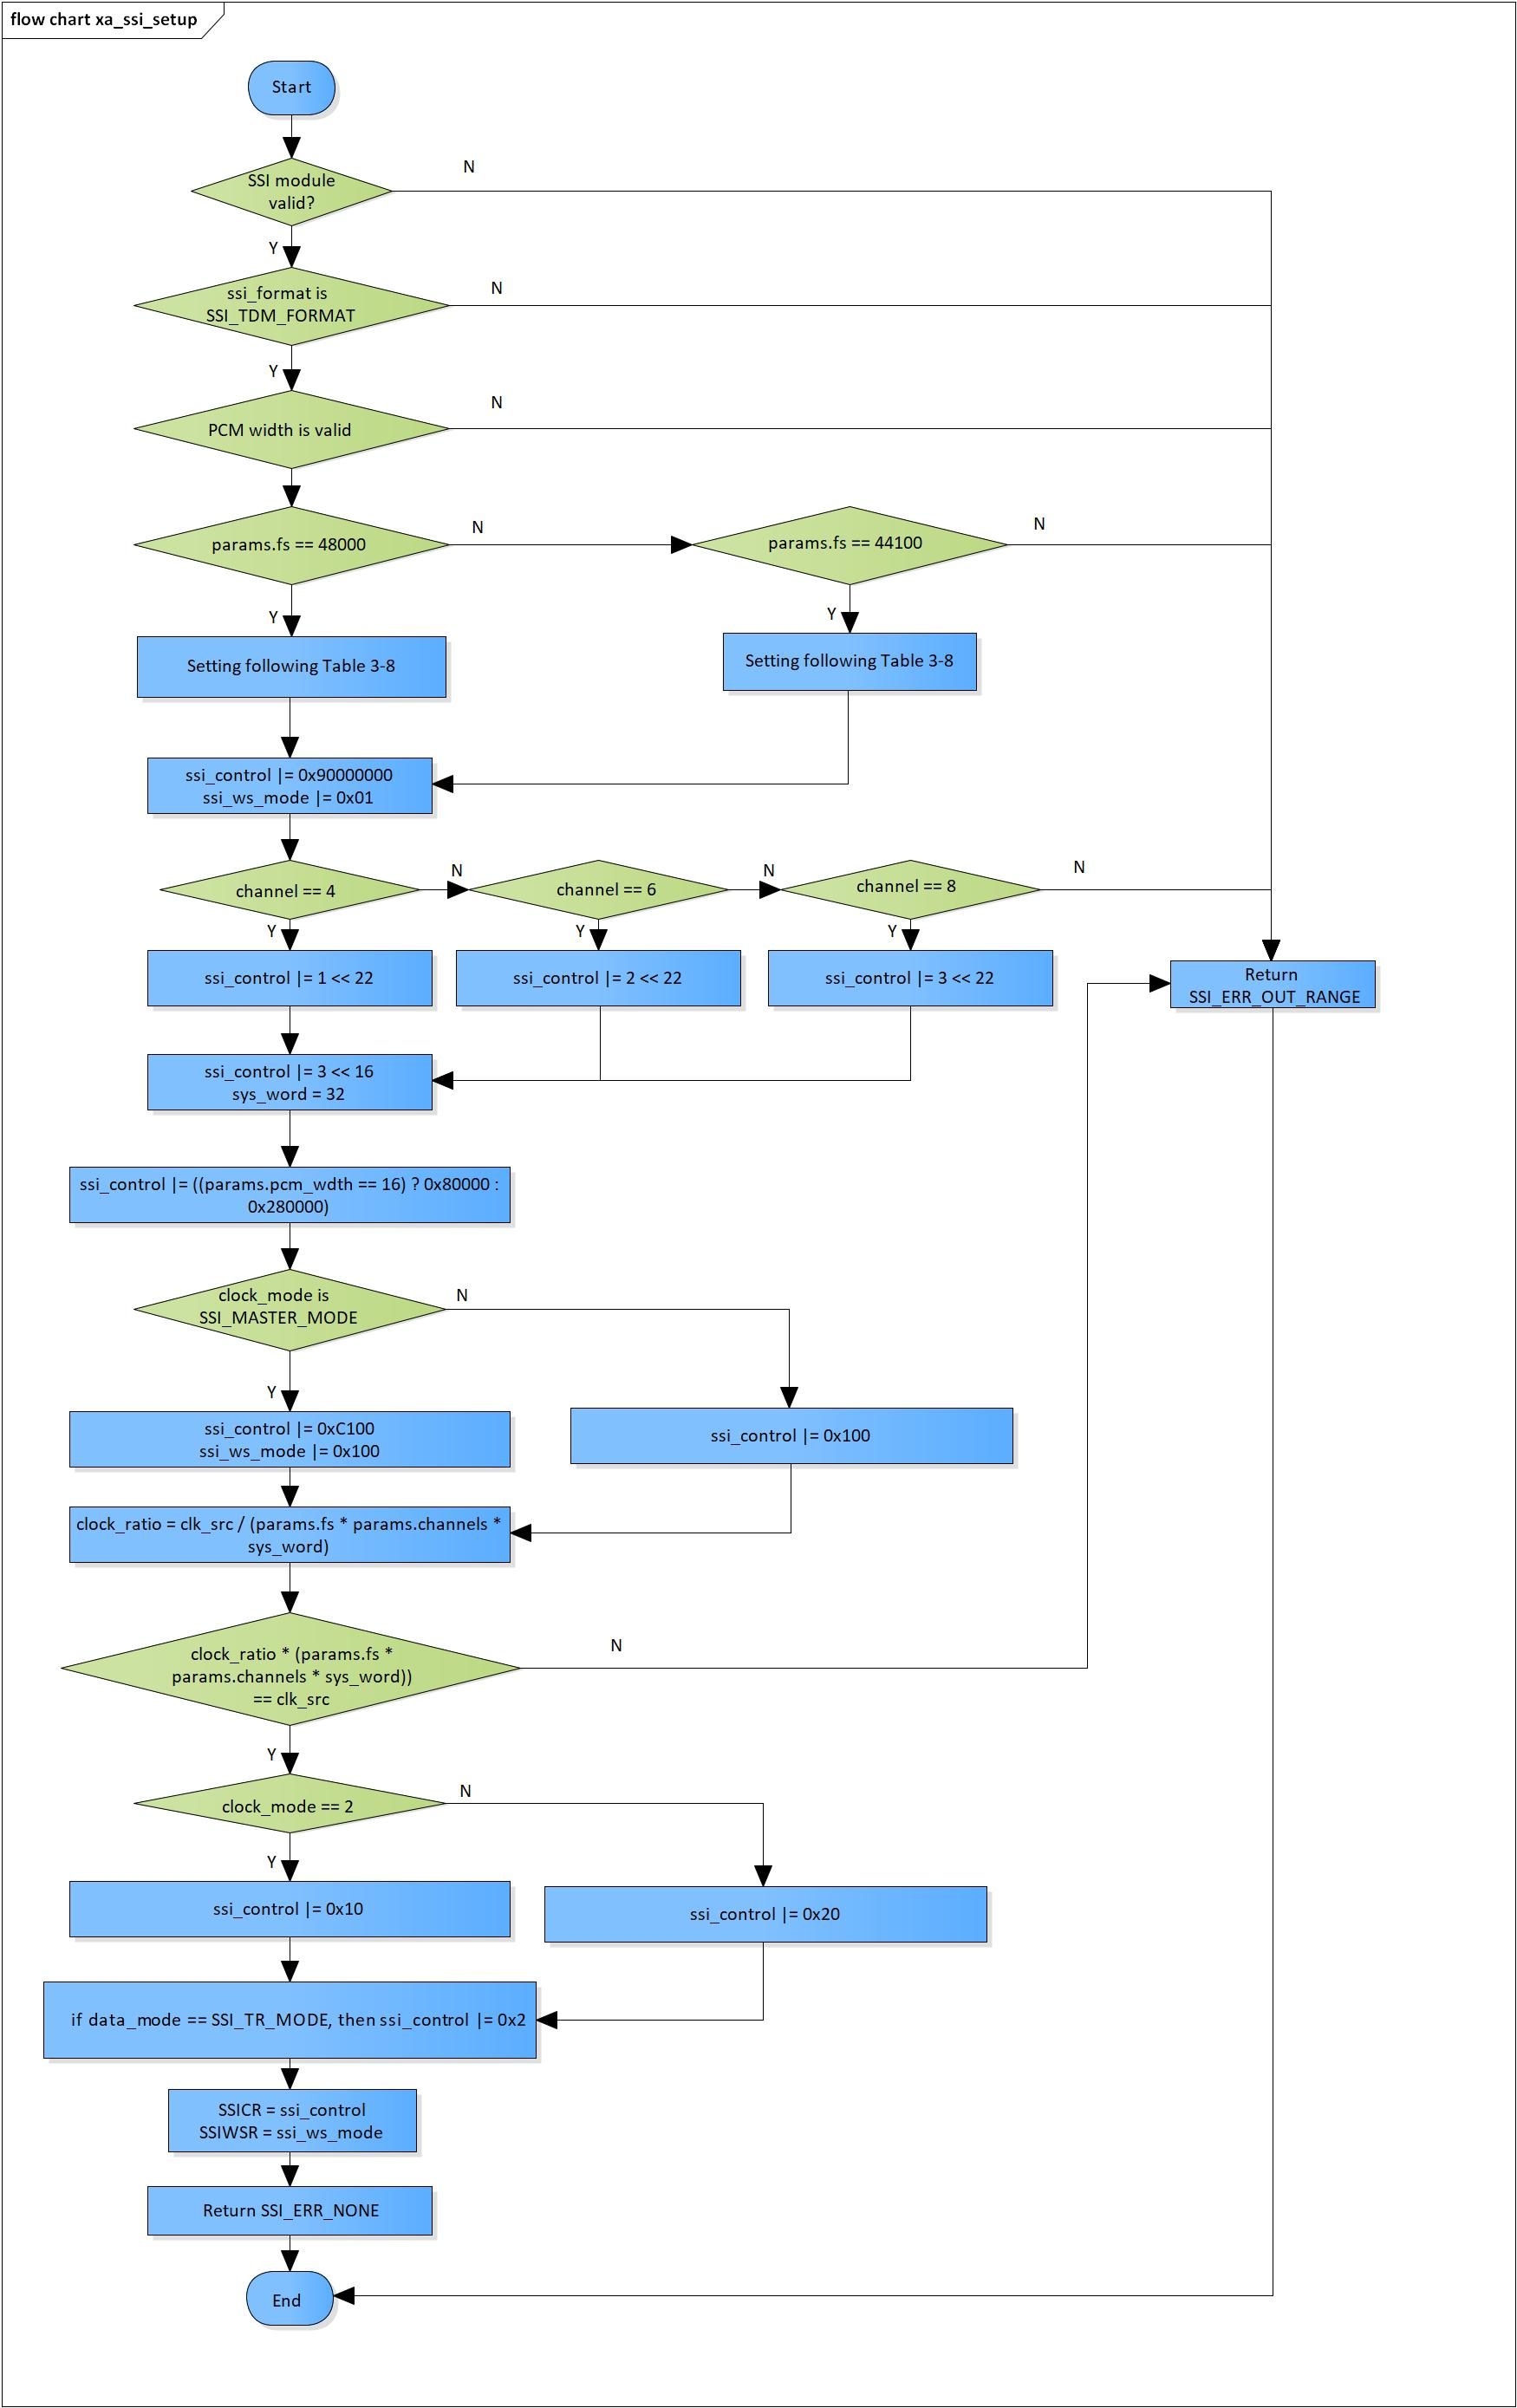

Figure 3‑4 xa_ssi_setup flowchart

### ssi_start

DD_PLG_TDM_07_005

|  |  |  |  |  |
| --- | --- | --- | --- | --- |
| **Syntax** | SSI_ERR_CODE xa_ssi_start(SSI_MODULE module) | | | |
| **Function** | This function is to start SSI module. | | | |
| **Arguments** | Type | Name | I/O | Description |
| SSI_MODULE | module | I | SSI module  Valid value: [0: 9] |
| **Return value** | SSI_ERR_BUSY | | SSI module is running | |
| SSI_ERR_NONE | | Normal end | |
| **Description** | * xa_ssi_start command processing:   - Set ‘1’ to SSICR’s bit 0 to start SSI | | | |

[Covers: FD_PLG_TDM_005]

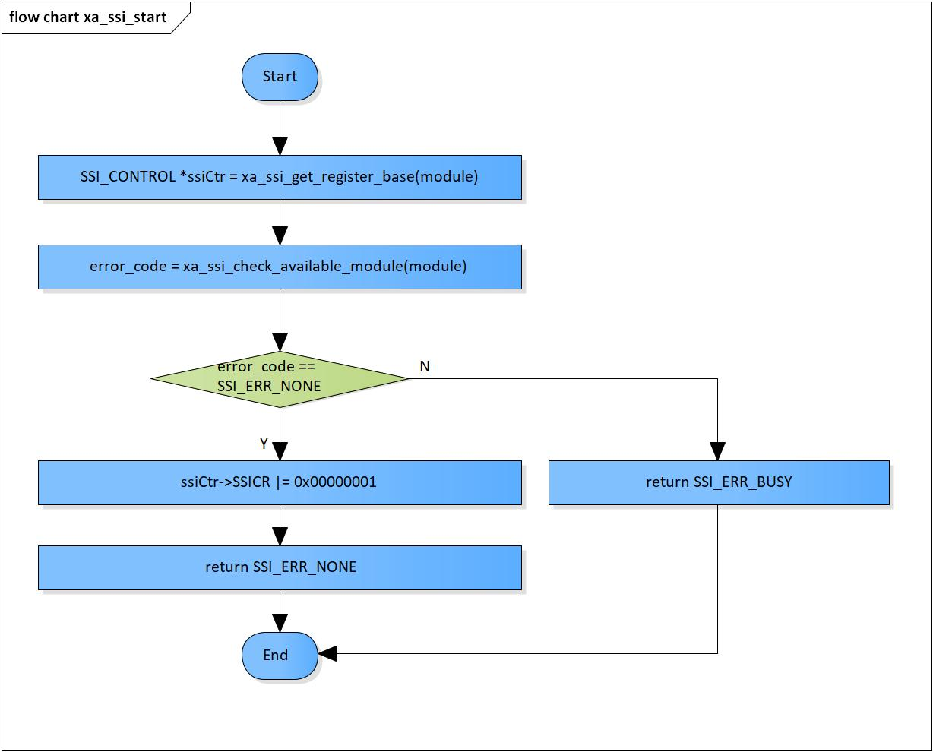

Figure 3‑5 xa_ssi_start flowchart

### xa_ssi_stop

DD_PLG_TDM_07_006

|  |  |  |  |  |
| --- | --- | --- | --- | --- |
| **Syntax** | SSI_ERR_CODE xa_ssi_stop(SSI_MODULE module) | | | |
| **Function** | This function is to stop SSI module. | | | |
| **Arguments** | Type | Name | I/O | Description |
| SSI_MODULE | module | I | SSI module  Valid value: [0: 9] |
| **Return value** | SSI_ERR_OUT_RANGE | | SSI module is invalid | |
| SSI_ERR_NONE | | Nomal end | |
| **Description** | * xa_ssi_start command processing:   - Set ‘0’ to SSICR’s bit 0 to stop SSI | | | |

[Covers: FD_PLG_TDM_017]

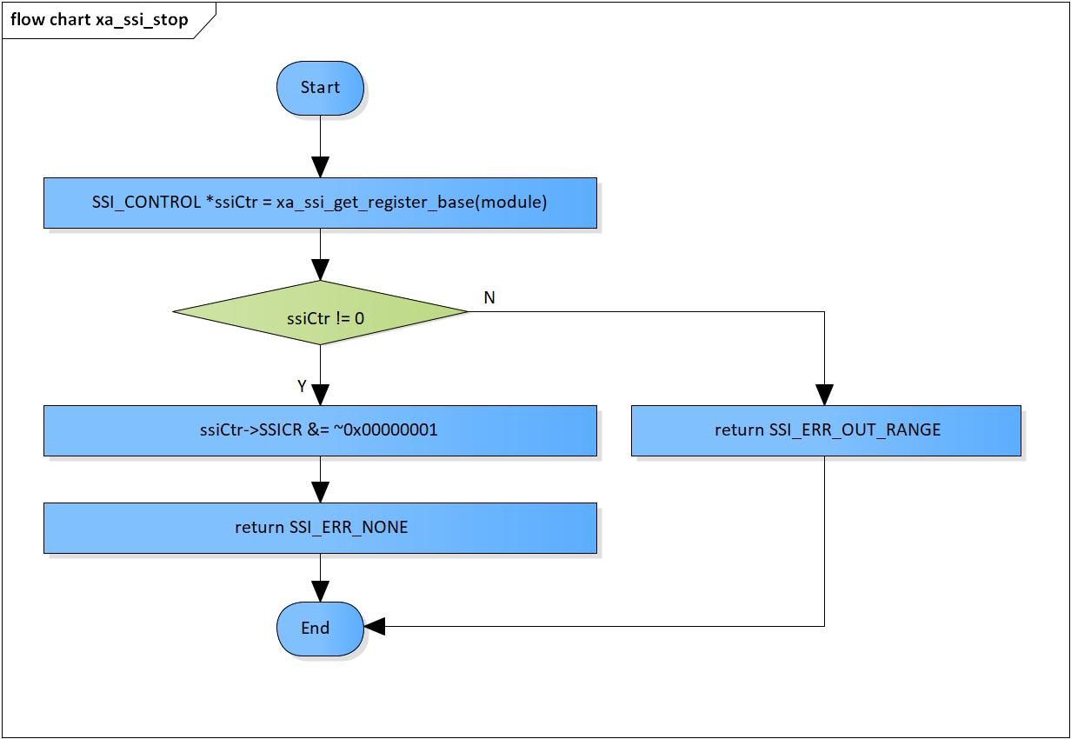

Figure 3‑6 xa_ssi_stop flowchart

### xa_ssi_check_available_module

DD_PLG_TDM_07_007

|  |  |  |  |  |
| --- | --- | --- | --- | --- |
| **Syntax** | SSI_ERROR_CODE xa_ssi_check_available_module(SSI_MODULE module_idx) | | | |
| **Function** | This function is check availability of SSI module. | | | |
| **Arguments** | Type | Name | I/O | Description |
| UWORD32 | module_idx | I | SSI module  Valid value: [0: 9] |
| **Return value** | SSI_ERR_OUT_RANGE | | SSI module is invalid | |
| SSI_ERR_BUSY | | SSI module is busy | |
| SSI_ERR_NONE | | Normal end | |
| **Description** | * xa_ssi_check_available_module command processing:   - Check if the current SSI module is running or not | | | |

[Covers: FD_PLG_TDM_005]

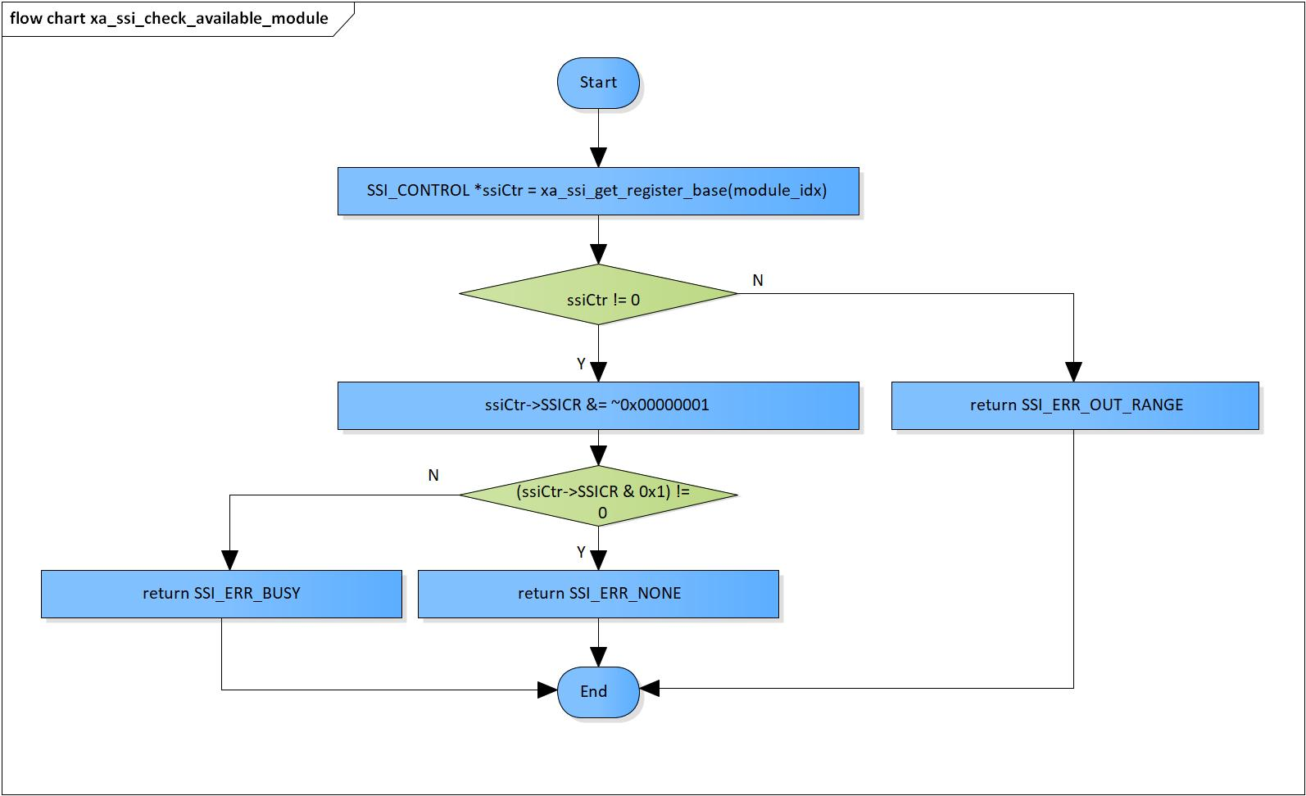

Figure 3‑7 xa_ssi_check_available_module flowchart

# Revision history

|  |  |  |  |  |  |
| --- | --- | --- | --- | --- | --- |
| **Version** | **Date** | **Page** | **Content** | **Approved** | **Changed** |
| 1.0.0 | Nov 14 2018 | - | First Edition issued | Vu Phan | Nguyen Dang |
| 1.1.0 | Dec 10 2018 | - | Add traceability ID | Vu Phan | Nguyen Dang |
| 1.2.0 | Jan 03, 2019 | - | Add range for input parameters | Vu Phan | Tien Tran |