**Document Type: Detail Design**

**Document Name:**

**ADSP FRAMEWORK: SSIU DRIVER**

Renesas Electronics Corporation

Renesas Design Vietnam Co. Ltd

R-Car Software Solution 2 Group

Middleware 1 Team

Table of Contents

1. Overview 3

2. Function list 4

3. Detail information 5

3.1 Data type definition 5

3.1.1 SSIU_SSI_MODULE 5

3.1.2 SSIU_SSI_INFO 5

3.1.3 SSIU_PIN_MODE 5

3.1.4 SSIU_SWAP_FUNC 6

3.1.5 SSIU_OPERATION_MODE 6

3.1.6 SSIU_PARAMS 7

3.1.7 SSIU_ERR_CODE 7

3.2 Macro definition 8

3.3 Function definition 9

3.3.1 xa_ssiu_get_register_base 9

3.3.2 xa_ssiu_get_pin_mode 10

3.3.3 xa_ssiu_check_valid_index 11

3.3.4 xa_ssiu_setup 12

3.3.5 xa_ssiu_start 14

3.3.6 xa_ssiu_stop 15

4. Revision history 16

List of Figures

Figure 1‑1 The software architecture 3

Figure 3‑1 xa_ssiu_get_register_base flowchart 9

Figure 3‑2 xa_ssiu_get_pin_mode flowchart 10

Figure 3‑3 xa_ssiu_check_valid_index flowchart 11

Figure 3‑4 xa_ssiu_setup flowchart 13

Figure 3‑5 xa_ssiu_start flowchart 14

Figure 3‑6 xa_ssiu_stop flowchart 15

List of Table

Table 2‑1 Function list 4

Table 3‑1 SSIU_PIN_MODE type information 5

Table 3‑2 SSIU_SSI_INFO type information 5

Table 3‑3 SSIU_PIN_MODE type information 5

Table 3‑4 SSIU_SWAP_FUNC type information 6

Table 3‑5 SSIU_OPERATION_MODE type information 6

Table 3‑6 SSIU_PARAMS type information 7

Table 3‑7 SSIU_ERR_CODE type information 7

Table 2‑1 Function list 4

Table 3‑1 SSIU_SSI_MODULE type information 5

Table 3‑2 SSIU_SSI_INFO type information 5

Table 3‑3 SSIU_PIN_MODE type information 5

Table 3‑4 SSIU_SWAP_FUNC type information 6

Table 3‑5 SSIU_OPERATION_MODE type information 6

Table 3‑6 SSIU_PARAMS type information 7

Table 3‑7 SSIU_ERR_CODE type information 7

# Overview

This section provides an overview of software architecture.

User Application

ADSP Interface

Kernel Space

User Space

ADSP Driver

ARM

Audio HW

**ADSP Framework**

Renderer class

TDM class

Equalizer class

Capture class

ADSP

Plugin

Equalizer Plugin*

TDM Plugin

Capture Plugin

Renderer Plugin

This document’s target is in side of red square

* not connect to hardware modules

DAC/

ADC

SCU

PDMA

FIFO

SSI

SSIUU

ADMA

Figure 1‑1 ****The software architecture****

# Function list

The following is list of functions:

Table 2‑1 Function list

|  |  |  |
| --- | --- | --- |
| **Type** | **Function Name** | **Outline** |
| API | xa_ssiu_setup | This API is to set up registers necessary for SSIU module execution |
| xa_ssiu_get_pin_mode | This API is to get the pin mode |
| xa_ssiu_check_valid_index | This API is to check the validity of SSIU interface index |
| xa_ssiu_start | This API is to start SSIU module |
| xa_ssiu_stop | This API is to stop SSIU module |
| Internal function | xa_ssiu_get_register_base | This function is to get register base of SSIU BUSIFn |

# Detail information

This section describes detail information of data types, macro definitions, implemented APIs and internal function units, global variable.

## Data type definition

### SSIU_SSI_MODULE

The data type SSIU_SSI_MODULE is a type-defined enumeration that lists all supported pin modes for SSIU.

Table 3‑1 SSIU_SSI_MODULE type information

|  |  |  |
| --- | --- | --- |
| **Member name** | **Value** | **Outline** |
| SSIU_SSI0 | 0 | SSI0 |
| SSIU_SSI1 | 1 | SSI1 |
| SSIU_SSI2 | 2 | SSI2 |
| SSIU_SSI3 | 3 | SSI3 |
| SSIU_SSI4 | 4 | SSI4 |
| SSIU_SSI5 | 5 | SSI5 |
| SSIU_SSI6 | 6 | SSI6 |
| SSIU_SSI7 | 7 | SSI7 |
| SSIU_SSI8 | 8 | SSI8 |
| SSIU_SSI9 | 9 | SSI9 |
| SSIU_SSIMAX | 10 | Maximum number of SSI modules |

### SSIU_SSI_INFO

The data type SSIU_SSI_INFO is a type-defined structure that lists SSIU’s properties: module index and bus index.

Table 3‑2 SSIU_SSI_INFO type information

|  |  |  |
| --- | --- | --- |
| **Member name** | **Data type** | **Outline** |
| module_index | UWORD32 | SSIU module index |
| bus_index | UWORD32 | SSIU bus index |

### SSIU_PIN_MODE

The data type SSIU_PIN_MODE is a type-defined enumeration that lists all supported pin modes for SSIU.

Table 3‑3 SSIU_PIN_MODE type information

|  |  |  |
| --- | --- | --- |
| **Member name** | **Value** | **Outline** |
| SSIU_NON_PIN_MODE | 0 | No setting pin mode for SSIU |
| SSIU_S3_S4_PIN_MODE | 1 | SSI3 works as slave and SSI4 works as slave |
| SSIU_M3_S4_PIN_MODE | 2 | SSI3 works as master and SSI4 works as slave |
| SSIU_S0_S2_PIN_MODE | 3 | SSI0 works as slave and SSI2 works as slave |
| SSIU_M0_S2_PIN_MODE | 4 | SSI0 works as master and SSI2 works as slave |
| SSIU_S0_S1_PIN_MODE | 5 | SSI0 works as slave and SSI1 works as slave |
| SSIU_M0_S1_PIN_MODE | 6 | SSI0 works as master and SSI1 works as slave |
| SSIU_S0_S9_PIN_MODE | 7 | SSI0 works as slave and SSI9 works as slave |
| SSIU_M0_S9_PIN_MODE | 8 | SSI0 works as master and SSI9 works as slave |
| SSIU_S3_S9_PIN_MODE | 9 | SSI3 works as slave and SSI9 works as slave |
| SSIU_M3_S9_PIN_MODE | 10 | SSI3 works as master and SSI9 works as slave |
| SSIU_S0_S3_PIN_MODE | 11 | SSI0 works as slave and SSI3 works as slave |
| SSIU_M0_S3_PIN_MODE | 12 | SSI0 works as master and SSI3 works as slave |

### SSIU_SWAP_FUNC

The data type SSIU_SWAP_FUNC is a type-defined enumeration of indicators of whether swap function is enabled or not.

Table 3‑4 SSIU_SWAP_FUNC type information

|  |  |  |
| --- | --- | --- |
| **Member name** | **Value** | **Outline** |
| SSIU_WORD_SWAP_DISABLE | 0 | Swap function is disabled |
| SSIU_WORD_SWAP_ENABLE | 1 | Swap function is enabled |

### SSIU_OPERATION_MODE

The data type SSIU_OPERATION_MODE is a type-defined enumeration of indicators of whether swap function is enabled or not.

Table 3‑5 SSIU_OPERATION_MODE type information

|  |  |  |
| --- | --- | --- |
| **Member name** | **Value** | **Outline** |
| SSIU_BASIC_MODE | 0 | SSIU basic mode |
| SSIU_TDM_EXT_MODE | 1 | SSIU TDM extension mode |
| SSIU_TDM_SPLIT_MODE | 2 | SSIU TDM split mode |
| SSIU_TDM_16CH_MODE | 3 | SSIU TDM 16-channel mode |

### SSIU_PARAMS

The data type SSIU_PARAMS is a type-defined structure that possesses necessary parameters for SSIU module.

Table 3‑6 SSIU_PARAMS type information

|  |  |  |
| --- | --- | --- |
| **Member name** | **Data type** | **Outline** |
| channels | UWORD32 | channel of data used for SSIU module |
| pcm_width | UWORD32 | PCM width of data used for SSIU module |
| pin_mode | SSIU_PIN_MODE | pin mode for SSIU module |
| swap_func | SSIU_SWAP_FUNC | Swap function indicator |
| operation_mode | SSIU_OPERATION_MODE | SSIU operation mode |

### SSIU_ERR_CODE

The data type SSIU_ERR_CODE is a type-defined enumeration that lists all error codes for SSIU module.

Table 3‑7 SSIU_ERR_CODE type information

|  |  |
| --- | --- |
| **Member name** | **Value** |
| SSIU_ERR_NONE | 0 |
| SSIU_ERR_OUT_RANGE | -1 |
| SSIU_ERR_BUSY | -2 |

## Macro definition

|  |  |  |
| --- | --- | --- |
| **Macros** | **Value** | **Outline** |
| SSI_MODE0 | XF_RCAR_REG_SSI_MODE0 | SSI Mode Register 0 |
| SSI_MODE1 | XF_RCAR_REG_SSI_MODE1 | SSI Mode Register 1 |
| SSI_MODE2 | XF_RCAR_REG_SSI_MODE2 | SSI Mode Register 2 |
| SSI_MODE3 | XF_RCAR_REG_SSI_MODE3 | SSI Mode Register 3 |
| SSIU_BUSMAX | 8 | Maximum number of bus |
| SSIU_PIN_MODE_S_S | 0 | Connection between two SSIs is slave-slave |
| SSIU_PIN_MODE_M_S | 1 | Connection between two SSIs is master-slave |
| BASE_REG(n) | XF_RCAR_REG_SSI_BUSIF_MODE(n) | Base register of SSI module |

Note: XF_RCAR_REG_SSI_MODEn (n = 0, 1, 2, 3) and XF_RCAR_REG_SSI_BUSIF_MODE(n) are in repository s492d/include/sys/xt-shmem/board-rcar/xf-registers.h

## Function definition

### xa_ssiu_get_register_base

DD_PLG_TDM_08_001

|  |  |  |  |  |
| --- | --- | --- | --- | --- |
| **Syntax** | static inline SSIU_CONTROL *xa_ssiu_get_register_base(SSIU_SSI_INFO module) | | | |
| **Function** | This function is to get register base of SSIU BUSIFn. | | | |
| **Arguments** | Type | Name | I/O | Description |
| SSIU_SSI_INFO | module | I | SSIU module information |
| **Return value** | Base register of SSIU | | | |
| **Description** | * xa_ssiu_get_register_base command processing:   - Get register base of SSIU BUSIFn | | | |

[Covers: FD_PLG_TDM_005, FD_PLG_TDM_017]

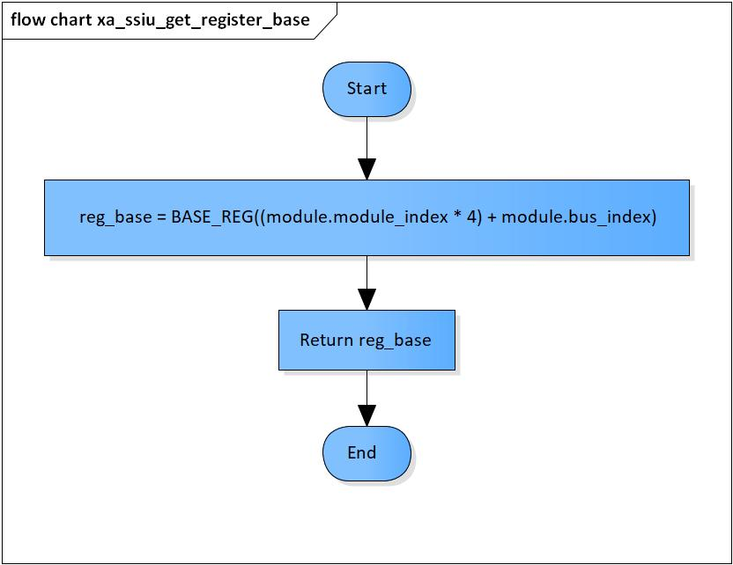

Figure 3‑1 xa_ssiu_get_register_base flowchart

### xa_ssiu_get_pin_mode

DD_PLG_TDM_08_002

|  |  |  |  |  |
| --- | --- | --- | --- | --- |
| **Syntax** | SSIU_PIN_MODE xa_ssiu_get_pin_mode(SSIU_SSI_INFO com_module, SSIU_SSI_INFO module, UWORD32 mode_type) | | | |
| **Function** | This function is to get pin mode. | | | |
| **Arguments** | Type | Name | I/O | Description |
| SSIU_SSI_INFO | com_module | I | Common SSIU module information |
| SSIU_SSI_INFO | module | I | SSIU module information |
| UWORD32 | mode_type | I | Operation mode type |
| **Return value** | Pin mode | | | |
| **Description** | * xa_ssiu_get_pin_mode command processing:   - Return pin mode based on com_module | | | |

[Covers: FD_PLG_TDM_005]

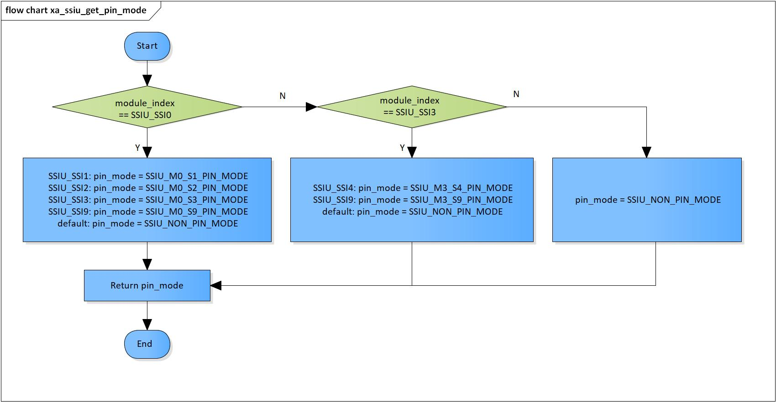

Figure 3‑2 xa_ssiu_get_pin_mode flowchart

### xa_ssiu_check_valid_index

DD_PLG_TDM_08_003

|  |  |  |  |  |
| --- | --- | --- | --- | --- |
| **Syntax** | SSIU_ERROR_CODE xa_ssiu_check_valid_index(UWORD32 bus_index) | | | |
| **Function** | This function is to check the validity of SSIU interface index. | | | |
| **Arguments** | Type | Name | I/O | Description |
| UWORD32 | bus_index | I | Bus index  Valid value: 0 |
| **Return value** | SSIU_ERR_OUT_RANGE | | Bus index is invalid | |
| SSIU_ERR_NONE | | Normal end | |
| **Description** | * xa_ssiu_check_valid_index command processing:   - Check the bus index | | | |

[Covers: FD_PLG_TDM_024, FD_PLG_TDM_026, FD_PLG_TDM_034, FD_PLG_TDM_036]

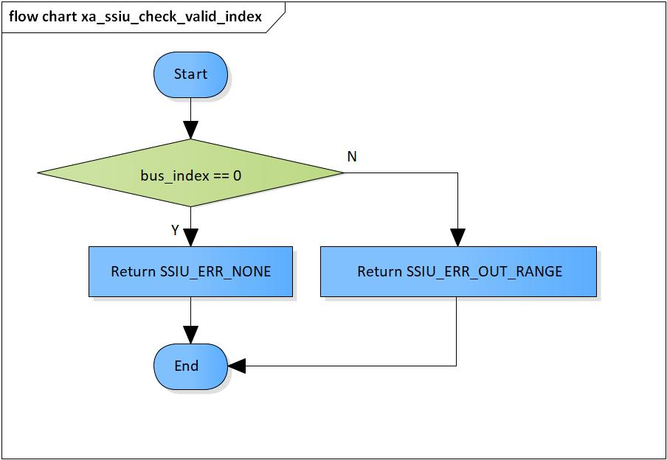

Figure 3‑3 xa_ssiu_check_valid_index flowchart

### xa_ssiu_setup

DD_PLG_TDM_08_004

|  |  |  |  |  |
| --- | --- | --- | --- | --- |
| **Syntax** | SSIU_ERR_CODE xa_ssiu_setup(SSIU_SSI_MODULE module, SSIU_PARAMS params) | | | |
| **Function** | This function is to set up registers necessary for SSIU module execution. | | | |
| **Arguments** | Type | Name | I/O | Description |
| SSIU_SSI_MODULE | module | I | SSIU module |
| SSIU_PARAMS | params | I | Struct of parameters to set |
| **Return value** | SSIU_ERR_OUT_RANGE | | Module index is invalid  Bus index is invalid  Channel is invalid  Pin mode is invalid  PCM width is invalid | |
| SSIU_ERR_NONE | | Normal end | |
| **Description** | * xa_ssiu_setup command processing:   - Set registers for SSIU execution | | | |

[Covers: FD_PLG_TDM_005]

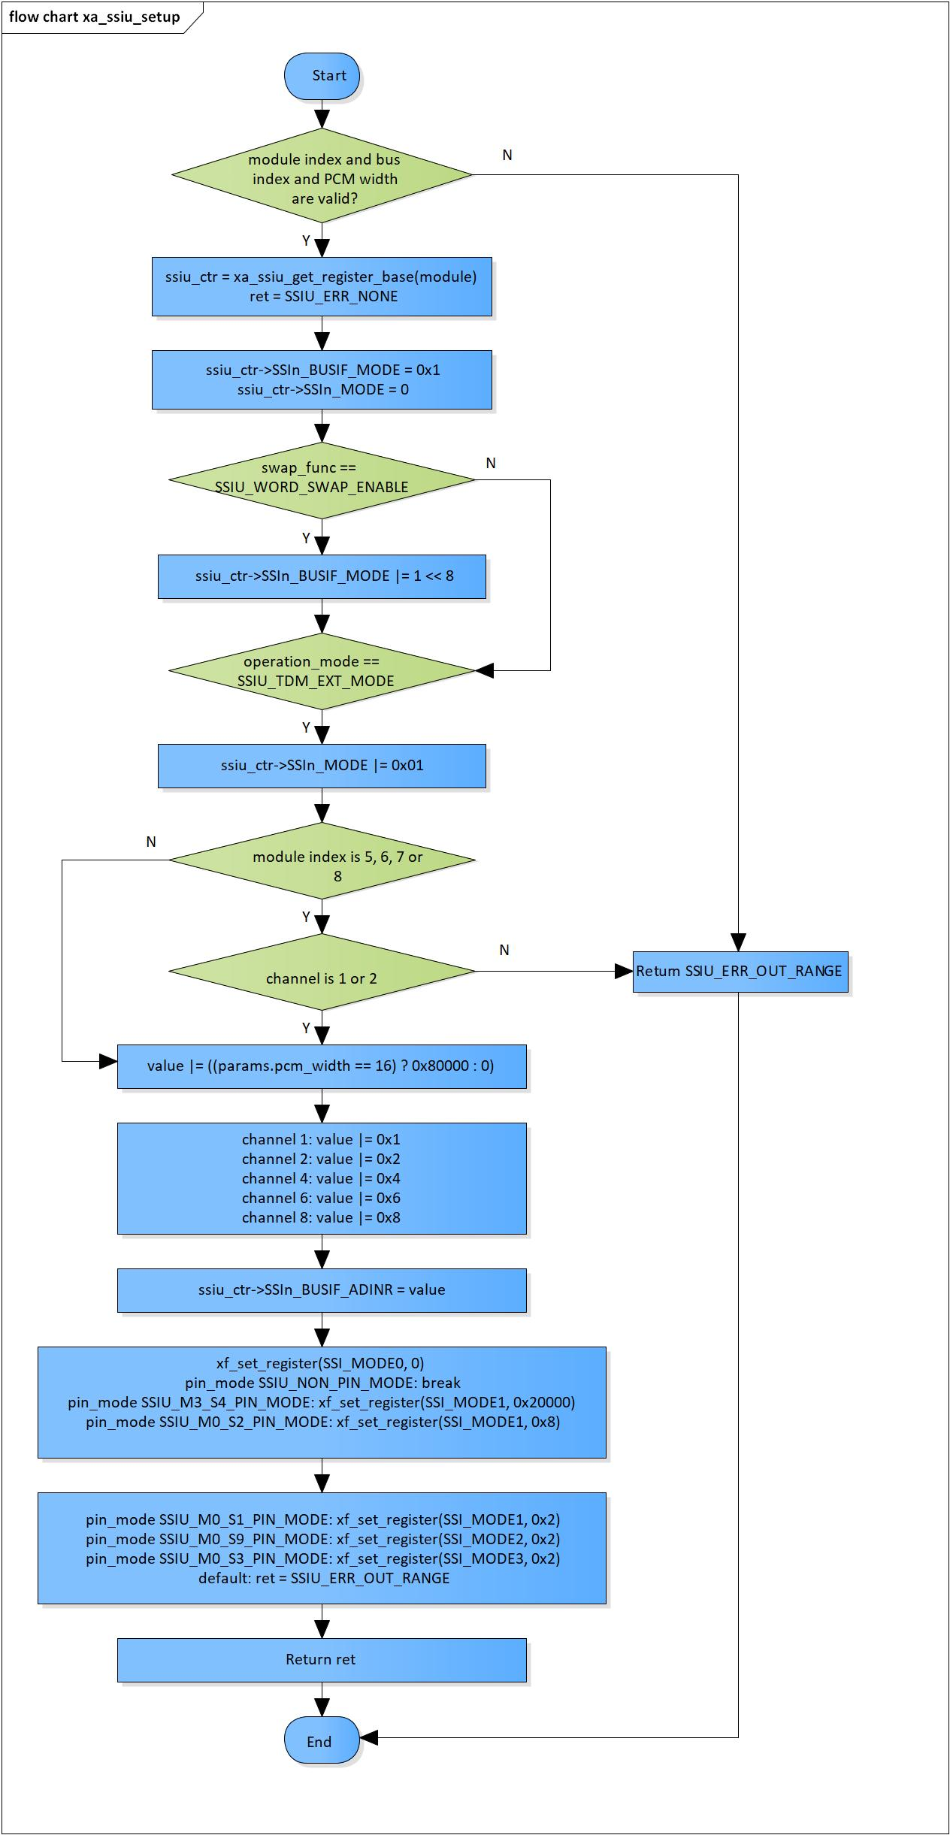

Figure 3‑4 xa_ssiu_setup flowchart

### xa_ssiu_start

DD_PLG_TDM_08_005

|  |  |  |  |  |
| --- | --- | --- | --- | --- |
| **Syntax** | SSIU_ERROR_CODE xa_ssiu_start(SSIU_SSI_INFO module) | | | |
| **Function** | This function is to start SSIU module. | | | |
| **Arguments** | Type | Name | I/O | Description |
| SSIU_SSI_INFO | module | I | SSIU module information |
| **Return value** | SSIU_ERR_OUT_RANGE | | Module index or bus index is invalid | |
| SSIU_ERR_BUSY | | SSIU is running | |
| SSIU_ERR_NONE | | Normal end | |
| **Description** | * xa_ssiu_start command processing:   - Set SSIn_CONTROL (n = 0, 1, 2, 3, 4, 5, 6, 7, 8, 9) register based on the bus index | | | |

[Covers: FD_PLG_TDM_005]

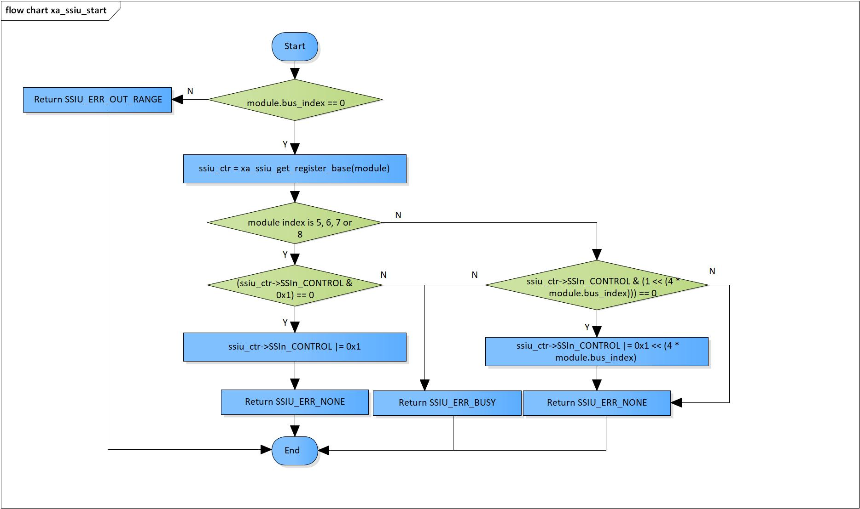

Figure 3‑5 xa_ssiu_start flowchart

### xa_ssiu_stop

DD_PLG_TDM_08_006

|  |  |  |  |  |
| --- | --- | --- | --- | --- |
| **Syntax** | SSIU_ERROR_CODE xa_ssiu_stop(SSIU_SSI_INFO module) | | | |
| **Function** | This function is to stop SSIU module. | | | |
| **Arguments** | Type | Name | I/O | Description |
| SSIU_SSI_MODULE | module | I | SSIU module |
| **Return value** | SSIU_ERR_OUT_RANGE | | Module index or bus index is invalid | |
| SSIU_ERR_NONE | | Normal end | |
| **Description** | * xa_ssiu_stop command processing:   - Set ‘0’ to SSIn_CONTROL (n = 0, 1, 2, 3, 4, 5, 6, 7, 8, 9) register’s bit corresponding with the bus index | | | |

[Covers: FD_PLG_TDM_017]

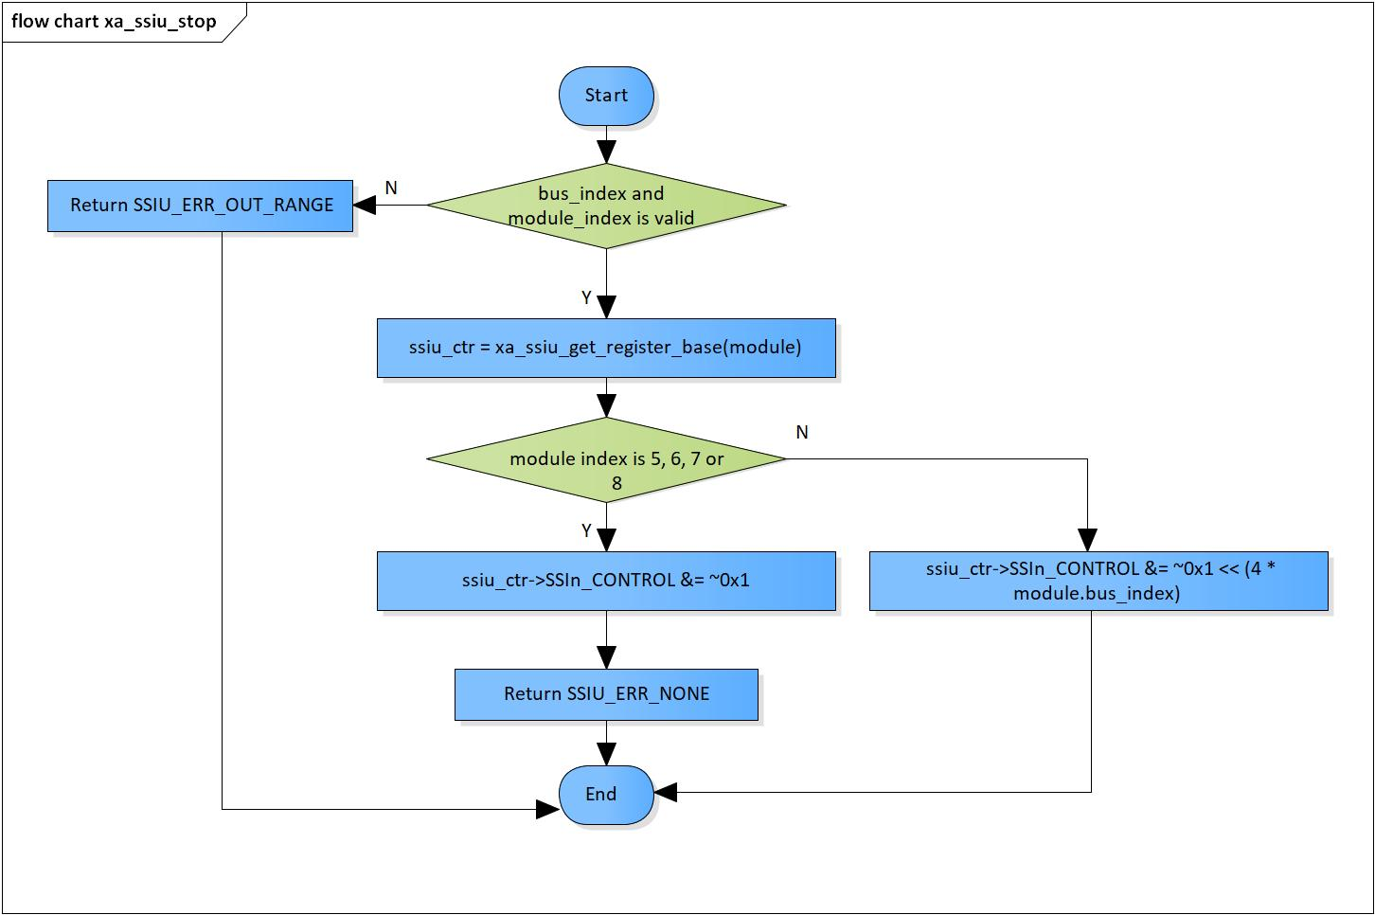

Figure 3‑6 xa_ssiu_stop flowchart

# Revision history

|  |  |  |  |  |  |
| --- | --- | --- | --- | --- | --- |
| **Version** | **Date** | **Page** | **Content** | **Approved** | **Changed** |
| 1.0.0 | Nov 14 2018 | - | First Edition issued | Vu Phan | Nguyen Dang |
| 1.1.0 | Dec 10 2018 | - | Add traceability ID | Vu Phan | Nguyen Dang |
| 1.2.0 | Jan 03, 2019 | - | Add range for input parameters | Vu Phan | Tien Tran |