**Document Type: Detail Design**

**Document Name:**

**ADSP OMX TDM**

Renesas Design Vietnam Co. Ltd

R-Car Software Solution 2 Group

Middleware 1 Team

Renesas Electronics Corporation

Table of Contents

1. Overview 3

2. Function list 4

3. Detail information 5

3.1 Data type and Macro definition 5

3.2 Function definition 6

3.2.1 OMX TDM_Capture 6

3.2.1.1 TDM_CAPTURE_Setup 6

3.2.1.2 TDM_CAPTURE_RuntimeInit 7

3.2.1.3 TDM_CAPTURE_GetParam 8

3.2.1.4 TDM_CAPTURE_TimeStamp 9

3.2.1.5 TDM_CAPTURE_GetParameter 10

3.2.1.6 TDM_CAPTURE_SetParameter 11

3.2.1.7 TDM_CAPTURE_ComponentInit 12

3.2.1.8 TDM_CAPTURE_ComponentDeInit 13

3.2.1.9 TDM_CAPTURE_ComponentCreate 14

3.2.2 OMX TDM RENDERER 16

3.2.2.1 TDM_RENDERER_Setup 16

3.2.2.2 RENDERER_RuntimeInit 17

3.2.2.3 TDM_RENDERER_GetParam 18

3.2.2.4 TDM_RENDERER_TimeStamp 19

3.2.2.5 TDM_RENDERER_GetParameter 20

3.2.2.6 TDM_RENDERER_SetParameter 21

3.2.2.7 TDM_RENDERER_ComponentInit 22

3.2.2.8 TDM_RENDERER_ComponentDeInit 23

3.2.2.9 TDM_RENDERER_ComponentCreate 24

4. Revision history 26

List of Figures

Figure 1‑1 The software architecture 3

Figure 3‑1 TDM_CAPTURE_Setup flowchart 6

Figure 3‑2 TDM_CAPTURE_RuntimeInit flowchart 7

Figure 3‑3 TDM_CAPTURE_GetParam flowchart 8

Figure 3‑4 TDM_CAPTURE_TimeStamp flowchart 9

Figure 3‑5 TDM_CAPTURE_GetParameter flowchart 10

Figure 3‑6 TDM_CAPTURE_SetParameter flowchart 11

Figure 3‑7 TDM_CAPTURE_ComponentInit flowchart 12

Figure 3‑8 TDM_CAPTURE_ComponentDeInit flowchart 13

Figure 3‑9 TDM_CAPTURE_ComponentCreate flowchart 15

Figure 3‑12 TDM_RENDERER_Setup flowchart 16

Figure 3‑13 TDM_RENDERER_GetParam flowchart 18

Figure 3‑14 TDM_RENDERER_TimeStamp flowchart 19

Figure 3‑15 TDM_RENDERER_GetParameter flowchart 20

Figure 3‑16 TDM_RENDERER_SetParameter flowchart 21

Figure 3‑17 TDM_RENDERER_ComponentInit flowchart 22

Figure 3‑18 TDM_RENDERER_ComponentDeInit flowchart 23

Figure 3‑19 TDM_RENDERER_ComponentCreate flowchart 25

List of Table

Table 2‑1 Function list of OMX TDM Capture 4

Table 2‑2 Function list of OMX TDM Renderer 4

Table 3‑1 XAOMX_TDM_CAP type structure information 5

Table 3‑2 XAOMX_TDM_RDR type structure information 5

Table 3‑3 Macro definitions of OMX TDM Capture 5

Table 3‑4 Macro definitions of OMX TDM Renderer 5

Table 2‑1 Function list of OMX TDM Capture 4

Table 2‑2 Function list of OMX TDM Renderer 4

Table 3‑1 XAOMX_TDM_CAP type structure information 5

Table 3‑2 XAOMX_TDM_RDR type structure information 5

Table 3‑3 Macro definitions of OMX TDM Capture 5

Table 3‑4 Macro definitions of OMX TDM Renderer 5

# Overview

In this chapter, overview of OMX TDM interface is explained.

User Application

OMX TDM

OMX Renderer/Capture

OMX Equalizer

User Space

ADSP Interface for Linux (base)

Kernel Space

ARM

ADSP Driver for Linux

Audio HW

ADSP

NC/EC

ADSP Framework

Renderer/Capture Plugin

TDM Plugin

Equalizer Plugin

Codec

This document’s target is in side of red square.

DAC/ADC

SRC/CTU/MIX/ DVC/ SSI/

ADMA

Figure 1‑1 ****The software architecture****

# Function list

The following is list of functions:

Table 2‑1 Function list of OMX TDM Capture

|  |  |  |
| --- | --- | --- |
| **No.** | **Function Name** | **Outline** |
| 1 | TDM_CAPTURE_Setup | TDM Capture prepare codec setup parameters. |
| 2 | TDM_CAPTURE_RuntimeInit | Get DMA channel 1 value to initialize output port of the component. |
| 3 | TDM_CAPTURE_GetParam | Get DMA channel 1 value from response structure. |
| 4 | TDM_CAPTURE_TimeStamp | Calculate timestamp for current output buffer and next buffer. |
| 5 | TDM_CAPTURE_GetParameter | Get TDM Capture parameter. |
| 6 | TDM_CAPTURE_SetParameter | Set TDM Capture parameter. |
| 7 | TDM_CAPTURE_ComponentDeInit | Destroy Capture component and private data. |
| 8 | TDM_CAPTURE_ComponentInit | Initialize base codec interface, parameters, PCM and TDM Capture format defaults. |
| 9 | TDM_CAPTURE_ComponentCreate | Create base component and initialize the TDM Capture component. |

Table 2‑2 Function list of OMX TDM Renderer

|  |  |  |
| --- | --- | --- |
| **No.** | **Function Name** | **Outline** |
| 1 | TDM_RENDERER_Setup | TDM Renderer prepare codec setup parameters. |
| 2 | TDM_RENDERER_RuntimeInit | This is a dummy function, not use in TDM Renderer runtime initialization. |
| 3 | TDM_RENDERER_GetParam | This is to check the message length is correct and return 0. |
| 4 | TDM_RENDERER_TimeStamp | Calculate timestamp for current input buffer and next buffer. |
| 5 | TDM_RENDERER_GetParameter | Get TDM Renderer parameter. |
| 6 | TDM_RENDERER_SetParameter | Set TDM Renderer parameter. |
| 7 | TDM_RENDERER_ComponentDeInit | Destroy TDM Renderer component and private data. |
| 8 | TDM_RENDERER_ComponentInit | Initialize base codec interface, parameters, PCM and TDM Renderer format. |
| 9 | TDM_RENDERER_ComponentCreate | Create base component and initialize the TDM Renderer component. |

# Detail information

This section describes detail information of data types, macro definitions.

## Data type and Macro definition

Table 3‑1 XAOMX_TDM_CAP type structure information

|  |  |
| --- | --- |
| Member name | Outline |
| XAOMXCodecBase base | Generic codec structure. |
| OMX_AUDIO_PARAM_PCMMODETYPE sPCM | PCM-specific parameters (output port). |
| XAOMX_AUDIO_PARAM_TDM_CAPTURE sTDM_CAPTURE | TDM Capture parameters. |

Note:

Structure XAOMXCodecBase is a base codec structure of OMX in omx-codec-base.h

Structure OMX_AUDIO_PARAM_PCMMODETYPE is a PCM format description in OMX_Audio.h

Structure XAOMX_AUDIO_PARAM_TDM_CAPTURE is a parametric TDM Capture settings structure.

Table 3‑2 XAOMX_TDM_RDR type structure information

|  |  |
| --- | --- |
| Member name | Outline |
| XAOMXCodecBase base | Generic codec structure. |
| OMX_AUDIO_PARAM_PCMMODETYPE sPCM | PCM-specific parameters (input port). |
| XAOMX_AUDIO_PARAM_TDM_RENDERER sTDM_RENDERER | TDM Renderer parameters. |

Note:

Structure XAOMX_AUDIO_PARAM_TDM_RENDERER is a parametric TDM Renderer settings structure.

Table 3‑3 Macro definitions of OMX TDM Capture

|  |  |  |
| --- | --- | --- |
| Macro | Value | Outline |
| NUM_OUTPUT_BUFFERS | 4 | Total amount of output buffers. |
| OUTPUT_BUFFER_LENGTH | 4096 | Default output buffer length. |
| BUFFER_ALIGNMENT | 32 | Required data alignment of TDM Capture. |

Table 3‑4 Macro definitions of OMX TDM Renderer

|  |  |  |
| --- | --- | --- |
| Macro | Value | Outline |
| NUM_INPUT_BUFFERS | 4 | Total amount of input buffers. |
| INPUT_BUFFER_LENGTH | 4096 | Default input buffer length. |
| BUFFER_ALIGNMENT | 32 | Required data alignment of TDM Renderer. |

## Function definition

### OMX TDM_Capture

#### TDM_CAPTURE_Setup

DD_API_TDM_01_001

|  |  |  |  |  |
| --- | --- | --- | --- | --- |
| **Syntax** | static s32 TDM_CAPTURE_Setup(XAOMXCodecBase *pBase, xf_set_param_msg_t *msg) | | | |
| **Function** | TDM Capture prepare codec setup parameters. | | | |
| **Arguments** | Type | Name | I/O | Description |
| XAOMXCodecBase* | pBase | I | Pointer to base codec structure of TDM Capture component. |
| xf_set_param_msg_t* | msg | O | Message send to TDM Capture plugin. |
| **Return value** | length | | Number of parameters want to set for TDM Capture plugin. | |
| **Description** | * TDM_CAPTURE_Setup processing:   - Prepare PCM width, channels, sample rate, input1, 2; DMA channel 1, 2; out sample rate, volume rate values into command message. | | | |

[Covers: FD_API_TDM_003]

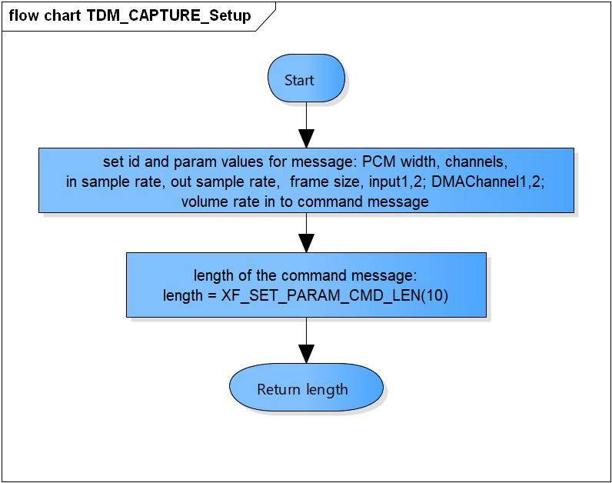

Figure 3‑1 TDM_CAPTURE_Setup flowchart

#### TDM_CAPTURE_RuntimeInit

DD_API_TDM_01_002

|  |  |  |  |  |
| --- | --- | --- | --- | --- |
| **Syntax** | static s32 TDM_CAPTURE_RuntimeInit(XAOMXCodecBase *pBase,  xf_start_msg_t *msg) | | | |
| **Function** | Get DMA channel 1 value to initialize output port of the component. | | | |
| **Arguments** | Type | Name | I/O | Description |
| XAOMXCodecBase* | pBase | I | Pointer to base codec structure of TDM Capture component. |
| xf_start_msg_t* | msg | O | Message send to TDM Capture plugin. |
| **Return value** | length | | Number of parameters want to set for TDM Capture plugin. | |
| **Description** | * TDM_CAPTURE_RuntimeInit processing:   - Save DMA channel 1 into command structure. | | | |

[Covers: FD_API_TDM_003]

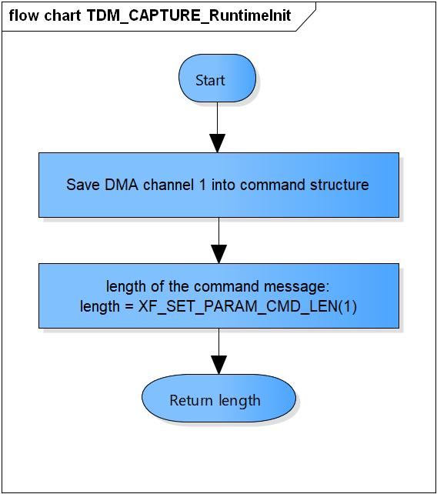

Figure 3‑2 TDM_CAPTURE_RuntimeInit flowchart

#### TDM_CAPTURE_GetParam

DD_API_TDM_01_003

|  |  |  |  |  |
| --- | --- | --- | --- | --- |
| **Syntax** | static s32 TDM_CAPTURE_GetParam(XAOMXCodecBase *pBase,  xf_get_param_msg_t *msg,  u32 length) | | | |
| **Function** | Get DMA channel 1 value from response structure. | | | |
| **Arguments** | Type | Name | I/O | Description |
| XAOMXCodecBase* | pBase | I/O | Pointer to base codec structure of TDM Capture component. |
| xf_get_param_msg_t * | msg | I | Message receive from TDM Capture plugin. |
| u32 | length | I | Length of message. |
| **Return value** | 0 | | Normal return. | |
| -EBADF | | The message length is invalid | |
| **Description** | * TDM_CAPTURE_GetParam processing:   - Get DMA channel 1 values from response structure. | | | |

[Covers: FD_API_TDM_003]

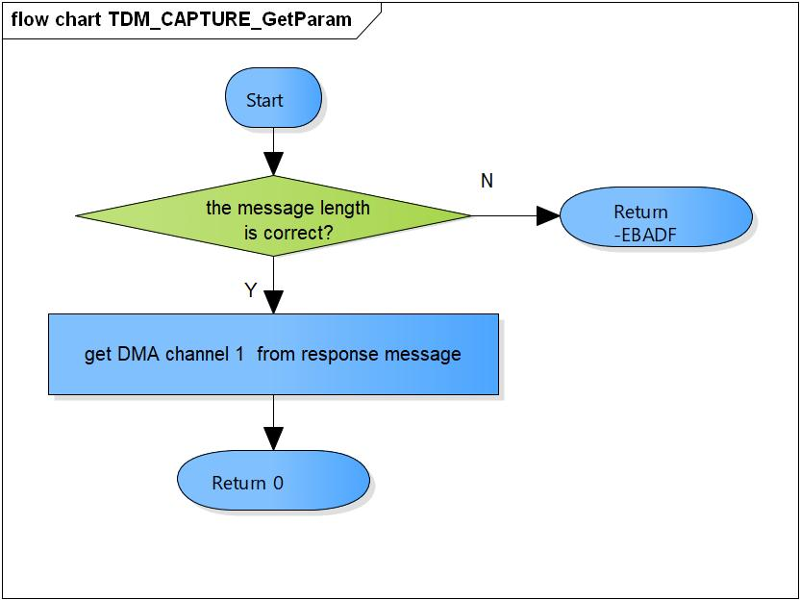

Figure 3‑3 TDM_CAPTURE_GetParam flowchart

#### TDM_CAPTURE_TimeStamp

DD_API_TDM_01_004

|  |  |  |  |  |
| --- | --- | --- | --- | --- |
| **Syntax** | static void TDM_CAPTURE_TimeStamp(XAOMXCodecBase *pBase,  OMX_BUFFERHEADERTYPE *pBufHdr) | | | |
| **Function** | Calculate timestamp for current output buffer and next buffer. | | | |
| **Arguments** | Type | Name | I/O | Description |
| XAOMXCodecBase* | pBase | I/O | Pointer to base codec structure of TDM Capture component. |
| OMX_BUFFERHEADERTYPE* | pBufHdr | O | Output buffer. |
| **Return value** | None. | | | |
| **Description** | * TDM_CAPTURE_TimeStamp processing:   - Add current timestamp to the output buffer.  - Calculate timestamp for the next buffer. | | | |

[Covers: FD_API_TDM_003]

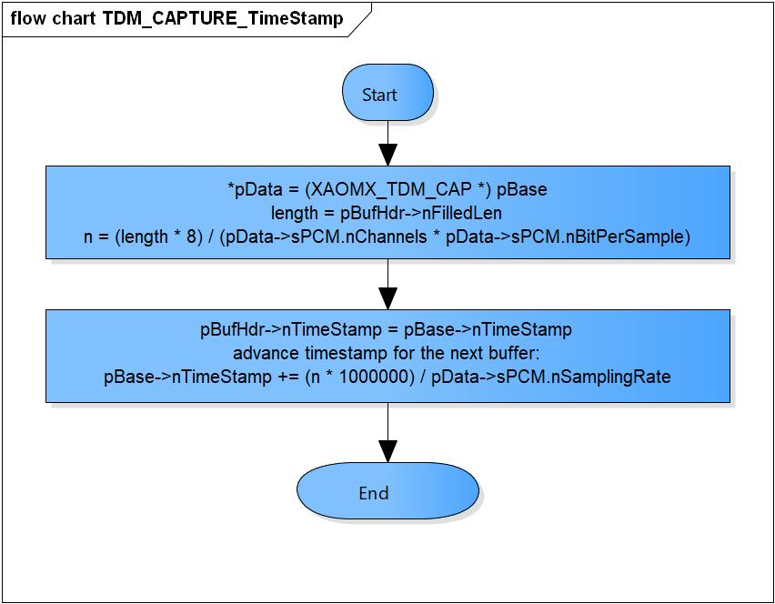

Figure 3‑4 TDM_CAPTURE_TimeStamp flowchart

#### TDM_CAPTURE_GetParameter

DD_API_TDM_01_005

|  |  |  |  |  |
| --- | --- | --- | --- | --- |
| **Syntax** | static OMX_ERRORTYPE TDM_CAPTURE_GetParameter(XAOMXCodecBase *pBase,  OMX_INDEXTYPE nIndex,  OMX_PTR pParam) | | | |
| **Function** | Get parameter and save to pParam. | | | |
| **Arguments** | Type | Name | I/O | Description |
| XAOMXCodecBase* | pBase | I/O | Pointer to base codec structure of TDM Capture component. |
| OMX_INDEXTYPE | nIndex | I | Index of parameter structure.  Valid values:  OMX_IndexParamAudioPcm  XAOMX_IndexParamAudioTDMCapture  OMX_IndexParamCompBufferSupplier |
| OMX_PTR | pParam | I | Pointer to parameter structure want to save |
| **Return value** | OMX_ErrorNone | | Normal return. | |
| OMX_ErrorUnsupportedIndex | | Wrong Index of structure | |
| **Description** | * TDM_CAPTURE_GetParameter processing:   - Get parameters of OMX_AUDIO_PARAM_PCMMODETYPE, XAOMX_AUDIO_PARAM_TDM_CAPTURE, OMX_PARAM_BUFFERSUPPLIERTYPE structure base on nIndex. | | | |

[Covers: FD_API_TDM_004]

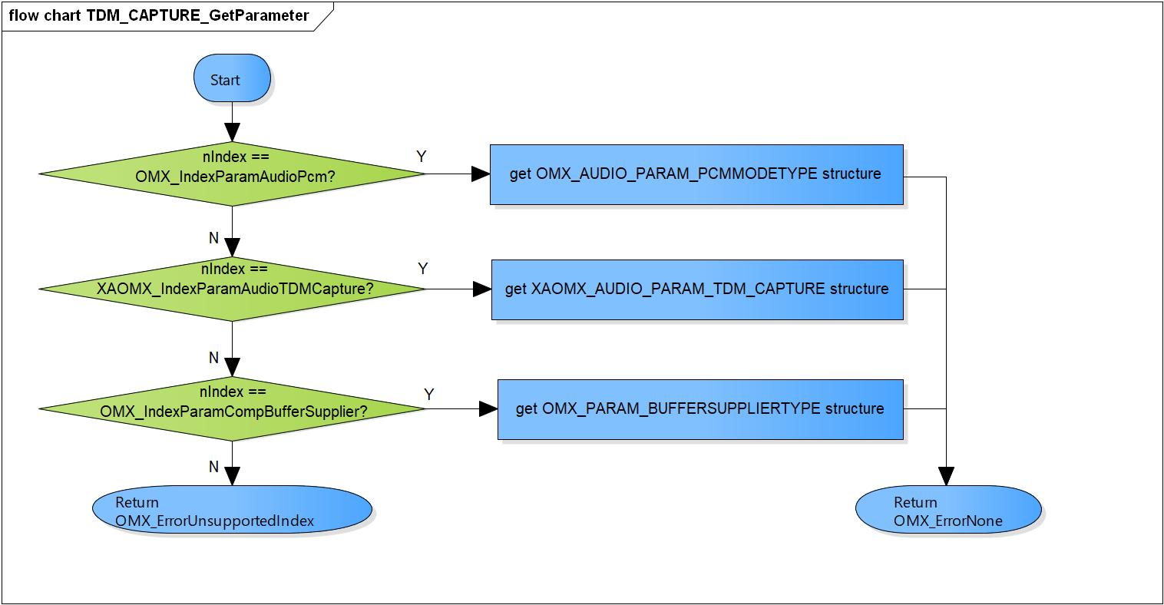

Figure 3‑5 TDM_CAPTURE_GetParameter flowchart

#### TDM_CAPTURE_SetParameter

DD_API_TDM_01_006

|  |  |  |  |  |
| --- | --- | --- | --- | --- |
| **Syntax** | static OMX_ERRORTYPE TDM_CAPTURE_SetParameter(XAOMXCodecBase *pBase,  OMX_INDEXTYPE nIndex,  OMX_PTR pParam) | | | |
| **Function** | Set parameter from pParam and save to parameter structure. | | | |
| **Arguments** | Type | Name | I/O | Description |
| XAOMXCodecBase* | pBase | I/O | Pointer to base codec structure of TDM Capture component. |
| OMX_INDEXTYPE | nIndex | I | Index of parameter structure.  Valid values:  OMX_IndexParamAudioPcm  XAOMX_IndexParamAudioTDMCapture  OMX_IndexParamCompBufferSupplier |
| OMX_PTR | pParam | O | Pointer to parameter structure want to set. |
| **Return value** | OMX_ErrorNone | | Normal return. | |
| OMX_ErrorUnsupportedIndex | | Wrong Index of structure. | |
| OMX_ErrorBadPortIndex | | Port index is invalid. | |
| **Description** | * TDM_CAPTURE_SetParameter processing:   - Set parameters of OMX_AUDIO_PARAM_PCMMODETYPE, XAOMX_AUDIO_PARAM_TDM_CAPTURE, OMX_PARAM_BUFFERSUPPLIERTYPE structure base on nIndex. | | | |

[Covers: FD_API_TDM_005]

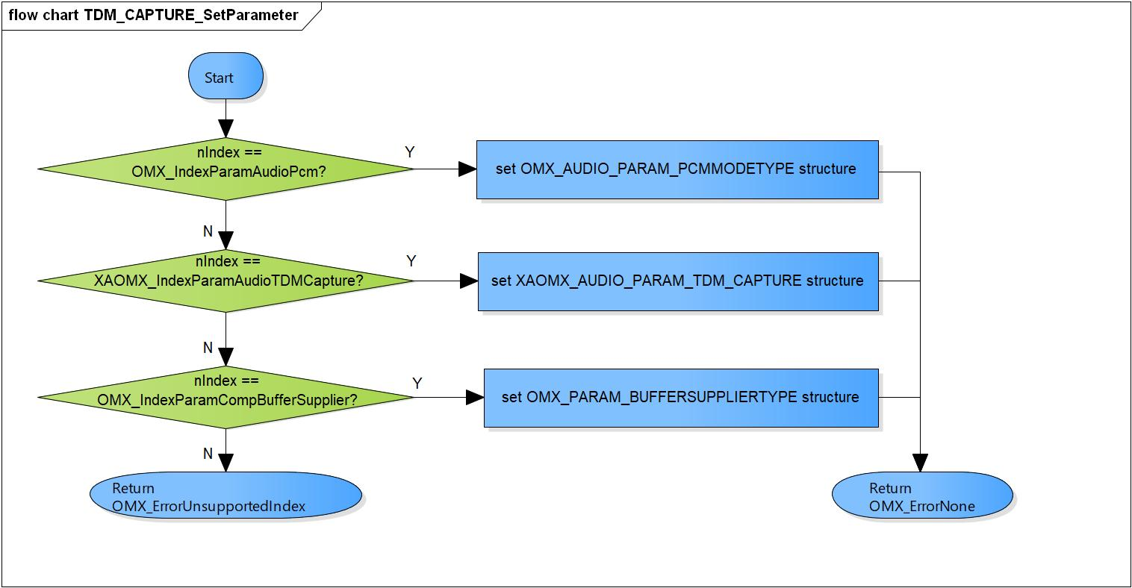

Figure 3‑6 TDM_CAPTURE_SetParameter flowchart

#### TDM_CAPTURE_ComponentInit

DD_API_TDM_01_007

|  |  |  |  |  |
| --- | --- | --- | --- | --- |
| **Syntax** | static OMX_ERRORTYPE CAPTURE_ComponentInit(xf_proxy_t *proxy,  OMX_HANDLETYPE hComponent,  OMX_PTR pAppData,  OMX_CALLBACKTYPE *pCallbacks) | | | |
| **Function** | Initialize base codec interface, parameters, PCM and TDM Capture format. | | | |
| **Arguments** | Type | Name | I/O | Description |
| xf_proxy_t * | proxy | O | OpenMAX interface proxy. |
| OMX_HANDLETYPE | hComponent | O | Pointer to TDM Capture component handle. |
| OMX_PTR | pAppData | I | Pointer to pAppData of TDM Capture component. |
| OMX_CALLBACKTYPE | pCallbacks | I | Pointer to Callbacks of TDM Capture component. |
| **Return value** | OMX_ErrorNone | | Normal return. | |
| OMX_ErrorInsufficientResources | | Initialize base codec interface is fail. | |
| **Description** | * TDM_CAPTURE_ComponentInit processing:   - Initialize base codec interface, parameters, PCM and TDM Capture format. | | | |

[Covers: FD_API_TDM_001]

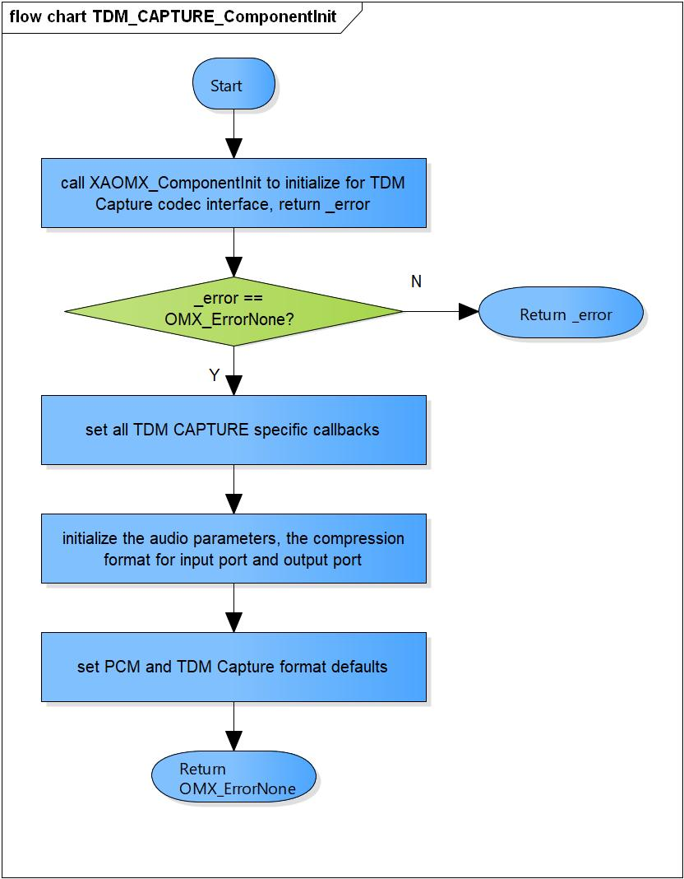

Figure 3‑7 TDM_CAPTURE_ComponentInit flowchart

#### TDM_CAPTURE_ComponentDeInit

DD_API_TDM_01_008

|  |  |  |  |  |
| --- | --- | --- | --- | --- |
| **Syntax** | static OMX_ERRORTYPE TDM_CAPTURE_ComponentDeInit(OMX_HANDLETYPE hComponent) | | | |
| **Function** | Destroy TDM Capture component and private data. | | | |
| **Arguments** | Type | Name | I/O | Description |
| OMX_HANDLETYPE | hComponent | O | Pointer to TDM Capture component handle. |
| **Return value** | OMX_ErrorNone | | Normal return. | |
| OMX_ErrorBadParameter | | Private data is NULL. | |
| **Description** | * TDM_CAPTURE_ComponentDeInit processing:   - Destroy TDM Capture component and private data. | | | |

[Covers: FD_API_TDM_002]

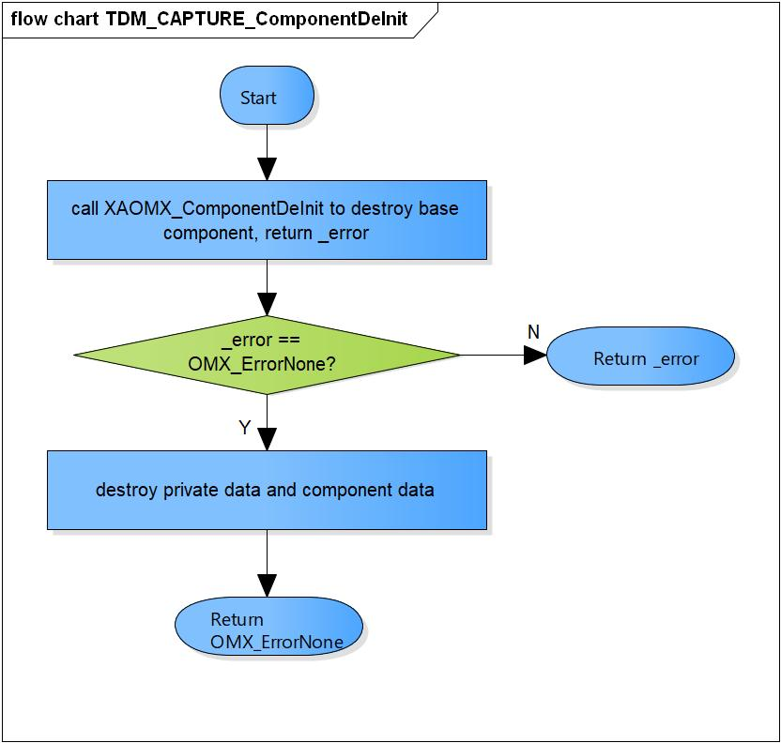

Figure 3‑8 TDM_CAPTURE_ComponentDeInit flowchart

#### TDM_CAPTURE_ComponentCreate

DD_API_TDM_01_009

|  |  |  |  |  |
| --- | --- | --- | --- | --- |
| **Syntax** | OMX_ERRORTYPE TDM_CAPTURE_ComponentCreate(xf_proxy_t *proxy, OMX_HANDLETYPE *hComponent, OMX_PTR pAppData, OMX_CALLBACKTYPE *pCallbacks) | | | |
| **Function** | Create base component and initialize the TDM Capture component. | | | |
| **Arguments** | Type | Name | I/O | Description |
| xf_proxy_t* | proxy | O | OpenMAX interface proxy. |
| OMX_HANDLETYPE* | hComponent | O | Pointer to TDM Capture component handle. |
| OMX_PTR | pAppData | I | Pointer to pAppData of TDM Capture component. |
| OMX_CALLBACKTYPE * | pCallbacks | I | Pointer to Callbacks of TDM Capture component. |
| **Return value** | OMX_ErrorNone | | Normal return. | |
| OMX_ErrorInsufficientResources | | Cannot create the base component.  Cannot allocate private memory.  Initialize the TDM Capture component is fail. | |
| **Description** | * TDM_CAPTURE_ComponentCreate processing:   - Create the base component.  - Allocate the private memory.  - Initialize the TDM Capture component. | | | |

[Covers: FD_API_TDM_001]

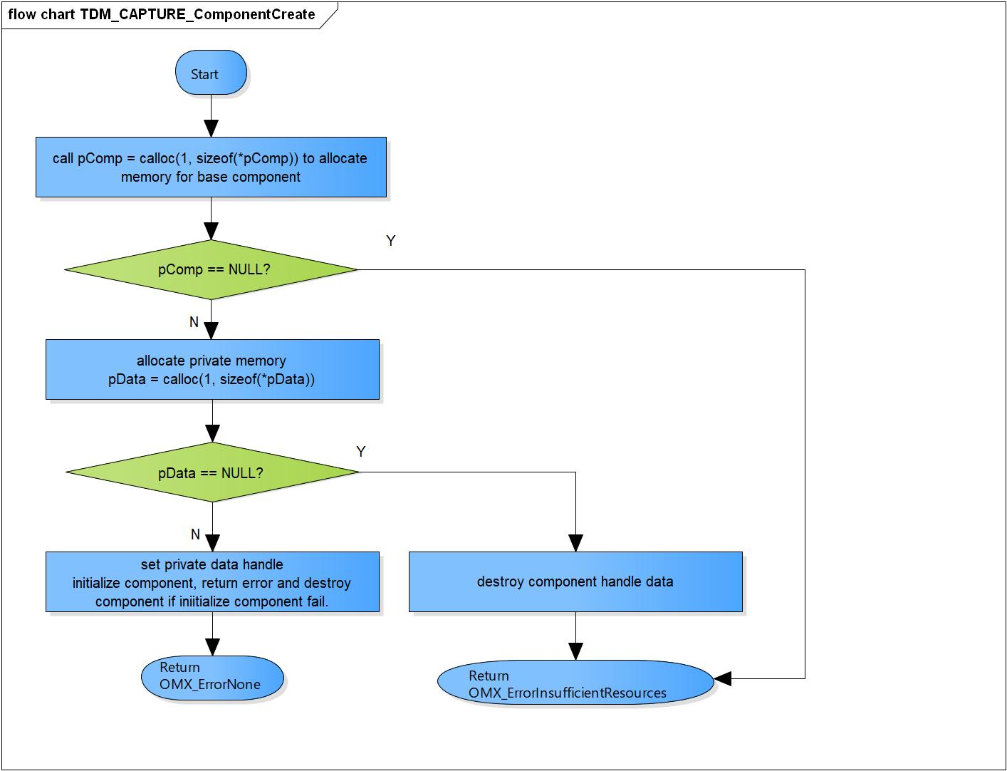

Figure 3‑9 TDM_CAPTURE_ComponentCreate flowchart

### OMX TDM RENDERER

#### TDM_RENDERER_Setup

DD_API_TDM_01_010

|  |  |  |  |  |
| --- | --- | --- | --- | --- |
| **Syntax** | static s32 TDM_RENDERER_Setup(XAOMXCodecBase *pBase,  xf_set_param_msg_t *msg) | | | |
| **Function** | TDM Renderer prepare codec setup parameters. | | | |
| **Arguments** | Type | Name | I/O | Description |
| XAOMXCodecBase* | pBase | I | Pointer to base codec structure of TDM Renderer component. |
| xf_set_param_msg_t* | msg | O | Message send to TDM Renderer plugin. |
| **Return value** | length | | Number of parameters want to set for TDM Renderer plugin. | |
| **Description** | * TDM_Renderer_Setup processing:   - Prepare PCM width, channels, sample rate, output1, 2; DMA channel 1, 2; out sample rate, volume rate values into command message. | | | |

[Covers: FD_API_TDM_003]

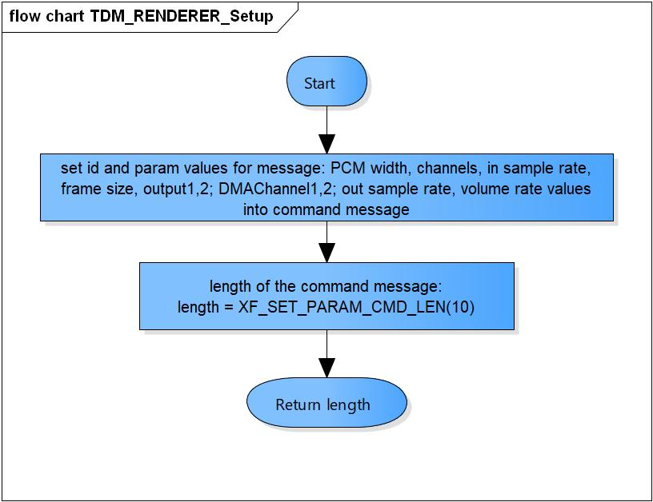

Figure 3‑10 TDM_RENDERER_Setup flowchart

#### RENDERER_RuntimeInit

DD_API_TDM_01_011

|  |  |  |  |  |
| --- | --- | --- | --- | --- |
| **Syntax** | static s32 TDM_RENDERER_RuntimeInit(XAOMXCodecBase*pBase,  xf_start_msg_t *msg) | | | |
| **Function** | This is a dummy function, not use in TDM Renderer runtime initialization. | | | |
| **Arguments** | Type | Name | I/O | Description |
| XAOMXCodecBase* | pBase | I | Pointer to base codec structure of TDM Renderer component. |
| xf_start_msg_t* | msg | O | Message send to TDM Renderer plugin. |
| **Return value** | 0 | | No parameter need to set to plugin | |
| **Description** | * TDM_RENDERER_RuntimeInit processing:   - Return 0. | | | |

[Covers: FD_API_TDM_003]

#### TDM_RENDERER_GetParam

DD_API_TDM_01_012

|  |  |  |  |  |
| --- | --- | --- | --- | --- |
| **Syntax** | static s32 TDM_RENDERER_GetParam(XAOMXCodecBase *pBase,  xf_get_param_msg_t *msg,  u32 length) | | | |
| **Function** | This is to check the message length is correct and return 0. | | | |
| **Arguments** | Type | Name | I/O | Description |
| XAOMXCodecBase* | pBase | I | Pointer to base codec structure of TDM RENDERER component. |
| xf_get_param_msg_t * | msg | I | Message receive from TDM RENDERER plugin. |
| u32 | length | I | Length of message. |
| **Return value** | 0 | | Normal return | |
| -EBADF | | The message length is invalid | |
| **Description** | * TDM_RENDERER_GetParam processing:   - Check the message length is correct and return 0. | | | |

[Covers: FD_API_TDM_003]

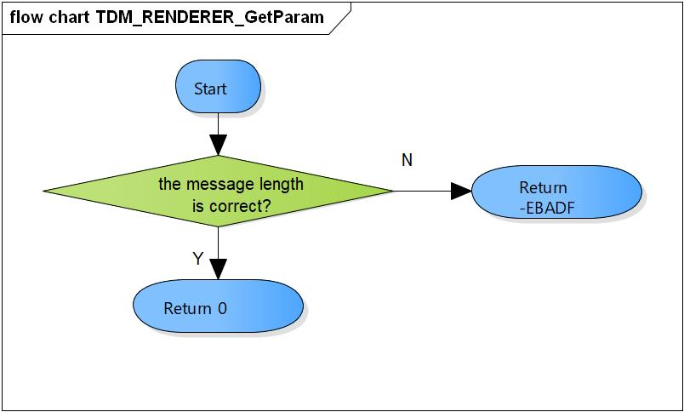

Figure 3‑11 TDM_RENDERER_GetParam flowchart

#### TDM_RENDERER_TimeStamp

DD_API_TDM_01_013

|  |  |  |  |  |
| --- | --- | --- | --- | --- |
| **Syntax** | static void TDM_RENDERER_TimeStamp(XAOMXCodecBase *pBase,  OMX_BUFFERHEADERTYPE *pBufHdr) | | | |
| **Function** | Calculate timestamp for current input buffer and next buffer. | | | |
| **Arguments** | Type | Name | I/O | Description |
| XAOMXCodecBase* | pBase | I/O | Pointer to base codec structure of TDM RENDERER component. |
| OMX_BUFFERHEADERTYPE* | pBufHdr | O | Input buffer. |
| **Return value** | None. | | | |
| **Description** | * TDM_RENDERER_TimeStamp processing:   - Add current timestamp to the Input buffer.  - Calculate timestamp for the next buffer. | | | |

[Covers: FD_API_TDM_003]

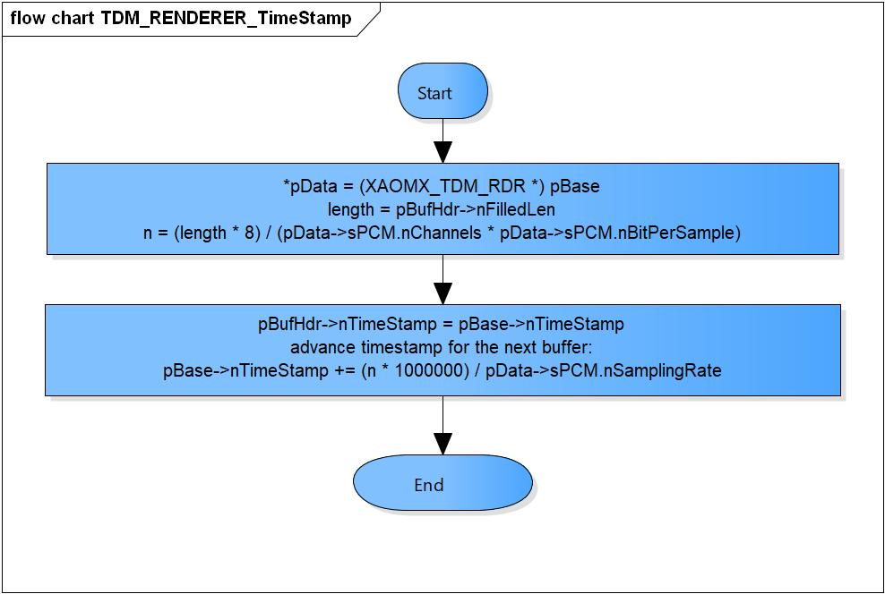

Figure 3‑12 TDM_RENDERER_TimeStamp flowchart

#### TDM_RENDERER_GetParameter

DD_API_TDM_01_014

|  |  |  |  |  |
| --- | --- | --- | --- | --- |
| **Syntax** | static OMX_ERRORTYPE TDM_RENDERER_GetParameter(XAOMXCodecBase *pBase,  OMX_INDEXTYPE nIndex,  OMX_PTR pParam) | | | |
| **Function** | Get parameter and save to pParam. | | | |
| **Arguments** | Type | Name | I/O | Description |
| XAOMXCodecBase* | pBase | I/O | Pointer to base codec structure of TDM Renderer component. |
| OMX_INDEXTYPE | nIndex | I | Index of parameter structure.  Valid values:  OMX_IndexParamAudioPcm  XAOMX_IndexParamAudioTDMRenderer  OMX_IndexParamCompBufferSupplier |
| OMX_PTR | pParam | O | Pointer to parameter structure want to save. |
| **Return value** | OMX_ErrorNone | | Normal return. | |
| OMX_ErrorUnsupportedIndex | | Wrong Index of structure. | |
| **Description** | * TDM_RENDERER_GetParameter pprocessing:   - Get parameters of OMX_AUDIO_PARAM_PCMMODETYPE, XAOMX_AUDIO_PARAM_TDM_RENDERER, OMX_PARAM_BUFFERSUPPLIERTYPE structure base on nIndex. | | | |

[Covers: FD_API_TDM_004]

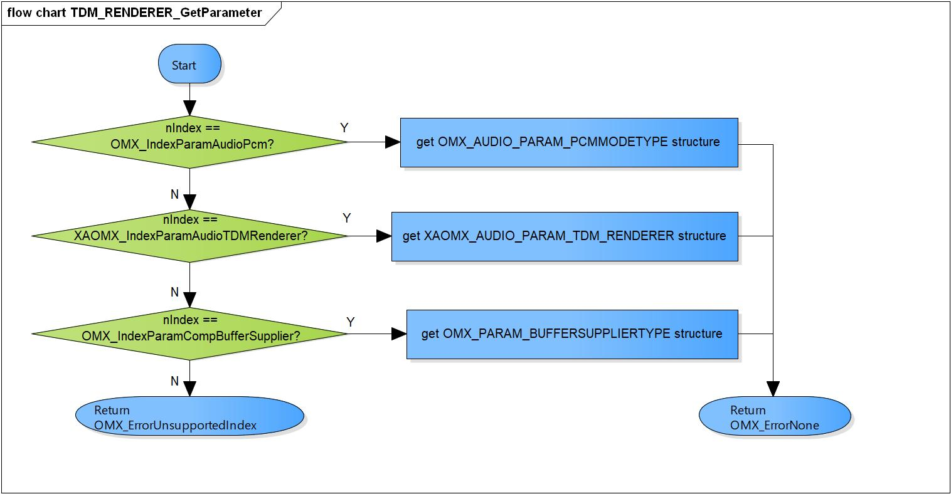

Figure 3‑13 TDM_RENDERER_GetParameter flowchart

#### TDM_RENDERER_SetParameter

DD_API_TDM_01_015

|  |  |  |  |  |
| --- | --- | --- | --- | --- |
| **Syntax** | static OMX_ERRORTYPE TDM_RENDERER_SetParameter(XAOMXCodecBase *pBase,  OMX_INDEXTYPE nIndex,  OMX_PTR pParam) | | | |
| **Function** | Set parameter from pParam and save to parameter structure. | | | |
| **Arguments** | Type | Name | I/O | Description |
| XAOMXCodecBase* | pBase | I/O | Pointer to base codec structure of TDM Renderer component. |
| OMX_INDEXTYPE | nIndex | I | Index of parameter structure.  Valid values:  OMX_IndexParamAudioPcm  XAOMX_IndexParamAudioTDMRenderer  OMX_IndexParamCompBufferSupplier |
| OMX_PTR | pParam | I | Pointer to parameter structure want to set. |
| **Return value** | OMX_ErrorNone | | Normal return. | |
| OMX_ErrorUnsupportedIndex | | Wrong Index of structure. | |
| OMX_ErrorBadPortIndex | | Port index is invalid. | |
| **Description** | * TDM_RENDERER_SetParameter processing:   - Set parameters of OMX_AUDIO_PARAM_PCMMODETYPE, XAOMX_AUDIO_PARAM_TDM_RENDERER, OMX_PARAM_BUFFERSUPPLIERTYPE structure base on nIndex. | | | |

[Covers: FD_API_TDM_005]

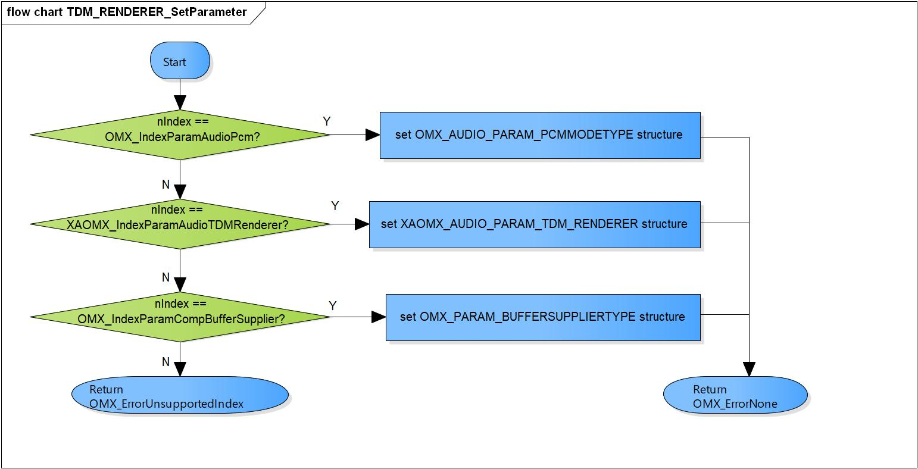

Figure 3‑14 TDM_RENDERER_SetParameter flowchart

#### TDM_RENDERER_ComponentInit

DD_API_TDM_01_016

|  |  |  |  |  |
| --- | --- | --- | --- | --- |
| **Syntax** | static OMX_ERRORTYPE TDM_RENDERER_ComponentInit(xf_proxy_t *proxy,  OMX_HANDLETYPE hComponent,  OMX_PTR pAppData,  OMX_CALLBACKTYPE *pCallbacks) | | | |
| **Function** | Initialize base codec interface, parameters, PCM and TDM Renderer format. | | | |
| **Arguments** | Type | Name | I/O | Description |
| xf_proxy_t * | proxy | O | OpenMAX interface proxy. |
| OMX_HANDLETYPE | hComponent | O | Pointer to TDM Renderer component handle. |
| OMX_PTR | pAppData | I | Pointer to pAppData of TDM Renderer component. |
| OMX_CALLBACKTYPE | pCallbacks | I | Pointer to Callbacks of TDM Renderer component. |
| **Return value** | OMX_ErrorNone | | Normal return. | |
| OMX_ErrorInsufficientResources | | Initialize base codec interface is fail. | |
| **Description** | * TDM_RENDERER_ComponentInit processing:   - Initialize base codec interface, parameters, PCM and TDM Renderer format. | | | |

[Covers: FD_API_TDM_001]

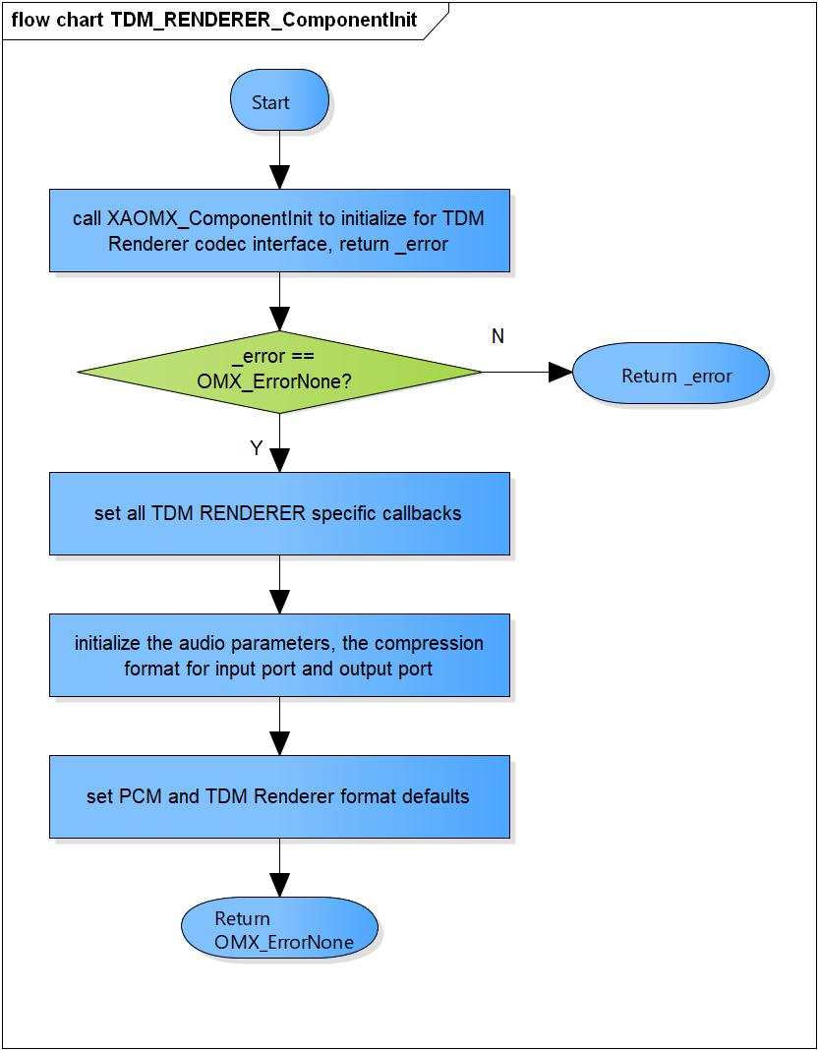

Figure 3‑15 TDM_RENDERER_ComponentInit flowchart

#### TDM_RENDERER_ComponentDeInit

DD_API_TDM_01_017

|  |  |  |  |  |
| --- | --- | --- | --- | --- |
| **Syntax** | static OMX_ERRORTYPE TDM_RENDERER_ComponentDeInit(OMX_HANDLETYPE hComponent) | | | |
| **Function** | Destroy TDM Renderer component and private data. | | | |
| **Arguments** | Type | Name | I/O | Description |
| OMX_HANDLETYPE | hComponent | O | Pointer to TDM Renderer component handle. |
| **Return value** | OMX_ErrorNone | | Normal return. | |
| OMX_ErrorBadParameter | | Private data is NULL. | |
| **Description** | * TDM_RENDERER_ComponentDeInit processing:   - Destroy TDM Renderer component and private data. | | | |

[Covers: FD_API_TDM_002]

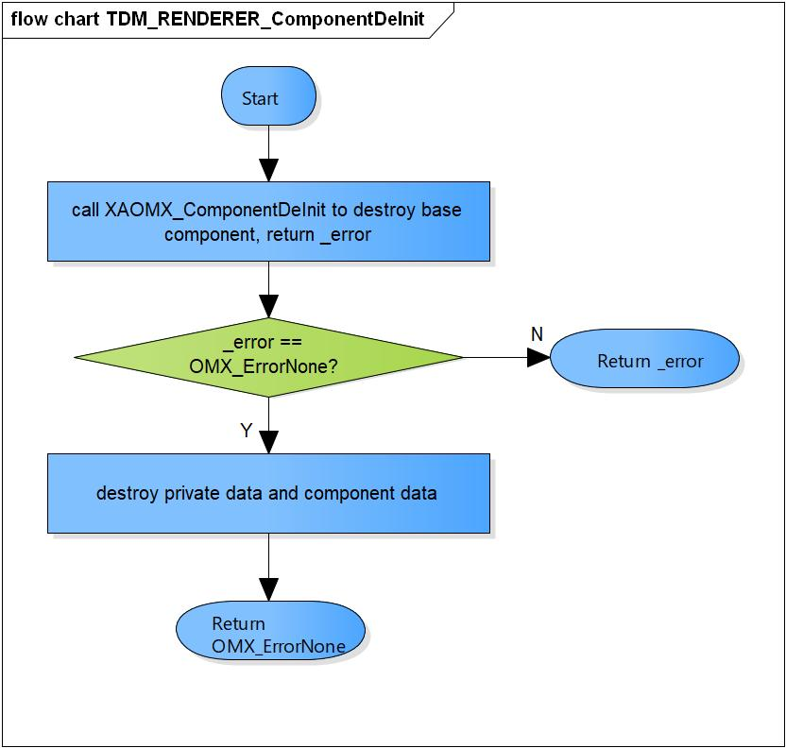

Figure 3‑16 TDM_RENDERER_ComponentDeInit flowchart

#### TDM_RENDERER_ComponentCreate

DD_API_TDM_01_018

|  |  |  |  |  |
| --- | --- | --- | --- | --- |
| **Syntax** | static OMX_ERRORTYPE TDM_RENDERER_ComponentCreate(OMX_HANDLETYPE hComponent) | | | |
| **Function** | Create base component and initialize the TDM Renderer component. | | | |
| **Arguments** | Type | Name | I/O | Description |
| xf_proxy_t* | proxy | O | OpenMAX interface proxy. |
| OMX_HANDLETYPE* | hComponent | O | Pointer to TDM Renderer component handle. |
| OMX_PTR | pAppData | I | Pointer to pAppData of TDM Renderer component. |
| OMX_CALLBACKTYPE * | pCallbacks | I | Pointer to Callbacks of TDM Renderer component. |
| **Return value** | OMX_ErrorNone | | Normal return. | |
| OMX_ErrorInsufficientResources | | Cannot create the base component.  Cannot allocate private memory.  Initialize the TDM Renderer component is fail. | |
| **Description** | * TDM_RENDERER_ComponentCreate processing:   - Create the base component.  - Allocate the private memory.  - Initialize the TDM Renderer component. | | | |

[Covers: FD_API_TDM_001]

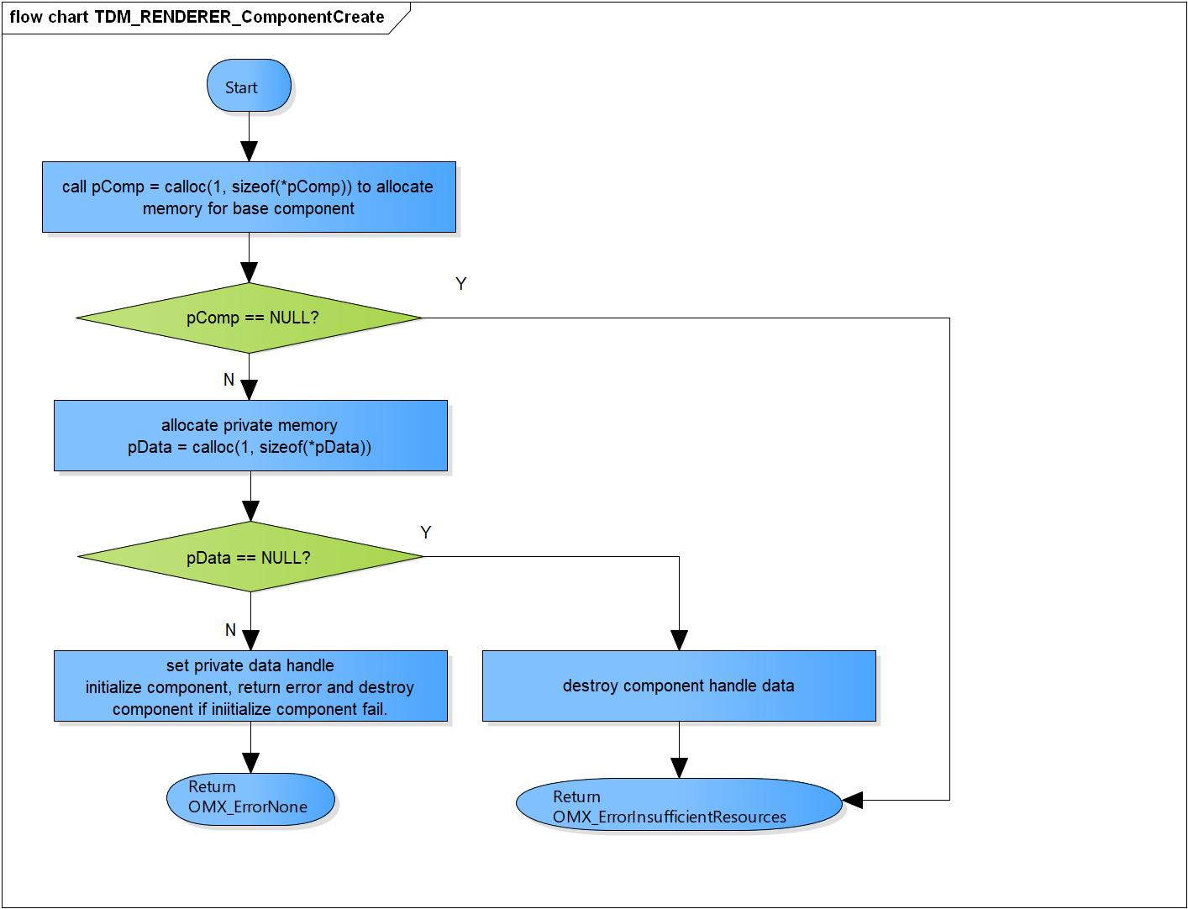

Figure 3‑17 TDM_RENDERER_ComponentCreate flowchart

# Revision history

|  |  |  |  |  |  |
| --- | --- | --- | --- | --- | --- |
| **Version** | **Date** | **Page** | **Content** | **Approved** | **Changed** |
| 1.0.0 | Nov 14 2018 | - | First Edition issued | Vu Phan | Ngu Pham |
| 1.1.0 | Dec 10 2018 | - | Add traceability ID | Vu Phan | Ngu Pham |
| 1.2.0 | Jan 03, 2019 | - | Add range for input parameters | Vu Phan | Tien Tran |