ASP.NET CORE API
- The project has 4 main layers:

- Abc.Api: main project for handling the request
- Abc.ApiContract: keep the contract for request and respone
- Abc.Dal: keep models and DbContext, has Unit Of Work and Repository
- Abc.Service: handle all requests while accessing to db

- Main functions:
Login by Gmail: at 1st time running time user must login to their Gmail before can access to API
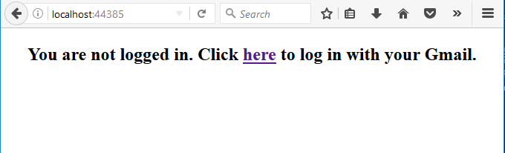
Just click and enter Gmail account to login.
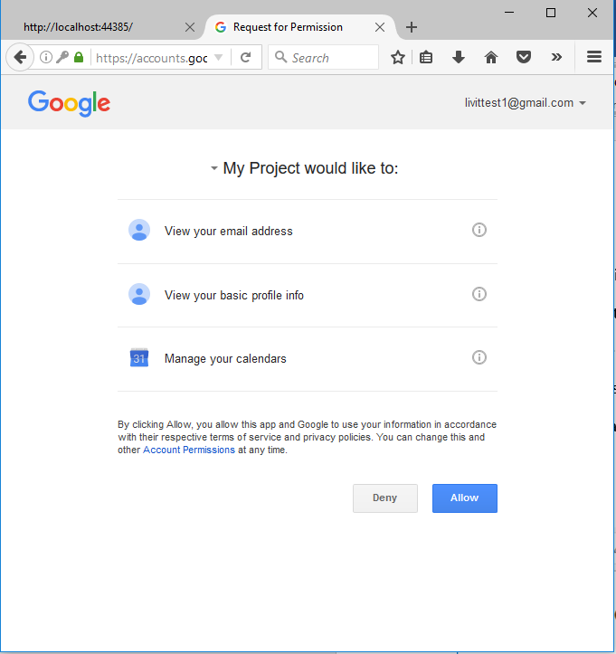
if login succeeded you can see a screen like this:
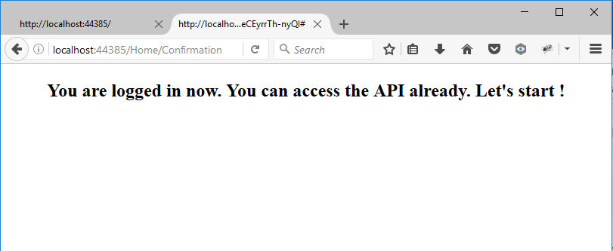
Now you can use POSTMAN to call API
You can request to create an Adsence by this request:
http://localhost:44385/api/absence/create
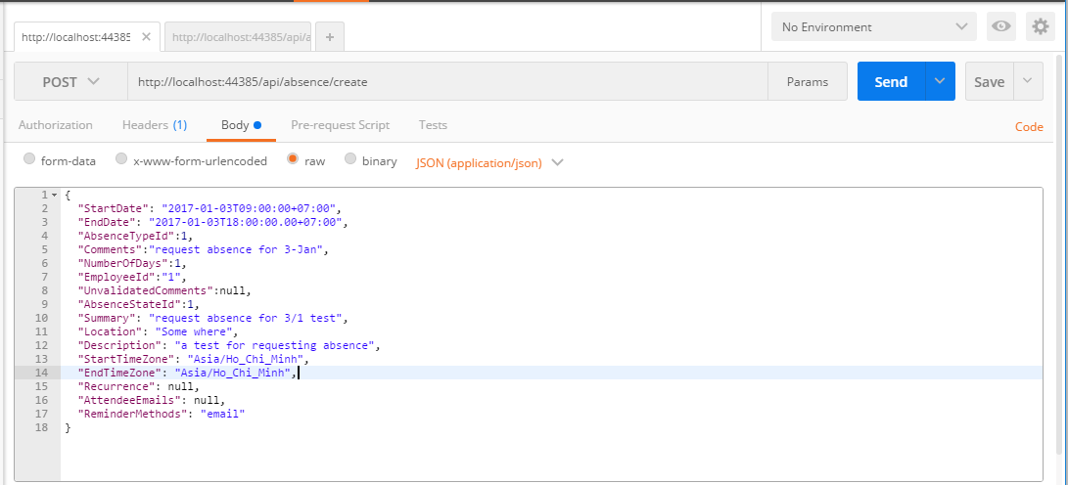
The JSON input format is attached in docs folder too

If the absence is created successfully, you can receive a respone like this:
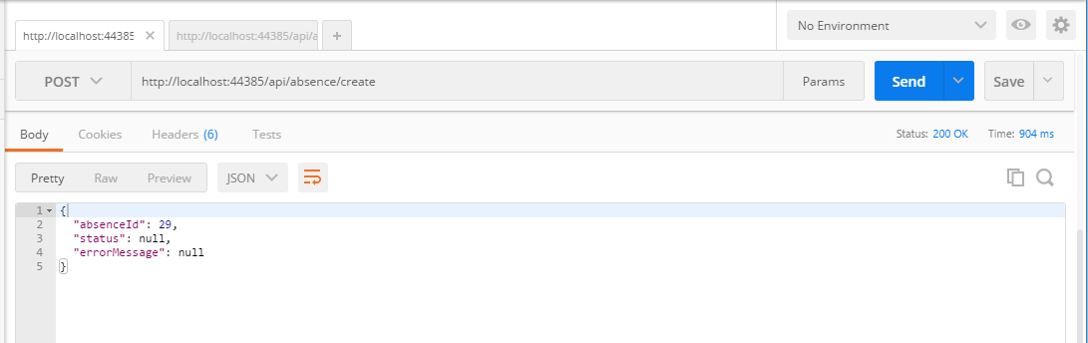
You can approve an absence if you are admin by this request
http://localhost:44385/api/absence/approve

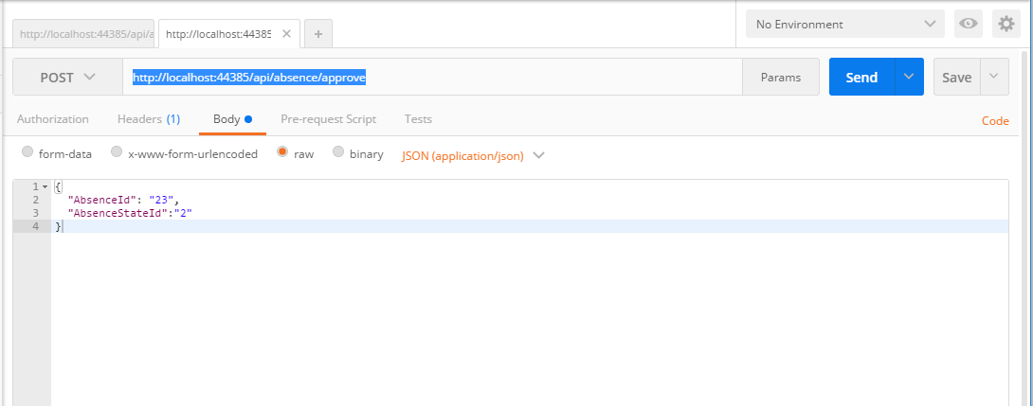
The JSON input format is in docs folder too
If the request is success you can receive a respone like this
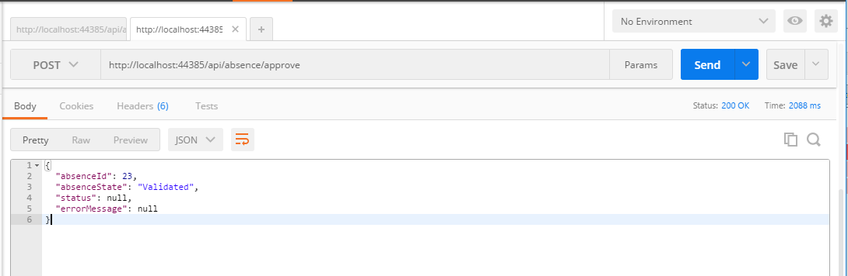
You need to have Admin role to approve an absence request. You can check and modify Role information in table Employee_Role & Role by SQLite Manager:
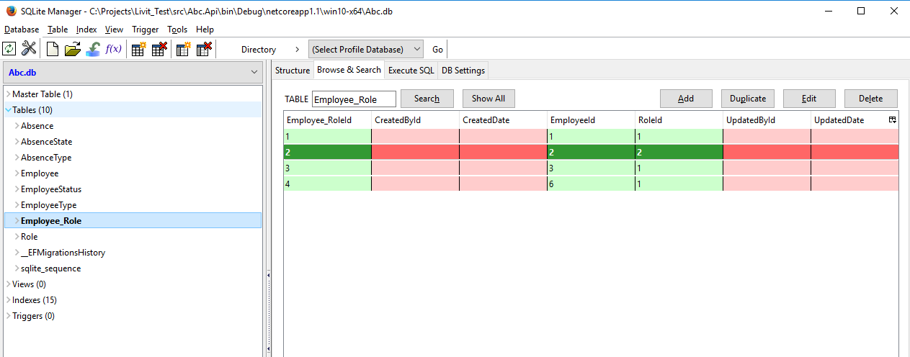
If you are not admin you will receive an error “Not have permission”. An adsence is approved will be added to google calendar immediately, you can check it in Google Calendar.

