
Karthik Krishnaswamy
919 439 3682 extn 9014
mohan@infomericainc.com

 | Professional Summary  Experienced Production support analyst with over 11 + years of experience in the IT industry. Knowledge in resolving problems, improving customer satisfaction, and driving overall operational improvements. Consistently saved costs while increasing profits.  Work History  T-Mobile – Sr Application Support Analyst  Plano, Texas  11/2020 - present  Responsibilities  - Worked as an Application support for the critical call center/wireline/wireless application.  - Monitored and managed kubernetes servers on Linux platform.  - Tracked code pushes, server bounces, CRs using an effective internal tracker tool.  - Installed and configured kubernetes software on testing environment.  - Automated deployment using shell scripting on test servers.  - Tracked various defects and identified bugs.  - Passed defects to the respective development team.  - Ensured closure of the defects.  - Automated Cron Jobs using Shell-Scripts and enabled/disabled various jobs.  - Deployed and administered applications and validated test case scenarios to verify the deployment as successful.  - Manage the AWS infrastructure and strategic vendor relationships including development firms.  - Worked with business unit managers to understand project scope, suggest possible alternatives and document each step of the design.  - Worked with internal teams to create the migration process of legacy systems to the AWS cloud.  - Configured control plane components and worker node components and involved in troubleshooting pods and nodes.  - Worked on implementing AWS using EC2, S3, RDS, ECS, ELB, Autoscaling groups.  - Responsible for maintaining 4-5 different testing/QA environments and erection of prod environment in aws monitoring live traffic, logs, memory utilization, disk utilization and various other factors which are important for deployment.  - Created automated build and deployment process for application, re-engineering set up for better user experience and leading upto building.  - Responsible for design of different release environments for new projects and monitoring.  T.RowePrice - Production Support Analyst  Owings Mills, MD  10/2018 – 11/2020  Responsibilities  - Handled production, scheduling, and processing, as well as job abends and corrections, problem reporting, change control, and automation.  - Ensured SLAs were met and serve as point of escalation.  - Supported weekend systems upgrades: provided technical support and knowledge of system availability times; in need of back outs, would set up conference calls to engage technical resources to coordinate action plan.  - Handled production deployments on several mission critical applications.  - Handled outage calls and incidents to resolve production related issues.  - Worked on Service Now to create change requests and problem tickets.  - Created powerful performance, throughput, and fault-management dashboards showing in real-time.  - Created multiple EC2 instances on the AWS cloud platform through terraform code.  - Configured VPCs, Security groups, through terraform automation.  - Performed disaster recovery tests to ensure system availability and functionality.  - Worked as the first escalation point from the tier 1 helpdesk team to help facilitate the resolution or act as the intermediary to the tier 3 teams.  - With elevated system/network access I was capable of resolving application errors with production systems without having to involve a tier 3 resource.  - Created and configured several monitoring tools for troubleshooting application and server issues.  - Hosted Web pages that require database support and application development platforms.  - Demonstrated ability to manage multiple high-profiles, complex projects and implement with minimal disruption to end users.  - Attended daily status meeting to follow-up and resolve outstanding group issues.  - Provided 24.  - 7 on call supports on weekly rotation basis.  - Resolving the production issues in a timely manner and on-call support.  - Expertise in Job Scheduling environments CA Workload Automation AE (AutoSys Edition).  - Extensively working on different test regions from Unit testing to User acceptance testing of the applications.  - Worked on setting up software's on EC2 instances and setting up S3 storage.  - Have configured web tier and app tier on AWS EC2 instances with auto scaling enabled.  - Making sure that ids and passwords are maintained regularly, data encryption is in orderly functioning, security lock and others are maintained etc.  - Managing Cyber-Ark Security that offers any enterprise a wide range of services and support options to making digital vault solution a success.  - Maintained password for correct authentication of users and administrators that were stored in Cyber Ark/AD and resolve password issues that may come up from time to time with the administrators and groups/users.  - Excellent experience in creating test cases, creation of test data and validation of test data.  - Extensive knowledge of Job Information Language (JIL) and capabilities to recommend suggestions that will comply with internal standards and CA best practices.  - Perform daily Production Support recurring tasks and monitoring of the tickets queue, assign tickets, resolve tickets, update root cause and remediation.  - Assist with migrating jobs into production.  - Creating Incidents to track the job failures and max run of the autosys jobs.  - Creating Problem tickets for all the issues using service now.  - Creating Change tickets in service now to track various housekeeping activities in production environment.  - Monitoring various status of the jobs using autosys dashboard.  - Assisted with implementation/upgrade of AutoSys and JAWS, troubleshoot errors, and documentation/procedures.  - Resolving job failure, investigating long running jobs, restarting and forcing completed jobs, ensuring production batch completed successfully.  - Perform problem determination and resolutions (Root Cause Analysis).  - Extensively worked on Perl and shell scripting on Unix platform.  - Creating and executed SQL Statements using DB visualizer.  - Provided extensive support during server maintenance activities and validated the application post maintenance.  - Created AWS Route53 to route traffic between different regions.  - Deployed code in the test and production environment.  - Monitoring and controlling the inbounding of funds from various vendors using confluence tool.  - Troubleshooting application deadlocks by analyzing the logs and resolved them by submitting securities using front end GUI.  - Installed applications on AWS platform and configured network/firewall on AWS platform to enable remote connectivity.  - Cognitive about designing, deploying and operating highly available, scalable and fault tolerant systems using Amazon Web Services (AWS).  - Extensively worked using AWS services along with wide and in depth understanding of each one of them.  - Utilized beyond compare/windiff softwares to determine if any differences in the incoming and outgoing fund prices.  - Provided 24.  - 7 On call support on a rotation basis.  - Environment: Unix/Linux, Autosys, Windows 7, Service Now, Splunk, DB Visualizer, Anova, Informatica, Bash, SQL.  AT&T - Production Support Analyst  Richardson, TX  03/2014 - 09/2018  Responsibilities  - Provided extensive support to call centre application by managing and monitoring its back end servers.  - Worked as an Application support for the critical call center/wireline/wireless application.  - Monitored and managed weblogic servers on UNIX platform.  - Tracked code pushes, server bounces, CRs using an effective internal tracker tool.  - Installed and configured weblogic 10.3.5 software on testing environment.  - Automated deployment using shell scripting on test servers.  - Tracked various defects and identified bugs.  - Passed defects to the respective development team.  - Ensured closure of the defects.  - Automated Cron Jobs using Shell-Scripts and enabled/disabled various jobs.  - Deployed and administered applications and validated test case scenarios to verify the deployment as successful.  - Built weblogic environments on test servers.  - Worked with Toad software to seek database related information.  - Created tickets in AOTS tool and resolved various issues and tracked those using the tool.  - Created CRs for maintenances such as server upgrade, db upgrade, deployments etc.  - Effectively used Tea leaf viewer for certain complex log searches.  - Responded to escalated client issues in a timely and effective manner.  - Understand the internal escalation procedures to effectively escalate critical and complex issues when necessary.  - Performed network connectivity and troubleshooting between different UNIX servers.  - Created Incident Email notifications during application outages.  - Maintained necessary back-up of the important files and documented Linux scripts for future reference.  - Closely monitored the environment using monitoring tools like introscope, sitescope and splunk.  - Created Introscope dashboards to effectively monitor the overall application.  - Developed unix shell scripts to monitor file systems and automated deployment scripts.  - Reviewed and Maintain logs of production failures and resolutions.  - Effectively worked on server installation using AJP (Application jump point) for remote execution of commands.  - Performed Server thread dumps and heap dumps to analyze the redundant state of servers.  - Configured data sources/JDBC connection pools on weblogic.  - Worked on linux environment in setting up weblogic servers.  - Identified root causes for the outages and applied appropriate fixes of application.  - Ability to work effectively with all levels of personnel and other groups.  - Documented the issues, migration and upgraded patches for Weblogic servers and web servers.  - Involved with the development team in trouble shooting and fixing day-to-day problems of the applications in production environment.  - Created cron jobs for timely running of scripts.  - Developed Error Handling, Error Tracking and Error Notification Module for entire project.  - Providing performance and system statistics like High Memory usage and analyzing the memory leaks and bottlenecks using Wily Introscope.  - Installation of SSL certificates for the Weblogic clustered environment.  - Worked on docker installations and set up on production servers.  - Configured error strings for monitoring in Kibana.  - Deployed code on kubernetes clusters.  - Provided on call support to wireless/wireline/call center applications.  - Environment: Solaris, Weblogic 10.3.5, JDK 1.6.27, Toad, Tea leaf, AOTS, Teamsite, Apache, SQL, AJP, UNIX, Linux, Ticket management, Change management, Introscope, Sitescope, Splunk, Patrol.  AT&T - Production Support Analyst  Bothell, WA  08/2011 - 02/2014  Responsibilities  - Extensive experience with BEA Weblogic Server 9.x/10.x, Unix/Linux/Windows Administration and Apache 2.2.x/iPlanet.  - Worked as a System administrator for the mission critical Premier/BID application.  - Installed, configured, Managed and Monitored weblogic servers on Unix/Red Hat Linux environments.  - Theoretical knowledge on websphere.  - Deployed various J2EE and enterprise applications (WAR, JAR, RAR and EAR) on Admin & Managed servers and cluster environment.  - Automated the deployment process of WAR, EAR and J2EE applications in Weblogic Server 9.x/10.x using UNIX Shell Scripts and weblogic.Deployer utility.  - Compiled, Installed and configured apache 2.2.15/2.2.17.  - Built some basic SQL scripts and indexes for data analysis and extraction.  - Performed Daily content push activities and validated all the passed tickets and pushed to production.  - Configured Weblogic proxy plug-in and applications on servers like Apache 2.0 HTTP Server, Apache 2.2 HTTP Server, Apache TOMCAT 5.x, 6.0.  - Evaluated new updates for weblogic 10 and make recommendations to ensure compatibility and effectiveness.  - Worked on Weblogic consoles for non-critical fixes.  - Setting up the SSH keys for different application user ids for automating tasks from remote boxes.  - Developed rsync scripts to automate the code push from the build environment to the test environment and to the production environment.  - Supported QA and Development Environments.  - Migrated domains from the development environment to production environments.  - Installed, upgraded and configured Web Agents for the Apache.  - Worked with Developers to identify data issues and resolved it to ensure optimal performance.  - Configured and Deployed new releases of telecom e-commerce applications to different environments like Development, System Test and Production.  - Involved in assisting QA team in Load and Integration testing of J2EE applications on Weblogic Server.  - Configured topics, queues, distributed queues, foreign servers, connection factories in Weblogic 9.x and 10.x.  - Developed scripts for automatic startup and shutdown of Admin Server and Managed Servers and created cron tabs to automate execute the same.  - Involved in some DBA activities using oracle database.  - Installed and configured LDAP server using Sun One Directory server for user authentication.  - Configured Virtual hosts, rewrite rules, alias, and document root in apache.  - Involved in documentation of environment using Visio tool.  - Configured and administered JDBC connection pools/multi pools/data sources on weblogic.  - Wrote Database Queries using JDBC for report generation.  - Worked on installing and configuring ATG ecommerce suite.  - Configured contact notifications using Nagios tool when service or host problems occur and eventually get it resolved.  - Created User groups, Users, categories and profiles using ATG control center for managing various project related activities.  - Installed and replaced SSL certificates for the Apache webservers.  - Implemented security by configuring Secured Socket Layer (SSL) for client authentication and data encryption.  - Worked on critical tasks such as server memory, CPU usage, disk space, session counts to improve the user traffic.  - Resolved the deployment errors by initializing the snapshots in QA and Production.  - Configured SSH keys on all the servers for easy SSH access from one common box.  - Tuned and deployed applications for weblogic domains.  - Worked with different teams to resolve any weblogic domains and environment related issues.  - Configured Node Manager for running managed servers.  - Executed cache invalidation on all the production servers using machine gun scripts.  - Resolved Server hang issues such as Deadlock, application and database level lock by taking thread dumps to highlight the root cause.  - Developed and executed UNIX shell scripts and implemented auto deployment process.  - Theoretical knowledge on web sphere.  - Monitored and managed the performance of the run time system and diagnosed and troubleshoot problems.  - Developed bash scripts to automate the routine tasks.  - Actively involved in troubleshooting memory management issues such as application leak, weblogic leak and sun java bug by tuning and profiling memory with third party tools.  - Worked in hand with the outage management team to resolve application/environment outages.  - Worked on Nagios monitoring tool to manage and monitor the health of the servers in the cluster.  - Customized the application servers as per the Development, Stage and Production environments.  - Configured bridges for specific applications in Weblogic 9.x and 10.x.  - Used config wizard extensively to create and manage weblogic domains.  - Trained and mentored junior administrators on middleware technologies.  - Worked on maintaining the security of the applications using custom security software.  - Deployed and configured custom build Authenticators for user authentication and authorization.  - Documented and recorded all failures on share point.  - Created bash and ksh scripts to monitor domains, recycle clusters, monitor disk space, monitor number of apache connections and executed them as cron jobs for timely running programs.  - Monitored error logs, troubleshooting and fixing the problems on weblogic servers.  - Resolved complex issues related to subsystems such as Plug-ins, Security, JDBC, Clusters, EJB, Web Apps, Mail Session, XML registries, JMS, Server and Domain Migrations and JDBC Drivers.  - Implemented log rotation in Weblogic 10.x using scripts.  - Provided backup and also provided the recovery steps for protection from the most common failure scenarios.  - Configured JNDI as repository for EJB Home stubs, JDBC data source, JMS connection factories, queues and topics.  - Tuned TCP/IP, JVM's, Garbage Collections, Java Stack and Native Thread.  - Worked with different teams like Apache, UNIX, Monitoring, LDAP, and DBA teams.  - Configured and maintained two sets of environments, in hot and cold mode.  - Worked on Tuning the Weblogic Application Server, Applications and Webservers by changing the Heap Size parameters and tuning JVM's Garbage Collector.  - Maintained load balancing high availability and Fail over for the servers.  - Generated Heap Dumps and Thread Dumps for the analysis of JVM performance.  - Utilized the Weblogic.Admin utility for retrieving and analyzing the Thread dump information, finding the Web Logic's Server state information, license information, storing user credentials etc.  - Responsible for converting the problem statement to well documented designs.  - Execute variety of tasks with limited supervision.  - Coordinated with Oracle/BEA to resolve issues related with BEA Weblogic products.  - Provided 24x7 on-call support for various production environments. |  |  |  | Skills  - Platforms: Windows, Linux, Unix, AWS(Cloud)  - Webservers: Apache, Nginx  - Monitoring: Splunk, Sitescope, Introscope, Tealeaf, Patrol, Nagios, Kibana, Grafana,  - Repository: Git, SVN  - Application Servers: Weblogic/Websphere, jboss  - DevOps: Docker, Kubernetes, Jenkins, Terraform  - Scripting/Programming : Shell scripting  - Networking: Http, Https, FTP  - DB Tools : DBVisualizer, Toad,  - Change/Ticket Management: Service Now, BMC remedy.  - Other Tools: Anova, ,Confluence, Eagle Pace, Informatica(AVOS)  Certifications  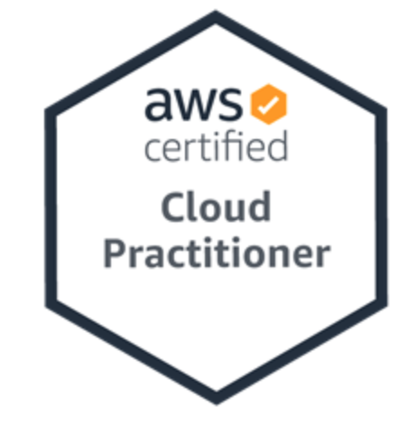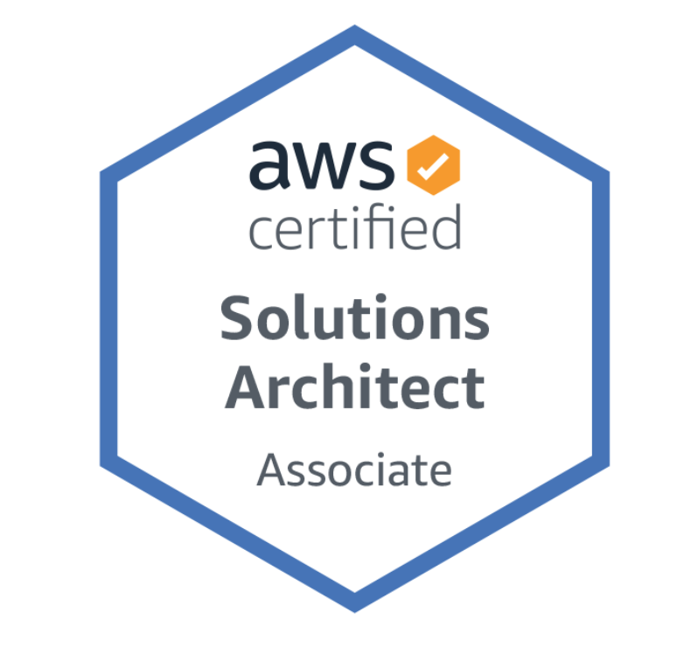  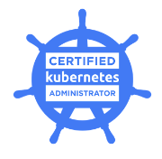  Education  05/2009  Anna University  Chennai,  Bachelor of Science: Electronics And Instrumentation Engineering  05/2011  Cleveland State University  Cleveland, OH  Master of Science: Industrial Engineering
.

