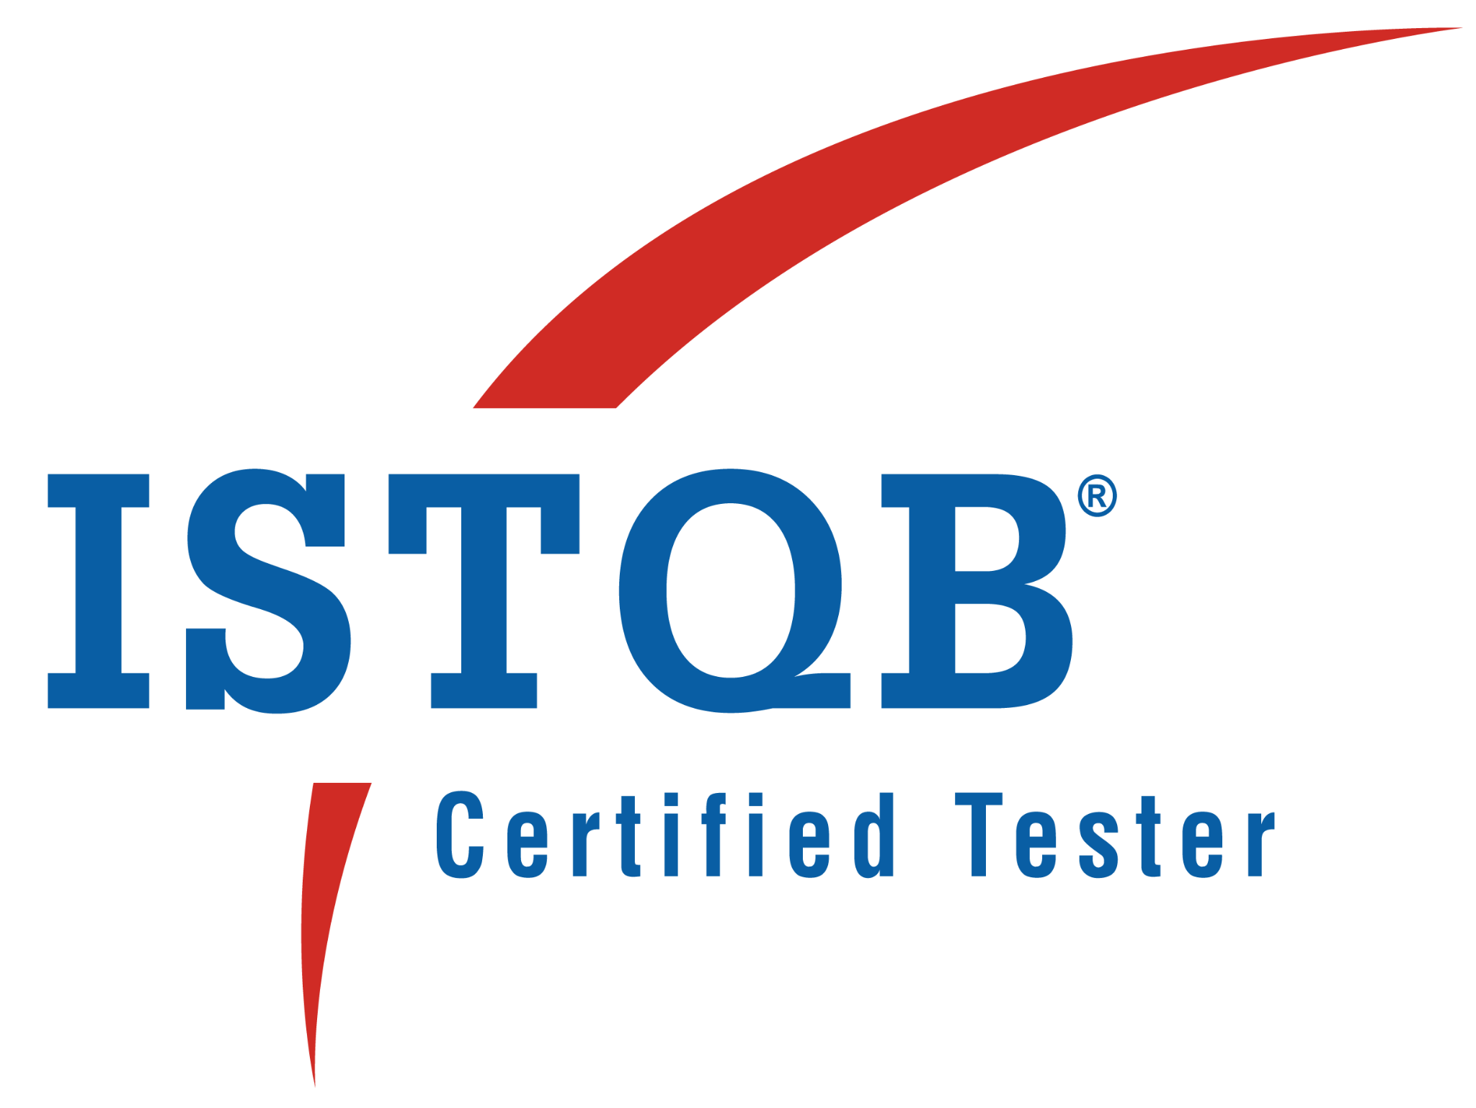
Vineela Gummakonda 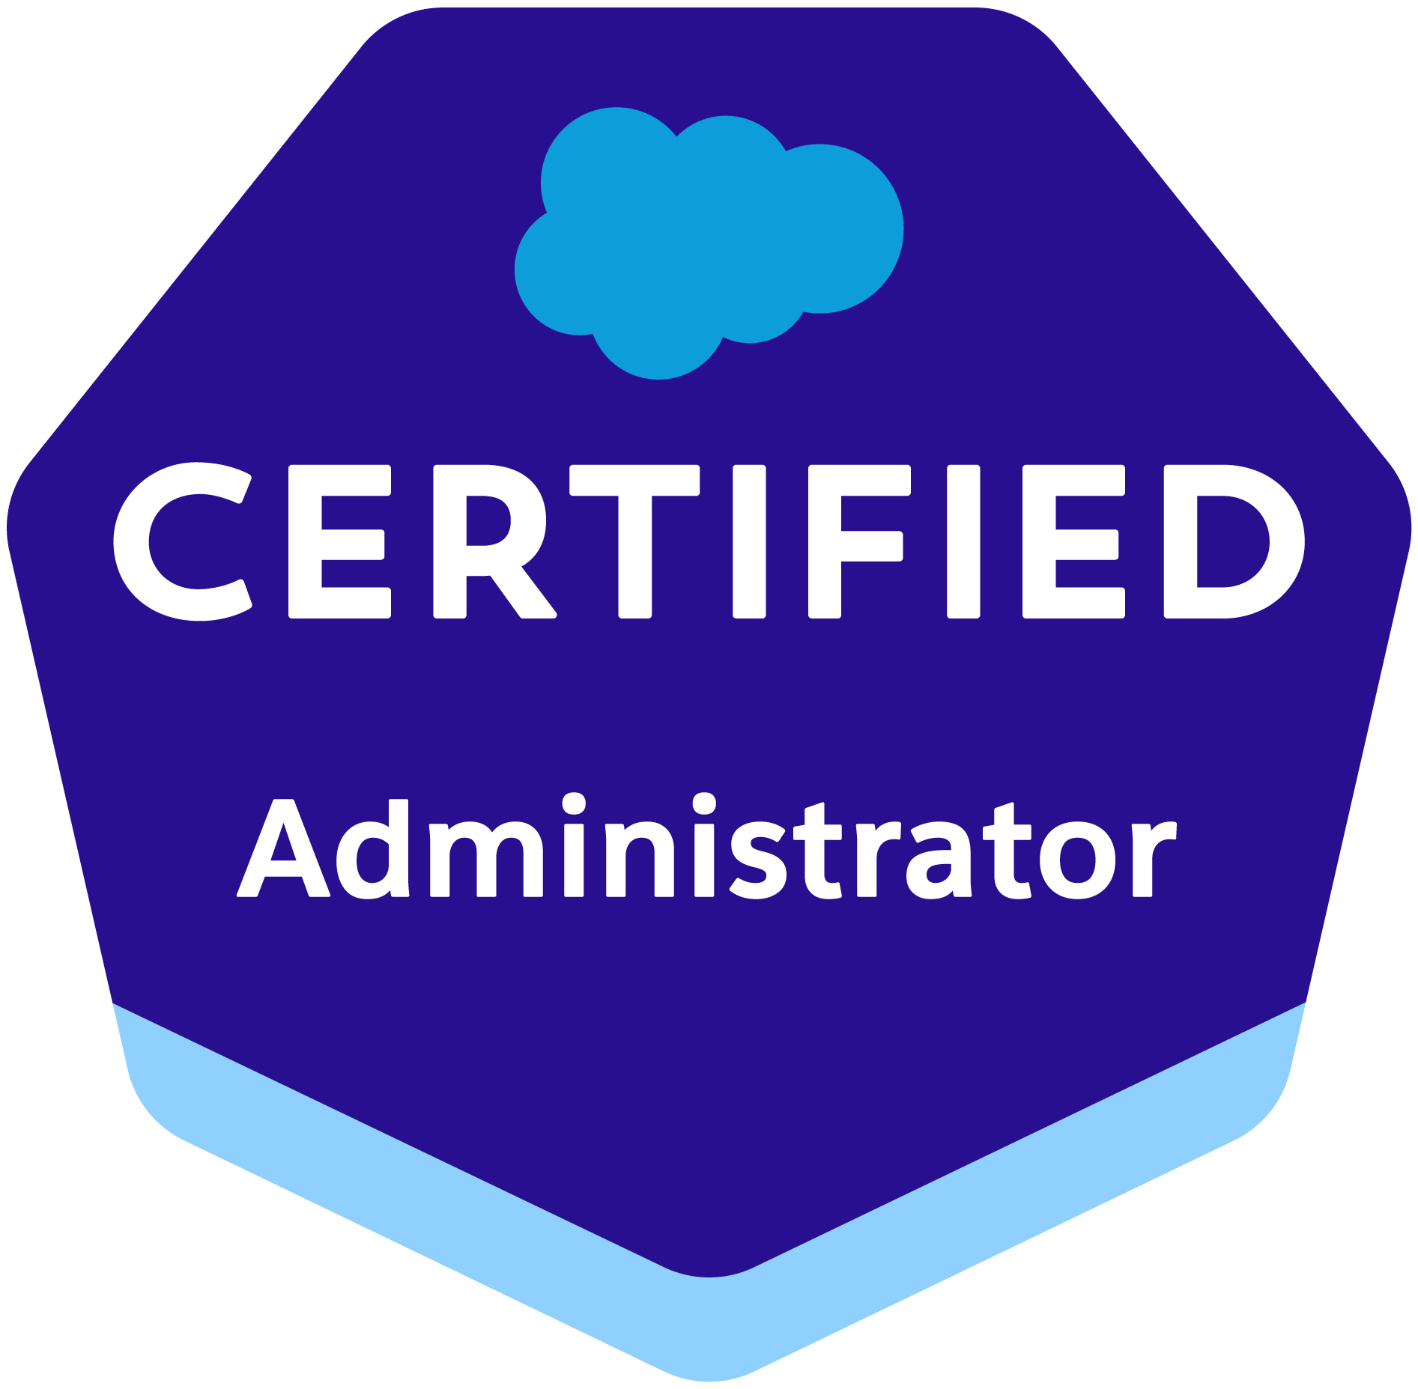
vineela.vin7@gmail.com | +1(248)-472-4477 | LinkedIn

Professional Summary:
- Key Experience: Over all experience: 13+ Years
- Key Experience 1: Business Analyst : 4 Years
- Key Experience 2: Salesforce Admin: 5 Years
- Key Experience 3: Quality Analyst : 4 Years

SUMMARY:
- Having 13+ years of experience in IT industry, which includes
- As a Business Analyst, experience in business process analysis, gathering business requirements and translate into technical solutions
- Experience in gathering and documenting business requirements into technical and functional specifications
- Create user stories, use cases, process flows and other relevant documentation to clearly articulate requirements and solution designs
- Assist in the prioritization and planning of system enhancements and new feature development based on business value and strategic goals
- Coordinating the design reviews and walkthroughs, implementation, testing and training phases of SDLC
- Conducting User Acceptance Testing (UAT) and providing feedback to enhance system functionality
- As a Salesforce Administrator, with experience in Salesforce CRM administration, Configuration and Customization
- Expertise in creating Custom Objects, Custom Fields, Tabs, Apps, Page Layouts, Record Types, Field Dependencies, Formula fields, Custom Validation Rules ad Relationships as per the business requirements
- Worked on configuring security settings using Profiles, Permission Sets, Roles, OWD, Sharing Rules
- Worked on Data Migration activities using Apex Data Loader, Import Wizard and Data Export
- Worked on configuring Workflow rules, Process Builder and Flow Builder
- Worked on creating Public Groups and Queues
- Worked on creating Reports and Dashboards
- Familiar using the Salesforce sales, marketing and service cloud
- Creating and maintaining comprehensive documentation outlining processes, policies and Salesforce help resources
- As an ETL Quality Analyst, experience validating data sources, data transformations, data marts and reports across various databases
- Extensive knowledge in ETL Testing, BI report testing, Functional Testing, Webservices testing and User Interface Testing
- Experience in test planning and execution along with test artefacts at each level like test plans, test cases and test reports
- Experience in performing Sanity testing and Regression testing
- Well versed with Test Management tools HP ALM, JIRA, Zephyr, qTest and Target Process
- Ability to work collaboratively with Business stakeholders, Testing teams, Developers and other team members to enhance the overall software product quality

EDUCATION

B. tech (EEE) – Nagarjuna University / Koneru Lakshmaiah College of Engineering - 2010

TECHNICAL SKILLS
Domain | Retail, Telecom, Banking
Technology | SQL Server, Oracle SQL Developer, Salesforce CRM, Apex Triggers, Visual Force pages, DML, SOSL, SOQL, Workflows, Process Builder and Approvals, Reports and Dashboards, Custom Objects and Standard Objects
Operating System | Windows 7,2000, XP ,10 Vista, 11
Tools | HP ALM, JIRA, qTest, Xray and JIRA Plugin for JIRA, Target Process, DataStage, Confluence

PROJECT DETAILS:
Proximus
July-2021 to Dec-2023
Project: Salesforce CRM / Business Analyst

- Conducted in-depth analysis of business processes, gathering and documenting requirements from stakeholders
- Collaborated with technical teams and business stakeholders to translate business requirements into functional specifications for system enhancement
- Helped enhance case management process, defining SLAs, configuring knowledge management systems and customizing reports and dashboard for the existing Salesforce service cloud
- Creating user stories by providing acceptance criteria and refining with the product owners and scrum masters
- Managing the product backlog and sprint planning to achieve the sprint goals
- Attending the demo sessions by IT team to review the implemented functionalities and provide feedback
- Performing User Acceptance Testing and coordinating with business users to perform business testing
- Worked closely with stakeholders to identify areas for process improvement and developed innovative solutions to streamline workflows
- Prepared and maintained comprehensive documentation, including process flow diagrams, business requirements documents, and user manuals

NJ Mutual Funds May-2019 to July 2021
Project: Salesforce CRM / Business Analyst

- Managed multiple scrum teams' product backlogs by creating and prioritizing epics and user stories for product development.
- Involved in requirement analysis, evaluation of business user problems, and development of system recommendations
- Analyze business requirements to understand their strengths and weaknesses to determine opportunities to automate processes and functions.
- Worked with various business units to create roadmaps and track and baseline milestones.
- Developed client deliverables by project requirements and approved documentation standards.
- Conducted project-related presentations periodically to the management and stakeholders during project phases like grooming, development, and testing.
- Experience using Tools - HP ALM Quality, JIRA, Confluence, Defect Tracker, Solution Manager, SharePoint.
- Attending the meetings with the delegates and follow the testing process and guidelines
- Following the Agile/Scrum techniques and the ceremonies in the team for implementing all kinds of projects and consulting
- Create and review - Test scenarios, Test suite preparation, Test Data creation, Test case execution, and Defect logging

Deutsch
Dec-2014 to May-2019
Role - PSBL Salesforce application / Admin

- Created custom Objects and also worked on Standard objects
- Responsible for customizing custom fields, Page Layouts, Record Types, Workflows and Approval Process, Validation Rules, Report Types
- Responsible for Import, Export and Update data into salesforce.com using Data Loader
- Responsible for deploying the components from one Sandbox environment to another Sandbox/Production environment using Force.com IDE tool and Change Sets
- Create and manage user accounts, profiles and roles
- Assign appropriate permissions and access levels based on user roles and responsibilities
- Define and enforce data security policies using sharing settings, roles and permission sets
- Setup and manage field-level security to control access to specific fields on objects
- Develop and maintain reports and dashboards to provide insights into business performance

Nordea
Oct-2012 to Dec-2014
Role - ETL / Quality Analyst

- Involved in Requirement Analysis, Evaluation, Design, Development, and Implementation using Datastage
- Worked on Data validation, merging, cleansing, and aggregation activities
- Involved in ETL Functional testing. Involved in testing Reports. Requirements gathering and freezing of those requirements
- Utilized sources to target data mapping and Business rules associated with the ETL processes
- Analyze the requirements and frame test scenarios
- Validate the data in the target tables against source data for Sourcing & Ingestion which has 100+ target tables
- Validate the target container tables which has transformed data from Sourcing & Ingestion target tables
- Validate the Data Mart which is populated from container tables
- Regression testing for every release
- Testing of data received from various sources, processed and sent for credit risk calculations
- Involved in ETL testing, BI Micro strategy Dashboards, and reports testing

M&S
Nov-2010 to Oct-2012
Role - ETL / Quality Analyst

- Involving in the project project right from the project initiation – understand the Business Requirements Document (BRD) and High-Level Design Document (HLD). Static review of design documents
- Prepare a test plan and test scenarios – get it reviewed and signed off from the business stakeholders
- Test execution, report status, update QC on a daily basis
- Prepare Test Results Summary Report (TRSR) after the execution completion and sign off
- Validation of the sales data aggregated and loaded into the sales aggregation tables
- Validating the data transformations for the data being sent to downstream systems
- Created ETL test data for all ETL mapping rules to test the functionality for claims data processing

