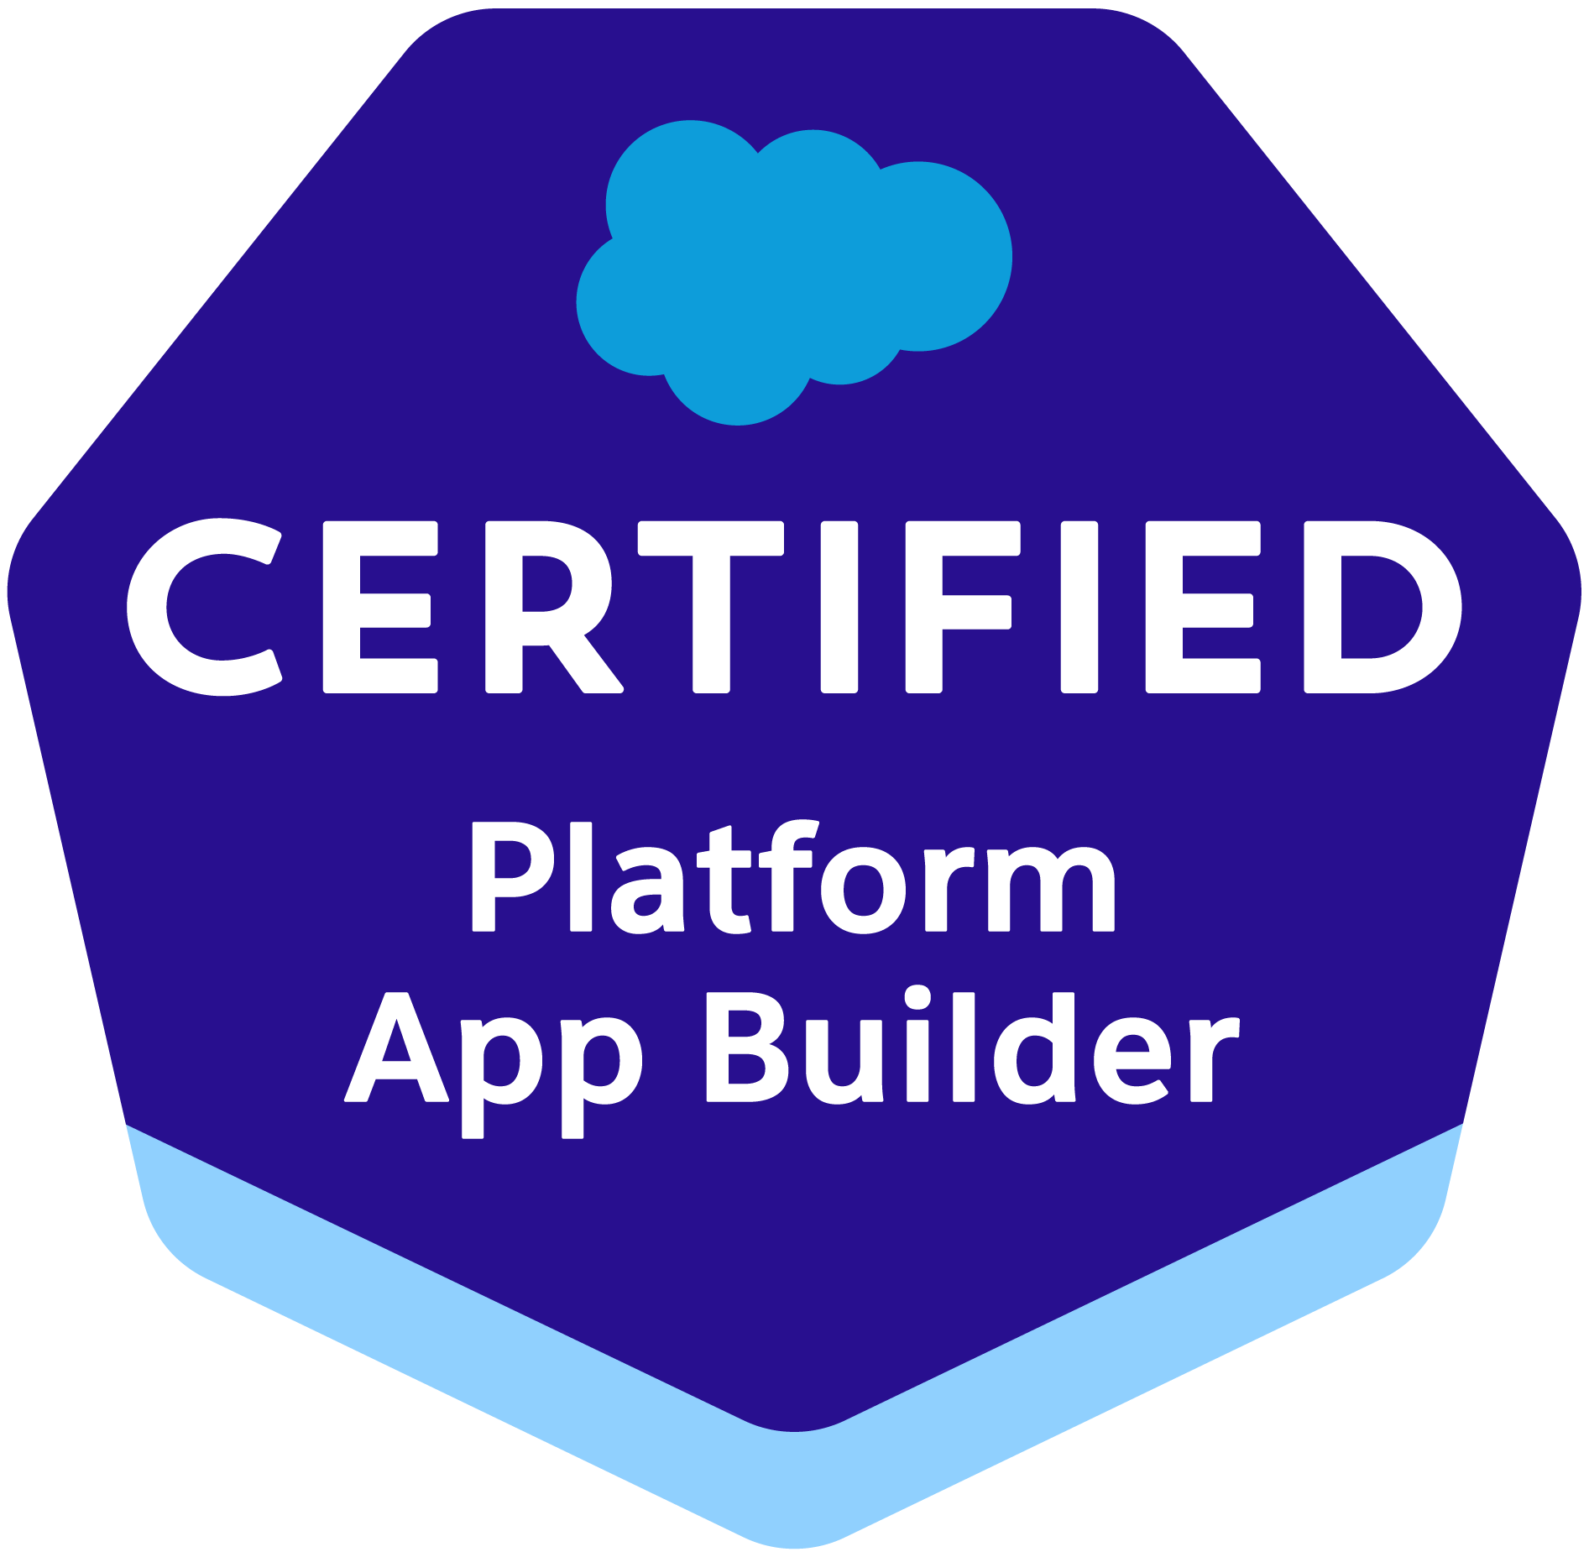

**Lakshmi**

**SFDC Developer**

**McCordsville, IN, US**

# Professional Summary

* **About 7 years** of experience in **Salesforce** CRM Implementations: Analysis, Design, Development, Administration, Integration, supporting the cloud applications, communities and migration from classic to Lightning, Lightning component development**.**
* Expertise in **Full Software Development Life Cycle (SDLC)** implementation analysis, requirement engineering, architecture design, development, enhancements, testing, deployment and maintenance of standalone, multi-tier, web-based, and portals-based object oriented enterprise applications.
* Experience on **Salesforce Lightning UI** using **Aura Components** and **LWC** (Lightning Web Components).
* Proficient in configuring and customizing Salesforce1 App.
* Hands - on experience in building responsive application using by creating **Lightning components** (**Client/Server side controllers) using aura framework, Salesforce LDS styling.**
* Extensive knowledge in implementing, configuring and customizing Salesforce solutions.
* Experience in working across various SFDC implementations covering **Sales Cloud**, **Service Cloud, Marketing Cloud, Communities** and **Force.com Sites**
* Experience in writing Apex Classes, Visual force Pages and Triggers.
* Experience in developing User Interface, Page Layouts, Tabs, Custom fields, Custom objects, Validation Rules etc.
* Worked on Migration tools Force.com IDE, Eclipse and have knowledge of Change set migration code and configuration from the Dev sandbox to Production.
* Salesforce Development and admin experience using **Sales, Marketing, Service cloud, Communities** and Force.com Platform and **SaaS** and well as **PaaS.**
* Profound knowledge in using Lightning components and Lightning Builder for Salesforce1.
* Expertise in maintaining the Functional areas of **Data Management,** Forecasting**, Accounts, Contacts, Leads, Campaigns, Opportunities,** Quotes, Activities**, Dashboards and Reports**.
* Extensive experience on working with **custom objects**, **custom fields**, **Pick-list**, **page layouts**, **Workflow Alerts** and **Actions**, **Approval Process**, **Validation Rules**, **custom Tabs**, **custom reports**, **report folders**, report extractions to various formats.
* Good experience in Salesforce Lightning in order to develop lightning components.
* Highly Skilled in upgrading Apps from **Salesforce Classic** **to Lightning Experience** to develop rich user interface and better interaction of pages. Worked on **Salesforce1** Platform to build Mobile App by enabling Lightning Components.
* Proficient in **Data Migration** from Traditional Applications to Salesforce using **Data Loader Utility**, **Apex Data Loader**.
* Experience working with Force.com IDE in design and development of Custom Application for Complex Business Processes in both Sales and Service Cloud Modules.
* Strong working experience in Agile Environment with daily Scrums.
* Extensive experience in designing of custom objects, custom fields, role based page layouts, Workflow Alerts and Actions, Validation Rules, Approval Processes, custom Tabs, report folders, report extractions to various formats.
* Experience in creating Dashboards, Reports, Custom Controllers, Visual Force pages, Tabs and analyzing the data in Salesforce.
* Added geographical redundancy to the computing needs in order to track the customer’s location using **Community Cloud**.
* Experience in working with client specific solutions like salesforce.com sandbox deployments, Force.com IDE, Eclipse, SOQL, SOSL and various production environments.
* A team player with a strong work ethic, excellent communication skills, a positive attitude and the ability to make the best use of individual resources.

**Technical Expertise:**

|  |  |
| --- | --- |
| **CRM** | Salesforce.com |
| **Salesforce.com** | Apex, Visualforce, SOQL, SOSL, Apex Triggers, Workflows, Approvals, Email Templates, Formulas, Validation Rules, AppExchange, Lightning Web Components, Aura framework, Eclipse, Salesforce.com, Force.com IDE, Apex Data Loader. |
| **SFDC Tools** | Force.com Eclipse IDE, Plug-in, Force.com Explorer, Force.com Excel Connector, Force.com Platform (Sandbox and Production) Exact target, Sales cloud, Service Cloud, Marketing Cloud. |
| **Integrating Tools** | Apex Data Loader, Import Wizard, Data Export |
| **Operating Systems** | Windows, Linux |
| **IDE** | Force.com IDE, Eclipse, Visual Studio |
| **Certifications** | Salesforce Certified Administrator, Salesforce Platform Developer1,Salesforce Certified Platform App Builder |

**Education:**

* B.tech from JNTU University 2006
* Masters (Computer science) from Purdue University 2015

**Work Experience:**

**Client: Claire's Stores, Hoffman Estates, IL Mar 2020 – Till Date**

**Role: Salesforce Developer**

**Responsibilities**:

* Involved on creating **Lightning** Pages inside Lightning **community** Builder.
* Worked on **Reports** and **Dashboards** in Salesforce Classic and Salesforce Lightning.
* Used **Salesforce Lightning** combines the new Lightning Design System, Lightning App Builder and Lightning Components to enable anyone to quickly and easily create modern enterprise apps build on Salesforce1 Platform.
* Used **Visual Studio Code** to develop lightning web components.
* Extensively used the Base **Lightning components like lightning data tables, lightning data service, Lightning pill** in every Salesforce release.
* Worked on lightning migration process, used latest **Apex features** like **Switch statements**, to refactor the Aura enabled Apex code.
* Extensively used **JavaScript** in **lightning component controllers** to manipulate the data and make it visible in Customer UI
* Extensively created **Apex classes, Apex Triggers, Test classes** using core Object oriented concepts
* Involved in the lightning implementation migration and used the lightning app builder for standard lightning components.
* Administered the **Sales cloud** application by creating the workflows for automated lead routing, lead escalation and email alert.
* Configured and customized the Salesforce **service cloud** application by setting up omnichannel routing, Salesforce knowledge, Case escalation rule.
* Worked with **marketing cloud** to implement **marketing campaigns** and created **journeys** using **marketing cloud tools** like **Journey builder** to understand the customer data and to create **strategies** with **journey mapping** and used **email studio** to **build** the **best email** and make them as **automated messages**.
* Experience in working with **interaction** **studio**(formerly known as **Evergage**) and **marketing** **cloud** **personalization**.
* Created connected apps for giving the Salesforce access for external apps and save those access tokens and consumer setting as custom settings for each environment.
* Worked on various Salesforce.com standard objects like **Accounts, Contacts, Leads, Opportunities, Reports and Dashboards.**
* Involved in deploying the **AppExchange** applications and integrating with third party applications.
* Wrote **triggers** to process incoming service e-mail requests from customers to automatically create new case records.
* Integrated the Web Servicesfor extracting the data from external systems to display in the pages of **Salesforce.com.**
* Worked on **Reports** and **Dashboards** in Salesforce Classic and Salesforce Lightning.
* Integrated the REST API based Web Services and Informatica for extracting the data from external systems.
* As per requirements, developed custom **Lightning Components** and used them in **Lightning App Builder**.
* understanding of the overall SDFC platform and SLC processes.

**Environment:** SFDC, Apex Language, Lightning Web Components, Force.com, Controllers, Triggers, Marketing Cloud, Process Builder, Workflow & Approvals, Workbench, Apex Data Loader, Salesforce.com platform, Web services, Apex Classes, Custom Reports, schedules apex, Dashboards, Sandbox data loading, Windows.

**Client: First Internet Bank, Fishers, IN Jul 2017 – Feb 2020**

**Role: Salesforce Developer**

**Responsibilities:**

* Used the Salesforce Lightning Design System (SLDS) in order to develop the Lightning Components.
* Created the lightning components and added them in to different communities.
* Create a complete file Upload utility in Lightning, Apex Classes and SOQL so that Users can attach files in the form and upload them to Salesforce case record.
* Used **field level security** along with **page layout** to manage the visibility and accessibility of fields for different profiles.
* Used **Salesforce Lightning** combines the new Lightning Design System, Lightning App Builder and Lightning Components to enable anyone to quickly and easily create modern enterprise apps build on Salesforce1 Platform.
* Worked on various Salesforce.com standard objects like **Accounts, Contacts, Leads, Opportunities, Reports and Dashboards.**
* Developed custom **REST Web Services** in Salesforce and published for External applications for consuming.
* Involved in developing Salesforce Lightening Apps, Components, Controllers and Events.
* Designed, Developed & deployed various **APEX Classes, Triggers**, Test methods also various Schedule, Batch and Future based **Apex classes** to implement the custom functionality. Developed **triggers** which added automatic templates to fire to the respective users.
* Wrote **triggers** to process incoming service e-mail requests from customers to automatically create new case records.
* Integrated the Web Servicesfor extracting the data from external systems to display in the pages of **Salesforce.com.**
* Imported data from excel sheets in to **Leads, Accounts, Contacts** and Opportunities using **Data Loader** and Import Wizard.
* Implemented **Web to Case, Email to Case** functionalities to provide a better customer support to the customers.
* Developed Assignment rules, Escalation rules to enable proper routing of cases to the case team members.
* Developed **Workflow rules, tasks, emails** and alerts to track customer related tasks and activities.
* Implemented and Consumed Knowledge Base **Dashboards** & **Reports** **AppExchange** for providing **Reports** and **Dashboards** that monitors the Knowledge Base.
* Involved in **data mapping** and **migration** of data from legacy systems to **Salesforce.com** Objects and fields.
* Involved in migrating the data from Oracle database to **Salesforce application** using **Apex Data Loader.**
* Wrote **SOQL** and **SOSL** statements within custom controllers, extensions and triggers by following the Governor limits in **Salesforce.com**.
* understanding of the overall SDFC platform and SLC processes.
* Designed various types Email templates for auto response to customers.
* Developed several custom reports to better assist managers and also report folders to provide report accessibility to appropriate personnel.
* Conducted training sessions to the UAT users to use the Salesforce Knowledge application and developed a feedback custom report.

**Environment:** Salesforce.com, Force.com, Apex Classes, Triggers, Controllers, Custom Objects, Records, Page Layouts, Roles, Work flows, Process Builder, SOSL, SOQL, Service Cloud, Cast Iron, Dash Boards, Data Loader, Data Migration and Windows.

**Client: Esurance Insurance Company, San Francisco, CA Sep 2015 – Jun 2017**

**Role: SFDC Developer / Admin**

**Responsibilities:**

* Written Apex Triggers, Apex Class (Controllers - Custom & Extensions), Utility classes and Exception classes.
* Worked with Visualforce **Pages**, **Custom Controllers**, **Extension Controllers**, **Apex Coding**, **Apex Web Services**, **Apex Classes** and **Apex Triggers**.
* Performed Salesforce administrative tasks - **Creating Users, Roles, Profiles, Permission Set, Public Groups, Queues, Sharing Rules, Validation Rules, Single Sign-On** and **Deployments**.
* Created workflow rules and defined related actions like, **time based** **trigger tasks, email alerts**, filed updates to implement business logic.
* Worked on various Salesforce.com standard objects like **Case Management**, Accounts, Contacts and **Reports**.
* Used Salesforce Developer Console to execute **Apex** Codes and **SOQL Queries** to verify **Salesforce data.**
* Created and maintained Reports and Dashboards to provide fast access to key business metrics.
* Involved in mapping the fields between the current reporting system and Salesforce using **dataloader**.
* Worked with business users in **pre-deployment** activities and fixing issues immediately in the UAT sandbox.

**Environment:** Apex language (Classes, Controller classes, Triggers), Visualforce, Force.com IDE, Validation rules, Time dependent action triggers, Email Templates, SOQL, Data loader.