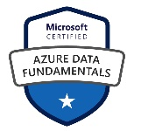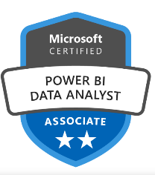**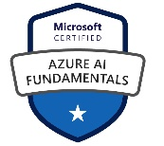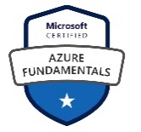Summary of Experience**

* Over **13+ years** of experience in IT and comprehensive industry knowledge in building Agile enterprise grade software.
* Experience in developing end-to-end **Technical Architecture** for Data-Driven solutions, technical design for data-driven applications and Enterprise Architecture. - Cloud and On-Premises
* Associated with **RFP**(Proposal) submissions – Timeline, Cost estimations, Solutioning and Use-cases (PoC).
* **Stakeholder Management, Mentoring** and **Team Building (Data science)**
* Strong familiarity in working with various cloud technologies like **Azure** and AWS
* Experience in building and deploying **GenerativeAI** solutions – LLM, RAG, FAISS, Prompt Engineering, Fine-Tuning.
* Experience hosting solution in **Power Apps** and **Azure Market Place**
* Exposure to **AutoML** tool in Feature selection, Model building and MLOps pipeline– **DataRobot**
* Managed and technically lead profitable **Lean** and **Agile** teams.
* Proficient at building robust Deep Learning models using **Convolution Neural Networks** (CNN) with **Tensor Flow** and **Keras**
* Product development experience in **O**ptical **C**haracter **R**ecognitionusing **GraphCNN**
* Exposure to Business Intelligence using PowerBi
* Experience in building solutions using **Computer Vision**: **Image** Classification (VGG Class, Inception class, ResNet) **& Object Detection** (Faster R-CNN, SSD)
* Experience in performing **Feature Selection,** Data Analysis, Power BI, Linear Regression, Logistic Regression, k - Means Clustering, Classification, Decision Tree, Supporting Vector Machines (SVM), Naive Bayes, K-Nearest Neighbors (KNN), Random Forest, and Gradient Descent, Neural Network algorithms.
* NLP: Embedding & Transformers – BERT, GPT.
* Expertized in Python data extraction and data manipulation, and widely used python libraries like **NumPy, Pandas, and Matplotlib** for data analysis.
* Quick learner having strong business domain knowledge in **Semiconductor, Finance**, Pharmaceutical, Healthcare and **Manufacturing** industry and can communication the business data insights easily with technical and nontechnical clients.

**Education**

* **Bachelor of Engineering – Electronics and Communication - 2007 to 2011**
* **PGDCS – Post Graduate Diploma in Computer Science (Data Science) - 2018 to 2019**

**Portfolio**

**LinkedIn:** <https://www.linkedin.com/in/rakesh-thoppaen/>

**Medium Blogs:** <https://rakesh-thoppaen.medium.com/>

**Generative AI Azure Marketplace Solution:**<https://azuremarketplace.microsoft.com/en-US/marketplace/apps/hexaware-technologies-1485696.bondrecogenerativeai?ocid=GTMRewards_WhatsNewBlog_bondrecogenerativeai_092123>

**Generative AI Solution Blog:** <https://hexaware.com/news/hexaware-reinforces-ai-leadership-with-double-win-at-microsoft-ai-solutions-foundry-wins-top-5-and-noteworthy-solutions-awards/?utm_source=linkedin&utm_medium=organic&utm_campaign=clt_ua_ln_o_pr_hrail-msaisolawd_global_webvisit_27-06-23&utm_content=Hexaware+Reinforces+AI+Leadership>

**Work Experience**

**Hexaware Technologies, Atlanta, USA DEC 2020 – Till Date**

**Senior Technical Architect - (Semi-Conductor, Insurance and Pharma)**

**Applied Materials Inc.**

**Lloyd's of London**

**IQVIA**

**Responsibilities:**

* Responsible for **architecting a Generative AI** solution to enhances the contextual understanding of LLMs by retrieving and integrating relevant contextual service documents. using RAG pipeline and Microsoft Enterprise OpenAI GPT3 LLM model and deploy in Azure for IQVIA.
* RAG pipeline
* GPT3
* Azure OpenAI
* Responsible for developing and deploying **data driven Recommendation Engine** and building knowledge-based systems to solve large scale computational problems for a US based major semiconductor equipment manufacturer using a team of 5.
* As a Senior Technical Architect, managed a program aimed at creating a knowledge base and software platform to deliver troubleshooting instructions through CRM.
* Designed the feature selection pipeline and applied techniques like Chi-Square test, Mutual Information and Boruta algorithms.
* Participated in features engineering such as feature generating, PCA, feature normalization and label encoding with Scikit-learn pre-processing.
* Develop necessary connectors to plug ML software into wider data pipeline architectures.
* Communicate the results with operations team for taking best decisions and Collect data needs and requirements by Interacting with the other departments.
* Involved in building the **Graph Convolution Neural Network** deep learning model for Lloyd’s of London to extract parameters from template agnostic insurance related contract documents that enabled automation in contract renewal process. Which helped in increasing the business and the drastically reduced the contract renewal time frame, thereby improving the business volume for Lloyd’s of London.
* Involved in architecting a solution to digitalize and automate the Coding / Bridging process.
* Designed an **Optical Character Recognition** component to extract parameters from multi-language and multi-template documents using cloud platform.
* Created an integration architecture to accommodate the digitalizing solution with customer’s existing enterprise architecture.
* Sign-off from business owners
* Developed bridging component using text-matching algorithms to improve accuracy of OCR output.
* Lead a POD team in Researching and Developing Enterprise ready **GenerativeAI** solutions using Microsoft Azure **OpenAI** SDKs.
* Developed 2 Proof of Concepts using OpenAI SDKs
  + Bond Validator – Top 5 winning solution Microsoft AI solution foundry
  + Medical Coding Solution – CPT, HCPC, ICD10CM, ICD10PCS
* Developed UI for the PoCs using Microsoft Power APP and Azure Functions
* Hosted the OpenAI Generative Solution in **Microsoft Market Place**
* Winner Microsoft AI solution foundry – **Top 5 winning solution for GenAI solution.** <https://www.linkedin.com/feed/update/urn:li:activity:7079475967831719936/>

**Renault Nissan Technical Business Center India (RNTBCI), Chennai, INDIA Sep 2019 – Dec 2020**

**Assistance Manager – Data Science (Manufacturing Domain)**

**Groupe Renault & Nissan Motors**

**Responsibilities:**

* Responsible for **architecting** an **AI based Audit Tool** to solve time consuming manual audit required on the engineering drawings for a major car manufacturer. Which improved the audit accuracy and turnaround time of audit on each component, reducing 2 FTEs overall.
* Worked on image data pre-processing using **OpenCV** to improve the quality of training data.
* Responsible for designing the whole technical architecture into a text detection and object detection pipeline.
* Developed text detection pipeline with OpenCV for preprocessing (kernel operation) and **pytesseract** to extract text.
* Developed object detection pipeline with OpenCV **morphological operations** and image classification to classify extracted objects (symbols).
* Involved in the collection of data to match templates.
* Involved in the collection of data to build the **image classification model**.
* Developed deep learning classification model using **keras**.
* Applied **Transfer Learning** technique to enhance the model performance and thereby realizing a substantial improvement in the model performance.
* Utilized GCP cloud CPU for training deep learning model.
* Exposure to project and workflow management using Smart sheet.
* Deployed the trained model in **GCP**, building an inference pipeline.

**HCL Technologies, Chennai, INDIA Jan 2015 – Aug 2019**

**Senior Software Engineer - Data Science (Semi-Conductor & Finance Domain)**

**KLA Tencor**

**International Personal Finance**

**Responsibilities:**

* Documented the complete process flow to describe program development, logic, testing, and implementation, application integration, coding.
* Worked with internal architects and, assisting in the development of current and target state enterprise data architectures.
* Developed Deep learning models to identify **defects** **in** **wafer** in a **semiconductor** equipment
* Involved in preprocessing of image data using Image Processing frameworks.
* Worked with project team representatives to ensure that logical and physical data models were developed in line with corporate standards and guidelines.
* Demonstrated and build statistical / machine learning systems to solve large-scale customer-focused problems and leveraging statistical methods and applying them to real-world business problems
* Performed preliminary data analysis using descriptive statistics and handled anomalies such as removing duplicates and imputing missing values.
* Develop necessary connectors to plug ML software into wider data pipeline architectures.
* Identify and assess available **machine learning**and**statistical analysis** libraries (including regressors, classifiers, statistical tests, and clustering algorithms).
* Conducted daily scrums and weekly sprints to understand the blockers and resolve them.
* Worked in client location, UK to collect project requirement and documented it using agile tools.
* Handled a client facing role in the UK, which enabled success conversion of 2 projects from a pilot stage.

**CGI, Bangalore, INDIA July 2011 - Nov 2014**

**Software Engineer (BFSI Domain)**

**Responsibilities:**

* Joined team as a **graduate** **fresher.**
* **Deep understanding of developing UI and relating User Experience with business logics as a developer involved in creating Mobile Applications.**
* Testing, debugging, diagnosing, and correcting errors and faults in an applications programming language within established testing protocols, guidelines and quality standards to ensure programs and applications perform to specification.
* **Writing** and **maintaining** program **code** to meet system requirements, system designs and technical specifications in accordance with quality accredited standards. Writing, updating and maintaining technical program, end user documentation and operational procedures.
* Prepared business and technical requirement specification documents.
* Working in **Agile methodology** creating backlog stories, grooming stories and estimating them.
* Participated in **daily scrums** and weekly sprints to understand the blockers and resolve them.

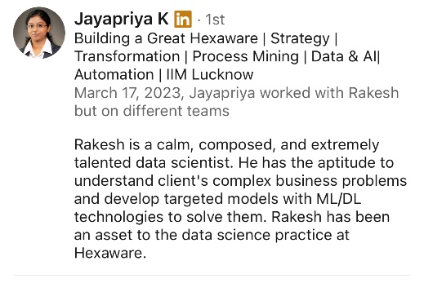**Personal Details**

|  |  |  |  |
| --- | --- | --- | --- |
| Name as in Passport | | : RAKESH THOPPAEN SURESH BABU | |
| Email id  Visa Status | | : [rakesh.thoppaen@gmail.com](mailto:rakesh.thoppaen@gmail.com)  : H1B | |
| **Accreditations** | |  | |
|  | |  | |
|  | |  | |
|  | |  | |
|  | |  | |
|  | |  | |

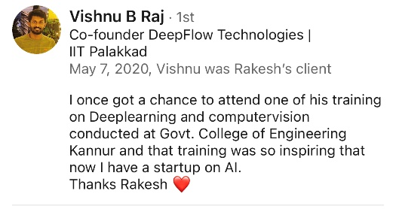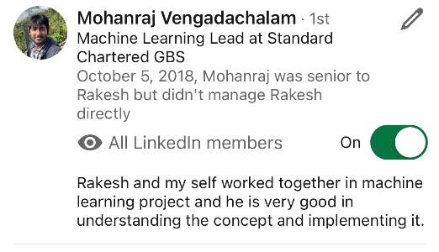

• Data Scientist: • Data analysis • Machine learning • Statistical modeling

• Data mining • Python/R programming • Deep learning • Predictive modeling • Data

visualization • Big data analytics • SQL • Artificial intelligence • Natural language

processing • Feature engineering • A/B testing • Algorithms • Time series analysis

• Clustering • Data preprocessing • Experimental design • Hypothesis testing Generative AI

Engineer: • Generative adversarial networks (GANs) • Deep learning frameworks

(TensorFlow, PyTorch) • Computer vision • Reinforcement learning • Neural networks • Image

synthesis • Creative AI • Reinforcement learning • Probability theory • Generative

models • Unsupervised learning • Transfer learning • Image processing • Game theory

• Adversarial training • Variational autoencoders (VAEs) • Synthetic data generation

• Pattern recognition • Image segmentation • Anomaly detection Data Science Manager:

• Team leadership • Project management • Data strategy • Data-driven decision making

• Business acumen • Data governance • Data quality management • Stakeholder management

• Data architecture • Budget management • Agile methodologies • Resource allocation

• Data ethics • Cross-functional collaboration • Data integration • Change management

• Talent development • Executive communication • Data storytelling • Risk management

NLP Engineer: • Natural language processing • Text mining • Sentiment analysis

• Named entity recognition (NER) • Part-of-speech tagging • Word embeddings • Language

modeling • Sequence-to-sequence models • Transformer architectures • Text summarization

• Dialogue systems • Language translation • Text classification • Speech recognition

• Text generation • Chatbots • Information retrieval • Speech synthesis • Language

understanding • Semantic analysis LLM Engineer (Large Language Models): • Pre-trained

language models • Transformer architectures • BERT (Bidirectional Encoder

Representations from Transformers) • GPT (Generative Pre-trained Transformer) • T5

(Text-to-Text Transfer Transformer) • XLNet • RoBERTa • DistilBERT • Fine-tuning models

• Natural language understanding • Conversational AI • Knowledge distillation

• Multimodal learning • Transfer learning • Zero-shot learning • Few-shot learning

• Knowledge extraction • Large-scale language modeling • Self-supervised learning

• Language understanding benchmarks Deep Learning Engineer: • Deep learning frameworks

(TensorFlow, PyTorch, Keras) • Convolutional neural networks (CNNs) • Recurrent neural

networks (RNNs) • Long short-term memory (LSTM) • Autoencoders • Restricted Boltzmann

machines (RBMs) • Reinforcement learning • Generative adversarial networks (GANs)

• Transfer learning • Neural architecture search • Hyperparameter tuning • Model

optimization • Explainable AI • Federated learning • Meta-learning • Adversarial training

• Deep reinforcement learning • Deep feature learning • Semi-supervised learning

• Continual learning Computer Vision Engineer: • Image processing • Object detection

• Image segmentation • Feature extraction • Deep learning for computer vision

• Convolutional neural networks (CNNs) • Transfer learning in computer vision • Pose

estimation • Optical character recognition (OCR) • Facial recognition • Image recognition

• 3D computer vision • Image synthesis • Motion analysis • Image enhancement

• Video analysis • Pattern recognition in images • Medical image analysis • Remote

sensing • Augmented reality