Rishika V

DevOps Engineer

* Irving,TX
* (945)-265-4148
* [vrishika2007@gmail.com](mailto:vrishika2007@gmail.com)

# Professional Summary

DevOps Engineer with 7+ years of experience in designing, implementing, and maintaining robust infrastructure solutions. Proficient in automating deployment processes, optimizing system performance, and managing cloud environments. Committed to enhancing operational efficiency and collaborating with cross-functional teams to deliver high-quality software solutions.

# Skills

* AWS: CLI, SDK (boto3), IAM, EC2, ASG, ELB, VPC, S3, CFN, Lambda,

CloudWatch, ElasticBeanstalk, RDS, ACM, SSM, Route53

* Network protocols: DNS, HTTP, HTTPS, SSH
* Linux OS
* Scripting Languages: Python, Bash
* Ansible ,Terraform
* CI/CD: Jenkins, AWS CodePipeline, AWS CodeCommit, AWS CodeBuild, AWS CodeDeploy
* SCM: Git and GitHub
* Docker,Kubernetes
* Grafana, ELK stack
* Agile Methodology
* Jira, Confluence

# Experience

**DevOps Engineer at Verizon** Mar 2023 - Present

## Irving,TEXAS

* + An active member of DevOps agile team for designing and developing robust cloud solutions to meet client requirements for functionality, scalability, high availability, and disaster recovery leveraging Scrum framework.
  + Configured Jenkins jobs with Git and Maven for generating artifacts and maintaining backups in Jenkins.
  + Installing and configuring Ansible and Involved in writing Ansible playbooks for configuring the servers.
  + Recommended automation improvements to facilitate team and project workflow.
  + Made consumption of data easier by automating the tasks that connect network tooling,scripting and databases through the use of standardized API automation.
  + Created Terraform/CFT scripts for automated infrastructure provisioning in AWS cloud.
  + Creating a dashboard for actionable insights to internal tools such as Code coverage, Defect tracker using Python and Grafana with ES and Cassandra as DB.
  + Automated the process of AWS cloud infrastructure using Terraform,manual deployment tasks through Ansible.
  + Used Ansible playbooks to setup continuous delivery pipeline including provisioning AWS environments.
  + Working on AWS Elastic load balancing for deploying applications in high availability .

## DevOps Engineer at HCL Technologies ltd., Hyderabad,INDIA

Nov 2021- Dec 2022

Certifications

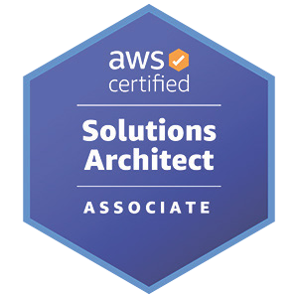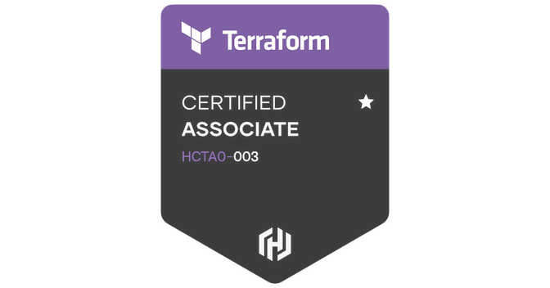

* AWS Certified Solution Architect

- Associate

* HashiCorp Certified Terraform Associate
* Built, maintained continuous Integration/Continuous Delivery systems leading to an improvement to ship new releases by 30%.
* Build and release software baselines, code merges, branch and label creation and interfaced between development and infrastructure.
* Created private cloud using Kubernetes that supports DEV, TEST, and PROD environments.
* Performed all necessary day-to-day GIT support for different projects. Responsible for design and maintenance of the GIT repositories and the access control strategies.
* Actively leveraging Terraform to automate various infrastructure provision for Prod, Dev, and QA cloud staging environments.
* Configured and maintained Jenkins to implement the CI process and integrated the tool with Maven to schedule the builds.
* Maintained and executed build scripts using Maven by coordinating with development and quality assurance teams in Linux Environments.
* Knowledge in data analytics for developing code coverage, defect tracker tool dashboard in python with elastic search, Cassandra, and Grafana.
* Created Terraform Scripts to create customized VPC, subnets, EC2 instances, ELB, security groups. Worked on tagging standard for proper identification and ownership of EC2 instances and other AWS services like Cloud Front, Cloud Watch, RDS, S3,Route53, SNS, SQS, Cloud Trail, Elastic Beanstalk, Elasticache and Code Deploy.
* Played an active part in migrating the conventional build and deploy process to CI/CD process.

# Software Engineer at Tata Consultancy Services Hyderabad, INDIA.

Aug 2016-Nov. 2021

* + Extensively worked on Jenkins CI/CD pipeline jobs for end-to-end automation to build, test, and deliver artifacts and troubleshoot the build issue during the Jenkins build process.
  + Worked with Docker and Kubernetes on AWS, from helping developers build and containerize their application (CI/CD) to deploy on cloud.
  + Developed robust, scalable, modular, API-centric infrastructures and added environments into handling deployments using code pipeline and AWS code deployment for various deployment scenarios.
  + Worked with software development and testing team members to design and develop robust solutions to meet client requirements for functionality, scalability, and performance.
  + Updated old code bases to modern development standards, improving functionality.
  + Designed GIT branching strategies, merging per the needs of release frequency by implementing GIT workflow on Bitbucket.
  + Regression tests on Juniper Routers for different stages of FRS releases.
  + Technical Competence: Basic Networking (OSI Model, TCP/IP, TCP, UDP, HTTP, HTTPS, SSL, FTP, ICMP, DNS, DHCP, ARP), Core Networking (Subnetting, VPN, NAT / PAT, CIDR, Security). Routing Protocols (RIP, OSPF, EIGRP)

# Education

Bachelor of Technology

Gokaraju Rangaraju Institute of Engineering and Technology, Hyderabad, INDIA

2017