# **Section A – Management Summary**

1. **Introduction the case study**
2. **About Green Groceries**

Green Groceries is a mid-sized company that specializes in locally sourced, organic grocery items. Through partnerships with neighboring farmers and environmentally conscious suppliers, the company has gained a strong position. Their business objective is to produce and promote and expand the range of organic goods to increase consumer access to the company's products.

1. **Introducing Green Groceries' project goals**

The goal of this project is said to be to develop an online platform for the company within the next three months.

The goals that the company set when implementing the project include:

* The firstly is expanding its market reach: This expansion allows the company to serve customers who prefer the convenience of online shopping or who cannot access the company’s brick-and-mortar stores.
* Secondly increase access to sustainable products: Green Grocers seeks to make organic and locally sourced grocery products more accessible to consumers and support its mission of promoting the company's eco-conscious lifestyle.
* Third is strengthening brand reputation: The launch of the online platform strengthens Green Groceries' reputation as a supplier of high-quality, sustainable goods.
* Fourth Drive Revenue Growth: Expansion into the online space presents an opportunity for Green Groceries to increase its revenue streams and allow the company to enter new markets and capitalize on growing demand for organic and locally sourced products, driving sales and profits.
* Finaly, enhance customer interaction: Through the online platform, Green Groceries can interact with customers beyond the point of sale.

1. **Introduction to Online Platform Development**

* Given that Green Groceries lacks an in-house software development team, the decision to outsource the development of their online platform underscores their commitment to efficient resource allocation and expertise acquisition. By partnering with an external team, such as System Concepts (SC), Green Groceries can leverage the specialized skills and experience of professionals who are well-versed in software development methodologies.
* The Online Platform Development project employs the SRUM methodology, which is similar to CRUM, a widely used Agile approach designed for small teams and characterized by sprint cycles. In SRUM, a Scrum master takes the lead role, addressing impediments hindering the team's daily tasks. Similarly, in CRUM, team members convene daily to address ongoing tasks, obstacles, and other factors influencing the team's progress, facilitating problem-solving and project advancement (According Schwaber, K. and Sutherland, J., (2011)).

[1]

Figure 1. CRUM methodology

* The Online Platform Development project has opted for the DSDM framework, an agile project framework centered around iterative development practices. DSDM aims to blend traditional project management approaches, like the waterfall methodology, with software and systems development requirements. Its core objective is to facilitate the adaptation of proven best practices and expertise within the agile framework to ensure the development of a suitable framework for the project(Stapleton, J., 1997)).

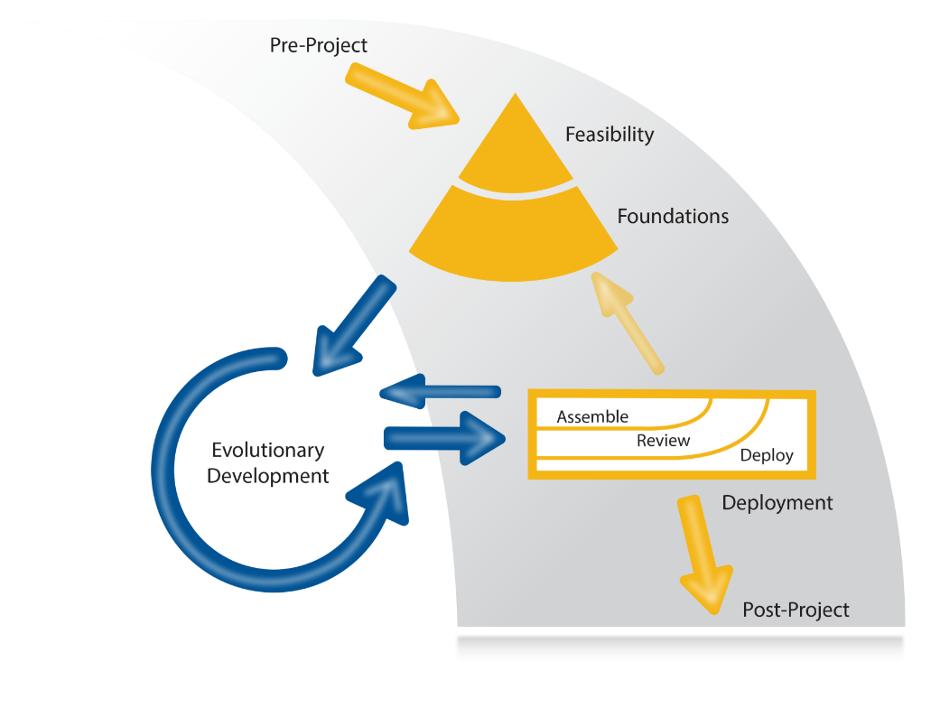[2]

Figure 2 DSDM framework

* The members receiving this project are the staff of the prestigious software consulting company Aglie (SC), including 5 members: Millie is a skilled programmer with high expertise. Peter, a highly specialized web developer, but sometimes disagrees with clients.Anita, has strong web development skills. Cheryl, is an experienced Agile development team leader as well as extremely good web development skills. And finally Pat, a part-time employee throughout the project, has good skills and understanding of web development and testing.
* For stakeholders including positions: CEO and Founder, Operations Director, Chief Accountant, Logistics Director, Financial Controller, Marketing Director. Each position has important tasks. Like CEO and Founder are the people who see things and the main decision makers. Financial Controller, a position with a very busy schedule but still makes time to attend meetings. Operations Director, a position with extensive background experience in Aglie software development. Chief Accountant, position Financial position in meetings. Marketing Manager, is a certified workshop facilitator and project manager, and contributes insights from a marketing perspective.

Evaluation of the members of this team is quite consistent with each other, each member has high skills and understanding of web development according to the Aglie model. And there is also a member named Cheryl, who has experience managing groups as a group leader. This person will lead the team as well as act as a bridge between team members and customers, because Peter in the team sometimes disagrees with customers. For the stakeholders, it is a good combination. The project development team is full of members with many skills in Agile web development and the stakeholders have positions with a broad vision. , has experience in project management as well as providing opinions and full support for the company's online platform development project.

1. **Introduction to Agile**
2. **Agile information**
   1. Definition

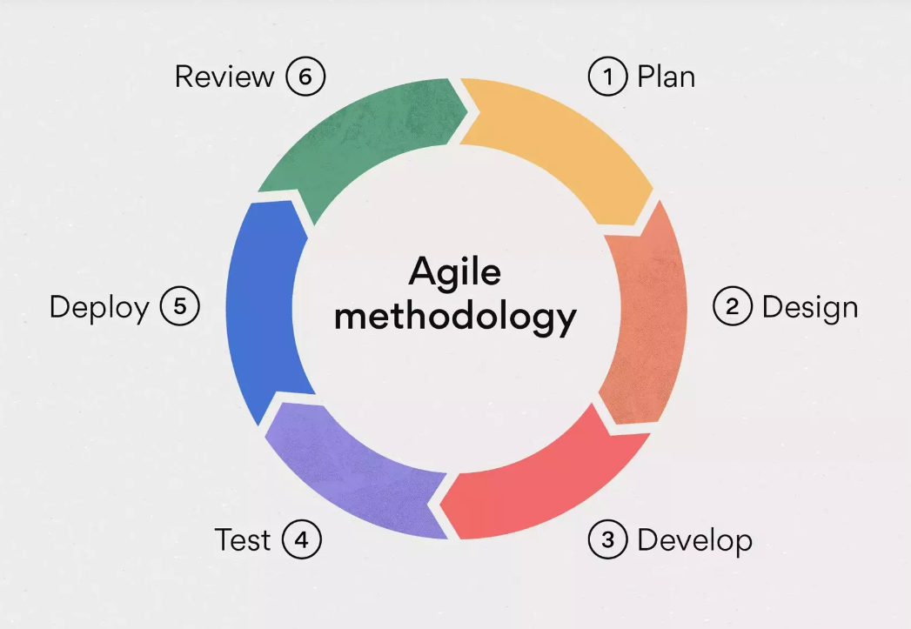

Figure 3. Aglie[3]

The Agile methodology is actually a project management framework that emphasizes iterative development and collaboration between cross-functional teams. It typically involves breaking the project into smaller parts called sprints, which typically last from one to four weeks. During each sprint, the team works on a set of predefined tasks, with the aim of delivering a deliverable increment by the end of the sprint. After each sprint, there is a period of time dedicated to reflection and improvement called a sprint retrospective. During this phase, the team gathers to review what went well during the sprint, what didn't go as planned, and what lessons can be learned. The goal is to identify areas for improvement and make the necessary adjustments to enhance the team's performance in upcoming sprints (According Manifesto, A., 2001)).

* 1. Advantages and disadvantages of Agile

Like any other methodology, Agile also has its advantages and disadvantages. Here, the advantages and disadvantages of Agile will be discussed in detail below(According Pargaonker, S (2023)).

* About advantages of Agile
* **Punctual Delivery**: Agile methodology aims at delivering functional components incrementally. After each sprint, a portion of the software is transferred to the client, ensuring steady progress and contentment(According Pargaonker, S (2023)).
* **Flexibility and Adaptability**: Agile methodology permits alterations in requirements even during the development phase. It encompasses flexibility and adjusts to changing needs(According Pargaonker, S (2023)).
* **Daily Engagement**: Agile stresses the importance of daily engagement between business stakeholders and developers, fostering collaboration and ensuring alignment with customer expectations(According Pargaonker, S (2023)).
* **Emphasis on Quality Design**: The development process under Agile methodology pays significant attention to product design, resulting in higher quality software(According Pargaonker, S (2023)).
* **Enhanced Customer Satisfaction**: Consistent delivery of features keeps customers involved and content. Their feedback can influence the direction of the product(According Pargaonker, S (2023)).
* **Organizational Harmony**: Agile methodologies, dismantle organizational barriers, nurture trust, and unite teams towards shared objectives(According Pargaonker, S (2023)).
* About disadvantaged of Agile
* **Punctual Delivery**: Agile methodology aims at delivering functional components incrementally. After each sprint, a portion of the software is transferred to the client, ensuring steady progress and contentment(According Pargaonker, S (2023)).
* **Flexibility and Adaptability**: Agile methodology permits alterations in requirements even during the development phase. It encompasses flexibility and adjusts to changing needs(According Pargaonker, S (2023)).
* **Daily Engagement**: Agile stresses the importance of daily engagement between business stakeholders and developers, fostering collaboration and ensuring alignment with customer expectations(According Pargaonker, S (2023)).
* **Emphasis on Quality Design**: The development process under Agile methodology pays significant attention to product design, resulting in higher quality software(According Pargaonker, S (2023)).
* **Enhanced Customer Satisfaction**: Consistent delivery of features keeps customers involved and content. Their feedback can influence the direction of the product(According Pargaonker, S (2023)).
* **Organizational Harmony:** Agile methodologies, like Scrum, dismantle organizational barriers, nurture trust, and unite teams towards shared objectives(According Pargaonker, S (2023)).

1. **Identify the Agile framework as a suitable method for the project.**

Upon examining Green Groceries' plans to introduce an online platform in the next three months and taking into account their outsourced project goals, it is evident that DSDM, would be a perfect fit for this project. Below is a breakdown of the reasoning behind this recommendation along with potential advantages and disadvantages:

* Appropriateness of Agile Framework:
* Agility to adapt to changing requirements: Agile methodologies such as SRUM prioritize iterative development cycles, enabling the project team to continuously adjust to evolving requirements and priorities. This aligns seamlessly with the dynamic nature of software development projects and can effectively address Green Groceries' evolving needs and market demands.
* Incremental Delivery of Value: Agile methodologies, such as DSDM, facilitate the division of the project into smaller, manageable increments known as sprints. This framework enables the team to deliver functional software components at regular intervals. By doing so, Green Groceries can begin to realize the value of the online platform early in the development process. Moreover, this approach allows for the collection of feedback from users and stakeholders, which can be used to refine and improve the platform iteratively.
* Collaboration and Transparency: Agile methodologies foster tight collaboration among the development team, stakeholders, and the client. In the context of Green Groceries, this collaborative approach can enhance communication between the company and System Concepts, ensuring that the provided solution closely aligns with Green Groceries' vision and requirements.
* Risk Mitigation: Agile methodologies provide inherent mechanisms for mitigating risks through frequent inspection and adaptation. By conducting regular sprint reviews and retrospectives, the project team can identify potential issues at an early stage and make necessary adjustments to minimize risks, thereby ensuring the success of the project.
* Advantages of Agile framework
* Rapid Delivery: Agile methodologies facilitate quicker time-to-market by prioritizing the delivery of valuable functionality in brief iterations. This can provide significant advantages for Green Groceries, enabling them to launch their online platform earlier and gain a competitive advantage in the market.
* Customer Satisfaction: Agile methodologies prioritize customer collaboration and responsiveness to change, resulting in higher customer satisfaction. By actively involving Green Groceries in the development process and iteratively incorporating their feedback, System Concepts can ensure that the final product meets or exceeds Green Groceries' expectations. This collaborative approach fosters a sense of ownership and ensures that the delivered solution aligns closely with Green Groceries' vision and requirements.
* Disadvantages of Agile framework
* Resource availability: Agile methodologies necessitate active customer participation throughout the development process. Green Groceries should allocate ample resources and involve key stakeholders in regular meetings, ensuring timely feedback to guarantee project success.
* Scope management: Agile methodologies may encounter challenges in handling expanding scope, particularly if requirements evolve frequently during the project. Green Groceries and System Concepts must establish clear priorities and mechanisms to manage scope changes effectively, thus averting project delays or budget overruns.
* ~~Conclution~~

~~Applying Agile methodology, especially DSDM framwoek, to develop their online platform is not only reasonable but also promising. Applying Agile principles ensures adaptability to changing requirements and enables incremental delivery, fostering collaboration among team members and stakeholders to align with the vision of the organization. Green Grocery Store. In addition, Agile methods prioritize risk management, ensuring smoother project progress and timely delivery. Overall, the adoption of DSDM aligns with Green Groceries' goals of sustainable market expansion and product reach, facilitating a successful online platform launch and business growth.~~

# **Section B – High level requirements analysis and MoSCoW prioritisation**

|  |  |  |
| --- | --- | --- |
| **No.** | **Requirements** | **Funcition/ Non-function** |
| F1 | As an Order Handling Clerk, I want to use the website to process telephone purchases, replacing the paper-based system. | FR |
| F2 | Maintain at least 20 office plants as part of the company's commitment to a green and healthy workspace. | NFR |
| F3 | As a customer, I want to be able to change my account details to ensure my most up-to-date information is recorded. | FR |
| F4 | Organize a virtual celebration on the website for the CEO's birthday to showcase the company's fun and friendly culture. | FR |
| F5 | As the Managing Director I want to be ensured that the site is Data Protection Act safe so that we do not get fined hundreds of thousands of pounds. | NRF |
| F6 | As a customer register an account. | FR |
| F7 | As a Customer I want a choice of delivery slots so that I can arrange my diary appropriately. | FR |
| F8 | As a customer, I want to be able to modify my shopping cart so that I can change my mind about what I want to buy. | FR |
| F9 | The company should adopt pet-friendly policies to create a positive and inclusive work environment. | NRF |
| F10 | The system must be designed to handle a 30% increase in traffic during peak periods without degradation in performance. | NFR |
| F11 | As a customer, I want to enter separate delivery and invoice addresses so that I can receive bags when staying at a friend’s house. | FR |
| F12 | As a Customer I want to be able to change my account details so that my most up to date details are recorded. | FR |
| F13 | As an Order Handling Clerk I want to use the Web site to process telephone purchases so that I can stop using the paper-based system. | FR |
| F14 | As a customer, I want to choose whether or not I am sent marketing information to avoid receiving excessive junk mail. | NF |
| F15 | All user data, including personal information and payment details, must be encrypted to ensure the highest level of security. | NFR |
| F16 | Maintain consistent branding elements and design across the website to reinforce their brand identity. | NFR |
| F17 | The development team should participate in a team-building event every quarter to foster collaboration and a positive work environment. | NFR |
| F18 | As the Marketing Director I would like an offers or discount page so that we can inform our customers of the aforementioned. | NFR |
| F19 | As the Chief Accountant I want to the Web site to adhere to legislation regarding VAT so we are not hit with a hefty fine. | FR |
| F20 | As the Operations Director, I want to accept all forms of payment to capture the largest market possible. | FR |

1. **Review the ‘base line requirements’ list**
2. **Present nonconforming requirements at a high-level requirement level.**

|  |  |  |
| --- | --- | --- |
| **No.** | **Requirements** | **Reason** |
| F2 | Maintain at least 20 office plants as part of the company's commitment to a green and healthy workspace. | The reason this requirement is not very relevant is because it is a non-functional requirement (NFR) in the first place. Second, it has nothing to do with the company's goals and also has nothing to do with the business goals and the project's goal is to develop an online platform. While the company's request is to develop an online platform to promote to many customers, here it is about the company's working environment. So this request is definitely inappropriate. |
| F4 | Organize a virtual celebration on the website for the CEO's birthday to showcase the company's fun and friendly culture. | This reason is not suitable because first it should be used to share the organization's fun and friendly cultural activities. Second, it goes against the company's original wishes when developing an online platform. Finally, because the project has a short implementation period, it should only focus on the main goal of the project and this requirement can be implemented in the next development phase in the future. |
| F9 | The company should adopt pet-friendly policies to create a positive and inclusive work environment. | The reason this requirement is not very relevant is because it is a non-functional requirement (NFR) in the first place. Second, it has nothing to do with the company's goals and also has nothing to do with the business goals and the project's goal is to develop an online platform. While the company's request is to develop an online platform to promote to many customers, here it is about the company's working environment. So this request is definitely inappropriate. |
| F17 | The development team should participate in a team-building event every quarter to foster collaboration and a positive work environment. | First, it concerns non-functional requirements (NFRs), which are necessary for system performance but do not directly address the functional needs of the system. Therefore, focusing on NFR may detract attention from core functions that are important to meeting user needs. Second, the solution involves project management rather than project development . While effective project management is certainly important, allocating resources to the project at this stage may be premature and may divert attention from important development tasks. Finally, the proposed solution was not related to the company's main goal of developing an online platform. Due to misalignment with project goals, investing time and resources in non-essential areas risks slowing progress toward achieving company goals. |
| F10 | The system must be designed to handle a 30% increase in traffic during peak periods without degradation in performance. | Firstly, it falls under the category of non-functional requirements (NFR), which typically encompass aspects such as performance, reliability, and scalability, rather than directly addressing the core functionalities of the platform. Secondly, the request pertains to performance design and optimization, which requires ongoing improvement over time. However, given that this is the company's inaugural venture into developing an online platform, prioritizing such a request may not be necessary at this stage. Instead, initial efforts should focus on establishing a solid foundation for the platform's core functionalities and ensuring its stability and usability. Therefore, while performance optimization is undoubtedly important, it may be more prudent to defer this request until the platform has matured and the company has gained more experience in online development. |
| F15 | All user data, including personal information and payment details, must be encrypted to ensure the highest level of security. | The stated solution is not suitable for many reasons. It essentially falls under the category of non-functional requirements (NFR), making it inadequate to address the specific functional needs of the system. Additionally, it also involves technical aspects in that established protocols already exist to support encryption for secure data transmission. Furthermore, modern development frameworks, like the modern frameworks that support Therefore, considering these factors, it is clear that the proposed solution lacks feasibility and suitability in addressing the requirements. system needs effectively. |
| F16 | Maintain consistent branding elements and design across the website to reinforce their brand identity. | Firstly, it belongs to the realm of non-functional requirements (NFR), which are critical for system performance but do not directly address the functional needs of the system. Secondly, the solution involves design development, particularly in terms of UI/UX (User Interface/User Experience). While crucial for enhancing user engagement and satisfaction, delving into UI/UX design may not be appropriate at this stage, especially if clear functional requirements have not been established.Thirdly, the absence of clear requirements, compounded by the organization's lack of brand identity standards, further complicates the feasibility of implementing the proposed solution. Brand identity standards are essential for ensuring consistency and coherence across all aspects of the platform. However, since the issue of brand identity is anticipated to evolve over time, allocating resources to address it at the project's outset may be premature. |
| F5 | As the Managing Director I want to be ensured that the site is Data Protection Act safe so that we do not get fined hundreds of thousands of pounds. | The stated solution is unsuitable for several reasons. Primarily, it falls under the category of non-functional requirements (NFR), rendering it inadequate for addressing the specific functional needs of the system. Additionally, it pertains to technical aspects where established protocols, such as HTTPS, already exist to support encryption for secure data transmission. Furthermore, contemporary development frameworks, like those supporting encryption methods such as bcrypt, offer robust solutions for safeguarding sensitive information. Therefore, considering these factors, it is evident that the proposed solution lacks viability and relevance in addressing the system's requirements effectively. |
| F7 | As a Customer I want a choice of delivery slots so that I can arrange my diary appropriately. | Firstly, it introduces a reliance on a third party for delivery, which deviates from the project's primary goal of expanding market reach and enhancing user accessibility. Secondly, while it may fulfill a customer request, the logistics involved-such as coordinating schedules and accommodating carrier requirements-pose considerable challenges. These logistical hurdles not only complicate the delivery process but also potentially disrupt the project timeline and resource allocation. Therefore, considering these constraints, the proposed solution is not aligned with the project's objectives and presents practical difficulties that may impede its successful implementation. |

1. **Present the high-level functional requirements necessary to build the system.**

|  |  |  |
| --- | --- | --- |
| **No.** | **High level functional requirements** | **Reason** |
| F3 | As a customer, I want to be able to change my account details to ensure my most up-to-date information is recorded. | Because this is one of the benefits of customers when using the company's online platform. When using the company's platform, customers who have problems with their account information can update it, for example, they can change their Phone Number when they use a new phone number. |
| F6 | As a customer register an account. | Because this is one of the benefits of customers when using the company's online platform. When registering for a customer account, they can secure their account, manage their translation history orders, and receive support when there are problems. |
| F1 | As an Order Handling Clerk, I want to use the website to process telephone purchases, replacing the paper-based system. | First, because using phones to process transactions has become common in e-commerce applications, it is necessary to keep up with the trend, as well as everyone having a phone number and communication. better between people, deducing this feature is very useful. Third, when implementing this request, it will be very useful for elderly users who are not very familiar with technology. This is to simplify ordering as well as be more accessible to users, as well as being on track with the company's goals. |
| F8 | As a customer, I want to be able to modify my shopping cart so that I can change my mind about what I want to buy. | Because customers often change their mind about what they want to buy while browsing. Allowing them to easily modify their shopping cart ensures they have control over their shopping experience and can make adjustments as needed, improving user satisfaction and reducing frustration. |
| F18 | As the Marketing Director I would like an offers or discount page so that we can inform our customers of the aforementioned. | Developing this requirement can have several beneficial outcomes for the company. Firstly, it aims to attract more customers interested in the company's products by offering them a convenient and user-friendly online platform. This enhanced accessibility can lead to an increase in customer acquisition and potentially expand the customer base.Secondly, by providing a seamless online shopping experience, the company can increase the satisfaction of existing customers who have been loyal to the brand over time. Satisfied customers are more likely to continue patronizing the company and may even become advocates, recommending the platform to others.Furthermore, by establishing an online presence, the company can effectively compete in the digital marketplace, increasing its visibility and positioning itself alongside competitors. This not only enhances the company's market share but also allows it to capitalize on new selling points and stay relevant in a competitive environment.Additionally, an online platform can facilitate inventory management and clearance. By reaching a broader audience and streamlining the purchasing process, the company can move surplus inventory more efficiently, reducing carrying costs and maximizing profitability. Overall, developing this requirement aligns with the company's objectives of attracting and retaining customers, increasing competitiveness, and optimizing inventory management, ultimately contributing to the company's growth and success in the market |
| F11 | As a customer, I want to enter separate delivery and invoice addresses so that I can receive bags when staying at a friend’s house. | Because customers may need to deliver to an address different from their billing address for a variety of reasons, such as when staying at a friend's house. Providing the option to enter separate delivery and invoice addresses addresses these needs and enhances customer convenience. |
| F14 | As a customer, I want to choose whether or not I am sent marketing information to avoid receiving excessive junk mail. | Some customers may not want to receive marketing communications to avoid flooding their inboxes with unwanted emails. Providing the option to opt in or out of receiving marketing communications respects your customers' preferences and helps maintain positive relationships with them. |
| F19 | As the Chief Accountant I want to the Web site to adhere to legislation regarding VAT so we are not hit with a hefty fine. | Indeed, ensuring compliance with legal and tax regulations is crucial for any organization, including developing an online business platform. Providing invoices and fulfilling tax obligations are basic requirements prescribed by law. Failure to comply with these obligations can result in legal consequences and financial penalties for the organization. Therefore, integrating features into online platforms that facilitate invoicing and tax contributions is not only necessary but also legally required. These features not only ensure compliance with regulatory requirements but also help maintain an organization's reputation and reliability. Therefore, while it may not directly contribute to the functionality or user experience of the platform, prioritizing the development of tax compliance and invoicing features is essential to meet these obligations, legal services and operate online business platforms legally and responsibly. |
| F20 | As the Operations Director, I want to accept all forms of payment to capture the largest market possible. | Provide multiple payment options that meet diverse customer preferences and increase platform accessibility. Accepting different forms of payment ensures that customers can complete transactions using their preferred method, reducing barriers to purchase and maximizing market reach and revenue potential. power. |

1. **MoSCoW/Timebox rules to prioritise the requirements ‘high level requirements list’**

|  |  |  |  |  |
| --- | --- | --- | --- | --- |
| **Num** | **Requirement ID** | **Requirement** | **Break tasks** | **Estimation (man.hour)** |
| 1 | F3 | As a customer, I want to register an account. | 1, Create tables in DB(40)  2,Design UI for register page(40)  3, Create Authentication(40)  4, Test API for register user(90)  5, Create route and method for register user(40)  6, Testing(10) | 260 |
| 2 | F1 | As a customer, I want to be able to change my account details to ensure my most up-to-date information is recorded. | 1, Design UI for change account page(40)  2, Test API for change account user(90)  3, Create route and method for change account(50)  4, Testing(10) | 190 |
| 3 | F8 | As an Order Handling Clerk, I want to use the website to process telephone purchases, replacing the paper-based system. | 1. Create tables in DB (40 man.hours)  2, Link and create a modal for inputing all info from telephone purchase (50 man.hours)  3, API for submission (130 man.hours)  4, Create route and method for data processing. (30 man.hours)  5, Testing(20) | 270 |
| 4 | F11 | As a customer, I want to be able to modify my shopping cart so that I can change my mind about what I want to buy. | 1, Create tables in DB(40)  2, Design UI for shopping cart(40)  3, Code function for shopping cart ( View cart, add cart, remove cart, update cart, payment cart)(190)  4, API for function shopping cart(140)  5, Testing(20) | 440 |
| 5 | F19 | As a customer, I want to enter separate delivery and invoice addresses so that I can receive bags when staying at a friend’s house. | 1, Design UI for choose Address delivery(20)  2,Code function for choose address delivery (90)  3,Testing(10) | 120 |
| 6 | F20 | As the Chief Accountant, I want the website to adhere to legislation regarding VAT so we are not hit with a hefty fine. | 1, Learn about tax regulations Value Added Tax (VAT)(10)  2, Configure the website backend to accurately apply the appropriate VAT rate to the products(60)  3, Implement the function to automatically create VAT compliant invoices for each transaction.(70) | 190 |
| 7 | F18 | As the Operations Director, I want to accept all forms of payment to capture the largest market possible. | 1, Research payment methods(20)  2, Design UI for Accept all Payment(30)  3, Develop features that integrate all payment features(110)  4, Test API for all accept payment(100)  5, Testing(10) | 260 |
| 8 | F14 | As the Marketing Director, I would like an offers or discount page so that we can inform our customers of the aforementioned. | 1, Design the user interface for the promotion page(40)  2, Create promotional incentives for users(70)  3, Create data processing methods(110)  4,Testing(10) | 230 |
| 9 | F3 | As a customer, I want to choose whether or not I am sent marketing information to avoid receiving excessive junk mail. | 1, Design DB tables for marketing priorities(20)  2, UI design users choose to prioritize marketing (50)  3,Develop features for users to choose marketing priorities(70)  4, Testing(10) | 150 |

|  |  |  |  |  |  |  |
| --- | --- | --- | --- | --- | --- | --- |
| **Requirement ID** | **Requirement** | **MoSCoW** | **Reason for prioritization** | **Effort** | **SUMMARY (man.hour)** | **Scale** |
| F3 | As a customer, I want to register an account. | M | This is the first step to allow customers to access the system and use its features by creating an account. | 260 | 1260 | 58.33% |
| F1 | As a customer, I want to be able to change my account details to ensure my most up-to-date information is recorded. | M | Ensure that customers can maintain accurate and up-to-date information, which is vital for effective communication and transactions. | 190 |
| F8 | As an Order Handling Clerk, I want to use the website to process telephone purchases, replacing the paper-based system. | M | Replacing the paper system with online processing helps improve efficiency and streamline the ordering process and also update the system's database. | 270 |
| F11 | As a customer, I want to be able to modify my shopping cart so that I can change my mind about what I want to buy. | M | Give customers flexibility to adjust their orders before completing their purchase, improving user experience and satisfaction. | 440 |
| F19 | As a customer, I want to enter separate delivery and invoice addresses so that I can receive bags when staying at a friend’s house. | S | While not critical for basic functionality, this feature enhances customer convenience and accommodates diverse delivery scenarios. |  | 520 | 24.07% |
| F20 | As the Chief Accountant, I want the website to adhere to legislation regarding VAT so we are not hit with a hefty fine. | S | Ensure legal compliance and minimize the risk of financial penalties, which is important for the stability and reputation of the organization. |  |
| F18 | As the Operations Director, I want to accept all forms of payment to capture the largest market possible. | S | While necessary to capture a larger market, this function is a bit less important than mandatory requirements as the website can still function without accepting accept all forms of payment. |  |
| F14 | As the Marketing Director, I would like an offers or discount page so that we can inform our customers of the aforementioned. | C | While beneficial for marketing purposes, this feature is not necessary for basic site functionality. It can be deployed once the core features are ready and functional. |  | 380 | 17,60% |
| F3 | As a customer, I want to choose whether or not I am sent marketing information to avoid receiving excessive junk mail. | C | Allowing customers to manage their communication preferences contributes to a positive user experience and reduces frustration from unwanted marketing materials, but this is not Basic functionality should be implemented later. |  |

# **Section C – Legal, Social, Ethical and Professional issues**

1. **Data Controller**
2. **Discuss about data protection (DPA - Data Protection Act)**
3. **Role of Data controller in Green Groceries**
4. **Legal, Social, Ethical and Professional issues**
5. Legal issues

**Compliance with data law:** The Green Grocery online platform, should ensure compliance with data protection laws and regulations, especially in the handling of sensitive customer information such as personal information and payment information. This needs to be under the Data Protection Act (DPA) or General Data Protection Regulation (GDPR).

Example: When the online platform Green Grocery Store collects personal information from customers, such as name, address, phone number and payment accounts, there should be a term for users to accept before collecting. Collect the above information, as well as the expiration date of the data. What's more, when that data is collected, it must be re-encrypted at the highest level to prevent the worst cases from being stolen with bad intentions.

**Intellectual property rights:** The intellectual property of the Green Groceries online platform may include trademarks, copyrights, patents and trade secrets. Such as developing the platform in a direction related to agricultural products, this will reflect the needs of the business.Contractual obligations

**Example:** Although this requirement primarily concerns VAT law, it indirectly addresses the protection of trade secrets and proprietary information. Complying with legal requirements related to financial data helps protect sensitive business information and ensures compliance with regulations governing financial reporting. Second, the platform should have a number of features Change or delete the order when the user does not want to buy such as the Delete or Edit button on the user's order.

**Contractual obligations:** Contractual obligations are critical to the successful development and deployment of the Green Grocery online platform. These obligations typically arise from agreements between Green Groceries and external parties, such as System Concepts, suppliers, service providers and customers.

**Example:** The website uses phone transactions for orders, although this is very convenient, there can also be some risks such as customers not wanting to receive the goods after placing the order. Because of this, there should be a small contract clause between the customer and the company, such as when placing an order but refusing to receive the goods, the customer must bear the delivery fee as well as 5% of the order.

1. Social issues

**Inclusivity and diversity**: Tính toàn diện và đa năng khi phát triển nền tảng trực tuyến là điều không thể thiếu nhằm đảm bảo nền tảng này phản ánh về giá trị bền vững và khả năng tiếp cần đến người dùng mà công ty tán thành. Ở đây có thể kể đến như là nền tảng phải hộ trợ đa ngôn ngữ, việc cung cấp nhiều ngôn ngữ hơn ngoài Tiếng Anh sẽ đảm bảo rằng sử dụng nền tảng ngoài dân bản sử có thể tương tác dễ dàng hơn. Hơn nữa là về tính nhạy cảm về văn hóa, khi thiết kế nền tảng phải tránh định kiến và tôn trọng sự khác biệt về văn hóa thể hiện cam kết về tính hòa nhập và đảm bảo rằng tất cả người dùng đều cảm thấy được tôn trọng và hòa nhập.

**Example**: Nền tảng nên có một nút nằm phải trên khi truy cập nền tảng, khi người dùng nhấn vào sẽ đổ menu xuống cho phép họ chọn ngôn ngữ phù hợp với họ.Đối với vấn đề nhạy cảm văn hóa thì công ty có thể đào tạo với nhân viên tư vấn bán hàng online về độ nhạy cảm văn hóa, họ sẽ tham khảo ý kiến của các cố vấn văn hóa hoặc lãnh đạo cộng đồng để đảm bảo rằng thông điệp của họ phù hợp về mặt văn hóa và nhạy cảm với hoàn cảnh đa dạng của khách hàng.

**Social impact and responsibilities: Khi phát triển nền tảng trực tuyến của cửa hàng Tập Hóa Xanh pjair xem xét đến tác động xã hội và trách nhiệm như là cân nhắc sự khác nhau về đạo đức, môi trường và liên quan đến cộng đồng. Chẳng hạn như nguồn cung có đạo dức và tính minh bạch, điều này đảm bảo được nguồn gốc hàng hóa của họ là hợp pháp. Tiếp đến là tính bền vững về môi trường, là một công ty tập chung vào các sản phẩm hữu cơ và có nguồn gốc từ địa phương điều này bao gồm việc giảm thiểu lượng rác bao bì, tối ưu hóa hậu cần chuỗi cung ứng để giảm lượng khí thải carbon và thực hiện các phương án vận chuyển thân thiện với môi trường; cung có thể giáo dục người dùng về lợi ích của bảo vệ môi trường.**

**Example: Công ty họ họ làm việc với một hợp tác xã nông dân địa phương trả lương công bằng cho công nhân và sử dụng các kỹ thuật canh tác hữu cơ, và Trên nền tảng, mỗi danh sách sản phẩm bao gồm thông tin về hoạt động của nhà cung cấp, cho phép khách hàng đưa ra quyết định mua hàng sáng suốt dựa trên giá trị của họ. Về tính bền vững về môi trường, nền tảng có thể tùy chọn đóng gói "không rác thải", nơi khách hàng có thể chọn các thùng chứa có thể tái sử dụng để mua hàng.**

**Stakeholders engagement and communication: Đây là khía cạnh quan trọng trong quá trình phát triển nền tảng trực tuyến của cửa hàng trực tuyến** **bằng cách tham gia và giao tiếp hiệu quả với các bên liên quan trong suốt dự án, công ty có thể đảm bảo sự phù hợp với các mục tiêu kinh doanh, thu thập những hiểu biết sâu sắc có giá trị và thúc đẩy sự hỗ trợ cho sáng kiến. Được thể hiện ở hiểu nhu cầu và mong đợi của các bên liên quan, cung cấp báo cáo tiến độ và cập nhật thường xuyên cho các bên liên quan.**

**Example: Bên công ty phải hiểu khách hàng mong muốn về giao diện thân thiện với người dùng, nhiều lựa chọn về sản phẩm hữu cơ và thông tin minh bạch về hoạt động tìm nguồn cung ứng. Nông dân địa phương nhấn mạnh tầm quan trọng của giá cả hợp lý và quan hệ đối tác đáng tin cậy. Và Green Groceries gửi báo cáo tiến độ hai tuần một lần cho các bên liên quan, nêu bật các cột mốc đạt được, những thách thức gặp phải và các nhiệm vụ sắp tới.**

1. Ethical issues

**Fairness: Khi phát triển nền tảng trực tuyến , vì một số vấn đề đạo đức liên quan đến sự công bằng sẽ nảy sinh, đặc biệt là liên quan đến quyền riêng tư dữ liệu, khả năng tiếp cận và tính bền vững của môi trường. Chẳng hạn như sự công bằng quy định rằng dữ liệu khách hàng được thu thập thông qua nền tảng trực tuyến phải được xử lý một cách có đạo đức và an toàn. Và sự công bằng cũng bao gồm sự đại diện và đối xử công bằng với tất cả các bên liên quan tham gia vào quá trình phát triển**

**Exmaple: Trong quá trình đăng ký, khách hàng sẽ được cung cấp một biểu mẫu đồng ý giải thích rõ ràng cách sử dụng dữ liệu của họ. Họ được cung cấp tùy chọn đồng ý với các phương pháp thu thập dữ liệu cụ thể, chẳng hạn như tiếp thị qua email hoặc đề xuất được cá nhân hóa, đảm bảo tính minh bạch và công bằng trong việc xử lý dữ liệu. Nên triển khai các tính năng như văn bản thay thế cho hình ảnh, điều hướng bằng bàn phím và kích thước văn bản có thể điều chỉnh có thể nâng cao khả năng tiếp cận và thúc đẩy sự công bằng bằng cách cung cấp quyền truy cập bình đẳng cho tất cả người dùng.**

**Protect consumer:**

**Protect business data and information:**

1. Professional issues

* Time and resourse contrains
* Technological challenges:

# **Section D – Conclusion**

The company's initiative to develop an online platform aligns perfectly with the current technological landscape, where advancements are rapid and digital presence is crucial. Opting for the Agile methodology over the traditional Waterfall approach demonstrates a forward-thinking strategy. Specifically, the adoption of the Atern DSDM framework combined with Scrum methodology has proven instrumental in overcoming challenges and ensuring timely project completion.

By embracing the iterative and collaborative nature of DSDM Atern alongside the structured approach of Scrum, the project not only addresses immediate requirements but also positions itself for a competitive edge in the market. This methodology allows for quick adaptation to evolving needs, facilitating effective team collaboration and maximizing efficiency.In essence, selecting the Agile methodology proves highly advantageous for the project, enabling it to navigate the complexities of development while capitalizing on the benefits of flexibility, adaptability, and streamlined teamwork.

# **Section E – Referances**

Pargaonkar, S., 2023. A Comprehensive Research Analysis of Software Development Life Cycle (SDLC) Agile & Waterfall Model Advantages, Disadvantages, and Application Suitability in Software Quality Engineering. *International Journal of Scientific and Research Publications (IJSRP)*, *13*(08).

Manifesto, A., 2001. Manifesto for agile software development.

Schwaber, K. and Sutherland, J., 2011. The scrum guide. *Scrum Alliance*, *21*(1), pp.1-38.

Stapleton, J., 1997. *DSDM, dynamic systems development method: the method in practice*. Cambridge University Press.

De Capitani Di Vimercati, S., Foresti, S., Livraga, G. and Samarati, P., 2012. Data privacy: Definitions and techniques. *International Journal of Uncertainty, Fuzziness and Knowledge-Based Systems*, *20*(06), pp.793-817.

1. The image CRUM methodology refenence from : https://hygger.io/guides/agile/scrum/scrum-artifacts/
2. The image DSDM framework reference from: https://agile-mercurial.com/2018/07/09/a-full-lifecycle-agile-approach-dynamic-systems-development-methodology-dsdm/
3. The Aglie imge reference from: “https://asana.com/resources/agile-methodology”