HU Extension Assignment 10 E63 Big Data Analytics

Handed out: 11/03/2017 Due by 9:30AM EST on Saturday, 11/11/2017
You are welcome to implement TensorFlow problems in this problem set in any of supported languages.

Problem 1. Install newest release of TensorFlow 1.4 on the operating system of your choice. Use installation instructions on https://www.tens1orflow.org site and instructions on https://github.com/tensorflow/tensorflow. If you know what you are doing install TensorFlow for GPU. Otherwise, install TensorFlow for CPU. Use attach Jupyter notebook: 0_test_install.ipynb to demonstrate that TensorFlow is properly installed. Please document all installation steps including the version of Python you are using. (15%)

# Install TensorFlow for CPU, open Anaconda Prompt:
(C:\Users\Devon\Anaconda3) C:\Users\Devon> conda install nb_conda
(C:\Users\Devon>pip install tensorflow
(C:\Users\Devon>pip install - -upgrade tensorflow
(C:\Users\Devon\Anaconda3) C:\Users\Devon>activate tensorflow
(tensorflow) C:\Users\Devon>pip install --ignore-installed --upgrade tensorflow
(tensorflow) C:\Users\Devon>pip install matplotlib
(tensorflow) C:\Users\Devon>python
>>> import tensorflow as tf
>>> tf._version_
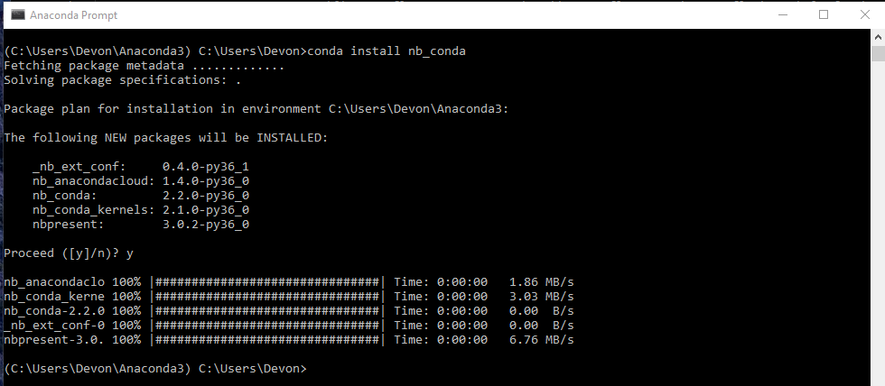
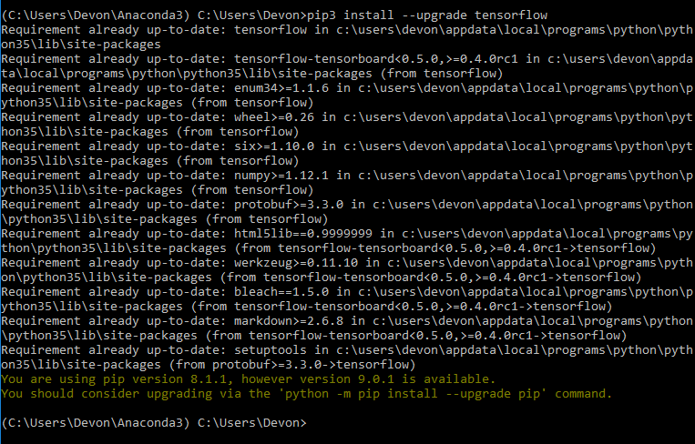

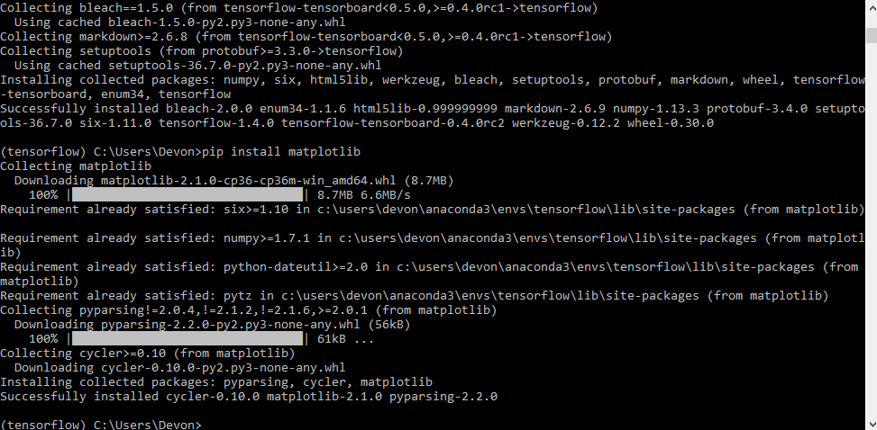
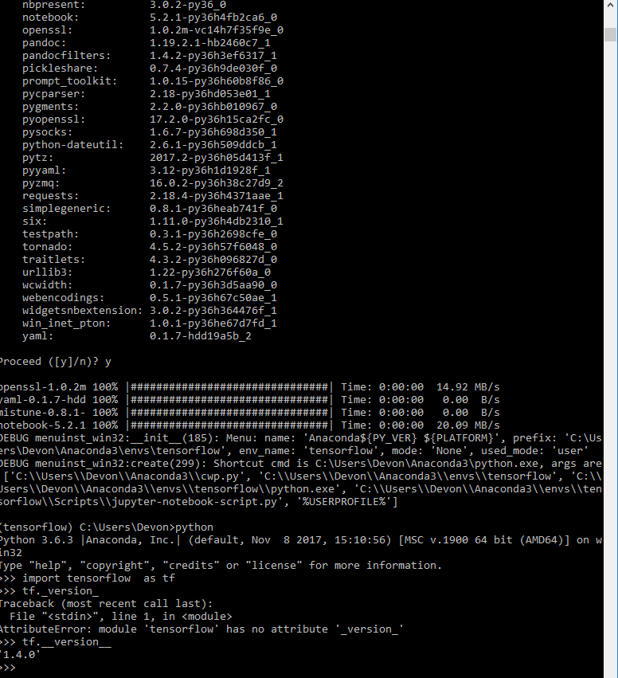eeeeeeeeeeeeeeeeeeeeeeeeeeeeeeeee

#Go to Jupyter Notebook, open 0_test_install-1 and run codes in there:
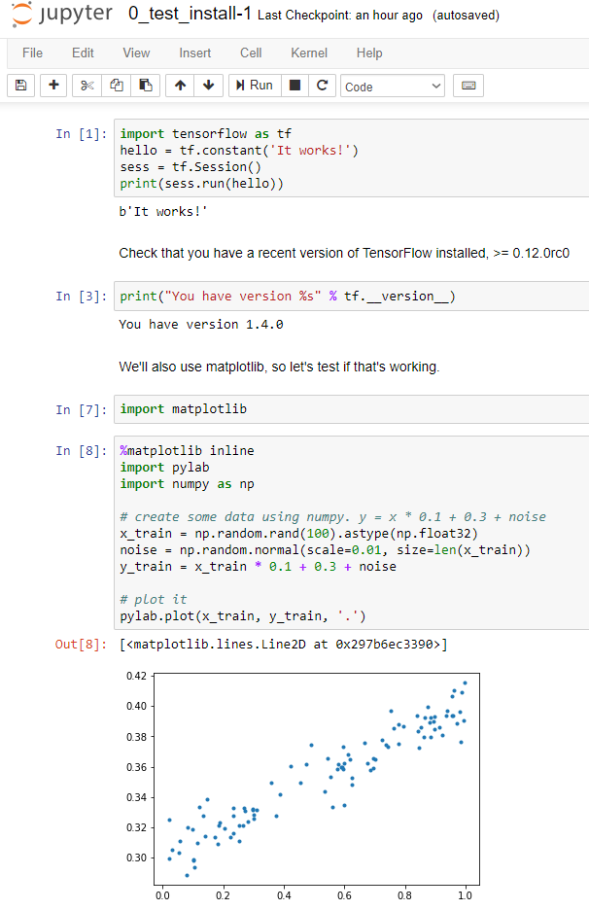
Problem 2. Construct a simple neural network (a network of logistic units) which will implement (X1 XOR X2) AND X3 function. Choose weights (-s) of all dendritic inputs and bias inputs. Demonstrate that your network works by presenting the truth table. Present your network by a simple graph. You can produce the graph in any way convenient including pan and paper. (25%)
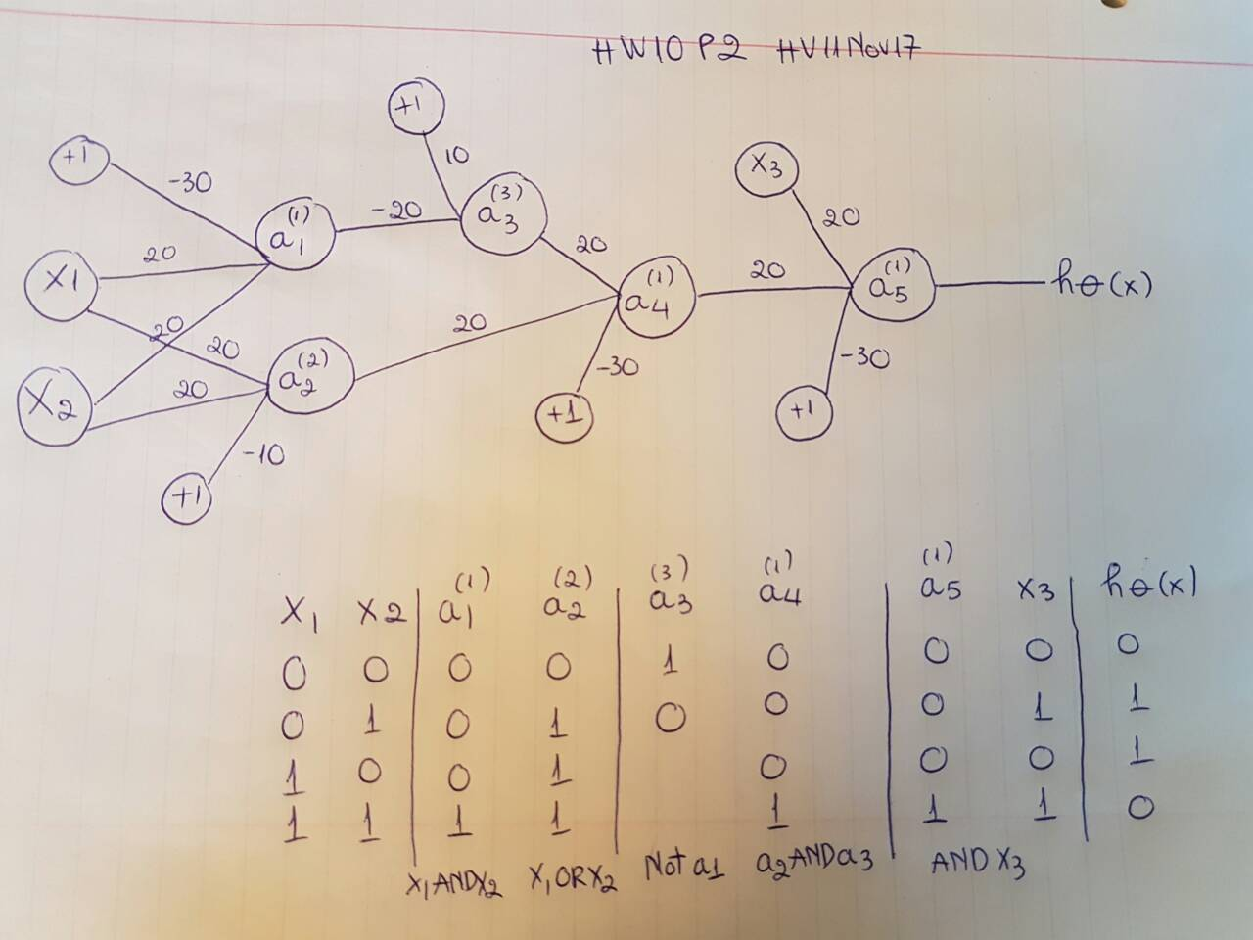

Problem 3. Determine the value of number e = 2.7183… to 6 decimal places using Taylor expansion. Export the TensorBoard graph of your process. Perform similar calculation using expression for e as . Again export the TensorBoard graph of you process. Provide working code for both approaches.
(25%)
Please look at HV10_HV_12Nov17.ipynb for problem 3 and 4 solutions
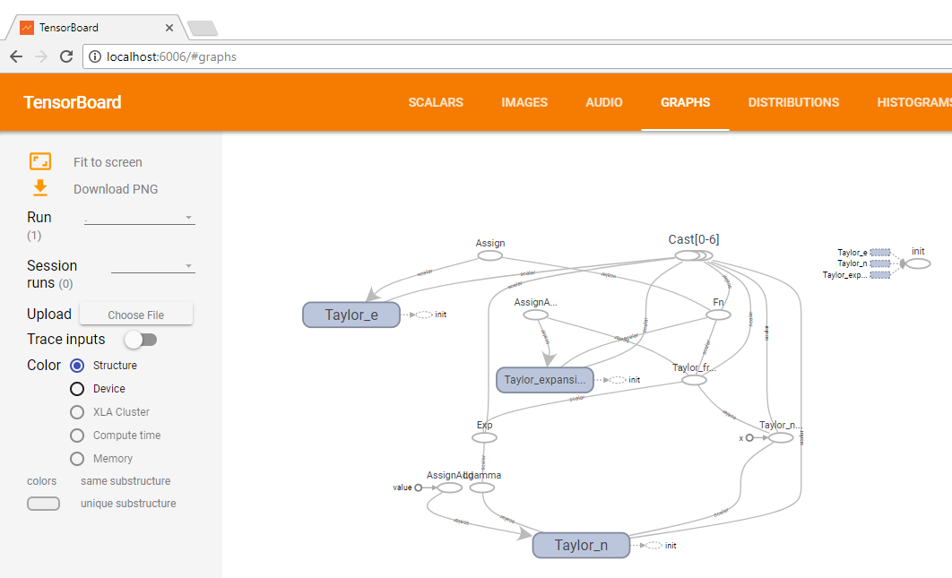

Problem 4. When I tried running code on page 63 om my notes for lecture 10, the resulting TensorBoard graph was not entirely identical with the graph on page 64. Please fix the code on page 63 in order to produce the graph identical to the graph on page 64.
(15%)
Please look at HV10_HV_12Nov17.ipynb for problem 3 and 4 solutions
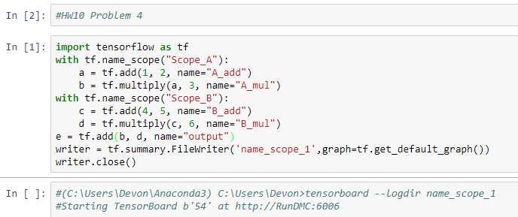
#Go to Anaconda Prompt:
(C:\Users\Devon\Anaconda3) C:\Users\Devon>cd Downloads
(C:\Users\Devon\Anaconda3) C:\Users\Devon\Downloads>tensorboard --logdir name_scope_1
#Open browser localhost:6006

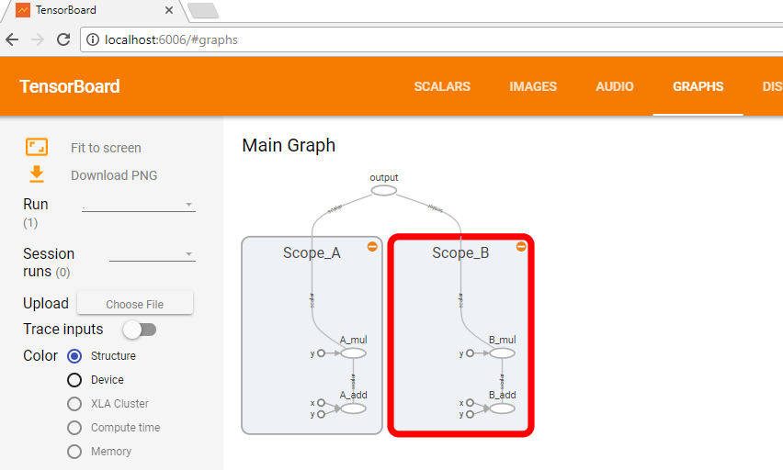

Problem 5. Please examine attached Jupyter notebook 2_linear_regression.ipynb. As you are running its cells, the notebook will complain about non-existent API calls. This notebook was written in an earlier version of TensorFlow API and some calls changed their names. Fix all code by replacing older calls with calls in TF 1.5. Uncomment all optional (print) lines. Provide a copy of this notebook with all intermediate results and the image of TensorFlow graph as captured by the TensorBoard.
(20%)
#Please look at attached file in canvas HW10P5HV.ipynb
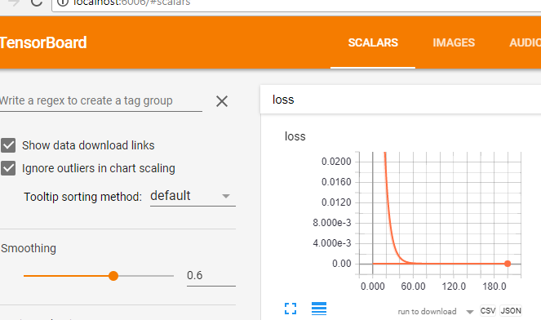
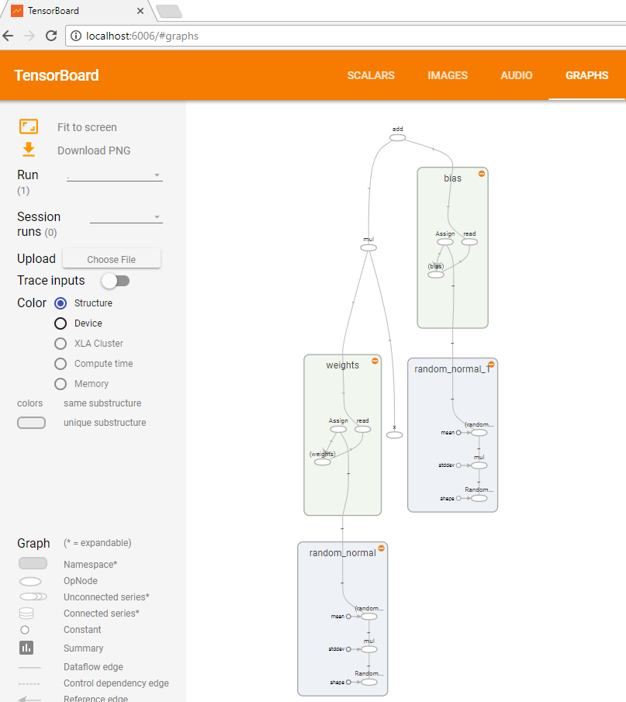

Please, describe every step of your work and present all intermediate and final results in a Word document. Please, copy past text version of all essential command and snippets of results into the Word document with explanations of the purpose of those commands. We cannot retype text that is in JPG images. Please, always submit a separate copy of the original, working scripts and/or class files you used. Sometimes we need to run your code and retyping is too costly. Please include in your MS Word document only relevant portions of the console output or output files. Sometime either console output or the result file is too long and including it into the MS Word document makes that document too hard to read. PLEASE DO NOT EMBED files into your MS Word document. For issues and comments visit the class Discussion Board.

