Student: Huynh Vo Assignment 03 E63 Big Data Analytics

Handed out: 09/15/2017 Due by 11:59 AM EST on Saturday, 09/23/2017
Problem 1. Create your own Virtual Machine with a Linux operating system. The lecture notes speak about CentOS. You are welcome to work with another Linux OS. When creating the VM, create an administrative user. Call that user whatever you feel like. Please record the password of the new user. Once the VM is created transfer the attached text file Ulysses10.txt to the home of new user. You can do it using scp (secure copy command) or email. Examine the version of Java, Python and Scala on your VM. If any of those versions is below requirements for Spark 2.2 install proper version. Set JAVA_HOME environmental variable. Set your PATH environmental variable properly, so that you can invoke: java, sbt and python commands from any directory on your system. [20%]
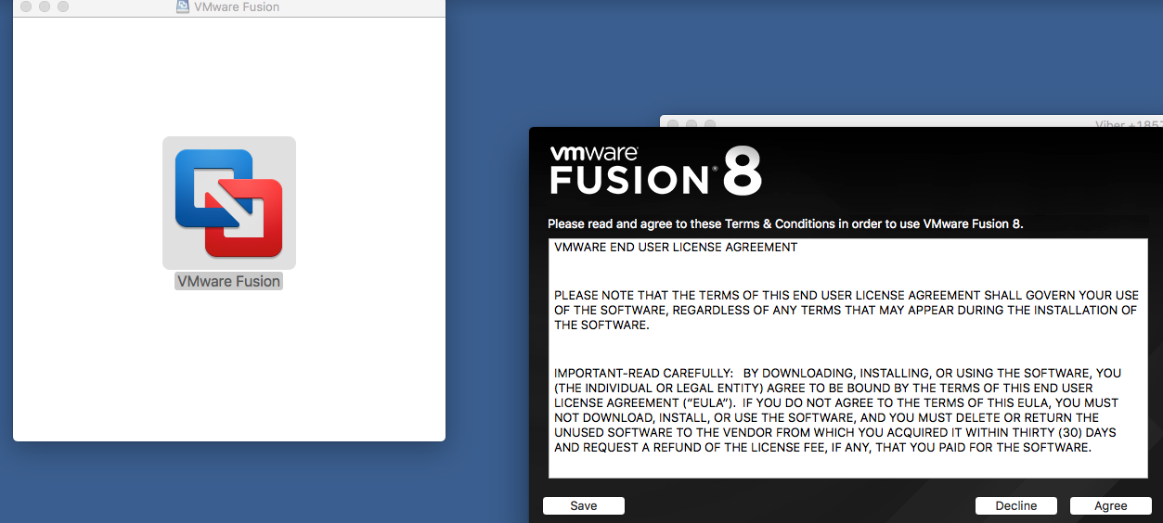

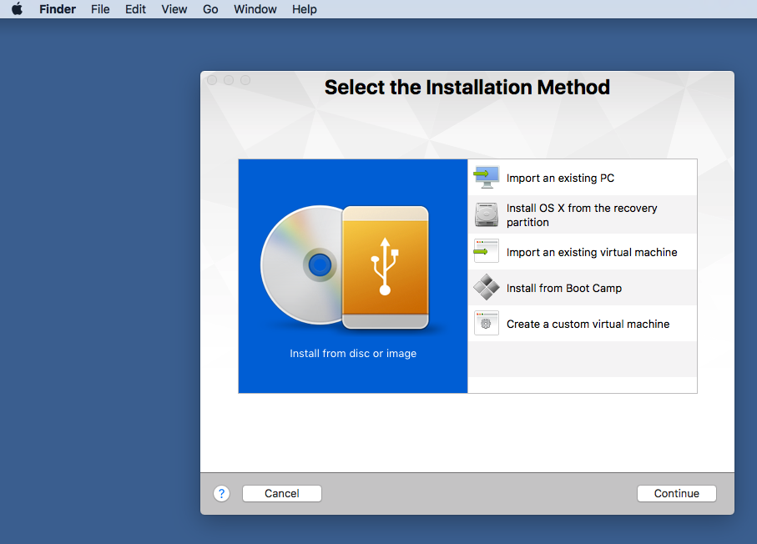
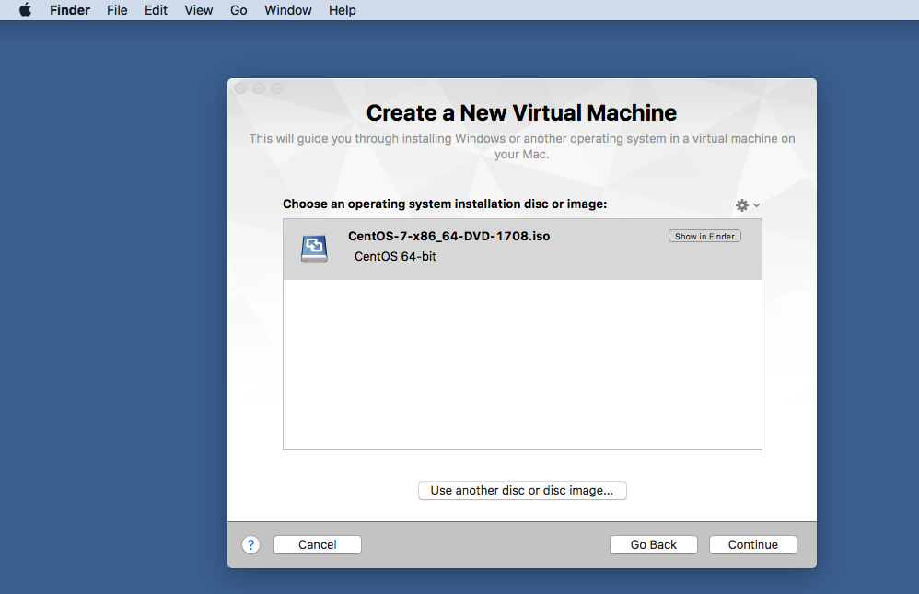
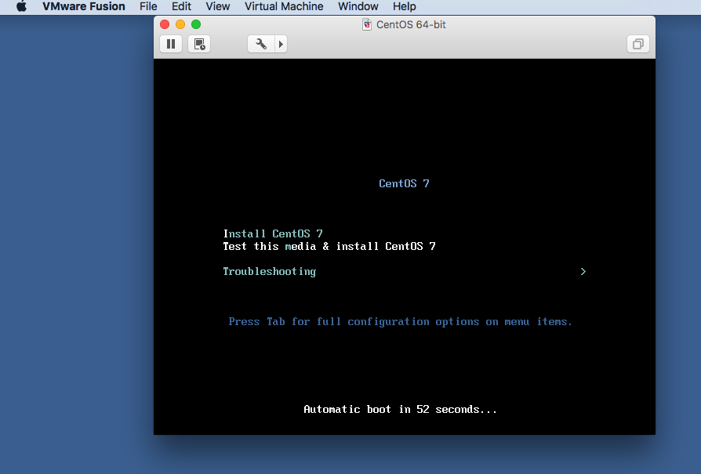
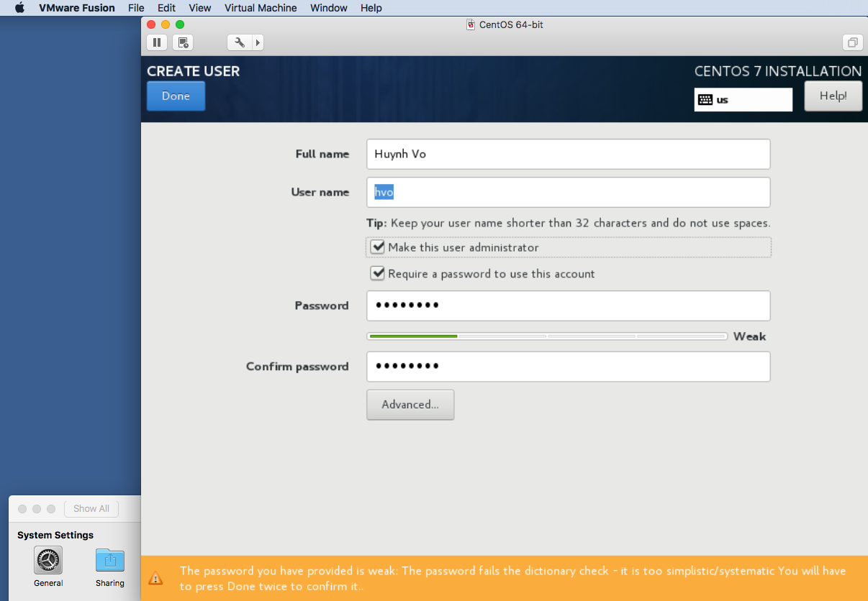

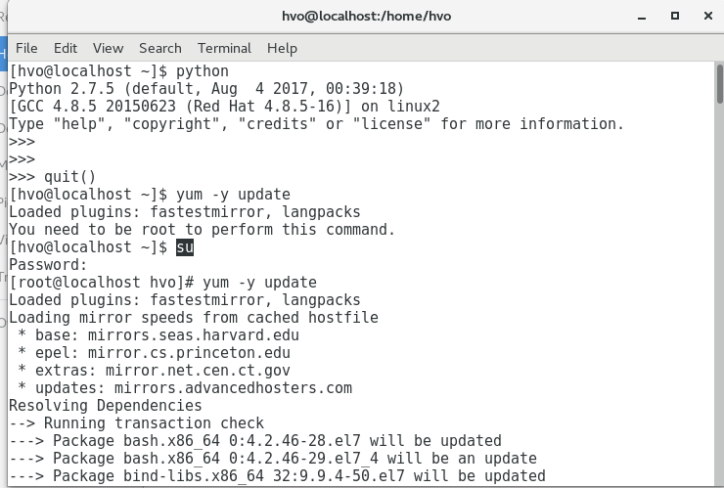


Problem 2. Install Spark 2.2 on your VM. Make sure that pyspark is also installed. Demonstrate that you can successfully open spark-shell and that you can eliminate most of WARNing messages.

Install step:

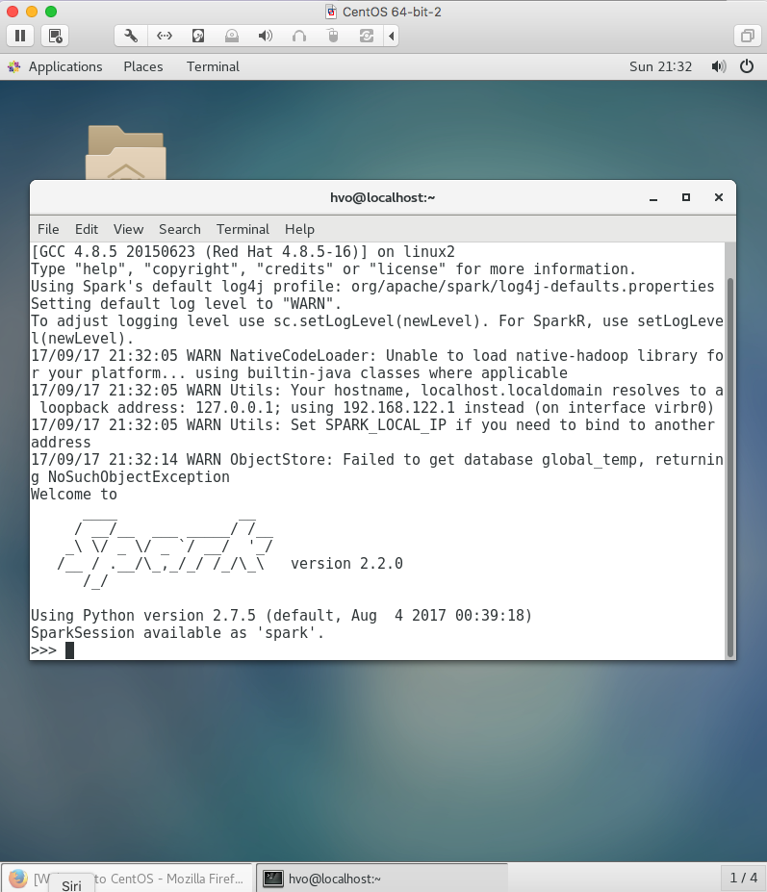

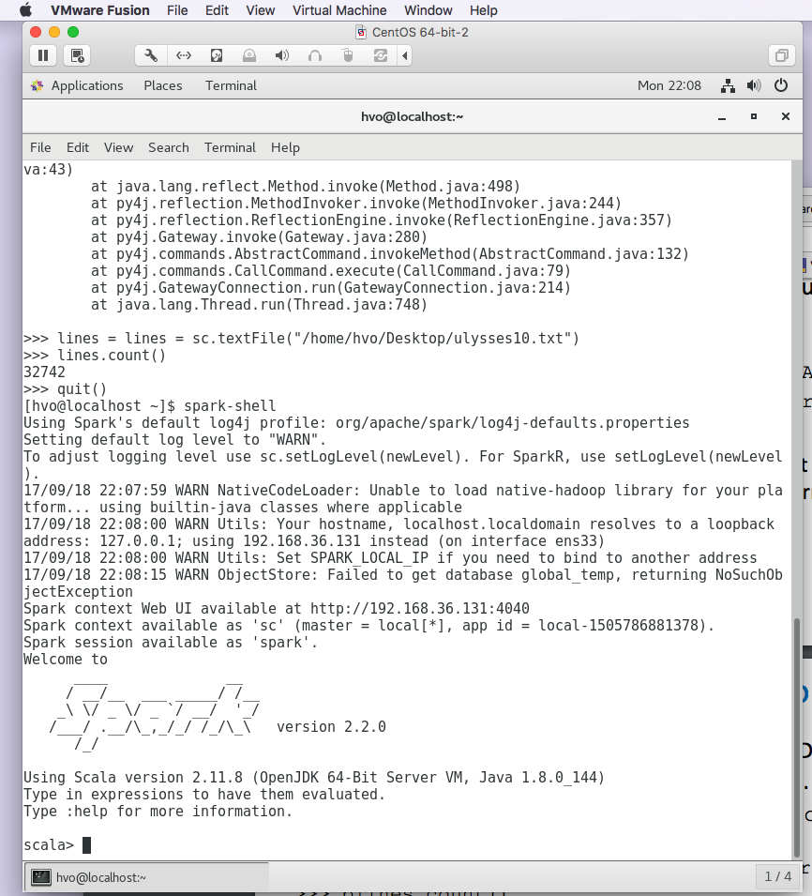

Eliminating Warning messages:

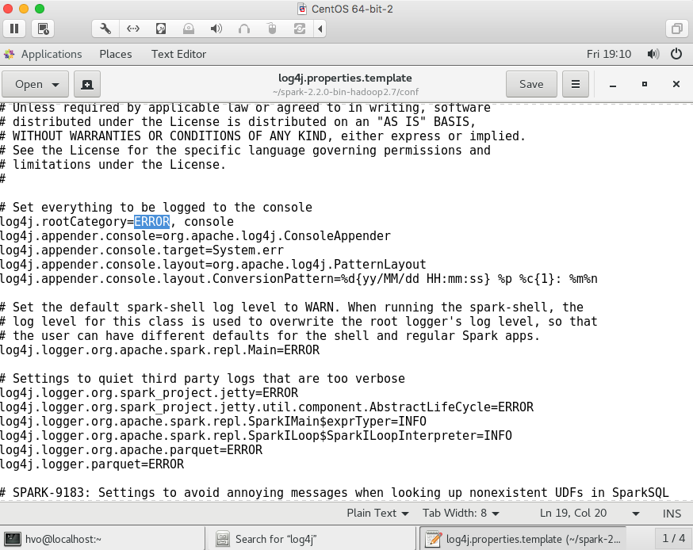

Problem 3. . Find the number of lines in the text file ulysses10.txt that contain word “afternoon” or “night” or “morning”. In this problem use RDD API.

Answer:
1st way: RDD with lambda function:
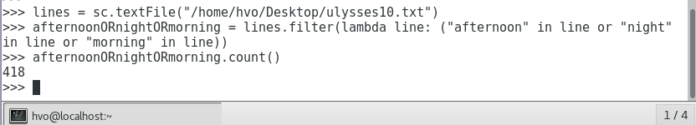

2nd way:
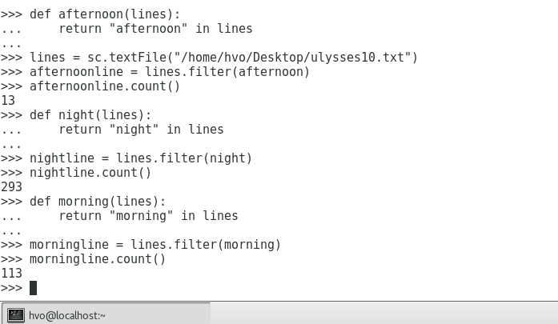

Problem 4. Implement the above task, finding the number of lines with one of those three words in file ulysses10.txt using Dataset/DataFrame API.

Dataset:
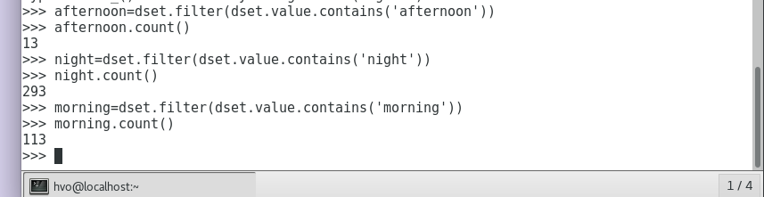
Another way: (I think…., if not, please comment so I can learn)
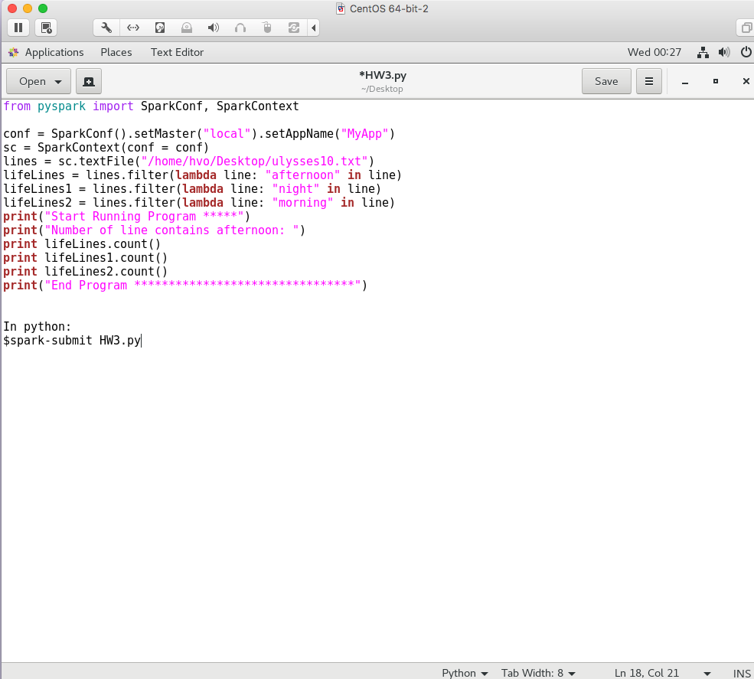

Problem 5. Create a standalone dataframe that will count all words in file ulysses10.txt. You are expected to produce a single number.
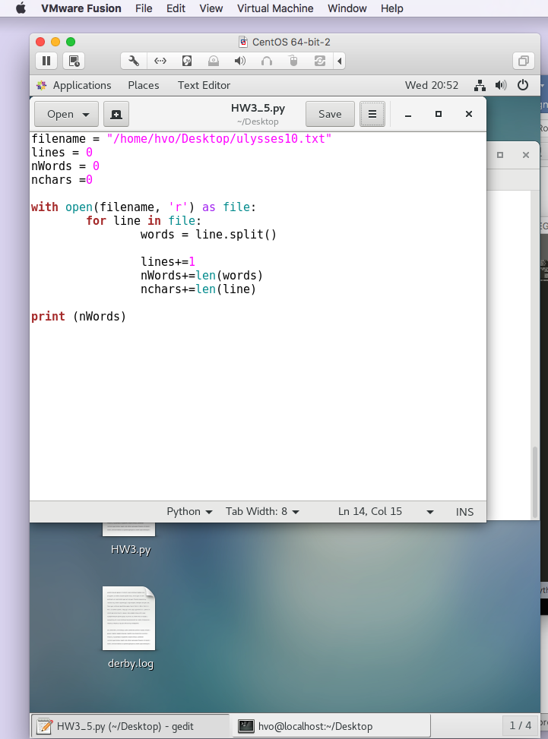
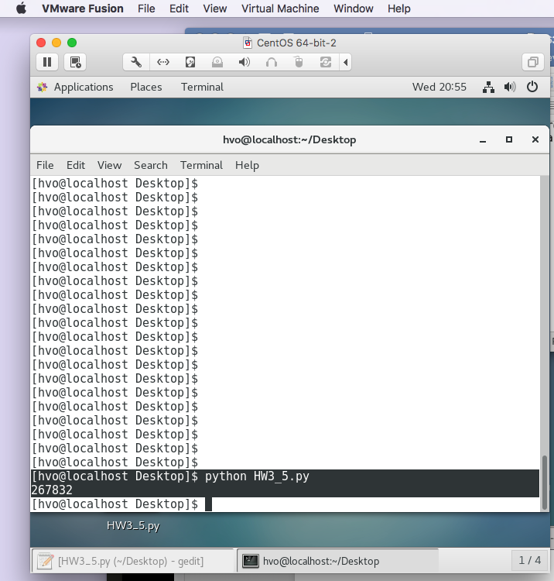

Problem 6. Create a standalone Python script that will count all words in file ulysses10.txt.

