Student: Huynh Vo
Assignment 04 E63 Big Data Analytics
Issued on: Sept 24, 2017
Problem 1. Consider two attached text files: bible.txt and 4300.txt. The first contains ASCII text of King James Bible and the other the text of James Joyce’s novel Ulysses. Use Spark transformation and action functions present in RDD API to transform those texts into RDD-s that contain words and numbers of occurrence of those words in respective text. From King James Bible,py eliminate all verse numbers of the form: 03:019:024. Eliminate from both RDDs so called “stop words”. Please use the list of stop words on Web page: http://www.lextek.com/manuals/onix/stopwords1.html. Create RDD-s that contain only words unique for each of text. Finally create an RDD that contains only the words common to both texts.
In latest RDD preserve numbers of occurrences in two texts. In other words a row in your RDD will look like (love 45 32). List for us 30 most frequent words in each RDD (text).
Print or store the words and the numbers of occurrences. Create for us the list of 20 most frequently used words common to both texts. In your report, print (store) the words, followed by the number of occurrences in Ulysses and then the Bible. Order your report in descending order starting by the number of occurrences in Ulysses. Present the same data this time ordered by the number of occurrences in the Bible. List for us a random samples containing 5% of words in the final RDD.

Answer:
#Launch pyspark
[root@localhost hvo]# cd /opt/spark/sbin
[root@localhost sbin]# sudo ./start-master.sh
[root@localhost hvo]# pyspark

#Transform RDDs that contain words and numbers of occurrence:
>>>file1RDD = sc.textFile("/home/hvo/Desktop/bible.txt")
>>>wordsfile1 = file1RDD.flatMap(lambda x: x.split(“ “))
>>> result1 = wordsfile1.map(lambda x: (x,1)).reduceByKey(lambda x, y: x+y)
>>> result1.countByValue()

>>>file2RDD = sc.textFile("/home/hvo/Desktop/ulyssesfile.txt")
>>>wordsfile2 = file2RDD.flatMap(lambda x: x.split(“ “))
>>> result2 = wordsfile1.map(lambda x: (x,1)).reduceByKey(lambda x, y: x+y)
>>> result2.countByValue()
#Remove 03:019:024
>>> import re
>>> def remove_verses(string):
... string = list(string)
... string.remove(theStr)
... string.remove([0-9]*:[0-9]*:[0-9])
... return ''.join(string)

# lowercase for letters and remove punctuation
>>> import rebible
>>> def dataPreparation(text):...
return re.sub("[s,.,?,!,W,#,@ (^a-zA-Z) ]", '', text).lower().strip()

#Split lines
>>> wordsbible = bible.map(dataPreparation).flatMap(lambda l: l.split(" ")).filter(None)
>>> wordsulyssesfile = ulyssesfile.map(dataPreparation).flatMap(lambda l: l.split(" ")).filter(None)

#Count words again
>>> countwordsbible = wordsbible.map(lambda x: (x, 1)).reduceByKey(lambda x, y: x + y)
>>> countwordsulyssesfile = wordsulyssesfile.map(lambda x: (x, 1)).reduceByKey(lambda x, y: x + y)

#Create stopwords
>>> with open('/home/hvo/Desktop/stopwords.txt') as f:
... stopwords = f.read().splitlines()
... stopwords = filter(lambda w: w[0] != '#', filter(None, stopwords))

#Eliminate stopwords in both RDDS:
>>> countwordsbible = countwordsbible.filter(lambda x : x[0] not in stopwords)
>>> countwordsulyssesfile = countwordsulyssesfile.filter(lambda x : x[0] not in stopwords

# Create for us the list of 20 most frequently used words common to both texts.
>>> countwordsbible.sortBy(lambda x : x[1], False).take(20)
>>> countwordsulyssesfile.sortBy(lambda x : x[1], False).take(20)

#Create RDD-s that contain only words unique for each of text
>>> uniquebible=countwordsbible.subtractByKey(countwordsbible)
>>> uniqueulysses = countwordsulyssesfile.subtractByKey(countwordsulyssesfile)

# Create an RDD that contains only the words common to both texts
>>> commonwords = countwordsbible.join(countwordsulyssesfile)

#List for us a random samples containing 5% of words in the final RDD
commonwords.takeSample(False, commonwords.count()/0.05)

Problem 2. Implement problem 1 using DataFrame API. You could implement this problem in a command shell or as a standalone program.

4300.txt ( I named it ulyssesfile.txt)
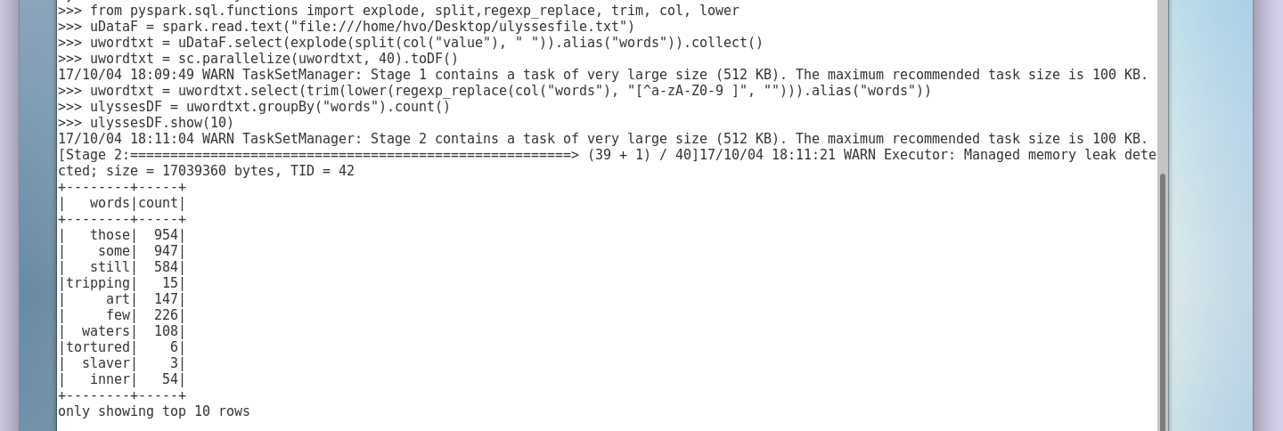
bible text

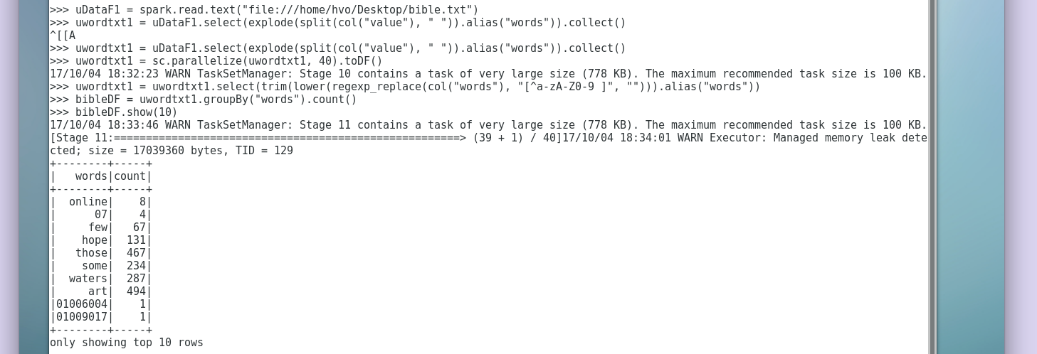

# From King James Bible, eliminate all verses number of the form 03:019:024
>>> bible=sc.textFile("file:///home/hco/Desktop/bible.txt")
>>> bible=sc.textFile("file:///home/hvo/Desktop/bible.txt")
>>> ulysses=sc.textFile("file:///home/hvo/Desktop/ulyssesfile.txt")
>>> stopwords=sc.textFile("file:///home/hvo/Desktop/stopwords.txt")
>>> bible1=bible.filter(lambda x: "[0:9]*:[0:9]*:[0:9]" in x)

#Eliminate from both RDDs so called “stop words” :
>>> stopwords= sc.textFile("file:///home/hvo/Desktop/stopwords.txt")
>>>bible2 = bible1.subtract(stopwords)
>>>print(bible2.take(30))

>>>ulysses1 = ulysses.subtract(stopwords)
>>>print(ulysses1.take(30))

#Something might also works for eliminate stopwords:
>>> stopwords = spark.read.text("file:///home/hvo/Desktop/stopwords.txt")
>>> bible = open(‘bible.txt’).read().strip(“’”).split(‘ ‘)
stopwords = open(‘stopwords.txt’).readline().split()
for i in stopwords:
if i in bible:
bible.remove(i)
new_bible = ‘ ’.join(bible)
print new_bible

>>> ulyssesfile = open(‘ulyssesfile.txt’).read().strip(“’”).split(‘ ‘)
stopwords = open(‘stopwords.txt’).readline().split()
for i in stopwords:
if i in bible:
ulyssesfile.remove(i)
new_ulyssesfile = ‘ ’.join(bible)
print new_ulyssesfile

# Create RDD-s that contain only words unique for each of text.

>>> unique_words= ulysses1.join(bible2)
>>> println(unique_words.count())
>>> unique_words.take(20).foreach(println)

#Finally, create an RDD that contains only words common to both texts, list 20.
>>>common_words = ulysses1.rightOuterJoin(bible2)
>>>println(common_words.count())
>>>common_words.take(20).foreach(println)

Problem 3. Consider attached files transactions.txt and products.txt. Each line in transactions.txt file contains a transaction date, time, customer id, product id, quantity bought and price paid, delimited with hash (#) sign. Each line in file products.txt contains product id, product name, unit price and quantity available in the store. Bring those data in Spark and organize it as DataFrames with named columns.

Find the names and total number sold of 10 most popular products. Order products once per the number sold and then by the total value (quanity*price) sold.
Pyspark
#For Transactions text file:
>>> from pyspark.sql import Row
>>> sc = spark.sparkContext
>>> transactions=sc.textFile("/home/hvo/Desktop/transactions.txt")
>>> transactions_fields = transactions.map(lambda e: e.split("#"))
>>> trans = transactions_fields.map(lambda e:Row(date = e[0], time = e[1], customerID = e[2], productID = e[3], quantity_bought = e[4], price_paid = float(e[5])))
>>> trans.collect()
>>> transDF = spark.createDataFrame(trans)
>>> transDF.show()

#For Products text file:
>>> products=sc.textFile("/home/hvo/Desktop/product.txt")
>>> products_field = products.map(lambda x: x.split("#"))
>>> prods = products_field.map(lambda x:Row(productID = x[0], product_name = x[1], unit_price = float(x[2]), quantity_vailable = int(x[3])))
>>> prods.collect()
>>> prodsDF = spark.createDataFrame(prods)
>>> prodsDF.show()

# Using either DataFrame methods or plain SQL statements find 5 customers with the largest spent on the day.
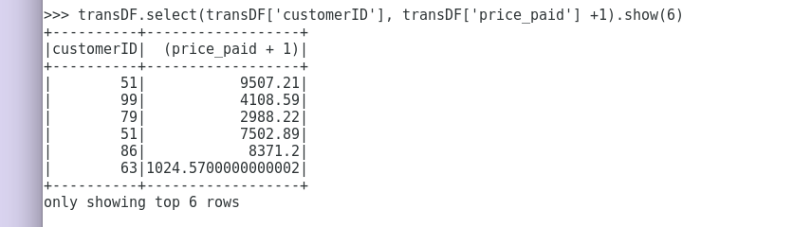

#Find the names of the products each of those 5 customers bought (5 customers with 5 customerID)

>>> type(prodsDF)
<class 'pyspark.sql.dataframe.DataFrame'>
>>> type(prods)
<class 'pyspark.rdd.PipelinedRDD'>
>>> transDF.createTempView('transDF')
>>> prodsDF.createTempView('prodsDF')
>>> sumDF=transDF.join(prodsDF, transDF.productID == prodsDF.productID)
>>> type(sumDF)
<class 'pyspark.sql.dataframe.DataFrame'>
>>> from pyspark.sql.functions import *
>>>sumDF.filter(sumDF['customerID'].like("51")).show()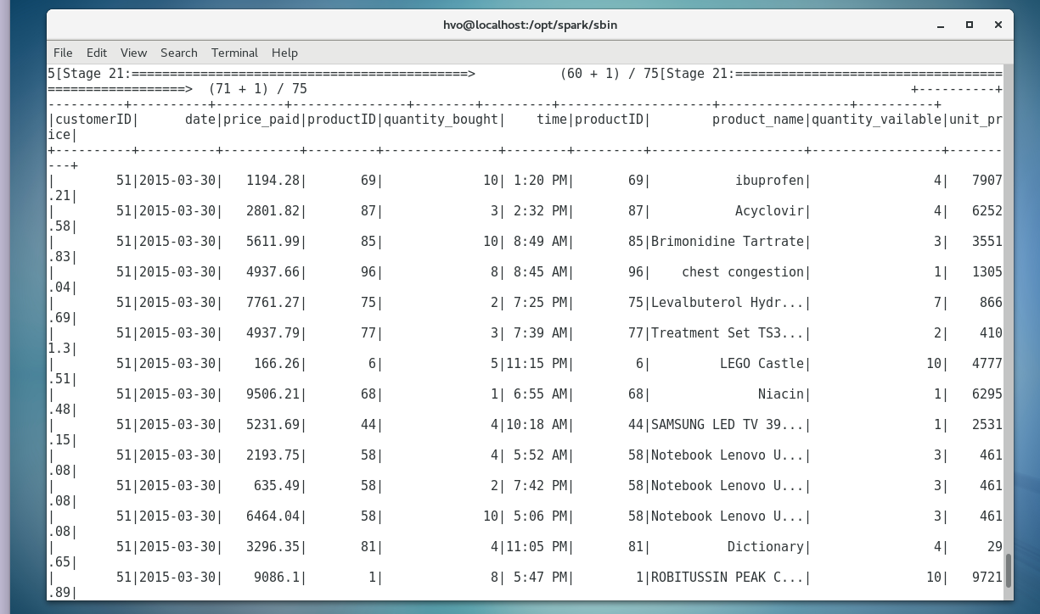

>>> sumDF.filter(sumDF['customerID'].like("99")).show()
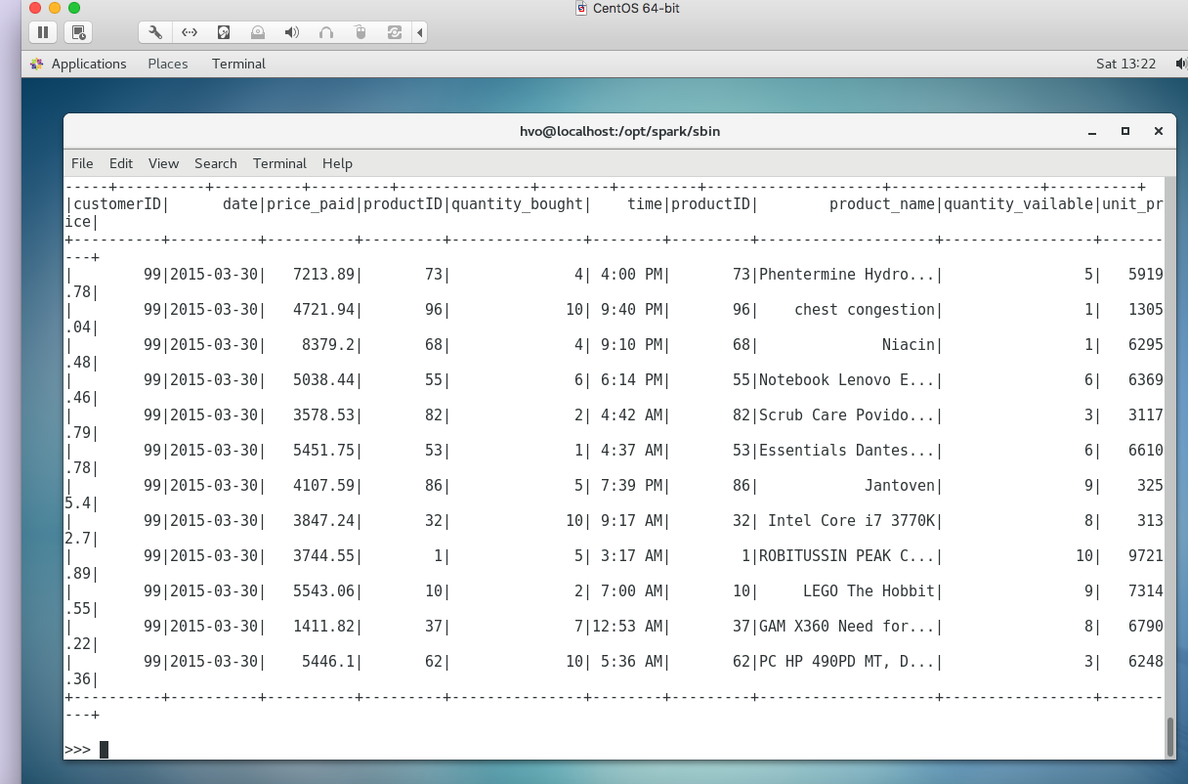

>>> sumDF.filter(sumDF['customerID'].like("79")).show()

## My computer runs really show up to this point, so I just show the remaining codes for remaining customers:

>>> sumDF.filter(sumDF['customerID'].like("86")).show()
>>> sumDF.filter(sumDF['customerID'].like("63")).show()

# Find the names and total number sold of 10 most popular products
>>> sumDF.orderBy('quantity_bought', ascending=False).show()
>>> sumDF.sort('quantity_bought', ascending=False).collect()

>>> spark.sql("Select prod.productname, sum(trans.quantity_bought) as product_count_sold from trans_tab t, prod_tab p where trans.productID=prod.productID group by prod.productName order by 2 desc, 1 desc limit 10").show(20, False)

Problem 4. Implement problem 3 using RDD APIs.
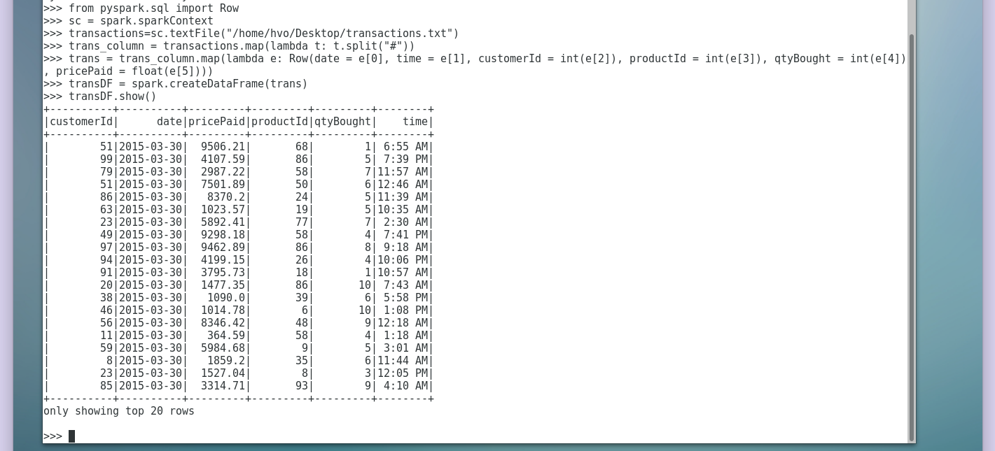

Pyspark
#For Transactions text file:
>>> from pyspark.sql import Row
>>> sc = spark.sparkContext
>>> transactions=sc.textFile("/home/hvo/Desktop/transactions.txt")
>>> transactions_fields = transactions.map(lambda e: e.split("#"))
>>> trans = transactions_fields.map(lambda e:Row(date = e[0], time = e[1], customerID = e[2], productID = e[3], quantity_bought = e[4], price_paid = float(e[5])))
>>> trans.collect()
>>>transDF = spark.createDataFrame(trans)
>>>transDF.show()

#For Products text file:
>>> products=sc.textFile("/home/hvo/Desktop/product.txt")
>>> products_field = products.map(lambda x: x.split("#"))
>>> prods = products_field.map(lambda x:Row(productID = x[0], product_name = x[1], unit_price = float(x[2]), quantity_vailable = int(x[3])))
>>> prods.collect()
>>>prodsDF = spark.createDataFrame(trans)
>>>prodsDF.show()

>>>sumDF.groupby(“product_name”).count().show()

val mostPopularProducts = sql("select count.(productID) count, productID from prods ,transDF where prodsDF.productID = transDF.productID).groupBy(transDF[‘productID’]).orderBy(count.desc").show(10)

>>> spark.sql("Select prod.productname, sum(trans.quantity_bought) as product_count_sold from trans_tab t, prod_tab p where trans.productID=prod.productID group by prod.productName order by 2 desc, 1 desc limit 10").show(20, False)

