HW1_Submission.R
HuynhVo
Sat Sep 9 11:46:41 2017
#CSCI E-63 HW1 Submission Student: Huynh Vo
#Problem 1
x <-rbinom(18,60,0.3)
y <-rbinom(30,60,0.5)
z <-rbinom(48,60,0.8)
boxplot(x, horizontal = FALSE)
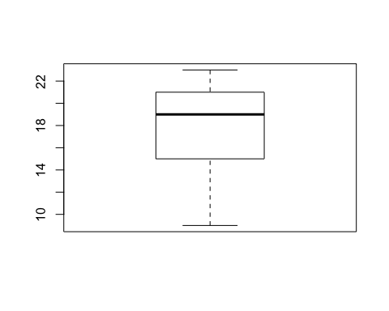
boxplot(y, horizontal = FALSE)
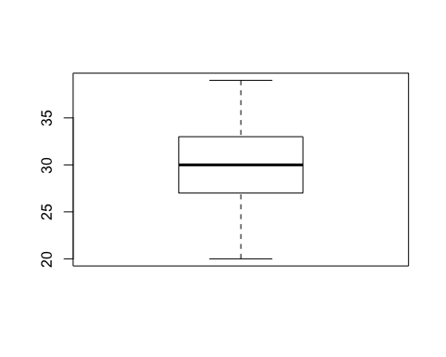
boxplot(z, horizontal = FALSE)
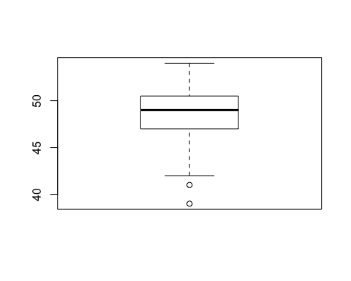
boxplot(x,y,z,horizontal = FALSE , names = c('p = 0.3','p = 0.5','p = 0.8') )
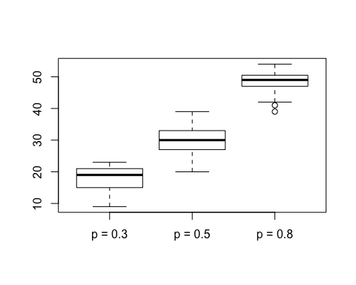
#Below are values for p = 0.3
mean(x)
## [1] 17.77778
median(x)
## [1] 19
sd(x)
## [1] 3.687109
quantile(x)
## 0% 25% 50% 75% 100%
## 9.00 15.25 19.00 20.75 23.00
#Below are values for p = 0.5
mean(y)
## [1] 30.3
median(y)
## [1] 30
sd(y)
## [1] 4.519307
quantile(y)
## 0% 25% 50% 75% 100%
## 20 27 30 33 39
#Below are values for p = 0.8
mean(z)
## [1] 48.29167
median(z)
## [1] 49
sd(z)
## [1] 3.168719
quantile(z)
## 0% 25% 50% 75% 100%
## 39.00 47.00 49.00 50.25 54.00
#Problem 2
head(faithful)
## eruptions waiting
## 1 3.600 79
## 2 1.800 54
## 3 3.333 74
## 4 2.283 62
## 5 4.533 85
## 6 2.883 55
duration = faithful$eruptions
waiting = faithful$waiting
plot(duration, waiting, xlab = "Eruption duration", ylab = "Time waited")
model = lm(waiting ~ duration, data = faithful)
abline(model, col = 'blue', lwd = 2)
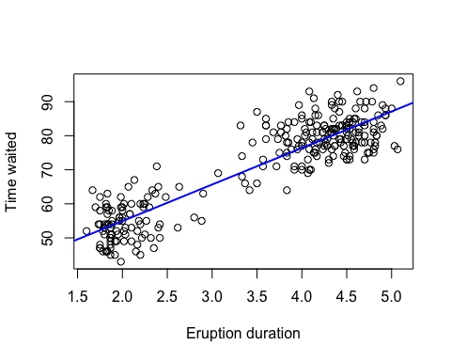
help(lm)
help(abline)
#Problem 3
cov(duration, waiting)
## [1] 13.97781
eigenValues <-eigen(cov(duration, waiting))$values
eigenVectors <- eigen(cov(duration, waiting))$vectors
poly(duration,waiting)
## 1.0 0.1
## [1,] 0.0059723704 0.0362059266
## [2,] -0.0898266195 -0.0755001989
## [3,] -0.0082378131 0.0138647015
## [4,] -0.0641205572 -0.0397542388
## [5,] 0.0556281803 0.0630153967
## [6,] -0.0321875606 -0.0710319539
## [7,] 0.0645161977 0.0764201317
## [8,] 0.0059723704 0.0630153967
## [9,] -0.0818433704 -0.0889049340
## [10,] 0.0458886163 0.0630153967
## [11,] -0.0880703047 -0.0755001989
## [12,] 0.0228436370 0.0585471516
## [13,] 0.0379053671 0.0317376815
## [14,] -0.0924877026 -0.1067779141
## [15,] 0.0645161977 0.0540789066
## [16,] -0.0702942699 -0.0844366890
## [17,] -0.0924877026 -0.0397542388
## [18,] 0.0698383638 0.0585471516
## [19,] -0.1004709518 -0.0844366890
## [20,] 0.0405664502 0.0362059266
## [21,] -0.0898266195 -0.0889049340
## [22,] -0.0924877026 -0.1067779141
## [23,] -0.0020108787 0.0317376815
## [24,] -0.0223947749 -0.0084765236
## [25,] 0.0556281803 0.0138647015
## [26,] 0.0059723704 0.0540789066
## [27,] -0.0809386021 -0.0710319539
## [28,] 0.0316784328 0.0228011915
## [29,] 0.0192777857 0.0317376815
## [30,] 0.0503060142 0.0362059266
## [31,] 0.0432275332 0.0093964564
## [32,] 0.0521155506 0.0272694365
## [33,] -0.0064282766 -0.0218812587
## [34,] 0.0290173497 0.0406741716
## [35,] 0.0183730175 0.0138647015
## [36,] -0.0782775191 -0.0844366890
## [37,] -0.0862607682 -0.1023096690
## [38,] 0.0715946786 0.0406741716
## [39,] -0.0880703047 -0.0531589738
## [40,] 0.0689335955 0.0853566218
## [41,] 0.0458886163 0.0406741716
## [42,] -0.0854092217 -0.0576272189
## [43,] 0.0574377167 0.0585471516
## [44,] -0.0924877026 -0.0576272189
## [45,] 0.0556281803 0.0093964564
## [46,] -0.0090893596 0.0540789066
## [47,] 0.0183730175 -0.0308177487
## [48,] -0.0738601212 -0.0799684439
## [49,] 0.0609503464 0.0496106616
## [50,] -0.0791822873 -0.0531589738
## [51,] 0.0698383638 0.0183329465
## [52,] 0.0653677442 0.0853566218
## [53,] -0.0880703047 -0.0755001989
## [54,] 0.0715946786 0.0406741716
## [55,] -0.0933924708 -0.0755001989
## [56,] 0.0742557616 0.0540789066
## [57,] 0.0121993048 0.0004599664
## [58,] -0.0969051005 -0.0308177487
## [59,] 0.0574377167 0.0272694365
## [60,] 0.0441323015 0.0451424166
## [61,] -0.0667816403 -0.0531589738
## [62,] 0.0538718654 0.0585471516
## [63,] -0.0924877026 -0.1023096690
## [64,] 0.0698383638 0.0496106616
## [65,] -0.0889218513 -0.0486907288
## [66,] 0.0485496993 0.0942931118
## [67,] 0.0361490523 0.0317376815
## [68,] 0.0645161977 0.0317376815
## [69,] -0.0756164360 -0.0263495037
## [70,] 0.0645161977 0.0093964564
## [71,] 0.0290173497 0.0496106616
## [72,] -0.0809386021 -0.0665637089
## [73,] 0.0538718654 0.0362059266
## [74,] 0.0272610349 0.0004599664
## [75,] -0.0800870556 -0.0397542388
## [76,] 0.0840485473 0.0228011915
## [77,] -0.0782775191 -0.0486907288
## [78,] 0.0574377167 0.0317376815
## [79,] 0.0210341005 0.0228011915
## [80,] 0.0059723704 0.0540789066
## [81,] 0.0343395158 0.0183329465
## [82,] 0.0449838480 0.0496106616
## [83,] 0.0325832010 -0.0040082786
## [84,] -0.0454929758 -0.0263495037
## [85,] 0.0308268862 0.0093964564
## [86,] 0.0769168447 0.0764201317
## [87,] 0.0245999518 0.0228011915
## [88,] 0.0547766337 0.0406741716
## [89,] -0.0702942699 -0.1023096690
## [90,] 0.0272610349 0.0674836417
## [91,] -0.0685379551 -0.0486907288
## [92,] 0.0449838480 0.0853566218
## [93,] -0.0862607682 -0.0933731790
## [94,] 0.0707431320 0.0317376815
## [95,] -0.0880703047 -0.0352859938
## [96,] 0.0432275332 0.0049282114
## [97,] 0.0627598828 0.0585471516
## [98,] 0.0139556196 0.0183329465
## [99,] -0.0862607682 -0.0889049340
## [100,] 0.0751605299 0.0496106616
## [101,] -0.0534762250 -0.0397542388
## [102,] 0.0467933845 0.0764201317
## [103,] -0.0738601212 -0.0978414240
## [104,] 0.0538718654 0.0540789066
## [105,] 0.0299221179 0.0451424166
## [106,] -0.0862607682 -0.1067779141
## [107,] 0.0645161977 0.0585471516
## [108,] -0.0907313878 -0.0844366890
## [109,] 0.0724994468 0.0674836417
## [110,] 0.0103897683 0.0451424166
## [111,] 0.0662725125 0.0183329465
## [112,] -0.0632157890 -0.0531589738
## [113,] 0.0751605299 0.0808883767
## [114,] 0.0494544676 0.0362059266
## [115,] -0.0951487857 -0.0531589738
## [116,] 0.0609503464 0.0451424166
## [117,] -0.0623110208 -0.0933731790
## [118,] 0.0591940316 0.0630153967
## [119,] -0.0889218513 -0.0531589738
## [120,] 0.0494544676 0.0719518867
## [121,] -0.0463445224 -0.0799684439
## [122,] 0.0308268862 -0.0084765236
## [123,] 0.0405664502 0.0272694365
## [124,] -0.0809386021 -0.0665637089
## [125,] 0.0591940316 0.0764201317
## [126,] 0.0148603879 0.0451424166
## [127,] -0.0835996852 -0.1157144041
## [128,] 0.0538718654 0.0496106616
## [129,] -0.0649721038 -0.0710319539
## [130,] 0.0618551146 0.0853566218
## [131,] -0.0862607682 -0.1157144041
## [132,] 0.0361490523 0.0540789066
## [133,] -0.0366049584 -0.0665637089
## [134,] 0.0449838480 0.0808883767
## [135,] -0.0880703047 -0.1112461591
## [136,] 0.0476449311 0.0496106616
## [137,] -0.0854092217 -0.0889049340
## [138,] 0.0769168447 0.0674836417
## [139,] -0.0774259725 -0.0799684439
## [140,] 0.0130508514 0.0362059266
## [141,] 0.0396616819 0.0451424166
## [142,] -0.0667816403 -0.0486907288
## [143,] 0.0556281803 0.0496106616
## [144,] 0.0707431320 0.0272694365
## [145,] 0.0449838480 0.0228011915
## [146,] -0.0800870556 -0.0531589738
## [147,] 0.0609503464 0.0406741716
## [148,] -0.0782775191 -0.0978414240
## [149,] 0.0858048621 0.1121660919
## [150,] -0.0898266195 -0.0799684439
## [151,] 0.0822390108 0.0272694365
## [152,] 0.0272610349 0.0272694365
## [153,] -0.0578936229 -0.0263495037
## [154,] 0.0591940316 0.0451424166
## [155,] 0.0042160556 0.0004599664
## [156,] 0.0272610349 -0.0040082786
## [157,] 0.0538718654 0.0451424166
## [158,] 0.0316784328 0.0987613568
## [159,] -0.0898266195 -0.0799684439
## [160,] 0.0255047201 0.0808883767
## [161,] -0.0685379551 -0.1157144041
## [162,] 0.0352442841 0.0674836417
## [163,] -0.0791822873 -0.0576272189
## [164,] 0.0183730175 0.0317376815
## [165,] 0.0006502043 -0.0218812587
## [166,] 0.0582892633 0.0228011915
## [167,] -0.0596499377 -0.0352859938
## [168,] 0.0804826960 0.0764201317
## [169,] -0.0827481386 -0.0844366890
## [170,] 0.0600987998 0.0987613568
## [171,] -0.0835996852 -0.0978414240
## [172,] -0.0747648895 -0.0620954639
## [173,] 0.0582892633 0.0272694365
## [174,] -0.0082378131 -0.0129447687
## [175,] 0.0361490523 0.0451424166
## [176,] 0.0449838480 0.0451424166
## [177,] 0.0538718654 0.0093964564
## [178,] -0.0569888546 -0.0933731790
## [179,] 0.0272610349 0.0630153967
## [180,] 0.0361490523 0.0138647015
## [181,] -0.0854092217 -0.0710319539
## [182,] 0.0582892633 0.0272694365
## [183,] 0.0405664502 0.0540789066
## [184,] 0.0148603879 0.0540789066
## [185,] -0.0774259725 -0.0889049340
## [186,] 0.0503060142 0.0317376815
## [187,] 0.0316784328 0.0585471516
## [188,] -0.0880703047 -0.1112461591
## [189,] 0.0494544676 0.0540789066
## [190,] -0.0694427233 -0.0710319539
## [191,] 0.0698383638 0.0451424166
## [192,] -0.0880703047 -0.0620954639
## [193,] 0.0698383638 0.0228011915
## [194,] 0.0325832010 0.0585471516
## [195,] 0.0254514984 0.0272694365
## [196,] 0.0396616819 0.0451424166
## [197,] 0.0006502043 0.0719518867
## [198,] 0.0467401629 0.0272694365
## [199,] -0.0658768720 -0.0889049340
## [200,] 0.0627598828 0.0317376815
## [201,] -0.0738601212 -0.0486907288
## [202,] 0.0458886163 0.0496106616
## [203,] 0.0343395158 0.0898248668
## [204,] -0.0862607682 -0.0799684439
## [205,] 0.0591940316 0.0317376815
## [206,] -0.0907313878 -0.1112461591
## [207,] 0.0467933845 0.0272694365
## [208,] 0.0192777857 0.0585471516
## [209,] -0.0827481386 -0.0978414240
## [210,] 0.0538718654 0.0540789066
## [211,] -0.0587983911 0.0004599664
## [212,] 0.0645161977 0.0406741716
## [213,] -0.0862607682 -0.0978414240
## [214,] 0.0183730175 0.0183329465
## [215,] -0.0037671935 -0.0308177487
## [216,] 0.0396616819 0.0228011915
## [217,] -0.0578936229 -0.0799684439
## [218,] 0.0698383638 0.1032296018
## [219,] -0.0791822873 -0.0710319539
## [220,] 0.0352442841 0.0228011915
## [221,] -0.0862607682 -0.0933731790
## [222,] 0.0414712184 0.0496106616
## [223,] -0.0924877026 -0.0755001989
## [224,] 0.0529670972 0.0183329465
## [225,] 0.0272610349 0.0317376815
## [226,] 0.0334879692 0.0362059266
## [227,] 0.0316784328 0.0317376815
## [228,] 0.0414712184 0.0317376815
## [229,] 0.0228436370 -0.0040082786
## [230,] 0.0565329485 0.0362059266
## [231,] 0.0316784328 -0.0040082786
## [232,] -0.0569888546 -0.0755001989
## [233,] 0.0370005989 0.0674836417
## [234,] -0.0676331869 -0.0933731790
## [235,] 0.0512107824 0.0853566218
## [236,] -0.0854092217 -0.0755001989
## [237,] -0.0871655365 -0.0755001989
## [238,] 0.0423227650 0.0272694365
## [239,] 0.0245999518 0.0362059266
## [240,] -0.0614594742 -0.0308177487
## [241,] 0.0352442841 0.0183329465
## [242,] -0.0605547059 -0.1067779141
## [243,] 0.0769168447 0.0674836417
## [244,] -0.0312827923 -0.0352859938
## [245,] 0.0582892633 0.0630153967
## [246,] 0.0183730175 0.0496106616
## [247,] -0.0747648895 -0.0620954639
## [248,] 0.0467933845 0.0496106616
## [249,] -0.0721038064 -0.0174130137
## [250,] 0.0458886163 0.0138647015
## [251,] -0.0685379551 -0.0755001989
## [252,] 0.0512107824 0.0540789066
## [253,] 0.0042160556 0.0093964564
## [254,] 0.0538718654 0.0093964564
## [255,] 0.0352442841 0.0764201317
## [256,] 0.0175214709 0.0406741716
## [257,] 0.0228436370 0.0004599664
## [258,] 0.0512107824 0.0540789066
## [259,] -0.0791822873 -0.0665637089
## [260,] 0.0423227650 0.0362059266
## [261,] 0.0680820490 0.0317376815
## [262,] 0.0556281803 0.0585471516
## [263,] -0.0871655365 -0.0576272189
## [264,] 0.0405664502 0.0540789066
## [265,] -0.0800870556 -0.1246508941
## [266,] -0.0658768720 -0.0486907288
## [267,] 0.0671772807 0.0183329465
## [268,] 0.0334879692 0.0451424166
## [269,] -0.0711990382 -0.1112461591
## [270,] 0.0494544676 0.0853566218
## [271,] -0.0889218513 -0.1112461591
## [272,] 0.0521155506 0.0138647015
## attr(,"degree")
## [1] 1 1
## attr(,"coefs")
## attr(,"coefs")[[1]]
## attr(,"coefs")[[1]]$alpha
## [1] 3.487783
##
## attr(,"coefs")[[1]]$norm2
## [1] 1.0000 272.0000 353.0394
##
##
## attr(,"coefs")[[2]]
## attr(,"coefs")[[2]]$alpha
## [1] 70.89706
##
## attr(,"coefs")[[2]]$norm2
## [1] 1.00 272.00 50087.12
##
##
## attr(,"class")
## [1] "poly" "matrix"
# Yes the 2 vectors are orthogonal.
#Problem 4
faithful$type <- duration <3.1
type <- faithful$type
boxplot(waiting ~ type, data = faithful, names = c('short', 'long'))
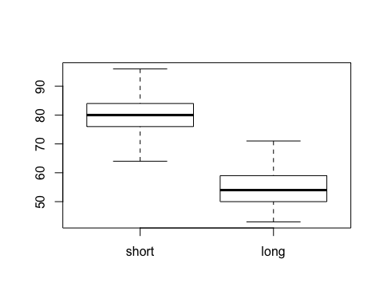
#Problem 5
#This is 1st distribution
a <- rnorm(4000, mean=0, sd=1)
b <- matrix(a,nrow=100, ncol=40)
hist(b)
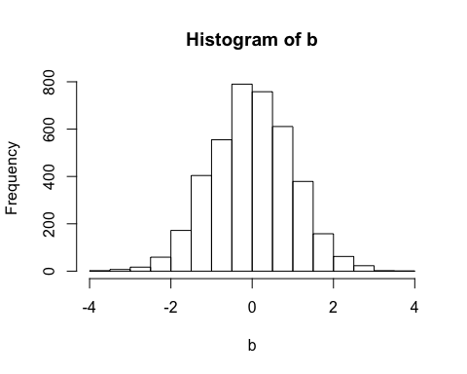
plot(density(b))
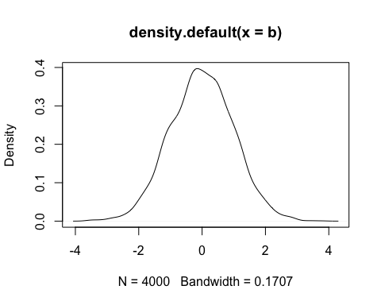
#This is 2nd distribution
c <- rnorm(4000, mean=0, sd=1)
d <- matrix(c,nrow=100, ncol=40)
hist(d)
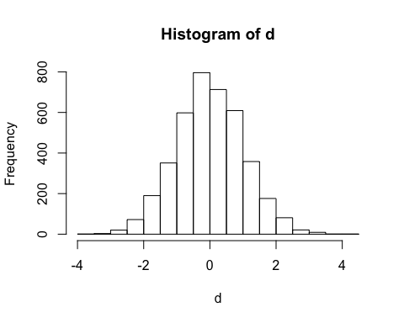
plot(density(d))
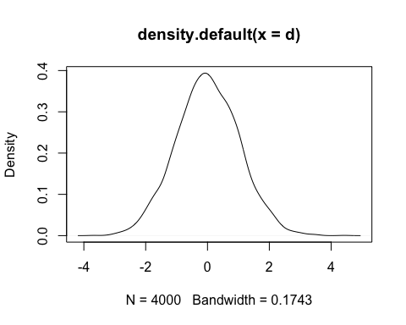
#The 2 above distributions are close to uniform.
#Problem 6
tab <- cbind(b, Total = rowSums(b))
hist(tab)
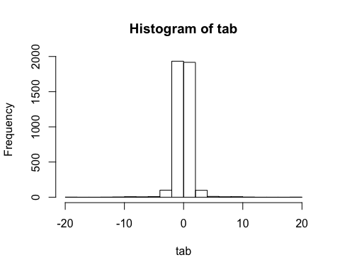
plot(density(tab))
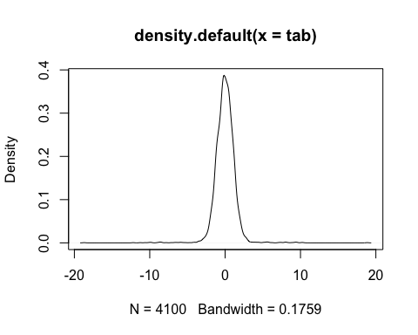
#Yes, the new distribution resembles the Gaussian curve.

