1250080198 Huỳnh Xuân Tình 12_ĐH_CNTT4
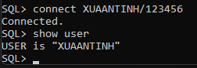

MỤC LỤC
HƯỚNG DẪN BÀI 1 – VIEW 2
Câu 1.1: Tạo view vw_course_summary - thông tin tổng quan môn học 2
Câu 1.2: Tạo view vw_student_status - thông tin sinh viên và tình trạng học tập 3
Câu 1.3: Tạo view vw_class_availability - lớp học còn chỗ trống 4
Câu 1.4: Tạo view vw_top_courses - chỉ đọc, top 5 môn được đăng ký nhiều nhất 6
Câu 1.5: Tạo view vw_pending_enrollment với WITH CHECK OPTION và kiểm 7
HƯỚNG DẪN BÀI 2 - STORED PROCEDURE 9
Câu 2.1: Thủ tục enroll_student - đăng ký sinh viên vào lớp học 9
Câu 2.2: Thủ tục update_final_grade - cập nhật điểm tổng kết 12
Câu 2.3: Thủ tục transfer_student - chuyển lớp cho sinh viên 16
Câu 2.4: Thủ tục report_class_detail — in báo cáo chi tiết lớp học 20
Câu 2.5: Thủ tục sync_grade_from_enrollment - đồng bộ điểm từ ENROLLMENT 25
HƯỚNG DẪN BÀI 3 – TRIGGER 29
Câu 3.1: Trigger trg_check_capacity - kiểm tra sức chứa khi đăng ký 29
Câu 3.2: Trigger trg_grade_audit_log - ghi nhật ký thay đổi điểm 31
Câu 3.3: Trigger trg_prevent_course_delete - ngăn xóa môn học đang có lớp 32
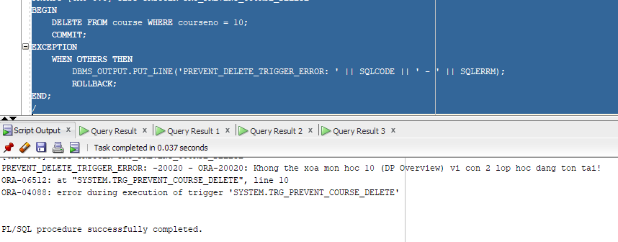 Câu 3.4: Trigger trg_update_grade_summary - cập nhật bảng thống kê tự động 33
HƯỚNG DẪN BÀI 4 - TỔNG HỢP 38
Câu 4.1: Hệ thống báo cáo hoàn chỉnh - View + Procedure + Cursor 38
Tao view vw_instructor_workload 38
Procedure print_system_report 39

HƯỚNG DẪN BÀI 1 – VIEW

Câu 1.1: Tạo view vw_course_summary - thông tin tổng quan môn học
CREATE OR REPLACE VIEW vw_course_summary AS
SELECT co.courseno,
co.description,
co.cost,
COUNT(DISTINCT cl.classid) AS so_lop,
COUNT(e.studentid) AS tong_sv
FROM course co
LEFT JOIN class cl
ON co.courseno = cl.courseno
LEFT JOIN enrollment e
ON cl.classid = e.classid
GROUP BY co.courseno, co.description, co.cost;

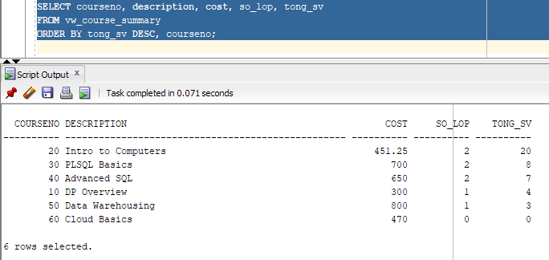

Câu 1.2: Tạo view vw_student_status - thông tin sinh viên và tình trạng học tập
CREATE OR REPLACE VIEW vw_student_status AS
SELECT s.studentid,
s.firstname || ' ' || s.lastname AS ho_ten,
COUNT(e.classid) AS so_lop_hoc,
NVL(SUM(co.cost), 0) AS tong_hoc_phi,
ROUND(AVG(e.finalgrade), 2) AS diem_tb
FROM student s
JOIN enrollment e
ON s.studentid = e.studentid
JOIN class cl
ON e.classid = cl.classid
JOIN course co
ON cl.courseno = co.courseno
GROUP BY s.studentid, s.firstname, s.lastname
HAVING COUNT(e.classid) >= 1;

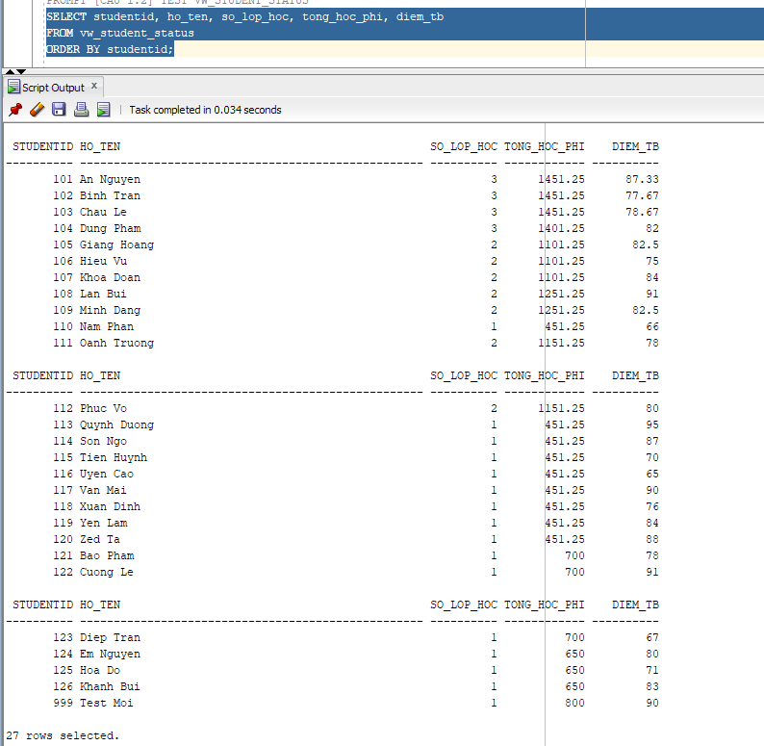

Câu 1.3: Tạo view vw_class_availability - lớp học còn chỗ trống

CREATE OR REPLACE VIEW vw_class_availability AS
SELECT cl.classid,
cl.courseno,
co.description,
i.firstname || ' ' || i.lastname AS ten_giao_vien,
cl.capacity,
COUNT(e.studentid) AS so_da_dk,
cl.capacity - COUNT(e.studentid) AS cho_trong,
CASE
WHEN cl.capacity - COUNT(e.studentid) > 0 THEN 'Con cho'
ELSE 'Het cho'
END AS trang_thai
FROM class cl
JOIN course co
ON cl.courseno = co.courseno
JOIN instructor i
ON cl.instructorid = i.instructorid
LEFT JOIN enrollment e
ON cl.classid = e.classid
GROUP BY cl.classid,
cl.courseno,
co.description,
i.firstname,
i.lastname,
cl.capacity
HAVING cl.capacity - COUNT(e.studentid) > 0;
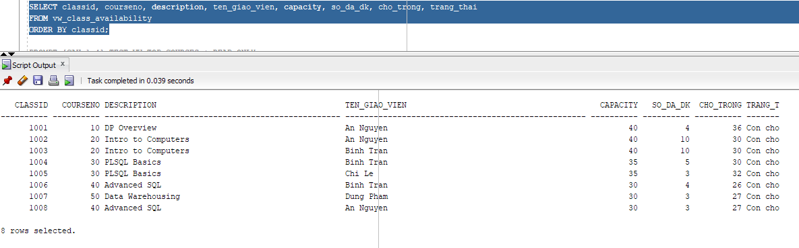

Câu 1.4: Tạo view vw_top_courses - chỉ đọc, top 5 môn được đăng ký nhiều nhất
CREATE OR REPLACE VIEW vw_top_courses AS
SELECT courseno, description, cost, tong_dk, hang
FROM (
SELECT co.courseno,
co.description,
co.cost,
COUNT(e.studentid) AS tong_dk,
RANK() OVER (ORDER BY COUNT(e.studentid) DESC) AS hang
FROM course co
LEFT JOIN class cl
ON co.courseno = cl.courseno
LEFT JOIN enrollment e
ON cl.classid = e.classid
GROUP BY co.courseno, co.description, co.cost
)
WHERE hang <= 5
WITH READ ONLY;

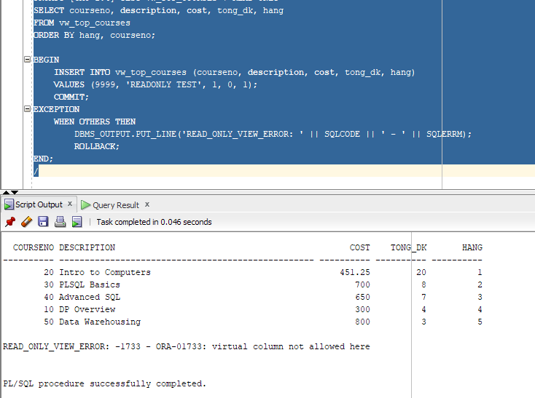

Câu 1.5: Tạo view vw_pending_enrollment với WITH CHECK OPTION và kiểm
Tra
CREATE OR REPLACE VIEW vw_pending_enrollment AS
SELECT studentid,
classid,
enrolldate,
finalgrade,
created_by,
created_date,
modified_by,
modified_date
FROM enrollment
WHERE finalgrade IS NULL
WITH CHECK OPTION;
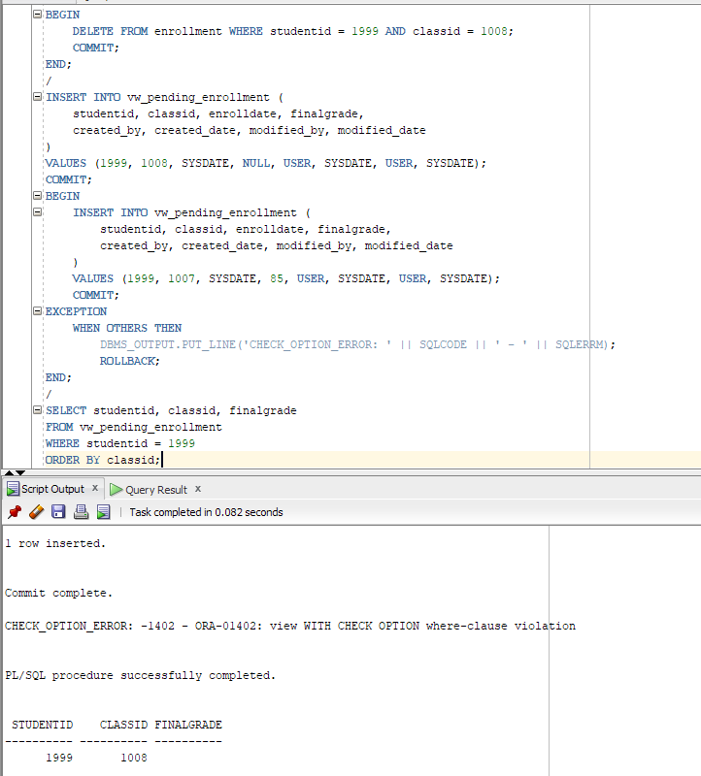

HƯỚNG DẪN BÀI 2 - STORED PROCEDURE

Câu 2.1: Thủ tục enroll_student - đăng ký sinh viên vào lớp học

CREATE OR REPLACE PROCEDURE enroll_student (
p_studentid IN NUMBER,
p_classid IN NUMBER
)
IS
v_check NUMBER;
v_capacity NUMBER;
v_enrolled NUMBER;
BEGIN
SELECT COUNT(*)
INTO v_check
FROM student
WHERE studentid = p_studentid;

IF v_check = 0 THEN
DBMS_OUTPUT.PUT_LINE('[LOI] Sinh vien ' || p_studentid || ' khong ton tai!');
RETURN;
END IF;

SELECT COUNT(*)
INTO v_check
FROM class
WHERE classid = p_classid;

IF v_check = 0 THEN
DBMS_OUTPUT.PUT_LINE('[LOI] Lop hoc ' || p_classid || ' khong ton tai!');
RETURN;
END IF;

SELECT capacity
INTO v_capacity
FROM class
WHERE classid = p_classid;

SELECT COUNT(*)
INTO v_enrolled
FROM enrollment
WHERE classid = p_classid;

IF v_capacity IS NOT NULL AND v_enrolled >= v_capacity THEN
DBMS_OUTPUT.PUT_LINE('[LOI] Lop ' || p_classid || ' da day! (' || v_enrolled || '/' || v_capacity || ')');
RETURN;
END IF;

SELECT COUNT(*)
INTO v_check
FROM enrollment
WHERE studentid = p_studentid
AND classid = p_classid;

IF v_check > 0 THEN
DBMS_OUTPUT.PUT_LINE('[LOI] Sinh vien da dang ky lop nay roi!');
RETURN;
END IF;

SELECT COUNT(*)
INTO v_check
FROM enrollment
WHERE studentid = p_studentid;

IF v_check >= 3 THEN
DBMS_OUTPUT.PUT_LINE('[LOI] Sinh vien da dang ky du 3 lop!');
RETURN;
END IF;

INSERT INTO enrollment (
studentid, classid, enrolldate, finalgrade,
created_by, created_date, modified_by, modified_date
)
VALUES (
p_studentid, p_classid, SYSDATE, NULL,
USER, SYSDATE, USER, SYSDATE
);

COMMIT;
DBMS_OUTPUT.PUT_LINE('[OK] Dang ky thanh cong! SV ' || p_studentid || ' -> Lop ' || p_classid);
EXCEPTION
WHEN OTHERS THEN
ROLLBACK;
DBMS_OUTPUT.PUT_LINE('[LOI HE THONG] ' || SQLERRM);
END enroll_student;
/

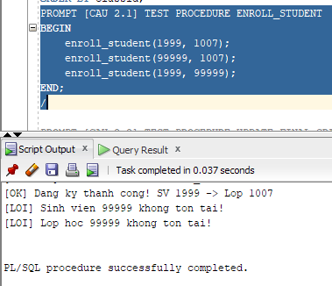

Câu 2.2: Thủ tục update_final_grade - cập nhật điểm tổng kết

CREATE OR REPLACE PROCEDURE update_final_grade (
p_studentid IN NUMBER,
p_classid IN NUMBER,
p_grade IN NUMBER
)
IS
v_check NUMBER;
v_old_grade NUMBER;
BEGIN
IF p_grade < 0 OR p_grade > 100 THEN
DBMS_OUTPUT.PUT_LINE('[LOI] Diem khong hop le! Phai tu 0 den 100.');
RETURN;
END IF;

SELECT COUNT(*)
INTO v_check
FROM enrollment
WHERE studentid = p_studentid
AND classid = p_classid;

IF v_check = 0 THEN
DBMS_OUTPUT.PUT_LINE('[LOI] Sinh vien chua dang ky lop nay!');
RETURN;
END IF;

SELECT finalgrade
INTO v_old_grade
FROM enrollment
WHERE studentid = p_studentid
AND classid = p_classid;

UPDATE enrollment
SET finalgrade = p_grade,
modified_by = USER,
modified_date = SYSDATE
WHERE studentid = p_studentid
AND classid = p_classid;

MERGE INTO grade g
USING (
SELECT p_studentid AS studentid,
p_classid AS classid,
p_grade AS finalgrade
FROM dual
) src
ON (g.studentid = src.studentid AND g.classid = src.classid)
WHEN MATCHED THEN
UPDATE SET g.grade = src.finalgrade,
g.modified_by = USER,
g.modified_date = SYSDATE
WHEN NOT MATCHED THEN
INSERT (
studentid, classid, grade, comments,
created_by, created_date, modified_by, modified_date
)
VALUES (
src.studentid, src.classid, src.finalgrade, NULL,
USER, SYSDATE, USER, SYSDATE
);

COMMIT;
DBMS_OUTPUT.PUT_LINE('[OK] Cap nhat diem thanh cong. Cu: ' || NVL(TO_CHAR(v_old_grade), 'NULL') || ' -> Moi: ' || p_grade);
EXCEPTION
WHEN OTHERS THEN
ROLLBACK;
DBMS_OUTPUT.PUT_LINE('[LOI] ' || SQLERRM);
END update_final_grade;
/
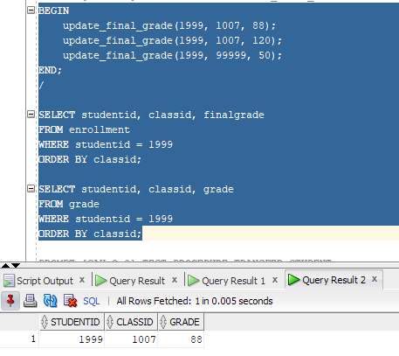

Câu 2.3: Thủ tục transfer_student - chuyển lớp cho sinh viên

CREATE OR REPLACE PROCEDURE transfer_student (
p_studentid IN NUMBER,
p_old_classid IN NUMBER,
p_new_classid IN NUMBER
)
IS
v_check NUMBER;
v_capacity NUMBER;
v_enrolled NUMBER;
BEGIN
IF p_old_classid = p_new_classid THEN
DBMS_OUTPUT.PUT_LINE('[LOI] Lop cu va lop moi phai khac nhau.');
RETURN;
END IF;

SELECT COUNT(*)
INTO v_check
FROM enrollment
WHERE studentid = p_studentid
AND classid = p_old_classid;

IF v_check = 0 THEN
DBMS_OUTPUT.PUT_LINE('[LOI] Sinh vien khong dang hoc lop ' || p_old_classid);
RETURN;
END IF;

SELECT COUNT(*)
INTO v_check
FROM class
WHERE classid = p_new_classid;

IF v_check = 0 THEN
DBMS_OUTPUT.PUT_LINE('[LOI] Lop moi ' || p_new_classid || ' khong ton tai.');
RETURN;
END IF;

SELECT capacity
INTO v_capacity
FROM class
WHERE classid = p_new_classid;

SELECT COUNT(*)
INTO v_enrolled
FROM enrollment
WHERE classid = p_new_classid;

IF v_capacity IS NOT NULL AND v_enrolled >= v_capacity THEN
DBMS_OUTPUT.PUT_LINE('[LOI] Lop moi ' || p_new_classid || ' da day!');
RETURN;
END IF;

SELECT COUNT(*)
INTO v_check
FROM enrollment
WHERE studentid = p_studentid
AND classid = p_new_classid;

IF v_check > 0 THEN
DBMS_OUTPUT.PUT_LINE('[LOI] Sinh vien da o trong lop moi roi!');
RETURN;
END IF;

SAVEPOINT sp_truoc_chuyen;

DELETE FROM grade
WHERE studentid = p_studentid
AND classid = p_old_classid;

DELETE FROM enrollment
WHERE studentid = p_studentid
AND classid = p_old_classid;

SAVEPOINT sp_sau_xoa;

INSERT INTO enrollment (
studentid, classid, enrolldate, finalgrade,
created_by, created_date, modified_by, modified_date
)
VALUES (
p_studentid, p_new_classid, SYSDATE, NULL,
USER, SYSDATE, USER, SYSDATE
);

COMMIT;
DBMS_OUTPUT.PUT_LINE('[OK] Da chuyen SV ' || p_studentid || ' tu lop ' || p_old_classid || ' sang lop ' || p_new_classid);
EXCEPTION
WHEN OTHERS THEN
ROLLBACK TO sp_truoc_chuyen;
DBMS_OUTPUT.PUT_LINE('[LOI] Chuyen lop that bai: ' || SQLERRM);
END transfer_student;
/
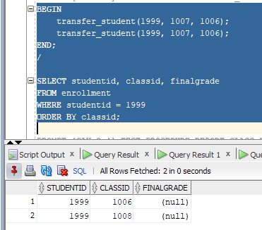

Câu 2.4: Thủ tục report_class_detail — in báo cáo chi tiết lớp học
CREATE OR REPLACE PROCEDURE report_class_detail (
p_classid IN NUMBER
)
IS
v_check NUMBER;
v_course VARCHAR2(50);
v_courseno NUMBER;
v_gv VARCHAR2(50);
v_loc VARCHAR2(50);
v_cap NUMBER;
v_stt NUMBER := 0;
v_tong NUMBER := 0;
v_sum_d NUMBER := 0;
v_co_d NUMBER := 0;
v_grade_txt VARCHAR2(15);
BEGIN
SELECT COUNT(*)
INTO v_check
FROM class
WHERE classid = p_classid;

IF v_check = 0 THEN
DBMS_OUTPUT.PUT_LINE('Lop hoc ' || p_classid || ' khong ton tai!');
RETURN;
END IF;

SELECT co.description,
co.courseno,
i.firstname || ' ' || i.lastname,
cl.location,
cl.capacity
INTO v_course, v_courseno, v_gv, v_loc, v_cap
FROM class cl
JOIN course co
ON cl.courseno = co.courseno
JOIN instructor i
ON cl.instructorid = i.instructorid
WHERE cl.classid = p_classid;

DBMS_OUTPUT.PUT_LINE('=== BAO CAO LOP HOC: ' || p_classid || ' ===');
DBMS_OUTPUT.PUT_LINE('Mon hoc : ' || v_courseno || ' - ' || v_course);
DBMS_OUTPUT.PUT_LINE('Giao vien: ' || v_gv);
DBMS_OUTPUT.PUT_LINE('Phong hoc: ' || NVL(v_loc, 'Chua xep phong'));
DBMS_OUTPUT.PUT_LINE('Suc chua : ' || v_cap || ' cho');
DBMS_OUTPUT.PUT_LINE(RPAD('-', 62, '-'));
DBMS_OUTPUT.PUT_LINE(RPAD('STT', 4) || ' | ' || RPAD('Ho Ten', 24) || ' | ' || LPAD('Diem TK', 8) || ' | Xep loai');
DBMS_OUTPUT.PUT_LINE(RPAD('-', 62, '-'));

FOR rec IN (
SELECT s.firstname || ' ' || s.lastname AS ho_ten,
e.finalgrade
FROM enrollment e
JOIN student s
ON e.studentid = s.studentid
WHERE e.classid = p_classid
ORDER BY s.lastname, s.firstname
)
LOOP
v_stt := v_stt + 1;
v_tong := v_tong + 1;

IF rec.finalgrade IS NULL THEN
v_grade_txt := 'Chua co diem';
ELSIF rec.finalgrade >= 90 THEN
v_grade_txt := 'A';
v_sum_d := v_sum_d + rec.finalgrade;
v_co_d := v_co_d + 1;
ELSIF rec.finalgrade >= 80 THEN
v_grade_txt := 'B';
v_sum_d := v_sum_d + rec.finalgrade;
v_co_d := v_co_d + 1;
ELSIF rec.finalgrade >= 70 THEN
v_grade_txt := 'C';
v_sum_d := v_sum_d + rec.finalgrade;
v_co_d := v_co_d + 1;
ELSIF rec.finalgrade >= 50 THEN
v_grade_txt := 'D';
v_sum_d := v_sum_d + rec.finalgrade;
v_co_d := v_co_d + 1;
ELSE
v_grade_txt := 'F';
v_sum_d := v_sum_d + rec.finalgrade;
v_co_d := v_co_d + 1;
END IF;

DBMS_OUTPUT.PUT_LINE(
LPAD(v_stt, 3) || ' | ' ||
RPAD(rec.ho_ten, 24) || ' | ' ||
LPAD(NVL(TO_CHAR(rec.finalgrade), 'NULL'), 8) || ' | ' ||
v_grade_txt
);
END LOOP;

DBMS_OUTPUT.PUT_LINE(RPAD('-', 62, '-'));
DBMS_OUTPUT.PUT_LINE('Tong so sinh vien : ' || v_tong);

IF v_co_d > 0 THEN
DBMS_OUTPUT.PUT_LINE('Diem trung binh lop: ' || ROUND(v_sum_d / v_co_d, 2));
ELSE
DBMS_OUTPUT.PUT_LINE('Diem trung binh lop: Chua co diem');
END IF;
END report_class_detail;
/

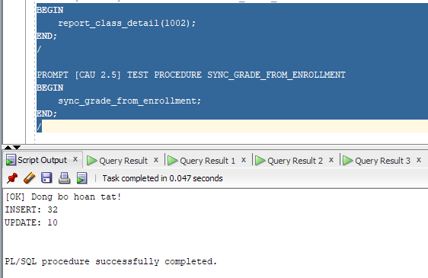

Câu 2.5: Thủ tục sync_grade_from_enrollment - đồng bộ điểm từ ENROLLMENT
sang GRADE
CREATE OR REPLACE PROCEDURE sync_grade_from_enrollment
IS
v_check NUMBER;
v_dem_insert NUMBER := 0;
v_dem_update NUMBER := 0;
BEGIN
FOR rec IN (
SELECT studentid, classid, finalgrade
FROM enrollment
WHERE finalgrade IS NOT NULL
)
LOOP
SELECT COUNT(*)
INTO v_check
FROM grade
WHERE studentid = rec.studentid
AND classid = rec.classid;

IF v_check = 0 THEN
INSERT INTO grade (
studentid, classid, grade, comments,
created_by, created_date, modified_by, modified_date
)
VALUES (
rec.studentid, rec.classid, rec.finalgrade, NULL,
USER, SYSDATE, USER, SYSDATE
);
v_dem_insert := v_dem_insert + 1;
ELSE
UPDATE grade
SET grade = rec.finalgrade,
modified_by = USER,
modified_date = SYSDATE
WHERE studentid = rec.studentid
AND classid = rec.classid;
v_dem_update := v_dem_update + 1;
END IF;
END LOOP;

COMMIT;
DBMS_OUTPUT.PUT_LINE('[OK] Dong bo hoan tat!');
DBMS_OUTPUT.PUT_LINE('INSERT: ' || v_dem_insert);
DBMS_OUTPUT.PUT_LINE('UPDATE: ' || v_dem_update);
EXCEPTION
WHEN OTHERS THEN
ROLLBACK;
DBMS_OUTPUT.PUT_LINE('[LOI] ' || SQLERRM);
END sync_grade_from_enrollment;
/

PROMPT [PHAN 4 - BAI 3 TRIGGER]
PROMPT [CAU 3.2 - BANG PHU] Tao bang grade_audit_log

CREATE TABLE grade_audit_log (
log_id NUMBER GENERATED ALWAYS AS IDENTITY PRIMARY KEY,
studentid NUMBER(8),
classid NUMBER(8),
grade_cu NUMBER(3),
grade_moi NUMBER(3),
nguoi_sua VARCHAR2(30),
thoi_gian DATE
);
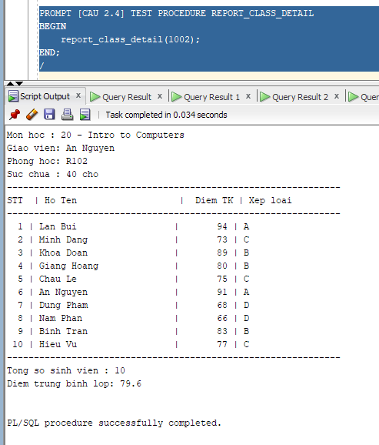

HƯỚNG DẪN BÀI 3 – TRIGGER

Câu 3.1: Trigger trg_check_capacity - kiểm tra sức chứa khi đăng ký
CREATE OR REPLACE TRIGGER trg_check_capacity
BEFORE INSERT ON enrollment
FOR EACH ROW
DECLARE
v_capacity NUMBER;
v_enrolled NUMBER;
BEGIN
SELECT capacity
INTO v_capacity
FROM class
WHERE classid = :NEW.classid;

SELECT COUNT(*)
INTO v_enrolled
FROM enrollment
WHERE classid = :NEW.classid;

IF v_capacity IS NOT NULL AND v_enrolled >= v_capacity THEN
RAISE_APPLICATION_ERROR(
-20010,
'LOI: Lop ' || :NEW.classid || ' da day! (' || v_enrolled || '/' || v_capacity || ' cho)'
);
END IF;
EXCEPTION
WHEN NO_DATA_FOUND THEN
RAISE_APPLICATION_ERROR(-20011, 'LOI: Lop hoc ' || :NEW.classid || ' khong ton tai.');
END trg_check_capacity;
/
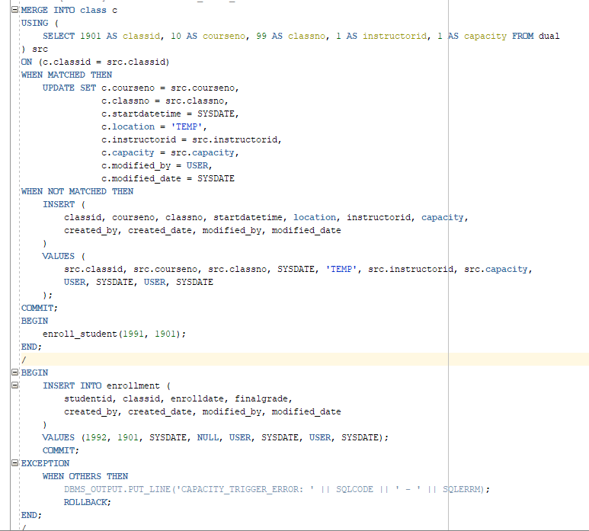
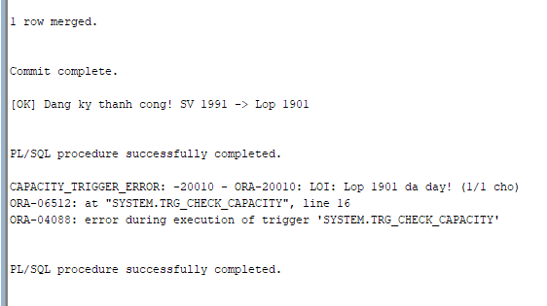

Câu 3.2: Trigger trg_grade_audit_log - ghi nhật ký thay đổi điểm
CREATE OR REPLACE TRIGGER trg_grade_audit_log
AFTER UPDATE OF finalgrade ON enrollment
FOR EACH ROW
BEGIN
IF NVL(:OLD.finalgrade, -999) <> NVL(:NEW.finalgrade, -999) THEN
INSERT INTO grade_audit_log (
studentid, classid, grade_cu, grade_moi, nguoi_sua, thoi_gian
)
VALUES (
:OLD.studentid, :OLD.classid, :OLD.finalgrade, :NEW.finalgrade, USER, SYSDATE
);
END IF;
END trg_grade_audit_log;
/

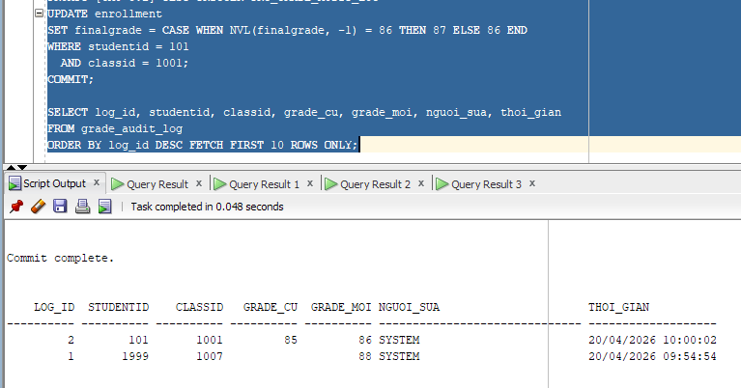

Câu 3.3: Trigger trg_prevent_course_delete - ngăn xóa môn học đang có lớp
CREATE OR REPLACE TRIGGER trg_prevent_course_delete
BEFORE DELETE ON course
FOR EACH ROW
DECLARE
v_so_lop NUMBER;
BEGIN
SELECT COUNT(*)
INTO v_so_lop
FROM class
WHERE courseno = :OLD.courseno;

IF v_so_lop > 0 THEN
RAISE_APPLICATION_ERROR(
-20020,
'Khong the xoa mon hoc ' || :OLD.courseno || ' (' || :OLD.description || ') vi con ' || v_so_lop || ' lop hoc dang ton tai!'
);
END IF;
END trg_prevent_course_delete;
/

Câu 3.4: Trigger trg_update_grade_summary - cập nhật bảng thống kê tự động
CREATE TABLE class_grade_summary (
classid NUMBER(8) PRIMARY KEY,
so_sv NUMBER,
diem_tb NUMBER(5, 2),
diem_cao_nhat NUMBER(3),
diem_thap_nhat NUMBER(3),
cap_nhat_luc DATE
);
CREATE OR REPLACE TRIGGER trg_update_grade_summary
FOR INSERT OR UPDATE OR DELETE ON enrollment
COMPOUND TRIGGER
TYPE t_seen IS TABLE OF BOOLEAN INDEX BY VARCHAR2(50);
TYPE t_list IS TABLE OF NUMBER INDEX BY PLS_INTEGER;
g_seen t_seen;
g_list t_list;
g_count PLS_INTEGER := 0;

PROCEDURE add_class(p_classid NUMBER) IS
v_key VARCHAR2(50);
BEGIN
IF p_classid IS NULL THEN
RETURN;
END IF;

v_key := TO_CHAR(p_classid);

IF NOT g_seen.EXISTS(v_key) THEN
g_count := g_count + 1;
g_list(g_count) := p_classid;
g_seen(v_key) := TRUE;
END IF;
END add_class;

AFTER EACH ROW IS
BEGIN
IF INSERTING OR UPDATING THEN
add_class(:NEW.classid);
END IF;

IF DELETING OR UPDATING THEN
add_class(:OLD.classid);
END IF;
END AFTER EACH ROW;

AFTER STATEMENT IS
v_so_sv NUMBER;
v_diem_tb NUMBER;
v_max_d NUMBER;
v_min_d NUMBER;
BEGIN
FOR i IN 1 .. g_count LOOP
SELECT COUNT(finalgrade),
ROUND(AVG(finalgrade), 2),
MAX(finalgrade),
MIN(finalgrade)
INTO v_so_sv, v_diem_tb, v_max_d, v_min_d
FROM enrollment
WHERE classid = g_list(i)
AND finalgrade IS NOT NULL;

MERGE INTO class_grade_summary cgs
USING (SELECT g_list(i) AS cid FROM dual) src
ON (cgs.classid = src.cid)
WHEN MATCHED THEN
UPDATE SET so_sv = v_so_sv,
diem_tb = v_diem_tb,
diem_cao_nhat = v_max_d,
diem_thap_nhat = v_min_d,
cap_nhat_luc = SYSDATE
WHEN NOT MATCHED THEN
INSERT (
classid, so_sv, diem_tb, diem_cao_nhat, diem_thap_nhat, cap_nhat_luc
)
VALUES (
g_list(i), v_so_sv, v_diem_tb, v_max_d, v_min_d, SYSDATE
);
END LOOP;
END AFTER STATEMENT;
END trg_update_grade_summary;
/
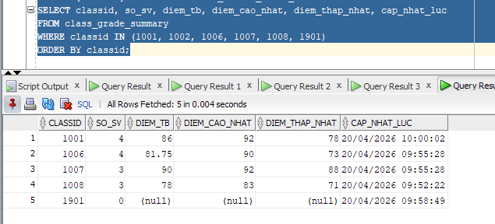

HƯỚNG DẪN BÀI 4 - TỔNG HỢP

Câu 4.1: Hệ thống báo cáo hoàn chỉnh - View + Procedure + Cursor

Tao view vw_instructor_workload
CREATE OR REPLACE VIEW vw_instructor_workload AS
SELECT i.instructorid,
i.firstname || ' ' || i.lastname AS ho_ten,
COUNT(DISTINCT cl.classid) AS so_lop,
COUNT(e.studentid) AS tong_sv,
ROUND(AVG(e.finalgrade), 2) AS diem_tb_chung,
CASE
WHEN COUNT(DISTINCT cl.classid) >= 3 THEN 'Ban nhieu'
WHEN COUNT(DISTINCT cl.classid) = 2 THEN 'Binh thuong'
ELSE 'Nhe nhang'
END AS muc_ban
FROM instructor i
LEFT JOIN class cl
ON i.instructorid = cl.instructorid
LEFT JOIN enrollment e
ON cl.classid = e.classid
GROUP BY i.instructorid, i.firstname, i.lastname;
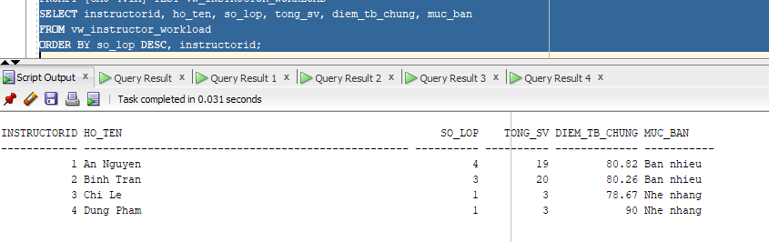

Procedure print_system_report

CREATE OR REPLACE PROCEDURE print_system_report
IS
v_so_mon NUMBER;
v_so_lop NUMBER;
v_so_sv NUMBER;
v_so_gv NUMBER;
BEGIN
SELECT COUNT(*) INTO v_so_mon FROM course;
SELECT COUNT(*) INTO v_so_lop FROM class;
SELECT COUNT(*) INTO v_so_sv FROM student;
SELECT COUNT(*) INTO v_so_gv FROM instructor;

DBMS_OUTPUT.PUT_LINE('==============================================');
DBMS_OUTPUT.PUT_LINE('BAO CAO TOAN HE THONG QUAN LY KHOA HOC');
DBMS_OUTPUT.PUT_LINE('==============================================');
DBMS_OUTPUT.PUT_LINE('Tong so mon hoc : ' || v_so_mon);
DBMS_OUTPUT.PUT_LINE('Tong so lop hoc : ' || v_so_lop);
DBMS_OUTPUT.PUT_LINE('Tong so sinh vien: ' || v_so_sv);
DBMS_OUTPUT.PUT_LINE('Tong so giao vien: ' || v_so_gv);
DBMS_OUTPUT.PUT_LINE(RPAD('-', 70, '-'));
DBMS_OUTPUT.PUT_LINE('THONG KE GIAO VIEN');

FOR rec IN (
SELECT *
FROM vw_instructor_workload
ORDER BY so_lop DESC, instructorid
)
LOOP
DBMS_OUTPUT.PUT_LINE(
RPAD(rec.ho_ten, 25) ||
' | ' || LPAD(rec.so_lop, 2) || ' lop' ||
' | ' || LPAD(rec.tong_sv, 3) || ' SV' ||
' | DTB: ' || NVL(TO_CHAR(rec.diem_tb_chung), '--') ||
' | ' || rec.muc_ban
);
END LOOP;

DBMS_OUTPUT.PUT_LINE(RPAD('-', 70, '-'));
DBMS_OUTPUT.PUT_LINE('TOP 3 MON HOC DUOC DANG KY NHIEU NHAT');

FOR rec IN (
SELECT *
FROM vw_top_courses
WHERE hang <= 3
ORDER BY hang, courseno
)
LOOP
DBMS_OUTPUT.PUT_LINE(
rec.hang || '. ' || RPAD(rec.description, 30) || ' - ' || rec.tong_dk || ' luot dang ky'
);
END LOOP;

DBMS_OUTPUT.PUT_LINE('==============================================');
END print_system_report;
/
