4.5 A Minimal Retransmission and Reliable Routing Protocol using Bdist
In this section, we propose the Minimal Retransmission and Reliable Routing Protocol (MRR) that using our Burstiness Distribution Metric to find the minimal retransmission path and reach our target PRR for reliability. We use the network topology as Figure 7 and use the number of probes in 1000 packets in MLQP. We use the config Directed Graph Radio Medium (DGRM) mode in Cooja Simulation to set up the PRR value and to form the link between two desired nodes excluding the others as Figure 12.
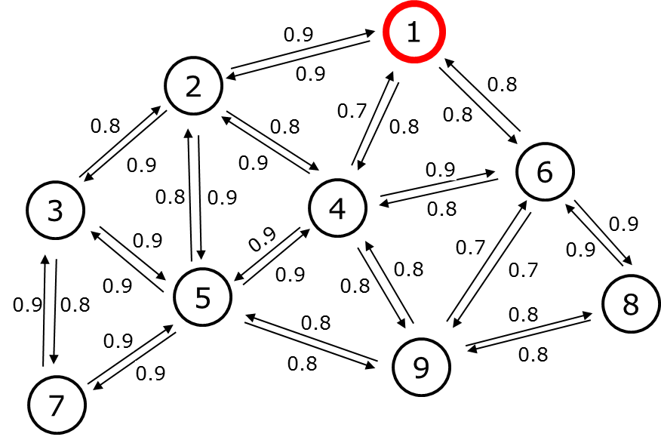
Figure 12. Network example with the PRR of each link.
After the MLQP, the receiver node calculates the number of retransmission for each incoming link of the neighbor node by Algorithm 1 using Burstiness Distribution Metric. Figure 13 shows the network graph with the number of retransmission as the metric value for the routing protocol.
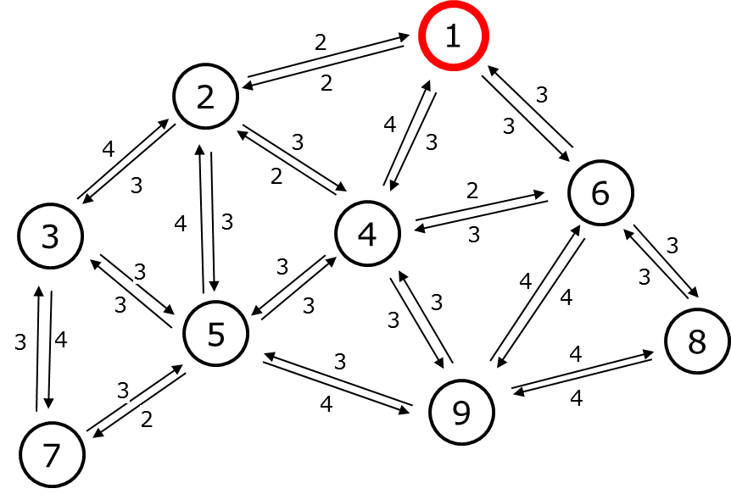
Figure 13. Network graph with the number of retransmission.
We only focus on the converge cast network here, so the MRR aims to find the path from the node to the sink and uses the number of retransmission as a route metric. Besides, the same approach can be applied for the download graph routing to control the node from the sink. In this paper, we only present the converge cast network. The route discovery process is performed by exchanging Route Request (RR) control packets between the node and the neighbor nodes. Each node maintains the neighbor list and the routing table for routing data packets. The routing table consists of a Route Entry (RE) with RE(p_{id}, h, r). The p_{id} denoted the parent identifier and h is the hop count, r is the rank calculated by the sum of retransmission through the path from that node to the sink node. The sink node will have RE(0, 0, 0) which means it doesn’t have a parent, the hop count is 0 and the rank is 0. The MRR starts from the sink node by broadcasting the RR control packet. The RR packet carries RR(s_{id}, h, [nbr_list(n_{id}, r)]) where s_{id} denotes the ID of sender node, h denotes hop count of sender node, and the nbr_list(id, r) denotes the neighbor list which contains neighbor ID (n_{id}) and the rank (r) of neighbor node calculated by the number of retransmission from this neighbor to sender node plus the rank of sender node. When a node Y receives RR(s_{id}, h, [nbr_list(n_{id}, r)]) packet from node X, it and creates a RE(p_{id} := s_{id}, h = h + 1, r = r). After that, if node Y receives another RR(s_{id}, h, [nbr_list(n_{id}, r)]) packet from node Z, it compares the newly create RE(p_{id} := s_{id}, h = h + 1, r = r) by the rank then the hop count. The lower rank is the better route due to the number of retransmission is minimal and if the rank is equal, we compare the hop count, the lower hop count is the better route. The node will send Route Response (RP) through the parent node in the routing table. The RP packet contains the path from the leaf node to the sink node. The sink node will save the path to check the Route discovery process is finish or not by check the number of nodes in the network compared with the number of nodes in the path received from RP.
For example, we use a network graph in Figure 13. The sink node is node 1 send the RR(1, 0, [(2, 2), (4, 4), (6, 3)]). Note that, the link quality estimator using Burstiness Distribution Metric that we present in the previous section is receiver estimator, so the sink node has the information of the number of retransmission from link L(2, 1), L(4, 1), and L(6, 1) is 2, 4, 3 respectively.
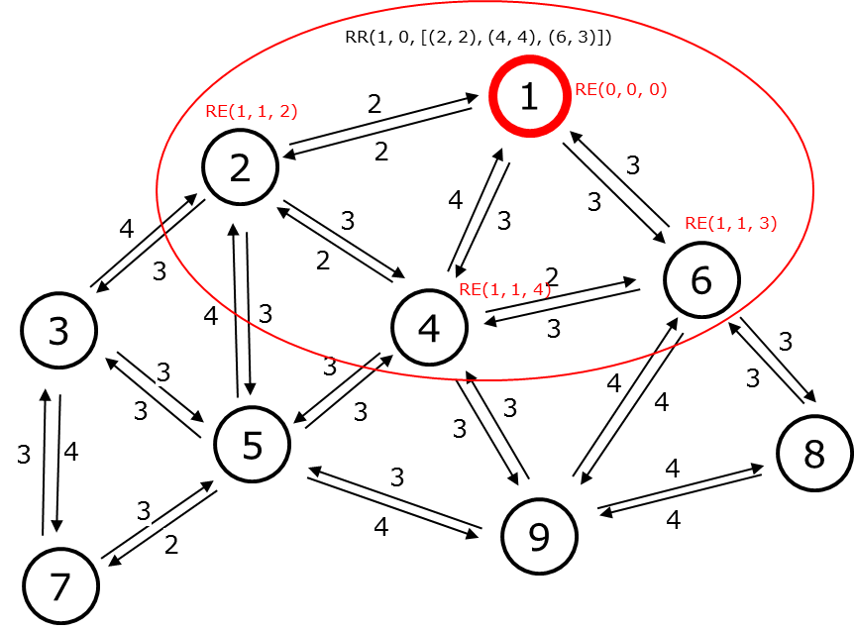
Figure 14. The sink node starts routing protocol by broadcasting the RR control packet.
When node 2, 4 and 6 receive RR(1, 0, [(2, 2), (4, 4), (6, 3)]) from node 1, node 2, 4 and 6 create the route entry RE(1, 1, 2), RE(1, 1, 4) and RE(1, 1, 3) respectively as Figure 14. After that, they create and broadcast their RR packet immediately as Figures 15, 16, and 17.
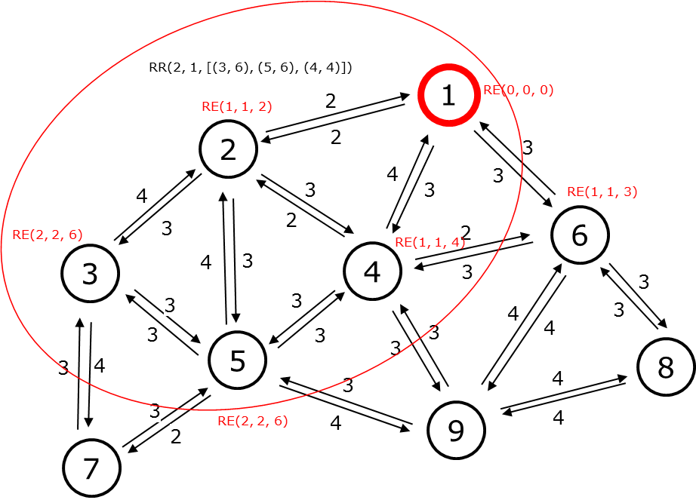
Figure 15. Node 2 broadcasting RR control packet and the neighbor create RE respectively.
Node 2 has the RE(1, 1, 2) after received RR from node 1. Neighbor node 3, 5, and 4 have the rank value of is the number of retransmission in link L(3, 2), L(5, 2), and L(6, 2) plus the rank of node 2. So it will create RR packet exclude node 1 RR(2, 1, [(3, 6), (5, 6), (4, 4)]). In this case, node 3 and 5 create new RE(2, 2, 6) and RE(2, 2, 6). For node 4, because it creates RE(2, 2, 4) compare with RE(1, 1, 4) create by receiving RR from node 1. They have the same rank 4 but RE(1, 1, 4) has only 1 hop compare with 2 hops from Node 2 RE(2, 2, 4). So node 4 keeps the better RE value.
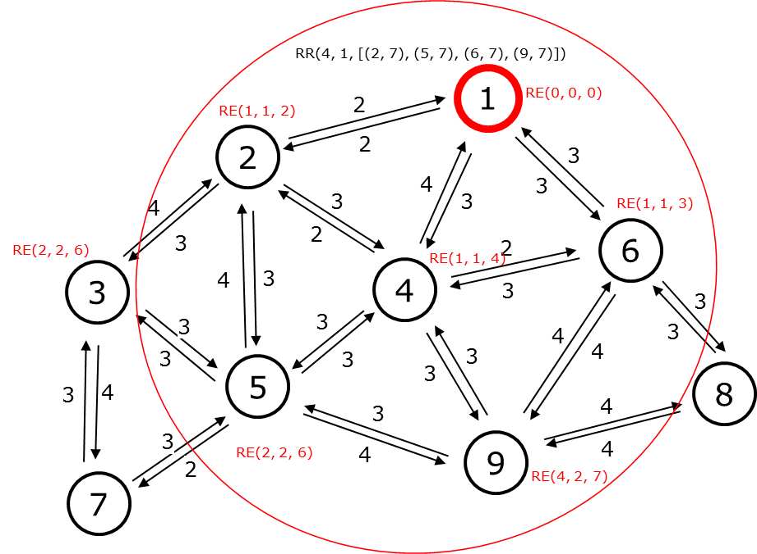
Figure 16. Node 4 broadcasting RR control packet and the neighbor create RE respectively.

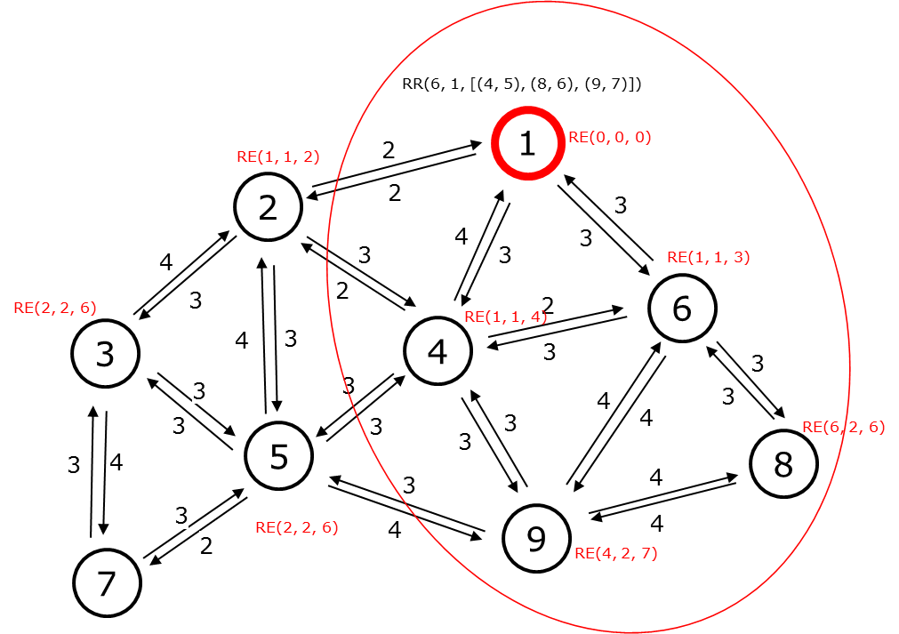
Figure 17. Node 6 broadcasting RR control packet and the neighbor create RE respectively.
The MRR route discovery runs the same operation until the network has the node received all RR control packet from its neighbor. Figure 18 shows the example for route response operation starts from Node 7. After receiving the RR packet from node 3 and node 5. Node 7 doesn’t create its RR packet due to all the neighbor nodes of Node 7 has a higher hop count than 7. Node 7 creates RP(7) which responds to the parent node 3 that node 7 chose it as a parent.
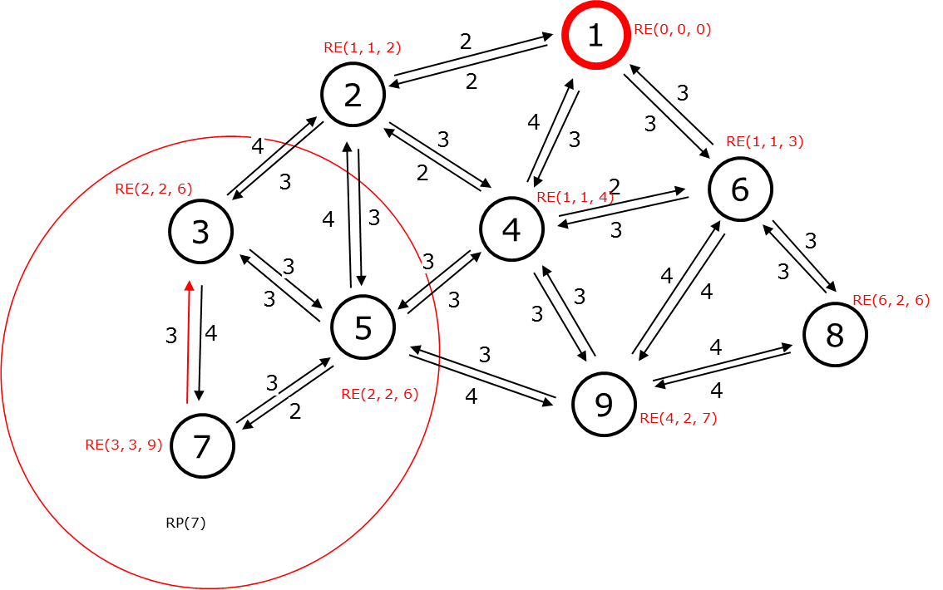
Figure 18. The route response operation from Node 7.
Node 3 after receiving RP(7) it updates RP(7, 3) then sends it to node 2 as Figure 19.
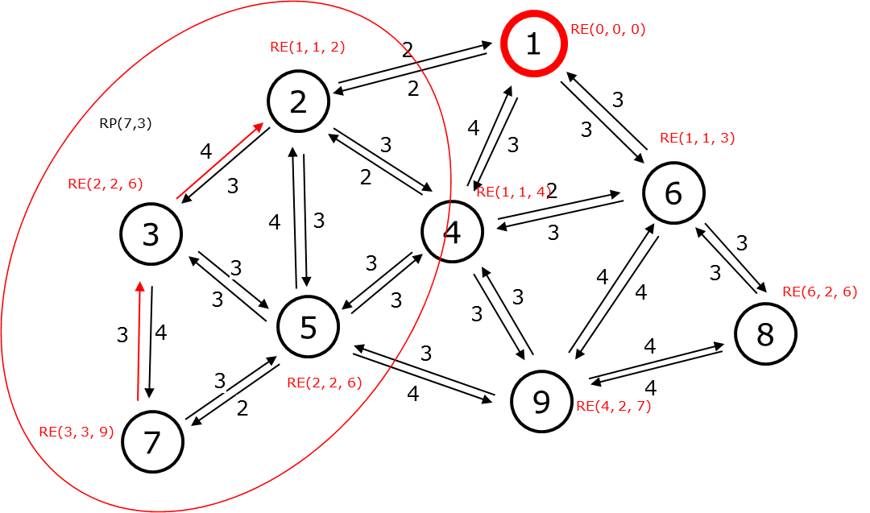
Figure 19. The route response operation from Node 3.
The RP operation will stop after the RP packet reaches the sink node. After the MRR routing protocol finishes. We have the converge cast tree topology of the example network as Figure 20.
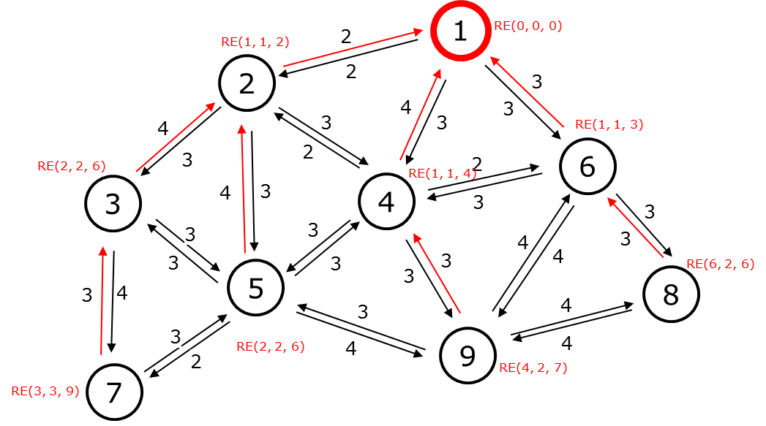
Figure 20. The converge cast tree topology of the example network.

