Article
Link Quality Estimation from Burstiness Distribution Metrics in Industrial Wireless Sensor Networks
Ngoc Huy Nguyen and Myung Kyun Kim*
University of Ulsan, 44610 Daehak-ro 93, Nam-gu Ulsan, South Korea
*Correspondence: mkkim@ulsan.ac.kr;
Received: date; Accepted: date; Published: date
Abstract: As mature industrial wireless sensor network applications increasingly require low-power operations, deterministic communications, and end-to-end reliability, it is very difficult to achieve these goals because of link burstiness and interference. In this paper, we propose a novel link quality estimation mechanism named the burstiness distribution metric, which uses the distribution of burstiness in the links to deal with variations in the link quality of wireless sensor networks. First, we estimate the link quality by counting the number of consecutive packets lost in each link at the receiver node. Based on that, we create a burstiness distribution list and estimate the number of retransmissions. Our simulation in the Cooja simulator from Contiki-NG shows that our proposal can be used in scheduling as an input metric to calculate the number of retransmissions in order to achieve a reliability target in industrial wireless sensor networks.
Keywords: IEEE 802.15.4e, Industrial Wireless Sensor Networks, Link Metric Measurements, Link Burstiness, Reliability.

1. Introduction
Nowadays, industrial wireless sensor networks are deploying many applications in fields such as environment monitoring, smart factories, healthcare, radiation checks, leakage detection, and process control. In these types of applications, many problems have to be considered, such as solving delays in data delivery, prolonging network lifetime [1][2], safety, and security [3][4][5]. However, the reliability of data transmission is the most important in designing a protocol for industrial wireless sensor networks. Many studies have tried to improve the reliability of data transmission over wireless sensor networks by improving the physical layer [6], the MAC protocol [7], and the routing protocol [8][9][10][11]. However, the previous studies did not consider the effect of link quality; they assumed the link quality is always stable. In real applications, link quality is not stable, and it can vary depending on the environment and time. Therefore, for industrial wireless sensor networks, it is necessary to study link quality measurement that has low computational complexity and that requires low energy consumption.
There are two types of link quality evaluation: hardware-based [12-15] and software-based [16-21]. Some studies used hardware-based metrics to evaluate the link quality. Noda et al. [12] proposed a new channel quality metric that is based on the availability of the channel over time and that meaningfully quantifies spectrum usage. However, in the presence of multipath fading, it may have problems estimating the channel quality. Audéoud and Heusse [13] studied the correlation between the Received Signal Strength Indicator (RSSI), Link Quality Indicator (LQI), and Packet Delivery Ratio (PDR). RSSI is a poor indication of the PDR that one can expect on a given link, and LQI gives more accurate information. Thus, work has focused on the utilization of LQI. However, in scenarios with impulsive noise, the LQI may overestimate the channel quality, since the LQI does not account for packet losses. Eskola and Heikkilä [14] proposed a classifier to identify disturbances in the wireless channel related to line-of-sight changes and radio frequency interference. However, the proposed technique does not provide any metrics to be used by protocols to optimize network performance. Gomes et al. [15] proposed a new type of node, the Link Quality Estimator (LQE), dedicated to estimating the link quality in real time using RSSI and information obtained from received packets. Typically, the LQE node is capable of capturing multipath, interference, and link asymmetry effects. They use RSSI and LQI values to infer the Packet Reception Rate (PRR) of the given links. Unfortunately, RSSI and PDR have proven to be only loosely correlated in many situations. The hardware-based estimators do not require computation resources because they use built-in hardware metrics. However, they do not provide accurate measurement, as was observed and reported in previous experimental studies.
Editor - Highlight - This reference citation format differs from the format used in the paragraph above. Please use the same format for all references (preferably not inserted by using Insert Citation under References on the Ribbon).
The software-based estimators, such as the PRR and the Required Number of Packets (RNP), are based on calculated information from the upper layer. RNP is more reactive than PRR, and is calculated based on the transmitted packets from senders. Thus, RNP can estimate the link quality as long as the traffic is generated from the sender. However, RNP can underestimate link quality if packets are retransmitted many times before being successfully received. Window Mean with Exponentially Weighted Moving Average (WMEWMA), Expected Transmission Count (ETX), and Four-Bit (FB) are some examples of RNP-based estimators. WMEWMA is a filter-based link quality estimator that uses an exponentially weighted moving average filter as the main estimation technique. Based on link measurements, the PRR is computed and then smoothed to the previously computed PRR using the EWMA filter, which provides a more stable but sufficiently agile estimation, compared to PRR [16]. The Kalman filter–based Link-quality Estimator (KLE) was proposed in [17] to overcome the poor reactivity of average-based LQEs, including PRR. ETX [18] is a receiver-initiated estimator that uses active monitoring. It considers link asymmetry by estimating the PRR in both directions to calculate the PRR of the backward link and the PRR of the forward link. However, Koksal and Balakrishnan [19] found that ETX based on passive monitoring fails in overloaded (congested) networks, since a large number of nodes are not able to compute the ETX because they do not receive packets. FB [20] link estimation is designed with four bits of information. FB assesses link quality as an approximation of the packet retransmission count by combining two metrics (RNP and WMEWMA) through the EWMA filter. A simulation was performed to compare five different LQEs (PRR, RNP, WMEWMA, ETX, and FB) on the Collection Tree Protocol (CTP) for smart-grid environments [21]. In the simulations described in that paper, ETX and FB presented a better performance in harsh smart-grid environments, since only ETX and FB from among the evaluated LQEs consider link asymmetry. However, they did not consider burstiness in the links during their measurements.
In this study, we examine the effect of link quality on designing a MAC protocol for wireless sensor networks. Then, we propose a link quality estimation metric that is based on counting the number of consecutively lost packets on each link at the receiving end, as calculated by the receiver node. The number of consecutively lost packets then gives the distribution of burstiness for each link in the wireless sensor network. Furthermore, based on the new link quality estimator, we propose a mechanism called the burstiness distribution metric, which is used for estimating the number of retransmissions in order to obtain a target PDR that can be used to find the shortest retransmission path in the routing protocol, and which is used for designing a MAC protocol for the wireless sensor network.
The remainder of this paper is organized as follows. In Section 2, we present the system model and a link burstiness–research overview. The proposed LQE is described in Section 3. In Section 4, we show the evaluation results from our method, and the conclusions are given in Section 5.

2. System model

2.1. System and network model
In this study, we focus on convergecast multi-hop networks that consist of one sink and some sensor nodes in a tree topology. All nodes are assigned identification numbers and are deployed randomly during network configuration. All sensor nodes transmit data to the sink periodically along the tree path. Two nodes are said to have a link if they can transmit directly to each other; a link on which a child and parent node communicate is a tree link.
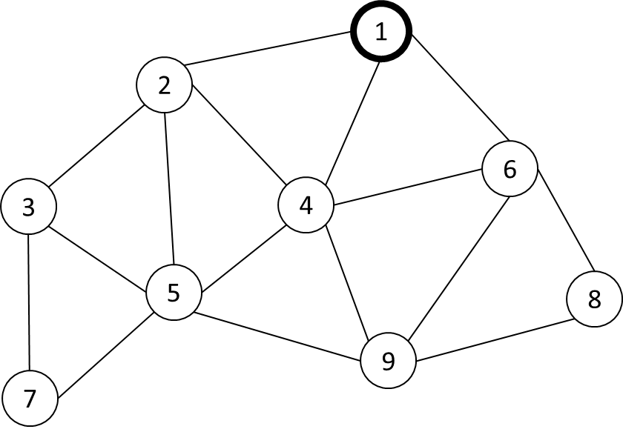
Figure 1. An example network topology.

2.2. Link burstiness research overview
Link burstiness is a physical property that implies that transmissions on a wireless link do not have an independent probability of failure; they have consecutive message losses in a burst. The authors in [22] and [23] proposed mechanisms to solve the link burstiness problem. Srinivasan et al. [22] presented a new metric, denoted as β, to measure link burstiness, and showed that we can avoid link burstiness by having an inter-packet delay of 500 ms. Even in the industrial fields, a 500 ms delay is a disadvantage for the network; we do not have to wait all that time to avoid packet loss when link burstiness happens. Munir et al. [23] proposed a new metric called maximum burst length (denoted Bmax) as the maximum error-burst length, estimated by using empirical data for a long experiment. A novel routing algorithm called least-burst-route is used in conjunction with this scheduling algorithm to minimize the sum of worst-case burst lengths over all links in the route. However, the algorithm to calculate Bmax is based on a long experiment data-trace before constructing the network. After processing the data-trace by computing the Bmax value, they apply it to the sensor network. They did not calculate the metric during network construction. That makes this algorithm hard to apply to an ad-hoc network, and this algorithm uses the number of retransmissions for a packet that is larger, so it increases end-to-end delay.

3. Link quality measurement and the metric for evaluating

3.1. Measure link quality principle
To measure the link quality between two sensor nodes, probe packets are used in which the number of probes is predefined. Each node generates a probe packet, P(node_id, sequence), in which sequence is a sequence of probe packets generated, and it increases from 1 up to the number of probes. Upon receiving P(node_id, sequence), the receiver will calculate the burstiness value by using the sequence number in P for the sender node, and then saves it to the burstiness distribution list (BDL). If a burstiness value duplicates others in the DBL, the burstiness time count for this burstiness value will increase by 1. For example, let us consider the measurement link quality for nodes 1 and 4 in Fig. 1, where node 1 received a probe packet from node 4 with sequence number 1, denoted by P(4, 1). The next received probe packet from node 4 is P(4, 4), which means probe packets P(4, 2) and P(4, 3) were lost due to burstiness, and thus, the burstiness value is 2. At this time, the probe packet is P(4, 4), and the receiver will receive the next probe packet and will again calculate the burstiness value. Assume that the probe packet is P(4, 7) the next time, so the burstiness value is again 2, but the burstiness time count will increase by 1 to indicate that burstiness value 2 was duplicated. Let the result of a transmission per link at the i^{th} sequence be “S” if it was successful and “F” if it failed. With the above example of node 1 and node 4, we have the result of transmissions after seven probe packets as “SFFSFFS”. After finishing the measure link quality (MLQ) period, we have the BDL of a link with 1000 probe packets transmitted, as shown in Table 1.
Table 1. Burstiness distribution list (BDL) of a link after finishing the MLQ period.
Burstiness value | 0 | 1 | 2 | 3 | 4
Burstiness time count | 634 | 129 | 31 | 2 | 1

Consider the relationship between burstiness value and burstiness time count in the BDL. The burstiness value is defined as the number of consecutive losses during probe packet transmission, and the burstiness time count defines the number of times the burstiness value appeared. For example, in Table 1, after transmitting 1000 probe packets, a burstiness value of 0 occured 634 times, a burstiness value of 1 occurred 129 times, and so on. It means that in the 1000 probe packets transmitted, 634 times the result of transmission was “SS”, and 129 times the result of transmission was “SFS”, and so on. With a link of good quality, the burstiness value will be small, whereas the burstiness time count will be large for the minimum burstiness value. Conversely, a bad link has a higher burstiness value and a low burstiness time count for the minimum burstiness value.
Editor - Highlight - Is this the intended meaning? If not, please rephrase as intended.
Figure 2. Burstiness distribution based on the link PRR.
For example, Figure 2 shows the simulation result from one pair of nodes with the different configurations of the PRR value. In Figure 2, the distribution of the burstiness values compared with a link PRR of 70%, 80%, and 90%, when the number of probes is 1000 packets, describes how with a good link (PRR 90%) we have a burstiness time count with a minimum burstiness value at 816 and a maximum burstiness value of 2. On the other hand, with bad link quality (PRR 70%) we have a burstiness time count with a minimum burstiness value of 480 and a maximum burstiness value of 4.

3.2. Burstiness distribution metric
In this section, we present a scheme to calculate the number of retransmissions by using the BDL with a named burstiness distribution (Bdist) metric. First, the neighbor list (nbrlist) and the BDL are set to empty. When sensor node x receives a probe packet from node y, it saves node y’s ID and sequence to its nbrlist if node y is not already on node x’s nbrlist. If node y is on node x’s nbrlist, node x will calculate the burstiness value for node y as follows:
burstiness_value (y) = seqno(y) – nbrlist[y].seqno(y) - 1
in which, seqno(y) is the sequence number in the new incoming probe packet from node y, and nbrlist[y].seqno(y) is the previous sequence number of node y saved in the neighbor list.
The parameter burstiness_time_count(y) refers to a burtiness_value(y) set to 1, and the pair {burstiness_value(y), burstiness_time_count(y)} will be saved in node y’s BDL if this value is not already on node y’s BDL. If burtiness_value(y) is on node y’s BDL, node x will increase the burtiness_time_count(y) referring to burstiness_value(y) by 1. Then, it updates the seqno(y) value in the neighbor list.
Editor - Highlight - Do these changes reflect the intended meaning? If not, please rephrase to clarify.
This process will repeat during the measure link quality period. The detailed algorithm is in Algorithm 1, and the flow chart is in Figure 3.
Editor - Highlight – Not found in this file? Please provide.
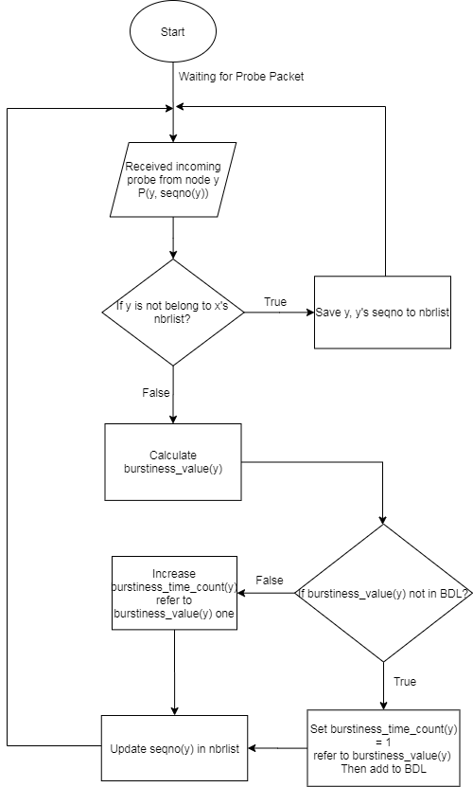
Figure 3. The flowchart of the main procedures in Algorithm 1.

3.3. Calculate burstiness distribution metric
To calculate the Bdist metric, we consider the possible loss ratio for each link, and determine the Bdist value from the BDL. We assume that a target PRR is considered. For example, to reach a PRR target of 99% for the data transmission period, the loss ratio should lower than 1% for each link. If the route has n hops, then every link L(i, j) that the route goes through has a loss ratio lower than $\sqrt[n]{0.01}$ . First, based on the hop count of the current node and the target PRR, the end-to-end loss ratio (${e2e}_{loss ratio}$) that we accept to reach the PRR target is calculated with Equation (1):
$${e2e}_{loss ratio}=1- \sqrt[h]{{PRR}_{target}}$$ | (1)
Then, we can calculate the packet loss threshold (P_{loss}) corresponding to the number of probes (N_{probes}) with Equation (2):
$$P_{loss threshold}=e2e_{loss ratio}×N_{probes}$$ | (2)
The number of retransmissions is set equal to the burstiness value, such that the packet loss threshold is lower than, or equal to, the current packet loss. The detailed number of retransmissions is in Algorithm 2, and the flowchart for Algorithm 2 is in Figure 4.
Algorithm 2: Calculate Burstiness Distribution Metric
Input : Ascending sorted burstiness distribution list (BDL),
number of probes (Nprobes), target PRR (PRRtarget), hop count (h)
Output : Burstiness distribution metric (Bdist)
1 : Calculate end-to-end loss ratio by using Equation (1)
2 : Calculate P_{loss} by using Equation (2)
3 : Initialize the current packet loss (P_{current loss}) to 0
4 : For loop in BDL from Bmax value to 0
5 : If the packet loss threshold is lower than, or equal to, the current packet loss
6 : Set Bdist to the current burstiness value
7 Break
8 : Else
9 : Increase the current packet loss by current burstiness time count
10 : End if
11 : End for
12 : Return Bdist
For example, a one-hop link has a configured PRR of 90%, and the number of probes is 1000 in order to measure the link quality, which means that 1% of 1000 packets can be lost. The number of packets that can be lost during data transmission is 10 packets. In the BDL in Figure 2, we can calculate the Bdist value for successful packet transmission as 2, since the consecutive loss of two transmissions in the link at a PRR of 90% was 5 packets, which is lower than the 10 allowed packet losses.
Editor - Highlight - Is this intended (not 10% and 100 packets)? Maybe 90% s/b changed to 99% (as seen in Table 2)?
Editor - Highlight - Is this the intended meaning? If not, please rephrase for clarity.

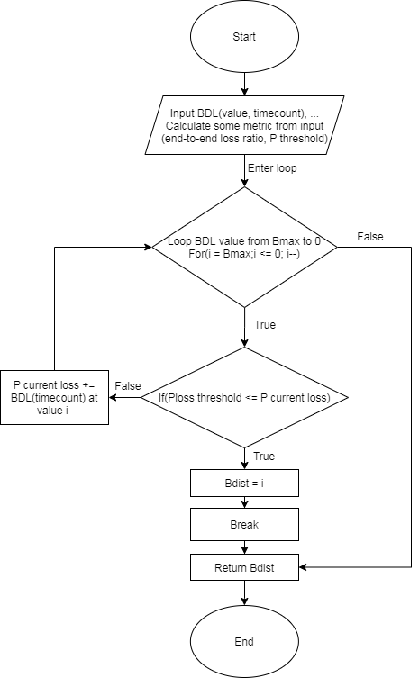
Figure 4. The flowchart of the main procedures in Algorithm 2.

4. Evaluation
By using the Cooja simulator, the Bdist metric was compared with schemes such as ETX and PRR. The key parameters are presented in Table 2.
Table 2. Summary of the simulation set-up parameters.
Number of nodes | 10
Number of probes | 1000
Target PRR | 99%
Link quality of the channel (set) | 70% - 90%
Number of data packets | 1000
Network area | 100m x 100m
Payload size | 26 bytes
Simulation time for each scenario | About 55 minutes
The link quality of the channel for each link indicates the percentage of successful packets at the receiver, compared with the number packets from senders. For example, a channel link quality at 70 indicates that the receiver will successfully receive 70 packets if sent 100 packets. The number of probes to measure the link quality and the number of data packets to evaluate the measured link quality metric are both 1000.

4.1. Relationship between the number of retransmissions and network performance
To evaluate the effect of the number of retransmissions on the performance of the network, a simple network with one sink (gateway) and nine sensor nodes was considered. The link quality of the channel was fixed, while the number of retransmissions varied from 0 to 3, and we examined the packet reception rate at the sink with each value for the number of retransmissions.
Figure 5. Relationship between the number of retransmissions and PRR.

The results in Figure 5 show that since the sensor nodes are not allowed retransmissions, the PRR at the sink achieved a low PRR: 66.3%. When the sensor nodes are allowed retransmissions, the PRR improved since the number of retransmissions increased. It is shown that when the link quality is not very good, the number of retransmissions will decide the network performance. Therefore, to estimate the number of retransmissions is very important.

4.2. Effect of the hop count on network performance
We evaluated the effect of the hop count on PRR. A simple linear network with the hop count varying from 1 to 4 was considered. We compared our proposed approach with schemes like ETX and PRR. Each scheme estimates the number of retransmissions by itself. We examined the packet reception rate at the sink for each value of the hop count.
Figure 6. Effect of the hop count on network performance.
The results are presented in Figure 6, where we can see that our proposed method achieved a very high PRR, even at the highest hop count. That is because our proposed method provides a good estimation of the number of retransmissions by using the target PRR to estimate link quality. Under other schemes, the PRR decreased since the hop count increased. This is because with the two other schemes, the estimate of the number of retransmissions is not very good.

4.3. Evaluating the network with other estimation schemes
In this examination, nine sensor nodes were deployed randomly, and the link quality between every two nodes was set randomly from 70% to 90%. Each sensor node generated 1000 packets periodically. The TSCH MAC protocol was used with the PCLLF [24] scheduling algorithm to guarantee no collisions in the network. We collected the packet reception rate of each sensor node at the sink.
The resulting data PRR for each sensor node at the sink is presented in Figure 7, where the PRR of the proposed scheme almost achieved the target PRR with the estimated number of retransmissions for each sensor node. It shows that the algorithm for calculating the number of retransmissions worked well. Furthermore, the other schemes achieved a much lower PRR since the estimation of the number of retransmissions by ETX and PRR is not very good. This is because ETX and PRR do not consider burstiness in the links.
Figure 7. The data PRR of sensor nodes under several estimation schemes.

4.4. Evaluating networks of several types
In this examination, we ran nine sensor nodes deployed with a link quality between two nodes set randomly between 70% and 90%. We compared network schemes using minimal scheduling, orchestra scheduling, and PCLLF scheduling, with Bdist as the metric value and PCLLF with no retransmission config. Each sensor node generated 1000 packets and transmitted using the time slot assigned by the scheduling algorithm. We collected the data packet reception rate at the sink.
Figure 8 shows the data PRR of each sensor node at the sink. From Figure 8, the network performance of the proposed Bdist metric had the highest reliability, compared with the other network schemes. Almost all sensor nodes achieved the target PRR by using the number of retransmissions calculated with our method. Other network schemes showed lower performance since they do not consider retransmissions.
Figure 8. The data PRR of sensor nodes under several network schemes.

5. Conclusions
In this study, we propose an LQE to apply to industrial wireless sensor networks with high reliability. Based on the burstiness property of wireless links, we estimate the number of transmissions required to reach the PRR target by using the burstiness distribution metric proposed in Section 3. We proved by simulation in Cooja that our approach estimates the number of transmissions that can reach the target PRR, as we expected. Based on the simulation in which we compared some RNP-based methods (ETX and PRR), our proposal can be used as the input metric to calculate the number of retransmissions in scheduling for industrial wireless sensor networks. Therefore, we conclude that our approach is highly suitable for industrial wireless sensor networks that require high reliability and energy efficiency for data transmissions. In the future, we will apply our approach to real devices for monitoring and controling systems in industrial environments.

References
[1] R. C. Shah, S. Roy, S. Jain, and W. Brunette, “Data MULEs: modeling and analysis of a three-tier architecture for sparse sensor networks,” Ad Hoc Networks, vol. 1, no. 2, pp. 215–233, 2003, doi: https://doi.org/10.1016/S1570-8705(03)00003-9.
[2] X. He, X. Fu, and Y. Yang, “Energy-Efficient Trajectory Planning Algorithm Based on Multi-Objective PSO for the Mobile Sink in Wireless Sensor Networks,” IEEE Access, vol. 7, pp. 176204–176217, 2019, doi: 10.1109/ACCESS.2019.2957834.
[3] X. Fu, H. Yao, and Y. Yang, “Cascading failures in wireless sensor networks with load redistribution of links and nodes,” Ad Hoc Networks, vol. 93, p. 101900, 2019.
[4] X. Fu, Y. Yang, and O. Postolache, “Invulnerability of Clustering Wireless Sensor Networks Against Cascading Failures,” IEEE Syst. J., vol. 13, no. 2, pp. 1431–1442, 2019, doi: 10.1109/JSYST.2018.2849779.
[5] M. Mittal, C. Iwendi, S. Khan, and A. Rehman Javed, “Analysis of security and energy efficiency for shortest route discovery in low-energy adaptive clustering hierarchy protocol using Levenberg-Marquardt neural network and gated recurrent unit for intrusion detection system,” Trans. Emerg. Telecommun. Technol., vol. n/a, no. n/a, p. e3997, Jun. 2020, doi: https://doi.org/10.1002/ett.3997.
[6] T. T. Nguyen and H. Oh, “A Receiver for Resource-Constrained Wireless Sensor Devices to Remove the Effect of Multipath Fading,” IEEE Trans. Ind. Electron., vol. 65, no. 7, pp. 6009–6016, Jul. 2018, doi: 10.1109/TIE.2017.2779423.
[7] T. T. Nguyen and H. Oh, “SCSMA: A Smart CSMA/CA Using Blind Learning for Wireless Sensor Networks,” IEEE Trans. Ind. Electron., p. 1, 2019, doi: 10.1109/TIE.2019.2960753.
[8] T. Winter et al., “RPL: IPv6 Routing Protocol for Low-Power and Lossy Networks.,” rfc, vol. 6550, pp. 1–157, 2012.
[9] M. Mittal and C. Iwendi, “A survey on energy-aware wireless sensor routing protocols,” EAI Endorsed Trans. Energy Web, vol. 6, no. 24, 2019.
[10] T. Clausen, J. Yi, and U. Herberg, “Lightweight on-demand ad hoc distance-vector routing-next generation (LOADng): protocol, extension, and applicability,” Comput. Networks, vol. 126, pp. 125–140, 2017.
[11] T. T. Nguyen and H. Oh, “Constructing an optimally balanced tree to maximize data throughput with multiple channels,” Wirel. Networks, vol. 24, no. 3, pp. 993–1005, Apr. 2018, doi: 10.1007/s11276-017-1550-x.
[12] C. Noda, S. Prabh, M. Alves, C. A. Boano, and T. Voigt, “Quantifying the channel quality for interference-aware wireless sensor networks,” ACM SIGBED Rev., vol. 8, no. 4, pp. 43–48, 2011.
[13] H.-J. Audéoud and M. Heusse, “Quick and efficient link quality estimation in wireless sensors networks,” in 2018 14th Annual Conference on Wireless On-demand Network Systems and Services (WONS), 2018, pp. 87–90.
[14] M. Eskola and T. Heikkilä, “Classification of radio channel disturbances for industrial wireless sensor networks,” Ad Hoc Networks, vol. 42, pp. 19–33, 2016.
[15] R. D. Gomes, D. V Queiroz, A. C. Lima Filho, I. E. Fonseca, and M. S. Alencar, “Real-time link quality estimation for industrial wireless sensor networks using dedicated nodes,” Ad Hoc Networks, vol. 59, pp. 116–133, 2017.
[16] G. Kirubasri and N. U. Maheswari, “A study on hardware and software link quality metrics for wireless multimedia sensor networks,” Int. J. Adv. Netw. Appl., vol. 8, no. 3, p. 3103, 2016.
[17] A. Woo and D. E. Culler, Evaluation of efficient link reliability estimators for low-power wireless networks. Computer Science Division, University of California Oakland, Calif, USA, 2003.
[18] D. S. J. De Couto, D. Aguayo, J. Bicket, and R. Morris, “A high-throughput path metric for multi-hop wireless routing,” in Proceedings of the 9th annual international conference on Mobile computing and networking, 2003, pp. 134–146.
[19] C. E. Koksal and H. Balakrishnan, “Quality-aware routing metrics for time-varying wireless mesh networks,” IEEE J. Sel. areas Commun., vol. 24, no. 11, pp. 1984–1994, 2006.
[20] R. Fonseca, O. Gnawali, K. Jamieson, and P. Levis, “Four-bit wireless link estimation.,” in HotNets, 2007.
[21] V. C. Gungor and M. K. Korkmaz, “Wireless link-quality estimation in smart grid environments,” Int. J. Distrib. Sens. Networks, vol. 8, no. 2, p. 214068, 2012.
[22] K. Srinivasan, M. A. Kazandjieva, S. Agarwal, and P. Levis, “The β-factor: measuring wireless link burstiness,” in Proceedings of the 6th ACM conference on Embedded network sensor systems, 2008, pp. 29–42.
[23] S. Munir, S. Lin, E. Hoque, S. M. S. Nirjon, J. A. Stankovic, and K. Whitehouse, “Addressing burstiness for reliable communication and latency bound generation in wireless sensor networks,” in Proceedings of the 9th ACM/IEEE International Conference on Information Processing in Sensor Networks, 2010, pp. 303–314.
[24] A. Darbandi and M. K. Kim, “Path collision-aware real-time link scheduling for TSCH wireless networks,” KSII Trans. Internet Inf. Syst., vol. 13, no. 9, pp. 4429–4445, 2019, doi: 10.3837/tiis.2019.09.006.

Publisher’s Note: MDPI stays neutral with regard to jurisdictional claims in published maps and institutional affiliations.
 | © 2020 by the authors. Submitted for possible open access publication under the terms and conditions of the Creative Commons Attribution (CC BY) license (http://creativecommons.org/licenses/by/4.0/).

