Master of Science

LINK QUALITY ESTIMATION FOR INDUSTRIAL WIRELESS SENSOR NETWORKS USING BURSTINESS DISTRIBUTION METRIC

The Graduate School of the University of Ulsan
Department of Electrical and Computer Engineering

NGOC HUY NGUYEN

LINK QUALITY ESTIMATION FOR INDUSTRIAL WIRELESS SENSOR NETWORKS USING BURSTINESS DISTRIBUTION METRIC
Supervisor: Professor MYUNG KYUN KIM
A Thesis
Submitted to
The Graduate School of the University of Ulsan
In partial Fulfillment of the Requirements for the Degree of

Master of Science
By
NGOC HUY NGUYEN

Department of Electrical and Computer Engineering
University of Ulsan, Korea
NOVEMBER 2020

LINK QUALITY ESTIMATION FOR INDUSTRIAL WIRELESS SENSOR NETWORKS USING BURSTINESS DISTRIBUTION METRIC

This certifies that this Thesis of Ngoc Huy Nguyen is approved by:

Committee Chair: Professor

Committee Member: Professor

Committee Member: Professor

Department of Electrical and Computer Engineering
University of Ulsan
November 2020
DEDICATED TO
My parent, my brother, and the people who have helped me.

ABSTRACT
As the mature of Industrial Wireless Sensor Network applications are increasingly requiring about low-power operations, deterministic communications, and end-to-end reliability. However, it is very difficult to achieve this goal because of link burstiness and interference. In this study, we propose a novel link quality estimation mechanism namely Burstiness Distribution Metric which uses the distribution of burstiness in the link to deal with the variations in the link quality of Wireless Sensor Networks. First, we estimate the link quality by counting the number of consecutive loss packet happenings in each bi-direction link at the receiver node. Then, based on that the node decides to choose the best route for the routing and estimate the number of retransmission to reach the reliability target in the scheduling algorithm. Our simulation in Cooja Simulator – the simulator of Contiki shows that our proposal can be used as the input metric to choose the minimal number of retransmission packet on each link for the routing protocol and calculate the number of retransmission in scheduling to achieve the energy efficiency and reliability target in Industrial Wireless Sensor Network.

TABLE OF CONTENTS
ABSTRACT v
ACKNOWLEDGEMENT viii
LIST OF FIGURES 1
LIST OF TABLES 3
Chapter 1: INTRODUCTION 4
1.1 Overview 4
1.2 Contribution of the Thesis 5
1.3 Structure of the Thesis 5
Chapter 2: BACKGROUND 6
2.1 Wireless Sensor Networks(WSNs) 6
2.2 IEEE 802.15.4 Standard 7
2.3 IEEE 802.15.4e TSCH 9
2.3.1 Slotframe structure 10
2.3.2 Channel Hopping 10
2.3.3 TSCH Scheduling 10
2.4 Contiki, Contiki-NG and Cooja Simulator 11
2.4.1 Contiki, Contiki-NG OS 11
2.4.2 Network stacks in Contiki, Contiki-NG 12
2.4.3 Cooja Simulator 14
Chapter 3: RELATED WORK 16
3.1 Wireless Link Quality Estimation 16
3.1.1 Category of Link Quality Estimators 16
3.1.2 Hardware-based Estimators 18
3.1.3 Software-based Estimators 19
Chapter 4: ALGORITHM AND IMPLEMENTATION 21
4.1 System and Network Model 21
4.2 The distribution of Burstiness compare with link PRR 24
4.3 The variation of Burstiness Max 25
4.4 Calculate the Burstiness Distribution Metric 26
4.5 A Minimal Retransmission and Reliable Routing Protocol using Bdist 28
4.6 Evaluation results 35
Chapter 5: CONCLUSION 39
REFERENCES 40

ACKNOWLEDGEMENT
This thesis describes the research work that I performed at the Computer Network Lab at the University of Ulsan under Professor Myung Kyun Kim. It is his wide area knowledge, broad interest, thoughtful guidance that gives me insight into the research process. He is the supervisor for my MSc thesis work, his help for this thesis is invaluable. I would like to express my sincere gratitude for his support, guidance, and encouragement for my work at the University of Ulsan. Further, I would like to say thanks also to all my co-workers in the laboratory with whom I have had many interesting and fruitful discussions, with whom I have written my conference and journal papers.
Thanks to BK21 Plus, which gave me research funding and provided me an interesting and promising research area, I had the opportunity to work with many excellent researchers. I have gained a lot during project meetings and discussions.
Finally, I would like to share a great deal of my achievement with my big family in Vietnam. Especially to my parent, who is always supportive of me. To my girlfriends, who is always the one with whom I would like to share all my happiness. Also to all my friends at the University of Ulsan, who give me a colorful life during my study in Ulsan.

Republic of Korea, Ulsan, NOVEMBER 2020
NGOC HUY NGUYEN

LIST OF FIGURES
Figure 1. The typical architecture of the sensor node. 6
Figure 2. The map of wireless standards and their key features. 7
Figure 3. A general structure of the IEEE 802.15.4 packet. 8
Figure 4. An example TSCH schedule. 11
Figure 5. Contiki, Contiki-NG Network stack, and some example protocols 13
Figure 6. Categories of some LQEs. 16
Figure 7. An example network. 21
Figure 8. Orchestra’s schedule assigns in NCP. 22
Figure 9. The distribution of Burstiness compares with link PRR. 24
Figure 10. The variation of burstiness max value with the config of the number of probes. 25
Figure 11. The burstiness time count of Bmax with the config of the number of probes. 26
Figure 12. Network example with the PRR of each link. 28
Figure 13. Network graph with the number of retransmission. 29
Figure 14. The sink node starts routing protocol by broadcasting the RR control packet. 30
Figure 15. Node 2 broadcasting RR control packet and the neighbor create RE respectively. 31
Figure 16. Node 4 broadcasting RR control packet and the neighbor create RE respectively. 32
Figure 17. Node 6 broadcasting RR control packet and the neighbor create RE respectively. 32
Figure 18. The route response operation from Node 7. 33
Figure 19. The route response operation from Node 3. 34
Figure 20. The converge cast tree topology of the example network. 34
Figure 21. The example network tree with 25 nodes. 35
Figure 22. The total number of transmissions compared by some RNP-based methods. 36
Figure 23. The end-to-end data PRR is calculated by 1000 data packets. 37
Figure 24. The end-to-end data PRR was calculated by 2000 data packets. 38
Figure 25. The average data PRR with a different number of data packets. 38

LIST OF TABLES
Table 1. IEEE 802.15.4 standard frequency, modulation, and data rate. 8
Table 2. Burstiness Distribution List of link L(1, 4) in MLQP. 23

Chapter 1: INTRODUCTION

Overview
Wireless sensor networks are deploying in many applications such as monitoring applications, radiation checks, leakage detection, process control applications, and have some advantages such as low cost and high flexibility when compared with the use of wired networks [1]. In which application, the data is collected by the sensor node and then transmitted to the sink (based station). Especially, in the industrial application, have strong requirements in terms of latency, energy efficiency, and reliability. The reliability of data transmission is decided by the link quality between every two sensor nodes. However, the link quality can be effect by a lot of causes such as internal interference, external-interference, self-interference, and burstiness link. The interference link is the physical property of the environment that causes the packet transmission between different links to interfere with one another. Burstiness link is another physical property which means transmissions of the wireless link do not contain a fixed probability of failure and have periods of continuous loss packet. Because of these non-deterministic wireless links, it's difficult to supply reliability for packet transmit over the wireless networks. Although the causes will make the link quality between two sensor nodes can be changed, however, it is not easy to estimate the link quality between two sensor nodes since the sensor node is limited to the energy consumption and the complexity computational. Therefore, it is necessary to study a link quality measurement that is low complexity computational, low energy consumption for wireless sensor networks.
The routing protocol is crucially important to reduce latency, energy efficiency, and reliability. There are some studies to design a Routing Protocol in multi-hop low power networks such as RPL [2], LOADng [3], LRP [4] to seek effective routes. These protocols have to keep their own foot-print small and select the best way to route for data traffic. So this preliminary link quality measurement needs to be precise and accurate to choose the best route to sink node to achieve reliability target at a low-cost. The author in [5], [6] proposed mechanisms to solve the Burstiness link problem. Srinivasan et al. [5] presented a new metric called β to measure the link burstiness and showed that we can avoid link burstiness by having an inter-packet delay of 500 ms. Though in the industrial area, 500ms of delay is a disadvantage for the network, we don’t have to wait that time to avoid packet loss when link burstiness happens. Munir et al. [6] propose a new metric called maximum burst length (Bmax) as the maximum length of error burst, estimated by using empirical data for a long experiment. The novel routing algorithm called least-burst-route is used in conjunction with this scheduling algorithm to minimize the sum of worst-case burst lengths over all links in the route. However, the algorithm to calculate Bmax value is gathered from the experiment measure link with the long sequence of data-trace before settings the network. It makes this algorithm hard to apply to the ad-hoc network and this algorithm uses the number of retransmission for a packet is too large, so it increases end-to-end delay.

Contribution of the Thesis
The major aim of this thesis is to analyze the link quality estimator of a different method such as hardware-based estimators and software-based estimators. We propose a link quality estimation metric calculated by the receiver node the number of consecutive loss packet then makes the distribution of burstiness of each link called the Burstiness Distribution Metric. Our proposal can be easy to apply to the ad-hoc network. Moreover, we can use Burstiness Distribution Metric for the Minimal Retransmission and Reliable (MMR) routing protocol to find the minimal retransmission path and calculate the number of retransmission for the Path Collision-aware Least Laxity First (PCLLF) [7] scheduling algorithm to reach a reliable target for the specific application.

Structure of the Thesis
The structure of the thesis is explained in this section. Chapter 2 starts by introducing the concepts behind wireless sensor networks. Then, it continues by discussing the various communication protocols of WSNs, the IEEE 802.15.4, and IEEE 802.15.4e standards. Moreover, chapter 2 presents the Contiki OS and its new version Contiki-NG (Next Generation), and also the currently supported network stacks. Finally, a summary of the simulator software Cooja accustomed to evaluate this work is presented.
The discussed in Chapter 3 mentioning the related work that has been done on the link quality estimators. Furthermore, a summary survey for the measure link quality topic is discussed in this chapter. Chapter 4 explains the proposed algorithm and the implementations in the Contiki-NG. Additionally, the configurations of the simulation work in the Cooja Simulator are discussed in detail to evaluate the software implementations of the proposed link quality estimator. Finally, the results of the simulation are shown and the main findings of this evaluation are presented. The conclusions of the thesis work are mentioned in chapter 5.

Chapter 2: BACKGROUND
This chapter presents the main concepts behind wireless sensor networks, their main characteristics, and the IEEE 802.15.4 standard. Moreover, the IEEE 802.15. 4e amendment is defined TSCH (Time Slotted Channel Hopping) mechanism is explained. TSCH is a scheme aiming to guarantee network reliability by keeping nodes time-synchronized at the MAC layer. Finally, an overview of the Contiki, Contiki-NG, Cooja Simulator is briefly presented.

2.1 Wireless Sensor Networks(WSNs)
Wireless Sensor Networks is a board system that typically consists of several cheap, low-power with the connectivity capability and more functional sensors nodes to sense data and/or perform actions. They are equipped with a transceiver module, power source, memory, sensors, and microprocessors, and therefore not only can sense the physical environment but also process and send data. Figure 1 shows the typical architecture of the sensor node. Communication takes place over a wireless medium and together they can monitor. Applications of WSNs with the aforementioned requirements might seem very limited to only high-end applications like radiation, land mine, and nuclear-threat detection systems. However, the number of applications and fields is quite huge and continues to increase along with the new advancements in technology such as environmental application, home automation, health care, control, and monitoring system,...
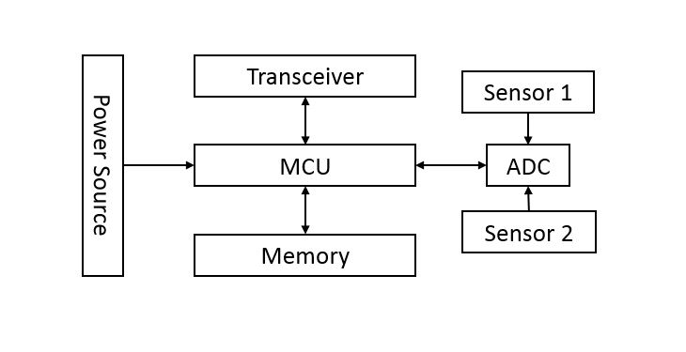
Figure 1. The typical architecture of the sensor node.
Wireless sensor nodes have great advantages over traditional wired networks, which get rids of the cables thus lowering the cost, simplifying for design network, installation, and maintenance. Moreover, they can be placed in a harsh environment where wired solutions are impossible [8].

2.2 IEEE 802.15.4 Standard
During the last few decades, a range of protocols and standards are introduced to produce communication and network functionalities to wireless sensor networks. The IEEE 802.15.4 [9] standard is a low data rate protocol for short-range wireless networks that aims to enable applications with relatively low throughput and latency requirements within wireless personal area networks.
The IEEE 802.15 task group 4 (TG4) published the first version of the standard in 2003. Several revisions were issued later in 2006 and 2011 [10]. The IEEE 802.15.4 protocol has been developed to address the increasing demand for short-range communications between the nodes in low-power sensor networks. Moreover, it is supported by a large number of research academic and commercial sensor nodes.
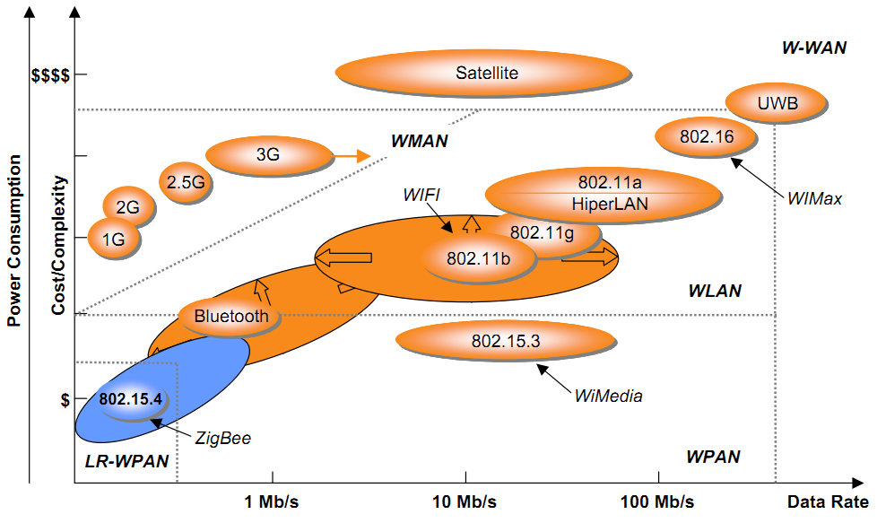
Figure 2. The map of wireless standards and their key features.
The standard defines the physical (PHY) and Medium Access Control (MAC) layer of the network stack for low power WSNs. The IEEE 802.15.4 standard has lower data rates, lower complexity, lower cost, and lower power consumption than other standards as shown in Figure 2 [11].

Frequency Band | Region | Channel number | Modulation | Bit rate
868-868.6 MHz | EU, Japan | 1 | BPSK | 20 kbps
902-928 MHz | USA | 10 (2003 rel)  30 (2006 rel) | BPSK | 40 kbps
2400 MHz | Global | 16 | O-QPSK | 250 kbps

Table 1. IEEE 802.15.4 standard frequency, modulation, and data rate.
The data rates of IEEE 802.15.4 standard approximately 20, 40, and 250 kbps. Depending on the specific application, we can use which Radio Frequency (RF) bands and digital modulation mechanisms to comply with our data rate expectation. Moreover, the standard supports both star and peer-to-peer network topologies. In the star topology, the PAN Coordinator plays the role of a border router where the sensor nodes of IEEE 802.15.4 can communicate through it to the internet world. With the peer-to-peer networks, sensor nodes can communicate with any other sensor nodes in their radio range, then base on the routing protocol, the sensor data packet will be forwarded to the PAN Coordinator. The MAC layer uses different mechanisms to access the channel such as Carrier-Sense Multiple Access with Collision Avoidance (CSMA/CA). Moreover, the protocol has four types of MAC frames: a data frame, a beacon frame, an acknowledgment frame, and a MAC command frame. As shown in Figure 3, the packet structure of IEEE 802.15.4 consists of four main fields: a preamble of four octets (32 bits) used for synchronization, a packet ID acting as a start of packet delimiter (8 bits), a PHY header which contains the Physical layer Service Data Unit (PSDU) length (8 bits), and finally a PSDU field which contains the actual data.
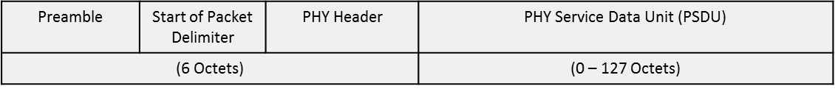
Figure 3. A general structure of the IEEE 802.15.4 packet.
Finally, there are two network device classes of the 802.15.4 standard: full-function devices (FFDs), reduced function devices (RFDs), and Coordinator. An FFDs is a node that has full levels of functionality. It can be used for sending and receiving data, but it can also route data from other nodes. However, RFDs is a device that has a reduced level of functionality. Typically it is an end node that may be typically a sensor or switch. RFDs can only talk to FFDs as they contain no routing functionality. The devices can be very low power devices because they do not need to route other traffic and they can be put into a sleep mode. These RFDs are often known as child devices as they need other parent devices with which to communicate. The coordinator is the node that controls the IEEE 802.15.4 network. This is a special form of FFD. In addition to the normal FFD functions, it also sets the IEEE 802.15.4 network up and acts as the coordinator or manager of the network.

2.3 IEEE 802.15.4e TSCH
While the IEEE 802.15.4 standard was initially published in 2003, other revisions and improvements for different aspects of the standard were introduced in 2006 and 2011 [10]. A new amendment to the 802.15.4-2006/2011 revisions was published in 2012 named IEEE 802.15.4e [12] to enhance the previous MAC protocols and communication modes while addressing the emerging needs of applications in industrial environments for the time-critical requirement. It introduced several general functional improvements and the following new MAC behavior modes: Asynchronous Multi-Channel Adaptation (AMCA) for infrastructure monitoring networks, Deterministic and Synchronous Multi-channel Extension (DSME) for deterministic latency and scalability requirements, Low Latency Deterministic Network (LLDN) for high reliability and low latency, and Time-Slotted Channel Hopping (TSCH) for high throughput requirements, bounded latency, and high reliability.
The TSCH MAC protocol [13] is one of the prominent IEEE 802.15.4e MAC behavior modes which was developed to satisfy industrial and vehicular sectors. The TSCH behavior mode combines time-slotted access, multichannel communication, and channel hopping which suits multi-hop networks. One of the key features was the TSCH mitigates two of the main causes of link failure external interference and multi-path fading. External interference occurs when simultaneous transmissions operate on the same frequency band will collide and introduce packet loss. Multi-path fading is the radio waves that will take many different paths to the destination, which will then receive multiple signals. Depending on several factors, this will create a destructive effect that results in packet loss [14]. Moreover, TSCH supports many network topologies such as star, tree, and mesh. The dedicated and shared links are supported by TSCH. Shared links are represented special communication slots that can be assigned to more than one transmitter, thus concurrent access by multiple nodes is allowed and based on the collision method. The dedicated link can prevent collision since it allows only one communication cell between one transmitter and one receiver at the same time. The core goals of TSCH are to support larger network capacity, predictable latency, high reliability, and low-power consumption. TSCH supports multichannel based on channel hopping up to 16 different channels. The channel is defined by channel offset, an integer value has the ranges from 0 to 15. More nodes can communicate at the same timeslot using different channels which are identified by their channel offset. Thus, at a time slot, we can assign up to 16 dedicated links.
The TSCH MAC behavior mode does not completely amend the physical layer structure. Thus, it can operate on any hardware that is compliant with the previous IEEE 802.15.4 standard.

2.3.1 Slotframe structure
In the TSCH network, time is cut into timeslots. The slot frame structure consists of several timeslots of 10ms duration typically. All sensor nodes in a TSCH network are tightly synchronized. Each pair of sensor nodes can exchange a maximum-size data frame or acknowledgment (ACK) for this frame through the duration of the timeslot. If the ACK is not received, retransmission of that frame is deferred until the next assigned transmit timeslot. The Absolute Slot Number (ASN) is the total number of slots elapsed, and it is used to synchronize nodes in a WSN. ASN is a timeslot counter and increases by 1 each timeslot. When joining nodes has received ASN, they use this to calculate which channel to communicate on. All scheduling cells have a specific slot offset and channel offset. For example, if node A has a transmitting slot to node B on channel offset 1, node B will have a receiving slot for node A on channel offset 1. The channel offset is then transformed to a frequency using the function below:
$f = F[(ASN + channelOffset)\%Nch]$ (1)
Where the Nch is the number of channels in use and F is the lookup table function containing the sets of available channels.

2.3.2 Channel Hopping
The channel hopping mechanism in TSCH is presented by Equation (1), where multiple frequencies can be returned for the same link at different timeslots. The channel hopping mechanism ensures that all the available channels are used for a specific link during their specified timeslot, thus mitigating the effects of interference and multipath fading, and thus improving the network reliability.

2.3.3 TSCH Scheduling
The IEEE 802.15.4e standard [12] does not specify how the communication schedule is built, optimized, and maintained. It only explains the mechanism of how the MAC layer can execute the schedule. Some several scheduling techniques were proposed such as centralized scheduling, distributed scheduling, and autonomous scheduling. With centralized scheduling, the Central Entity is responsible for building and optimizing the network schedule and download the schedule for sensor nodes. However, the distributed scheduling doesn’t have Central Entity for computes scheduling, it takes decisions locally based on the control packet they are negotiating with their neighbors. With the autonomous scheduling, all the schedule is generated by the sensor node without any control packet transfer with their neighbors. Figure 4 shows an example of the TSCH schedule.
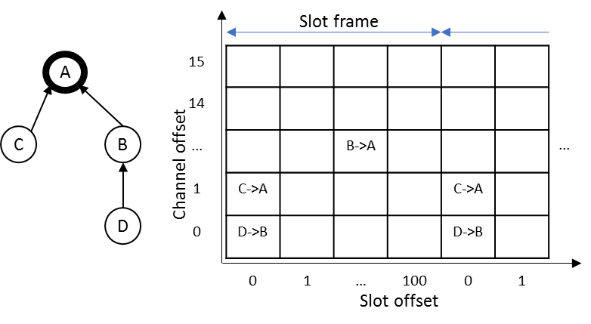
Figure 4. An example TSCH schedule.

2.4 Contiki, Contiki-NG and Cooja Simulator
In the last few decades, many software and operating system (OS) have been introduced to address different requirements in the WSN field. This section describes the software and toolchain used to accomplish the practical work and evaluate the required implementations.

2.4.1 Contiki, Contiki-NG OS
In WSN, the OS differs from the traditional OS used in other devices such as PC, mobile phone,… It is a small OS that enables basic programming on embedded systems such as sensor nodes to be utilized by application developers. A wide range of WSN OS is available for usage and testing such as RIOT, OpenWSN, TinyOS, Contiki, and Contiki-NG.
Contiki [15] is a lightweight WSN OS designed for resource-constrained platforms. Contiki does not fully support Real-time OS (RTOS) functionalities. Contiki uses a hybrid model to combine the advantages of event-driven processes and preemptive threads. It introduced protothreads that provide event-driven services while enabling optional preemptive multithreading through an application library that can be linked only with the applications that require this preemptive feature explicitly in a specific process.
Contiki-NG is a new version of the Contiki project. Contiki-NG provides an RFC-compliant, low-power IPv6 communication stack, enabling Internet connectivity. Contiki-NG started as a fork of the Contiki operating system with five goals obtained. Focus on dependable (reliable and secure), standard-based IPv6 communication; Focus on modern IoT platforms, e.g. ARM Cortex M3 and other 32-bit MCUs; Modernize the structure, configuration, logging, and platforms, to reflect the goals above; Improve the documentation, both code API, module description, and tutorials; Implement a more agile development process, with easier inclusion of new features, and with periodic releases.

2.4.2 Network stacks in Contiki, Contiki-NG
Contiki [15] is an open-source, lightweight, and multi-tasking operating system built with memory-constrained networked embedded systems and wireless sensor networks in mind. Because Contiki is open-source and has many different contributors that often cause the documentation to be a little short. The lack of proper documentation apart from its source code comments and examples which made it challenging to acquire sufficient information about its network stack. Contiki-NG started as a fork of the Contiki OS and retains some of its original features. There are some small and significant changes to the operating system from the predecessor Contiki-OS to the new Contiki-NG. The former core directory is renamed to OS. The apps directory is now moved to OS, and top-level directory dev, CPU, and platform are now under one directory called arch. [16]
Three types of network stacks [17] can be used in Contiki: uIP’s (IPv4 and IPv6) stacks and rime stack. The uIP stack is a concise implementation of the TCP/IP network suite which provides IPv4 networking capabilities and later on, it was extended to provide IPv6 capabilities. The rime stack offers a set of custom networking primitives to enable communication for low-power wireless networks using lightweight layering and the ability to build complex abstractions. Contiki adopts a five-layer network stack which is roughly similar to the TCP/IP model but simpler considering the computation and memory constraints of most networked embedded systems. At the same time, it also covers the traditional seven layers of the Open Systems Interconnection (OSI) model as shown in Figure 5. The description of each layer is briefly explained in the following subsections.
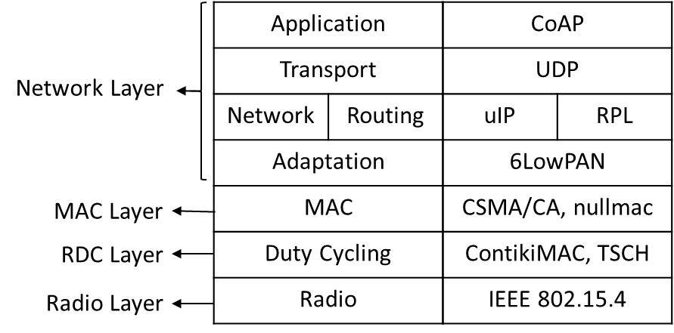
Figure 5. Contiki, Contiki-NG Network stack, and some example protocols
Radio Layer
The radio or physical layer is the lowest layer of the Contiki, Contiki-NG model. This layer is handled by radio module from sensor nodes and it defines how the input data are structured and built to be transmitted to the upper layers of the network. Most radio layer work on the mechanism of IEEE 802.15.4.
Frame Layer
The framer layer is not shown in the network stack in Figure 5 but it is located between the Radio layer and the RDC layer. The framer layer does not have a regular layer implementation like the rest of the layers. The frame layer consists of a set of auxiliary functions that are used for either creating and parsing the frame.
RDC Layer
The Radio Duty Cycling (RDC) layer plays a critical role in the network stack as it greatly determines the energy usage of the nodes by forcing the nodes to switch off their radio transceiver while they sleep and making sure that their radio transceivers are awake to transmit or receive the packet. Contiki currently offers three specified RDC protocols : LPP, X-MAC, and ContikiMAC. The LPP protocol was built on the basis of the original Low-Power Probing protocol thus improving power consumption. Contiki 's X-MAC is the same as the X-MAC protocol, thereby improving certain aspects of networking and power use. ContikiMAC was eventually designed to improve the low-power listening mechanisms used by subsequent RDC protocols while at the same time improving energy efficiency. Contiki-NG uses the ContikiMAC protocol on the basis of low-power listening requirements. ContikiMAC uses Time Slotted Channel Hopping (TSCH) as part of the MAC amendment layer IEEE 802.15.4e-2012.
MAC Layer
The Medium Access Control ( MAC) layer is situated on the top of the RDC layer. It also plays a vital role in the Contiki and Contiki-NG net stack, as it decides how the nodes can communicate while the network is congested. In the case of a collision, the MAC layer is responsible for avoiding collisions and retransmitting packets. There are two MAC protocols to be used: Carrier Sense Multiple Access with Collision Avoidance (CSMA/CA) and carrier nullmac. CSMA/CA provides a variety of features, such as detecting the channel / radio media before sending back-off if another node is sending, waiting for a certain time depending on the RDC protocol used, and retransmitting missing packets after collisions. Alternatively, nullmac does not deliver any MAC-level handling, since it only forwards packets from the radio driver to the upper layer and vice versa, and thus technically has more packet loss ratio than CSMA.
Network Layer
The network layer is the topmost layer in Contiki and Contiki-NG where it protects the various sublayer functions as seen in Figure 5. It is primarily responsible for packaging the packets until they are sent out. In other words, it offers various networking and routing roles for received packets when modifying those packet frames to fit the upper sublayer standard, such as IPv6, before being sent to other nodes. RPL (Routing Protocol for Low-power and Lossy networks) is the routing protocol used by Contiki. It is responsible for finding the best route that the transmitted packets will take by creating an acyclic routing graph starting from the root node, called the DODAG (Destination Oriented Directed Acyclic Graph). Contiki-NG supports ContikiRPL, and the modified version is RPL Lite. The last two uppermost sub-layers are the transport and application sub-layers. The transport sub-layer protocol, such as the User Datagram Protocol (UDP), determines the means of communication between the source and the destination nodes. At the top, the application sublayer serves as an interface between host applications and lower layers and vice versa. One of the existing protocols in the application sub-layer is the IETF Constrained Application Protocol (CoAP), a low-power deployment program that aims to exploit every common service cycle protocol and achieve low-energy consumption.

2.4.3 Cooja Simulator
Cooja [18] is a Java-based simulator designed to simulate WSN sensors that run ContikiOS. It provides a series of functions to monitor the output of the sensor nodes. Several software, such as the MSPsim system emulator, mobility plug-ins, and the power trace function, are offered along with the simulator. The MSPsim emulator can be used via Cooja to provide emulation of sensor nodes such as Tmote Sky and Zolertia Z1 based on the MSP430 microcontroller. Cooja's simulated motes have three key properties: a data memory containing the program code required for testing, a mote type that can be shared between multiple motos while using the same source code, and hardware peripherals.

Chapter 3: RELATED WORK

3.1 Wireless Link Quality Estimation

3.1.1 Category of Link Quality Estimators
Link quality estimators in WSN can be roughly divided into two groups known as hardware-based estimators and software-based estimators. Hardware-based estimators include Link Quality Indicator (LQI) Received Signal Strength Indicator (RSSI) and Signal to-Noise Ratio (SNR). These estimators are directly obtained from the hardware. Their advantage is that they do not require any computation overhead as they are built-in directly on the hardware. However, as it was observed and reported in previous experimental studies, hardware-based estimators do not provide accurate estimates. These metrics are measured based on 8 symbols of a received packet and not the whole packet. Second, these metrics are only measured for successfully received packets. Therefore, when a radio link suffers from excessive packet loss, they could overestimate the transmission performance by not considering the information of lost packets. They are also dependant on the transceiver model, as LQI, for instance, might not be available on all radio transceivers. Figure 6 represents the categories of some different link quality metrics based on their estimation type.
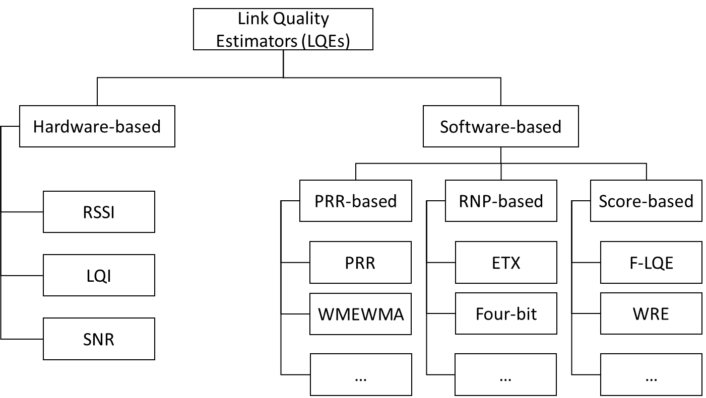
Figure 6. Categories of some LQEs.
On the other hand, software-based LQEs are computed by the number of received and sent packets and different strategies are adopted to calculate these software-based link quality estimators. Some software-based link quality estimators are calculated at the sender node side, while others are calculated at the receiver node side [xx]. These estimators enable us to count or approximate either the reception rate or the average number of packet transmissions/re-transmissions, required before its successful reception. Based on that Software-based LQEs can be classified into three categories, such as (i.) PRR-based: either count or approximate the PRR, (ii.) RNP-based: either count or approximate the RNP (Required number of Packet retransmissions), and (iii.) Score-based: provide a score identifying the link quality. Some of the software LQEs are Packet Reception Rate (PRR), Acquitted Reception Rate (ARR) count the reception rate, and ETX - based metrics will account for the expected number of retransmission for the successful reception of data.
These link quality estimators are simple, yet they have been widely used in routing protocols. The main difference between hardware and software-based estimators is the fact that hardware-based estimators only rely on received packet information, they do not account for packet loss.
Software-based estimators account for packet loss by incorporating data collected from the data link layer, such as packet retransmissions. Although hardware metrics provide a fast and inexpensive way to classify links as either good or bad, they are incapable of providing a fine grain estimation of link quality. The above limitations of hardware-based LQEs do not mean that this category of LQEs is not useful. Each of these LQEs provides particular information on the link-state, but none of them can provide a holistic characterization of the link quality. Currently, there is a growing awareness that the combination of hardware metrics with software metrics can improve the accuracy of the link quality estimation.
Link quality estimation is a fundamental problem in wireless networks, and in particular sensor and mobile ad hoc networks, because the accuracy of link quality estimation has a fundamental impact on the efficiency of networking protocols. In Wireless Sensor Networks (WSNs) routes towards sinks are evaluated using link cost metrics also known as link estimators. Link estimators can play an important role in a routing algorithm to choose the “best” route towards the sink using different properties of the links. A link estimator chooses one of the neighboring nodes as a parent node and transmits data towards the sink using that node. The node that a link estimator chooses as a parent is considered as the “best” in terms of a cost function. Poor link estimation may lead to a less stable network with higher packet loss and/or higher delays. Ideally, a routing protocol for a wireless multihop network should favor the use of good quality links. The problem is particularly critical in multihop routing when link-quality-aware metrics [xx] (e.g., expected transmission count (ETX), expected transmission time are used to select the best neighbor to relay a message. The availability of robust link quality estimates is even more critical when routing needs to support the quality of service provisioning (e.g. in the case of voice or video data transmissions). Other important applications that can benefit from the availability of accurate link estimation models include, among others: sensor placement, topology control, and load-balancing, relay node placement, network failure diagnosis, coordination in sensor-actuator networks. Accurate and reliable link quality estimation is a challenging task in wireless networks. The effective quality of Link assessment is required for a better comprehension of the environments we cope with. More specifically, a good perception of the link behavior helps to design robust link quality estimators (LQEs). A good LQE for routing has to guarantee low energy consumption, stable topology, a high throughput, a low end-to-end delay, reliable paths when retransmissions are present, and low churn (neighbor changes). On the other hand, it should be reactive, able to predict short and long term link fluctuations, stable in time, to accurately discriminate link quality, should rely on simple computation (light memory footprint), or to have accurate predefined thresholds to Discriminate unreliable neighbors (blacklist mechanism). To overcome the energy waste, LQEs should properly foresee the quality of the link over a few samples. Since a wrong decision leads to packet loss and costly neighbor changes. More exactly, when routing relies on bad links, retransmissions at the MAC layer increase, which causes energy waste. If the metric fails to choose an unreliable neighbor, interferences through concurrent transmissions are introduced. Interference that affects the quality of neighboring links. Therefore, the main requirements related to forwarding data over dynamic wireless links are designing good link estimators.

3.1.2 Hardware-based Estimators
The IEEE 802.15.4 standard proposed two ways to assess the link quality after receiving a packet which is RSSI and LQI. RSSI is used to describe the power which is presented by received radio signal strength in dBm and coarsely correlated with the distance. However, RSSI only relies on received packets on the receiver side, not account for the number of the lost packet, and the interference can influence the RSSI value. The LQI measurement is based on the received packets but the IEEE 802.15.4 standards do not define the computation method for LQI value. The standard only states that the range of LQI value is from 0 to 255. Moreover, to develop a general computation using this metric is very difficult since the different vendor has different ways to calculate LQI value. Some studies used the RSSI or LQI to estimate the channel quality.
Noda et al. [19] proposed a new channel quality metric which is based on the availability of the channel over time and meaningfully quantifies spectrum usage. However, with the presence of multipath fading, it may have problems to estimate the channel quality.
HJ Audéoud et al. [20] studied the correlation between RSSI, LQI, and PDR (Packet Delivery Ratio). The RSSI is a poor indication of PDR that one can expect on a given link, LQI (Link Quality Indicator) gives more accurate information. Thus, the work has focused on the utilization of LQI. However, in scenarios with impulsive noise, the LQI may overestimate the channel quality, since the LQI does not account for the packet loss.
Eskola et al. [21] proposed a classifier to identify disturbances in the wireless channel related to line-of-sight changes and radio frequency interferences. However, the proposed technique does not provide any metric to be used by protocols to optimize network performance.
Gomes et al. [22] proposed a new type of node, the LQE node dedicated to estimating the link quality in real-time using RSSI and information obtained from received packets. Typically, the LQE node is capable of capturing the effects of multipath, interference, and link asymmetry. They use the RSSI and LQI values to infer the Packet Delivery Ratio (PDR) of the given links. Unfortunately, RSSI and PDR have been proved to be only loosely correlated in many situations.

3.1.3 Software-based Estimators
The software-based estimators such as PRR and RNP are based on the calculated information from the upper layer. The use of PRR-based metrics for links with very high or very low quality can be achieved with narrow time measurement. However, intermediate links need much larger measure time to accurate link quality estimation. The RNP is more reactive than PRR, it is calculated based on the transmitted packet in the sender side. Thus, RNP can estimate the link quality as long as the traffic is generated from the sender. However, RNP can underestimate link quality since packets are retransmitted many times before being successfully received. This situation yields to good PRR but bad RNP. The Window Mean with Exponentially Weighted Moving Average (WMEWMA), Expected Transmission Count (ETX), and 4-Bit Link are some examples of RNP-based estimators. The WMEWMA is a filter-based link quality estimator that uses the Exponentially Weighted Moving Average (EWMA) filter as the main estimation technique, based on link measurements, the PRR is computed and then smoothed to the previously computed PRR using the EWMA filter which provides a more stable but sufficiently agile estimation compared to PRR [xx]. The Kalman filter based link quality estimator (KLE) was proposed in [xx] to overcome the poor reactivity of average-based LQEs, including PRR. The ETX [xx] is a receiver-initiated estimator that uses active monitoring. The ETX considers link asymmetry by estimating the PRR in both directions to calculate the PRR of the backward link and the PRR of the forward link. However, [xx] found that ETX based on passive monitoring fails in overloaded (congested) networks since a large number of nodes are not able to compute the ETX because they do not receive packets. The Four-Bit (FB) [xx] Link estimation is designed with four bits of information. The first bit is obtained from the physical layer, to identify the quality of the channel in a received packet. The ack bit is from the link layer and indicates whether an acknowledgment is received for a sent packet, and considers forward and backward links. The other two bits are obtained from the network layer and are useful for route decisions. FB assesses link quality as an approximation of the packet retransmissions count by combining two metrics (RNP and WMEWMA) through the EWMA filter. A simulation study was performed to compare five different LQEs (PRR, RNP, WMEWMA, ETX, and FB) on the collection tree routing protocol for smart-grid environments in [xx]. In the simulations described in the paper, ETX and FB presented a better performance in harsh smart grid environments, since only ETX and FB consider the link asymmetry among the evaluated LQEs. However, they are not considering the burstiness link during their measurements.

Chapter 4: ALGORITHM AND IMPLEMENTATION

4.1 System and Network Model
We focus here on the converge cast multi-hop networks that consist of one sink and some sensor nodes for tree topology. All nodes are assigned identification numbers during network configuration. All sensor nodes transmit data to a sink periodically along the tree path. Two nodes are said to have a link if they can transmit directly to each other and a link on which a child and parent node communicates together is a tree link.
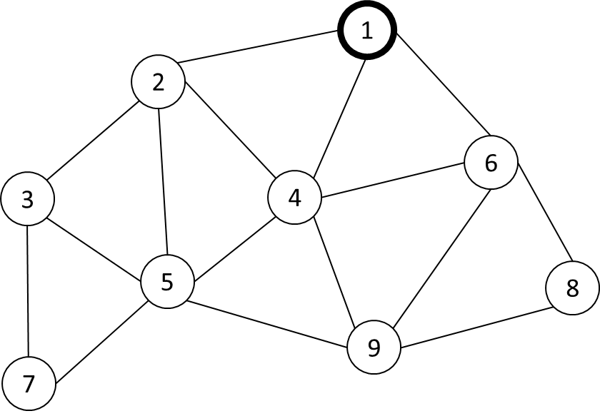
Figure 7. An example network.

Given the fixed number of periodic nodes generated sensor data in the network N = {N₁, N₂, N₃, …, N_{n}} with N₁ is the Coordinator, and N₂ to N_{n} is the set of sensor nodes. We assume nodes are stationary and deployed randomly. For example, we consider the network as shown in Figure 7. If the two nodes are in the radio range of each other, they are connected by an edge. The link between two pairs of nodes Ni and Nj denoted by L(i, j) and the symmetric link L(j, i). The MAC protocol used in this paper is based on Time Slotted Channel Hopping (TSCH) mechanism, in which all nodes in the network are assigned timeslot and channel to communicate to the parent node or child node which is collision-free with the neighbor node. We use the advantage of Orchestra's dedicated schedule based on the fixed number of nodes in the network to make the collision-free during joining and measure link quality. Orchestra [29] is an autonomous scheduling mechanism where each node independently decides its schedule based on its unique Node-ID settings in orchestra rules.
In the Network Construction Period, we define the Joining Period (JP) and Measure Link Quality Period (MLQP). In the JP, when a node starts, it auto-assign the schedule base on Node-ID with the rule each node autonomous assigns transmit (Tx) at timeslot calculated by (Node-ID – 1) since the timeslot value starts from 0, and receive (Rx) timeslot in all the other timeslots. For example with Node 1 in Figure 8, it assigns TX at timeslot 0 and Rx from timeslot 1 to 8 with the example network in Figure 7. Then all the sensor nodes start scanning mode in the same channel to detect the Enhanced Beacon (EB) packet broadcasting from the Coordinator (Node 1) to join the network. TSCH defines a timeslot counter called Absolute Slot Number (ASN). The ASN is initialized to 0 when the network created from the Coordinator, then it increments by 1 at each timeslot. After a node joins the network, it will become a broadcasting node to broadcast itself EB packet to expanding the network. When all the sensor nodes join the network, it will update the schedule base on the neighbor has the radio in range then switch to MLQP as shown in Figure 8. The schedule is updated to reduce the redundant assigned timeslot.
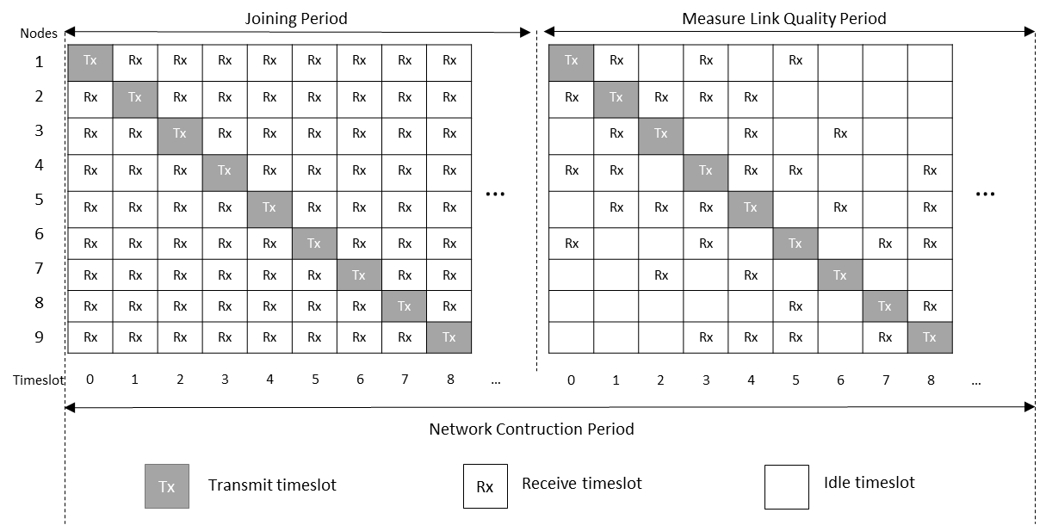
Figure 8. Orchestra’s schedule assigns in NCP.

In the MLQP, we use Probe Packet to measure the link quality in the receiver node. The number of probes has been predefined for the MLQP. Each node creates probe packet P(id, sequence) where id denoted the node id, and sequence is a sequence of probe packet created (it increases from 1 to the number of probes). If the node receiving the probe packet P(id, sequence), by using the sequence number, the node will calculate the burstiness value by each sender node then add to the Burstiness Distribution List. If the burstiness value happens again, the burstiness time count for that burstiness value will increase by 1. For example, node 1 received the current probe packet from node 4 with the sequence number is 15, denoted by P(4, 15). The next received probe packet from node 4 is P(4, 18). It means that burstiness happens in the probe packet P(4, 16) and P(4, 17), thus burstiness value is 2. At this time the current probe packet is P(4, 18) and the receiver will receive the next probe packet and calculate the burstiness value. If the bustiness value equal to the current value in Burstiness Distribution List, the burstiness time count will be increased by 1 value.
Burstiness value | 0 | 1 | 2 | 3 | 4
Burstiness time count | 634 | 129 | 31 | 2 | 1

Table 2. Burstiness Distribution List of link L(1, 4) in MLQP.
For example with link L(1, 4), we use the number of probes is 1000 packets. We have a Burstiness Distribution List of L(1, 4) calculated in node 4 as shown in Table 1. With the burstiness value from 0 to 4 and the burstiness time count respectively, the burstiness time count is the time burstiness value happens during probe packets transmission. The burstiness value is 0 means that the burstiness does not happen and node 4 has received the probe packet successfully consecutively 634 times. In case burstiness value is 4 means that the burstiness happens in 4 consecutive transmissions, but it only happens 1 time. For each pair of connected node Ni and Nj, we have two Burstiness Distribution List calculated by the receiver node. The link L(i, j) has Burstiness Distribution List calculated by node j and the symmetric link L(j, i) has Burstiness Distribution List calculated by node i. The Algorithm 1 computes the Burstiness Distribution List for each incoming link by the receiver node base on the probe packet that we receive from neighbor nodes.
Algorithm 1: Calculate Burstiness Distribution List
Input | : | Incoming probe packet P(Pid, Psequence), number of probes packet Nprobes
Output | : | Burstiness Distribution List (BDL(Bvalue, Btimecount))
1 | : | Initialize BDL is empty
2 | : | If the receiver receives the first incoming probe packet P
2.1 | : | Set the current neighbor id (Nid) and neighbor sequence (Nsequence) by the first probe packet information  (Nid = Pid)  (Nsequence = Psequence)
3 | : | If finished MLQP
3.1 | : | Return the BDL(Bvalue, Btimecount), Exit.  End if
4 | : | If new incoming probe packet from the same neighbor (Pid == Nid)
4.1 | : | Calculate burstiness value (Bvalue = Psequence – Nsequence – 1)
4.1.1 | : | If BDL contains this burstiness value  Increase the burstiness time count by 1 (Btimecount++)
4.1.2 | : | Else  Add new burstiness value to the BDL.
4.1.3 | : | Set burstiness time count to 1 (Btimecount = 1)
4.1.4 | : | End if
5 | : | End if

4.2 The distribution of Burstiness compare with link PRR
Figure 9. The distribution of Burstiness compares with link PRR.
Figure 9 shows the distribution of Burstiness compare with link PRR 70%, 80%, and 90% with the number of probes is 1000 packets. The burstiness value is the number of consecutive loss during probes transmission and the burstiness time count is the time burstiness value happen.

4.3 The variation of Burstiness Max
To determine the impact of the number of probes packet we use in the MLQP with the Burstiness value, we evaluate the variation of burstiness max value and the burstiness time count of burstiness max base on some config of the number of probes. Figure 10 shows the variation of burstiness max value with the config of the number of probes from 500 to 5000 packets.
Figure 10. The variation of burstiness max value with the config of the number of probes.
We can see the burstiness max value slightly increase with the increase in the number of probes. Figure 11 shows the burstiness time count of burstiness max value (the time burstiness max happened) during the number of probes. As the result, we can see the burstiness max value happens always lower than 1% of the number of probes packet. Base on this observation, we define our algorithm to calculate the number of retransmission by using the Burstiness Distribution List.
Figure 11. The burstiness time count of Bmax with the config of the number of probes.

4.4 Calculate the Burstiness Distribution Metric
We present the algorithm to calculate the number of retransmission by Burstiness Distribution List. We named the number of retransmission packet calculated by our method is the Burstiness Distribution Metric (Bdist). The key idea to calculate Bdist is, we define the target PRR for specific applications and base on the Burstiness Distribution List (BDL). BDL is the distribution of consecutive packet transmission failure due to a burst. Then from the number of probes in the MLQP, we consider the possible loss ratio for the transmission and determine the Bdist value. For example, to reach the PRR target 99% for the data transmission period, the loss ratio should lower than 1% for each link. If the route has n hops, then every link L(i, j) that the route go through have the loss ration lower than $\sqrt[n]{0.01}$ . With the link has PRR 90% and the number of probes is 1000, it means that 1% of 1000 packets can be lost. The number of packets that can be lost during data transmission is 10 packets. From the BDL, we can calculate the Bdist value for successful packet transmission is 2 since the consecutive loss of two times transmission in 90% link is 5 packets as Figure 9, lower than 10 is the number of allowing packet loss. Note that the different links will have a different distribution of burstiness values.
The Algorithm 2 Calculate Burstiness Distribution Metric has input parameter is the sorted Burstiness Distribution List (BDL), the number of probes packet (N_{probes}), the target PRR (PRR_{target}), and the hop count (h) of the current node. It returns the Bdist value required for successful packet transmission to reach the target PRR. Firstly, base on the hop count of the current node, and target PRR, the end-to-end loss ratio (e2e_{loss ratio}) that we accepted to reach PRR_{target} is calculated by Equation (2):
$${e2e}_{loss ratio}=1- \sqrt[h]{{PRR}_{target}} (2)$$
Then we can calculate the packet loss threshold (P_{loss threshold}) in the MLQP corresponding with the number of probes (N_{probes}) by Equation (3):
$$P_{loss threshold}=e2e_{loss ratio}×N_{probes} \left(3\right)$$
The current packet loss (P_{current loss}) is initialized as 0 means that there is no packet loss. Then we traverse in the Burstiness Distribution List from burstiness max (B_{max}) value. If the packet loss threshold (P_{loss threshold}) lower or equal to the current packet loss (P_{current loss}) we set the Bdist value by the current burstiness value in the Burstiness Distribution List. Else, the current packet loss will be increased by the number of loss count get from the Burstiness Distribution List.
Algorithm 2: Calculate Burstiness Distribution Metric
Input | : | Ascending sorted Burstiness Distribution List (BDL), number of probes N_{probes}, target PRR PRR_{target}, hop count h
Output | : | Burstiness Distribution Metric Bdist
1 | : | Calculate end-to-end loss ratio by using Equation (2)  e2e_{loss ratio} = 1 − pow(PRR_{target}, 1/h)
2 | : | Calculate the packet loss threshold by using Equation (3)  P_{loss threshold} = N_{probes}*e2e_{loss ratio}
3 | : | Initialize the current packet loss to 0 (P_{current loss} 0)
4 | : | Loop in BDL from Bmax value to 0  (for i = B_{max} in BDL to 0 do)
4.1 | : | If the packet loss threshold lower or equal to the current packet loss (P_{loss threshold} ≤ P_{current loss})
4.1.1 | : | Set the Burstiness Distribution Metric to the current burstiness value (Bdist = i)
4.1.2 | : | Break
4.2 | : | Else
4.2.1 | : | Increase the current packet loss by current burstiness time count (P_{current loss} P_{current loss} + BDL[i])
4.3 | : | end if
5 | : | end for
6 | : | return Bdist

4.5 A Minimal Retransmission and Reliable Routing Protocol using Bdist
In this section, we propose the Minimal Retransmission and Reliable Routing Protocol (MRR) that using our Burstiness Distribution Metric to find the minimal retransmission path and reach our target PRR for reliability. We use the network topology as Figure 7 and use the number of probes is 1000 packets in MLQP. We use the config Directed Graph Radio Medium (DGRM) mode in Cooja Simulation to set up the PRR value and to form the link between two desired nodes excluding the others as Figure 12.
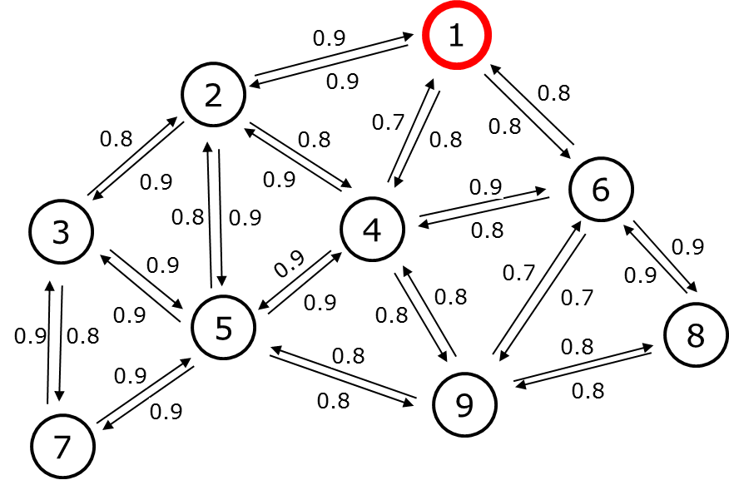
Figure 12. Network example with the PRR of each link.
After the MLQP, the receiver node calculates the number of retransmission for each incoming link of the neighbor node by Algorithm 1 using Burstiness Distribution Metric. Figure 13 shows the network graph with the number of retransmission as the metric value for the routing protocol.
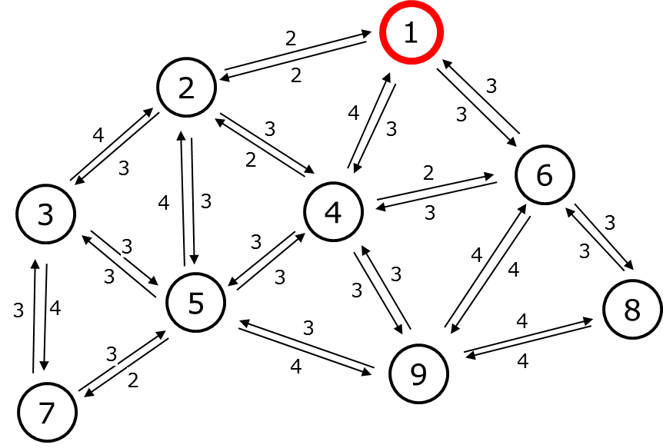
Figure 13. Network graph with the number of retransmission.
We only focus on the converge cast network here, so the MRR aims to find the path from the node to the sink and uses the number of retransmission as route metric. Besides, the same approach can be applied for the download graph routing to control the node from the sink. In this paper, we only present the converge cast network. The route discovery process is performed by exchanging Route Request (RR) control packets between the node and the neighbor nodes. Each node maintains the neighbor list and the routing table for routing data packets. The routing table consists of a Route Entry (RE) with RE(p_{id}, h, r). The p_{id} denoted the parent identifier and h is the hop count, r is the rank calculated by the sum of retransmission through the path from that node to the sink node. The sink node will have RE(0, 0, 0) which means it doesn’t have a parent, the hop count is 0 and the rank is 0. The MRR starts from the sink node by broadcasting the RR control packet. The RR packet carries RR(s_{id}, h, [nbr_list(n_{id}, r)]) where s_{id} denotes the ID of sender node, h denotes hop count of sender node, and the nbr_list(id, r) denotes the neighbor list which contains neighbor ID (n_{id}) and the rank (r) of neighbor node calculated by the number of retransmission from this neighbor to sender node plus the rank of sender node. When a node Y receives RR(s_{id}, h, [nbr_list(n_{id}, r)]) packet from node X, it and creates a RE(p_{id} := s_{id}, h = h + 1, r = r). After that, if node Y receives another RR(s_{id}, h, [nbr_list(n_{id}, r)]) packet from node Z, it compares the newly create RE(p_{id} := s_{id}, h = h + 1, r = r) by the rank then the hop count. The lower rank is better route due to the number of retransmission is minimal and if the rank is equal, we compare the hop count, lower hop count is the better route. The node will send Route Response (RP) through the parent node in the routing table. The RP packet contains the path from the leaf node to the sink node. The sink node will save the path to check the Route discovery process is finish or not by check the number of nodes in the network compared with the number of nodes in the path received from RP.
For example, we use a network graph in Figure 13. The sink node is node 1 send the RR(1, 0, [(2, 2), (4, 4), (6, 3)]). Note that, the link quality estimator using Burstiness Distribution Metric that we present in the previous section is receiver estimator, so the sink node has the information of the number of retransmission from link L(2, 1), L(4, 1), and L(6, 1) is 2, 4, 3 respectively.
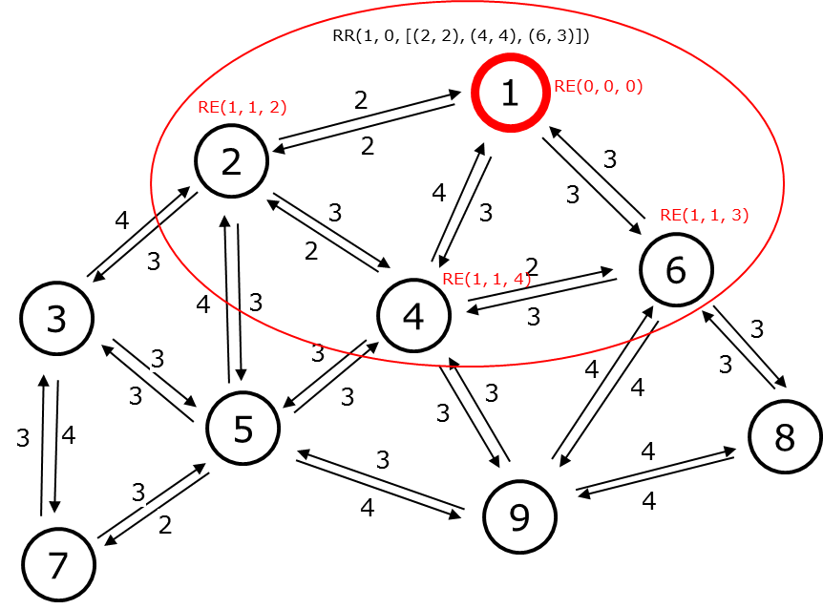
Figure 14. The sink node starts routing protocol by broadcasting the RR control packet.
When node 2, 4 and 6 receive RR(1, 0, [(2, 2), (4, 4), (6, 3)]) from node 1, node 2, 4 and 6 create the route entry RE(1, 1, 2), RE(1, 1, 4) and RE(1, 1, 3) respectively as Figure 14. After that, they create and broadcast their RR packet immediately as Figure 15, 16, and 17.
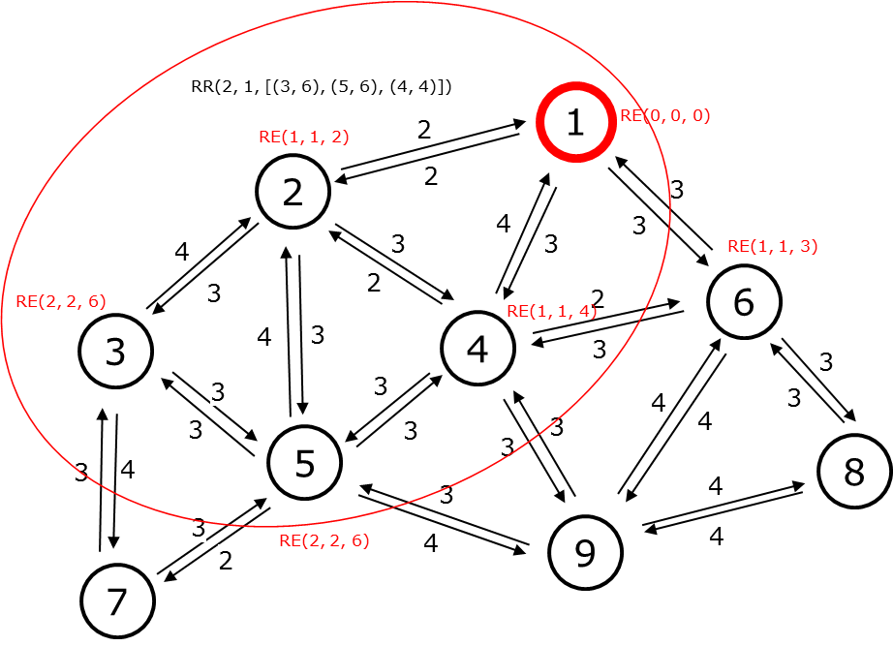
Figure 15. Node 2 broadcasting RR control packet and the neighbor create RE respectively.
Node 2 has the RE(1, 1, 2) after received RR from node 1. Neighbor node 3, 5, and 4 have the rank value of is the number of retransmission in link L(3, 2), L(5, 2), and L(6, 2) plus the rank of node 2. So it will create RR packet exclude node 1 RR(2, 1, [(3, 6), (5, 6), (4, 4)]). In this case, node 3 and 5 create new RE(2, 2, 6) and RE(2, 2, 6). For node 4, because it creates RE(2, 2, 4) compare with RE(1, 1, 4) create by receiving RR from node 1. They have the same rank is 4 but RE(1, 1, 4) has only 1 hop compare with 2 hops from Node 2 RE(2, 2, 4). So node 4 keeps the better RE value.
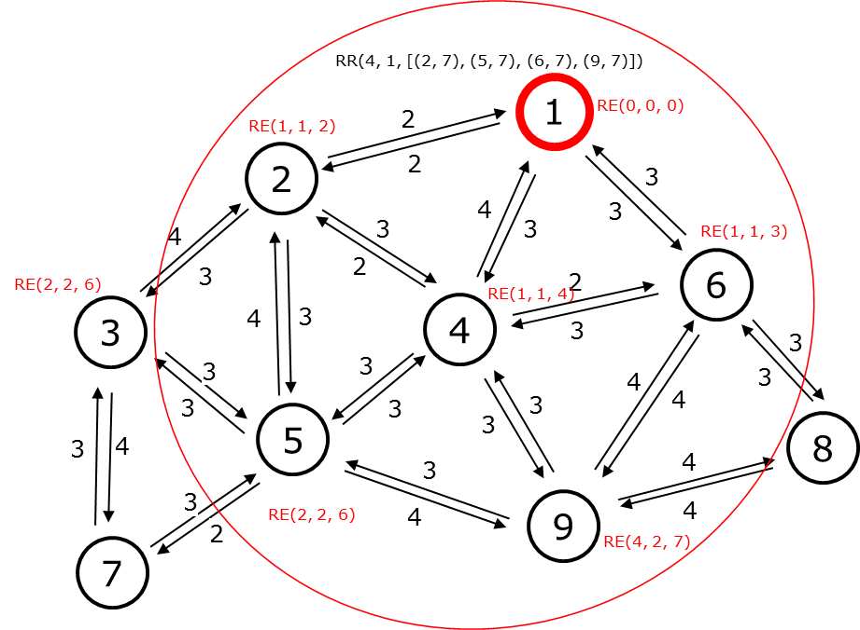
Figure 16. Node 4 broadcasting RR control packet and the neighbor create RE respectively.

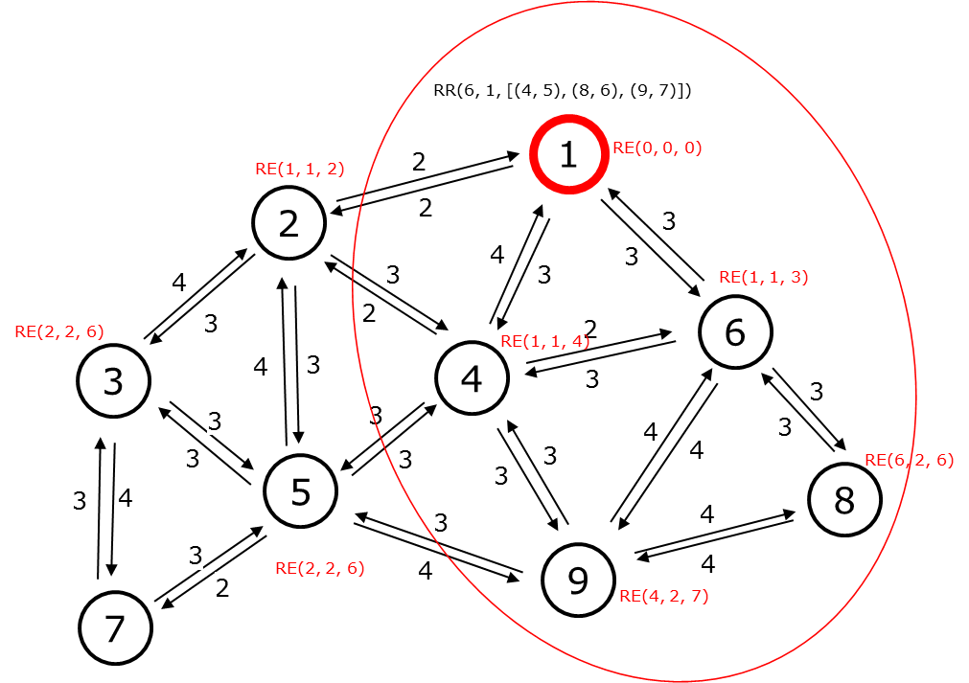
Figure 17. Node 6 broadcasting RR control packet and the neighbor create RE respectively.
The MRR route discovery runs the same operation until the network has the node received all RR control packet from its neighbor. Figure 18 shows the example for route response operation starts from Node 7. After receiving the RR packet from node 3 and node 5. Node 7 doesn’t create its RR packet due to all the neighbor nodes of Node 7 has the higher hop count than 7. Node 7 creates RP(7) which responds to the parent node 3 that node 7 chose it as a parent.
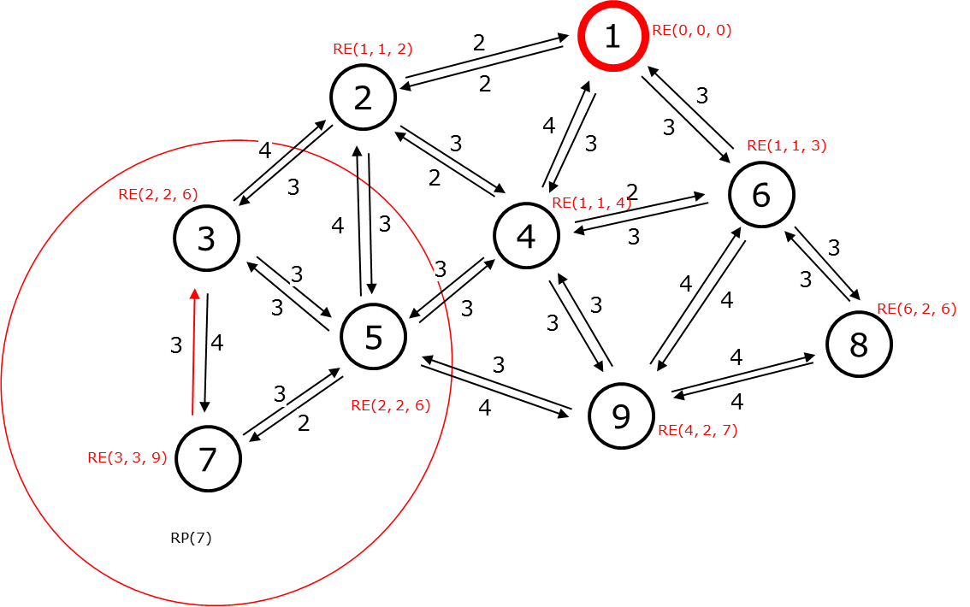
Figure 18. The route response operation from Node 7.
Node 3 after receiving RP(7) it updates RP(7, 3) then sends it to node 2 as Figure 19.
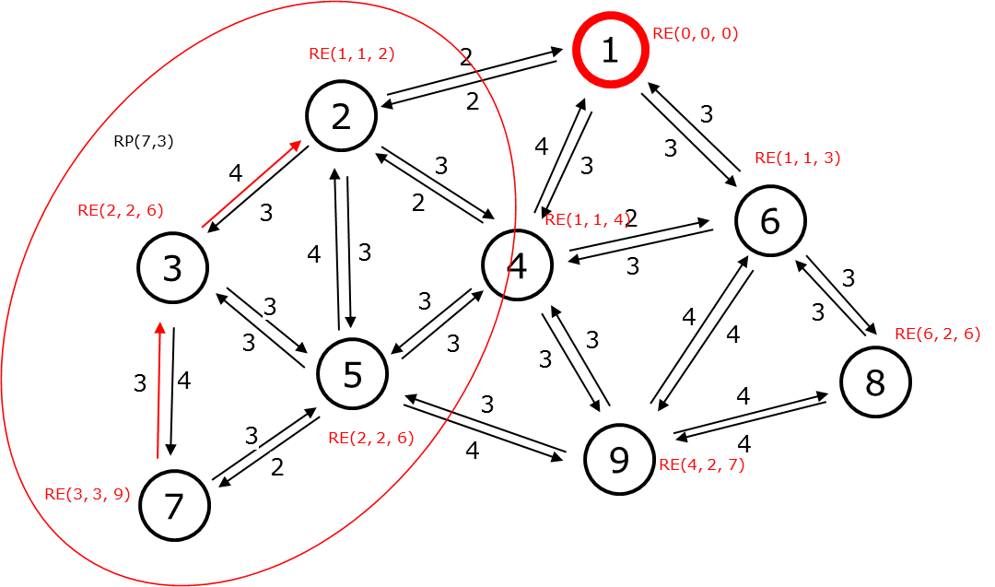
Figure 19. The route response operation from Node 3.
The RP operation will stop after the RP packet reaches the sink node. After the MRR routing protocol finishes. We have the converge cast tree topology of the example network as Figure 20.
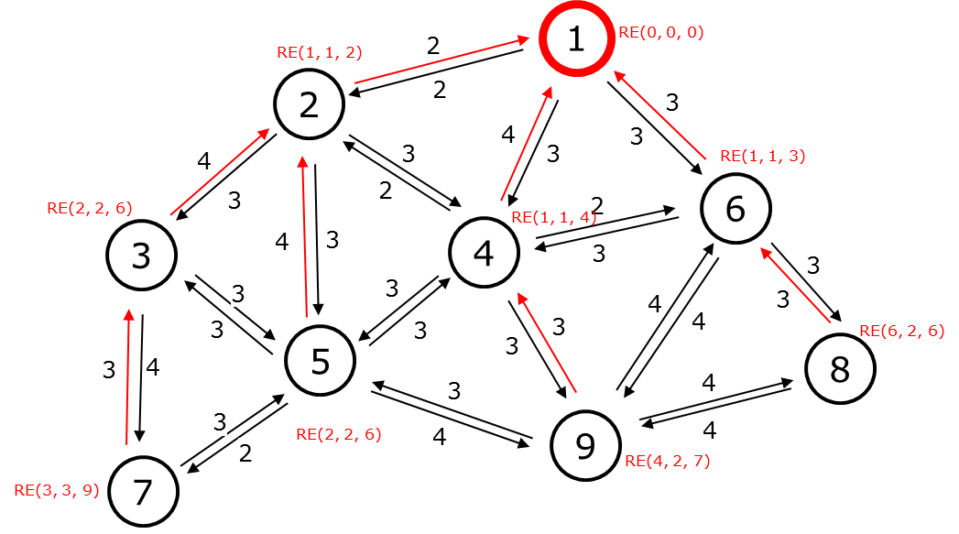
Figure 20. The converge cast tree topology of the example network.

4.6 Evaluation results
In this section, we evaluate our LQE Burstiness Distribution Metric (Bdist) with some LQE using the same method RNP-based such as ETX, end to end PRR, and the Burstiness max value (Bmax). We use the Cooja Simulator with the config Directed Graph Radio Medium (DGRM) model. In the DGRM model, we can set up the link quality by PRR. Then we compare our method with other RNP-based method using the number of transmission and the end to end PRR of the data packet in data transmission as the metrics. We evaluate the metrics by changing the network scale in our simulation from 10 – 30 nodes. The network is deployed randomly to the link PRR with the range from 70% to 99%. The number of probe packet we use for MLQP is 1000 packets and the number of the data packet to evaluate the end-to-end PRR is 1000 packets. The target PRR for the data transmission we set up is 99%. To construct the tree, we applied the algorithm to find the minimal number of the transmission path from the node to the sink with the maximum hop is 4 hops. Our simulation using a forwarding method to collect the data packet to the sink, so the node near the sink has transmitted its packet and forward the packet generates by its child. Figure 21 is an example network with 25 nodes in Cooja Simulator.
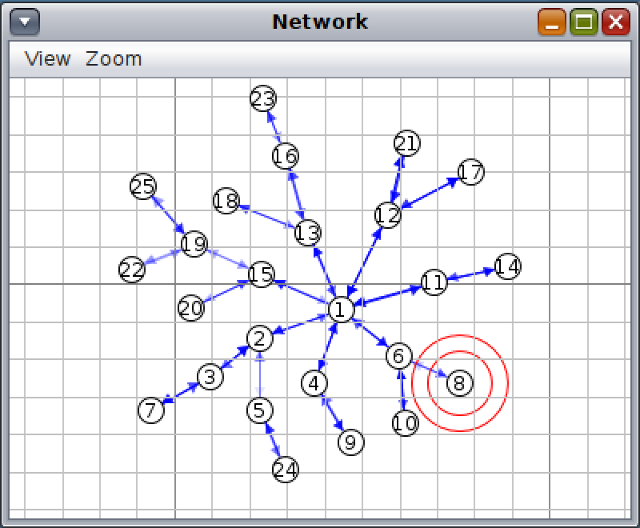
Figure 21. The example network tree with 25 nodes.
Figure 22 shows the total number of transmission in the network by using ETX, e2e-PRR, Bdist, and Bmax with the different config number of nodes. Our approach (Bdist) using the Burstiness Distribution to optimize the number of transmissions we need to reach the target PRR. It reduced about 23% and 5% number of transmission when compared with Bmax and e2e-PRR, respectively. ETX has the lowest estimate for the number of transmissions but can not reach the target PRR for data transmission due to the ETX method doesn’t consider when the burst happens. Because of this, our approach can reduce the total number of transmissions thus reduce energy consumption.
Figure 22. The total number of transmissions compared by some RNP-based methods.
In the next experiment, we compare the end-to-end PRR of data transmission with 10 nodes network. We perform by using the modification of the Path Collision-aware Least Laxity First (PCLLF) [7] algorithm to schedule for our tree topology network with all the period data is set to 64. Then we use the RNP-based metric we calculated from the MLQP and applied to the PCLLF Algorithm. Firstly, we use 1000 data packets to evaluate the end-to-end data PRR by some RNP-based metric we calculated from MLQP. The result in Figure 23 shows that our approach and Bmax metric has a better estimation for the reliability of data transmission compare with ETX and e2e-PRR. Most of the sensor nodes in the network can deliver the packet through a multi-hop routing tree with a successful ratio in range [99, 99.9] percent with Bdist and [99.1, 100] with Bmax because Bmax has a more assigned number of transmission for a link.
Figure 23. The end-to-end data PRR is calculated by 1000 data packets.
To evaluate the stability of the measured value, we perform again this experiment with the increase of the data packet to 2 times: 2000 data packets. Figure 24 shows the result we get after change the number of data packets we transmit. All the link quality measurement method has slightly changed in end-to-end data PRR, because of more data transmission packet, there are many chances for the burst happens in the link. In this experiment, Bdist and Bmax still keep the better result compare with EXT and e2e-PRR. The end-to-end data PRR range of Bdist was reduced to [98.1, 99.9] and Bmax [98.2, 100].
Figure 24. The end-to-end data PRR was calculated by 2000 data packets.
We calculate the average end-to-end data PRR for all the sensor nodes in the network. The average end-to-end PRR of data transmission for the network is calculated by the number of data packet we received at the Coordinator divided by the total number of data transmission from all the sensor nodes. Figure 25 shows that we can reach the average end-to-end data PRR for the network with our defined target PRR is 99% with Bdist and Bmax measurement method.
Figure 25. The average data PRR with a different number of data packets.

Chapter 5: CONCLUSION
In this study, we propose an LQE to apply to Industrial Wireless Sensor networks with high reliability and reduce the number of transmission for energy efficient. Based on the burstiness link property of wireless, we estimate the number of transmissions required to reach the end-to-end PRR target by using the Burstiness Distribution we get in MLQP. We proved by simulation in Cooja that our approach estimates the number of transmissions can reach the target PRR as we expected. According to the simulation, we compared with some RNP-based methods such as ETX, e2e-PRR, and Bmax. Our approach can reduce number of transmission up to 23% and still reach the end-to-end PRR is 99% for the network compare with other method. Therefore we conclude that our approach is highly suitable for Industrial Wireless Sensor networks that are required for high reliability and energy-efficient for data transmission. In the future, we will apply our approach to the real device for monitoring and control systems in industrial environments.

REFERENCES
[1] B. Sinopoli, C. Sharp, L. Schenato, S. Schaffert, and S. S. Sastry, “Distributed control applications within sensor networks,” Proc. IEEE, vol. 91, no. 8, pp. 1235–1246, Aug. 2003, doi: 10.1109/JPROC.2003.814926.
[2] T. Winter et al., “RPL: IPv6 Routing Protocol for Low-Power and Lossy Networks.,” rfc, vol. 6550, pp. 1–157, 2012.
[3] T. Clausen, J. Yi, and U. Herberg, “Lightweight on-demand ad hoc distance-vector routing-next generation (LOADng): protocol, extension, and applicability,” Comput. Networks, vol. 126, pp. 125–140, 2017.
[4] H.-J. Audéoud and M. Heusse, “Experimental Comparison of Routing Protocols for Wireless Sensors Networks: Routing Overhead and Asymmetric Links,” in 2017 29th International Teletraffic Congress (ITC 29), 2017, vol. 1, pp. 55–62.
[5] K. Srinivasan, M. A. Kazandjieva, S. Agarwal, and P. Levis, “The β-factor: measuring wireless link burstiness,” in Proceedings of the 6th ACM conference on Embedded network sensor systems, 2008, pp. 29–42.
[6] S. Munir, S. Lin, E. Hoque, S. M. S. Nirjon, J. A. Stankovic, and K. Whitehouse, “Addressing burstiness for reliable communication and latency bound generation in wireless sensor networks,” in Proceedings of the 9th ACM/IEEE International Conference on Information Processing in Sensor Networks, 2010, pp. 303–314.
[7] A. Darbandi and M. K. Kim, “Path collision-aware real-time link scheduling for TSCH wireless networks,” KSII Trans. Internet Inf. Syst., vol. 13, no. 9, pp. 4429–4445, 2019, doi: 10.3837/tiis.2019.09.006.
[8] J. Zheng and A. Jamalipour, Wireless sensor networks: a networking perspective. John Wiley & Sons, 2009.
[9] J. A. Gutierrez, M. Naeve, E. Callaway, M. Bourgeois, V. Mitter, and B. Heile, “IEEE 802.15. 4: a developing standard for low-power low-cost wireless personal area networks,” IEEE Netw., vol. 15, no. 5, pp. 12–19, 2001.
[10] IEEE Computer Society., “IEEE Standard for Local and Metropolitan Area Networks- Specific Requirements Part 15.4:Wireless Medium Access Control (MAC) and Physical Layer (PHY) Specification for Low-Rate Wireless Personal Area Networks (LRWPANs),” pp. 1–314, 2011.
[11] J. A. Gutierrez, “IEEE Std. 802.15. 4. Enabling Pervasive Wireless Sensor Networks,” Eat. Corp., Berkeley Uni, 2005.
[12] 802.15. 4e-2012, “IEEE standard for local and metropolitan area networks—part 15.4: low-rate wireless personal area networks (LR-WPANs) amendment 1: MAC sublayer.” IEEE Standard, 2012.
[13] D. De Guglielmo, G. Anastasi, and A. Seghetti, “From ieee 802.15. 4 to ieee 802.15. 4e: A step towards the internet of things,” in Advances onto the Internet of Things, Springer, 2014, pp. 135–152.
[14] T. Watteyne, C. Adjih, and X. Vilajosana, “Lessons learned from large-scale dense IEEE802. 15.4 connectivity traces,” in 2015 IEEE International Conference on Automation Science and Engineering (CASE), 2015, pp. 145–150.
[15] A. Dunkels, B. Gronvall, and T. Voigt, “Contiki-a lightweight and flexible operating system for tiny networked sensors,” in 29th annual IEEE international conference on local computer networks, 2004, pp. 455–462.
[16] “Contiki-NG Wiki.” [Online]. Available: https://github.com/contiki-ng/contiki-ng/wiki/. [Accessed: 09-Oct-2020].
[17] “Network Stack - Contiki.” [Online]. Available: http://anrg.usc.edu/contiki/index.php/Network_Stack. [Accessed: 09-Oct-2020].
[18] F. Osterlind, A. Dunkels, J. Eriksson, N. Finne, and T. Voigt, “Cross-level sensor network simulation with cooja,” in Proceedings. 2006 31st IEEE Conference on Local Computer Networks, 2006, pp. 641–648.
[19] C. Noda, S. Prabh, M. Alves, C. A. Boano, and T. Voigt, “Quantifying the channel quality for interference-aware wireless sensor networks,” ACM SIGBED Rev., vol. 8, no. 4, pp. 43–48, 2011.
[20] H.-J. Audéoud and M. Heusse, “Quick and efficient link quality estimation in wireless sensors networks,” in 2018 14th Annual Conference on Wireless On-demand Network Systems and Services (WONS), 2018, pp. 87–90.
[21] M. Eskola and T. Heikkilä, “Classification of radio channel disturbances for industrial wireless sensor networks,” Ad Hoc Networks, vol. 42, pp. 19–33, 2016.
[22] R. D. Gomes, D. V Queiroz, A. C. Lima Filho, I. E. Fonseca, and M. S. Alencar, “Real-time link quality estimation for industrial wireless sensor networks using dedicated nodes,” Ad Hoc Networks, vol. 59, pp. 116–133, 2017.
[23] G. Kirubasri and N. U. Maheswari, “A study on hardware and software link quality metrics for wireless multimedia sensor networks,” Int. J. Adv. Netw. Appl., vol. 8, no. 3, p. 3103, 2016.
[24] A. Woo and D. E. Culler, Evaluation of efficient link reliability estimators for low-power wireless networks. Computer Science Division, University of California Oakland, Calif, USA, 2003.
[25] D. S. J. De Couto, D. Aguayo, J. Bicket, and R. Morris, “A high-throughput path metric for multi-hop wireless routing,” in Proceedings of the 9th annual international conference on Mobile computing and networking, 2003, pp. 134–146.
[26] C. E. Koksal and H. Balakrishnan, “Quality-aware routing metrics for time-varying wireless mesh networks,” IEEE J. Sel. areas Commun., vol. 24, no. 11, pp. 1984–1994, 2006.
[27] R. Fonseca, O. Gnawali, K. Jamieson, and P. Levis, “Four-bit wireless link estimation.,” in HotNets, 2007.
[28] V. C. Gungor and M. K. Korkmaz, “Wireless link-quality estimation in smart grid environments,” Int. J. Distrib. Sens. Networks, vol. 8, no. 2, p. 214068, 2012.
[29] S. Duquennoy, B. Al Nahas, O. Landsiedel, and T. Watteyne, “Orchestra: Robust mesh networks through autonomously scheduled TSCH,” in Proceedings of the 13th ACM conference on embedded networked sensor systems, 2015, pp. 337–350.

