**Lab 4 – Web Application**

**Guide**

Contents

1. Create Data Transfer Layer (folder DTL) 2

2. Create Database Access Layer (folder DAL) 2

3. Create Site.Master, Default page 3

3.1. Site.Master 3

3.2. Default page 3

4. Create GUI layer (folder GUI) 4

4.1. BookGUI page 4

4.2. CopyGUI page 5

4.2.1. Configure control ObjectDataSource 5

4.2.2. Configure control GridView 8

4.2.3. Code of Page 9

4.3. BorrowerGUI page 11

4.4. BorrowGUI page 12

4.5. ReturnGUI page 13

4.6. ReserveGUI page 14

# Create Data Transfer Layer (folder DTL)

There are the following classes:

* 1. Borrower
  2. Book
  3. Copy
  4. CirculatedCopy
  5. Reservation

# Create Database Access Layer (folder DAL)

There are the following classes

1. BorrowerDAO
2. BookDAO
3. CopyDAO
4. CirculatedCopyDAO
5. ReservationDAO

# Create Site.Master, Default page

## Site.Master

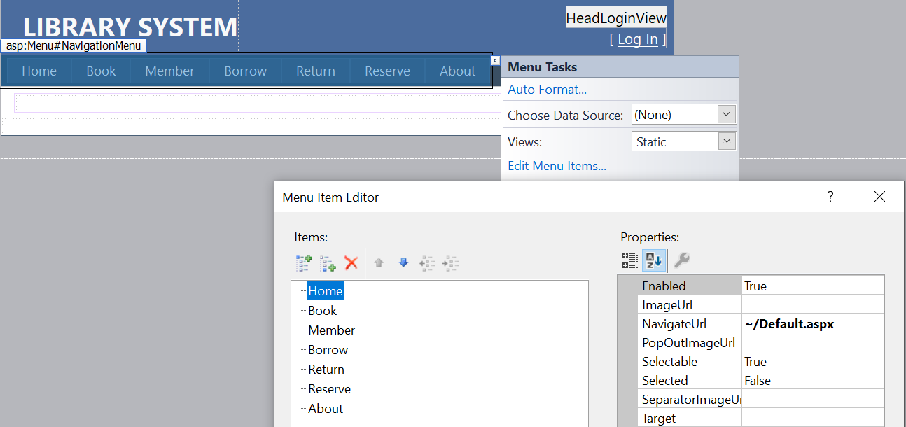

Requirement: Modify menu as above

## Default page

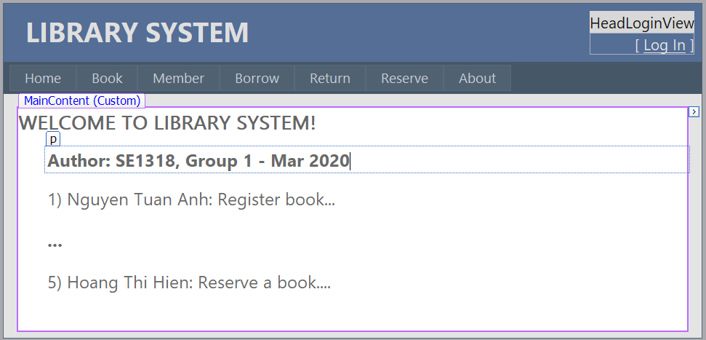

Requirement: Name of class, group number, and list of members with their function they made

# Create GUI layer (folder GUI)

## BookGUI page

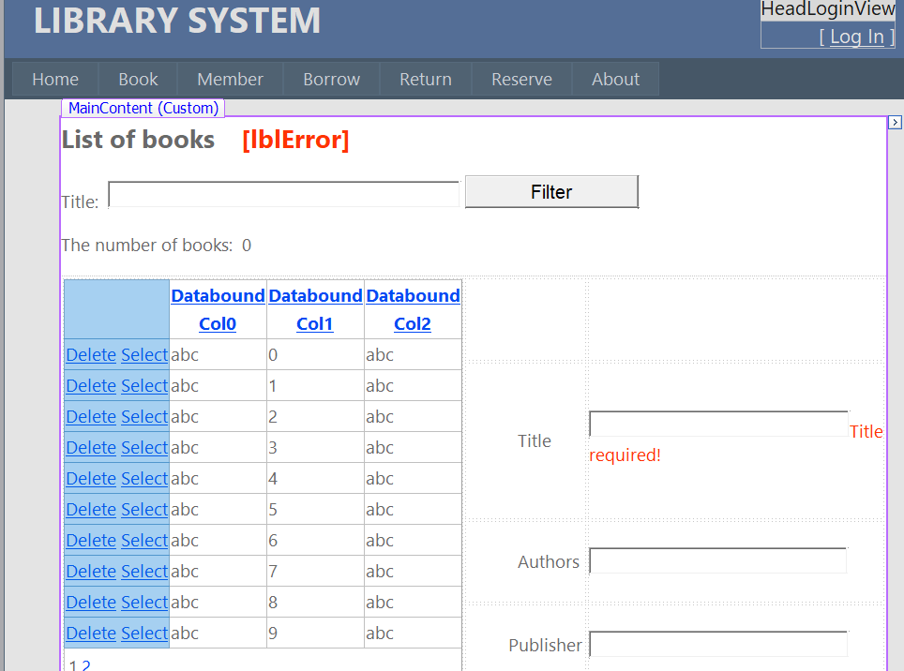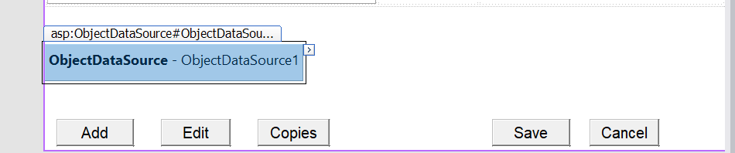

## CopyGUI page

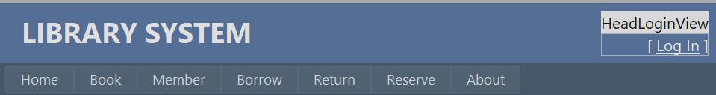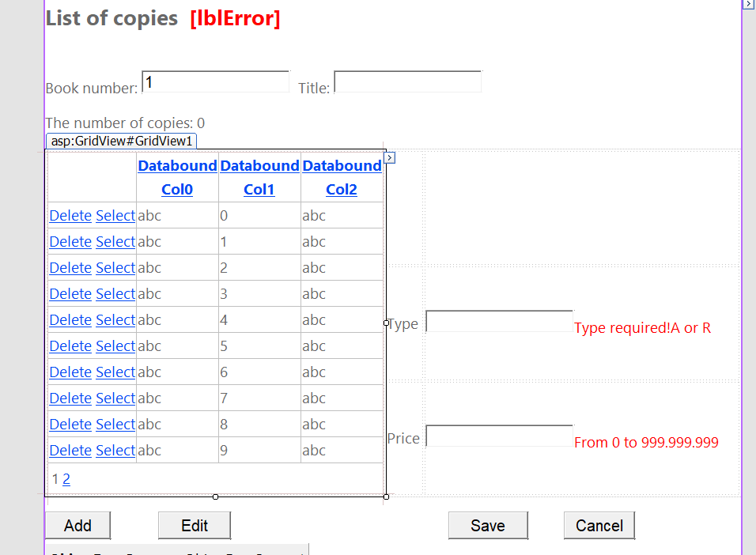

### Configure control ObjectDataSource

1. Open “ObjectDataSource Tasks” as bellow

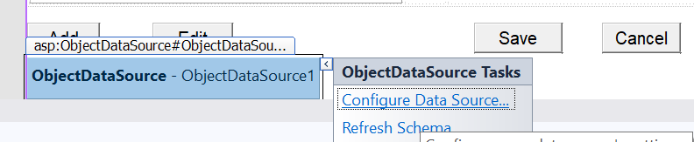

1. Open a window “Choose a Business Object”, then choose CopyDAO for Business object as bellow

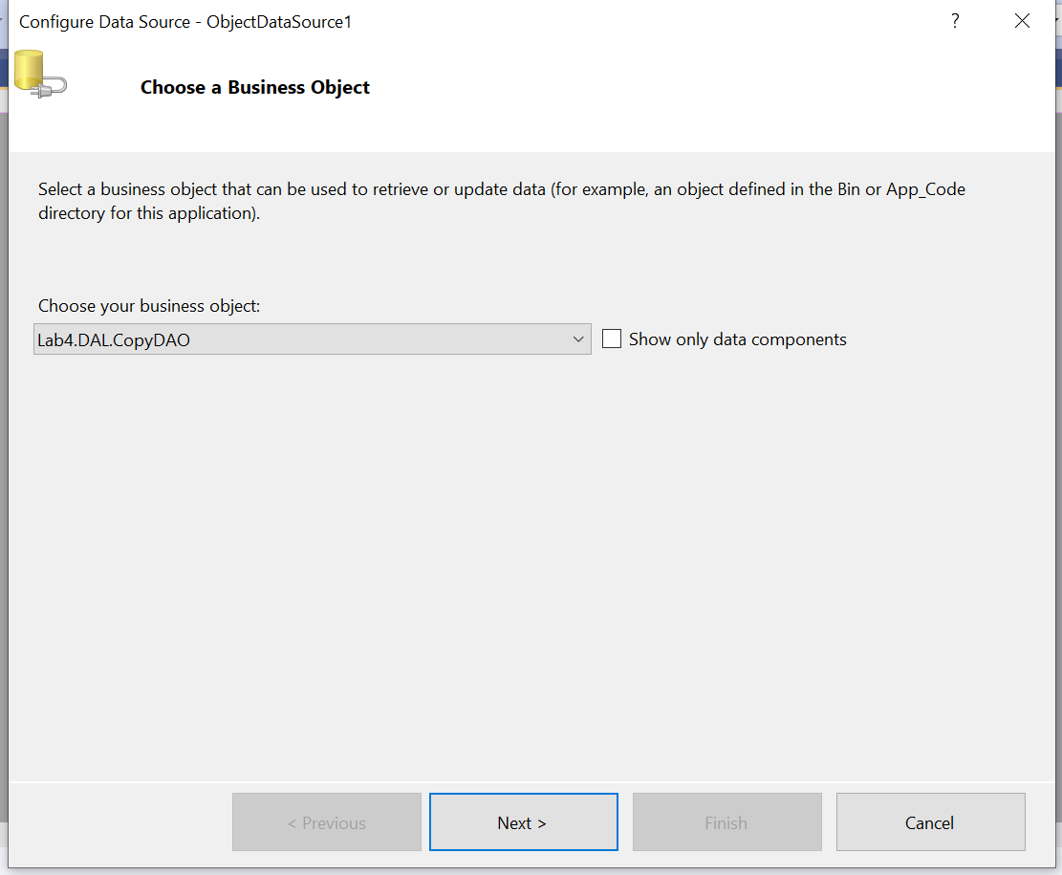

1. In the window “Define Data methods”, in the Tab “SELECT” choose method GetDataTable() as bellow

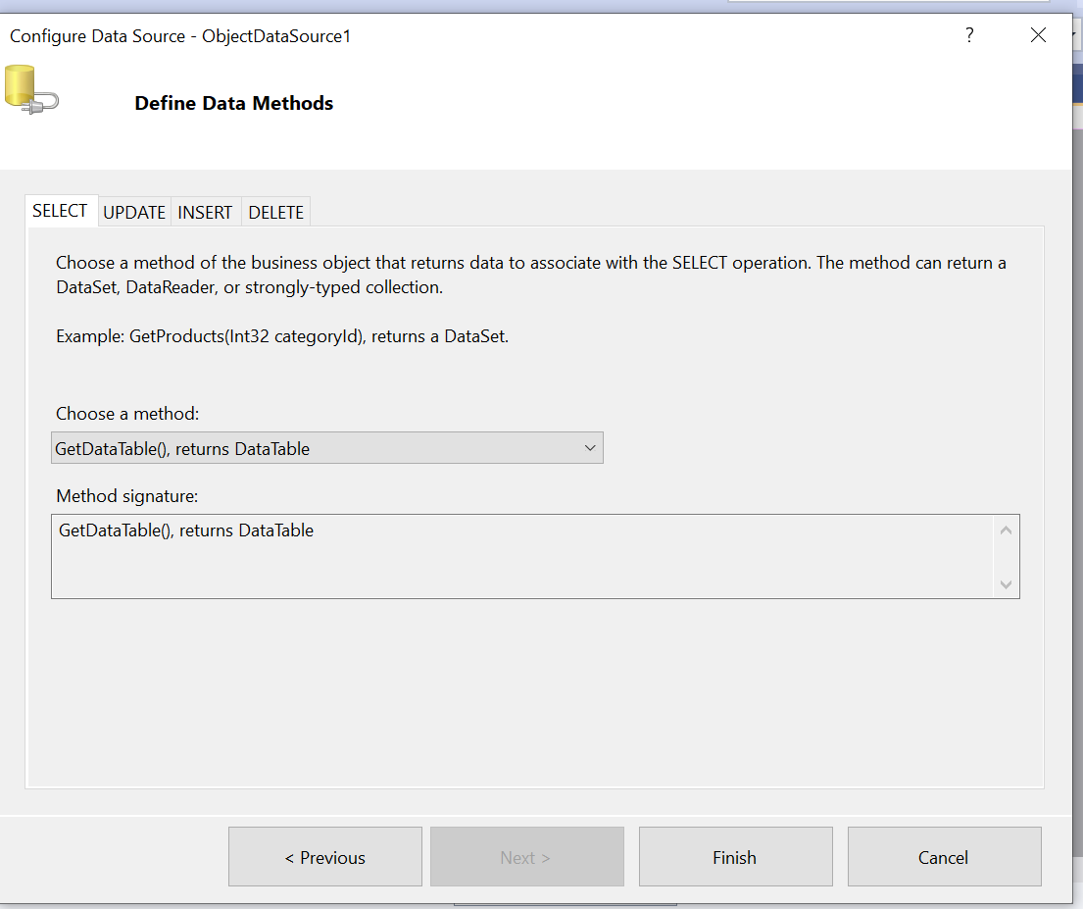

1. In the window “Define Data methods”, in the Tab “DELETE” choose method Delete(Copy c) as bellow

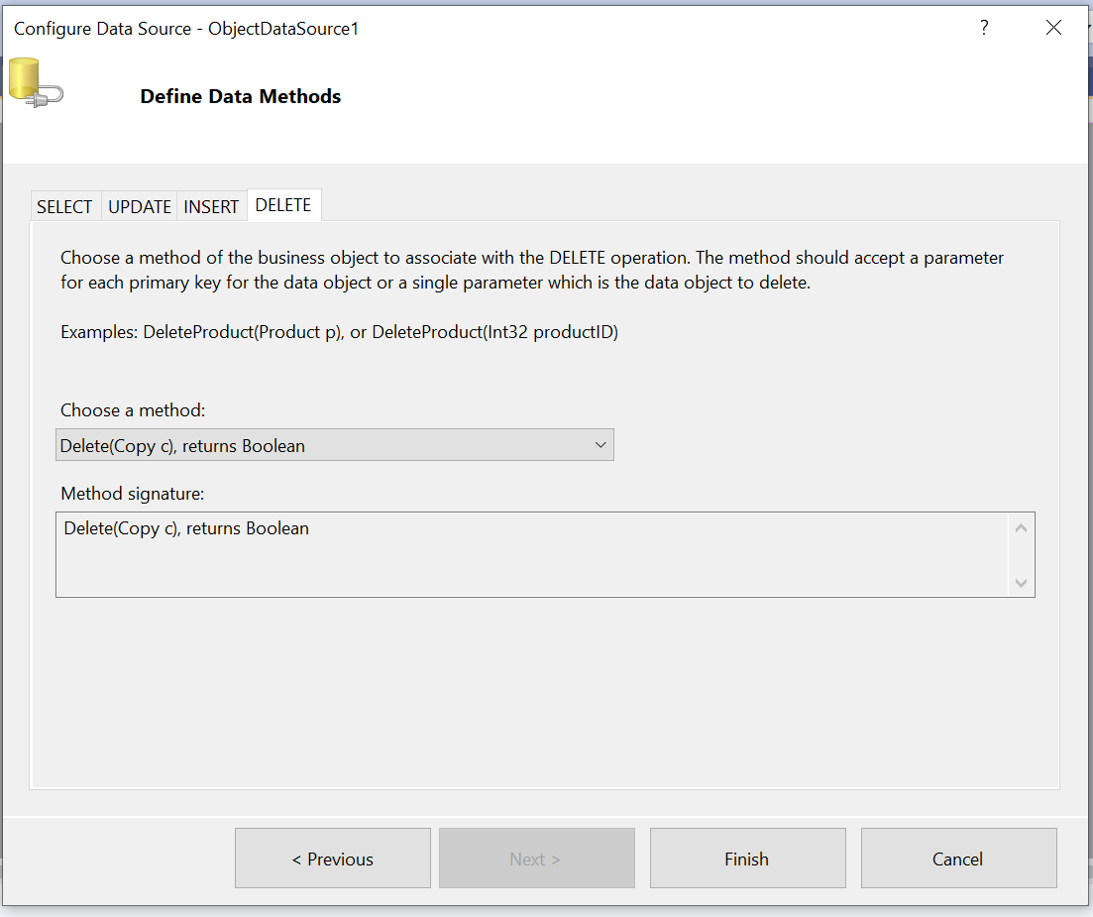

1. Open window “property” of ObjectDataSouce1,then set bookNumber = {0} for FilterExpression as below
2. 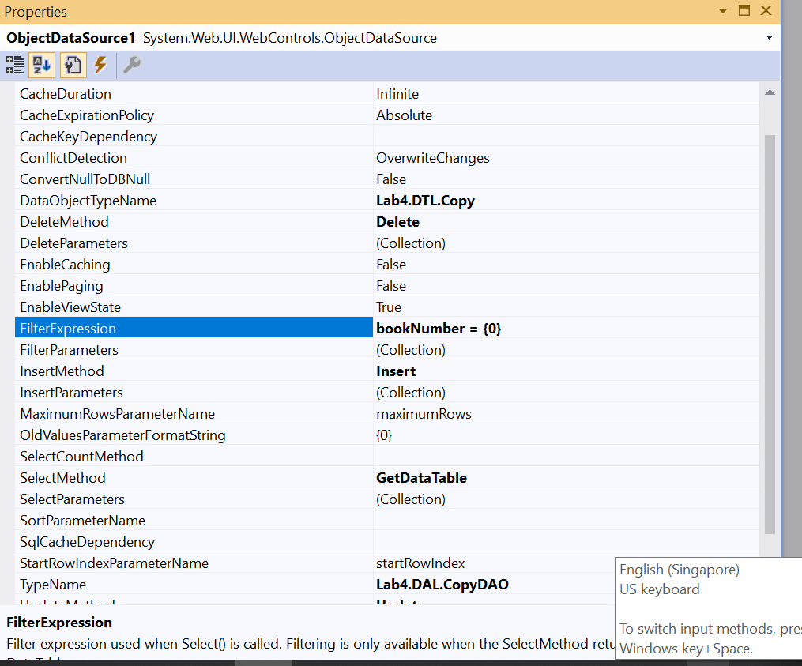
3. Click FilterParameters to open a window “Parameter Collection Editor”, add a new parameter, choose Control for Parameter source, and choose txtBookNumber for ControlID as bellow

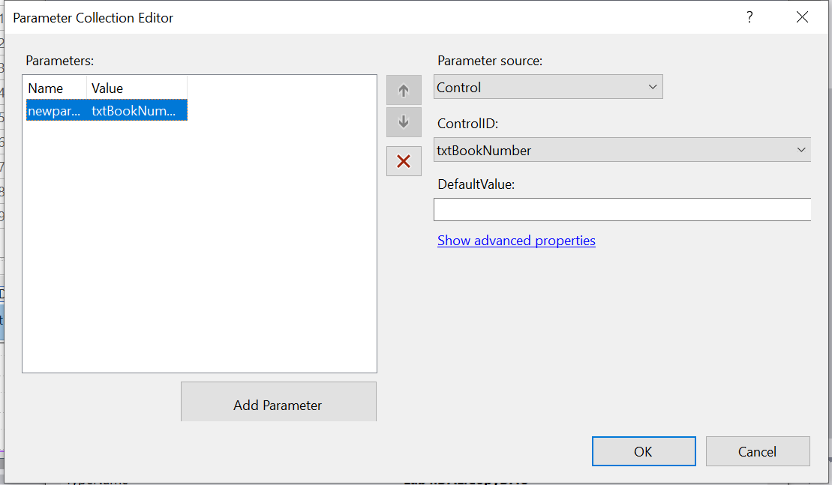

### Configure control GridView

* 1. Open window “GridView Tasks”, Choose “ObjectDataSourse1” for Data Source, and check “Enable Paging”, “Enable Sorting”, “Enable Deleting” and “Enable Selection” as below

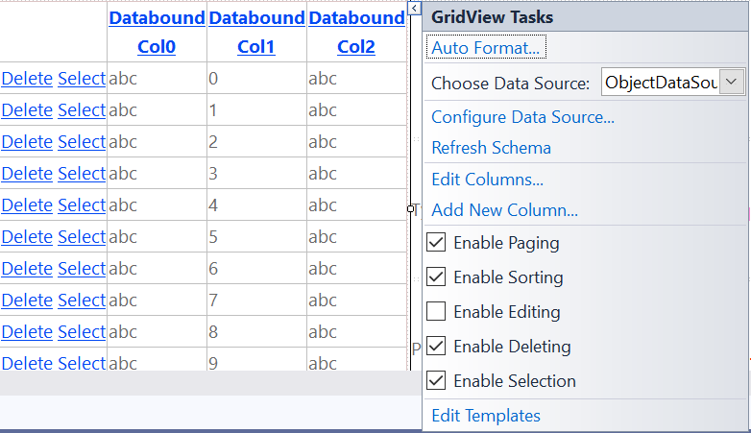

* 1. Open window “Properties” of GridView1, set “CopyNumber” for DataKeyNames, and choose color “Yellow” for BackColor under SelectedRowStyle as below

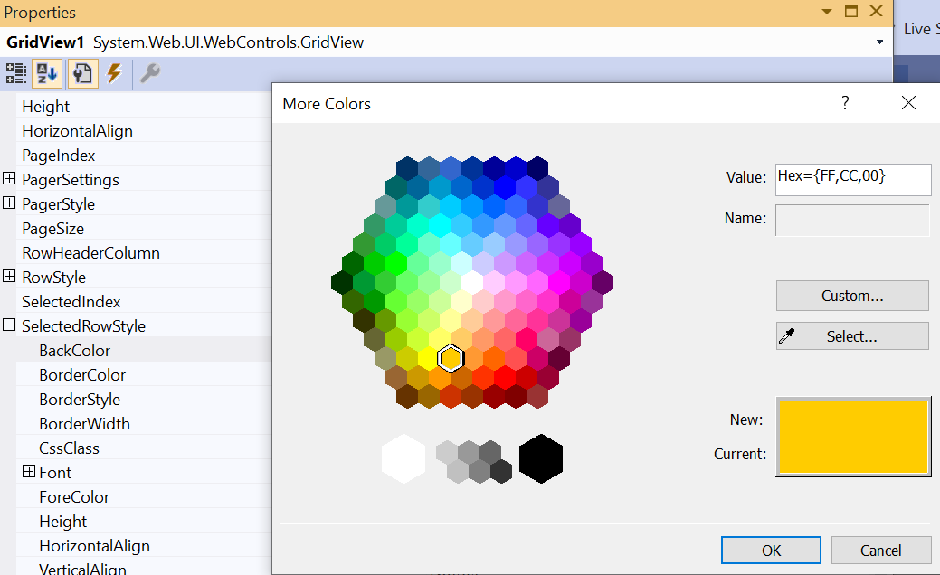

### Code of Page

namespace Lab4.GUI

{

public partial class CopyGUI : System.Web.UI.Page

{

protected void Page_Load(object sender, EventArgs e)

{

if (!IsPostBack && Session["book"] != null)

{

GridViewRow vrow = (GridViewRow) Session["book"];

txtBookNumber.Text = vrow.Cells[1].Text;

txtTiitle.Text = vrow.Cells[2].Text;

displayButtons(1);

}

}

private void displayButtons(int state)

{

switch (state)

{

// View

case 1:

txtType.Enabled = false;

txtPrice.Enabled = false;

btnAdd.Enabled = true;

btnEdit.Enabled = true;

btnSave.Enabled = false;

btnCancel.Enabled = false;

break;

// Adding or editing

case 2:

txtType.Enabled = true;

txtPrice.Enabled = true;

txtType.Focus();

btnAdd.Enabled = false;

btnEdit.Enabled = false;

btnSave.Enabled = true;

btnCancel.Enabled = true;

break;

}

}

protected void btnAdd_Click(object sender, EventArgs e)

{

Session["add"] = 1;

displayButtons(2);

}

protected void GridView1_DataBound(object sender, EventArgs e)

{

lblNoRows.Text = GridView1.Rows.Count.ToString();

}

protected void btnEdit_Click(object sender, EventArgs e)

{

if (GridView1.SelectedRow == null)

{

lblError.Text = "Error: No a copy is selected!";

return;

}

Session["add"] = 2;

displayButtons(2);

}

protected void btnSave_Click(object sender, EventArgs e)

{

int add = (int)Session["add"];

Copy c = new Copy();

c.BookNumber = int.Parse(txtBookNumber.Text);

c.SequenceNumber = CopyDAO.GetSequenceNumberMax(c.BookNumber) + 1;

c.Type = txtType.Text[0];

if (txtPrice.Text == "") c.Price = 0;

else

c.Price = int.Parse(txtPrice.Text);

if (add == 1)

CopyDAO.Insert(c);

else

{

c.CopyNumber = (int)Session["copyNumber"];

CopyDAO.Update(c);

}

ObjectDataSource1.Select();

GridView1.DataBind();

}

protected void GridView1_SelectedIndexChanged(object sender, EventArgs e)

{

Session["copyNumber"] = int.Parse(GridView1.SelectedRow.Cells[1].Text);

txtType.Text = Server.HtmlDecode(GridView1.SelectedRow.Cells[4].Text);

txtPrice.Text = Server.HtmlDecode(GridView1.SelectedRow.Cells[5].Text);

}

protected void GridView1_DataBound1(object sender, EventArgs e)

{

lblNoRows.Text = GridView1.Rows.Count.ToString();

}

}

}

## BorrowerGUI page

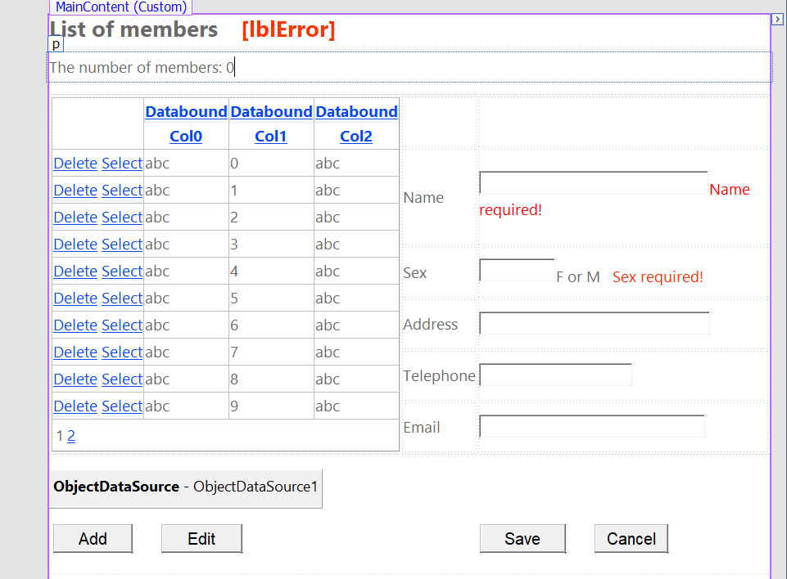

## BorrowGUI page

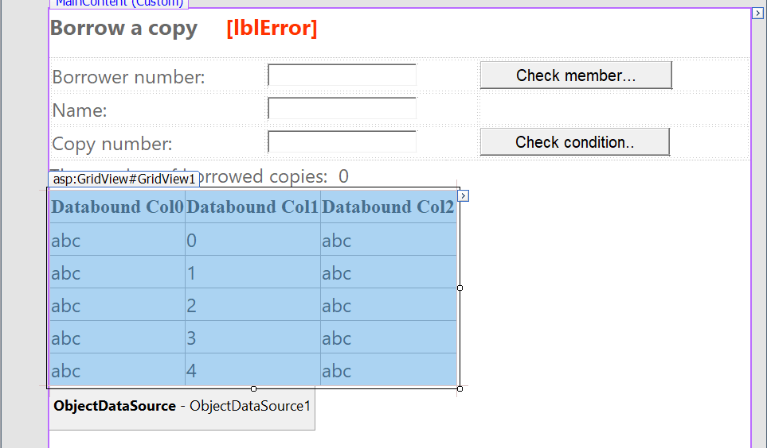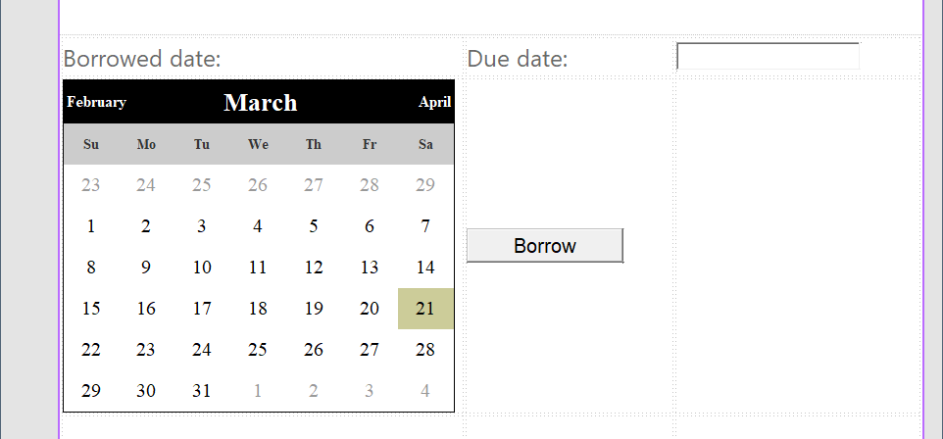

## ReturnGUI page

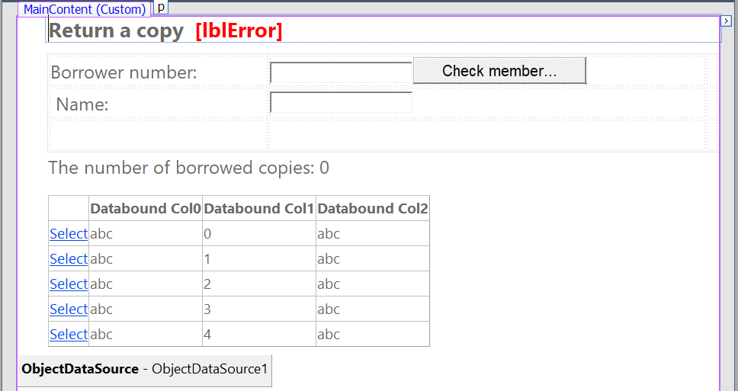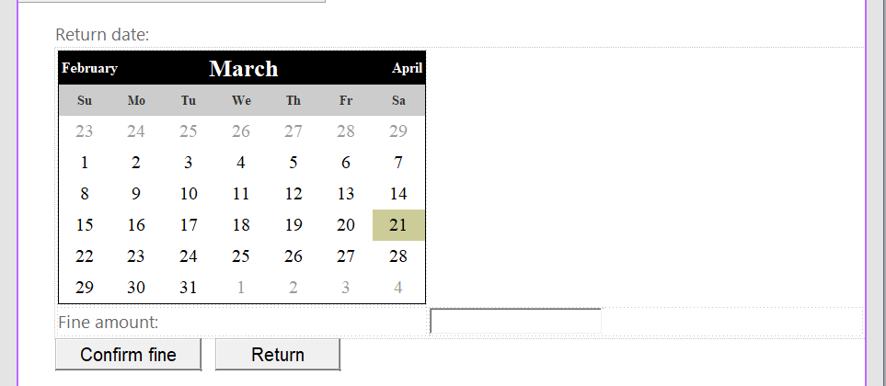

## ReserveGUI page

