Read the following description of a C# program and program itself, and then fill into the blanks from

A

label4.Visible = true;

textBox3.Visible = true;

textBox4.Visible = true;

button2.Visible = true;

this.Text = "Test account";

I

label4.Visible = true;

textBox3.Visible = true;

textBox4.Visible = true;

button2.Visible = true;

this.Text = "Test account";

to

[Program description]

A simple bank account simulation program is written in GUI C#. This simulation allows the

user to create a new account and test it. There are two methods given for account

management: deposit and withdraw.

|  |  |
| --- | --- |
| Method | Description |
| Deposit | To add the amount to the bank account |
| Withdraw | To subtract the amount from the bank account |

There are two screens given: Create Account and Test Account. Create Account screen is

used to create a new account number. Test Account screen is used to test deposit and

withdrawal operations for the bank account.

Diagram 1: Create Account

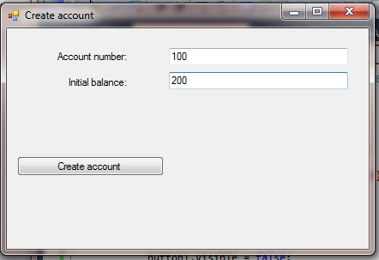

Diagram 1 shows a sample input screen. The user is asked to enter a numeric account number

and the initial balance. The user then clicks on the Create Account button.

Diagram 2: Test Account – Transaction Successful

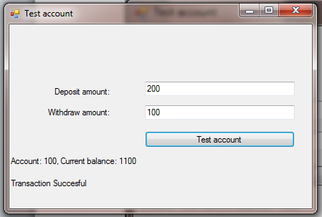

In diagram 2, the user is asked to test the bank account by keying in the amount for deposit

and withdrawal. If deposit only, enter “0” for withdrawal. If withdrawal only, enter “0” for

deposit. After clicking the Test Account button, the user sees the message.

Diagram 3: Test Account – No withdrawal

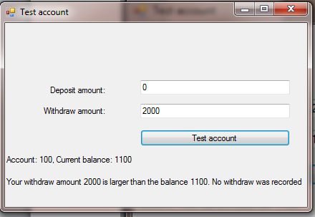

In diagram 3, the user has keyed in the amount for withdrawal larger than the balance

available. The message shows that the withdrawal is not successful.

[Program 1- class Account]

class Account

{

private int accNum;

public int AccNum

{

get { return accNum; }

set { accNum = value; }

}

private double amount;

public double Amount

{

get { return amount; }

set { amount = value; }

}

public Account() { }

A

label4.Visible = true;

textBox3.Visible = true;

textBox4.Visible = true;

button2.Visible = true;

this.Text = "Test account";

{

this.accNum = accNum;

this.amount = amount;

}

public void Deposit(double amount)

{

this.amount += amount;

}

public void Withdraw(double amount)

{

if (this.amount < amount)

{

B

label4.Visible = true;

textBox3.Visible = true;

textBox4.Visible = true;

button2.Visible = true;

this.Text = "Test account";

throw new Exception ( );

}

this.amount -= amount;

}

}

[Program 2 – CreateAccount Windows form]

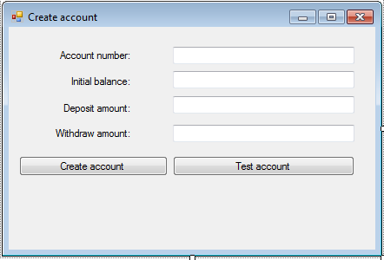

lbl1

label1

label2

label3

label4

textBox2

textBox3

textBox4

button2

button1

lbl

textBox1

public partial class CreateAccount : Form

{

Account a;

public CreateAccount()

{

InitializeComponent();

C

label4.Visible = true;

textBox3.Visible = true;

textBox4.Visible = true;

button2.Visible = true;

this.Text = "Test account";

}

private void button1_Click(object sender, EventArgs e)

{

int accNum;

double amount;

D

label4.Visible = true;

textBox3.Visible = true;

textBox4.Visible = true;

button2.Visible = true;

this.Text = "Test account";

a = new Account(accNum, amount);

E

label4.Visible = true;

textBox3.Visible = true;

textBox4.Visible = true;

button2.Visible = true;

this.Text = "Test account";

lbl1.Text =

F

label4.Visible = true;

textBox3.Visible = true;

textBox4.Visible = true;

button2.Visible = true;

this.Text = "Test account";

}

private void button2_Click(object sender, EventArgs e)

{

double d_amt, w_amt;

d_amt = double.Parse(textBox3.Text);

w_amt = double.Parse(textBox4.Text);

E

label4.Visible = true;

textBox3.Visible = true;

textBox4.Visible = true;

button2.Visible = true;

this.Text = "Test account";

lbl1.Text =

lbl.Text =

G

label4.Visible = true;

textBox3.Visible = true;

textBox4.Visible = true;

button2.Visible = true;

this.Text = "Test account";

}

private string testAcount(double d_amt, double w_amt)

{

string msg;

H

label4.Visible = true;

textBox3.Visible = true;

textBox4.Visible = true;

button2.Visible = true;

this.Text = "Test account";

msg = "Transaction Succesful";

try

{

a.Withdraw(w_amt);

}

catch (Exception ex)

{

I

label4.Visible = true;

textBox3.Visible = true;

textBox4.Visible = true;

button2.Visible = true;

this.Text = "Test account";

}

return msg;

}

}