|  |
| --- |
| Software design |
| Lemon Tea Shop |
| Version 1.0 |
| Prepared by class SE1315, Group 6  Nguyen Quang Huy  Nguyen Quoc Hieu  Le Nguyen Duc Anh  Khuat Dinh Quoc An    March 31, 2020 |

Contents

Revision history 3

1. Document description 4

2. SRS overview 4

2.1. List of system users 4

2.2. List of use cases 4

2.3. Use case diagram 5

2.3.1. Preliminary use case diagram 5

2.4. Activity diagrams of use case scenarios 5

2.4.1. Activity diagram for use case “Sales” 6

3. Data model 7

3.1. Entity Relationship Diagram 7

3.2. Table details/Chi tiết các bảng 7

3.2.1. Table name: Category 7

3.2.2. Table name: Order 8

3.2.3. Table name: OrderDetail 8

3.2.4. Table name: Product 8

3.2.5. Table name: Role 8

3.2.6. Table name: Staff 9

3.2.7. Table name: User 9

4. Class diagram (p.61 – p70) 10

4.1. List of classes in the Layers 10

4.2. Modeling the Class Behaviors - sequence diagrams (p. 66, 77) 11

4.2.1. Sequence diagram for use case “Sales” 11

5. User Interface Model Design (p. 70 – p.74) 11

5.1. User interface model design 12

5.1.1. Screen “Login” 12

5.1.2. Screen “Main” 12

5.1.3. Screen “Sales and Bill Dialog” 13

5.1.4. Screen “Register Staff” 14

5.1.5. Screen “Register Product” 14

5.1.6. Screen “Report Statistic” 15

5.2. Interface Flow Diagrams (p. 51) 15

# Revision history

|  |  |  |  |
| --- | --- | --- | --- |
| **Date** | **Authors** | **Modifications** | **Version** |
|  |  |  |  |
|  |  |  |  |
|  |  |  |  |
|  |  |  |  |
|  |  |  |  |

# Document description

This document describes OO solution version 1.0 for Lemon Tea Shop. It is divided into the following sections:

* In the section 2 an overview of the Lemon Tea Shop’s requirements will be provided, including list of system users, use cases, use case diagram, and activity diagrams that describes the most important use case scenarios.
* In the section 3 an E-R diagram and all tables of the Lemon Tea Shop in detail will be presented.
* In the section 4 all classes organized in the layers and their behaviors (sequence diagrams) for the most important use cases will be presented.
* In the section 5 the most screen prototypes will be presented.

# SRS overview

## 2.1. List of system users

1. Administrator: The person is Shop’s owner

2. Staff: The person works in this Shop

## 2.2. List of use cases

1. Login

2. Logout

3. Sales

4. Register Staff

5. Register Product

6. Report

## 2.3. Use case diagram

### 2.3.1. Preliminary use case diagram

Lemon Tea Shop

Staff

Admin

## 2.4. Activity diagrams of use case scenarios

### 2.4.1. Activity diagram for use case “Sales”

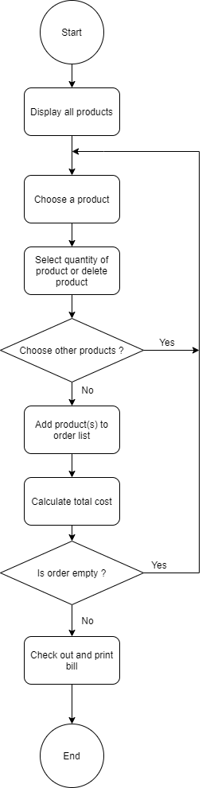

# Data model

## Entity Relationship Diagram

## C:\Users\FPT\Desktop\PRN292\Project\MyProject\diagram\Database.PNG

## Table details/Chi tiết các bảng

Note: Attribute with underline is Primary key

### Table name: Category

|  |  |  |  |
| --- | --- | --- | --- |
| **Field name** | **Type** | **Size** | **Note** |
| ID | Integer |  | Primary key |
| Name | String | 255 | Not null |

### Table name: Order

|  |  |  |  |
| --- | --- | --- | --- |
| **Field name** | **Type** | **Size** | **Note** |
| ID | Integer |  | Primary key |
| StaffId | Integer |  | Foreign key |
| Date | Date |  | Not null |

### Table name: OrderDetail

|  |  |  |  |
| --- | --- | --- | --- |
| **Field name** | **Type** | **Size** | **Note** |
| Id | Integer |  | Primary key |
| OrderId | Integer |  | Foreign key |
| ProductId | Integer |  | Foreign key |
| Quantity | Integer |  | Not null |

### Table name: Product

|  |  |  |  |
| --- | --- | --- | --- |
| **Field name** | **Type** | **Size** | **Note** |
| ID | Integer |  | Primary key |
| Name | String | 255 | Not null |
| CategoryId | Integer |  | Foreign key |
| Size | String | 255 | Not null |
| Price | Float |  | Not null |
| Image | String | 255 | Not null |

### Table name: Role

|  |  |  |  |
| --- | --- | --- | --- |
| **Field name** | **Type** | **Size** | **Note** |
| ID | Integer |  | Primary key |
| Name | String | 255 | Not null |

### Table name: Staff

|  |  |  |  |
| --- | --- | --- | --- |
| **Field name** | **Type** | **Size** | **Note** |
| ID | Integer |  | Primary key |
| Name | String | 255 | Not null |
| Gender | String | 255 | Not null |
| Dob | Date |  | Not null |
| Address | String | 255 | Not null |
| PhoneNumber | String | 255 | Not null |
| Date_of_join | Date |  | Not null |
| Salary | Float |  | Not null |

### Table name: User

|  |  |  |  |
| --- | --- | --- | --- |
| **Field name** | **Type** | **Size** | **Note** |
| ID | Integer |  | Primary key |
| UserName | String | 255 | Not null |
| Password | String | 255 | Not null |
| RoleId | Integer |  | Foreign key |
| StaffId | Integer |  | Foreign key |

# Class diagram (p.61 – p70)

## List of classes in the Layers

Layer DT

Layer GUI

Category

BillDialog

LoginGUI

SalesGUI

ProductGUI

MainGUI

StatisticGUI

StaffGUI



OrderDetail

Order

Role

StaffDAO

Staff

Layer DA

ProductDAO

UserDAO

StatisticDAO

User

CategoryDAO

OrderDAO

OrderDetailDAO

Product

Note: Allow to use

BL: Business logic DT: Data transfer

DA: Data access

ProjectPRN292 Database

## 

## Modeling the Class Behaviors - sequence diagrams (p. 66, 77)

### Sequence diagram for use case “Sales”

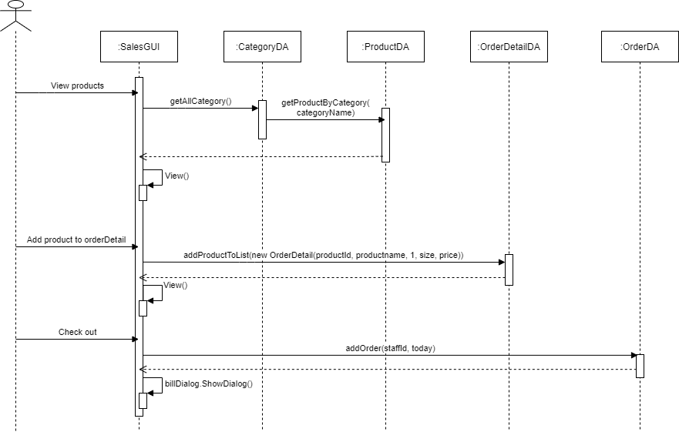

# User Interface Model Design (p. 70 – p.74)

## User interface model design

### Screen “Login”

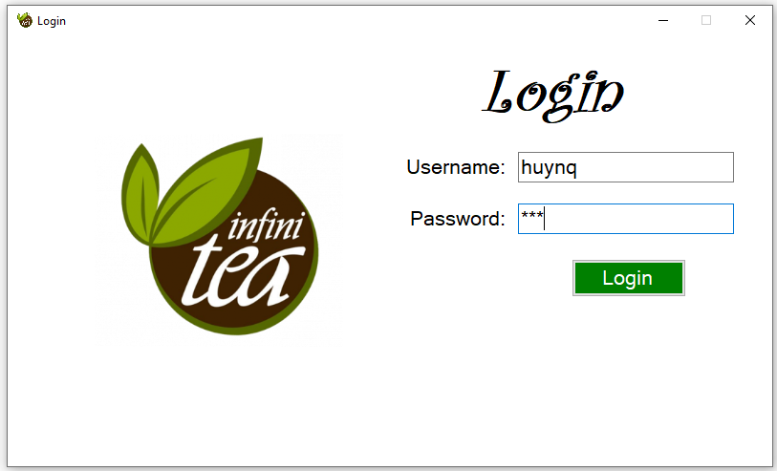

### Screen “Main”

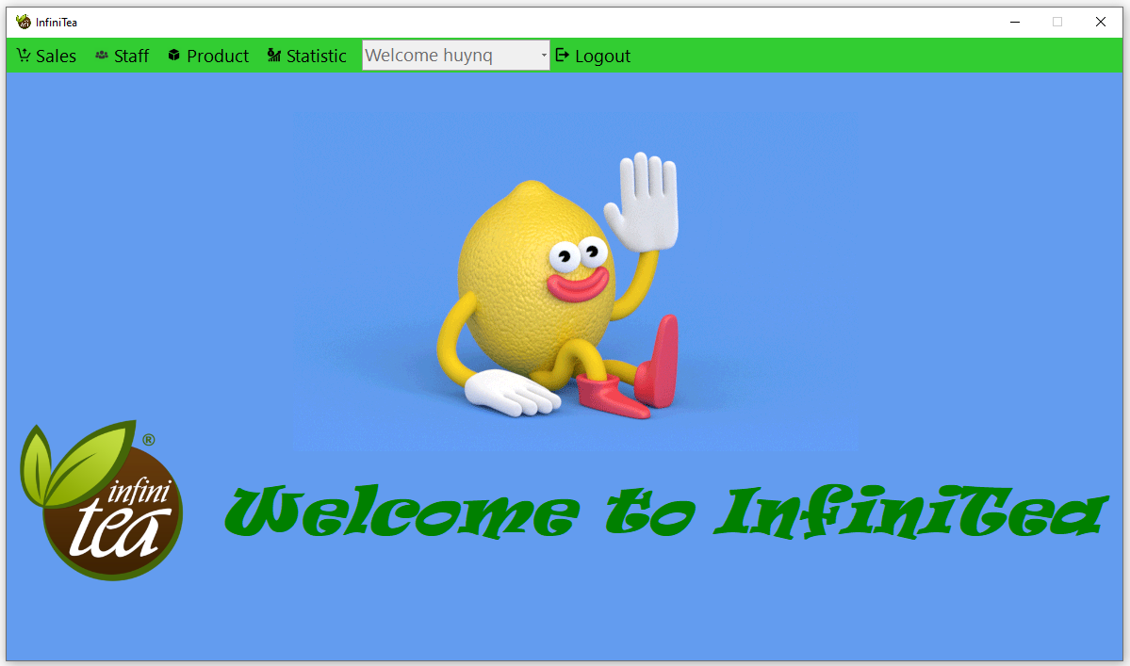

### Screen “Sales and Bill Dialog”

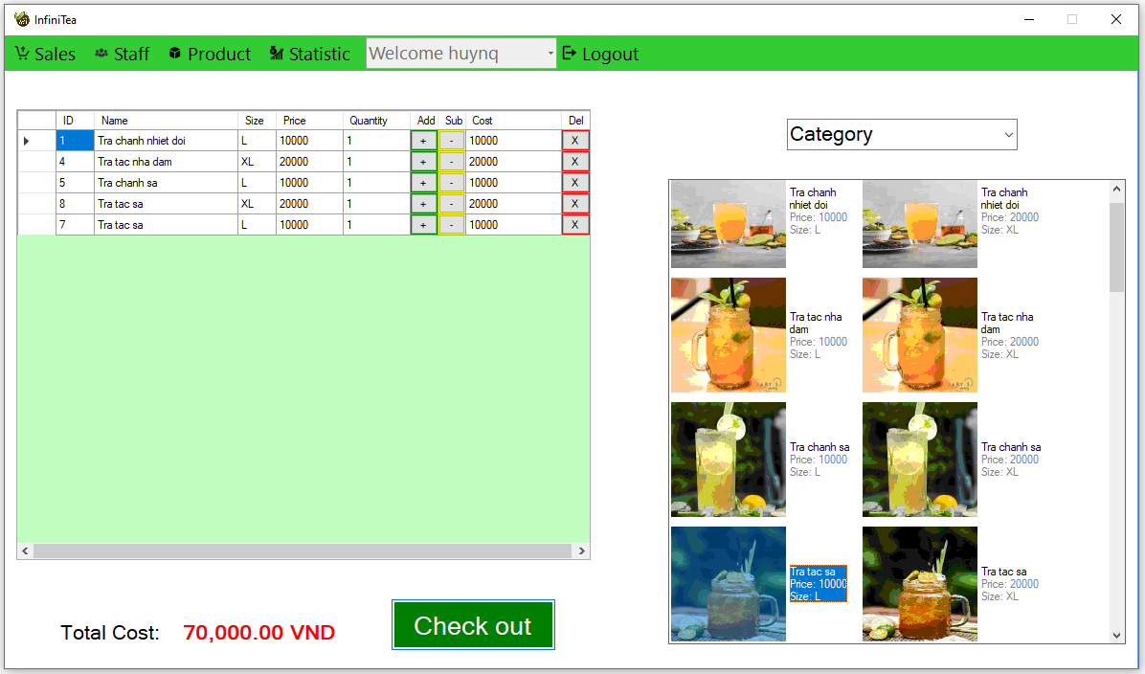

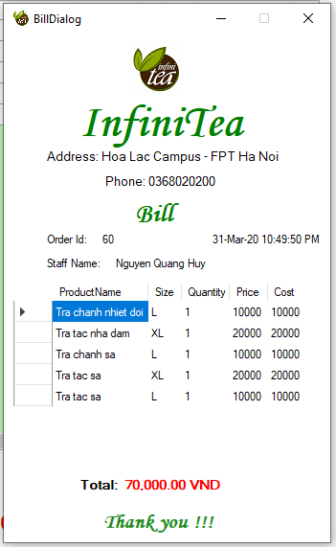

### Screen “Register Staff”

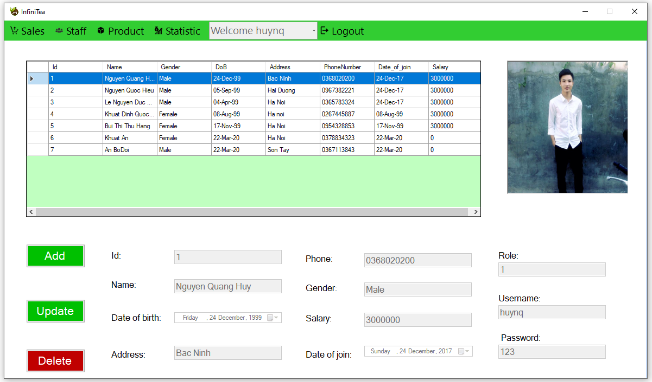

### Screen “Register Product”

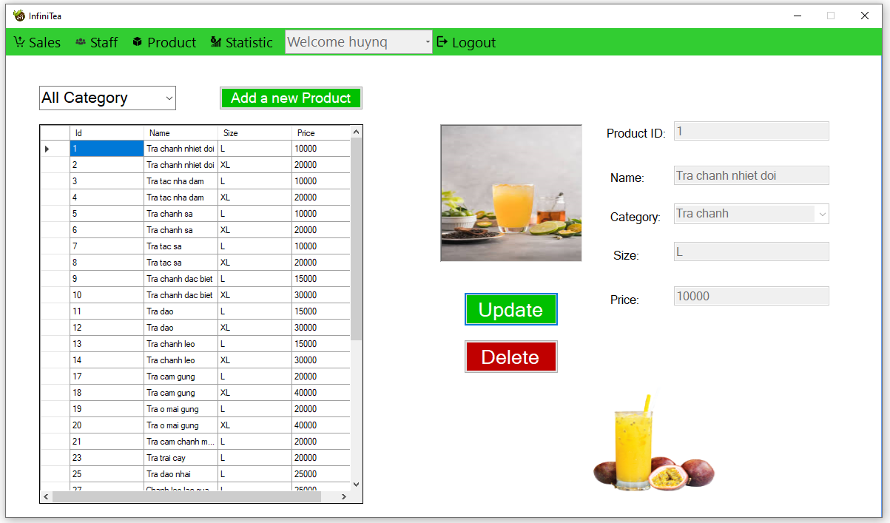

### Screen “Report Statistic”

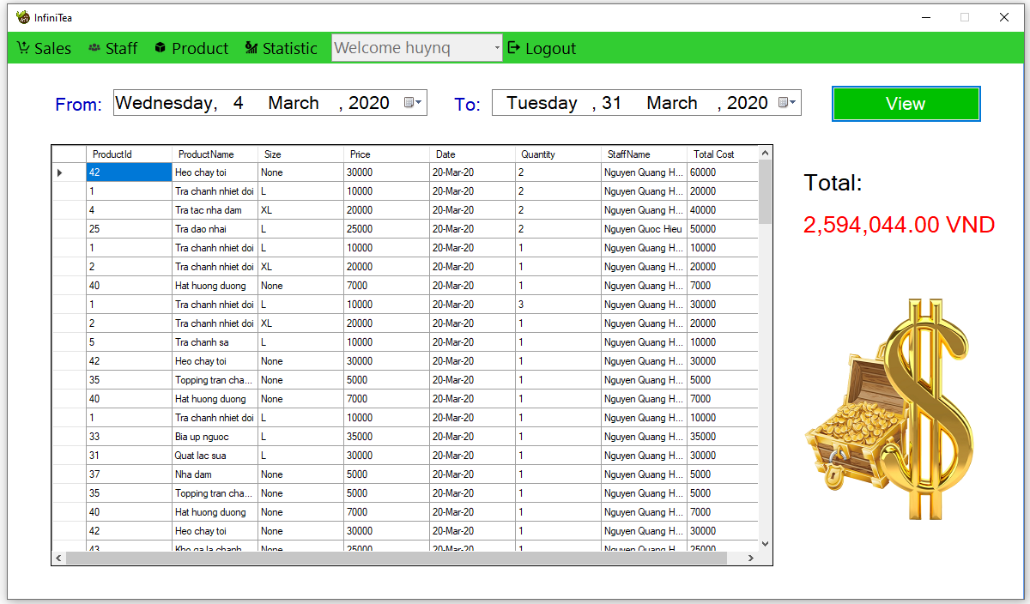

## Interface Flow Diagrams (p. 51)

