(30 points): Create a Web page to select information of outcomes based on the selected ship name.
1. Name of page: Question3.aspx (5 points)
2. User Interface (when load page) (10 points)
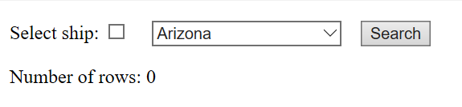
Requirements:
- Bind data of ship names of “outcomes” table to DropDownList control. Order data by ship name (5 points).
4. Click “Search” button (15 point)
- If checkbox “Select battle” is not checked, then display all outcomes from table “outcomes” (5 points)

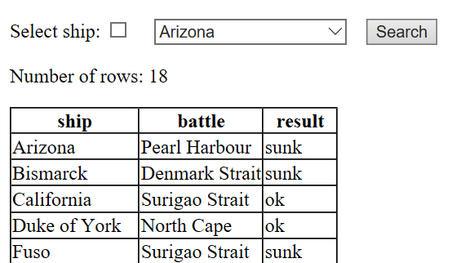

- If checkbox “Select ship” is checked, then display all outcomes of the selected battle (5 points)
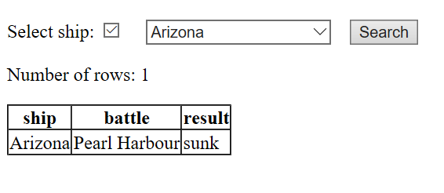
- Display the number of rows (5 points)

