(3 Point)
Design and code a class named Printer that holds information about a Printer.

Printer | Where:  1. getName():String – return name of a Printer  2. getPrice():double– return price of a Printer
-price:double
-name:String
+Printer()
+Printer(name:String,price:double)
+getName():String
+getPrice():double

The interface IPrinter is given (DO NOT CREATE THIS ONE). Design and code a class named MyPrinter which will implement interface IPrinter and complete 2 methods which were declared in IPrinter:
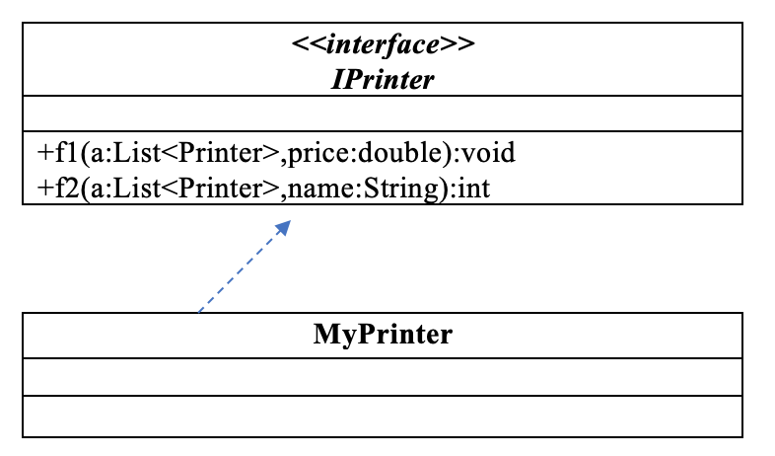
- void f1(List<Printer> a, double price) – remove from the list of printers "a" all printers which has price less than or equals to given price.
- Sort all printer in list “a”
- Decreasing price and then ascending name
- int f2(List<Printer> a, String name) - count and return number of printers which are in the list “a” and has name contains given name. The comparison must ignores the case during comparison.

Given some data which is added to list “a” in the Main already:

Printer name | Printer price
HP 200J | 110
HP 2000G | 150
Canon G1240 | 120

By using given data, the program output might look something like:

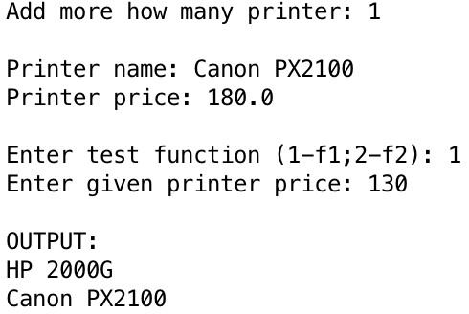 | 