Create components using NetBean
Create new project:
File -> New Project -> Java -> Java Application -> …
Create new package:
Right-click on the Proroject -> New -> Folder… (or Java Package…)
Create new class:
Right-click on the Proroject -> New -> Java class…

Create new form using JFrame class:
Right-click on the Proroject -> New -> Jframe Form…
JFrame f = new JFrame("Frame Demo");
f.setSize(350, 250);
f.setVisible(true);
f.setDefaultCloseOperation(JFrame.EXIT_ON_CLOSE);

Create new form using JDialog class::
Right-click on the Proroject -> New -> Others -> Swing GUI Forms -> JDialog

Like a JFrame, JDialog is a container, which can appear alone and can contain components. But there are some differences between them:
A Frame is used for main and document windows where a Dialog is for dialogs to enter some values or click ok/cancel.
The main differences are that a Dialog belongs to a parent window so you will need a Frame first to show a Dialog with this Frame as its parent. A Dialog cannot be minimized or maximized but it can be modal which means it blocks any Input to the parent windows while it is visible thus enforcing the user to close the dialog before he can continue to use the parent window.

Like JFrame, by default JDialog form also contains the main function and thus it can be run alone. If you want to use it as dialog window only, you can remove the main function in it.

Create menu: (A menu consists of: Menu bar, Menus and Menu items).
Create appearance:
- Click on the icon Menu Bar in the Pallete Window, drag and drop on the Jframe form.
- Edit and add menu
- Right-click on each menu to add menu item. (e.g. right-click on the Menu bar to add menu, right-click on the menu to add menu items…)
- Create shortcut for menu item (e.g. Ctrl+H): double-click on shortcut cell (beside the menu item text)
Create code according to an action:
Double-click on the menu item or
Right-click on the object -> Events -> Action -> actionPerformed
Right-click on the object -> Events -> Mouse -> mouseClicked (or others)

Create popup menu: (A menu which is activated when right-clicking the mouse).
If if the popup menu is applied for the panel x, then you should open the properties window of the panel, select the item componentPopupMenu and select the name of the popup menu.

JTable, JList and JComboBox:
JTable:
import javax.swing.*;
import javax.swing.table.*;
DefaultTableModel g = (DefaultTableModel) tbl1.getModel();

Insert row into table (example):
DefaultTableModel t = (DefaultTableModel) tbl1.getModel();
t.insertRow(t.getRowCount(),new Object[3]);
t.removeRow(tbl1.getSelectedRow());

JList:
import javax.swing.*;
import java.util.*;
DefaultListModel t = new DefaultListModel();
list1.setModel(t);

JComboBox:
// like JList
DefaultComboBoxModel t = new DefaultComboBoxModel();
combo1.setModel(t);

Create panel in form:
Important property: Border (Bevel Border, Titled Border,...)

Create Tabbed Pane in form:(https://www.youtube.com/watch?v=psFT0_pOpw0)
- Create Tabbed Pane.
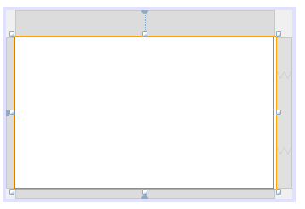
- Add tabs (panels) to tabbed pane.
Move the pane up until its’ dash border arround the tabbed pane.
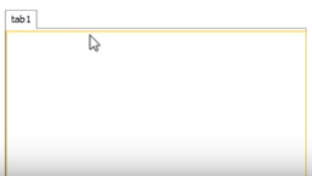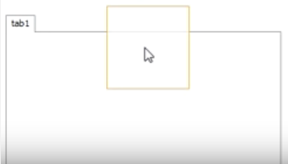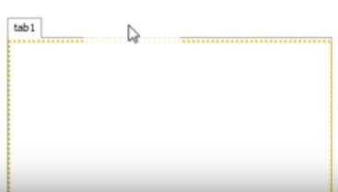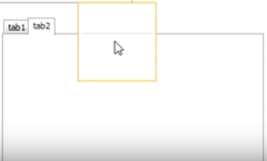

Using JSplitPane
https://www.youtube.com/watch?v=yOeGNX2ljVI
1. Create split pane
Click on the item Split Pane and drag to the form you see the split pane like below:
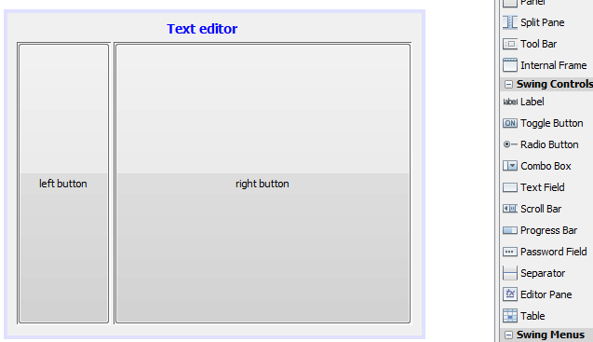
By default, the width of the left pane is 84. You can change it by write clicking on the split pane, activate the Properties window and enter the new value to the field after the text dividerLocation. In the picture below the value has been changed to 100.
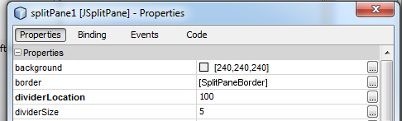

2. Add 2 panels to split pane
Click on the item panel in the Palette window and drag to split pane until you see the red dash border then release the mouse.
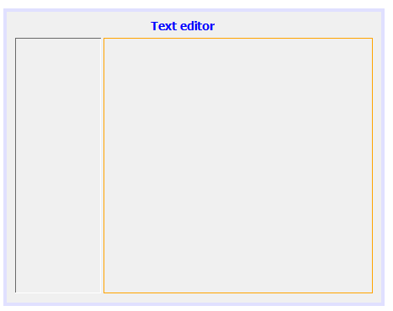
Suppose you want to create a text area in the right pane, so that this occupies the whole pane area, then you should select the Layout of the pane as Border Layout:
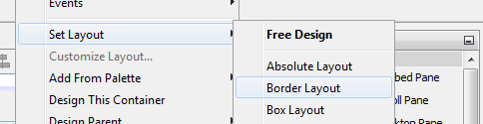

View Projects window: Window -> Project
View Navigator window: Window -> Navigator
View Pallete window: Window -> IDE Tools -> Pallete
View Properties window: Window -> IDE Tools -> Properties (or Right-click on the object -> Properties)

Create radio buttons group:
- Create radio buttons
- Create a button group: Right-click on “Other components” -> Add from Palette -> Swing Controls -> Button Group
- Select each radio button -> Properties -> buttonGroup -> Select the according button group
View the value of the selected button (example):
String x = "";
if(radOrange.isSelected()) x = radOrange.getText();
if(radLemon.isSelected()) x = radLemon.getText();
if(radMango.isSelected()) x = radMango.getText();
txtRad.setText(x);

Create radio checkbox buttons:
Create checkbox buttons
View the value of the selected buttons (example):
String x = "";
if(chkRose.isSelected()) x += chkRose.getText() + "\r\n";
if(chkDaisy.isSelected()) x += chkDaisy.getText() + "\r\n";
if(chkLotus.isSelected()) x += chkLotus.getText() + "\r\n";
txtAChk.setText(x);

Create list box:
Create list box
Get all selected items (example):
int [] a = list1.getSelectedIndices();
ListModel u = (ListModel) list1.getModel();
int n, i;
n = a.length;
String [] b = new String[n];
for(int i=0;i<n) b[i] = (String) u.getElementAt(a[i]);
Get all items (example):
int n,i;
ListModel u = (ListModel) list1.getModel();
n = u.getSize();
String [] b = new String[n];
for(i=0;i<n;i++) b[i] = (String) u.getElementAt(i);

Create list box with non string Type parameters:
Create list box
Click on it and select Properties, select the tab “Code”, go to line “Type Parameters”, Delete <String>
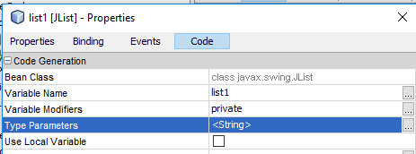

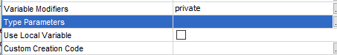
Suppose you want to use the list to store Book objects, you should write statements like below:
In the class Book you should override the method toString(), be cause Java will use this method to convert the Book object to a string when adding to the list.
DefaultListModel<Emp> model1 = new DefaultListModel<Emp>();
list1.setModel(model1);
Then all data in the list will be deleted and from now on the contents of the list1 and model1 are the same.
For the Book object x, you use the statement:
model1.addElement(x);
Then the object x is added to model1 and then Java uses the toString() method of the class Book to convert x to a string and add to list1.

Create combo box:
Create combo box
View the value of the selected item (example):
int k = combo1.getSelectedIndex();
ListModel t = combo1.getModel();
String x = (String) t.getElementAt(k);
txtCombo.setText(x);

Using Timer (examples):
import javax.swing.*;
import java.awt.event.*;
…
void initTimer()
{ActionListener h = new ActionListener()
{public void actionPerformed(ActionEvent e) {fun(); }
};
t = new Timer(200,h);
}

Create Formatted and Password Fields:
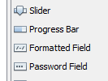
The following table shows the characters you can use in the formatting mask of the Formatted field:
Character | Description
# | Any valid number (Character.isDigit).
'  (single quote) | Escape character, used to escape any of the special formatting characters.
U | Any character (Character.isLetter). All lowercase letters are mapped to uppercase.
L | Any character (Character.isLetter). All uppercase letters are mapped to lowercase.
A | Any character or number (Character.isLetter or Character.isDigit).
? | Any character (Character.isLetter).
* | Anything.
H | Any hex character (0-9, a-f or A-F).

Set a background image for a JFrame or JPanel using Jlabel
https://www.youtube.com/watch?v=WOLJQ6lsFGE
Write click on the form -> Set Layout -> Null Layout.
Create a label in the left-top corner, drag so that the label enlarges the full content of the form. Select the properties window of the label, delete text, then select the item icon, then select the picture file for background image.
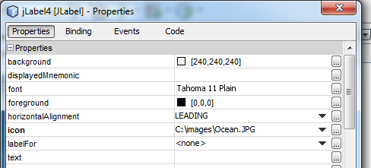
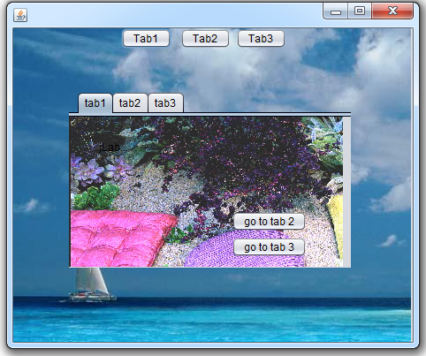

Some problems:
Sometime you meet the case that you cannot resize the form to the smaller size. In this case you can right-click on the form, click “Edit Layout Space”, then check the Resizable checkbox like below:
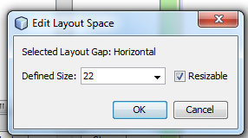

Date and time:
Date class:
import java.util.*;
Date d = new Date();
System.out.println(" Year: " + (1900 + d.getYear()));
System.out.println(" Month: " + (d.getMonth()+1));
System.out.println(" Day of week: " + (d.getDay()+1));
System.out.println(" Hour: " + d.getHours());
System.out.println(" Minute: " + d.getMinutes());
System.out.println(" Second: " + d.getSeconds());
System.out.println(" Milli seconds from 1900: " + System.currentTimeMillis());

Calendar class:
import java.util.*;
Calendar t = Calendar.getInstance();
System.out.println("Time: " + t.getTime());
System.out.println("Hour of say: " + t.get(Calendar.HOUR_OF_DAY));
System.out.println("Minute): " + t.get(Calendar.MINUTE));
System.out.println("Second: " + t.get(Calendar.SECOND));

Color and font:
import java.awt.*;
import javax.swing.*;
lbl1.setFont(new Font("Tahoma",Font.BOLD, 20));
lbl1.setBackground(Color.YELLOW);
red.setForeground(Color.RED);

