Core Java swing exercises
1. Develope GUI looks like bellow:
At design:  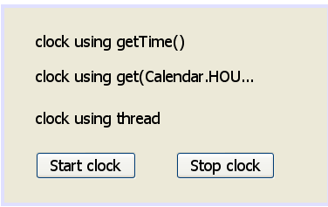 | At running after pressing "Start clock" button:  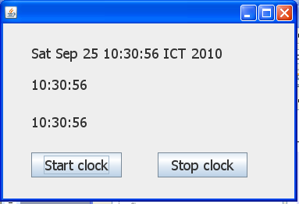

2. Develope GUI looks like bellow:
At design:  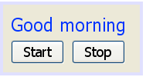 | At running after pressing "Start" button the text  starts running from right to left.  If an user press "Stop" button, the text  stops running.  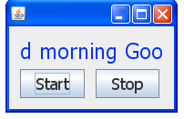

3. Develope GUI looks like question 2 but without "start" and "stop" buttons.
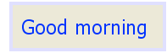
At start of running the text does not move. However if an user left-mouse clicks on the text then it begins running from right to left and if an user right-mouse clicks on the text then it begins running from left to right.

4. Develope GUI looks like bellow:
At design:  Form1 Form2  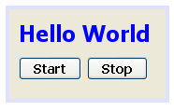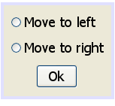 | At running after pressing "Start" button the Form2 is  displayed. An user can select a radio button to  decide the direction of text moving.  If an user press "Stop" button, the text stops running.  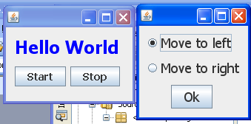

5. Develope GUI looks like bellow:
At design:
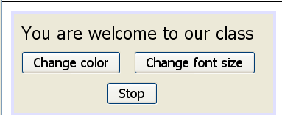
At running if an user press "Change color" button then the text's color will be changing every 0.5 second. At first the color changes from black to red, then red to blue, and blue to black and so on.
If an user press "Change font size" button then the text's font size will be increased by 5 every 0.5 second. When the font size ≥ 40 it get the original font size and so on.
If an user press "Stop" button then the changing stops at current situation.

