Read the below instructions carefully before you start.
- Download the given material then unzip.
- Software Requirement: NetBeans 8.*, MS SQL Server 2008 R2+
- You receive folders: FinalQ1_XXX (1) and FinalQ2_XXX (2)… They are template for your corresponding exam questions. FinalQ1_XXX used for question number 1 and FinalQ2_XXX for question number 2 and so on. Open them as NetBeans project, replace XXX by [your student ID], e.g. FinalQ1_SE1111, FinalQ2_SE1111, FinalQ3_SE1111. Change the context application to new name, e.g. /FinalQ1_SE1111/Index.html instead of /FinalQ1_XXX/Index.html. Your work will not be considered for grading, if this condition is not satisfied.
- Copy given file DBContext.java (3) to source package (src\java) under folder (1),(2),.... You might need to use and name a java package for (3), free to set the name of package.
- You MUST use DBContext.java for your all database connection. Update your database connection string by filling values for instance variables in this class. DO NOT edit getConnection method.
- All extra libraries (if needed) must be used by available NetBeans libraries only.
- On completion, read submission guide carefully.

Question 1:
(3 points)
You are given a NetBeans template project (read more detail in the first page). The given project already added some files including: circle.jsp, model.Circle.java.
Note: student must not edit the code inside given files.
- The Circle.java used to describe the data structure of the circle where x,y attributes represent the center’s coordinate , r represents the radius of the circle.
- circle.jsp plays role to displays all of circles forwarded to it. The shared data stored in the Request Scope with name of “data”. Figure 1 illustrates the idea of what circle.jsp does.
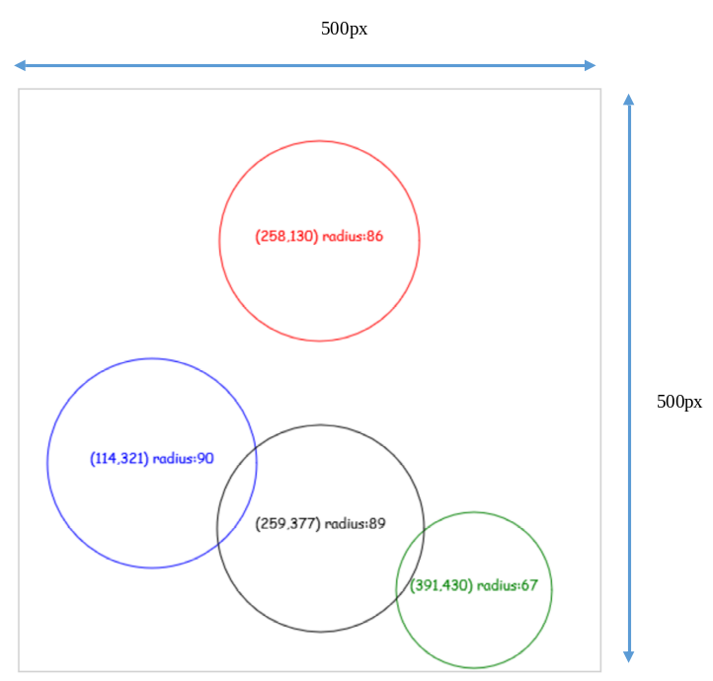
Figure 1: Circles drawn by a canvas
Your tasks:
- Create CircleServlet, the component can be accessed via url: /circle
- User can use string query to pass the parameter ‘num’ as number of rectangles to be random generated.
Example: /circle?num=4
- The random generated rectangle should follow below rules
- r is greater or equal 50 , and smaller or equal 100
- The circle must fit the canvas size.
Note: 0 given to student’s work if any of listed requirement cannot be satisfied.
Question 2:
(4 points)
You are asked to build a web application using the given database structure as Figure 1.
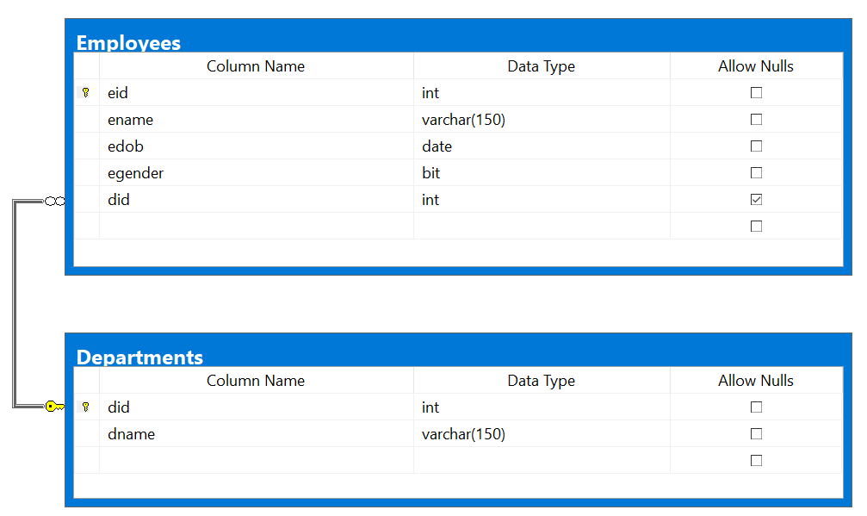
Figure 1: Database Structure
User can type /list (/ represents your web application context path) to access List Employees Page.
- When the page load (first access) (2 points)
  - [Departments] Dropdown list loads all of departments from [Department] table and add one more item with content “------------------“ to the head of the list. Of course this item will be selected by default.
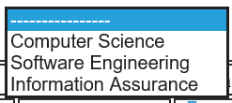
Figure 2: Dropdown list of Departments
  - The table Employees display info of all Employees.
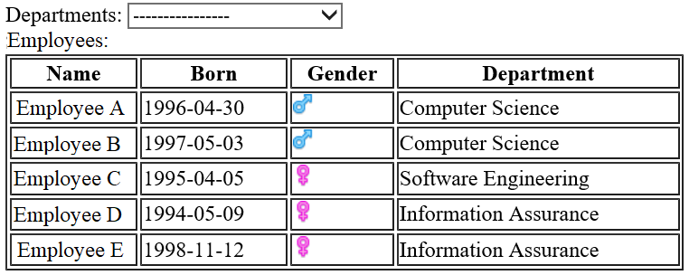
Figure 3: List Employees Page in case of displaying all Employees

- When user selects an item on [Departments] dropdown list, system display the corresponding Employees of the selected department only. ( 2 points)
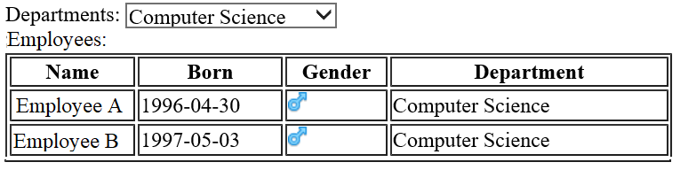
Figure 4: List Employees Page in case of displaying some Employees
Note: Reload page is necessary, however the state of the page must be kept after reloading.

Question 3:
(3 points)
You are asked to build a web application using the given database structure as Figure 1.
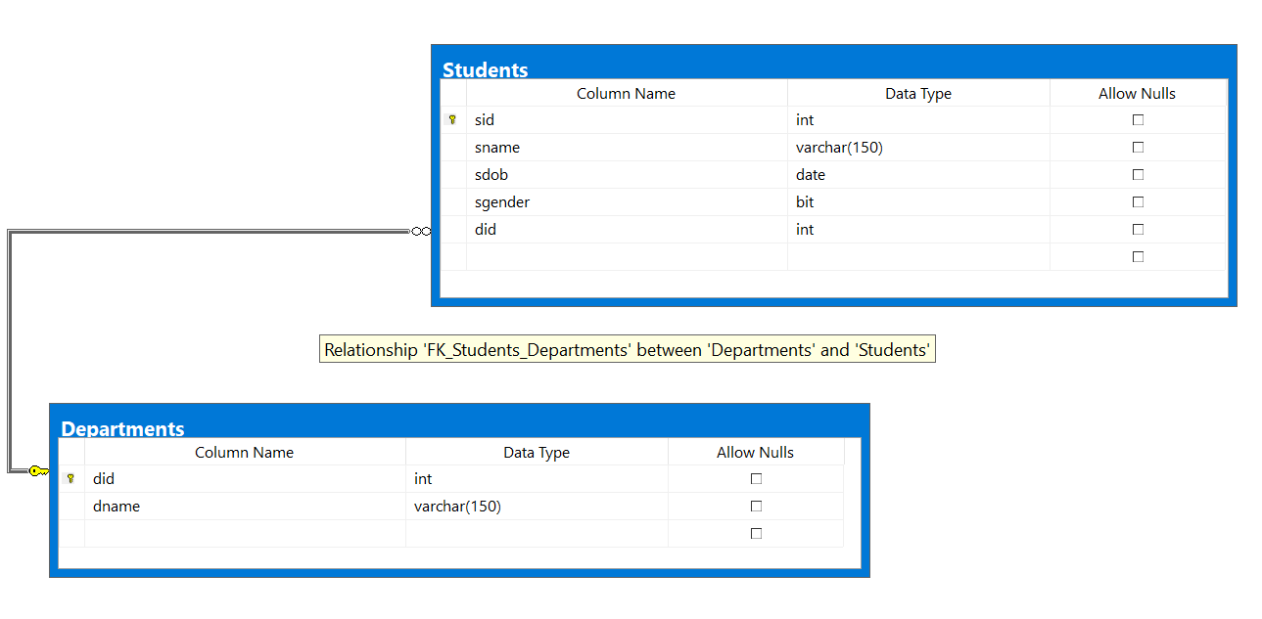
Figure 1: Database Structure
User can type /add (/ represents your web application context path) to access Add Students Page.
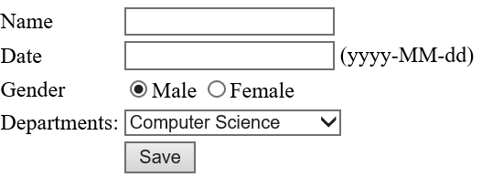
Figure 2: Add Student page
- The Department dropdown list must load data from [Departments] table
- When user fills all fields of the form and then clicks [Save] button, the new Student will be inserted to [Students] table
Note: 3 points only given to the work that satisfied all of the requirements

