**Gas Clan**



Nov. 23, 2015

Garena Labs

**Version History**

|  |  |  |  |  |
| --- | --- | --- | --- | --- |
| No. | Version | Updated Content | Personnel | Date |
| 1 | 1.0.0 | Create web doc | Yixin | Nov. 23, 2015 |
| 2 | 1.0.1 | Add Clan Request Management Page | Yixin | Dec. 7, 2015 |

# **Editor’s Information**

Gas Mobile team: Chen Yixin <[chenyx@garena.com](mailto:chenyx@garena.com)>

Wang Xiangjun <[wangxj@garena.com](mailto:wangxj@garena.com)>

1. Introduction

# 1.1. Purpose

Based on Gas Forum, Gas Clan is a new feature inside Gas for Mobile/PC users to create their own group to invite, discuss, and initiate events with friends from Garena games.

# 1.2 Overview

Basically, a clan has all the features that a forum does: following a clan, creating new thread, replying to thread and etc. However, compared with a normal forum, clans have more special features.

* Unlike forums that are created by Garena staff, clans are created and operated purely by users themselves.
* Clan is a relatively close group including members with different classes (owner, admins and members).
* Clan forum are only visible to its members if the clan is set “private”.
* Members can create events whereby other members could follow and join easily.

Generally, Gas Clan is an expanded version from Gas Forum, which includes more socialized and customized features for users who enjoy being special and having a feeling of belonging.

2. Structure Design

# 2.1. Overall

From the bottom design perspective, clan is not a brand new concept but an expanded version of current forum design.



Unlike forums which belong to both a certain region and tag, clans are only restricted by its region. A clan is only visible when users are browsing under the region it belongs to.

For the Gas Clan prototype design, please refer to the following link:

[Gas Clan Prototype Design](http://lvhdmw.axshare.com/home.html)

# 2.2. Details

Except for **Tags**, which are not included in the structure of Gas Clan, the three remaining features **Regions, Forums, Threads** are exactly of the same design Gas Forum. Please refer to [Gas Forum Main Document](https://docs.google.com/document/d/1bltGFq1TiC5OU81CoY0HIFXBXIqeAJFfqAIsCuod_wY/edit) Section 2.2 for more details.

Besides those basic features, the special features of Gas Clan will be illustrated in the next sections.

## **2.2.1 Clan homepage**

Clan homepage (with a tile of “All Clans”) is designed for users to quickly enter recently visited clans, browse recommended clans and create new clans. A search function is also provided for users to find a particular clan.

Note that users can search by:

* clan name: only support specific search, user will be then redirected to the target clan.
* game tag: recommended clans of that tag will be displayed in the drop down panel, only Garena game tags can be searched, such as: LOL, TS and etc.

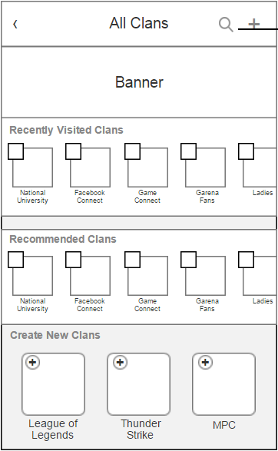

Note that the header position is also reserved for banners which allows operation teams to do cross promotion for official forums, events, or mobile games.

For configuration of the clan banner, please refer to [How to Configure Gas Clan Banner](https://docs.google.com/spreadsheets/d/1tmRy7hr3psgi5DGw8NIUrizB0dyW6LzPpYmB3fHI2SI/edit):

## **2.2.2 Clan collection page**

Users may access the clan collection page (with a title of “My Clans”) by two entrances:

* click the clan logo at the **2nd place** of followed forum list,
* or click the **3rd thread** with clan flag in the recommended thread list.

A particular clan collection page consists of two sections: followed clans and recommended clan thread list. The followed clan section shows all clans that one has joined while the recommended list displays the latest threads from these followed clans.

Hence, the recommended clan thread list is sorted according to the **Creation Time**.

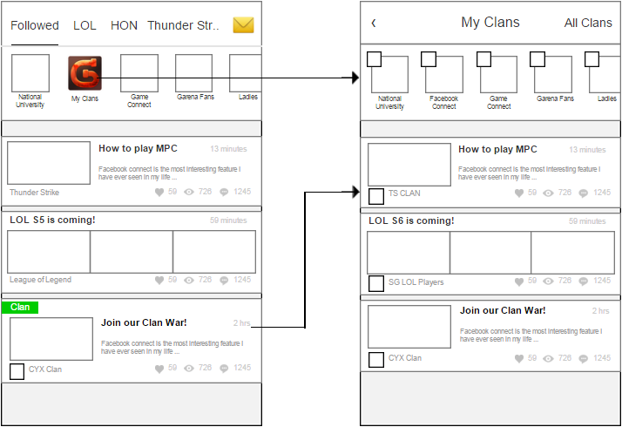

Note that users can jump to clan homepage by clicking the “All Clans” button in the top right corner.

## **2.2.3 Clan Profile**

Compared with forum, one of the most significant difference is that every clan will have a profile page.

A particular clan profile page consists of below information:

* *Clan Avatar*: icon of the clan, minimum icon size is 180px by 180px.
* *Clan Name*: name of the clan, visible to anyone.
* *Clan Flag*: to be determined.
* *Clan Description*: a short text that briefly describes the features of this clan, or introduces the rules or recent announcements.
* *Clan Members*: number of members in this clan, including owner and admins.
* *Associated Game*: indicate the games which this clan is interested in. A clan may have more than one associated games but this field cannot be empty.
* *Type:* when the type is set “private”, the clan forum becomes only visible to its members, while the forum of a public clan can be browsed by anyone.

From the profile page, visitors may have a brief impression of this clan.

## **2.2.4 Event**

Threads are the main elements of Gas forum. An event is a special type of thread, which allows starter to set a event location and event time. Other clan members could choose “follow” or “maybe” in the bottom of the main thread.

When the event starts, a push notification will be sent to all followed members. If approved by owner or admins, the starter can also choose to send notification to **all** clan members. One can view all the “followed” and “stand-by” users of this event by clicking the follower’s list.

3. Use Case

# 3.1. Browse clans

Placeholder.

# 3.2. Join clans

Like the “follow” feature of Gas Forum, users can join a clan to become a member hence they could get the latest update and involve in the events of this clan.

In the clan forum, one can enter the clan profile page by clicking the clan avatar.

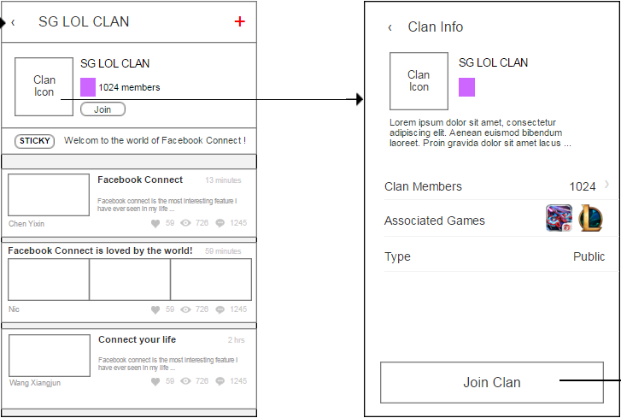

By clicking the “join clan” button, a popup window will appear. The applicant is suggested to fill in the self introduction message in the request. The application will then be sent to the clan owner and admins for approval.

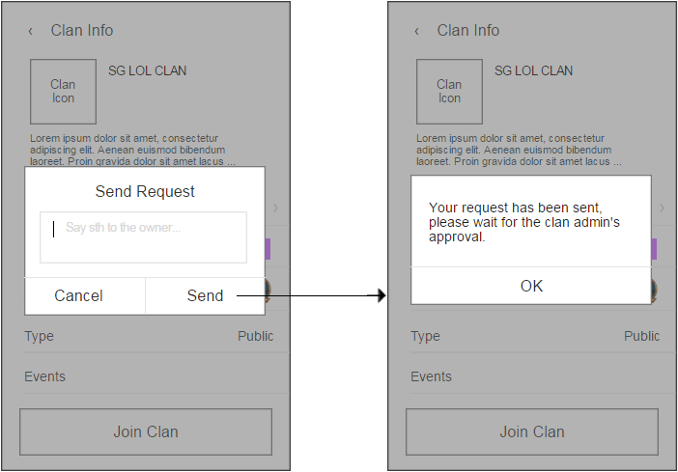

Once the request has been approved, the applicant will receive a notification that he/she has been approved to join this clan.

# 3.3. Create new thread/reply to a thread/reply to a post/like a thread

These use cases are exactly the same as Gas Forum. Please refer to [Gas Forum Main Document](https://docs.google.com/document/d/1bltGFq1TiC5OU81CoY0HIFXBXIqeAJFfqAIsCuod_wY/edit) Section 3.3 - 3.6 for more details.

Note that from section 3.4 on, the **clan-only** features will be illustrated in details. For quick reference, please check the permission table below:

|  |  |  |  |
| --- | --- | --- | --- |
|  | **Owner** | **Admin(s)** | **Member(s)** |
| Update clan Info | **✓** | **✗** | **✗** |
| Create an event | **✓** | **✓** | **✓** |
| Approve event notification to all | **✓** | **✓** | **✗** |
| Invite friends | **✓** | **✓** | **✓** |
| Approve request or invitation | **✓** | **✓** | **✗** |
| Make admin/ remove as admin | **✓** | **✗** | **✗** |
| Remove members from clan | **✓** | **✓** | **✗** |
| Remove admins from clan | **✓** | **✗** | **✗** |
| Set sticky thread | **✓** | **✓** | **✗** |

# 3.4. Create a clan

Any user can create his/her own clan. In the clan homepage, one can enter the clan creation page by clicking either the “plus” button in the top right corner or game icons in the bottom area.

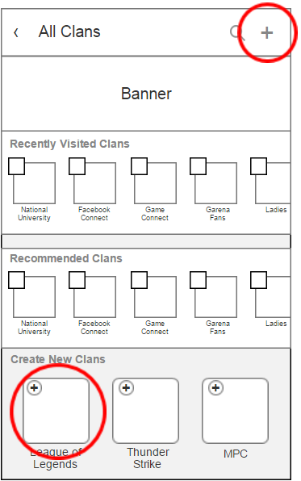

When creating a clan, the following are elements need to be specified:

* *Clan Name*: name of the new clan, visible to anyone. **(Compulsory, 2-16 characters)**
* *Clan Icon*: avatar of the new clan, , minimum icon size is 180px by 180px. **(Compulsory)**
* *Clan Description*: a short text that briefly describes the features of this clan, or introduces the rules or recent announcements. **(Compulsory)**
* *Associated Game*: indicate the games which this clan is interested in. A clan may have more than one associated games but this field cannot be empty. **(Compulsory, at least 1)**
* *Type:* when the type is set “private”, the clan forum becomes only visible to its members, while the forum of a public clan can be browsed by anyone. **(Public by default)**

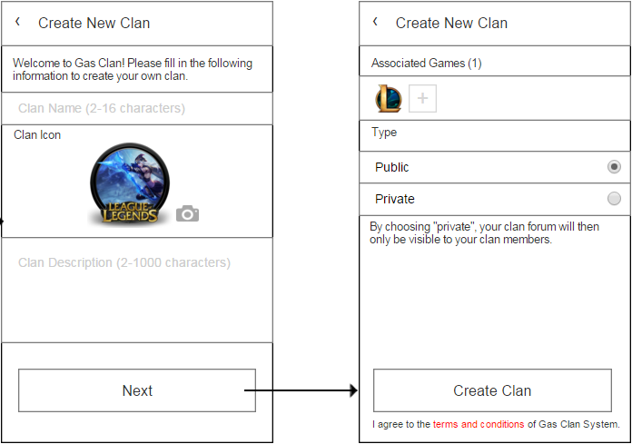

Once the new clan is created, it will appear in the **1st place** of the owner’s followed clans. Note that every Gas user is only allowed to own at most three clans.

# 3.5. Update clan info

Placeholder.

# 3.6. Create an event

Basically, an event is a special type of thread, which allows starter to set a event location and event time. Other clan members could choose “follow” or “maybe” in the bottom of the main content of an event.

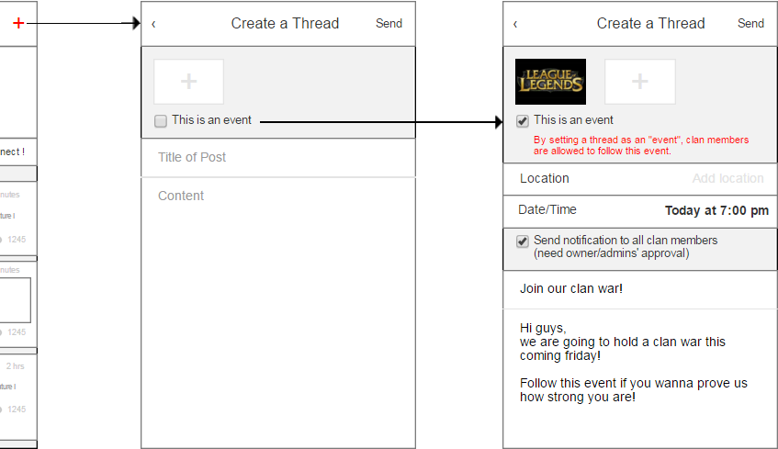

Any clan members could create events. In the normal thread creation page, click on the option “This is an event”, advanced option panel for event settings will appear.

A particular event consists of the following elements:

* *Title*: title of the created event. **(Compulsory)**
* *Content*: description of the event details. **(Compulsory)**
* *Attached Images*: users are required to attach at least one image for the event, note that the images will be displayed before the event content, and the prefered image format is JPG and PNG. **(Compulsory, 1-9 images)**
* *Event flag*: indicate this thread is an event.
* *Location*: allow starter to set a location for this event. **(Optional)**
* *Date/Time*: starter needs to set when the events will be held, upon the time all followers will receive a push notification. By default it is the creation time of the event. **(Compulsory)**
* Send Notification to All: once the option is turned on and approved by owner/admins, upon the time when the event starts, all clan members will receive a notification. **(Optional)**

Once the event is created, it will appear in the thread list of the clan forum. Other forum members may choose “Follow” or “Maybe” to response.

* *“Follow”*: indicate that the user will join this event and is willing to receive notification when the event starts.
* *“Maybe”*: indicate that the user is not sure about the given schedule and does not want to receive notifications.

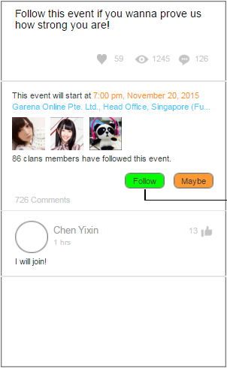

Note that one can view all the user who followed this event by clicking the list of followers. The followers are divided into three categories: event creator, followers (those who chose “follow”) and stand-bys (those who chose “maybe”).

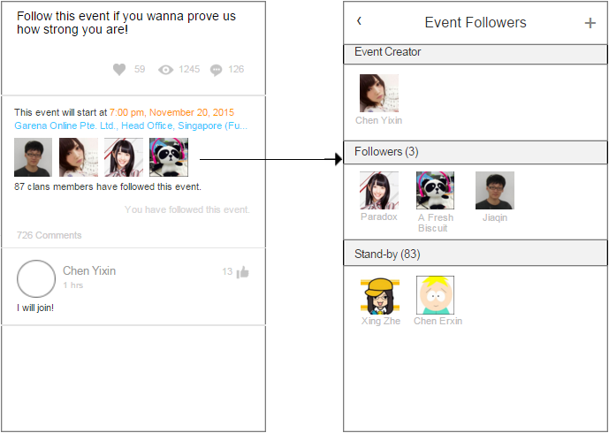

One can also invite his/her friends to join this event by clicking the “plus” button in the top right corner. The invitation will be sent through the notification system and open the notification will direct the invitee to this event.

# 3.7. Invite friends

Any clan members are allow to invite their friends to join their clan. In the clan profile page, enter the member detail page by clicking the “Clan Members” area. Users can click the “plus” button in the top right corner, their Gas buddy list will be pulled up and they can choose one friend to send the invitation.

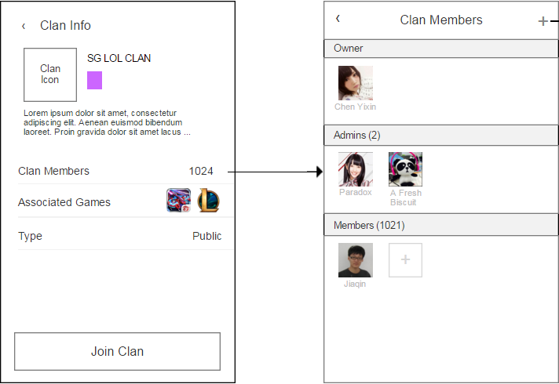

**Note that the invitation will be sent to the target first, before the owner or admins’ approval.**

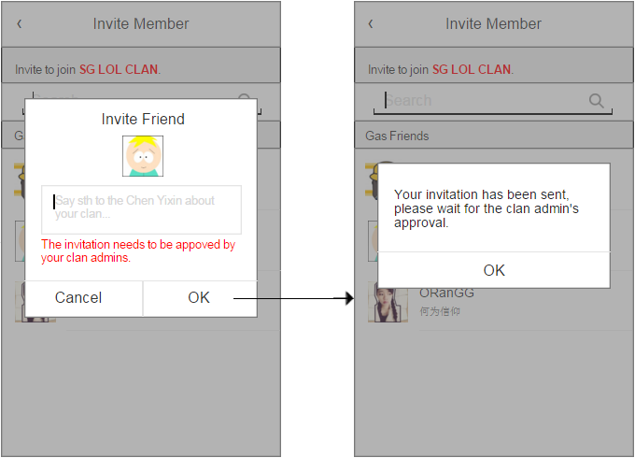

# 3.8. Make admin/remove as admin

Only the clan owner has the authority to make one clan member admin or remove one admin. In the clan member detail page, long press on one’s avatar to enable the management panel. Note that every clan can has at most 5 admins.

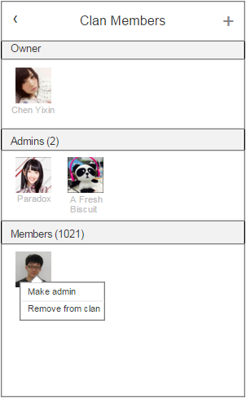

Note that the promoted admin will receive an promotion notification and the all members will receive a notification that a new admin has been appointed.

# 3.9. Remove from clan

The clan owner has the right to remove anyone from his/her clan while the admins hold the rights to remove normal members.



Note that the kicked member will receive a notification.

# 3.10. Manage Request

Clan owner/admins can use the option panel to enter the clan request management page.

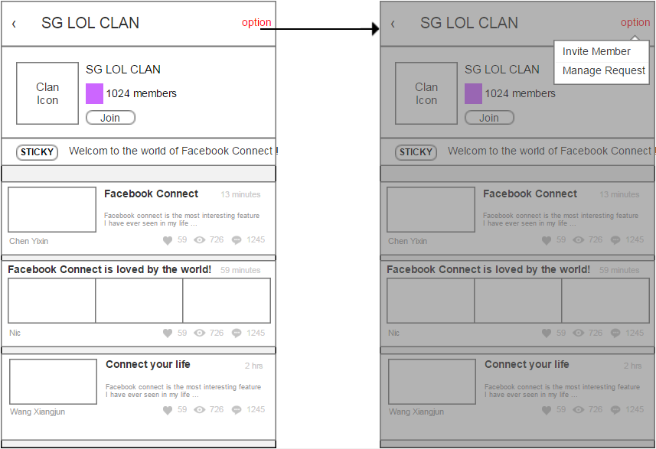

Basically there are two kinds of requests in any clan:

* Join Request: requests from those who wants to join this clan
* Sending Notification Request: requests from event creators who wants to send notification to all clan member upon events starting

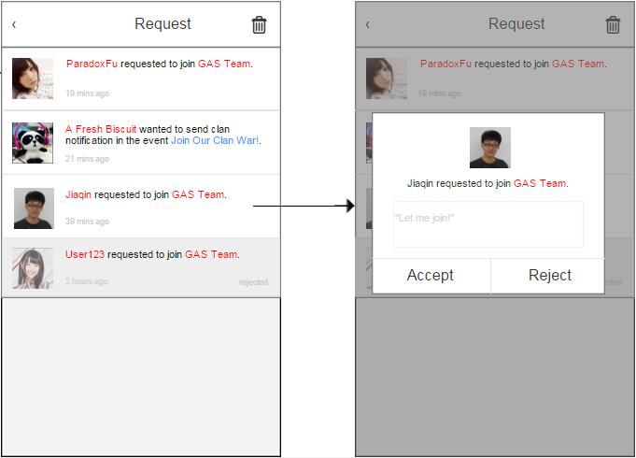

Note that owner/admins cannot manage a request which has been processed by other admins. An “accepted” or “rejected” marker will be displayed then.

# 3.11. Set sticky thread

Placeholder.

# 3.12. Leave a clan

Placeholder.