Full Name: Nguyễn Thế Huy

Class: K57CA

Student Code: 12020174

Assignment Report – Artificial Intelligence

1. How to detect and avoid repeated state in A\* implementation ?

In my solution, I use set (a kind of data structure is supported in C++) to check duplicate

Sets of C++ are containers that store unique elements following a specific order and implemented in binary search tree.

Here is my code to check if a state existed in set:



Explain:

In a set, it provide find() method to find a specific element. If found, find() return pointer to element is found. If no, find() return pointer to the last element of set. So, we can check: if find(state) is not equal to last element (provided by end() method), this state existed in our set.

So if we detect a repeated state, we will not insert it to set and skip it

Full code:

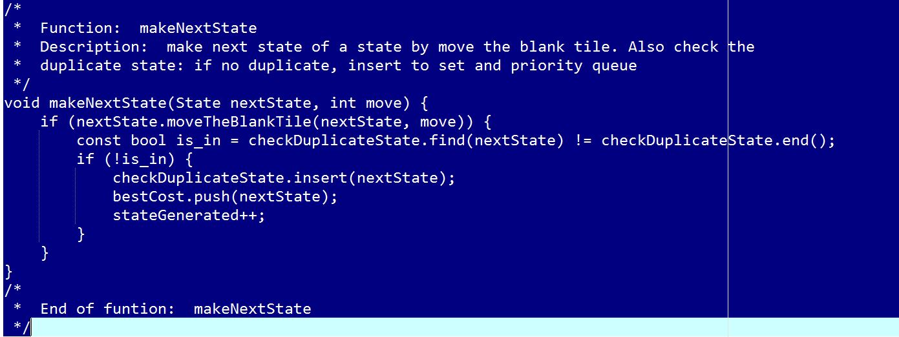

Because of implementing in binary search tree, set is fast to find and check duplicate element with time complexity average: O(log n)