The Covid-19 supporting, tracking and analyzing website

Trinh Quang Hien   
*IT major,* *FPT University*   
*FPT University*  
DaNang, Vietnam  
hientqde140248@fpt.edu.vn

Nguyen Xuan Huy  
*IT major,* *FPT University*   
*FPT University*  
DaNang, Vietnam  
huynxde130146@fpt.edu.vn Doan Duc Tin  
*IT major,* *FPT University*   
*FPT University*  
DaNang, Vietnam  
tinddde140094@fpt.edu.vn

Nguyen Quoc Hung  
*IT major, FPT University*

*FPT University*

DaNang, Vietnam  
hungnqde140090@fpt.edu.vn

Quynh Tran Ly  
*IT Department, FPT University*   
*FPT University*DaNang, Vietnam  
tranlq@fe.edu.vn

*Abstract*—The worldwide COVID-19 pandemic is the situation in which people are suffering not only the global health crisis as Covid-19 affection, depression and death, but also the slowing down of global economy as losing jobs and income. Indeed, the pandemic has a negative impact on living standard of thousands of peoples and put our society in a threat stage that is hard to recover. In this study, we present the useful HTH Covid-19 Tracker website for finding the urgent place where the charity sponsor can provide food, finance and medical equipment immediately, viewing the threat zone by regions, time and importantly, searching the safe place to go. The HTH Covid-19 Tracker is operated based on data of 386 Covid-19 patients living in Danang City, which is published and updated by Danang Department of Health. The main language we used here is Java with deployment platform run by Azure, MSSQL and Linux Virtual Machine. The backbone advanced frameworks are Spring MVC, Hibernate, Google API, the statistical computing and graphics R language, and Business Intelligent and embed ELF. We expect that the HTH Covid-19 Tracker will have the great contribution to protect people from poor, disease and bring safety to our livings.

Keywords—Covid-19 tracker, supporting, analyzing, tracking, R language, Business Intelligent, Spring MVC, Hibernate, Google API.

# **INTRODUCTION**

The worldwide COVID-19 pandemic actually brings us into the enormous challenge to face and deal global health and economic crisis. Thus, preventing sickness and recovering our country are the two crucial missions for all fields of society. Under the 4.0 technology, website is believed as one of the most advanced digital technology that helps the worldwide COVID-19 pandemic in under control due to its spreading propagating or fast notification to the users.

Recently, a number of websites have built for the tracking, supporting and overcome the Covid-19 situation. However, there is no website is constructed with the function of doing charity, viewing a rich picture of Covid-19 patients (C19P) with most dangerous zone per our city, per districts or by time. Hence, our team determined to carry out this gap to contribute the HTH Covid-19 Tracker website providing users helpful tool to solve the pandemic’s problems happening in Vietnam, especially in Da Nang city.

There are four main aspects that the HTH Covid-19 website can offers users. First, as a role of Guest, user can track how many C19P, the affected area around them, and the information of whether these patients recovered or not. Second, as a role of charity sponsor, the HTH Covid-19 website effectively support sponsors to approach to urgent urgent place to provide charity products in the fasted way. Third, the HTH Covid-19 website generate an impressive visualization with the map Vietnam based on District’s threat zone specifically. This function is for people realizing the dangerous situation of the current Covid-19 pandemic happening. Four and importantly, user can search the safe place to go with the protective distance of around 100 meters from the affected area. These functions are described as the use-case diagram bellows.

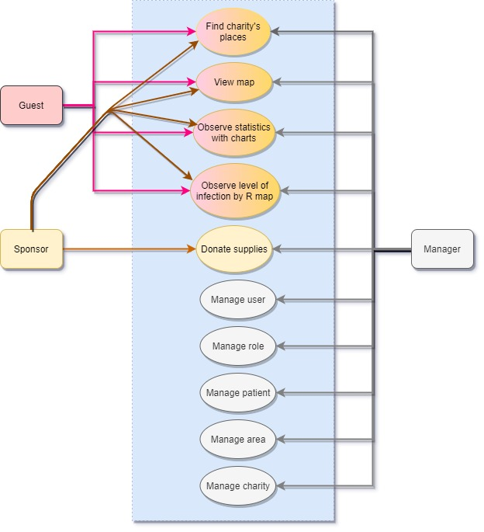

1. Use case of HTH Covid tracker website

The contribution of our study is classified into two different aspects such as IT frameworks and usability functions of the website.

As for the former, Java with deployment Azure, MSSQL and Linux Virtual Machine platform is operated. To be more specific, this web application is structured and designed with five main parts. First, the backbone advanced frameworks as Spring MVC and Spring Data JPA (Hibernate). Second, the group of R, BI and Embed ELF will handle data analysis. Third, besides the common media of website’s display such as HTML/JSP, CSS, JS, etc, we also use DOMO, Sitemesh, Google JS API, Google Place API, Spring form for visualization. Four, security part as MD5, Google Auth API, Facebook Auth API, Spring Security are applied to boost the encryption’s ability of the HTH Covid-19 website. Five, technological apps such as Maven, Json, SQL Server, JSTL also embedded to the code. As for the latter, the HTH Covid-19 website was build and implemented based on the real raw Da Nang Covid-19 patients data, maps, charity lists and these supporting functions are completed to already being employed to use in the current Covid-19 circumstance, especially in Da Nang city.

# **METHODS**

## Data

Data was obtained from 386 Covid-19 patients who were tested for the coronavirus due to their symptoms of COVID-19 infection or their livings closed to the C19P. The data was published and updated by Danang Department of Healthhourly with 152 males and 234 females, and age between 2-month year old to 93 years old by 31/08/2020. The format of data is the excel file and the information of patient was collected in terms Code (patient’s code), gender, year of birth, status of treatment, coordinate (latitude, longitude). This raw data was pre-processed by several user-defined functions to select the suitable features, which were used as the database of the website. The table illustrates the details of five C19P who are the youngest (*), the oldest (**) and the three C19P selected randomly.

Data sample

|  |  |  |  |  |  |  |  |
| --- | --- | --- | --- | --- | --- | --- | --- |
| Code | Gender | Birth | Status | District | Address | Coordinate | |
| latitude | longitude |
| 954(*) | F | 2020 | R | Cẩm Lệ | Trường Chinh, | 16.03157 | 108.1889 |
| 985 | M | 1955 | A | Hải Châu | Nguyễn Du | 16.07885 | 108.2206 |
| 968 | M | 1971 | A | Thanh Khê | Võ Văn Tần | 16.06678 | 108.2023 |
| 1011 | F | 1982 | R | Hải Châu | Phan Thanh | 16.06206 | 108.2085 |
| 666(**) | M | 1927 | D | Thanh Khê | Lê Duẫn | 16.06892 | 108.2092 |

1. Five Sample of a data table in database.

Note: F: Female M: Male

R: Recovery A: Affection D: Death

## Tracking Covid-19 patients

With the support of the robust tool *Google Maps API*

[2](Boulos 2005), the tracking function provide user a researchable Maps Embed API to display the live data synching with its location. Indeed, when using the website, the user can investigate the correct numbers of C19P and their own effected geographic positions. It helps them to realize the current trend of the Covid-19 pandemic occurred. Furthermore, the function also allows user to track the number of deceased C19P cases, treatment C19P cases, recovered C19P cases and blocked area where a number of C19P livings close.

When the users click to button “Home”, function *initMap()* was first called to put the atlas [3](Svennerberg 2010) into JSP index web page to retrieve the map from Google Maps API. This function was set by connecting to the database, and then extracted all the cases coordinating with the own places. As for the interface of website, the class *google.maps.Marker* with the function of *setIcon(), setContent()* is called to create icons and labels for the four cases including “Death”, “Affection”, “Recovered” and “Blocked”. In addition, users can easily locate their current positions by clicking to the navigating button on this map.

One of the drawback of the tracking is the speed of searching/locating location quite slow. To solve this, the searching tool of HTT tracker website is add-on the two speedy functions such as *Autocomplete()* and *Advanced Search()*. More specifically, the *Autocomplete()* provides the accurate coordinates of place where user are looking for. The Advanced Search() provides a faster search due to its handle multi-searching request. Importantly, the *google.maps.places.autocomplete()* is embedded in *google.maps.places.searchBox()* working currently with these two functions to reach the faster searching [1](Dincer and Uraz 2013).

Figure 2 indicates how our home-page map display to the customer for tracking.

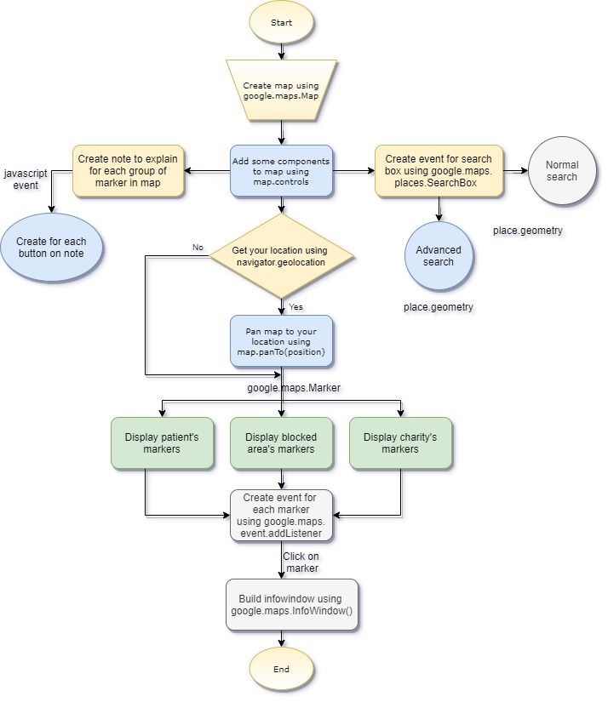

1. The overall functions on Google Map flowchart

After creating the world map from google.maps.Map and set the default center place is in Da Nang City, the function will generate the whole interface with adding the Marker’s icons, which shows Covid cases, blocked areas and charity’s points, with the usage of google.maps.Marker. Besides attaching the signs on Map, each icon will go with an information window created by google.maps.InfoWindow(). Search Box of Google is also integrated in this atlas. Exception for using place.geometry as an imported technique of Google, the search function is enhanced because users can search more places with the Advanced Searching developed by our team.

## Supporting Charity

The Supporting Charity provides the users in two categories such as finding the List of Charity, and the affected areas urgently needing supports. More specifically, charity function allows the sponsors to enter their own charity information such as food, medical equipment and finance and store them in the database of the website. As a result, the website can display the list of charity to help sponsors managing their donation easily. In addition, the manager role can enter the information of several urgent needing support places and store them. This might help the sponsors easy to find the place where need support urgently. Therefore, the hard people is identified and receive the basic daily charity support immediately. As a result, these sharing utility might leads to reduce the global poverty caused by the Covid-19 [4] in our society.

Interestingly, to let the sponsor enter their address correctly and simply, the Google Map API is called and let the sponsor clicking their donation’s address on their map visually. After that, the latitude and longitude of the entered address is automatically generated and put into the database. Next, the icons and labels of entered address is created by using the *google.maps.Marker* class. By using the infowindow.setcontent() method, the sponsor can easily view and locate the details of the urgent needing places in the form of the exactly address of street and city.

Figure 3 displays the algorithm of searching and adding a place by getting its latitude and longitude. Users can see the information of charity’s points directly on Map. Philanthropists are also able to create new supporting location from the coordinates as mentioned above.

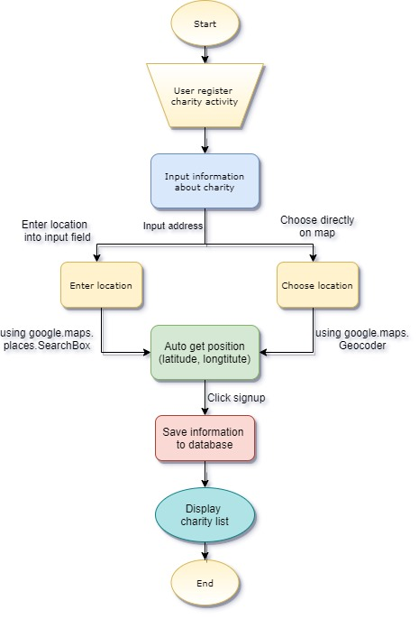

1. Functioning of Charity feature flowchart

## Analyzing Covid-19 Data pattern using R and BI

The statistical computing and graphics R language (R) and Business Intelligent (BI) are the two self-learning tools of our team. They are conducted and implemented to visually view the pattern of data such as R threat zone and BI chart.

Regarding to the R, the RStudio tools [5](Bivand, Pebesma et al. 2008) is used to analyze the raw C19P data excel files. In our website, the threat zone is defined as the geographical area which is affected by Covid-19 patients during a specified time frame. The DaNang’s map and VietNam’s are draw and coloured based the number of C19P per regions. To draw such maps, the four important libraries raster, ggplot2, viridis and readxl are imported into the process. Raster and readxl are to generate the world map and load the raw C19P data excel files. Interestingly, to draw VietNam in detail of districts, the getData("GADM", country = "Vietnam", level = 1) method is called. For Danang districts map, the command vietnam_h [vietnam_h$GID_1=='VNM.19_1'] is called and merge with data of Da Nang city by id. Finally, ggplot2 is called to plot the map completely. Importantly, to let user realize which location has the highest number of C19P, geom_polygon method is called to compare and present the map together with level of dark colour. The darker the colour is, the more dangerous that place is. The threat zone image is saved by running a script java file and is taken as the input for the website.

Figure 4 describes the process of creating the map using R programming language.

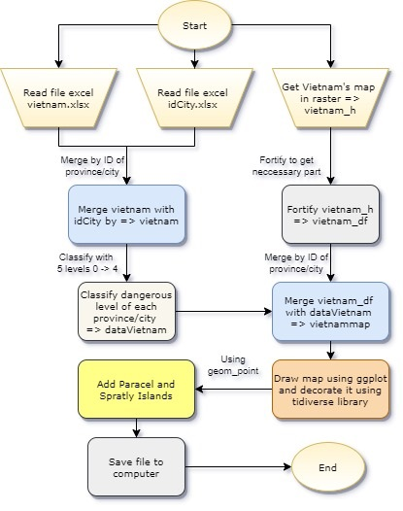

1. Generate map with R language flowchart

Briefly, *readxl* library is called to read and push the data from idCity.xlsx, vietnam.xlsx and raster’s one is responsible for get the map of Vietnam in raster graphic. Then it is merged by id of provinces/cities to get the points for shaping provinces/cities. Finally, ggplot2 prints out the map. Being parallel with draw map, data from vietnam.xlsx is also distributed to each place by idCity to display the level of color for each province.

Regarding to the BI, it is a cloud-based business analytics and data visualization service that enables anyone to visualize and analyze data with greater speed, efficiency, and understanding. BI connects users to a broad range of data through easy-to-use dashboards, interactive reports, and compelling visualizations that bring data to life. Therefore, BI draw different types of charts, different entities, such as age, name, city, etc basing on the raw data files imported. Finally, by the graph algorithm called forecasting and the C19P data, the website is able to synthesize and predict the data in the bar chart pattern.

## Searching a safe place to go

Safe places assessment is one of the most incredible functions in this website. This function is to help user finding the place to go. For example, user want to go the market, so he will receive the list of market around him with the information of Covid-19 affection within a radius of 30-100m.

Basically, Google's algorithm is used to find the nearest places by keywords (nearby places). Specifically, the Google-made tools we used here are Google Maps Places API and Places library. To be more details, the address, which is looked for by users, will be handled by *textSearch()* method imported by Places Library. The address including location and query will be considered as the center of the searching circle. Then it is time for calculating distance between user’s point and the nearest ones (Blocked Area or Patient’s House). To come out accurate figures of distance, we import one more library, it is Geometry one. Following, the position (latitude and longitude) of two places including user’s location and dangerous point will be retrieved respectively to put into the *computeDistanceBetween()*. After running the two-for loop, the position is evaluated whether it is dangerous, warning or safe according to the standard.

The standard for assessment is based on the distances. If user appears in a blockade area or the home of the patient or within 30 meters radius, it is considered Dangerous Area. Similarly, within a radius of 30-100 meters is a Warning Area and if it beyond 100 meters, it is the Safe Area. From there, users can choose suitable locations to serve their needs and avoid going to Covid-19 easily spread locations (Figure 5).

# **RESULTS**

The collected dataset was run by our applied methods and the results was shown as the output images together with the steps using the website. The session is separated into four sessions such as *Tracking Covid-19 patients, Supporting Charity, Data pattern using R and BI and Searching a safe place.*

## Tracking Covid-19 patients

Figure 6 shows the welcome interface of HTH Covid-19 tracker website. This is the default interface displayed as soon as users get access to HTH Covid-19 tracker. When using the function, the users having role as guests, can observe the visual map, which is illustrated as the four types of C19P icons

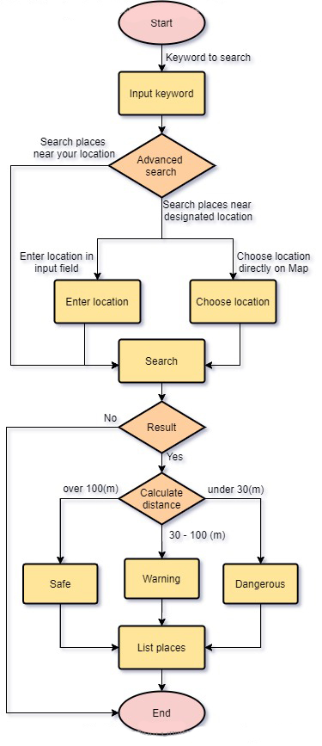

1. Safe place assessment flowchart

including “Death”, “Affection”, “Recovered” and “Blocked”. The meaning of these icons based on the status of patients who are dead, affected Corona virus, recovered after treatment or the blocked areas which including a large group of C19P. Users can see the four icons the top right of the map. Besides that, the search box of Google platform provide user experienced the advanced search functions. They can simply enter their address based on the correct Google Map API map. Furthermore, user can click on the menu on the left of the website for further tracking Covid-19 situation.

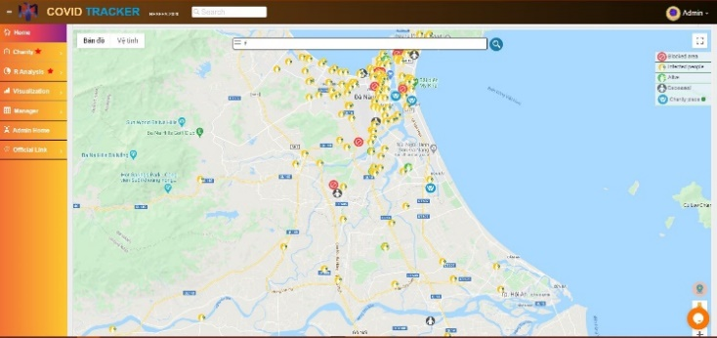

1. The welcome Interface of HTH Covid tracker website

## Supporting Charity

Accessing as a guest role, user is able to search for the charity’s place information with the keywords such as “charity” or “Từ thiện” to display the list of charity who can provide them the supporting foods. Therefore, they can find the charity organization to get the supporting goods. This function is simply designed for those who are not experts in IT; therefore, a diversity of users can use this function for their daily needing charity support.

Figure 7 displays the list of charity organizations, which can provide the users with the food, such as DH FPT; “Nhà tình thương 37”, “Mái ấm tình thương TP ĐN” together with their own addresses. As a result, the user can easily find the way to go and apply.

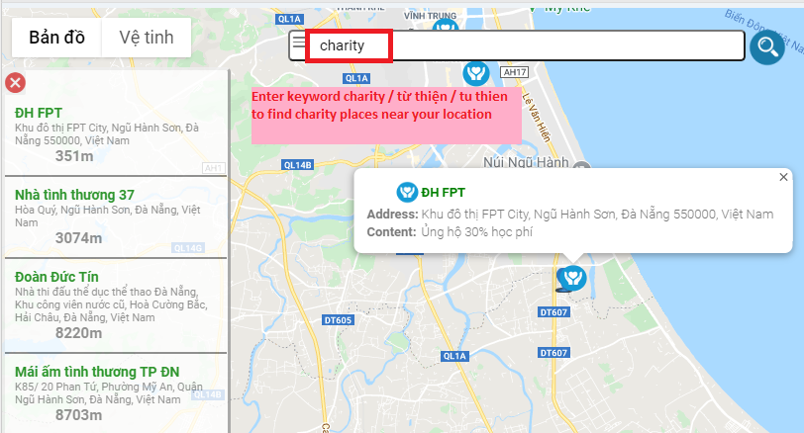

1. Charity using search box

In addition, guest role can use the button of charity’s place at the top-right corner of the Map (the right corner of Fig. 8) to display the details of their chosen charity’s place. Visually, the user can view the nearest charity’s location from their position by merely choosing the blue icon to retrieve the address information (Fig. 8).

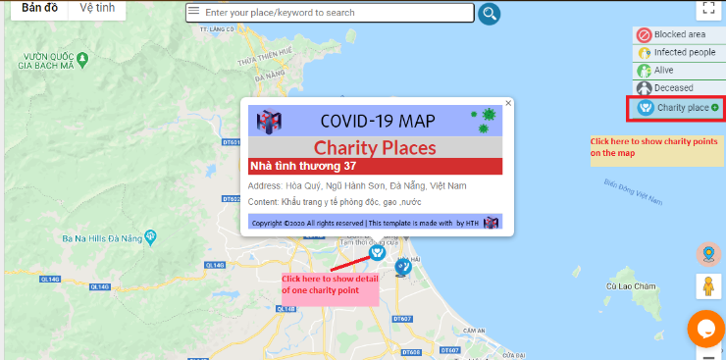

1. Charity using search box

With the same purpose of displaying the charity information, the guest role can use the List Charity tab on the left side of the website to expose more details (Fig. 9).

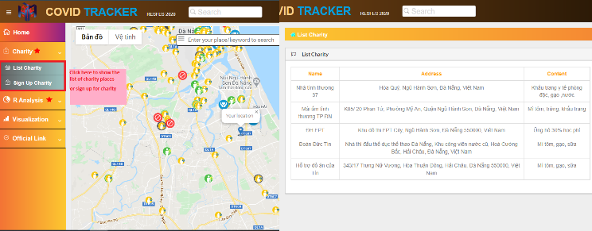

1. Charity’s navigation

Futher advanced function is for the role of sponsor who want to donate their own supporting. Simply, they must register their account which offers philanthropist feature to the system first. After the Manager approve their account (Figure 1), the information of charity sponsor are stored to the database and then the sponsor can manage their own charity support by adding their own supporting materials such as finance, food, chemical equipments. The advanced point is that the sponsor role can visually add a donating point based on the Google Map API (Fig. 10).

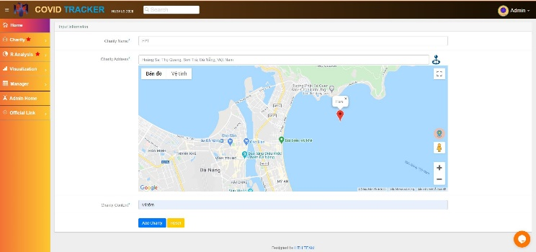

1. Philanthropist’s function

In general, the supporting charity function might create the caring environment where the hard people can find those who can help them to survive and the sponsor can find the easiest way to help others. This function is expected to ease the suffering of poverty and disease due to the affection of Covid-19 worldwilde pandemic in our society.

## Analyzing Covid-19 Data pattern using R and BI

#### The statistical computing and graphics R language

Proving the information of threat zone is one of the useful tool of the website. Threat zone is defined as the highest potentially infecting area in our study. Basing on the real raw C19P data, the R programming language was conducted and built for the threat zone tools. The guest role can view the threat zones in each district of a city. Therefore user might have a right decision to choose the safe place to go, especially for the shopping or visiting purpose.

Figure 11 show the threat zone per five districts such as Hai Chau, Hoa Vang, Cam Le, Thanh Khe and Lien Chieu of Da Nang city. The colour of the map was generated based on the number of C19P per each districts using the R. As can be seen in Fig.11, the darkest colour is present for the area of Hai Chau district with the highest number of C19P. The lightest colour is present for the Hoa Vang district with the smallest number of C19P. Indeed, the map successfully illustrated the threat zone per the districts of a Da Nang city based on our real raw data taken by 31/08/2020.

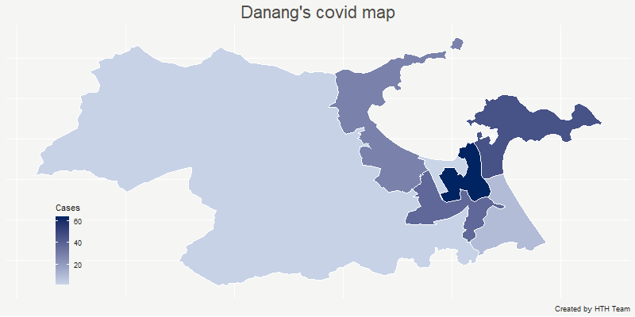

1. Da Nang city’s level of infection map by color

Figure 12 shows the threat zone based on the number of C19P in accordance with the city of Vietnam. The darkest red colour is belong to Da Nang city and Ha Noi, which shown the largest number of C19P. This map is generated using R function and the data of Vietnam Health Department by 31/08/2020.

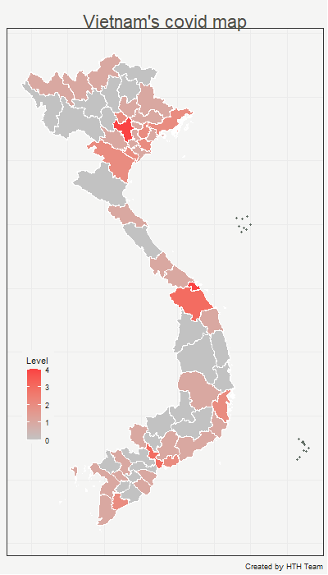

1. Vietnam’s level infection of map by color

#### BI (Business Intelligence)

Figure 13 shows the visual information such as the live column chart describing the Covid-19 situation by day using BI. Moreover, using the advanced BI algorithm, the opaque columns can predict for future cases using the current C19P data.

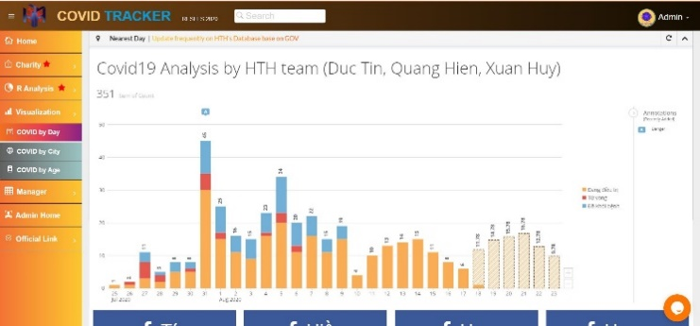

1. BI column chart with future data prediction

## Searching a safe place to go

“Searching a safe place to go” is one of the outstanding functions of the website. The key point of this feature is calculating the distance from user’s location (latitude and longitude) to the searching location closing to the Covid-19 affected location. The user can view the list of searching locations that are nearest to risky Covid-10 area, and was then reported and warned about the risky areas. Therefore, the user can know whether they are in the warning area or not and then they might make the safe place to go such as safest hospital, super market, school or the entertainment place.

The figure 14 show the codes to determines the Warning status. The latitudes and longitudes which are included in the “new google.maps.LatLng()” are the two variables to measure by using geometry.spherical.computeDistanceBetween(). The result will be checked in a three-standard if function for identify whether user is in dangerous position or not.

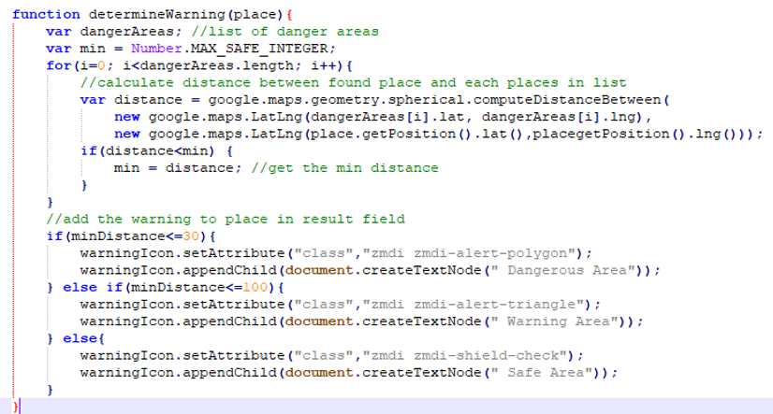

1. How we solved the risky assessment.

The first “Searching a safe place to go” function is the finding warning area. Figure 15 show the demo when the user search a particular address and this address is reported as the warning area based on our risk’s evaluation algorithm. More specific, when the user put an address in the search box, the map will display all the places being relevant to that address. After that, users can observe all the areas that are around the address based on risky distance assessment. The green icon is for safe areas, yellow icon would be the warning areas and red icons are dangerous areas.

##### E:\The Covid Tracker\images\TEMP\4.JPG

1. Figure 15: “You are in warning area!”

The second “Searching a safe place to go” function is using the icon to assess the multiple searching address. User can type a keyword in a search box by clicking on the three-line icon locating on the head of search box bar. Then particular address will be automatically generated after this action. ( Figure 16)

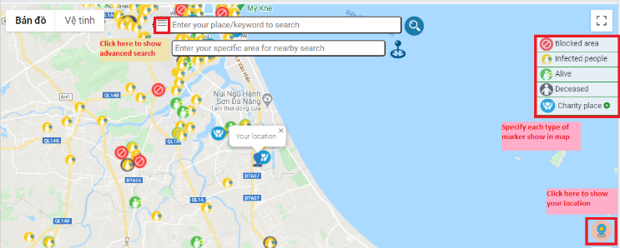

1. Choose this icon to access to advanced search feature

In figure 17, according to multiple searching using advanced method, user can view all the coffee shops near “FPT University, Đào Tấn, Khu đô thị FPT City, Hòa Hải, Ngũ Hành Sơn, Đà Nẵng” which is highlighted by red box.

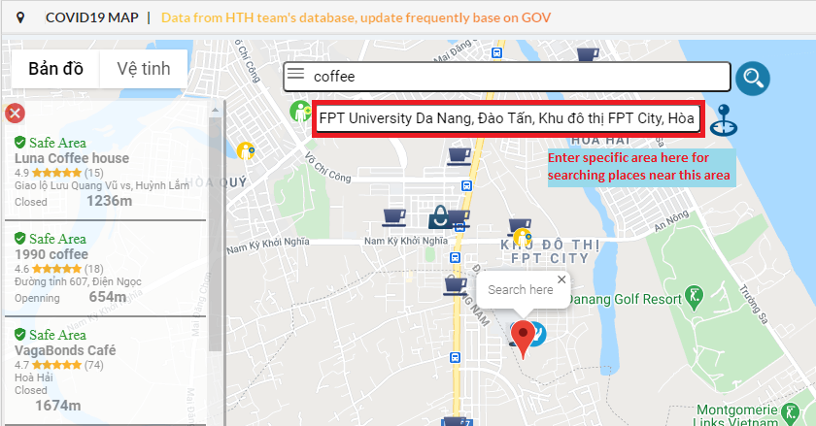

1. Input of advanced search bar

The third “Searching a safe place to go” function is for reporting to user a list of addresses and their risk assessment based on the visual icons. Moreover, searcher could also use the icon right next to advanced search box to choose an address conveniently without any typing (Fig.18).

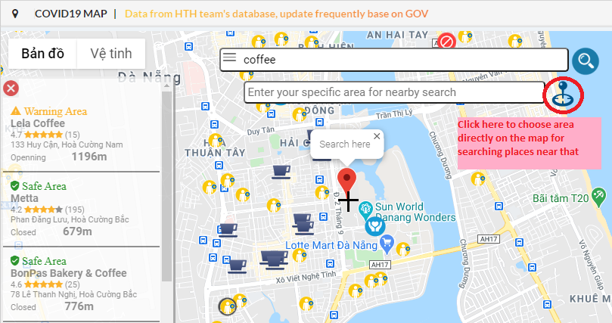

1. Figure 18: Auto address choosing without typing

Basically, the searching function was built with the multiple interfaces with the purpose of creating the easiest way to searching the risky Covid-19 area for the variety of user who experienced different IT levels. This function is contributed to reduce the risk of Covid-19 affection because the user can recognize the safe place to go.

# **DISCUSSION**

Regarding to the helpful tool of the tracking Covid-19 patients function, the location of COVID-19 infections via MAP was operated based on the real C19P data updated directly from the Danang Health Government website (MOH). This ensure the reliability, transparency and accuracy of the website. Furthermore, the function displays the C19P situations, C19P locations, and blocked area per a specific city as well as its districts; which is easy to view.

In the case of a more intense disease outbreak, more speed and details are required at the aim of analysis and display of graphically specific information for a dataset of disease. As for the request above, analyzing Covid-19 Data pattern using R and BI will be aggregate the data and lively visualize to the users. No matter how large an excel data file is, the R algorithm written by our team will help the data statistics conduct quickly and intuitively when the data is continuously updated. Images of maps are also synchronized hourly on the website. Beside R, using BI technology linked with the pandemic dataset as above, we can draw polymorphic and visual graphs, display patients’ data by regions, ages, and columns of time for cases in a color manner accurately. In addition, it is possible to predict future data based on the f (x) graph of the chart which is automatically plotted with past data.

In terms of searching a safe place to go, users can instantly search for places to visit and know whether they are at risk of infection when they get there or not. Unlike the others Covid-19 applications [6] like Bluezone which is for detection on contact only, the function of website will help people proactively avoid the dangerous places before they become at-risk people. Therefore, The Covid-19 spreading will be minimized; which is one of the urgent tasks for our society.

However, the website is presently concerned with several trials relating to data entry; the approval of community relating to sufficient number of philanthropists to access the website; the manually re-run the R algorithm to achieve the R Map images. Moreover, the danger zone data is calculated from the algorithm through the patient's location, but the patient's home location is an information that is partially protected by the government, making it difficult to update the whole set. Because of the fact that automation in updating data is limited as above, information about dangerous zones can be processed slowly and lose accuracy.

# **CONCLUSION AND FUTURE DEVELOPMENT**

In conclusion, with all the features as mentioned above, HTH Covid-19 tracker website provides a remarkable technological product to the users for avoiding and limiting the fast spread-out of Covid-19 pandemic. Beside the lively visualization of cases, this website also offers the specific information about charity’s activities so that philanthropists could connect to the needy easier and more efficiently. All are for Vietnam’s target described through the slogan: “NO ONE IS LEFT BEHIND”.

The website is built and operated successfully with the real raw Covid-19 patients data of a specific location-Da Nang city. For further extension of geographic regions, it is expected to be implemented the data of other regions and using our current frameworks.

Further development should focus on the automatically update raw C19P data through official sources to significantly increase accuracy using BI; the identification whether the C19P has moved to a place where there is a risk of infection, if so, mark the person as F1, similar to F2,…, Fn; the calculating tool which shows the exact quantity for each product that the philanthropist provides to the people; the safe Root showing us a safe path to minimize the risk of disease spread in the community. It is hoped that we will develop the; the Safe Root shortly for the next time.

##### **Acknowledgment**

The authors would like to thank for the lecturers and staffs in the FPT University Da Nang for their teaching, guiding and supporting in our learning process. The authors would also like to extend my special thanks to the organization, the judges of FPT Edu Research Festival 2020 (Resfes) who provide us a chance to learn and conduct a useful research of Covid-19 pandemic that is happening and affecting our livings and family. The authors would like to express my very great appreciation to the staffs of Danang Health Department who provides us the raw C19P data for doing the research. In addition, the author appreciate the contribution of the open source from the R code, nationalgeograhic.org and pt-edu-vn-1.domo.com. Finally, the authors wish to thank our parents for their unconditional love, support and encouragement throughout my study as well as the Resfes research.

##### **References**

1. Dincer, A. and B. Uraz (2013). Google Maps JavaScript API Cookbook, Packt Publishing Ltd. Available link: <https://rb.gy/1tvszk>

Place Autocomplete of Google Places API. Availble link: <https://developers.google.com/maps/documentation/javascript/examples/places-autocomplete>

Places Search Box of Maps Javascript API in Google Maps Platfor. Available link:

<https://developers.google.com/maps/documentation/javascript/examples/places-searchbox>

1. Boulos, M. N. K. (2005). Web GIS in practice III: creating a simple interactive map of England's strategic Health Authorities using Google Maps API, Google Earth KML, and MSN Virtual Earth Map Control, BioMed Central. Available link:

<https://ij-healthgeographics.biomedcentral.com/articles/10.1186/1476-072X-4-22>

Google Maps API Platform Guilds. Available link:

<https://developers.google.com/places/web-service/overview/>

1. Svennerberg, G. (2010). Beginning Google Maps API 3, Apress. Available link: <https://rb.gy/zdgg9t>

Geography, Geographic Information Systems (GIS). Available link:

<https://www.nationalgeographic.org/encyclopedia/map/>

1. Inspiration of charity’s ideas in a lot of types. Available link:

<https://www.cafonline.org/covid-19-support/help-charities>

1. Bivand, R. S., et al. (2008). Applied spatial data analysis with R,

Springer. Available link:

<https://link.springer.com/content/pdf/10.1007/978-1-4614-7618-4.pdf>

Tool using for implementing R environment. Available link:

<https://rstudio.com/>

1. The way functioning Bluezone application through questionnaire page. Available link: <https://bluezone.gov.vn/cac-cau-hoi-thuong-gap>