Patrick Tulabut, Johnny Thich, Jordan Llopis, Huy Pham, Francisco Avalos

CSC 131

Disclaimer: During the earlier stages of the project. The team has had difficulties with github and had to delete and restart the whole repository, so evidence of some commit numbers are not available

Deliverable Name Max Points

**Minimum Deliverable Total Points (75% credit) 150**

collection resource 14

/movies/categories/{category}/{year}



commit number: 980a433

/categories/{category}/year/{year}



commit number: 8e8571b

singleton resource 14

/{category}/year/{year}/winner



/movies/categories/{category}/{year}/type/{winner}



commit number: lost during restart

query endpoint 14

/movies/search



/search



commit number: ff000e3

base text documentation 14

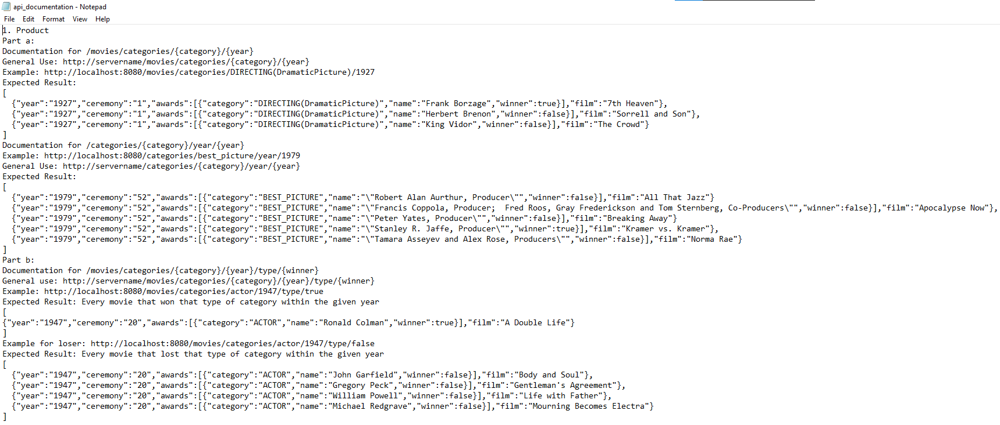

rest of documentation located in the zip file

product vision 8

|  |  |
| --- | --- |
| For | People |
| Who | Want to look up past nominated and/or award-winning Oscar movies by category. |
| Quick Search | Is a search-based application |
| That | Allows users to search past nominated and/or award-winning Oscar movies by category on the web with information from providers and critics. |
| Unlike | Other sites that do not group the movies into categories and only show information about one specific movie. |
| Our Product | Will provide a web-based search experience. |

visual persona with minimal Contextual Inquiry Notes 14

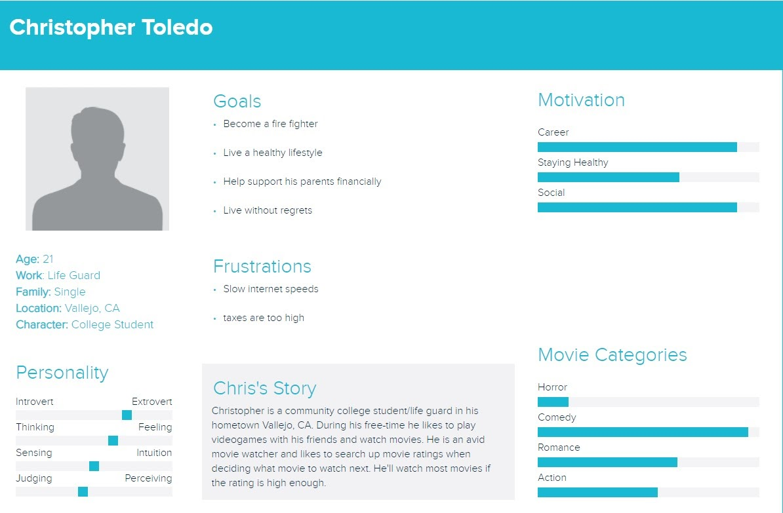

Interview Location: Vallejo, CA (interviewed online)

Interview Duration: 5 min

Q: How often do you search for movie ratings?

A: He searches up movie ratings at least 16 times a month

Q: How would you like to interact with the product?

A: He would like to interact with this product on a website and as a mobile application so he can search the movies up on his phone.

Q: What do you wish to accomplish with the search app?

A: To search for movies that are nominees / award winning to watch.

Q: What are some barriers we need to face for this product to work?

A: The product should be user friendly, have an eye pleasing design, and have the ability to add user reviews for more variety instead of just critics.

Q: What should happen if something goes wrong with the app?

A: The app should have a report button so that you can keep track of what needs to be fixed or take recommendations by the viewers.

SCM w/ongoing activity(#commits/week) 14

flying donut w/ ongoing activity 14

1 story/sprint 14

Sprint 1

Sprint 2

Sprint 3

Sprint 4

Sprint 5

unit test, 2 classes 14

<https://docs.google.com/document/d/1yw12Oseooh4io4zKoFvyAHfFS-7OvimJ68VgkwwruhA/edit>

Presentation 16

**Beyond Minimum Additions (up to > 150% credit)151**

Date Range Query 5

/searchRange

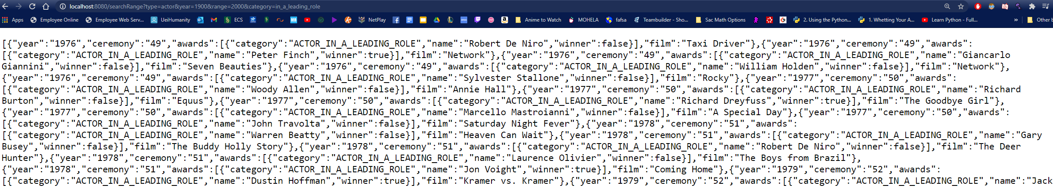

commit number: ff000e3

extra collection endpoints (up to 2 extra) 6

/winner

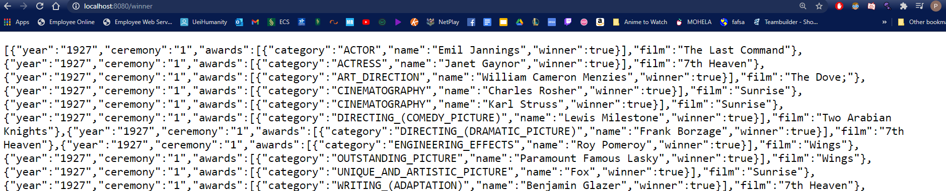

/movies/categories

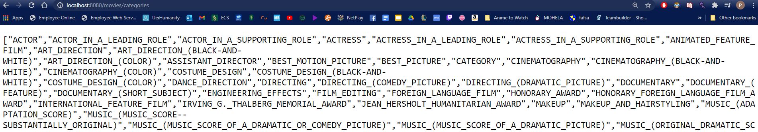

commit number: lost during restart

extra singleton endpoints (up to 2 extra) 6

> 1 search category (up to 2 extra) 6

/search2Cat

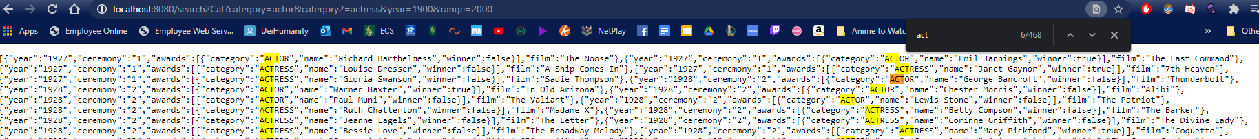

commit number: ff000e3

GUI- well designed and appealing 14

evidence: in html file in the zip folder

Clickable mockup (add) 5

made mockup not implemented in the code

evidence: by presentation

Obstacles/approaches 5

Extra Features in Product,Process,Presentation 10

**Project Credit (all categories # points not including duplicates) 301**

**100% Credit (# points) 200**

**Max % Credit (all categories not including duplicates) 150.5**