**Q1**. Find the critical points , phase portrait of the given autonomous first order differential equation . Classify each critical point as asymptotically stable, unstable or semi stable . By hand sketch the typical solution curves in the region in the x y plane determined by the graphs of the equilibrium solutions :Y’ = y ( y –1 ) ( y –3 )

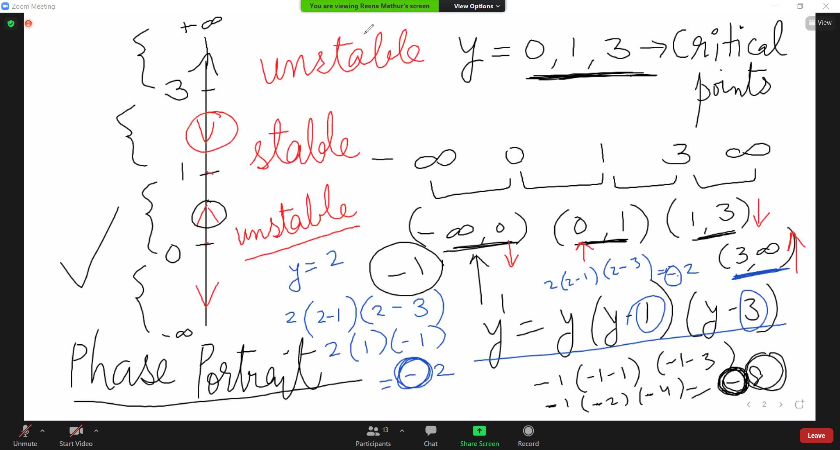

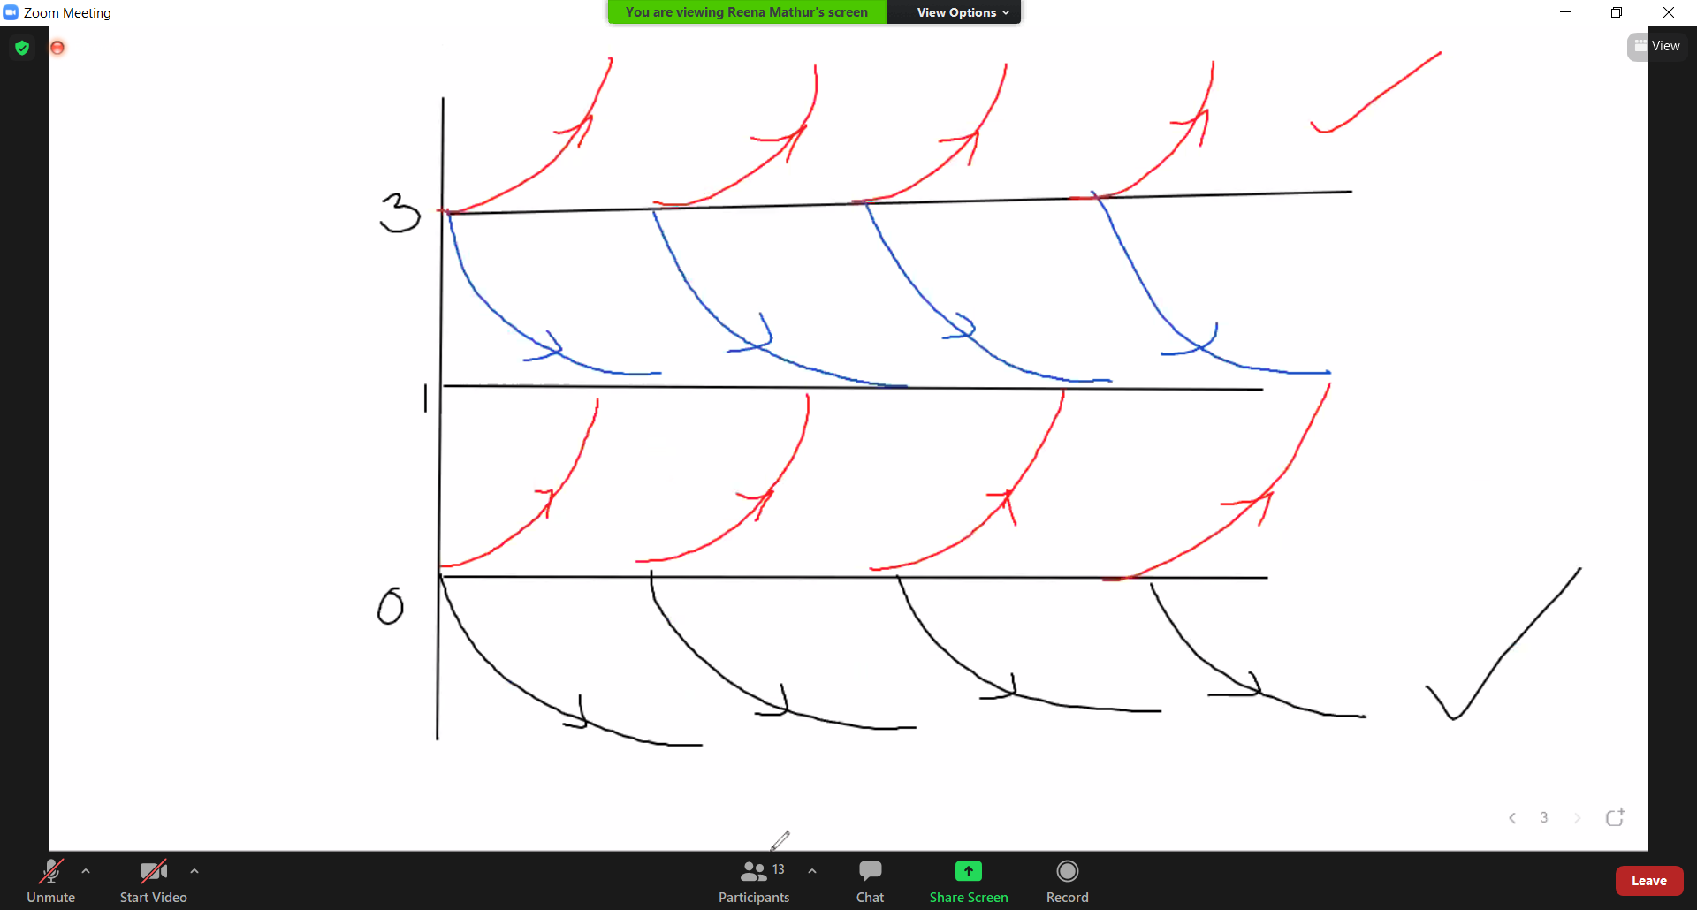

(3, inf): semi

2.

Q2. Solve the linear differential equation and find if there are any transient terms in general solution :

1. dy / dx –3y = 6

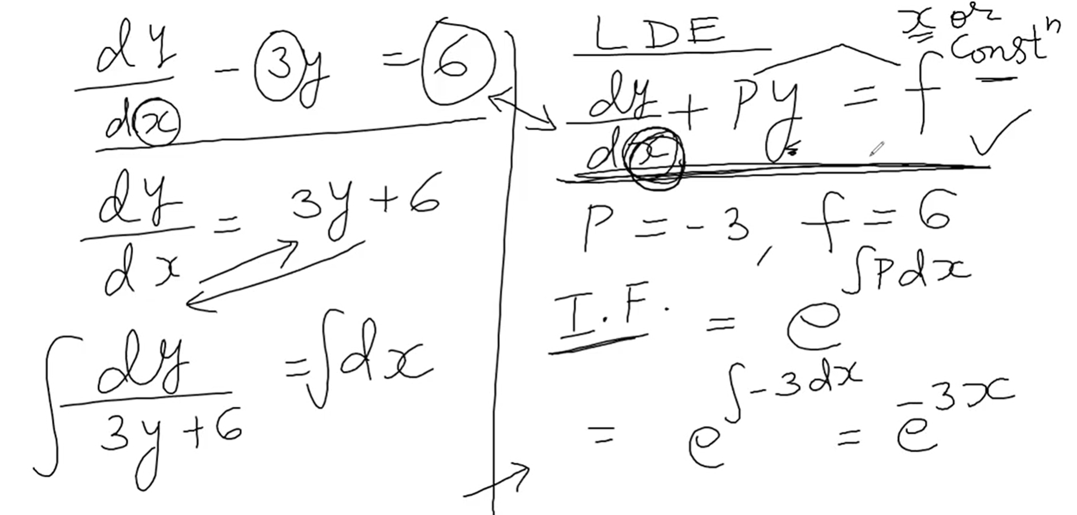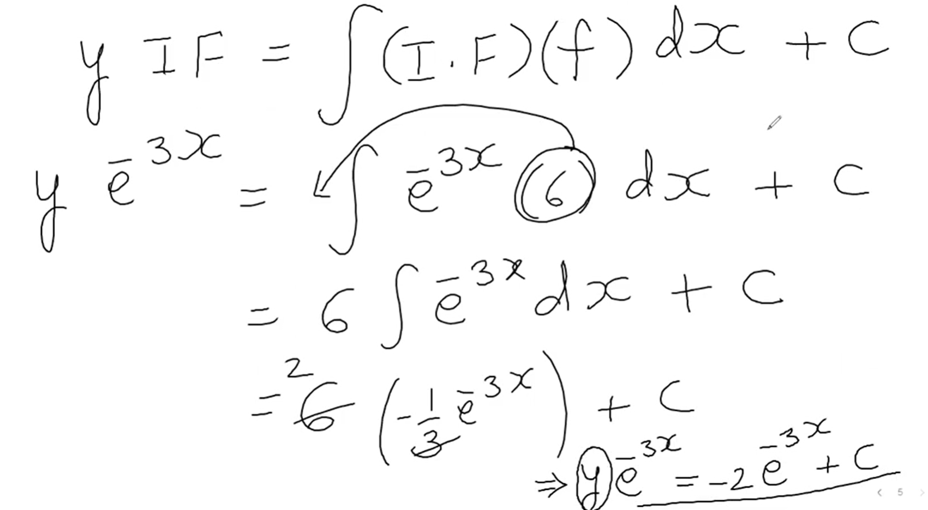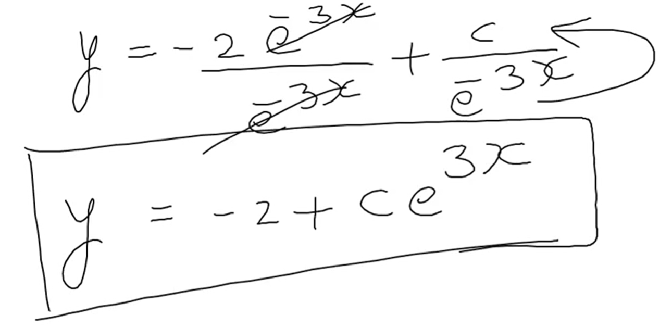

2/ Check the transient term

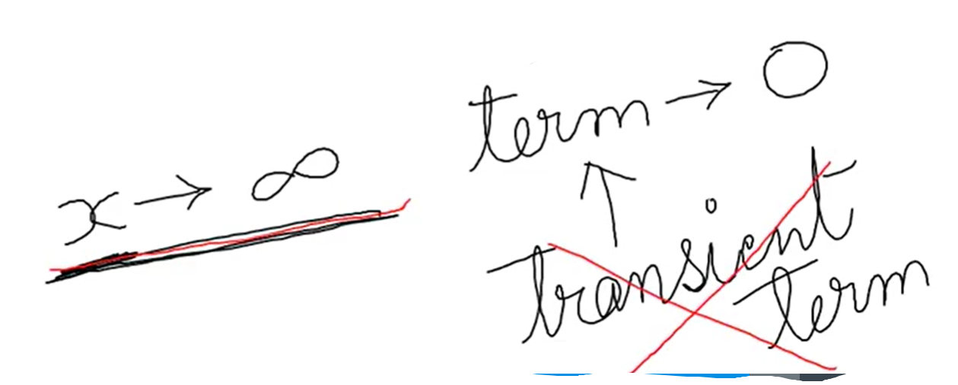

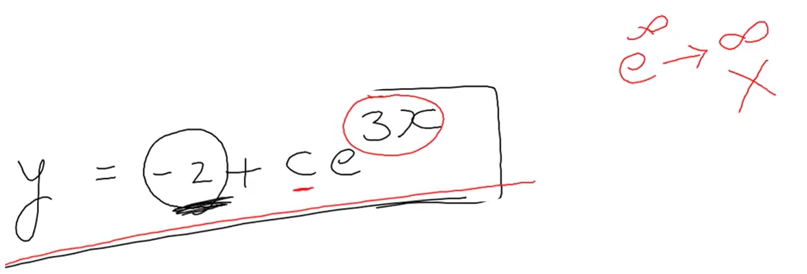=>> Not transient

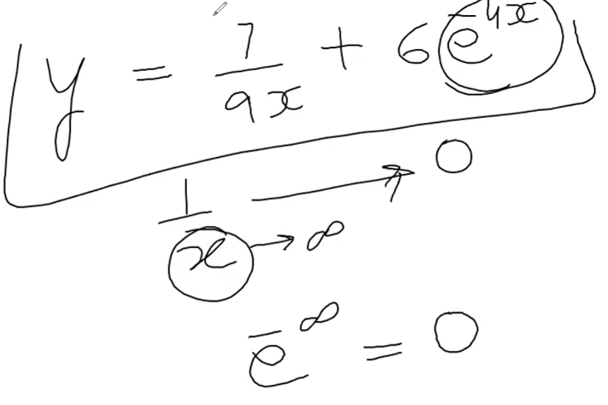

=>> transient term

**Q3**. Y = c1𝑒𝑥+ c2𝑒−𝑥 is a two parameter family of solutions of second order DE y” –y = 0 .Find the solution of the second order IVP consisting of this differential equation and the given initial conditions.

a) Y(1) = 0 , y’(1) = e Ans : y=𝑒𝑥2−𝑒2−𝑥2

b) Y(0) =0 , y’(0) =0 Ans : y = 0

1/ Plug the value of y(1) into the given function.

Derivative the function then plug the value of y’(1)

2/ Have 2 functions. Find c1 or c2

3/ Find the another c.

4/ Plug in c1, c2 into the given function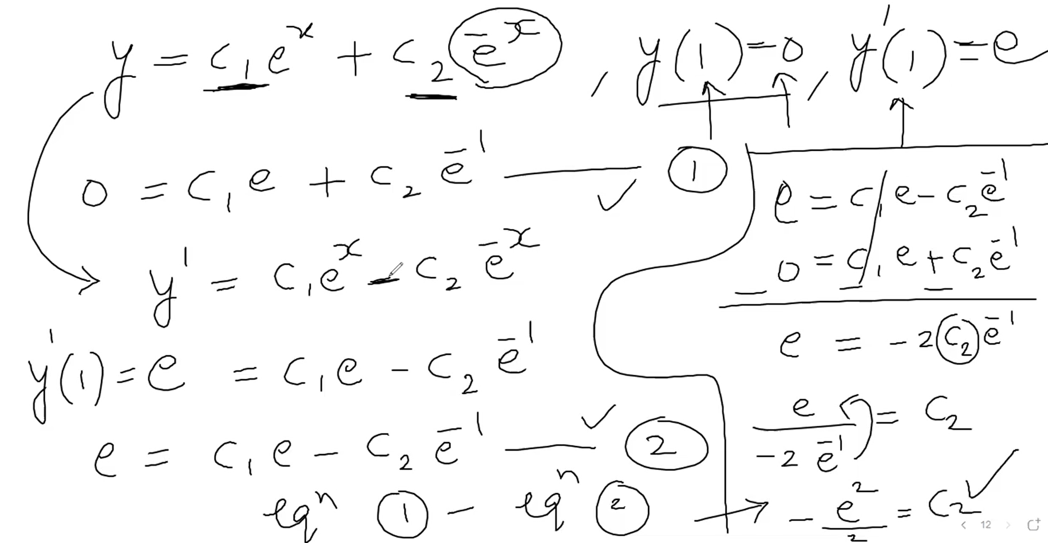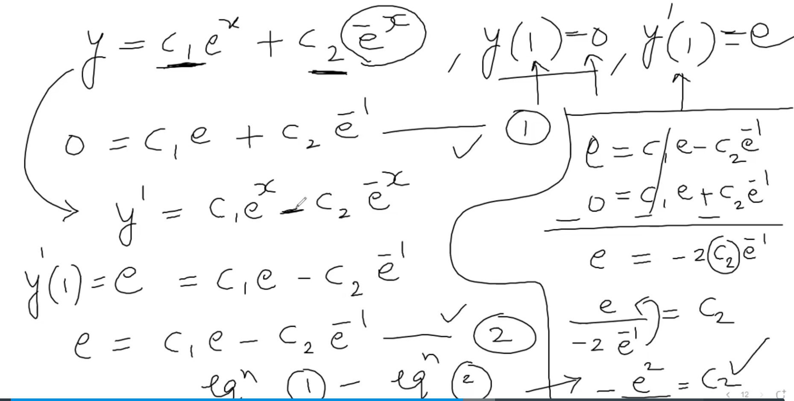

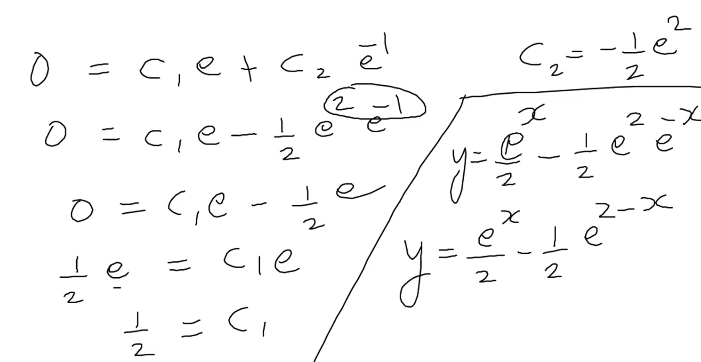

**Q4**. Solve exact differential equations :

a)( 5x + 4y ) dx + ( 4x –8 y3)dy=0 Ans : c = 5𝑥22+ 4 xy –2 y4

1/ Check exact

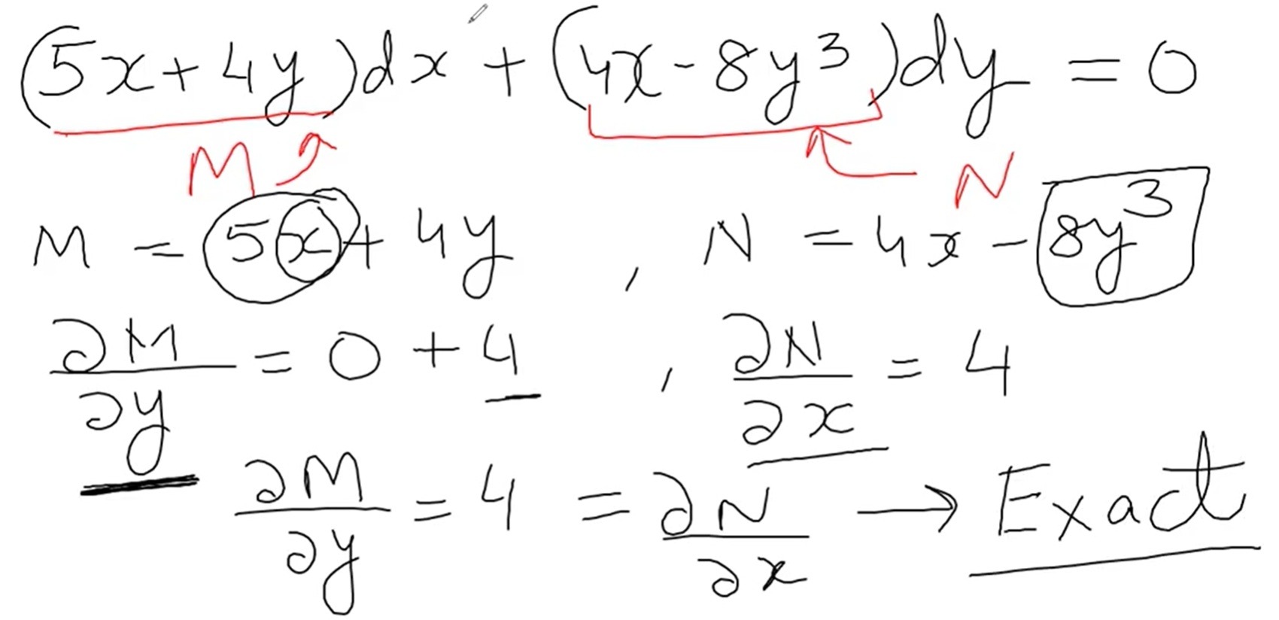

2/ Set eq.1a and 1b

