Creating a VPC with Database and EC2 Instances

# Writeup

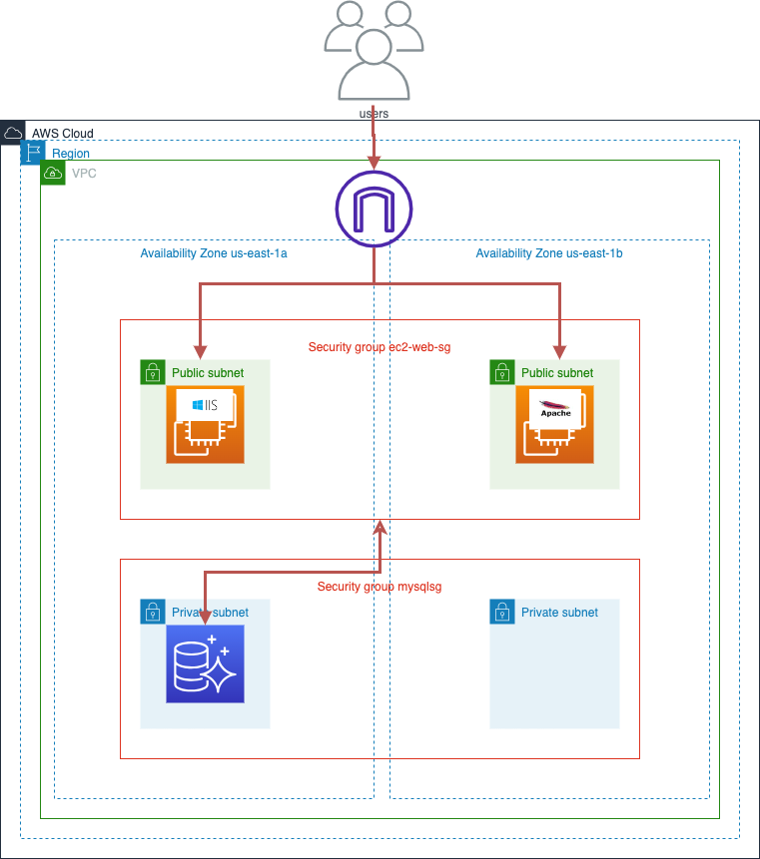

The diagram shows the architecture of the project result. The user’s requests are received by the internet gateway and forwarded to the webserver of a EC2 instance in the public subnet dependent on the IP-Address. Only the EC2 instances within the security group ec2-web-sg are allowed to communicate with the mysql database instance in the private subnet.

# Step by step instruction

## Create Virtual Private Cloud (VPC)

Go to AWS Management Console VPC->Your VPCs->Create VPC

1. Ressources: “VPC and more”
2. Enable Auto-generate: „p1“
3. IPv4 CIDR: „192.168.0.0/16“
4. VPC endpoints: Select None
5. Keep the default for the remaining specifications
6. Create VPC
7. By following these steps, I successfully created and configured my AWS VPC.

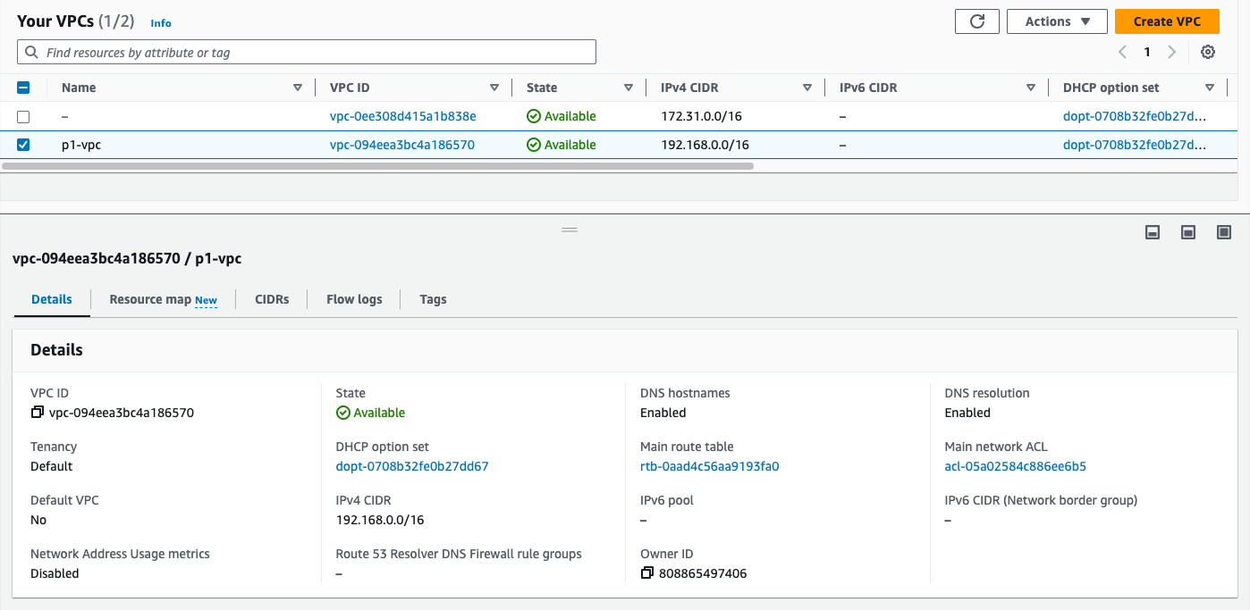

1. By following these steps, I successfully created and configured my subnets for my VPC.

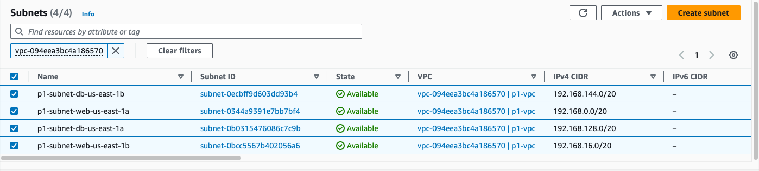

1. By following these steps, I successfully created my internet gateway and attached it to my VPC.

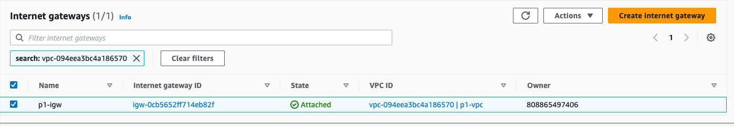

1. By following these steps, I successfully created my route tables for my VPC.

Rename public routing table to “p1-rtb-web” and add web-subnets to routing table

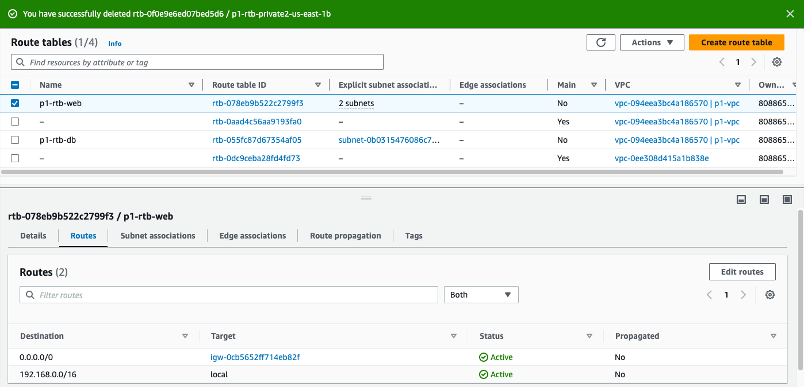

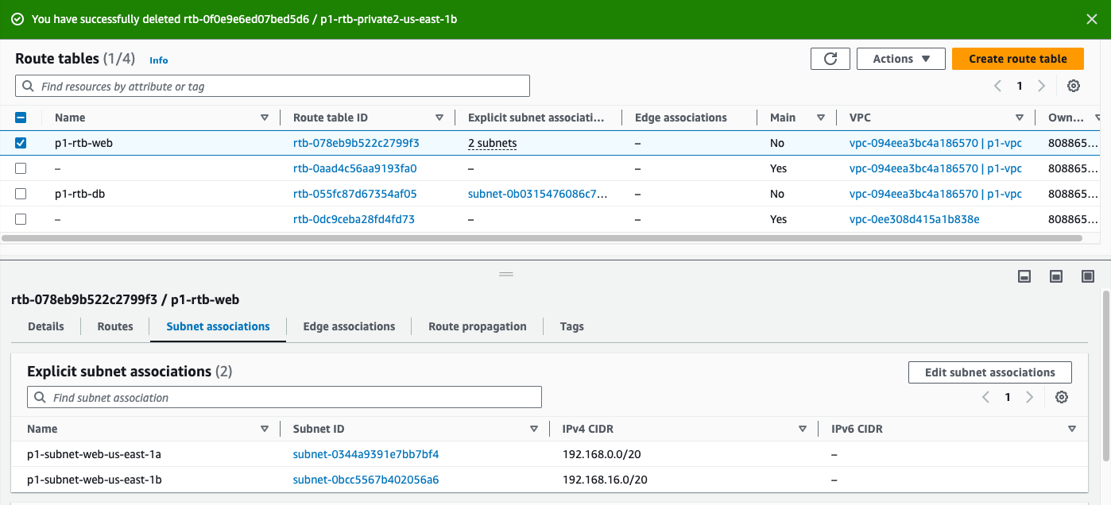

Rename private routing table to “p1-rtb-db” and add private db-subnets to routing table

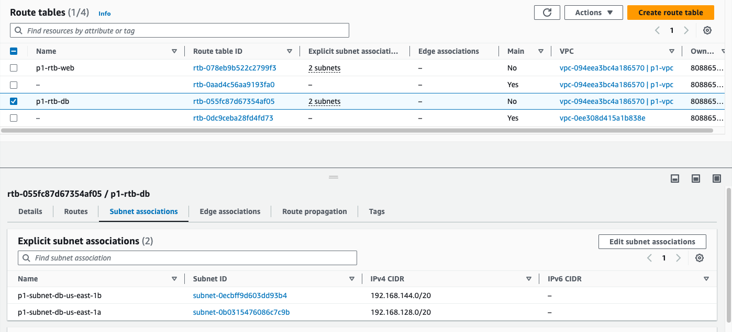

## Create database subnet group

Go to AWS Management Console RDS->Subnet groups->Create db subnet group

1. Name: “p1-subnet-group-db”
2. VPC: p1-vpc
3. Availability Zone: Select the zones from the private db-subnets
4. Subnets: Select the private db-subnets
5. Create

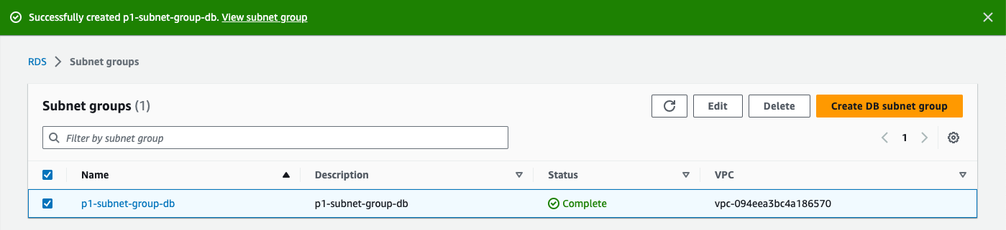

## Create relational database

Go to AWS Management Console RDS->Create database

1. Select Standard create
2. Engine options: Select MySQL
3. Engine Version: Select newest Version MySQL 8.0.34
4. Templates: Dev/Test with Multi-AZ DB instance
5. DB instance identifier: “mysql1”
6. Type Master Password/Confirm master password
7. DB instance classe: Select Burstable classes: db.t3.micro
8. Storage type: Select General Puropose SSD (gp2)
9. Allocated storage: 20
10. Maximum storage threshold: 50
11. Connectivity. Compute resource: Select Don’t connect to an EC2 compute ressource
12. VPC: Select p1-vpc
13. VPC security group: Create new with security group name: “mysqlsg”
14. Public Access: No
15. Database authentication options: Password and IAM authentication
16. Disable Monitoring
17. Create database

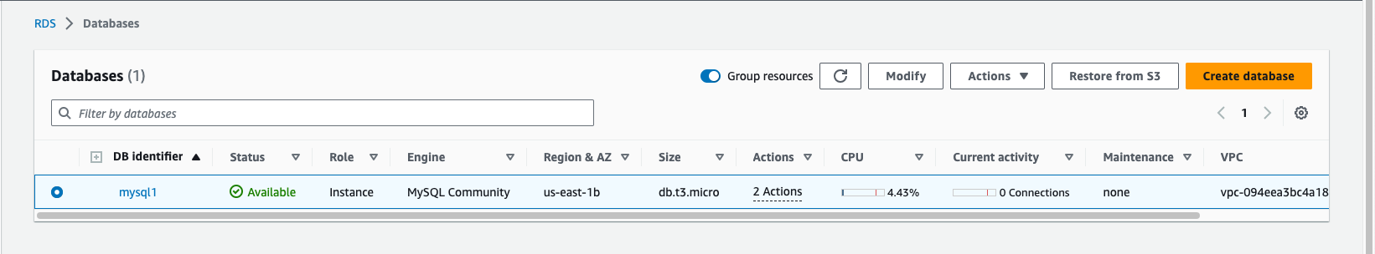

## Create and launch the EC2-Windows instance

Go to AWS Management Console EC2->Instances->Launch an instance

1. Name: “ec2-web”
2. Application and OS Images: Select Windows
3. Instance type: Select t2.micro
4. Key pair(login) : Create new key pair
   1. Key pair name: “windows1”
   2. Create key pair
5. Edit Network settings.
   1. VPC: Select “p1-vpc”
   2. Subnet: Select one of the web-subnet
6. Enable Auto-assign public IP
7. Security group name: “ec2-web-sg”
8. Firewall->Add security group rule: Type=Http, Souryetype=Anywhere
9. UserData: Add commands:

<powershell>

Install-WindowsFeature -name Web-Server -IncludeManagementTools

New-Item -Path C:\inetpub\wwwroot\index.html -ItemType File -Value “Hello World Page” -Force

</powershell>

1. Launch instance
2. Keep the default for the remaining specifications
3. By following these steps, I successfully launch my new EC2 instance within my VPC.

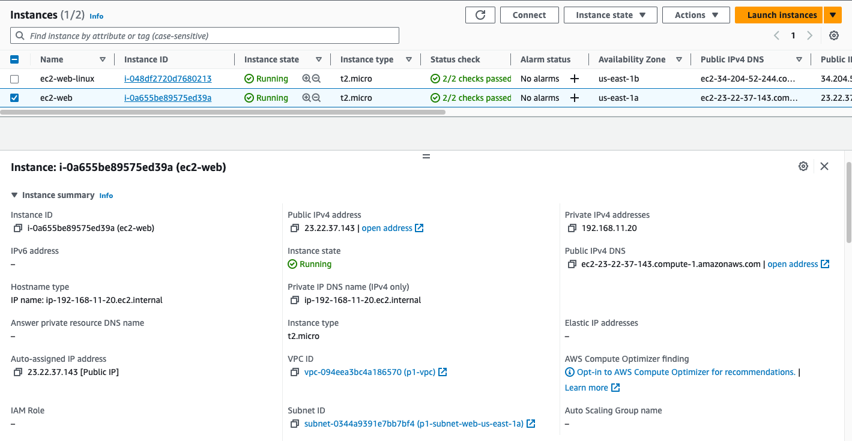

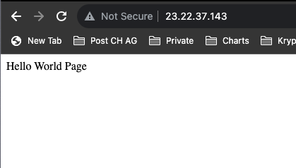

## Create and launch the EC2-Linux instance

Go to AWS Management Console EC2->Instances->Launch an instance

1. Name: “ec2-web-linux”
2. Application and OS Images: Select Amazon Linux
3. Instance type: Select t2.micro
4. Key pair(login) : Create new key pair
   1. Key pair name: “linux1”
   2. Create key pair
5. Edit Network settings.
   1. VPC: Select “p1-vpc”
   2. Subnet: Select one of the web-subnet
6. Firewall->Select existing security group rule: “ec2-web-sg”
7. Launch instance
8. Keep the default for the remaining specifications

By following these steps, I successfully launch my new EC2 instance within my VPC.

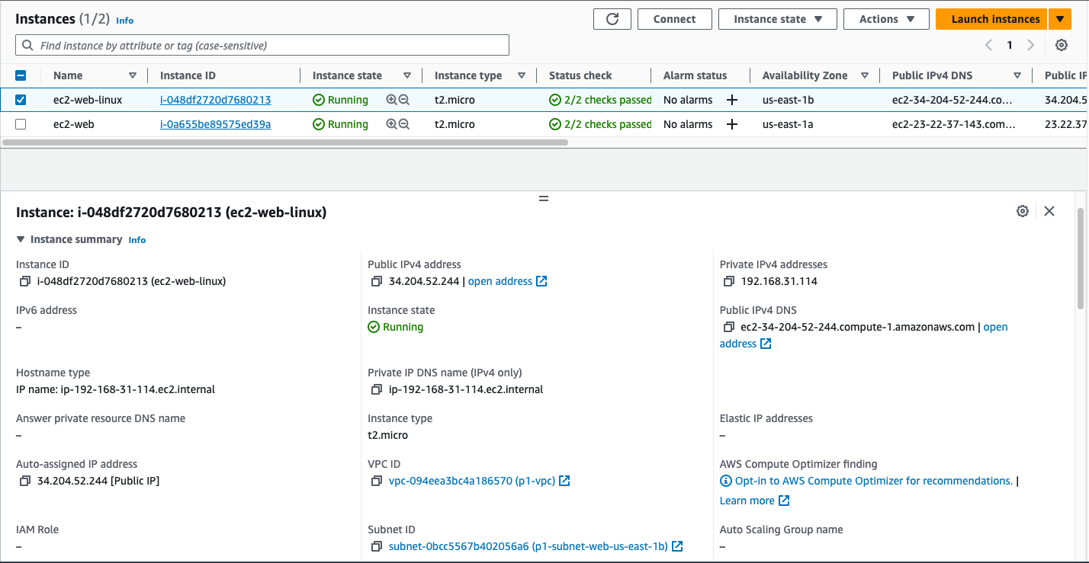

## Extend inbound rule of security group “ec2-web-sg” to enable ssh

Go to AWS Management Console EC2->Security groups->”ec2-web-sg->Edit inbound rules

1. Add rule: Type=SSH, Source=Custom:0.0.0.0/0
2. Save rules

## Install Apache Web-Server on EC2-Linux instance

Go to AWS Management Console EC2->Instances->EC2-Linux instance->Connect to instance

Select EC2 Instance Connect

1. sudo su
2. yum install httpd -y
3. service httpd status (optional:check status)
4. service httpd start

## 

## Extend inbound rule of db security group “mysqlsg” to enable access from ec2-web-sg

Go to AWS Management Console EC2->Security groups->”mysqlsg”->Edit inbound rules

1. Add rule: Type=All traffic, Source=Custom: “ex2-weg-sg”
2. Add rule: Type=All traffic, Source=Custom: “mysqlsg”
3. Save rules

