**TABLE OF FIGURES**

Figure 1: Entity Relationship Diagram for eTutoring system 9

Figure 2: First SPRINT Burndown Chart 12

Figure 3:Second SPRINT Burndown Chart 14

Figure 4: Third SPRINT Burndown Chart 17

Figure 5: Use case Diagram for Staff 18

Figure 6:Use case Diagram for Student 18

Figure 7: Use case Diagram for Tutor 19

Figure 8: Wireframe for the Login page 19

Figure 9: Wireframe for the Blog page 20

Figure 10: Wireframe for Blog detail 20

Figure 11: Wireframe for the Create Blog page 21

Figure 12: Wireframe for the Chat page 21

Figure 13: Wireframe for the Student’s Dashboard page 22

Figure 14: Wireframe for the Tutor’s Dashboard page 22

Figure 15: Wireframe for the Allocate page 23

Figure 16: Wireframe for Staff view Student’s Dashboard page 23

Figure 17: Wireframe for Staff view Student’s Dashboard page 24

Figure 18: Wireframe for Staff’s report page (Statistic report) 24

Figure 19: Wireframe for Staff’s report (Exception report) 25

Figure 20:Login page 25

Figure 21: Student’s blog page 26

Figure 22: Student’s Blog detail page 27

Figure 23: Student’s comment view 27

Figure 24:Student’s Create blog page 28

Figure 25: Student’s Chat page 28

Figure 26: Student’s Dashboard page 29

Figure 27:Tutor’s Blog page 29

Figure 28: Tutor’s Blog detail page 30

Figure 29:Tutor’s Comment view 30

Figure 30:Tutor’s Create blog page 31

Figure 31:Tutor’s Chat page 31

Figure 32:Tutor’s View student list page 32

Figure 33: Tutor’s Dashboard page 32

Figure 34: Staff's Allocate page 33

Figure 35:Staff’s report page (Statistic report) 34

Figure 36:Staff’s report page (Exception report) 35

Figure 37: Staff’s view Student’s dashboard page 35

Figure 38: Staff’s view Tutor’s dashboard page 36

Figure 39: Login test result 37

Figure 40: Creating new Blog result 38

Figure 41: Comments result 39

Figure 42: Chat result 39

Figure 43: Tutor Dashboard result 40

Figure 44: Reallocate result 41

Figure 45: View Students Dashboard result 42

Table 1: Members and their roles in team 4

Table 2: Objectives and description 6

Table 3: Product backlog for eTutoring 8

Table 4: Desctiption of the relationship 10

Table 5: First SPRINT backlog 11

Table 6: First SPRINT Retrospective 12

Table 7: Second SPRINT backlog 14

Table 8: Second SPRINT Retrospective 15

Table 9: Third SPRINT Backlog 16

Table 10: Third SPRINT Retrospective 17

Table 11: Test Plan 37

Table 12: Login Test case 37

Table 13: Creating new blog Test Case 38

Table 14: Comment Test Case 38

Table 15: Chat test case 39

Table 16: Test case for Tutor Dashboard 40

Table 17: Test case for Reallocate function 40

Table 18: Test case for View Students Dashboard function 41

Table 19: Test Log 43

1. **Introduction**

During the Enterprise Web Software Development course, we will form a team of up to six members to do research and work together with the overall goal of completing the Coursework group of this subject. This Coursework group requires that we will build together a web-based secure role-based system for eTutoring in a large university. For members who will play the roles of the database designer, programmer, web designer, and tester, but these roles will not be fixed, members will take turns to participate in other roles so that they can experience and learn. more knowledge. Together, we will learn how to effectively apply Agile Scrum throughout the project.

1. **Project planning and analysis**
   1. **The role of each member**

|  |  |  |
| --- | --- | --- |
|  | **Name** | **Role** |
| Team members | Nguyen Minh Tam | Designer, tester |
| Vu Tran Trung Hieu | Front-end developer, Designer |
| Tran Ngoc Huy | Back-end developer, Scrum master |
| Le Tien Dung | Database design, Back-end developer, designer |
| Le Tien Dung | Tester, designer |

Table 1: Members and their roles in team

* 1. **Tools and Technologies**

During this project, the team agreed to use the C # language along with ASP.NET MVC technology for web development that provided by Microsoft. Also, database storage will be performed by Microsoft SQL Server. Below is a list of the tools the group will use:

* Visual Studio 2019 for coding the system.
* Microsoft SQL Server 2007 for storing data.
* Microsoft Office word for writing report.
* Microsoft Office Excel for summarizing and creating chart.
* Skype and Messenger for meeting online.
  1. **Project objectives**

|  |  |
| --- | --- |
| **Objectives** | **description** |
| All student must have a personal tutor | Each student will have a personal tutor to manage their study |
| Any authorized member of staff can allocate or reallocate personal tutors to students. | Personal tutor for students can be allocated or reallocated by an authorized member of staff |
| The student and the personal tutors will get notification emails when allocate or reallocate happens | The system will notify students and the personal tutors when the allocate or reallocate happen |
| Bulk allocation of students to their personal tutor (e.g. 10 at a time) needs to be implemented. | Member of staff can Bulk allocation of students (e.g. 10 at a time) to the personal tutor |
| All students and their tutors are to use the eTutoring system for messaging, arranging, and recording meetings (both real and virtual), uploading documents and commenting on them, and for blogging. | All students and personal tutors can use eTutoring system to messaging, arranging, and recording meeting (both real and virtual), the system also allows to upload documents and commenting on them and for blogging. |
| Email between students and their personal tutors is to be used only for notification of events recorded in the backend database. No other content is to be sent via email. | No content other than events stored in the database will be notified via emails to students and personal tutors |
| Student and staff data are accessed from the university MIS system. The maintenance of this is outside the scope of this project. | The maintenance of Student and staff data is outside the scope of this project. |
| Each student will have their own personal dashboard summarizing their interaction with their personal tutor. | The interaction between students and their personal tutors will be summarized through each student's personal dashboard. |
| Each personal tutor will have a dashboard of their personal tutees that can be sorted and filtered appropriately | Each personal tutor will have a personal dashboard for their students, which makes it easy to sort and filter. |
| Authorized staff will have access to the dashboards of other staff, and to individual dashboards for students. | Authorized staff can access personal tutor dashboards and student’s personal dashboards. |
| The interface must be suitable for all devices (e.g. mobile phones, tablets, desktops) | The website must be a responsive website. |

Table 2: Objectives and description

* 1. **User stories List**
* As a user, I want to be able to login the website.
* As a tutor, I want to see all the necessary information of students who are taught by me.
* As a staff, I want to allocate or reallocate personal tutors to students.
* As a student (or personal tutor), I want to be notified via email when allocating or reallocating happens
* As a staff, I want to allocate a huge number of students (10 students at the time) to the personal tutor.
* As a student (or personal tutor), I want to use this system to write blogs, send messages for each other, arrange as well as recording meetings, upload documents and comment on them.
* As a Student (or personal Tutor), I want eTutoring system to send to me the automatic email to notify about special events.
* As a Student, I want to have a personal dashboard that summarize my interaction with my personal tutor.
* As a tutor, I want a dashboard that can be sorted and filtered appropriately.
* As a staff, I want to have access to the dashboard of other staff, and to individual dashboards for students.
* As a staff, I want to have some statistic reports and exception reports.
* As a user, I want the website to be compatible with all mobile devices, computers.
  1. **Product backlog**

|  |  |  |  |
| --- | --- | --- | --- |
| **ID** | **Requirements** | **Detail** | **Priority** |
| 1 | Allow Login to eTutoring website | Staff, student, personal tutor can log in their account. | Must have |
| 2 | Allow personal tutors to see student’s information | Personal tutors can see the information of students who are responsible by them | Must have |
| 3 | Allocate or reallocate personal tutors to students | Staff can assign or reassign personal tutors to students | Must have |
| 4 | Allow write blogs, send messages for each other, arrange as well as recording meetings, upload documents and comment on them | eTutoring system allows messaging, arranging, and recording meetings (both real and virtual), uploading documents and commenting on them, and for blogging | Must have |
| 5 | Allow access data from the university MIS system. The maintenance of this is outside the scope of this project. | The data of students and personal tutors cannot be impacted. | Must have |
| 6 | Receive notification via email when allocate and reallocate happen | Email notification to students and personal tutors when allocating or reallocating happens. | Should have |
| 7 | Allow Allocate a huge number of students | Allocate bulk of student at the time for personal tutors | Should have |
| 8 | Receive notify email on special events | Sending to each student and personal tutors the automatic email to notify about specified events or schedules | Should have |
| 9 | Dashboard showing the interaction between student and their tutor | Student personal dashboard to summarize their interaction with their personal tutor | Should have |
| 10 | Allow sort and filter on personal tutor dashboard | The personal tutor’s dashboard can sort and filter appropriately. | Should have |
| 11 | Allow access to other staff and students dashboard | Authorize the access to the dashboards of other staff, and to individual dashboards for students. | Should have |
| 12 | want the website to be compatible with all devices | The website must responsive to all devices. | Could have |

Table 3: Product backlog for eTutoring

1. **Design** 
   1. **ERD Design and Relationships**

To better understand the system, we will use the Entity Relationship Diagram (ERD). This diagram will help visualize the overview, what objects the system has. Therefore, we can analyse the scope of objects and make sure the relationships in the database are accurate. The ERD design helps the team ensure better system analysis and better debug database.

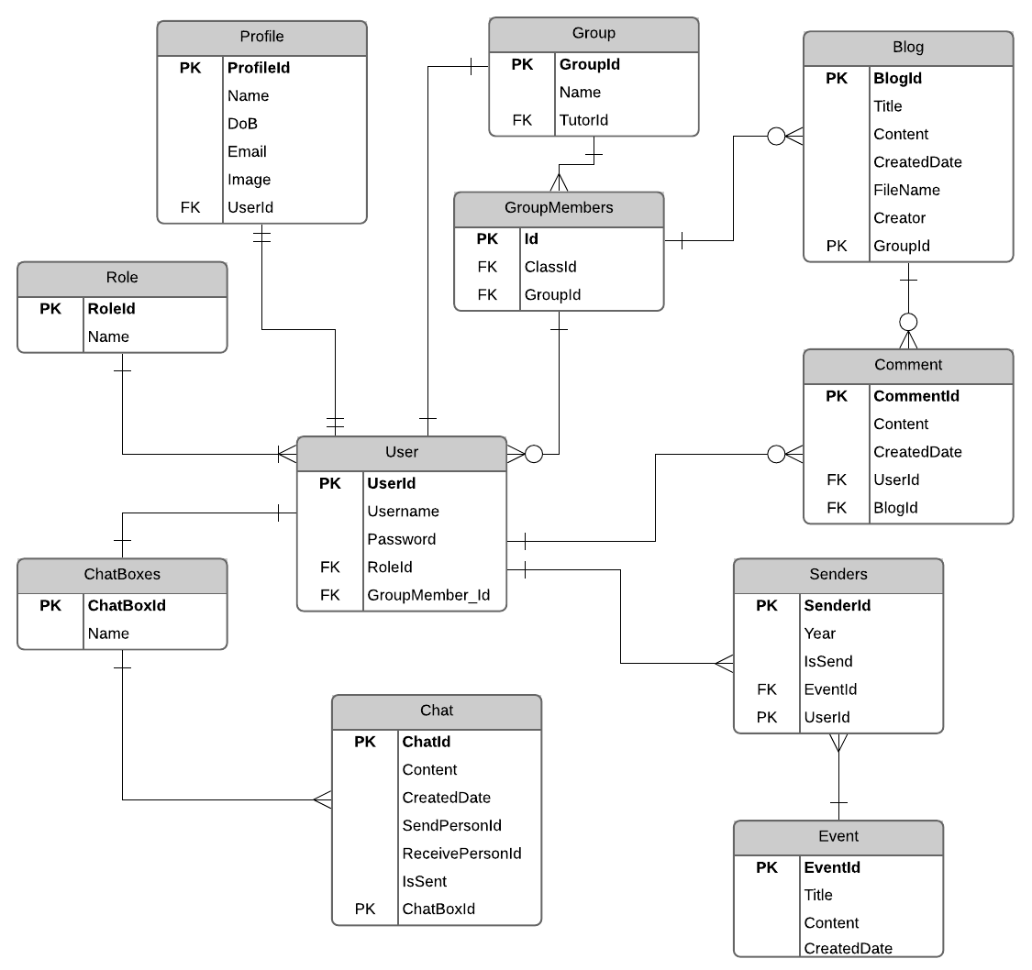

Figure 1: Entity Relationship Diagram for eTutoring system

|  |  |  |
| --- | --- | --- |
| Table | Relationship | Description |
| Role | 1-many | Each User belongs to a role.  A role can have many users. |
| User | Many-1 | A User has role is student belongs to a Class Member.  Each Group Member can have many User have role student. |
| 1 - zero or many | A User can have zero or many Blogs.  Each blog belongs to a User. |
| 1 – zero or many | An Account can have zero or many Comments.  Each comment belongs to an Account. |
| Chat Box | Zero or many-1 | An Account can have zero or many Chat Box.  Each Chat Box belongs to an Account. |
| Chat | Zero or many - 1 | A Chat Box can have zero or many Chat. Each Chat belongs to a Chat Box. |
| Group | 1-1 | A Group can only have a User has role is Tutor.  Each User has role is Tutor can only belong to a group. |
| Group Members | 1-many | A Group can have one or many Group Members.  Each member belongs to a group. |
| Profile | 1 - 1 | An Account only belongs to a profile.  A profile is also only belonged to an account. |
| Blog | 1-zero or many | A Blog can have zero or many Comments.  Each comment is belonged to a Blog |
| Comment | Zero or many - 1 | An account can have zero or many comments.  Each comment belongs to an account. |
| Senders | Many-1  1 - many | This is the middle table between User and Event. |
| Event | 1-many | A user can have many events.  An event can belong to many User. |

Table 4: Description of the relationship

1. **Planning**
   1. **First SPRINT**
      1. **Meeting minute**

In the first SPRINT, we have two meeting minutes. The first meeting was held online from 2:00 PM – 5:00 PM (02/03/2020) and the second meeting was held online from 2:00 PM – 5:00 PM (09/03/2020) . The Agenda was:

* Define role for all members.
* Discussion on the group project.
* Analysis the requirements that project require
* Discuss on ERD design.
* Discuss on the Login page UI.
* Test the Login function.
* Test the Login function
* Planning for second SPRINT.
  + 1. **First SPRINT backlog**

|  |  |  |  |  |  |  |  |  |
| --- | --- | --- | --- | --- | --- | --- | --- | --- |
| User Stories | Tasks | Implementer | Estimate hours | Day 1 | Day 2 | Day 3 | Day 4 | Day 5 |
| As a user, I want to be able to login website. | Design Login Wireframe | N.M.Tam | 2 | 2 | 0 | 0 | 0 | 0 |
| Design Login Interface | V.T.T.Hieu | 5 | 3 | 2 | 0 | 0 | 0 |
| Design ERD | L.T.Dung | 5 | 3 | 0 | 2 | 0 | 0 |
| Code Database Model | L.T.Dung | 4 | 0 | 0 | 2 | 2 | 0 |
| Code Login function | T.N.Huy | 4 | 0 | 0 | 2 | 2 | 0 |
| Test Login Function | L.Tan.Nguyen | 1 | 0 | 0 | 0 | 0 | 1 |
|  | | | | | | | | |
| As a tutor, I want to see all the necessary information of students who are taught by me. | Design Tutor manage page wireframe | N.M.Tam | 2 | 2 | 0 | 0 | 0 | 0 |
| Design Tutor manage page interface | V.T.T.Hieu | 3 | 3 | 0 | 0 | 0 | 0 |
| Design Function to list student’s information | T.N.Huy | 4 | 2 | 2 | 0 | 0 | 0 |
|  | | | | | | | | |
| As a staff, I want to allocate or reallocate personal tutors to students. | Design Allocate page wireframe | N.M.Tam | 2 | 1 | 1 | 0 | 0 | 0 |
| Design Allocate page Interface | V.T.T.Hieu | 4 | 0 | 2 | 2 | 0 | 0 |
| Code Allocate function | T.N.Huy | 8 | 2 | 3 | 1 | 2 | 0 |
| Test Allocate function | L.T.Nguyen | 1 | 0 | 0 |  | 1 | 0 |
|  |  | **Total** | 45 | 18 | 10 | 9 | 7 | 1 |

Table 5: First SPRINT backlog

* + 1. **Burndown chart**

Figure 2: First SPRINT Burndown Chart

* + 1. **SPRINT goals**
* As a user, I want to be able to login website.
* As a tutor, I want to see all the necessary information of students who are taught by me
* As a staff, I want to allocate or reallocate personal tutors to students.
  + 1. **Retrospective**

|  |  |
| --- | --- |
| **Tasks did well** | **Tasks need improvement** |
| The wireframe design of sprint 1 is on time | Wireframe design is quite simple and not eye-catching |
| User interface design is exactly like wireframe | Complex ERD design and inaccurate relationships |
| Login function can save the information of the current user | Login function completed slower than planned |
| You must use the Login function to gain access to the system |  |
| ERD design is on time |  |
| The allocate and reallocate functions complete correctly at the scheduled time. |  |

Table 6: First SPRINT Retrospective

* 1. **Second SPRINT**
     1. **Meeting minute**

In the second SPRINT, we have one meeting minute. The meeting was held online from 2:00 PM – 5:00 PM (16/03/2020). The Agenda was:

* Testing the uploading and blogging
* Use partial view for the Comment function
* Review the previous database
* The Chat UI is not fix to the current system UI
* Update Allocate and reallocate
  + 1. **SPRINT backlog**

|  |  |  |  |  |  |  |  |  |
| --- | --- | --- | --- | --- | --- | --- | --- | --- |
| User Stories | Tasks | Implementer | Estimate hours | Day 1 | Day 2 | Day 3 | Day 4 | Day 5 |
| As a student (or personal tutor), I want to be notified via email when allocating or reallocating happens | Code email sending function | T.N.Huy | 8 | 2 | 2 | 2 | 2 | 0 |
| Test email sending function | L.T.Nguen | 1 | 0 | 0 | 0 | 1 | 0 |
| As a staff, I want to allocate a huge number of students (10 students at time) to the personal tutor. | Update allocate function | T.N.Huy | 5 | 3 | 2 | 0 | 0 | 0 |
| Test allocate function | L.T.Nguen | 1 | 0 | 1 | 0 | 0 | 0 |
| As a student (or personal tutor), I want to use this system to write blog, send message for each other, arrange as well as recording meetings, upload documents and comment on them. | Design blog page wireframe | N.M.Tam, V.T.T.Hieu | 4 | 3 | 1 | 0 | 0 | 0 |
| Design chat page wireframe | N.M.Tam, V.T.T.Hieu | 4 | 3 | 1 | 0 | 0 | 0 |
| Code Chat function | L.T.Dung | 10 | 6 | 2 | 2 | 0 | 0 |
| Code Blog function | T.N.Huy | 10 | 3 | 3 | 2 | 0 | 2 |
| Code comment function | T.N.Huy | 8 | 0 | 1 | 4 | 3 | 0 |
| Test Chat function | L.T.Nguen | 1 | 0 | 0 | 0 | 0 | 1 |
| Test blog function | L.T.Nguen | 1 | 0 | 0 | 0 | 0 | 1 |
| Test comment function | L.T.Nguen | 1 | 0 | 0 | 0 | 0 | 1 |
|  |  | **Total** | 54 | 20 | 13 | 10 | 6 | 5 |

Table 7: Second SPRINT backlog

* + 1. **Burndown chart**

Figure 3:Second SPRINT Burndown Chart

* + 1. **SPRINT goals**
* As a student (or personal tutor), I want to be notified via email when allocating or reallocating happens.
* As a staff, I want to allocate a huge number of students (10 students at time) to the personal tutor.
* As a student (or personal tutor), I want to use this system to write blog, send message for each other, arrange as well as recording meetings, upload documents and comment on them.
  + 1. **Retrospective**

|  |  |
| --- | --- |
| **Tasks did well** | **Tasks need improvement** |
| Email notify function is on time. | Testing is needing more cases and more carefully. |
| Allocate function is on time. | Allocate wireframe is slower than planned. |
| Good team coordination on the Comment function. | Login function completed slower than planned. |
| Upload and Blogging function work well. | Sending message function is slower than planned. |
|  | Send Message wireframe is slower than planned. |
|  | Blogging wireframe is slower than planned. |
|  | Database need to improve. |

Table 8: Second SPRINT Retrospective

* 1. **Third SPRINT**
     1. **Meeting minute**
     2. **SPRINT backlog**

|  |  |  |  |  |  |  |  |  |
| --- | --- | --- | --- | --- | --- | --- | --- | --- |
| User Stories | Tasks | Implementer | Estimate hours | Day 1 | Day 2 | Day 3 | Day 4 | Day 5 |
| As a Student (or personal Tutor), I want eTutoring system to send to me the automatic email to notify about special events. | Code email sending function | T.N.Huy | 1 | 1 | 0 | 0 | 0 | 0 |
| Test email sending function | L.T.Nguyen | 1 | 1 | 0 | 0 | 0 | 0 |
| As a Student, I want to have a personal dashboard that summarize my interaction with my personal tutor. | Design Student dashboard wireframe | N.M.Tam, V.T.T.Hieu | 2 | 2 | 0 | 0 | 0 | 0 |
| Code student dashboard function | T.N.Huy | 5 | 4 | 1 | 0 | 0 | 0 |
| Test Student Dashboard function | L.T.Nguyen | 1 | 0 | 1 | 0 | 0 | 0 |
| As a tutor, I want a dashboard that can be sorted and filtered appropriately. | Design Tutor dashboard wireframe | N.M.Tam, V.T.T.Hieu | 2 | 2 | 0 | 0 | 0 | 0 |
| Code Tutor dashboard function | T.N.Huy | 5 | 0 | 4 | 1 | 0 | 0 |
| Test Tutor Dashboard function | L.T.Nguyen | 1 | 0 | 0 | 1 | 0 | 0 |
| As a staff, I want to have some statistic reports and exception reports. | Design Staff dashboard wireframe | N.M.Tam, V.T.T.Hieu | 2 | 0 | 2 | 0 | 0 | 0 |
| Code Statistic reports | T.N.Huy | 5 | 0 | 0 | 1 | 2 | 2 |
| Code Exception reports | T.N.Huy | 5 | 0 | 0 | 1 | 2 | 2 |
| Test Statistic reports and exception reports | L.T.Nguyen | 1 | 0 | 0 | 0 | 0 | 1 |
| As a staff, I want to have access to the dashboard of other staff, and to individual dashboards for students. | Design Page for Staff to see individual student dashboard wireframe | N.M.Tam, V.T.T.Hieu | 2 | 0 | 0 | 2 | 0 | 0 |
| Code function for staff to see individual student dashboard | T.N.Huy | 2 | 0 | 0 | 1 | 1 | 0 |
| Design Page for Staff to see Tutor dashboard wireframe | N.M.Tam, V.T.T.Hieu | 2 | 0 | 0 | 2 | 0 | 0 |
| Code function for staff to see Tutor dashboard | T.N.Huy | 2 | 0 | 0 | 0 | 2 | 0 |
| Test Tutor and Individual student dashboard | L.T.Nguyen | 1 | 0 | 0 | 0 | 1 | 0 |
|  |  | Total | 40 | 10 | 8 | 9 | 8 | 5 |

Table 9: Third SPRINT Backlog

* + 1. **Burndown chart**

Figure 4: Third SPRINT Burndown Chart

* + 1. **SPRINT goals**
* As a Student (or personal Tutor), I want eTutoring system to send to me the automatic email to notify about special events.
* As a Student, I want to have a personal dashboard that summarize my interaction with my personal tutor.
* As a tutor, I want a dashboard that can be sorted and filtered appropriately.
* As a staff, I want to have some statistic reports and exception reports.
* As a staff, I want to have access to the dashboard of other staff, and to individual dashboards for students.
  + 1. **Retrospective**

|  |  |
| --- | --- |
| **Tasks did well** | **Tasks need improvement** |
| Student individual dashboard is on time | Tutor dashboard wireframe is slower than planned |
| Tutor dashboard is on time | Testing is needing more cases and more carefully. |
| Staff report is on time |  |
| Student individual dashboard wireframe is on time |  |

Table 10: Third SPRINT Retrospective

* 1. **Use Case Diagram**

To support the analysis and development of the eTutoring system, we will use the Use case Diagram. Use case will help capture the functional requirements of the system. Each Use case will describe how external users interact with the system to achieve certain goals as required by the scenario.

* **Staff Use case**

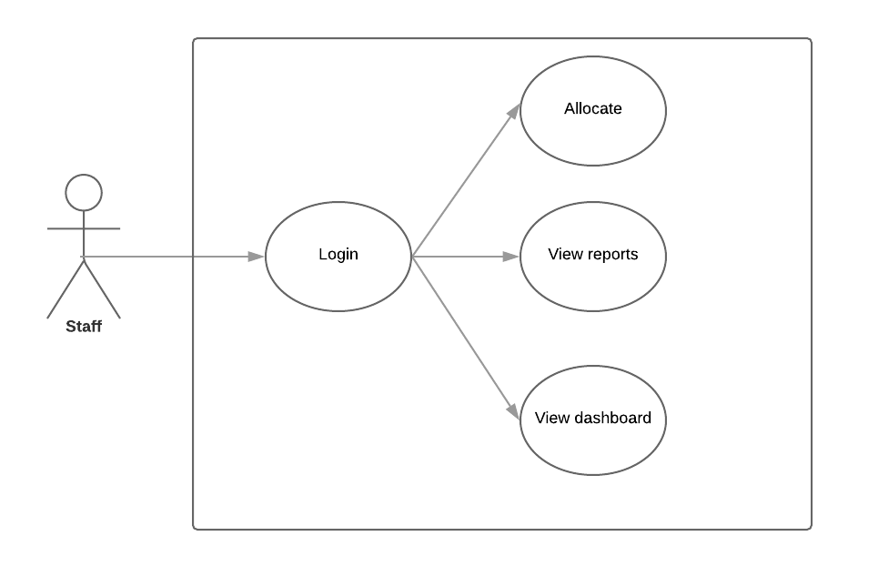

Figure 5: Use case Diagram for Staff

* **Student Use case**

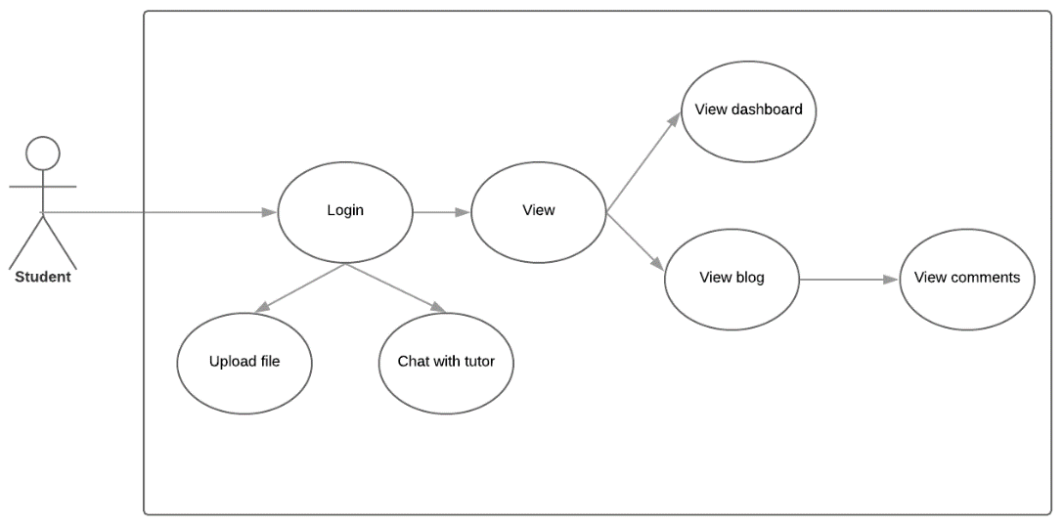

Figure 6:Use case Diagram for Student

* **Tutor Use case**

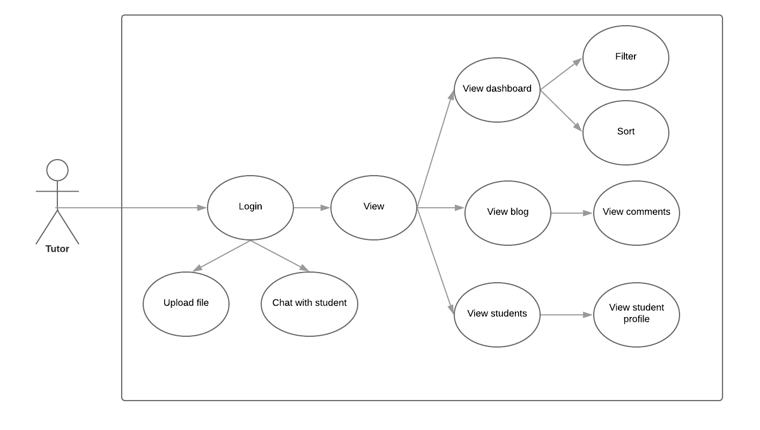

Figure 7: Use case Diagram for Tutor

1. **Website Design**
   1. **Website Wireframes**

To ensure the design of the website interface is consistent, and members can easily visualize the interface structure of the website. Designing Wireframes helps members to get a better idea of ​​the website, helping members understand the structure of the website and give ideas to improve the site better.

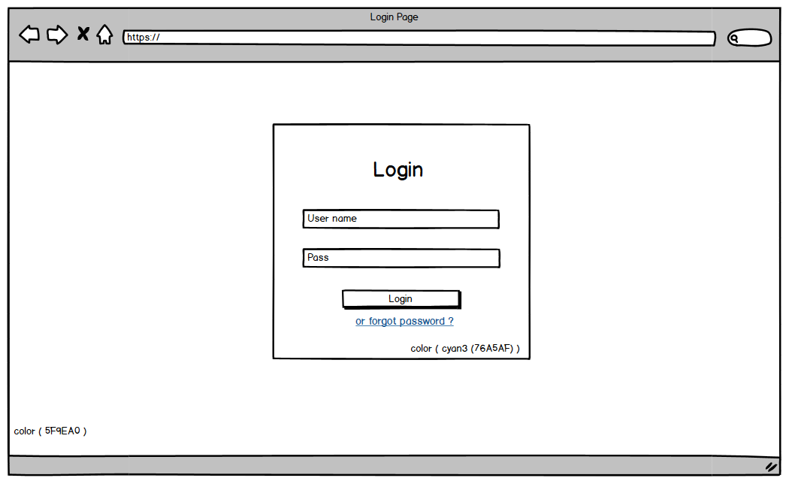

Figure 8: Wireframe for the Login page

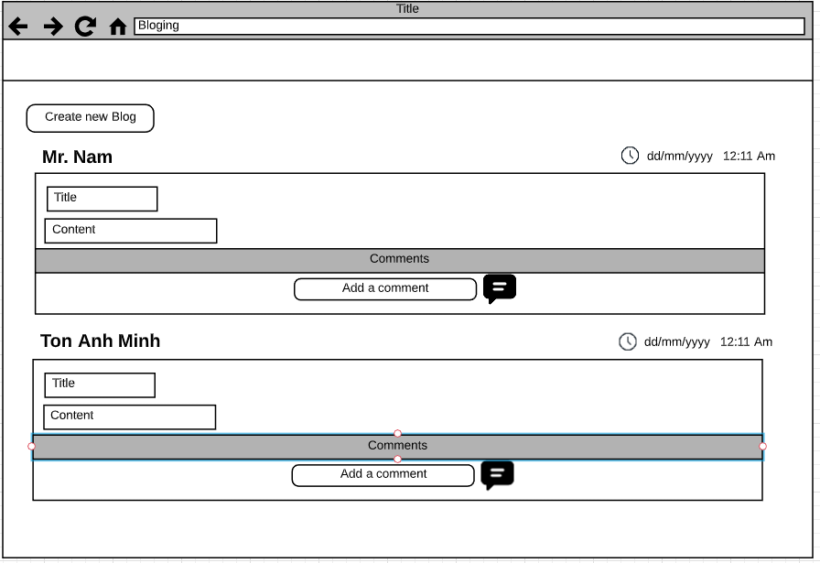

Figure 9: Wireframe for the Blog page

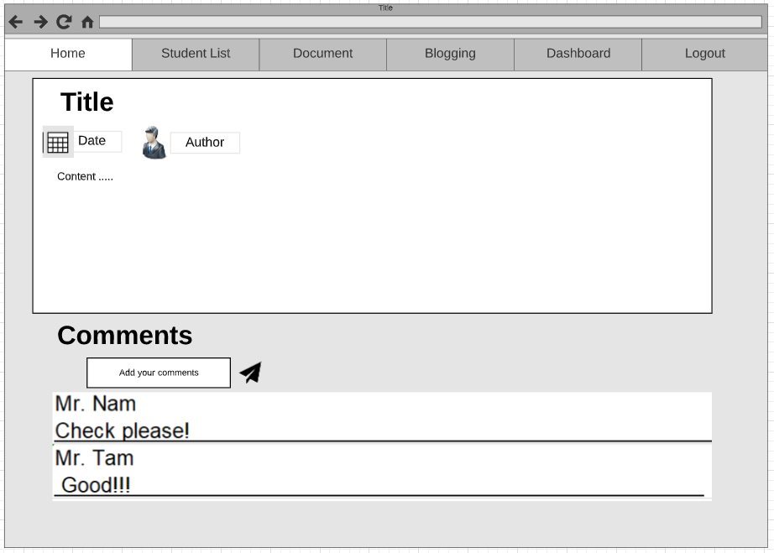

Figure 10: Wireframe for Blog detail

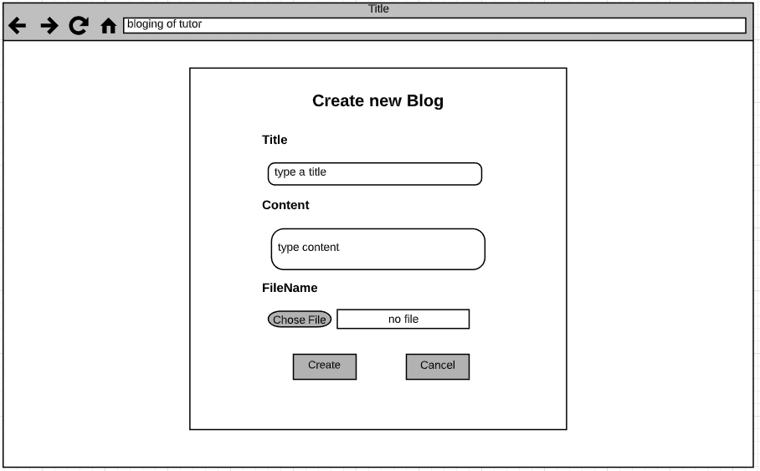

Figure 11: Wireframe for the Create Blog page

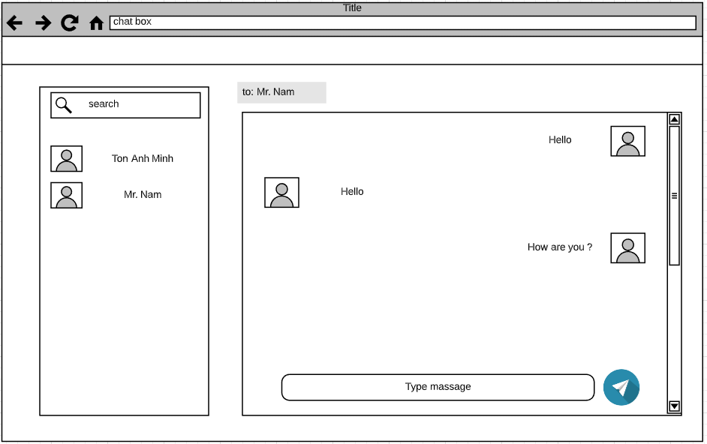

Figure 12: Wireframe for the Chat page

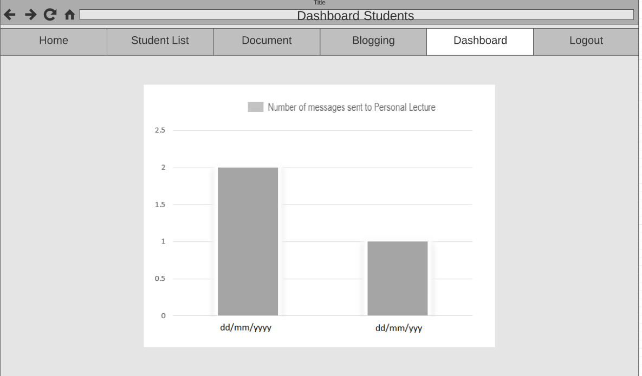

Figure 13: Wireframe for the Student’s Dashboard page

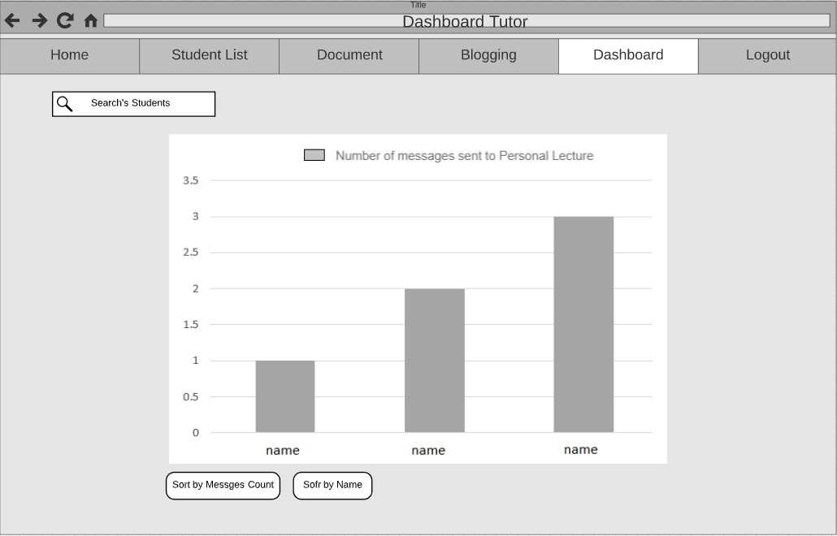

Figure 14: Wireframe for the Tutor’s Dashboard page

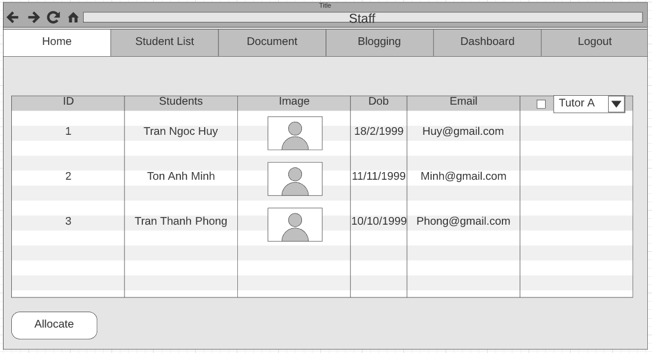

Figure 15: Wireframe for the Allocate page

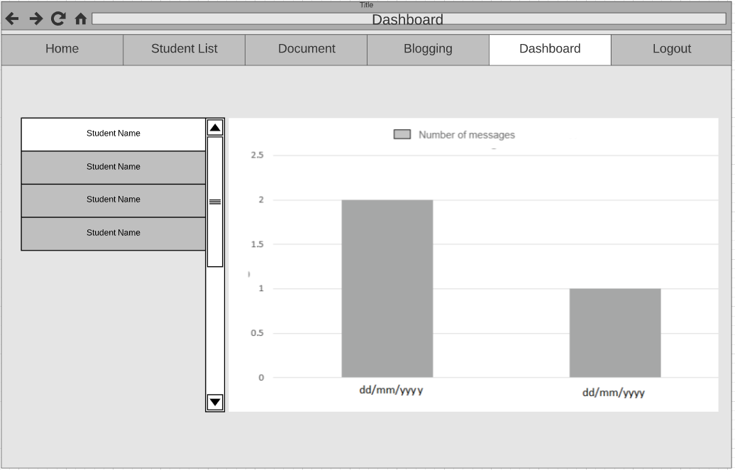

Figure 16: Wireframe for Staff view Student’s Dashboard page

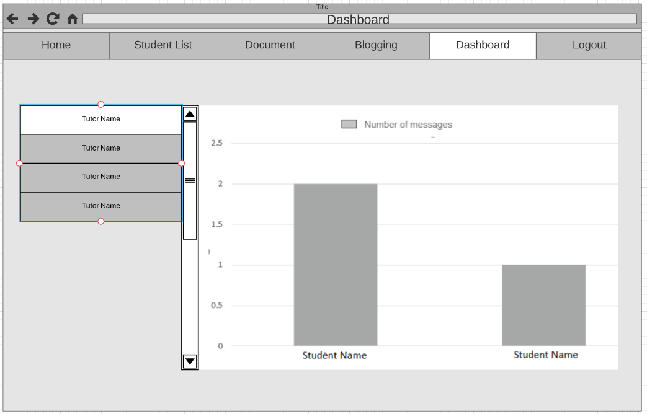

Figure 17: Wireframe for Staff view Student’s Dashboard page

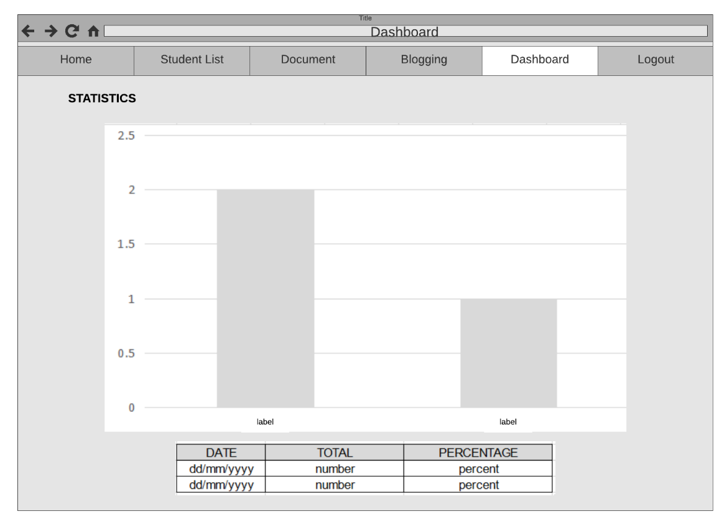

Figure 18: Wireframe for Staff’s report page (Statistic report)

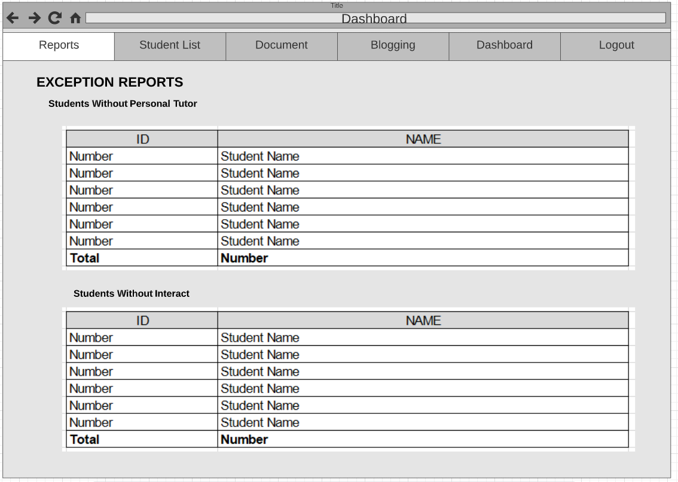

Figure 19: Wireframe for Staff’s report (Exception report)

* 1. **Site map**

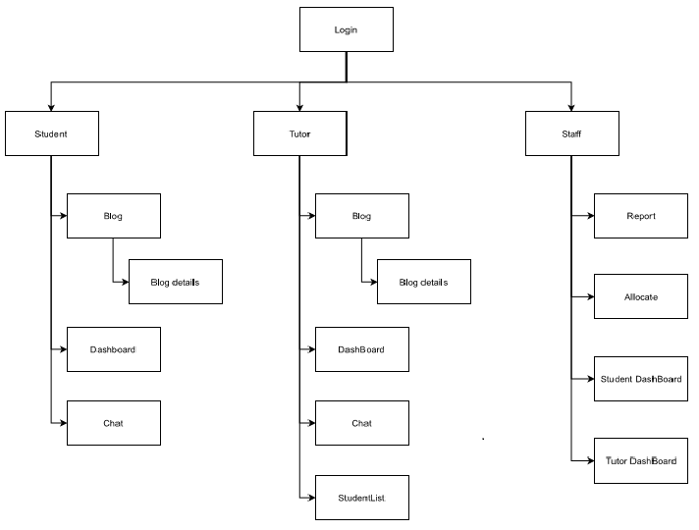

Figure : site map

1. **Screen shots of eTutoring system**
   1. **Login page**

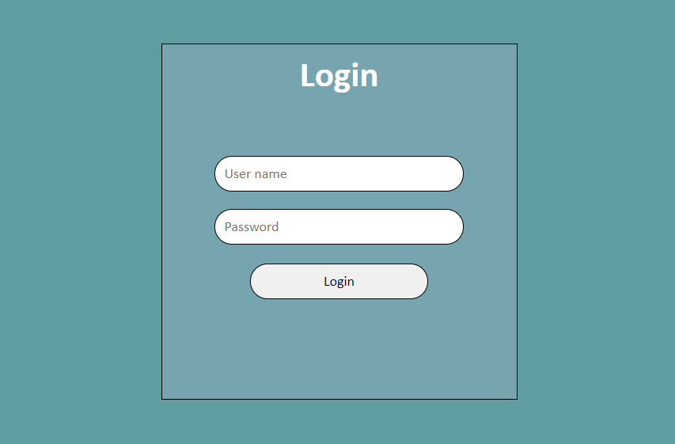

Figure 21:Login page

* 1. **Student’s pages**

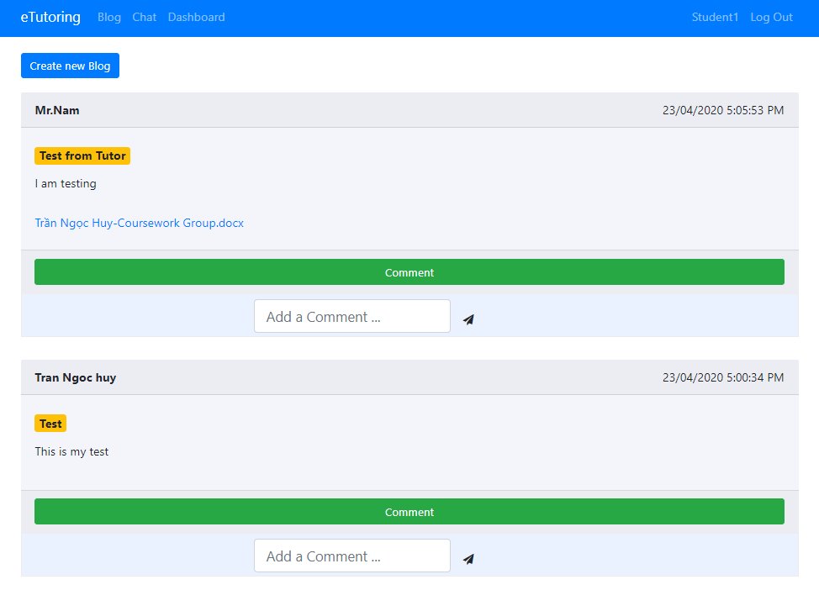

Figure 22: Student’s blog page

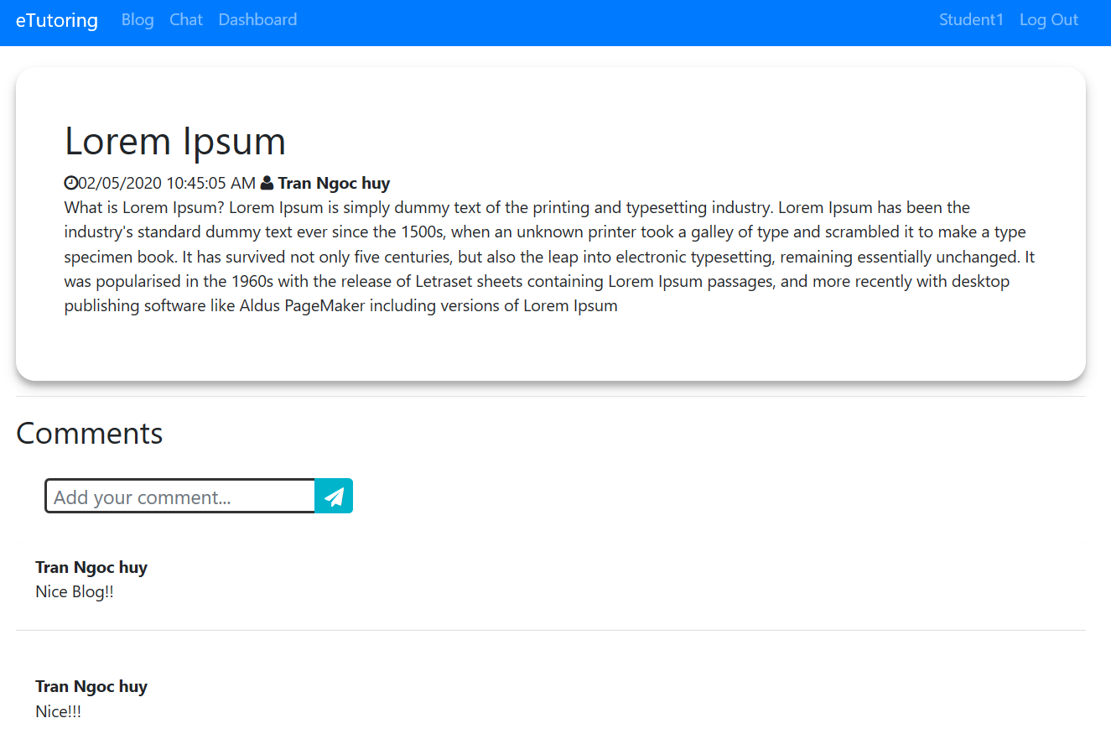

Figure 23: Student’s Blog detail page

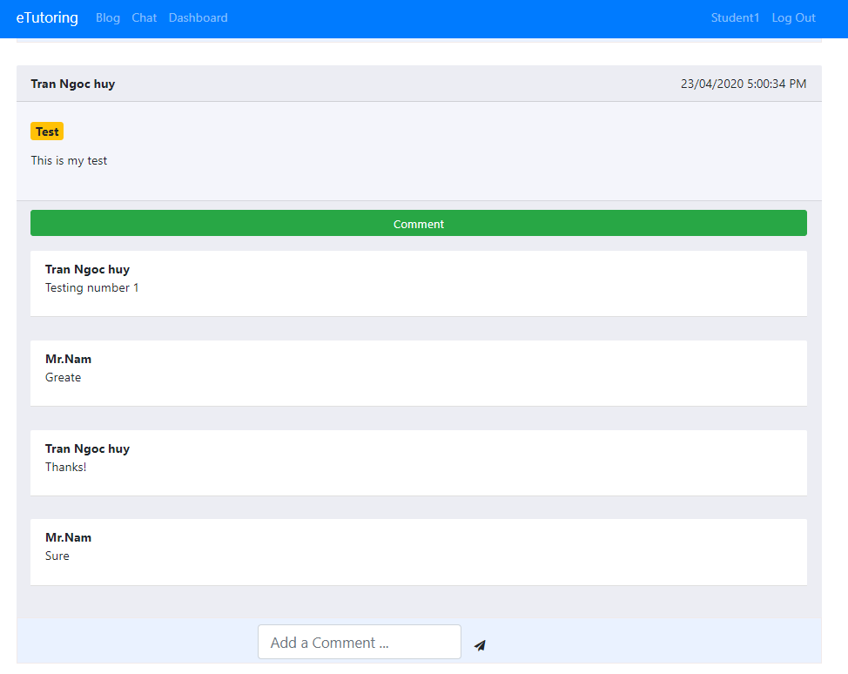

Figure 24: Student’s comment view

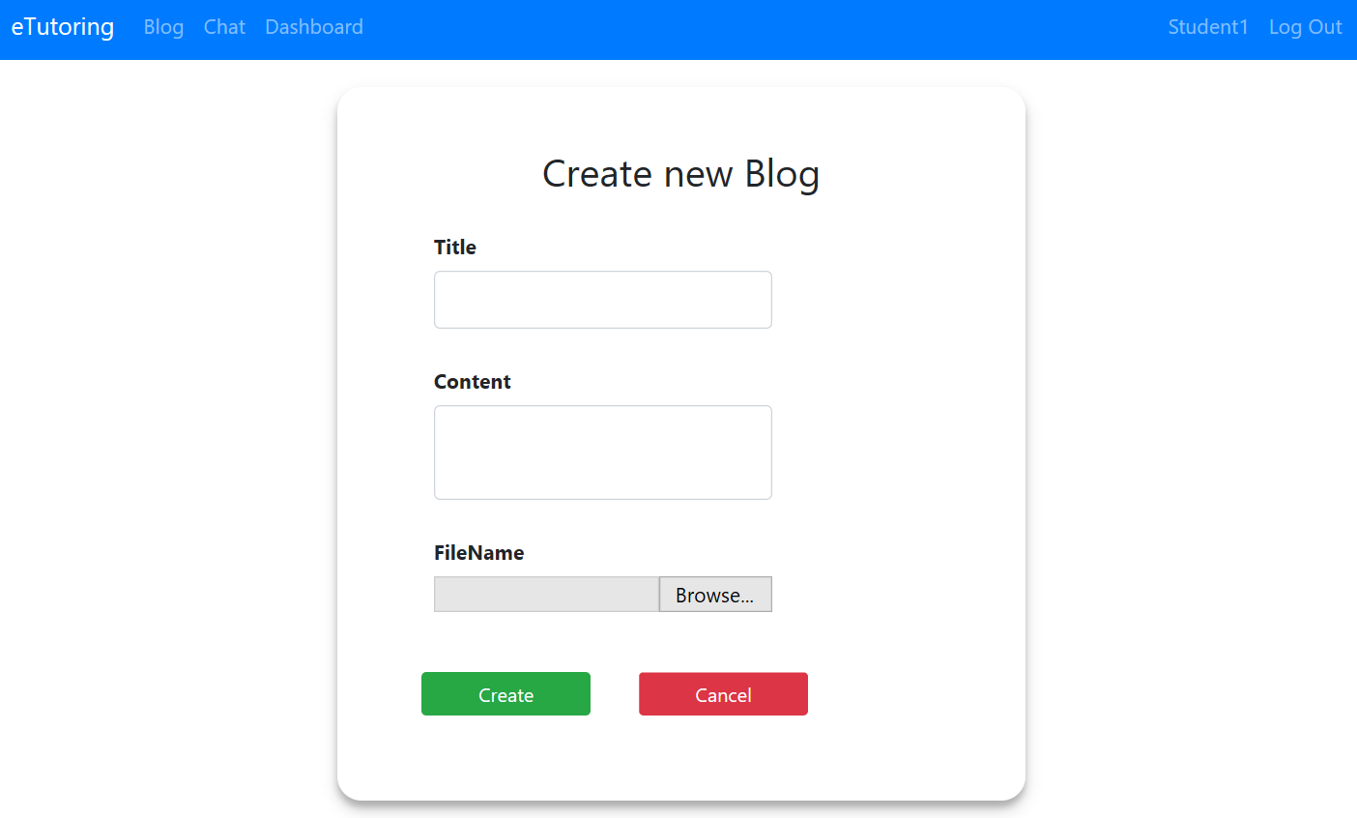

Figure 25:Student’s Create blog page

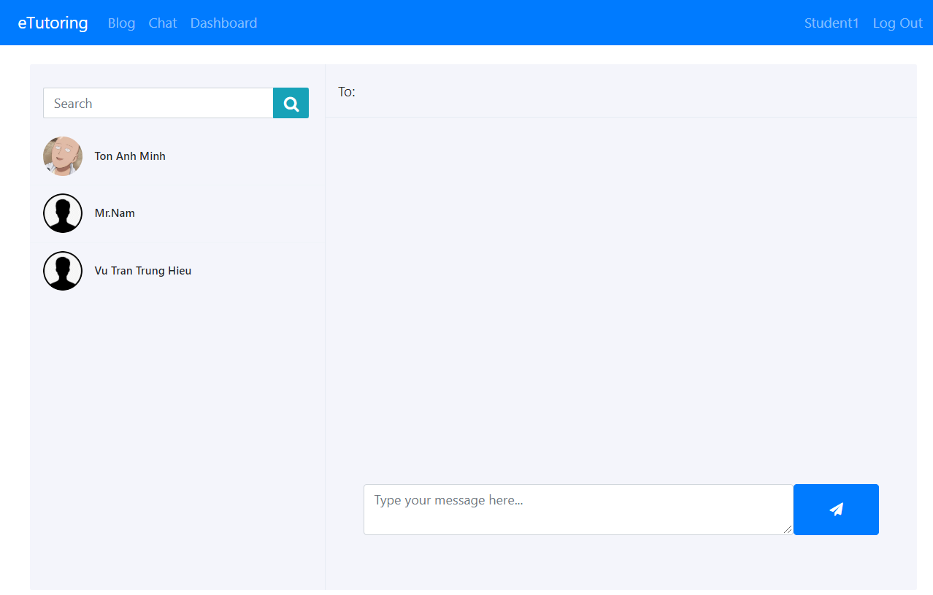

Figure 26: Student’s Chat page

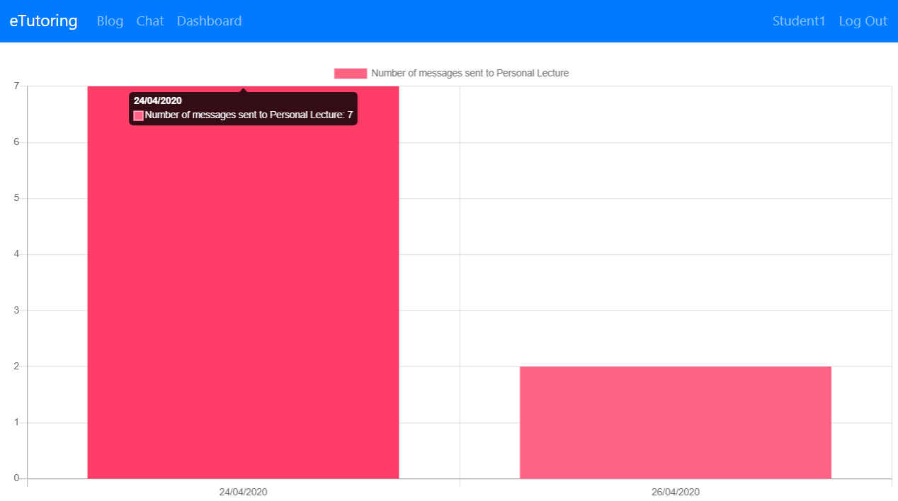

Figure 27: Student’s Dashboard page

* 1. **Tutor’s pages**

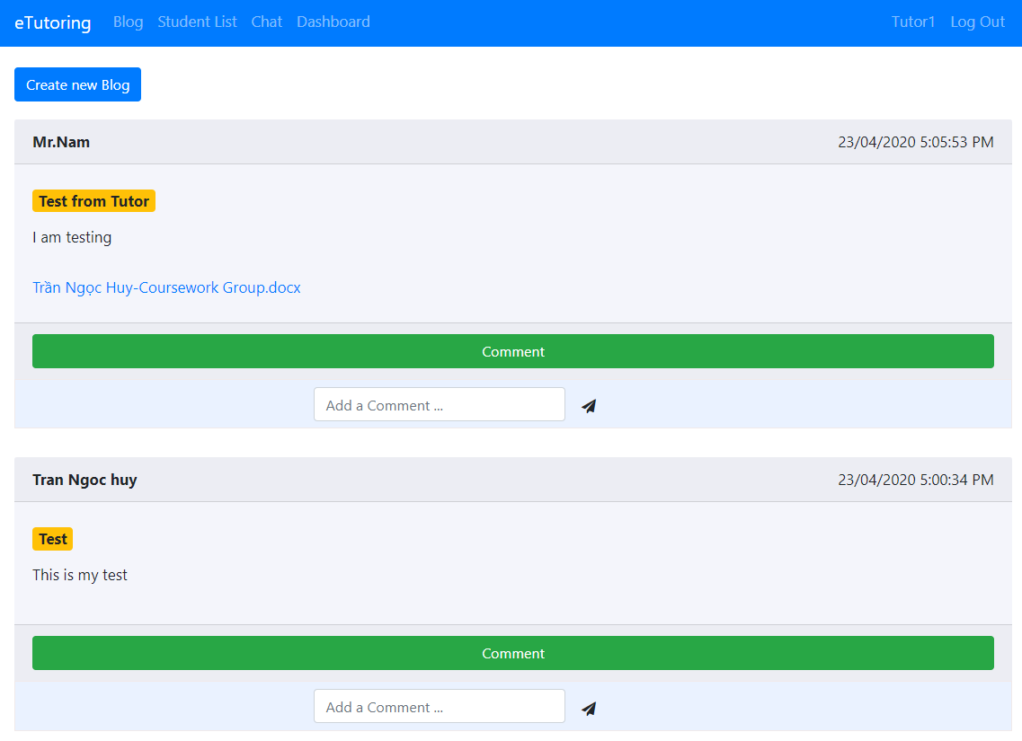

Figure 28:Tutor’s Blog page

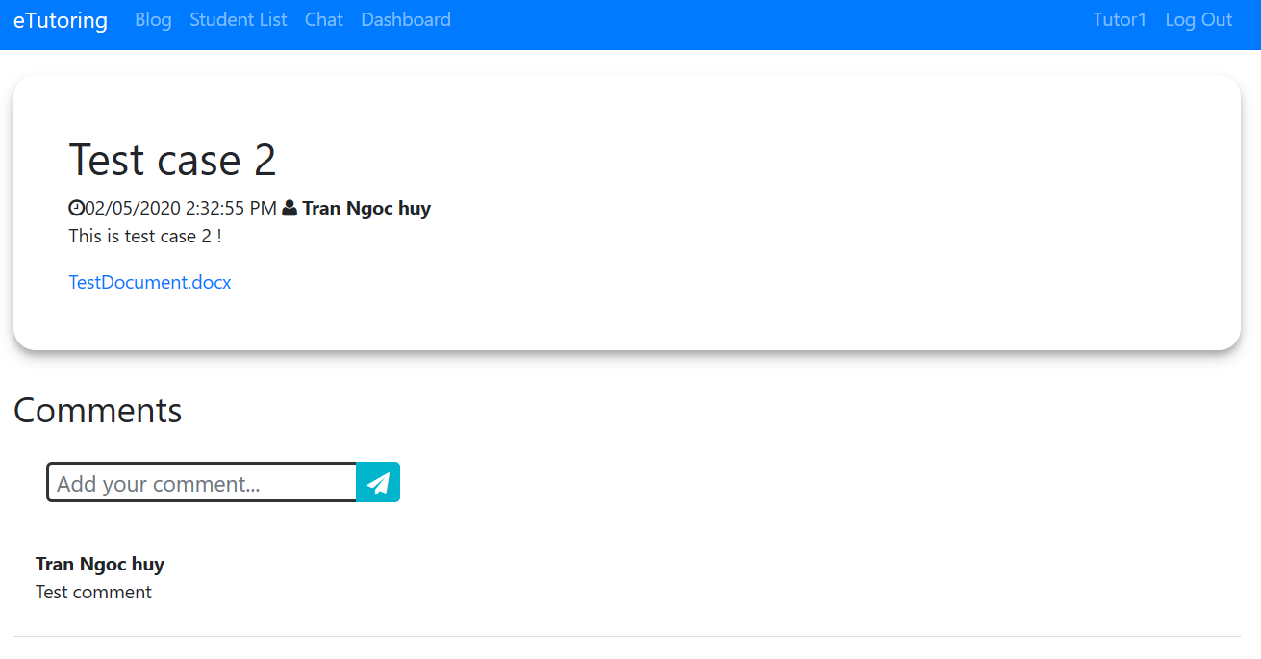

Figure 29: Tutor’s Blog detail page

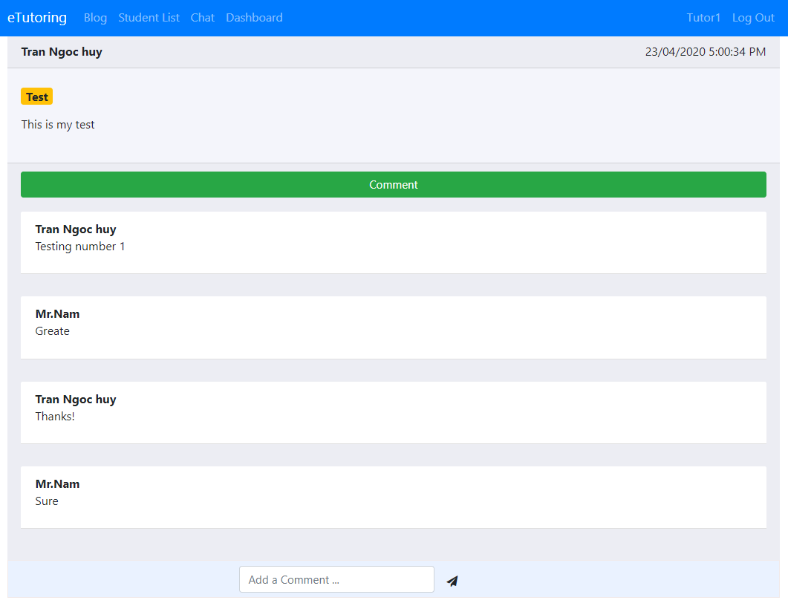

Figure 30:Tutor’s Comment view

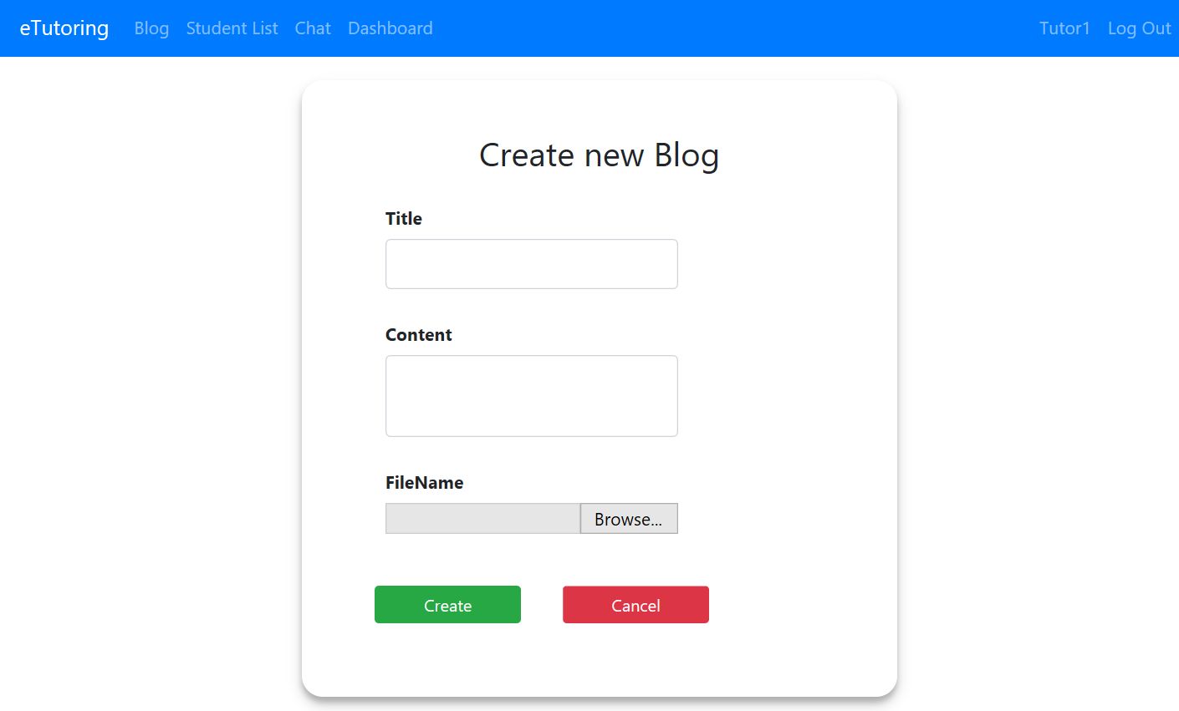

Figure 31:Tutor’s Create blog page

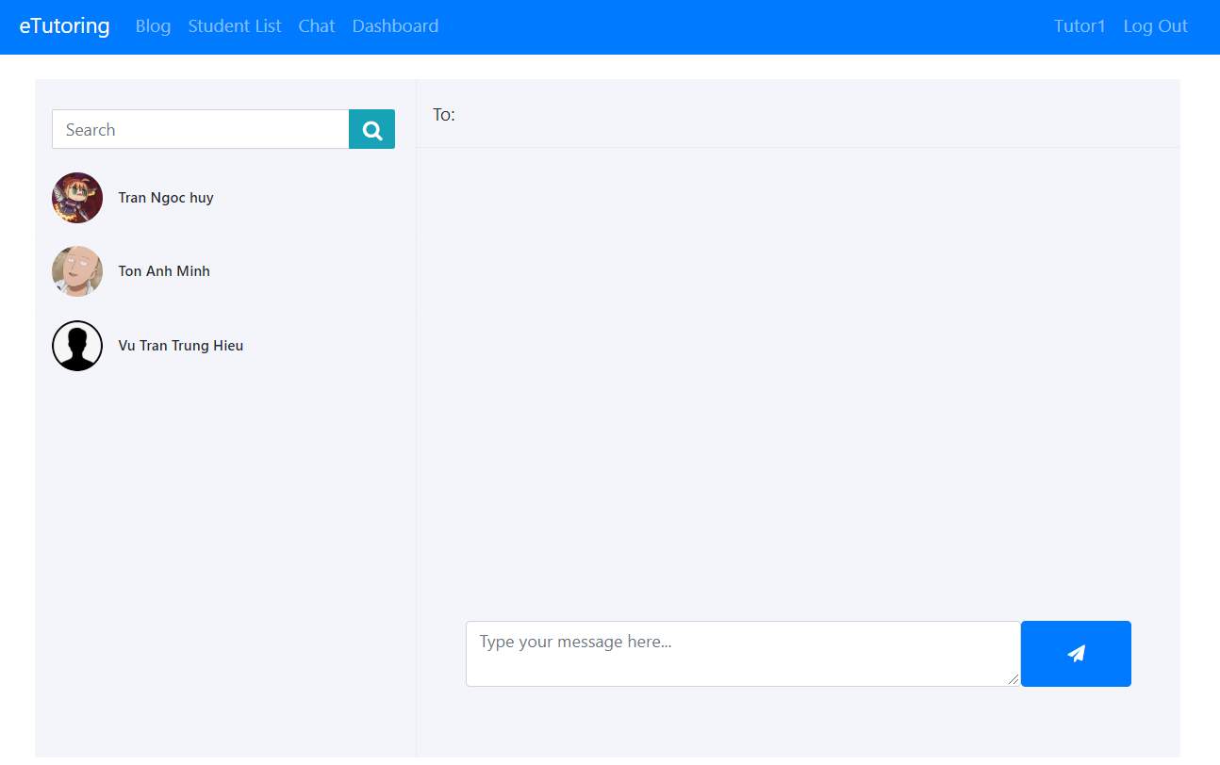

Figure 32:Tutor’s Chat page

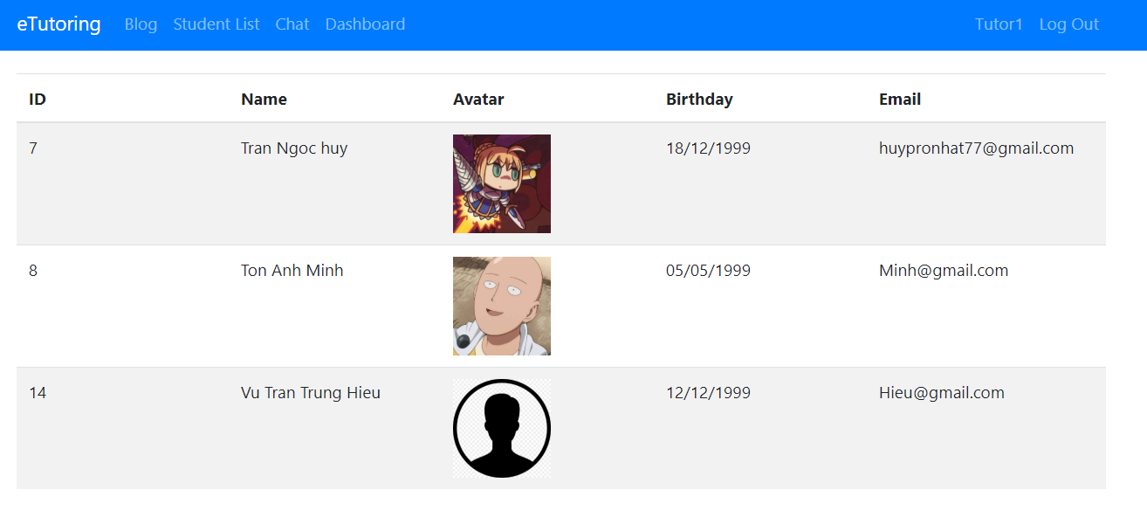

Figure 33:Tutor’s View student list page

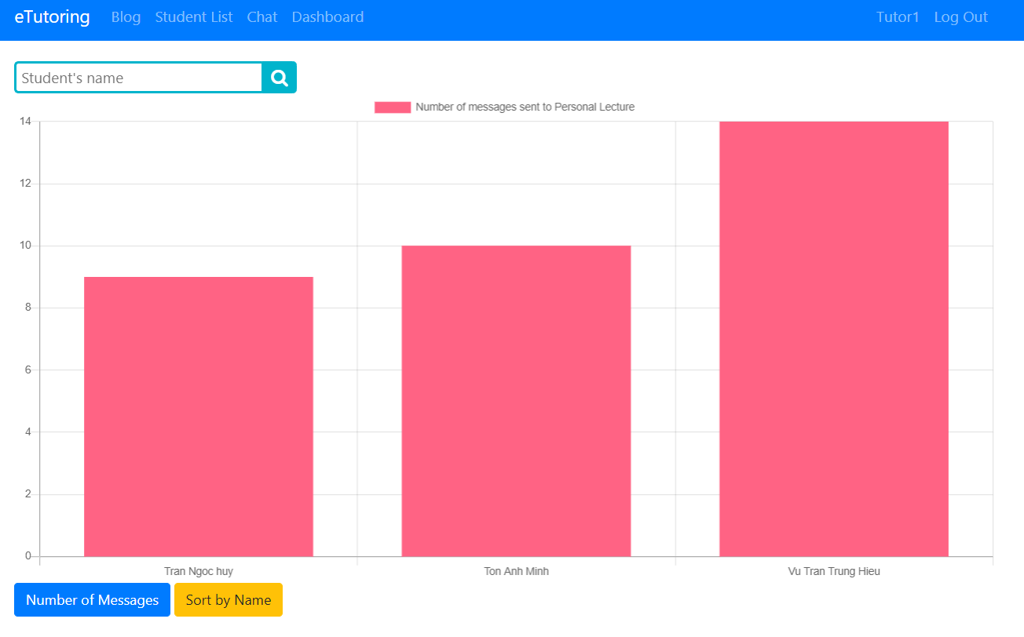

Figure 34: Tutor’s Dashboard page

* 1. **Staff’s page**

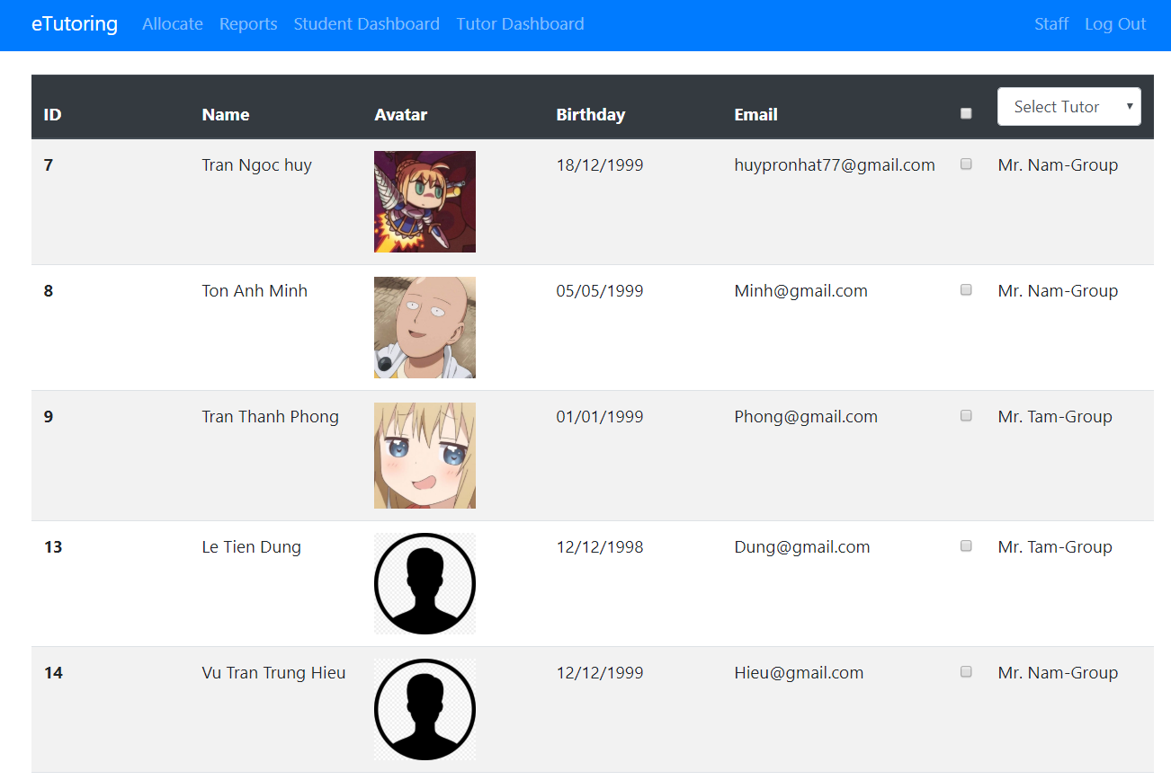

Figure 35: Staff's Allocate page

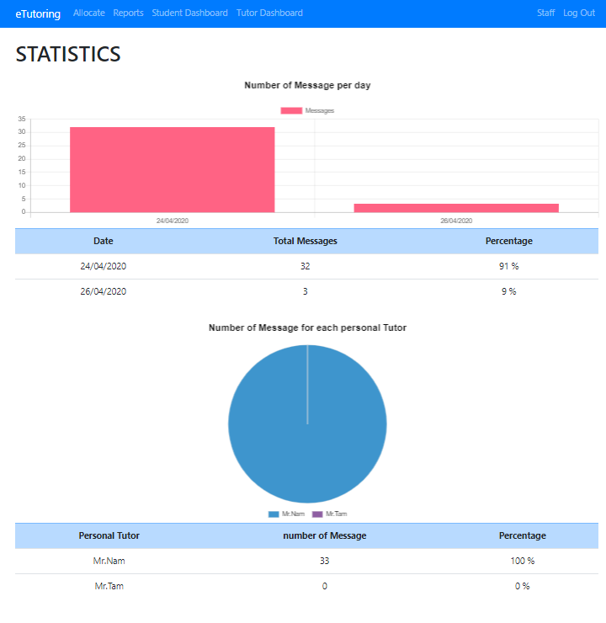

Figure 36:Staff’s report page (Statistic report)

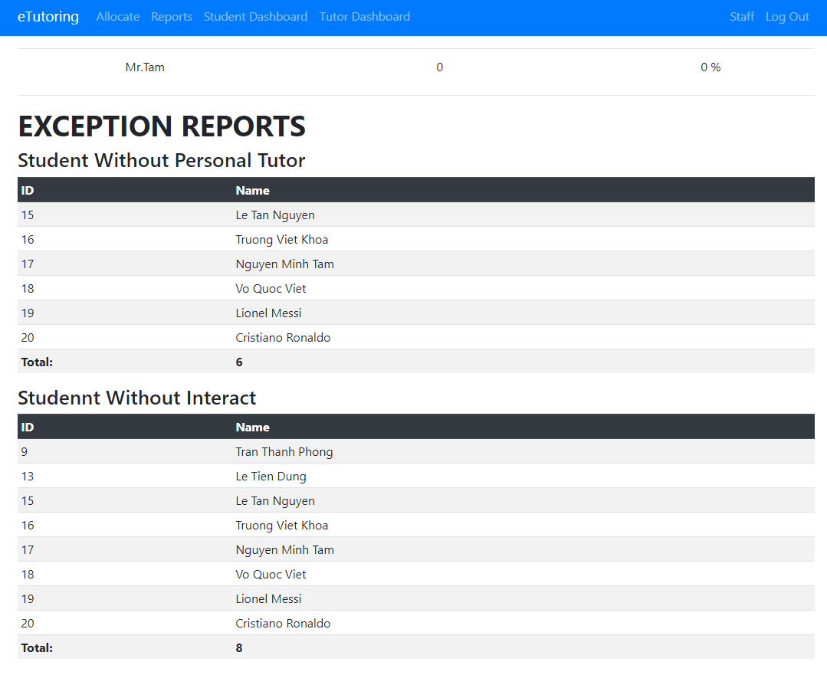

Figure 37:Staff’s report page (Exception report)

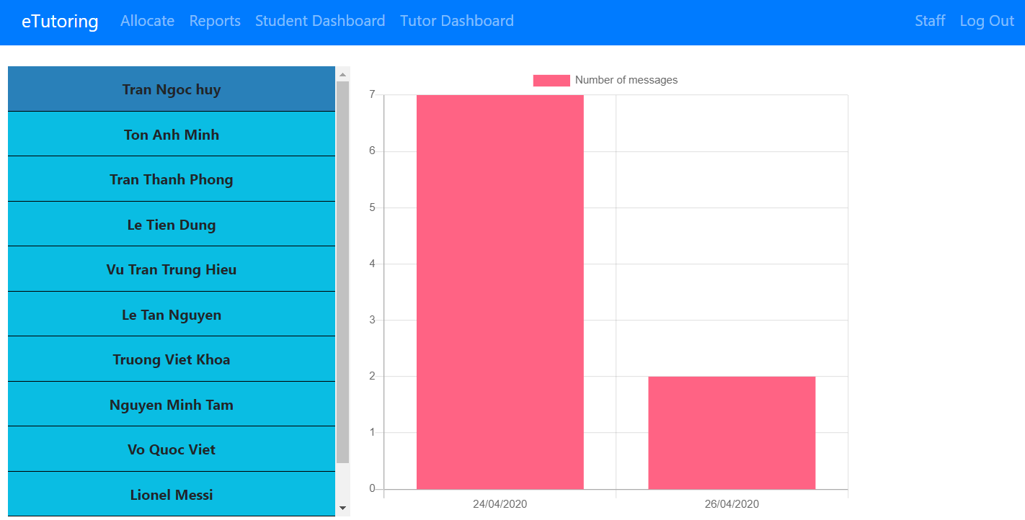

Figure 38: Staff’s view Student’s dashboard page

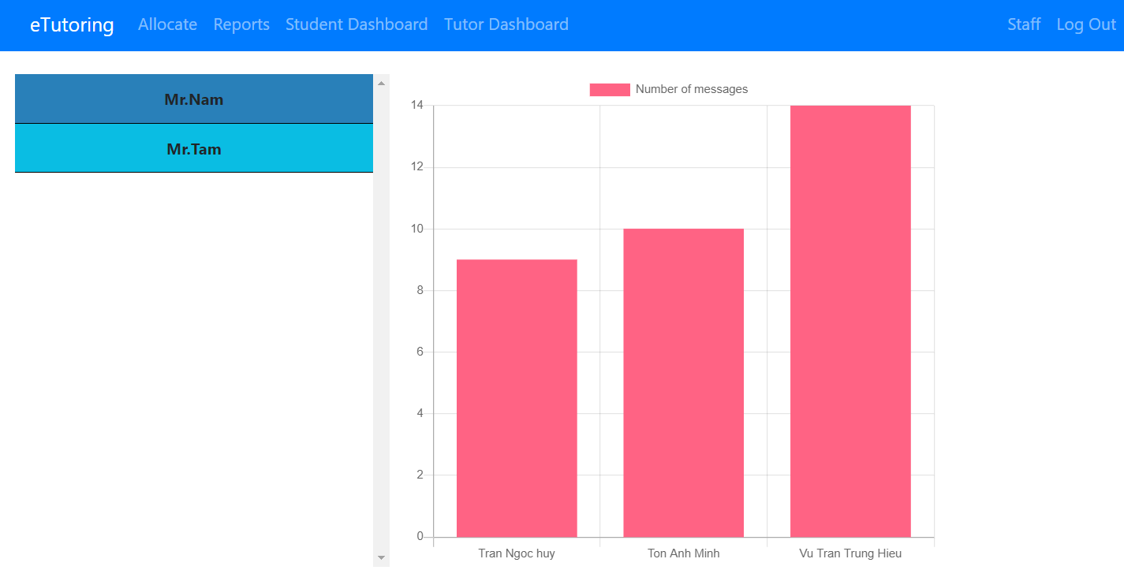

Figure 39: Staff’s view Tutor’s dashboard page

1. **Testing**
   1. **Test Plan**

|  |
| --- |
| 1. **Scope of the test**    1. **In Scope**  * Login. * Responsive on other devices. * Upload files. * Receive emails. * Sort on dashboard. * Check correct data. * Font on the website * Test on another browser   1. **Out of Scope** * Speed of the system * Test on another operating system * Database logical  1. **Testing Environment**  * Browser: Google Chrome, Microsoft Edge * IDE: Visual Studio 19 * Document: Microsoft Excel, Microsoft Word * Operating System: Window 10  1. **Test Approach**   The eTutoring system uses the Scrum model to develop. After completing a function, the functions will be assigned to the tester and run the test. If there are errors or bugs are detected during the test, the tester will notify the person responsible for that function. And at the end of each SPRINT, we will test overall again to make sure the system is free of errors.   1. **Test Schedule**  * Preparation: 3 days * Testing: 2 days * Fix bugs: 1 days * Re-test: 1 days |

Table 11: Test Plan

* 1. **Test case**
     1. **Test care for login function**

|  |  |  |  |  |  |  |
| --- | --- | --- | --- | --- | --- | --- |
| Test case ID | Function | Test data | Procedure/ Step | Expected Result | Result | Pass / Fail |
| 1 | Login | Username: students Password: 2 | Input: Username/Password | Show invalid message | Show invalid message | Pass |

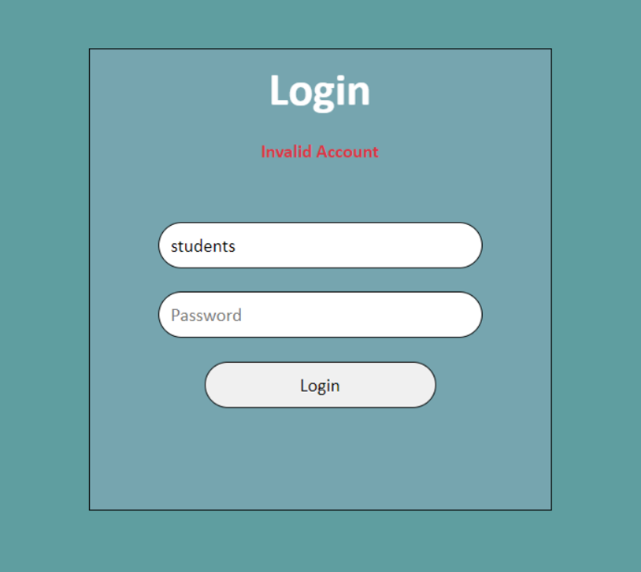Table 12: Login Test case

Figure 40: Login test result

* + 1. Test case for creating new blog function

|  |  |  |  |  |  |  |
| --- | --- | --- | --- | --- | --- | --- |
| Test case ID | Function | Test data | Procedure/ Step | Expected Result | Result | Pass / Fail |
| 2 | Create Blog | Title: Test care 2 Content: This is test case 2 File: TestDocument.docx | Input: Title / Content Choose file to upload Click Create | Upload successful | Upload successful | Pass |

Table 13: Creating new blog Test Case

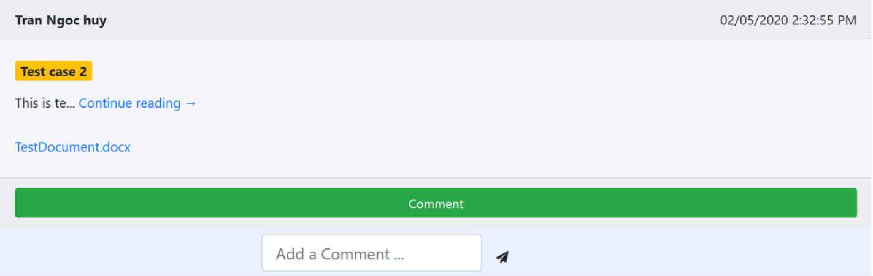

Figure 41: Creating new Blog result

+

* + 1. Test case for comments function

|  |  |  |  |  |  |  |
| --- | --- | --- | --- | --- | --- | --- |
| Test case ID | Function | Test data | Procedure/ Step | Expected Result | Result | Pass / Fail |
| 3 | Comment | Content: Test comment | Input: Comment's content | Show comment and user name who comment | Comment Successfully | Pass |

Table 14: Comment Test Case

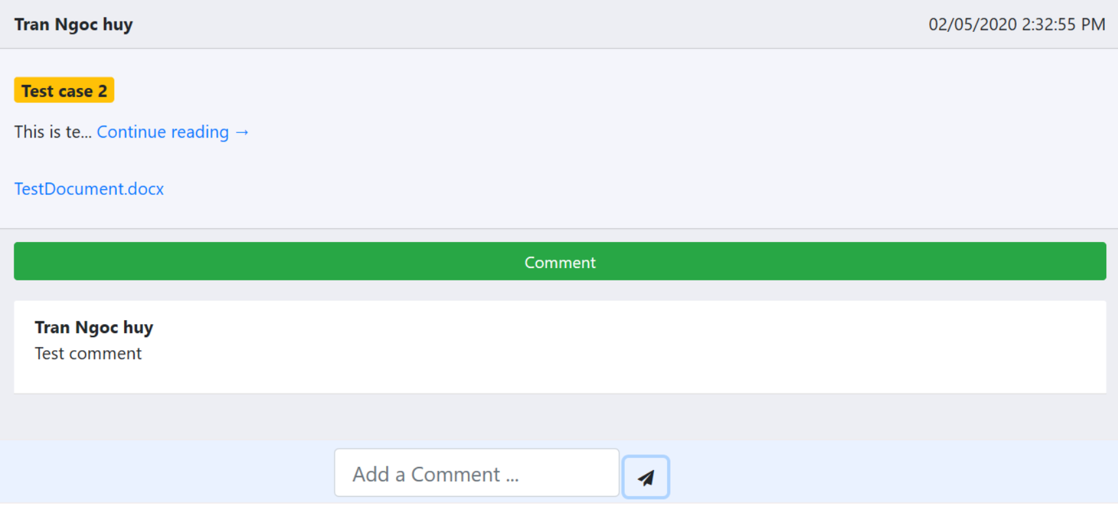

Figure 42: Comments result

* + 1. **Test case for chat function**

|  |  |  |  |  |  |  |
| --- | --- | --- | --- | --- | --- | --- |
| Test case ID | Function | Test data | Procedure/ Step | Expected Result | Result | Pass / Fail |
| 4 | Chat | Message: Chat testing | Input: Massage  Send button | Send message successfully | Send message successfully | Pass |

Table 15: Chat test case

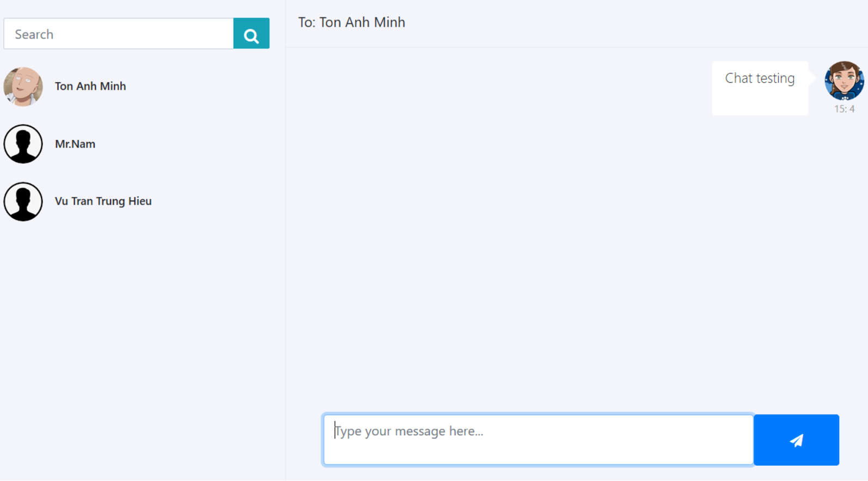

Figure 43: Chat result

* + 1. Test case for tutor’s dashboard

|  |  |  |  |  |  |  |
| --- | --- | --- | --- | --- | --- | --- |
| Test case ID | Function | Test data | Procedure/ Step | Expected Result | Result | Pass / Fail |
| 5 | Tutor Dashboard | Student's name | Input: Student's name | Show student whose name contain the search data | Show student whose name contain the search data | Pass |

Table 16: Test case for Tutor Dashboard

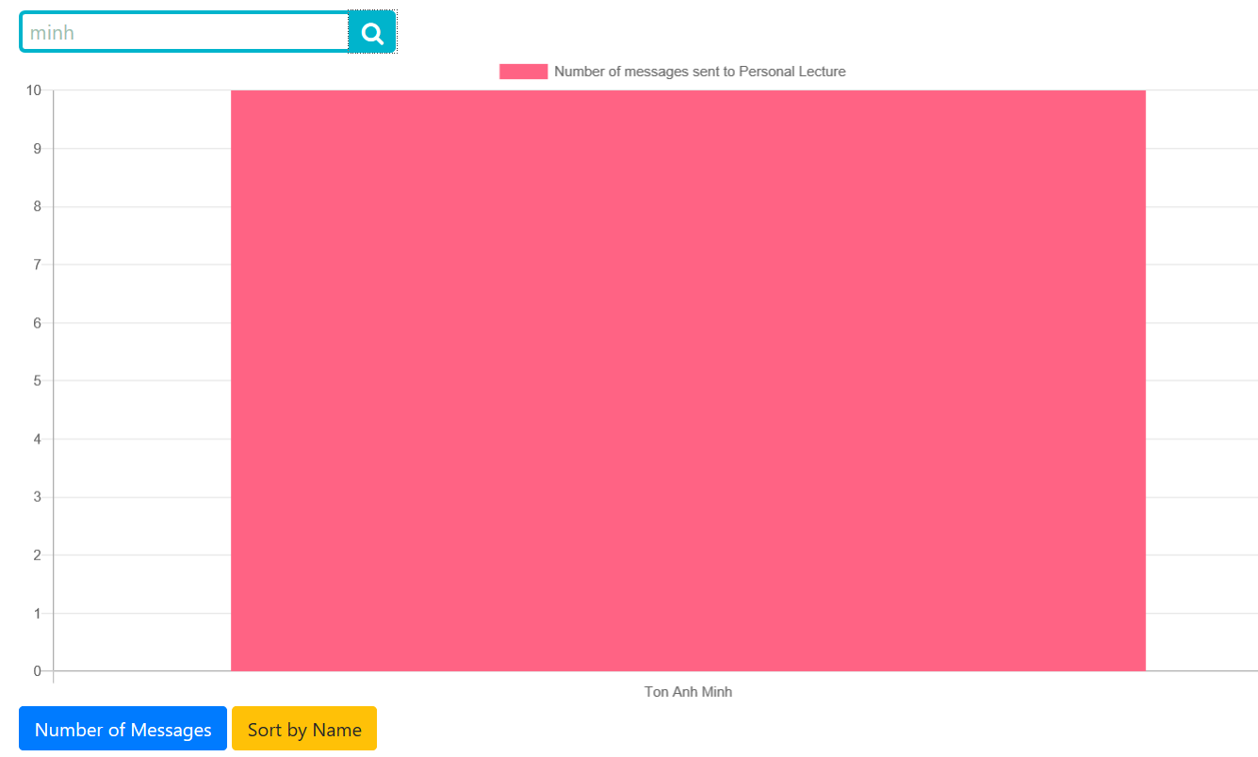

Figure 44: Tutor Dashboard result

* + 1. Test case for Reallocate function

|  |  |  |  |  |  |  |
| --- | --- | --- | --- | --- | --- | --- |
| Test case ID | Function | Test data | Procedure/ Step | Expected Result | Result | Pass / Fail |
| 6 | Test Reallocate | Student name: Tran Thanh Phong | Select check box Click allocate button | Reallocate Successfully | Reallocate Successfully | Pass |

Table 17: Test case for Reallocate function

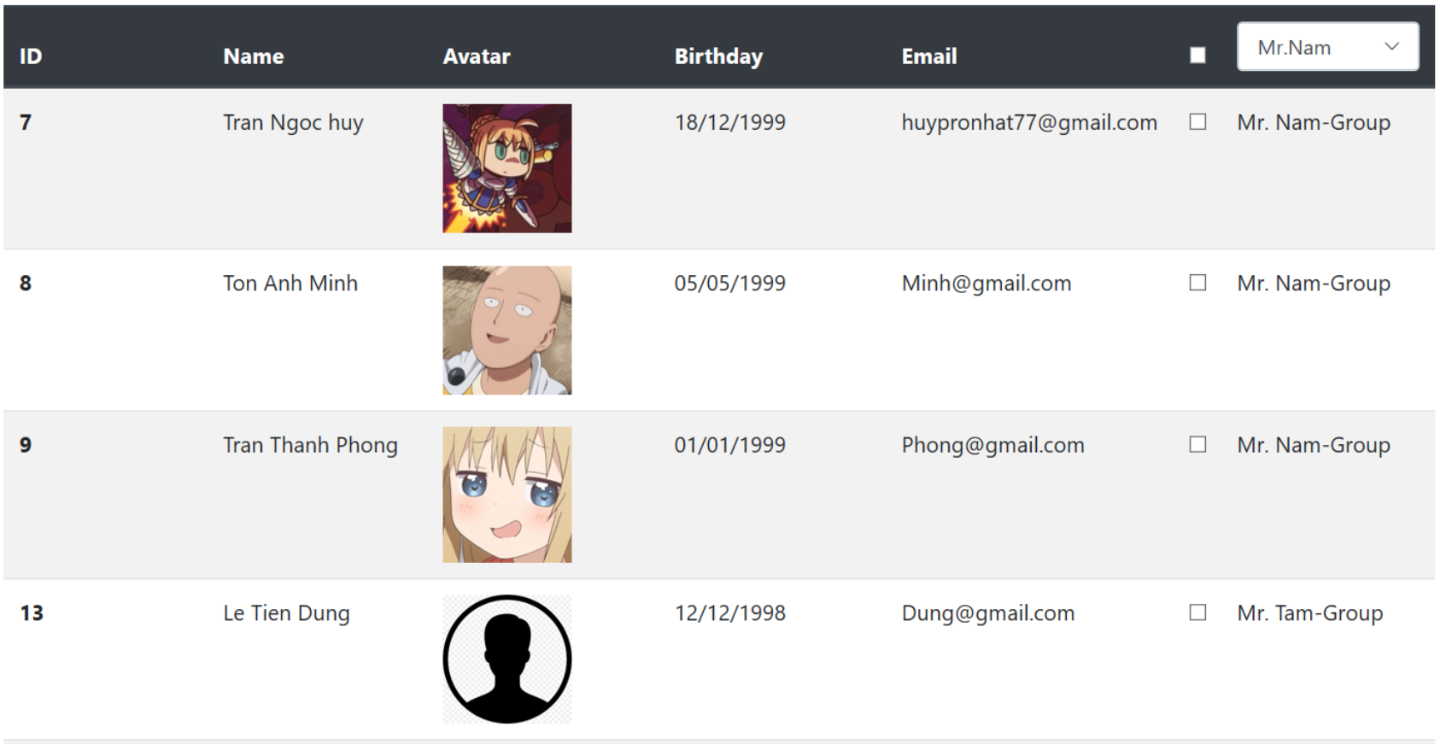

Figure 45: Reallocate result

* + 1. Test case for View Students Dashboard function

|  |  |  |  |  |  |  |
| --- | --- | --- | --- | --- | --- | --- |
| Test case ID | Function | Test data | Procedure/ Step | Expected Result | Result | Pass / Fail |
| 7 | View Students Dashboard | Students name: Tran Ngoc Huy | Select student's name | Show correct dashboard | Show correct dashboard | Pass |

Table 18: Test case for View Students Dashboard function

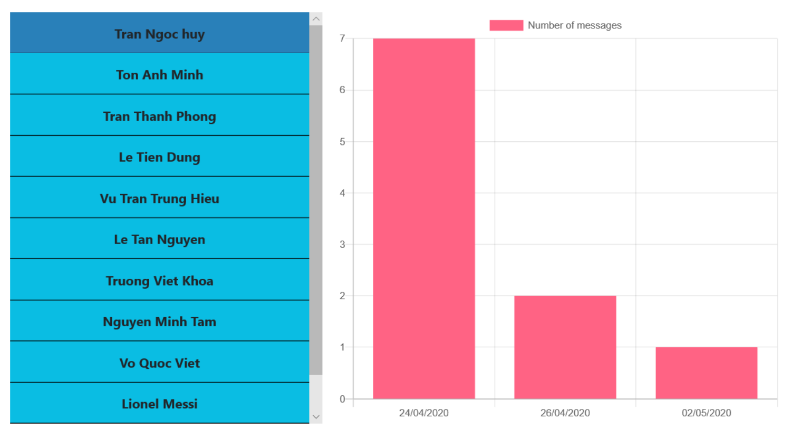

Figure 46: View Students Dashboard result

* 1. **Test Log**

|  |  |  |  |  |  |  |  |
| --- | --- | --- | --- | --- | --- | --- | --- |
| Test | What is being test | How | Test data used | Expected result | Date | Actual Result | Action taken |
| 1 | The Login function of the eTutoring system | Input: Username/Password | Username: students Password: 2 | Show invalid message | 01/05/2020 | Show invalid message | No action needed |
| 2 | Creating new blog with upload file | Input: Title / Content Choose file to upload Click Create | Title: Test care 2 Content: This is test case 2 File: TestDocument.docx | Upload successful | 01/05/2020 | Upload successfully | No action needed |
| 3 | Comment on the Blog | Input: Comment's content | Content: Test comment | Show comment and user name who comment | 01/05/2020 | Comment Successfully | No action needed |
| 4 | Send Message to another user | Input: Massage | Message: Chat testing | Send message successfully | 02/05/2020 | Send message successfully | No action needed |
| 5 | Searching on Tutor Dashboard | Input: Student's name | Student's name | Show student whose name contain the search data | 02/05/2020 | Show student whose name contain the search data | No action needed |
| 6 | Allocate/ Reallocate Students | Select check box Click allocate button | Student name: Tran Thanh Phong | Reallocate Successfully | 02/05/2020 | Reallocate Successfully | No action needed |
| 7 | View student's Dashboard | Select student's name | Students name: Tran Ngoc Huy | Show correct dashboard | 02/05/2020 | Show correct dashboard | No action needed |

Table 19: Test Log

1. **Assumptions**

* Students, personal tutors, and staff can log into the eTutoring system.
* Students can view the Blog.
* Students can create a Blog.
* Students can Upload file.
* Students can comment on the blog.
* Students can chat with their personal tutors.
* Students can view the dashboard summarizing their interaction with their personal tutor.
* Tutors can view the Blog.
* Tutors can create blogs.
* Tutors can Upload files.
* Tutors can comment on the blog.
* Tutors can chat with their Students.
* Tutors can view the dashboard of their students and they can sort and filter on that dashboard.
* Staff can allocate or reallocate students to personal tutors.
* Staff can view the dashboard of each student and the dashboard of a personal tutor.
* Staff can view reports.
* The interface of the website is compatible with phone and tablet devices.

The system meets most requirements of coursework. In addition, the eTutoring system has a clear decentralization of roles for functions. The interface of the system is designed to be compatible with other devices such as mobile, tablet, etc. The website design is easy to use and avoids confusing the user. However, the eTutoring System still needs a lot of improvement in the design and validate data from the user, so it is better to avoid the damage of data in the future.