Thẻ 1
Introduction to Software Engineering

Project Proposal

GROUP 6



Software Engineering Department Faculty of Information and Technology
University of Science
Table of Contents
Objectives 1
- Member Contribution Assessment 2
- Preliminary Problem Statement 3
- Proposed Solution 4
- Development Plan 5
- Human Resources & Costing Plan 6
- Tools setup 7

Project Proposal

Objectives

This document focus on the following topics:

Completing the Project Proposal document with the following sections:

Preliminary Problem Statement

Proposed Solution

Development Plan

Human Resources & Costing Plan

Understanding the Project Proposal document.

Member Contribution Assessment

ID | Name | Contribution (%) | Signature
23127138 | Phan Trung Tuấn | 20% | 
23127092 | Nguyễn Nhật Nam | 20% | 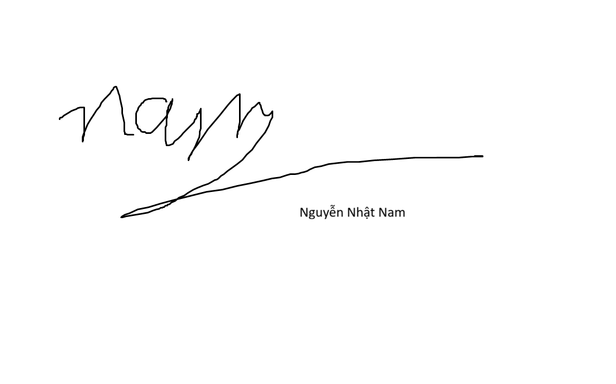
23127066 | Nguyễn Bách Khoa | 20% | 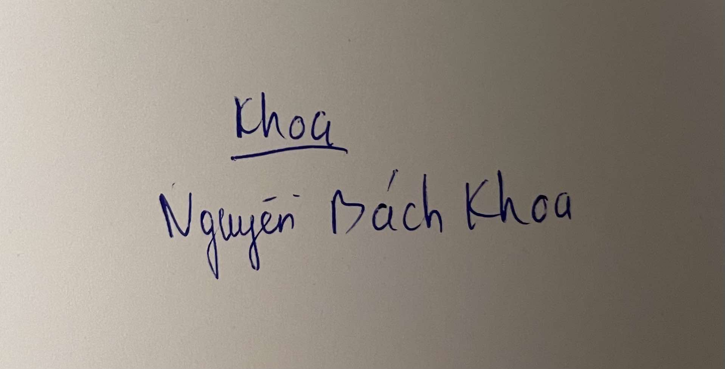
23127530 | Trương Quang Huy | 20% | 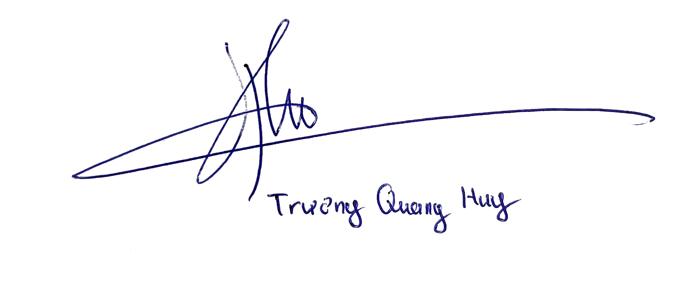
23127120 | Trần Danh Thiện | 20% | 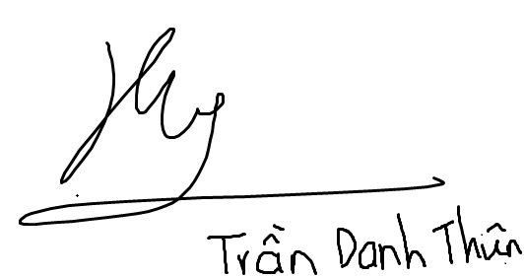

Preliminary Problem Statement

2.1 Preliminary Problem Statement
In the current technological landscape, large language models (LLMs) are demonstrating immense value. However, general-purpose models like the standard versions of ChatGPT or Gemini lack knowledge of a specific organization's internal data, private policies, or product information.
Businesses and individuals have a significant need to "train" AI on their own data for specialized purposes (e.g., customer support, internal documentation Q&A). However, building a complete RAG system from scratch requires high technical expertise in AI, data processing (vectorization), vector database management, and API integration.
This creates a substantial barrier, especially for Small and Medium-sized Businesses (SMBs) or non-technical users. Consequently, there is a clear demand for a "Chatbot-as-a-Service" (CaaS) platform that allows users to create specialized bots quickly and without coding (no-code/low-code).

The core problem this project addresses is the high technical barrier and cost associated with creating and deploying custom, knowledge-aware AI chatbots.
The proposed solution is a centralized web application that abstracts away the entire complexity of the AI infrastructure:
- User Side: Only needs to provide two things: (1) A task description (system prompt) and (2) Knowledge documents.
- Platform Side: Will automatically handle all complex backend tasks, including:
  - Integration with multiple AI provider APIs (OpenAI, Google, Anthropic...).
  - Execution of the RAG pipeline (text splitting, embedding generation, vector storage, and retrieval).
  - Management of user authentication and bot sharing permissions.
  - Providing a user-friendly chat interface.
In this way, the platform enables users to deploy a specialized AI chatbot in minutes instead of months, democratizing access to advanced AI technology.

2.2 Operating Environment
- Client-Side: Any modern web browser supporting HTML5, CSS3, and JavaScript (ES6+) (e.g., Google Chrome, Mozilla Firefox, Microsoft Edge, Safari).
- Server-Side:
  - Web Server: A server to handle HTTP requests and serve the application. Options include Nginx (preferred) or Apache.
  - Application Server: A runtime environment for backend business logic and APIs (e.g., Uvicorn for Python/FastAPI, or Node.js).
  - Database Server: A database server to store structured and vector data.

2.3 Design and Implementation Constraints
- Programming Language (Backend): Python (version 3.10+). This is a mandatory choice due to its extremely rich AI/ML ecosystem (e.g., langchain, llama-index, openai, google-generativeai).
- Programming Language (Frontend): JavaScript (ES6+) or TypeScript.
- Backend Framework: FastAPI. This is mandatory due to its high performance, modern syntax (async/await), and rapid API development capabilities.
- Frontend Framework: Next.js. This is the required framework for building the application, leveraging its capabilities for both server-side rendering (SSR), static generation (SSG), and client-side interactivity.
- Database: PostgreSQL (version 15+). This is mandatory. The primary reason is its support for the pgvector extension, which allows storing both relational data (users, bots) and vector data (from the knowledge base) within the same database, simplifying the architecture.
- AI Libraries: The project will heavily rely on the LangChain or LlamaIndex library to standardize and simplify the RAG pipeline and model integration.
- Authentication: JWT (JSON Web Tokens) will be used for managing login sessions and API authentication.
- Documentation Standards:
  - All Python source code must adhere to the PEP 8 standard and include clear Docstrings.
  - Frontend code must adhere to standard linters (e.g., ESLint).
  - Analysis documents (e.g., SRS - Software Requirements Specification) and design documents (e.g., SDD - Software Design Document) must be completed in the later phases of the projec

2.4 Project Scope
This project focuses on the development of a Web-based platform, tentatively named "AI-CaaS," which allows users to build, manage, and interact with customized AI chatbots. The core scope of this project will encompass the following main functions:
- Chatbot Creation: Allow registered users to create a new chatbot. This process includes naming the bot, selecting a large language model (LLM) as its foundation (e.g., GPT-4o, Gemini 1.5 Pro), and defining the bot's role and task via a "system prompt."
- Knowledge Ingestion (RAG): Provide functionality for users to upload documents (e.g., .pdf, .txt, .docx files) to serve as a private knowledge base for the chatbot. The system will automatically process these documents so the chatbot can answer questions based on the provided content (utilizing the Retrieval-Augmented Generation - RAG technique).
- Chat Interaction: Offer an intuitive chat interface for users to immediately converse with and test the chatbots they have created.
- Bot Sharing: Enable the chatbot owner to invite other users on the platform to join and use their chatbot.
Advanced features such as a Helpdesk system, payment integration, and embedding the bot into external websites are considered long-term visions for the product but will be outside the primary implementation scope of this academic project.

Proposed Solution

Software

Features
To justify the necessary features for the "AI-CaaS" platform, we utilize user story mapping. The primary actors are the Registered User (or "Bot Owner") and the Invited User. The core features are derived from the project scope and are mapped to user needs below.

User Story (As a...) | Feature (I want to...) | Justification (So that I can...) | Priority
User & Auth
As a new user, | I want to register for an account | ...I can access the platform and create my own bots. | High
As a registered user, | I want to log in securely (using JWT) | ...I can access my private dashboard and chatbots. | High
Chatbot Creation
As a registered user, | I want to create a new chatbot | ...I can start a new, specialized AI project. | High
As a bot owner, | I want to name my bot, select an LLM (e.g., GPT-4o, Gemini 1.5 Pro), and set a system prompt | ...I can define my bot's identity, role, and foundational model. | High
Knowledge Ingestion (RAG)
As a bot owner, | I want to upload documents (.pdf, .txt, .docx) to my bot | ...I can provide a private knowledge base for the bot to use | High
As a bot owner, | I want the system to automatically process these documents (RAG pipeline) | ...the bot can answer questions based on the content I provided. | High
Chat & Sharing
As a bot owner, | I want an intuitive chat interface | ...I can immediately test and converse with the bot I just created. | High
As a bot owner, | I want to invite other registered users to my bot | ...my team members or collaborators can also use the bot. | Medium
As an invited user, | I want to see and interact with bots that have been shared with me | ...I can utilize the specialized knowledge in that bot. | Medium

Software Architecture
The "AI-CaaS" platform will be built using a modern, decoupled web architecture, separating the client-side presentation from the server-side business logic. The architecture consists of the following mandatory components as defined in the project constraints:
- Frontend (Client): A Next.js application. This choice allows for a high-performance, interactive user interface with capabilities for both server-side rendering (SSR) and static site generation (SSG). The client will run in the user's web browser and communicate with the backend via REST APIs.
- Backend (Application Server): A FastAPI (Python 3.10+) application. This server will handle all core business logic, including user authentication (via JWT), chatbot management, and API requests. FastAPI is chosen for its high performance and asynchronous capabilities. It will run using an ASGI server like Uvicorn.
- Database (DB Server): A PostgreSQL (v15+) server. This single database instance will serve two critical functions:
  - Relational Data: Storing structured data such as user accounts, bot configurations (names, system prompts), and sharing permissions.
  - Vector Data: Utilizing the pgvector extension, it will store the vector embeddings generated from the user's uploaded knowledge documents. This simplifies the architecture by avoiding the need for a separate vector database.
- RAG & AI Integration: The backend (FastAPI) will integrate heavily with AI libraries like LangChain or LlamaIndex. When a user uploads a document, the backend will use these libraries to execute the RAG pipeline: splitting text, generating embeddings (via an AI provider), and storing them in the pgvector database. When a user chats, the backend retrieves relevant context from the database to augment the prompt sent to the external LLM APIs (OpenAI, Google, etc.).
This architecture is visually represented by the following flow:
[User's Browser (Next.js)] <-> [API Server (FastAPI)] <-> [Database (PostgreSQL + pgvector)] [API Server (FastAPI)] -> [External LLM APIs (OpenAI, Google)]

Hardware
The hardware and equipment requirements for the "AI-CaaS" project are divided into development and operational (deployment) environments.
- Development Environment (Team Equipment):
- Developer Machines: 5x developer laptops (PC or Mac) capable of running modern IDEs (e.g., VS Code), Docker Desktop (for containerizing services like PostgreSQL), Python 3.10+, and Node.js.
- Minimum Specs: 8GB RAM (16GB recommended), SSD, multi-core CPU.
- Operational Environment (Server-Side):\
- Client-Side: Any modern device with a web browser (e.g., PC, laptop, smartphone, tablet) as specified in the operating environment. No special hardware is required for end-users.
- Web/Application Server : A virtual private server (VPS) or cloud instance (e.g., AWS EC2, Azure VM) to host the Nginx web server and the FastAPI (Uvicorn) application server.
  - Recommended Specs: 2+ vCPUs, 4GB+ RAM (RAM requirements will increase based on the number of concurrent users and the complexity of RAG processing).
- Database Server : A server to run the PostgreSQL (v15+) instance. This can be a managed database service (e.g., AWS RDS, Azure Database for PostgreSQL) or hosted on a separate cloud instance for better performance.
  - Recommended Specs: 2+ vCPUs, 4GB+ RAM, and sufficient SSD storage to hold both relational data and the vector embeddings from all users. Storage is the key scaling factor.

Development Plan
- The student team should present a detailed software development plan, along with the specific deliverables for each phase.

Requirements Analysis
- Objective: To define, document, and finalize the complete scope, functionalities, and constraints of the software.
- Key Activities:
  - Analyze and detail all Functional Requirements (FRs), describing what the system must do (e.g., user authentication, bot creation, document processing).
  - Analyze and detail all Non-Functional Requirements (NFRs), defining system quality attributes (e.g., performance, security, usability).
  - Create a prioritized Product Backlog (list of all features) to guide development.
- Deliverables:
  - A comprehensive Software Requirements Specification (SRS) document.
  - A finalized Product Backlog with prioritized user stories.

Software Design
- Objective: To create a high-level technical blueprint for the system, translating requirements into a structured design.
- Key Activities:
  - Design the overall System Architecture (e.g., three-tier, AI processing pipeline).
  - Create the Database Schema, including designs for both relational data and vector data storage.
  - Develop UI/UX (User Interface/User Experience) wireframes and mockups for the main application screens.
- Deliverables:
  - A Software Design Document (SDD), including system architecture diagrams.
  - Database schema diagrams (ERD).
  - A complete set of UI/UX Mockups.

Implementation
- Objective: To build, code, and integrate all software components based on the design specifications in an iterative manner.
- Key Activities:
  - Iteration 1 (Foundation): Set up the backend and frontend project structures. Implement user authentication (registration, login) and establish database connectivity.

  - Iteration 2 (Core AI Pipeline): Develop the proof-of-concept for the AI (RAG) pipeline. This includes file uploading, text processing (chunking, embedding), vector storage, and a basic chat API that queries the language model with retrieved context.
  - Iteration 3 (UI Integration): Build the primary user interfaces for bot creation, document management, and the interactive chat window.
  - Iteration 4 (MVP Completion): Fully integrate the frontend and backend to achieve a Minimum Viable Product (MVP). This includes completing the end-to-end user flow (create bot -> upload doc -> get answer) and implementing the "source citation" feature.
  - Iteration 5 (Advanced Features): Implement secondary features such as the "Share Bot" functionality and refine the overall system stability and performance.
- Deliverables:
  - A complete, runnable, and version-controlled Source Code repository.
  - A functional Minimum Viable Product (MVP) after Iteration 4.
  - The final, feature-complete software product after Iteration 5.

Testing
- Objective: To systematically verify and validate that the software is free of critical defects and meets all specified requirements.

- Key Activities:
  - Conduct Integration Testing to ensure all components (frontend, backend, database, AI pipeline) work together correctly.
  - Perform Functional Testing against the requirements defined in the SRS.
  - Execute User Acceptance Testing (UAT) to confirm the system is usable and meets user expectations.
  - Identify, log, and track all bugs and issues.

- Deliverables:
  - A comprehensive Test Plan and Test Case-
  - A final Test Report detailing the results of all tests and the status of all identified defects.

Deployment and Maintainance
- Objective: To release the finalized software product to a live environment and provide initial support.
- Key Activities:
  - Prepare the production environment (server configuration, database setup).
  - Deploy the application to the server.
  - Conduct final "smoke tests" on the live environment to ensure a successful launch.
  - Monitor the application for any immediate issues post-launch.
- Deliverables:
  - A Deployment Guide with detailed installation and configuration instructions.
  - The final, deployed software application accessible to users.

Human Resources & Costing Plan
5.1 . Human Resources Plan
a. Team Roles and Responsibilities

Student Name | Project Role | Key Responsibilities
Phan Trung Tuấn | Project Manager | - Plan and track project progress.  - Manage risks and communication.  - Coordinate team efforts.
Nguyễn Bách Khoa | Backend Developer | - Design and build the database.  - Develop the server-side logic and APIs.
Nguyễn Nhật Nam | Frontend Developer | - Develop the User Interface (UI).  - Integrate APIs.  - Ensure a good User Experience (UX).
Trần Danh Thiện | AI/ML Engineer | - Collect and preprocess training data.  - Design, train, and evaluate models.  - Create an API for model predictions.
Trương Quang Huy | QA & Tester | - Write and execute test cases.  - Report and track bugs.  - Verify all requirements are met.

b. Personnel Structure by Phase
Phase 1: Analysis & Design
- Focus: Planning, system architecture, UX/UI design.
- Roles Involved: All members, with the Project Manager and Frontend Developer (for UX/UI) taking the lead.
Phase 2: Development
- Focus: Writing code, building features, database implementation.
- Roles Involved: Backend Developer and Frontend Developer are most active. Project Manager tracks progress.
Phase 3: Testing & Deployment
- Focus: Finding bugs, fixing issues, and launching the product.
- Roles Involved: QA & Tester leads this phase. Developers fix bugs. Project Manager oversees the final deployment.
5.2. Costing Plan
a. Labor Costs (Notional)

Role | Est. Hours | Rate/Hour | Total Notional Cost
Project Manager | 100 hrs | $20.00 | $2,000.00
Backend Developer | 150 hrs | $20.00 | $3,000.00
Frontend Developer | 150 hrs | $20.00 | $3,000.00
AI/ML Engineer | 150hrs | $20.00 | $3.000.00
QA & Tester | 80 hrs | $20.00 | $1,600.00
Total Notional Labor | 630 hrs |  | $12,600.00

3. Total Project Cost Summary

Category | Cost
Total Direct Costs (Budget required) | $62.00
Total Notional Labor Costs | $12,600.00
Total Project Value | $12,662.00

TOOLS SETUP

To ensure effective teamwork, collaboration, and project management throughout the development of the "AI-CaaS" platform, our team will utilize a suite of professional tools as mandated by the project guidelines. These tools are selected to facilitate seamless communication, version control, task tracking, documentation management, and submission processes. The Teaching Assistants (TAs) will assist in setting up these tools during the initial lab sessions. Below, we outline the specific tools chosen by our team, their purposes, and detailed usage guidelines. Effective use of these tools is critical for monitoring team performance and will be evaluated as part of the project's grading criteria.

6.1 Communication and Collaboration Tools
- Tool for Group Discussions and Interactions: Slack
  - Purpose: Slack will serve as the primary platform for real-time discussions, file sharing, and quick updates among group members. It supports channels for organized conversations, integrations with other tools (e.g., JIRA for task updates), and mobile notifications to keep everyone responsive.
  - Specific Setup and Usage:
    - TAs will create a dedicated Slack workspace for the project and add all students.
    - Channels:
      - #general: For overall project announcements, questions, and non-group-specific discussions (shared with all project groups).
      - #group-ai-caas: Our group's private channel for daily stand-ups, brainstorming, issue resolution, and Trello/JIRA updates. Any changes in JIRA (e.g., task assignments or sprint completions) will automatically post notifications here via integrations.
      - #meetings: For scheduling and recapping video meetings, including agendas and action items.
      - #off-topic: For non-project-related chit-chat to build team rapport without cluttering main channels.
    - Guidelines:
      - All members must respond to mentions within 24 hours.
      - Use threads for in-depth discussions on specific topics (e.g., debugging a backend issue).
      - Share screenshots, code snippets, or quick polls for feedback.
      - Integrate with JIRA: Enable bots to notify the channel when tasks are created, assigned, or completed.
      - Mobile/Desktop App: Required for all members to stay connected outside lab hours.
  - Alternative Consideration: If Slack experiences downtime, we can fallback to Microsoft Teams, but Slack is our primary choice due to its ease of use and Trello/JIRA integrations.
- Tool for Group Meetings: Zoom (Integrated with Slack)
  - Purpose: For virtual face-to-face meetings, such as weekly stand-ups, sprint reviews, and design discussions. This complements Slack's text-based communication by allowing screen sharing for code reviews or UI mockups.
  - Specific Setup and Usage:
    - Schedule meetings via Slack's /zoom command or shared calendar invites.
    - Frequency: Weekly team meetings (e.g., every Tuesday at 8 PM) and ad-hoc sessions for urgent issues (e.g., integration bugs).
    - Duration: 30-60 minutes per session, with agendas posted in Slack 24 hours in advance.
    - Recording: All meetings will be recorded and shared in Slack for absent members.
    - Guidelines: Use breakout rooms for parallel discussions (e.g., frontend vs. backend teams). The Project Manager will facilitate and ensure minutes are documented in JIRA as tasks.

6.2 Project Management and Progress Tracking Tools
- Tool for Task Management and Progress Tracking: JIRA
  - Purpose: JIRA will be used to organize tasks into sprints, track progress, assign responsibilities, and monitor timelines. It supports agile methodologies, which align with our iterative development plan (e.g., Iterations 1-5 in the Development Plan).
  - Specific Setup and Usage:
    - Each group will have a dedicated JIRA board set up by TAs.
    - Board Structure:
      - Backlog: All user stories from the Product Backlog (e.g., "Implement user authentication" as a story with subtasks).
      - Sprints: Divided into 2-week sprints corresponding to project phases (e.g., Sprint 1: Requirements Analysis; Sprint 2-3: Implementation Iterations 1-2).
      - Columns: To Do, In Progress, Review, Done.
      - Issue Types: Epics (e.g., "RAG Pipeline"), Stories (e.g., "Upload documents"), Tasks (e.g., "Integrate pgvector"), Bugs (e.g., "Fix JWT token expiration").
    - Guidelines:
      - Assign tasks based on roles (e.g., Backend Developer for API tasks).
      - Use labels for priorities (High/Medium/Low) and phases (Analysis/Design/Implementation).
      - Track time spent via worklogs to align with the Human Resources Plan (e.g., estimating 150 hours for Backend Developer).
      - Daily updates: Members must move their tasks and add comments on progress.
      - Burndown Charts: Reviewed weekly to monitor velocity and adjust plans.
      - Integration: Link to Slack for real-time notifications and GitHub for commit-linked issues.
  - Alternative Consideration: If JIRA is unavailable, Azure Boards can be used, but JIRA is preferred for its robust sprint planning features.

6.3 Source Control and Documentation Management Tools
- Tool for Code Management: GitHub
  - Purpose: GitHub will handle version control for source code, ensuring collaborative coding, branch management, and easy rollbacks. It also supports pull requests for code reviews, integrating with JIRA for task linking.
  - Specific Setup and Usage:
    - TAs will create a team repository for our group.
    - Repository Structure:
      - /src: For all source code, divided into subfolders like /backend (FastAPI code), /frontend (Next.js code), /ai-pipeline (LangChain/LlamaIndex scripts).
      - /docs: For documentation, with subfolders:
        - /management: Planning documents (e.g., weekly reports, Project Proposal updates).
        - /requirements: SRS document, user stories, and vision docs.
        - /analysis-and-design: SDD, UML diagrams, ERD, UI mockups.
        - /test: Test plans, cases, and reports.
      - /pa: Subfolders for each Project Assignment submission (e.g., /pa1 for initial proposal).
    - Guidelines:
      - Branching Strategy: Main branch for production-ready code; feature branches (e.g., feature/rag-upload) for new work; Pull Requests required for merges with at least one reviewer.
      - Commit Standards: Use descriptive messages (e.g., "Implement JWT authentication - fixes #JIRA-123").
      - Code Reviews: Assigned based on roles (e.g., AI/ML Engineer reviews RAG code).
      - Integration: Link commits to JIRA issues; use GitHub Actions for CI/CD (e.g., auto-testing on push).
  - Alternative Consideration: Bitbucket if GitHub quotas are an issue, but GitHub is chosen for its free tier and familiarity.

6.4 Submission and Assignment Tools
- Tool for Posting and Submitting Assignments: Moodle
  - Purpose: Moodle will be the official platform for submitting all deliverables, such as the SRS, SDD, test reports, and final project artifacts.
  - Specific Setup and Usage:
    - Access via university login.
    - Submissions: Group submissions only, uploaded by the Project Manager after team review.
    - Guidelines: Tag files with group ID (e.g., "Group_AI-CaaS_SRS_v1.pdf"). Check deadlines and feedback regularly.

6.5 Additional Tools for Productivity
- Documentation Editing: Google Docs (Integrated with Slack/GitHub)
  - For collaborative editing of docs before committing to GitHub (e.g., real-time SRS drafting).
- Design Tools: Figma
  - For UI/UX mockups and wireframes during the Design phase.
- Monitoring and Compliance: The Project Manager will generate weekly reports from JIRA/Slack activity (e.g., participation metrics) to ensure everyone contributes effectively.

