Introduction to Software Engineering

Requirements Analysis



Software Engineering Department Faculty of Information and Technology
University of Science
Table of Contents
Objectives 1
- Member Contribution Assessment 2
- Problem Statement 3
- Requirements Overview 4
- Requirements Analysis 5
- Prototype/Mockup 6

Software Requirements Specification

Objectives

This document focus on the following topics:

Complete the Software Requirements Specification (SRS) document with the following contents:

Elaborate on the Problem Statement

Overview of Requirements (Functional and Non-Functional), Stakeholders

Use Case Model

Use Case Specifications

Create Prototype and Mockup Diagrams of the System Interface

Member Contribution Assessment

ID | Name | Contribution (%) | Signature
23127092 | Nguyễn Nhật Nam | 20% | 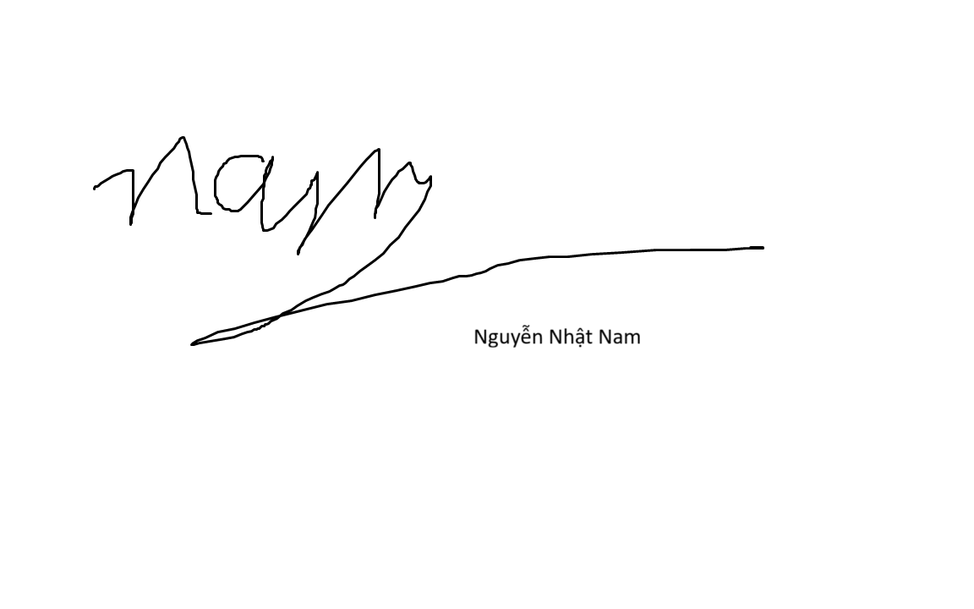
23127066 | Nguyễn Bách Khoa | 20% | 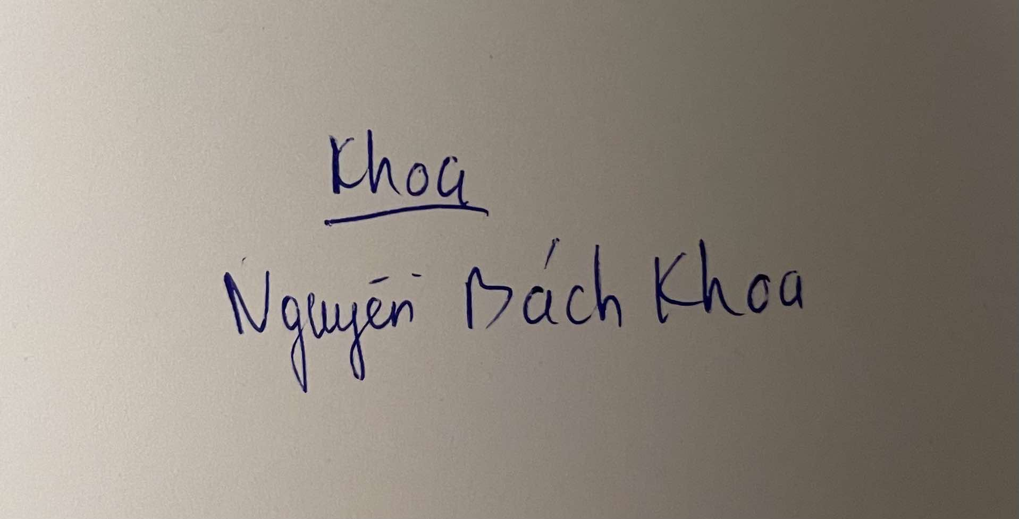
23127120 | Trần Danh Thiện | 20% | 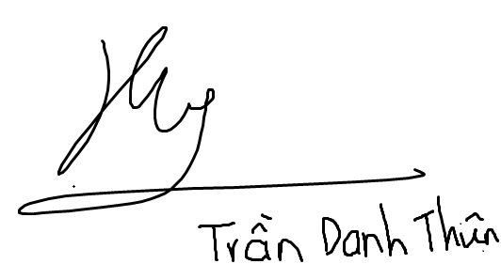
23127138 | Phan Trung Tuấn | 20% | 
23127530 | Trương Quang Huy | 20% | 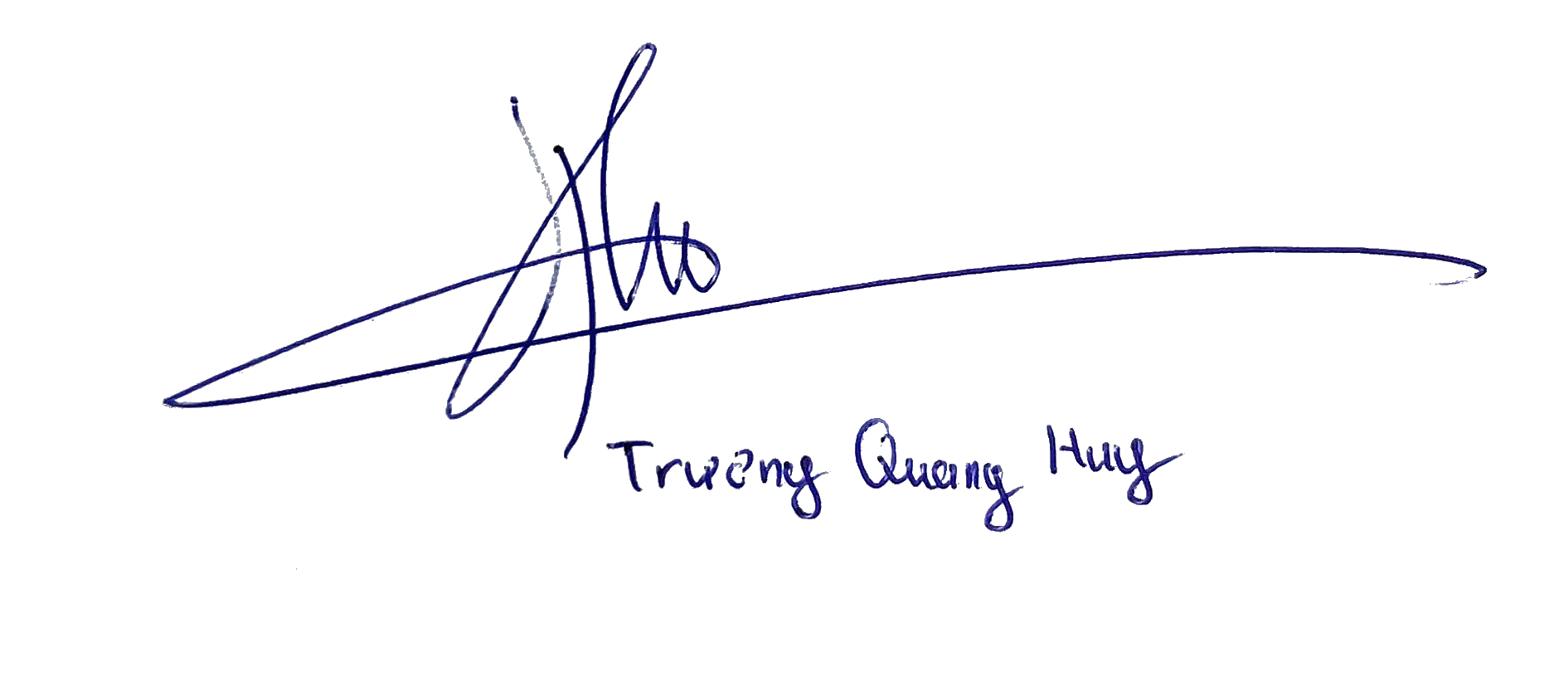

Problem Statement
In the rapidly evolving landscape of artificial intelligence, large language models (LLMs) such as OpenAI's GPT series or Google's Gemini have revolutionized how businesses and individuals interact with technology. These models excel in general-purpose tasks, generating human-like responses across a wide array of queries. However, their inherent limitation lies in their training on public datasets, which excludes proprietary or organization-specific information. For instance, a company's internal policies, product manuals, customer data, or specialized knowledge bases remain inaccessible to these off-the-shelf models. This gap creates significant challenges for enterprises seeking to leverage AI for tailored applications, such as automated customer support, internal Q&A systems, or domain-specific advisory tools.
Businesses, particularly Small and Medium-sized Businesses (SMBs), and non-technical users face a pressing need to customize AI models with their own data. Traditional approaches require "training" or fine-tuning LLMs, but this process demands substantial expertise in machine learning, data processing, and infrastructure management. Building a Retrieval-Augmented Generation (RAG) system from scratch involves multiple complex steps: ingesting documents, splitting text into chunks, generating embeddings using AI APIs, storing vectors in specialized databases, and integrating retrieval mechanisms with LLM queries. These technical barriers not only increase development time—often spanning months—but also escalate costs through hiring specialized talent or investing in cloud resources. As a result, many organizations are deterred from adopting AI, leading to missed opportunities for efficiency gains and competitive advantages.
The core problem this project addresses is the democratization of AI customization. Without accessible tools, only large enterprises with dedicated AI teams can deploy knowledge-aware chatbots, leaving SMBs and individuals reliant on generic solutions that fail to provide accurate, context-specific responses. For example, a small e-commerce business might need a chatbot trained on its product catalog and FAQs to handle customer inquiries effectively, but the lack of no-code/low-code platforms makes this infeasible. This issue is exacerbated by the fragmented AI ecosystem, where users must navigate multiple provider APIs (e.g., OpenAI, Google, Anthropic) and manage security concerns like data privacy and authentication.
To solve this, the proposed "AI-CaaS" (Chatbot-as-a-Service) platform offers a centralized web application that abstracts away the underlying complexities. Users—ranging from business owners to individual developers—need only provide a system prompt (defining the bot's role and task) and upload knowledge documents (e.g., PDFs, text files). The platform handles the rest: integrating with various LLM APIs for generation, executing the RAG pipeline for document processing and retrieval, managing user authentication, and enabling bot sharing. This approach reduces deployment time from months to minutes, making advanced AI accessible to non-experts. By focusing on a web-based interface, the platform ensures scalability and ease of use, aligning with modern digital workflows.

Operating Environment
The AI-CaaS platform is designed to operate in a standard web ecosystem, ensuring compatibility and performance across diverse user devices.
- Client-Side: The application will run on any modern web browser that supports HTML5, CSS3, and JavaScript (ES6+). Recommended browsers include Google Chrome (version 90+), Mozilla Firefox (version 88+), Microsoft Edge (version 91+), and Safari (version 14+). No additional plugins or software installations are required for end-users, as the frontend leverages Next.js for responsive, interactive experiences. This setup supports desktop, tablet, and mobile devices, with a minimum screen resolution of 1024x768 for optimal usability.
- Server-Side:
  - Web Server: Nginx (version 1.18+) is preferred for handling HTTP/HTTPS requests, serving static files, and acting as a reverse proxy. It provides high performance, load balancing, and security features like SSL termination.
  - Application Server: The backend logic will be hosted on Uvicorn (version 0.15+), an ASGI server optimized for asynchronous Python applications built with FastAPI. This ensures efficient API handling for real-time operations like chat interactions.
  - Database Server: PostgreSQL (version 15+) with the pgvector extension (version 0.4+) will store both relational data (e.g., user profiles, bot configurations) and vector embeddings. The server requires a minimum of 4GB RAM and SSD storage for low-latency queries, scalable to handle growing data volumes.
The system assumes a stable internet connection (minimum 5 Mbps download/upload) for API calls to external LLM providers. Deployment can occur on cloud platforms like AWS, Azure, or Heroku, with containerization via Docker for portability.

Design and Implementation Constraints
To ensure robustness, maintainability, and alignment with industry standards, the project adheres to the following constraints:
- Programming Languages:
  - Backend: Python 3.10+ is mandatory, leveraging its extensive AI/ML libraries (e.g., LangChain or LlamaIndex for RAG pipelines, OpenAI and Google APIs for LLM integration).
  - Frontend: JavaScript (ES6+) or TypeScript for enhanced type safety and scalability.
- Frameworks and Libraries:
  - Backend: FastAPI for API development, chosen for its async capabilities, automatic documentation, and high throughput.
  - Frontend: Next.js for building the user interface, supporting server-side rendering (SSR), static site generation (SSG), and client-side interactivity.
  - Database: PostgreSQL with pgvector to unify relational and vector data storage, simplifying architecture and reducing overhead.
  - AI Integration: LangChain or LlamaIndex to manage the RAG workflow, including text splitting, embedding generation, and context retrieval.
  - Authentication: JSON Web Tokens (JWT) for secure session management and API protection.
- Documentation and Standards:
  - All Python code must follow PEP 8 style guidelines, with comprehensive Docstrings for functions and modules.
  - Frontend code will adhere to ESLint rules for consistency and error prevention.
  - Analysis and design documents (e.g., SRS, SDD) will be completed in subsequent phases, using tools like draw.io for diagrams.
  - Version control via GitHub, with commit messages following conventional commits (e.g., "feat: add bot creation endpoint").
These constraints, derived from the project's academic scope, prioritize efficiency and future extensibility while minimizing complexity. For instance, using PostgreSQL with pgvector avoids the need for separate vector databases like Pinecone, reducing costs and integration points. Overall, this setup ensures the platform can handle core functionalities like chatbot creation and knowledge ingestion while remaining adaptable to advanced features in future iterations.

Requirements Overview

Stakeholders
Based on the AI-CaaS (Chatbot-as-a-Service) system context, the following table lists the key stakeholders and their roles:

STT | Stakeholder | Description
1 | Project Sponsor | The course instructor who defines the project scope, evaluates the final deliverables, and approves the SRS document.
2 | Bot Owner | A registered user who creates chatbots, purchases credits, uploads knowledge base documents (PDF/TXT), and manages bot sharing permissions.
3 | Registered User | An end-user (or employee) who logs in to interact with chatbots or submit support tickets. They may use their own bots or bots shared with them.
4 | Guest | An unauthenticated user who can only access the landing page, view system information, and perform registration or login actions.

Requirements
The functional requirements are categorized into four main modules based on the system's core operations:

Functional Requirements Specification
3.2.1.1. Authentication and Account Management
This module handles user entry, security, and session management within the system.
- The system shall allow Guests to register for a new account by providing a valid Email, Full Name, and Password.
- The system shall allow registered users to log in using their credentials (email and password).
- The system must manage user sessions securely using JSON Web Tokens (JWT), allowing users to remain logged in until expiration or manual logout.
- The system shall allow users to log out, terminating their current session token immediately.
3.2.1.2. Chatbot Management and RAG Pipeline
This module covers the core business logic regarding chatbot creation and document processing.
- The system shall allow Bot Owners to create a new chatbot by defining a Bot Name, Description, and System Prompt (Persona).
- The system shall automatically deduct a specific amount of credits (fee) from the Bot Owner's account balance upon the successful creation of a bot.
- The system shall allow Bot Owners to upload knowledge base documents in PDF or TXT formats (maximum 50MB per file).
- The system must automatically process uploaded documents using a Retrieval-Augmented Generation (RAG) pipeline, which includes text chunking, embedding generation, and storage in a vector database.
- The system shall provide a dashboard for Bot Owners to view the status of their bots and update or delete associated knowledge documents.
3.2.1.3. Interaction and Sharing
This module manages the chat interface and the sharing permissions between users.
- The system shall allow users to select a specific chatbot (either owned by them or shared with them) to initiate a conversation.
- The system shall generate AI responses to user queries based on the specific context retrieved from the selected bot's Knowledge Base.
- The system must calculate and deduct a usage fee from the user's balance for every message sent to the AI.
- The system shall allow Bot Owners to share access rights to their chatbots with other registered users via email address.
- The system shall allow Invited Users to view and interact with bots shared with them in a dedicated "Shared with Me" section (Read/Use access only).
3.2.1.4. Support System
This module ensures users can report issues and receive automated or manual assistance.
- The system shall allow Registered Users to create Support Tickets containing a Subject and a detailed Description of the issue.
- The system shall utilize an internal AI Agent to analyze incoming tickets and post an immediate automated response or solution based on the support knowledge base.
- The system shall allow users to track the status of their tickets (Pending, Responded, Closed) and view the entire conversation history.

Non-Functional Requirements Specification
3.2.2.1. Performance Requirements
- AI Response Latency: The AI Chatbot must generate the first token of a response within 3 to 5 seconds under standard network conditions.
- Authentication Speed: The system must complete user login and authentication processes within 2 seconds.
- Document Processing Time: The processing of uploaded knowledge documents (files under 10MB) must be completed within 1 minute to ensure the bot is ready for use quickly.
3.2.2.2. Security Requirements
- Password Encryption: All user passwords must be hashed and salted before storage in the database to prevent unauthorized access.
- Data Transmission Security: All data transmission between the client and the server must be encrypted using the HTTPS (TLS/SSL) protocol.
- Malware Scanning: The system must scan all uploaded files for malware or malicious code before processing them in the RAG pipeline.
- Data Isolation: The system must enforce strict data isolation; a chatbot must only retrieve context from its own assigned Knowledge Base, ensuring no data leakage between different users.
3.2.2.3. Reliability and Availability
- System Uptime: The system shall operate with a target availability of 99% uptime during business hours.
- Atomic Transactions: Financial transactions (such as credit deduction for bot creation or messaging) must be atomic; the system must ensure that either the action completes fully or not at all to prevent data inconsistency.
3.2.2.4. Scalability and Environment
- Interface Responsiveness: The user interface must be responsive and fully functional across modern web browsers (Chrome, Edge, Firefox, Safari) on Desktop, Tablet, and Mobile devices.
- Containerization: The backend architecture must be containerized (e.g., using Docker) to allow for horizontal scaling and easy deployment on cloud platforms.

Requirements Analysis

Use Case model
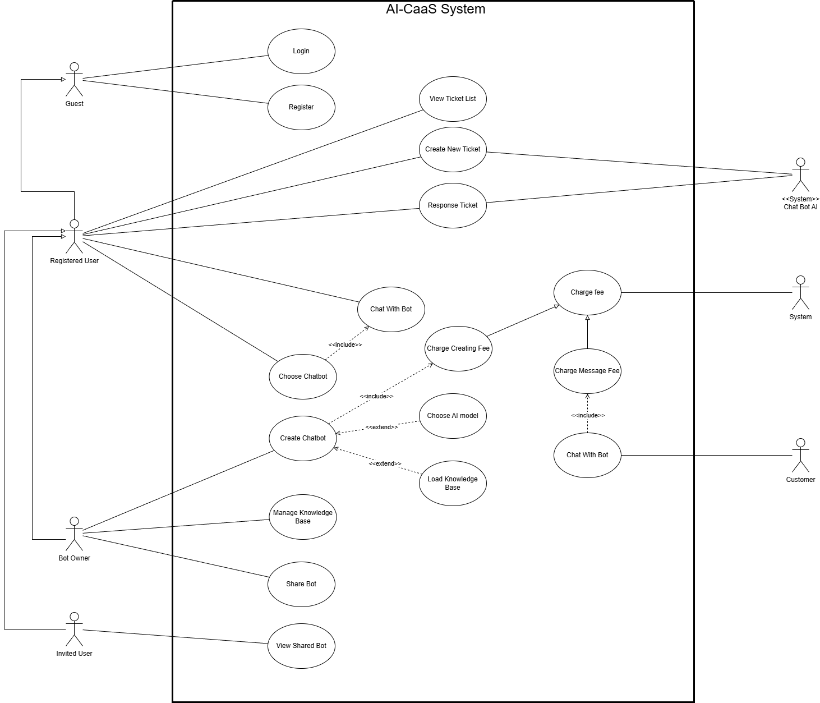

Use Case Specification

Use Case 1

Use case ID | U001
Use Case | Login
Brief Description | Describes how a Guest authenticates into the system to gain Registered User privileges.
Actor | Guest (Primary)
Pre-Condition | 1. User must have a valid account (via Register).  2. User is currently logged out.
Result | Success: User is authenticated and redirected to the dashboard.  Failure: User remains on the login screen with an error message.
Main Scenario | 1. Guest navigates to the login screen.  2. Guest enters Username and Password.  3. Guest clicks "Login".  4. System validates credentials against the database.  5. System confirms validity.  6. System grants access and redirects the user.
Alternative Scenarios | A. Invalid Credentials: In Step 4, if data does not match, System displays "Invalid username or password".  B. Empty Fields: If fields are blank, System prompts "Please fill in all required fields".
Non-Functional Constraints | 1. Security: Passwords must be hashed before storage and transmitted over HTTPS.  2. Performance: Login validation must complete within 2 seconds.  3. Usability: Error messages must be generic to prevent user enumeration attacks.
4.2.2. Use case 2

Use case ID | U002
Use Case | Register
Brief Description | Allows a Guest to create a new account to use the AI-CaaS services.
Actor | Guest
Pre-Condition | User does not have an account.
Result | A new account is created in the database
Main Scenario | 1. Guest selects "Register".  2. Guest enters personal details (Email, Name, Password).  3. System validates input format.  4. System saves the new account and confirms success.
Alternative Scenarios | A. Account Exists: System reports "Email already in use".
Non-Functional Constraints | 1. Security: Passwords must meet complexity rules (min 8 chars, 1 special char).  2. Data Integrity: Email addresses must be unique within the system.  3. Privacy: User personal data must be stored in compliance with data protection regulations (e.g., GDPR).
4.2.3. Use case 3

Use case ID | U003
Use Case | Create Chatbot
Brief Description | Allows a Bot Owner to configure, pay for, and create a new chatbot instance
Actor | Bot Owner
Pre-Condition | User is logged in as a Bot Owner.
Result | A new chatbot is created, and the fee is deducted.
Main Scenario | 1. Bot Owner inputs Bot Name/Description.  2. System executes Charge Creating Fee.  3. System saves the Chatbot and notifies the user.
Alternative Scenarios | A. Choose AI Model: Owner selects specific model.  B. Load Knowledge Base: Owner uploads training data.
Non-Functional Constraints | 1. Reliability: The payment deduction and bot creation must be an atomic transaction (both succeed or both fail).  2. Performance: Knowledge base upload should support files up to 50MB.  3. Security: Uploaded files must be scanned for malware before processing.
4.2.4. Use case 4

Use case ID | U004
Use Case | Chat with Bot
Brief Description | A user interacts with the AI. The system charges a fee per message.
Actor | Registered User / Customer, System, Chat Bot AI
Pre-Condition | Chatbot is active and user has sufficient balance (if applicable).
Result | Message processed, fee charged, response displayed.
Main Scenario | 1. User sends a message.  2. System executes Charge Message Fee.  3. Chat Bot AI generates a response.  4. System displays the response.
Alternative Scenarios | A. Insufficient Funds: System denies the message.
Non-Functional Constraints | 1. Performance: The AI should generate a response within 3-5 seconds.  2. Scalability: System must support concurrent chats without degradation.  3. Accuracy: Billing for messages must be precise and recorded in real-time logs.
4.2.5. Use case 5

Use case ID | U005
Use Case | Create new ticket
Brief Description | Allows a user to submit a support request or report an issue to the system. The request is processed by the system or the Support Chat Bot AI.
Actor | Registered User, Chat Bot AI (Support System)
Pre-Condition | 1. User must be logged into the system.  2. The Ticket System service must be active.
Result | Success: A new ticket is created, saved in the database with a "Pending" status.  Failure: No ticket is created; an error message is displayed.
Main Scenario | 1. Registered User navigates to the ticket list and selects "Create New Ticket".  2. System displays the ticket creation form.  3. Registered User enters the Ticket Subject and Description.  4. Registered User clicks the "Submit" button.  5. System sends the data to the Chat Bot AI for initial classification.  6. System saves the ticket to the database and generates a unique Ticket ID.  7. System displays a "Success" message and shows the ticket details.
Alternative Scenarios | A. Missing Information:  - In Step 4, if the user leaves the Subject or Description blank.  - System displays an error: "Please fill in all required fields."  - System retains the entered text so the user can complete the form.  B. User Cancellation:  - At any point before Step 4, if the user clicks "Cancel".  - System discards the input and returns the user to the Ticket List screen.  C. System Connection Error:  - In Step 6, if the system fails to save the data due to a database error.  - System displays an error: "Unable to create ticket at this time. Please try again later."
Non-Functional Constraints | 1. Availability: The ticketing service must be available 24/7.  2. Traceability: Every ticket must have a unique ID that never repeats.  3. Capacity: The Description field supports a maximum of 2000 characters.  4. Response Time: The system must confirm the ticket creation (success or failure) within 2 seconds.
4.2.6. Use case 6

Use case ID | U006
Use Case | Share bot
Brief Description | Allows a Bot Owner to grant access rights of a specific Chatbot to another user (Invited User).
Actor | Bot Owner
Pre-Condition | 1. Bot Owner is logged in.  2. The Chatbot to be shared is active.
Result | Success: The Invited User is granted access to the bot.  Failure: Access is not granted; error message displayed.
Main Scenario | 1. Bot Owner navigates to the "My Bots" dashboard.  2. Bot Owner selects a specific bot and clicks "Share".  3. System displays a dialog requesting the recipient's email.  4. Bot Owner enters the email of the Invited User.  5. System validates that the email exists in the database.  6. System records the permission and sends a notification to the Invited User.  7. System confirms "Bot shared successfully".
Alternative Scenarios | A. User Not Found:  - In Step 5, if the email does not belong to a registered user.  - System displays: "User not found. Please check the email address."
Non-Functional Constraints | 1. Security: Only the creator (Owner) of the bot can initiate sharing.  2. Real-time: The Invited User should receive access immediately after the confirmation.
4.2.7. Use case 7

Use case ID | U007
Use Case | View shared bot
Brief Description | Allows an Invited User to view and access chatbots that have been shared with them by other owners.
Actor | Invited User
Pre-Condition | User is logged in and has been invited to at least one bot.
Result | A list of shared bots is displayed.
Main Scenario | 1. Invited User navigates to the "Shared with Me" section.  2. System queries the database for bots linked to this user's account via sharing permissions.  3. System displays the list of bots (Name, Description, Owner Name).  4. Invited User clicks on a bot to view details or start chatting.
Alternative Scenarios | A. No Shared Bots:  - If the list is empty.  - System displays: "No bots have been shared with you yet."
Non-Functional Constraints | 1. Access Control: The Invited User must have "Read/Use" permissions only, not "Edit/Delete" permissions.creation (success or failure) within 2 seconds.
4.2.8. Use case 8

Use case ID | U008
Use Case | Manage knowledge base
Brief Description | Allows the Bot Owner to update, add, or delete the training data/documents for an existing chatbot.
Actor | Bot Owner
Pre-Condition | Bot Owner is logged in and managing a specific bot.
Result | The bot's knowledge base is updated and the AI model is retrained (if necessary)..
Main Scenario | 1. Bot Owner selects the "Knowledge Base" tab for a bot.  2. System displays the current list of uploaded files/text.  3. Bot Owner uploads a new document or deletes an old one.  4. System scans the file for validity and security.  5. System processes the data and updates the vector database.  6. System displays "Knowledge Base updated".
Alternative Scenarios | A. Invalid File Type:  - In Step 3, if the user uploads an unsupported format (e.g., .exe).  - System rejects the file and shows "Invalid file format. Please upload PDF or TXT."
Non-Functional Constraints | 1. Performance: File processing should not take longer than 1 minute for files under 10MB.  2. Availability: The bot should remain active for chatting while the knowledge base is updating in the background.
4.2.9. Use case 9

Use case ID | U009
Use Case | View ticket list
Brief Description | Allows a Registered User to view a history of their support tickets and their current status.
Actor | Registered User
Pre-Condition | User is logged in.
Result | A list of support tickets is displayed.
Main Scenario | 1. Registered User navigates to the "Support" or "My Tickets" page.  2. System retrieves all tickets associated with the user ID.  3. System displays the list sorted by date (newest first).  4. Registered User clicks on a ticket to view the conversation/response.
Alternative Scenarios | A. List Empty:  - System displays "You have no support tickets." and offers a button to "Create New Ticket".
Non-Functional Constraints | 1. Privacy: Users can only see their own tickets.  2. UI/UX: Status tags (Open, Closed, Pending) should be color-coded for easy recognition.
4.2.10. Use case 10

Use case ID | U010
Use Case | Choose chatbot
Brief Description | Allows a user to select a specific chatbot from a list to begin an interaction.
Actor | Registered User
Pre-Condition | User is logged in and has access to at least one bot (Created or Shared).
Result | The chat interface for the selected bot is loaded.
Main Scenario | 1. Registered User views the dashboard containing available bots.  2. Registered User clicks on a Bot card.  3. System validates access rights.  4. System loads the chat history and input interface for that specific bot.  5. System initiates the Chat With Bot use case.
Alternative Scenarios | A. Bot Disabled:  - If the selected bot has been disabled by the admin or owner.  - System displays: "This bot is currently unavailable."
Non-Functional Constraints | 1. Latency: The switch between the list view and the chat interface should be under 1 second.
4.2.11. Use case 11

Use case ID | U011
Use Case | Response Ticket
Brief Description | The System (via Chat Bot AI) analyzes a new support ticket and provides an automated response or solution.
Actor | Chat Bot AI (System Agent)
Pre-Condition | A new ticket has been created with status "Pending".
Result | The ticket receives a reply and status is updated.
Main Scenario | 1. System detects a new ticket submission.  2. Chat Bot AI reads the Subject and Description.  3. Chat Bot AI searches the support knowledge base for relevant solutions.  4. Chat Bot AI generates a response.  5. System posts the response to the ticket thread.  6. System updates ticket status to "Responded" and notifies the user.
Alternative Scenarios | A. Low Confidence:  - If the AI cannot determine a solution (Confidence score < 50%).  - Chat Bot AI responds: "We have received your request. A human agent will review it shortly."  - System flags the ticket for manual review.
Non-Functional Constraints | 1. Timing: Automated responses must be generated within 5 minutes of ticket creation.  2. Tone: The AI response must be polite and professional.

Prototype/Mockup
5.1 Introduce this part.
This section presents the user interface design (UI Prototype/Mockup) of the AI-CaaS system. The mockups are built based on the Functional Requirements stated in section 4, ensuring an intuitive description of the main user operations when using the system.
5.2 List of interface screens.
STT | Screen Name | Goal
1 | Login Page | Log in to the system
2 | Register Page | Register an account
3 | Dashboard | View and manage bots
4 | Create Bot Page | Create new chatbot
5 | Knowledge Upload Page | Upload documents to the Knowledge Base
6 | Chat Interface | Chat với bot
7 | Share Bot Page | Invite other users to use the bot

5.3 Detailed mockups of each screen.
5.3.1 Login Page.
5.3.1.1 Goal.
This screen allows users to log in with their email and password to access the Dashboard. This is the first step in the system usage flow.
5.3.1.2 Main interface components.
- Email Input Box
- Password Input Box
- “Login” Button
- “Sign up” Link
5.3.1.3 Interface mockup.
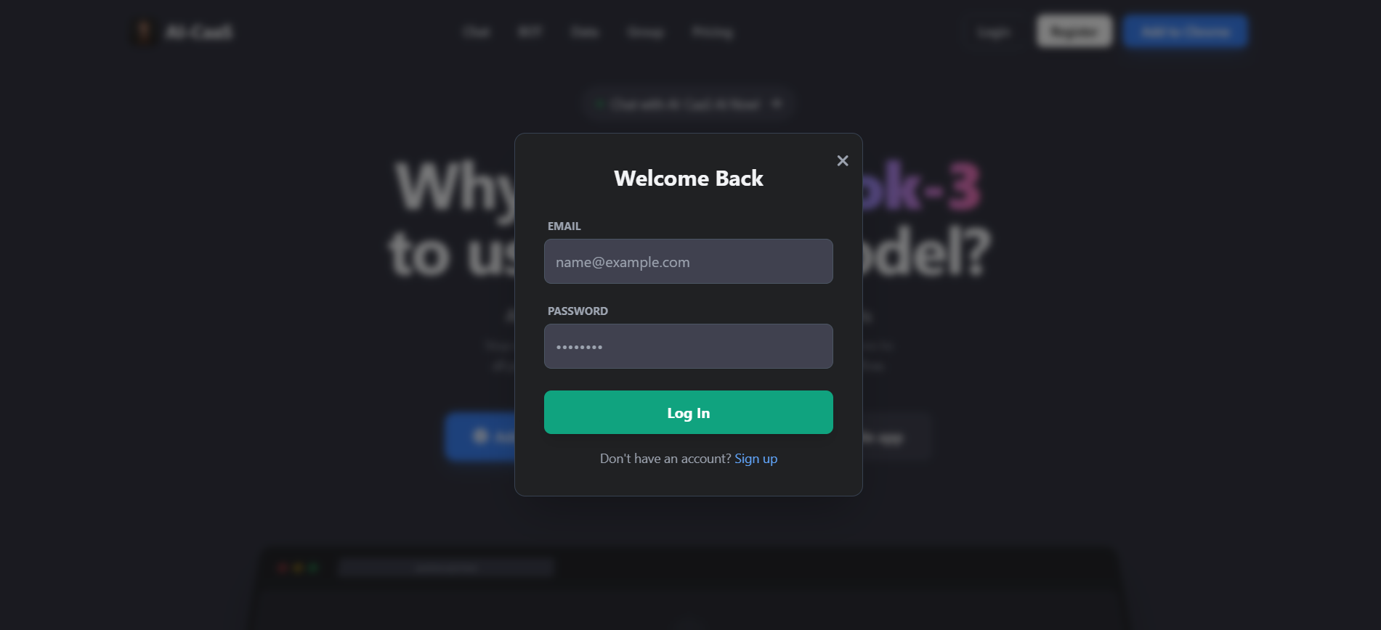
5.3.2 Register Page.
5.3.1.1 Goal.
The Register (Create Account) screen allows new users to create an account to access the AI-CaaS system. This is the first step in the entire flow, allowing users to register with an email and password. After successful registration, users will be able to log in, create chatbots, upload documents and use the platform's features.
5.3.1.2 Main interface components.
- Email Input Box
- Password Input Box
- “Sign up” Button
- “Log in” Link
5.3.1.3 Interface mockup.
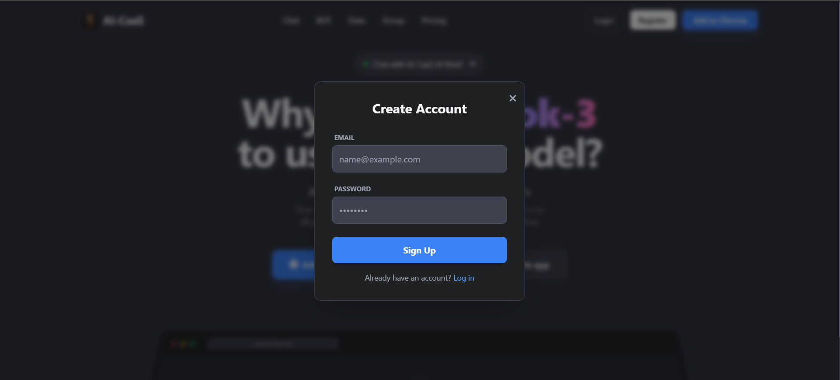
5.3.3 Dashboard.
5.3.1.1 Goal.
- User Acquisition: Appeal to cost-saving psychology.
- Value Comparison: Claim that using this service is cheaper and more versatile (access to all AI models) than competitors (only 1 expensive model).
- Conversion: Encourage users to install Extension or App immediately.
5.3.1.2 Main interface components.
- Header: Logo, Navigation Menu and Login/Register button.
- Headline: Large headline directly comparing with the opponent (Grok-3).
- Sub-text: Value promise (1 low price - All models).
- CTA Buttons: 2 action buttons (Add to Chrome and Download App).
5.3.1.3 Interface mockup.
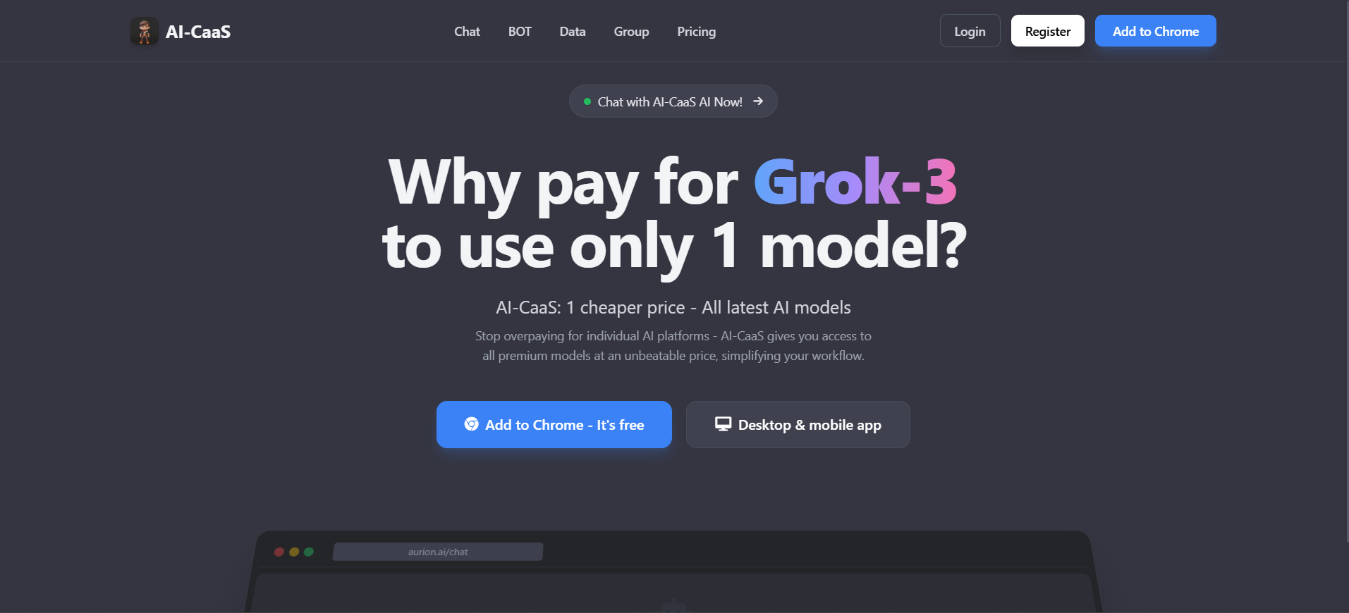
5.3.4 Create Bot Page.
5.3.1.1 Goal.
- Management: This is the list page to manage the created Bots as well as create bots.
- Action Navigation (Empty State): Since there is no data yet, the main purpose of this screen is to encourage users to
5.3.1.2 Main interface components.
- Header: Title of the "Bots" page.
- Toolbar: Includes Search bar and Filter (Filter "All Bots") for manipulation when there is a lot of data.
- Primary CTA: The most prominent blue "+ Create Bot" button, located in the right corner.
- Notification Area (Empty State Area): Located in the middle, it includes an illustrated icon (binoculars), a message line "No bots found" and text instructing the user to click the create button to start.
5.3.1.3 Interface mockup.
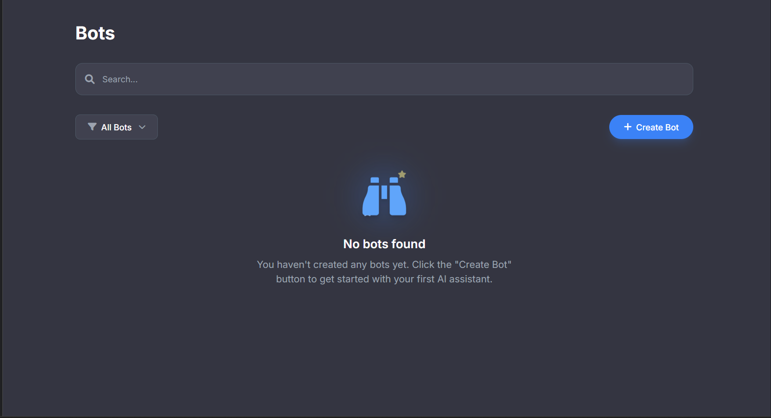
5.3.5 Knowledge Upload Page.
5.3.1.1 Goal.
- Resource Management: A place to store and manage data/knowledge (Knowledge Base) that users input into the Bot.
- Empty State: Similar to the previous screen, the main purpose when there is no data is to encourage users to add new data so that the system can operate.
5.3.1.2 Main interface components.
- Header: The title of the "Knowledge Base" page.
- Search Bar: A long input bar that takes up most of the horizontal space to search for content (Note: This screen does not have a Filter button like the Bots screen).
- Primary CTA: The blue "+ Create Knowledge" button in the right corner.
5.3.1.3 Interface mockup.
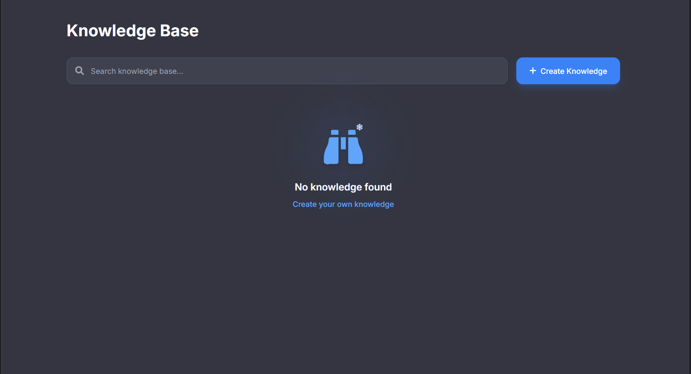
5.3.6 Chat Interface.
5.3.1.1 Goal.
- Core Interaction: This is the main workspace where users chat and give commands to the AI.
- Conversion & Retention: Since this appears to be an interface for non-logged-in or free users, the important goal is to drive sign-ups/upgrades via a large banner in the middle of the screen.
- Activation: Prompts help new users know what to ask to get started right away.
5.3.1.2 Main interface components.
- Greeting Section
- Conversion Card (Most Prominent): The center notification block invites you to create an account or upgrade to a Pro plan, with two clear action buttons ("Sign in Now" and the blue "Start Free Trial" button).
- Model Selector: Model selection menu (GPT-4o mini).
- Toolbar: Hàng loạt icon tiện ích (đính kèm file, web search, vẽ, v.v.).
- Quick Action: "+ Create Bot" button.
- Suggestion Bar: A line suggesting sample commands ("Gains Profile Analysis") for users to try right away.
5.3.1.3 Interface mockup.
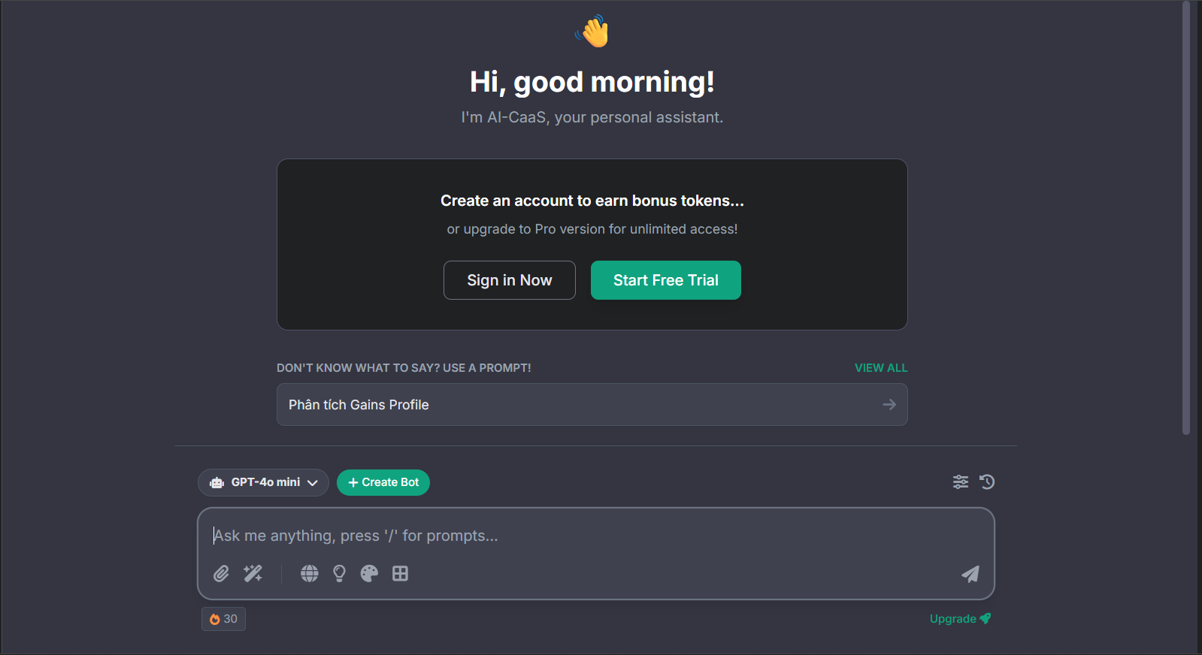
5.3.7 Share Bot Page.
5.3.1.1 Goal.
- Collaboration & Access Control: This is the center for managing resource sharing. The main purpose is to group users together to grant specific Bot access, instead of having to manually share to each person.
- Organization: Helps administrators organize the order of teams/departments in the system.
- Encourage setup: Since there are no groups yet, the centralized interface encourages users to create their first group.
5.3.1.2 Main interface components.
- Header & Sub-header: The large title followed by a small description line ("Organize your group and manage shared access...") helps users immediately understand the purpose of this screen is to share access.
- Search Bar: Group search tool (with prominent blue border).
- Primary CTA: The blue "+ Create Group" button in the right corner.

5.3.1.3 Interface mockup.
