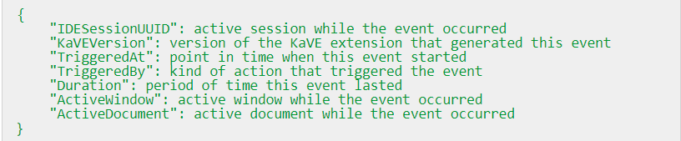

Each .zip contains all events that have been shared by the same user. The folder name is the date on which the user shared data with us for the first time

IDESessionUUID: generated once per day and group all events of that day together and bring them in a logical context.

KaVEVersion: KaVE is added to Visual Studio as an extension. Therefore, this shows the version of the extension that generates the event

**CURRENT EVENT**

**ACTIVITY EVENT**: no specific content, whenever user is active in IDE

Events170301/2017-02-24/0/1.json

{"$type":"KaVE.Commons.Model.Events.**ActivityEvent**, KaVE.Commons","IDESessionUUID":"d008680e-c4ba-4183-a50a-f23e88bbe801","KaVEVersion":"0.1015-Default","TriggeredAt":"2016-12-25T16:07:23.894606+01:00","**TriggeredBy":1**,"Duration":"00:00:25.3132161","ActiveWindow":"0Win:vsWindowTypeToolWindow Start Page"}

**COMMAND EVENT**: triggered whenever action is invoked: click a button, press shortcut

Events170301/2017-02-24/0/1774.json

{"$type":"KaVE.Commons.Model.Events.**CommandEvent**, KaVE.Commons","**CommandId**":"**VsAction:1:Edit.CharLeft**","IDESessionUUID":"8f80a55a-0eb6-4ff7-ac07-303dc1214f63","KaVEVersion":"0.1015-Default","TriggeredAt":"2017-02-23T19:19:24.6770435+01:00","TriggeredBy":0,"ActiveWindow":"0Win:vsWindowTypeDocument main.c","ActiveDocument":"0Doc:C/C++ \\Project1\\main.c"}

**CommandID**: determine the action that trigger this event. In this case is user hitting the left arrow button

**IDE STATE EVENT:** represent user actions to change work environments: rearrange windows, open new view

{"$type":"KaVE.Commons.Model.Events.VisualStudio.**IDEStateEvent**, KaVE.Commons","**IDELifecyclePhase**":0,"OpenWindows":["0Win:vsWindowTypeToolWindow Start Page"],"OpenDocuments":[],"IDESessionUUID":"d008680e-c4ba-4183-a50a-f23e88bbe801","KaVEVersion":"0.1015-Default","TriggeredAt":"2016-12-25T16:07:24.0263557+01:00","TriggeredBy":0,"Duration":"00:00:00.0156264","ActiveWindow":"0Win:vsWindowTypeToolWindow Start Page"}

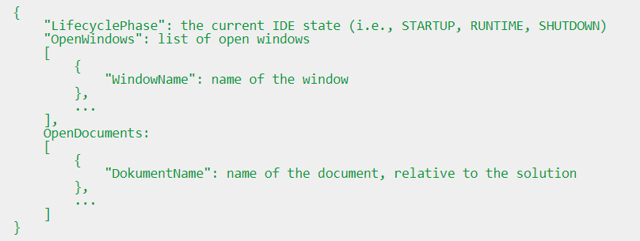

**WINDOW EVENT**



**Example:**

Events170301/2017-02-24/0/3.json

{"$type":"KaVE.Commons.Model.Events.VisualStudio.**WindowEvent**, KaVE.Commons","**Window**":"0Win:main Microsoft Visual Studio","**Action**":1,"IDESessionUUID":"d008680e-c4ba-4183-a50a-f23e88bbe801","KaVEVersion":"0.1015-Default","TriggeredAt":"2016-12-25T16:07:24.9123042+01:00","TriggeredBy":0,"Duration":"00:00:00","ActiveWindow":"0Win:vsWindowTypeToolWindow Start Page"}

**COMPLETION EVENT**

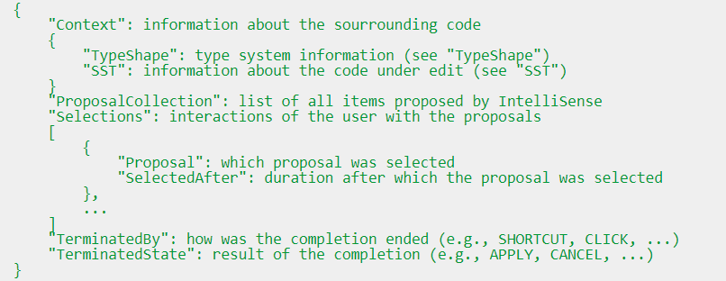

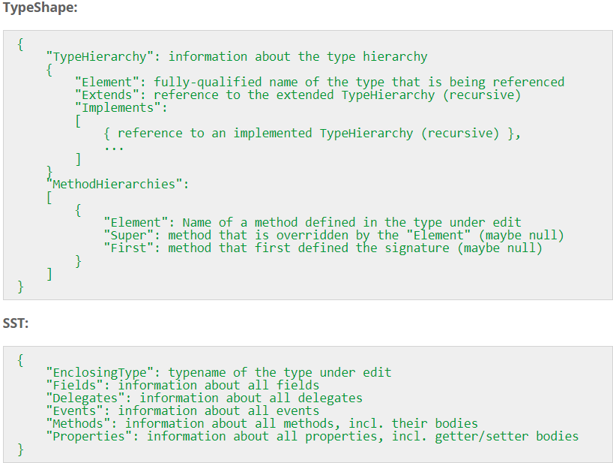

**Example:**

Events-170301/2016-05-09/10.zip 63887.json {'$type': 'KaVE.Commons.Model.Events.CompletionEvents.**CompletionEvent**, KaVE.Commons', '**Context2**': {'$type': 'KaVE.Commons.Model.Events.CompletionEvents.**Context**, KaVE.Commons', '**TypeShape'**: {'$type': 'KaVE.Commons.Model.TypeShapes.**TypeShape**, KaVE.Commons', '**TypeHierarchy**': {'$type': 'KaVE.Commons.Model.TypeShapes.**TypeHierarchy**, KaVE.Commons', '**Element**': '0T:FireHoseLoader.Program, FireHoseLoader', '**Implements**': []}, '**NestedTypes**': [], '**Delegates**': [], '**EventHierarchies**': [], '**Fields**': [], '**MethodHierarchies**': [{'$type': 'KaVE.Commons.Model.TypeShapes.**MethodHierarchy**, KaVE.Commons', '**Element**': **'0M:static [p:void] [FireHoseLoader.Program, FireHoseLoader].Main([p:string[]] args)'**}, {'$type': 'KaVE.Commons.Model.TypeShapes.**MethodHierarchy**, KaVE.Commons', '**Element**': '0M:static [i:System.Collections.Generic.IEnumerable`1[[T -> p:string]], mscorlib, 4.0.0.0] [FireHoseLoader.Program, FireHoseLoader].GetLines([p:string] filename)'}], '**PropertyHierarchies**': []}, '**SST**': {'$type': '[SST:SST]', '**EnclosingType**': '0T:FireHoseLoader.Program, FireHoseLoader', '**Fields**': [], '**Properties**': [], '**Methods**': [{'$type': '[SST:Declarations.**MethodDeclaration**]', '**Name**': '0M:static [p:void] [FireHoseLoader.Program, FireHoseLoader].Main([p:string[]] args)', '**IsEntryPoint**': True, '**Body**': [{'$type': '[SST:Statements.**ExpressionStatement**]', '**Expression'**: {'$type': '[SST:Expressions.Assignable.**InvocationExpression**]', '**Reference**': {'$type': '[SST:References.**VariableReference**]', '**Identifier**': ''}, '**MethodName**': **'0M:static [p:void] [System.Console, mscorlib, 4.0.0.0].WriteLine([p:string] value)'**, '**Parameters**': [{'$type': '[SST:Expressions.Simple.UnknownExpression]'}]}}, {'$type': '[SST:Statements.VariableDeclaration]', 'Reference': {'$type': '[SST:References.VariableReference]', 'Identifier': 'credentials'}, 'Type': '0T:Amazon.Runtime.StoredProfileAWSCredentials, AWSSDK.Core, 3.1.0.0'}, {'$type': '[SST:Statements.Assignment]', 'Reference': {'$type': '[SST:References.VariableReference]', 'Identifier': 'credentials'}, 'Expression': {'$type': '[SST:Expressions.Assignable.InvocationExpression]', 'Reference': {'$type': '[SST:References.VariableReference]', 'Identifier': ''}, 'MethodName': '0M:[p:void] [Amazon.Runtime.StoredProfileAWSCredentials, AWSSDK.Core, 3.1.0.0]..ctor([p:string] profileName)', 'Parameters': [{'$type': '[SST:Expressions.Simple.ConstantValueExpression]'}]}}, {'$type': '[SST:Statements.VariableDeclaration]', 'Reference': {'$type': '[SST:References.VariableReference]', 'Identifier': 'cli'}, 'Type': '0T:Amazon.KinesisFirehose.AmazonKinesisFirehoseClient, AWSSDK.KinesisFirehose, 3.1.0.0'}, {'$type': '[SST:Statements.Assignment]', 'Reference': {'$type': '[SST:References.VariableReference]', 'Identifier': 'cli'}, 'Expression': {'$type': '[SST:Expressions.Assignable.InvocationExpression]', 'Reference': {'$type': '[SST:References.VariableReference]', 'Identifier': ''}, 'MethodName': '0M:[p:void] [Amazon.KinesisFirehose.AmazonKinesisFirehoseClient, AWSSDK.KinesisFirehose, 3.1.0.0]..ctor([Amazon.Runtime.AWSCredentials, AWSSDK.Core, 3.1.0.0] credentials, [Amazon.RegionEndpoint, AWSSDK.Core, 3.1.0.0] region)', 'Parameters': [{'$type': '[SST:Expressions.Simple.ReferenceExpression]', 'Reference': {'$type': '[SST:References.VariableReference]', 'Identifier': 'credentials'}}, {'$type': '[SST:Expressions.Simple.ReferenceExpression]', 'Reference': {'$type': '[SST:References.FieldReference]', 'Reference': {'$type': '[SST:References.VariableReference]', 'Identifier': ''}, 'FieldName': '0F:static [Amazon.RegionEndpoint, AWSSDK.Core, 3.1.0.0] [Amazon.RegionEndpoint, AWSSDK.Core, 3.1.0.0].USEast1'}}]}}, {'$type': '[SST:Blocks.UsingBlock]', 'Reference': {'$type': '[SST:References.VariableReference]', 'Identifier': 'cli'}, 'Body': [{'$type': '[SST:Statements.VariableDeclaration]', 'Reference': {'$type': '[SST:References.VariableReference]', 'Identifier': 'putReq'}, 'Type': '0T:Amazon.KinesisFirehose.Model.PutRecordRequest, AWSSDK.KinesisFirehose, 3.1.0.0'}, {'$type': '[SST:Statements.Assignment]', 'Reference': {'$type': '[SST:References.VariableReference]', 'Identifier': 'putReq'}, 'Expression': {'$type': '[SST:Expressions.Assignable.InvocationExpression]', 'Reference': {'$type': '[SST:References.VariableReference]', 'Identifier': ''}, 'MethodName': '0M:[p:void] [Amazon.KinesisFirehose.Model.PutRecordRequest, AWSSDK.KinesisFirehose, 3.1.0.0]..ctor()', 'Parameters': []}}, {'$type': '[SST:Statements.Assignment]', 'Reference': {'$type': '[SST:References.PropertyReference]', 'Reference': {'$type': '[SST:References.VariableReference]', 'Identifier': 'putReq'}, 'PropertyName': '0P:set get [p:string] [Amazon.KinesisFirehose.Model.PutRecordRequest, AWSSDK.KinesisFirehose, 3.1.0.0].DeliveryStreamName()'}, 'Expression': {'$type': '[SST:Expressions.Simple.ConstantValueExpression]'}}, {'$type': '[SST:Statements.VariableDeclaration]', 'Reference': {'$type': '[SST:References.VariableReference]', 'Identifier': 'lineCount'}, 'Type': '0T:p:int'}, {'$type': '[SST:Statements.Assignment]', 'Reference': {'$type': '[SST:References.VariableReference]', 'Identifier': 'lineCount'}, 'Expression': {'$type': '[SST:Expressions.Simple.ConstantValueExpression]', 'Value': '0'}}, {'$type': '[SST:Statements.ExpressionStatement]', 'Expression': {'$type': '[SST:Expressions.Assignable.CompletionExpression]', 'TypeReference': '0T:System.Console, mscorlib, 4.0.0.0', 'Token': ''}}, {'$type': '[SST:Statements.VariableDeclaration]', 'Reference': {'$type': '[SST:References.VariableReference]', 'Identifier': '$0'}, 'Type': '0T:i:System.Collections.Generic.IEnumerable`1[[T -> p:string]], mscorlib, 4.0.0.0'}, {'$type': '[SST:Statements.Assignment]', 'Reference': {'$type': '[SST:References.VariableReference]', 'Identifier': '$0'}, 'Expression': {'$type': '[SST:Expressions.Assignable.InvocationExpression]', 'Reference': {'$type': '[SST:References.VariableReference]', 'Identifier': ''}, 'MethodName': '0M:static [i:System.Collections.Generic.IEnumerable`1[[T -> p:string]], mscorlib, 4.0.0.0] [FireHoseLoader.Program, FireHoseLoader].GetLines([p:string] filename)', 'Parameters': [{'$type': '[SST:Expressions.Simple.ConstantValueExpression]'}]}}, {'$type': '[SST:Blocks.ForEachLoop]', 'Declaration': {'$type': '[SST:Statements.VariableDeclaration]', 'Reference': {'$type': '[SST:References.VariableReference]', 'Identifier': 'line'}, 'Type': '0T:p:string'}, 'LoopedReference': {'$type': '[SST:References.VariableReference]', 'Identifier': '$0'}, 'Body': [{'$type': '[SST:Statements.VariableDeclaration]', 'Reference': {'$type': '[SST:References.VariableReference]', 'Identifier': '$1'}, 'Type': '0T:p:int'}, {'$type': '[SST:Statements.Assignment]', 'Reference': {'$type': '[SST:References.VariableReference]', 'Identifier': '$1'}, 'Expression': {'$type': '[SST:Expressions.Assignable.BinaryExpression]', 'LeftOperand': {'$type': '[SST:Expressions.Simple.UnknownExpression]'}, 'Operator': 13, 'RightOperand': {'$type': '[SST:Expressions.Simple.ConstantValueExpression]'}}}, {'$type': '[SST:Statements.VariableDeclaration]', 'Reference': {'$type': '[SST:References.VariableReference]', 'Identifier': '$2'}, 'Type': '0T:p:bool'}, {'$type': '[SST:Statements.Assignment]', 'Reference': {'$type': '[SST:References.VariableReference]', 'Identifier': '$2'}, 'Expression': {'$type': '[SST:Expressions.Assignable.BinaryExpression]', 'LeftOperand': {'$type': '[SST:Expressions.Simple.ReferenceExpression]', 'Reference': {'$type': '[SST:References.VariableReference]', 'Identifier': '$1'}}, 'Operator': 3, 'RightOperand': {'$type': '[SST:Expressions.Simple.ConstantValueExpression]', 'Value': '0'}}}, {'$type': '[SST:Blocks.IfElseBlock]', 'Condition': {'$type': '[SST:Expressions.Simple.ReferenceExpression]', 'Reference': {'$type': '[SST:References.VariableReference]', 'Identifier': '$2'}}, 'Then': [{'$type': '[SST:Statements.ExpressionStatement]', 'Expression': {'$type': '[SST:Expressions.Assignable.InvocationExpression]', 'Reference': {'$type': '[SST:References.VariableReference]', 'Identifier': ''}, 'MethodName': '0M:static [p:void] [System.Console, mscorlib, 4.0.0.0].Write([p:string] value)', 'Parameters': [{'$type': '[SST:Expressions.Simple.ConstantValueExpression]'}]}}], 'Else': []}, {'$type': '[SST:Statements.VariableDeclaration]', 'Reference': {'$type': '[SST:References.VariableReference]', 'Identifier': '$3'}, 'Type': '0T:Amazon.KinesisFirehose.Model.Record, AWSSDK.KinesisFirehose, 3.1.0.0'}, {'$type': '[SST:Statements.Assignment]', 'Reference': {'$type': '[SST:References.VariableReference]', 'Identifier': '$3'}, 'Expression': {'$type': '[SST:Expressions.Assignable.InvocationExpression]', 'Reference': {'$type': '[SST:References.VariableReference]', 'Identifier': ''}, 'MethodName': '0M:[p:void] [Amazon.KinesisFirehose.Model.Record, AWSSDK.KinesisFirehose, 3.1.0.0]..ctor()', 'Parameters': []}}, {'$type': '[SST:Statements.VariableDeclaration]', 'Reference': {'$type': '[SST:References.VariableReference]', 'Identifier': '$4'}, 'Type': '0T:System.Text.Encoding, mscorlib, 4.0.0.0'}, {'$type': '[SST:Statements.Assignment]', 'Reference': {'$type': '[SST:References.VariableReference]', 'Identifier': '$4'}, 'Expression': {'$type': '[SST:Expressions.Simple.ReferenceExpression]', 'Reference': {'$type': '[SST:References.PropertyReference]', 'Reference': {'$type': '[SST:References.VariableReference]', 'Identifier': ''}, 'PropertyName': '0P:get static [System.Text.Encoding, mscorlib, 4.0.0.0] [System.Text.Encoding, mscorlib, 4.0.0.0].Default()'}}}, {'$type': '[SST:Statements.VariableDeclaration]', 'Reference': {'$type': '[SST:References.VariableReference]', 'Identifier': '$5'}, 'Type': '0T:p:byte[]'}, {'$type': '[SST:Statements.Assignment]', 'Reference': {'$type': '[SST:References.VariableReference]', 'Identifier': '$5'}, 'Expression': {'$type': '[SST:Expressions.Assignable.InvocationExpression]', 'Reference': {'$type': '[SST:References.VariableReference]', 'Identifier': '$4'}, 'MethodName': '0M:[p:byte[]] [System.Text.Encoding, mscorlib, 4.0.0.0].GetBytes([p:string] s)', 'Parameters': [{'$type': '[SST:Expressions.Simple.ReferenceExpression]', 'Reference': {'$type': '[SST:References.VariableReference]', 'Identifier': 'line'}}]}}, {'$type': '[SST:Statements.Assignment]', 'Reference': {'$type': '[SST:References.PropertyReference]', 'Reference': {'$type': '[SST:References.VariableReference]', 'Identifier': '$3'}, 'PropertyName': '0P:set get [System.IO.MemoryStream, mscorlib, 4.0.0.0] [Amazon.KinesisFirehose.Model.Record, AWSSDK.KinesisFirehose, 3.1.0.0].Data()'}, 'Expression': {'$type': '[SST:Expressions.Assignable.InvocationExpression]', 'Reference': {'$type': '[SST:References.VariableReference]', 'Identifier': ''}, 'MethodName': '0M:[p:void] [System.IO.MemoryStream, mscorlib, 4.0.0.0]..ctor([p:byte[]] buffer)', 'Parameters': [{'$type': '[SST:Expressions.Simple.ReferenceExpression]', 'Reference': {'$type': '[SST:References.VariableReference]', 'Identifier': '$5'}}]}}, {'$type': '[SST:Statements.Assignment]', 'Reference': {'$type': '[SST:References.PropertyReference]', 'Reference': {'$type': '[SST:References.VariableReference]', 'Identifier': 'putReq'}, 'PropertyName': '0P:set get [Amazon.KinesisFirehose.Model.Record, AWSSDK.KinesisFirehose, 3.1.0.0] [Amazon.KinesisFirehose.Model.PutRecordRequest, AWSSDK.KinesisFirehose, 3.1.0.0].Record()'}, 'Expression': {'$type': '[SST:Expressions.Simple.ReferenceExpression]', 'Reference': {'$type': '[SST:References.VariableReference]', 'Identifier': '$3'}}}, {'$type': '[SST:Statements.VariableDeclaration]', 'Reference': {'$type': '[SST:References.VariableReference]', 'Identifier': 'resp'}, 'Type': '0T:Amazon.KinesisFirehose.Model.PutRecordResponse, AWSSDK.KinesisFirehose, 3.1.0.0'}, {'$type': '[SST:Statements.Assignment]', 'Reference': {'$type': '[SST:References.VariableReference]', 'Identifier': 'resp'}, 'Expression': {'$type': '[SST:Expressions.Assignable.InvocationExpression]', 'Reference': {'$type': '[SST:References.VariableReference]', 'Identifier': 'cli'}, 'MethodName': '0M:[Amazon.KinesisFirehose.Model.PutRecordResponse, AWSSDK.KinesisFirehose, 3.1.0.0] [Amazon.KinesisFirehose.AmazonKinesisFirehoseClient, AWSSDK.KinesisFirehose, 3.1.0.0].PutRecord([Amazon.KinesisFirehose.Model.PutRecordRequest, AWSSDK.KinesisFirehose, 3.1.0.0] request)', 'Parameters': [{'$type': '[SST:Expressions.Simple.ReferenceExpression]', 'Reference': {'$type': '[SST:References.VariableReference]', 'Identifier': 'putReq'}}]}}]}, {'$type': '[SST:Statements.ExpressionStatement]', 'Expression': {'$type': '[SST:Expressions.Assignable.InvocationExpression]', 'Reference': {'$type': '[SST:References.VariableReference]', 'Identifier': ''}, 'MethodName': '0M:static [p:void] [System.Console, mscorlib, 4.0.0.0].WriteLine()', 'Parameters': []}}]}, {'$type': '[SST:Statements.ExpressionStatement]', 'Expression': {'$type': '[SST:Expressions.Assignable.InvocationExpression]', 'Reference': {'$type': '[SST:References.VariableReference]', 'Identifier': ''}, 'MethodName': '0M:static [p:void] [System.Console, mscorlib, 4.0.0.0].WriteLine([p:string] value)', 'Parameters': [{'$type': '[SST:Expressions.Simple.UnknownExpression]'}]}}, {'$type': '[SST:Statements.ExpressionStatement]', 'Expression': {'$type': '[SST:Expressions.Assignable.InvocationExpression]', 'Reference': {'$type': '[SST:References.VariableReference]', 'Identifier': ''}, 'MethodName': '0M:static [s:System.ConsoleKeyInfo, mscorlib, 4.0.0.0] [System.Console, mscorlib, 4.0.0.0].ReadKey()', 'Parameters': []}}]}, {'$type': '[SST:Declarations.MethodDeclaration]', 'Name': '0M:static [i:System.Collections.Generic.IEnumerable`1[[T -> p:string]], mscorlib, 4.0.0.0] [FireHoseLoader.Program, FireHoseLoader].GetLines([p:string] filename)', 'IsEntryPoint': False, 'Body': [{'$type': '[SST:Statements.VariableDeclaration]', 'Reference': {'$type': '[SST:References.VariableReference]', 'Identifier': 'inf'}, 'Type': '0T:System.IO.StreamReader, mscorlib, 4.0.0.0'}, {'$type': '[SST:Statements.Assignment]', 'Reference': {'$type': '[SST:References.VariableReference]', 'Identifier': 'inf'}, 'Expression': {'$type': '[SST:Expressions.Assignable.InvocationExpression]', 'Reference': {'$type': '[SST:References.VariableReference]', 'Identifier': ''}, 'MethodName': '0M:[p:void] [System.IO.StreamReader, mscorlib, 4.0.0.0]..ctor([p:string] path)', 'Parameters': [{'$type': '[SST:Expressions.Simple.ReferenceExpression]', 'Reference': {'$type': '[SST:References.VariableReference]', 'Identifier': 'filename'}}]}}, {'$type': '[SST:Blocks.UsingBlock]', 'Reference': {'$type': '[SST:References.VariableReference]', 'Identifier': 'inf'}, 'Body': [{'$type': '[SST:Statements.VariableDeclaration]', 'Reference': {'$type': '[SST:References.VariableReference]', 'Identifier': 'line'}, 'Type': '0T:p:string'}, {'$type': '[SST:Blocks.WhileLoop]', 'Condition': {'$type': '[SST:Expressions.LoopHeader.LoopHeaderBlockExpression]', 'Body': [{'$type': '[SST:Statements.VariableDeclaration]', 'Reference': {'$type': '[SST:References.VariableReference]', 'Identifier': '$0'}, 'Type': '0T:p:string'}, {'$type': '[SST:Statements.Assignment]', 'Reference': {'$type': '[SST:References.VariableReference]', 'Identifier': '$0'}, 'Expression': {'$type': '[SST:Expressions.Simple.UnknownExpression]'}}, {'$type': '[SST:Statements.VariableDeclaration]', 'Reference': {'$type': '[SST:References.VariableReference]', 'Identifier': '$1'}, 'Type': '0T:p:string'}, {'$type': '[SST:Statements.Assignment]', 'Reference': {'$type': '[SST:References.VariableReference]', 'Identifier': '$1'}, 'Expression': {'$type': '[SST:Expressions.Assignable.ComposedExpression]', 'References': [{'$type': '[SST:References.VariableReference]', 'Identifier': '$0'}]}}, {'$type': '[SST:Statements.VariableDeclaration]', 'Reference': {'$type': '[SST:References.VariableReference]', 'Identifier': '$2'}, 'Type': '0T:p:bool'}, {'$type': '[SST:Statements.Assignment]', 'Reference': {'$type': '[SST:References.VariableReference]', 'Identifier': '$2'}, 'Expression': {'$type': '[SST:Expressions.Assignable.BinaryExpression]', 'LeftOperand': {'$type': '[SST:Expressions.Simple.ReferenceExpression]', 'Reference': {'$type': '[SST:References.VariableReference]', 'Identifier': '$1'}}, 'Operator': 6, 'RightOperand': {'$type': '[SST:Expressions.Simple.ConstantValueExpression]', 'Value': 'null'}}}, {'$type': '[SST:Statements.ReturnStatement]', 'Expression': {'$type': '[SST:Expressions.Simple.ReferenceExpression]', 'Reference': {'$type': '[SST:References.VariableReference]', 'Identifier': '$2'}}, 'IsVoid': False}]}, 'Body': []}]}]}], 'Events': [], 'Delegates': []}}, '**ProposalCollection**': [{'$type': 'KaVE.Commons.Model.Events.CompletionEvents.**Proposal**, KaVE.Commons', '**Name**': '0General:LookupItem`1[[PostfixTemplateInfo]]:0'}, {'$type': 'KaVE.Commons.Model.Events.CompletionEvents.Proposal, KaVE.Commons', 'Name': '0M:static [p:void] [System.Console, mscorlib, 4.0.0.0].WriteLine()'}, {'$type': 'KaVE.Commons.Model.Events.CompletionEvents.Proposal, KaVE.Commons', 'Name': '0M:static [s:System.ConsoleKeyInfo, mscorlib, 4.0.0.0] [System.Console, mscorlib, 4.0.0.0].ReadKey()'}, {'$type': 'KaVE.Commons.Model.Events.CompletionEvents.Proposal, KaVE.Commons', 'Name': '0M:static [p:void] [System.Console, mscorlib, 4.0.0.0].Write([p:string] format, [p:object] arg0)'}, {'$type': 'KaVE.Commons.Model.Events.CompletionEvents.Proposal, KaVE.Commons', 'Name': '0M:static [p:void] [System.Console, mscorlib, 4.0.0.0].MoveBufferArea([p:int] sourceLeft, [p:int] sourceTop, [p:int] sourceWidth, [p:int] sourceHeight, [p:int] targetLeft, [p:int] targetTop)'}, {'$type': 'KaVE.Commons.Model.Events.CompletionEvents.Proposal, KaVE.Commons', 'Name': '0M:static [p:void] [System.Console, mscorlib, 4.0.0.0].Beep()'}, {'$type': 'KaVE.Commons.Model.Events.CompletionEvents.Proposal, KaVE.Commons', 'Name': '0M:static [System.IO.Stream, mscorlib, 4.0.0.0] [System.Console, mscorlib, 4.0.0.0].OpenStandardOutput()'}, {'$type': 'KaVE.Commons.Model.Events.CompletionEvents.Proposal, KaVE.Commons', 'Name': '0M:static [System.IO.Stream, mscorlib, 4.0.0.0] [System.Console, mscorlib, 4.0.0.0].OpenStandardInput()'}, {'$type': 'KaVE.Commons.Model.Events.CompletionEvents.Proposal, KaVE.Commons', 'Name': '0M:static [System.IO.Stream, mscorlib, 4.0.0.0] [System.Console, mscorlib, 4.0.0.0].OpenStandardError()'}, {'$type': 'KaVE.Commons.Model.Events.CompletionEvents.Proposal, KaVE.Commons', 'Name': '0P:set get static [p:string] [System.Console, mscorlib, 4.0.0.0].Title()'}, {'$type': 'KaVE.Commons.Model.Events.CompletionEvents.Proposal, KaVE.Commons', 'Name': '0P:set get static [p:int] [System.Console, mscorlib, 4.0.0.0].CursorLeft()'}, {'$type': 'KaVE.Commons.Model.Events.CompletionEvents.Proposal, KaVE.Commons', 'Name': '0P:set get static [p:int] [System.Console, mscorlib, 4.0.0.0].CursorTop()'}, {'$type': 'KaVE.Commons.Model.Events.CompletionEvents.Proposal, KaVE.Commons', 'Name': '0P:get static [p:int] [System.Console, mscorlib, 4.0.0.0].LargestWindowWidth()'}, {'$type': 'KaVE.Commons.Model.Events.CompletionEvents.Proposal, KaVE.Commons', 'Name': '0P:set get static [p:int] [System.Console, mscorlib, 4.0.0.0].CursorSize()'}, {'$type': 'KaVE.Commons.Model.Events.CompletionEvents.Proposal, KaVE.Commons', 'Name': '0M:static [p:void] [System.Console, mscorlib, 4.0.0.0].SetBufferSize([p:int] width, [p:int] height)'}, {'$type': 'KaVE.Commons.Model.Events.CompletionEvents.Proposal, KaVE.Commons', 'Name': '0E:static [d:[p:void] [System.ConsoleCancelEventHandler, mscorlib, 4.0.0.0].([p:object] sender, [System.ConsoleCancelEventArgs, mscorlib, 4.0.0.0] e)] [System.Console, mscorlib, 4.0.0.0].CancelKeyPress'}, {'$type': 'KaVE.Commons.Model.Events.CompletionEvents.Proposal, KaVE.Commons', 'Name': '0M:static [p:int] [System.Console, mscorlib, 4.0.0.0].Read()'}, {'$type': 'KaVE.Commons.Model.Events.CompletionEvents.Proposal, KaVE.Commons', 'Name': '0P:set get static [e:System.ConsoleColor, mscorlib, 4.0.0.0] [System.Console, mscorlib, 4.0.0.0].ForegroundColor()'}, {'$type': 'KaVE.Commons.Model.Events.CompletionEvents.Proposal, KaVE.Commons', 'Name': '0P:set get static [e:System.ConsoleColor, mscorlib, 4.0.0.0] [System.Console, mscorlib, 4.0.0.0].BackgroundColor()'}, {'$type': 'KaVE.Commons.Model.Events.CompletionEvents.Proposal, KaVE.Commons', 'Name': '0P:set get static [p:bool] [System.Console, mscorlib, 4.0.0.0].CursorVisible()'}, {'$type': 'KaVE.Commons.Model.Events.CompletionEvents.Proposal, KaVE.Commons', 'Name': '0P:get static [System.IO.TextReader, mscorlib, 4.0.0.0] [System.Console, mscorlib, 4.0.0.0].In()'}, {'$type': 'KaVE.Commons.Model.Events.CompletionEvents.Proposal, KaVE.Commons', 'Name': '0P:set get static [p:int] [System.Console, mscorlib, 4.0.0.0].BufferWidth()'}, {'$type': 'KaVE.Commons.Model.Events.CompletionEvents.Proposal, KaVE.Commons', 'Name': '0M:static [p:string] [System.Console, mscorlib, 4.0.0.0].ReadLine()'}, {'$type': 'KaVE.Commons.Model.Events.CompletionEvents.Proposal, KaVE.Commons', 'Name': '0P:set get static [System.Text.Encoding, mscorlib, 4.0.0.0] [System.Console, mscorlib, 4.0.0.0].InputEncoding()'}, {'$type': 'KaVE.Commons.Model.Events.CompletionEvents.Proposal, KaVE.Commons', 'Name': '0P:set get static [p:bool] [System.Console, mscorlib, 4.0.0.0].TreatControlCAsInput()'}, {'$type': 'KaVE.Commons.Model.Events.CompletionEvents.Proposal, KaVE.Commons', 'Name': '0P:set get static [System.Text.Encoding, mscorlib, 4.0.0.0] [System.Console, mscorlib, 4.0.0.0].OutputEncoding()'}, {'$type': 'KaVE.Commons.Model.Events.CompletionEvents.Proposal, KaVE.Commons', 'Name': '0P:set get static [p:int] [System.Console, mscorlib, 4.0.0.0].WindowWidth()'}, {'$type': 'KaVE.Commons.Model.Events.CompletionEvents.Proposal, KaVE.Commons', 'Name': '0P:set get static [p:int] [System.Console, mscorlib, 4.0.0.0].WindowHeight()'}, {'$type': 'KaVE.Commons.Model.Events.CompletionEvents.Proposal, KaVE.Commons', 'Name': '0P:get static [p:bool] [System.Console, mscorlib, 4.0.0.0].IsInputRedirected()'}, {'$type': 'KaVE.Commons.Model.Events.CompletionEvents.Proposal, KaVE.Commons', 'Name': '0M:static [p:void] [System.Console, mscorlib, 4.0.0.0].SetIn([System.IO.TextReader, mscorlib, 4.0.0.0] newIn)'}, {'$type': 'KaVE.Commons.Model.Events.CompletionEvents.Proposal, KaVE.Commons', 'Name': '0M:static [p:void] [System.Console, mscorlib, 4.0.0.0].SetWindowSize([p:int] width, [p:int] height)'}, {'$type': 'KaVE.Commons.Model.Events.CompletionEvents.Proposal, KaVE.Commons', 'Name': '0P:get static [p:bool] [System.Console, mscorlib, 4.0.0.0].IsOutputRedirected()'}, {'$type': 'KaVE.Commons.Model.Events.CompletionEvents.Proposal, KaVE.Commons', 'Name': '0P:set get static [p:int] [System.Console, mscorlib, 4.0.0.0].WindowTop()'}, {'$type': 'KaVE.Commons.Model.Events.CompletionEvents.Proposal, KaVE.Commons', 'Name': '0P:get static [System.IO.TextWriter, mscorlib, 4.0.0.0] [System.Console, mscorlib, 4.0.0.0].Out()'}, {'$type': 'KaVE.Commons.Model.Events.CompletionEvents.Proposal, KaVE.Commons', 'Name': '0M:static [p:void] [System.Console, mscorlib, 4.0.0.0].SetCursorPosition([p:int] left, [p:int] top)'}, {'$type': 'KaVE.Commons.Model.Events.CompletionEvents.Proposal, KaVE.Commons', 'Name': '0P:set get static [p:int] [System.Console, mscorlib, 4.0.0.0].BufferHeight()'}, {'$type': 'KaVE.Commons.Model.Events.CompletionEvents.Proposal, KaVE.Commons', 'Name': '0M:static [p:void] [System.Console, mscorlib, 4.0.0.0].Clear()'}, {'$type': 'KaVE.Commons.Model.Events.CompletionEvents.Proposal, KaVE.Commons', 'Name': '0P:get static [p:bool] [System.Console, mscorlib, 4.0.0.0].KeyAvailable()'}, {'$type': 'KaVE.Commons.Model.Events.CompletionEvents.Proposal, KaVE.Commons', 'Name': '0P:get static [p:bool] [System.Console, mscorlib, 4.0.0.0].CapsLock()'}, {'$type': 'KaVE.Commons.Model.Events.CompletionEvents.Proposal, KaVE.Commons', 'Name': '0M:static [p:void] [System.Console, mscorlib, 4.0.0.0].SetWindowPosition([p:int] left, [p:int] top)'}, {'$type': 'KaVE.Commons.Model.Events.CompletionEvents.Proposal, KaVE.Commons', 'Name': '0M:static [p:void] [System.Console, mscorlib, 4.0.0.0].SetError([System.IO.TextWriter, mscorlib, 4.0.0.0] newError)'}, {'$type': 'KaVE.Commons.Model.Events.CompletionEvents.Proposal, KaVE.Commons', 'Name': '0P:set get static [p:int] [System.Console, mscorlib, 4.0.0.0].WindowLeft()'}, {'$type': 'KaVE.Commons.Model.Events.CompletionEvents.Proposal, KaVE.Commons', 'Name': '0P:get static [p:bool] [System.Console, mscorlib, 4.0.0.0].NumberLock()'}, {'$type': 'KaVE.Commons.Model.Events.CompletionEvents.Proposal, KaVE.Commons', 'Name': '0M:static [p:void] [System.Console, mscorlib, 4.0.0.0].ResetColor()'}, {'$type': 'KaVE.Commons.Model.Events.CompletionEvents.Proposal, KaVE.Commons', 'Name': '0P:get static [p:bool] [System.Console, mscorlib, 4.0.0.0].IsErrorRedirected()'}, {'$type': 'KaVE.Commons.Model.Events.CompletionEvents.Proposal, KaVE.Commons', 'Name': '0P:get static [System.IO.TextWriter, mscorlib, 4.0.0.0] [System.Console, mscorlib, 4.0.0.0].Error()'}, {'$type': 'KaVE.Commons.Model.Events.CompletionEvents.Proposal, KaVE.Commons', 'Name': '0P:get static [p:int] [System.Console, mscorlib, 4.0.0.0].LargestWindowHeight()'}, {'$type': 'KaVE.Commons.Model.Events.CompletionEvents.Proposal, KaVE.Commons', 'Name': '0M:static [p:void] [System.Console, mscorlib, 4.0.0.0].SetOut([System.IO.TextWriter, mscorlib, 4.0.0.0] newOut)'}], '**Selections**': [{'$type': 'KaVE.Commons.Model.Events.CompletionEvents.**ProposalSelection**, KaVE.Commons', '**Proposal**': {'$type': 'KaVE.Commons.Model.Events.CompletionEvents.Proposal, KaVE.Commons', '**Name**': '0M:static [p:void] [System.Console, mscorlib, 4.0.0.0].Write([p:string] format, [p:object] arg0)'}, '**SelectedAfter**': '00:00:00', 'Index': 3}, {'$type': 'KaVE.Commons.Model.Events.CompletionEvents.ProposalSelection, KaVE.Commons', 'Proposal': {'$type': 'KaVE.Commons.Model.Events.CompletionEvents.Proposal, KaVE.Commons', 'Name': '0M:static [p:void] [System.Console, mscorlib, 4.0.0.0].WriteLine()'}, 'SelectedAfter': '00:00:00.0004996', 'Index': 1}], '**TerminatedBy**': 3, '**TerminatedState'**: 0, '**ProposalCount**': 48, '**IDESessionUUID**': '56fde61a-dc60-4ca6-9c9c-3fc1c22fad35', '**KaVEVersion**': '0.1010-Default', '**TriggeredAt**': '2016-07-20T05:32:41.3803675+02:00', '**TriggeredBy**': 4, 'Duration': '00:00:00.8924424', '**ActiveWindow**': '0Win:vsWindowTypeDocument Program.cs', '**ActiveDocument**': '0Doc:CSharp \\FireHoseLoader\\Program.cs'}

**Naming Scheme for Code Elements** The central part of our meta model is a naming scheme for fully-qualify references to types and type elements that allows us to unambiguously refer to source-code elements in object-oriented programs. For example, a method reference does not only contain the (simple) name, but also its declaring type, its parameter list (incl. types and parameter names), and so forth. Consider the method reference

[p:int] [a.b.c.MyType, MyProject].M([some.framework.IBla, fw, 1.2.3.4] foo)

that illustrates several points. First of all, members like this method follow the structure [<return type>] [<declaring type>].<simple name>(<parameter list>). Applied to the example, we can extract the information that the method M is defined in the "local" type a.b.c.MyType, MyProject. The type is local in the sense that it was defined in MyProject that is defined in the local workspace and is not in a referenced assembly. The method has one parameter foo that has the type some.framework.IBla, fw, 1.2.3.4. This type IBla is an example for a "non-local type" that is defined in the namespace some.framework of assembly fw and has the version 1.2.3.4. The return type of the method is an example for another special case. Predefined types like System.Integer32, mscorlib, 4.0.0.0 are shortened to the simple names that are used in C# code, e.g., int, bool, etc., prefixed by p:.

**Type System** Recovering typing information is expensive after the fact. We provide a lightweight infrastructure for type resolution that is based on type shapes, an abstraction for the structure and hierarchy of a type. It can be looked up for any type in our type table using a fully-qualified type name.

**Simplified Syntax Trees** At the lowest level, we capture a source-code representation of type declarations in a simplified syntax tree. The tree starts on the level of a type declaration and contains all declared members. We also store the contents of their bodies and go down to the expression level.

**BUILD EVENT**

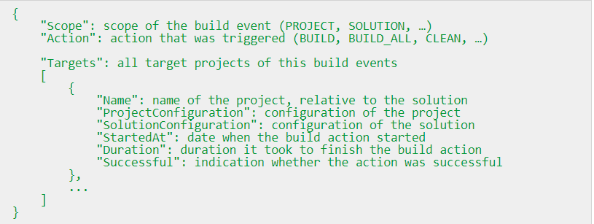

Events-170301/2016-05-09/10.zip 85930.json {'$type': 'KaVE.Commons.Model.Events.VisualStudio.**BuildEvent**, KaVE.Commons', '**Scope**': '**vsBuildScopeSolution**', '**Action**': 'vsBuildActionBuild', '**Targets'**: [{'$type': 'KaVE.Commons.Model.Events.VisualStudio.**BuildTarget**, KaVE.Commons', '**Project**': 'cryptlib.vcxproj', '**ProjectConfiguration**': 'DLL-Import Release', '**Platform**': 'x64', '**SolutionConfiguration**': 'DLL-Import Release|x64', '**StartedAt**': '2016-08-13T14:51:41.7269929+02:00', '**Duration**': '00:00:22.7738787', '**Successful**': True}, {'$type': 'KaVE.Commons.Model.Events.VisualStudio.BuildTarget, KaVE.Commons', 'Project': 'cryptest.vcxproj', 'ProjectConfiguration': 'DLL-Import Release', 'Platform': 'x64', 'SolutionConfiguration': 'DLL-Import Release|x64', 'StartedAt': '2016-08-13T14:52:04.5113719+02:00', 'Duration': '00:00:12.3285298', 'Successful': False}, {'$type': 'KaVE.Commons.Model.Events.VisualStudio.BuildTarget, KaVE.Commons', 'Project': 'cryptdll.vcxproj', 'ProjectConfiguration': 'Release', 'Platform': 'x64', 'SolutionConfiguration': 'DLL-Import Release|x64', 'StartedAt': '2016-08-13T14:52:16.841901+02:00', 'Duration': '00:00:28.3401299', 'Successful': False}, {'$type': 'KaVE.Commons.Model.Events.VisualStudio.BuildTarget, KaVE.Commons', 'Project': 'dlltest.vcxproj', 'ProjectConfiguration': 'Release', 'Platform': 'x64', 'SolutionConfiguration': 'DLL-Import Release|x64', 'StartedAt': '2016-08-13T14:52:45.1850298+02:00', 'Duration': '00:00:02.7980728', 'Successful': True}], 'IDESessionUUID': 'a862de98-ccad-4b2d-860d-11a377563281', 'KaVEVersion': '0.1010-Default', 'TriggeredAt': '2016-08-13T14:51:41.7264933+02:00', 'TriggeredBy': 0, 'Duration': '00:01:06.3061092', 'ActiveWindow': '0Win:vsWindowTypeSolutionExplorer Solution Explorer'}

**DEBUGGER EVENT**

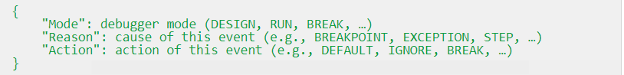

Events-170301/2016-05-09/10.zip 16698.json {'$type': 'KaVE.Commons.Model.Events.VisualStudio.**DebuggerEvent**, KaVE.Commons', '**Mode**': 2, '**Reason**': 'dbgEventReasonStep', '**Action**': 'dbgExecutionActionDefault', 'IDESessionUUID': '7639de18-b8d5-4593-88f5-8d8f4f700719', 'KaVEVersion': '0.1004-Default', 'TriggeredAt': '2016-05-17T01:48:13.5987645+02:00', 'TriggeredBy': 0, 'Duration': '00:01:45.1109469', 'ActiveWindow': '0Win:vsWindowTypeDocument HomeController.cs', 'ActiveDocument': '0Doc:CSharp \\Controllers\\HomeController.cs'}

**DOCUMENT EVENT**

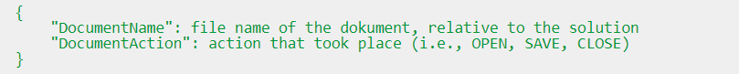

Events-170301/2016-05-09/10.zip 23051.json {'$type': 'KaVE.Commons.Model.Events.VisualStudio.**DocumentEvent**, KaVE.Commons', '**Document**': '0Doc:CSharp \\Controllers\\HomeController.cs', '**Action**': 2, 'IDESessionUUID': 'a12b7757-6cfd-45dd-9a15-b579faed49d3', 'KaVEVersion': '0.1004-Default', 'TriggeredAt': '2016-05-24T22:33:54.5325341+02:00', 'TriggeredBy': 0, 'Duration': '00:00:00', 'ActiveWindow': '0Win:vsWindowTypeMainWindow Assemble.Public.AuditEventExampleWebApp - Microsoft Visual Studio (Administrator)'}

**EDIT EVENT**



Events-170301/2016-05-09/10.zip 23362.json {'$type': 'KaVE.Commons.Model.Events.VisualStudio.**EditEvent**, KaVE.Commons', '**Context2**': {'$type': 'KaVE.Commons.Model.Events.CompletionEvents.Context, KaVE.Commons', '**TypeShape**': {'$type': 'KaVE.Commons.Model.TypeShapes.TypeShape, KaVE.Commons', '**TypeHierarchy**': {'$type': 'KaVE.Commons.Model.TypeShapes.TypeHierarchy, KaVE.Commons', '**Element**': '0T:?', '**Implements**': []}, '**NestedTypes**': [], '**Delegates**': [], '**EventHierarchies**': [], '**Fields**': [], '**MethodHierarchies**': [], '**PropertyHierarchies**': []}, '**SST**': {'$type': '[SST:SST]', '**EnclosingType**': '0T:?', '**Fields**': [], '**Properties**': [], '**Methods**': [], '**Events**': [], '**Delegates**': []}}, '**NumberOfChanges**': 2, '**SizeOfChanges**': 518, 'IDESessionUUID': '0e914c68-e1fb-4dc5-a234-be68791c41f3', 'KaVEVersion': '0.1004-Default', 'TriggeredAt': '2016-05-24T22:40:39.8646865+02:00', 'TriggeredBy': 0, 'Duration': '00:00:37.4550872', 'ActiveWindow': '0Win:vsWindowTypeMainWindow TheOne - Microsoft Visual Studio (Administrator)'}

**FIND EVENT** (search in IDE, only interested if the search is successful or cancelled)



Events-170301/2016-05-09/10.zip 74269.json {'$type': 'KaVE.Commons.Model.Events.VisualStudio.FindEvent, KaVE.Commons', '**Cancelled**': False, 'IDESessionUUID': '3c346752-38b4-4c86-aa6d-922f81bb8f0b', 'KaVEVersion': '0.1010-Default', 'TriggeredAt': '2016-07-26T01:21:00.6869127+02:00', 'TriggeredBy': 0, 'Duration': '00:00:00', 'ActiveWindow': '0Win:vsWindowTypeToolWindow Find Results 1', 'ActiveDocument': '0Doc:CSharp \\Assemble.Notifications\\Notifications.Templates\\Core\\TemplateProcessor.cs'}

**SOLUTION EVENT**



Events-170301/2016-05-09/10.zip 86273.json {'$type': 'KaVE.Commons.Model.Events.VisualStudio.**SolutionEvent**, KaVE.Commons', '**Action**': 3, '**Target**': '0Itm:{66A26722-8FB5-11D2-AA7E-00C04F688DDE} Notifications.Services.Tests', 'IDESessionUUID': '89bec1cb-7be3-43c5-b719-e526a4c72359', 'KaVEVersion': '0.1010-Default', 'TriggeredAt': '2016-08-15T18:03:33.4908232+02:00', 'TriggeredBy': 0, 'Duration': '00:00:00', 'ActiveWindow': '0Win:vsWindowTypeDocument ModelTreeUtilities.cs', 'ActiveDocument': '0Doc:CSharp ModelTreeUtilities.cs'}

**VERSION CONTROL EVENT**

Capture interaction with version control system outside of IDE like GitHub. Used to identify stable version of the code (committed) and versions that should be ignored (happen before a reset)

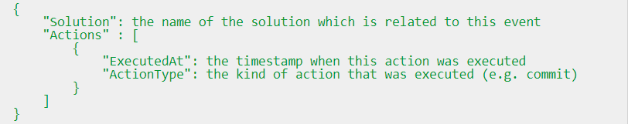

Events-170301/2016-05-09/10.zip 17507.json {'$type': 'KaVE.Commons.Model.Events.VersionControlEvents.**VersionControlEvent**, KaVE.Commons', '**Actions**': [{'$type': 'KaVE.Commons.Model.Events.VersionControlEvents.**VersionControlAction**, KaVE.Commons', **'ExecutedAt**': '2016-05-17T02:45:37+02:00', '**ActionType**': 4}], '**Solution**': '0Sln:Assemble.Public.AuditEventExampleWebApp', 'IDESessionUUID': '7639de18-b8d5-4593-88f5-8d8f4f700719', 'KaVEVersion': '0.1004-Default', 'TriggeredAt': '2016-05-17T02:45:37.8269173+02:00', 'TriggeredBy': 0, 'Duration': '00:00:00', 'ActiveWindow': '0Win:vsWindowTypeDocument HomeController.cs', 'ActiveDocument': '0Doc:CSharp \\Controllers\\HomeController.cs'}

**USER PROFILE EVENT**

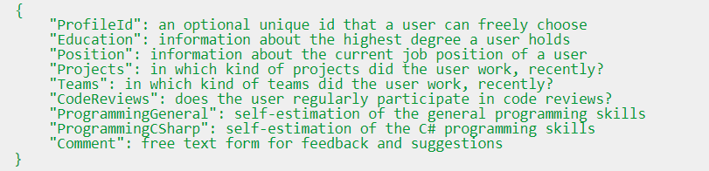

Events-170301/2016-05-09/10.zip 17540.json {'$type': 'KaVE.Commons.Model.Events.UserProfiles.**UserProfileEvent**, KaVE.Commons', '**ProfileId**': 'cbd2dd71-d462-4454-8702-ea2689871e00', '**Education**': 4, '**Position**': 5, '**ProjectsCourses**': False, '**ProjectsPersonal**': True, '**ProjectsSharedSmall'**: True, '**ProjectsSharedMedium**': True, '**ProjectsSharedLarge**': False, '**TeamsSolo**': True, '**TeamsSmall**': False, '**TeamsMedium**': True, '**TeamsLarge**': False, '**CodeReviews**': 2, '**ProgrammingGeneral**': 5, '**ProgrammingCSharp**': 6, '**Comment**': '', 'IDESessionUUID': '6d171b9f-9fa8-4cf3-a94b-def213d64af9', 'KaVEVersion': '0.1004-Default', 'TriggeredAt': '2016-05-17T23:27:26.9401475+02:00', 'TriggeredBy': 0, 'ActiveWindow': '0Win:vsWindowTypeMainWindow Assemble.Publisher - Microsoft Visual Studio (Administrator)'}

**NAVIGATION EVENT**

Capture the location in the code, like the surrounding method declaration, or jumps to new location (by ctrl-click a reference)

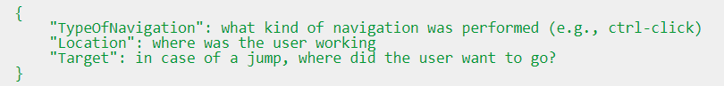

Events-170301/2016-05-09/10.zip 13300.json {'$type': 'KaVE.Commons.Model.Events.**NavigationEvent**, KaVE.Commons', '**Target**': '0General:???', '**Location'**: '0T:Assemble.WebClient.ViewModels.Events.EventsRequestViewModel, Assemble.WebClient', '**TypeOfNavigation**': 3, 'IDESessionUUID': 'c33463ea-8592-45d3-a821-8e194f15bfd1', 'KaVEVersion': '0.1004-Default', 'TriggeredAt': '2016-05-16T23:35:28.8304875+02:00', 'TriggeredBy': 3, 'ActiveWindow': '0Win:vsWindowTypeDocument EventsRequestViewModel.cs', 'ActiveDocument': '0Doc:CSharp \\Assemble\\WebClient\\ViewModels\\Events\\EventsRequestViewModel.cs'}

**SYSTEM EVENT**



Events-170301/2016-05-09/10.zip 1091.json {'$type': 'KaVE.Commons.Model.Events.**SystemEvent**, KaVE.Commons', '**Type**': 3, 'IDESessionUUID': 'cf20b71e-d8b8-46c7-af24-cc8f94d44d03', 'KaVEVersion': '0.1004-Default', 'TriggeredAt': '2016-05-07T00:36:50.7017658+02:00', 'TriggeredBy': 0, 'Duration': '00:00:00', 'ActiveWindow': '0Win:vsWindowTypeDocument UsersController.cs', 'ActiveDocument': '0Doc:CSharp \\Assemble\\WebClient\\Areas\\Administration\\Controllers\\UsersController.cs'}

**TEST RUN EVENT**

Which tests are run, duration and result

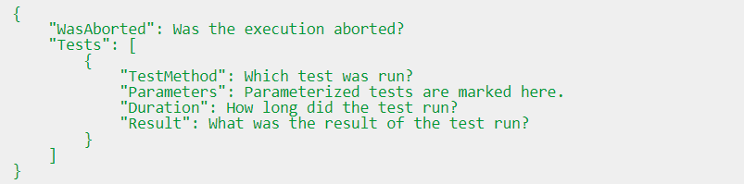

Events-170301/2016-05-09/10.zip 52888.json {'$type': 'KaVE.Commons.Model.Events.TestRunEvents.**TestRunEvent**, KaVE.Commons', '**WasAborted**': False, '**Tests**': [{'$type': 'KaVE.Commons.Model.Events.TestRunEvents.**TestCaseResult**, KaVE.Commons', '**TestMethod**': '0M:[p:void] [Assemble.Integration.Tests.ProjectManagement.Sorting.SortingArchivedProjectIntegrationTests, Assemble.Integration.Tests].SortingArchivedProjectsByName()', '**Parameters**': '', '**Duration**': '00:00:00.0159962', '**Result**': 2}], 'IDESessionUUID': '6127f015-2e67-4db7-aadf-679b0de1ebd6', 'KaVEVersion': '0.1010-Default', 'TriggeredAt': '2016-06-23T00:23:22.2838934+02:00', 'TriggeredBy': 0, 'Duration': '00:03:09.7001852', 'ActiveWindow': '0Win:vsWindowTypeDocument ProjectManagementUtilities.cs', 'ActiveDocument': '0Doc:CSharp ProjectManagementUtilities.cs'}

**INFO EVENT**



Cannot find in the dataset

**ERROR EVENT**



Cannot find in the dataset

**DEPRECATED EVENT**

**INSTALL EVENT**



Cannot find in the dataset

**UPDATE EVENT**

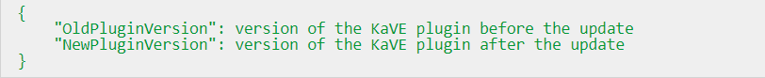

Cannot find in the dataset

6+