[**Data Understanding And Visualization Report**](https://github.com/huyson1810/NguyenHuySon_18021102_Group2_DataUnderstandingAndVisualization)

*Nguyen Huy Son - Group2*

* Work: Understanding + Filtering + Analysing + Visualising Data (based on crawled data: sosanhgia & kenh14 - output file text in project’ folder)
* Working Status: **Completed**
* Description:
* **Sosanhgia Data Visualization:**

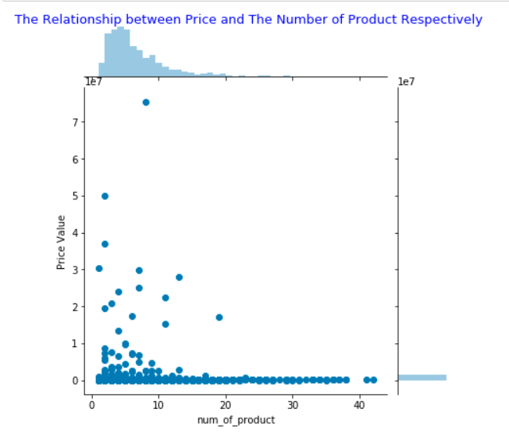

Figure 1.1

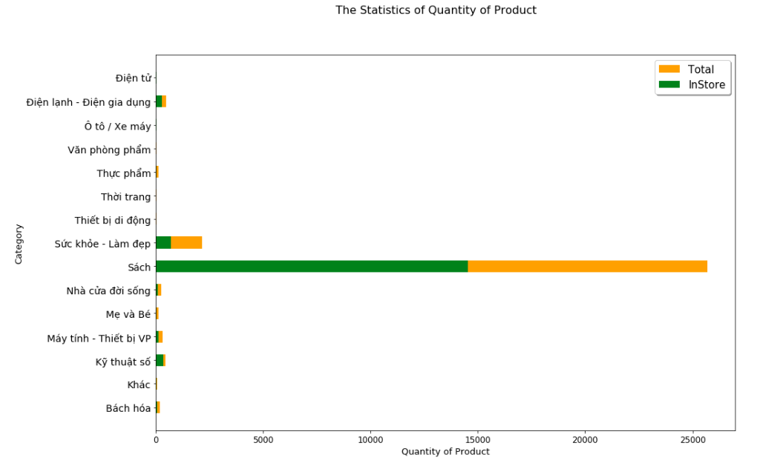

Figure 1.2

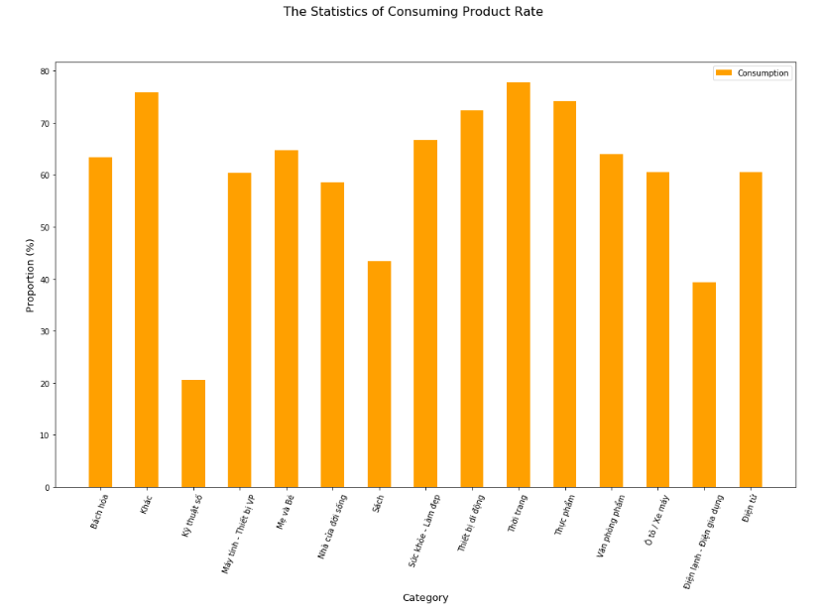

Figure 1.3

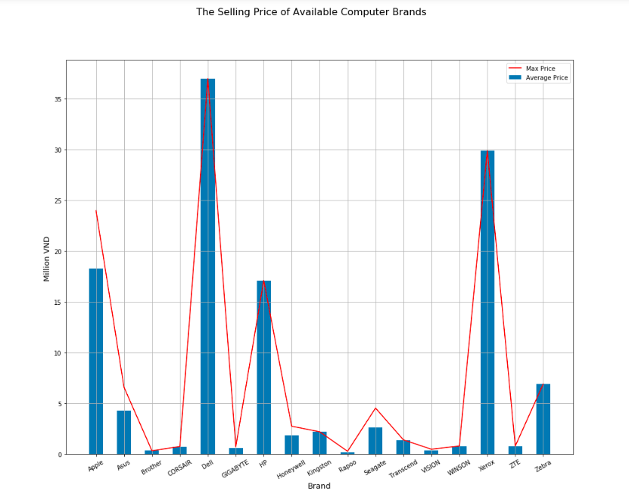

Figure 1.4

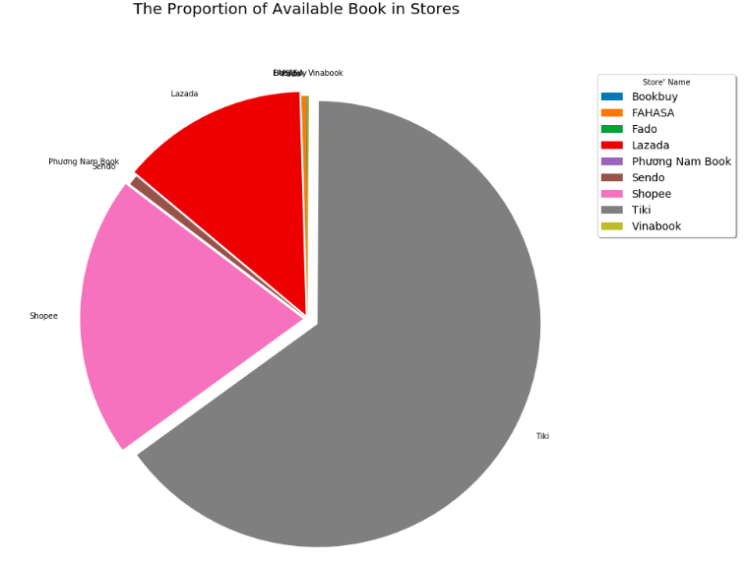

Figure 1.5

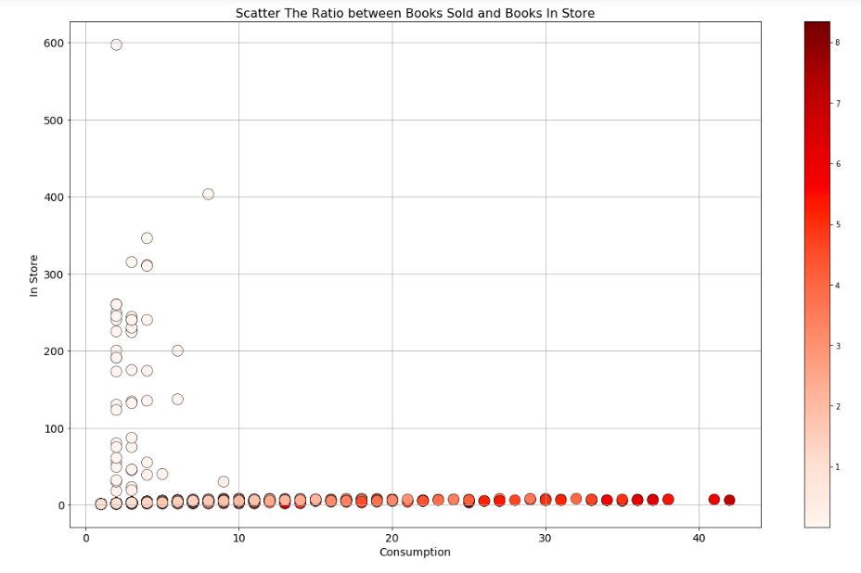

Figure 1.6

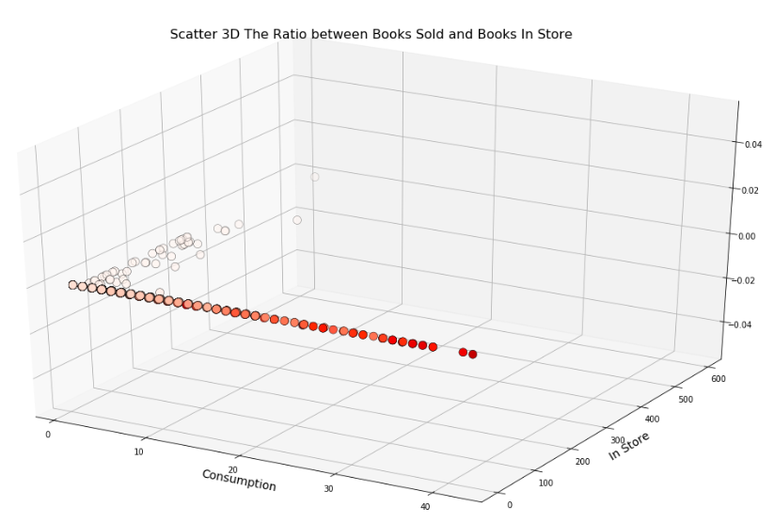

Figure 1.7

* **Kenh14 Data Visualization:**

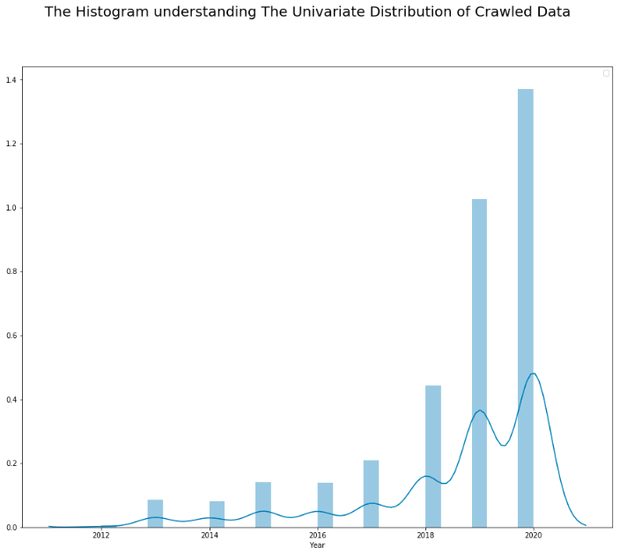

Figure 2.1

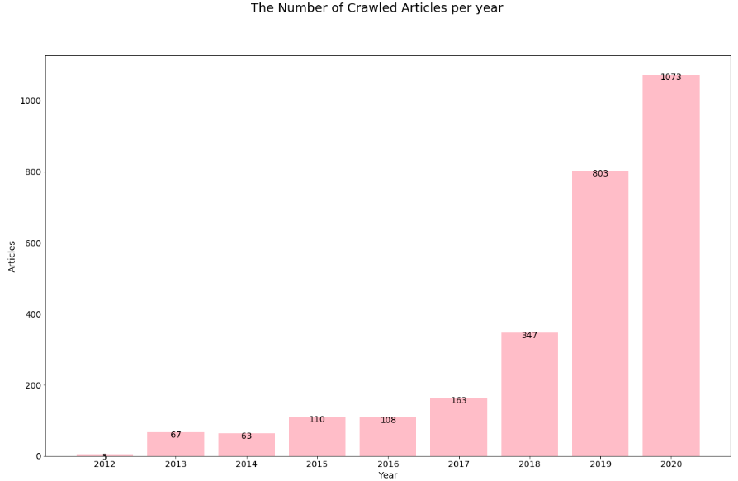

Figure 2.2

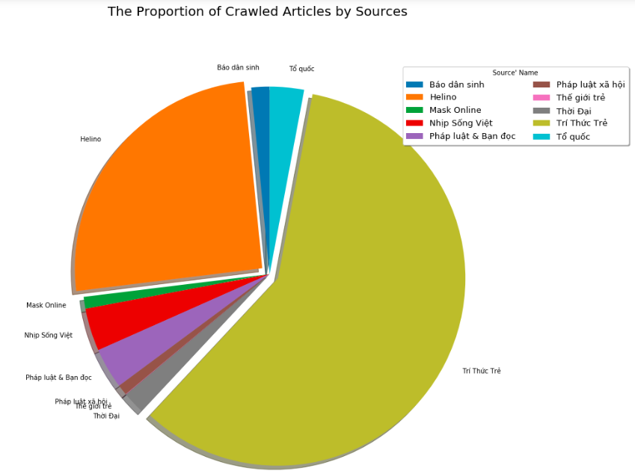

Figure 2.3

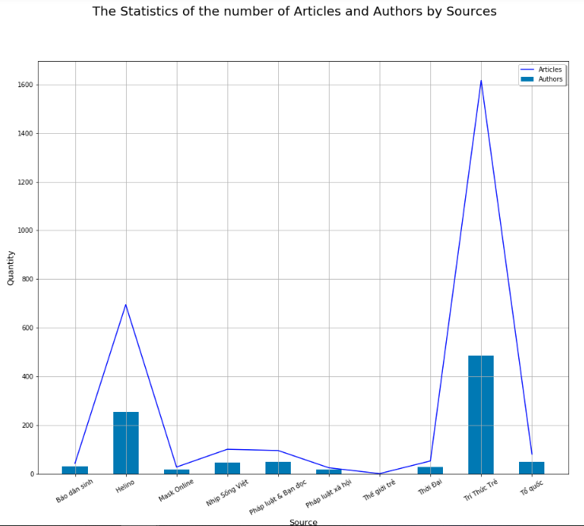

Figure 2.4