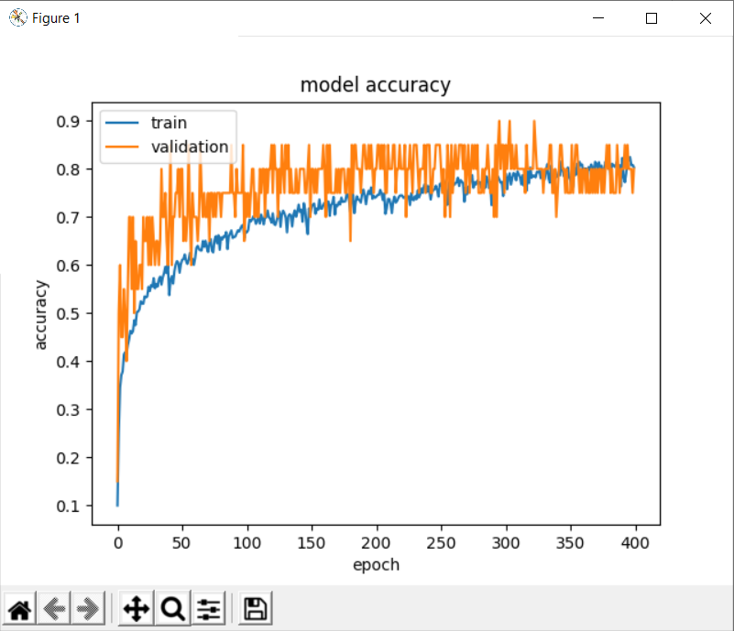

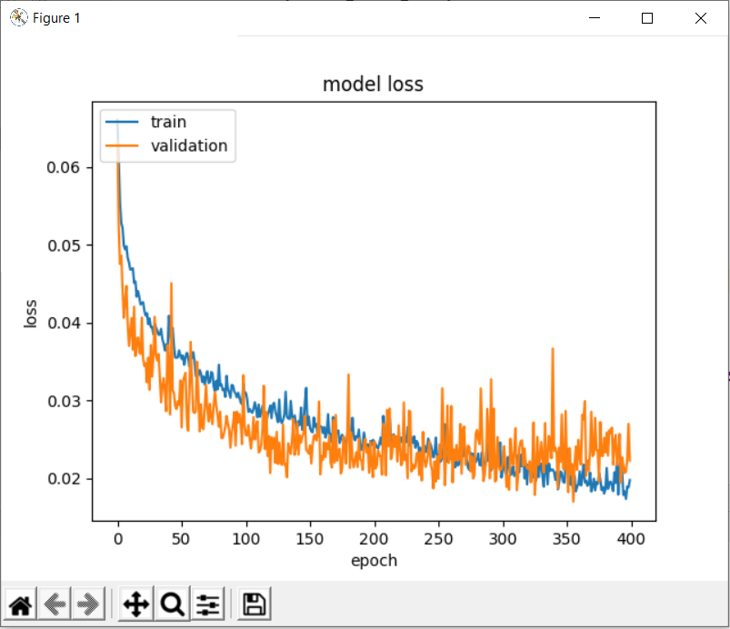

35/35 [==============================] - 0s 12ms/step - loss: 0.0319 - accuracy: 0.6881

loss 0.03191831335425377

accuracy 0.6881144046783447

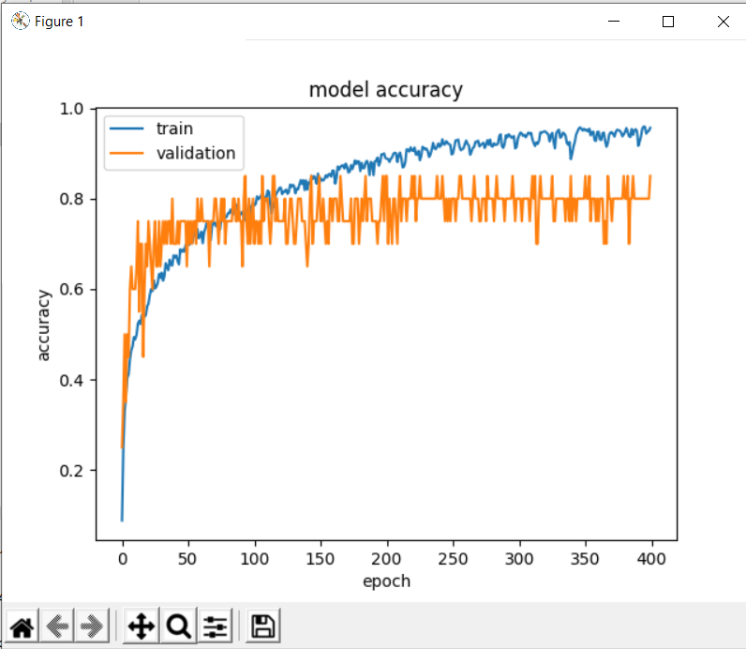

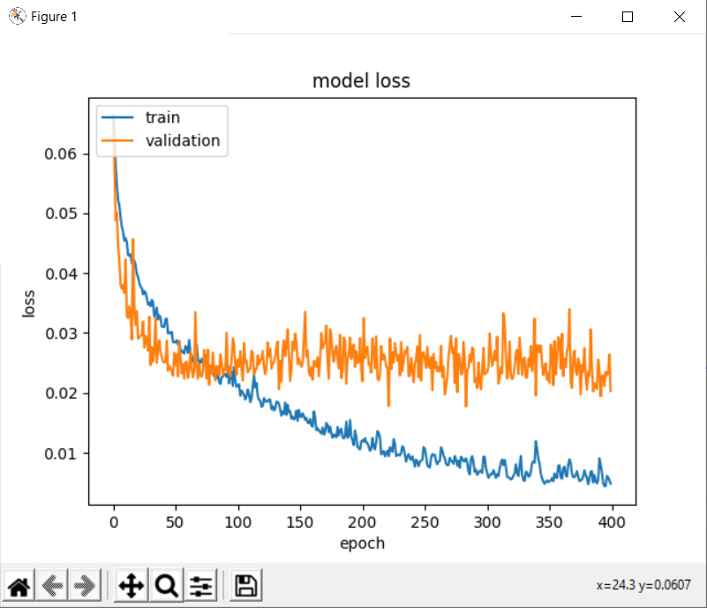

35/35 [==============================] - 0s 12ms/step - loss: 0.0256 - accuracy: 0.7641

loss 0.02561342343688011

accuracy 0.7640750408172607

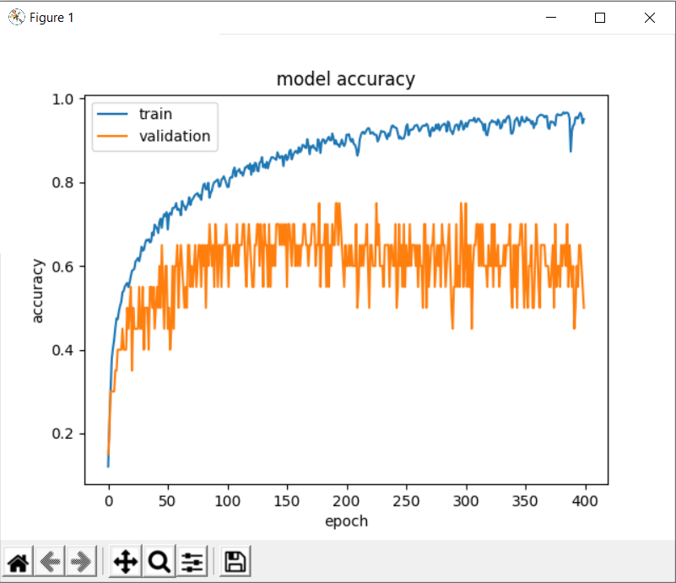

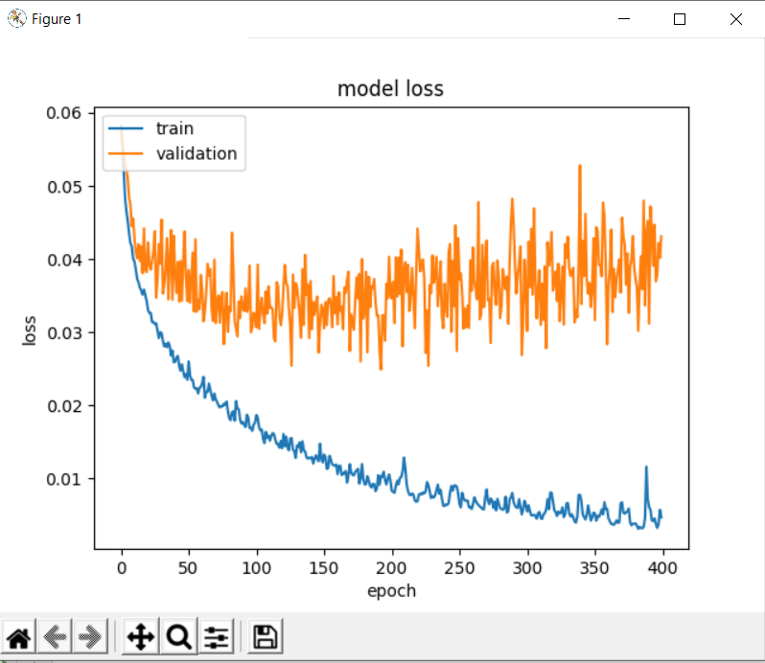

Train trên 14 phân loại mỗi loại 400 mẫu, Trong đó Vaid= 20%, Test = 30%

*# Dinh nghia mang LSTM*def fun_getModelLSTM(rnn_size: int = 512, input_shape: tuple = (20, 4096), num_classify: int = 3):  
 modelLSTM = Sequential()  
 modelLSTM.add(LSTM(rnn_size, input_shape=input_shape))  
 modelLSTM.add(Dense(1024))  
 modelLSTM.add(Activation(**'relu'**))  
 modelLSTM.add(Dense(50))  
 modelLSTM.add(Activation(**'sigmoid'**))  
 modelLSTM.add(Dense(num_classify))  
 modelLSTM.add(Activation(**'softmax'**))  
 modelLSTM.compile(loss=**'mean_squared_error'**, optimizer=**'adam'**, metrics=[**'accuracy'**])  
 return modelLSTM

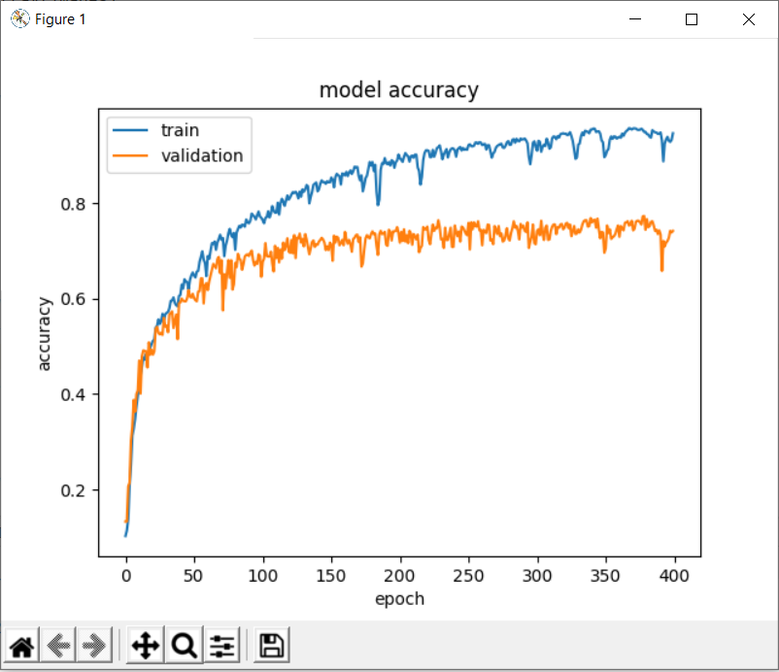

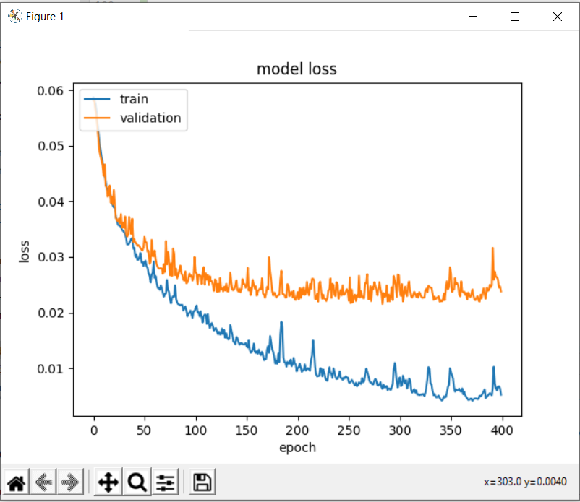

Len Test: 1919

any:

60/60 [==============================] - 1s 12ms/step - loss: 0.0229 - accuracy: 0.7582

loss 0.022871822118759155

accuracy 0.758207380771637

16 Phan loai: 400 ~

RNN_SIZE = 600  
DENSE1 = 1024  
DENSE2 = 70  
EPOCH = 400  
BATCH_SIZE = 300  
LEARNING_RATE = 0.00001

*# Dinh nghia mang LSTM 2*

def fun_getModelLSTM_2(rnn_size: int = RNN_SIZE, input_shape: tuple = (NUM_FRAME_INPUT_LSTM, TRANSFER_VALUE_SIZE), num_classify: int = NUM_CLASSIFY):  
 modelLSTM = Sequential()  
 modelLSTM.add(LSTM(rnn_size, input_shape= input_shape))  
 modelLSTM.add(Dense(DENSE1))  
 modelLSTM.add(Activation(**'relu'**))  
 modelLSTM.add(Dense(DENSE2))  
 modelLSTM.add(Activation(**'sigmoid'**))  
 modelLSTM.add(Dense(num_classify))  
 modelLSTM.add(Activation(**'softmax'**))  
  
 opt = keras.optimizers.Adam(learning_rate= LEARNING_RATE)  
 modelLSTM.compile(loss=**'mean_squared_error'**, optimizer=opt, metrics=[**'accuracy'**])  
  
 return modelLSTM

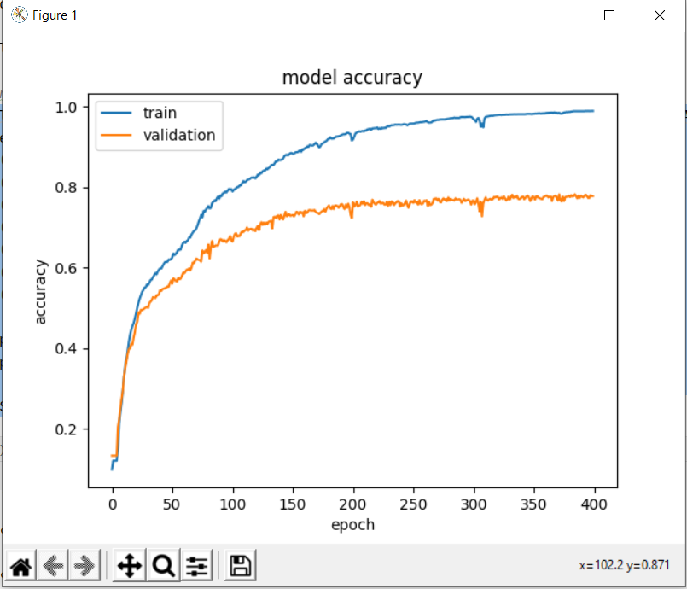

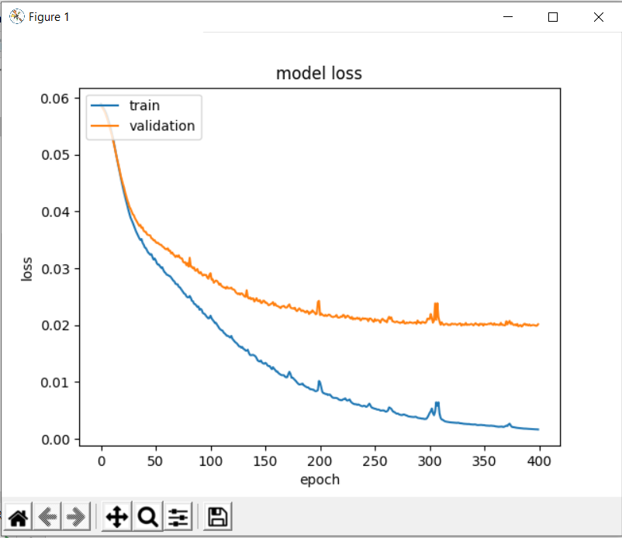

Len Test: 1920

any:

60/60 [==============================] - 1s 12ms/step - loss: 0.0183 - accuracy: 0.7969

loss 0.018303988501429558

accuracy 0.796875