*Algorithms: Linear Search*

**Look at every element**

This is a very straightforward loop comparing every element in the array with the key. As soon as an equal value is found, it returns. If the loop finishes without finding a match, the search failed and -1 is returned.

**Performance**

For small arrays, linear search is a good solution because it's so straightforward. In an array of a million elements linear search on average will take 500,000 comparisons to find the key. For a *much* faster search, take a look at[binary search](http://www.leepoint.net/notes-java/algorithms/searching/binarysearch.html).

## Example

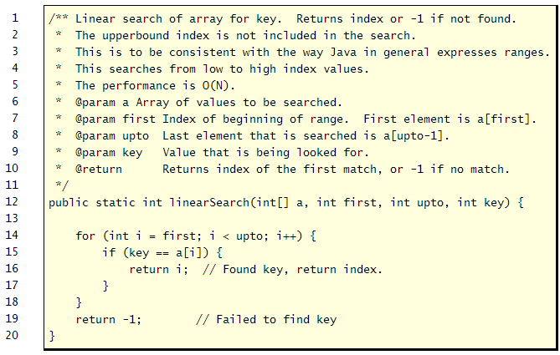

<http://www.roseindia.net/tutorial/java/core/linear-search.html>