 | International Programming Training Center  SOFTECH – APTECH DANANG  *** | 

E-project Report
Certificate Generation System


Group 2 – Batch 97A

Members:
- Le Huy Thang (Group Leader)
- Phan Cong Huu
- Ngo Khanh Nhat

Lecture : Hoang Nhac Trung

Danang, 09/2012




This is to certify that
Has successfully Designed
and
Developed
_____________________________
Submitted by:
Date of Issue:
Authorized Signature:
Mr./Ms.
---------
----------
---------------------

catalog

- Introduction
- The Purpose
- Problem Definition
- Requements and business Flow
- Screen Shot’s
- Source Code with Comments
- User Guide
- Developer’s Guide (Module Descriptions)
- Managerment And Project Plan
- Checked Lists

Acknowledgement

First, our groups send the most sincere thanks to Mr. Hoang Nhac Trung. Through his caring guidance the project was completed on time.
- Besides, the group also thank Softech-Aptech Danang IT Education Center has support equipment, reference materials... to create conditions for the project team completed a fast and convenient way.
- Finally, I thank the members of the group that was enthusiastic comments and coordinate effectively contributing to the success of the project.
- Once again please thanks to all who have supported and helped enthusiastically so that the project team completed a quality and highly effective.
- In the process of implementing the project certainly have inevitable errors. So I would like to have sympathy of teacher.

Sincerely thanks

- Introduction :

This is a Certificate Department which works for “ABC” institute for developing the certificate for the students who had completed their course. This system also deals with the student registration, checking the payment scenario, inputting the marks of the students and after all verification is done they develop the
certificate of completion of the course for the students.

This work is handled by the Department manually where they keep the track of the data by making separate file for each section (like Students Registration files, Payment status of the students, Marks Entry file). Finally they develop the certificate of the students by mapping all the data from the files. Due to increase in the number of the courses the mapping of all the data becomes difficult. Sometimes the mismatching also occurs and also this work is time consuming.

The Purpose:

To increase the efficiency and accuracy in jobs.

Management and access to student information.

Developing the certificate for the students.

…

- Problem Definition

  - Proposed System
To overcome the above problem the organization had finally decided to computerize its certificate department. Organization wants following things to be implemented in the system.
There should be three logins:
        - Admin
        - Certificate Cell
        - Student Login

    - Admin
The Role of Admin will be to maintain the database of Students Registration and Fees details of the students. And it is also supposed to enter the marks of the students (After the completion of the exam)

    - Certificate Cell
The Role of the Exam Center will be to produce the certificate for the students. But it also verifies the status of the students like whether he/she has completed their total payment. If the payment of the students is not clear then the students Certificate will not be produce. It should also check whether the students have given the all exam, if he/she has not given one exam, the certificate for the particular should not get printed instead it should generate the appropriate message to the students for that.

    - Student Login
The student will be provided with their authentication details and are suppose to enter in their login form to view:
      - Payment status
      - Certificate (if all the criteria mentioned above are satisfied).

3.2. System Requirements:
Hardware
Server
Processor | Core 2 Duo 1.6 GHz or higher
Memory | 1 Gigabytes or higher
Hard Disk | 80 Gigabytes or higher
Modem/ADSL | Connecting to internet 24/24

Client
CPU | Pentium IV 1.8 or higher
Memory | 512 MB RAM or higher
Hard Disk | >10 MB to install software
Modem/ADSL | Connected to internet

Software
Server
Platform | Java JDK 1.6.0_35 or higher.
Software | MySQL Server 5.5 or higher.

Client
Platform | Java JRE 1.6.0_35 or higher.

- Requements and business Flow.
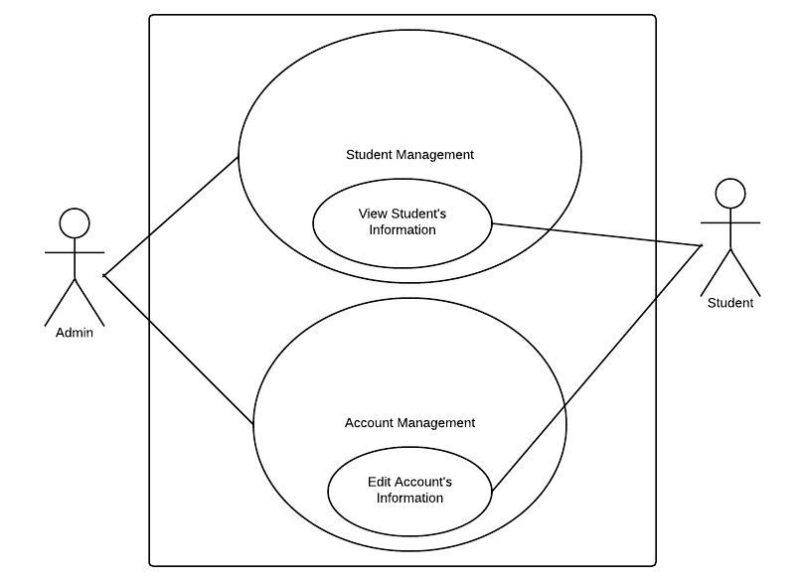
  - Use Case Diagram.
    - Admin
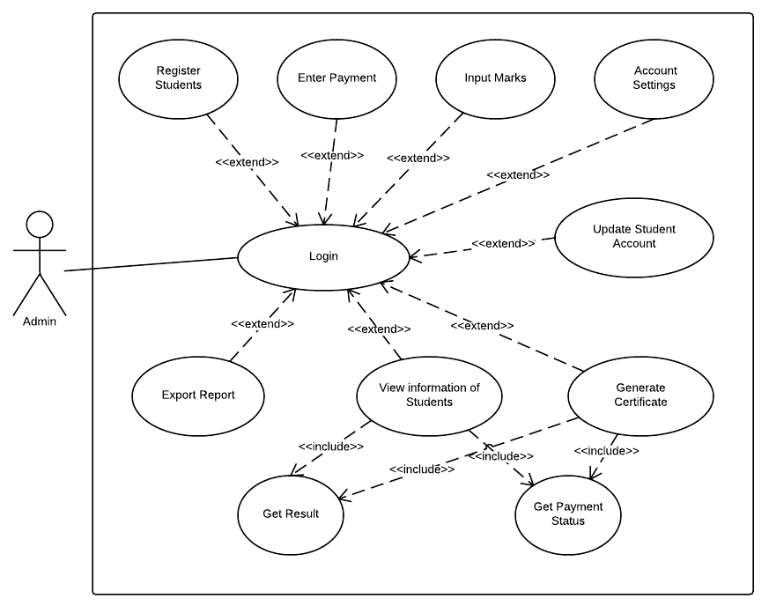

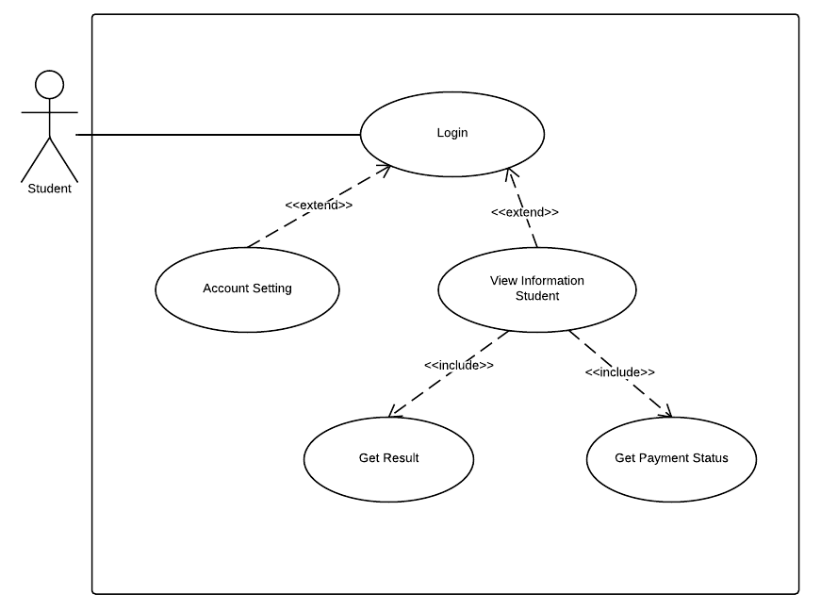
    - Student
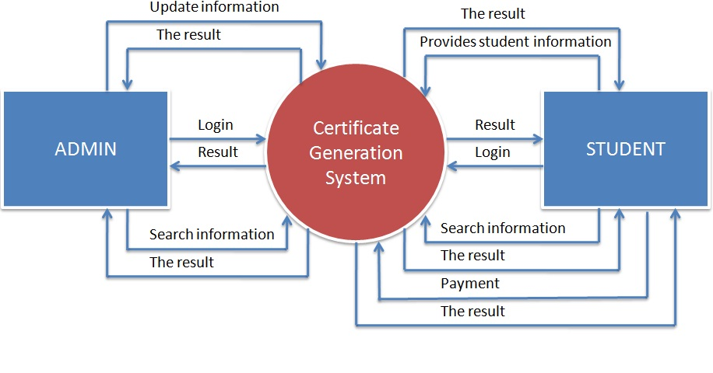
  - FlowCharts
  - DFD's
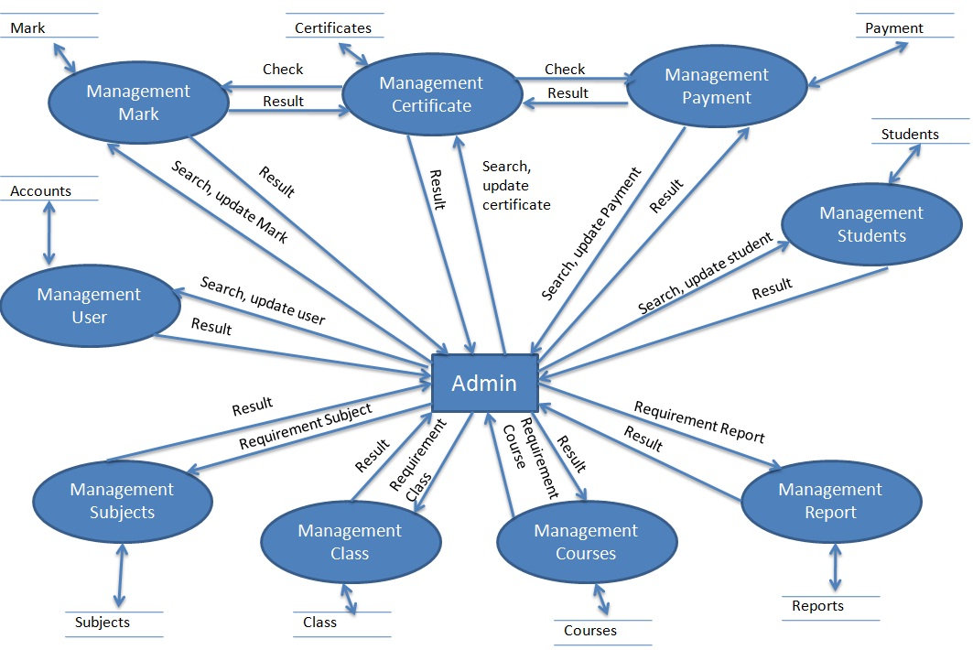
    - Admin

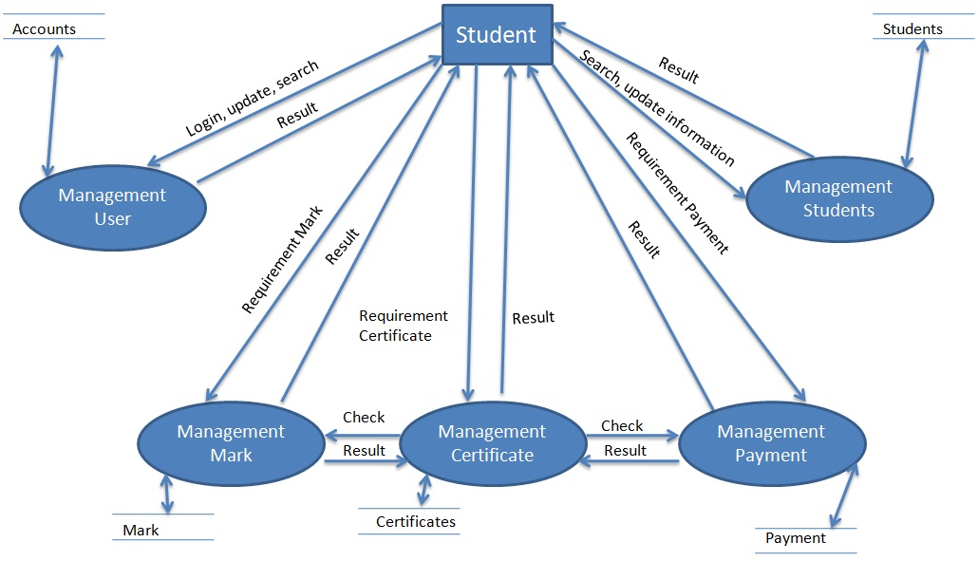
    - Student

  - Proccess Diagrams
    - Connect to server
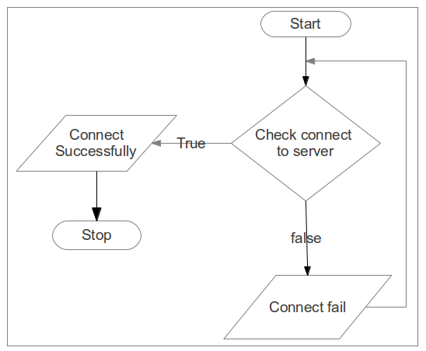
    - Login
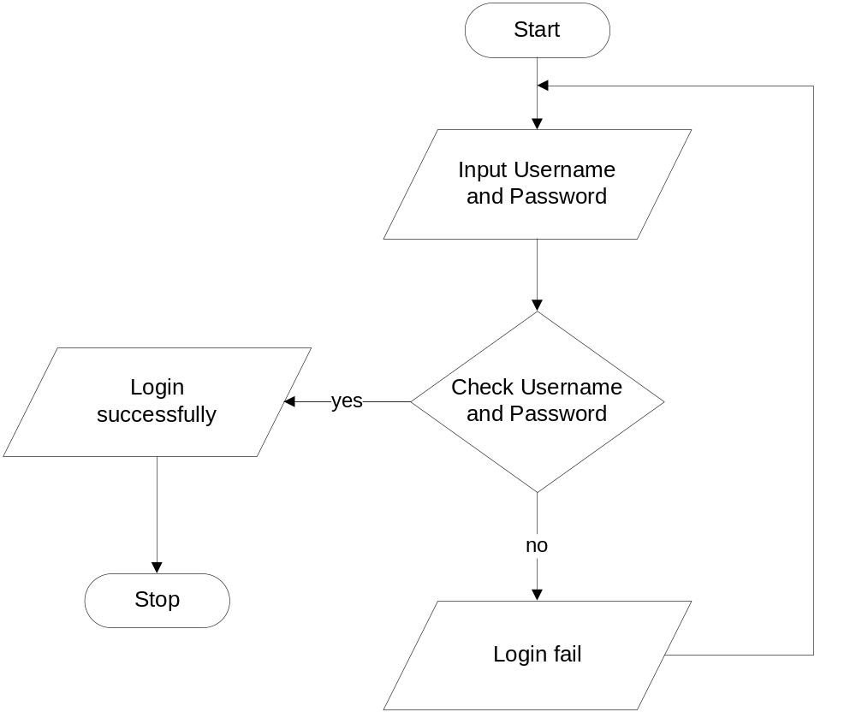
    - Fuction Add:
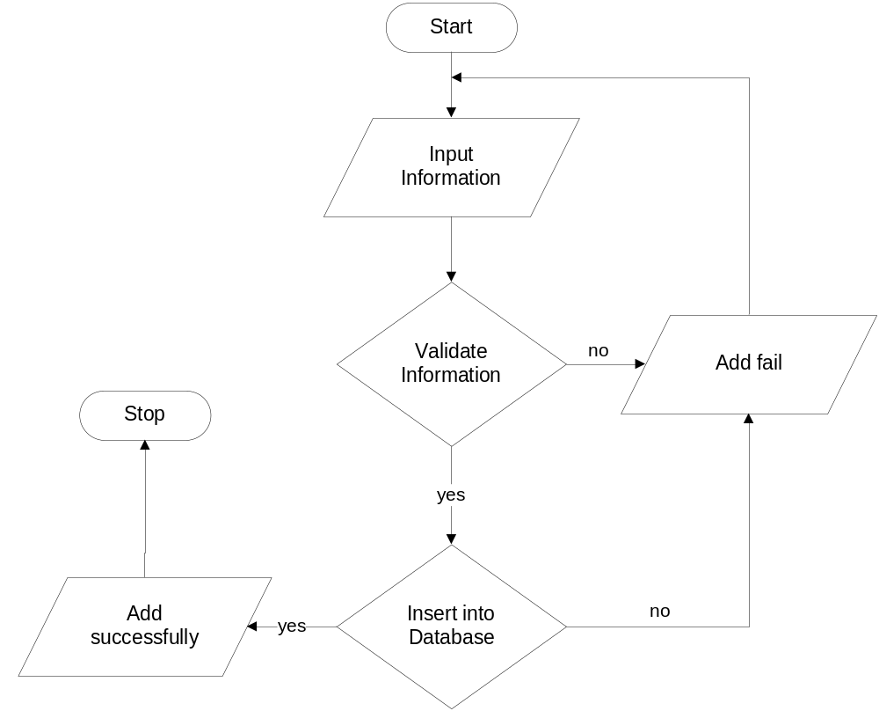
    - Function Update:
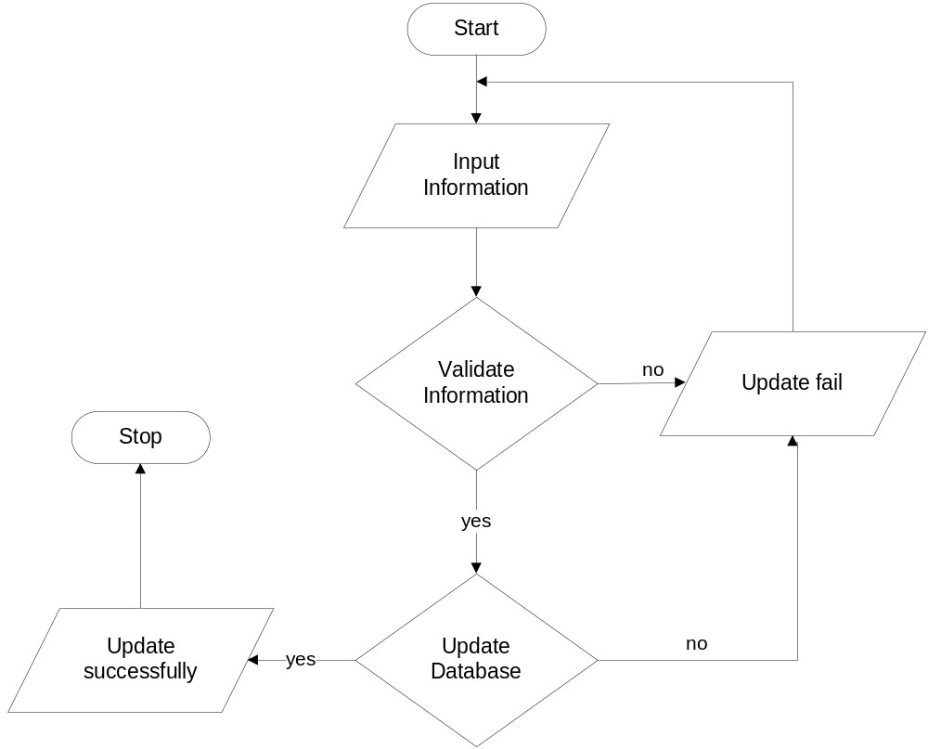
    - Function Delete:
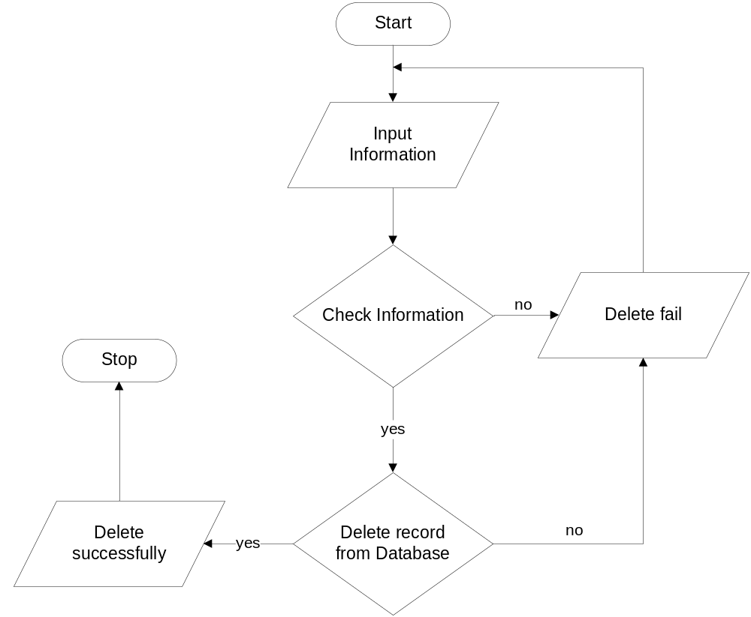
    - Function Search and Display
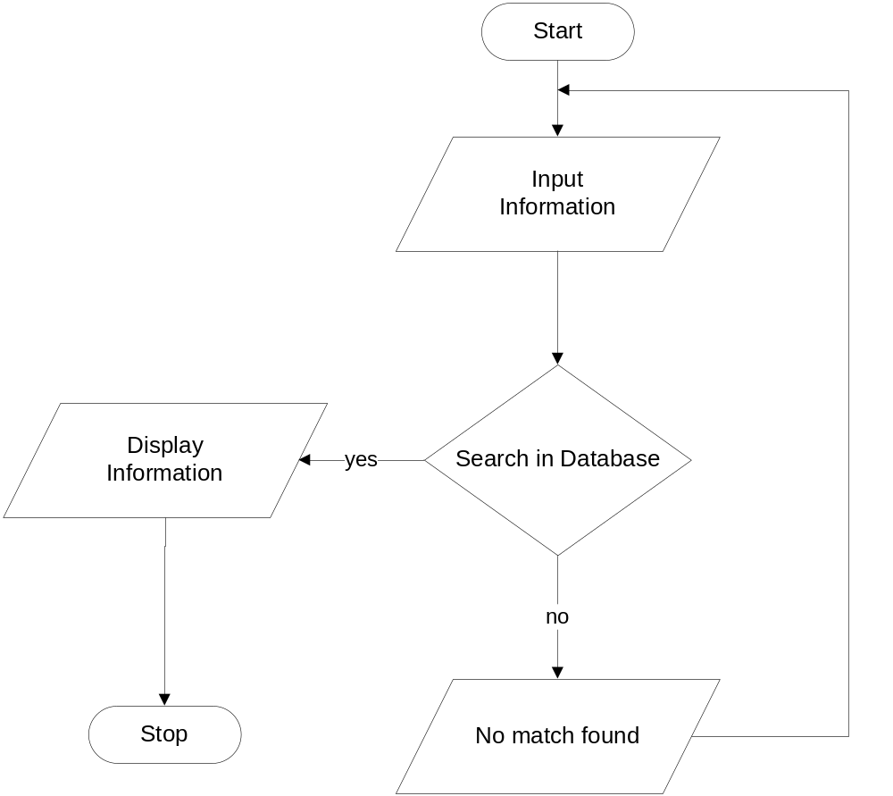

  - Database Diagram / Structure
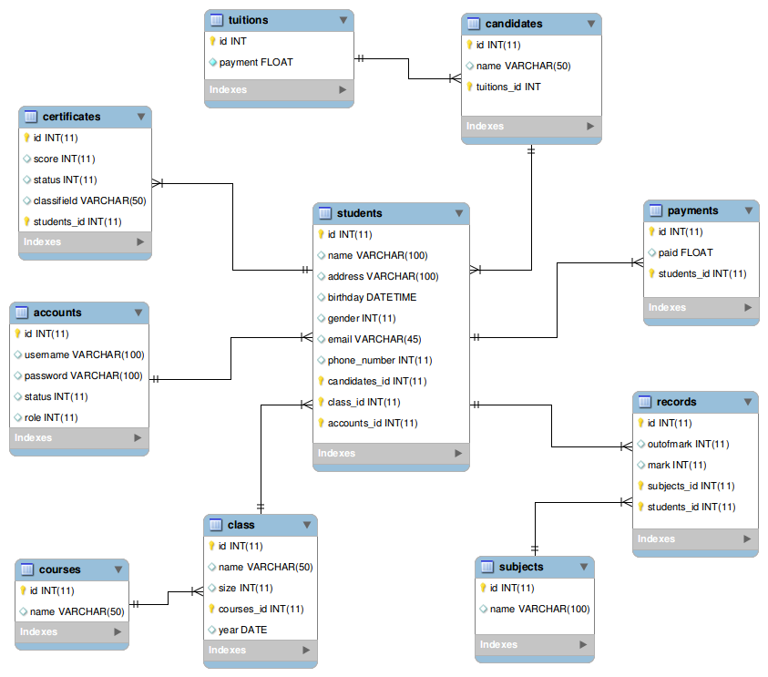
    - Database Diagram
    - Structure

Table: students
Field Name | Date Type | Null | Key | Description
id | int(11) | No | PK
name | varchar(100) | No
address | varchar(100)
birthday | datetime
gender | int(11)
email | varchar(45)
phone_number | int(11)
candidates_id | int(11) |  | FK
class_id | int(11) |  | FK
accounts_id | int(11) |  | FK

Table: accounts
Field Name | Date Type | Null | Key | Description
id | int(11) |  | PK
username | varchar(100)
password | varchar(100)
status | int(11)
role | int(11)

Table: courses
Field Name | Date Type | Null | Key | Description
id | Int(11) |  | PK
name | varchar(50)

Table: class
Field Name | Date Type | Null | Key | Description
id | int(11) |  | PK
name | varchar(50)
size | int(11)
year | date
courses_id | int(11) |  | FK

Table: subjects
Field Name | Date Type | Null | Key | Description
id | int(11) |  | PK
name | varchar(100)

Table: records
Field Name | Date Type | Null | Key | Description
id | int(11) |  | PK
outomark | int(11)
mark | int(11)
subjects_id | int(11) |  | FK
students_id | int(11) |  | FK

Table: tuitions
Field Name | Date Type | Null | Key | Description
id | int(11) |  | PK
payment | float

Table: candidates
Field Name | Date Type | Null | Key | Description
id | int(11) |  | PK
name | varchar(50)
tuitions_id | int |  | FK

Table: payments
Field Name | Date Type | Null | Key | Description
id | int(11) |  | PK
paid | float
students_id | int(11) |  | FK

Table: certificates
Field Name | Date Type | Null | Key | Description
id | int(11) |  | PK
score | int(11)
status | int(11)
classifield | varchar(50)
students_id | int(11) |  | FK

- Screen Shot’s
- Source Code with Comments
- User Guide
- Developer’s Guide (Module Descriptions)
- Managerment And Project Plan

Project Ref. No: |  | Project Title | Activity Plan  Prepare By | Date of Preparation of activety Plan
Sr.No | Task |  |  | Actual Start Date | Actual Days | Team Members Names | Status
1 | Application analyse | CGS |  |  |  | Huy Thang,  Cong Huu | Complete
2 | Database Design | CGS |  |  |  | Cong Huu,  Huy Thang | Complete
3 | Data in Database | CGS
4 |  | CGS
5 |  | CGS
6 |  | CGS
7 |  | CGS
8 |  | CGS
9 |  | CGS
10 |  | CGS

- Checked Lists

Check List of Validation

Option | Validated

Submission Checklist

No | Particulars | Yes | No | N/A | Comments

