 | International Programming Training Center  SOFTECH – APTECH DANANG  *** | 

E-project Report
Certificate Generation System


Group 2 – Batch 97A

Members:
- Le Huy Thang (Group Leader)
- Phan Cong Huu
- Ngo Khanh Nhat (Not protected)

Lecture : Hoang Nhac Trung

Danang, 10/2012




This is to certify that
Has successfully Designed
and
Developed
_____________________________
Submitted by:
Date of Issue:
Authorized Signature:
Mr./Ms.
---------
----------
---------------------

Acknowledgement

First, our groups send the most sincere thanks to Mr. Hoang Nhac Trung. Through his caring guidance the project was completed on time.
- Besides, the group also thank Softech-Aptech Danang IT Education Center has support equipment, reference materials... to create conditions for the project team completed a fast and convenient way.
- Finally, I thank the members of the group that was enthusiastic comments and coordinate effectively contributing to the success of the project.
- Once again please thanks to all who have supported and helped enthusiastically so that the project team completed a quality and highly effective.
- In the process of implementing the project certainly have inevitable errors. So I would like to have sympathy of teacher.

Sincerely thanks

- Introduction :

This is a Certificate Department which works for “ABC” institute for developing the certificate for the students who had completed their course. This system also deals with the student registration, checking the payment scenario, inputting the marks of the students and after all verification is done they develop the
certificate of completion of the course for the students.

This work is handled by the Department manually where they keep the track of the data by making separate file for each section (like Students Registration files, Payment status of the students, Marks Entry file). Finally they develop the certificate of the students by mapping all the data from the files. Due to increase in the number of the courses the mapping of all the data becomes difficult. Sometimes the mismatching also occurs and also this work is time consuming.

The Purpose:

To increase the efficiency and accuracy in jobs.

Management and access to student information.

Developing the certificate for the students.

…

- Problem Definition

  - Proposed System
To overcome the above problem the organization had finally decided to computerize its certificate department. Organization wants following things to be implemented in the system.
There should be three logins:
        - Admin
        - Certificate Cell
        - Student Login

    - Admin
The Role of Admin will be to maintain the database of Students Registration and Fees details of the students. And it is also supposed to enter the marks of the students (After the completion of the exam)

    - Certificate Cell
The Role of the Exam Center will be to produce the certificate for the students. But it also verifies the status of the students like whether he/she has completed their total payment. If the payment of the students is not clear then the students Certificate will not be produce. It should also check whether the students have given the all exam, if he/she has not given one exam, the certificate for the particular should not get printed instead it should generate the appropriate message to the students for that.

    - Student Login
The student will be provided with their authentication details and are suppose to enter in their login form to view:
      - Payment status
      - Certificate (if all the criteria mentioned above are satisfied).

3.2. System Requirements:
Hardware
Server
Processor | Pentium IV 1.8 GHz or higher
Memory | 512 MB RAM or higher
Hard Disk | 1 Gigabytes or higher
Modem/ADSL | Connecting to internet 24/24

Client
Processor | Pentium IV 1.8 GHz or higher
Memory | 512 MB RAM or higher
Hard Disk | >10 MB to install software
Modem/ADSL | Connected to internet

Software
Server
Platform | Java JDK 1.7.0 or higher.
Software | MySQL Server 5.5 or higher.

Client
Platform | Java JRE 1.7.0 or higher.

- Requirements and business Flow.
  - Use Case Diagram. 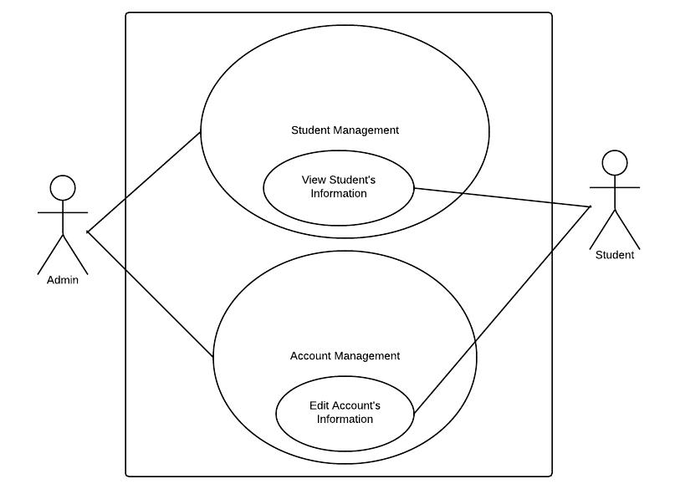

    - Admin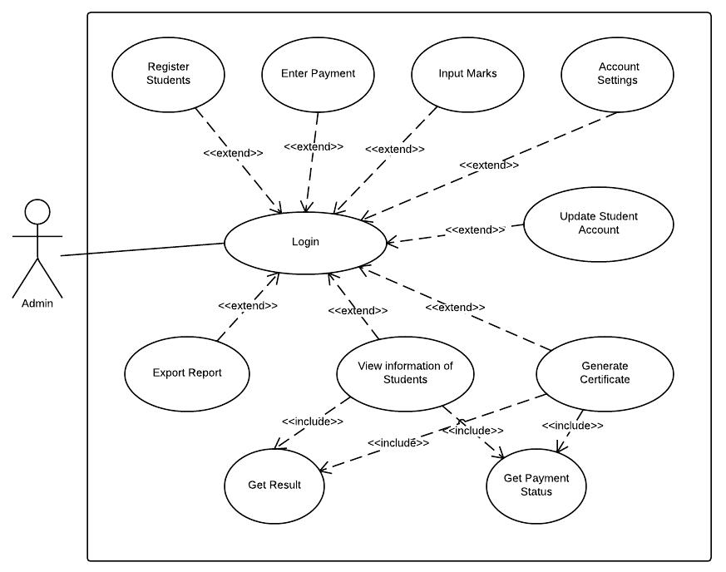
    - Student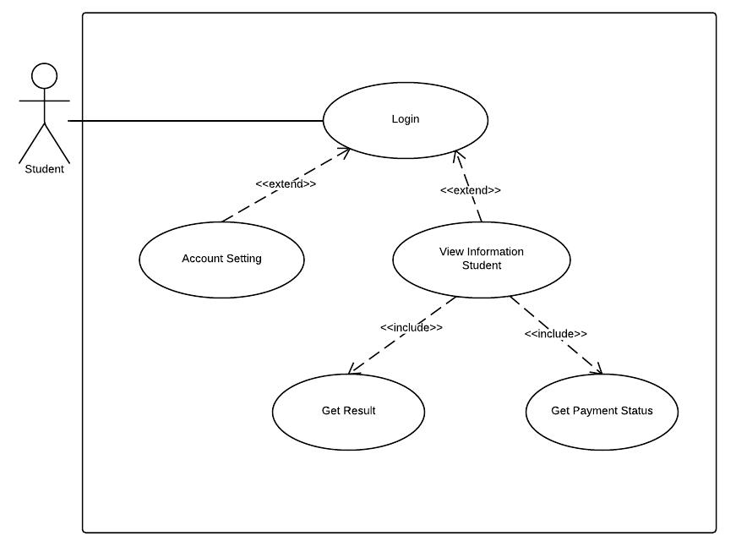
  - FlowCharts
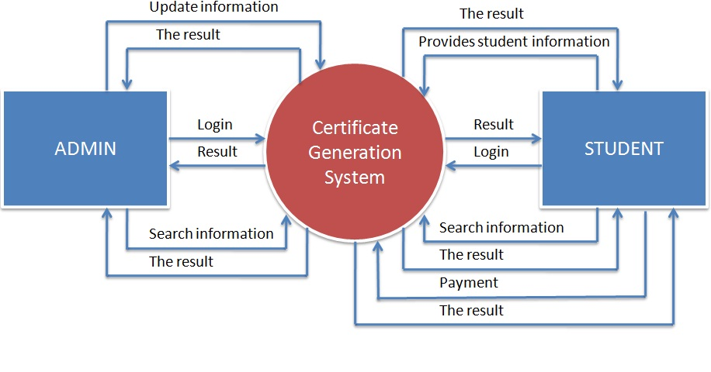
  - DFD's
    - Admin
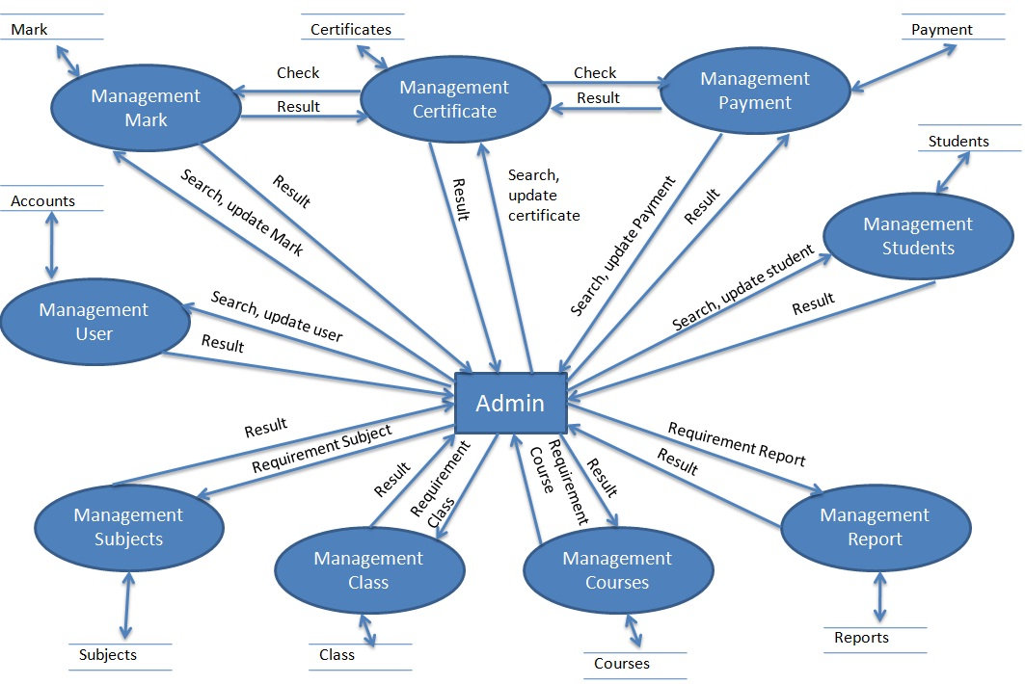
    - Student
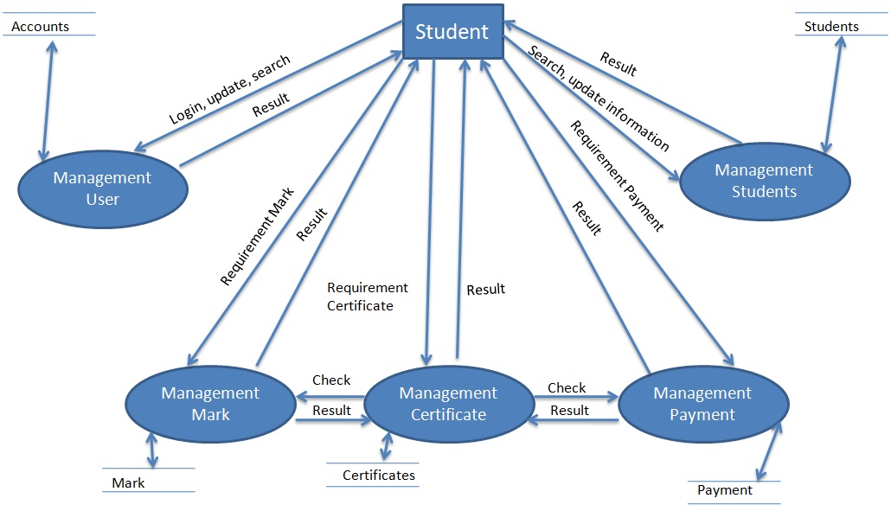
  - Process Diagrams
    - Connect to server
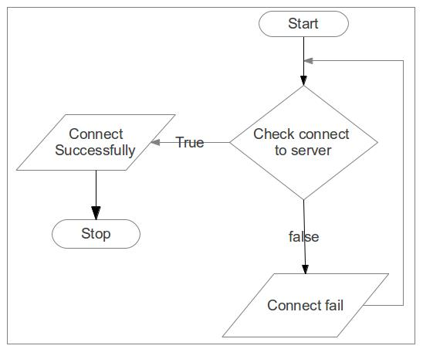
    - Login
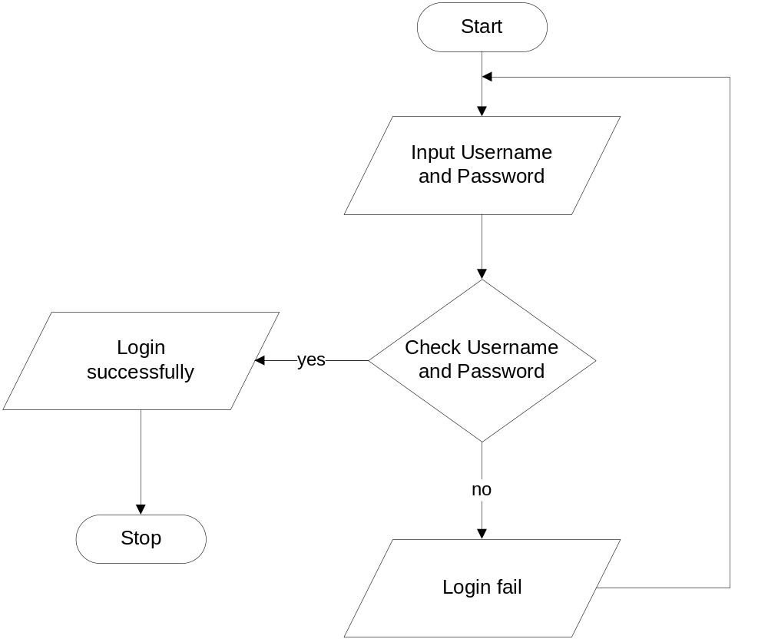

    - Function Add: 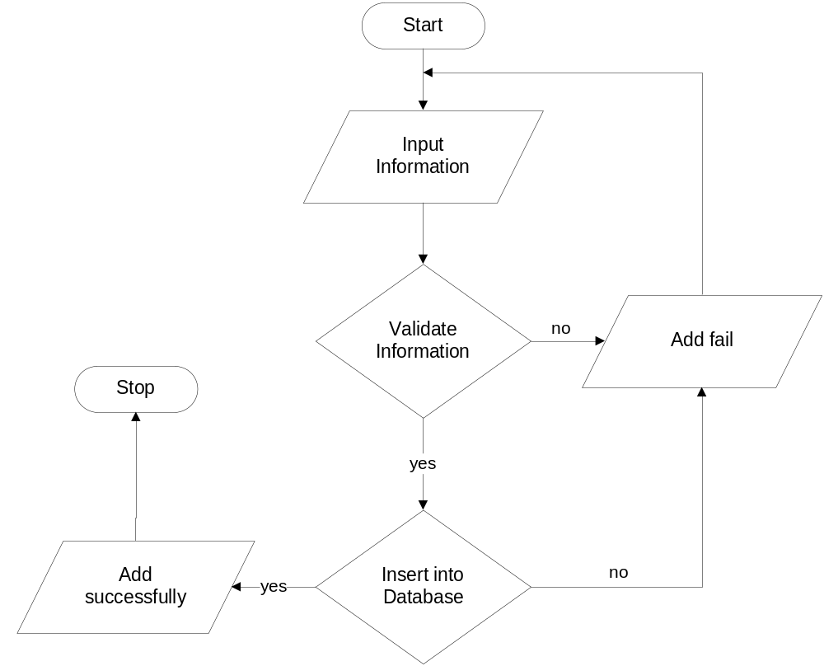
    - Function Update:
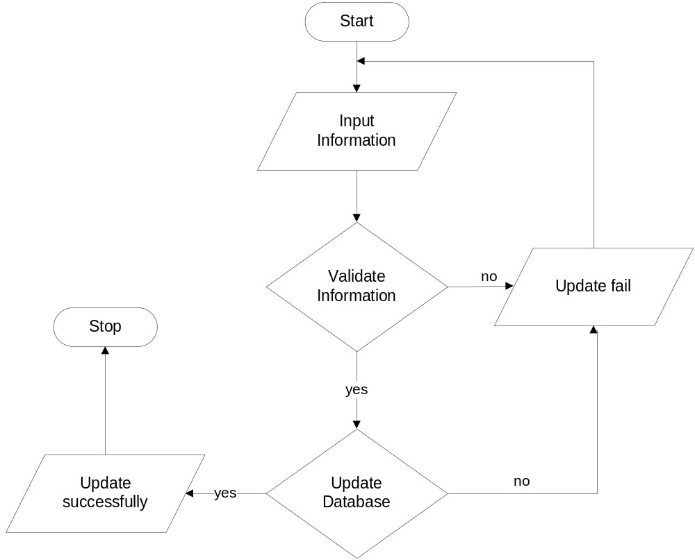
    - Function Delete:
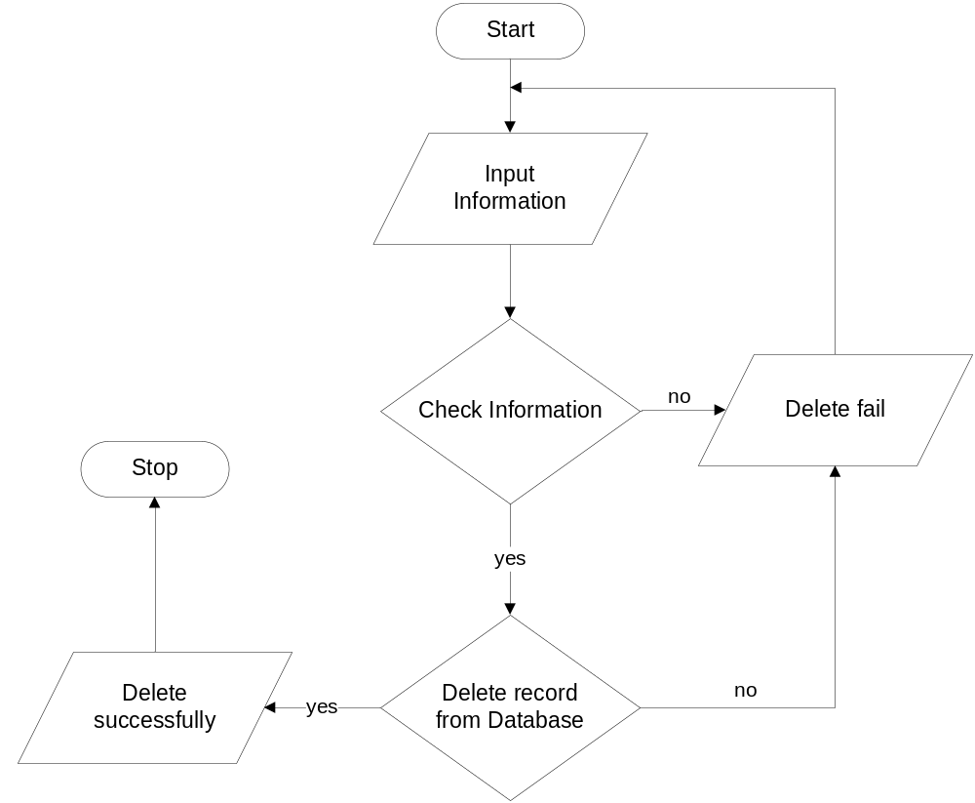
    - Function Search and Display
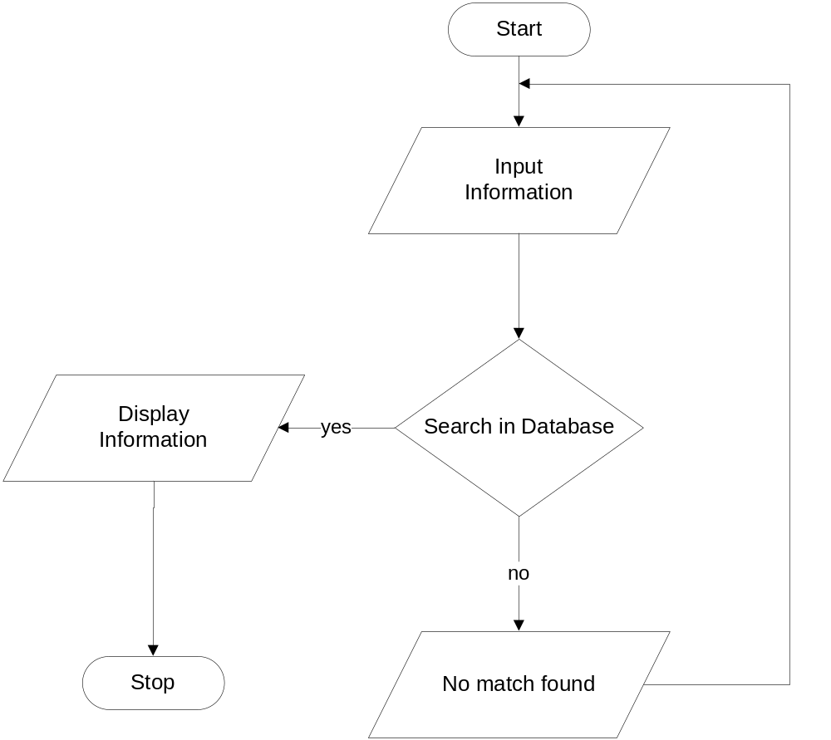
  - Database Diagram / Structure
    - Database Diagram
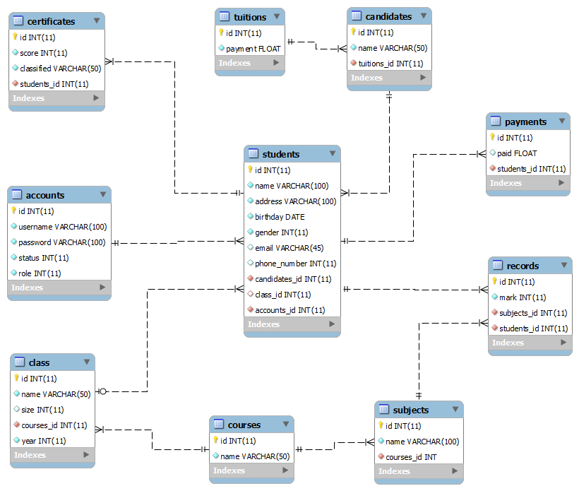
    - Structure

Table: students
Field Name | Date Type | Null | Key | Description
id | int(11) | Not null | PK | Id of the student
name | varchar(100) | Not null |  | Full name of the student
address | varchar(100) | Not null |  | Address of the student
birthday | date | Not null |  | Birthday of the student
gender | int(11) | Not null |  | Gender of the student
email | varchar(45) | Null |  | Email of the student
phone_number | int(11) | null |  | Phone of the student
candidates_id | int(11) | Not null | FK | Id of the candidate
class_id | int(11) | Null | FK | Id of the class
accounts_id | int(11) | Not null | FK | Id of the account

Table: accounts
Field Name | Date Type | Null | Key | Description
id | int(11) | Not null | PK | Id of the account
username | varchar(100) | Not null |  | Username of the account
password | varchar(100) | Not null |  | Password of the account
status | int(11) | Not null |  | Status of the account  (1: enable, 0: disable)
role | int(11) | Not null |  | Role of the account  (1: admin; 0: student)

Table: courses
Field Name | Date Type | Null | Key | Description
id | Int(11) | Not null | PK | Id of the course
name | varchar(50) | Not null |  | Name of the course

Table: class
Field Name | Date Type | Null | Key | Description
id | int(11) | Not null | PK | Id of the class
name | varchar(50) | Not null |  | Name of the class
size | int(11) | Null |  | number of students in the class
year | int | Not null |  | years of start
courses_id | int(11) | Not null | FK | Id of the course

Table: subjects
Field Name | Date Type | Null | Key | Description
id | int(11) | Not null | PK | Id of the subject
name | varchar(100) | Not null |  | Name of the subject
courses_id | Int(11) | Not nul | FK | Id of the course

Table: records
Field Name | Date Type | Null | Key | Description
id | int(11) | Not null | PK | Id of the record
mark | int(11) | Not null |  | Mark
subjects_id | int(11) | Not null | FK | Id of the subject
students_id | int(11) | Not null | FK | Id of the student

Table: tuitions
Field Name | Date Type | Null | Key | Description
id | int(11) | Not null | PK | Id of the tuitions
payment | float | Not null |  | Payment of the tuition

Table: candidates
Field Name | Date Type | Null | Key | Description
id | int(11) | Not null | PK | Id of the candidates
name | varchar(50) | Not null |  | Name of the candidate
tuitions_id | int | Not null | FK | Id of the tuitions

Table: payments
Field Name | Date Type | Null | Key | Description
id | int(11) | Not null | PK | Id of the payments
paid | float | null |  | amount paid of the student
students_id | int(11) | Not null | FK | Id of the students

Table: certificates
Field Name | Date Type | Null | Key | Description
id | int(11) | Not null | PK | Id of the certificates
score | int(11) | Not null |  | Score of the student  (in percent)
classified | varchar(50) | Not null |  | Classified of the student
students_id | int(11) | Not null | FK | Id of the student

- Screen Shot’s
  - Server
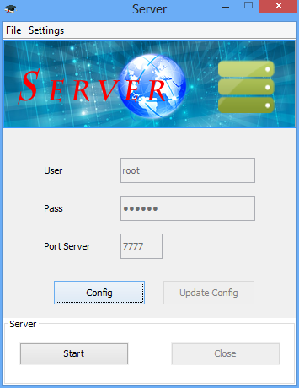
figure 1: server frame
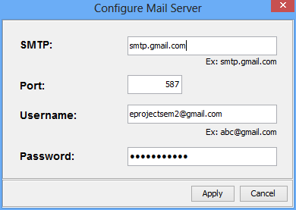
figure 2: Configure Mail Server Frame
  - Client
    - Admin
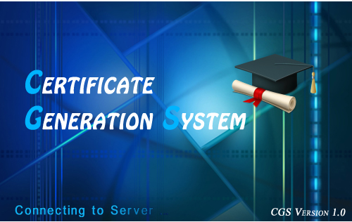
figure 3: SplashScreen
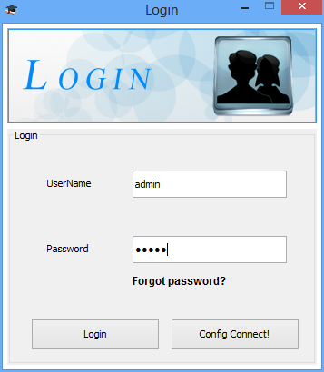
figure 4: Login
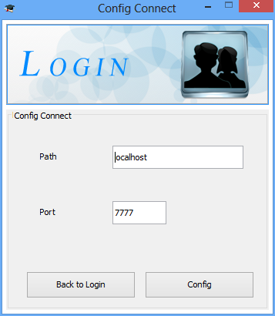
figure 5: config connect to server
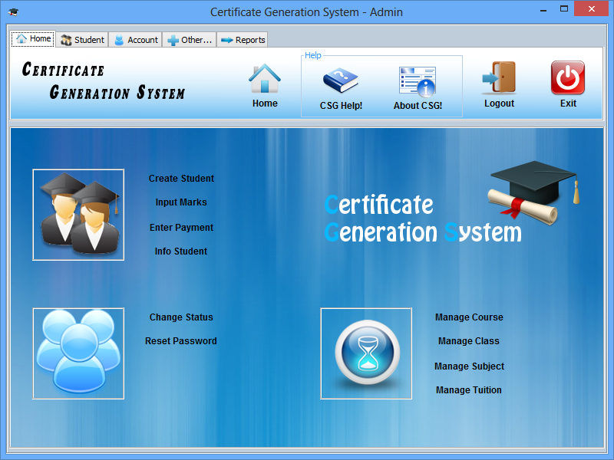
figure 6: Admin home pane

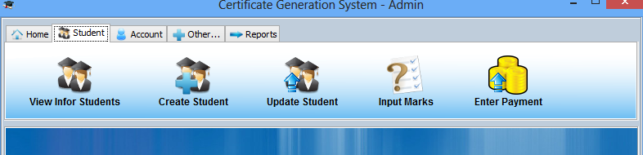
figure 7: tab Student
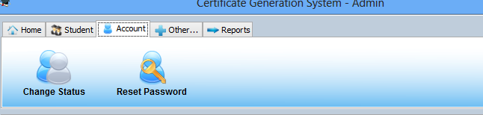
figure 8: tab Account
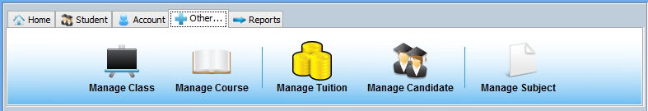
figure 9: tab Other
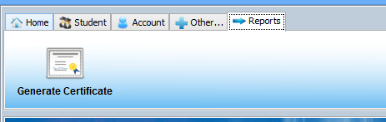
figure 10: tab Reports
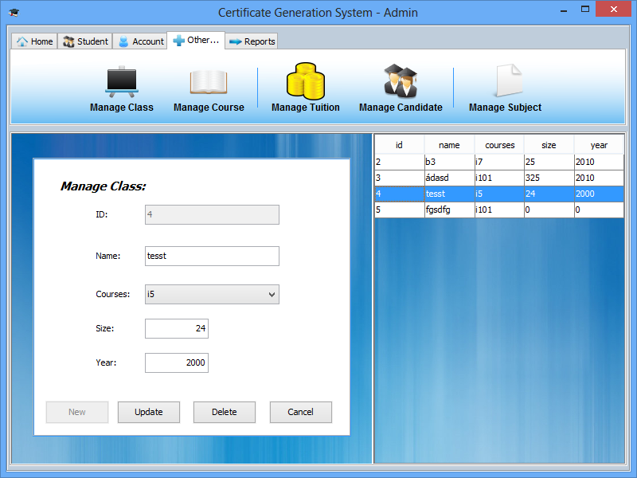
figure 11: manage class
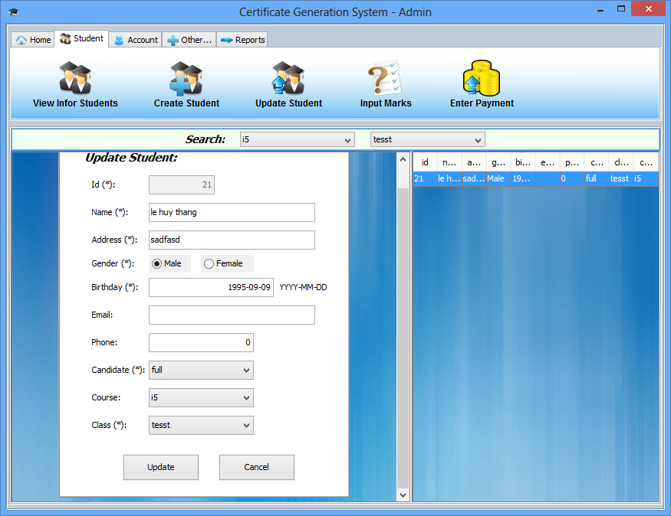
figure 12: update student
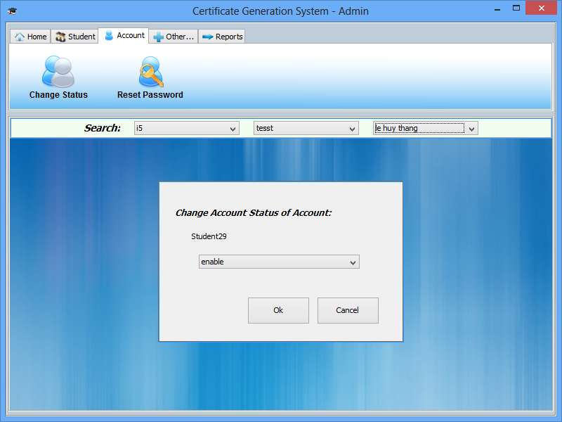
figure 13: change status account
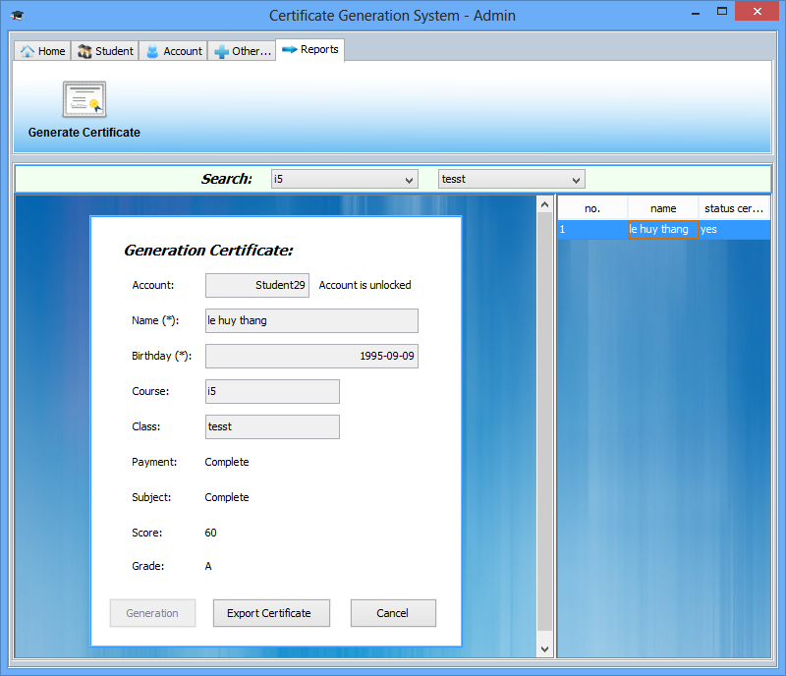
figure 14: generation certificate
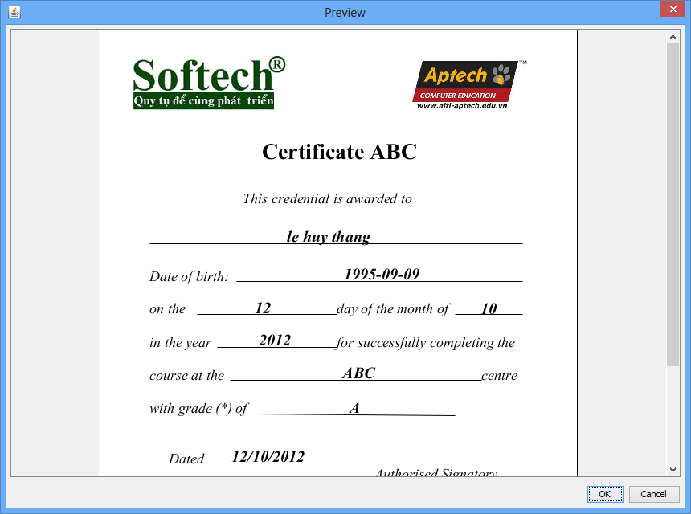
figure 15: preview certificate image

5.2.2 Student
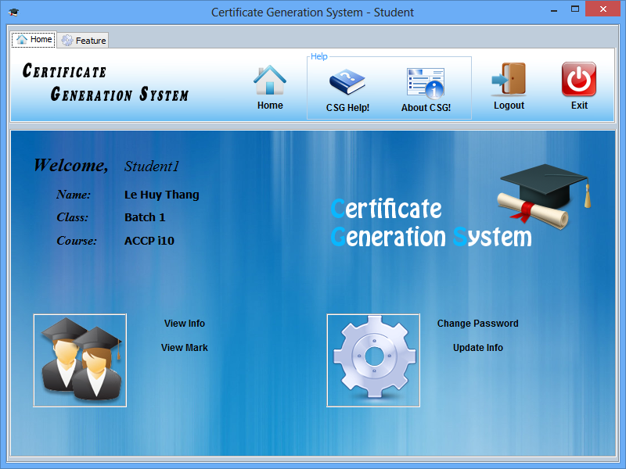
figure 16: Student
- Source Code with Comments
Server.java

/*
* huythang38
*/

package server;

import java.net.InetAddress;
import java.net.MalformedURLException;
import java.net.UnknownHostException;
import java.rmi.Naming;
import java.rmi.NotBoundException;
import java.rmi.RemoteException;
import java.rmi.registry.LocateRegistry;
import java.rmi.server.UnicastRemoteObject;
import java.sql.Connection;
import java.sql.DriverManager;
import java.sql.SQLException;

import javax.swing.JFrame;
import javax.swing.JOptionPane;

import server.actionDatabase.Excutable;
import server.config.Config;
import server.event.read_data.AccountsTable;
import server.event.read_data.CandidatesTable;
import server.event.read_data.CertificatesTable;
import server.event.read_data.ClassTable;
import server.event.read_data.CoursesTable;
import server.event.read_data.PaymentsTable;
import server.event.read_data.RecordsTable;
import server.event.read_data.StudentsTable;
import server.event.read_data.SubjectsTable;
import server.event.read_data.TuitionsTable;

public class Server {
private static Excutable run;
private InetAddress dc;
private int port;
private String userData;
private String passData;
public static Connection conn;
public static AccountsTable accountsTable;
public static StudentsTable studentsTable;
public static CoursesTable coursesTable;
public static ClassTable classTable;
public static TuitionsTable tuitionsTable;
public static CandidatesTable candidatesTable;
public static PaymentsTable paymentsTable;
public static SubjectsTable subjectsTable;
public static RecordsTable recordsTable;
public static CertificatesTable certificatesTable;

public boolean startServer() {
try {
dc = InetAddress.getLocalHost();
run = new Excutable();
port = (new Config()).getPort();
System.out.println(port);
try {
LocateRegistry.createRegistry(port);
} catch (RemoteException e1) {
}

Naming.rebind("rmi://" + dc.getHostAddress() + ":" + port
+ "/certificate", run);
JOptionPane.showMessageDialog(new JFrame(),
"start server successfully!");

// start connect to DataBase
readConfigDatabase();
connectDatabase();
callData();
return true;
} catch (MalformedURLException ex) {
JOptionPane.showMessageDialog(new JFrame(), "not start Server");
return false;
} catch (UnknownHostException e) {
JOptionPane.showMessageDialog(new JFrame(), "not get IP Local");
return false;
} catch (RemoteException e) {
e.printStackTrace();
return false;
}

}

public void closeServer() throws RemoteException {
try {
Naming.unbind("rmi://localhost:" + port + "/certificate");
UnicastRemoteObject.unexportObject(run, true);
disConnectDatabase();
JOptionPane.showMessageDialog(new JFrame(),
"Close server successfully!");
} catch (MalformedURLException e) {
// TODO Auto-generated catch block
e.printStackTrace();
} catch (NotBoundException e) {
// TODO Auto-generated catch block
e.printStackTrace();
}
// run.disConnect();
// System.exit(0);
}

public void readConfigDatabase() {
Config config = new Config();
userData = config.getUser();
passData = config.getPass();
port = config.getPort();
}

public void connectDatabase() {
// TODO Auto-generated method stub
try {
try {
Class.forName("com.mysql.jdbc.Driver").newInstance();
} catch (InstantiationException ex) {
ex.printStackTrace();
} catch (IllegalAccessException ex) {
ex.printStackTrace();
}
} catch (ClassNotFoundException ex) {
JOptionPane.showMessageDialog(new JFrame(), "lib jdbc not found!");
}
try {
conn = DriverManager.getConnection(
"jdbc:mysql://localhost:3306/certificate", userData,
passData);
System.out.println("Connect Database succeeded!");
} catch (SQLException ex) {
JOptionPane.showMessageDialog(new JFrame(),
"error Connect Database!");

}
}

public void disConnectDatabase() {
try {
conn.close();
} catch (SQLException e) {
// TODO Auto-generated catch block
e.printStackTrace();
}

}

public void callData(){
accountsTable = new AccountsTable();
studentsTable = new StudentsTable();
coursesTable = new CoursesTable();
classTable = new ClassTable();
tuitionsTable = new TuitionsTable();
candidatesTable = new CandidatesTable();
paymentsTable = new PaymentsTable();
subjectsTable = new SubjectsTable();
recordsTable = new RecordsTable();
certificatesTable = new CertificatesTable();
}
}

Client.java
/*
* huythang38
*/
package client;

import java.net.MalformedURLException;
import java.rmi.Naming;
import java.rmi.NotBoundException;
import java.rmi.RemoteException;

import server.actionDatabase.IDatabase;

public class Client {
public static IDatabase conn;
public static boolean checkConnect;
//
public Client() { }

// connect to server
public boolean connectServer(String path, int port){
checkConnect = false;
try {
conn = (IDatabase) Naming.lookup("rmi://" + path + ":" + port
+ "/certificate");
checkConnect = true;
} catch (MalformedURLException e) {
// TODO Auto-generated catch block
e.printStackTrace();
checkConnect = false;
} catch (RemoteException e) {
// TODO Auto-generated catch block
e.printStackTrace();
checkConnect = false;
} catch (NotBoundException e) {
// TODO Auto-generated catch block
e.printStackTrace();
checkConnect = false;
}
return checkConnect;
}

public void disConnectServer(){
conn = null;
}

}
- Install guide
  - Install Database (Attach database in MySql Workbech 5.2 CE)
- Start MySql Workbech 5.2 CE
- Choice SQL Development
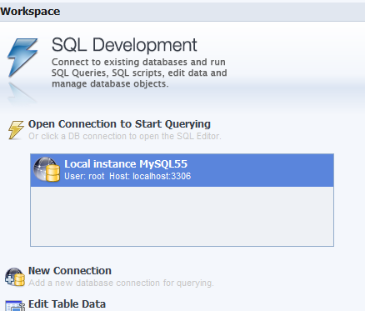
- File → Open SQL Script…
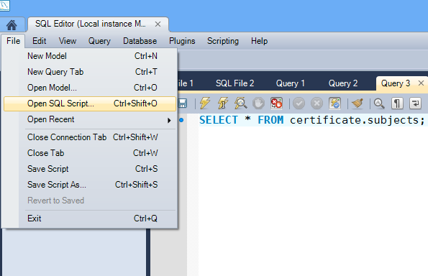
- Choice ‘certificate.sql’ file in the ‘Database’ folder
- Execute script…
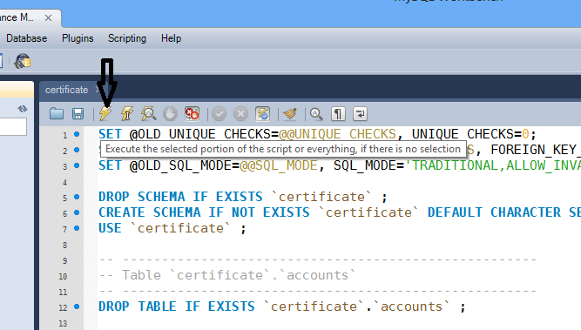
- Result
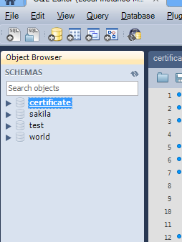
- File → Open SQL Script… and choice ‘Database.sql’ file
- Execute script… to insert data into database
  - Config Server
- Start Server Program
- Click button ‘Config’, enter the name and password of the data in the 'User' and 'Pass'
- Enter the port of the Server(RMI) in the ‘Port Server’
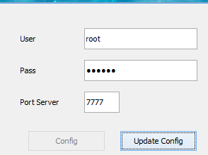
-Click ‘Update Config’
  - Build Server Program (.jar file)
Choice packages: (/source_code/src)
- extend_lib
- server
And manifest file (/source_code/src/server): ‘MANIFEST.MF’
And library folder (/source_code/lib)
  - Build Client Program (.jar file)
Choice packages: (/source_code/src)
- extend_lib
- client
- server/actionDatabase/IDatabase.java
And manifest file (/source_code/src/client): ‘MANIFEST.MF’
And library folder (/source_code/lib)

  - Config Server IP
- after building server program, I create server.bat file with the following content: (change the IP below with your IP)
java -jar -Djava.rmi.server.hostname=10.71.202.107 server.jar
  - Config connect to server
- Start Client Program
- on login and config frame click ‘Config Connect!’ button
- enter the ip and port of the server in the ‘Path’ and ‘Port’
- click ‘Config’ button
  - Config Mail Server
- Developer’s Guide
View in the ‘Document\Class diagram’ folder

- Management And Project Plan

Project Ref. No: |  | Project Title | Date of Preparation of activety Plan
Sr.No | Task |  | Actual Start Date | Team Members Names | Status
1 | Application analysis | CGS | 05-Sep | Huy Thang,  Cong Huu | Complete
2 | Database Design | CGS | 06-Sep | Cong Huu,  Huy Thang | Complete
3 | Use Case | CGS | 21-Sep | Huy Thang | Complete
4 | Flowchart | CGS | 22-Sep | Cong Huu | Complete
5 | Data Flow Diagram | CGS | 14-Sep | Huy Thang | Complete
6 | DFD’s | CGS | 22-Sep | Cong Huu | Complete
7 | Process Diagram | CGS | 21_Sep | Huy Thang | Complete
8 | Specification Document | CGS | 15-Sep | Huy Thang | Complete
9 | Data in Database | CGS | 11-Sep | Huy Thang | Complete
10 | RMI | CGS | 07-Sep | Huy Thang | Complete
11 | Login | CGS | 11-Sep | Huy Thang | Complete
12 | Forgot Password | CGS | 24-Sep | Huy Thang | Complete
14 | Server Program | CGS | 11-Sep | Huy Thang | Complete
13 | Admin:  Manage Student | CGS | 5-Oct | Huy Thang | Complete
15 | Admin:  Manage Account | CGS | 1-Oct | Huy Thang | Complete
16 | Admin:  Manage Course | CGS | 4-Oct | Huy Thang | Complete
17 | Admin:  Manage Class | CGS | 9-Oct | Huy Thang | Complete
18 | Admin:  Manage Tuition | CGS | 4-Oct | Huy Thang | Complete
19 | Admin:  Manage Candidate | CGS | 4-Oct | Huy Thang | Complete
20 | Admin:  Manage Subject | CGS | 8-Oct | Huy Thang | Complete
21 | Admin:  Generation Certificate | CGS | 13-Oct | Huy Thang | Complete
22 | Design Gui | CGS | 11-Sep | Huy Thang | Complete
23 | Student:  View Info | CGS | 9-Oct | Huy Thang
24 | Student:  Update Info | CGS | 9-Oct | Huy Thang
25 | Developer’s Guide | CGS | 14-Oct | Huy Thang
26 | User Guide | CGS | 14-Oct | Huy Thang
- Checked Lists

Check List of Validation

Option | Validated
Can admin login to the application? | Yes
Has the hardware and software been correctly chosen? | Yes
Does the application’s functionality resolve the user problem, and satisfy their needs | Yes
Do all the options present in the application display the correct result? | Yes

