

**Work Assignment Team 1**

ATM management document Dương Trí Tín

Trần Ngọc Mẫn Huy

Hà Thúc Huỳnh Duy

Huỳnh Nhựt Tân

**\* Problem Defination:**

The project entitled ATM system has a drastic change to that of the olderversion of banking system, customer feel inconvenient with the transaction method as it wasin the hands of the bank employees.

In our ATM system, the above problem is overcome here, the transactions aredone in person by the customer thus makes the customers feel safe and secure.

Thus the application of our system helps the customer in checking the balanceand transaction of the amount by validating the pin number therefore ATM system is moreuser friendly.

**\* Customer Requirement Specification**

- Menu for User:

+ DEPOSIT: every time user select the deposit option user must enter the amount he wants to deposit.

+ WITHDRAW: every time user select the withdrawal option user must enter the amount he/she wants to withdrawal. If the user is entering the amount more than his/her balance then the error message should be generated stating “Invalid Balance”.

+ BALANCE ENQUIRY: on the select of this option the available balance of the user should be on the display.

+ CHANGE PASSWORD: it would help the user to change / reset the password. Once the user select the change password option, user must enter 3 values: one for the old password and the other two fields for new password and confirmation of the new password respectively. Once the password is changed the user should be lead to “very first screen” and needs to enter with the changed password.

- Menu for Admin:

+ DEPOSIT: there should be verification / check for deposit : a user neither can deposit more than 25000 $ in a single day nor the user can deposit more than 5 times in a single day.

+ WITHDRAW: there should be verification / check for withdrawal: a user neither can withdraw more than 25000 $ in a single day nor the user can withdraw more than 5 times in a single day

+ BALANCE ENQUIRY: on select of this option user last balance should be stated . Along with this , user can view the last 5 transaction with a complete description such as date, debited, credited and particulars of the transaction.

+ CHANGE PASSWORD: one for the old password and other two for the new password and confirmation password respectively. Once the password is changed the admin page should log out automatically and then he/she is suppose to login with the new password.

+ CHANGE THE LIMIT TIME OF DEPOSIT / WITHDRAWL

+ CHANGE THE LIMIT MONEY OF DEPOSIT / WITHDRAWL

+ CREATE NEW USER ACCOUNT: new user account has full of necessary information: name , unique number, balance, age, gender, phone number. Unique number does not duplicate with existing number.

- Admin’s report:

+ WITHDRAWAL REPORT: here the Date is taken as input and all the withdraw transaction done on that day should be generated with the fields like name , unique number, withdraw amount , balance .

+ DEPOSIT REPORT: here also the date is taken as input and all the deposit transaction done on that day should be generated with fields like name, unique number, Deposited amount, balance.

+ ACCOUNT REPORT: here the list of all the registered user should be displayed with details like name, unique identification number, password, contact number, gender, age.

**\* Project Plan**

1. Quản lí Log in >Duy 12/01

Làm theo đề.

Phải bắt user nhập số thẻ:

+ Số thẻ không tồn tại => báo lỗi

+ Nhập số thẻ đúng => cho nhập password:

* sai pass => nhập lại

* đúng pass => hiện menu

/* menu gồm 4 chức năng, chia ra user dùng & admin quản

Deposit

Withdrawal

Balance Enquiry

Change Password */

2. Làm menu cho USER dùng > Huy + Tan 12/03

* Deposit : cho user nhập số tiền muốn gửi

* Withdrawal : cho user nhập số tiền muốn rút, nhập nhiều hơn số tiền có trong thẻ thì báo lỗi Invalid Balance

* Balance Enquiry : hiện số dư

* Change Password : pass cũ, pass mới, nhập lại pass mới

3. Làm menu ADMIN quản lí >Huy + Tin 12/04

* Deposit : mỗi lần gửi không quá $25000, không quá 5 lần/ngày

* Withdrawal : (sau khi đã check có đủ tiền ở phần(2) Withdrawal của USER) mỗi lần rút không quá $25000, không quá 5 lần/ngày

* Balance Enquiry : hiện số dư của tất cả User

* Change Password : xác thực pass cũ, cập nhật pass mới, nhập lại pass mới

* Other: thay đổi giới hạn/ số lần gửi / rút tiền, tạo tài khoản mới

4. ADMIN’s report > Tin + Duy 12/02

* Withdrawal report : ghi nhận giao dịch rút tiền của tất cả USER: date + name + IDuser + withdraw amount + balance

* Deposit report : tương tự trên

* Account report : thông tin của USER: name + ID + pass + 5 lần giao dịch gần nhất

5. Mô tả Word + Excel > Tin + Duy 12/04

* Problem Defination

* Customer Requirement Specification

* Project Plan

* Object Oriented diagram (tách ra thành 6. Vẽ sơ đồ)

* Use-case diagram (tách ra thành 6. Vẽ sơ đồ)

* Algorithms (tách ra thành 7. Code)

* Task sheet (Excel)

* Project Review and Monitoring Report (Excel)

* Check List

6. Vẽ sơ đồ > Tan + Tin 12/01

* Object Oriented diagram: sơ đồ hướng đối tượng

* Use-case diagram: *https://www.google.com/search?q=use+case+diagram+l%C3%A0+g%C3%AC&oq=use+ca&aqs=chrome.4.0l2j69i57j0l2j69i60l3.5063j0j4&sourceid=chrome&ie=UTF-8*

7. Code > chung 12/05

*Code java *(liên quan với phần 1, 2, 3, 4)*

*Thuật toán

8. Database + SQL > Tan + Huy 12/05

9. powerpoint để thuyết trình > chung 12/06

**\* Object Oriented diagram**

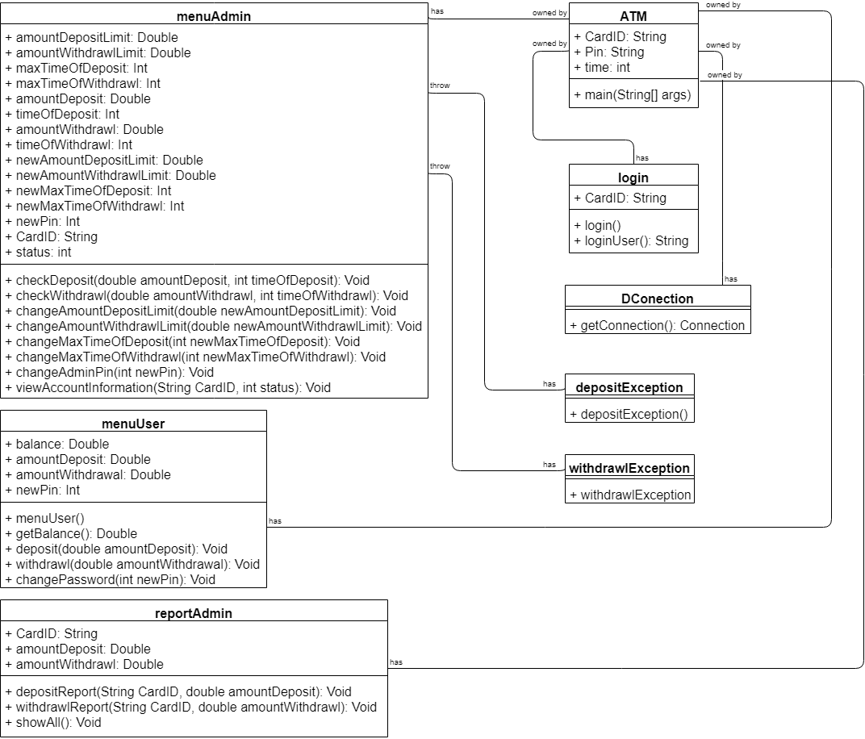

**\* Use-case diagram:**

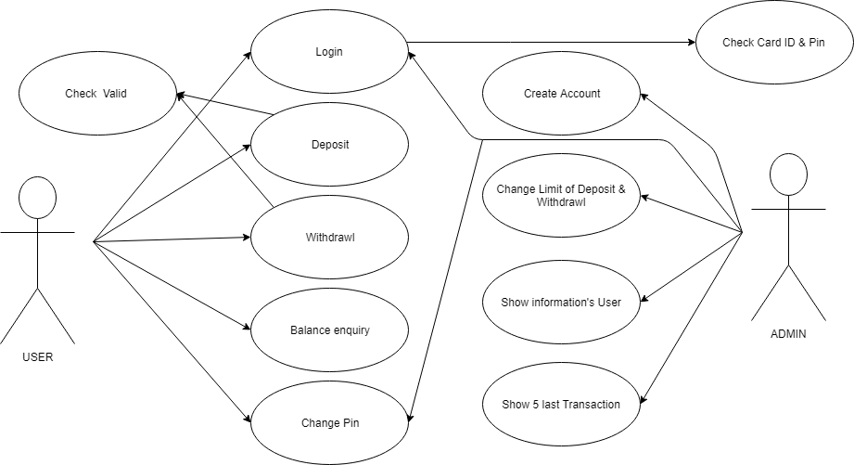

**\* Tesing Check List**

|  |  |  |
| --- | --- | --- |
| Work | Case | Status |
| Login | Input not exist Card ID | Wrong CardID or Wrong PIN |
| Login | Input Pin doesn’t match Card ID | Wrong CardID or Wrong PIN |
| Deposit | Input money more than limit | Invalid input or out of deposit times |
| Deposit | Time of input money more than limit | Invalid input or out of deposit times |
| Withdrawl | Input money more than limit | Invalid input or out of withdrawl times |
| Withdrawl | Time of input money more than limit | Invalid input or out of withdrawl times |
| Change Pin | Input wrong old Pin | Wrong PIN |
| Change Pin | Input new pin doesn’t match comfirm pin | the PIN not matched |
| Change limit | Input new limit equal or smaller than 0 | New Amount Limit must be greater than 0 |
| Create new account | Duplicate Pin | Invalid input |
| Create new account | Wrong format phone number | Invalid input |
| Create new account | Wrong format age | Invalid input |
| Create new account | Wrong format gender | Invalid input |