TopRunner WebSphere Resource Analyzer (TRWRA)
Introduction
TRWRA tool helps an SA to tune and identify application server’s performance problem running within WebSphere server. It can monitor multiple servers on a node or many servers on many nodes in a cluster.
What is TRWRA tool?
TRWRA tool is written 100% Java and using IBM WebSphere AdminClient (PMI API) version 6.1+. This tool right now is only running on Linux or Unix. TRWRA tool can monitor and display resources
• JDBC Connection Pools
• JVM Runtime
• Servlet Session Manager
• Thread Pools
• -->Default
• -->HAManager.thread.pool
• -->Message Listener
• -->Object Request Broker
• -->Process Discovery
• -->SOAPConnectorThreadPool
• -->TCPChannelDCS
• -->WebContainer
• Web Applications
• Transaction Manager

on a window terminal (just like a top command) and it also logs resources information in a file for later use or plot a graph. It can monitor resources on all servers on a node or all servers on all nodes within a cluster at the same time. If one of a server in a node or a cluster stop/crash/error during the monitoring session, this tool will tell you which server in which node has a problem.
Why did I write this? The reason I wrote this tool because the Tivoli Performance Viewer (plug-in web browser) can only monitor one server at a time per browser. Tivoli Performance Viewer is doing a great job but it does not meet my need. If you want to monitor more than one servers, you have to open more than one web browser for each server you want to monitor. This is hard for me to monitor resources for two or more servers in a node or all servers in all nodes with in a cluster at the same time.
This tool is useful for QA and stress test environment because it runs on a manager node of Network Deployment (ND) or on a WebSphere Base version or on a separate box with WebSphere AdminClient. You need to run only one TRWRA tool to monitor resources on one or more servers with in a node or on two or more nodes with in a cluster. This tool uses very little hardware resources (CPU, memory, I/O). It is better to run this tool just after WebSphere servers restarted.
There is a pro and con for this tool. Con: It does not provide GUI and graphics at this time. Pro: It can monitor many servers at the same time on many nodes in a cluster.
TopRunner WebSphere Resource Analyzer can be custom to your need with a quick change in the configuration.
The first screen, TRWRA monitors WebSphere cluster with two nodes and two application servers: node AppServer01Node01, node AppServer02Node02, application server SASServer and BKNServer. On each application server, it monitors a WebContainer, a JVM and two DataSources jdbc/SASDataSource and jdbc/SASDataSoure. NA symbol on the first screen means the resource is not available for that server in that particular node. Also, it displays more detail information on datasources. The datasource monitoring configuration can be specified with in a configuration file.
See Figure 1
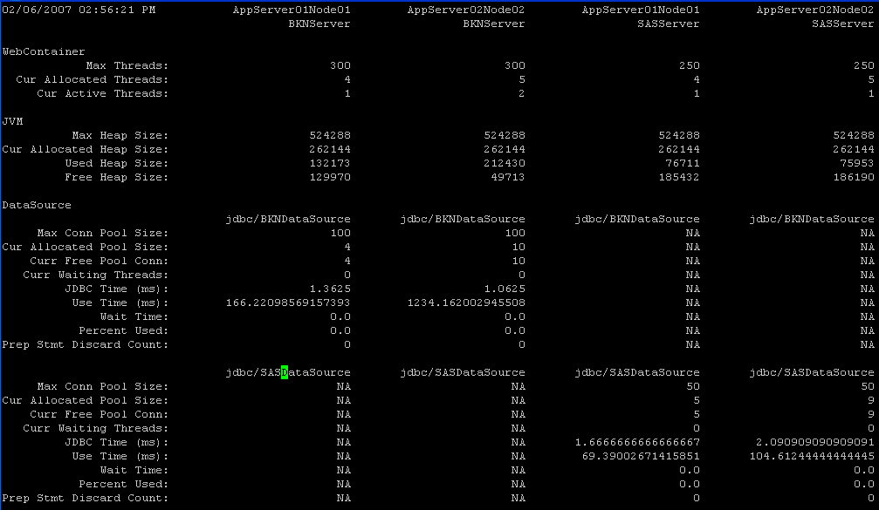

The second screen, TRWRA monitors a WebSphere cluster with two nodes and two application servers: node AppServer01Node01, node AppServer02Node02, application server SASServer and BKNServer. On each application server, it monitors a WebContainer, a JVM and two dataSources jdbc/SASDataSource and jdbc/SASDataSoure. NA and DOWN on the second screen mean the resource is not available and the server on that node is down. It also has a different time format than other screen shot and the datasource information displayed in this screen had less information then the first screen because you can specify the time format and datasource monitoring level with in a configuration file.

See Figure 2
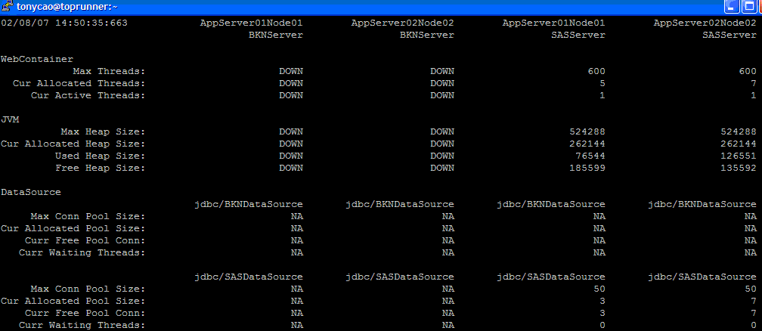

The third screen, TRWRA monitors a WebSphere cluster with four nodes and one application server: node AppServer01Node01, node AppServer02Node02, node AppServer03Node03 node AppServer04Node04 and an application server BKNServer. On the application server BKNServer, it monitors a WebContainer, a JVM and a dataSource jdbc/BKNDataSoure. The datasource information displayed in this screen had less information then the first screen because you can specify the datasource monitoring level with in a configuration file.

See Figure 3
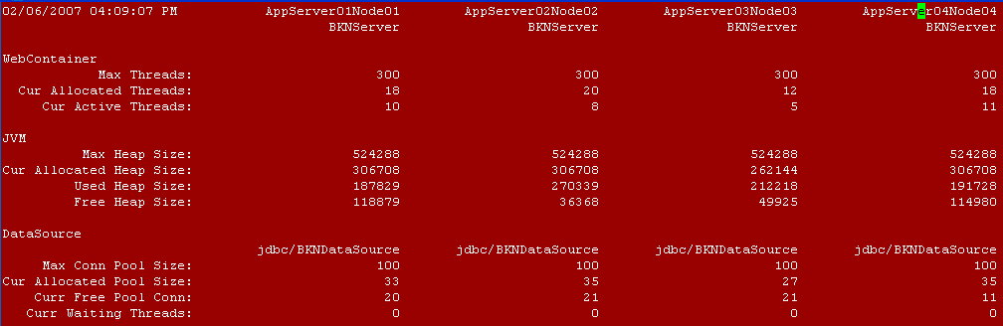

The fourth screen, TRWRA monitors a WebSphere cluster with four nodes and one application server: node ServerApp01Node01, node ServerApp02Node02, node ServerApp03Node03 node ServerApp04Node04 and an application server TicketServer. On the application server TicketServer, it monitors a WebContainer, a JVM and two dataSources jdbc/SPDDataSoure and jdbc/TCKDataSource. The datasource information displayed in this screen had less information then the first screen because you can specify the datasource monitoring level with in a configuration file.

See Figure 4
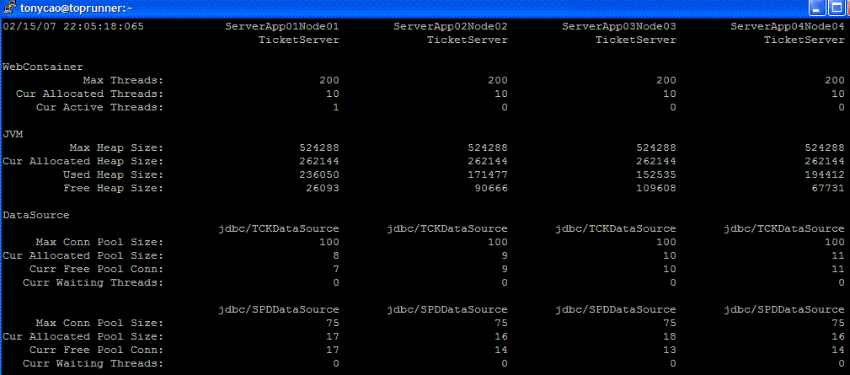

The fifth screen, TRWRA monitors a WebSphere cluster with four nodes and one application server: node ServerApp01Node01, node ServerApp02Node02, node ServerApp03Node03 node ServerApp04Node04 and an application server TicketServer. On the application server TicketServer, it monitors a WebContainer, a JVM and two dataSources jdbc/SPDDataSoure and jdbc/TCKDataSource. The datasource information displayed in this screen had more information then the fourth screen because you can specify the datasource monitoring level with in a configuration file.

See Figure 5
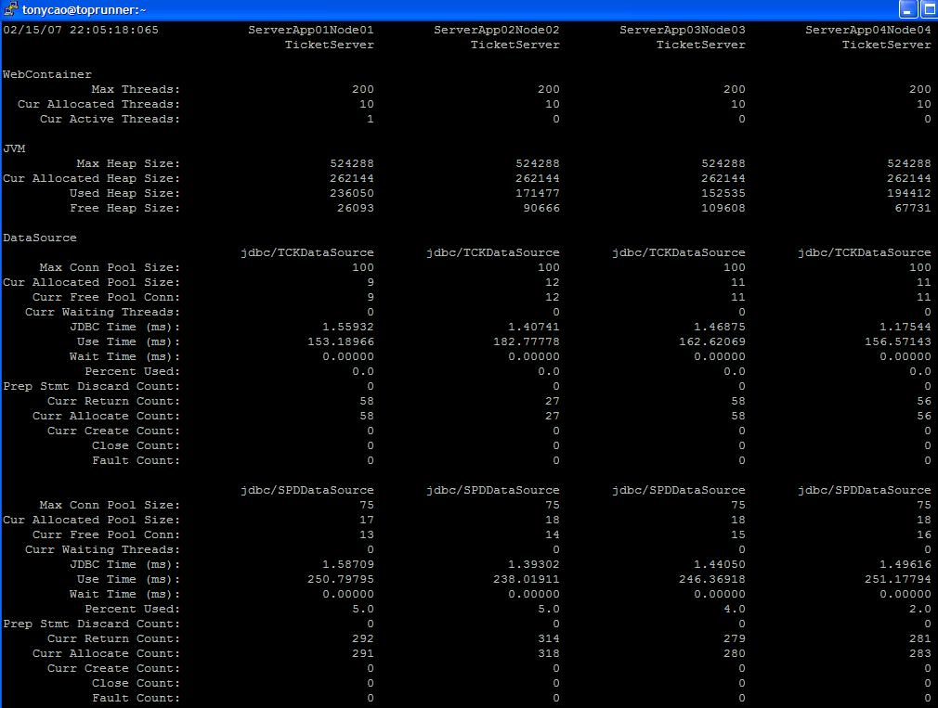

The sixth screen, TRWRA monitors a WebSphere cluster with two nodes and one application server: node newyork01Node01, node newyork02Node02 and an application server FlightServer. On the application server FlightServer, it monitors Thread Pool (HAManager, Message Listener, Process Discovery, ORB, SOAP, TCP Channel and Web Container), JVM, dataSources jdbc/FlightDataSoure, Servlet/JSP (action, flightreg.jsp, auth.jsp). The datasource information displayed in this screen had less information then the fifth screen because you can specify the datasource monitoring level with in a configuration file. You can rearrange the order of the information displayed within the configuration file.

See Figure 6
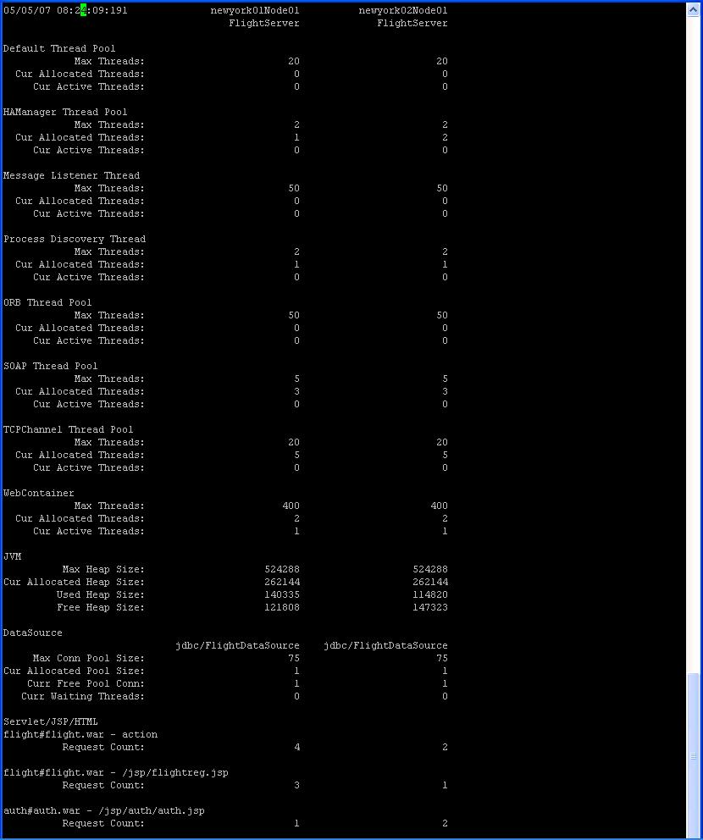

Requirement

You need to download IBM WebSphere AdminClient version 6.1+ to use with this tool.

Installation and Setup

You need to change the ND_HOSTNAME and ND_PORT variables in the startTRWA<version>.sh script.
ND_HOSTNAME=172.26.76.7
# SOAP port for ND application is listening on
ND_PORT=8879

You need to change the ROOTDIR variable for WebSphere AdminClient in the TRWSAppClient<version>.sh

ROOTDIR=/home/tonycao/IBM/WebSphere/AppClient_6.1.0.9

Start / Stop TRWRA Tool

Start TRWRA tool
startTRWA<version>.sh

After you are done with your monitoring and want to stop monitoring.
stopTRWA<version>.sh

Here is a configuration file how to setup to monitor servers (see figure 1)

#
# "#" sign is used for comment and it must be at the beginning of the line. If a "#" sign is not at the
# beginning of the line, it will not be treated at comment.
#
# If you have any question, please feel free to send me an email to the email addresses below:
# huycao@verizon.net (home)
# huycao69@gmail.com (home)
# tony.cao@dowjones.com (work)
# I will response when time is permitted.
#
# This TopRunner WebSphere Resource Analyzer tool is designed to use for WebSphere ND version. It designed
# for a domain with clustering with multiple nodes running on Linux or Unix.
#

#==============================================================================================
# list of server(s) node to monitor. Use "|" as a separator.
#
# This is in a ND box. You can find the nodes in directory structure like below:
# cd /opt/IBM/WebSphere/AppServer/profiles/TPDmgr/config/cells/RH42NDCell01/nodes
# ls
# RH42B1Node01 RH42B2Node01 RH42NDCellManager01
#
# Example 1: You have domain with only one node and node name is MyNode1
# Nodes=MyNode1
#
# Example 2: You have domain with four nodes and node names are MyNode1, MyNode2, MyNode3 and MyNode4
# Nodes=MyNode1|MyNode2|MyNode3|MyNode4
#==============================================================================================
Nodes=AppServer01Node1|AppServer02Node02

#==============================================================================================
# list of application server(s) to monitor. Use "|" as a separator
#
# This is in the base box. You can find the application servers in directory structure like below:
# cd /opt/IBM/WebSphere/AppServer/profiles/TP/logs
# ls
# AuthServer
#
# Example 1: You have one application server and its name is MyServer
# AppServers=MyServer
#
# Example 2: You have two application servers and their names are MyServer1 and MyServer2
# AppServers=MyServer1|MyServer2
#==============================================================================================
AppServers=BKNServer|SASServer

#==============================================================================================
# Monitor values level
# L - low (default)
# M - medium
# H - high
#==============================================================================================
MonitorLevel=M

#==============================================================================================
# Monitor values displayed in the order below. If you want to change to order, you can rearrange it.
# yes - monitor this resource
# no - do not monitor this resource
#==============================================================================================
# Web Container
MonitorWebContainerThreadPool=yes
# JVM
MonitorJVM=yes
# DataSource
MonitorDatasource=yes
# Session no
MonitorSessions=no
# Web Application (Servlet/JSP/etc...) no
MonitorServlet=no
# default
MonitorDefaultThreadPool=no
# HAManager
MonitorHAManagerThreadPool=no
# Messager Listener
MonitorMessageListenerThreadPool=no
# ORB
MonitorORBThreadPool=no
# Process Discovery
MonitorProcessDiscoveryThreadPool=no
# SOAP connector
MonitorSOAPConnectorThreadPool=no
# TCP Channel DCS
MonitorTCPChannelDCSThreadPool=no
# Transaction Manager
MonitorTransactionManager=no

#==============================================================================================
# list JDBCDriver(s) and datasource(s) to monitor. Use "|" as a separator for each datasource and ";"
# for each JDBCDriver list. ":" is a separator between JDBCDriver and DataSource
#
# format is below:
# JDBCDriverName:jdbc/DataSourceName|jdbc/DataSourceName2;JDBCDriverName1:jdbc/DataSourceName1
#
# Example 1: JDBCDriver name is OracleJDBCDriver and datasource name is jdbc/MyDataSource
# Datasources=OracleJDBCDriver:jdbc/MyDataSource
#
# Example 2: JDBCDriver name is OracleJDBCDriver and two datasource names are jdbc/MyDataSource and
# jdbc/MyDataSource1
# Datasources=OracleJDBCDriver:jdbc/MyDataSource|jdbc/MyDataSource
#
# Example 3: JDBCDriver name is OracleJDBCDriver and two datasource names are jdbc/MyDataSource and
# jdbc/MyDataSource1. JDBCDriver name is SybaseJDBCDriver and a datasource name is
# jdbc/MyDataSource2.
# Datasources=OracleJDBCDriver:jdbc/MyDataSource|jdbc/MyDataSource;SybaseJDBCDriver:jdbc/MyDataSource2.
#
#==============================================================================================
#Datasources=
Datasources=OracleJDBCDriver:jdbc/BKNDataSource|jdbc/SASDataSource

#==============================================================================================
# list of Servlet Session Manager. Use "#" as a separator for application name and warfile. Use "|" as
# a separator for more than one sessions. appname#warfile.war is in the IBM WebSphere Resource format.
# format is:
# appname#warfile.war|appname1#warfile1.war
#
# Example 1: Application name is TradeApp and in Trade.war file
# SessionAppNames=TradeApp#Trade.war
#
# Example 2: Application name is TradeApp and it is in Trade.war file. Another application name is
# OrderApp and it is in Order.war file.
# SessionAppNames=TradeApp#Trade.war|OrderApp#Order.war
#
# Example 3: Application name are TradeApp and OrderApp and both are in TradeOrder.war file.
# OrderApp and it is in Order.war file.
# SessionAppNames=TradeApp#TradeOrder.war|OrderApp#TradeOrder.war
#
#==============================================================================================
SessionAppNames=
#SessionAppNames=StdWorldClock_war#StdWorldClock.war
#SessionAppNames=syndication#syndication.war

#==============================================================================================
# list of Web Application. Use "#" as a separator for application name and warfile. Use "|" as
# a separator for more than one servlet/JSP/HTML. ":" is to separate between war file and servlet/JSP/HTML.
# ";" is to separate between two or more appname#warfile.war.
# servlet/JSP/HTM. appname#warfile.war is in the IBM WebSphere Resource format.
# format is
# appname#warfile.war:servletname|jspname;appname1#warfile1.war:servletname
#
# Example 1: Applicaiton name is TradeApp and in Trade.war file. It contains one of the servlet called
# action you want to monitor
# ServletAppNames=TradeApp#Trade.war:action
#
# Example 2: Applicaiton name is TradeApp and it is in Trade.war file. It contains two of the servlets
# called auth and register you want to monitor.
# ServletAppNames=TradeApp#Trade.war:auth|register
#
# Example 3: Applicaiton name are TradeApp and OrderApp and both are in TradeOrder.war file. TradeApp
# contains two of the servlets called auth and register. OrderApp contains of the
# JSP called reg.jsp.
# ServletAppNames=TradeApp#TradeOrder.war:auth|register;OrderApp#TradeOrder.war:reg.jsp
#
#==============================================================================================
ServletAppNames=
#ServletAppNames=StdWorldClock_war#StdWorldClock.war:Portlets
#ServletAppNames=syndication#syndication.war:/jsp/syndication/modules/Newsitem.jsp|action

#==============================================================================================
# display on screen
# yes - display the monitor resources on the screen.
# no - do not display the monitor resources on the screen (result is going to be written to a DataFile).
#==============================================================================================
DisplayOnScreen=yes

#==============================================================================================
# reset values before start monitoring session
# yes - clear all resources values before running.
# no - do not clear all resources values before running.
#==============================================================================================
ResetValuesBeforeStart=yes

#==============================================================================================
# writes all resource information to a file (give full path). Directory must exist.
# THIS MUST BE PROVIDED.
#==============================================================================================
DataFile=/home/tonycao/IBM/WebSphere/TRWSPMI/data.txt

#==============================================================================================
# writes all error to a file (give fullpath). Directory must exist. THIS MUST BE PROVIDED.
#==============================================================================================
ErrorLogFile=/home/tonycao/IBM/WebSphere/TRWSPMI/error.txt

#==============================================================================================
# Monitor time (how long do you want it to run). It is in minutes.
# Sample rate in second
#
# Example: Run for two hours and refresh rate 30 seconds.
# MonitorDuration=120
# MonitorInterval=30
#==============================================================================================
MonitorDuration=60
MonitorInterval=30

#==============================================================================================
# Email alert feature.
# This feature will send you and email alert if a server or a node is down.
# To disable email alert, set MAILHOST= to empty string. Right now password is in clear text, I will try
# to encrypt it in the next release.
# If you have a list of email addresses that you want to send. User "|" sign as a separator. This works
# for MailTo, MailCc, MailBcc.
#
# To turn email authentication off, simple make the MailUserid= and MailPasswd= to empty string.
#
# Example:
# MailHost=
# MailUserid=
# MailPasswd=
#
# Example: Send email to two email addresses test@test.com and test@aol.com
# MailTo=test@test.com|test@aol.com
# will be available later
#==============================================================================================
MailHost=
#MailHost=mailserver
#MailUserid=
#MailPasswd=
#MailTo=tony.cao@wsj.com|huycao@verizon.net
#MailFrom=tony.cao@wsj.com
#MailCc=tony.cao@wsj.com
#MailBcc=tony.cao@wsj.com

#==============================================================================================
# For a WebSphere with security turns on
# Set SecurityEnable to no will disable all security. Right now password is in clear text, I will try
# to encrypt it in the next release.
#
# yes - security is turned on
# no - security is not turned on

# Example 1: to turn off security
# SecurityEnable=no
#
# Example 2: turn on security with username and password and certificate. Make sure the TrustStorefile and
# KeyStoreFile must come from Network Deployment (ND). So the TopRunner WebSphere Resource Analyzer can do
# hand shaking with ND.
#
# SecurityEnable=yes
# SecurityUserName=test2
# SecurityPasswd=test2
# TrustStoreFile=/opt/IBM/WebSphere/AppServer/profiles/TPDmgr/etc/DummyClientTrustFile.jks
# TrustStorePasswd=WebAS
# KeyStoreFile=/opt/IBM/WebSphere/AppServer/profiles/TPDmgr/etc/DummyClientKeyFile.jks
# KeyStorePassword=WebAS
#==============================================================================================
#SecurityEnable=no
SecurityEnable=yes
SecurityUserName=wasadmin
SecurityPasswd=wasadmin
TrustStoreFile=/home/tonycao/IBM/WebSphere/AppClient_6.1.0.9/etc/DummyClientTrustFile.jks
TrustStorePasswd=WebAS
KeyStoreFile=/home/tonycao/IBM/WebSphere/AppClient_6.1.0.9/etc/DummyClientKeyFile.jks
KeyStorePassword=WebAS

Conclusion

This tool helps you troubleshoot performance bottle neck and tuning web application server. It displays all information in one screen.

Download

Java classes and jar files
http://www.zoolert.com/tony/trwra.tar

About the author

I am a programmer for more than 15 years (C/C++, Java, shell, Perl, PHP, Jython, basics) and also a WebSphere system administrator for 6 years. I am currently working at Dow Jones.

Contact

If you have any question or bug, please let send me an email.

huycao69@gamil.com (home)

Open Source Code:

https://github.com/huytonycao/WebSphereRA

