Manual for Drosophila embryo MS2-MCP movie analysis

# I. Overview:

## 1. Requirements

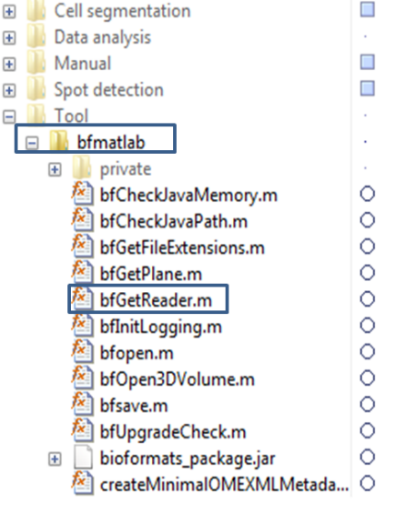1) MATLAB 2013 or higher (not tested with lower version)

2) SEGNUP matlab package

3) Bioformat package for MATLAB

-Download from <http://downloads.openmicroscopy.org/bio-formats/5.1.10/>

-Extract the zipped file to ImgProc_pipeline\Tool\bfmatlab

-bfGetReader.m should be in this folder.

Additionally, you can install ImageJ or any tiff/lsm/czi manipulation software to visualize, extract or manipulate the images. In case of ImageJ, you need the Bioformat package for ImageJ (<http://downloads.openmicroscopy.org/bio-formats/5.2.4/>)

## 2. Inputs

1) Experiment output file: called 3D movie. It has two channels:

-Channel 1: (RED) Nuclear envelop for cell segmentation

-Channel 2: (GREEN) MCP-GFP channel for monitoring of transcription activity

2) Experiment’s configuration, which includes:

-Number of image frame

-shiftleftX, shiftrightX (position of embryo poles relative to the captured frame)

-sampling interval: dt

-XY and Z resolution (µm/pixel)

-Anterior direction (left or right)

## 3. Output:

1) Nuclei segmentation and lineage information:

-Typically in “**_Track.mat**” file

2) Spot intensity in each nuclei (currently only 1 spot per nuclei) over time.

-Example file: “**th30_20.txt**”

-The results file is in table_summary folder, in the main movie folder.

-See Header.txt for output file format.

3) Configuration file “**correction.mat**” that should be put in the same folder as the spot intensity file:

- The file stores the experiment configuration, specifying bad cells, frames of interest…

-To be created manually

-See III. correction.m for reference

4) Other miscellaneous files that you can forget about after the segmentation process:

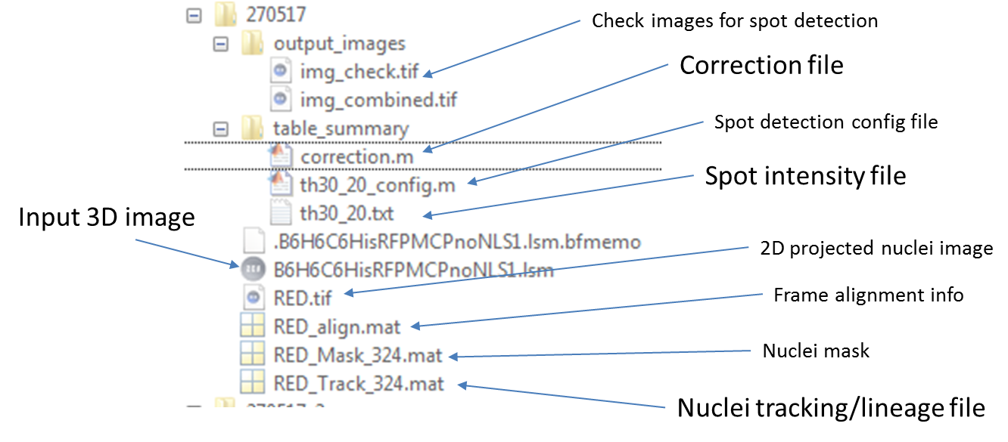

## 4. Work flow:

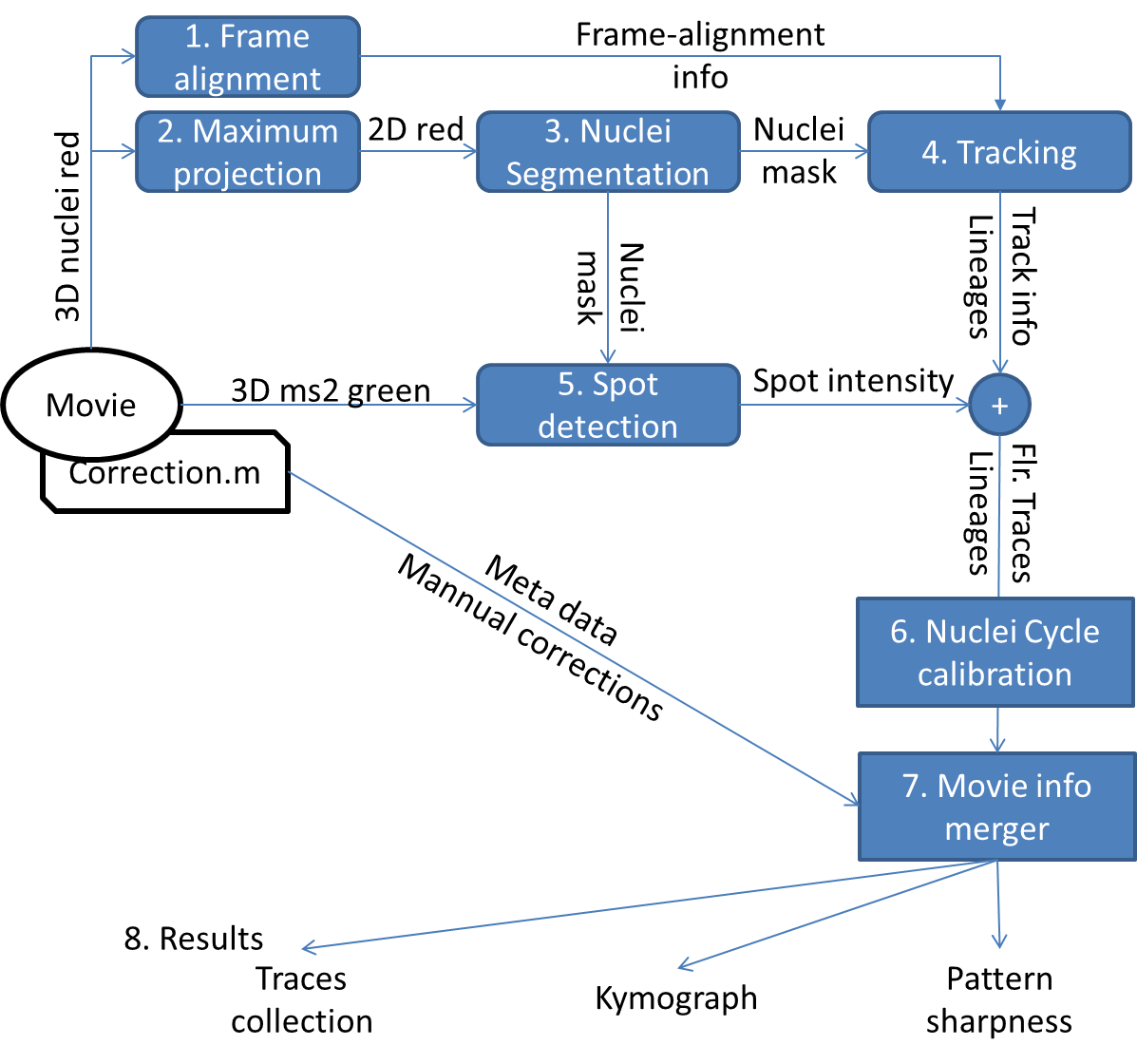

The package consists of 4 modules:

1) Nuclei segmentation and tracking: Task 1,2,3,4

2) Spot detection: Task 5

3) Nuclei cycle calibration: Task 6

4) Movie merger and analyzer: Task 7,8

Yes, the modules look very daunting, and it seems there are bazillions of things to learn to master this tool! But don’t panic. With some guidance from a senior “ball finder”, you will find yourself processing a movie in half a day.

Let’s think of this manual as a lookup tool for what to do next.

# II. Nuclei segmentation

## 1. Create 2D movie for nuclei segmentation

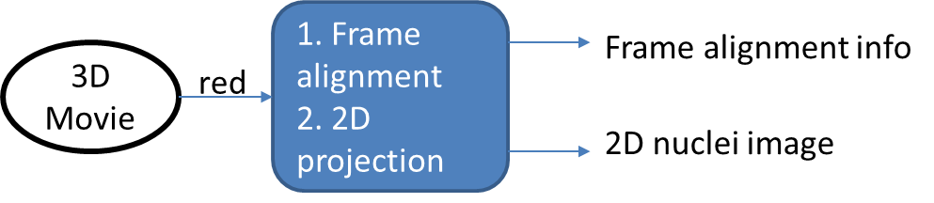

1. Open Cell segmentation/Create_maximum_projection.m

2. Specify the following parameters:

folder: movie file location (e.g. ..\Test\)

mov_in: 3D movie input file name (e.g. “**TOTAL.tif**”)

mov_out: 2D movie output file name (e.g. “**RED**”), without file extension

n_frame: Range of frame to be analyzed (e.g. [1:100])

3. Additional parameters: see comments in .m file

4. Run the file (F5). A file titled as mov_out is now created. The nuclei segmentation will be done based on this file (referred as “**RED.tif**”).

Also created is the file “**RED_align.mat**” containing the frame-by-frame alignment information. This alignment information is used to predict a nuclei position in the next frame given the drift between the frames and crucial in tracking cell lineages.

## 2. The nuclei segmentation interface

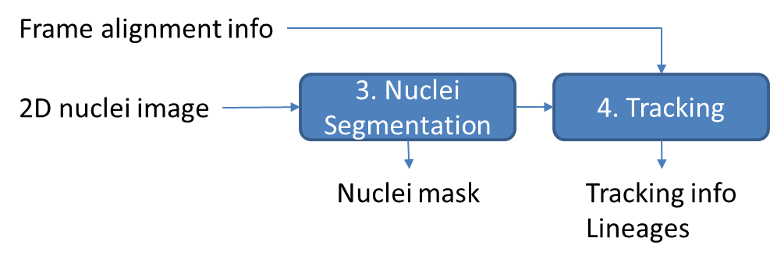

1. Run the file Cell segmentation/SEGNUP3.m

You expect to see an interface layout like the picture bellow:

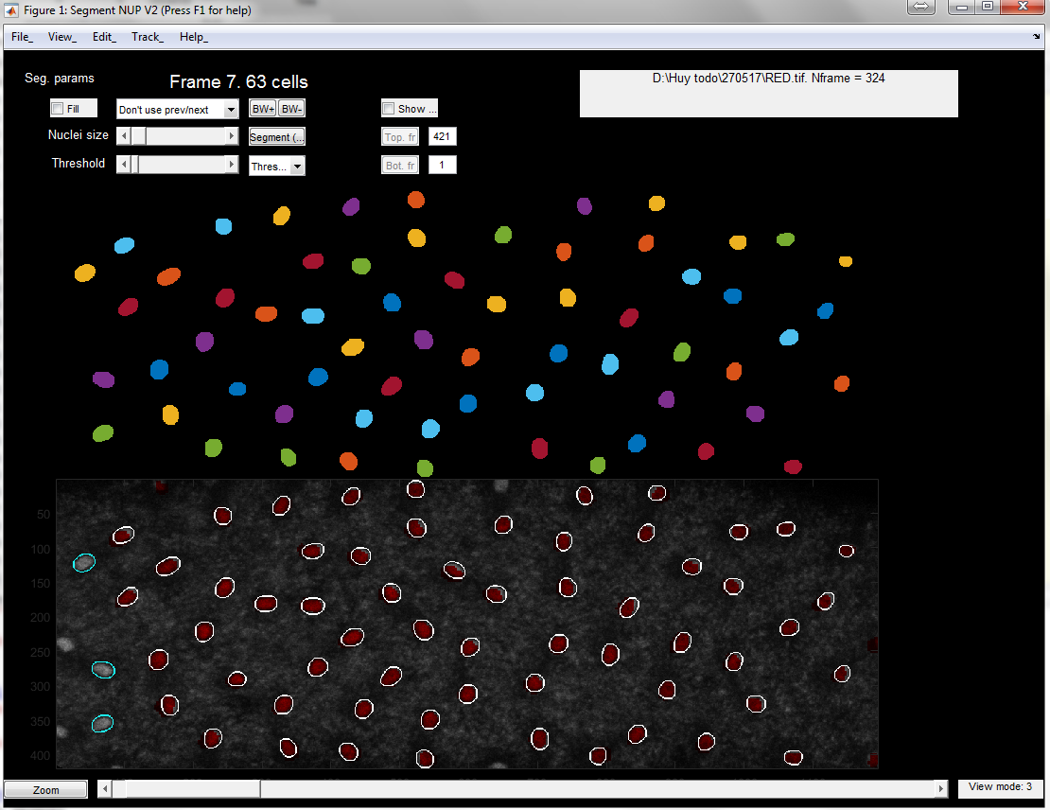

2. Load the 2D movie “**RED.tif**”

-Click **Menu>File>Load image**, navigate to file “**RED.tif**” generated previously.

-Choose the number of time frame you wish to analyze. Set this value (***Nf***) to either 0 or greater than number of available time frames will load all frames.

-Choose the cell cycle at frame 1.

3. Navigate through frames:

-Scroll mouse or controlling the slider at the GUI’s bottom to navigate through the frames.

-The frame index, and the number of nuclei detected is shown in the top left corner.

4. Save and Load Mask:

-During the segmentation process, you can save the temporary masking results by select **Menu>File>Save Mask**. The file is stored in the same folder as “**RED.tif**”. (e.g. “RED_Mask_10.tif”, the final number of the number of frame you wish to analyze).

-Select **Menu>File>Load Mask** button will load the image. Note that the number of frame ***Nf*** must be specified correctly when loading the movie.

5. Segment the cell (see section II.3)

6. Cell tracking and lineage construction

When you are done with the segmentation process, press **Menu>Track>Track** to check for segmentation consistency. A new window will appear and show the tracking process, frame by frame.

Once the tracking process is complete, you can see the lineage tree by pressing **Menu>Track>Plot Lineage tree**.

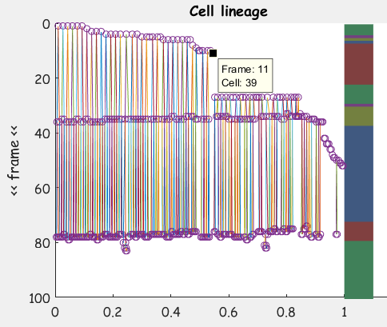

7. To check for irregularities here, for example, you can ask:

-Do the nuclei divide at roughly the same time? (e.g. in the picture above, you see that they all divide at the ~40 mins and ~80 mins, so it is ok).

-Does each nucleus have two daughters?

You can click with Data tooltip on Irregular balls to see which frame and cell it is.

Navigate to the frame with irregularities and press **Menu>Track>Check Track** to see the tracking results here.

Fix the frame and restart the Track proces again.

When completed, the program will generate an output “**RED_Track_10.tif**”, which will be used in the spot detection process.

If you are not happy with the way the nuclear cycle is detected, Press **Menu>Track>Set cycles** to manually specify the beginning and end frame of each cell cycle.

## 3. View modes

1. View modes on image panel:

There are 4 view modes, applied to the image panel:

|  |  |
| --- | --- |
| 1. Original   There is no mask added to this image |  |
| 1. Red mask   A red mask layer of the current frame is added to the original image |  |
| 1. Contour mask   A contoured mask of the current frame is added to the original image |  |
| 1. Contour mask + projected red mask   The contour mask of the current frame is added on top of the red mask of previous frame.  The contour mask without overlapping red mask (orphaned nuclei) is marked as cyan |  |

2. View modes on mask panel:

Tick on **Check ecc** to highlight eccentric nuclei and nuclei with too small size. This is helpful but computationally costly.

3. Zoom in/out:

Press **Zoom** at lower left corner to adjust the panel size.

4. View cell count:

Select **View>View Cell count** to view the total number of nuclei and nuclei with mother per frame.

This is helpful to check for masking consistency before the tracking process.

## 4. Nuclei segmentation (in details)

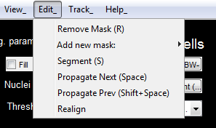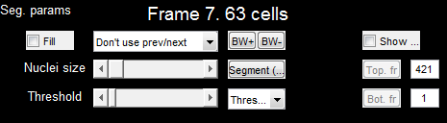

1. Segmentation strategy:

-We perform segmentation frame by frame.

-In each frame, we start with automatic segmentation first, followed by manual correction if needed.

-In automatic segmentation, the segmentation results and parameters of one frame can be used for the segmentation of the next, which should reduce the manual correction work.

-Get familiar with Hotkeys.

2. Automatic segmentation:

-There are 3 modes of automatic segmentation:

-Threshold 1: Basic filtering, thresholding and select only big nuclei

-Threshold 2: Basic filtering, thresholding and select medium and big nuclei

-Circle: The program will find circle-like objects. Helpful on NUP movies

-Select the proper **Nuclei size** and **Threshold** (top left) using the sliders. As you adjusting the sliders, you will see the binary mask corresponding to these values. The following cell numbering will be based on this mask.

-Press  (hotkey **S**) to perform automatic segmentation using Thresholding method. If you are not satisfied, keep adjusting **Nuclei size** and **Threshold**.

3. Manual correction:

-Press  (hotkey **O** or **P**) to either increase or decrease the mask size of all nuclei by 1 pixel.

-Add a new nuclei **Edit>Add new mask**:

-You can choose to use **Free hand** tool (Hotkey A) or add **Elliptic mask** (Shift+A)

-Remove a nuclei:  (hotkey **R**)

-Double click on the mask of nuclei to be removed in the first panel

4. Restrict the masking region



Adjuding the Top.fr and Bot. fr to select the vertical range of the masking region. All nuclei that border specified region will be excluded from masking.

## 5. Tracking (in details)

The tracking process is done automatically. Here is a brief explanation of what is going on in the process of each frame:

1. Get the separate colored region from current frame’s mask. Each region correspond to a single nuclei.

2. Get the projected mask from the previous frame using the alignment information. Attribute the nuclei from the current frame to the previous frame based on the overlapping mask.

3. Check if nuclei in the previous frame have more than one direct progenies in the current frame. If yes, assign new labels to the progeny and attribute them as daughters of the nuclei from the previous frames.

# III. Spot detection

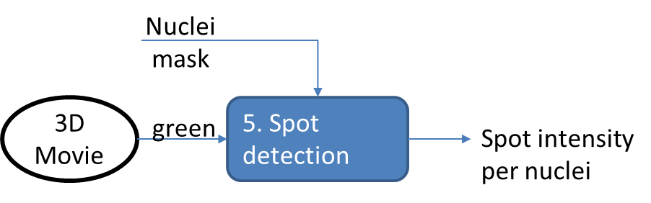

## 1. Spot detection

1. Open file Spot detection/main_Spot_detection.m

2. Specify the input movies and frame to be analyze

-Movie folder **mov_folder**

-The original movie file (time-lapse, 3D, 2 channels): **main_mov**

-The nuclei movie file name: **nuclei_mov**

-Frame range to analyze. To test the spot detection function, it is recommended to select one or two frames with spots first.

3. Specify movie parameters (e.g shiftleftX, shiftrightX, dt …). These parameters are then saved at the local **table_summary** folder and can be loaded if reanalysis is needed.

4. Select spot detection criteria: It is good to take a look at the parameters and see what it means in the comment section.

5. Select threshold values for spot detection

There are two parameters that can be tuned to change the sensitivity of the spot detection methods:

-**th1**: minimum absolute spot intensity

-**th2**: minimum spot intensity above the background level.

To enter the mode of finding the threshold values, *set either of th1 and th2 to 0*. When you ran main_Spot_detection.m, a figure panel will appear:

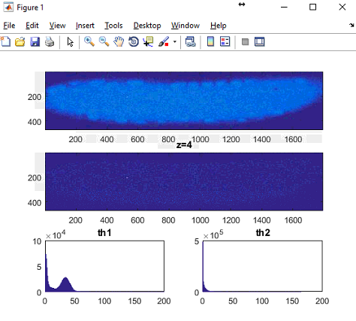

The first panel is the unfiltered image. The second panel is the image with background subtraction (you can see a spot here). You can zoom into the spot location and use “data tool tip” to see what the right threshold for the detection is.

Once you find the right value for th1 and th2, press **Ctrl + C** to break away from the script.

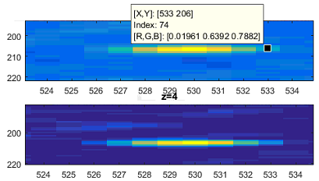

Set th1 and th2 and run main_Spot_detection.m

5. Check the spot detection process:

Check output_images folder (in the script directory) to check the spot detection process.

## 2. Export the data

Set the frame to analyze to the whole movie and restart the script. The output file is that in the original movie file that has the file name “th[th1] [th2].txt”.

The header of the output file is in Header.txt of the script file for look up purpose.

# IV. Nuclei cycle calibration:

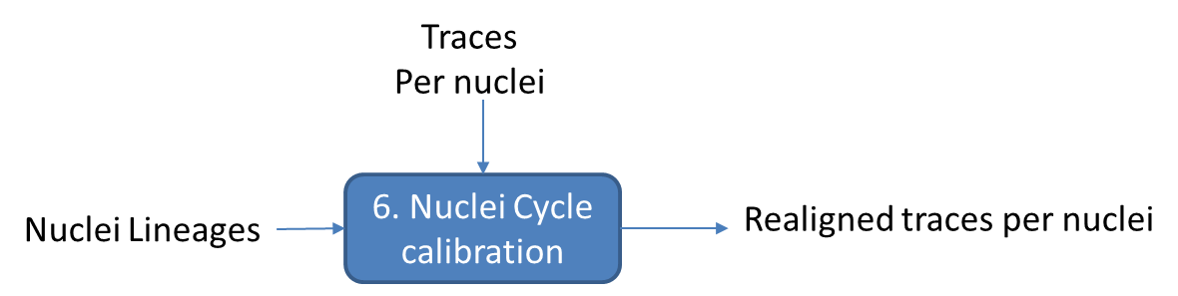

Due to the mitotic wave, traces may not have similar beginning time. To correct for this effect, we adjust the intensity traces in time according to their corresponding initiation time.

## 1. Defining a trace beginning time

We define a trace’s start the time when mitosis in the respective nucleus ends. During mitosis, the two sister chromosome are rapidly pulled away from one another. Once reaching a certain distances, their drifting away speed slows down.

We set the end of mitosis as the first time their drifting away speed slow down.

## 2. Trace alignment

# V. Finalizing the movie data:

To finalize the movie data, we need to create a file called “correction.m” in the same folder as the data file (here, referred as “movie_data.txt”, instead of “th[th1] [th2].txt”).

The template for correction.m is located in Data analysis/extract_data folder.

Have a look at the comment section. Copy the template from here and modify the file as seen fit.

# VI. Data analysis

## 1. Merge movies

## 2. Show features’ patterns

## 3. Trace collection

## 4. Pattern dynamics