

BrewBoss — Cafe Shop Management System
Software Design Document

Project Code: PRM393
Document Code: BrewBoss_SDS – v1.0

– Hanoi, September 2026 –

Table of Contents
Right-click here and choose Update Field to build the table of contents.

I. Project Report

1. Status Report
Record of changes of this document:
Date | A*  M, D | In charge | Change Description
28/09/2026 | A | Trần Ngọc Huy | First version. Architecture, component, database and interaction design for UC01–UC46, derived from SRS v1.0, Use Case Specifications v1.2 and Product Brief v0.1. New diagrams in docs/diagrams/sds-diagrams.drawio.

*A - Added M - Modified D - Deleted
Status of the design by section:
Section | Content | Status
II.1–2 | Introduction, system architecture, assumptions, constraints | Done
II.3 | Architectural views: process, logical, development, deployment | Done
II.4.1 | Common design: navigation, state management, errors, transactions, security, notifications | Done
II.4.2–4.10 | Component design of the 9 modules: classes, screens, sequence diagrams | Done; class members are refined during implementation
II.5 | Firestore collections, indexes and project files | Done; data model frozen at the end of W1
Code | Reference slice (auth, staff: my shift) implemented; other modules not started | In progress

2. Team Involvements
No | Member | Student ID | Role / modules | SDS sections
1 | Trần Ngọc Huy |  | Leader — AUTH, STAFF, core/ | I, II.1–3, II.4.1, II.4.2 AUTH, II.4.3 STAFF
2 | Phạm Khắc Nghĩa |  | POS — orders, payment, VietQR | II.4.6 POS, payment and order transactions in II.4.1.6
3 | Nguyễn Bá Cường |  | BAR, CUS, tables, RPT, LOY, Security Rules | II.4.7 BAR, II.4.8 CUS and tables, II.4.9 RPT, II.4.10 LOY, security design II.4.1.7
4 | Lại Hữu Quang Anh | HE190282 | MENU, INV, models/ | II.4.4 MENU, II.4.5 INV, II.5 Database design

3. Issues/Suggestions
# | Issue | Decision / suggestion
1 | Q1 — does the course need a custom backend? | No. Firebase (Auth, Firestore, Storage, Functions, Hosting) is the backend; all business rules run in the app and are enforced again by Security Rules.
2 | Q2 (carried from the SRS) — customer ordering as Flutter Web or in-app only? | Decided: Flutter Web build of the same codebase, hosted on Firebase Hosting. The table QR encodes https://<host>/c/{tableId}; customers need no install. Staff use the mobile app.
3 | Q4 — Cloud Functions need the Blaze plan | Enable Blaze (free quota is enough). Fallback already designed: Firestore listeners show in-app alerts (ready orders, low stock) when push is unavailable.
4 | Server vs client timestamps | The reference slice writes Timestamp.now() (client clock) because server timestamps read back as null before the write is acknowledged. Switch to FieldValue.serverTimestamp() with a null-safe converter if times must be trusted.
5 | Daily shortId counter is a hot document | One counter document per day (counters/shortId-yyyyMMdd) updated in the create-order transaction. Enough for one shop; shard only if contention errors appear.
6 | Role lookup in Security Rules costs one read per request | Accepted for v1. Mirror the role into custom claims with a Cloud Function if reads become a cost problem.

II. Software Design Document

1 Introduction

1.1 Purpose
This document describes the design of BrewBoss, a cafe shop management system built as one Flutter application on Firebase. It turns the requirements of the SRS (UC01–UC46, FR/NFR/BR identifiers) into an architecture, component, interaction and data design that the four team members implement module by module.
Intended readers: the development team (implementation and code review), the instructor (assessment of the design), and testers (the class and sequence designs name the rules and transactions to test).

1.2 Definitions, Acronyms and Abbreviations
Term | Meaning
SRS / SDS | Software Requirement Specification / Software Design Specification (this document)
UC, FR, NFR, BR | Use case, functional requirement, non-functional requirement, business rule identifiers from the SRS
S01–S22 | Screen identifiers (SRS §3.1.2)
POS | Point of Sale — the cashier's ordering and payment screens
VietQR | Vietnamese interbank QR standard (NAPAS) for bank transfers
Firestore | Cloud Firestore, the NoSQL document database of Firebase
FCM | Firebase Cloud Messaging (push notifications)
Riverpod | flutter_riverpod, the state management and dependency injection library
Provider | A Riverpod object that exposes a value or stream (e.g. StreamProvider)
Controller | A Riverpod AsyncNotifier that performs writes for a screen
Repository | Data-layer class; the only kind of class that calls Firebase
freezed | Code generator for immutable Dart data classes with copyWith and JSON
Transaction | Firestore runTransaction: all reads first, then writes; committed all or nothing
shortId | Human-readable order code <letter><4 digits>, reset daily (BR-ORD-06)
Batch | Round of items added to an order; the barista sees only the latest batch (BR-ORD-04)
Anonymous auth | Firebase sign-in without credentials, used for customers ordering by table QR

1.3 References
# | Document | Version / date | Location
1 | BrewBoss Software Requirement Specification | v1.0, 28/09/2026 | docs/srs_prm.docx
2 | BrewBoss Use Case Specifications (UC01–UC46) | v1.2, 28/09/2026 | docs/BrewBoss_UseCase_Specifications.docx
3 | BrewBoss Product Brief | v0.1, 23/09/2026 | docs/product-brief.md
4 | BrewBoss Task Assignment | v1.3, 28/09/2026 | docs/BrewBoss_Task_Assignment.docx
5 | Coding rules and code templates | — | docs/CODING_RULES.md
6 | Diagrams (draw.io sources and PNG exports) | — | docs/diagrams/ (sds-diagrams.drawio, erd.drawio, order-flow.drawio, …)
7 | IEEE Std 1016-2009, Software Design Descriptions | 2009 | IEEE
8 | Flutter, Riverpod, go_router documentation | — | docs.flutter.dev, riverpod.dev, pub.dev/packages/go_router
9 | Firebase documentation (Auth, Firestore, Security Rules, Functions) | — | firebase.google.com/docs
10 | VietQR Quick Link (image API) | — | vietqr.io — img.vietqr.io/image/{bin}-{account}-compact2.png

2 System Architecture

2.1 System Overview
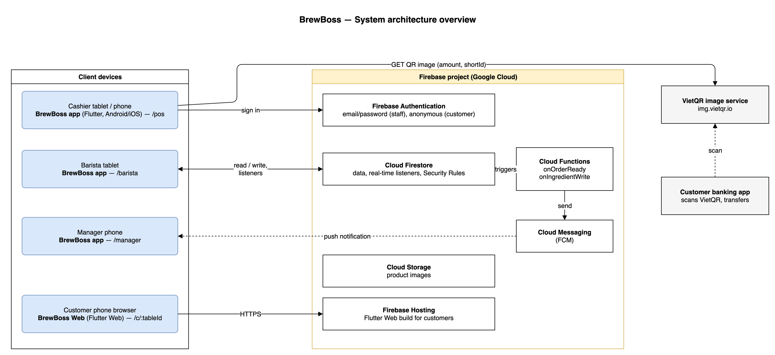
Figure 2-1: System architectural overview
As described in Figure 2-1, the system has the following components:
- BrewBoss app (Flutter, Android / iOS): the software being developed. One app for the three staff roles; after login the role guard opens the Cashier (/pos), Barista (/barista) or Manager (/manager) home. Runs on tablets and phones.
- BrewBoss Web (Flutter Web): the same codebase built for the web and limited to the customer routes /c/:tableId (S17, S18). Customers open it by scanning the table QR; no install, no login (anonymous auth).
- Firebase Authentication: email/password accounts for staff, anonymous accounts for customers. Passwords never reach Firestore (NFR-SEC-02).
- Cloud Firestore: all business data (users, orders, menu, stock, …). Real-time listeners deliver new orders to the barista in under 2 s (NFR-PERF-01); Security Rules enforce the role permissions (NFR-SEC-01); transactions keep payment, stock and points consistent (NFR-REL-01).
- Cloud Storage: product images uploaded by the Manager.
- Cloud Functions + FCM: server-side triggers that push 'order ready' to cashiers and 'low stock' to managers (FR-BAR-05, FR-INV-06).
- Firebase Hosting: serves the customer web build.
- VietQR image service (img.vietqr.io): public service that returns a VietQR image for a bank account, amount and transfer note. No API key; the cashier confirms the transfer manually.

2.2 Assumptions
The system is designed on the following assumptions:
- One shop, one branch (A1). No multi-branch data partitioning.
- Staff devices: Android 8.0+ or iOS 14+ phones and tablets with Wi-Fi or 4G (NFR-COMP-01). The barista uses a tablet mounted at the bar.
- Customers use their own phone with a modern mobile browser (Chrome, Safari) to open the table QR link.
- Every user has exactly one role; the Manager holds all Cashier and Barista permissions.
- The UI is Vietnamese; code and documents are English (A3). Money is an integer in VND.
- VietQR transfers are confirmed manually by the cashier (A4); no payment gateway webhook.
- The Firebase project can use the Blaze plan for Cloud Functions; if not, in-app listeners replace push notifications.
- Order volume of a small cafe: a few hundred orders per day, fewer than 20 staff devices at the same time.

2.3 Design Constraints
- Fixed stack: Flutter + flutter_riverpod (plain providers, no code generation) + go_router + Firebase + freezed/json_serializable + intl. No second state-management or routing library.
- Architecture rules: feature-first folders; dependency direction presentation → application → data; only data/ touches Firebase; cross-feature access only through application/ providers (NFR-MAINT-01).
- Security: every read and write is checked by Firestore Security Rules per role (NFR-SEC-01); customers may only create awaiting orders and read their own.
- Consistency: payment + stock deduction + loyalty points + voucher usage run in one Firestore transaction (NFR-REL-01). Firestore transactions require all reads before writes.
- Performance: new order visible at the bar in ≤ 2 s (real-time listener, no polling); cold start < 3 s; menu of 100 products scrolls at 60 fps (lazy lists, cached images).
- Availability: Firestore offline cache is enabled so short network drops do not lose in-progress orders (NFR-REL-02); transactions need the network and fail with a retry message offline.
- Data rules: money is int VND; Firestore field names follow SRS §3.1.6 exactly; order items store a name/price snapshot.
- Quality gates: flutter analyze with zero warnings (NFR-MAINT-02); every business rule BR-* has a unit test; Security Rules tested on the Firebase Emulator.
- Usability: tap targets ≥ 48 dp, VND format 45.000 ₫, phone and tablet layouts (NFR-USE-02, 03).

3 Software Architecture Design

3.1 Architectural Representation
The architecture is described with the 4+1 view model. The use-case view is the SRS (use case diagrams D0–D5, A1–A5 and specifications UC01–UC46); the other four views are in this document:
Table 3-1: Architectural views
View | Purpose | Model elements | Section
Use-case view | Functional requirements that drive the design | Actors, use cases (SRS) | SRS §2.3
Process view | Runtime behaviour: order lifecycle, concurrency, real-time updates, transactions | Activity diagram, state machine, sequence diagrams | 3.2.1, 4.x.3
Logical view | Domain classes and their relationships | Class diagram of lib/models | 3.2.2
Development view | Source code organisation and dependencies | Package diagram, per-module class diagrams | 3.2.3, 4.x.1
Deployment view | Devices, Firebase services and artifacts | Deployment diagram | 3.2.4

3.2 Software Architecture
BrewBoss is a serverless client application: each device runs the full application logic and talks directly to Firebase. Inside the app the code is organised feature-first, and each feature follows a three-layer pattern.
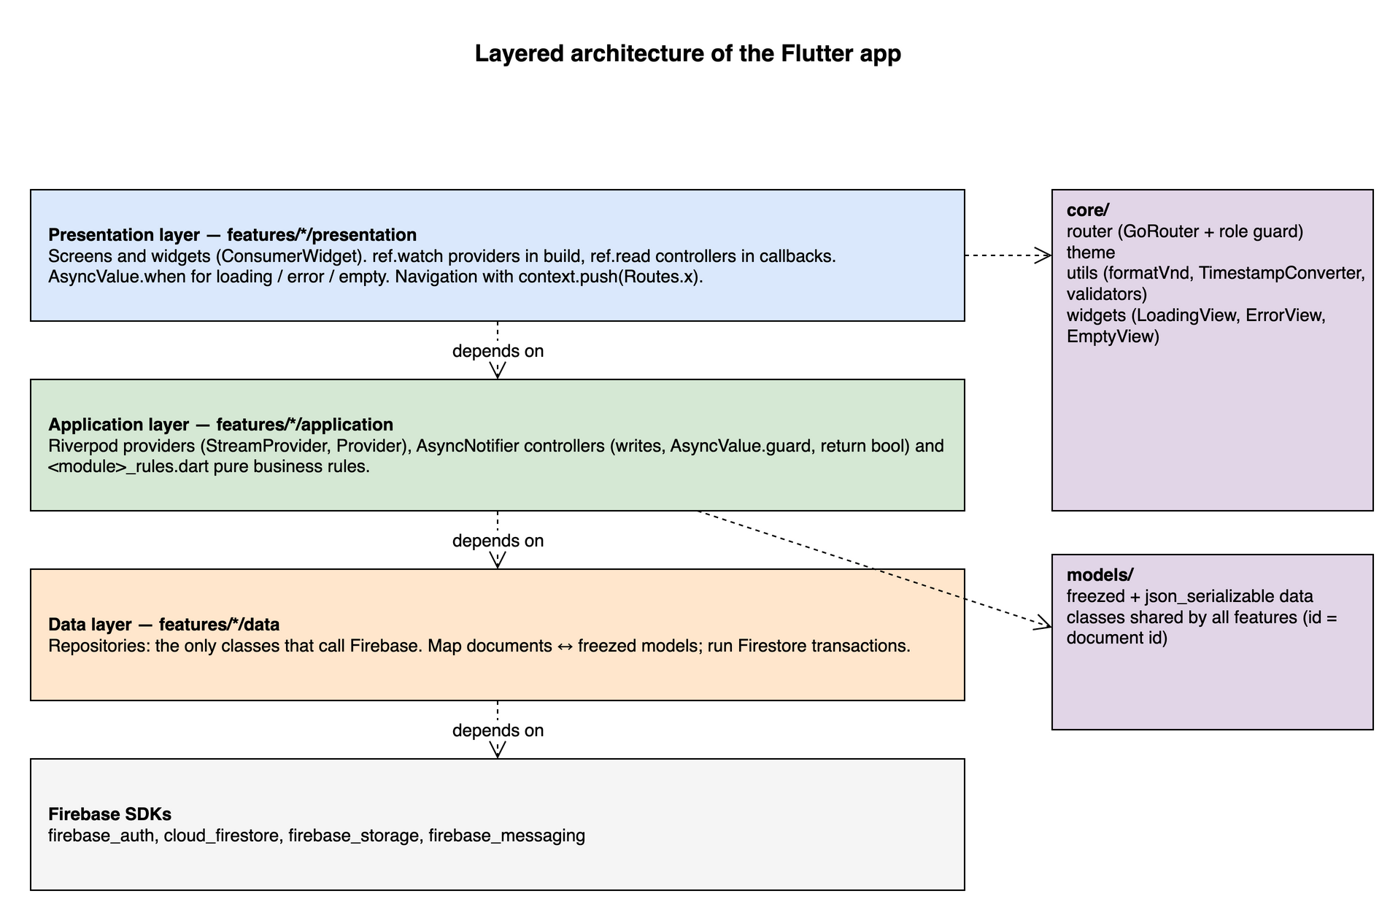
Figure 3-1: Layered architecture of the Flutter app
Table 3-2: Layers
Layer | Contents | Rules
Presentation | Screens (ConsumerWidget / ConsumerStatefulWidget), feature widgets | ref.watch in build, ref.read in callbacks; AsyncValue.when for loading / error / empty; check context.mounted after await; navigation via context.push(Routes.x)
Application | Providers (Provider, StreamProvider, .family, .autoDispose), controllers (AsyncNotifier<void>), <module>_rules.dart | Controllers wrap writes in AsyncValue.guard and return bool; business rules are pure Dart functions with unit tests
Data | Repositories, one per collection group | Only layer that imports cloud_firestore / firebase_auth / firebase_storage; maps documents ↔ freezed models (id = document id, not stored)
core/ | router (GoRouter + role guard), theme, utils (formatVnd, TimestampConverter), shared widgets | Owned by M1; no Firebase calls
models/ | freezed data classes shared by all features | Owned by M4; changes need team agreement (model frozen after W1)

Technology choices:
Table 3-3: Technology stack
Concern | Choice | Reason
Framework | Flutter (stable), Dart 3 | Course requirement; one codebase for Android, iOS and Web
State / DI | flutter_riverpod 3 | Compile-safe dependency injection, streams as providers, easy to override in tests
Routing | go_router | Declarative routes, deep links (/c/:tableId), redirect-based role guard
Backend | Firebase Auth, Cloud Firestore, Storage, Messaging, Functions, Hosting | Real-time data without hosting a server
Models | freezed + json_serializable | Immutable models, copyWith, JSON mapping
Charts / QR / images | fl_chart, qr_flutter, mobile_scanner, image_picker, cached_network_image | Reports, table QR, product images
Formatting | intl | VND currency and dates
Testing | flutter_test, fake_cloud_firestore, mocktail, Firebase Emulator | Unit, repository, widget and Security Rules tests

3.2.1 Process View
The process view shows how the actors and the software components cooperate at runtime. Every device runs one Flutter isolate; concurrency between devices is handled by Firestore (real-time listeners and optimistic transactions), not by threads in the app.

3.2.1.1 Order process
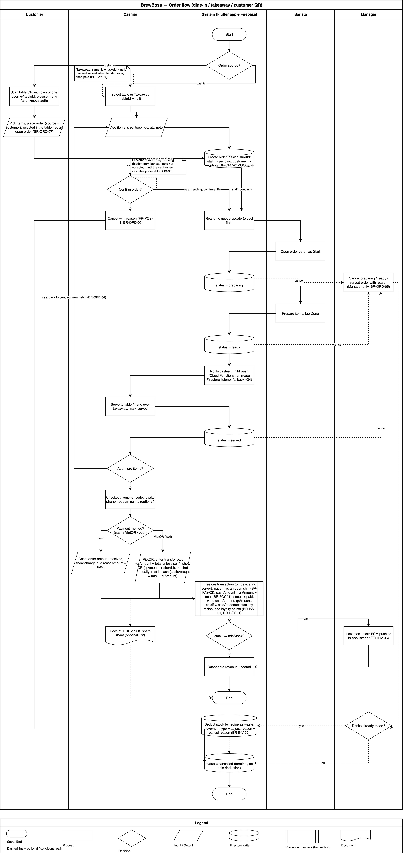
Figure 3-2: Order process (dine-in, takeaway, customer QR)
As described in Figure 3-2, the order process has the following steps:
- Step 1: The order is created either by the cashier (status pending) or by a customer through the table QR (status awaiting). An awaiting order is hidden from the barista and does not occupy the table.
- Step 2: The cashier confirms an awaiting order. If the table is free the order becomes pending; if the table already has an open order the items are appended to it and the QR order is closed (BR-ORD-07).
- Step 3: The barista queue listener receives the pending order (≤ 2 s). The barista taps Start (preparing) and Done (ready).
- Step 4: A Cloud Function notifies the cashiers that the order is ready; the cashier serves it and marks it served.
- Step 5: Items can still be added; adding to a ready or served order starts a new batch and sends the order back to pending (BR-ORD-04).
- Step 6: The cashier takes payment (cash, VietQR or split). One transaction marks the order paid, deducts stock by recipe, adds loyalty points, increments voucher usage and frees the table.
- Step 7: A Manager (or the cashier for awaiting / pending orders) can cancel with a reason; drinks already made are deducted as waste (BR-INV-02).

3.2.1.2 Order status state machine
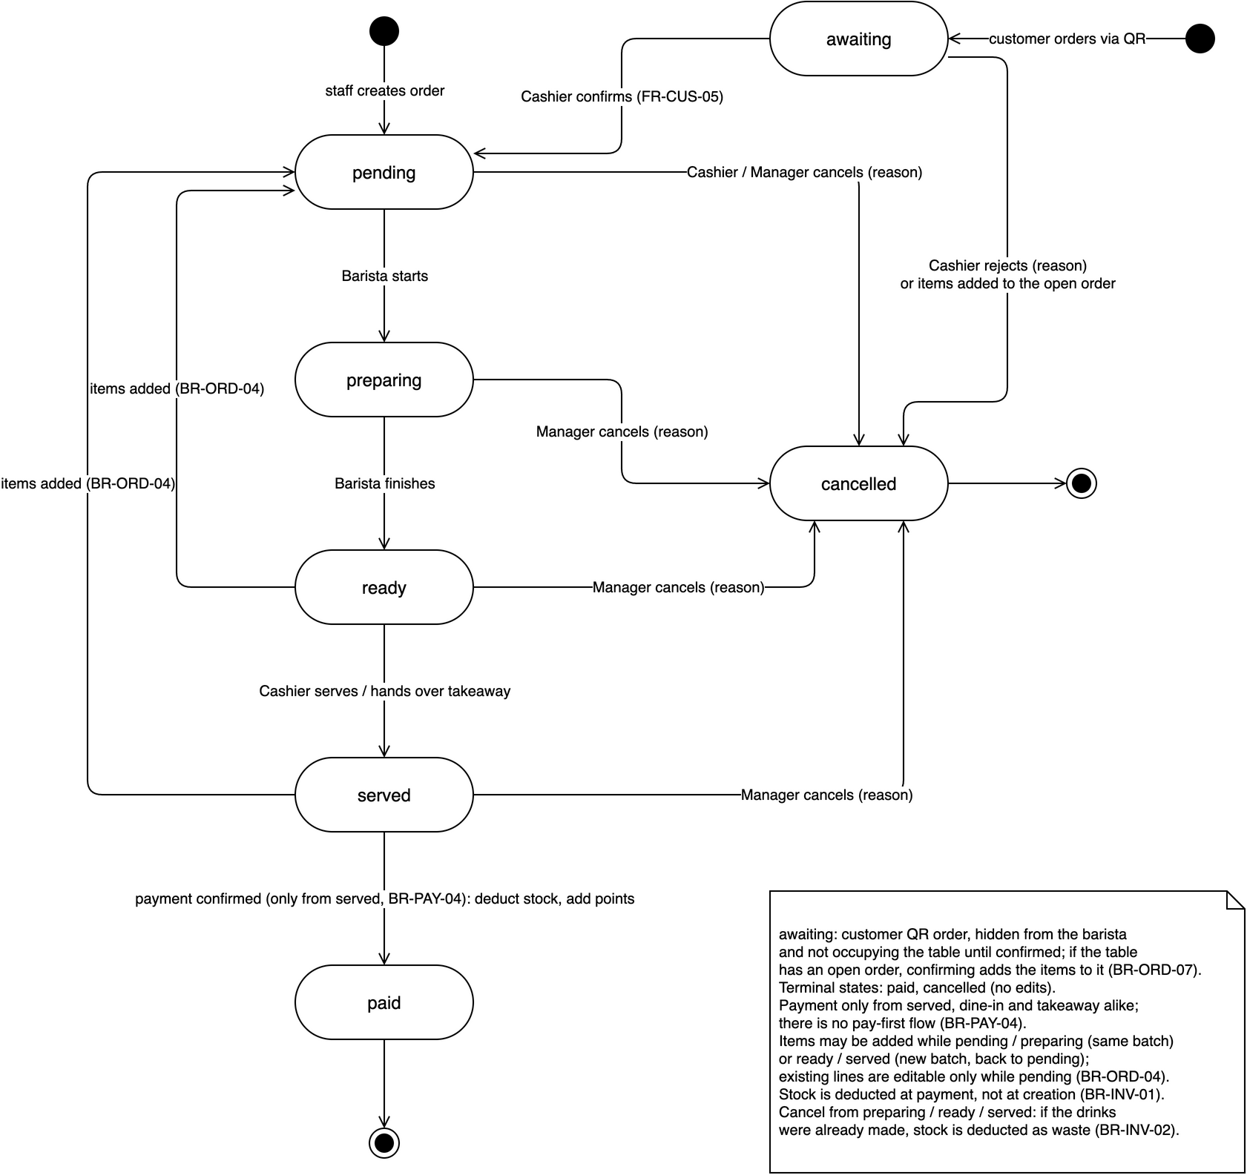
Figure 3-3: Order status state machine
Table 3-4: Allowed order transitions (order_rules.canTransition)
From | To | Who | Trigger / rule
— | awaiting | Customer | Order via table QR (FR-CUS-05)
— | pending | Cashier, Manager | Create order (UC20)
awaiting | pending | Cashier | Confirm on a free table (BR-ORD-07)
awaiting | cancelled | Cashier | Reject, or items added to the table's open order (mergedIntoId)
pending | preparing | Barista | Start
preparing | ready | Barista | Done
ready | served | Cashier | Mark served (FR-POS-12)
ready, served | pending | Cashier | Items added: new batch (BR-ORD-04)
served | paid | Cashier with open shift | Payment transaction (BR-PAY-03, 04)
pending | cancelled | Cashier, Manager | Reason required (BR-ORD-05)
preparing, ready, served | cancelled | Manager | Reason required; 'Đã pha' → waste (BR-INV-02); merge source (BR-ORD-08)

3.2.1.3 Concurrency and real-time behaviour
- Real-time listeners: screens that show shared state (table map, barista queue, dashboard, customer status) watch StreamProviders backed by Firestore snapshots(). No polling.
- Optimistic transactions: multi-document writes use runTransaction. If two devices change the same order at the same time Firestore retries the transaction (up to 5 times) on fresh data; rules are re-checked inside the transaction (e.g. the status is still served when paying), so the second writer fails with a clear message instead of corrupting data.
- Single writers per field: the barista only changes status pending → preparing → ready; the cashier owns items, payment and serving. This keeps conflicts rare.
- Asynchronous side effects: push notifications run in Cloud Functions after the write is committed; the app never waits for them.
- Offline: the Firestore cache serves reads and queues simple writes; transactions (payment, confirm, merge, cancel) require a connection and show 'Mất kết nối, thử lại'.
- Timers: the barista screen re-computes elapsed time and the late colour every 30 s from createdAt; nothing is written.

3.2.1.4 Shift and cash handover process
A cashier or manager checks in with the opening cash (S07). Every payment stores paidBy and paidAt, so at check-out the app sums cashAmount of the orders the user confirmed since checkIn: expectedCash = openingCash + Σ cashAmount (VietQR shown only for reference). The user enters the counted cash; a non-zero difference requires a note, and the shift is saved with the snapshot values (BR-STAFF-03..05, sequence SD-07).

3.2.2 Logical View
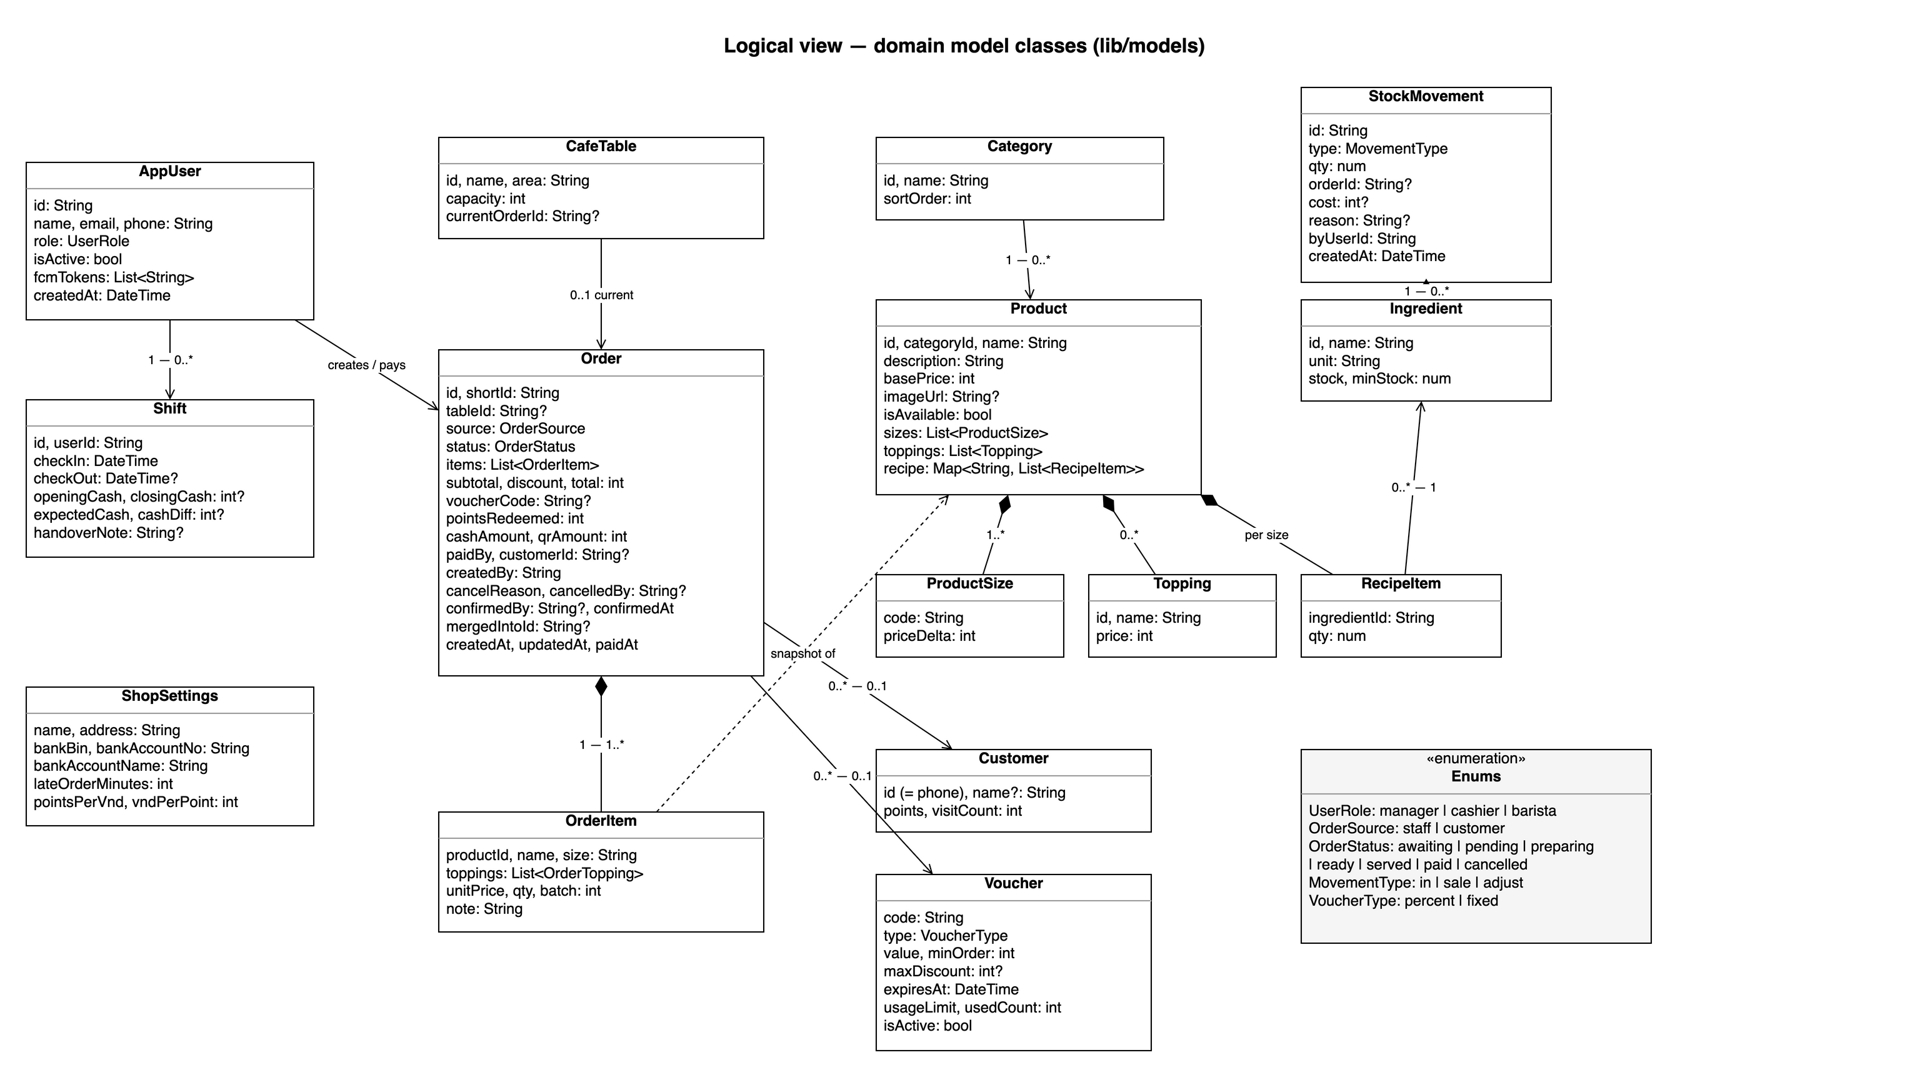
Figure 3-4: Logical view — domain model classes
Figure 3-4 shows the domain classes in lib/models. Each is a freezed class with fromJson/toJson; the id field is the Firestore document id and is not stored in the document.
Table 3-5: Domain classes
Class | Firestore | Responsibility
AppUser | users/{uid} | Staff account: role, active flag, FCM tokens
Shift | shifts/{id} | Check-in / check-out and cash handover snapshot
Category, Product (ProductSize, Topping, RecipeItem) | categories, products | Menu; recipe per size links to ingredients
Ingredient, StockMovement | ingredients, ingredients/{id}/movements | Stock level and every change (in, sale, adjust)
CafeTable | tables/{id} | Table and its current open order
Order (OrderItem, OrderTopping) | orders/{id} | Order lifecycle, embedded items with price snapshot, payment split
Customer | customers/{phone} | Loyalty points and visit count
Voucher | vouchers/{code} | Discount definition and usage counter
ShopSettings | settings/shop | Shop info, VietQR bank account, late minutes, loyalty rates
Enums | string values | UserRole, OrderSource, OrderStatus, MovementType, VoucherType — stored as lower-case strings

3.2.3 Development View

3.2.3.1 Package Diagram
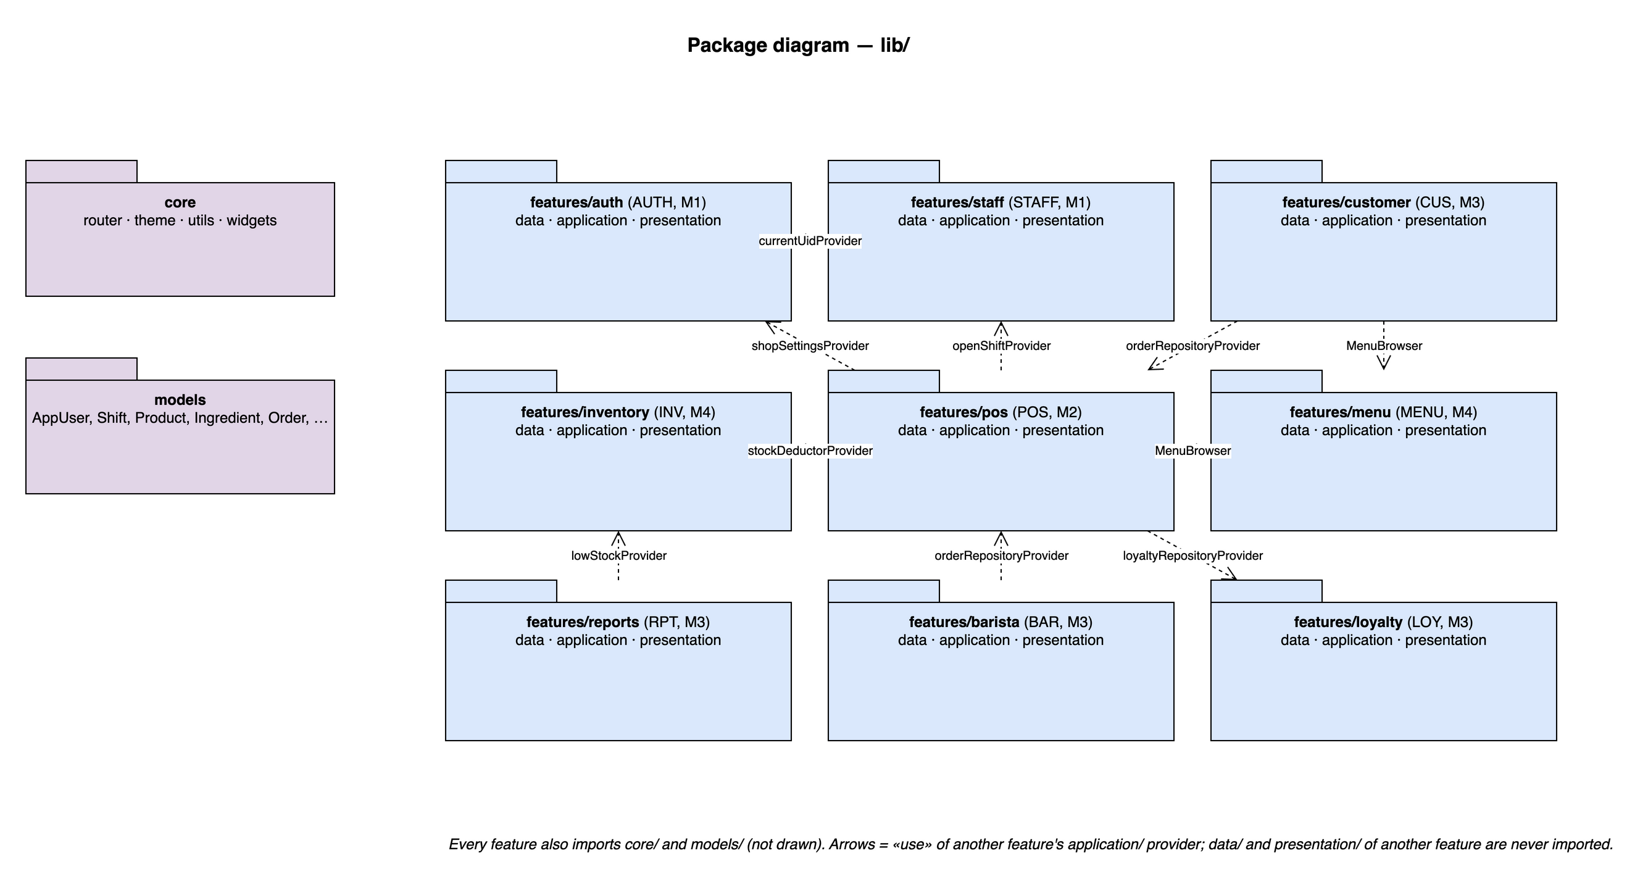
Figure 3-5: Package diagram
Table 3-6: Packages description
No | Package | Description
01 | lib/main.dart, lib/app.dart | Firebase.initializeApp, ProviderScope, MaterialApp.router with the theme
02 | lib/core/router | routes.dart (Routes constants), app_router.dart (GoRouter, role guard redirect)
03 | lib/core/theme | Colors, text styles, tablet breakpoints
04 | lib/core/utils | format.dart (formatVnd, formatDateTime, formatDuration), timestamp_converter.dart, validators.dart
05 | lib/core/widgets | LoadingView, ErrorView, EmptyView, ConfirmDialog, MoneyField
06 | lib/models | freezed domain classes (§3.2.2)
07 | lib/features/auth | Authentication and Profile (AUTH, UC01–UC03, UC29; owner M1)
08 | lib/features/staff | Staff, Shifts and Cash Handover (STAFF, UC04–UC06, UC44, UC45; owner M1)
09 | lib/features/menu | Menu (MENU, UC07–UC10; owner M4)
10 | lib/features/inventory | Inventory (INV, UC11–UC17, UC42, UC43; owner M4)
11 | lib/features/pos | Point of Sale (POS, UC19–UC28, UC46; owner M2)
12 | lib/features/barista | Barista Display (BAR, UC30, UC31; owner M3)
13 | lib/features/customer | Customer QR Ordering and Tables (CUS, UC18, UC32, UC33; owner M3)
14 | lib/features/reports | Reports (RPT, UC34–UC37; owner M3)
15 | lib/features/loyalty | Loyalty and Vouchers (LOY, UC38–UC41; owner M3)
16 | functions/ | Cloud Functions (TypeScript/JavaScript, Node.js 20): onOrderReady, onIngredientWrite
17 | test/ | Mirrors lib/: test/features/<module>/*_rules_test.dart, *_repository_test.dart, widget tests

3.2.3.2 Component Diagram
Features collaborate only through providers in their application/ layer. The published providers are:
Table 3-7: Cross-feature components
No | Component (provider) | Owner | Used by | Purpose
01 | currentUidProvider, currentUserProvider | auth | all | Signed-in user and role
02 | shopSettingsProvider | auth | pos, barista, loyalty | VietQR account, lateOrderMinutes, loyalty rates
03 | openShiftProvider | staff | pos | BR-PAY-03 check before payment
04 | MenuBrowser, menuQueryProvider | menu | pos, customer | Shared menu grid, filter and search
05 | stockDeductorProvider | inventory | pos | Stock deduction inside payment / cancel transactions
06 | lowStockProvider | inventory | reports | Low-stock banner on the dashboard
07 | orderRepositoryProvider, orderProvider | pos | barista, customer, staff | Queue, customer status, cash handover sums
08 | loyaltyRepositoryProvider | loyalty | pos | Customer points and voucher usage inside the payment transaction

3.2.4 Deployment View
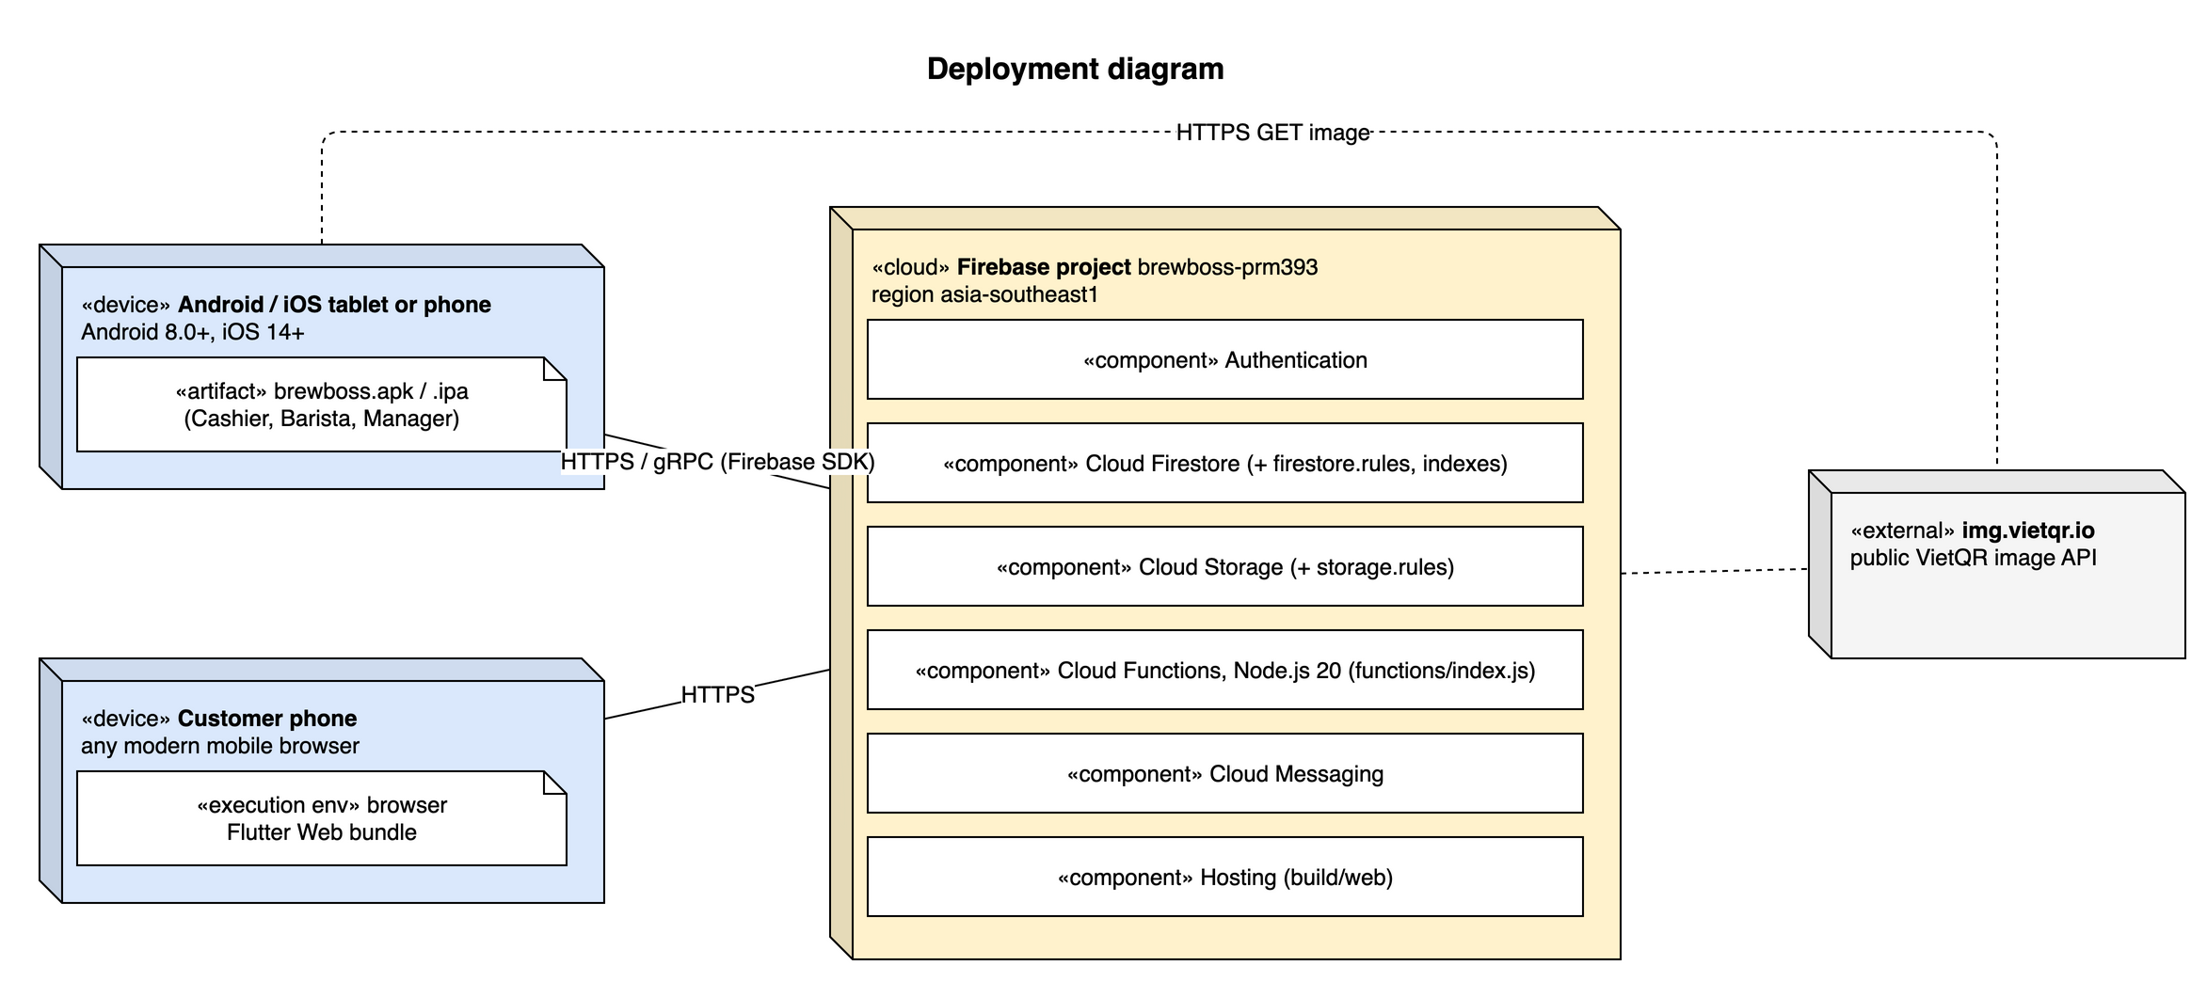
Figure 3-6: Deployment structure
Table 3-8: Configuration description
No | Component / Node | Description
01 | Staff device | Android 8.0+ / iOS 14+ phone or tablet running brewboss.apk / .ipa (flutter build apk / ipa). Firestore offline persistence on.
02 | Customer device | Any mobile browser loading the Flutter Web build (flutter build web --target lib/main_customer.dart) from Firebase Hosting.
03 | Firebase project brewboss-prm393 | Region asia-southeast1. Auth (email/password + anonymous enabled), Firestore (rules + composite indexes deployed with firebase deploy), Storage, Functions (Node.js 20, Blaze plan), Messaging, Hosting.
04 | img.vietqr.io | External HTTPS service returning the VietQR PNG; called by the cashier device only.
05 | Firebase Emulator Suite | Developer machines and CI: Auth, Firestore and Functions emulators for Security Rules and repository tests.

4 Detailed Component Design

4.1 Common Design

4.1.1 UI structure and navigation
Routes are constants in core/router/routes.dart and screens are registered in app_router.dart grouped by module. The role guard is one redirect function: not signed in → /login; signed in on a route the role may not open → the role's home. Screens never check roles.
Table 4-1: Routes
Screen | Route | Roles | Module
S01 Splash | / | All | AUTH
S02 Login | /login | Staff | AUTH
S03 Forgot password | /forgot-password | Staff | AUTH
S04 Dashboard | /manager | Manager | RPT
S05 Staff | /manager/staff | Manager | STAFF
S06 Shift history | /manager/shifts | Manager | STAFF
S07 My shift | /shift | Staff | STAFF
S08 Menu | /manager/menu | Manager | MENU
S09 Product form | /manager/menu/:id | Manager | MENU, INV
S10 Ingredients | /manager/inventory | Manager | INV
S11 Stock history | /manager/inventory/:id | Manager | INV
S12 Tables + QR | /manager/tables | Manager | CUS
S13 Table map | /pos | Cashier | POS
S14 Order editor | /pos/order/:id | Cashier | POS
S15 Payment | /pos/order/:id/pay | Cashier | POS, LOY
S16 Barista queue | /barista | Barista | BAR
S17 Customer menu | /c/:tableId | Customer | CUS
S18 Customer status | /c/:tableId/order/:id | Customer | CUS
S19 Reports | /manager/reports | Manager | RPT
S20 Order history | /manager/orders | Manager | RPT
S21 Customers & vouchers | /manager/loyalty | Manager | LOY
S22 Profile / settings | /profile | Staff | AUTH

Layout: phones use a single column; at width ≥ 840 dp (tablets) the order editor shows menu and cart side by side and the barista queue uses a grid. Sheets (item options, stock-in, customer lookup) are modal bottom sheets; destructive actions use a confirm dialog.

4.1.2 State management pattern
Every feature follows the reference slice (lib/features/staff). Reads are providers; writes are controller methods:
final openShiftProvider = StreamProvider.autoDispose<Shift?>((ref) {
final uid = ref.watch(currentUidProvider);
if (uid == null) return Stream.value(null);
return ref.watch(shiftRepositoryProvider).watchOpenShift(uid);
});

class MyShiftController extends AsyncNotifier<void> {
@override
Future<void> build() async {}

Future<bool> checkIn() => _run(() async { /* rules, then repository */ });

Future<bool> _run(Future<void> Function() action) async {
state = const AsyncLoading();
state = await AsyncValue.guard(action);
return !state.hasError;
}
}

- Screens call ref.read(xControllerProvider.notifier).method() in callbacks and pop / navigate only when it returns true and context.mounted.
- Screens ref.listen the controller and show next.error in a SnackBar; the button is disabled while isLoading.
- Business rules are called by the controller before the repository, and again inside transactions for anything another device can change.

4.1.3 Error handling and messages
Errors are caught once, in the controller (AsyncValue.guard). Repositories let FirebaseException propagate; rule violations throw StateError with a Vietnamese message. A single mapper in core/utils/error_message.dart turns exceptions into user text:
Table 4-2: Error mapping
Source | Code / type | Message shown (vi)
FirebaseAuthException | invalid-credential, wrong-password, user-not-found | Email hoặc mật khẩu không đúng
FirebaseAuthException | too-many-requests | Thử lại sau ít phút
FirebaseException | permission-denied | Bạn không có quyền thực hiện thao tác này
FirebaseException | unavailable, deadline-exceeded | Mất kết nối, thử lại
FirebaseException | aborted (transaction contention) | Dữ liệu vừa thay đổi, vui lòng thử lại
StateError | business rule | Message of the rule, e.g. 'Bạn đang trong ca, hãy check-out trước'
Other | — | Đã có lỗi xảy ra

Every screen renders AsyncValue.when: loading → LoadingView, error → ErrorView with 'Thử lại' (ref.invalidate), empty data → EmptyView with a hint.

4.1.4 Logging
- Development: debugPrint / dart:developer log in controllers for caught errors; removed from release by the analyzer rule avoid_print.
- Release: FirebaseCrashlytics is optional (not in v1); uncaught Flutter errors go to FlutterError.onError.
- Business audit is data, not logs: cancelledBy, confirmedBy, paidBy, byUserId, handoverNote and timestamps are stored on the documents (NFR-AUD-01).

4.1.5 Utility classes and shared components
Table 4-3: Shared utilities
Name | File | Description
formatVnd(int) | core/utils/format.dart | 45000 → '45.000 ₫' (NFR-USE-03)
formatDateTime, formatTime, formatDuration | core/utils/format.dart | dd/MM/yyyy HH:mm, HH:mm, '2h 05m'
TimestampConverter | core/utils/timestamp_converter.dart | Firestore Timestamp ↔ DateTime for json_serializable
validators | core/utils/validators.dart | email, phone (VN 10 digits), non-negative money
errorMessage(Object) | core/utils/error_message.dart | Exception → Vietnamese text (§4.1.3)
LoadingView, ErrorView, EmptyView | core/widgets/ | Standard states for AsyncValue.when
MoneyField | core/widgets/money_field.dart | Numeric keyboard, thousands separator, returns int
ConfirmDialog | core/widgets/confirm_dialog.dart | Yes / no dialog, optional required reason field

4.1.6 Transaction management
Writes that touch more than one document or depend on data another device can change run in one Firestore transaction inside a repository. All reads happen before the first write; each transaction re-checks the rule that allowed it.
Table 4-4: Transactions
Transaction | Reads | Writes | Rules checked
Create order (OrderRepository.create) | counters/shortId-{day}, table | counter++, new order, table.currentOrderId | BR-ORD-03, BR-ORD-06
Confirm customer order | order, table, open order | order pending or items appended + QR order cancelled; table | BR-ORD-07, BR-ORD-04
Add items | order | items, subtotal, total, status / batch | BR-ORD-04
Payment | order, shift of payer, voucher, customer, recipe ingredients | order paid; ingredients + sale movements; customer; voucher; table | BR-PAY-01..04, BR-DIS-*, BR-LOY-*, BR-INV-01
Cancel | order, recipe ingredients if made | order cancelled; table; waste movements | BR-ORD-05, BR-INV-02
Merge tables | source and target orders | target items/totals; source cancelled; source table | BR-ORD-08
Move table | order, target table | order.tableId; both tables | target table free
Stock-in / adjust / stocktake | ingredient | stock; movement | BR-INV-03
Check-out (not a transaction) | orders by paidBy / paidAt | shift | BR-STAFF-04, 05

4.1.7 Security design
Security Rules (firestore.rules) read the caller's role from users/{uid}. Helper functions: isSignedIn(), role(), isManager(), isStaff() (active cashier, barista or manager), isAnon(). The permission matrix implemented by the rules:
Table 4-5: Permission matrix
Resource | Manager | Cashier | Barista | Customer (anonymous)
users | CRUD | read self | read self | —
shifts | read all | create / update own; cash fields locked after checkOut | create / update own | —
categories, products | CRUD | read; update isAvailable only | read | read
ingredients, movements | CRUD | — (writes only inside payment / cancel) | — | —
tables | CRUD | read; update currentOrderId | read | read one
orders | CRUD | create; update while not paid | read; update status pending→preparing→ready only | create with source = customer, status = awaiting, no price-trust fields; read own and its mergedIntoId
customers | CRUD | read, create, update points | — | —
vouchers | CRUD | read; usedCount + 1 in payment | — | —
settings/shop | CRUD | read | read | read name only

- Deactivated users fail isStaff(), so they are locked out even if a session is still valid (FR-AUTH-06).
- Table ids are Firestore auto-ids so table URLs cannot be guessed; spam QR orders stop at the cashier confirmation gate (BR-ORD-07).
- The cashier confirmation re-computes prices from the products, so a tampered customer price never reaches payment.
- Rules are tested with @firebase/rules-unit-testing on the emulator, one allowed and one denied case per row of the matrix (owner M3).

4.1.8 Notifications
Table 4-6: Cloud Functions
Function | Trigger | Action | In-app fallback
onOrderReady | orders/{id} updated, status → ready | FCM to fcmTokens of active cashiers (and managers): 'Bàn T3 — A0123 đã xong' | Table map card turns green (listener)
onIngredientWrite | ingredients/{id} updated, stock crosses ≤ minStock | FCM to managers: 'Sắp hết <name>' | lowStockProvider banner on S04
(client) FCM token | login / logout | users/{uid}.fcmTokens arrayUnion / arrayRemove; stale tokens removed on 'unregistered' | —

4.2 AUTH - Authentication and Profile
Owner: M1 Trần Ngọc Huy. Use cases: UC01–UC03, UC29. Screens: S01, S02, S03, S22. Source: lib/features/auth/.

4.2.1 Class/Component Design

4.2.1.1 Classes/Component Structure
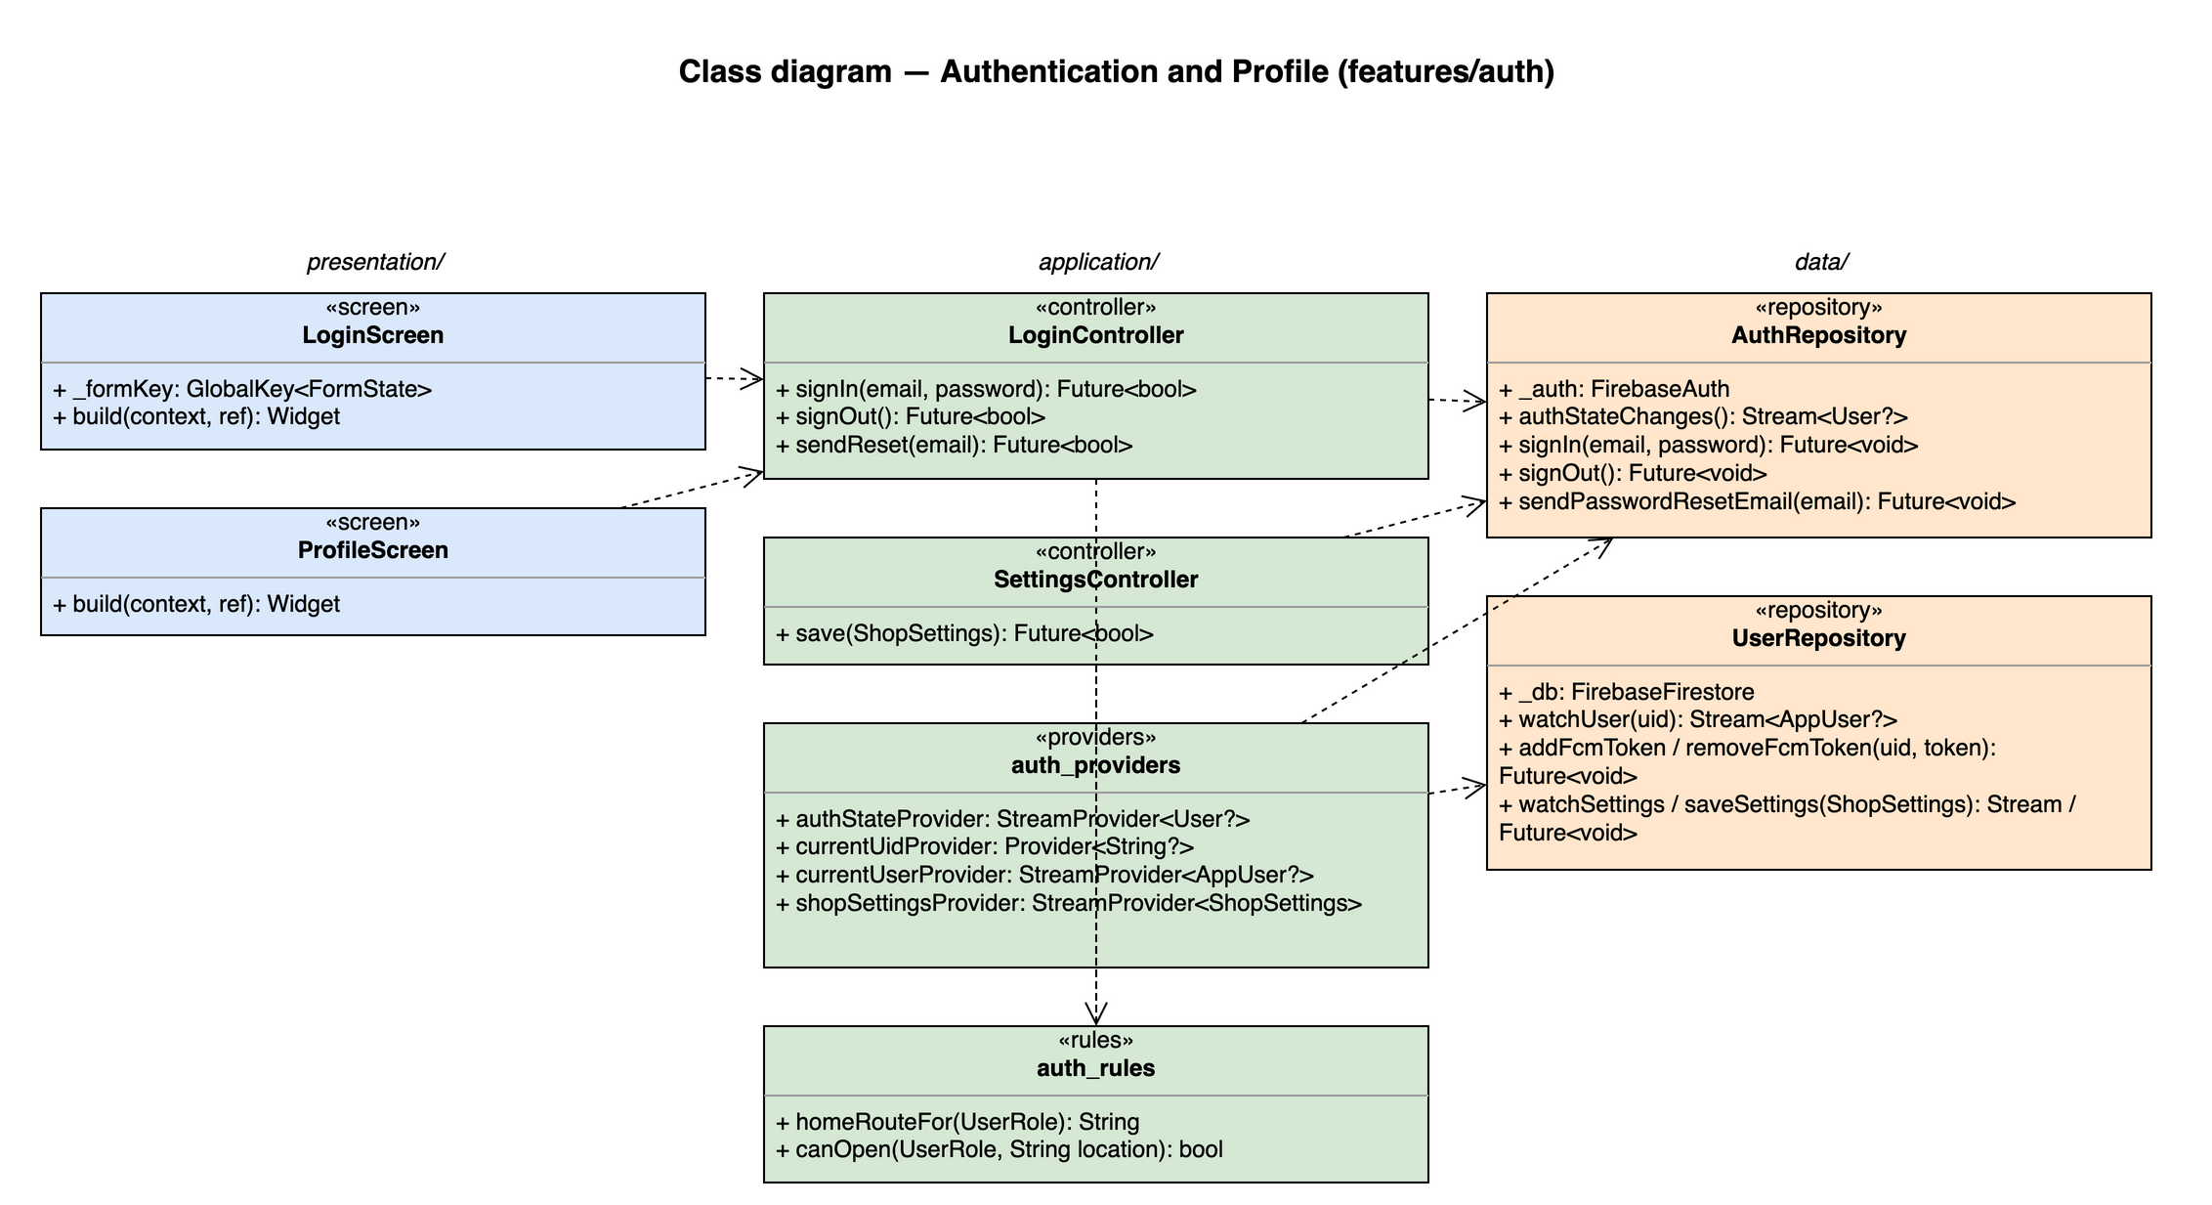
Figure 4-1: Class diagram for Authentication and Profile

4.2.1.2 Classes/Component Description

LoginScreen
Class | LoginScreen
Description | S02. Email + password form; shows the controller error as a SnackBar.
Base class | ConsumerStatefulWidget
Source file | lib/features/auth/presentation/login_screen.dart
Attributes | Name | Type | Description
 | _formKey | GlobalKey<FormState> | Validates email format and non-empty password
Methods | Name | Input → Output | Description
 | build | context, ref → Widget | Watches loginControllerProvider to disable the button while loading

ProfileScreen
Class | ProfileScreen
Description | S22. Profile, log out and — for the Manager — the shop settings section (UC29).
Base class | ConsumerWidget
Source file | lib/features/auth/presentation/profile_screen.dart
Methods | Name | Input → Output | Description
 | build | context, ref → Widget | Watches currentUserProvider and shopSettingsProvider

LoginController
Class | LoginController
Description | Login, logout and password reset. Every method wraps its work in AsyncValue.guard and returns bool.
Base class | AsyncNotifier<void>
Source file | lib/features/auth/application/login_controller.dart
Methods | Name | Input → Output | Description
 | signIn | email, password → Future<bool> | Signs in, loads users/{uid}; signs out again and fails with 'Tài khoản đã bị khoá' when isActive = false (FR-AUTH-06); registers the FCM token
 | signOut | — → Future<bool> | Removes this device's FCM token, then signs out (UC02)
 | sendReset | email → Future<bool> | Sends the Firebase password reset email (UC03)

SettingsController
Class | SettingsController
Description | Manager edits settings/shop (UC29, FR-POS-13).
Base class | AsyncNotifier<void>
Source file | lib/features/auth/application/settings_controller.dart
Methods | Name | Input → Output | Description
 | save | ShopSettings → Future<bool> | Validates bank BIN/account and lateOrderMinutes > 0, then writes settings/shop

auth_providers
Class | auth_providers
Description | Riverpod providers other features depend on instead of FirebaseAuth.
Base class | —
Source file | lib/features/auth/application/auth_providers.dart
Attributes | Name | Type | Description
 | authStateProvider | StreamProvider<User?> | Firebase user; persists across restarts (FR-AUTH-05)
 | currentUidProvider | Provider<String?> | uid of the signed-in user
 | currentUserProvider | StreamProvider<AppUser?> | users/{uid} document incl. role
 | shopSettingsProvider | StreamProvider<ShopSettings> | settings/shop, read by POS, BAR and LOY

auth_rules
Class | auth_rules
Description | Pure functions used by the router redirect.
Base class | —
Source file | lib/features/auth/application/auth_rules.dart
Methods | Name | Input → Output | Description
 | homeRouteFor | UserRole → String | manager → /manager, cashier → /pos, barista → /barista
 | canOpen | UserRole, String location → bool | Screen authorization matrix (SRS §3.1.3)

AuthRepository
Class | AuthRepository
Description | Wraps FirebaseAuth.
Base class | —
Source file | lib/features/auth/data/auth_repository.dart
Attributes | Name | Type | Description
 | _auth | FirebaseAuth | Injected instance
Methods | Name | Input → Output | Description
 | authStateChanges | — → Stream<User?>
 | signIn | email, password → Future<void>
 | signOut | — → Future<void>
 | sendPasswordResetEmail | email → Future<void>

UserRepository
Class | UserRepository
Description | users/{uid} and settings/shop documents.
Base class | —
Source file | lib/features/auth/data/user_repository.dart
Attributes | Name | Type | Description
 | _db | FirebaseFirestore
Methods | Name | Input → Output | Description
 | watchUser | uid → Stream<AppUser?>
 | addFcmToken / removeFcmToken | uid, token → Future<void> | arrayUnion / arrayRemove on fcmTokens
 | watchSettings / saveSettings | ShopSettings → Stream / Future<void> | settings/shop

4.2.2 Screen Design
Field-level screen definitions are in SRS §3 (Screen Definition tables). This section binds each main screen object to the provider or controller method that serves it.
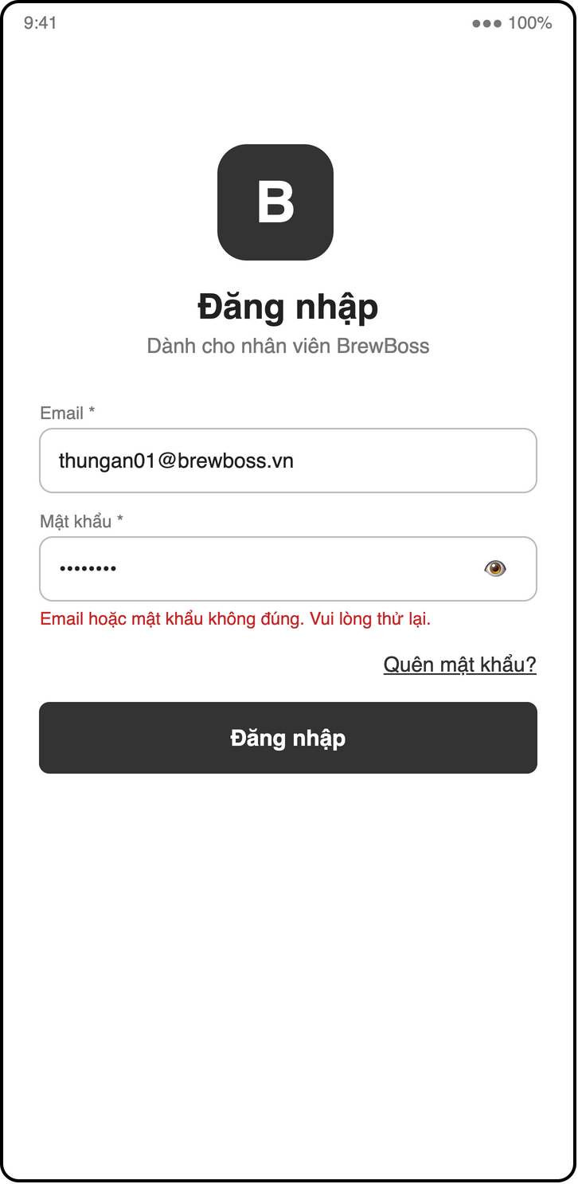
Figure 4-2: Screen design of S02 Login
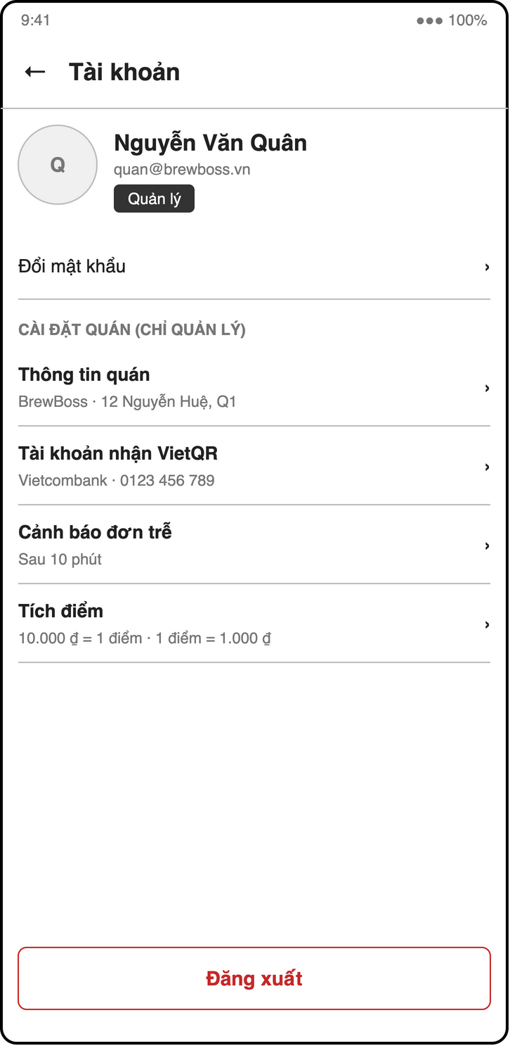
Figure 4-3: Screen design of S22 Profile / settings
Table 4-7: S02 Login object binding
No | Object Name | Type | Bound to | Description
1 | emailField | TextFormField | validators.email | Email
2 | passwordField | TextFormField | — | Obscured, non-empty
3 | loginButton | FilledButton | LoginController.signIn | Disabled while loading; error in SnackBar
4 | forgotLink | TextButton | context.push(Routes.forgotPassword) | S03

Table 4-8: S22 Profile / settings object binding
No | Object Name | Type | Bound to | Description
1 | profileCard | Card | currentUserProvider | Name, email, role
2 | shopSection | Form | shopSettingsProvider / SettingsController.save | Manager only: shop, bank BIN, account, late minutes, loyalty rates
3 | logoutButton | OutlinedButton | LoginController.signOut | Confirm dialog, then /login

4.2.3 Object Interactions (Sequence Diagrams)
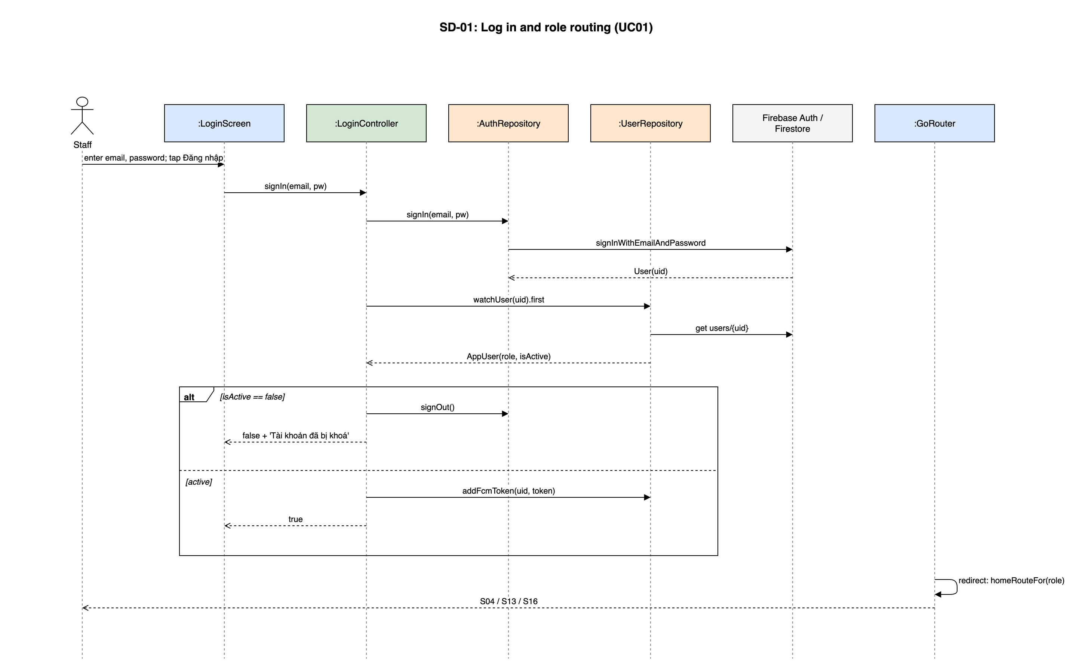
Figure 4-4: SD-01: Log in and role routing (UC01)

4.3 STAFF - Staff, Shifts and Cash Handover
Owner: M1 Trần Ngọc Huy. Use cases: UC04–UC06, UC44, UC45. Screens: S05, S06, S07. Source: lib/features/staff/.

4.3.1 Class/Component Design

4.3.1.1 Classes/Component Structure
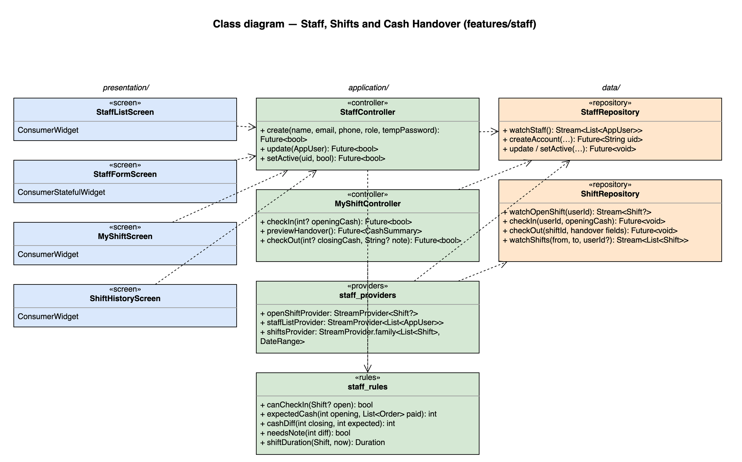
Figure 4-5: Class diagram for Staff, Shifts and Cash Handover

4.3.1.2 Classes/Component Description

StaffListScreen
Class | StaffListScreen
Description | S05. Staff list filtered by role; opens StaffFormScreen.
Base class | ConsumerWidget
Source file | lib/features/staff/presentation/staff_list_screen.dart

StaffFormScreen
Class | StaffFormScreen
Description | S05b. Create / edit form; role dropdown; activate switch hidden for the Manager's own account.
Base class | ConsumerStatefulWidget
Source file | lib/features/staff/presentation/staff_form_screen.dart

MyShiftScreen
Class | MyShiftScreen
Description | S07. Check in (opening cash), in-shift timer, check out with cash handover.
Base class | ConsumerWidget
Source file | lib/features/staff/presentation/my_shift_screen.dart

ShiftHistoryScreen
Class | ShiftHistoryScreen
Description | S06. Shifts and hours per staff; cash handover columns and the 'only with difference' filter (UC45).
Base class | ConsumerWidget
Source file | lib/features/staff/presentation/shift_history_screen.dart

StaffController
Class | StaffController
Description | Create / edit / (de)activate staff (UC04).
Base class | AsyncNotifier<void>
Source file | lib/features/staff/application/staff_controller.dart
Methods | Name | Input → Output | Description
 | create | name, email, phone, role, tempPassword → Future<bool> | Creates the Auth user on a secondary FirebaseApp so the Manager stays signed in, then writes users/{uid}
 | update | AppUser → Future<bool> | Name, phone, role
 | setActive | uid, bool → Future<bool> | Rejects the Manager's own account (BR-STAFF-02)

MyShiftController
Class | MyShiftController
Description | Check in / check out of the signed-in user (UC05, UC44).
Base class | AsyncNotifier<void>
Source file | lib/features/staff/application/my_shift_controller.dart
Methods | Name | Input → Output | Description
 | checkIn | int? openingCash → Future<bool> | BR-STAFF-01, BR-STAFF-03
 | previewHandover | — → Future<CashSummary> | Sums cashAmount / qrAmount of orders paidBy = uid since checkIn
 | checkOut | int? closingCash, String? note → Future<bool> | Writes checkOut, expectedCash, cashDiff, handoverNote (BR-STAFF-04, 05)

staff_providers
Class | staff_providers
Description | —
Base class | —
Source file | lib/features/staff/application/staff_providers.dart
Attributes | Name | Type | Description
 | openShiftProvider | StreamProvider<Shift?> | Open shift of the signed-in user; POS reads it for BR-PAY-03
 | staffListProvider | StreamProvider<List<AppUser>>
 | shiftsProvider | StreamProvider.family<List<Shift>, DateRange> | Shift history

staff_rules
Class | staff_rules
Description | Pure functions, unit tested.
Base class | —
Source file | lib/features/staff/application/staff_rules.dart
Methods | Name | Input → Output | Description
 | canCheckIn | Shift? open → bool | BR-STAFF-01
 | expectedCash | int opening, List<Order> paid → int | opening + sum(cashAmount) (BR-STAFF-04)
 | cashDiff | int closing, int expected → int | BR-STAFF-05
 | needsNote | int diff → bool | diff != 0
 | shiftDuration | Shift, now → Duration

StaffRepository
Class | StaffRepository
Description | users collection (staff side).
Base class | —
Source file | lib/features/staff/data/staff_repository.dart
Methods | Name | Input → Output | Description
 | watchStaff | — → Stream<List<AppUser>>
 | createAccount | … → Future<String uid>
 | update / setActive | … → Future<void>

ShiftRepository
Class | ShiftRepository
Description | shifts collection.
Base class | —
Source file | lib/features/staff/data/shift_repository.dart
Methods | Name | Input → Output | Description
 | watchOpenShift | userId → Stream<Shift?> | where checkOut == null, limit 1
 | checkIn | userId, openingCash → Future<void>
 | checkOut | shiftId, handover fields → Future<void>
 | watchShifts | from, to, userId? → Stream<List<Shift>> | index userId ASC, checkIn DESC

4.3.2 Screen Design
Field-level screen definitions are in SRS §3 (Screen Definition tables). This section binds each main screen object to the provider or controller method that serves it.
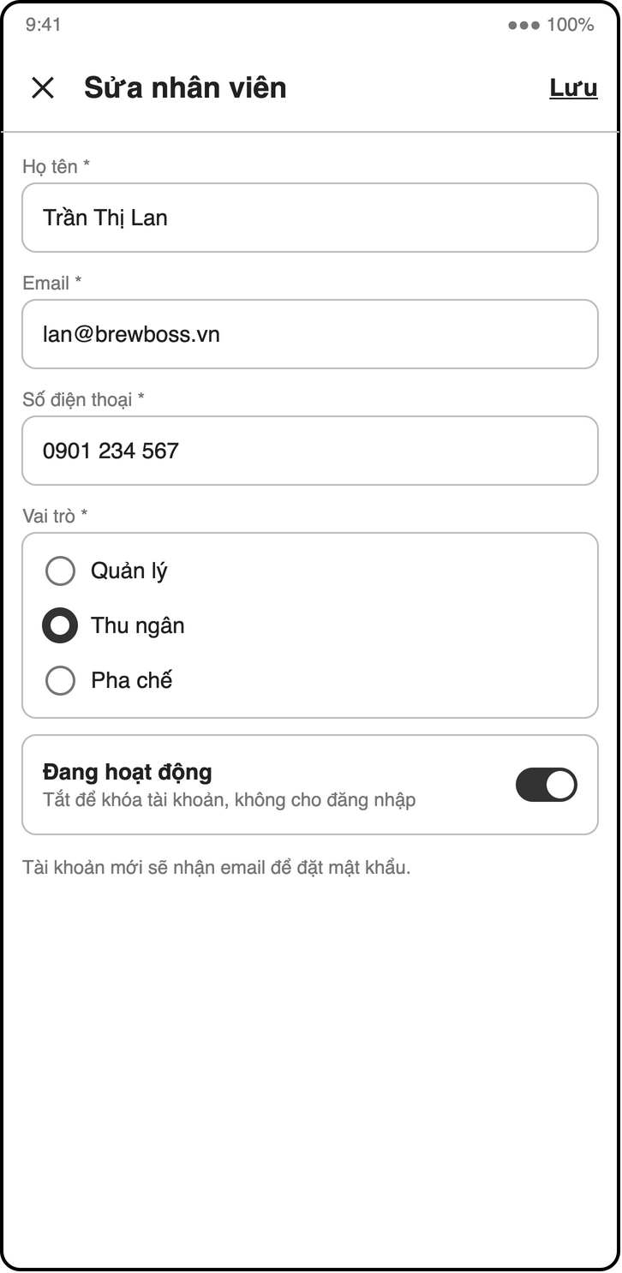
Figure 4-6: Screen design of S05b Staff form
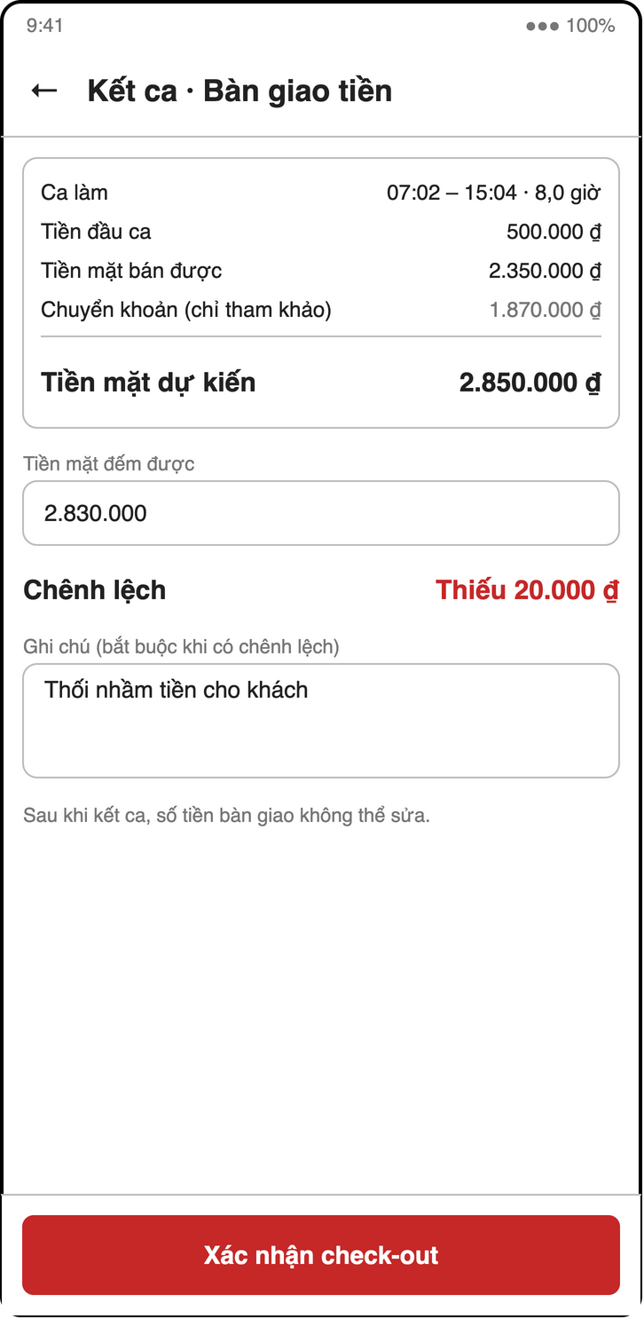
Figure 4-7: Screen design of S07c My shift — check-out with cash handover
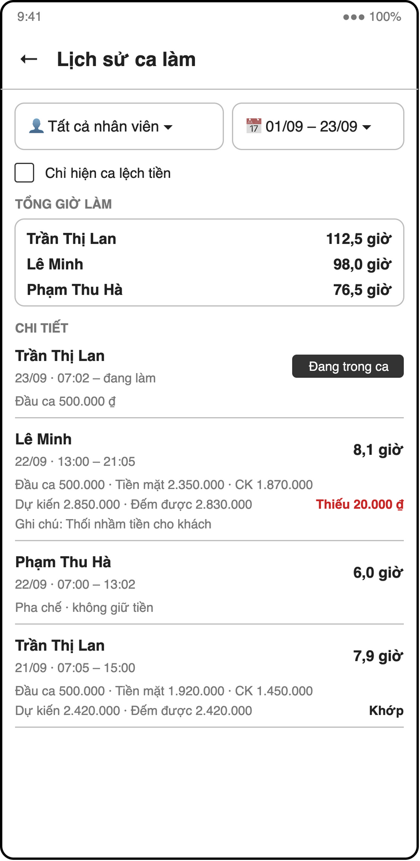
Figure 4-8: Screen design of S06 Shift history + cash handover
Table 4-9: S05 / S05b Staff object binding
No | Object Name | Type | Bound to | Description
1 | roleFilter | SegmentedButton | staffListProvider | All / cashier / barista / manager
2 | staffList | ListView | staffListProvider | Name, role, active badge
3 | saveButton | FilledButton | StaffController.create / update | Temp password only on create
4 | activeSwitch | Switch | StaffController.setActive | Hidden for own account (BR-STAFF-02)

Table 4-10: S07 My shift object binding
No | Object Name | Type | Bound to | Description
1 | openingCashField | MoneyField | MyShiftController.checkIn | Cashier / Manager only (BR-STAFF-03)
2 | shiftTimer | Text | openShiftProvider + shiftDuration | Elapsed time
3 | handoverPanel | Column | MyShiftController.previewHandover | Opening, cash sales, VietQR sales, expected
4 | countedCashField / noteField | MoneyField / TextField | MyShiftController.checkOut | Note required when difference ≠ 0

Table 4-11: S06 Shift history object binding
No | Object Name | Type | Bound to | Description
1 | periodPicker | DateRangePicker | shiftsProvider(range)
2 | onlyDiffFilter | FilterChip | local state | Shifts with cashDiff ≠ 0 (UC45)
3 | shiftTable | DataTable | shiftsProvider | Hours, opening, cash, VietQR, expected, counted, difference, note

4.3.3 Object Interactions (Sequence Diagrams)
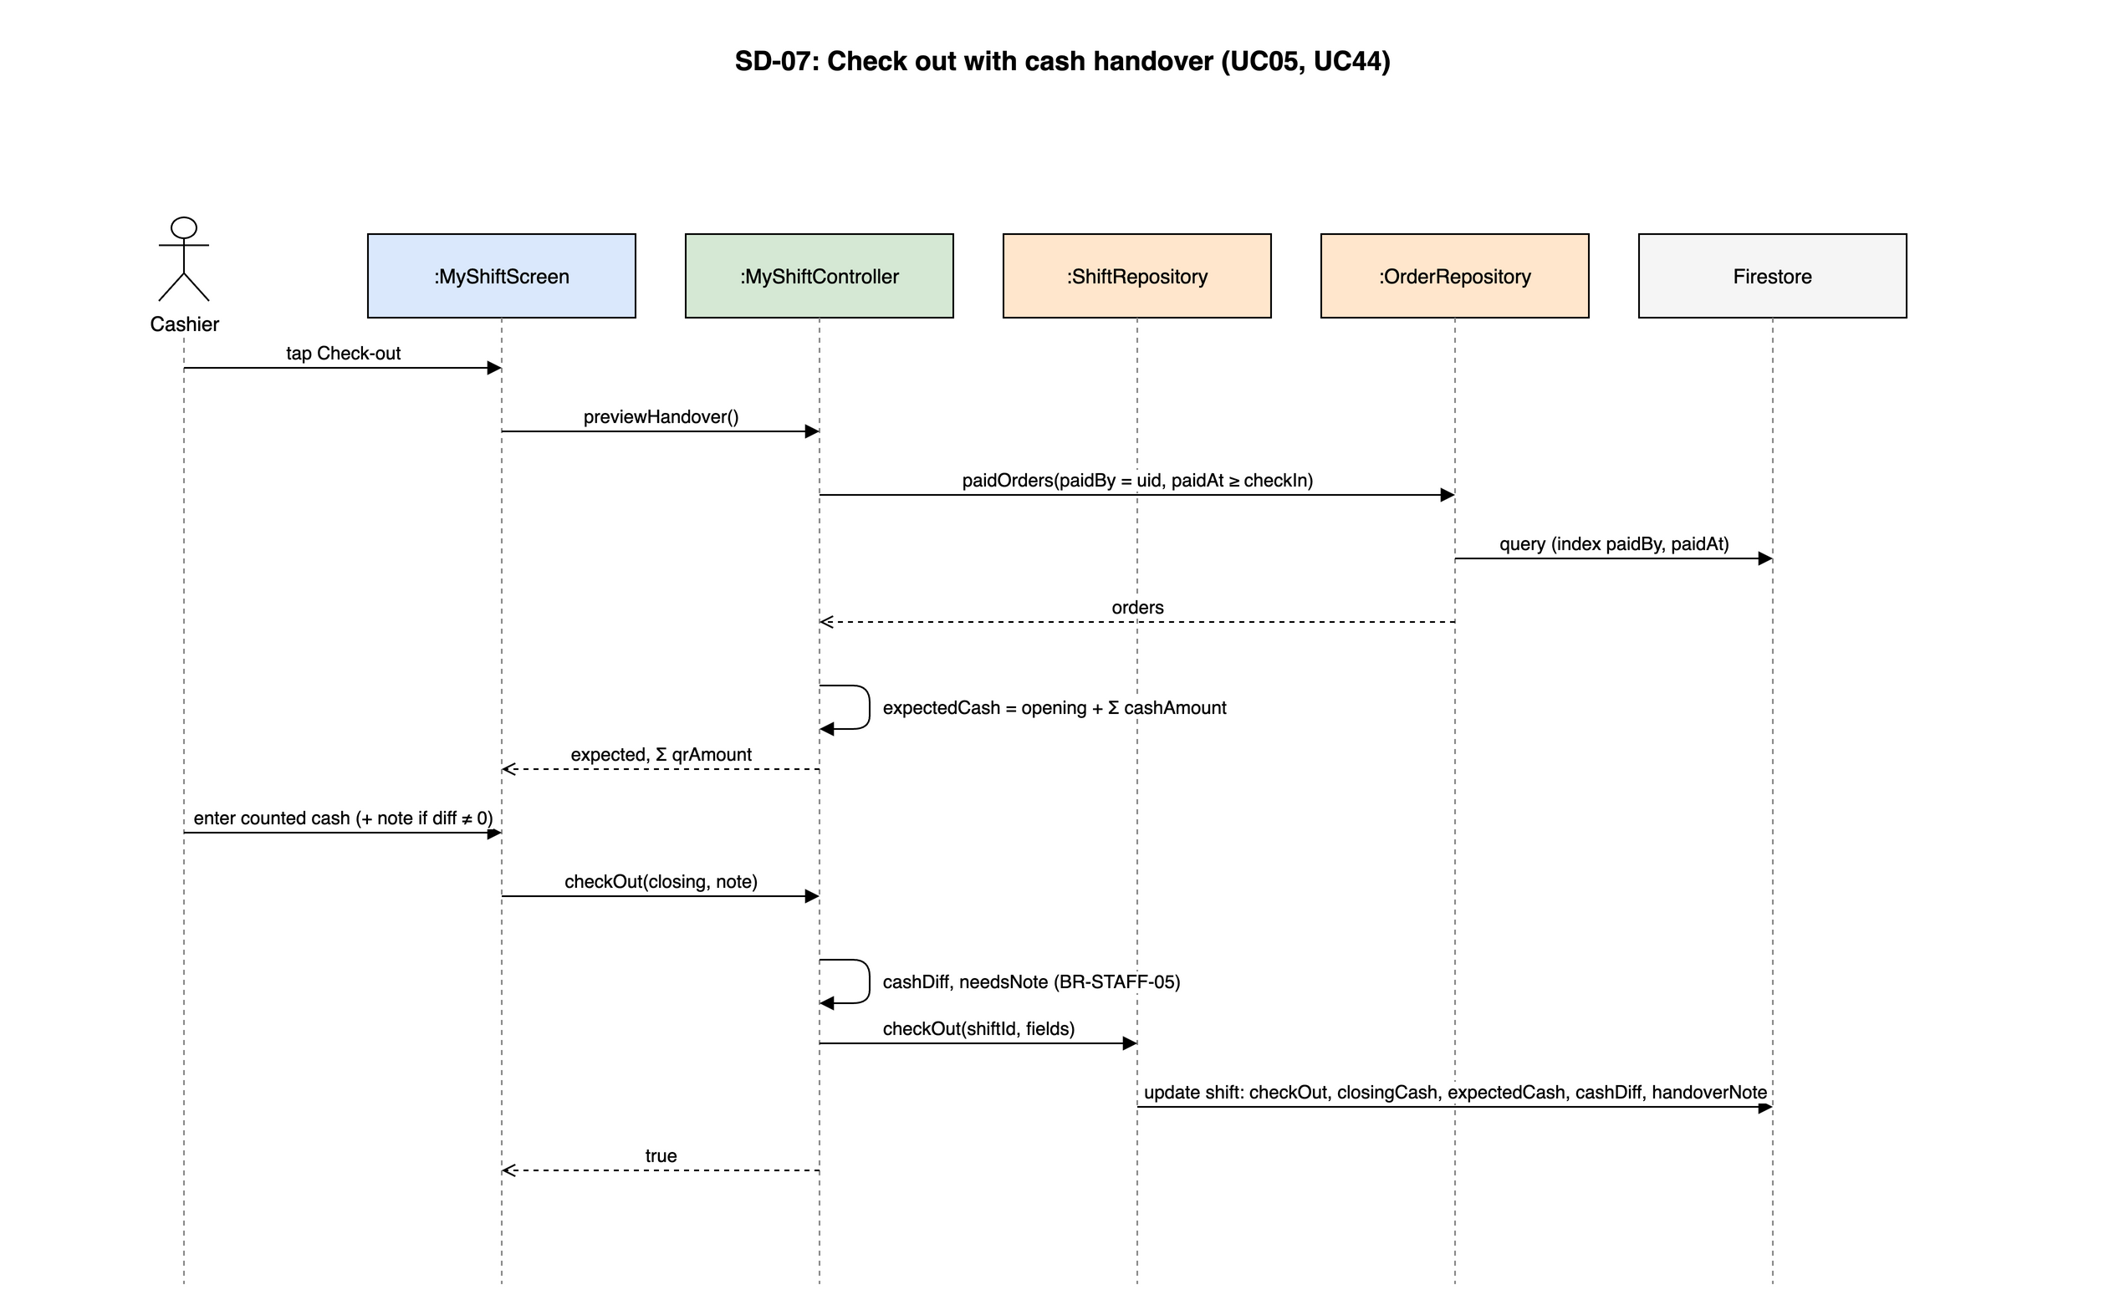
Figure 4-9: SD-07: Check out with cash handover (UC05, UC44)
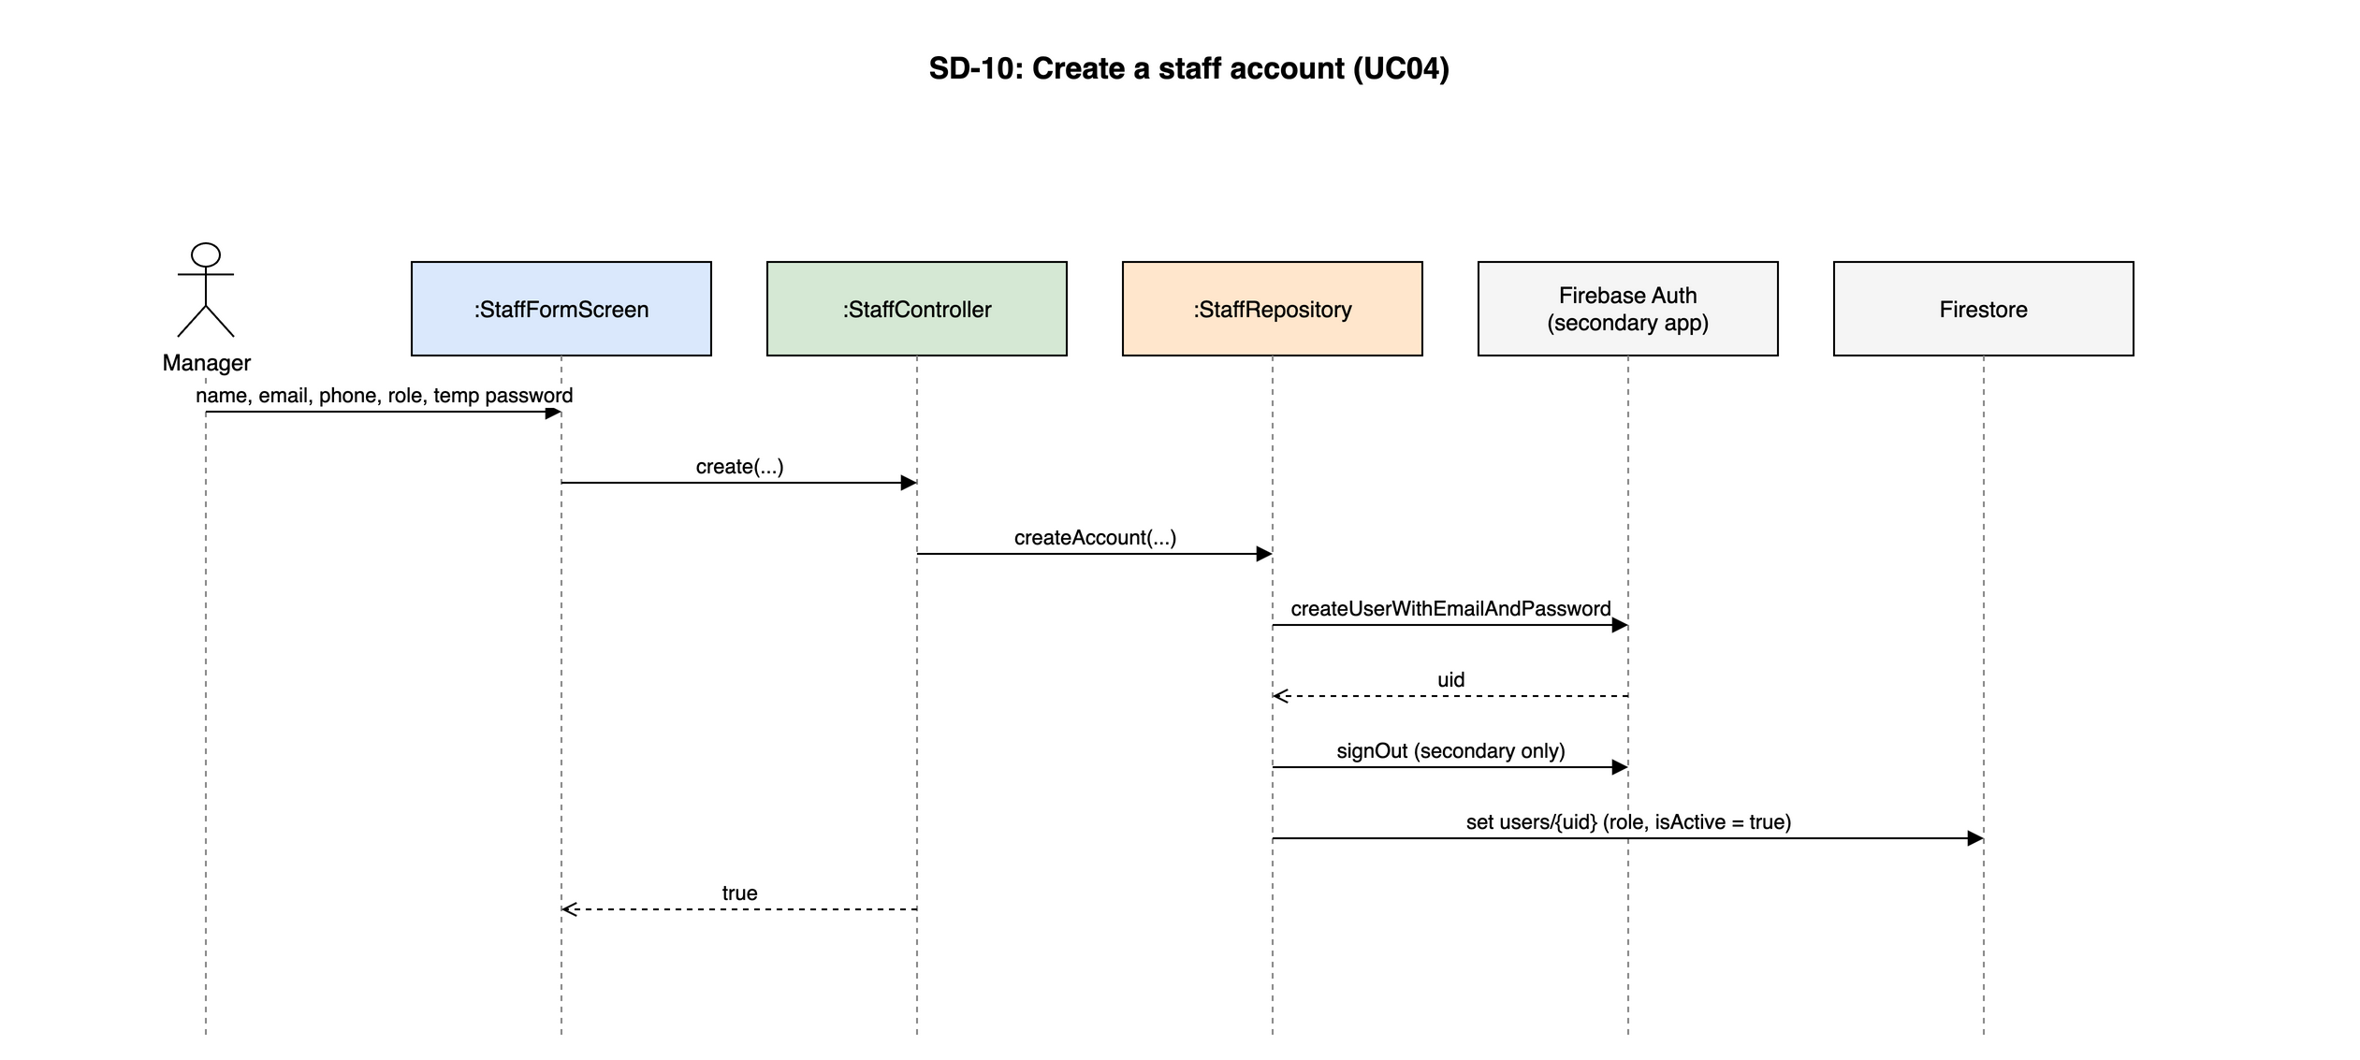
Figure 4-10: SD-10: Create a staff account (UC04)

4.4 MENU - Menu
Owner: M4 Lại Hữu Quang Anh. Use cases: UC07–UC10. Screens: S08, S09. Source: lib/features/menu/.

4.4.1 Class/Component Design

4.4.1.1 Classes/Component Structure
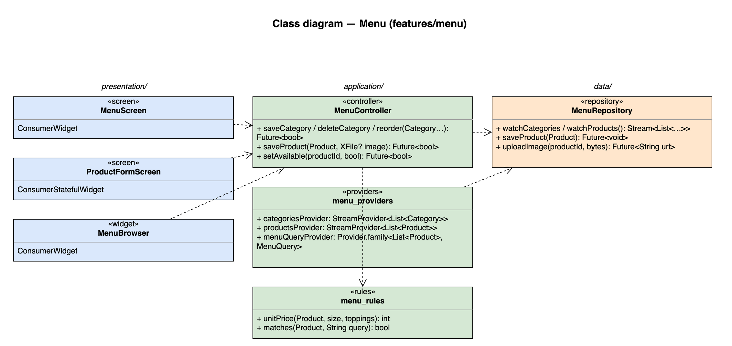
Figure 4-11: Class diagram for Menu

4.4.1.2 Classes/Component Description

MenuScreen
Class | MenuScreen
Description | S08. Category tabs (reorder, CRUD dialog) and product list with availability switch.
Base class | ConsumerWidget
Source file | lib/features/menu/presentation/menu_screen.dart

ProductFormScreen
Class | ProductFormScreen
Description | S09. Base price, sizes, toppings, image and the recipe editor per size (INV).
Base class | ConsumerStatefulWidget
Source file | lib/features/menu/presentation/product_form_screen.dart

MenuBrowser
Class | MenuBrowser
Description | Shared menu grid with category filter and accent-insensitive search (UC10); exposed to POS and CUS through menu_providers.
Base class | ConsumerWidget
Source file | lib/features/menu/presentation/menu_browser.dart

MenuController
Class | MenuController
Description | —
Base class | AsyncNotifier<void>
Source file | lib/features/menu/application/menu_controller.dart
Methods | Name | Input → Output | Description
 | saveCategory / deleteCategory / reorder | Category… → Future<bool> | Delete is refused while the category still has products
 | saveProduct | Product, XFile? image → Future<bool> | Uploads the compressed image first, then writes the product
 | setAvailable | productId, bool → Future<bool> | Manager and Cashier (UC09)

menu_providers
Class | menu_providers
Description | —
Base class | —
Source file | lib/features/menu/application/menu_providers.dart
Attributes | Name | Type | Description
 | categoriesProvider | StreamProvider<List<Category>> | ordered by sortOrder
 | productsProvider | StreamProvider<List<Product>>
 | menuQueryProvider | Provider.family<List<Product>, MenuQuery> | Filter + search, used by MenuBrowser

menu_rules
Class | menu_rules
Description | —
Base class | —
Source file | lib/features/menu/application/menu_rules.dart
Methods | Name | Input → Output | Description
 | unitPrice | Product, size, toppings → int | base + size delta + toppings (BR-ORD-01)
 | matches | Product, String query → bool | Vietnamese accent-insensitive search

MenuRepository
Class | MenuRepository
Description | categories, products and Cloud Storage images.
Base class | —
Source file | lib/features/menu/data/menu_repository.dart
Methods | Name | Input → Output | Description
 | watchCategories / watchProducts | — → Stream<List<…>>
 | saveProduct | Product → Future<void>
 | uploadImage | productId, bytes → Future<String url> | products/{id}.jpg in Cloud Storage

4.4.2 Screen Design
Field-level screen definitions are in SRS §3 (Screen Definition tables). This section binds each main screen object to the provider or controller method that serves it.
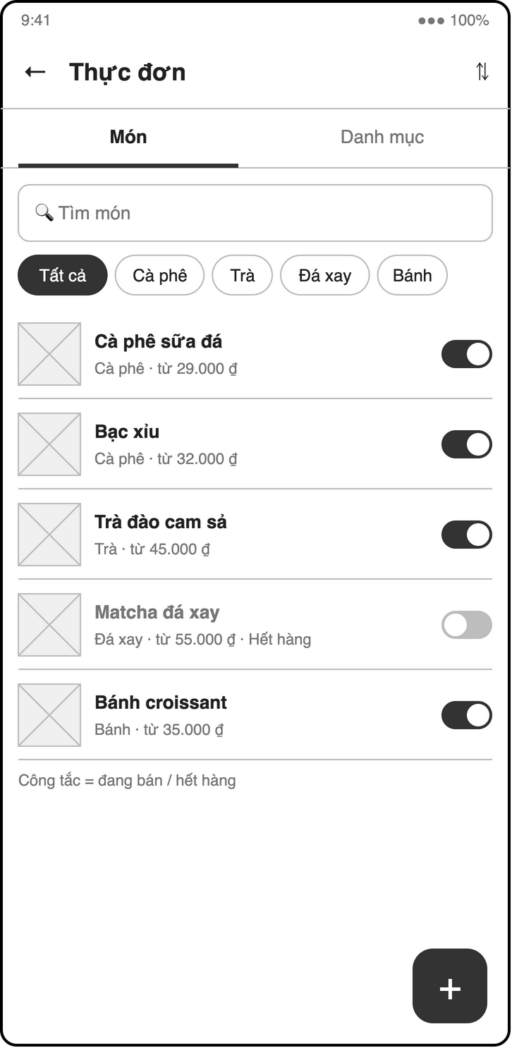
Figure 4-12: Screen design of S08 Category & product list
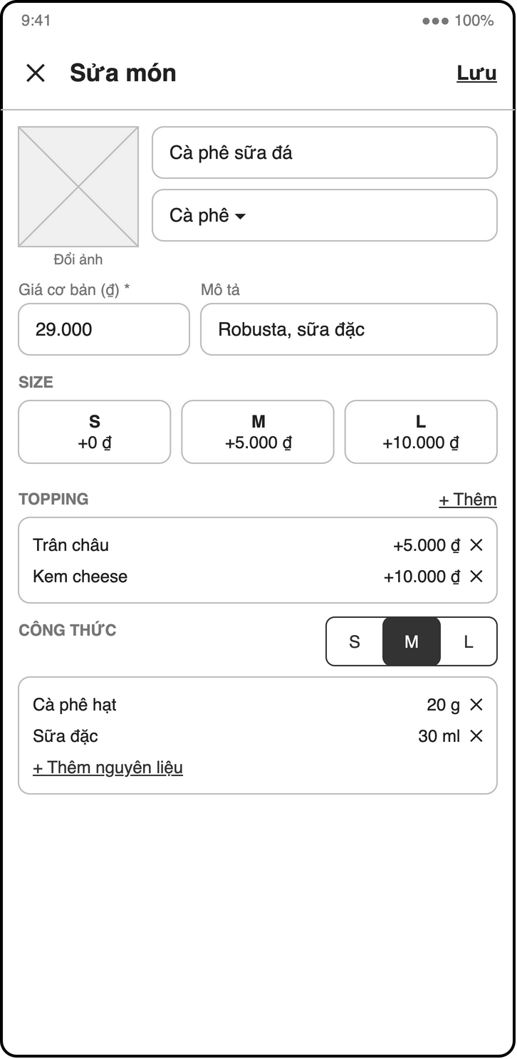
Figure 4-13: Screen design of S09 Product form (sizes, toppings, recipe)
Table 4-12: S08 Menu object binding
No | Object Name | Type | Bound to | Description
1 | categoryTabs | ReorderableListView | categoriesProvider / MenuController.reorder | Long-press to reorder
2 | addCategory | IconButton | MenuController.saveCategory | Dialog
3 | productList | ListView | productsProvider | Image, name, base price
4 | availableSwitch | Switch | MenuController.setAvailable | UC09

Table 4-13: S09 Product form object binding
No | Object Name | Type | Bound to | Description
1 | nameField / priceField | TextFormField / MoneyField | — | Required, price ≥ 0
2 | sizesEditor | Column | local state | S / M / L with price delta
3 | toppingsEditor | Column | local state | Name + price
4 | imagePicker | InkWell | image_picker | Compressed before upload
5 | recipeEditor | Tab per size | ingredientsProvider | Ingredient + qty (INV, UC14)
6 | saveButton | FilledButton | MenuController.saveProduct

4.4.3 Object Interactions (Sequence Diagrams)
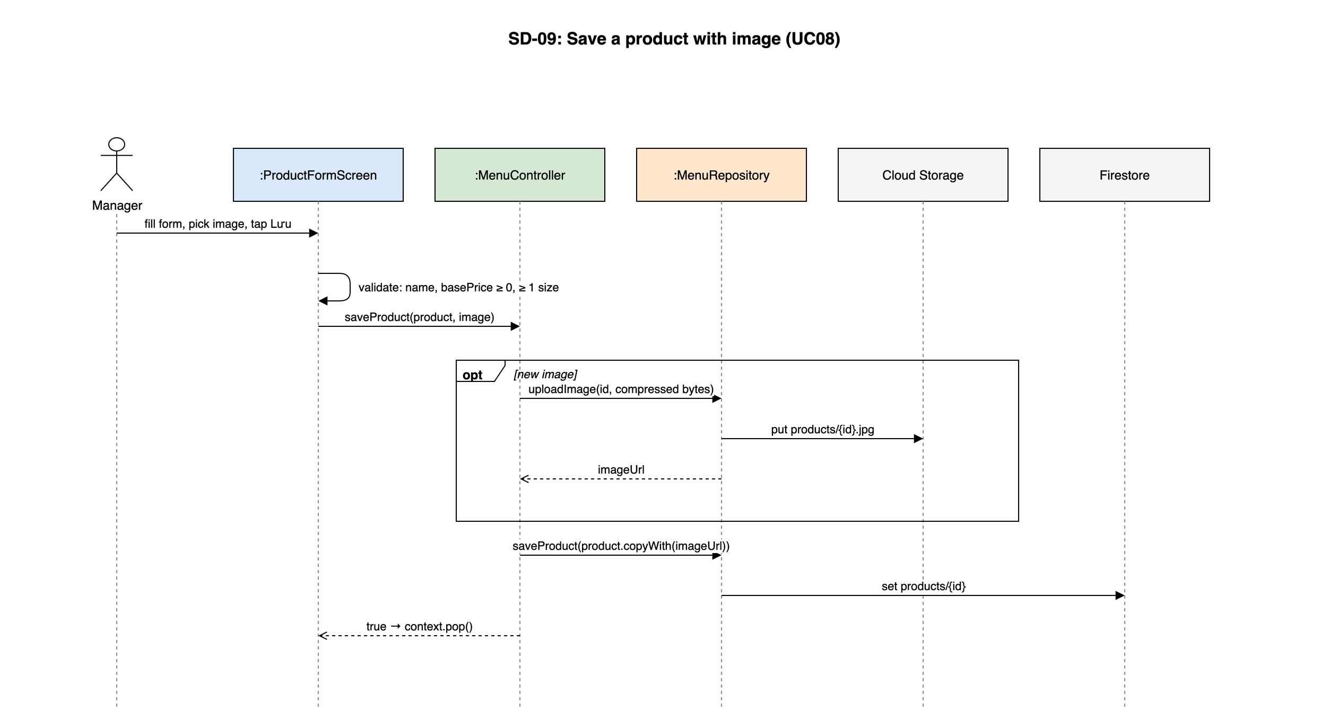
Figure 4-14: SD-09: Save a product with image (UC08)

4.5 INV - Inventory
Owner: M4 Lại Hữu Quang Anh. Use cases: UC11–UC17, UC42, UC43. Screens: S10, S11. Source: lib/features/inventory/.

4.5.1 Class/Component Design

4.5.1.1 Classes/Component Structure
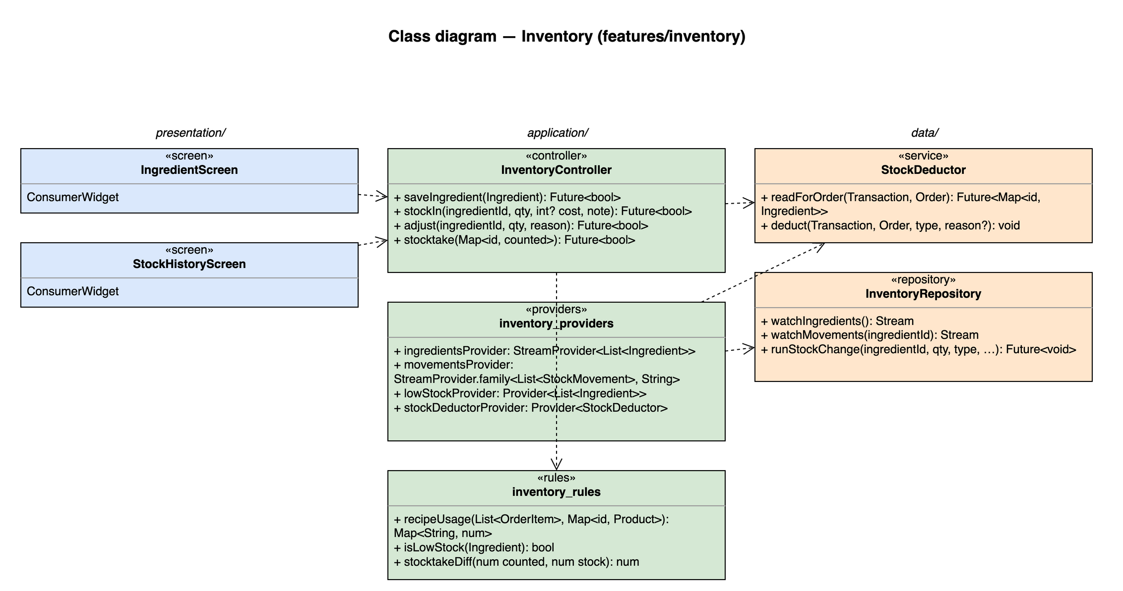
Figure 4-15: Class diagram for Inventory

4.5.1.2 Classes/Component Description

IngredientScreen
Class | IngredientScreen
Description | S10. Ingredient list with low / negative stock highlight, form, stocktake mode.
Base class | ConsumerWidget
Source file | lib/features/inventory/presentation/ingredient_screen.dart

StockHistoryScreen
Class | StockHistoryScreen
Description | S11. Movements of one ingredient with type filter; stock-in and adjustment sheets.
Base class | ConsumerWidget
Source file | lib/features/inventory/presentation/stock_history_screen.dart

InventoryController
Class | InventoryController
Description | —
Base class | AsyncNotifier<void>
Source file | lib/features/inventory/application/inventory_controller.dart
Methods | Name | Input → Output | Description
 | saveIngredient | Ingredient → Future<bool>
 | stockIn | ingredientId, qty, int? cost, note → Future<bool> | Transaction: stock += qty, movement type = in (UC12)
 | adjust | ingredientId, qty, reason → Future<bool> | Reason required (UC13)
 | stocktake | Map<id, counted> → Future<bool> | One transaction per ingredient, logs counted − stock (UC42, BR-INV-03)

inventory_providers
Class | inventory_providers
Description | —
Base class | —
Source file | lib/features/inventory/application/inventory_providers.dart
Attributes | Name | Type | Description
 | ingredientsProvider | StreamProvider<List<Ingredient>>
 | movementsProvider | StreamProvider.family<List<StockMovement>, String>
 | lowStockProvider | Provider<List<Ingredient>> | In-app banner on S04 (fallback for UC16 push)
 | stockDeductorProvider | Provider<StockDeductor> | Used by POS inside its transactions

inventory_rules
Class | inventory_rules
Description | —
Base class | —
Source file | lib/features/inventory/application/inventory_rules.dart
Methods | Name | Input → Output | Description
 | recipeUsage | List<OrderItem>, Map<id, Product> → Map<String, num> | Sum of recipe[size] × qty per ingredient; toppings excluded (BR-INV-04)
 | isLowStock | Ingredient → bool | stock <= minStock
 | stocktakeDiff | num counted, num stock → num

StockDeductor
Class | StockDeductor
Description | deductStock(txn, order) helper called inside the POS payment and cancel transactions (UC15, UC43).
Base class | —
Source file | lib/features/inventory/data/stock_deductor.dart
Methods | Name | Input → Output | Description
 | readForOrder | Transaction, Order → Future<Map<id, Ingredient>> | All reads before any write (Firestore rule)
 | deduct | Transaction, Order, type, reason? → void | stock -= qty and one movement per ingredient; stock may go negative

InventoryRepository
Class | InventoryRepository
Description | ingredients and movements subcollection.
Base class | —
Source file | lib/features/inventory/data/inventory_repository.dart
Methods | Name | Input → Output | Description
 | watchIngredients | — → Stream
 | watchMovements | ingredientId → Stream | createdAt DESC
 | runStockChange | ingredientId, qty, type, … → Future<void> | Transaction + movement record

4.5.2 Screen Design
Field-level screen definitions are in SRS §3 (Screen Definition tables). This section binds each main screen object to the provider or controller method that serves it.
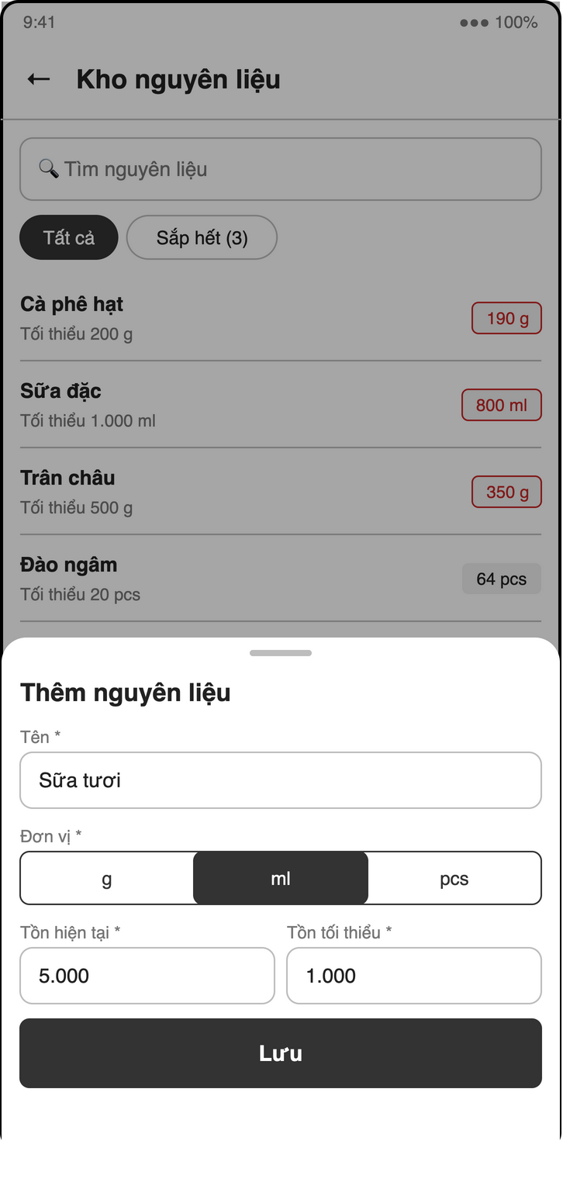
Figure 4-16: Screen design of S10 Ingredient list / form
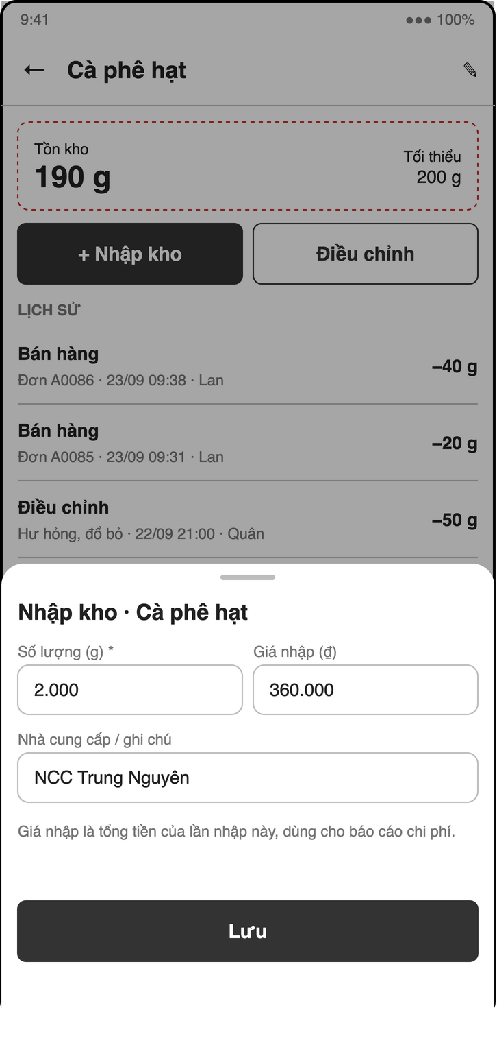
Figure 4-17: Screen design of S11b Stock-in sheet
Table 4-14: S10 Ingredients object binding
No | Object Name | Type | Bound to | Description
1 | ingredientList | ListView | ingredientsProvider | Stock, unit; red when ≤ minStock or negative
2 | stocktakeMode | Toggle | InventoryController.stocktake | Counted field per row (UC42)
3 | ingredientForm | Dialog | InventoryController.saveIngredient | Name, unit, stock, minStock

Table 4-15: S11 / S11b Stock object binding
No | Object Name | Type | Bound to | Description
1 | typeFilter | ChoiceChip | movementsProvider(id) | in / sale / adjust
2 | movementList | ListView | movementsProvider | Date, qty ±, cost, reason, user
3 | stockInSheet | BottomSheet | InventoryController.stockIn | Qty, total cost (optional), note
4 | adjustSheet | BottomSheet | InventoryController.adjust | Qty ±, reason required

4.5.3 Object Interactions (Sequence Diagrams)
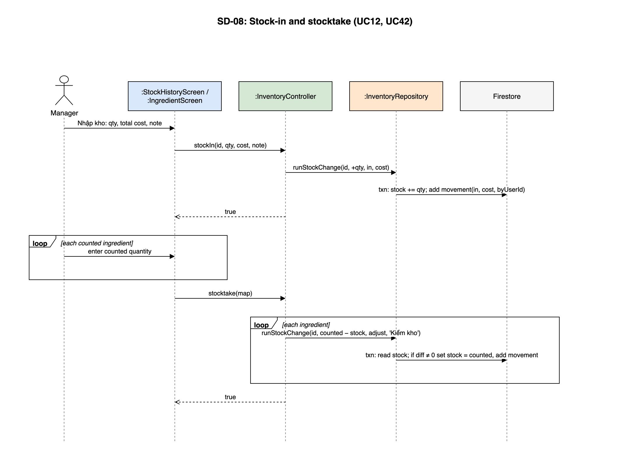
Figure 4-18: SD-08: Stock-in and stocktake (UC12, UC42)
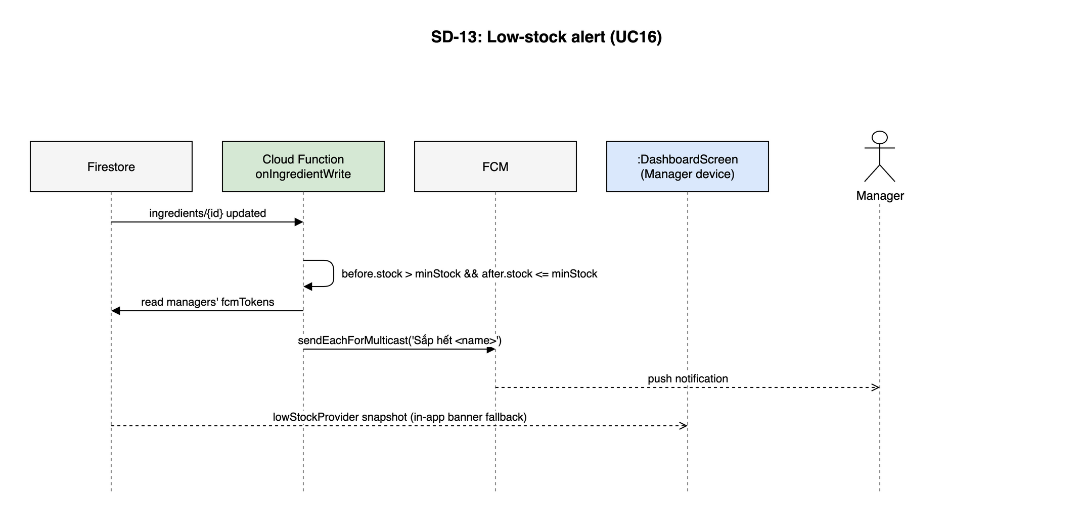
Figure 4-19: SD-13: Low-stock alert (UC16)

4.6 POS - Point of Sale
Owner: M2 Phạm Khắc Nghĩa. Use cases: UC19–UC28, UC46. Screens: S13, S14, S15. Source: lib/features/pos/.

4.6.1 Class/Component Design

4.6.1.1 Classes/Component Structure
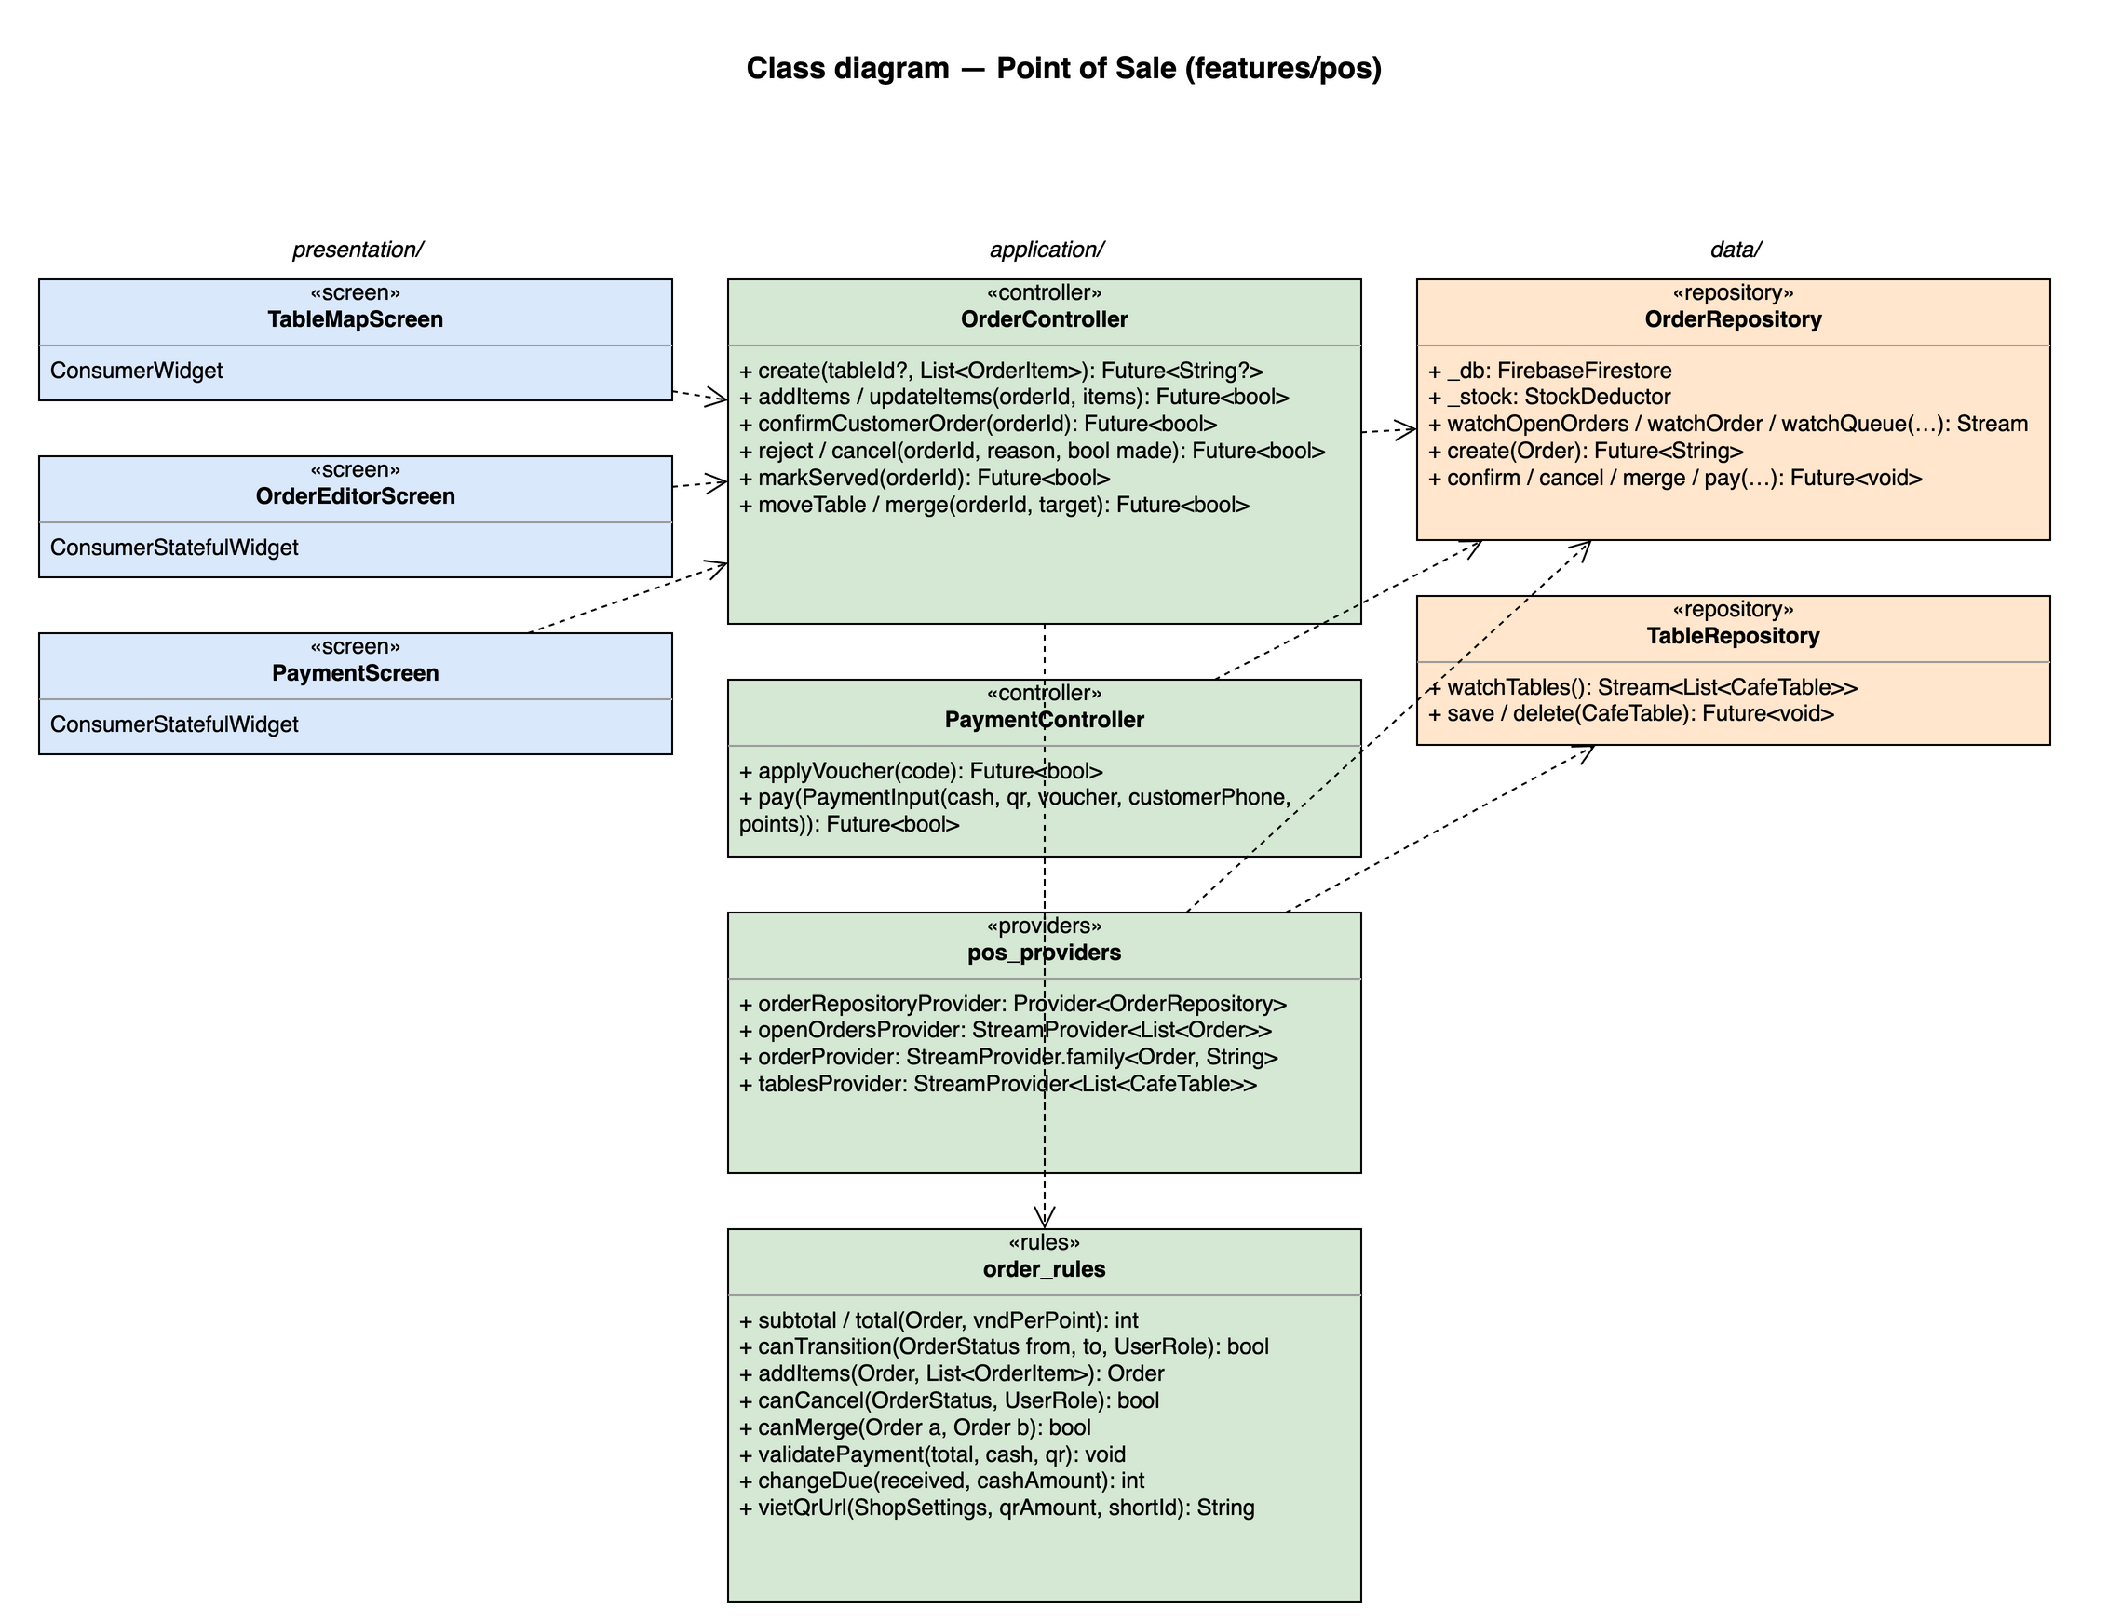
Figure 4-20: Class diagram for Point of Sale

4.6.1.2 Classes/Component Description

TableMapScreen
Class | TableMapScreen
Description | S13. Area tabs + 'Mang đi' tab; table colour from its open order; badge for awaiting customer orders.
Base class | ConsumerWidget
Source file | lib/features/pos/presentation/table_map_screen.dart

OrderEditorScreen
Class | OrderEditorScreen
Description | S14. MenuBrowser + cart; item options sheet, confirm customer order, move / merge, cancel.
Base class | ConsumerStatefulWidget
Source file | lib/features/pos/presentation/order_editor_screen.dart

PaymentScreen
Class | PaymentScreen
Description | S15. Voucher, loyalty phone, points, cash / VietQR / split, change due.
Base class | ConsumerStatefulWidget
Source file | lib/features/pos/presentation/payment_screen.dart

OrderController
Class | OrderController
Description | —
Base class | AsyncNotifier<void>
Source file | lib/features/pos/application/order_controller.dart
Methods | Name | Input → Output | Description
 | create | tableId?, List<OrderItem> → Future<String?> | Allocates shortId, status = pending, occupies the table
 | addItems / updateItems | orderId, items → Future<bool> | BR-ORD-04 batch logic
 | confirmCustomerOrder | orderId → Future<bool> | BR-ORD-07 transaction
 | reject / cancel | orderId, reason, bool made → Future<bool> | BR-ORD-05, BR-INV-02
 | markServed | orderId → Future<bool> | ready → served
 | moveTable / merge | orderId, target → Future<bool> | BR-ORD-08

PaymentController
Class | PaymentController
Description | —
Base class | AsyncNotifier<void>
Source file | lib/features/pos/application/payment_controller.dart
Methods | Name | Input → Output | Description
 | applyVoucher | code → Future<bool> | Validates via loyalty rules (UC24)
 | pay | PaymentInput(cash, qr, voucher, customerPhone, points) → Future<bool> | Runs the payment transaction (UC25, UC46)

pos_providers
Class | pos_providers
Description | —
Base class | —
Source file | lib/features/pos/application/pos_providers.dart
Attributes | Name | Type | Description
 | orderRepositoryProvider | Provider<OrderRepository> | Also read by BAR, CUS, RPT
 | openOrdersProvider | StreamProvider<List<Order>> | status in awaiting..served
 | orderProvider | StreamProvider.family<Order, String>
 | tablesProvider | StreamProvider<List<CafeTable>>

order_rules
Class | order_rules
Description | State machine and money maths, unit tested.
Base class | —
Source file | lib/features/pos/application/order_rules.dart
Methods | Name | Input → Output | Description
 | subtotal / total | Order, vndPerPoint → int | BR-ORD-02, never below 0
 | canTransition | OrderStatus from, to, UserRole → bool | State machine brief §4.2
 | addItems | Order, List<OrderItem> → Order | Same batch or max + 1 and back to pending (BR-ORD-04)
 | canCancel | OrderStatus, UserRole → bool | BR-ORD-05
 | canMerge | Order a, Order b → bool | BR-ORD-08
 | validatePayment | total, cash, qr → void | cash + qr = total, both ≥ 0 (BR-PAY-01)
 | changeDue | received, cashAmount → int | BR-PAY-02
 | vietQrUrl | ShopSettings, qrAmount, shortId → String | img.vietqr.io compact2 URL

OrderRepository
Class | OrderRepository
Description | orders collection and all order transactions.
Base class | —
Source file | lib/features/pos/data/order_repository.dart
Attributes | Name | Type | Description
 | _db | FirebaseFirestore
 | _stock | StockDeductor | From inventory provider
Methods | Name | Input → Output | Description
 | watchOpenOrders / watchOrder / watchQueue | … → Stream | Queue: status in [pending, preparing] ORDER BY createdAt
 | create | Order → Future<String> | Transaction with counters/shortId-{yyyyMMdd}
 | confirm / cancel / merge / pay | … → Future<void> | Each one runTransaction (see §4.1.6)

TableRepository
Class | TableRepository
Description | tables collection (CRUD by M3, UC18).
Base class | —
Source file | lib/features/pos/data/table_repository.dart
Methods | Name | Input → Output | Description
 | watchTables | — → Stream<List<CafeTable>>
 | save / delete | CafeTable → Future<void> | Delete refused while currentOrderId != null

4.6.2 Screen Design
Field-level screen definitions are in SRS §3 (Screen Definition tables). This section binds each main screen object to the provider or controller method that serves it.
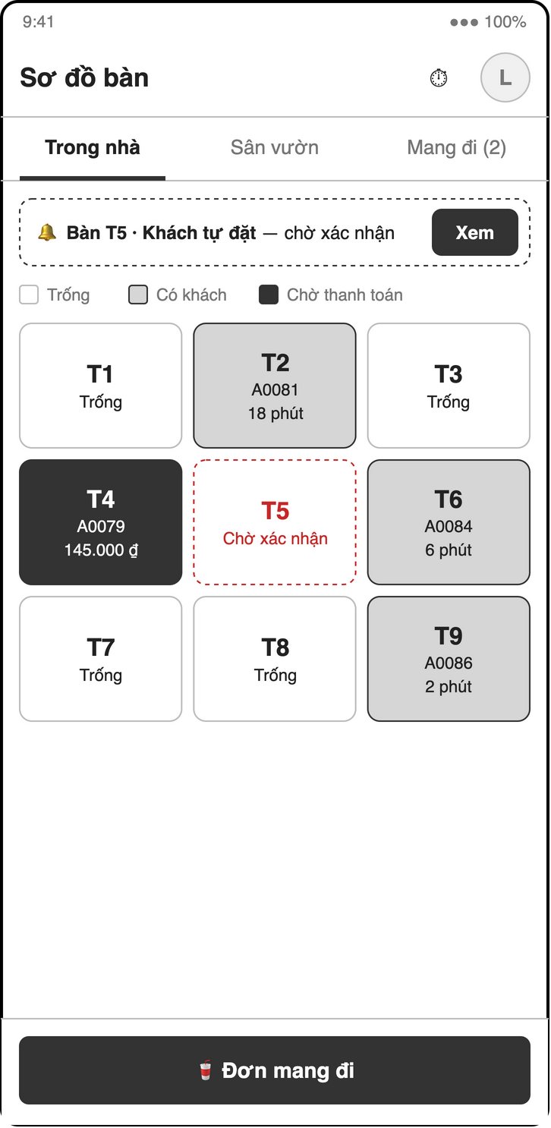
Figure 4-21: Screen design of S13 Table map
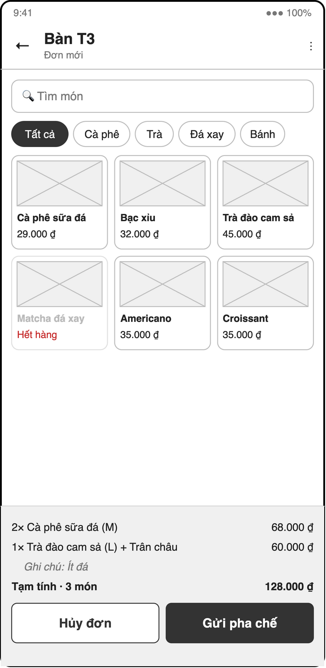
Figure 4-22: Screen design of S14 Order editor
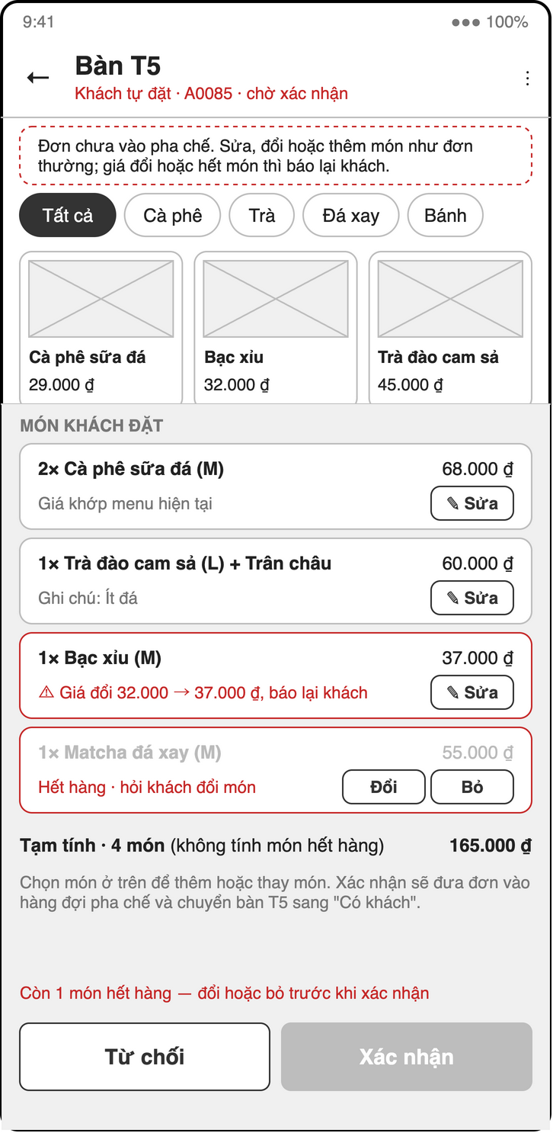
Figure 4-23: Screen design of S14c Confirm customer order
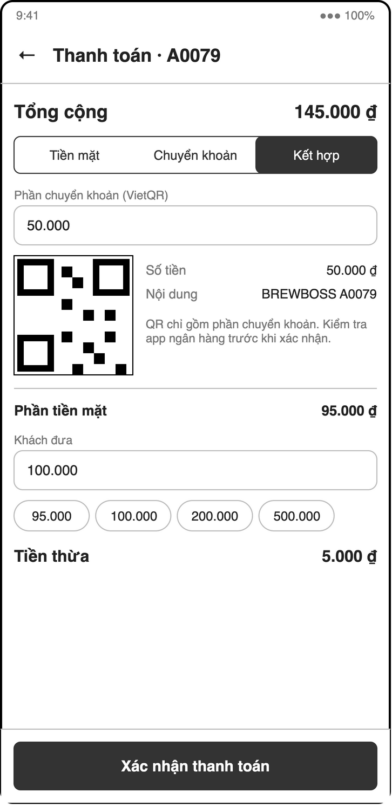
Figure 4-24: Screen design of S15c Payment — split cash + VietQR
Table 4-16: S13 Table map object binding
No | Object Name | Type | Bound to | Description
1 | areaTabs | TabBar | tablesProvider | Areas + 'Mang đi'
2 | tableCard | Card | tablesProvider + openOrdersProvider | Empty / occupied / ready / awaiting badge
3 | newTakeaway | FAB | context.push(Routes.posOrder('new')) | tableId = null

Table 4-17: S14 Order editor object binding
No | Object Name | Type | Bound to | Description
1 | menuBrowser | MenuBrowser | menuQueryProvider | Sold-out items disabled
2 | itemOptionsSheet | BottomSheet | menu_rules.unitPrice | Size, toppings, qty, note
3 | cart | ListView | local state / orderProvider | Lines of the current batch editable only while pending
4 | sendButton | FilledButton | OrderController.create / addItems
5 | confirmBar | Banner | OrderController.confirmCustomerOrder / reject | Awaiting orders
6 | menuActions | PopupMenu | OrderController.markServed / moveTable / merge / cancel | Per status and role

Table 4-18: S15 Payment object binding
No | Object Name | Type | Bound to | Description
1 | voucherField | TextField | PaymentController.applyVoucher | UC24
2 | customerButton | Button | CustomerSheet | UC38, UC39
3 | methodToggle | SegmentedButton | local state | Tiền mặt / VietQR / Kết hợp
4 | vietQrImage | Image.network | order_rules.vietQrUrl | Only the transfer part
5 | cashField / changeText | MoneyField / Text | order_rules.changeDue
6 | confirmButton | FilledButton | PaymentController.pay | Disabled without open shift

4.6.3 Object Interactions (Sequence Diagrams)
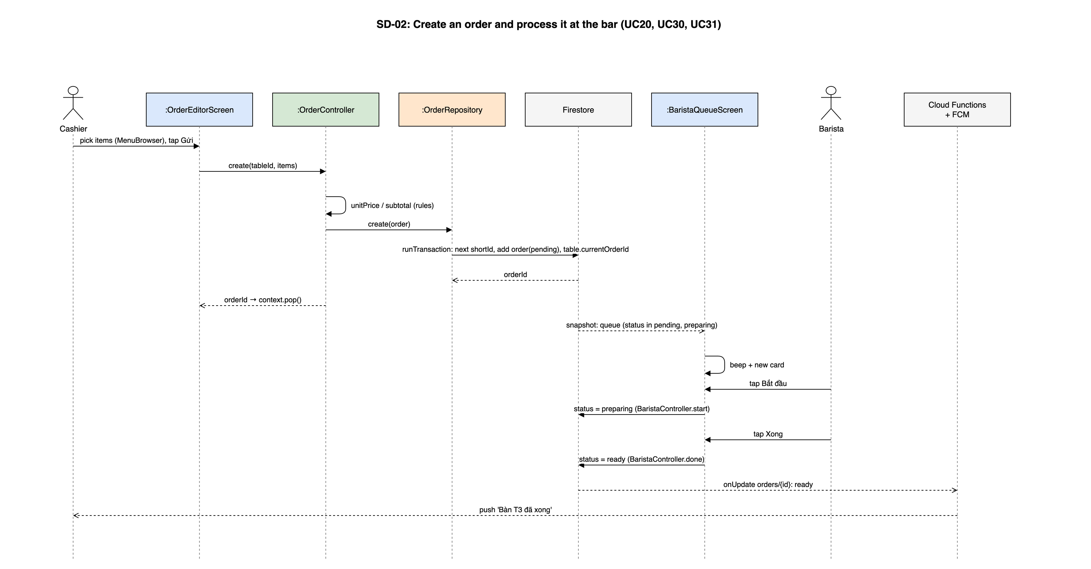
Figure 4-25: SD-02: Create an order and process it at the bar (UC20, UC30, UC31)
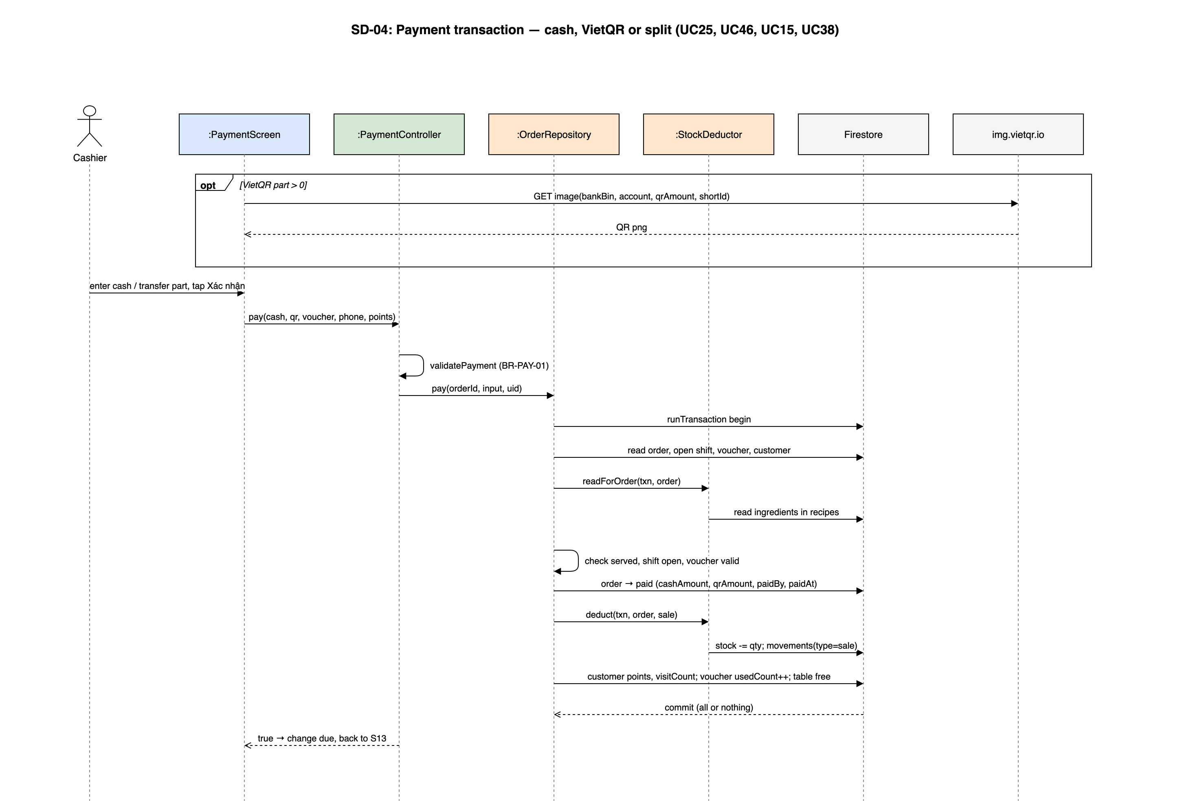
Figure 4-26: SD-04: Payment transaction — cash, VietQR or split (UC25, UC46, UC15, UC38)
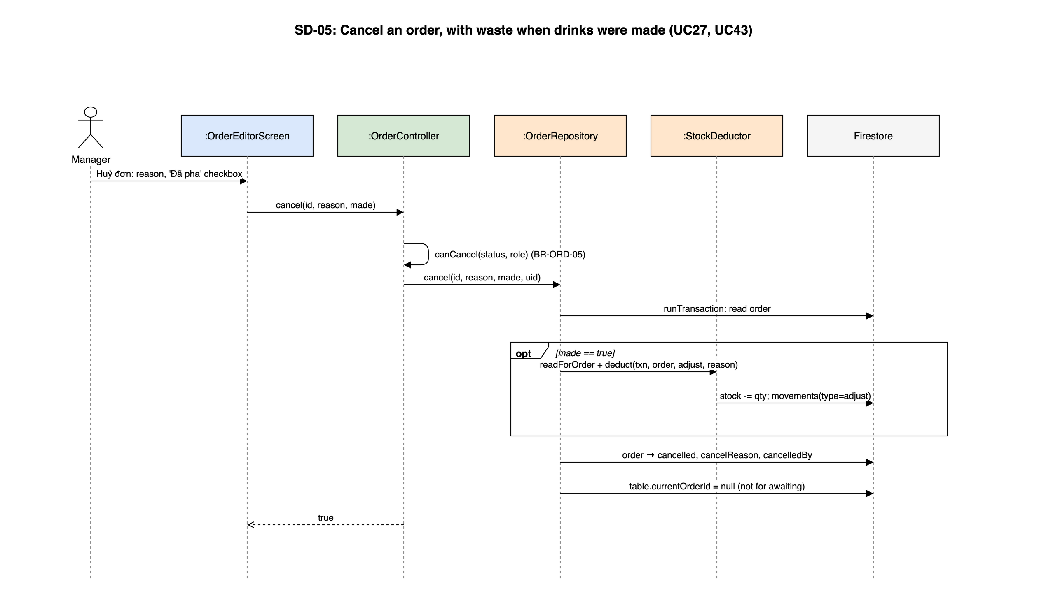
Figure 4-27: SD-05: Cancel an order, with waste when drinks were made (UC27, UC43)
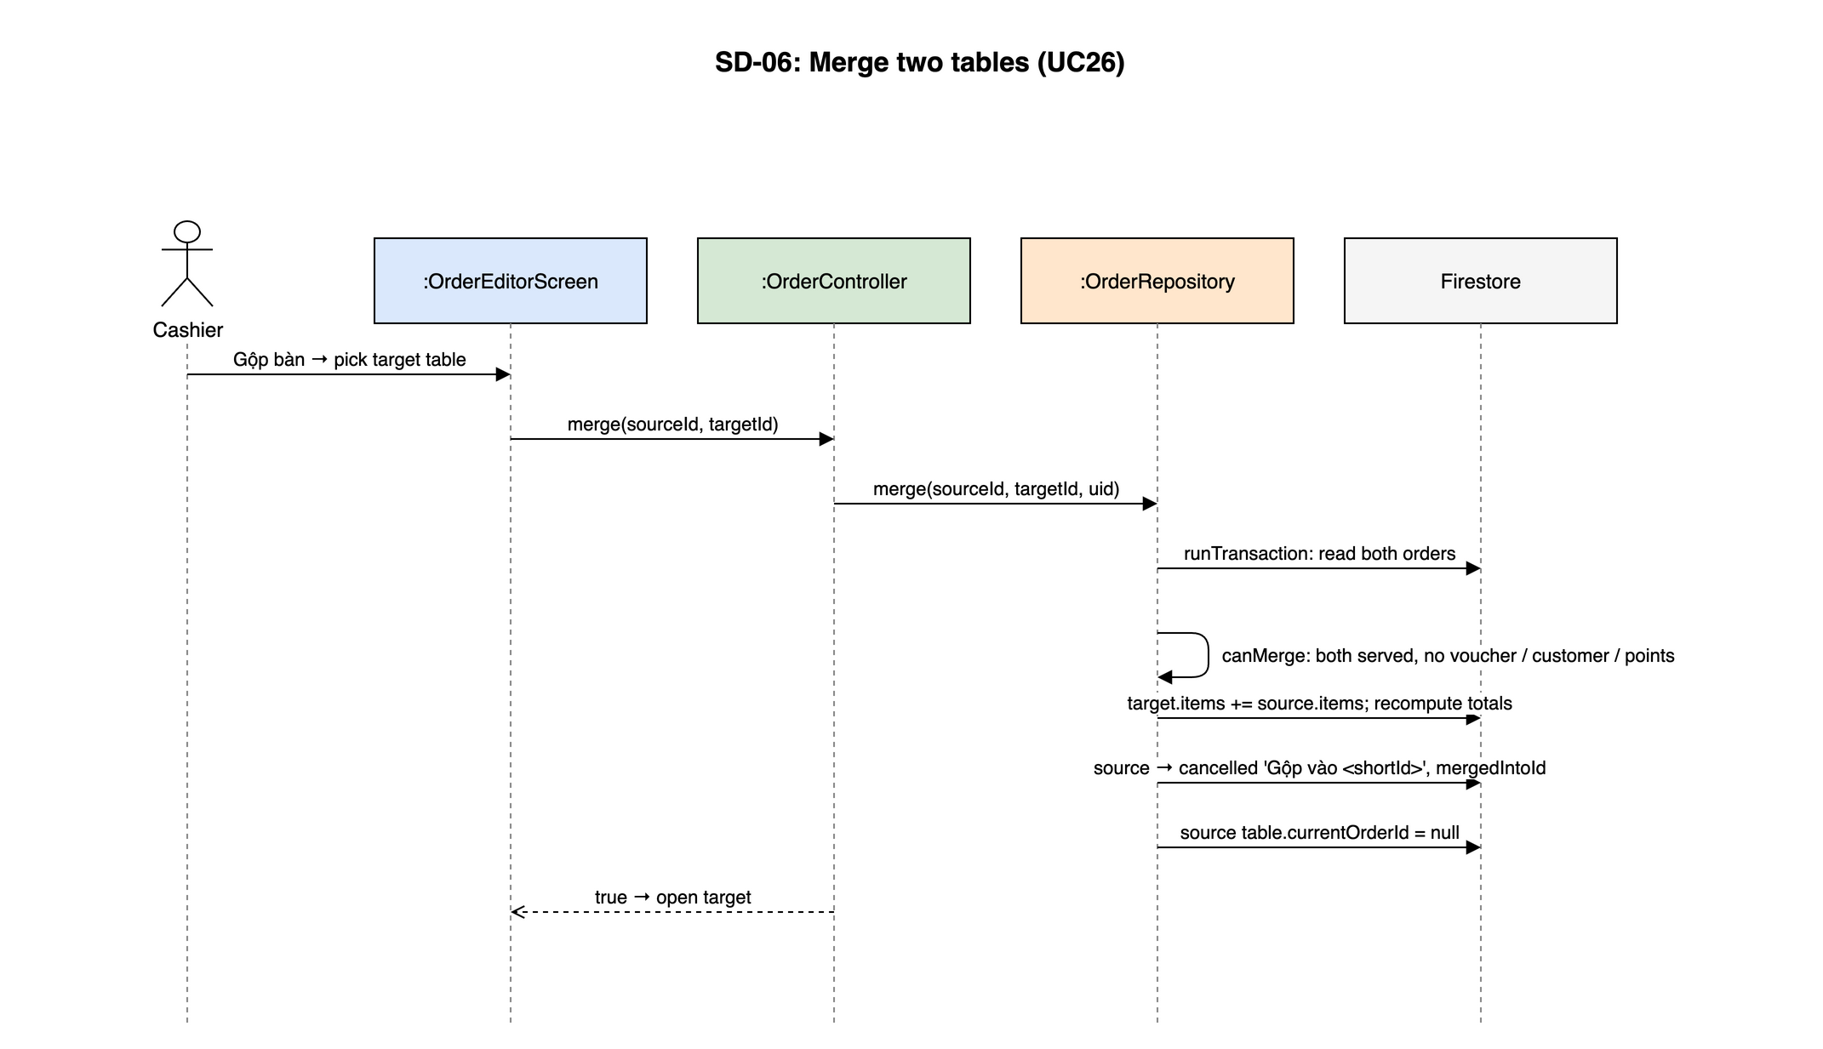
Figure 4-28: SD-06: Merge two tables (UC26)

4.7 BAR - Barista Display
Owner: M3 Nguyễn Bá Cường. Use cases: UC30, UC31. Screens: S16. Source: lib/features/barista/.

4.7.1 Class/Component Design

4.7.1.1 Classes/Component Structure
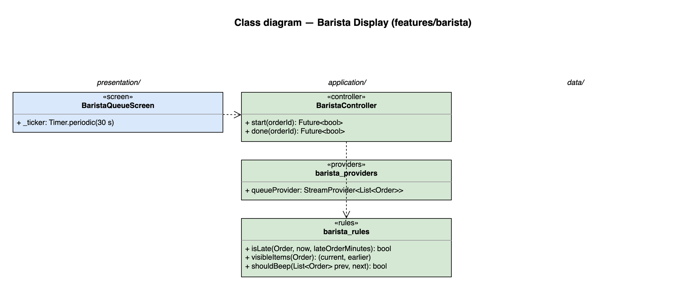
Figure 4-29: Class diagram for Barista Display

4.7.1.2 Classes/Component Description

BaristaQueueScreen
Class | BaristaQueueScreen
Description | S16. Tablet grid of order cards, oldest first; Start / Done buttons; late colour; sound on new order or add-on.
Base class | ConsumerStatefulWidget
Source file | lib/features/barista/presentation/barista_queue_screen.dart
Attributes | Name | Type | Description
 | _ticker | Timer.periodic(30 s) | Refreshes elapsed time and late colour

BaristaController
Class | BaristaController
Description | —
Base class | AsyncNotifier<void>
Source file | lib/features/barista/application/barista_controller.dart
Methods | Name | Input → Output | Description
 | start | orderId → Future<bool> | pending → preparing
 | done | orderId → Future<bool> | preparing → ready; Cloud Function pushes to cashiers

barista_providers
Class | barista_providers
Description | —
Base class | —
Source file | lib/features/barista/application/barista_providers.dart
Attributes | Name | Type | Description
 | queueProvider | StreamProvider<List<Order>> | orderRepository.watchQueue()

barista_rules
Class | barista_rules
Description | —
Base class | —
Source file | lib/features/barista/application/barista_rules.dart
Methods | Name | Input → Output | Description
 | isLate | Order, now, lateOrderMinutes → bool | FR-BAR-04
 | visibleItems | Order → (current, earlier) | Latest batch vs collapsed batches (BR-ORD-04)
 | shouldBeep | List<Order> prev, next → bool | New order or more items in a queued order (FR-BAR-06)

4.7.2 Screen Design
Field-level screen definitions are in SRS §3 (Screen Definition tables). This section binds each main screen object to the provider or controller method that serves it.
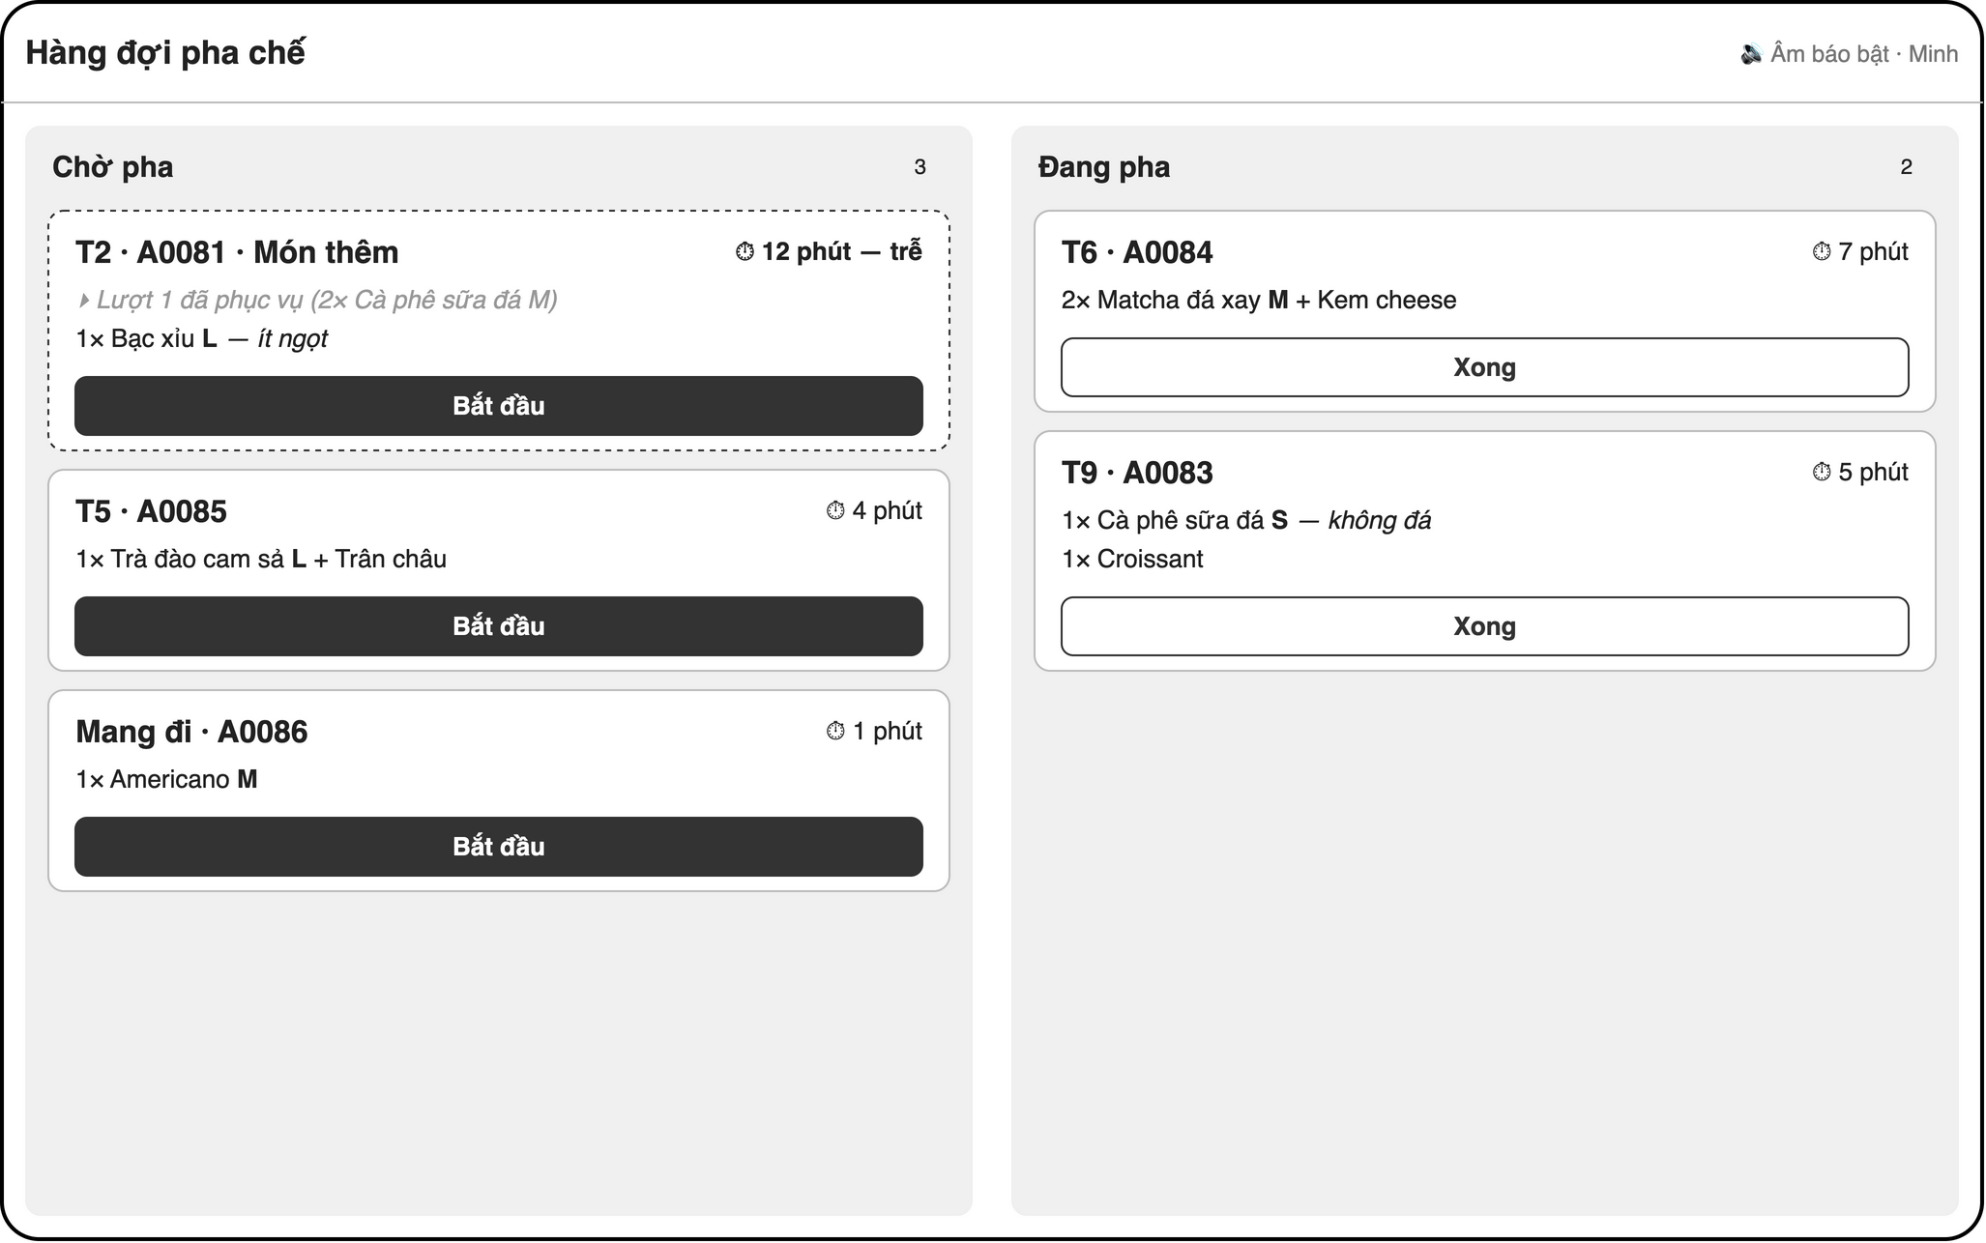
Figure 4-30: Screen design of S16 Barista queue (tablet)
Table 4-19: S16 Barista queue object binding
No | Object Name | Type | Bound to | Description
1 | orderCard | Card (grid) | queueProvider | Table / takeaway, shortId, elapsed; late colour (isLate)
2 | batchList | Column | barista_rules.visibleItems | Latest batch; earlier ones collapsed
3 | startButton | FilledButton | BaristaController.start | pending
4 | doneButton | FilledButton | BaristaController.done | preparing
5 | beep | AudioPlayer | barista_rules.shouldBeep | FR-BAR-06

4.7.3 Object Interactions (Sequence Diagrams)
No module-specific sequence. The queue and status flow is part of SD-02 in §4.6.3; the ready notification is §4.1.8.

4.8 CUS - Customer QR Ordering and Tables
Owner: M3 Nguyễn Bá Cường. Use cases: UC18, UC32, UC33. Screens: S12, S17, S18. Source: lib/features/customer/.

4.8.1 Class/Component Design

4.8.1.1 Classes/Component Structure
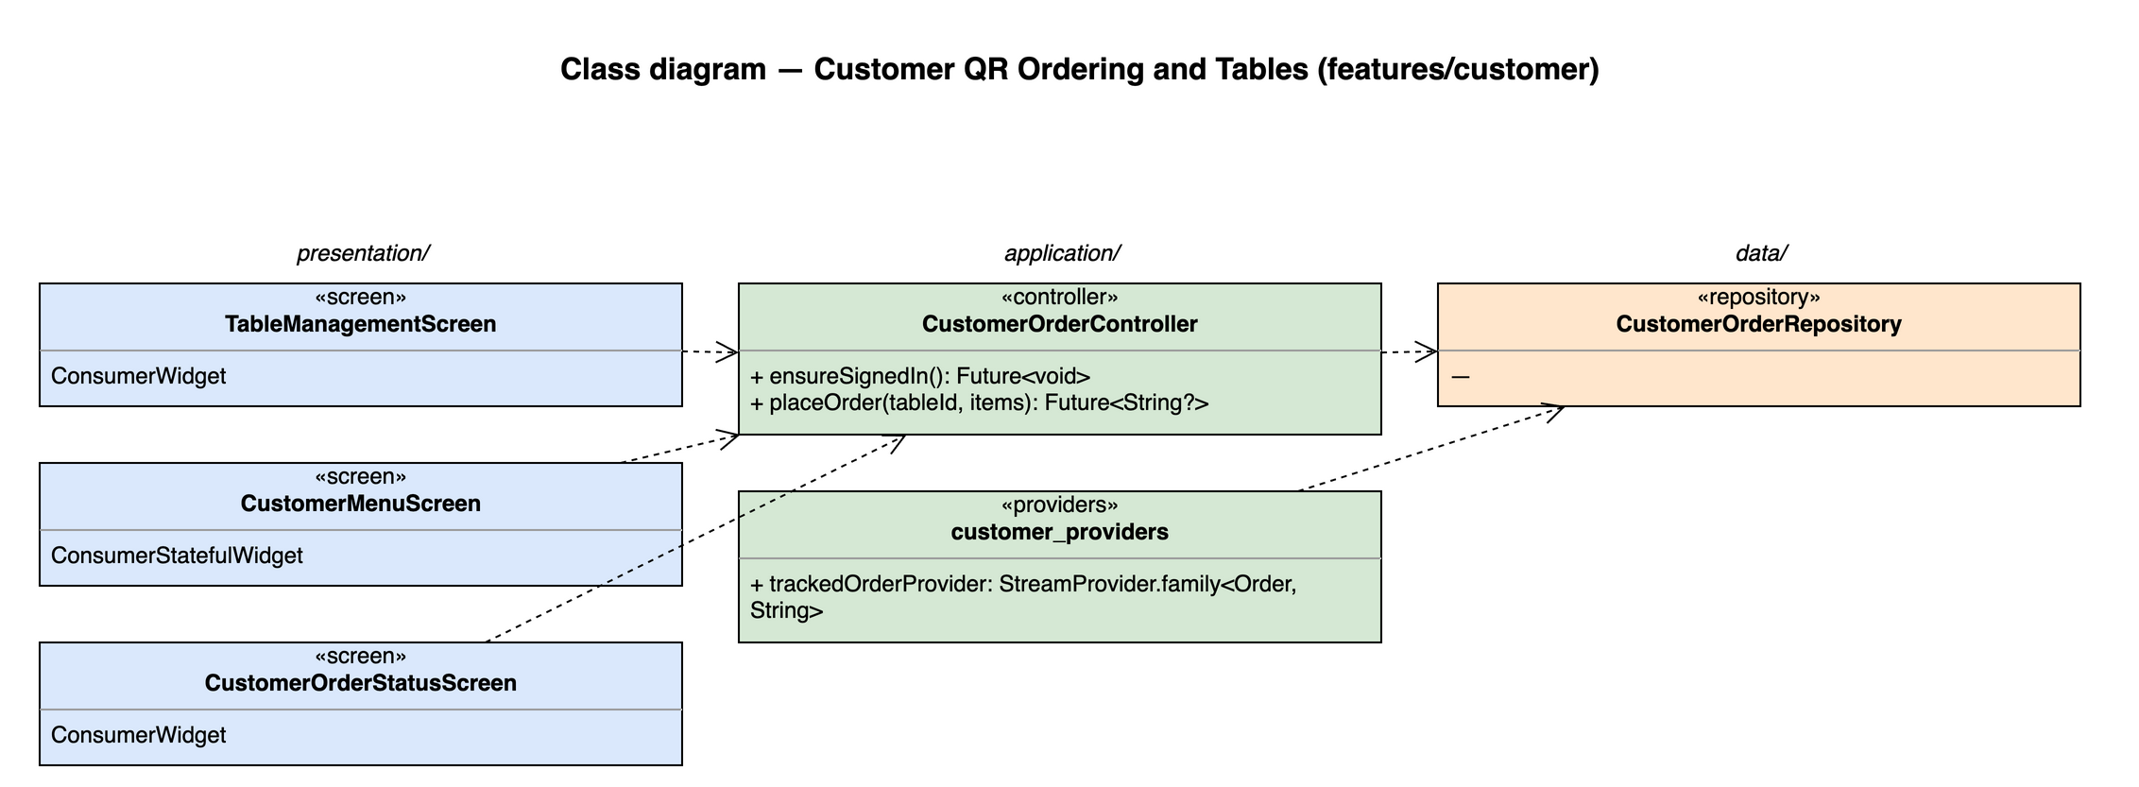
Figure 4-31: Class diagram for Customer QR Ordering and Tables

4.8.1.2 Classes/Component Description

TableManagementScreen
Class | TableManagementScreen
Description | S12. Table CRUD and printable QR (qr_flutter) encoding https://<host>/c/{tableId}.
Base class | ConsumerWidget
Source file | lib/features/customer/presentation/table_management_screen.dart

CustomerMenuScreen
Class | CustomerMenuScreen
Description | S17. Anonymous menu (MenuBrowser, available products only) and cart.
Base class | ConsumerStatefulWidget
Source file | lib/features/customer/presentation/customer_menu_screen.dart

CustomerOrderStatusScreen
Class | CustomerOrderStatusScreen
Description | S18. Live status; follows mergedIntoId after an add-on is confirmed.
Base class | ConsumerWidget
Source file | lib/features/customer/presentation/customer_order_status_screen.dart

CustomerOrderController
Class | CustomerOrderController
Description | —
Base class | AsyncNotifier<void>
Source file | lib/features/customer/application/customer_order_controller.dart
Methods | Name | Input → Output | Description
 | ensureSignedIn | — → Future<void> | signInAnonymously() once per browser
 | placeOrder | tableId, items → Future<String?> | source = customer, status = awaiting, createdBy = anonymous uid

customer_providers
Class | customer_providers
Description | —
Base class | —
Source file | lib/features/customer/application/customer_providers.dart
Attributes | Name | Type | Description
 | trackedOrderProvider | StreamProvider.family<Order, String> | Switches to the mergedIntoId order when set

CustomerOrderRepository
Class | CustomerOrderRepository
Description | Anonymous-auth writes; rules allow only awaiting customer orders without price-trust fields.
Base class | —
Source file | lib/features/customer/data/customer_order_repository.dart

4.8.2 Screen Design
Field-level screen definitions are in SRS §3 (Screen Definition tables). This section binds each main screen object to the provider or controller method that serves it.
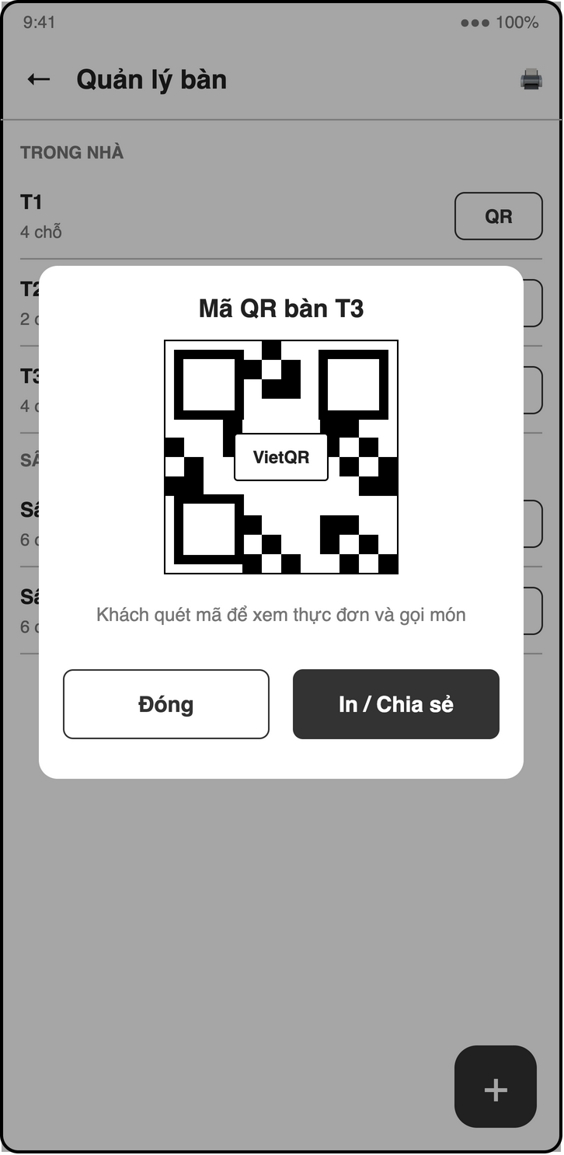
Figure 4-32: Screen design of S12 Table management + QR print
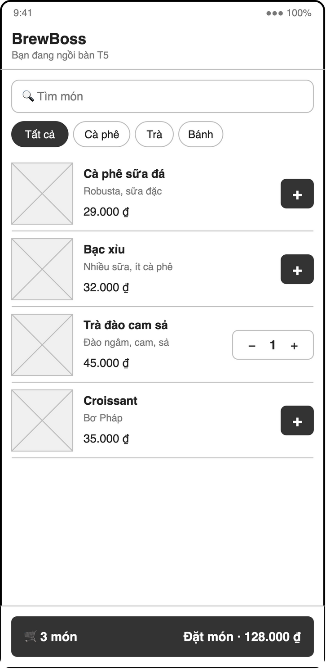
Figure 4-33: Screen design of S17 Customer menu via QR
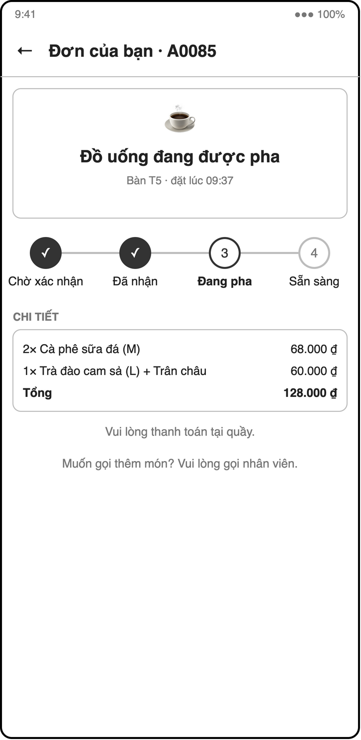
Figure 4-34: Screen design of S18 Customer order status
Table 4-20: S12 Tables object binding
No | Object Name | Type | Bound to | Description
1 | tableList | ListView | tablesProvider | Name, area, capacity
2 | tableForm | Dialog | TableRepository.save
3 | qrPreview | QrImageView | qr_flutter | https://<host>/c/{tableId}; print / share

Table 4-21: S17 / S18 Customer object binding
No | Object Name | Type | Bound to | Description
1 | menuBrowser | MenuBrowser | menuQueryProvider(availableOnly)
2 | cart | BottomSheet | local state
3 | sendButton | FilledButton | CustomerOrderController.placeOrder
4 | statusStepper | Stepper | trackedOrderProvider | awaiting → pending → preparing → ready

4.8.3 Object Interactions (Sequence Diagrams)
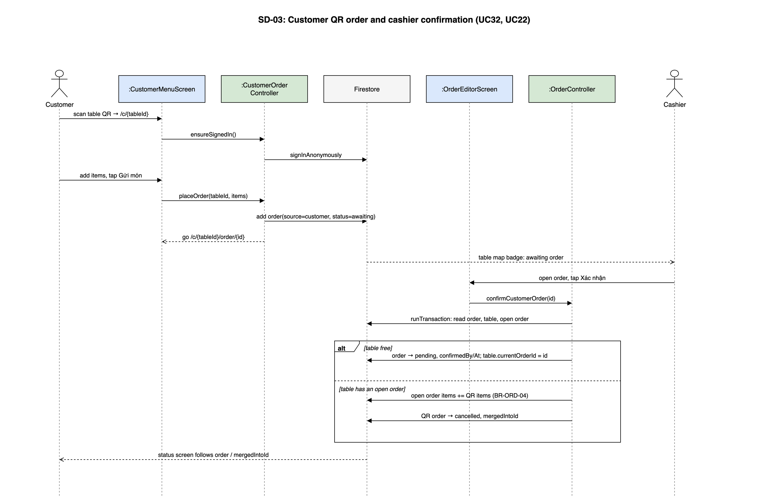
Figure 4-35: SD-03: Customer QR order and cashier confirmation (UC32, UC22)

4.9 RPT - Reports
Owner: M3 Nguyễn Bá Cường. Use cases: UC34–UC37. Screens: S04, S19, S20. Source: lib/features/reports/.

4.9.1 Class/Component Design

4.9.1.1 Classes/Component Structure
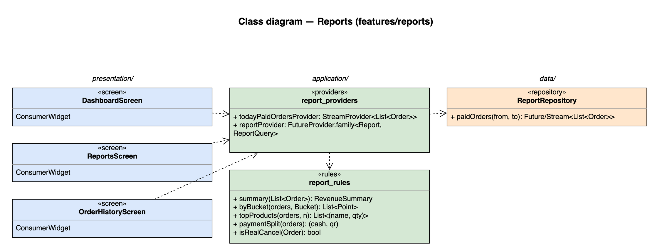
Figure 4-36: Class diagram for Reports

4.9.1.2 Classes/Component Description

DashboardScreen
Class | DashboardScreen
Description | S04. Today's revenue, order count, average value, low-stock banner, navigation hub.
Base class | ConsumerWidget
Source file | lib/features/reports/presentation/dashboard_screen.dart

ReportsScreen
Class | ReportsScreen
Description | S19. fl_chart revenue by day / week / month, top products, cash vs VietQR; export (P2).
Base class | ConsumerWidget
Source file | lib/features/reports/presentation/reports_screen.dart

OrderHistoryScreen
Class | OrderHistoryScreen
Description | S20. Orders filtered by date, status, cashier.
Base class | ConsumerWidget
Source file | lib/features/reports/presentation/order_history_screen.dart

report_providers
Class | report_providers
Description | —
Base class | —
Source file | lib/features/reports/application/report_providers.dart
Attributes | Name | Type | Description
 | todayPaidOrdersProvider | StreamProvider<List<Order>> | status = paid, paidAt ≥ today 00:00 (live)
 | reportProvider | FutureProvider.family<Report, ReportQuery>

report_rules
Class | report_rules
Description | —
Base class | —
Source file | lib/features/reports/application/report_rules.dart
Methods | Name | Input → Output | Description
 | summary | List<Order> → RevenueSummary | sum(total), count, average
 | byBucket | orders, Bucket → List<Point> | day / week / month
 | topProducts | orders, n → List<(name, qty)>
 | paymentSplit | orders → (cash, qr) | sum(cashAmount), sum(qrAmount)
 | isRealCancel | Order → bool | Excludes 'Gộp vào …' (BR-ORD-08)

ReportRepository
Class | ReportRepository
Description | Read-only order queries.
Base class | —
Source file | lib/features/reports/data/report_repository.dart
Methods | Name | Input → Output | Description
 | paidOrders | from, to → Future/Stream<List<Order>> | index status ASC, paidAt DESC

4.9.2 Screen Design
Field-level screen definitions are in SRS §3 (Screen Definition tables). This section binds each main screen object to the provider or controller method that serves it.
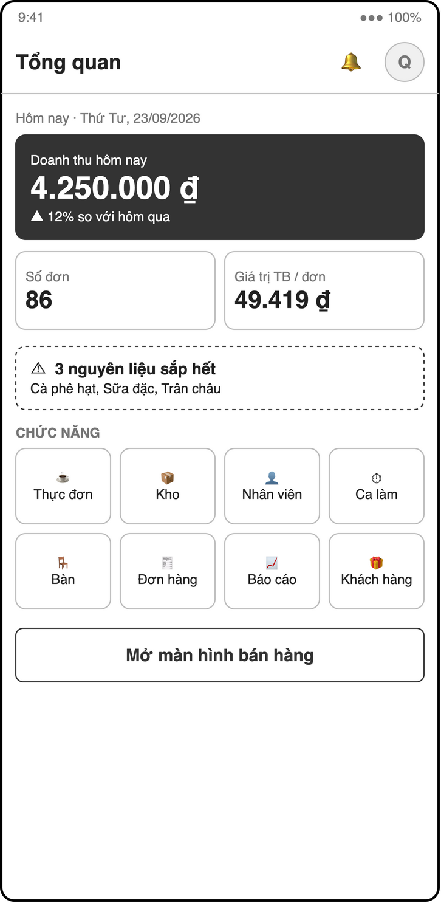
Figure 4-37: Screen design of S04 Manager home / dashboard
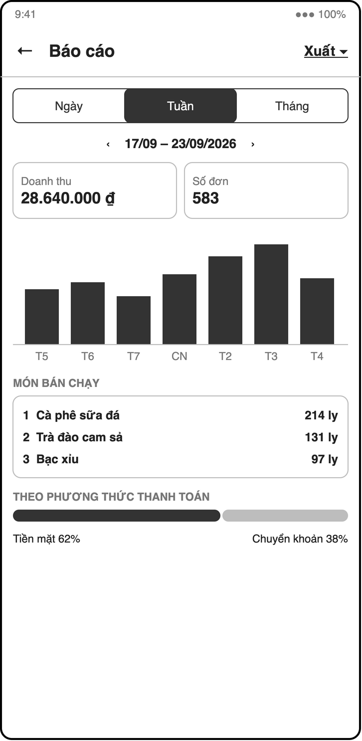
Figure 4-38: Screen design of S19 Reports
Table 4-22: S04 Dashboard object binding
No | Object Name | Type | Bound to | Description
1 | kpiRow | Row of cards | todayPaidOrdersProvider + report_rules.summary | Revenue, orders, average
2 | lowStockBanner | MaterialBanner | lowStockProvider
3 | navGrid | GridView | context.push | Management screens

Table 4-23: S19 / S20 Reports object binding
No | Object Name | Type | Bound to | Description
1 | rangePicker | SegmentedButton | reportProvider(query) | Day / week / month
2 | revenueChart | BarChart (fl_chart) | report_rules.byBucket
3 | topList | ListView | report_rules.topProducts
4 | splitChart | PieChart | report_rules.paymentSplit | Cash vs VietQR
5 | orderFilters / orderList | Chips / ListView | ReportRepository | Date, status, cashier

4.9.3 Object Interactions (Sequence Diagrams)
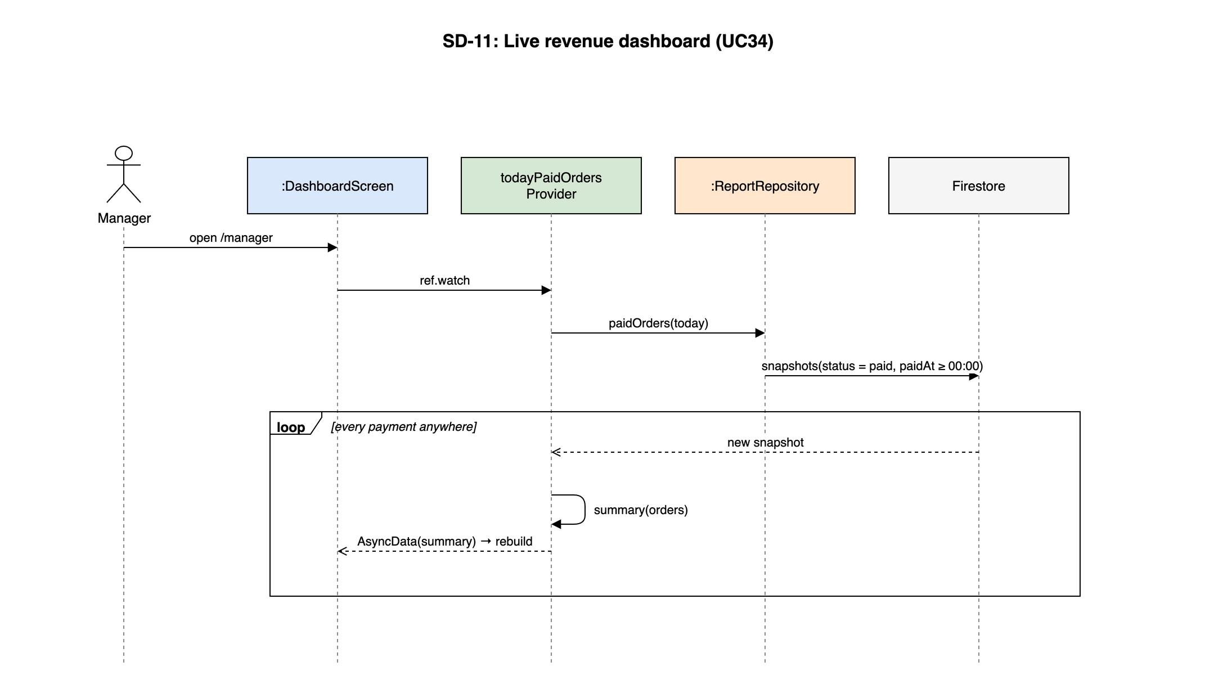
Figure 4-39: SD-11: Live revenue dashboard (UC34)

4.10 LOY - Loyalty and Vouchers
Owner: M3 Nguyễn Bá Cường. Use cases: UC38–UC41. Screens: S21. Source: lib/features/loyalty/.

4.10.1 Class/Component Design

4.10.1.1 Classes/Component Structure
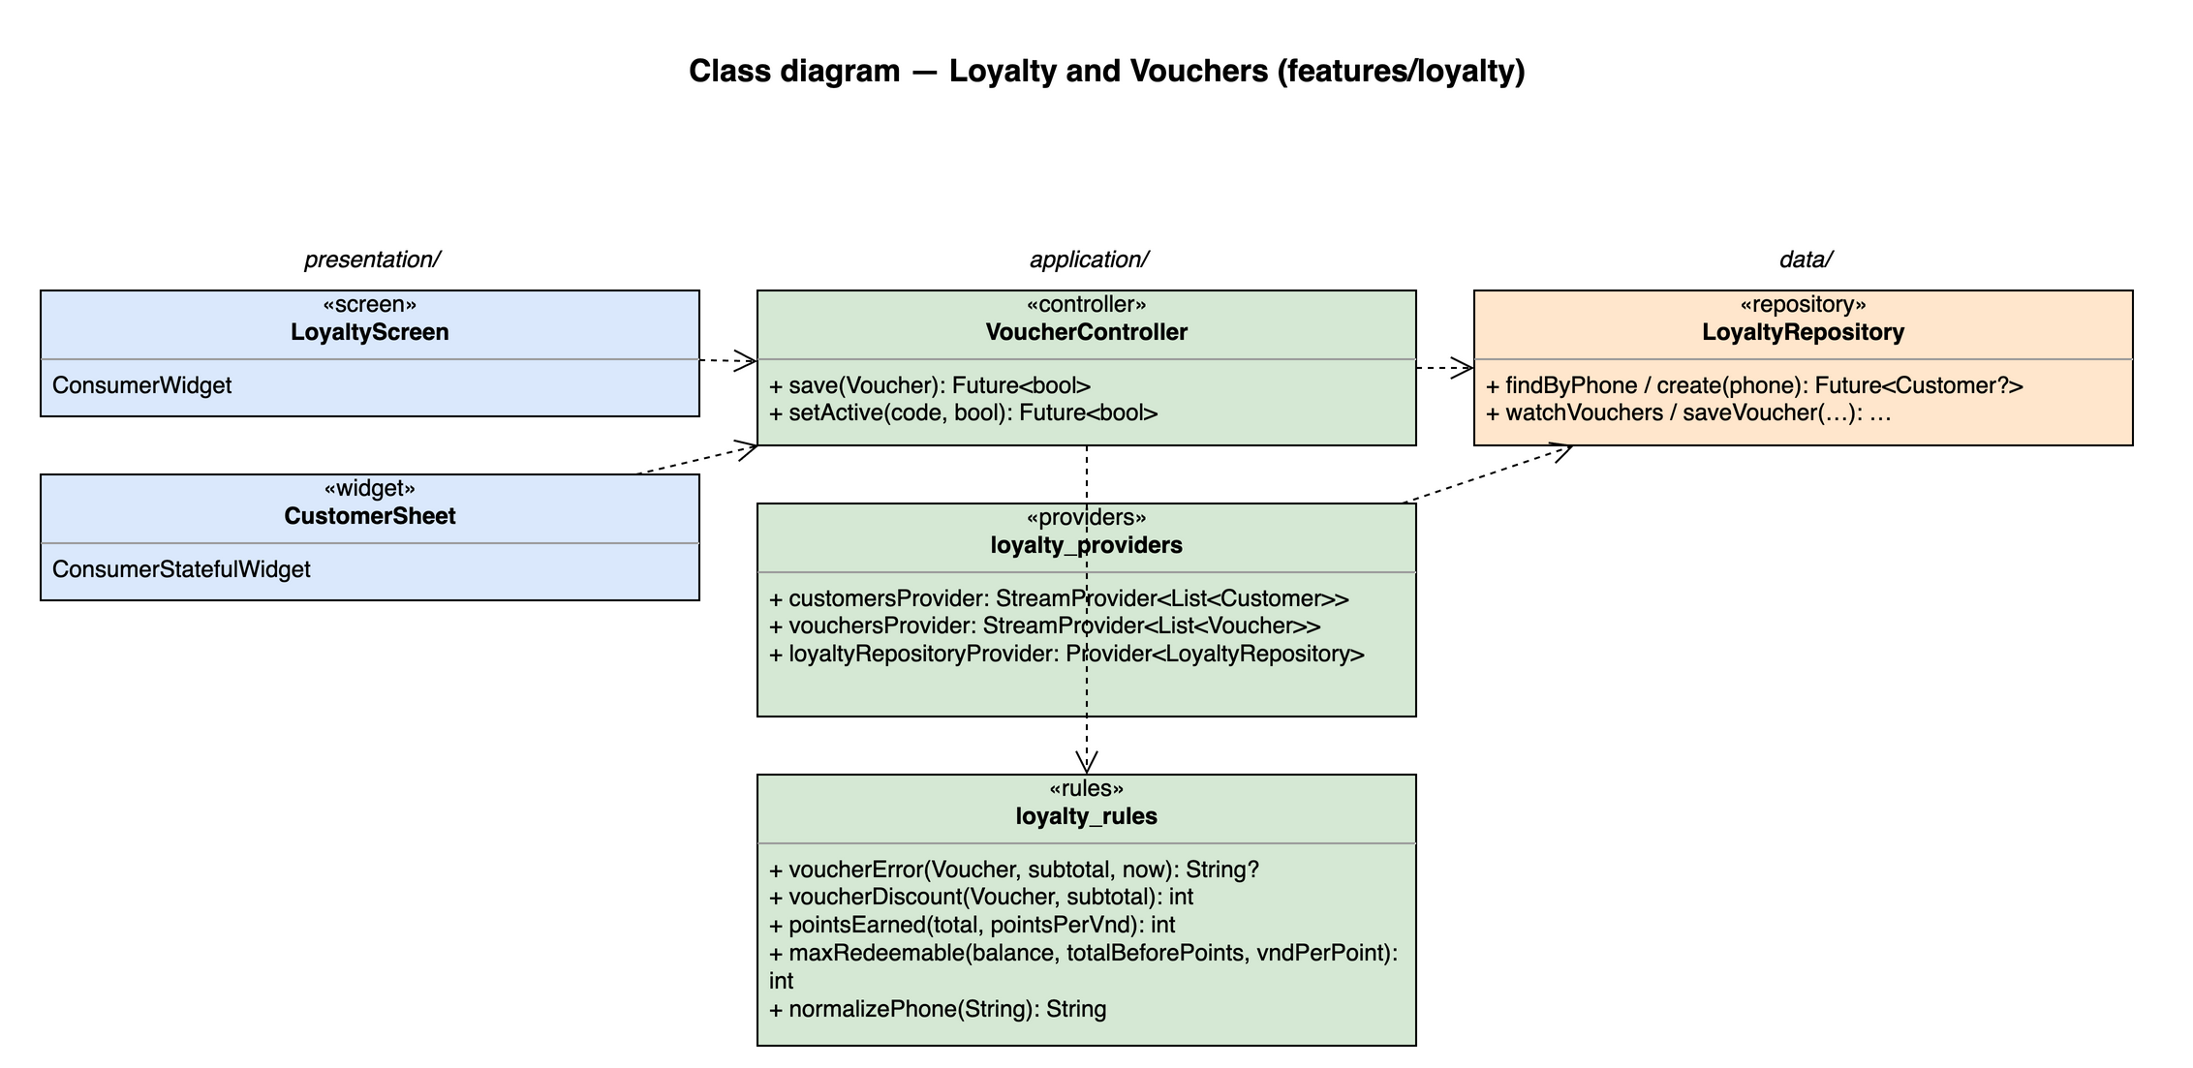
Figure 4-40: Class diagram for Loyalty and Vouchers

4.10.1.2 Classes/Component Description

LoyaltyScreen
Class | LoyaltyScreen
Description | S21. Tabs: customers (points, visits) and vouchers (CRUD).
Base class | ConsumerWidget
Source file | lib/features/loyalty/presentation/loyalty_screen.dart

CustomerSheet
Class | CustomerSheet
Description | Bottom sheet on S15: phone lookup / create, points to redeem (UC38, UC39).
Base class | ConsumerStatefulWidget
Source file | lib/features/loyalty/presentation/customer_sheet.dart

VoucherController
Class | VoucherController
Description | —
Base class | AsyncNotifier<void>
Source file | lib/features/loyalty/application/voucher_controller.dart
Methods | Name | Input → Output | Description
 | save | Voucher → Future<bool> | Code upper-cased and unique (doc id)
 | setActive | code, bool → Future<bool>

loyalty_providers
Class | loyalty_providers
Description | —
Base class | —
Source file | lib/features/loyalty/application/loyalty_providers.dart
Attributes | Name | Type | Description
 | customersProvider | StreamProvider<List<Customer>>
 | vouchersProvider | StreamProvider<List<Voucher>>
 | loyaltyRepositoryProvider | Provider<LoyaltyRepository> | Used by the POS payment transaction

loyalty_rules
Class | loyalty_rules
Description | —
Base class | —
Source file | lib/features/loyalty/application/loyalty_rules.dart
Methods | Name | Input → Output | Description
 | voucherError | Voucher, subtotal, now → String? | Active, not expired, usedCount < usageLimit, subtotal ≥ minOrder
 | voucherDiscount | Voucher, subtotal → int | Percent capped by maxDiscount (BR-DIS-02)
 | pointsEarned | total, pointsPerVnd → int | floor (BR-LOY-01)
 | maxRedeemable | balance, totalBeforePoints, vndPerPoint → int | BR-LOY-02
 | normalizePhone | String → String | Doc id of customers/

LoyaltyRepository
Class | LoyaltyRepository
Description | customers and vouchers.
Base class | —
Source file | lib/features/loyalty/data/loyalty_repository.dart
Methods | Name | Input → Output | Description
 | findByPhone / create | phone → Future<Customer?>
 | watchVouchers / saveVoucher | … → …

4.10.2 Screen Design
Field-level screen definitions are in SRS §3 (Screen Definition tables). This section binds each main screen object to the provider or controller method that serves it.
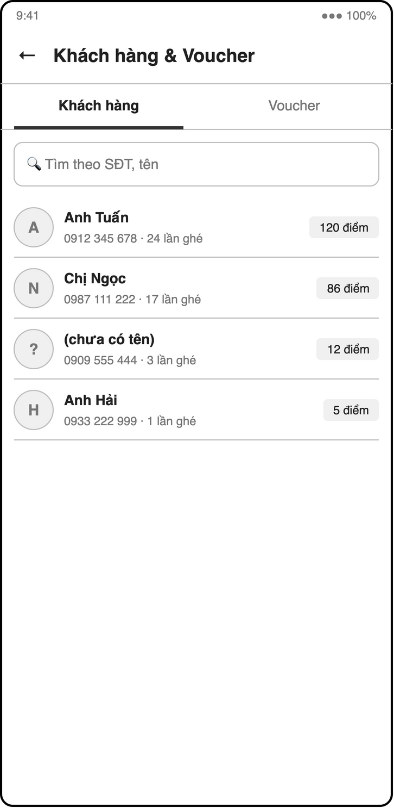
Figure 4-41: Screen design of S21 Customers & vouchers — customers tab
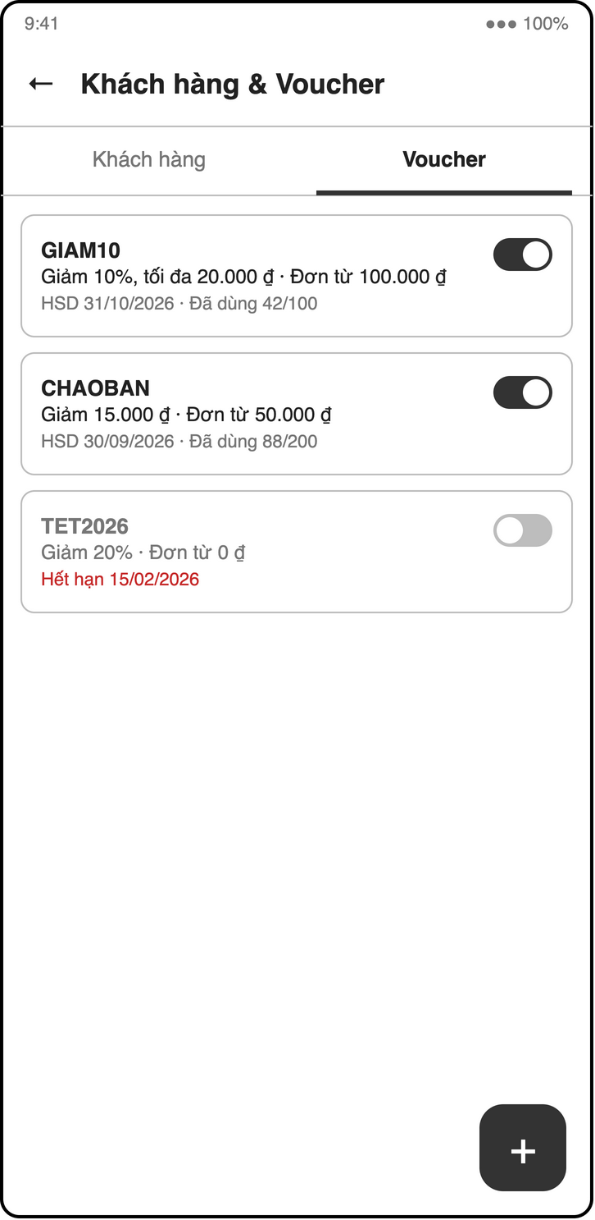
Figure 4-42: Screen design of S21b Customers & vouchers — vouchers tab
Table 4-24: S21 Customers & vouchers object binding
No | Object Name | Type | Bound to | Description
1 | customerList | ListView | customersProvider | Phone, name, points, visits
2 | voucherList | ListView | vouchersProvider | Code, type, value, expiry, used / limit
3 | voucherForm | Dialog | VoucherController.save | percent / fixed, minOrder, maxDiscount, expiresAt, usageLimit

4.10.3 Object Interactions (Sequence Diagrams)
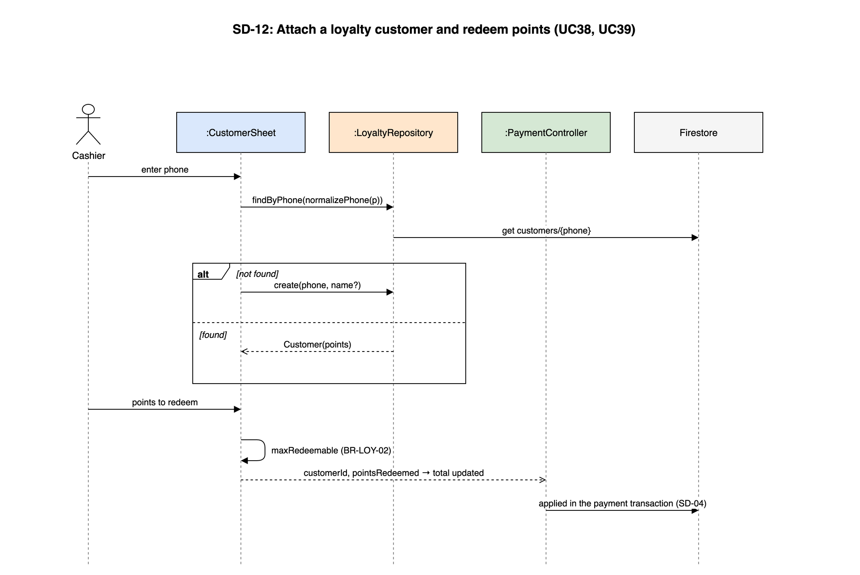
Figure 4-43: SD-12: Attach a loyalty customer and redeem points (UC38, UC39)

5. Database Design

5.1 Database Design
The database is Cloud Firestore (document store). Collections, subcollections and embedded objects are shown in the entity relationship diagram; dashed boxes are embedded arrays or maps inside a document. Money is int VND; timestamps are Firestore Timestamp; the document id is never stored as a field.
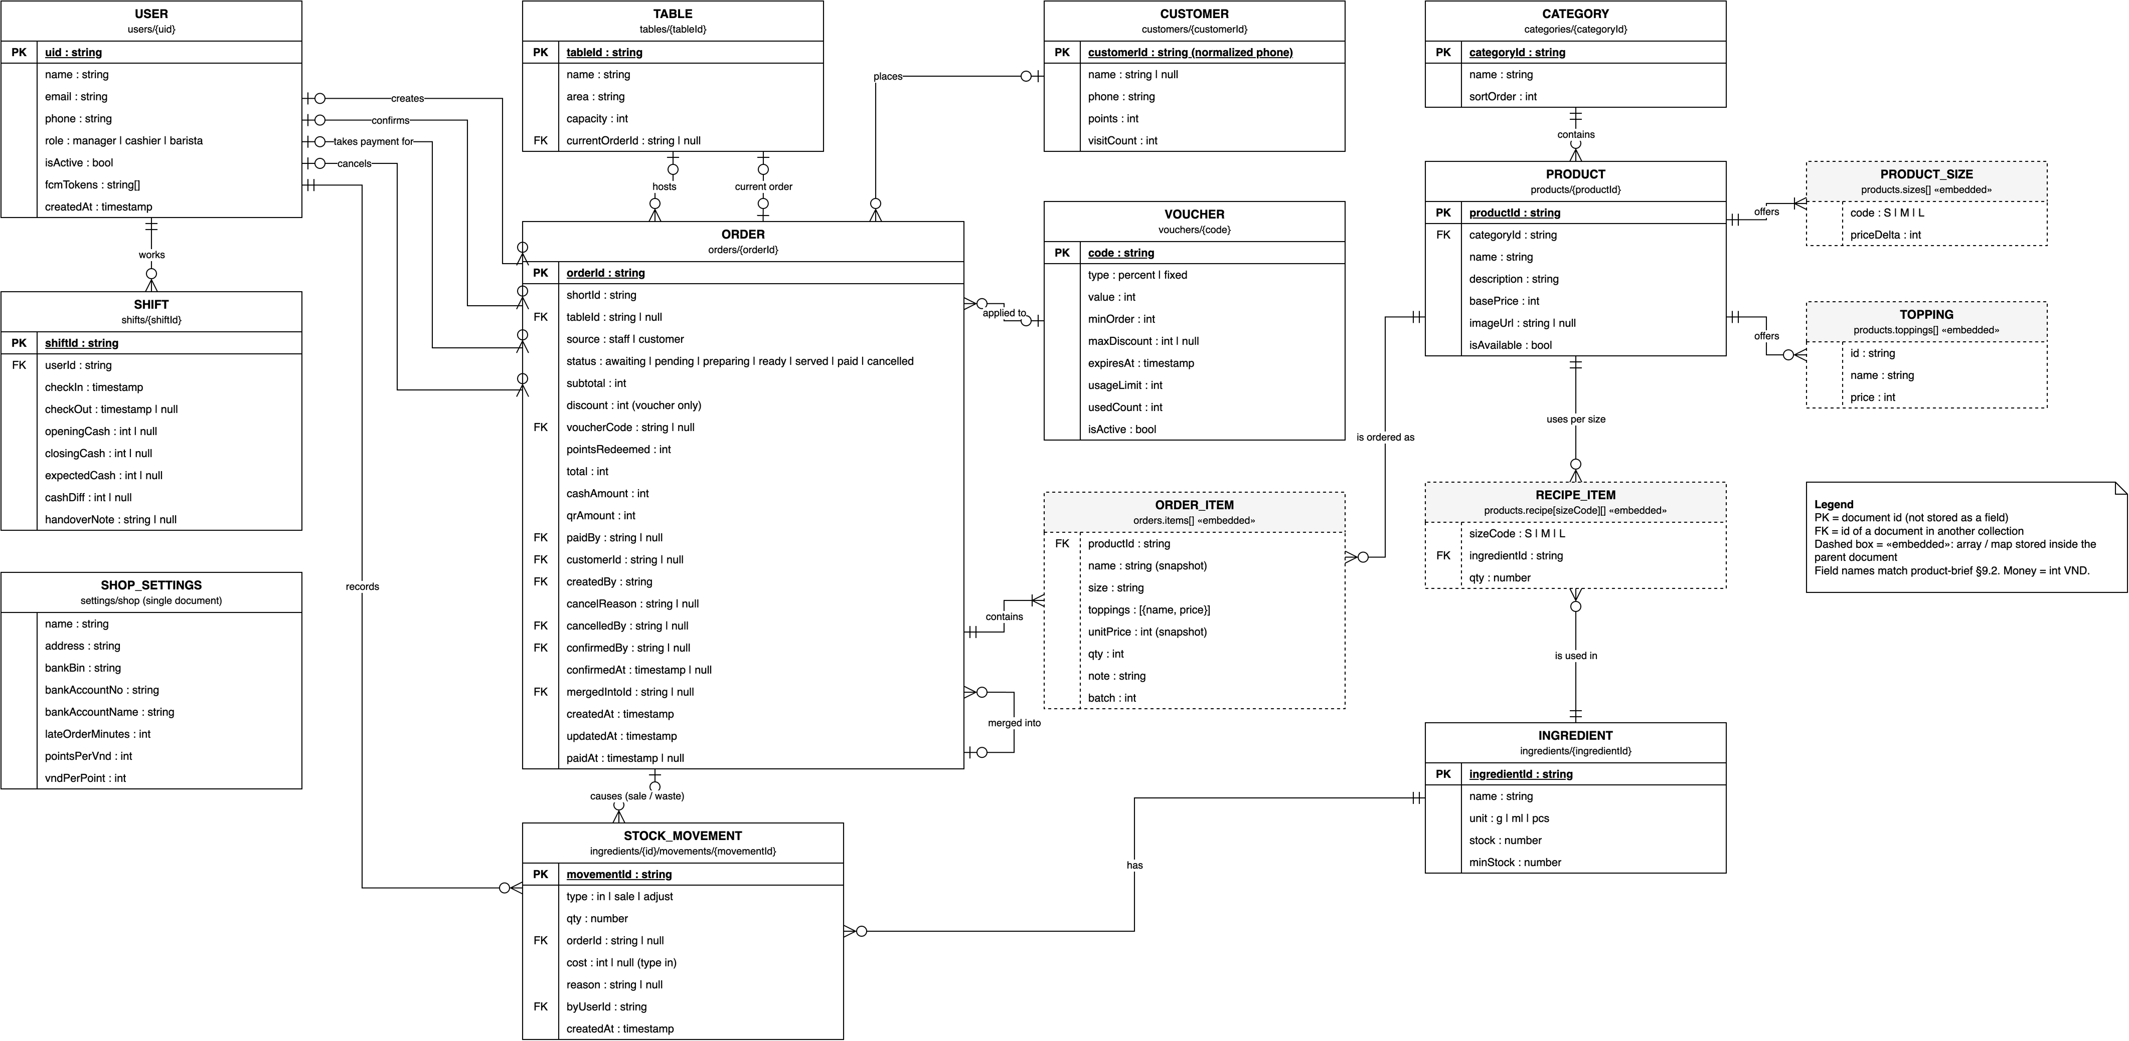
Figure 5-1: Entity relationship diagram (Firestore collections)

a. users/{uid}
Staff accounts; document id = Firebase Auth uid.
# | Field name | Type | Size | Unique | Not Null | PK/FK | Notes
1 | (document id) | string |  | Yes | Yes | PK | uid
2 | name | string | ≤ 100 |  | Yes
3 | email | string | ≤ 254 | Yes | Yes
4 | phone | string | 10 | Yes | Yes
5 | role | "manager" | "cashier" | "barista" |  |  | Yes
6 | isActive | bool |  |  | Yes
7 | fcmTokens | string[] |  |  | Yes
8 | createdAt | timestamp |  |  | Yes

b. shifts/{shiftId}
One document per check-in; cash fields only for cashier / manager.
# | Field name | Type | Size | Unique | Not Null | PK/FK | Notes
1 | (document id) | string |  | Yes | Yes | PK | shiftId
2 | userId | string |  |  | Yes | FK users
3 | checkIn | timestamp |  |  | Yes
4 | checkOut | timestamp |  |  | No
5 | openingCash | int |  |  | No |  | cashier/manager only; null for barista
6 | closingCash | int |  |  | No |  | counted at check-out
7 | expectedCash | int |  |  | No |  | snapshot at check-out (BR-STAFF-04)
8 | cashDiff | int |  |  | No |  | closingCash - expectedCash
9 | handoverNote | string | ≤ 200 |  | No |  | required when cashDiff != 0

c. categories/{categoryId}
Menu categories.
# | Field name | Type | Size | Unique | Not Null | PK/FK | Notes
1 | (document id) | string |  | Yes | Yes | PK | categoryId
2 | name | string | ≤ 100 |  | Yes
3 | sortOrder | int |  |  | Yes

d. products/{productId}
Products with embedded sizes, toppings and recipe per size.
# | Field name | Type | Size | Unique | Not Null | PK/FK | Notes
1 | (document id) | string |  | Yes | Yes | PK | productId
2 | categoryId | string |  |  | Yes | FK categories
3 | name | string | ≤ 100 |  | Yes
4 | description | string | ≤ 500 |  | Yes
5 | basePrice | int |  |  | Yes
6 | imageUrl | string |  |  | No
7 | isAvailable | bool |  |  | Yes
8 | sizes | array / map (embedded) |  |  | Yes |  | Embedded — see Table 5-1
9 | toppings | array / map (embedded) |  |  | Yes |  | Embedded — see Table 5-1
10 | recipe | array / map (embedded) |  |  | Yes |  | Embedded — see Table 5-1

e. ingredients/{ingredientId}
Ingredients and current stock.
# | Field name | Type | Size | Unique | Not Null | PK/FK | Notes
1 | (document id) | string |  | Yes | Yes | PK | ingredientId
2 | name | string | ≤ 100 |  | Yes
3 | unit | "g" | "ml" | "pcs" |  |  | Yes
4 | stock | number |  |  | Yes
5 | minStock | number |  |  | Yes

f. ingredients/{ingredientId}/movements/{movementId}
Every stock change of one ingredient.
# | Field name | Type | Size | Unique | Not Null | PK/FK | Notes
1 | (document id) | string |  | Yes | Yes | PK | movementId
2 | type | "in" | "sale" | "adjust" |  |  | Yes
3 | qty | number |  |  | Yes |  | positive = in, negative = out
4 | orderId | string |  |  | No | FK orders | set for "sale" and for cancel waste ("adjust")
5 | cost | int |  |  | No |  | total purchase cost in VND, set for "in" (FR-INV-02)
6 | reason | string | ≤ 200 |  | No |  | required for "adjust": cancel reason, "Kiểm kho", ...
7 | byUserId | string |  |  | Yes | FK users
8 | createdAt | timestamp |  |  | Yes

g. tables/{tableId}
Tables; id is an auto-id so table URLs cannot be guessed.
# | Field name | Type | Size | Unique | Not Null | PK/FK | Notes
1 | (document id) | string |  | Yes | Yes | PK | tableId
2 | name | string | ≤ 100 |  | Yes |  | "T1", "Sân vườn 2"
3 | area | string |  |  | Yes
4 | capacity | int |  |  | Yes
5 | currentOrderId | string |  |  | No | FK orders

h. orders/{orderId}
Orders with embedded items (read and written as a whole).
# | Field name | Type | Size | Unique | Not Null | PK/FK | Notes
1 | (document id) | string |  | Yes | Yes | PK | orderId
2 | shortId | string | 5 | Per day | Yes |  | human-readable, e.g. "A0123", used in VietQR note
3 | tableId | string |  |  | No | FK tables | null = takeaway
4 | source | "staff" | "customer" |  |  | Yes
5 | status | "awaiting" | "pending" | "preparing" | "ready" | "served" | "paid" | "cancelled" |  |  | Yes
6 | items | array (embedded) |  |  | Yes |  | Embedded — see Table 5-1
7 | subtotal | int |  |  | Yes
8 | discount | int |  |  | Yes |  | voucher discount only (BR-DIS-03)
9 | voucherCode | string |  |  | No | FK vouchers
10 | pointsRedeemed | int |  |  | Yes
11 | total | int |  |  | Yes
12 | cashAmount | int |  |  | Yes |  | cash kept, change excluded; 0 until paid
13 | qrAmount | int |  |  | Yes |  | VietQR transfer; 0 until paid
14 | paidBy | string |  |  | No | FK users | uid who confirmed payment
15 | customerId | string |  |  | No | FK customers
16 | createdBy | string |  |  | Yes | FK users | uid, or "anonymous"
17 | cancelReason | string | ≤ 200 |  | No
18 | cancelledBy | string |  |  | No | FK users | uid who cancelled (NFR-AUD-01)
19 | confirmedBy | string |  |  | No | FK users | uid who confirmed a customer order (FR-CUS-05)
20 | confirmedAt | timestamp |  |  | No
21 | mergedIntoId | string |  |  | No | FK orders | open order that received this order's items (BR-ORD-07 add-on, BR-ORD-08 merge)
22 | createdAt | timestamp |  |  | Yes
23 | updatedAt | timestamp |  |  | Yes
24 | paidAt | timestamp |  |  | No

i. customers/{customerId}
Loyalty customers; id = normalized phone.
# | Field name | Type | Size | Unique | Not Null | PK/FK | Notes
1 | (document id) | string |  | Yes | Yes | PK | customerId
2 | name | string | ≤ 100 |  | No
3 | phone | string | 10 | Yes | Yes
4 | points | int |  |  | Yes
5 | visitCount | int |  |  | Yes

j. vouchers/{code}
Vouchers; id = upper-case code.
# | Field name | Type | Size | Unique | Not Null | PK/FK | Notes
1 | (document id) | string |  | Yes | Yes | PK | code
2 | type | "percent" | "fixed" |  |  | Yes
3 | value | int |  |  | Yes
4 | minOrder | int |  |  | Yes
5 | maxDiscount | int |  |  | No
6 | expiresAt | timestamp |  |  | Yes
7 | usageLimit | int |  |  | Yes
8 | usedCount | int |  |  | Yes
9 | isActive | bool |  |  | Yes

k. settings/shop
Single settings document.
# | Field name | Type | Size | Unique | Not Null | PK/FK | Notes
1 | (document id) | string |  | Yes | Yes | PK | shop
2 | name | string | ≤ 100 |  | Yes
3 | address | string |  |  | Yes
4 | bankBin | string | 6 |  | Yes |  | for VietQR
5 | bankAccountNo | string | ≤ 19 |  | Yes
6 | bankAccountName | string |  |  | Yes
7 | lateOrderMinutes | int |  |  | Yes |  | FR-BAR-04, default 10
8 | pointsPerVnd | int |  |  | Yes |  | e.g. 10000 (1 point per 10.000 ₫)
9 | vndPerPoint | int |  |  | Yes |  | e.g. 1000 (1 point = 1.000 ₫)

Embedded structures
Table 5-1: Embedded objects
Parent | Structure | Fields
products.sizes[] | ProductSize | code: 'S' | 'M' | 'L', priceDelta: int
products.toppings[] | Topping | id: string, name: string, price: int
products.recipe | map sizeCode → RecipeItem[] | ingredientId: string (FK ingredients), qty: number
orders.items[] | OrderItem | productId (FK products), name (snapshot), size, toppings[{name, price}], unitPrice (snapshot), qty, note, batch
users.fcmTokens[] | string | FCM registration tokens of the user's devices

Composite indexes
Table 5-2: Composite indexes (firestore.indexes.json)
Collection | Fields | Used by
orders | status ASC, createdAt ASC | Barista queue (SD-02)
orders | status ASC, paidAt DESC | Dashboard and reports (SD-11)
orders | tableId ASC, status ASC | Table map, confirm customer order
orders | paidBy ASC, paidAt ASC | Expected cash at check-out (SD-07)
shifts | userId ASC, checkIn DESC | Shift history, open shift

Supporting document
# | Field name | Type | Size | Unique | Not Null | PK/FK | Notes
1 | (document id) | string |  | Yes | Yes | PK | counters/shortId-yyyyMMdd
2 | next | int |  |  | Yes |  | Next number of the day; shortId = letter + 4 digits (BR-ORD-06)

5.2 Data File Design
Table 5-3: Project data and configuration files
# | File Name | Type | Notes
1 | firestore.rules | Security Rules | Permission matrix §4.1.7
2 | firestore.indexes.json | JSON | Composite indexes §5.1
3 | storage.rules | Security Rules | products/* images: read all, write Manager, ≤ 1 MB, image/*
4 | firebase.json, .firebaserc | JSON | Hosting (build/web), emulators, functions config
5 | lib/firebase_options.dart | Dart (generated) | flutterfire configure output for Android, iOS, Web
6 | functions/index.js | JavaScript | onOrderReady, onIngredientWrite
7 | lib/models/*.dart (+ .freezed.dart, .g.dart) | Dart (generated parts committed) | app_user, shift, category, product, ingredient, stock_movement, cafe_table, order, customer, voucher, shop_settings
8 | tool/seed.dart | Dart script | Seed data for demo: staff, menu, tables, ingredients, vouchers (owner M3)
9 | pubspec.yaml / analysis_options.yaml | YAML | Dependencies; analyzer rules (zero warnings)
10 | docs/diagrams/sds-diagrams.drawio | draw.io | Sources of every new figure in this document

