
BrewBoss — Cafe Shop Management System
Software Requirement Specification
Project Code: PRM393
Document Code: BrewBoss_SRS – v1.0

– Hanoi, September 2026 –
Table of Contents
Right-click here and choose Update Field to build the table of contents.

I. Record of Changes
Date | A*  M, D | In charge | Change Description
23/09/2026 | A | Trần Ngọc Huy, Phạm Khắc Nghĩa, Nguyễn Bá Cường | First version. Compiled from Product Brief v0.1, Use Case Specifications v1.1 (UC01–UC46, OI-01..OI-11 resolved) and the diagrams in docs/diagrams.
28/09/2026 | M | Trần Ngọc Huy | Named the team members (M1–M4) in A5, the Record of Changes and every use case Author field. Use case diagrams D3 and D5: the Cashier connects to UC25 only; UC24, UC28, UC38 and UC39 reach it through «extend».
28/09/2026 | M | Trần Ngọc Huy | Named M4 Lại Hữu Quang Anh (HE190282) in A5 and in the Author field of UC07–UC17 and UC42–UC43.

*A - Added M - Modified D - Deleted

II. Software Requirement Specification

1. Product Overview
BrewBoss is a cafe shop management system delivered as one Flutter mobile app (Android and iOS, phone and tablet layouts) with role-based access. It replaces paper order slips, verbal handoffs between cashier and barista and end-of-day manual cash counting in small and mid-size cafes in Vietnam.
Today these shops suffer from lost or wrong orders during peak hours, no visibility into best sellers or ingredients running out, revenue leakage from unrecorded sales and untracked discounts, and time-consuming shift and attendance tracking.
BrewBoss digitizes the full order lifecycle: order creation by the cashier or by the customer through a table QR code, real-time preparation on the barista screen, payment in cash, by VietQR bank transfer or split between both, automatic inventory deduction by recipe, loyalty points, shift cash handover and real-time reporting. The backend is Firebase; there is no custom server.
Goals of this release:
ID | Goal | Measurable target (demo)
G1 | Faster order handoff | Order visible on the barista screen < 2 s after creation
G2 | Accurate inventory | Stock auto-deducted on every paid order via recipes
G3 | Instant business insight | Revenue dashboard updates in real time
G4 | Less manual admin | Staff check-in/out, cash handover and shift history without paper

Out of scope for this release:
- Multi-branch / franchise management (single shop, single branch).
- Full accounting: tax filing and e-invoices under Decree 123.
- Delivery platform integration (GrabFood, ShopeeFood).
- Bluetooth thermal printer support.
- Offline-first sync (only the Firestore offline cache is used, NFR-REL-02).
- Automatic bank confirmation of VietQR transfers; the cashier confirms manually.
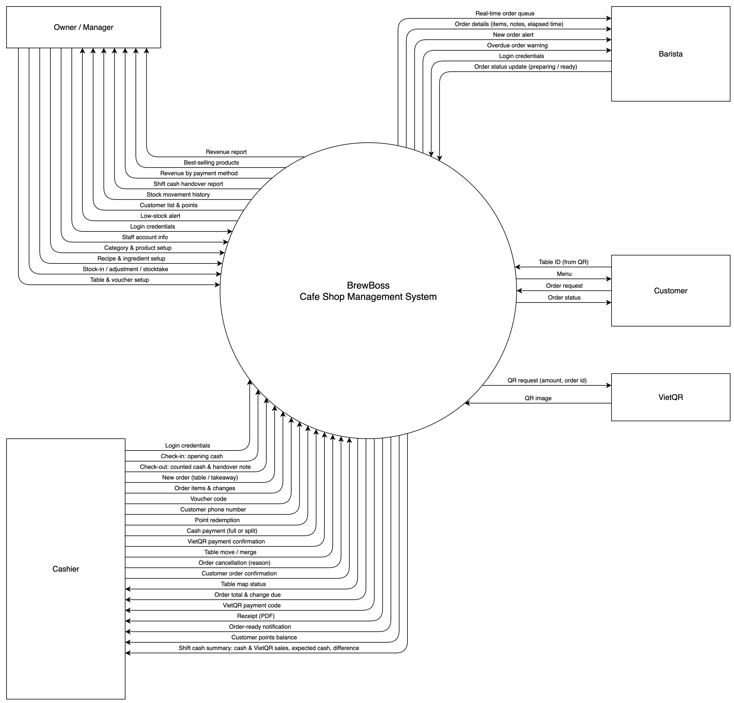
Figure 1-1: BrewBoss context diagram
As described in figure 1-1, BrewBoss interacts with the following external entities. Firebase is the backend the system is built on and sits inside the system boundary, so it is not an external entity here; it appears as an external interface in section 4.1:
External entity | Data exchanged with BrewBoss
Owner / Manager | Sets up staff, menu, recipes, ingredients, tables and vouchers; records stock-in, adjustments and stocktakes. Receives revenue reports, best sellers, revenue by payment method, shift cash handover reports, stock history, the customer list and low-stock alerts.
Cashier | Sends login, opening/counted cash, orders and changes, voucher codes, customer phone numbers, point redemptions, cash and VietQR payment confirmations, table moves/merges, cancellations and customer order confirmations. Receives the table map, totals and change due, the VietQR code, receipts, order-ready notifications, points balances and the shift cash summary.
Barista | Sends login and order status updates (preparing / ready). Receives the real-time order queue with details, new order alerts and overdue warnings.
Customer | Sends the table ID (from the QR) and an order request. Receives the menu and the order status.
VietQR (img.vietqr.io) | Public image service; receives a QR request (bank, account, amount, order short ID) and returns the QR image. No API key.

Modules and priorities (P0 = must have for the core demo flow, P1 = should have, P2 = could have if time allows):
Module | Code | P0 | P1 | P2
Authentication & Staff | AUTH, STAFF | Login, roles, staff CRUD | Shifts, check-in/out, cash handover | QR check-in
Menu | MENU | Categories, products, sizes, toppings | Images, availability toggle | Combo items
Inventory | INV | Ingredients CRUD, manual stock in/out | Recipe-based deduction, waste on cancel, stocktake, low-stock alert | Supplier management
Point of Sale | POS | Table map, create order, cash payment | Vouchers, VietQR, split cash + VietQR, move/merge table | PDF receipt
Barista Display | BAR | Real-time queue, status update | Push notification on ready | Prep time stats
Customer Ordering | CUS | — | Scan table QR, browse menu, place order | Order tracking
Reports | RPT | Daily revenue, order list | Charts, best sellers, date range | Export PDF / Excel
Loyalty | LOY | — | Points by phone number, vouchers | Tiered membership

2. User Requirements

2.1 Business Processes
BrewBoss supports three business processes of a single cafe: serving and charging orders, running staff shifts with cash handover, and controlling ingredient stock.

2.1.1 Order process (dine-in, takeaway, customer QR)
1. Order creation. The cashier selects an empty table (or "Mang đi" for takeaway, tableId = null) and adds items with size, toppings, quantity and note; the order is created as pending. Alternatively a customer scans the table QR, browses the menu anonymously and places an order that is created as awaiting.
2. Customer order confirmation. An awaiting order is not on the barista queue and does not occupy the table. The cashier re-validates prices and confirms it (→ pending, table occupied) or rejects it with a reason (→ cancelled). A QR order on a table that already has an open order is an add-on: on confirmation its items are added to the open order (BR-ORD-04) and the QR order is closed.
3. Preparation. The barista sees pending and preparing orders oldest first, taps "Bắt đầu" (→ preparing) and "Xong" (→ ready). Cashiers are notified by push (or an in-app listener).
4. Serving. The cashier marks the order served (takeaway: when handed over). Items can be added while the order is open: while pending or preparing they join the current batch; items added to a ready or served order form a new batch and send the order back to pending.
5. Payment. From served only, the cashier optionally attaches a loyalty customer, applies a voucher or redeems points, then takes cash, VietQR or split payment. One Firestore transaction marks the order paid, deducts stock by recipe, updates points, increments voucher usage and frees the table.
6. Cancellation. Awaiting / pending orders can be cancelled by the cashier; preparing / ready / served only by the manager, who states whether the drinks were already made (then ingredients are deducted as waste).
The order status follows the state machine in figure 2-1 and the transition table below; paid and cancelled are terminal, and payment is only possible from served (no pay-first flow).
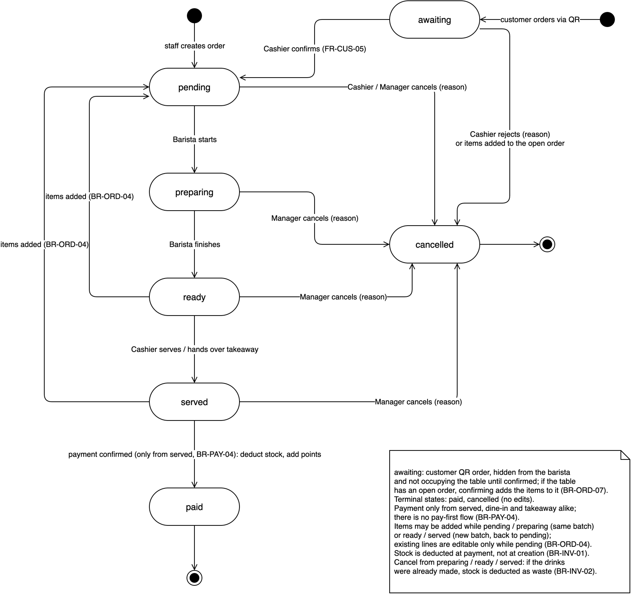
Figure 2-1: Order status state machine
From | To | Event | Actor
— | awaiting | Customer places an order via table QR | Customer
— | pending | Staff creates an order | Cashier / Manager
awaiting | pending | Cashier confirms the customer order (FR-CUS-05) | Cashier
awaiting | cancelled | Cashier rejects the customer order with a reason, or its items are added to the table's open order (BR-ORD-07) | Cashier
pending | preparing | Barista taps "Bắt đầu" | Barista
pending | cancelled | Cancel with reason | Cashier / Manager
preparing | ready | Barista taps "Xong" | Barista
preparing / ready / served | cancelled | Cancel with reason (drinks made → waste, BR-INV-02) | Manager
ready | served | Cashier marks served | Cashier
ready / served | pending | Items added as a new batch (BR-ORD-04) | Cashier
served | paid | Payment confirmed (BR-PAY-04) | Cashier

2.1.2 Shift and cash handover process
- Check-in: every staff member checks in on "Ca làm của tôi". Cashiers and managers also enter the opening cash in the drawer; baristas have no cash fields.
- Selling: a payment can be confirmed only by a user with an open shift, so every sale belongs to one shift.
- Check-out and cash handover: the system computes expected cash = opening cash + cash sales confirmed by the user during the shift (VietQR shown for reference only). The cashier enters the counted cash; a non-zero difference requires a note. Cash fields are locked after check-out.
- Review: the manager reviews shift hours and the cash handover per shift, filtering shifts with a difference.

2.1.3 Inventory process
- Setup: the manager defines ingredients (unit g / ml / pcs, min stock) and a recipe per product size.
- Stock-in: received goods increase stock and log a movement with the total purchase cost.
- Sale: stock is deducted by recipe when an order is paid, never at order creation.
- Waste on cancel: cancelling an order whose drinks were already made deducts the ingredients as an adjustment.
- Adjustment and stocktake: waste and physical counts are logged as adjustments with a reason; a stocktake logs counted − system stock per ingredient.
- Alert: when stock crosses to ≤ min stock, managers receive a low-stock alert.

2.2 Actors
# | Actor | Description
1 | Staff (abstract) | Any employee with an account. Logs in with email and password, resets the password, checks in and out of shifts and browses the menu. Cashier, Barista and Manager specialize Staff; a user has exactly one role.
2 | Owner / Manager | Runs the shop on a phone. Manages staff, menu, recipes, inventory, tables, vouchers and shop settings; views the dashboard, reports, order history, shift and cash handover reports; is the only role that can cancel an order after preparation has started. Holds every Cashier and Barista permission.
3 | Cashier | Takes orders at the counter on a tablet or phone: table map, orders, customer order confirmation, service, vouchers, loyalty, cash / VietQR / split payment, table move and merge, cancellation of awaiting / pending orders, product availability, cash handover at check-out.
4 | Barista | Prepares drinks on a tablet mounted at the bar; works the real-time order queue (pending → preparing → ready).
5 | Customer | A guest using their own phone through the table QR without an account (Firebase anonymous auth). Browses the menu, places an order for that table and follows its status.
6 | System (Cloud Functions) | Server-side triggers with no human actor: low-stock alert and order-ready notification. Stock deduction by recipe and cancel waste run inside the client transactions of payment and cancellation.
7 | Firebase Auth | External system that verifies credentials, sends password reset emails and issues anonymous sessions for customers.
8 | Firebase Cloud Messaging | External system that delivers push notifications (low stock, order ready).
9 | VietQR | External image service that renders the NAPAS VietQR code for a bank account, amount and transfer note.

2.3 Use Cases

2.3.1 Diagram(s)
The use case model is drawn per module group (D1–D5) and per actor (A1–A5). Staff is an abstract actor specialized by Cashier, Barista and Manager; the Manager also holds every Cashier and Barista permission. Only actor associations, <<include>> and <<extend>> are drawn. Sources: docs/diagrams/use-case-diagrams.drawio and use-case-by-actor.drawio.
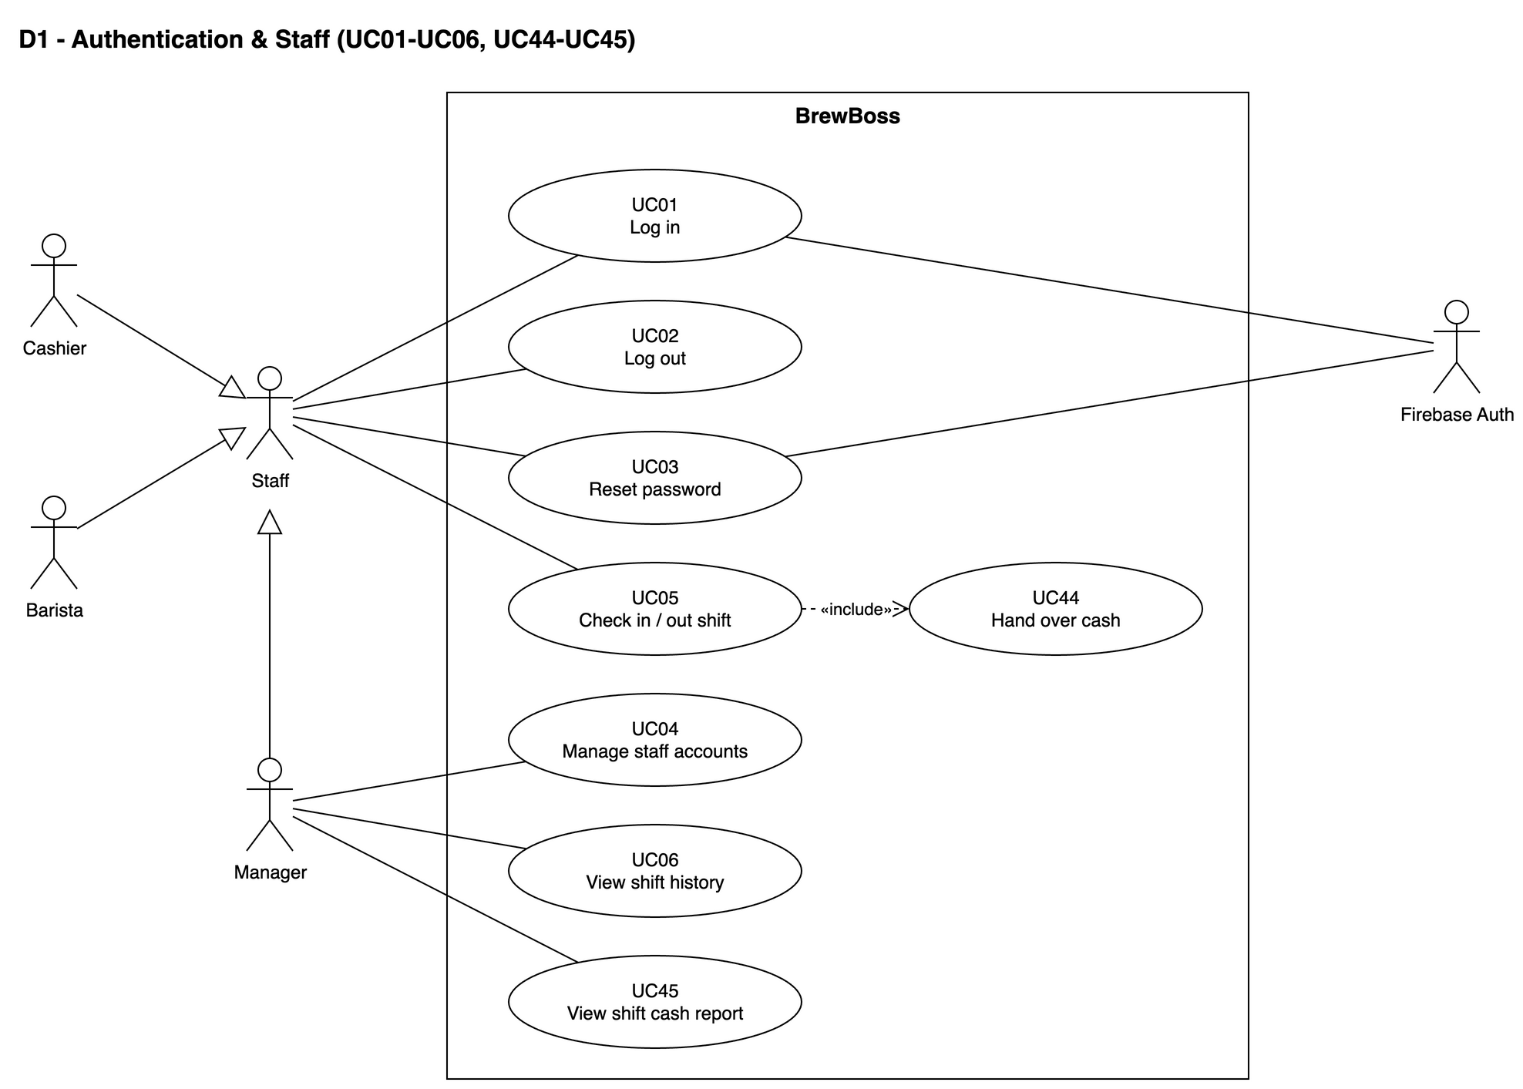
Figure 2-2: Use case diagram — Authentication and staff (UC01–UC06, UC44–UC45)
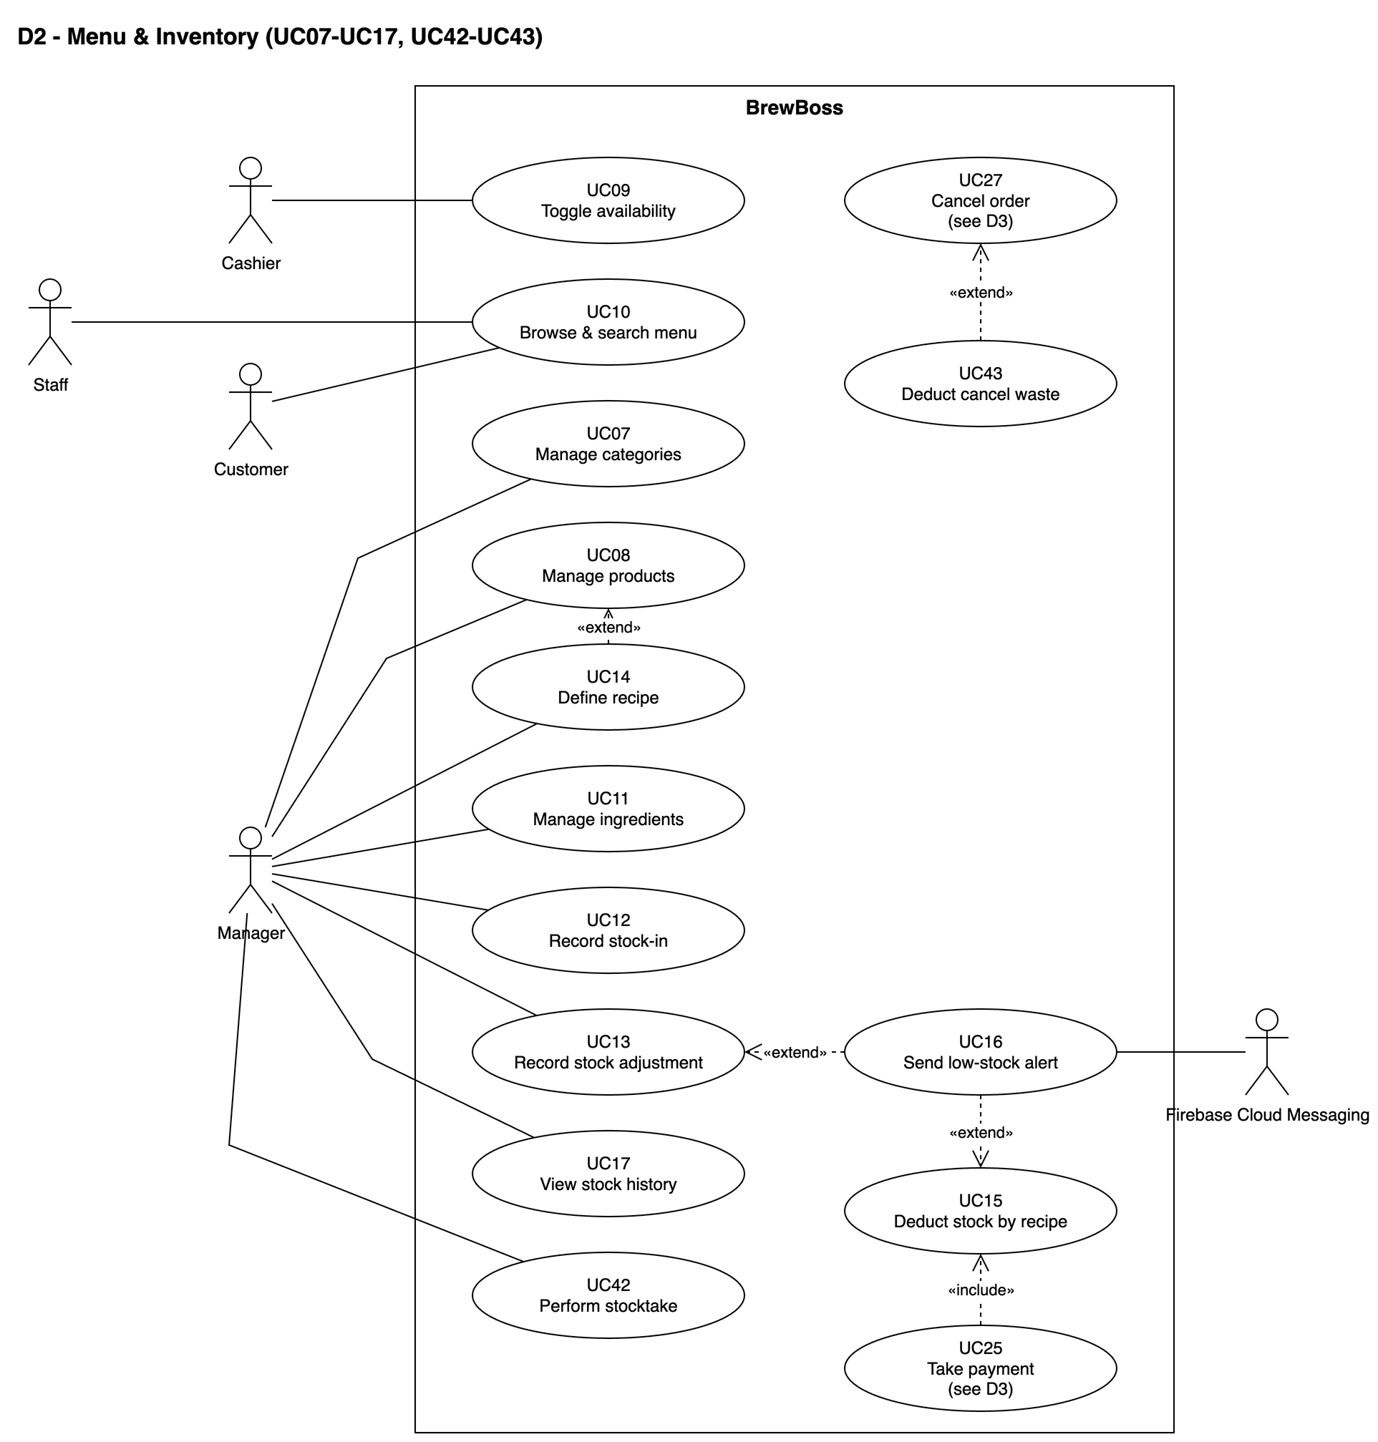
Figure 2-3: Use case diagram — Menu and inventory (UC07–UC17, UC42–UC43)
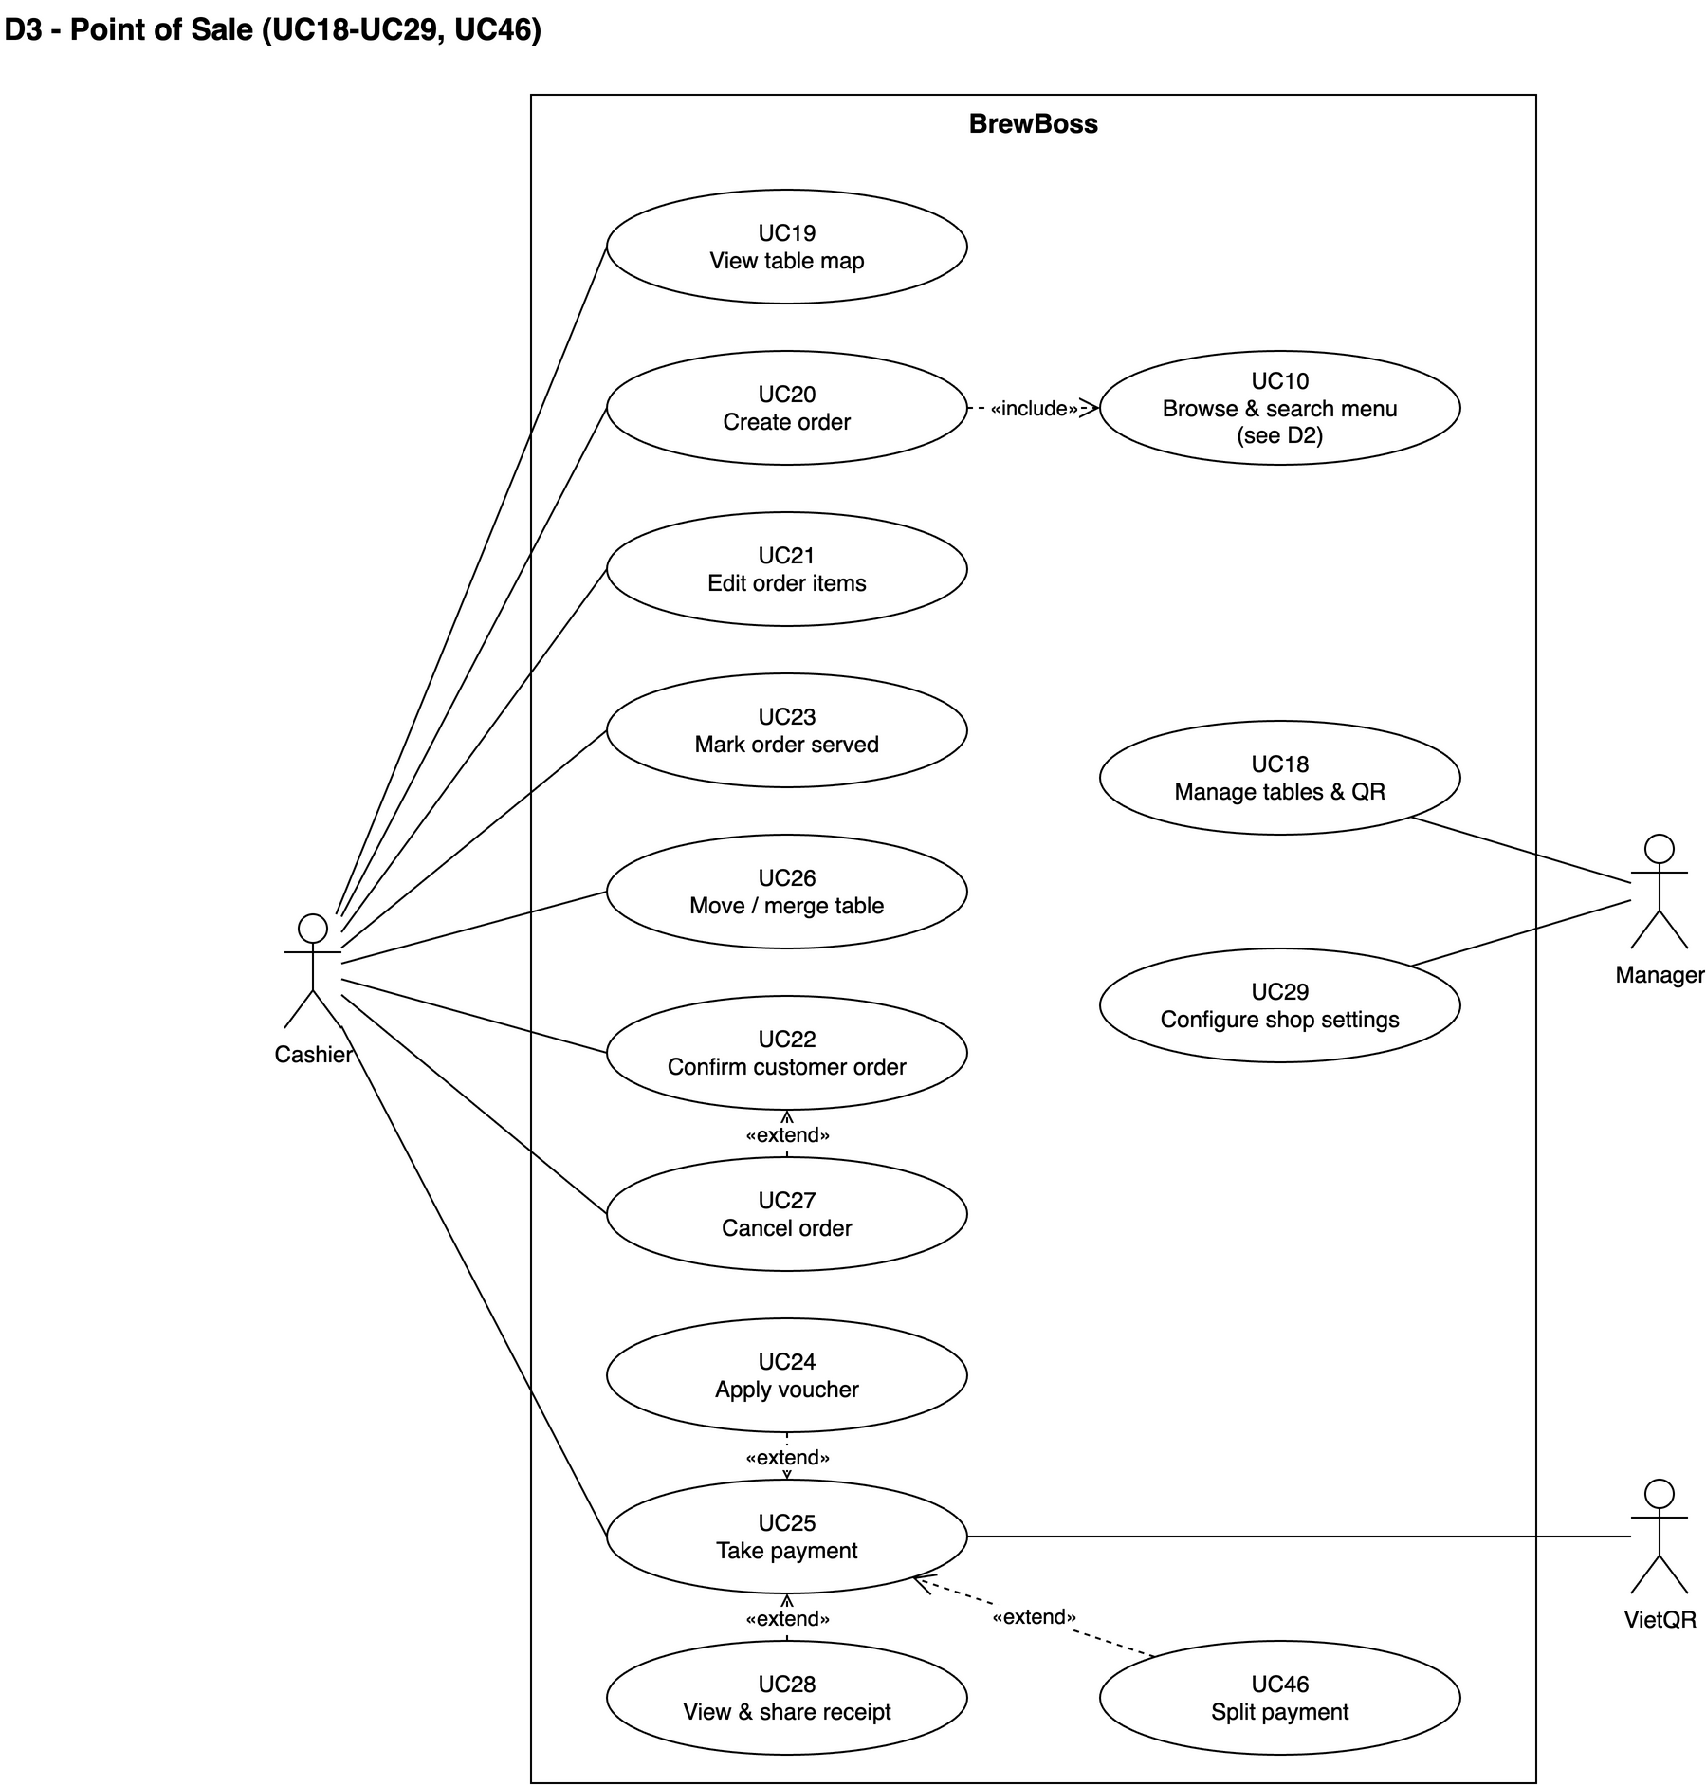
Figure 2-4: Use case diagram — Point of sale (UC18–UC29, UC46)
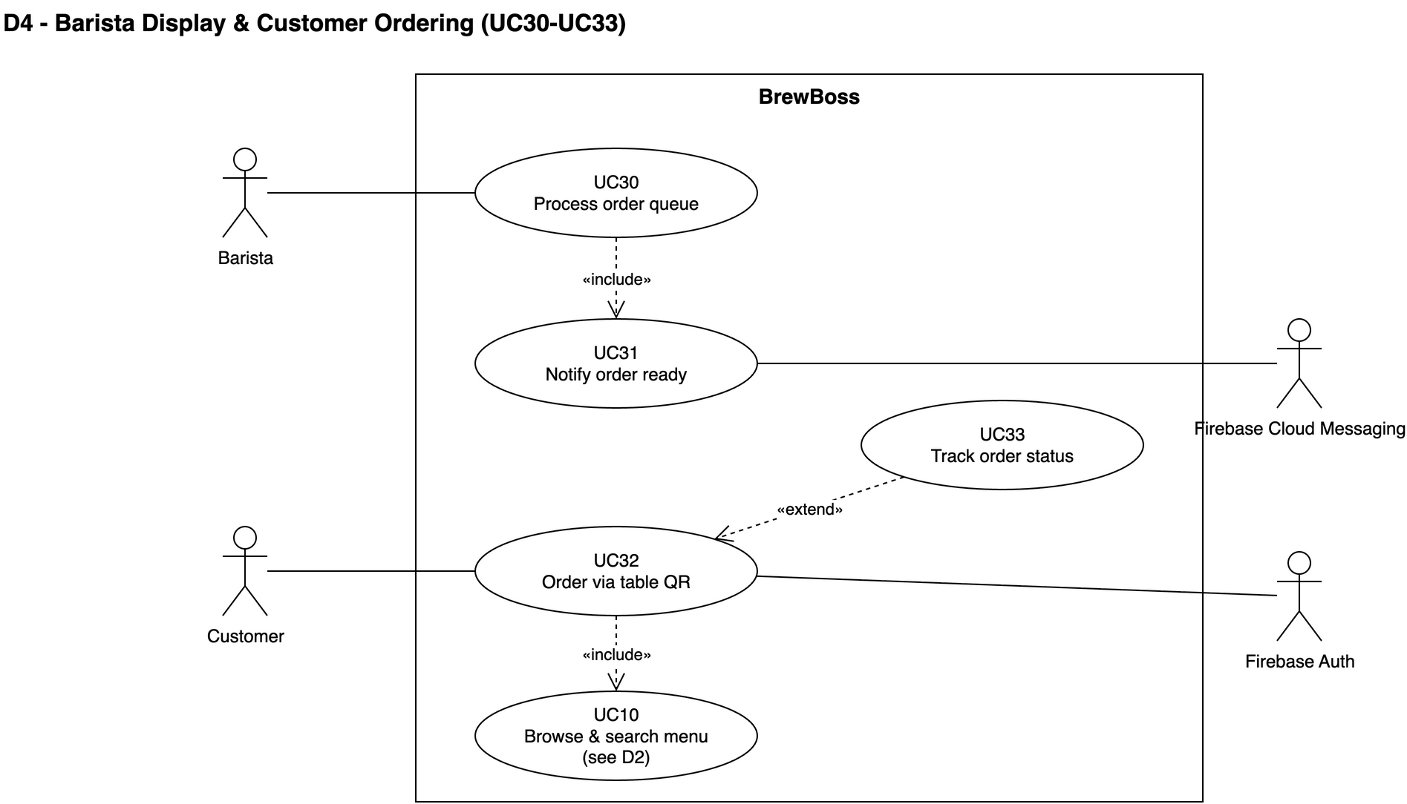
Figure 2-5: Use case diagram — Barista display and customer ordering (UC30–UC33)
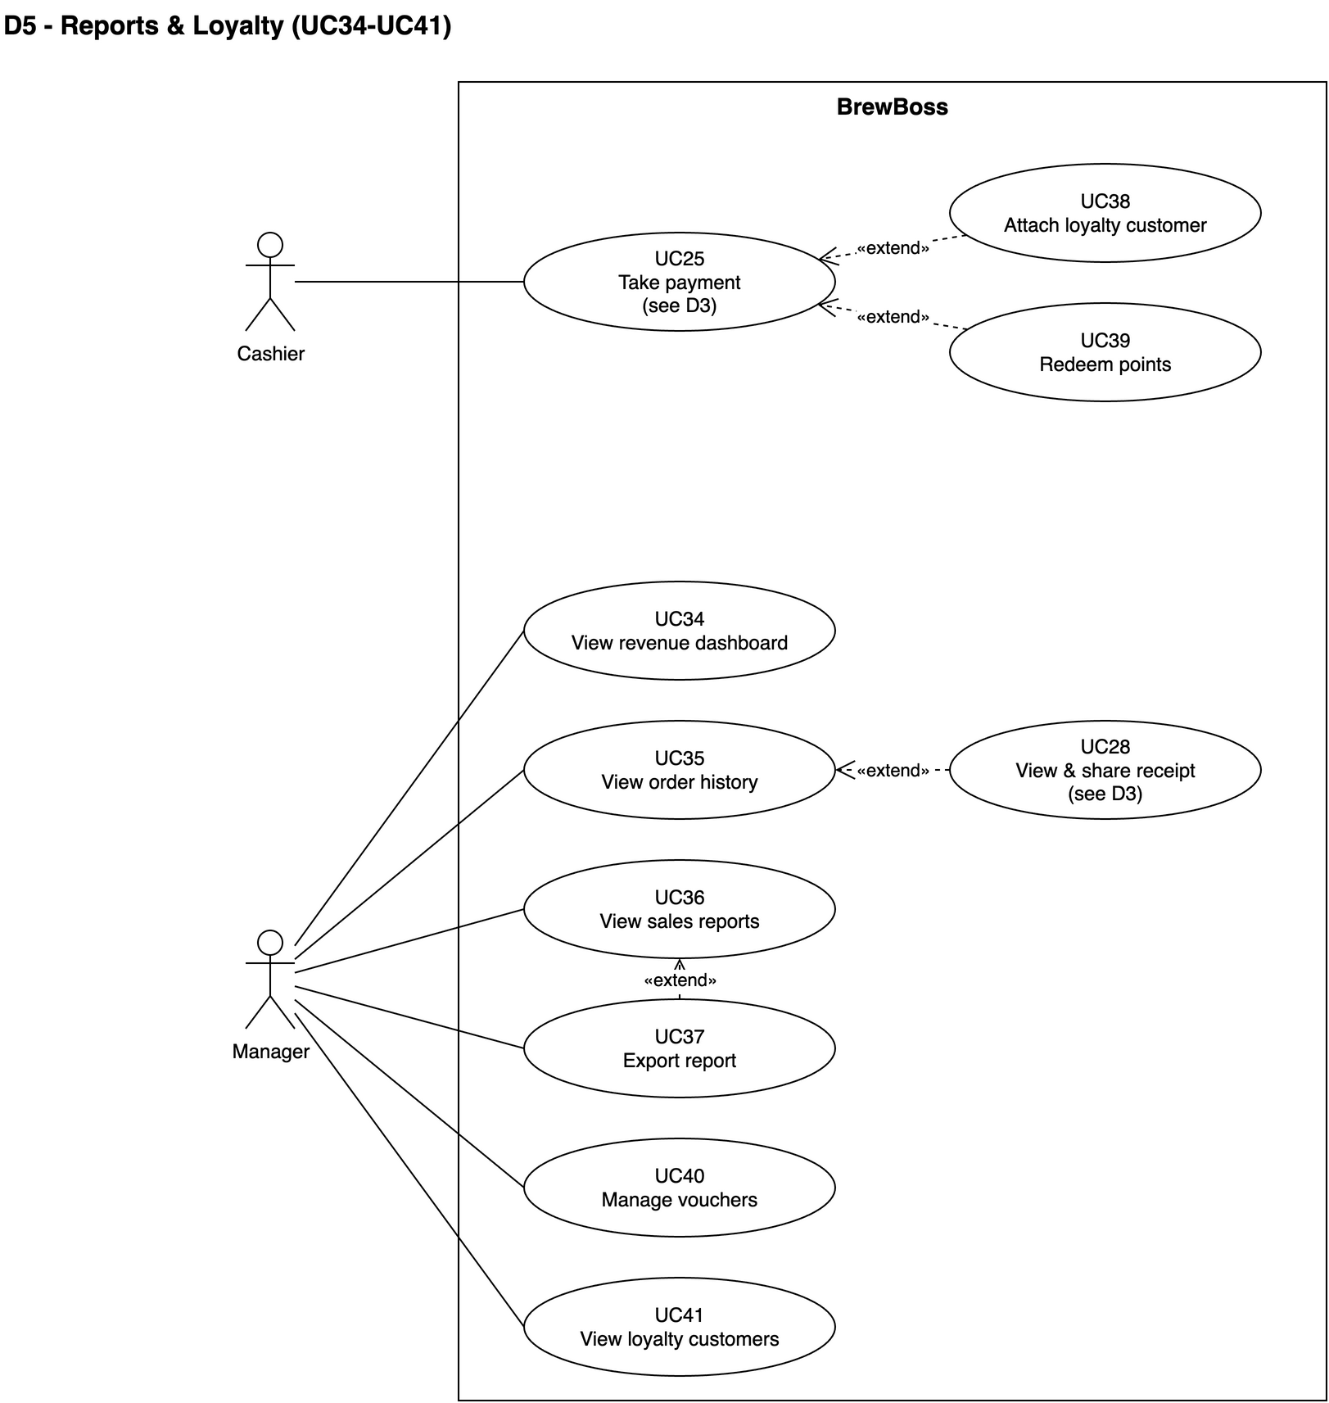
Figure 2-6: Use case diagram — Reports and loyalty (UC34–UC41)
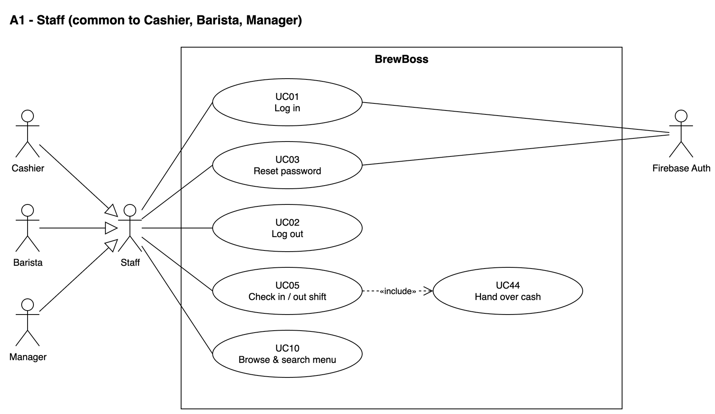
Figure 2-7: Use case diagram — Actor Staff
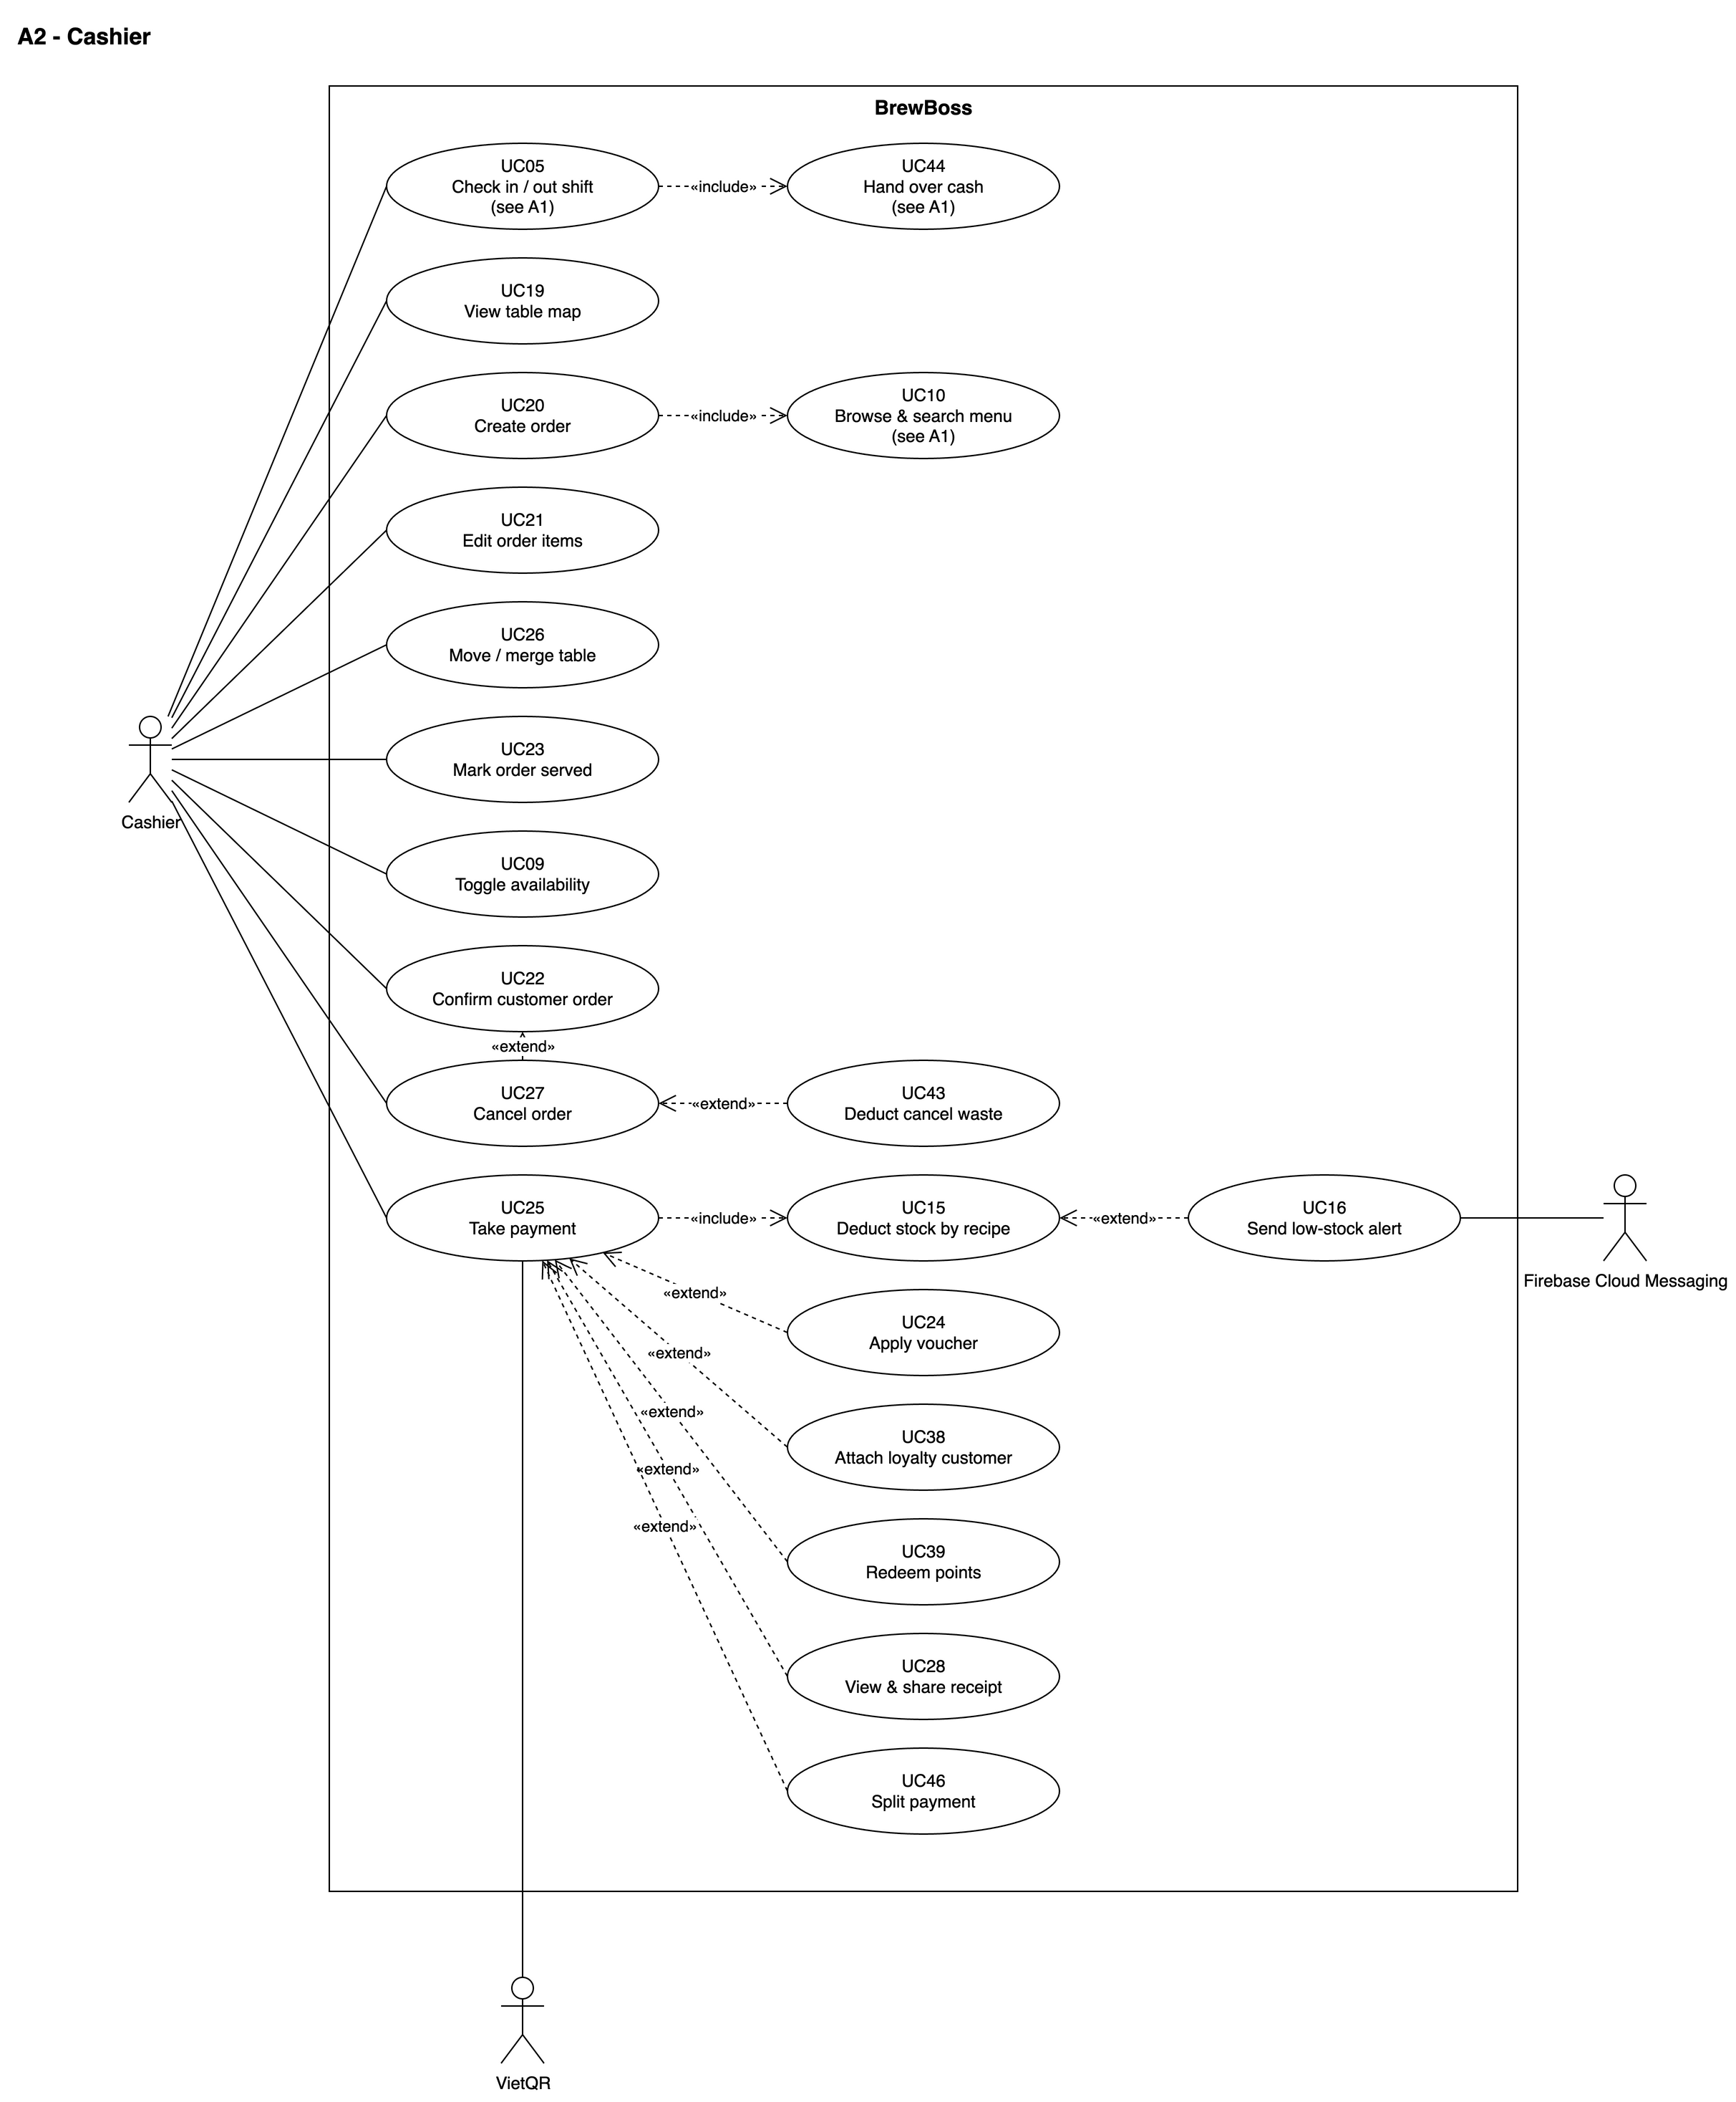
Figure 2-8: Use case diagram — Actor Cashier
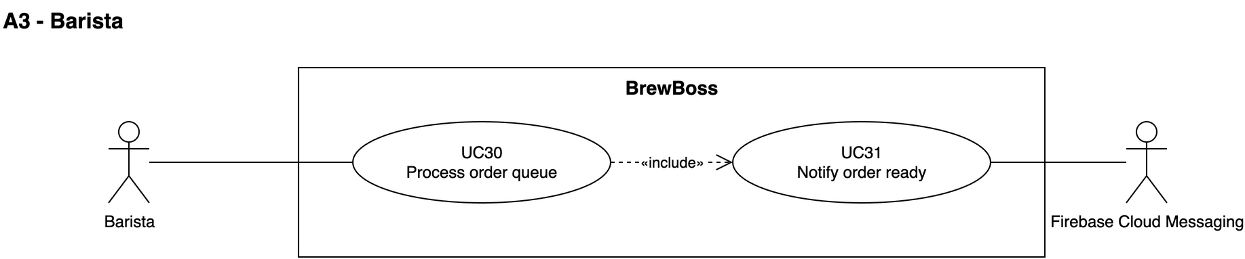
Figure 2-9: Use case diagram — Actor Barista
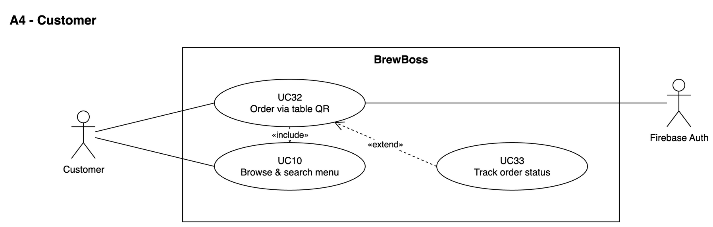
Figure 2-10: Use case diagram — Actor Customer
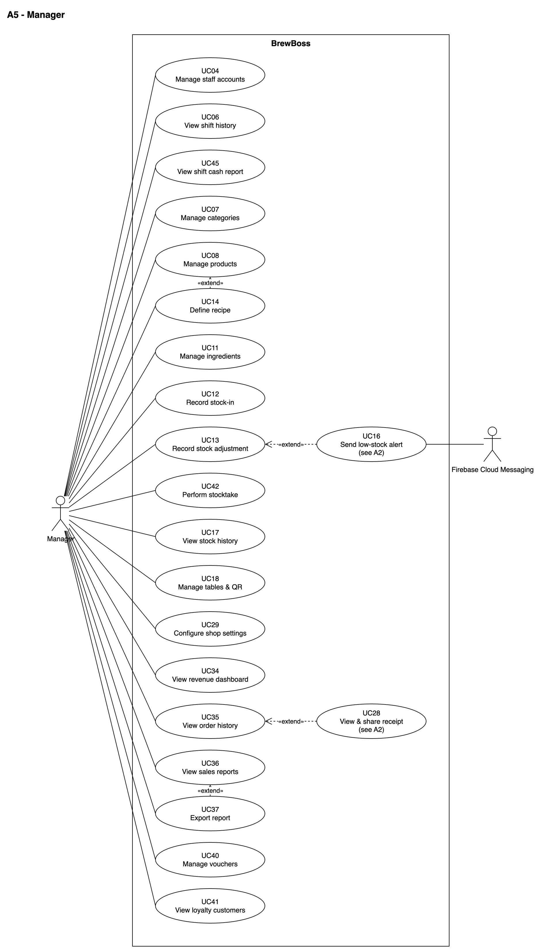
Figure 2-11: Use case diagram — Actor Manager

2.3.2 Descriptions
ID | Group function | Use Case | Actors | Use Case Description
UC01 | Authentication | Log in and enter the role home screen | Manager / Cashier / Barista | A staff member signs in with email and password. The system checks that the account is active and routes the user to the home screen of their role.
UC02 | Authentication | Log out | Manager / Cashier / Barista | A staff member ends their session on the current device.
UC03 | Authentication | Reset password by email | Manager / Cashier / Barista | A staff member who forgot their password requests a reset link by email.
UC04 | Staff & Shift Management | Manage staff accounts | Manager | The manager creates staff accounts, edits their details and role, and deactivates or reactivates them.
UC05 | Staff & Shift Management | Check in and check out of a shift | Cashier / Barista / Manager | A staff member records the start and end of their shift on the app. A cashier or manager also declares the opening cash at check-in and hands over the cash at check-out (UC44).
UC06 | Staff & Shift Management | View shift history and working hours | Manager | The manager reviews shifts and total hours worked per staff member for a period. Cash handover details per shift are in UC45.
UC44 | Staff & Shift Management | Hand over cash at end of shift | Cashier (Manager inherits) | At check-out, the cashier counts the cash drawer; the system compares it with the expected cash from the shift's cash sales and records the difference.
UC45 | Staff & Shift Management | View shift cash report | Manager | The manager reviews the cash handover of each shift and finds shifts with a cash difference.
UC07 | Menu | Manage menu categories | Manager | The manager creates, renames, reorders and deletes menu categories.
UC08 | Menu | Manage products, sizes and toppings | Manager | The manager creates and edits products with base price, sizes (price delta), toppings and an optional image.
UC09 | Menu | Toggle product availability | Cashier / Manager | Staff marks a product as sold out or available again.
UC10 | Menu | Browse and search the menu | Manager / Cashier / Barista / Customer | Any actor browses products by category or searches them by name.
UC11 | Inventory | Manage ingredients | Manager | The manager creates, edits and deletes ingredients with unit, stock and minimum stock.
UC12 | Inventory | Record stock-in | Manager | The manager records ingredients received from a supplier.
UC13 | Inventory | Record stock adjustment | Manager | The manager corrects stock for waste or after a physical count, with a reason.
UC14 | Inventory | Define product recipe per size | Manager | The manager defines which ingredients and how much of each one product size uses.
UC15 | Inventory | Deduct stock by recipe on payment | System | When an order is paid, the system deducts every ingredient used by its items according to the recipes.
UC16 | Inventory | Send low-stock alert | System | The system notifies managers when an ingredient's stock falls to or below its minimum.
UC17 | Inventory | View stock movement history | Manager | The manager reviews every change to an ingredient's stock.
UC42 | Inventory | Perform stocktake | Manager | The manager counts every ingredient in one pass; the system logs each difference from system stock as an adjustment.
UC43 | Inventory | Deduct cancel waste | System | When a manager cancels an order whose drinks were already made, the system deducts the ingredients by recipe as waste.
UC18 | Point of Sale | Manage tables and print table QR codes | Manager | The manager sets up the shop's tables and prints a QR code for each table.
UC19 | Point of Sale | View table map | Cashier | The cashier sees all tables with their live status.
UC20 | Point of Sale | Create an order | Cashier | The cashier creates a dine-in or takeaway order with items, sizes, toppings, quantities and notes and sends it to the barista.
UC21 | Point of Sale | Edit order items | Cashier | The cashier changes, removes or adds items on an open order.
UC22 | Point of Sale | Confirm a customer order | Cashier | The cashier reviews an order placed by a customer via table QR, re-validates prices and confirms or rejects it.
UC23 | Point of Sale | Mark an order as served | Cashier | The cashier records that a ready order was delivered to the customer (takeaway: when handed to the customer).
UC24 | Point of Sale | Apply a voucher | Cashier | The cashier applies a voucher code to an order; vouchers are the only discount (BR-DIS-03).
UC25 | Point of Sale | Take payment (cash or VietQR) | Cashier | The cashier collects payment in cash, by VietQR bank transfer, or split between both (UC46); the system closes the order, deducts stock and updates loyalty points in one transaction.
UC26 | Point of Sale | Move or merge tables | Cashier | The cashier moves an open order to an empty table or merges two served orders into one shared bill.
UC27 | Point of Sale | Cancel an order | Cashier / Manager | Staff cancels an order that will not be completed, with a mandatory reason.
UC28 | Point of Sale | View and share a receipt | Cashier | The cashier generates a PDF receipt for a paid order and shares or prints it.
UC29 | Point of Sale | Configure shop settings | Manager | The manager edits shop-wide settings: shop info, bank account for VietQR, late-order threshold and loyalty rates.
UC46 | Point of Sale | Split payment between cash and VietQR | Cashier | The customer pays one order partly by VietQR transfer and the rest in cash; the system stores both amounts on the order.
UC30 | Barista Display | Process the order queue | Barista | The barista sees orders in real time, oldest first, and moves each one from pending to preparing to ready.
UC31 | Barista Display | Notify cashier when an order is ready | System | The system notifies cashiers and managers when an order becomes ready.
UC32 | Customer Ordering | Place an order via table QR | Customer | A customer scans the QR code on their table, browses the menu without logging in and sends an order to that table.
UC33 | Customer Ordering | Track order status | Customer | The customer follows their order status in real time after placing it.
UC34 | Reports | View today's revenue dashboard | Manager | The manager sees today's revenue, order count and average order value, updated live.
UC35 | Reports | View order history | Manager | The manager searches past orders by date, status and cashier and opens their details.
UC36 | Reports | View sales reports | Manager | The manager views revenue charts, best-selling products and revenue by payment method for a period.
UC37 | Reports | Export a report | Manager | The manager exports the current report to PDF or Excel.
UC38 | Loyalty | Attach a loyalty customer to an order | Cashier | The cashier links an order to a customer by phone number, creating the customer if new.
UC39 | Loyalty | Redeem loyalty points | Cashier | The cashier converts a customer's points into a discount on the current order.
UC40 | Loyalty | Manage vouchers | Manager | The manager creates, edits and deactivates voucher codes.
UC41 | Loyalty | View loyalty customers | Manager | The manager browses loyalty customers with their points and visit count.

3. Software Features

3.1 Functional Overview

3.1.1 Screens Flow
After login the router sends each role to its home: Manager → S04, Cashier → S13, Barista → S16. Customers enter through the table QR deep link /c/:tableId (S17) with anonymous auth. S07 My shift and S22 Profile are reachable from the app bar of every staff home. Logging out clears the navigation stack.
Figures 3-1 to 3-5 show the screen flow per actor. Sheets and dialogs opened on top of a screen have a rounded, dashed border; screens drawn on another figure are grey with a “see Fx” reference.
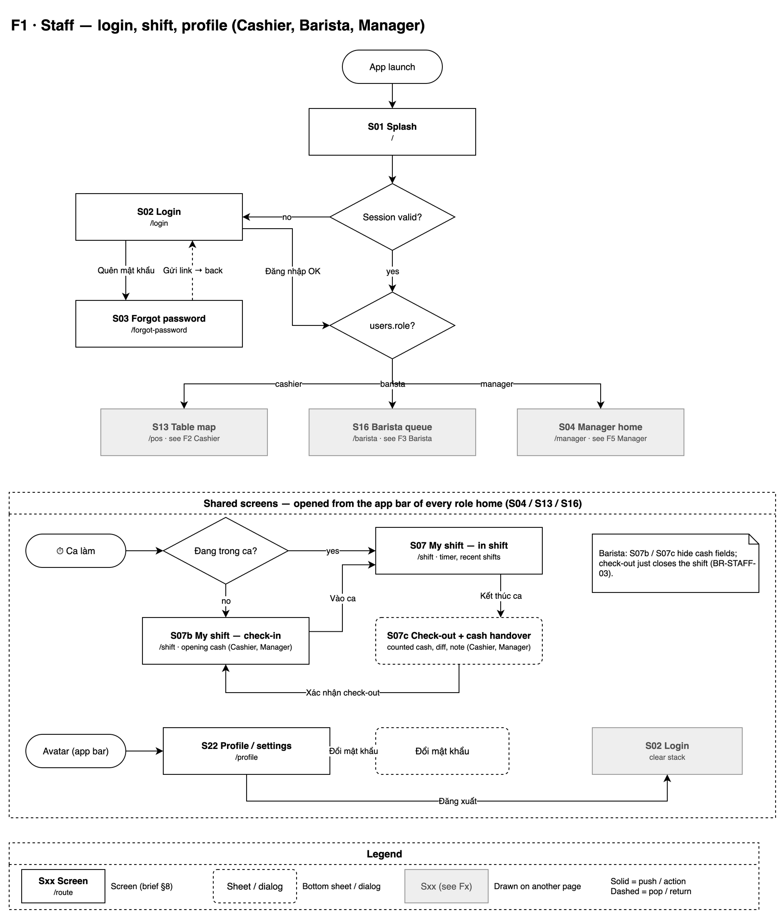
Figure 3-1: Screen flow — Staff — login, shift and profile (shared by Cashier, Barista, Manager)
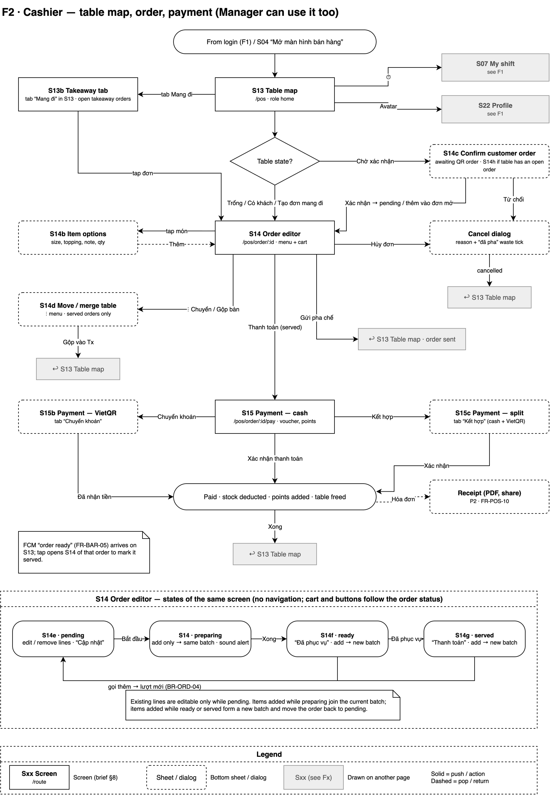
Figure 3-2: Screen flow — Cashier — table map, order editor and payment
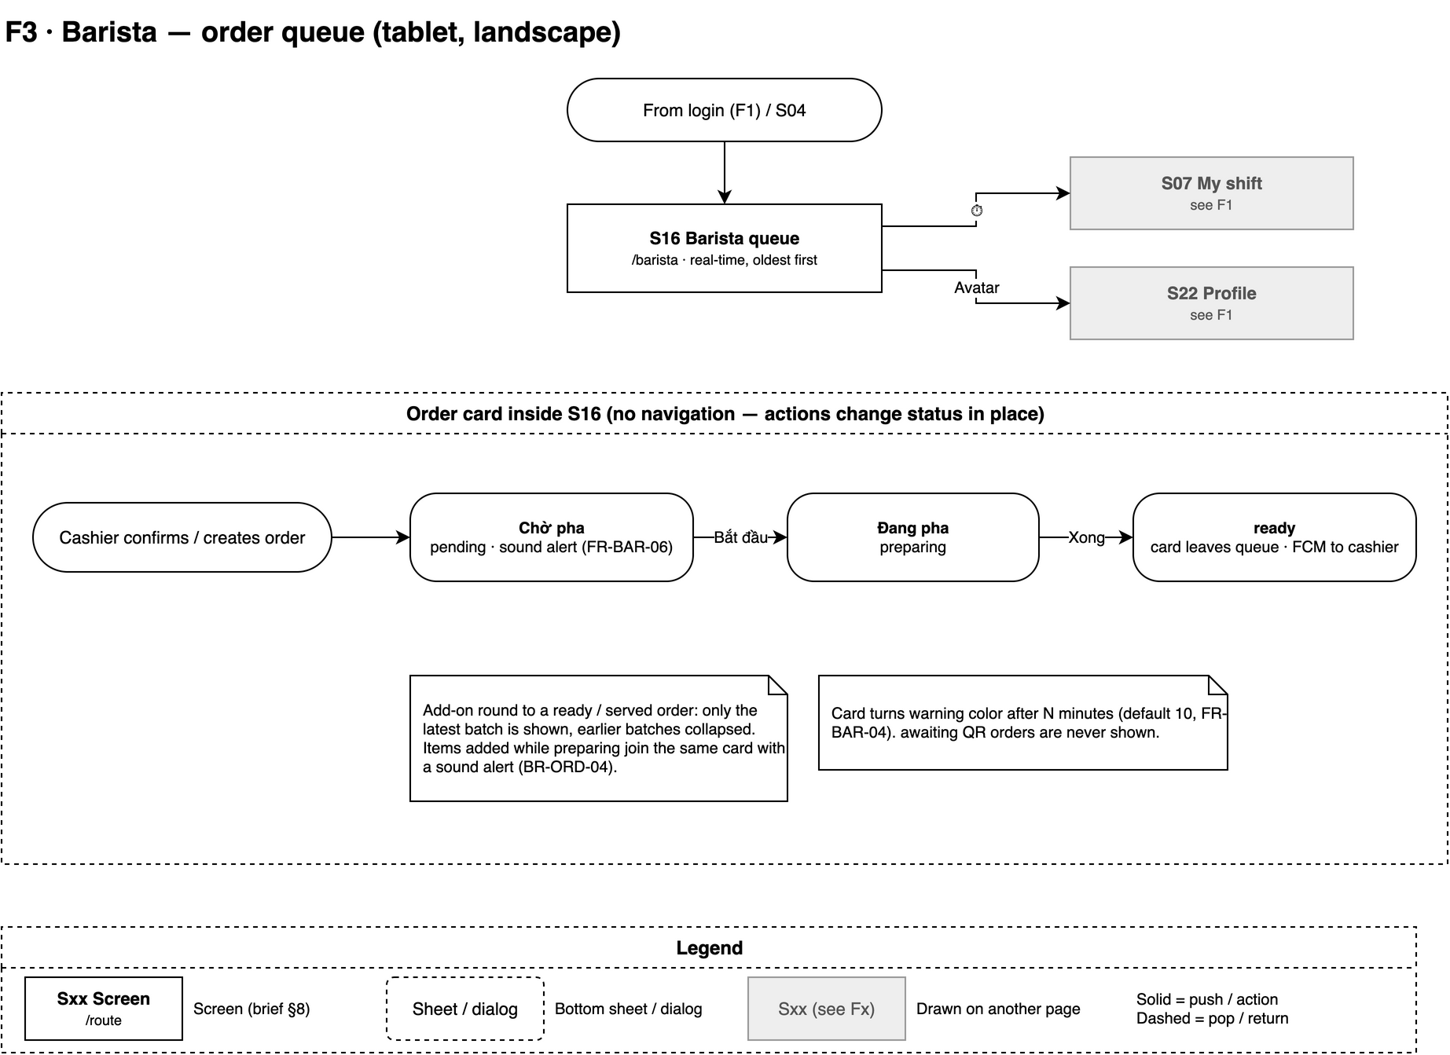
Figure 3-3: Screen flow — Barista — order queue and in-place status actions
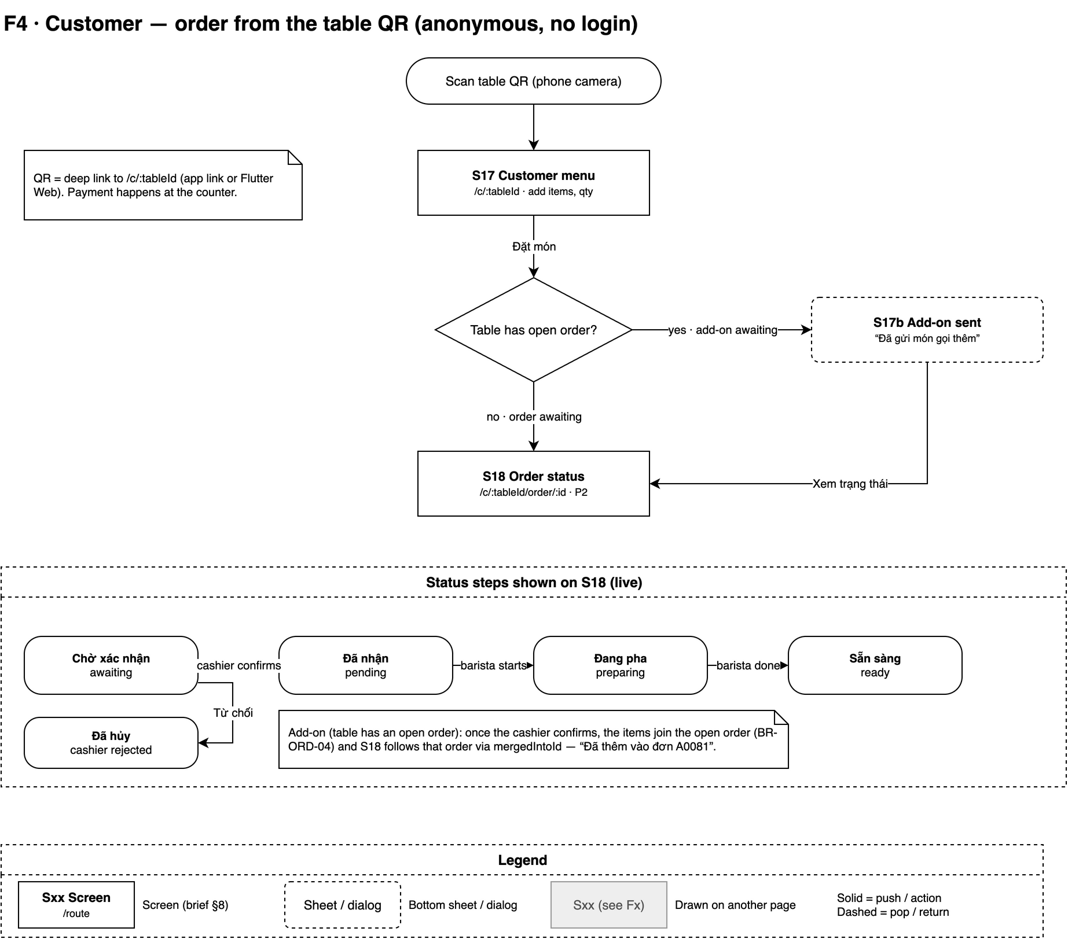
Figure 3-4: Screen flow — Customer — ordering through the table QR
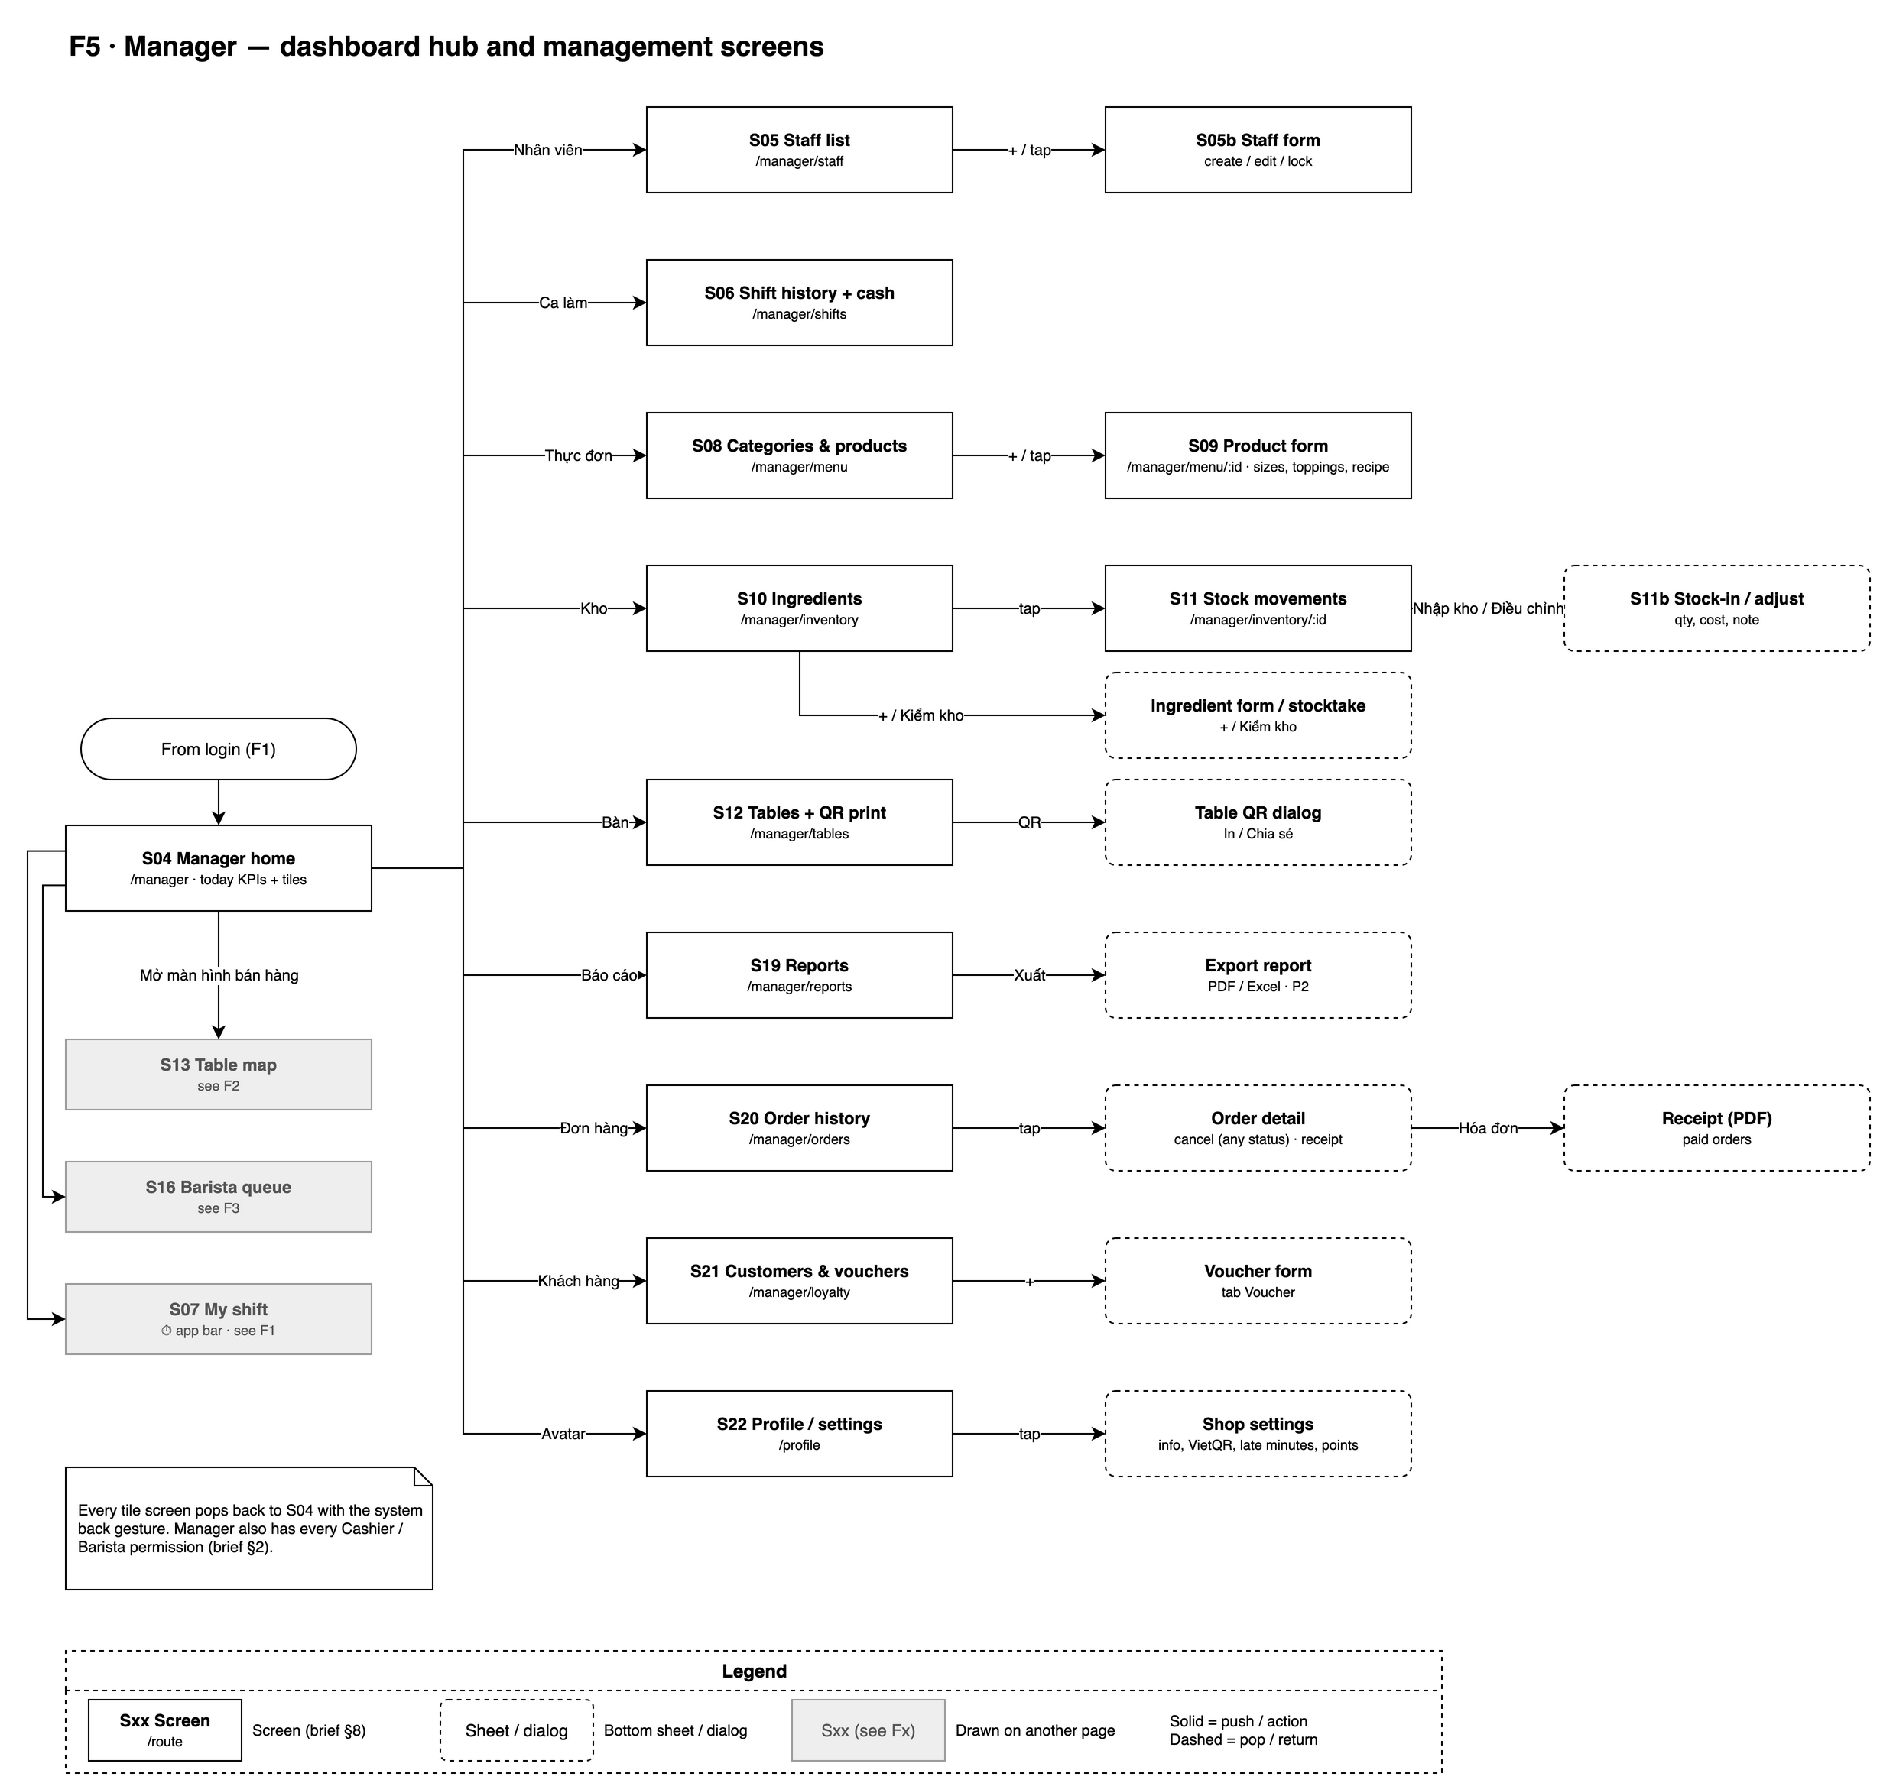
Figure 3-5: Screen flow — Manager — dashboard hub and management screens

3.1.2 Screen Descriptions
# | Feature | Screen | Description
S01 | Authentication | Splash  / | App logo and version; checks the saved session and routes to Login or the role home.
S02 | Authentication | Login  /login | Email and password sign-in for staff with an inline error and a "Quên mật khẩu?" link.
S03 | Authentication | Forgot password  /forgot-password | Email field that sends a Firebase password reset link.
S04 | Reports | Manager home / dashboard  /manager | Today's revenue, order count and average order value (live); shortcuts to low stock, open orders, staff on shift and all manager functions.
S05 | Staff | Staff list / detail / form  /manager/staff | Searchable staff list filtered by role; form to create or edit a staff member and activate / deactivate the account.
S06 | Staff | Shift history + cash handover  /manager/shifts | Shifts and total hours per staff member for a period; "Giao ca" details with opening, cash sales, VietQR sales, expected, counted, difference and note.
S07 | Staff | My shift  /shift | Check-in (with opening cash for cashier / manager), running timer, check-out with cash handover, recent shifts.
S08 | Menu | Category & product list  /manager/menu | Product tab with search, category filter and availability switch; category tab to add, rename, reorder and delete categories.
S09 | Menu, Inventory | Product form  /manager/menu/:id | Product name, category, image, base price, description, sizes with price delta, toppings and recipe per size.
S10 | Inventory | Ingredient list / form / stocktake  /manager/inventory | Ingredient list with low / negative stock highlight, ingredient form and the stocktake sheet.
S11 | Inventory | Stock movement history  /manager/inventory/:id | Current stock and movement history of one ingredient; stock-in and adjustment sheets.
S12 | Point of Sale, Customer Ordering | Table management + QR print  /manager/tables | Tables grouped by area; table form; QR code per table and print-all.
S13 | Point of Sale | Table map  /pos | Cashier home: live table status (Trống / Có khách / Chờ thanh toán), customer-order and ready badges, takeaway tab.
S14 | Point of Sale | Order editor  /pos/order/:id | Menu with search and categories, cart, item options sheet, customer order confirmation, move / merge, serve and cancel actions.
S15 | Point of Sale, Loyalty | Payment  /pos/order/:id/pay | Order summary, loyalty customer, voucher, points, cash / VietQR / split payment and change due.
S16 | Barista Display | Barista queue  /barista | Tablet queue of pending and preparing orders, oldest first, with elapsed time, overdue warning and start / done actions.
S17 | Customer Ordering | Customer menu (via QR)  /c/:tableId | Anonymous menu for one table with cart and "Đặt món"; shows the rejection when the table has an open order.
S18 | Customer Ordering | Customer order status  /c/:tableId/order/:id | Live progress of the customer's order: Chờ xác nhận / Đã nhận / Đang pha / Sẵn sàng.
S19 | Reports | Reports  /manager/reports | Revenue chart by day / week / month, best sellers, revenue by payment method, export.
S20 | Reports | Order history  /manager/orders | Orders filtered by date, status and cashier with details and receipt.
S21 | Loyalty | Customers & vouchers  /manager/loyalty | Customer tab (phone, name, points, visits) and voucher tab (list and form).
S22 | Authentication, Point of Sale | Profile / settings  /profile | Account info, change password, log out; shop settings section (Manager only): shop info, VietQR account, late-order minutes, loyalty rates.

3.1.3 Screen Authorization
X = allowed. Indented rows are actions inside the screen. Manager holds every Cashier and Barista permission.
Screen / Action | Manager | Cashier | Barista | Customer
S01 Splash / S02 Login / S03 Forgot password | X | X | X
S04 Manager home / dashboard | X
S05 Staff list / form | X
Create / edit staff, change role | X
Deactivate / reactivate (not own account) | X
S06 Shift history + cash handover | X
S07 My shift | X | X | X
Enter opening cash / cash handover | X | X
S08 Category & product list | X
Toggle availability ("Hết hàng") | X | X
S09 Product form (incl. recipe) | X
S10 Ingredient list / form / stocktake | X
S11 Stock movement history, stock-in, adjustment | X
S12 Table management + QR print | X
S13 Table map | X | X
S14 Order editor | X | X
Create / edit order, confirm or reject customer order | X | X
Mark served, move / merge tables | X | X
Cancel awaiting / pending order | X | X
Cancel preparing / ready / served order | X
S15 Payment (voucher, loyalty, cash, VietQR, split) | X | X
Confirm payment (requires an open shift) | X | X
S16 Barista queue | X |  | X
Start / finish an order | X |  | X
S17 Customer menu (via QR) |  |  |  | X
Place order (source = customer, status = awaiting) |  |  |  | X
S18 Customer order status (own order only) |  |  |  | X
S19 Reports, export | X
S20 Order history, receipt | X
S21 Customers & vouchers | X
S22 Profile, change password, log out | X | X | X
Shop settings section | X

The same rules are enforced on the data by Firestore Security Rules (NFR-SEC-01):
Collection | Manager | Cashier | Barista | Customer (anonymous)
users | CRUD | read self | read self | —
shifts | read all | create / update own (cash fields locked after check-out) | create / update own | —
categories, products | CRUD | read, toggle availability | read | read
ingredients, movements | CRUD | — | — | —
tables | CRUD | read, update currentOrderId | read | read one
orders | CRUD | create, update (not paid) | read, update status only | create (source = customer, status = awaiting), read own
customers | CRUD | read, create, update points | — | —
vouchers | CRUD | read | — | —
settings | CRUD | read | read | read (shop name only)

3.1.4 Non-Screen Functions
# | Feature | System Function | Description
1 | Authentication | Role guard | go_router redirect reads the current user's role and sends any unauthorized route to the role's home (S04 / S13 / S16); unauthenticated users go to S02.
2 | Authentication | FCM token registration | Stores the device token in users/{uid}.fcmTokens at login and removes it at logout; stale tokens are removed when FCM reports them unregistered.
3 | Point of Sale | Short ID allocation | Allocates the next human-readable order code for the day, format <letter><4 digits>, reset daily (BR-ORD-06), inside the create-order transaction.
4 | Point of Sale | Payment transaction | One Firestore transaction: verifies status = served, open shift, cashAmount + qrAmount = total and the voucher; writes the paid order, stock deduction and sale movements, loyalty points, voucher usage and frees the table (NFR-REL-01).
5 | Point of Sale | Confirm customer order transaction | Writes re-validated prices and confirmedBy / confirmedAt. Free table: status = pending and table.currentOrderId. Table with an open order: appends the items to it (BR-ORD-04), closes the QR order as cancelled with mergedIntoId (BR-ORD-07).
6 | Point of Sale | Merge tables transaction | Moves the source items to the target order, recomputes totals, cancels the source with reason "Gộp vào <target shortId>" and frees the source table (BR-ORD-08).
7 | Point of Sale | Cancellation transaction | Sets cancelled with reason and cancelledBy, frees the table and, when "Đã pha" is ticked, deducts ingredients as waste (BR-ORD-05, BR-INV-02).
8 | Point of Sale | VietQR URL builder | Builds https://img.vietqr.io/image/{bankBin}-{bankAccountNo}-compact2.png?amount={qrAmount}&addInfo={shortId}&accountName={bankAccountName}.
9 | Inventory | Stock deduction by recipe (UC15) | Sums recipe qty × item qty per ingredient and deducts it inside the payment transaction; stock may go negative.
10 | Inventory | Low-stock alert (UC16) | Cloud Function on ingredients/{id} update; when stock crosses from > minStock to ≤ minStock it pushes "Sắp hết <name>: còn <stock> <unit>" to all active managers. Fallback: in-app listener.
11 | Barista Display | Order-ready notification (UC31) | Cloud Function on orders/{id} update; when status becomes ready it pushes "Đơn <shortId> — <table> đã sẵn sàng" to active cashiers and managers. Fallback: in-app listener.
12 | Staff | Expected cash computation | At check-out, sums cashAmount of orders with paidBy = uid, status = paid and paidAt in the shift; expectedCash = openingCash + sum, stored as a snapshot (BR-STAFF-04).
13 | Security | Firestore Security Rules | Enforce the per-role data permissions of 3.1.3, the anonymous customer write restrictions and the lock on shift cash fields after check-out.

3.1.5 Entity Relationship Diagram
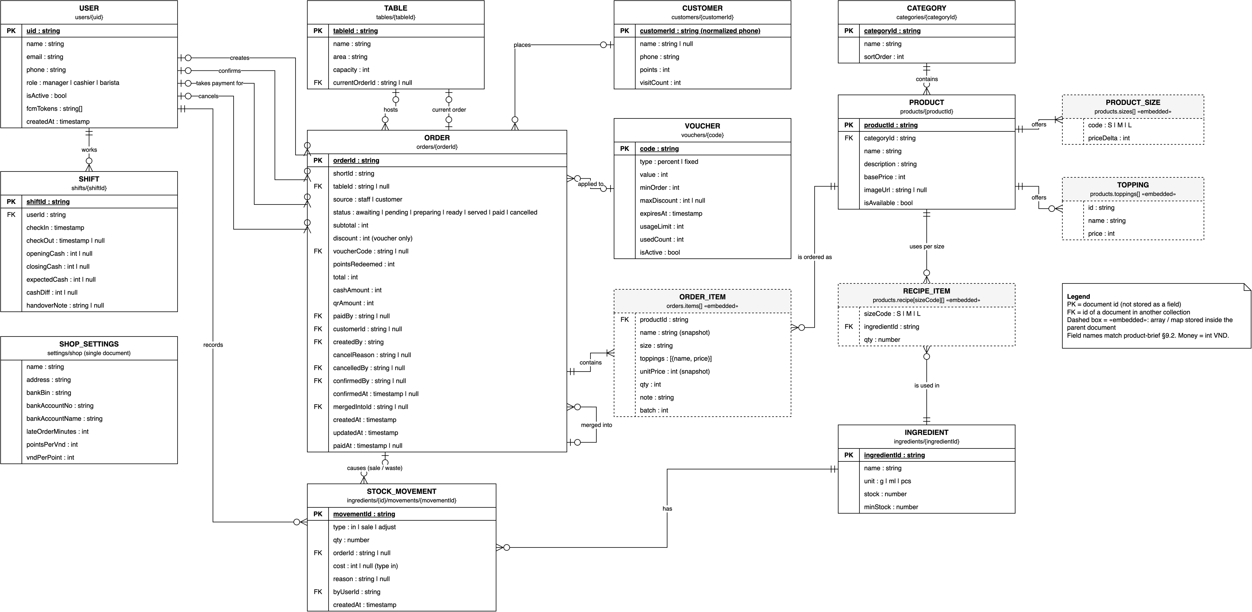
Figure 3-6: Entity relationship diagram (Firestore collections; dashed = embedded)
Entities Description
# | Entity | Description
1 | User (users) | A staff account with one role (manager / cashier / barista); linked to the Firebase Auth uid.
2 | Shift (shifts) | One work session of a staff member, with the cash handover fields for cashier / manager.
3 | Category (categories) | Menu group with a display order.
4 | Product (products) | Menu item with base price, sizes, toppings, availability and a recipe per size (embedded).
5 | Size (embedded in Product) | Size code S / M / L with a price delta.
6 | Topping (embedded in Product) | Optional add-on with a price; no recipe in v1 (BR-INV-04).
7 | Recipe item (embedded in Product.recipe) | Ingredient and quantity used by one product size.
8 | Ingredient (ingredients) | Tracked raw material with unit, current stock and min stock.
9 | Stock movement (ingredients/{id}/movements) | Any change to an ingredient's stock: in, sale or adjust.
10 | Table (tables) | Physical table with area, capacity and the current open order.
11 | Order (orders) | An order for a table or takeaway with status, amounts and audit fields.
12 | Order item (embedded in Order) | Snapshot of a product line: name, size, toppings, unit price, quantity, note and batch.
13 | Customer (customers) | Loyalty member keyed by normalized phone number, with points and visit count.
14 | Voucher (vouchers) | Discount code (percent or fixed) with limits and usage count.
15 | Shop settings (settings/shop) | Single document with shop info, VietQR bank account, late-order threshold and loyalty rates.

3.1.6 Entity Details
All money values are integers in VND; all timestamps are Firestore Timestamps. The document id is the primary key and is not stored as a field.
users/{uid}
# | Attribute name | PK | Type | Mandatory | Description
1 | uid | x | String | Yes | Document id = Firebase Auth uid (not stored as a field)
2 | name |  | String | Yes | Full name
3 | email |  | String | Yes | Login email
4 | phone |  | String | Yes | Phone number, 10 digits
5 | role |  | Enum | Yes | manager | cashier | barista
6 | isActive |  | Boolean | Yes | false = cannot log in (FR-AUTH-06)
7 | fcmTokens |  | String[] | Yes | Push tokens of the user's devices
8 | createdAt |  | Timestamp | Yes | Creation time

shifts/{shiftId}
# | Attribute name | PK | Type | Mandatory | Description
1 | shiftId | x | String | Yes | Document id
2 | userId |  | String (FK users) | Yes | Staff member
3 | checkIn |  | Timestamp | Yes | Server time at check-in
4 | checkOut |  | Timestamp | No | null while the shift is open
5 | openingCash |  | Integer (VND) | No | Cashier / manager only; null for barista
6 | closingCash |  | Integer (VND) | No | Counted cash at check-out
7 | expectedCash |  | Integer (VND) | No | Snapshot at check-out (BR-STAFF-04)
8 | cashDiff |  | Integer (VND) | No | closingCash − expectedCash
9 | handoverNote |  | String | No | Required when cashDiff ≠ 0

categories/{categoryId}
# | Attribute name | PK | Type | Mandatory | Description
1 | categoryId | x | String | Yes | Document id
2 | name |  | String | Yes | Unique category name
3 | sortOrder |  | Integer | Yes | Display order

products/{productId}
# | Attribute name | PK | Type | Mandatory | Description
1 | productId | x | String | Yes | Document id
2 | categoryId |  | String (FK categories) | Yes | Category
3 | name |  | String | Yes | Product name
4 | description |  | String | Yes | Short description (may be empty)
5 | basePrice |  | Integer (VND) | Yes | Non-negative base price
6 | imageUrl |  | String | No | Cloud Storage URL
7 | isAvailable |  | Boolean | Yes | false = sold out
8 | sizes |  | Array of {code, priceDelta} | Yes | code S | M | L, priceDelta int VND; at least one size
9 | toppings |  | Array of {id, name, price} | Yes | May be empty; price int VND ≥ 0
10 | recipe |  | Map sizeCode → [{ingredientId, qty}] | Yes | Ingredients per size; a size may have no recipe

ingredients/{ingredientId}
# | Attribute name | PK | Type | Mandatory | Description
1 | ingredientId | x | String | Yes | Document id
2 | name |  | String | Yes | Unique ingredient name
3 | unit |  | Enum | Yes | g | ml | pcs
4 | stock |  | Number | Yes | Current stock; may be negative
5 | minStock |  | Number | Yes | Low-stock threshold

ingredients/{ingredientId}/movements/{movementId}
# | Attribute name | PK | Type | Mandatory | Description
1 | movementId | x | String | Yes | Document id
2 | type |  | Enum | Yes | in | sale | adjust
3 | qty |  | Number | Yes | Positive = in, negative = out
4 | orderId |  | String (FK orders) | No | Set for sale and for cancel waste (adjust)
5 | cost |  | Integer (VND) | No | Total purchase cost, set for in
6 | reason |  | String | No | Required for adjust: cancel reason, "Kiểm kho", …
7 | byUserId |  | String (FK users) | Yes | Who made the change
8 | createdAt |  | Timestamp | Yes | When

tables/{tableId}
# | Attribute name | PK | Type | Mandatory | Description
1 | tableId | x | String | Yes | Firestore auto-id (not guessable)
2 | name |  | String | Yes | e.g. "T1", "Sân vườn 2"
3 | area |  | String | Yes | Area / zone
4 | capacity |  | Integer | Yes | Seats, > 0
5 | currentOrderId |  | String (FK orders) | No | Open order; null = empty

orders/{orderId}
# | Attribute name | PK | Type | Mandatory | Description
1 | orderId | x | String | Yes | Document id
2 | shortId |  | String | Yes | <letter><4 digits>, reset daily; used in the VietQR note
3 | tableId |  | String (FK tables) | No | null = takeaway
4 | source |  | Enum | Yes | staff | customer
5 | status |  | Enum | Yes | awaiting | pending | preparing | ready | served | paid | cancelled
6 | items |  | Array of order item | Yes | See Order item
7 | subtotal |  | Integer (VND) | Yes | Σ unitPrice × qty
8 | discount |  | Integer (VND) | Yes | Voucher discount only (BR-DIS-03)
9 | voucherCode |  | String (FK vouchers) | No | Applied voucher
10 | pointsRedeemed |  | Integer | Yes | Points used on this order
11 | total |  | Integer (VND) | Yes | subtotal − discount − pointsRedeemed × vndPerPoint, min 0
12 | cashAmount |  | Integer (VND) | Yes | Cash kept (change excluded); 0 until paid
13 | qrAmount |  | Integer (VND) | Yes | VietQR transfer; 0 until paid
14 | paidBy |  | String (FK users) | No | Who confirmed the payment
15 | customerId |  | String (FK customers) | No | Loyalty customer
16 | createdBy |  | String | Yes | Staff uid or "anonymous"
17 | cancelReason |  | String | No | Required when cancelled
18 | cancelledBy |  | String (FK users) | No | Who cancelled
19 | confirmedBy |  | String (FK users) | No | Who confirmed a customer order
20 | confirmedAt |  | Timestamp | No | When it was confirmed
21 | mergedIntoId |  | String (FK orders) | No | Open order that received this order's items (BR-ORD-07 add-on, BR-ORD-08 merge)
22 | createdAt |  | Timestamp | Yes | Creation time
23 | updatedAt |  | Timestamp | Yes | Last change
24 | paidAt |  | Timestamp | No | Payment time

Order item (embedded in orders.items)
# | Attribute name | PK | Type | Mandatory | Description
1 | productId |  | String (FK products) | Yes | Product
2 | name |  | String | Yes | Snapshot at order time
3 | size |  | String | Yes | Size code
4 | toppings |  | Array of {name, price} | Yes | Snapshot, may be empty
5 | unitPrice |  | Integer (VND) | Yes | base + size delta + toppings, snapshot (BR-ORD-01)
6 | qty |  | Integer | Yes | Quantity ≥ 1
7 | note |  | String | Yes | Free note (may be empty)
8 | batch |  | Integer | Yes | 1 = first round; add-on to a ready or served order = max + 1 (BR-ORD-04)

customers/{customerId}
# | Attribute name | PK | Type | Mandatory | Description
1 | customerId | x | String | Yes | Normalized phone number
2 | name |  | String | No | Optional name
3 | phone |  | String | Yes | 10 digits, starts with 0
4 | points |  | Integer | Yes | Points balance
5 | visitCount |  | Integer | Yes | Number of paid orders

vouchers/{code}
# | Attribute name | PK | Type | Mandatory | Description
1 | code | x | String | Yes | Unique, A–Z 0–9
2 | type |  | Enum | Yes | percent | fixed
3 | value |  | Integer | Yes | Percent 1–100 or VND amount > 0
4 | minOrder |  | Integer (VND) | Yes | Minimum subtotal
5 | maxDiscount |  | Integer (VND) | No | Cap for percent vouchers
6 | expiresAt |  | Timestamp | Yes | Expiry
7 | usageLimit |  | Integer | Yes | ≥ 1
8 | usedCount |  | Integer | Yes | Times used
9 | isActive |  | Boolean | Yes | false = deactivated

settings/shop
# | Attribute name | PK | Type | Mandatory | Description
1 | name |  | String | Yes | Shop name
2 | address |  | String | Yes | Shop address
3 | bankBin |  | String | Yes | Bank BIN for VietQR
4 | bankAccountNo |  | String | Yes | Digits only
5 | bankAccountName |  | String | Yes | Account holder name
6 | lateOrderMinutes |  | Integer | Yes | Barista overdue threshold, default 10
7 | pointsPerVnd |  | Integer | Yes | VND per earned point, default 10.000
8 | vndPerPoint |  | Integer | Yes | VND value of one point, default 1.000

3.2 Authentication

3.2.1 UC01 – Log in and enter the role home screen
3.2.1.1 Screen Mock-up
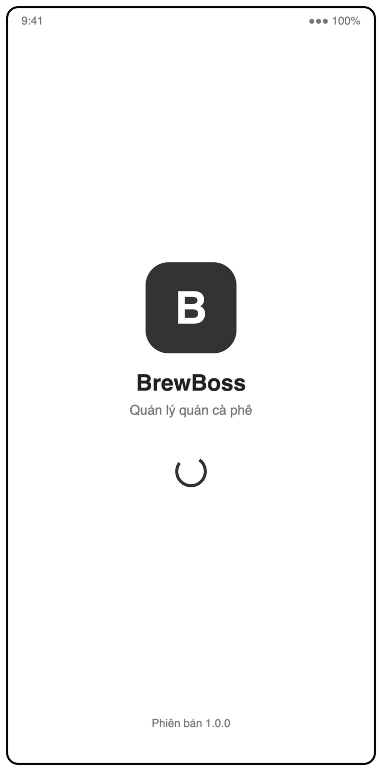
Figure 3-7: Screen Design of S01 Splash
Table 3-1: Screen Definition of S01 Splash
# | Field Name | Type | Mandatory | Max Length | Description
1 | Logo / app name | Label |  | — | "BrewBoss" and "Quản lý quán cà phê"
2 | Version | Label |  | — | "Phiên bản 1.0.0"
3 | (auto) | — |  | — | Checks the saved session: valid → role home (UC01 alt 1a), none → Login

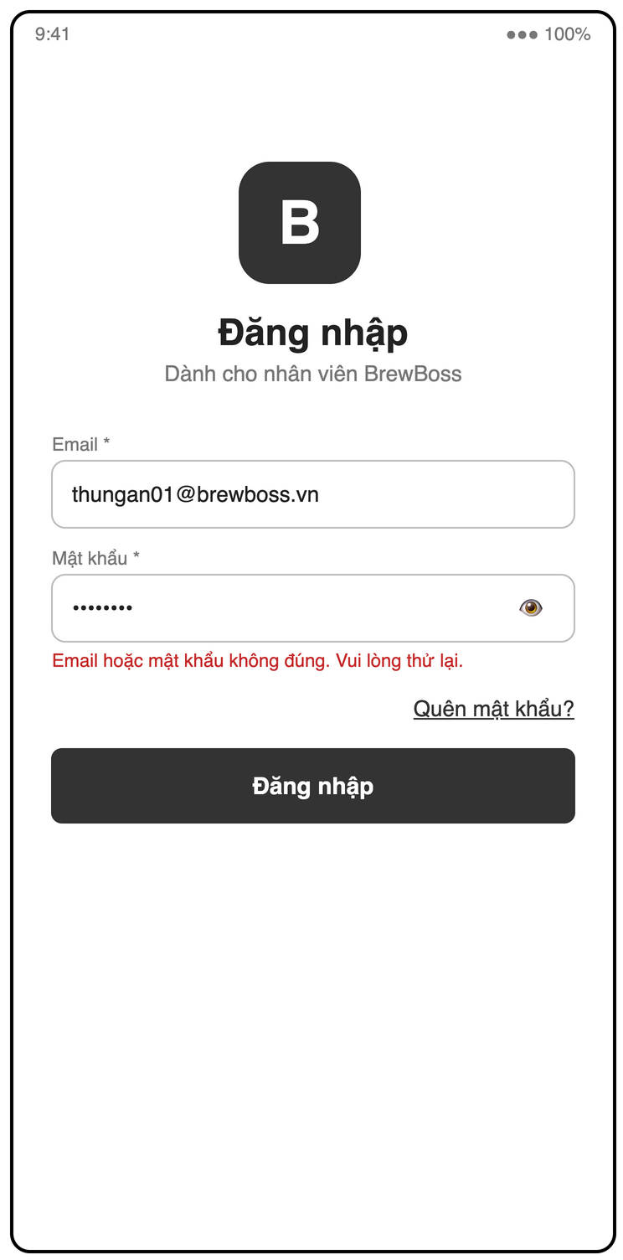
Figure 3-8: Screen Design of S02 Login
Table 3-2: Screen Definition of S02 Login
# | Field Name | Type | Mandatory | Max Length | Description
1 | Email | Text (email) | Yes | — | Valid email syntax
2 | Mật khẩu | Text (password) | Yes | — | Not empty; masked, eye icon shows / hides the text
3 | Error message | Label |  | — | Inline: "Email hoặc mật khẩu không đúng. Vui lòng thử lại."
4 | Quên mật khẩu? | Link |  | — | Opens S03
5 | Đăng nhập | Button |  | — | Signs in and routes by role (UC01)

3.2.1.2 Use Case Description
Use Case ID | UC01 | Use Case Name | Log in and enter the role home screen
Author | Trần Ngọc Huy | Version | 1.0
Date | 23/09/2026 | Priority | High
Actor | Manager / Cashier / Barista
Description | A staff member signs in with email and password. The system checks that the account is active and routes the user to the home screen of their role.  Goal: Give each staff member access only to the screens and data of their role, and keep them signed in across app restarts.
Precondition | The staff account exists in Firebase Auth and in users/{uid}.
Trigger | The app starts with no saved session, or the user was logged out.
Post-Condition | A session is saved on the device, the device FCM token is stored in users/{uid}.fcmTokens, and the user is on the home screen of their role.
Main flows
Step | Actor | Action
1 | User | User opens the app.
1 | System | System shows the Splash screen (S01) and checks for a saved session.
2 | System | No session is found; System shows the Login screen (S02).
3 | User | User enters email and password and taps "Đăng nhập".
3 | System | System validates the input format (email syntax, password not empty).
4 | System | System verifies the credentials with Firebase Auth.
5 | System | System reads users/{uid} and checks isActive = true.
6 | System | System registers the device FCM token in users/{uid}.fcmTokens.
7 | System | System routes by role: Manager → /manager (S04), Cashier → /pos (S13), Barista → /barista (S16).

Alternative flows
AT1 | At step 1 in the main flows: A valid saved session exists (FR-AUTH-05).
Sub step | Actor | Action
1a.1 | System | System skips steps 2–4 and continues at step 5.
AT2 | At step 6 in the main flows: The user denies the notification permission.
Sub step | Actor | Action
6a.1 | System | System skips token registration and continues; push alerts will not reach this device.

Exceptions
# | Exception code | Condition | System handling
1 | invalid-argument | Invalid input | Email format is wrong or password is empty. System shows an inline error and sends nothing.
2 | invalid-credential | Wrong credentials | Email or password is wrong. System shows "Email hoặc mật khẩu không đúng" without revealing which one.
3 | too-many-requests | Too many attempts | Firebase blocks sign-in temporarily. System shows "Thử lại sau ít phút".
4 | user-disabled | Account deactivated | users/{uid}.isActive = false (FR-AUTH-06). System signs out and shows "Tài khoản đã bị vô hiệu hóa. Liên hệ quản lý."
5 | not-found | Profile missing | users/{uid} does not exist. System signs out and shows "Tài khoản chưa được cấu hình".

Business Rules
# | Rule Description
NFR-SEC-02 | Passwords are handled only by Firebase Auth and never stored in Firestore.
BR-AUTH-ROUTE | Each user has exactly one role; the router guard redirects any unauthorized route to the role's home.

3.2.2 UC02 – Log out
3.2.2.1 Screen Mock-up
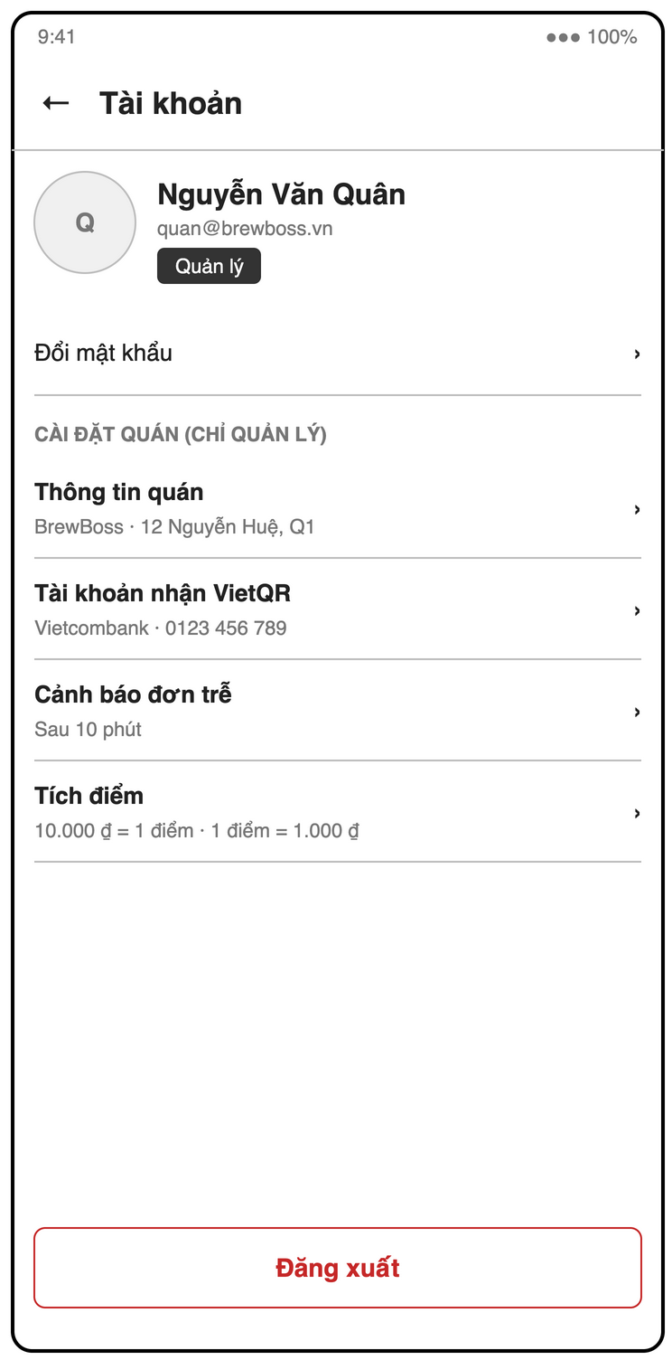
Figure 3-9: Screen Design of S22 Profile / settings
Table 3-3: Screen Definition of S22 Profile / settings
# | Field Name | Type | Mandatory | Max Length | Description
1 | Account | Label |  | — | Avatar, name, email, role
2 | Đổi mật khẩu | Link |  | — | Change password
3 | Cài đặt quán (chỉ quản lý) | Section |  | — | Visible to managers only
4 | Thông tin quán | Text × 2 | Yes | — | Shop name, address
5 | Tài khoản nhận VietQR | Dropdown + Text × 2 | Yes | — | Bank (BIN picker), account number (digits only), account name
6 | Cảnh báo đơn trễ | Number (minutes) | Yes | — | > 0, default 10
7 | Tích điểm | Number × 2 | Yes | — | pointsPerVnd > 0 (default 10.000), vndPerPoint > 0 (default 1.000)
8 | Đăng xuất | Button |  | — | Confirms and logs out (UC02)

3.2.2.2 Use Case Description
Use Case ID | UC02 | Use Case Name | Log out
Author | Trần Ngọc Huy | Version | 1.0
Date | 23/09/2026 | Priority | High
Actor | Manager / Cashier / Barista
Description | A staff member ends their session on the current device.  Goal: Let a shared device be handed to another staff member safely.
Precondition | The user is logged in.
Trigger | User taps "Đăng xuất" on Profile (S22).
Post-Condition | The session is cleared, this device's FCM token is removed from users/{uid}.fcmTokens, and the Login screen is shown.
Main flows
Step | Actor | Action
1 | User | User opens Profile (S22) and taps "Đăng xuất".
1 | System | System asks for confirmation.
2 | User | User confirms.
2 | System | System removes this device's FCM token and signs out of Firebase Auth.
3 | System | System navigates to Login (S02).

Alternative flows
AT1 | At step 2 in the main flows: User cancels the confirmation.
Sub step | Actor | Action
2a.1 | System | System keeps the session unchanged.
AT2 | At step 2 in the main flows: User still has an open shift (UC05).
Sub step | Actor | Action
2b.1 | System | System warns "Bạn chưa check-out ca làm" and offers "Check-out và đăng xuất" or "Vẫn đăng xuất".

Exceptions
# | Exception code | Condition | System handling
1 | unavailable | Offline | The device has no network. System queues the token removal and still signs out locally.

Business Rules
No specific business rule.

3.2.3 UC03 – Reset password by email
3.2.3.1 Screen Mock-up
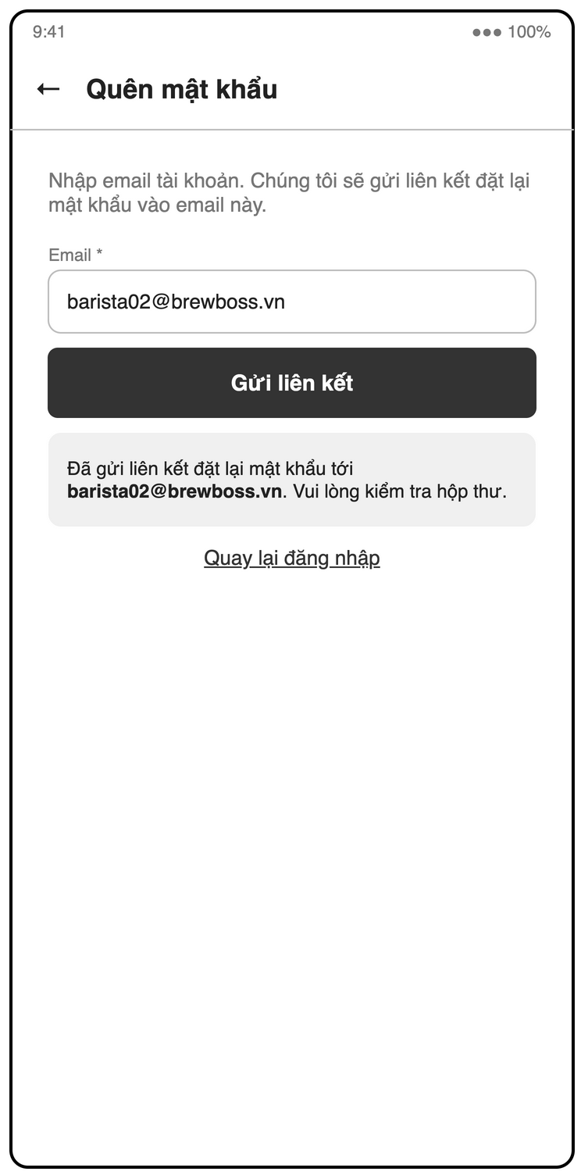
Figure 3-10: Screen Design of S03 Forgot password
Table 3-4: Screen Definition of S03 Forgot password
# | Field Name | Type | Mandatory | Max Length | Description
1 | Back | Icon button |  | — | Returns to S02
2 | Email | Text (email) | Yes | — | Valid email syntax
3 | Gửi liên kết | Button |  | — | Sends the Firebase password reset email
4 | Result message | Label |  | — | Same message whether or not the email exists
5 | Quay lại đăng nhập | Link |  | — | Returns to S02

3.2.3.2 Use Case Description
Use Case ID | UC03 | Use Case Name | Reset password by email
Author | Trần Ngọc Huy | Version | 1.0
Date | 23/09/2026 | Priority | Medium
Actor | Manager / Cashier / Barista
Description | A staff member who forgot their password requests a reset link by email.  Goal: Let staff recover access without asking the manager to recreate the account.
Precondition | None; the user is not logged in.
Trigger | User taps "Quên mật khẩu?" on Login (S02).
Post-Condition | A password reset email is sent if the account exists.
Main flows
Step | Actor | Action
1 | User | User taps "Quên mật khẩu?".
1 | System | System opens Forgot password (S03).
2 | User | User enters their email and taps "Gửi".
2 | System | System validates the email format and calls Firebase Auth sendPasswordResetEmail.
3 | System | System shows "Nếu email tồn tại, liên kết đặt lại mật khẩu đã được gửi" and returns to Login.
4 | User | User opens the email link and sets a new password.
4 | System | Firebase Auth updates the password.

Alternative flows
None.
Exceptions
# | Exception code | Condition | System handling
1 | invalid-email | Invalid email | Email format is wrong. System shows an inline error.
2 | user-not-found | Unknown email | No account for this email. System shows the same message as step 3 to avoid account enumeration.

Business Rules
# | Rule Description
NFR-SEC-02 | Passwords are handled only by Firebase Auth and never stored in Firestore.

3.3 Staff & Shift Management

3.3.1 UC04 – Manage staff accounts
3.3.1.1 Screen Mock-up
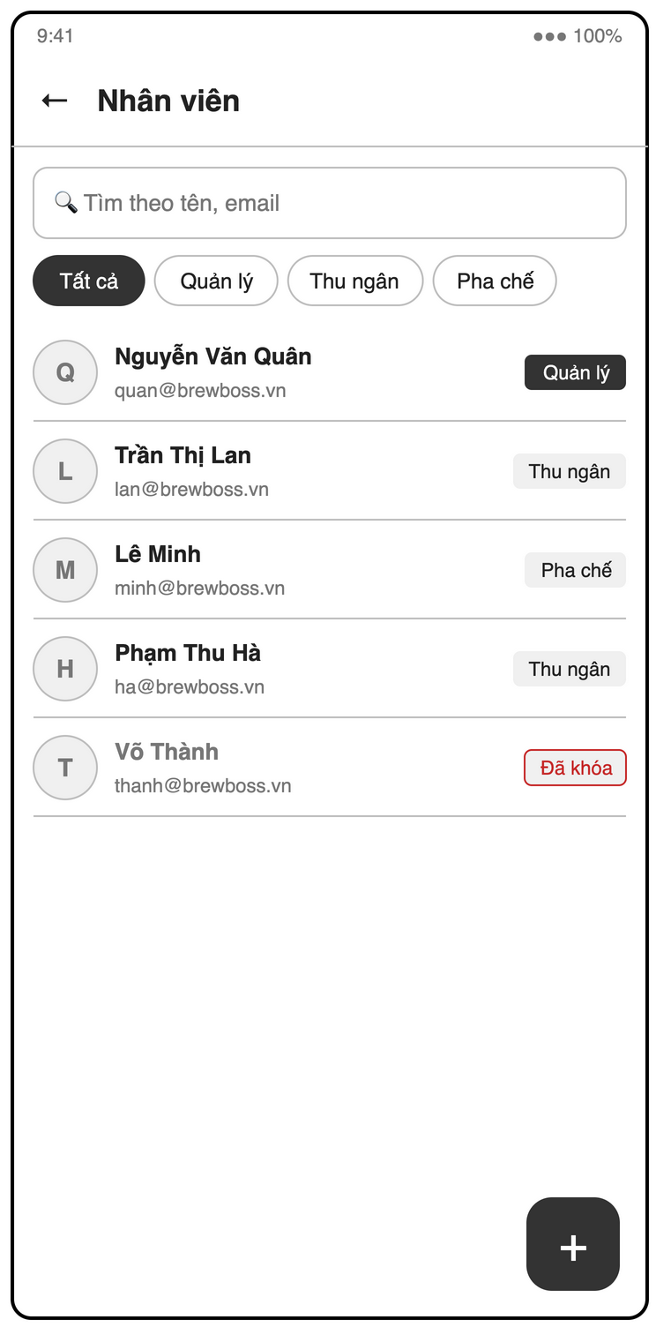
Figure 3-11: Screen Design of S05 Staff list
Table 3-5: Screen Definition of S05 Staff list
# | Field Name | Type | Mandatory | Max Length | Description
1 | Search | Text | No | — | Filter by name or email
2 | Role filter | Chips |  | — | Tất cả / Quản lý / Thu ngân / Pha chế
3 | Staff list | List |  | — | Avatar, name, email, role badge or "Đã khóa" when inactive
4 | + | Floating button |  | — | Opens the staff form (create)

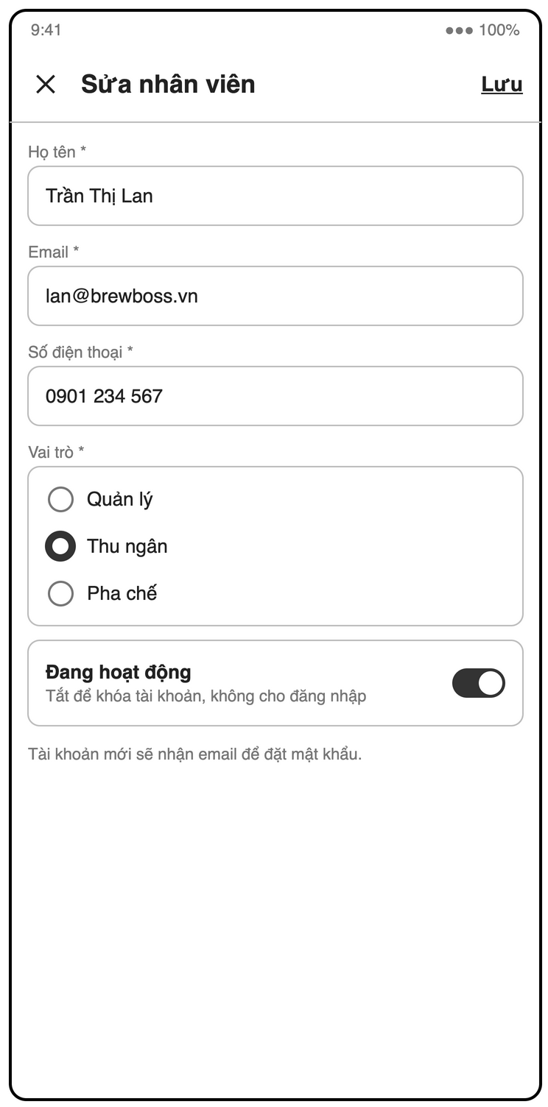
Figure 3-12: Screen Design of S05b Staff form
Table 3-6: Screen Definition of S05b Staff form
# | Field Name | Type | Mandatory | Max Length | Description
1 | Close | Icon button |  | — | Discards changes
2 | Họ tên | Text | Yes | — | Not empty
3 | Email | Text (email) | Yes | — | Valid and not already used; read-only when editing
4 | Số điện thoại | Text (phone) | Yes | — | 10 digits
5 | Vai trò | Radio | Yes | — | Quản lý / Thu ngân / Pha chế
6 | Mật khẩu tạm | Text (password) | Yes (create) | — | Temporary password on create (UC04 step 2)
7 | Đang hoạt động | Switch |  | — | Deactivate / reactivate; disabled for the manager's own account (BR-STAFF-02)
8 | Lưu | Button |  | — | Saves the account

3.3.1.2 Use Case Description
Use Case ID | UC04 | Use Case Name | Manage staff accounts
Author | Trần Ngọc Huy | Version | 1.0
Date | 23/09/2026 | Priority | High
Actor | Manager
Description | The manager creates staff accounts, edits their details and role, and deactivates or reactivates them.  Goal: Control who can use the app and with which role.
Precondition | The caller has role = manager.
Trigger | A new employee joins, an employee changes role, or an employee leaves.
Post-Condition | The Firebase Auth account and users/{uid} are created or updated.
Main flows
Step | Actor | Action
1 | Manager | Manager opens Staff (S05) and taps "Thêm nhân viên".
1 | System | System shows the staff form.
2 | Manager | Manager enters name, email, phone, role and a temporary password.
2 | System | System validates required fields, email format and phone format (10 digits).
3 | Manager | Manager taps "Lưu".
3 | System | System creates the Firebase Auth account and users/{uid} with isActive = true and createdAt = now.
4 | System | System shows the new staff member in the list.

Alternative flows
AT1 | At step 1 in the main flows: Manager opens an existing staff member and edits name, phone or role (FR-STAFF-02).
Sub step | Actor | Action
1a.1 | System | System saves the change; a new role takes effect on the user's next route change.
AT2 | At step 1 in the main flows: Manager toggles "Đang hoạt động" off (FR-STAFF-03).
Sub step | Actor | Action
1b.1 | System | System sets isActive = false; the user is signed out at the next app start or role check (UC01).
AT3 | At step 1 in the main flows: Manager toggles "Đang hoạt động" on.
Sub step | Actor | Action
1c.1 | System | System sets isActive = true; the user can log in again.

Exceptions
# | Exception code | Condition | System handling
1 | invalid-argument | Invalid input | A required field is missing or badly formatted. System shows inline errors and saves nothing.
2 | email-already-in-use | Duplicate email | The email is already registered. System shows "Email đã được sử dụng".
3 | failed-precondition | Self-deactivation | Manager tries to deactivate or demote their own account. System disables the action (BR-STAFF-02).

Business Rules
# | Rule Description
BR-STAFF-02 | Manager cannot deactivate their own account.
IMPL-AUTH | Creating an Auth user from the client signs out the current user; use a secondary FirebaseApp instance or a Cloud Function (decide in SDS).

3.3.2 UC05 – Check in and check out of a shift
3.3.2.1 Screen Mock-up
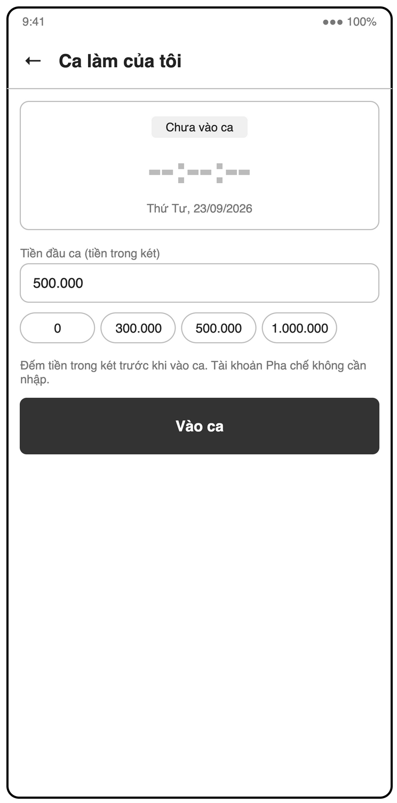
Figure 3-13: Screen Design of S07b My shift (check-in, opening cash)
Table 3-7: Screen Definition of S07b My shift (check-in, opening cash)
# | Field Name | Type | Mandatory | Max Length | Description
1 | Status | Label |  | — | "Chưa vào ca"
2 | Tiền đầu ca | Number (VND) | Yes (cashier / manager) | — | ≥ 0; hidden for barista (BR-STAFF-03)
3 | Quick amounts | Chips |  | — | 0 / 300.000 / 500.000 / 1.000.000
4 | Vào ca | Button |  | — | Creates the shift; hidden when a shift is already open (BR-STAFF-01)

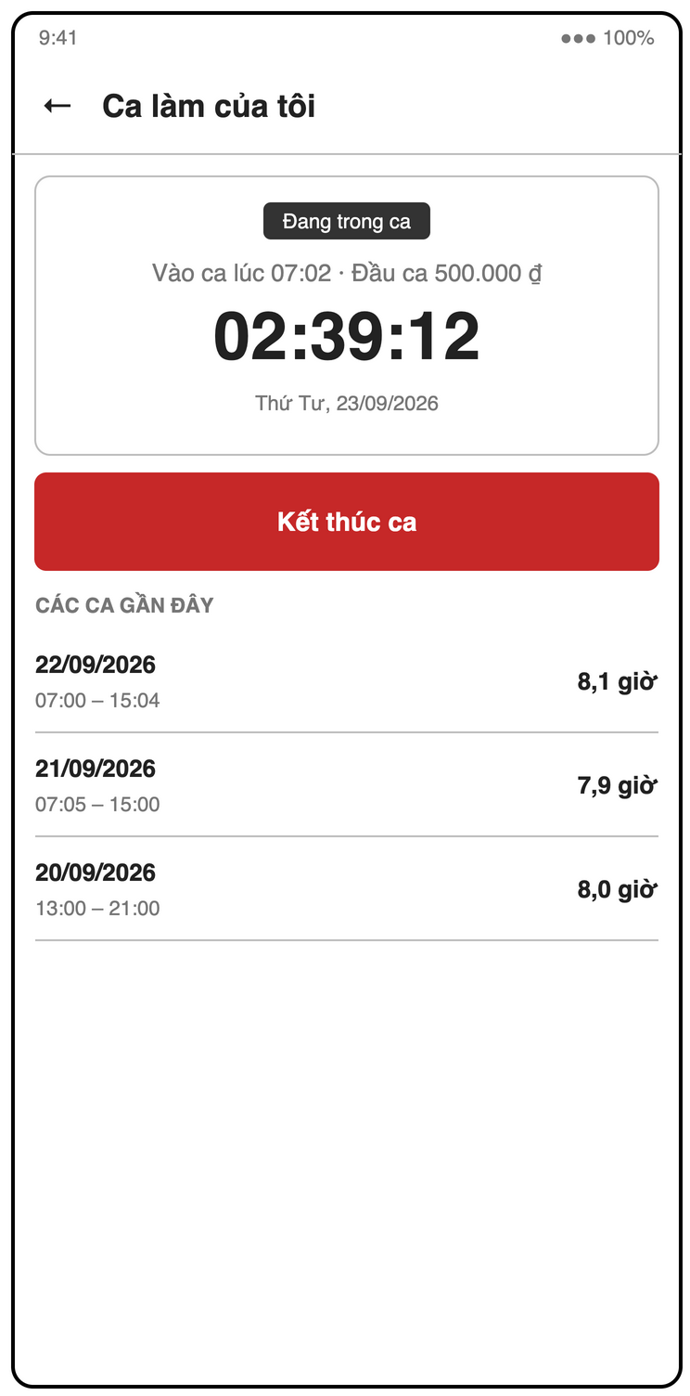
Figure 3-14: Screen Design of S07 My shift (in shift)
Table 3-8: Screen Definition of S07 My shift (in shift)
# | Field Name | Type | Mandatory | Max Length | Description
1 | Status | Label |  | — | "Đang trong ca", check-in time and opening cash
2 | Timer | Label |  | — | Running shift duration
3 | Kết thúc ca | Button |  | — | Barista: checks out; cashier / manager: opens the cash handover (S07c)
4 | Các ca gần đây | List |  | — | Recent shifts: date, time range, hours

3.3.2.2 Use Case Description
Use Case ID | UC05 | Use Case Name | Check in and check out of a shift
Author | Trần Ngọc Huy | Version | 1.1
Date | 23/09/2026 | Priority | Medium
Actor | Cashier / Barista / Manager
Description | A staff member records the start and end of their shift on the app. A cashier or manager also declares the opening cash at check-in and hands over the cash at check-out (UC44).  Goal: Replace paper attendance with an accurate shift record.
Precondition | The user is logged in.
Trigger | Staff member starts or ends a shift.
Post-Condition | Check-in: a shifts document with checkOut = null exists; for a cashier or manager it has openingCash. Check-out: that document has checkOut = now; for a cashier or manager UC44 also sets closingCash, expectedCash, cashDiff and handoverNote.
Main flows
Step | Actor | Action
1 | User | Staff opens My shift (S07).
1 | System | System shows the current state "Chưa vào ca".
2 | User | Staff taps "Check in".
2 | System | System checks there is no open shift for this user (BR-STAFF-01).
3 | User | Cashier or manager enters the opening cash in the drawer and confirms.
3 | System | System validates openingCash ≥ 0 (BR-STAFF-03).
4 | System | System creates shifts/{id} with userId, checkIn = server time, checkOut = null and openingCash, and shows a running timer.
5 | User | At the end of the shift, staff taps "Check out" and confirms.
5 | System | For a barista, System sets checkOut = server time and shows the shift duration. For a cashier or manager, System runs UC44 (include), which closes the shift with the cash handover.

Alternative flows
AT1 | At step 2 in the main flows: QR check-in is enabled (FR-STAFF-06, P2).
Sub step | Actor | Action
2a.1 | System | System opens the camera; staff scans the shop QR; System verifies the code before step 2.
AT2 | At step 3 in the main flows: The user is a barista.
Sub step | Actor | Action
3a.1 | System | System skips step 3 and creates the shift without cash fields (BR-STAFF-03).

Exceptions
# | Exception code | Condition | System handling
1 | already-exists | Open shift exists | The user already has an open shift. System hides "Check in" and shows only "Check out".
2 | invalid-argument | Wrong QR | The scanned QR is not the shop code. System shows "Mã QR không hợp lệ" and creates no shift.
3 | invalid-argument | Invalid opening cash | Opening cash is negative or not a number. System shows "Số tiền không hợp lệ" and creates no shift.

Business Rules
# | Rule Description
BR-STAFF-01 | A staff member cannot check in twice without checking out.
BR-STAFF-03 | Cashier and Manager must enter openingCash (≥ 0) at check-in; Barista shifts have no cash fields.

3.3.3 UC44 – Hand over cash at end of shift
3.3.3.1 Screen Mock-up
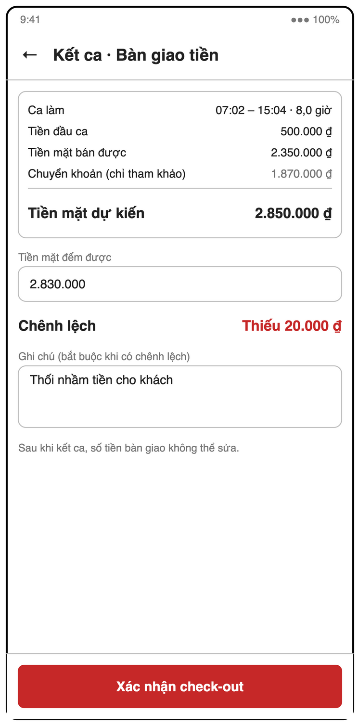
Figure 3-15: Screen Design of S07c My shift (check-out, cash handover)
Table 3-9: Screen Definition of S07c My shift (check-out, cash handover)
# | Field Name | Type | Mandatory | Max Length | Description
1 | Ca làm | Label |  | — | Time range and duration
2 | Tiền đầu ca | Label (VND) |  | — | openingCash
3 | Tiền mặt bán được | Label (VND) |  | — | Σ cashAmount of orders paid by the user in the shift
4 | Chuyển khoản (chỉ tham khảo) | Label (VND) |  | — | Σ qrAmount, not counted in the drawer
5 | Tiền mặt dự kiến | Label (VND) |  | — | openingCash + cash sales (BR-STAFF-04)
6 | Tiền mặt đếm được | Number (VND) | Yes | — | ≥ 0
7 | Chênh lệch | Label (VND) |  | — | counted − expected; "Khớp" when 0, "Thiếu" / "Thừa" in red otherwise
8 | Ghi chú | Text | Yes if difference ≠ 0 | — | Handover note (BR-STAFF-05)
9 | Xác nhận check-out | Button |  | — | Disabled until valid; closes the shift and locks cash fields

3.3.3.2 Use Case Description
Use Case ID | UC44 | Use Case Name | Hand over cash at end of shift
Author | Trần Ngọc Huy | Version | 1.0
Date | 23/09/2026 | Priority | Medium
Actor | Cashier (Manager inherits)
Description | At check-out, the cashier counts the cash drawer; the system compares it with the expected cash from the shift's cash sales and records the difference.  Goal: Trace any missing or extra cash to one shift and one person (FR-STAFF-07).
Precondition | The user has an open shift with openingCash set (BR-STAFF-03).
Trigger | Included by UC05 when a cashier or manager taps "Check out".
Post-Condition | The shift has checkOut = now, closingCash, expectedCash, cashDiff and handoverNote (required when cashDiff ≠ 0). The cash fields are locked (BR-STAFF-05).
Main flows
Step | Actor | Action
1 | System | System queries orders with paidBy = current uid, status = paid and paidAt between checkIn and now.
2 | System | System shows opening cash, cash sales = Σ cashAmount and expected cash = openingCash + Σ cashAmount (BR-STAFF-04); VietQR sales = Σ qrAmount are shown for reference only.
3 | User | Cashier counts the drawer and enters the counted cash.
3 | System | System computes cashDiff = closingCash − expectedCash and shows it; 0 is shown as "Khớp".
4 | User | Cashier taps "Xác nhận check-out".
4 | System | System updates the shift in one write: checkOut = server time, closingCash, expectedCash (snapshot), cashDiff and handoverNote = null, and shows the shift duration.

Alternative flows
AT1 | At step 3 in the main flows: cashDiff ≠ 0.
Sub step | Actor | Action
3a.1 | System | System shows the difference in red ("Thiếu" or "Thừa" with the amount) and requires a note: "Vui lòng nhập ghi chú cho khoản chênh lệch".
3a.2 | User | Cashier enters the note and taps "Xác nhận check-out".
3a.2 | System | System continues at step 4 and saves handoverNote.
AT2 | At step 3 in the main flows: Cashier taps "Hủy".
Sub step | Actor | Action
3b.1 | System | System keeps the shift open; nothing is written.

Exceptions
# | Exception code | Condition | System handling
1 | invalid-argument | Invalid amount | Counted cash is negative or not a number. System shows "Số tiền không hợp lệ".
2 | failed-precondition | Note missing | cashDiff ≠ 0 and the note is empty. "Xác nhận check-out" stays disabled.
3 | permission-denied | Cash locked | An edit of cash fields on a closed shift is rejected by Security Rules.
4 | unavailable | Offline | The orders query or the write fails. System shows the error, keeps the shift open and allows retry.

Business Rules
# | Rule Description
BR-STAFF-03 | Cashier and Manager must enter openingCash (≥ 0) at check-in; Barista shifts have no cash fields.
BR-STAFF-04 | expectedCash = openingCash + sum(cashAmount) of orders they marked paid during the shift. VietQR is not counted.
BR-STAFF-05 | cashDiff = closingCash − expectedCash; a non-zero difference requires handoverNote. Cash fields cannot be edited after check-out.
BR-PAY-03 | Only a user with an open shift can confirm a payment, so every sale belongs to a shift.
IDX | Needs composite index orders: paidBy ASC, paidAt ASC (brief §9.4).

3.3.4 UC06 – View shift history and working hours
3.3.4.1 Screen Mock-up
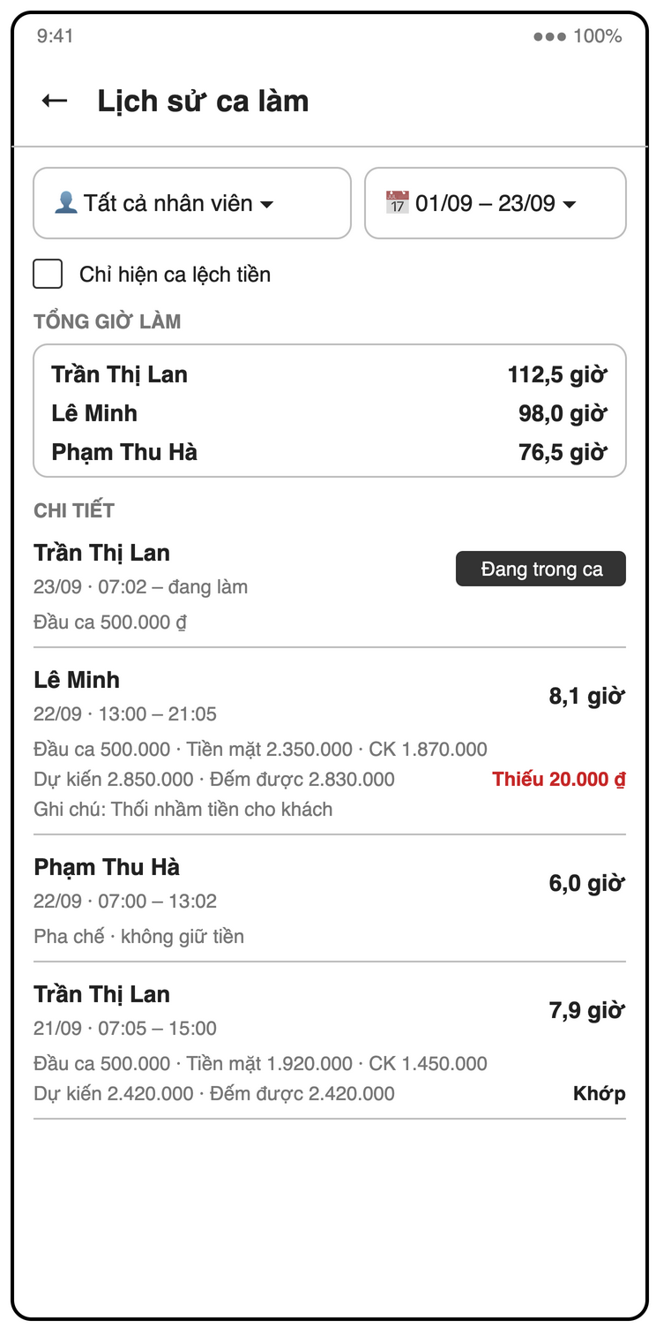
Figure 3-16: Screen Design of S06 Shift history + cash handover
Table 3-10: Screen Definition of S06 Shift history + cash handover
# | Field Name | Type | Mandatory | Max Length | Description
1 | Staff filter | Dropdown | No | — | Tất cả nhân viên or one staff member
2 | Period | Date range picker | Yes | — | Day / week / month / custom; default this week
3 | Chỉ hiện ca lệch tiền | Checkbox | No | — | Only shifts with cashDiff ≠ 0, largest shortage first
4 | Tổng giờ làm | List |  | — | Total hours per staff member (open shifts excluded)
5 | Shift list | List |  | — | Staff, date, check-in – check-out, duration; for cashier / manager: opening, cash sales, VietQR, expected, counted, difference (Khớp / Thiếu / Thừa) and note; open shift shows "Đang trong ca"

3.3.4.2 Use Case Description
Use Case ID | UC06 | Use Case Name | View shift history and working hours
Author | Trần Ngọc Huy | Version | 1.1
Date | 23/09/2026 | Priority | Medium
Actor | Manager
Description | The manager reviews shifts and total hours worked per staff member for a period. Cash handover details per shift are in UC45.  Goal: Support payroll and attendance checks without paper.
Precondition | The caller has role = manager.
Trigger | Manager opens Shift history (S06).
Post-Condition | None. The use case changes no state.
Main flows
Step | Actor | Action
1 | Manager | Manager opens Shift history (S06).
1 | System | System shows this week's shifts, newest first, grouped by staff.
2 | Manager | Manager selects a period (day / week / month / custom) and optionally a staff member.
2 | System | System loads the shifts in the period.
3 | System | System shows each shift (check-in, check-out, duration) and the total hours per staff member.

Alternative flows
AT1 | At step 3 in the main flows: A shift is still open.
Sub step | Actor | Action
3a.1 | System | System shows its duration as "Đang trong ca" and excludes it from totals.
AT2 | At step 3 in the main flows: Manager taps a cashier's or manager's shift, or opens the "Giao ca" tab.
Sub step | Actor | Action
3b.1 | System | System starts UC45 for the cash handover details.

Exceptions
# | Exception code | Condition | System handling
1 | not-found | No data | No shifts in the period. System shows "Không có ca làm nào".

Business Rules
No specific business rule.

3.3.5 UC45 – View shift cash report
3.3.5.1 Screen Mock-up
Uses screen(s) S06 (defined in 3.3.4).
3.3.5.2 Use Case Description
Use Case ID | UC45 | Use Case Name | View shift cash report
Author | Trần Ngọc Huy | Version | 1.0
Date | 23/09/2026 | Priority | Medium
Actor | Manager
Description | The manager reviews the cash handover of each shift and finds shifts with a cash difference.  Goal: Reconcile cash per shift and follow up shortages (FR-STAFF-08, FR-RPT-05).
Precondition | The caller has role = manager.
Trigger | Manager opens the "Giao ca" tab of Shift history (S06), or taps a shift in UC06.
Post-Condition | None. The use case changes no state.
Main flows
Step | Actor | Action
1 | Manager | Manager opens the "Giao ca" tab on S06.
1 | System | System loads cashier and manager shifts of the current week, newest first.
2 | Manager | Manager selects a period and optionally a staff member.
2 | System | System reloads the list.
3 | System | System shows per shift: staff, check-in, check-out, opening cash, cash sales (expectedCash − openingCash), VietQR sales (Σ qrAmount of orders paidBy the staff during the shift), expected, counted, difference and note.
4 | System | System shows period totals: cash sales, VietQR sales and net difference (shortage and surplus).

Alternative flows
AT1 | At step 2 in the main flows: Manager turns on "Chỉ ca có chênh lệch".
Sub step | Actor | Action
2a.1 | System | System shows only shifts with cashDiff ≠ 0, largest shortage first.
AT2 | At step 3 in the main flows: A shift is still open.
Sub step | Actor | Action
3a.1 | System | System shows it as "Đang trong ca" with opening cash only and excludes it from totals.
AT3 | At step 3 in the main flows: A barista shift is in the period.
Sub step | Actor | Action
3b.1 | System | System does not list it (no cash fields, BR-STAFF-03).

Exceptions
# | Exception code | Condition | System handling
1 | not-found | No data | No shifts match the filter. System shows "Không có ca làm nào".
2 | permission-denied | Manager only | A non-manager opens the route; the role guard redirects to the role home.

Business Rules
# | Rule Description
BR-STAFF-04 | expectedCash = openingCash + sum(cashAmount) of orders they marked paid during the shift. VietQR is not counted.
BR-STAFF-05 | cashDiff = closingCash − expectedCash; a non-zero difference requires handoverNote. Cash fields cannot be edited after check-out.
BR-RPT-01 | Revenue counts only orders with status = paid.

3.4 Menu

3.4.1 UC07 – Manage menu categories
3.4.1.1 Screen Mock-up
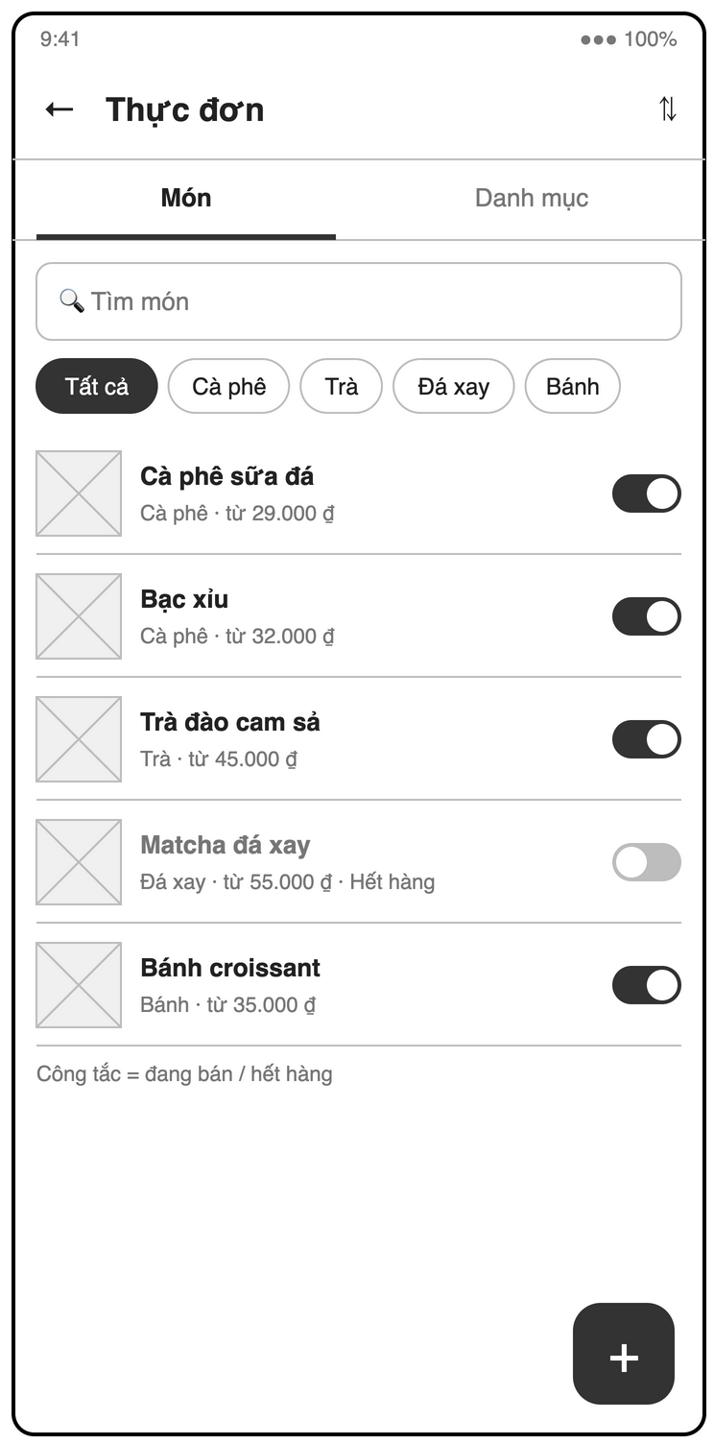
Figure 3-17: Screen Design of S08 Category & product list
Table 3-11: Screen Definition of S08 Category & product list
# | Field Name | Type | Mandatory | Max Length | Description
1 | Tabs | Tab |  | — | Món / Danh mục
2 | Reorder | Icon button |  | — | Drag categories to reorder (category tab)
3 | Tìm món | Text | No | — | Case- and accent-insensitive search
4 | Category filter | Chips |  | — | Tất cả and each category by sortOrder
5 | Product list | List |  | — | Image, name, category, "từ <price>", "Hết hàng" flag
6 | Availability | Switch |  | — | On = đang bán, off = hết hàng (UC09)
7 | + | Floating button |  | — | Product tab: add product (S09); category tab: add category (name field + Lưu)

3.4.1.2 Use Case Description
Use Case ID | UC07 | Use Case Name | Manage menu categories
Author | Lại Hữu Quang Anh | Version | 1.0
Date | 23/09/2026 | Priority | High
Actor | Manager
Description | The manager creates, renames, reorders and deletes menu categories.  Goal: Keep the menu organized so staff and customers find products quickly.
Precondition | The caller has role = manager.
Trigger | Manager opens Menu (S08), category tab.
Post-Condition | The categories collection is updated.
Main flows
Step | Actor | Action
1 | Manager | Manager taps "Thêm danh mục" and enters a name.
1 | System | System validates the name.
2 | Manager | Manager taps "Lưu".
2 | System | System saves the category with sortOrder = last + 1.

Alternative flows
AT1 | At step 1 in the main flows: Manager renames a category.
Sub step | Actor | Action
1a.1 | System | System updates the name.
AT2 | At step 1 in the main flows: Manager drags categories to reorder them.
Sub step | Actor | Action
1b.1 | System | System rewrites sortOrder of the affected categories.
AT3 | At step 1 in the main flows: Manager deletes an empty category.
Sub step | Actor | Action
1c.1 | System | System asks for confirmation and deletes it.

Exceptions
# | Exception code | Condition | System handling
1 | invalid-argument | Invalid name | Name is empty or duplicated. System shows an inline error.
2 | failed-precondition | Category not empty | The category still has products. System shows "Danh mục còn sản phẩm. Hãy chuyển hoặc xóa sản phẩm trước."

Business Rules
No specific business rule.

3.4.2 UC08 – Manage products, sizes and toppings
3.4.2.1 Screen Mock-up
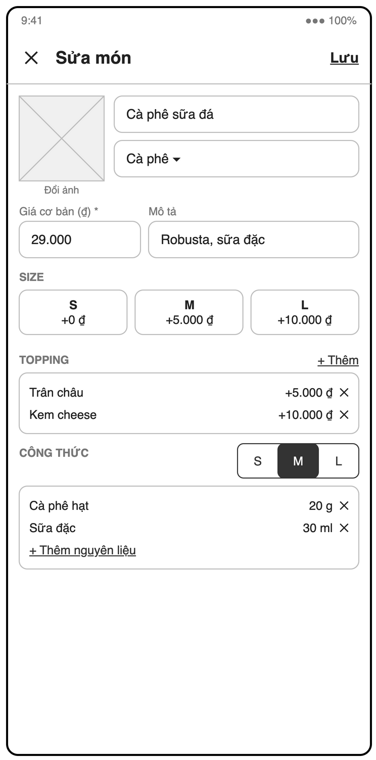
Figure 3-18: Screen Design of S09 Product form (sizes, toppings, recipe)
Table 3-12: Screen Definition of S09 Product form (sizes, toppings, recipe)
# | Field Name | Type | Mandatory | Max Length | Description
1 | Image | Image picker | No | — | Camera or gallery; compressed and uploaded ("Đổi ảnh")
2 | Tên món | Text | Yes | — | Not empty
3 | Danh mục | Dropdown | Yes | — | Existing category
4 | Giá cơ bản (₫) | Number (VND) | Yes | — | Non-negative integer
5 | Mô tả | Text | No | — | Short description
6 | Size | Editable list | Yes (≥ 1) | — | Code S / M / L (unique) + price delta; "+ Thêm"
7 | Topping | Editable list | No | — | Name + price ≥ 0; ✕ removes
8 | Công thức | Tabs per size + list | No | — | Ingredient + quantity (> 0, unit of the ingredient), no duplicate ingredient per size; "+ Thêm nguyên liệu", "Sao chép từ size <X>"
9 | Lưu | Button |  | — | Saves the product (and recipe)

3.4.2.2 Use Case Description
Use Case ID | UC08 | Use Case Name | Manage products, sizes and toppings
Author | Lại Hữu Quang Anh | Version | 1.0
Date | 23/09/2026 | Priority | High
Actor | Manager
Description | The manager creates and edits products with base price, sizes (price delta), toppings and an optional image.  Goal: Keep product data and prices correct for every order.
Precondition | At least one category exists.
Trigger | Manager taps "Thêm sản phẩm" or an existing product on Menu (S08).
Post-Condition | products/{id} is created or updated.
Main flows
Step | Actor | Action
1 | Manager | Manager opens Product form (S09).
1 | System | System shows the form.
2 | Manager | Manager enters name, category, base price and description.
2 | System | System validates the fields as they are entered.
3 | Manager | Manager adds sizes with price delta, e.g. S +0, M +5.000, L +10.000 (FR-MENU-03).
3 | System | System checks size codes are unique.
4 | Manager | Manager adds toppings with name and price, e.g. Trân châu +5.000 (FR-MENU-04).
4 | System | System checks topping price ≥ 0.
5 | Manager | Manager taps "Lưu".
5 | System | System saves the product with isAvailable = true.

Alternative flows
AT1 | At step 2 in the main flows: Manager picks a product image from camera or gallery (FR-MENU-05).
Sub step | Actor | Action
2a.1 | System | System compresses the image, uploads it to Cloud Storage and saves imageUrl.
AT2 | At step 5 in the main flows: Manager continues to the recipe section.
Sub step | Actor | Action
5a.1 | System | System starts UC14.
AT3 | At step 1 in the main flows: Manager edits an existing product.
Sub step | Actor | Action
1a.1 | System | System saves the change; it applies to new orders only.
AT4 | At step 1 in the main flows: Manager deletes a product.
Sub step | Actor | Action
1b.1 | System | System asks for confirmation and deletes it; past orders keep their snapshot.

Exceptions
# | Exception code | Condition | System handling
1 | invalid-argument | Invalid product | Name missing, base price not a non-negative integer, or no size defined. System shows inline errors.
2 | storage/unknown | Upload failed | The image upload fails. System lets the manager save without image and offers retry.

Business Rules
# | Rule Description
BR-ORD-01 | Item unit price = product base price + size delta + sum(topping prices).
SNAPSHOT | Order items store a snapshot of name and prices; editing the menu never changes historical orders.

3.4.3 UC09 – Toggle product availability
3.4.3.1 Screen Mock-up
Uses screen(s) S08 (defined in 3.4.1), S14 (defined in 3.6.3).
3.4.3.2 Use Case Description
Use Case ID | UC09 | Use Case Name | Toggle product availability
Author | Lại Hữu Quang Anh | Version | 1.0
Date | 23/09/2026 | Priority | Medium
Actor | Cashier / Manager
Description | Staff marks a product as sold out or available again.  Goal: Stop staff and customers from ordering products that cannot be made.
Precondition | The product exists.
Trigger | A product runs out or is back in stock.
Post-Condition | products/{id}.isAvailable is flipped and all menus update in real time.
Main flows
Step | Actor | Action
1 | User | Actor long-presses a product in Order editor (S14) or taps its switch on Menu (S08).
1 | System | System shows the "Hết hàng" toggle.
2 | User | Actor toggles "Hết hàng".
2 | System | System updates isAvailable.
3 | System | System greys out the product on all POS menus and hides it on customer menus.

Alternative flows
None.
Exceptions
# | Exception code | Condition | System handling
1 | permission-denied | Not allowed | A cashier tries to change any other product field. Security Rules allow only isAvailable for cashier.

Business Rules
# | Rule Description
NFR-SEC-01 | All data access is enforced by Firestore Security Rules per role.

3.4.4 UC10 – Browse and search the menu
3.4.4.1 Screen Mock-up
Uses screen(s) S08 (defined in 3.4.1), S14 (defined in 3.6.3), S17 (defined in 3.8.1).
3.4.4.2 Use Case Description
Use Case ID | UC10 | Use Case Name | Browse and search the menu
Author | Lại Hữu Quang Anh | Version | 1.0
Date | 23/09/2026 | Priority | High
Actor | Manager / Cashier / Barista / Customer
Description | Any actor browses products by category or searches them by name.  Goal: Find a product in a few taps during peak hours.
Precondition | None.
Trigger | Actor opens a menu view (S08, S14 or S17).
Post-Condition | None. The use case changes no state.
Main flows
Step | Actor | Action
1 | User | Actor opens a menu view.
1 | System | System shows categories by sortOrder and the products of the first category.
2 | User | Actor taps a category or types in the search box.
2 | System | System filters products; search is case- and accent-insensitive ("ca phe" matches "Cà phê").

Alternative flows
AT1 | At step 1 in the main flows: The actor is a customer (S17).
Sub step | Actor | Action
1a.1 | System | System hides unavailable products instead of greying them out.

Exceptions
# | Exception code | Condition | System handling
1 | not-found | No results | Nothing matches the search. System shows "Không tìm thấy món".

Business Rules
# | Rule Description
NFR-PERF-03 | The menu screen with 100 products scrolls at 60 fps.

3.5 Inventory

3.5.1 UC11 – Manage ingredients
3.5.1.1 Screen Mock-up
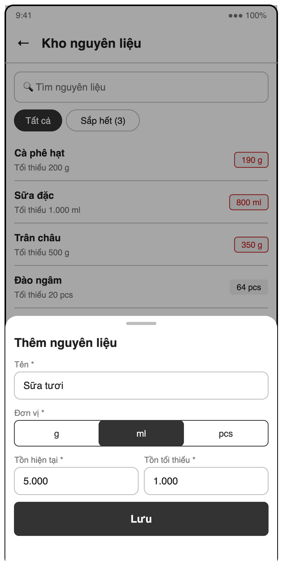
Figure 3-19: Screen Design of S10 Ingredient list / form
Table 3-13: Screen Definition of S10 Ingredient list / form
# | Field Name | Type | Mandatory | Max Length | Description
1 | Tìm nguyên liệu | Text | No | — | Search by name
2 | Filter | Chips |  | — | Tất cả / Sắp hết (n)
3 | Ingredient list | List |  | — | Name, stock + unit, min stock; low (≤ min) and negative stock highlighted
4 | Kiểm kho | Button |  | — | Opens the stocktake sheet: all ingredients, system stock, "Thực tế" field (Number, optional, ≥ 0) and the difference (UC42)
5 | Tên | Text | Yes | — | Unique
6 | Đơn vị | Radio | Yes | — | g / ml / pcs
7 | Tồn hiện tại | Number | Yes | — | ≥ 0; opening stock on create only (logged as "Tồn đầu kỳ")
8 | Tồn tối thiểu | Number | Yes | — | ≥ 0
9 | Lưu | Button |  | — | Saves the ingredient

3.5.1.2 Use Case Description
Use Case ID | UC11 | Use Case Name | Manage ingredients
Author | Lại Hữu Quang Anh | Version | 1.1
Date | 23/09/2026 | Priority | High
Actor | Manager
Description | The manager creates, edits and deletes ingredients with unit, stock and minimum stock.  Goal: Keep a list of every ingredient the shop tracks.
Precondition | The caller has role = manager.
Trigger | Manager opens Inventory (S10).
Post-Condition | ingredients/{id} is created or updated.
Main flows
Step | Actor | Action
1 | Manager | Manager opens Ingredient list (S10).
1 | System | System shows name, stock, unit and min stock; low (≤ min) and negative stock are highlighted.
2 | Manager | Manager taps "Thêm nguyên liệu" and enters name, unit (g / ml / pcs), opening stock and min stock.
2 | System | System validates the input.
3 | Manager | Manager taps "Lưu".
3 | System | System saves the ingredient; if opening stock > 0 it logs a movement type = in with reason "Tồn đầu kỳ".

Alternative flows
AT1 | At step 1 in the main flows: Manager edits name, unit or min stock.
Sub step | Actor | Action
1a.1 | System | System saves the change. Stock itself is not editable here; it changes only through UC12, UC13 or UC42.
AT2 | At step 1 in the main flows: Manager deletes an ingredient not used by any recipe.
Sub step | Actor | Action
1b.1 | System | System asks for confirmation and deletes it.

Exceptions
# | Exception code | Condition | System handling
1 | invalid-argument | Invalid ingredient | Name empty or duplicated, or stock / min stock negative. System shows inline errors.
2 | failed-precondition | Used in recipe | The ingredient is used in a recipe. System shows "Nguyên liệu đang được dùng trong công thức: <products>".

Business Rules
# | Rule Description
NFR-AUD-01 | Cancellations, vouchers, payments, stock adjustments and cash handovers record who and when.

3.5.2 UC12 – Record stock-in
3.5.2.1 Screen Mock-up
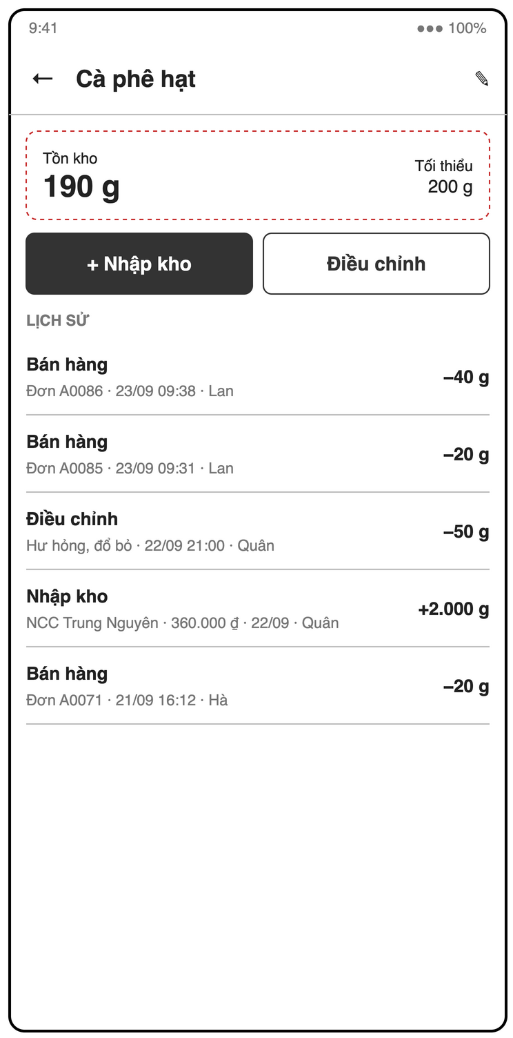
Figure 3-20: Screen Design of S11 Stock movement history
Table 3-14: Screen Definition of S11 Stock movement history
# | Field Name | Type | Mandatory | Max Length | Description
1 | Header | Label |  | — | Ingredient name and current stock; ✎ edits the ingredient
2 | + Nhập kho | Button |  | — | Opens the stock-in sheet (UC12)
3 | Điều chỉnh | Button |  | — | Opens the adjustment sheet: mode Hao hụt / Kiểm kê (Radio, Yes), value (Number, Yes), reason (Text, Yes) (UC13)
4 | Filter | Chips + date range | No | — | By type and date
5 | Lịch sử | List |  | — | Signed quantity, type (Nhập kho / Bán hàng / Điều chỉnh), order short ID or reason / supplier, time, user; tap a sale → S20

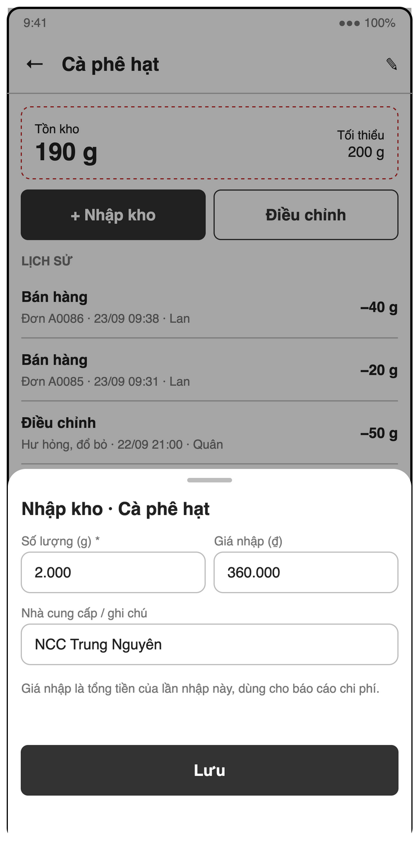
Figure 3-21: Screen Design of S11b Stock-in sheet (with cost)
Table 3-15: Screen Definition of S11b Stock-in sheet (with cost)
# | Field Name | Type | Mandatory | Max Length | Description
1 | Số lượng (<unit>) | Number | Yes | — | > 0
2 | Giá nhập (₫) | Number (VND) | No | — | Total cost of this delivery, ≥ 0
3 | Nhà cung cấp / ghi chú | Text | No | — | Free note
4 | Lưu | Button |  | — | Increments stock and logs a movement type = in

3.5.2.2 Use Case Description
Use Case ID | UC12 | Use Case Name | Record stock-in
Author | Lại Hữu Quang Anh | Version | 1.1
Date | 23/09/2026 | Priority | High
Actor | Manager
Description | The manager records ingredients received from a supplier.  Goal: Keep stock accurate and keep a history of purchases.
Precondition | The ingredient exists.
Trigger | An ingredient delivery arrives.
Post-Condition | stock += qty and a movement type = in is logged with qty, cost (total purchase cost in VND, null if not entered), byUserId and createdAt.
Main flows
Step | Actor | Action
1 | Manager | Manager opens an ingredient (S11) and taps "Nhập kho".
1 | System | System shows the stock-in form.
2 | Manager | Manager enters quantity, total purchase cost (optional) and note.
2 | System | System validates quantity > 0 and cost ≥ 0 if entered.
3 | Manager | Manager taps "Lưu".
3 | System | System runs a transaction: increments stock and writes the movement with cost.
4 | System | System shows the new stock and the new history row.

Alternative flows
None.
Exceptions
# | Exception code | Condition | System handling
1 | invalid-argument | Invalid quantity | Quantity ≤ 0 or not a number. System shows an inline error.

Business Rules
# | Rule Description
NFR-AUD-01 | Cancellations, vouchers, payments, stock adjustments and cash handovers record who and when.

3.5.3 UC13 – Record stock adjustment
3.5.3.1 Screen Mock-up
Uses screen(s) S11 (defined in 3.5.2).
3.5.3.2 Use Case Description
Use Case ID | UC13 | Use Case Name | Record stock adjustment
Author | Lại Hữu Quang Anh | Version | 1.1
Date | 23/09/2026 | Priority | High
Actor | Manager
Description | The manager corrects stock for waste or after a physical count, with a reason.  Goal: Make system stock match real stock while keeping an audit trail.
Precondition | The ingredient exists.
Trigger | Waste occurs, or a physical count differs from the system.
Post-Condition | Stock is changed and a movement type = adjust is logged with reason, user and time.
Main flows
Step | Actor | Action
1 | Manager | Manager opens an ingredient (S11) and taps "Điều chỉnh".
1 | System | System shows two modes: "Hao hụt" (quantity lost) and "Kiểm kê" (actual count).
2 | Manager | Manager chooses a mode, enters the value and a reason.
2 | System | System computes the signed delta: loss → negative; count → actual − current.
3 | Manager | Manager taps "Lưu".
3 | System | System runs a transaction: applies the delta and writes the movement with the reason.

Alternative flows
None.
Exceptions
# | Exception code | Condition | System handling
1 | invalid-argument | Reason missing | The reason is empty. System shows "Vui lòng nhập lý do".
2 | failed-precondition | No change | The delta is 0. System saves nothing and shows "Tồn kho không thay đổi".

Business Rules
# | Rule Description
NFR-AUD-01 | Cancellations, vouchers, payments, stock adjustments and cash handovers record who and when.

3.5.4 UC14 – Define product recipe per size
3.5.4.1 Screen Mock-up
Uses screen(s) S09 (defined in 3.4.2).
3.5.4.2 Use Case Description
Use Case ID | UC14 | Use Case Name | Define product recipe per size
Author | Lại Hữu Quang Anh | Version | 1.0
Date | 23/09/2026 | Priority | Medium
Actor | Manager
Description | The manager defines which ingredients and how much of each one product size uses.  Goal: Enable automatic stock deduction on every paid order.
Precondition | The product has sizes and the ingredients exist.
Trigger | Manager opens the recipe section of Product form (S09).
Post-Condition | products/{id}.recipe[sizeCode] is saved.
Main flows
Step | Actor | Action
1 | Manager | Manager selects a size tab (S / M / L).
1 | System | System shows the current recipe rows of that size.
2 | Manager | Manager adds rows: ingredient + quantity in the ingredient's unit.
2 | System | System validates each row.
3 | Manager | Manager repeats for other sizes.
3 | System | System keeps the rows per size.
4 | Manager | Manager taps "Lưu".
4 | System | System writes the recipe map.

Alternative flows
AT1 | At step 3 in the main flows: Manager taps "Sao chép từ size <X>".
Sub step | Actor | Action
3a.1 | System | System copies the rows of size X for editing.
AT2 | At step 4 in the main flows: A size has no recipe.
Sub step | Actor | Action
4a.1 | System | System allows it and shows a warning badge on the product; paying for that size deducts nothing.

Exceptions
# | Exception code | Condition | System handling
1 | invalid-argument | Invalid row | Quantity ≤ 0 or the same ingredient appears twice in one size. System shows an inline error.

Business Rules
# | Rule Description
BR-INV-04 | Toppings have no recipe in v1 and do not deduct stock; their ingredients are corrected by stocktake (BR-INV-03).

3.5.5 UC15 – Deduct stock by recipe on payment
3.5.5.1 Screen Mock-up
Non-screen function (see 3.1.4); no screen mock-up.
3.5.5.2 Use Case Description
Use Case ID | UC15 | Use Case Name | Deduct stock by recipe on payment
Author | Lại Hữu Quang Anh | Version | 1.0
Date | 23/09/2026 | Priority | Medium
Actor | System
Description | When an order is paid, the system deducts every ingredient used by its items according to the recipes.  Goal: Keep stock accurate without manual counting.
Precondition | An order is being paid.
Trigger | Included in UC25 (payment transaction).
Post-Condition | For each ingredient used, stock -= Σ(recipe qty × item qty) and one movement type = sale is logged with the orderId.
Main flows
Step | Actor | Action
1 | System | For each order item, System looks up products/{productId}.recipe[item.size].
2 | System | System sums the quantity per ingredient across all items (recipe qty × item qty).
3 | System | Inside the payment transaction, System decrements each ingredient's stock and writes one sale movement with negative qty and orderId.
4 | System | After commit, System starts UC16 for each ingredient whose new stock ≤ min stock.

Alternative flows
AT1 | At step 1 in the main flows: The product was deleted or has no recipe for that size.
Sub step | Actor | Action
1a.1 | System | System skips the item and deducts nothing for it.
AT2 | At step 3 in the main flows: Stock goes below zero.
Sub step | Actor | Action
3a.1 | System | System allows it (the drink was already made) and highlights the ingredient in red on S10 for correction by UC13.

Exceptions
# | Exception code | Condition | System handling
1 | aborted | Transaction failed | The transaction fails. The whole payment rolls back and UC25 shows the error.

Business Rules
# | Rule Description
BR-INV-01 | Stock deduction happens at payment, not at order creation. Cancelled orders do not consume stock unless BR-INV-02 applies.
NFR-REL-01 | Payment, stock deduction and points run in one Firestore transaction (all or nothing).
EX-US04 | Example: "Cà phê sữa đá (M)" = 20 g coffee + 30 ml milk; 2 × paid → coffee 1000 g → 960 g, movement qty = −40.

3.5.6 UC16 – Send low-stock alert
3.5.6.1 Screen Mock-up
Non-screen function (see 3.1.4); no screen mock-up.
3.5.6.2 Use Case Description
Use Case ID | UC16 | Use Case Name | Send low-stock alert
Author | Lại Hữu Quang Anh | Version | 1.0
Date | 23/09/2026 | Priority | Medium
Actor | System
Description | The system notifies managers when an ingredient's stock falls to or below its minimum.  Goal: Let the manager restock before an ingredient runs out.
Precondition | At least one active manager has a registered FCM token.
Trigger | An ingredient's stock crosses from > minStock to ≤ minStock (after UC15 or UC13).
Post-Condition | Every active manager receives one push notification per crossing.
Main flows
Step | Actor | Action
1 | System | A Cloud Function on ingredients/{id} update compares stock before and after.
2 | System | If before > minStock and after ≤ minStock, it sends FCM to all active managers: "Sắp hết <name>: còn <stock> <unit>".
3 | System | Manager taps the notification.
3 | System | System opens Stock movement history (S11) of that ingredient.

Alternative flows
AT1 | At step 1 in the main flows: The Firebase Blaze plan is not available.
Sub step | Actor | Action
1a.1 | System | Manager app listens to ingredients where stock ≤ minStock and shows an in-app banner and badge instead of push.
AT2 | At step 2 in the main flows: Stock was already below minimum before the change.
Sub step | Actor | Action
2a.1 | System | System sends no new alert, to avoid one alert per sale.

Exceptions
# | Exception code | Condition | System handling
1 | messaging/registration-token-not-registered | Stale token | An FCM token is no longer valid. System removes it from users/{uid}.fcmTokens.

Business Rules
No specific business rule.

3.5.7 UC17 – View stock movement history
3.5.7.1 Screen Mock-up
Uses screen(s) S11 (defined in 3.5.2).
3.5.7.2 Use Case Description
Use Case ID | UC17 | Use Case Name | View stock movement history
Author | Lại Hữu Quang Anh | Version | 1.0
Date | 23/09/2026 | Priority | Medium
Actor | Manager
Description | The manager reviews every change to an ingredient's stock.  Goal: Explain any stock difference and find waste or errors.
Precondition | The ingredient exists.
Trigger | Manager opens an ingredient (S11).
Post-Condition | None. The use case changes no state.
Main flows
Step | Actor | Action
1 | Manager | Manager opens an ingredient.
1 | System | System shows current stock and movements newest first: time, type (Nhập / Bán / Điều chỉnh), signed quantity, order short ID or reason, and user.
2 | Manager | Manager filters by type and date range.
2 | System | System reloads the list.
3 | Manager | Manager taps a sale movement.
3 | System | System opens that order in Order history (S20).

Alternative flows
None.
Exceptions
# | Exception code | Condition | System handling
1 | not-found | No movements | The ingredient has no movements. System shows an empty state.

Business Rules
No specific business rule.

3.5.8 UC42 – Perform stocktake
3.5.8.1 Screen Mock-up
Uses screen(s) S10 (defined in 3.5.1).
3.5.8.2 Use Case Description
Use Case ID | UC42 | Use Case Name | Perform stocktake
Author | Lại Hữu Quang Anh | Version | 1.1
Date | 23/09/2026 | Priority | Medium
Actor | Manager
Description | The manager counts every ingredient in one pass; the system logs each difference from system stock as an adjustment.  Goal: Correct drift from wrong measures, remakes and unrecorded waste in one periodic pass (FR-INV-09).
Precondition | At least one ingredient exists.
Trigger | A periodic stocktake (e.g. end of week), or the manager suspects stock drift.
Post-Condition | For each counted ingredient with a difference, stock = counted and a movement type = adjust, qty = counted − stock, reason = "Kiểm kho" is logged with user and time.
Main flows
Step | Actor | Action
1 | Manager | Manager opens the ingredient list (S10) and taps "Kiểm kho".
1 | System | System lists all ingredients with their system stock and an empty "Thực tế" field.
2 | Manager | Manager enters the counted quantity of each ingredient.
2 | System | System shows the difference next to each field and highlights non-zero ones.
3 | Manager | Manager taps "Lưu".
3 | System | For each ingredient with a non-zero difference, System runs a transaction: re-reads stock, sets stock = counted and writes the adjust movement.
4 | System | System shows "Đã điều chỉnh N nguyên liệu" and returns to S10.

Alternative flows
AT1 | At step 2 in the main flows: Manager leaves an ingredient blank.
Sub step | Actor | Action
2a.1 | System | System skips it; its stock is unchanged.
AT2 | At step 3 in the main flows: Manager wants to correct only one ingredient.
Sub step | Actor | Action
3a.1 | System | Use UC13 ("Kiểm kê" mode) instead.

Exceptions
# | Exception code | Condition | System handling
1 | invalid-argument | Invalid count | A count is negative or not a number. System shows "Số lượng không hợp lệ".
2 | failed-precondition | No change | Every difference is 0. System saves nothing and shows "Tồn kho không thay đổi".

Business Rules
# | Rule Description
BR-INV-03 | Recipe deviations (wrong measure, remakes) are not tracked per drink; they are corrected by stocktake, which logs counted − system stock as one adjustment.
NFR-AUD-01 | Cancellations, vouchers, payments, stock adjustments and cash handovers record who and when.

3.5.9 UC43 – Deduct cancel waste
3.5.9.1 Screen Mock-up
Non-screen function (see 3.1.4); no screen mock-up.
3.5.9.2 Use Case Description
Use Case ID | UC43 | Use Case Name | Deduct cancel waste
Author | Lại Hữu Quang Anh | Version | 1.1
Date | 23/09/2026 | Priority | Medium
Actor | System
Description | When a manager cancels an order whose drinks were already made, the system deducts the ingredients by recipe as waste.  Goal: Keep stock accurate when made drinks are thrown away or given away.
Precondition | A manager is cancelling the order inside the UC27 transaction.
Trigger | Extends UC27 when the manager ticks "Đã pha" for an order in preparing, ready or served.
Post-Condition | For each ingredient used, stock -= Σ(recipe qty × item qty) and one movement type = adjust is logged with the orderId and reason = cancelReason. The order's cancelledBy is written by the same UC27 transaction.
Main flows
Step | Actor | Action
1 | System | For each order item, System looks up products/{productId}.recipe[item.size].
2 | System | System sums the quantity per ingredient across all items (recipe qty × item qty).
3 | System | Inside the cancel transaction, System decrements each ingredient's stock and writes one adjust movement with negative qty, orderId and reason = cancelReason.

Alternative flows
AT1 | At step 1 in the main flows: The product was deleted or has no recipe for that size.
Sub step | Actor | Action
1a.1 | System | System skips the item and deducts nothing for it.
AT2 | At step 3 in the main flows: Stock goes below zero.
Sub step | Actor | Action
3a.1 | System | System allows it and highlights the ingredient in red on S10 for correction by UC13 or UC42.

Exceptions
# | Exception code | Condition | System handling
1 | aborted | Transaction failed | The transaction fails. The whole cancellation rolls back and UC27 shows the error.

Business Rules
# | Rule Description
BR-INV-02 | Cancelling an order whose drinks were already made deducts ingredients by recipe as waste (adjust, reason = cancel reason). Default: ticked for ready / served, unticked for preparing, not offered for awaiting / pending.
BR-INV-01 | Stock deduction happens at payment, not at order creation. Cancelled orders do not consume stock unless BR-INV-02 applies.
NFR-AUD-01 | Cancellations, vouchers, payments, stock adjustments and cash handovers record who and when.

3.6 Point of Sale

3.6.1 UC18 – Manage tables and print table QR codes
3.6.1.1 Screen Mock-up
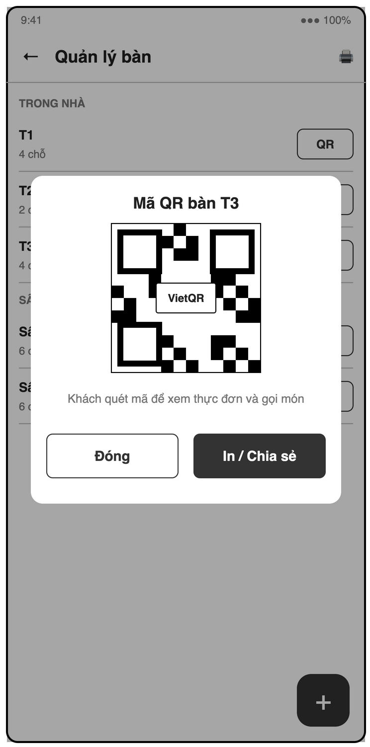
Figure 3-22: Screen Design of S12 Table management + QR print
Table 3-16: Screen Definition of S12 Table management + QR print
# | Field Name | Type | Mandatory | Max Length | Description
1 | Print all | Icon button |  | — | One page with the QR codes of all tables
2 | Table list | List |  | — | Grouped by area: name, capacity, QR button
3 | QR dialog | Dialog |  | — | QR for /c/{tableId} with the table name; "Đóng", "In / Chia sẻ"
4 | + | Floating button |  | — | Table form: name (Text, Yes, unique), area (Text, Yes), capacity (Number, Yes, > 0)

3.6.1.2 Use Case Description
Use Case ID | UC18 | Use Case Name | Manage tables and print table QR codes
Author | Phạm Khắc Nghĩa | Version | 1.0
Date | 23/09/2026 | Priority | High
Actor | Manager
Description | The manager sets up the shop's tables and prints a QR code for each table.  Goal: Model the physical floor plan and enable customer self-ordering.
Precondition | The caller has role = manager.
Trigger | Manager opens Table management (S12).
Post-Condition | tables/{id} is created or updated; its QR code is ready to print.
Main flows
Step | Actor | Action
1 | Manager | Manager opens S12.
1 | System | System lists tables grouped by area.
2 | Manager | Manager taps "Thêm bàn" and enters name (e.g. "T1"), area and capacity.
2 | System | System validates the input.
3 | Manager | Manager taps "Lưu".
3 | System | System saves the table with currentOrderId = null.

Alternative flows
AT1 | At step 1 in the main flows: Manager edits name, area or capacity.
Sub step | Actor | Action
1a.1 | System | System saves the change.
AT2 | At step 1 in the main flows: Manager deletes a table with no open order.
Sub step | Actor | Action
1b.1 | System | System asks for confirmation and deletes it.
AT3 | At step 1 in the main flows: Manager taps "In QR" on a table (FR-CUS-01).
Sub step | Actor | Action
1c.1 | System | System renders a QR encoding the customer URL /c/{tableId} with the table name and opens the share / print sheet.
AT4 | At step 1 in the main flows: Manager taps "In tất cả".
Sub step | Actor | Action
1d.1 | System | System builds one page with the QR codes of all tables.

Exceptions
# | Exception code | Condition | System handling
1 | invalid-argument | Invalid table | Name duplicated or capacity ≤ 0. System shows inline errors.
2 | failed-precondition | Table in use | The table has an open order. System shows "Bàn đang có đơn, không thể xóa".

Business Rules
No specific business rule.

3.6.2 UC19 – View table map
3.6.2.1 Screen Mock-up
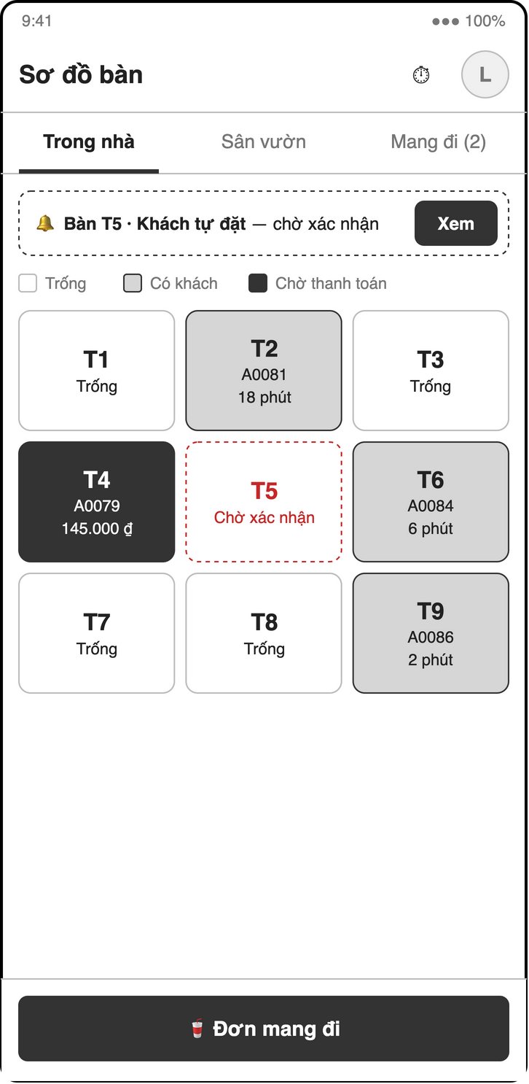
Figure 3-23: Screen Design of S13 Table map
Table 3-17: Screen Definition of S13 Table map
# | Field Name | Type | Mandatory | Max Length | Description
1 | Profile avatar / shift | Icon button |  | — | S22 / S07
2 | Area tabs | Tab |  | — | One tab per area, plus "Mang đi (n)" listing open takeaway orders (S13b)
3 | Customer order banner | Banner |  | — | "Bàn <x> · Khách tự đặt — chờ xác nhận" (or "Khách gọi thêm" when the table has an open order) with "Xem" (UC22)
4 | Table grid | Tile buttons (live) |  | — | Trống / Có khách / Chờ thanh toán, plus awaiting and ready badges; tap → S14
5 | Đơn mang đi | Button |  | — | Creates a takeaway order (tableId = null)

The "Mang đi" tab lists open takeaway orders with their status and a quick action (Đã giao when ready, Thanh toán when served).
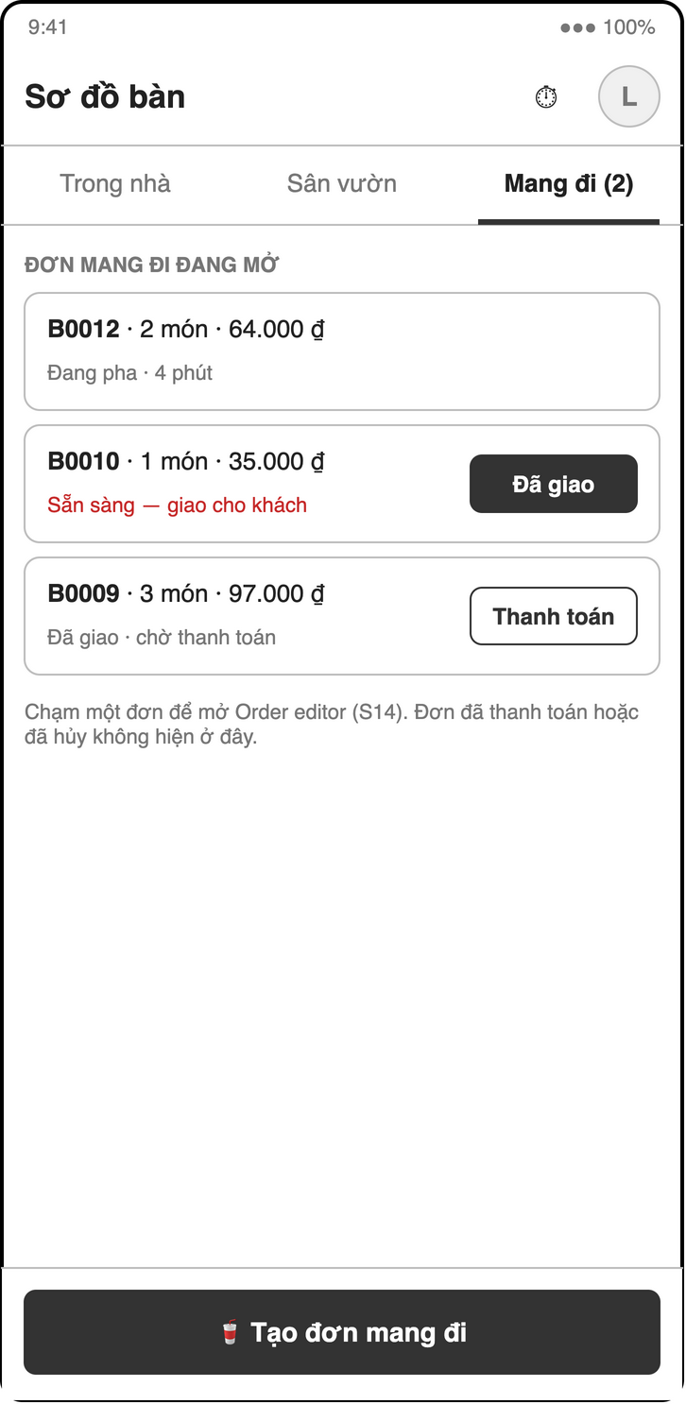
Figure 3-24: Screen Design of S13b Table map (takeaway tab)
3.6.2.2 Use Case Description
Use Case ID | UC19 | Use Case Name | View table map
Author | Phạm Khắc Nghĩa | Version | 1.0
Date | 23/09/2026 | Priority | High
Actor | Cashier
Description | The cashier sees all tables with their live status.  Goal: Know at a glance which tables are free, busy or waiting to pay.
Precondition | Tables exist.
Trigger | Cashier opens POS home (S13).
Post-Condition | None. The use case changes no state.
Main flows
Step | Actor | Action
1 | Cashier | Cashier opens S13.
1 | System | System shows tables grouped by area, updating in real time.
2 | System | System colors each table: Trống (currentOrderId = null), Có khách (open order pending / preparing / ready), Chờ thanh toán (open order served).
3 | System | System marks tables with an awaiting customer order (UC22) and tables with a ready order. An awaiting order does not make the table occupied.
4 | Cashier | Cashier taps a table.
4 | System | Empty table → UC20. Occupied table → Order editor (S14) of its open order.

Alternative flows
AT1 | At step 1 in the main flows: Cashier opens the "Mang đi" tab.
Sub step | Actor | Action
1a.1 | System | System lists open takeaway orders (tableId = null) with a "Tạo đơn mang đi" button.

Exceptions
# | Exception code | Condition | System handling
1 | unavailable | Offline | The connection is lost. System shows cached statuses and a "Mất kết nối" banner.

Business Rules
# | Rule Description
BR-ORD-03 | A table can have at most one open order (status not awaiting/paid/cancelled). awaiting orders do not occupy the table.

3.6.3 UC20 – Create an order
3.6.3.1 Screen Mock-up
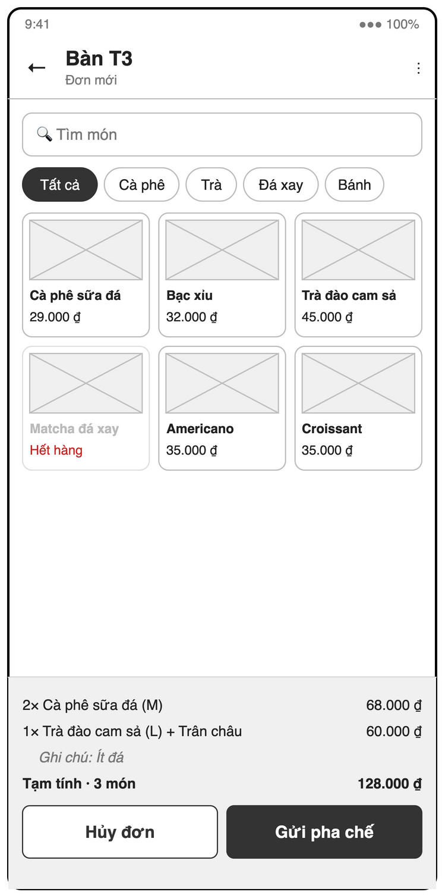
Figure 3-25: Screen Design of S14 Order editor (menu + cart)
Table 3-18: Screen Definition of S14 Order editor (menu + cart)
# | Field Name | Type | Mandatory | Max Length | Description
1 | Header | Label |  | — | Table or "Mang đi", order short ID and status
2 | ⋮ menu | Menu |  | — | Chuyển bàn, Gộp bàn, Hủy đơn, Đã phục vụ (when ready)
3 | Tìm món / category chips | Text / Chips | No | — | Menu search and filter (UC10)
4 | Product grid | Tile buttons |  | — | Name and price; greyed out when sold out; long-press toggles "Hết hàng"; "+" quick add
5 | Cart | List |  | — | Qty × name (size) + toppings and line price; edit or swipe to remove while pending; batch shown for add-ons
6 | Tạm tính | Label (VND) |  | — | Subtotal and item count
7 | Hủy đơn | Button |  | — | Cancel with reason (UC27)
8 | Gửi pha chế / Cập nhật | Button |  | — | Creates or updates the order; disabled when the cart is empty
9 | Thanh toán | Button |  | — | Shown when served; opens S15

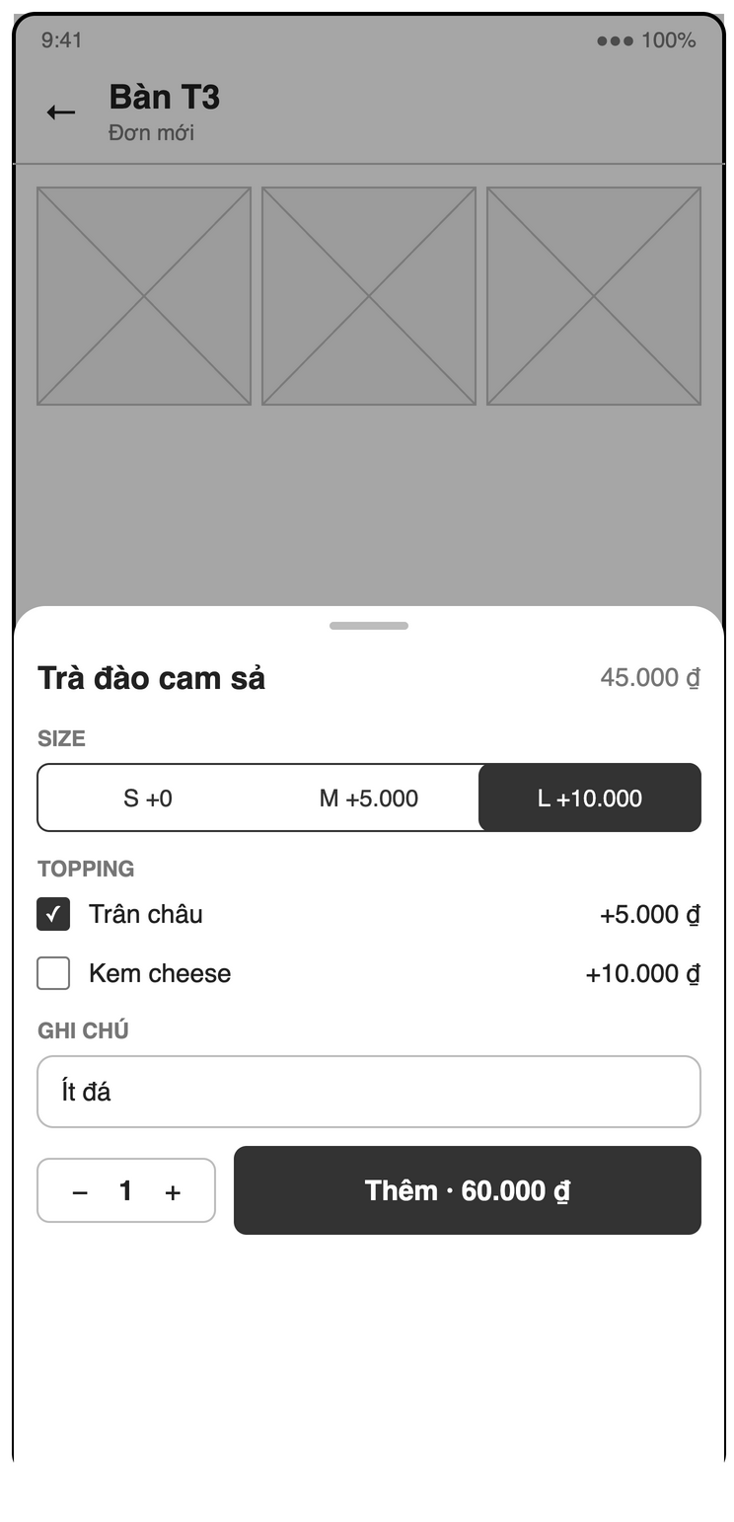
Figure 3-26: Screen Design of S14b Item options sheet
Table 3-19: Screen Definition of S14b Item options sheet
# | Field Name | Type | Mandatory | Max Length | Description
1 | Product | Label |  | — | Name and base price
2 | Size | Radio | Yes | — | Default: first size; shows price delta
3 | Topping | Checkbox list | No | — | Name and price
4 | Ghi chú | Text | No | — | e.g. "Ít đá"
5 | Quantity | Stepper | Yes | — | ≥ 1, default 1
6 | Thêm · <price> | Button |  | — | Adds the line with unitPrice = base + size + toppings

3.6.3.2 Use Case Description
Use Case ID | UC20 | Use Case Name | Create an order
Author | Phạm Khắc Nghĩa | Version | 1.1
Date | 23/09/2026 | Priority | High
Actor | Cashier
Description | The cashier creates a dine-in or takeaway order with items, sizes, toppings, quantities and notes and sends it to the barista.  Goal: Hand the order to the barista instantly and without errors.
Precondition | For dine-in, the table has no open order (BR-ORD-03).
Trigger | Cashier taps an empty table or "Tạo đơn mang đi".
Post-Condition | orders/{id} exists with status = pending, source = staff and today's shortId; the table's currentOrderId is set; the order is on the barista queue within 2 s.
Main flows
Step | Actor | Action
1 | Cashier | Cashier taps an empty table on S13.
1 | System | System opens Order editor (S14) with an empty cart.
2 | Cashier | Cashier browses the menu (UC10) and taps a product.
2 | System | System shows the item sheet: size (default first size), toppings, quantity (default 1), note.
3 | Cashier | Cashier confirms the item.
3 | System | System adds the line with unitPrice = base + size delta + Σ toppings and a snapshot of name and prices.
4 | Cashier | Cashier repeats steps 2–3 for more items.
4 | System | System updates the subtotal live.
5 | Cashier | Cashier taps "Gửi pha chế".
5 | System | System runs a transaction: re-checks the table is free, allocates the next shortId for today, creates the order and sets tables/{id}.currentOrderId.
6 | System | System returns to S13; the table shows "Có khách".

Alternative flows
AT1 | At step 1 in the main flows: Cashier creates a takeaway order.
Sub step | Actor | Action
1a.1 | System | System creates the order with tableId = null and skips the table update.
AT2 | At step 2 in the main flows: Cashier taps "+" on a product card.
Sub step | Actor | Action
2a.1 | System | System adds the default size, no toppings, quantity 1 (quick add).
AT3 | At step 4 in the main flows: Cashier edits or swipes away a line before sending.
Sub step | Actor | Action
4a.1 | System | System updates the cart and subtotal.

Exceptions
# | Exception code | Condition | System handling
1 | failed-precondition | Product sold out | The product is unavailable. System greys it out and does not add it.
2 | invalid-argument | Empty cart | The cart has no items. System disables "Gửi pha chế".
3 | aborted | Table taken | Another order was opened on the table meanwhile. System shows "Bàn đã có đơn" and opens the existing order.
4 | failed-precondition | Item became sold out | A product in the cart became unavailable. System flags the line; cashier must remove it before sending.

Business Rules
# | Rule Description
BR-ORD-01 | Item unit price = product base price + size delta + sum(topping prices).
BR-ORD-03 | A table can have at most one open order (status not awaiting/paid/cancelled). awaiting orders do not occupy the table.
BR-ORD-06 | shortId resets daily, format <letter><4 digits>.
NFR-PERF-01 | A new order appears on the barista screen within 2 s on normal 4G/Wi-Fi.
NFR-USE-01 | Cashier can create a 3-item order in ≤ 5 taps per item.

3.6.4 UC21 – Edit order items
3.6.4.1 Screen Mock-up
Uses screen S14 (defined in 3.6.3). The cart changes with the order status: pending lines are editable (S14e); once the order is served, earlier batches are read-only and new items form the next batch (S14g).
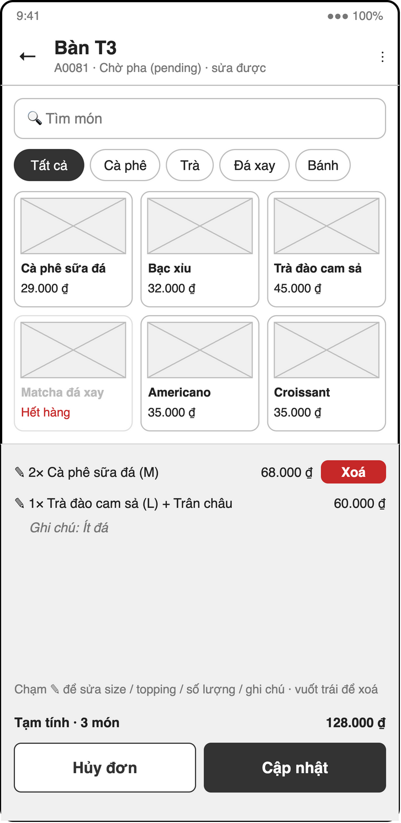
Figure 3-27: Screen Design of S14e Order editor (pending, edit)
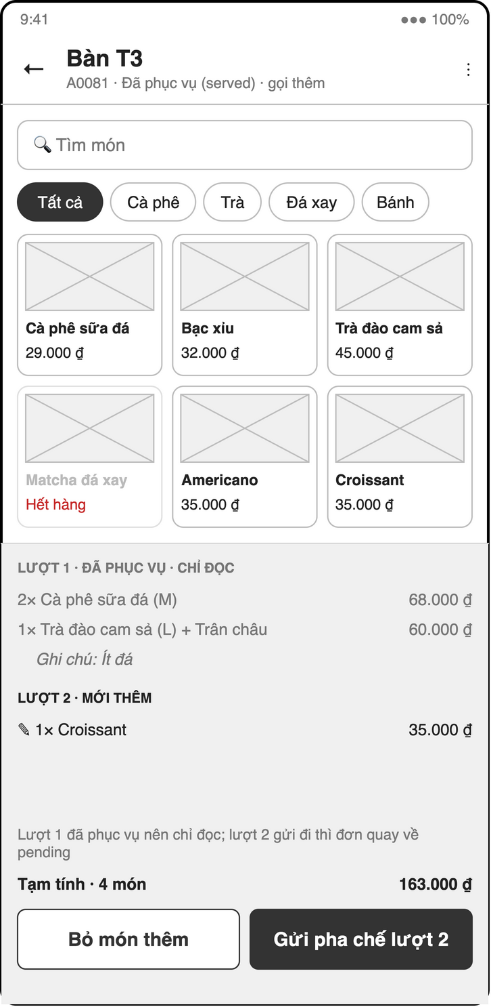
Figure 3-28: Screen Design of S14g Order editor (served, add-on batch)
3.6.4.2 Use Case Description
Use Case ID | UC21 | Use Case Name | Edit order items
Author | Phạm Khắc Nghĩa | Version | 1.1
Date | 23/09/2026 | Priority | High
Actor | Cashier
Description | The cashier changes, removes or adds items on an open order.  Goal: Fix mistakes and take extra items without creating a new order.
Precondition | Order status is pending (edit / remove / add) or preparing / ready / served (add only).
Trigger | Cashier opens an open order in Order editor (S14).
Post-Condition | Items and subtotal are updated; updatedAt = now.
Main flows
Step | Actor | Action
1 | Cashier | Cashier opens the order (S14).
1 | System | System shows the items; all lines are editable because the order is pending.
2 | Cashier | Cashier changes size, toppings, quantity or note, removes a line, or adds items.
2 | System | System recomputes line prices and subtotal.
3 | Cashier | Cashier taps "Cập nhật".
3 | System | System re-reads the order in a transaction, verifies status is still pending and saves items and subtotal.

Alternative flows
AT1 | At step 1 in the main flows: The order is preparing, ready or served (BR-ORD-04).
Sub step | Actor | Action
1a.1 | System | System enables only "Thêm món"; existing lines are read-only.
1a.2 | Cashier | Cashier adds items and taps "Cập nhật".
1a.2 | System | System appends the new lines. Preparing: they join the current batch, the status stays and the barista hears an alert. Ready / served: they get batch = max(batch) + 1, the status moves back to pending and the barista sees only the new batch.
AT2 | At step 2 in the main flows: Cashier removes the last line.
Sub step | Actor | Action
2a.1 | System | System offers to cancel the order instead (UC27).

Exceptions
# | Exception code | Condition | System handling
1 | failed-precondition | Already preparing | Status changed to preparing meanwhile while existing lines were edited. System shows "Đơn đang được pha, chỉ thêm món được", discards the changes and reopens the order in add-only mode.
2 | failed-precondition | Read-only order | Order is ready, paid or cancelled. System shows the order read-only.

Business Rules
# | Rule Description
BR-ORD-01 | Item unit price = product base price + size delta + sum(topping prices).
BR-ORD-04 | Adding items to a ready or served order moves it back to pending; the new items get batch = max(batch) + 1 and the barista card shows only the latest batch. Items added while pending or preparing join the current batch (status unchanged, sound alert).
STATE | Order status follows the state machine: awaiting → pending (cashier confirms) or cancelled (cashier rejects); pending → preparing → ready → served → paid; ready / served → pending (items added); pending / preparing / ready / served → cancelled. paid and cancelled are terminal.

3.6.5 UC22 – Confirm a customer order
3.6.5.1 Screen Mock-up
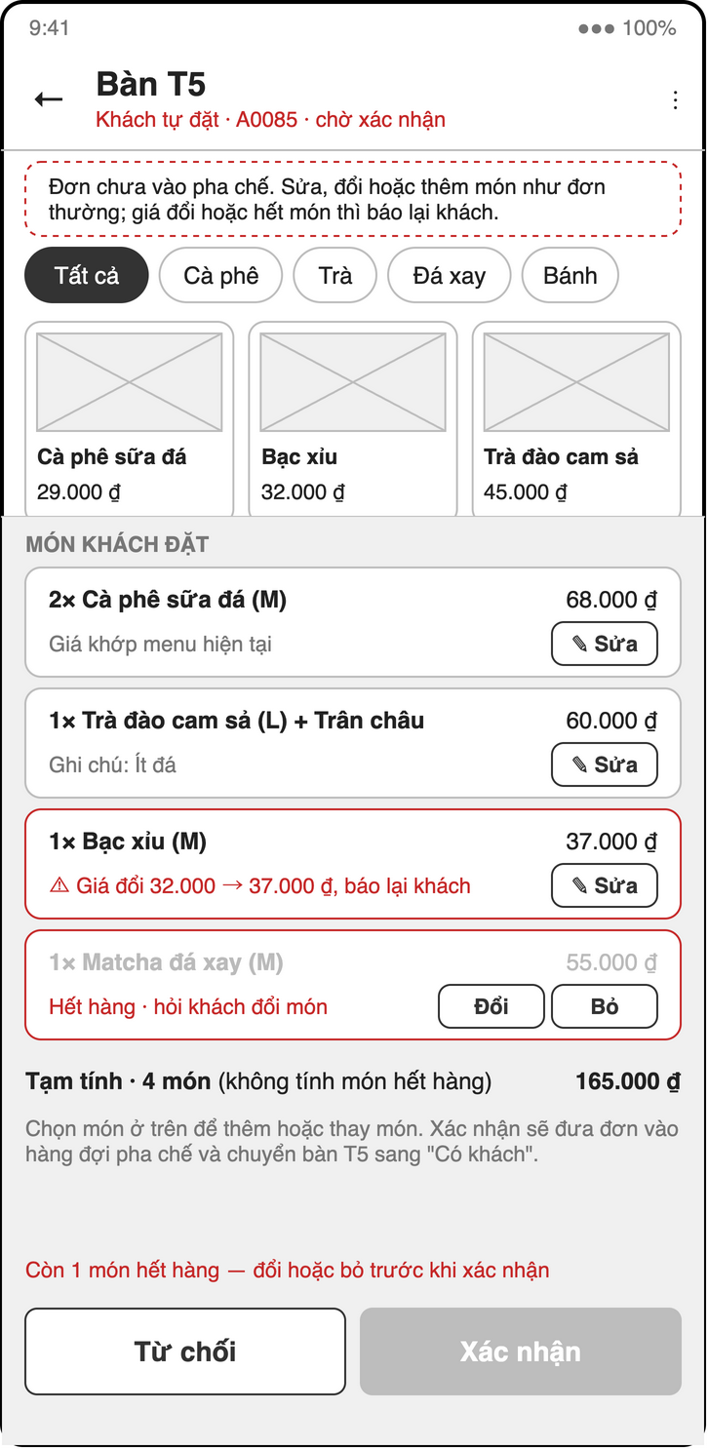
Figure 3-29: Screen Design of S14c Confirm customer order
Table 3-20: Screen Definition of S14c Confirm customer order
# | Field Name | Type | Mandatory | Max Length | Description
1 | Header | Label |  | — | Table, short ID, "Khách tự đặt · chờ xác nhận"; "Khách gọi thêm · vào đơn <shortId>" when the table has an open order
2 | Info | Label |  | — | The order is not on the barista queue yet; the menu grid and cart work as in S14 so items can be edited, swapped or added
3 | Món khách đặt | List |  | — | Each line with the current menu price; price changes ("báo lại khách") and sold-out items highlighted
4 | Bỏ | Button |  | — | "✎ Sửa" edits a line; "Đổi" swaps a sold-out item for another product from the menu above; "Bỏ" removes the line
5 | Tạm tính | Label (VND) |  | — | Recomputed from current prices
6 | Từ chối | Button |  | — | Rejects: cancel with reason (UC27)
7 | Xác nhận | Button |  | — | Disabled while sold-out lines remain; confirms → pending

When the table already has an open order, S14c opens as an add-on (S14h): the open order is shown read-only above the customer's items, totals show the add-on and the new order total, and the confirm button reads "Thêm vào <shortId>" (BR-ORD-07).
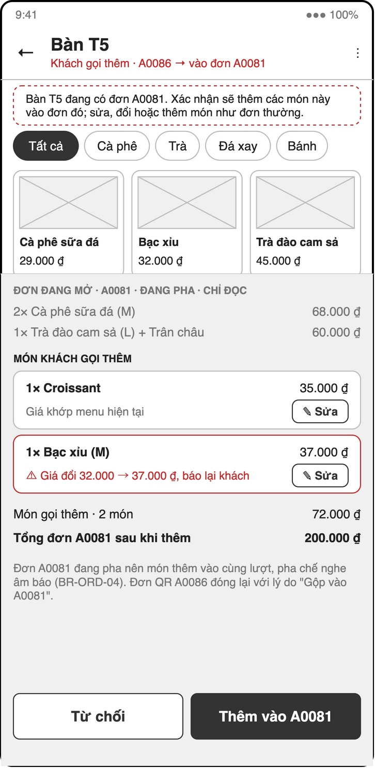
Figure 3-30: Screen Design of S14h Confirm customer add-on (table has open order)
3.6.5.2 Use Case Description
Use Case ID | UC22 | Use Case Name | Confirm a customer order
Author | Phạm Khắc Nghĩa | Version | 1.1
Date | 23/09/2026 | Priority | Medium
Actor | Cashier
Description | The cashier reviews an order placed by a customer via table QR, re-validates prices and confirms or rejects it.  Goal: Protect the shop from wrong or tampered customer orders.
Precondition | The order was created by UC32 and has status = awaiting.
Trigger | A customer order (status = awaiting) appears on S13 with a badge.
Post-Condition | Prices are re-validated against the current menu and confirmedBy / confirmedAt are set. Free table: the order has status = pending, the table's currentOrderId is set and the order is on the barista queue. Table with an open order: the items are in the open order (BR-ORD-04) and the QR order is cancelled with cancelReason "Gộp vào <shortId>" and mergedIntoId.
Main flows
Step | Actor | Action
1 | Cashier | Cashier opens the flagged order (S14).
1 | System | System shows the items and, next to each, the current menu price.
2 | System | System recomputes every unitPrice from current product data and highlights mismatches and unavailable items.
3 | Cashier | Cashier tells the customer about price changes and sold-out items, then edits, swaps (from the menu) or removes lines as agreed and taps "Xác nhận".
3 | System | System runs a transaction: writes the corrected prices, confirmedBy and confirmedAt, then reads the table. Free table: sets status = pending and the table's currentOrderId. Table with an open order: appends the items to it (same batch while pending / preparing, new batch and back to pending while ready / served), recomputes its totals and closes the QR order as cancelled with cancelReason "Gộp vào <shortId>" and mergedIntoId.

Alternative flows
AT1 | At step 3 in the main flows: Cashier rejects the order.
Sub step | Actor | Action
3a.1 | System | System starts UC27 to cancel it with a reason.

Exceptions
# | Exception code | Condition | System handling
1 | failed-precondition | Open order closed meanwhile | The table's open order was paid or cancelled during confirmation. System re-reads the table and retries; the QR order then becomes the table's order.

Business Rules
# | Rule Description
BR-ORD-01 | Item unit price = product base price + size delta + sum(topping prices).
BR-ORD-07 | Customer QR orders are created as awaiting and reach the barista only when a cashier confirms them. If the table has no open order at confirmation, the QR order becomes the table's order (→ pending). If it has one, the QR items are added to that open order under BR-ORD-04 and the QR order is closed as cancelled with cancelReason = "Gộp vào <shortId>" and mergedIntoId; the customer's status screen then follows the open order.
SEC-CONFIRM | Only staff can set confirmedBy and confirmedAt; Security Rules reject them on customer writes.

3.6.6 UC23 – Mark an order as served
3.6.6.1 Screen Mock-up
Uses screen(s) S13 (defined in 3.6.2), S14 (defined in 3.6.3).
A ready order opens in S14 with read-only lines and a full-width "Đã phục vụ" button (S14f); takeaway orders can also be marked from the "Mang đi" tab (S13b, "Đã giao").
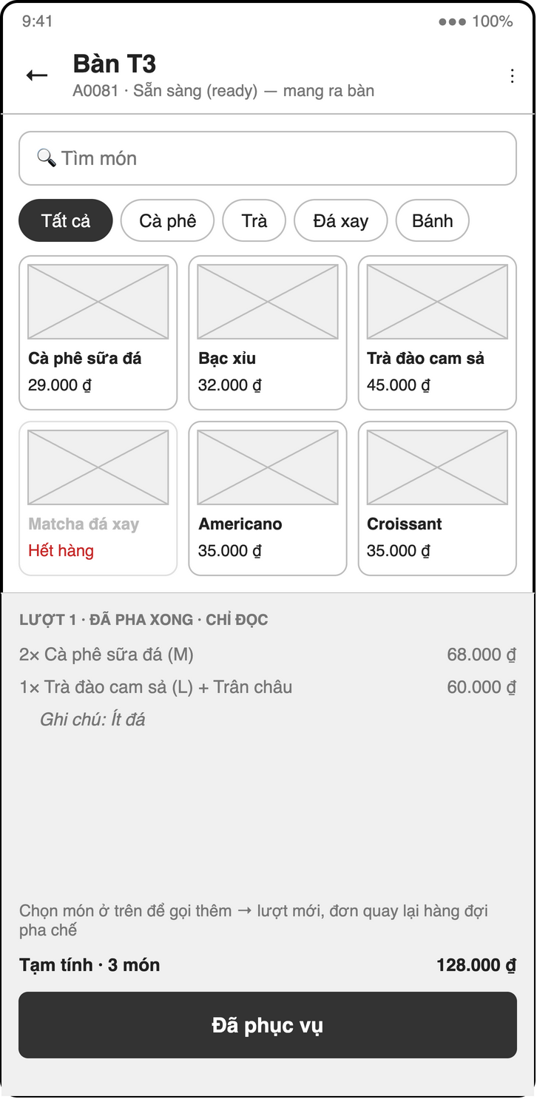
Figure 3-31: Screen Design of S14f Order editor (ready, serve or add)
3.6.6.2 Use Case Description
Use Case ID | UC23 | Use Case Name | Mark an order as served
Author | Phạm Khắc Nghĩa | Version | 1.1
Date | 23/09/2026 | Priority | High
Actor | Cashier
Description | The cashier records that a ready order was delivered to the customer (takeaway: when handed to the customer).  Goal: Move the order to the payment step and show the table as waiting for payment (FR-POS-12).
Precondition | Order status = ready.
Trigger | The order is ready (UC31 notification or table indicator).
Post-Condition | Order status = served; the table shows "Chờ thanh toán".
Main flows
Step | Actor | Action
1 | Cashier | Cashier taps "Đã phục vụ" on the order, table or notification.
1 | System | System sets status = served and updatedAt = now.
2 | System | System updates the table map.

Alternative flows
None.
Exceptions
# | Exception code | Condition | System handling
1 | failed-precondition | Wrong status | The order is no longer ready (e.g. cancelled). System refreshes the order and shows its current status.

Business Rules
# | Rule Description
STATE | Order status follows the state machine: awaiting → pending (cashier confirms) or cancelled (cashier rejects); pending → preparing → ready → served → paid; ready / served → pending (items added); pending / preparing / ready / served → cancelled. paid and cancelled are terminal.

3.6.7 UC24 – Apply a voucher
3.6.7.1 Screen Mock-up
Uses screen(s) S15 (defined in 3.6.8).
3.6.7.2 Use Case Description
Use Case ID | UC24 | Use Case Name | Apply a voucher
Author | Phạm Khắc Nghĩa | Version | 1.1
Date | 23/09/2026 | Priority | Medium
Actor | Cashier
Description | The cashier applies a voucher code to an order; vouchers are the only discount (BR-DIS-03).  Goal: Support promotions while keeping every discount controlled by a voucher.
Precondition | The order is open (not paid or cancelled).
Trigger | Cashier taps "Mã giảm giá" in Order editor (S14) or Payment (S15).
Post-Condition | voucherCode and discount are set and total is recomputed by BR-ORD-02.
Main flows
Step | Actor | Action
1 | Cashier | Cashier taps "Mã giảm giá" and enters a code.
1 | System | System reads vouchers/{code}.
2 | System | System validates isActive, expiresAt > now, usedCount < usageLimit and subtotal ≥ minOrder.
3 | System | System computes the discount: fixed → value; percent → subtotal × value / 100, capped by maxDiscount; never above subtotal.
4 | Cashier | Cashier taps "Áp dụng".
4 | System | System saves voucherCode and discount and shows the new total.

Alternative flows
AT1 | At step 1 in the main flows: An order already has a voucher and a new code is entered.
Sub step | Actor | Action
1a.1 | System | System replaces the old voucher with the new one.
AT2 | At step 1 in the main flows: Cashier removes the voucher.
Sub step | Actor | Action
1b.1 | System | System sets discount = 0 and voucherCode = null.

Exceptions
# | Exception code | Condition | System handling
1 | not-found | Unknown code | The voucher does not exist. System shows "Mã không tồn tại".
2 | deadline-exceeded | Expired | The voucher has expired or is inactive. System shows "Mã đã hết hạn".
3 | resource-exhausted | Used up | usedCount ≥ usageLimit. System shows "Mã đã hết lượt".
4 | failed-precondition | Below minimum | subtotal < minOrder. System shows "Đơn tối thiểu <minOrder>".

Business Rules
# | Rule Description
BR-DIS-01 | Only one voucher per order.
BR-DIS-02 | Percent voucher discount is capped by maxDiscount if set.
BR-DIS-03 | There is no manual discount; discount comes only from a valid voucher (BR-DIS-01, BR-DIS-02).
BR-ORD-02 | Order total = subtotal − discount − (pointsRedeemed × vndPerPoint), minimum 0.
NFR-AUD-01 | Cancellations, vouchers, payments, stock adjustments and cash handovers record who and when.

3.6.8 UC25 – Take payment (cash or VietQR)
3.6.8.1 Screen Mock-up
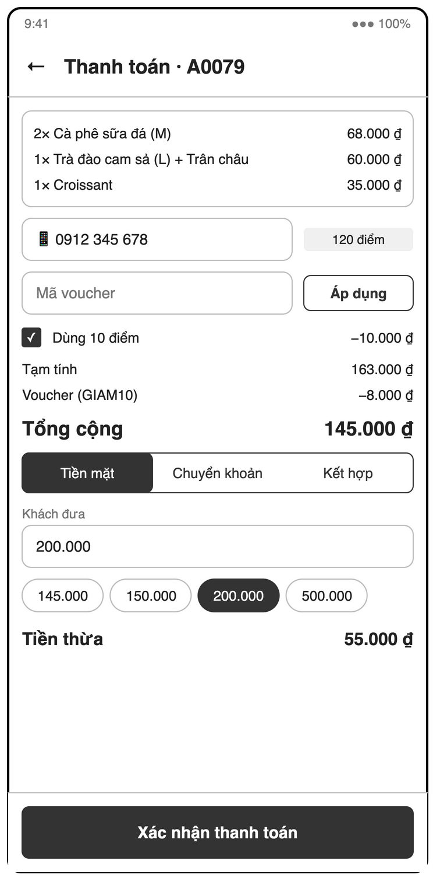
Figure 3-32: Screen Design of S15 Payment (cash)
Table 3-21: Screen Definition of S15 Payment (cash)
# | Field Name | Type | Mandatory | Max Length | Description
1 | Items | List |  | — | Order lines with prices
2 | Khách hàng thành viên | Text (phone) | No | — | 10 digits starting with 0; shows name and points; "Tạo khách mới" if unknown (UC38)
3 | Mã voucher | Text | No | — | Code + "Áp dụng" (UC24)
4 | Dùng điểm | Checkbox / Number | No | — | Points to redeem ≤ max redeemable; "Dùng tối đa" (UC39)
5 | Tạm tính / Voucher / Điểm / Tổng cộng | Label (VND) |  | — | BR-ORD-02
6 | Payment method | Segmented | Yes | — | Tiền mặt / Chuyển khoản / Kết hợp
7 | Khách đưa | Number (VND) | Yes (cash) | — | ≥ total; quick amounts (exact, rounded notes)
8 | Tiền thừa | Label (VND) |  | — | Received − total; not stored
9 | Xác nhận thanh toán | Button |  | — | Disabled while received < total; runs the payment transaction

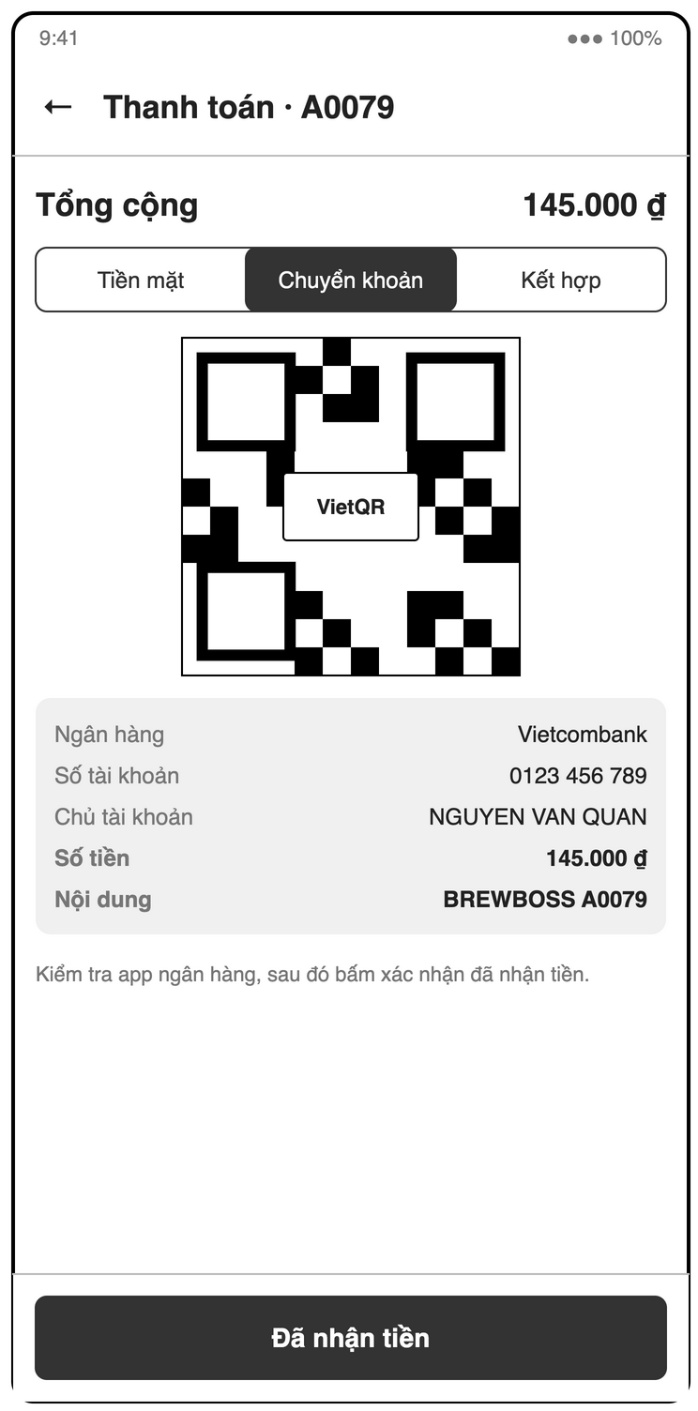
Figure 3-33: Screen Design of S15b Payment (VietQR)
Table 3-22: Screen Definition of S15b Payment (VietQR)
# | Field Name | Type | Mandatory | Max Length | Description
1 | Tổng cộng | Label (VND) |  | — | Amount to transfer (qrAmount = total)
2 | VietQR image | Image |  | — | From img.vietqr.io with amount and short ID; bank, account number, account name, amount and note as text fallback
3 | Info | Label |  | — | Check the bank app before confirming
4 | Đã nhận tiền | Button |  | — | Confirms the transfer and runs the payment transaction
5 | Hủy | Button |  | — | Back to method selection; nothing written

3.6.8.2 Use Case Description
Use Case ID | UC25 | Use Case Name | Take payment (cash or VietQR)
Author | Phạm Khắc Nghĩa | Version | 1.1
Date | 23/09/2026 | Priority | High
Actor | Cashier
Description | The cashier collects payment in cash, by VietQR bank transfer, or split between both (UC46); the system closes the order, deducts stock and updates loyalty points in one transaction.  Goal: Close every sale correctly so revenue, stock and points always match.
Precondition | Order status = served (BR-PAY-04; takeaway orders are marked served when handed over). The payer has an open shift (BR-PAY-03, UC05).
Trigger | Cashier taps "Thanh toán" on an order.
Post-Condition | In one transaction: order paid with cashAmount, qrAmount (cashAmount + qrAmount = total), paidBy = payer uid and paidAt; stock deducted with sale movements; customer points and visitCount updated; voucher usedCount++; table currentOrderId = null.
Main flows
Step | Actor | Action
1 | Cashier | Cashier opens Payment (S15).
1 | System | System shows items, subtotal, discount, points redeemed and total.
2 | Cashier | Cashier optionally attaches a loyalty customer, applies a voucher or redeems points.
2 | System | System runs UC38, UC24 or UC39 and recomputes the total.
3 | Cashier | Cashier selects "Tiền mặt" and enters the amount received (quick buttons: exact, 50.000, 100.000, 200.000, 500.000).
3 | System | System shows change due = received − total (not stored, BR-PAY-02).
4 | Cashier | Cashier taps "Xác nhận thanh toán".
4 | System | System starts one Firestore transaction: re-reads the order and verifies its status, verifies the payer has an open shift (BR-PAY-03) and cashAmount + qrAmount = total (BR-PAY-01), re-validates the voucher, reads recipe ingredients and the customer.
5 | System | System writes: order status = paid, cashAmount = total, qrAmount = 0, paidBy = payer uid, paidAt = now; stock deduction and sale movements (UC15); customer points += floor(total / pointsPerVnd) − pointsRedeemed and visitCount++; voucher usedCount++; table currentOrderId = null.
6 | System | System shows "Thanh toán thành công" with a receipt option (UC28) and returns to S13; the table shows "Trống".

Alternative flows
AT1 | At step 3 in the main flows: Cashier selects "Chuyển khoản" (FR-POS-08).
Sub step | Actor | Action
3a.1 | System | System builds https://img.vietqr.io/image/{bankBin}-{bankAccountNo}-compact2.png?amount={qrAmount}&addInfo={shortId}&accountName={bankAccountName} from settings/shop (qrAmount = total) and shows it full screen.
3a.2 | Cashier | Customer scans the QR and transfers; cashier checks the bank app and taps "Đã nhận tiền".
3a.2 | System | System continues at step 4 with cashAmount = 0, qrAmount = total.
AT2 | At step 3 in the main flows: The total is 0 after the voucher and points.
Sub step | Actor | Action
3b.1 | System | System skips step 3 and records cashAmount = 0, qrAmount = 0.
AT3 | At step 3 in the main flows: Extension point "Split payment": the customer pays part by transfer and the rest in cash; cashier selects "Kết hợp" (FR-POS-14).
Sub step | Actor | Action
3c.1 | System | System runs UC46 (extend), then continues at step 4 with the split cashAmount and qrAmount.
AT4 | At step 6 in the main flows: An ingredient falls to or below min stock.
Sub step | Actor | Action
6a.1 | System | System starts UC16 after commit.

Exceptions
# | Exception code | Condition | System handling
1 | invalid-argument | Not enough cash | Received < total. System disables "Xác nhận" and shows "Số tiền chưa đủ".
2 | failed-precondition | No open shift | The payer has no open shift (BR-PAY-03). System shows "Bạn cần vào ca trước khi thanh toán" with a shortcut to UC05; nothing is written.
3 | failed-precondition | Bank not configured | settings/shop has no bank data. System shows "Chưa cấu hình tài khoản ngân hàng" and links to UC29 for managers.
4 | unavailable | QR not loaded | The VietQR image cannot load. System shows bank, account and amount as text.
5 | cancelled | Transfer not received | Customer did not pay. Cashier taps "Hủy" and picks another method; nothing is written.
6 | aborted | Transaction failed | Offline, conflict, voucher used up or status changed. Nothing is written; System shows the reason and keeps S15 open for retry.

Business Rules
# | Rule Description
BR-ORD-02 | Order total = subtotal − discount − (pointsRedeemed × vndPerPoint), minimum 0.
BR-DIS-01 | Only one voucher per order.
BR-PAY-01 | cashAmount + qrAmount = total, both ≥ 0. A single-method payment sets the other field to 0.
BR-PAY-02 | cashAmount is the cash kept by the shop; change due = cash received − cashAmount and is not stored.
BR-PAY-03 | Only a user with an open shift can confirm a payment, so every sale belongs to a shift.
BR-LOY-01 | Points earned = floor(total / pointsPerVnd), computed on the amount actually paid.
BR-LOY-02 | Redeemed points cannot exceed customer balance or make total negative.
BR-INV-01 | Stock deduction happens at payment, not at order creation. Cancelled orders do not consume stock unless BR-INV-02 applies.
NFR-REL-01 | Payment, stock deduction and points run in one Firestore transaction (all or nothing).

3.6.9 UC46 – Split payment between cash and VietQR
3.6.9.1 Screen Mock-up
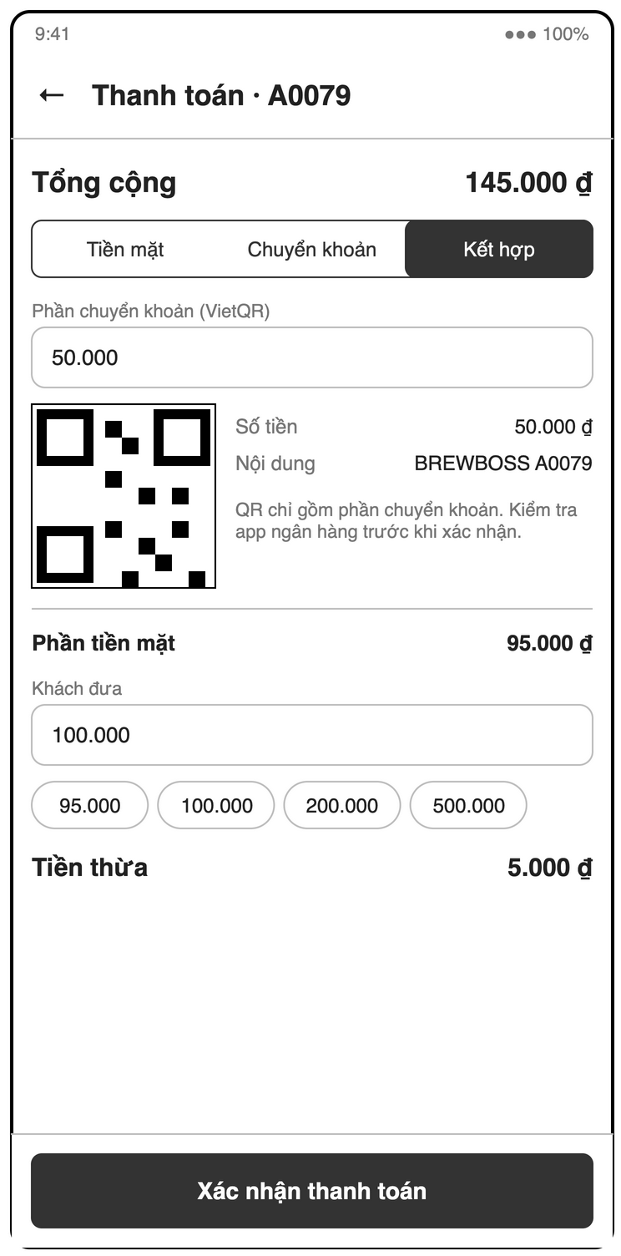
Figure 3-34: Screen Design of S15c Payment (split cash + VietQR)
Table 3-23: Screen Definition of S15c Payment (split cash + VietQR)
# | Field Name | Type | Mandatory | Max Length | Description
1 | Phần chuyển khoản (VietQR) | Number (VND) | Yes | — | 0 < qrAmount < total
2 | VietQR image | Image |  | — | Amount = transfer part only
3 | Phần tiền mặt | Label (VND) |  | — | total − qrAmount
4 | Khách đưa | Number (VND) | Yes | — | ≥ cash part; quick amounts
5 | Tiền thừa | Label (VND) |  | — | Received − cash part; not stored
6 | Xác nhận thanh toán | Button |  | — | Runs the payment transaction with cashAmount and qrAmount

3.6.9.2 Use Case Description
Use Case ID | UC46 | Use Case Name | Split payment between cash and VietQR
Author | Phạm Khắc Nghĩa | Version | 1.0
Date | 23/09/2026 | Priority | Medium
Actor | Cashier
Description | The customer pays one order partly by VietQR transfer and the rest in cash; the system stores both amounts on the order.  Goal: Accept mixed payments without breaking revenue, cash handover or reports (FR-POS-14).
Precondition | UC25 preconditions hold (payable order, payer has an open shift, BR-PAY-03); settings/shop has bank data.
Trigger | Extends UC25 at step 3 when the cashier selects "Kết hợp".
Post-Condition | UC25 continues at step 4 with qrAmount = transfer part and cashAmount = total − qrAmount (BR-PAY-01).
Main flows
Step | Actor | Action
1 | Cashier | Cashier selects "Kết hợp" on Payment (S15).
1 | System | System shows the total and a field for the transfer part.
2 | Cashier | Cashier enters the transfer part.
2 | System | System validates 0 < qrAmount < total and shows the cash part = total − qrAmount.
3 | System | System builds the VietQR image with amount={qrAmount} and shows it full screen.
4 | Cashier | Customer scans and transfers; cashier checks the bank app and taps "Đã nhận tiền".
4 | System | System shows the cash part and asks for the cash received.
5 | Cashier | Cashier enters the cash received (quick buttons as in UC25).
5 | System | System shows change due = received − cashAmount (not stored, BR-PAY-02).
6 | Cashier | Cashier taps "Xác nhận thanh toán".
6 | System | System returns to UC25 step 4 with cashAmount and qrAmount.

Alternative flows
AT1 | At step 2 in the main flows: The transfer part is 0 or equals the total.
Sub step | Actor | Action
2a.1 | System | System switches to a cash-only (UC25 step 3) or VietQR-only (UC25 3a.1) payment.

Exceptions
# | Exception code | Condition | System handling
1 | invalid-argument | Invalid transfer part | qrAmount < 0 or > total. System shows "Số tiền chuyển khoản không hợp lệ" and stays at step 2.
2 | invalid-argument | Not enough cash | Received < cashAmount. System disables "Xác nhận" and shows "Số tiền chưa đủ".
3 | unavailable | QR not loaded | The VietQR image cannot load. System shows bank, account and qrAmount as text.
4 | cancelled | Transfer not received | Customer did not transfer. Cashier taps "Hủy" and returns to UC25 step 3; nothing is written.

Business Rules
# | Rule Description
BR-PAY-01 | cashAmount + qrAmount = total, both ≥ 0. A single-method payment sets the other field to 0.
BR-PAY-02 | cashAmount is the cash kept by the shop; change due = cash received − cashAmount and is not stored.

3.6.10 UC26 – Move or merge tables
3.6.10.1 Screen Mock-up
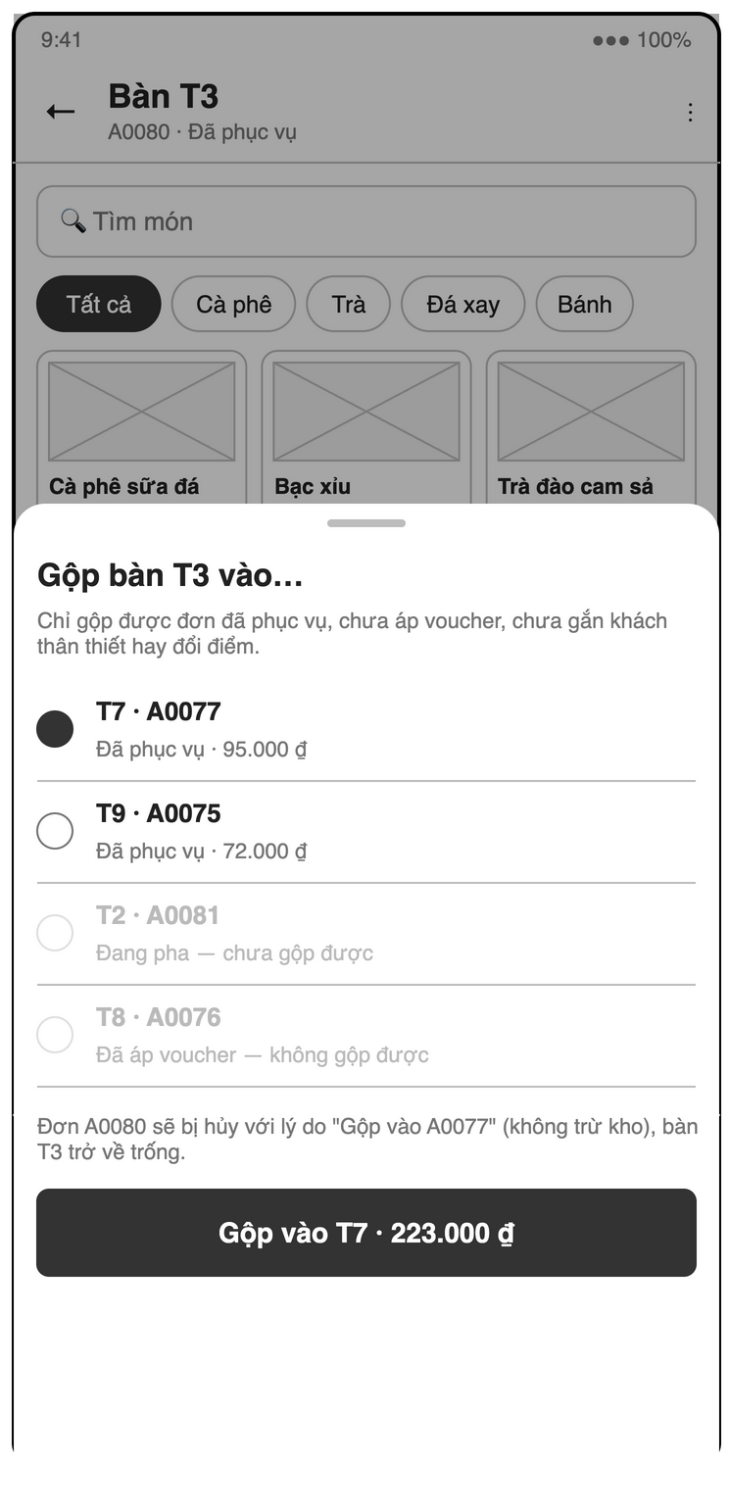
Figure 3-35: Screen Design of S14d Merge tables sheet
Table 3-24: Screen Definition of S14d Merge tables sheet
# | Field Name | Type | Mandatory | Max Length | Description
1 | Rule note | Label |  | — | Only served orders without voucher, customer or redeemed points can be merged
2 | Target list | List (single select) | Yes | — | Tables with an open order; non-mergeable ones disabled with the reason
3 | Impact note | Label |  | — | Source order will be cancelled with reason "Gộp vào <shortId>" (no stock deduction)
4 | Gộp vào <table> · <total> | Button |  | — | Runs the merge transaction (BR-ORD-08)
5 | Chuyển bàn (move) | List (single select) | Yes | — | Same sheet in move mode lists empty tables only

3.6.10.2 Use Case Description
Use Case ID | UC26 | Use Case Name | Move or merge tables
Author | Phạm Khắc Nghĩa | Version | 1.0
Date | 23/09/2026 | Priority | Medium
Actor | Cashier
Description | The cashier moves an open order to an empty table or merges two served orders into one shared bill.  Goal: Follow guests when they change or join tables without losing items.
Precondition | The source table has an open order.
Trigger | Guests move to another table or two groups join.
Post-Condition | Move: the order is on the target table and the source is empty. Merge: one open order remains on the target table and the source is empty.
Main flows
Step | Actor | Action
1 | Cashier | Cashier opens the order and taps "Chuyển bàn".
1 | System | System shows empty tables only.
2 | Cashier | Cashier picks the target table.
2 | System | System runs a transaction: re-checks the target is empty, sets order.tableId = target, target.currentOrderId = order and source.currentOrderId = null.

Alternative flows
AT1 | At step 1 in the main flows: Cashier taps "Gộp bàn".
Sub step | Actor | Action
1a.1 | System | System shows tables whose open order is served.
1a.2 | Cashier | Cashier picks the target table.
1a.2 | System | System runs a transaction: appends the source order's items to the target order, recomputes subtotal and total, cancels the source order with reason "Gộp vào <target shortId>" and mergedIntoId without stock deduction and clears the source table (BR-ORD-08).

Exceptions
# | Exception code | Condition | System handling
1 | aborted | Target occupied | The target table was taken meanwhile. System shows "Bàn đã có khách" and changes nothing.
2 | failed-precondition | Cannot merge | Either order is not served or has a voucher, customer or redeemed points. System shows "Không thể gộp đơn này".

Business Rules
# | Rule Description
BR-ORD-03 | A table can have at most one open order (status not awaiting/paid/cancelled). awaiting orders do not occupy the table.
BR-ORD-08 | Two tables can be merged only when both orders are served and neither has a voucher, customer or redeemed points. The target order receives the source items; the source order is cancelled with reason "Gộp vào <target shortId>" without stock deduction and is excluded from cancellation counts.

3.6.11 UC27 – Cancel an order
3.6.11.1 Screen Mock-up
Uses screen(s) S14 (defined in 3.6.3).
3.6.11.2 Use Case Description
Use Case ID | UC27 | Use Case Name | Cancel an order
Author | Phạm Khắc Nghĩa | Version | 1.1
Date | 23/09/2026 | Priority | High
Actor | Cashier / Manager
Description | Staff cancels an order that will not be completed, with a mandatory reason.  Goal: Remove unwanted orders while keeping an auditable record of every cancellation.
Precondition | Order status = awaiting or pending; or preparing / ready / served when the actor is a manager.
Trigger | The customer leaves (even after being served), the order was wrong, or a customer order is rejected.
Post-Condition | status = cancelled with cancelReason and cancelledBy; the table is cleared; no sale deduction. If "Đã pha" was ticked, stock is deducted as waste (UC43).
Main flows
Step | Actor | Action
1 | User | Actor opens the order and taps "Hủy đơn".
1 | System | System asks for a reason (preset list + free text). For preparing / ready / served orders it also shows a "Đã pha" checkbox (ticked by default for ready / served).
2 | User | Actor enters the reason and confirms.
2 | System | System runs a transaction: re-checks status and role, sets status = cancelled, cancelReason, cancelledBy and updatedAt, and clears the table's currentOrderId.
3 | System | System removes the order from the barista queue and the table map.

Alternative flows
AT1 | At step 2 in the main flows: Manager ticks "Đã pha".
Sub step | Actor | Action
2a.1 | System | System runs UC43 inside the same cancel transaction.

Exceptions
# | Exception code | Condition | System handling
1 | invalid-argument | Reason missing | The reason is empty. System shows "Vui lòng nhập lý do hủy".
2 | permission-denied | Manager only | The order is preparing, ready or served and the actor is a cashier. System shows "Chỉ quản lý được hủy đơn đã bắt đầu pha".
3 | failed-precondition | Not cancellable | The order is paid or cancelled. System hides the action.

Business Rules
# | Rule Description
BR-ORD-05 | Cancellation requires a reason; awaiting and pending orders can be cancelled by Cashier or Manager; preparing, ready and served orders only by Manager, except the source order of a merge (BR-ORD-08).
BR-INV-01 | Stock deduction happens at payment, not at order creation. Cancelled orders do not consume stock unless BR-INV-02 applies.
BR-INV-02 | Cancelling an order whose drinks were already made deducts ingredients by recipe as waste (adjust, reason = cancel reason). Default: ticked for ready / served, unticked for preparing, not offered for awaiting / pending.
NFR-AUD-01 | Cancellations, vouchers, payments, stock adjustments and cash handovers record who and when.

3.6.12 UC28 – View and share a receipt
3.6.12.1 Screen Mock-up
Uses screen(s) S15 (defined in 3.6.8), S20 (defined in 3.9.2).
3.6.12.2 Use Case Description
Use Case ID | UC28 | Use Case Name | View and share a receipt
Author | Phạm Khắc Nghĩa | Version | 1.1
Date | 23/09/2026 | Priority | Low
Actor | Cashier
Description | The cashier generates a PDF receipt for a paid order and shares or prints it.  Goal: Give customers a receipt when they ask for one.
Precondition | Order status = paid.
Trigger | Cashier taps "Hóa đơn" after payment or on a paid order in history.
Post-Condition | A PDF is generated on the device (not stored).
Main flows
Step | Actor | Action
1 | Cashier | Cashier taps "Hóa đơn".
1 | System | System generates a PDF: shop name and address, short ID, table, time, cashier (paidBy), items, subtotal, voucher discount, points, total, cash amount and VietQR amount (change is shown only right after payment; it is not stored, BR-PAY-02).
2 | Cashier | Cashier taps "Chia sẻ" or "In".
2 | System | System opens the system share or print sheet.

Alternative flows
None.
Exceptions
No specific exception beyond the common ones (permission-denied, unavailable; see 5.2).
Business Rules
No specific business rule.

3.6.13 UC29 – Configure shop settings
3.6.13.1 Screen Mock-up
Uses screen(s) S22 (defined in 3.2.2).
3.6.13.2 Use Case Description
Use Case ID | UC29 | Use Case Name | Configure shop settings
Author | Phạm Khắc Nghĩa | Version | 1.1
Date | 23/09/2026 | Priority | High
Actor | Manager
Description | The manager edits shop-wide settings: shop info, bank account for VietQR, late-order threshold and loyalty rates.  Goal: Change operating values without a new app release (FR-POS-13).
Precondition | The caller has role = manager.
Trigger | Manager opens Profile / settings (S22), shop settings section (Manager only) → "Cài đặt cửa hàng".
Post-Condition | settings/shop is updated and read by UC25, UC30 and the loyalty use cases.
Main flows
Step | Actor | Action
1 | Manager | Manager opens "Cài đặt cửa hàng".
1 | System | System shows the current values.
2 | Manager | Manager edits shop name, address, bank (BIN picker), account number, account name, lateOrderMinutes, pointsPerVnd and vndPerPoint.
2 | System | System validates each value.
3 | Manager | Manager taps "Lưu".
3 | System | System saves settings/shop.

Alternative flows
None.
Exceptions
# | Exception code | Condition | System handling
1 | invalid-argument | Invalid value | Account number is not digits only, or minutes / pointsPerVnd / vndPerPoint ≤ 0. System shows inline errors.

Business Rules
# | Rule Description
DEFAULTS | lateOrderMinutes = 10, pointsPerVnd = 10.000, vndPerPoint = 1.000.

3.7 Barista Display

3.7.1 UC30 – Process the order queue
3.7.1.1 Screen Mock-up
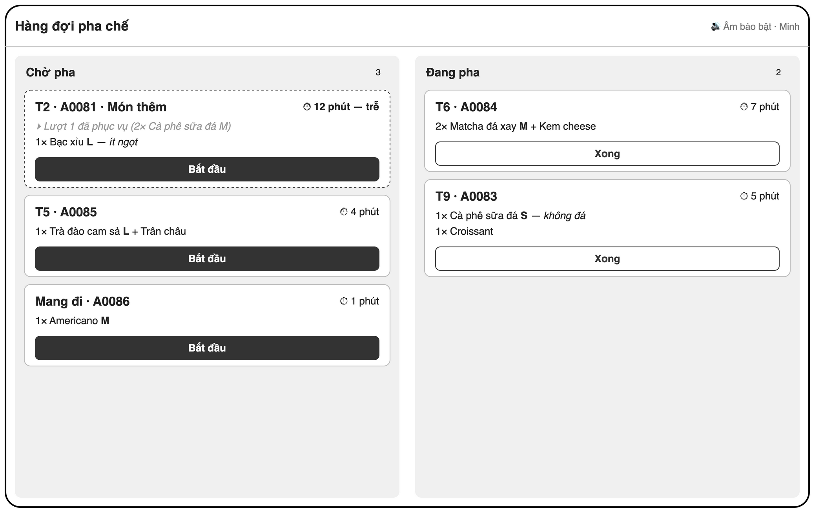
Figure 3-36: Screen Design of S16 Barista queue (tablet)
Table 3-25: Screen Definition of S16 Barista queue (tablet)
# | Field Name | Type | Mandatory | Max Length | Description
1 | Columns | Label |  | — | Chờ pha / Đang pha with counts; oldest first; awaiting orders not shown
2 | Order card | Card (live) |  | — | Table or "Mang đi", short ID, items with size, toppings, qty, note; elapsed time; warning color after lateOrderMinutes; add-on rounds show only the latest batch ("Món thêm"), earlier batches collapsed
3 | Bắt đầu | Button |  | — | pending → preparing
4 | Xong | Button |  | — | preparing → ready; "Hoàn tác" within 5 s
5 | New order alert | Sound |  | — | Played when a new order arrives

3.7.1.2 Use Case Description
Use Case ID | UC30 | Use Case Name | Process the order queue
Author | Nguyễn Bá Cường | Version | 1.1
Date | 23/09/2026 | Priority | High
Actor | Barista
Description | The barista sees orders in real time, oldest first, and moves each one from pending to preparing to ready.  Goal: Prepare drinks in the right order and tell the counter when they are done.
Precondition | The caller has role = barista or manager.
Trigger | Barista opens Barista queue (S16) and keeps it open during the shift.
Post-Condition | The order moved pending → preparing → ready.
Main flows
Step | Actor | Action
1 | Barista | Barista opens S16.
1 | System | System shows a real-time queue of pending and preparing orders, oldest createdAt first; awaiting customer orders are not shown.
2 | System | Each card shows table or "Mang đi", short ID, items with size, toppings, quantity, notes and elapsed time.
3 | Barista | A new order is created anywhere.
3 | System | System plays a sound and appends the card at the end of the queue within 2 s.
4 | Barista | Barista taps "Bắt đầu" on a pending card.
4 | System | System sets status = preparing and changes the card style.
5 | Barista | Barista taps "Xong" on a preparing card.
5 | System | System sets status = ready, removes the card and starts UC31.

Alternative flows
AT1 | At step 2 in the main flows: Elapsed time exceeds lateOrderMinutes (FR-BAR-04).
Sub step | Actor | Action
2a.1 | System | System turns the card to a warning color.
AT2 | At step 2 in the main flows: The order came back from ready or served (BR-ORD-04).
Sub step | Actor | Action
2b.1 | System | System shows only the latest batch as "Món thêm"; earlier batches are collapsed as already made (BR-ORD-04).
AT3 | At step 4 in the main flows: The order is cancelled while on screen.
Sub step | Actor | Action
4a.1 | System | System removes the card with a short "Đã hủy" notice.
AT4 | At step 5 in the main flows: Barista taps "Hoàn tác" within 5 s of "Xong".
Sub step | Actor | Action
5a.1 | System | System sets the status back to preparing.

Exceptions
# | Exception code | Condition | System handling
1 | aborted | Status changed | Another device changed the status first. System refreshes the card without an error dialog.
2 | unavailable | Offline | The connection is lost. System shows "Mất kết nối", keeps cached cards and queues status taps.

Business Rules
# | Rule Description
STATE | Order status follows the state machine: awaiting → pending (cashier confirms) or cancelled (cashier rejects); pending → preparing → ready → served → paid; ready / served → pending (items added); pending / preparing / ready / served → cancelled. paid and cancelled are terminal.
NFR-PERF-01 | A new order appears on the barista screen within 2 s on normal 4G/Wi-Fi.
NFR-USE-02 | Tap targets ≥ 48 × 48 dp; text readable at arm's length on the barista tablet.

3.7.2 UC31 – Notify cashier when an order is ready
3.7.2.1 Screen Mock-up
Uses screen(s) S14 (defined in 3.6.3).
3.7.2.2 Use Case Description
Use Case ID | UC31 | Use Case Name | Notify cashier when an order is ready
Author | Nguyễn Bá Cường | Version | 1.0
Date | 23/09/2026 | Priority | Medium
Actor | System
Description | The system notifies cashiers and managers when an order becomes ready.  Goal: Serve drinks while they are fresh without the barista calling out.
Precondition | At least one cashier or manager device has an FCM token.
Trigger | An order's status changes to ready (from UC30).
Post-Condition | A push notification is sent to all active cashiers and managers.
Main flows
Step | Actor | Action
1 | System | A Cloud Function on orders/{id} update detects status changed to ready.
2 | System | It sends FCM: "Đơn <shortId> — <table> đã sẵn sàng".
3 | System | Cashier taps the notification.
3 | System | System opens the order (S14) with the "Đã phục vụ" action (UC23).

Alternative flows
AT1 | At step 1 in the main flows: The Firebase Blaze plan is not available.
Sub step | Actor | Action
1a.1 | System | POS listens to orders with status = ready and shows an in-app banner and sound.
AT2 | At step 2 in the main flows: The app is in the foreground.
Sub step | Actor | Action
2a.1 | System | System shows an in-app snackbar instead of a system notification.

Exceptions
# | Exception code | Condition | System handling
1 | messaging/registration-token-not-registered | Stale token | An FCM token is invalid. System removes it from users/{uid}.fcmTokens.

Business Rules
No specific business rule.

3.8 Customer Ordering

3.8.1 UC32 – Place an order via table QR
3.8.1.1 Screen Mock-up
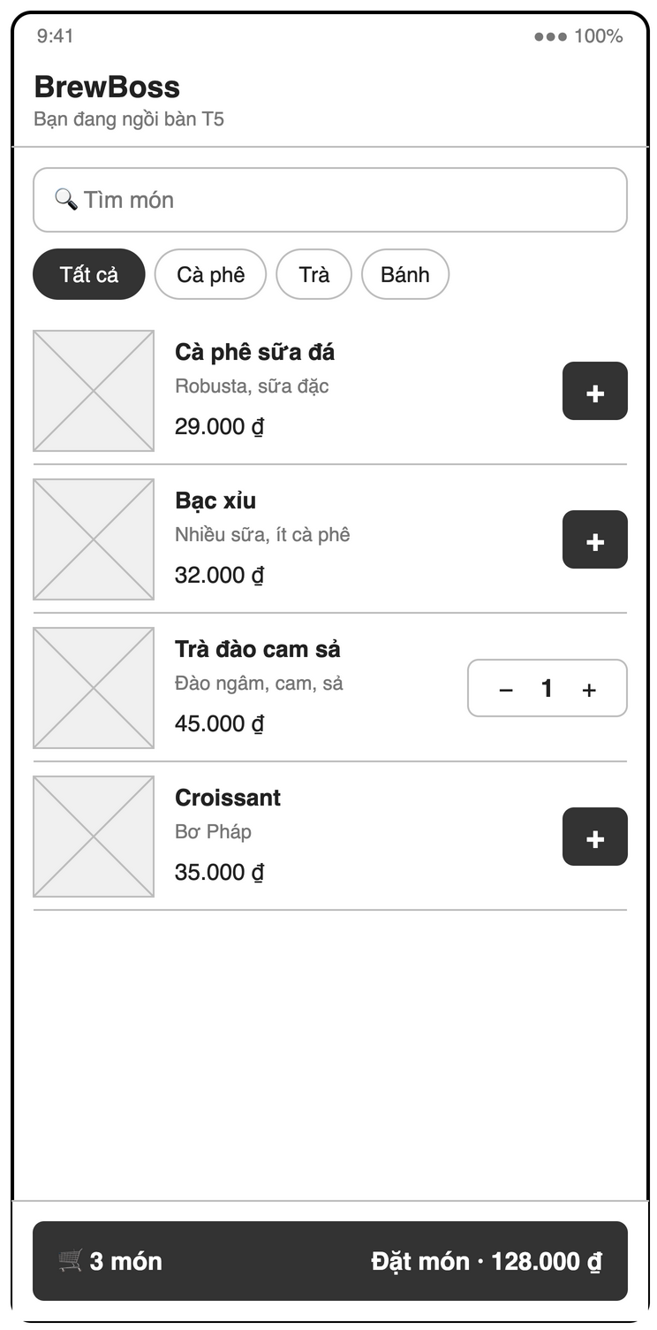
Figure 3-37: Screen Design of S17 Customer menu (via QR)
Table 3-26: Screen Definition of S17 Customer menu (via QR)
# | Field Name | Type | Mandatory | Max Length | Description
1 | Header | Label |  | — | Shop name and "Bạn đang ngồi bàn <x>"
2 | Tìm món / category chips | Text / Chips | No | — | Available products only
3 | Product list | List |  | — | Image, name, description, price; "+" or stepper
4 | Item options | Sheet |  | — | Size, toppings, quantity, note (as S14b)
5 | Cart | Button |  | — | Item count
6 | Đặt món · <total> | Button |  | — | Creates the order as awaiting

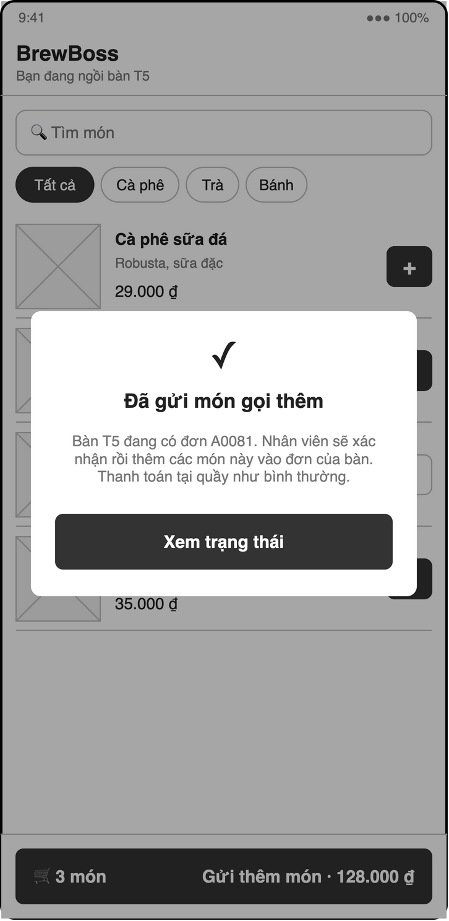
Figure 3-38: Screen Design of S17b Add-on sent (table has open order)
Table 3-27: Screen Definition of S17b Add-on sent (table has open order)
# | Field Name | Type | Mandatory | Max Length | Description
1 | Add-on dialog | Dialog |  | — | "Đã gửi món gọi thêm" — the table has an open order; the items are added to it once the cashier confirms (BR-ORD-07)
2 | Đã hiểu | Button |  | — | "Xem trạng thái": opens S18; the cart is cleared

3.8.1.2 Use Case Description
Use Case ID | UC32 | Use Case Name | Place an order via table QR
Author | Nguyễn Bá Cường | Version | 1.0
Date | 23/09/2026 | Priority | Medium
Actor | Customer
Description | A customer scans the QR code on their table, browses the menu without logging in and sends an order to that table.  Goal: Let customers order without queuing at the counter.
Precondition | The table exists and its QR was printed (UC18).
Trigger | Customer scans the QR on a table.
Post-Condition | An order exists with source = customer, status = awaiting and the anonymous uid as createdBy; the table is not occupied and the order is not on the barista queue until the cashier confirms it (UC22); the cashier sees a badge.
Main flows
Step | Actor | Action
1 | Customer | Customer scans the table QR with the phone camera.
1 | System | System opens Customer menu (S17) for /c/{tableId}.
2 | System | System signs in anonymously and reads the table name and shop name.
3 | Customer | Customer browses the menu (UC10).
3 | System | System shows available products only.
4 | Customer | Customer picks items with size, toppings, quantity and note.
4 | System | System adds them to the cart and shows the subtotal.
5 | Customer | Customer taps "Đặt món".
5 | System | System creates the order; Security Rules allow only source = customer and status = awaiting.
6 | System | System shows "Đã gửi đơn — nhân viên sẽ xác nhận" and the cashier confirms it (UC22).

Alternative flows
AT1 | At step 1 in the main flows: The customer does not have the app installed.
Sub step | Actor | Action
1a.1 | System | Depends on the SDS decision (brief Q2): open a Flutter Web build of the same route, or deep-link to the store.
AT2 | At step 5 in the main flows: The table already has an open order.
Sub step | Actor | Action
5a.1 | System | System still creates the awaiting order and shows "Đã gửi món gọi thêm" (S17b); once the cashier confirms (UC22), the items join the open order (BR-ORD-07).
AT3 | At step 6 in the main flows: Order tracking (P2) is built.
Sub step | Actor | Action
6a.1 | System | System opens Order status (UC33).

Exceptions
# | Exception code | Condition | System handling
1 | not-found | Invalid table | The table ID is invalid or deleted. System shows "Mã QR không hợp lệ, vui lòng gọi nhân viên".
2 | failed-precondition | Item sold out | A product became unavailable before submit. System flags the line; the customer must remove it.
3 | unavailable | Network error | The order cannot be sent. System shows "Không gửi được đơn, thử lại" and keeps the cart.

Business Rules
# | Rule Description
BR-ORD-01 | Item unit price = product base price + size delta + sum(topping prices).
BR-ORD-03 | A table can have at most one open order (status not awaiting/paid/cancelled). awaiting orders do not occupy the table.
SEC-ANON | Anonymous users may only create orders with source = customer and status = awaiting; prices are re-validated by the cashier (UC22).
SEC-REMOTE | Anyone with the table URL can order remotely, but the order stays awaiting and never reaches the barista until a cashier confirms it (UC22). Table IDs are Firestore auto-ids. No location check in v1; add a per-uid rate limit in Security Rules if spam appears.

3.8.2 UC33 – Track order status
3.8.2.1 Screen Mock-up
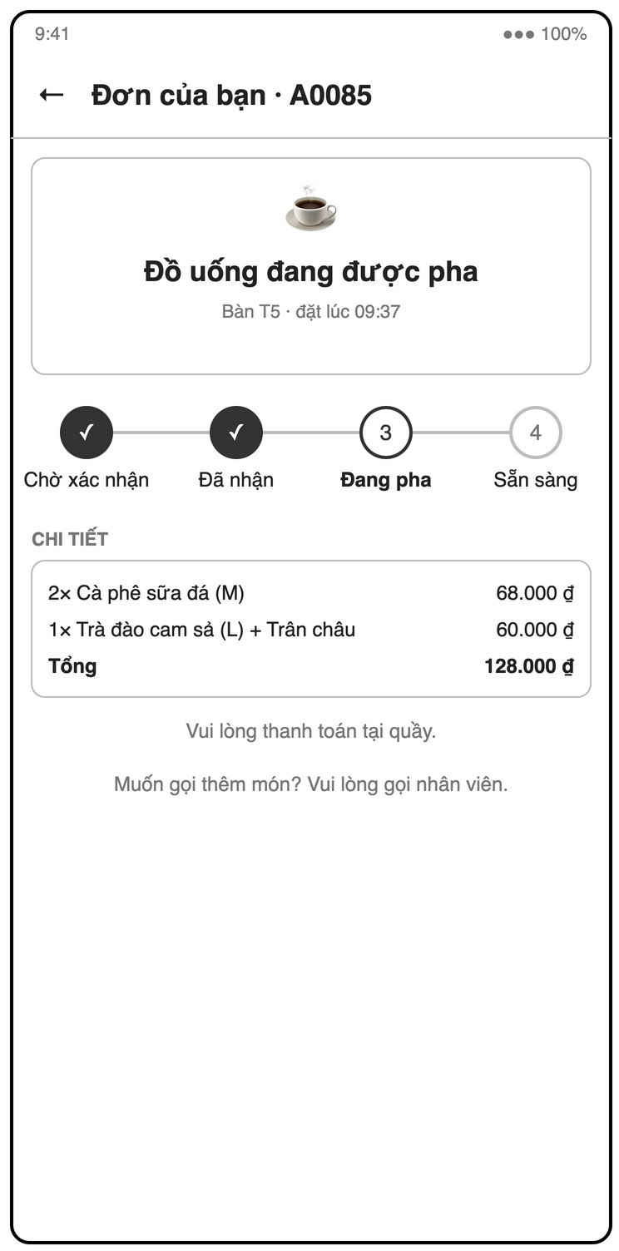
Figure 3-39: Screen Design of S18 Customer order status
Table 3-28: Screen Definition of S18 Customer order status
# | Field Name | Type | Mandatory | Max Length | Description
1 | Header | Label |  | — | Order short ID, table and order time
2 | Progress | Stepper (live) |  | — | Chờ xác nhận / Đã nhận / Đang pha / Sẵn sàng; cancelled shows a notice
3 | Chi tiết | List |  | — | Items and total
4 | Notes | Label |  | — | Pay at the counter; after an add-on is confirmed, shows "Đã thêm vào đơn <shortId>" and follows that order

3.8.2.2 Use Case Description
Use Case ID | UC33 | Use Case Name | Track order status
Author | Nguyễn Bá Cường | Version | 1.0
Date | 23/09/2026 | Priority | Low
Actor | Customer
Description | The customer follows their order status in real time after placing it.  Goal: Tell the customer when their drink is being made and when it is ready.
Precondition | The customer's anonymous session created the order.
Trigger | The customer finishes UC32.
Post-Condition | None. The use case changes no state.
Main flows
Step | Actor | Action
1 | Customer | Customer opens Order status (S18).
1 | System | System shows short ID, items, total and a live progress bar: Chờ xác nhận / Đang pha / Sẵn sàng.
2 | System | System updates the status in real time; once the order was added to the table's open order (mergedIntoId), it follows that order.

Alternative flows
AT1 | At step 1 in the main flows: Customer closes and reopens the link.
Sub step | Actor | Action
1a.1 | System | System finds the last order of this anonymous uid for the table.
AT2 | At step 2 in the main flows: The order is cancelled.
Sub step | Actor | Action
2a.1 | System | System shows "Đơn đã bị hủy — vui lòng liên hệ nhân viên".

Exceptions
No specific exception beyond the common ones (permission-denied, unavailable; see 5.2).
Business Rules
No specific business rule.

3.9 Reports

3.9.1 UC34 – View today's revenue dashboard
3.9.1.1 Screen Mock-up
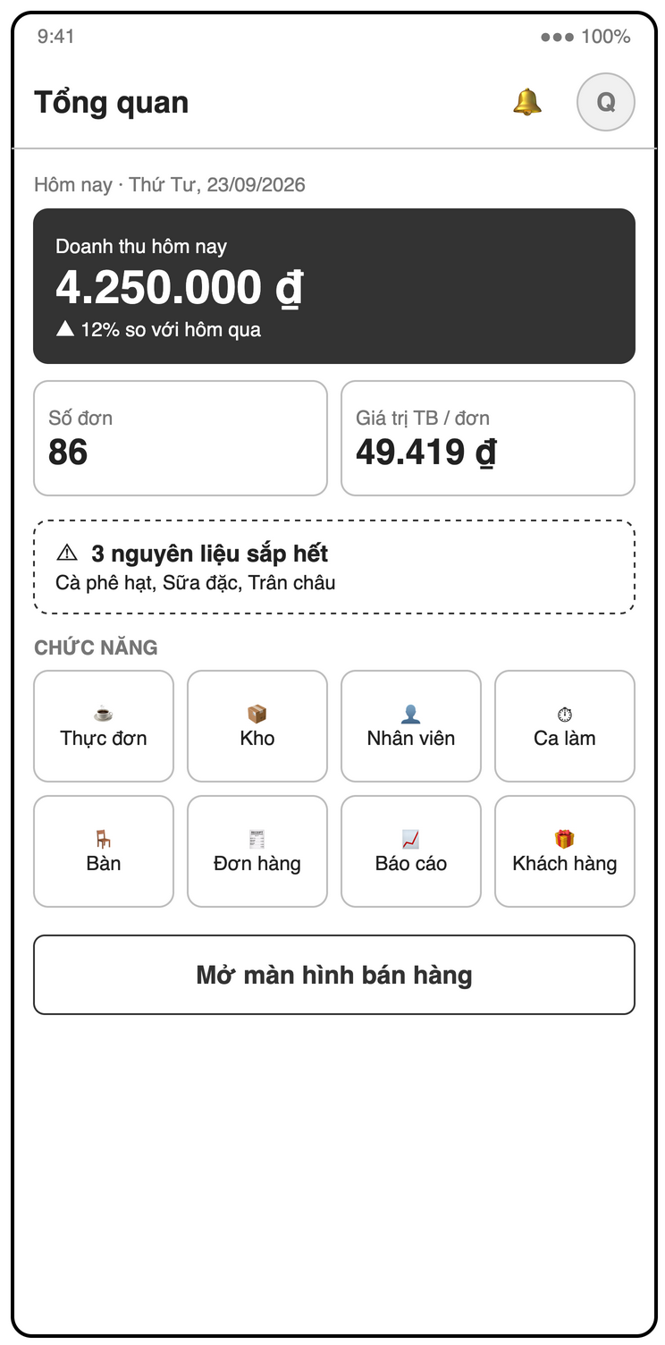
Figure 3-40: Screen Design of S04 Manager home / dashboard
Table 3-29: Screen Definition of S04 Manager home / dashboard
# | Field Name | Type | Mandatory | Max Length | Description
1 | Profile avatar | Icon button |  | — | Opens S22
2 | Notifications | Icon button |  | — | Low-stock / order alerts
3 | Date | Label |  | — | Today, e.g. "Hôm nay · Thứ Tư, 23/09/2026"
4 | Revenue / order count / average order value | Label (live) |  | — | Σ total of paid orders today, count, revenue / count (UC34)
5 | Shortcuts | Label |  | — | Low-stock count, open orders, staff on shift
6 | Chức năng grid | Tile buttons |  | — | Thực đơn (S08), Kho (S10), Nhân viên (S05), Ca làm (S06), Bàn (S12), Đơn hàng (S20), Báo cáo (S19), Khách hàng (S21)
7 | Mở màn hình bán hàng | Button |  | — | Opens the table map S13 (Manager has Cashier permissions)

3.9.1.2 Use Case Description
Use Case ID | UC34 | Use Case Name | View today's revenue dashboard
Author | Nguyễn Bá Cường | Version | 1.0
Date | 23/09/2026 | Priority | High
Actor | Manager
Description | The manager sees today's revenue, order count and average order value, updated live.  Goal: Give the owner instant insight into the day's business.
Precondition | The caller has role = manager.
Trigger | Manager logs in (home screen) or opens S04.
Post-Condition | None. The use case changes no state.
Main flows
Step | Actor | Action
1 | Manager | Manager opens Manager home (S04).
1 | System | System listens to orders with status = paid and paidAt today.
2 | System | System shows revenue = Σ total, order count, and average order value = revenue / count (0 when no orders).
3 | System | System updates the figures live when a payment is confirmed.
4 | System | System also shows shortcuts: low-stock count, open orders and staff on shift.

Alternative flows
None.
Exceptions
# | Exception code | Condition | System handling
1 | not-found | No sales yet | No paid orders today. System shows 0 ₫ and an empty-state hint.

Business Rules
# | Rule Description
BR-RPT-01 | Revenue counts only orders with status = paid.

3.9.2 UC35 – View order history
3.9.2.1 Screen Mock-up
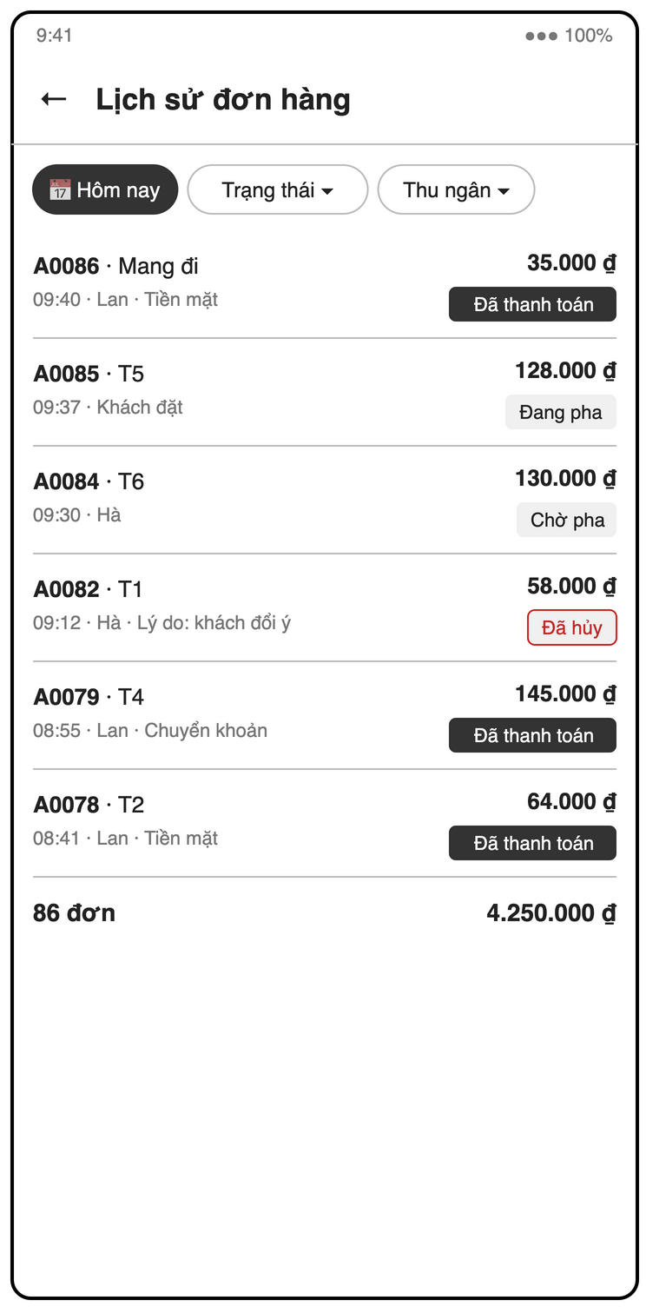
Figure 3-41: Screen Design of S20 Order history
Table 3-30: Screen Definition of S20 Order history
# | Field Name | Type | Mandatory | Max Length | Description
1 | Date | Date range picker | No | — | Default today
2 | Trạng thái | Dropdown | No | — | Order status
3 | Thu ngân | Dropdown | No | — | Staff member
4 | Order list | List |  | — | Short ID, table / Mang đi, time, cashier, method, total, status, cancel reason
5 | Order detail | Page |  | — | Items, voucher, points, amounts, who / when; "Hóa đơn" for paid orders
6 | Footer | Label |  | — | Order count and total

3.9.2.2 Use Case Description
Use Case ID | UC35 | Use Case Name | View order history
Author | Nguyễn Bá Cường | Version | 1.1
Date | 23/09/2026 | Priority | High
Actor | Manager
Description | The manager searches past orders by date, status and cashier and opens their details.  Goal: Check any order, cancellation or voucher after the fact.
Precondition | The caller has role = manager.
Trigger | Manager opens Order history (S20).
Post-Condition | None. The use case changes no state.
Main flows
Step | Actor | Action
1 | Manager | Manager opens S20.
1 | System | System shows today's orders newest first: short ID, time, table, cashier, status, total and paid amounts (cash / VietQR).
2 | Manager | Manager filters by date range, status and cashier.
2 | System | System reloads the list.
3 | Manager | Manager taps an order.
3 | System | System shows items, voucher, points, cancel reason and who did what and when.

Alternative flows
AT1 | At step 3 in the main flows: The order is paid and the manager taps "Hóa đơn".
Sub step | Actor | Action
3a.1 | System | System starts UC28.

Exceptions
# | Exception code | Condition | System handling
1 | not-found | No results | No orders match the filter. System shows an empty state.

Business Rules
# | Rule Description
NFR-AUD-01 | Cancellations, vouchers, payments, stock adjustments and cash handovers record who and when.
IDX | Needs composite indexes beyond brief §9.4, e.g. createdBy ASC, createdAt DESC.

3.9.3 UC36 – View sales reports
3.9.3.1 Screen Mock-up
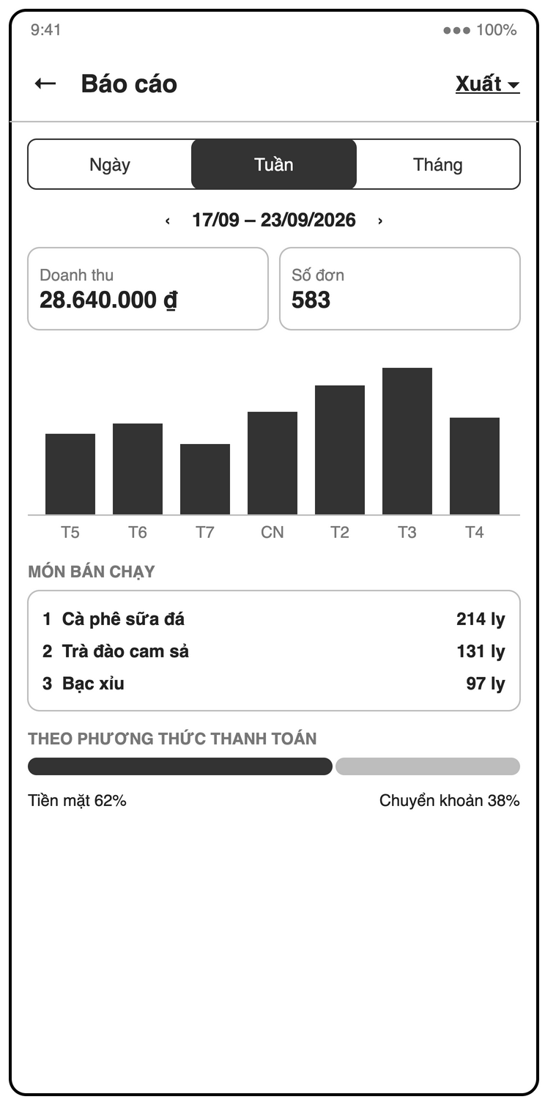
Figure 3-42: Screen Design of S19 Reports
Table 3-31: Screen Definition of S19 Reports
# | Field Name | Type | Mandatory | Max Length | Description
1 | Xuất | Dropdown button |  | — | PDF / Excel (UC37)
2 | Grouping | Segmented | Yes | — | Ngày / Tuần / Tháng
3 | Period | Date range navigator | Yes | — | Previous / next; 7 days, this month or custom
4 | Revenue chart | Bar chart |  | — | Revenue per bucket; tap a bar → S20 filtered
5 | Món bán chạy | List |  | — | Top N (default 10) by quantity with revenue
6 | Theo phương thức thanh toán | Chart |  | — | Σ cashAmount vs Σ qrAmount

3.9.3.2 Use Case Description
Use Case ID | UC36 | Use Case Name | View sales reports
Author | Nguyễn Bá Cường | Version | 1.1
Date | 23/09/2026 | Priority | Medium
Actor | Manager
Description | The manager views revenue charts, best-selling products and revenue by payment method for a period.  Goal: Decide on menu, promotions and purchasing from real data.
Precondition | The caller has role = manager.
Trigger | Manager opens Reports (S19).
Post-Condition | None. The use case changes no state.
Main flows
Step | Actor | Action
1 | Manager | Manager picks a range (7 days / this month / custom) and a grouping (day / week / month).
1 | System | System loads paid orders in the range.
2 | System | System shows a revenue chart per bucket (FR-RPT-03).
3 | System | System shows the top N best-selling products by quantity with revenue (FR-RPT-04, N = 10 by default).
4 | System | System shows revenue split by payment method: Σ cashAmount vs Σ qrAmount (FR-RPT-05); a split order counts in both.
5 | Manager | Manager taps a bar.
5 | System | System opens UC35 filtered to that bucket.

Alternative flows
AT1 | At step 1 in the main flows: The range is large and loading is slow.
Sub step | Actor | Action
1a.1 | System | System reads dailyStats/{yyyy-MM-dd} aggregates if they are built (brief §9.3).
AT2 | At step 5 in the main flows: Manager taps "Xuất".
Sub step | Actor | Action
5a.1 | System | System starts UC37.

Exceptions
# | Exception code | Condition | System handling
1 | not-found | No data | No paid orders in the range. System shows empty charts with a message.

Business Rules
# | Rule Description
BR-RPT-01 | Revenue counts only orders with status = paid.
BR-PAY-01 | cashAmount + qrAmount = total, both ≥ 0. A single-method payment sets the other field to 0.

3.9.4 UC37 – Export a report
3.9.4.1 Screen Mock-up
Uses screen(s) S19 (defined in 3.9.3).
3.9.4.2 Use Case Description
Use Case ID | UC37 | Use Case Name | Export a report
Author | Nguyễn Bá Cường | Version | 1.1
Date | 23/09/2026 | Priority | Low
Actor | Manager
Description | The manager exports the current report to PDF or Excel.  Goal: Share figures with partners or the accountant.
Precondition | The report has data.
Trigger | Manager taps "Xuất" on Reports (S19).
Post-Condition | A file is generated and handed to the system share sheet.
Main flows
Step | Actor | Action
1 | Manager | Manager taps "Xuất" and picks PDF or Excel.
1 | System | System generates the file for the current range: summary, revenue per bucket, top products, payment split (Σ cashAmount / Σ qrAmount), and (Excel only) the full order list.
2 | System | System opens the share sheet.

Alternative flows
None.
Exceptions
No specific exception beyond the common ones (permission-denied, unavailable; see 5.2).
Business Rules
No specific business rule.

3.10 Loyalty

3.10.1 UC38 – Attach a loyalty customer to an order
3.10.1.1 Screen Mock-up
Uses screen(s) S15 (defined in 3.6.8).
3.10.1.2 Use Case Description
Use Case ID | UC38 | Use Case Name | Attach a loyalty customer to an order
Author | Nguyễn Bá Cường | Version | 1.0
Date | 23/09/2026 | Priority | Medium
Actor | Cashier
Description | The cashier links an order to a customer by phone number, creating the customer if new.  Goal: Reward returning customers with points.
Precondition | The order is open.
Trigger | The customer gives their phone number during payment (from UC25).
Post-Condition | order.customerId is set and customers/{phone} exists.
Main flows
Step | Actor | Action
1 | Cashier | Cashier taps "Khách hàng thành viên" in Payment (S15) and enters the phone number.
1 | System | System normalizes it (strip spaces, +84 → 0) and validates it (10 digits, starts with 0).
2 | System | System reads customers/{phone} and shows name, points balance and visit count.
3 | Cashier | Cashier confirms.
3 | System | System sets order.customerId.

Alternative flows
AT1 | At step 2 in the main flows: The phone number is new.
Sub step | Actor | Action
2a.1 | System | System offers "Tạo khách mới" with an optional name and creates customers/{phone} with points = 0 and visitCount = 0.
AT2 | At step 3 in the main flows: Cashier detaches the customer before payment.
Sub step | Actor | Action
3a.1 | System | System clears customerId and any redeemed points.

Exceptions
# | Exception code | Condition | System handling
1 | invalid-argument | Invalid phone | The phone number is badly formatted. System shows an inline error.

Business Rules
No specific business rule.

3.10.2 UC39 – Redeem loyalty points
3.10.2.1 Screen Mock-up
Uses screen(s) S15 (defined in 3.6.8).
3.10.2.2 Use Case Description
Use Case ID | UC39 | Use Case Name | Redeem loyalty points
Author | Nguyễn Bá Cường | Version | 1.0
Date | 23/09/2026 | Priority | Medium
Actor | Cashier
Description | The cashier converts a customer's points into a discount on the current order.  Goal: Give customers a reason to come back.
Precondition | A customer with points > 0 is attached (UC38).
Trigger | The customer wants to use points during payment.
Post-Condition | order.pointsRedeemed is set, total is recomputed, and the balance is deducted at payment.
Main flows
Step | Actor | Action
1 | System | System shows the balance and max redeemable = min(balance, ceil((subtotal − discount) / vndPerPoint)).
2 | Cashier | Cashier enters the points to redeem or taps "Dùng tối đa".
2 | System | System validates the value (BR-LOY-02).
3 | System | System shows the new total = subtotal − discount − points × vndPerPoint, minimum 0.
4 | System | Points are deducted inside the payment transaction of UC25.

Alternative flows
None.
Exceptions
# | Exception code | Condition | System handling
1 | invalid-argument | Too many points | Value exceeds balance or makes total negative. System shows "Vượt quá số điểm cho phép (tối đa X)".
2 | aborted | Balance changed | The balance changed before payment (e.g. used on another device). The payment transaction fails and the cashier adjusts.

Business Rules
# | Rule Description
BR-LOY-02 | Redeemed points cannot exceed customer balance or make total negative.
BR-ORD-02 | Order total = subtotal − discount − (pointsRedeemed × vndPerPoint), minimum 0.
BR-LOY-01 | Points earned = floor(total / pointsPerVnd), computed on the amount actually paid.

3.10.3 UC40 – Manage vouchers
3.10.3.1 Screen Mock-up
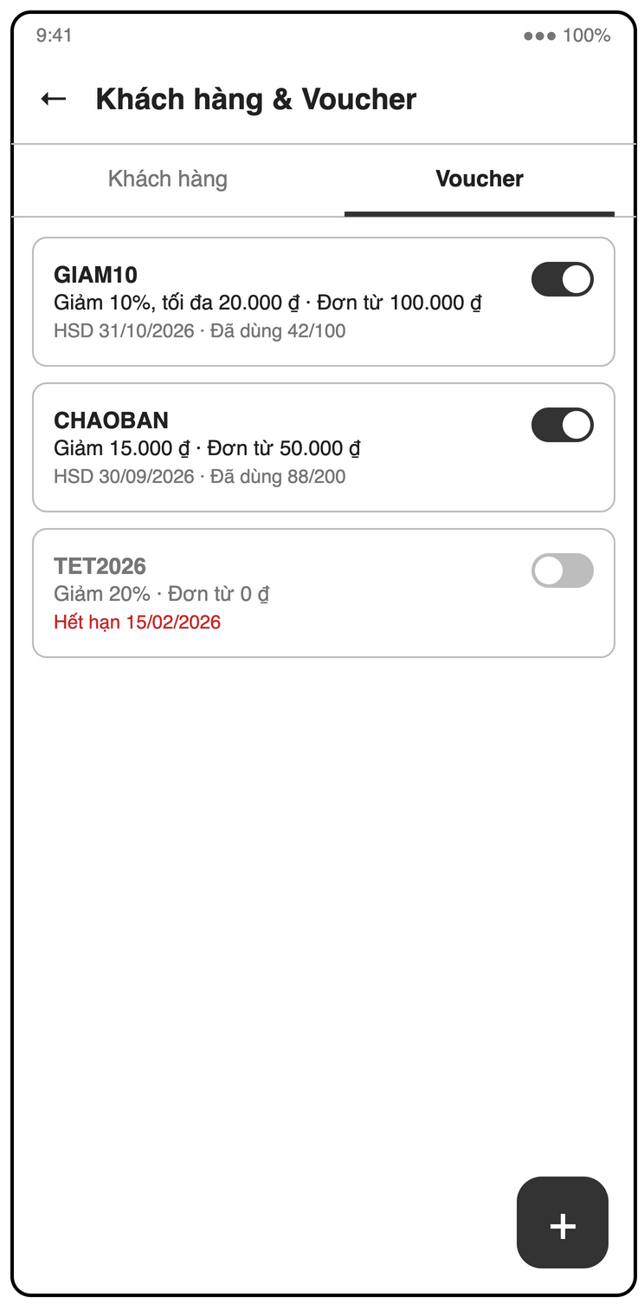
Figure 3-43: Screen Design of S21b Customers & vouchers (vouchers tab)
Table 3-32: Screen Definition of S21b Customers & vouchers (vouchers tab)
# | Field Name | Type | Mandatory | Max Length | Description
1 | Voucher list | List |  | — | Code, type / value, status (active / expired / used up), usedCount / usageLimit
2 | + | Floating button |  | — | Opens the voucher form
3 | Mã | Text | Yes | — | A–Z 0–9, unique; read-only when editing
4 | Loại | Radio | Yes | — | percent / fixed
5 | Giá trị | Number | Yes | — | Percent 1–100 or VND > 0
6 | Đơn tối thiểu | Number (VND) | Yes | — | ≥ 0
7 | Giảm tối đa | Number (VND) | No | — | Percent only
8 | Hết hạn | Date picker | Yes | — | Not in the past
9 | Số lượt | Number | Yes | — | ≥ 1
10 | Đang hoạt động | Switch |  | — | Deactivate; used vouchers are never deleted

3.10.3.2 Use Case Description
Use Case ID | UC40 | Use Case Name | Manage vouchers
Author | Nguyễn Bá Cường | Version | 1.0
Date | 23/09/2026 | Priority | Medium
Actor | Manager
Description | The manager creates, edits and deactivates voucher codes.  Goal: Run promotions with controlled value, validity and usage.
Precondition | The caller has role = manager.
Trigger | Manager opens Customers & vouchers (S21), voucher tab.
Post-Condition | vouchers/{code} is created or updated.
Main flows
Step | Actor | Action
1 | Manager | Manager taps "Tạo voucher".
1 | System | System shows the voucher form.
2 | Manager | Manager enters code, type (percent / fixed), value, min order, max discount (percent only), expiry and usage limit.
2 | System | System validates the input.
3 | Manager | Manager taps "Lưu".
3 | System | System saves the voucher with usedCount = 0 and isActive = true.

Alternative flows
AT1 | At step 1 in the main flows: Manager edits a voucher.
Sub step | Actor | Action
1a.1 | System | System saves all fields except code and usedCount.
AT2 | At step 1 in the main flows: Manager deactivates a voucher.
Sub step | Actor | Action
1b.1 | System | System sets isActive = false; used vouchers are never deleted.
AT3 | At step 1 in the main flows: Manager views the list.
Sub step | Actor | Action
1c.1 | System | System shows status (active / expired / used up) and usedCount / usageLimit.

Exceptions
# | Exception code | Condition | System handling
1 | invalid-argument | Invalid voucher | Code not unique or not A–Z 0–9, percent value outside 1–100, fixed value ≤ 0, expiry in the past or usage limit < 1.

Business Rules
# | Rule Description
BR-DIS-01 | Only one voucher per order.
BR-DIS-02 | Percent voucher discount is capped by maxDiscount if set.

3.10.4 UC41 – View loyalty customers
3.10.4.1 Screen Mock-up
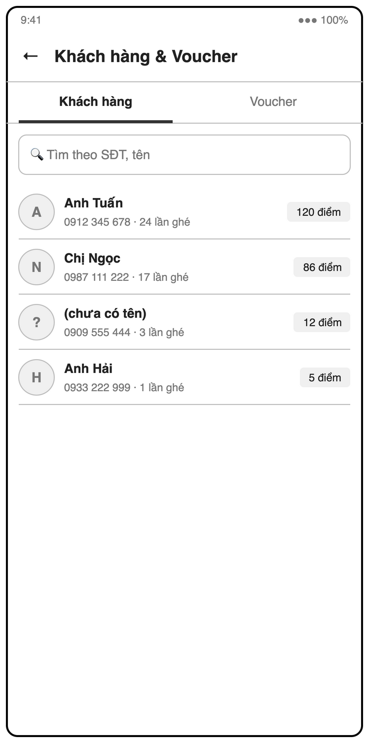
Figure 3-44: Screen Design of S21 Customers & vouchers (customers tab)
Table 3-33: Screen Definition of S21 Customers & vouchers (customers tab)
# | Field Name | Type | Mandatory | Max Length | Description
1 | Tabs | Tab |  | — | Khách hàng / Voucher
2 | Tìm theo SĐT, tên | Text | No | — | Search
3 | Sort | Dropdown | No | — | By points or visits
4 | Customer list | List |  | — | Name (or "(chưa có tên)"), phone, visits, points; tap → paid orders, edit name

3.10.4.2 Use Case Description
Use Case ID | UC41 | Use Case Name | View loyalty customers
Author | Nguyễn Bá Cường | Version | 1.0
Date | 23/09/2026 | Priority | Medium
Actor | Manager
Description | The manager browses loyalty customers with their points and visit count.  Goal: Know the regular customers and their value.
Precondition | The caller has role = manager.
Trigger | Manager opens Customers & vouchers (S21), customer tab.
Post-Condition | None, except an optional name edit.
Main flows
Step | Actor | Action
1 | Manager | Manager opens the customer tab.
1 | System | System lists customers: phone, name, points and visit count.
2 | Manager | Manager searches by phone or name and sorts by points or visits.
2 | System | System reloads the list.
3 | Manager | Manager taps a customer.
3 | System | System shows the customer's paid orders.

Alternative flows
AT1 | At step 3 in the main flows: Manager edits the customer's name.
Sub step | Actor | Action
3a.1 | System | System saves the name.

Exceptions
# | Exception code | Condition | System handling
1 | not-found | No results | No customer matches the search. System shows an empty state.

Business Rules
No specific business rule.

4. Non-Functional Requirements

4.1 External Interfaces
User interfaces
- Flutter mobile UI in Vietnamese (NFR-USE-03); currency shown as "45.000 ₫"; phone and tablet layouts (NFR-COMP-01).
- Tap targets ≥ 48 × 48 dp; barista tablet text readable at arm's length (NFR-USE-02).
- Every screen shows a loading, an error (with retry) and an empty state; validation errors are shown inline next to the field, other errors in a snackbar.
- Screen layouts follow the low-fidelity mock-ups in docs/diagrams/screen-mockups.drawio (S01–S22).
Hardware interfaces
- Android 8.0+ and iOS 14+ phones and tablets (NFR-COMP-01); the barista screen runs on a tablet mounted at the bar.
- Camera: product image capture (FR-MENU-05), table / shop QR scanning (FR-STAFF-06, P2). Customers scan the table QR with their own phone camera.
- Printing and sharing use the operating system share / print sheet (table QR, PDF receipt, exported reports). Bluetooth thermal printers are out of scope.
Software interfaces
System | Used for | Interface
Firebase Authentication | Staff email / password login, password reset email, anonymous auth for customers | firebase_auth SDK
Cloud Firestore | All business data, real-time listeners, transactions, offline cache | cloud_firestore SDK; Security Rules per role
Cloud Storage for Firebase | Product images | firebase_storage SDK
Firebase Cloud Messaging | Push: low-stock alert (FR-INV-06), order ready (FR-BAR-05) | firebase_messaging SDK; tokens in users/{uid}.fcmTokens
Cloud Functions for Firebase | Firestore triggers that send the push notifications | Requires the Blaze plan; fallback: in-app Firestore listeners
VietQR image service | QR image for bank transfer with amount and order short ID | HTTPS GET https://img.vietqr.io/image/{bankBin}-{bankAccountNo}-compact2.png?amount=…&addInfo=…&accountName=… (no API key)

Communication interfaces
All traffic goes over HTTPS through the Firebase SDKs on normal 4G or Wi-Fi. VietQR transfers are confirmed manually by the cashier; there is no payment gateway webhook.

4.2 Quality Attributes

4.2.1 Usability
ID | Requirement
NFR-USE-01 | Cashier can create a 3-item order in ≤ 5 taps per item
NFR-USE-02 | Tap targets ≥ 48 × 48 dp; text readable at arm's length on barista tablet
NFR-USE-03 | UI language: Vietnamese; currency format 45.000 ₫

4.2.2 Reliability
ID | Requirement
NFR-REL-01 | Payment + stock deduction + points run in one Firestore transaction (all or nothing)
NFR-REL-02 | Firestore offline cache enabled so brief network drops do not lose in-progress orders

Every multi-document write (payment, customer order confirmation, merge, cancellation, stock-in, adjustment, stocktake) runs in one Firestore transaction and rolls back as a whole. Availability, MTBF and MTTR targets are not defined for this release; the system relies on the Firebase service level.

4.2.3 Performance
ID | Requirement
NFR-PERF-01 | New order appears on barista screen within 2 s on normal 4G/Wi-Fi
NFR-PERF-02 | App cold start < 3 s on a mid-range Android device
NFR-PERF-03 | Menu screen with 100 products scrolls at 60 fps

4.2.4 Security
ID | Requirement
NFR-SEC-01 | All data access enforced by Firestore Security Rules per role
NFR-SEC-02 | Passwords handled only by Firebase Auth; never stored in Firestore

- Role is stored in users/{uid}.role and read by the Security Rules; the router guard redirects unauthorized routes to the role home.
- Anonymous customers may only create orders with source = customer and status = awaiting, cannot set price fields or confirmedBy / confirmedAt, and read only their own order and the order its mergedIntoId points to.
- Remote ordering through a copied table URL is contained by the cashier confirmation gate (BR-ORD-07); table ids are Firestore auto-ids. A per-uid rate limit is added only if spam appears.
- Shift cash fields cannot be edited after check-out (BR-STAFF-05).
- Security Rules are tested with the Firebase Emulator before the demo.

4.2.5 Compatibility
ID | Requirement
NFR-COMP-01 | Android 8.0+ and iOS 14+; phone and tablet layouts

4.2.6 Maintainability
ID | Requirement
NFR-MAINT-01 | Feature-first folder structure; each feature independently testable
NFR-MAINT-02 | flutter analyze passes with zero warnings on main

4.2.7 Auditability
ID | Requirement
NFR-AUD-01 | Cancellations, vouchers, payments, stock adjustments and cash handovers record who and when

5. Requirement Appendix

5.1 Business Rules
ID | Rule Definition
BR-ORD-01 | Item unit price = product base price + size delta + sum(topping prices)
BR-ORD-02 | Order total = subtotal − discount − (pointsRedeemed × vndPerPoint), minimum 0
BR-ORD-03 | A table can have at most one open order (status not awaiting/paid/cancelled). awaiting orders do not occupy the table
BR-ORD-04 | Adding items to a ready or served order moves it back to pending; the new items get batch = max(batch) + 1 and the barista card shows only the latest batch. Items added while pending or preparing join the current batch and are appended at the end of the card (status unchanged, sound alert). Existing lines can be edited or removed only while pending
BR-ORD-05 | Cancellation requires a reason; awaiting and pending orders can be cancelled by Cashier or Manager; preparing, ready and served orders only by Manager, except the source order of a merge (BR-ORD-08)
BR-ORD-06 | shortId resets daily, format <letter><4 digits>
BR-ORD-07 | Customer QR orders are created as awaiting and reach the barista only when a cashier confirms them. If the table has no open order at confirmation, the QR order becomes the table's order (→ pending). If it has one, the QR items are added to that open order under BR-ORD-04 and the QR order is closed as cancelled with cancelReason = "Gộp vào <shortId>" and mergedIntoId; the customer's status screen then follows the open order
BR-ORD-08 | Two tables can be merged only when both orders are served and neither has a voucher, customer or redeemed points. The target order keeps its id and receives the source items; the source order is cancelled with reason "Gộp vào <target shortId>" without stock deduction. Cancellation counts in reports exclude this reason
BR-PAY-01 | cashAmount + qrAmount = total, both ≥ 0. A single-method payment sets the other field to 0
BR-PAY-02 | cashAmount is the cash kept by the shop; change due = cash received − cashAmount and is not stored
BR-PAY-03 | Only a user with an open shift can confirm a payment, so every sale belongs to a shift
BR-PAY-04 | An order can be paid only when its status is served; takeaway orders are marked served when handed to the customer
BR-DIS-01 | Only one voucher per order
BR-DIS-02 | Percent voucher discount is capped by maxDiscount if set
BR-DIS-03 | There is no manual discount; discount comes only from a valid voucher (BR-DIS-01, BR-DIS-02)
BR-LOY-01 | Points earned = floor(total / pointsPerVnd), computed on the amount actually paid
BR-LOY-02 | Redeemed points cannot exceed customer balance or make total negative
BR-INV-01 | Stock deduction happens at payment, not at order creation. Cancelled orders do not consume stock unless BR-INV-02 applies
BR-INV-02 | Cancelling an order whose drinks were already made deducts ingredients by recipe as waste (adjust, reason = cancel reason). Default: ticked for ready/served, unticked for preparing, not offered for pending
BR-INV-03 | Recipe deviations (wrong measure, remakes) are not tracked per drink; they are corrected by stocktake, which logs counted − system stock as one adjustment
BR-INV-04 | Toppings have no recipe in v1 and do not deduct stock; their ingredients are corrected by stocktake (BR-INV-03). Upgrade path: a recipe per topping plus the topping id in the order item snapshot
BR-STAFF-01 | A staff member cannot check in twice without checking out
BR-STAFF-02 | Manager cannot deactivate their own account
BR-STAFF-03 | Cashier and Manager must enter openingCash (≥ 0) at check-in; Barista shifts have no cash fields
BR-STAFF-04 | expectedCash = openingCash + sum(cashAmount) of orders they marked paid during the shift. VietQR is not counted
BR-STAFF-05 | cashDiff = closingCash − expectedCash; a non-zero difference requires handoverNote. Cash fields cannot be edited after check-out
BR-AUTH-ROUTE | Each user has exactly one role; the router guard redirects any unauthorized route to the role's home.
BR-RPT-01 | Revenue counts only orders with status = paid.
DEFAULTS | lateOrderMinutes = 10, pointsPerVnd = 10.000, vndPerPoint = 1.000.
SEC-ANON | Anonymous users may only create orders with source = customer and status = awaiting; prices are re-validated by the cashier (UC22).
SEC-CONFIRM | Only staff can set confirmedBy and confirmedAt; Security Rules reject them on customer writes.
SEC-REMOTE | Anyone with the table URL can order remotely, but the order stays awaiting and never reaches the barista until a cashier confirms it (UC22). Table IDs are Firestore auto-ids. No location check in v1; add a per-uid rate limit in Security Rules if spam appears.
SNAPSHOT | Order items store a snapshot of name and prices; editing the menu never changes historical orders.
STATE | Order status follows the state machine: awaiting → pending (cashier confirms) or cancelled (cashier rejects); pending → preparing → ready → served → paid; ready / served → pending (items added); pending / preparing / ready / served → cancelled. paid and cancelled are terminal.

5.2 Common Requirements
- Money is an integer amount in VND (no floating point) and is displayed as "45.000 ₫".
- Timestamps are Firestore server timestamps; dates are shown as dd/MM/yyyy and times as HH:mm.
- All user-facing text is Vietnamese; code, data field names and documents are English.
- Every list or detail screen handles loading, error (with retry) and empty states.
- Validation errors are shown inline next to the field; save buttons stay disabled while the form is invalid or saving.
- Destructive actions (delete, cancel order, log out, deactivate) ask for confirmation.
- Actions that change money, stock or order status record who and when (NFR-AUD-01).
- Common exceptions on every use case: permission-denied (Security Rules reject the write; the screen shows the error) and unavailable (offline; the Firestore cache keeps the last data and a "Mất kết nối" banner is shown).
- Order item names and prices are snapshots; editing the menu never changes existing orders.
- Only one open order per table (BR-ORD-03); every write to a table's currentOrderId runs in a transaction.

5.3 Application Messages List
# | Message code | Message Type | Context | Content
1 | MSG01 | On screen | UC01 | Email hoặc mật khẩu không đúng
2 | MSG02 | On screen | UC01 | Thử lại sau ít phút
3 | MSG03 | On screen | UC01 | Tài khoản đã bị vô hiệu hóa. Liên hệ quản lý.
4 | MSG04 | On screen | UC01 | Tài khoản chưa được cấu hình
5 | MSG05 | Dialog | UC02 | Bạn chưa check-out ca làm
6 | MSG06 | On screen | UC03 | Nếu email tồn tại, liên kết đặt lại mật khẩu đã được gửi
7 | MSG07 | On screen | UC04 | Email đã được sử dụng
8 | MSG08 | On screen | UC05 | Mã QR không hợp lệ
9 | MSG09 | On screen | UC05 | Số tiền không hợp lệ
10 | MSG10 | On screen | UC06 | Không có ca làm nào
11 | MSG11 | On screen | UC07 | Danh mục còn sản phẩm. Hãy chuyển hoặc xóa sản phẩm trước.
12 | MSG12 | On screen | UC10 | Không tìm thấy món
13 | MSG13 | On screen | UC11 | Nguyên liệu đang được dùng trong công thức: <products>
14 | MSG14 | On screen | UC13 | Vui lòng nhập lý do
15 | MSG15 | On screen | UC13 | Tồn kho không thay đổi
16 | MSG16 | Push notification | UC16 | Sắp hết <name>: còn <stock> <unit>
17 | MSG17 | On screen | UC18 | Bàn đang có đơn, không thể xóa
18 | MSG18 | Banner | UC19 | Mất kết nối
19 | MSG19 | On screen | UC20 | Bàn đã có đơn
20 | MSG20 | On screen | UC21 | Đơn đang được pha, chỉ thêm món được
21 | MSG21 | On screen | UC22 | Đã thêm vào đơn <shortId>
22 | MSG22 | On screen | UC24 | Mã không tồn tại
23 | MSG23 | On screen | UC24 | Mã đã hết hạn
24 | MSG24 | On screen | UC24 | Mã đã hết lượt
25 | MSG25 | On screen | UC24 | Đơn tối thiểu <minOrder>
26 | MSG26 | On screen | UC25 | Thanh toán thành công
27 | MSG27 | On screen | UC25 | Số tiền chưa đủ
28 | MSG28 | On screen | UC25 | Bạn cần vào ca trước khi thanh toán
29 | MSG29 | On screen | UC25 | Chưa cấu hình tài khoản ngân hàng
30 | MSG30 | On screen | UC26 | Bàn đã có khách
31 | MSG31 | On screen | UC26 | Không thể gộp đơn này
32 | MSG32 | On screen | UC27 | Vui lòng nhập lý do hủy
33 | MSG33 | On screen | UC27 | Chỉ quản lý được hủy đơn đã bắt đầu pha
34 | MSG34 | Push notification | UC31 | Đơn <shortId> — <table> đã sẵn sàng
35 | MSG35 | On screen | UC32 | Đã gửi đơn — nhân viên sẽ xác nhận
36 | MSG36 | On screen | UC32 | Đã gửi món gọi thêm — nhân viên sẽ xác nhận
37 | MSG37 | On screen | UC32 | Mã QR không hợp lệ, vui lòng gọi nhân viên
38 | MSG38 | On screen | UC32 | Không gửi được đơn, thử lại
39 | MSG39 | On screen | UC33 | Đơn đã bị hủy — vui lòng liên hệ nhân viên
40 | MSG40 | On screen | UC39 | Vượt quá số điểm cho phép (tối đa X)
41 | MSG41 | On screen | UC42 | Đã điều chỉnh N nguyên liệu
42 | MSG42 | On screen | UC42 | Số lượng không hợp lệ
43 | MSG43 | On screen | UC44 | Vui lòng nhập ghi chú cho khoản chênh lệch
44 | MSG44 | On screen | UC46 | Số tiền chuyển khoản không hợp lệ

5.4 Other Requirements
Assumptions and constraints
- A1: Single shop, single branch.
- A2: The backend is Firebase; no custom server. Push notifications use Cloud Functions on the Firebase Blaze plan, with in-app listeners as fallback.
- A3: UI in Vietnamese; code and documents in English.
- A4: VietQR payments are confirmed manually by the cashier.
- A5: Project duration is about 8 weeks, 4 team members: M1 Trần Ngọc Huy (leader, AUTH, STAFF), M2 Phạm Khắc Nghĩa (POS), M3 Nguyễn Bá Cường (BAR, CUS, tables, RPT, LOY); M4 Lại Hữu Quang Anh (MENU, INV).
- A user has exactly one role; the Manager holds every Cashier and Barista permission.
Open decision carried to the SDS
Q2: whether customer ordering (S17, S18) ships as a Flutter Web build of the same route (no install) or only inside the mobile app via app link. The requirements above hold for both.
Resolved requirement issues
# | Issue | Resolution
OI-01 | Takeaway pay-first conflicted with the state machine | No pay-first flow; every order is paid only from served (BR-PAY-04).
OI-02 | A served order sent back to pending showed all lines to the barista | Order items carry batch; the barista card shows only the latest batch (BR-ORD-04).
OI-03 | Customer orders reached the barista before confirmation | New status awaiting; only confirmed orders reach the queue (BR-ORD-07).
OI-04 | Manual discounts had no approval flow | Manual discount removed; vouchers are the only discount (BR-DIS-03).
OI-05 | Merge-table semantics undefined | Merge only served orders without voucher, customer or points; source cancelled without stock deduction (BR-ORD-08).
OI-06 | Ready / served orders could not be cancelled | Manager-only cancel with reason; made drinks deducted as waste (BR-ORD-05, BR-INV-02).
OI-07 | Customer QR order on an occupied table | Accepted as an add-on: after the cashier confirms, the items join the open order (BR-ORD-07).
OI-08 | Missing FRs for mark served and shop settings | FR-POS-12 and FR-POS-13 added.
OI-09 | Missing schema fields | movement cost, order confirmedBy / confirmedAt, cancelledBy added.
OI-10 | Toppings do not deduct stock | Accepted for v1; corrected by stocktake (BR-INV-04).
OI-11 | Anyone with a table URL can order remotely | Contained by the cashier confirmation gate; auto-id table ids.

Definitions
Term | Meaning
POS | Point of Sale — the cashier's ordering and payment screen
VietQR | Vietnamese interbank QR standard (NAPAS) for bank transfers
Recipe | Ingredients and quantities consumed to make one product size
Stock movement | Any change to ingredient stock (in, sale, adjust — adjust covers waste, cancel waste and stocktake)
Stocktake | Physical count of ingredients; the difference from system stock is logged as an adjustment
Short ID | Human-readable order code shown to staff and used in transfer notes
Opening cash | Cash in the drawer when a cashier checks in
Expected cash | Opening cash plus the cash sales the cashier confirmed during the shift
Cash difference | Counted cash minus expected cash at check-out; negative = shortage
Split payment | One order paid partly in cash and partly by VietQR
Anonymous auth | Firebase sign-in without credentials, used for customers
Takeaway | Order without a table

References
- docs/product-brief.md — BrewBoss Product Brief v0.1 (requirements FR-*, NFR-*, BR-*, data model).
- docs/BrewBoss_UseCase_Specifications.docx — Use Case Specifications v1.2 (UC01–UC46).
- docs/diagrams — use case diagrams (D0–D5, A1–A5), context diagram, state machine, screen flow, ERD, screen mock-ups.
- docs/BrewBoss_Task_Assignment.docx — task assignment v1.3.

