

BrewBoss — Cafe Shop Management System

Software Design Document
Project Code: PRM393
Document Code: BrewBoss_SDS – v1.0

Group Members | Trần Ngọc Huy | HE194355 (Leader)
Group Members | Lại Hữu Quang Anh | HE190282
Group Members | Nguyễn Bá Cường | HE186626
Group Members | Phạm Khắc Nghĩa | HE191134
Supervisor / Lecturer | SangNV
– Hanoi, October 2026 –

Record of Changes
Date | A*M, D | In charge | Change Description
29/10/2026 | A | Trần Ngọc Huy, Phạm Khắc Nghĩa, Nguyễn Bá Cường, Lại Hữu Quang Anh | First version of the SDS, derived from SRS v1.1 (UC01–UC46, S01–S22). Resolves SRS open decision Q2: customer ordering ships as a Flutter Web build on Firebase Hosting. Architecture, package, deployment, class and sequence diagrams in diagrams/sds-diagrams.drawio; the domain role enum, deployment artifact, SD-01 / SD-02 messages and SD-05 actor aligned with the Shift Supervisor role of SRS v1.1.
29/10/2026 | M | Trần Ngọc Huy | Cross-review fixes: class and package diagrams redrawn with orthogonal connectors (no crossing lines), wrong dependencies corrected; customer orders get their shortId at confirmation and store the anonymous uid; shift cash totals kept on the shift and re-read at check-out; single open shift enforced with shiftLocks; stocktake re-reads stock in its transaction; loyalty customer and points saved on the order when attached; Security Rules matrix completed (own shifts, FCM tokens, POS reads, settings/public); Riverpod / GoRouter declarations corrected.

*A - Added M - Modified D - Deleted

Table of Contents
Right-click and choose Update Field to build the table of contents.

1 Introduction

1.1 Purpose
This Software Design Document (SDD) describes how BrewBoss — Cafe Shop Management System will be built to satisfy the Software Requirement Specification BrewBoss_SRS v1.1. It turns the 46 use cases, 22 screens, business rules and quality attributes of the SRS into an architecture (system, software, process, logical, development and deployment views), a detailed design per feature (screen definitions, classes and object interactions) and a database design for Cloud Firestore.
The intended readers are:
• Developers (M1–M4) — implement each feature folder from sections 3 and 4; the class names, files and method signatures here are the contract between features.
• Testers — derive unit tests from the *_rules.dart functions and integration tests from the sequence diagrams and the Security Rules matrix (section 5.1).
• Lecturer / reviewer (SangNV) — checks that every requirement of the SRS is traceable to a design element.

1.2 Definitions, Acronyms and Abbreviations
Term | Meaning
SDD / SDS | Software Design Document / Specification (this document)
SRS | Software Requirement Specification, BrewBoss_SRS v1.1
UC, S, BR, MSG, NFR | Use case, screen, business rule, application message and non-functional requirement codes defined in the SRS
SD-nn | Sequence diagram number nn of this document (diagrams/sds-diagrams.drawio)
Flutter | Google UI toolkit; one Dart code base builds the Android, iOS and Web apps
Riverpod | State management and dependency injection library (flutter_riverpod); Provider, StreamProvider, AsyncNotifier
GoRouter | Declarative router package (go_router) with a redirect used as the role guard
freezed / json_serializable | Code generators for immutable data classes with copyWith and JSON mapping
Firestore | Cloud Firestore, the NoSQL document database of Firebase; collection / document / sub-collection
Security Rules | Server-side access rules of Firestore and Cloud Storage, evaluated on every request
FCM | Firebase Cloud Messaging, push notification service
Cloud Functions | Server-side Node.js functions triggered by Firestore writes
Transaction | Firestore runTransaction: all reads first, then writes, committed atomically or retried
VietQR | NAPAS interbank QR standard; img.vietqr.io renders the QR image
POS | Point of Sale — the cashier ordering and payment screens
shortId | Human-readable daily order code <letter><4 digits> (BR-ORD-06)
Anonymous auth | Firebase sign-in without credentials, used for customers ordering by table QR

1.3 References
# | Document / source | Version, date | Location
[1] | BrewBoss — Software Requirement Specification (BrewBoss_SRS) | v1.1, 29/10/2026 | SRS_PRM393_G2_Cafe_Shop_Management.docx
[2] | Diagram sources: SDS diagrams, ERD, screen mock-ups, business process, state machine | 29/10/2026 | diagrams/*.drawio
[3] | FPT University, Software Design Document template | 2019 | Course template provided by the lecturer
[4] | Flutter documentation | 3.x | https://docs.flutter.dev
[5] | Riverpod documentation | 2.x | https://riverpod.dev
[6] | Firebase documentation: Authentication, Cloud Firestore (transactions, Security Rules, offline persistence), Cloud Functions, Cloud Messaging, Hosting | current | https://firebase.google.com/docs
[7] | VietQR Quick Link (image API) | current | https://www.vietqr.io/danh-sach-api/link-tao-ma-nhanh
[8] | P. Kruchten, "The 4+1 View Model of Architecture," IEEE Software, 12(6) | 1995 | IEEE Xplore

2 System Architecture

2.1 System Overview
BrewBoss is a client-heavy system: one Flutter code base runs on the staff tablets and phones (Android / iOS) and, as a Flutter Web build, in the customer's phone browser. There is no custom application server; the Firebase project provides authentication, the database with real-time listeners, file storage, server-side triggers, push notifications and web hosting.
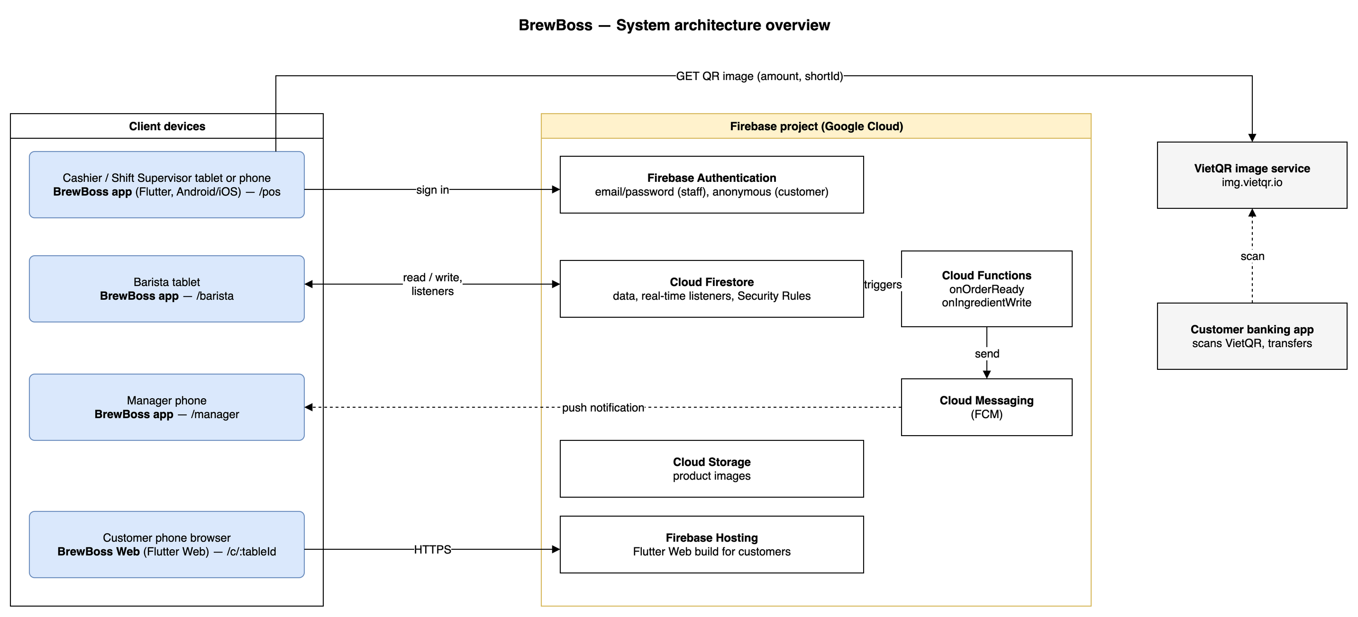
Figure 2-1: System Architectural Overview
As described in figure 2-1, the system has the following components:
• BrewBoss app (developing software) — Flutter 3 / Dart 3 application with role-based routing. The same build serves the Manager (/manager, phone), Shift Supervisor and Cashier (/pos, counter tablet or phone) and Barista (/barista, bar tablet).
• BrewBoss Web (developing software) — Flutter Web build of the customer routes /c/:tableId and /c/:tableId/order/:id, deployed on Firebase Hosting so a customer orders by scanning the table QR without installing anything. This resolves SRS open decision Q2.
• Firebase Authentication — email / password sign-in and password reset for staff; anonymous sessions for customers.
• Cloud Firestore — all business data, real-time listeners (table map, barista queue, dashboard, customer status), transactions for every multi-document write, offline cache and Security Rules that enforce the per-role permissions.
• Cloud Storage for Firebase — product images.
• Cloud Functions (developing software) — two Firestore triggers: onOrderReady (UC31) and onIngredientWrite (UC16). They only send notifications; every business write happens in the app transactions.
• Firebase Cloud Messaging — delivers the order-ready and low-stock pushes to the device tokens stored in users/{uid}.fcmTokens.
• VietQR image service (external) — img.vietqr.io returns the QR image for the bank account, amount and order shortId; the customer pays with their own banking app and the cashier confirms the transfer manually.

2.2 Assumptions
This system is designed on the following assumptions:
• One shop, one branch (SRS A1); the data model has no branch id.
• Staff devices: Android 8.0+ or iOS 14+ phones and tablets with Google Play Services on Android for FCM (NFR-COMP-01). The barista tablet stays on and connected during opening hours.
• Customers use their own phone camera and a current mobile browser (Chrome, Safari) to open the table QR.
• Normal 4G or Wi-Fi in the shop; brief drops are covered by the Firestore offline cache (NFR-REL-02).
• The Firebase project runs on the Blaze (pay-as-you-go) plan so Cloud Functions can be deployed; the expected load of one cafe stays inside the free quota. Without Blaze, the in-app listeners described in 4.1 take over the notifications.
• Development tools: Flutter 3.x stable, Dart 3, Android Studio / VS Code, Firebase CLI and Emulator Suite, Node.js 20 for Cloud Functions, Git.
• User interface text is Vietnamese; code, identifiers and documents are English (SRS A3).
• Possible later changes (out of scope now): multi-branch, Bluetooth thermal printers, topping recipes (BR-INV-04 upgrade path), automatic bank confirmation of VietQR transfers. The layered design keeps each of them inside one feature folder.

2.3 Design Constraints
The design must comply with the following constraints:
# | Constraint | Impact on the design
C1 | Backend is Firebase only; no custom server (SRS A2) | Business logic runs in the app; integrity is protected by Firestore transactions and Security Rules instead of a server API.
C2 | All data access enforced by Security Rules per role (NFR-SEC-01); passwords only in Firebase Auth (NFR-SEC-02) | Every collection has a rule set mirroring SRS 3.1.3; the role is read from users/{uid}.role. Rules are tested on the Emulator before the demo.
C3 | Payment, stock deduction and points in one transaction (NFR-REL-01) | OrderRepository.pay runs one runTransaction including StockDeductor; Firestore requires every read before the first write, so StockDeductor has separate read and write steps.
C4 | New order on the barista screen within 2 s (NFR-PERF-01) | The barista queue is a Firestore snapshot listener, not polling; the queue query has a composite index (status, createdAt).
C5 | Cold start < 3 s, 100-product menu at 60 fps (NFR-PERF-02, -03) | Lazy GridView.builder, cached network images, images compressed to ≤ 1024 px before upload.
C6 | Feature-first structure, each feature testable; flutter analyze with zero warnings (NFR-MAINT-01, -02) | lib/features/<feature>/{data,application,presentation}; pure rules files without Flutter imports; very_good_analysis lint set in CI.
C7 | Who and when on every money, stock and status change (NFR-AUD-01) | paidBy, cancelledBy, confirmedBy, byUserId and server timestamps are written by the same transaction as the change.
C8 | Money as integer VND (SRS 5.2) | All amounts are int in Dart and integer in Firestore; formatting only at display time (formatVnd).
C9 | Customers have no account | Anonymous auth; customer writes are limited to creating awaiting orders (SEC-ANON) and the cashier confirmation gate re-validates prices (SEC-CONFIRM).
C10 | 8-week project, 4 members (SRS A5) | Feature folders map to members (AUTH / STAFF: M1, POS: M2, BAR / CUS / RPT / LOY: M3, MENU / INV: M4) to avoid merge conflicts.

3 Software Architecture Design

3.1 Architectural Representation
The architecture is described with the 4+1 view model [8]. The use-case view is the SRS use case model (SRS 2.3) and is not repeated; the other views are:
View | Section | Model elements | UML diagrams
Process view | 3.2.1 | Business processes, runtime execution units (app isolates, Firestore listeners, transactions, Cloud Functions) and their communication | Activity diagram, state machine
Logical view | 3.2.2 | Domain classes of lib/models and their relationships | Class diagram
Development view | 3.2.3 | Source packages (core, models, features/*) and their «use» dependencies | Package diagram, layered diagram
Deployment view | 3.2.4 | Devices, Firebase services, external service, artifacts and protocols | Deployment diagram
Detailed design | 4 | Screens, classes per feature and object interactions per use case | Class diagrams, sequence diagrams

3.2 Software Architecture
The app follows a layered, feature-first architecture (figure 3-1). Each feature folder has three layers; a layer depends only on the layer below it, and features talk to each other only through providers of their application layer.
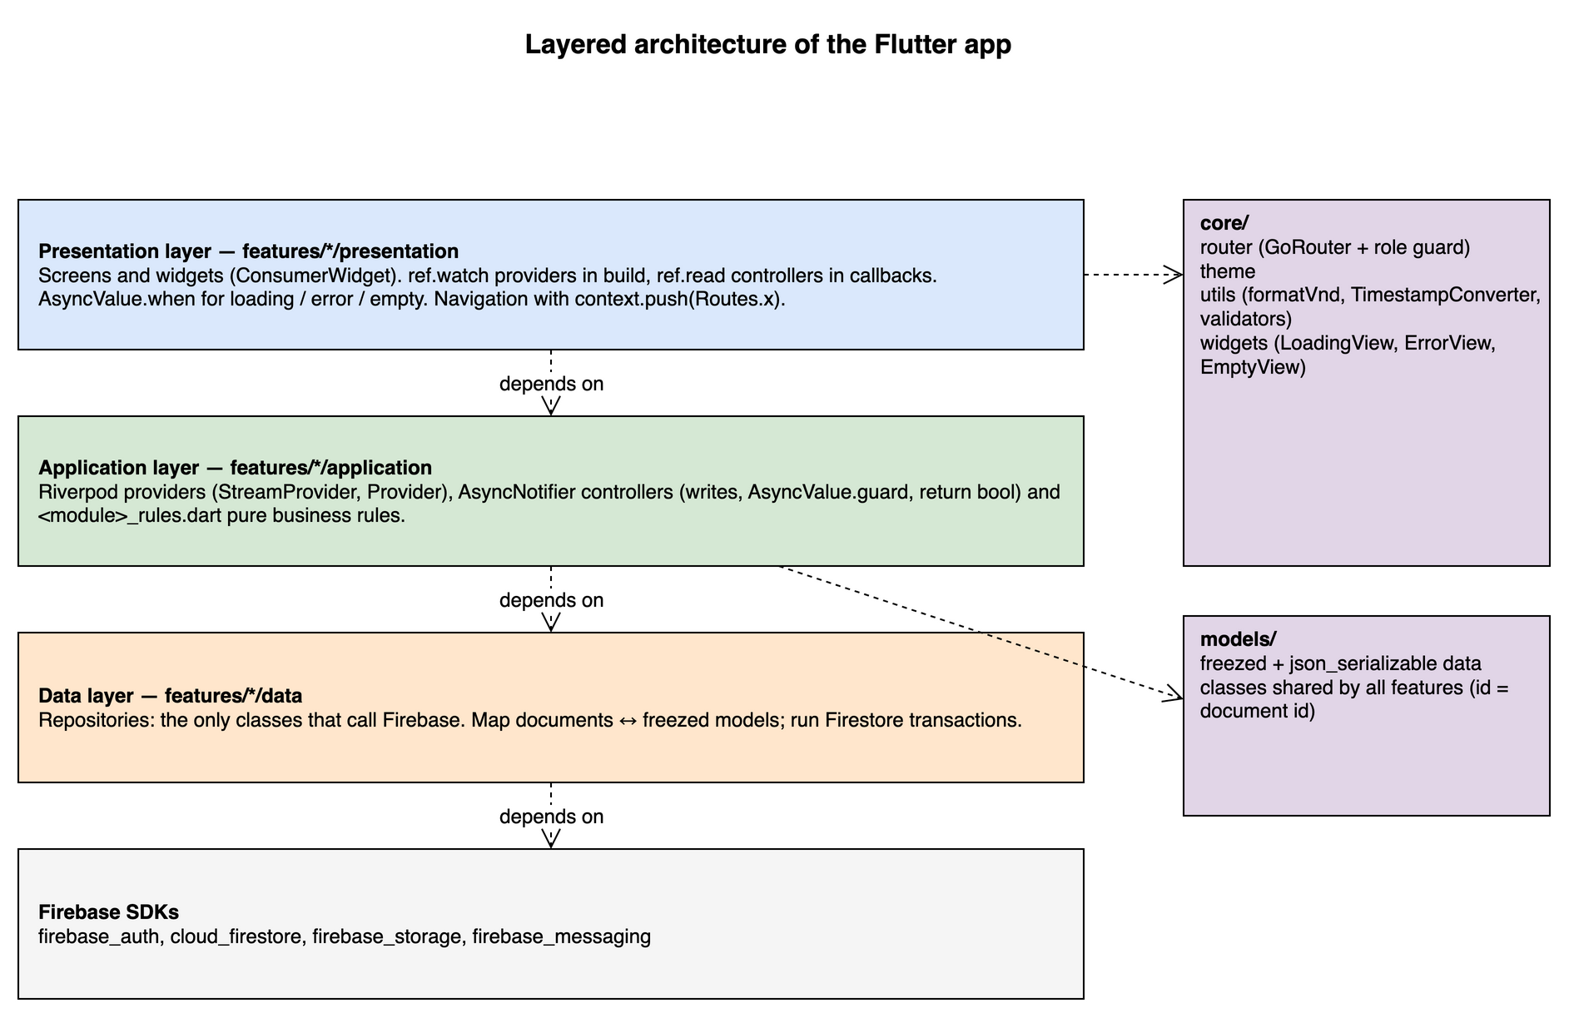
Figure 3-1: Layered architecture of the Flutter app
Layer / package | Responsibility | Relationship
Presentation (features/*/presentation) | Screens and widgets (ConsumerWidget / ConsumerStatefulWidget). Render AsyncValue states (loading, error with retry, empty, data), inline validation, navigation with context.push. | ref.watch providers in build; ref.read controllers in callbacks. Never calls Firebase.
Application (features/*/application) | Riverpod providers (read side), AsyncNotifier controllers (write side, wrap calls in AsyncValue.guard and return bool), <feature>_rules.dart pure business rules. | Uses repositories of its own feature and providers of other features.
Data (features/*/data) | Repositories: the only classes that call Firebase SDKs; map documents ↔ freezed models; run transactions. | Depends on Firebase SDKs and models/.
core/ | GoRouter with role guard, theme, utils (formatVnd, TimestampConverter, validators), shared widgets (LoadingView, ErrorView, EmptyView). | Used by every layer.
models/ | freezed + json_serializable data classes shared by all features (id = document id). | Used by every layer.
Firebase SDKs | firebase_auth, cloud_firestore, firebase_storage, firebase_messaging. | Lowest layer.

3.2.1 Process View
The process view shows how BrewBoss supports the business processes at runtime and which execution units run concurrently.

3.2.1.1 Daily Business Process
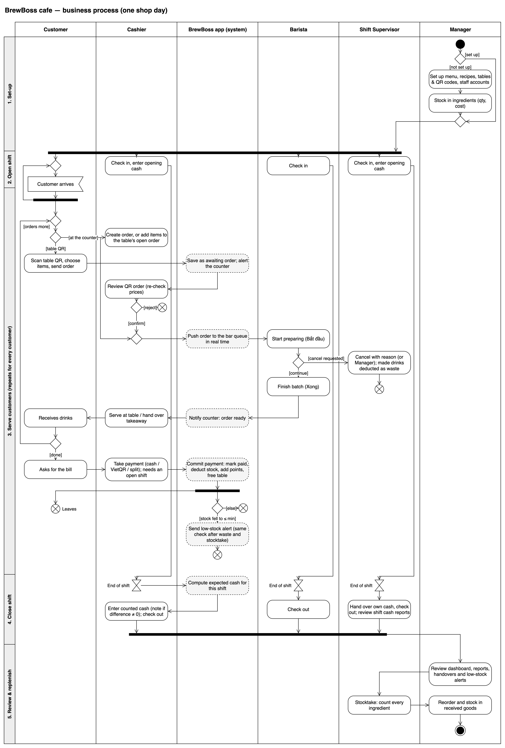
Figure 3-2: Daily business process supported by BrewBoss (activity diagram, SRS figure 2-1)
As described in figure 3-2, one shop day runs as follows:
Step 1 (set-up, once): the Manager enters menu, recipes, tables with QR codes and staff accounts in the app (S08–S12, S05) and stocks in ingredients (S11). Each save is a Firestore write guarded by the Manager rules.
Step 2 (open shift): every staff member checks in on S07; cashier, shift supervisor and manager enter the opening cash. A shifts document is created with a server timestamp.
Step 3 (serve, repeats): the cashier creates an order on S14, or a customer orders through the table QR on S17 and the cashier confirms it. The order write is picked up by the barista queue listener (S16) in under 2 s; the barista moves it to preparing and ready; onOrderReady pushes a notification and the table map badge updates; the cashier marks it served.
Step 4 (payment): on S15 the cashier takes cash, VietQR or split payment; one transaction marks the order paid, deducts stock by recipe, updates loyalty points and voucher usage and frees the table. A stock crossing min stock fires onIngredientWrite and a low-stock push to managers.
Step 5 (close shift): at check-out the app computes the expected cash from the user's paid orders and stores the handover snapshot; the cash fields are then locked by Security Rules.
Step 6 (review): the Manager watches the live dashboard (S04), reports (S19) and shift handovers (S06); the shift supervisor or manager runs the stocktake (S10).

3.2.1.2 Order Lifecycle
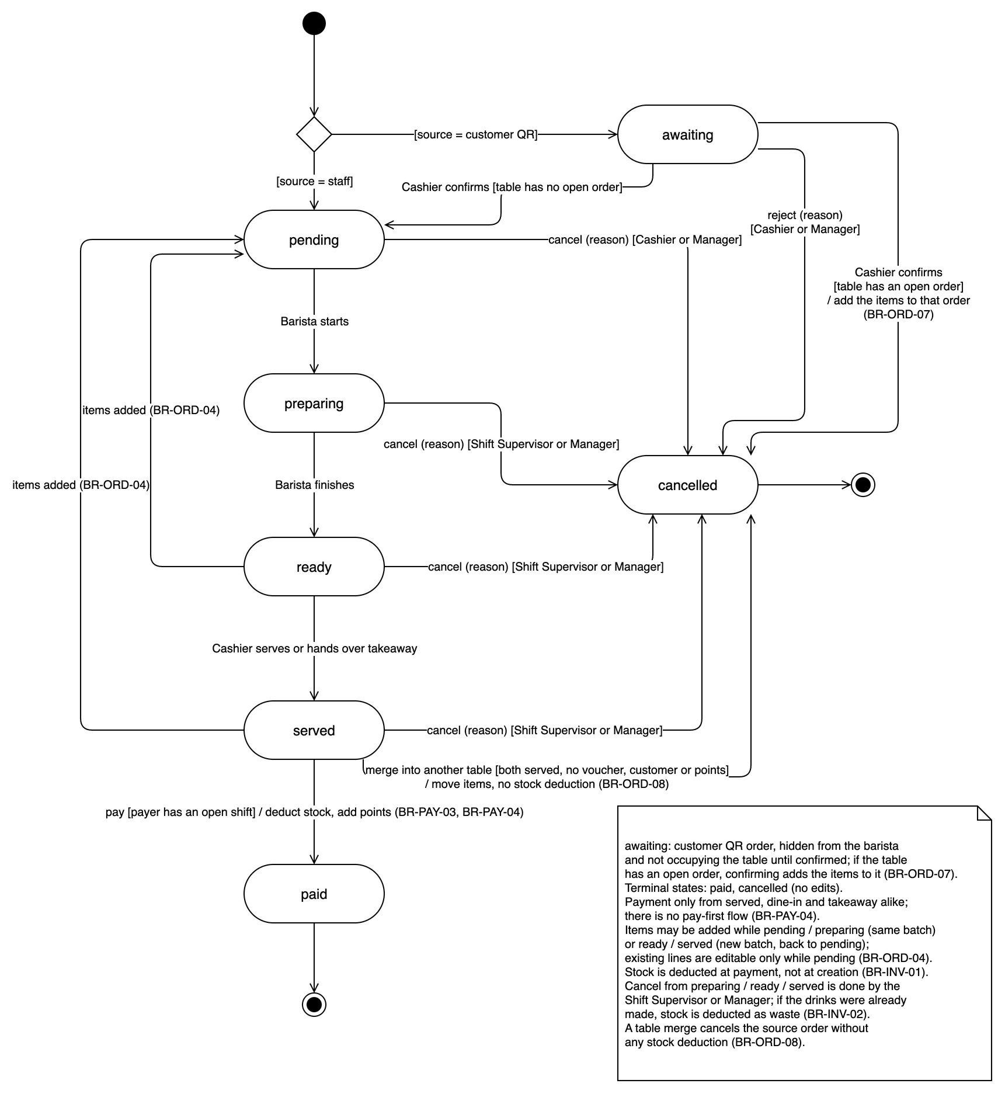
Figure 3-3: Order status state machine (SRS figure 2-2)
Each transition of figure 3-3 is one Firestore write performed by exactly one execution unit: OrderRepository transactions on the cashier device (create, confirm, add items, serve, merge, cancel, pay), BaristaController on the bar tablet (pending → preparing → ready) and CustomerOrderRepository in the customer browser (create awaiting). order_rules.canTransition checks the transition on the client and Security Rules check it again on the server, so a stale screen cannot skip a state.

3.2.1.3 Runtime Execution Units and Concurrency
# | Execution unit | Runs on | Communication | Concurrency handling
1 | Flutter UI isolate (one per device) | Staff device / customer browser | Firestore SDK listeners deliver snapshots asynchronously; writes are Futures | Riverpod rebuilds only widgets watching the changed provider; controllers expose AsyncValue so a button is disabled while its write is running.
2 | Firestore snapshot listeners | Each device | Server push over a persistent gRPC / WebChannel stream | Ordered per query; the offline cache shows the last data and queues writes during brief drops (MSG18 banner).
3 | Firestore transactions | Initiating device, committed by Firestore | Optimistic concurrency: the transaction retries (up to 5 times) when a read document changed | Two cashiers paying, merging or confirming on the same table cannot both commit; shortId allocation and table.currentOrderId are always written inside a transaction (BR-ORD-03).
4 | Cloud Function onOrderReady | Google Cloud (Node.js 20) | Firestore update trigger → FCM multicast | At-least-once delivery; fires only on the before ≠ ready, after = ready edge, so a retry sends at most a duplicate push, never a data change.
5 | Cloud Function onIngredientWrite | Google Cloud (Node.js 20) | Firestore update trigger → FCM multicast | Fires on the stock > min → stock ≤ min edge only (UC16).
6 | FCM message handler | Staff device (foreground / background) | Push from FCM | Foreground: in-app snackbar; background: system notification that opens S14 for the order or S11 for the ingredient.
7 | Barista ticker | Bar tablet | Timer.periodic(30 s) | Recomputes elapsed time and overdue colour without any read.

3.2.2 Logical View
The logical view is the domain model shared by all features (lib/models). Every class is an immutable freezed class with fromJson / toJson; the id field is the Firestore document id and is not stored in the document. Product.sizes, toppings and recipe and Order.items are embedded arrays / maps, not separate collections, so an order or a product is read in one document read.
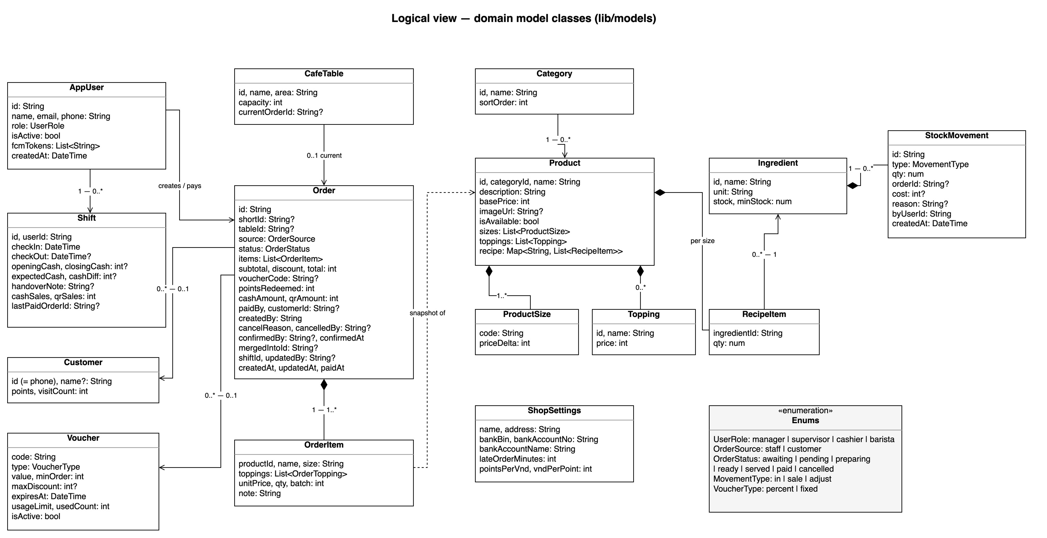
Figure 3-4: BrewBoss logical overview — domain model classes
Class | Responsibility | Important relationships
AppUser | Staff account with one UserRole (manager, supervisor, cashier, barista) and isActive flag | Owns Shifts; creates, confirms, pays and cancels Orders (audit fields)
Shift | One work session with the cash handover snapshot | Belongs to one AppUser; its cash sales are the Orders paidBy that user inside checkIn..checkOut
Order / OrderItem | The central aggregate: status, money fields, audit fields; items are price snapshots with a batch number | Optional CafeTable (null = takeaway), Customer and Voucher; OrderItem refers to Product only as a snapshot
CafeTable | Physical table with currentOrderId | 0..1 current Order (BR-ORD-03)
Category / Product | Menu; Product composes ProductSize (1..*), Topping (0..*) and RecipeItem per size | RecipeItem refers to one Ingredient
Ingredient / StockMovement | Raw material with stock and minStock; movement log (in, sale, adjust) | Movements are a sub-collection of their ingredient
Customer / Voucher | Loyalty member keyed by phone; discount code | Referenced by Orders
ShopSettings | Single settings/shop document: shop info, VietQR account, late-order minutes, loyalty rates | Read by POS, barista and loyalty rules

3.2.3 Development View
The source code is organised feature-first. The Flutter project root contains lib/ (app code), test/ (unit and widget tests mirroring lib/), functions/ (Cloud Functions), firestore.rules, storage.rules, firestore.indexes.json and firebase.json.

3.2.3.1 Package Diagram
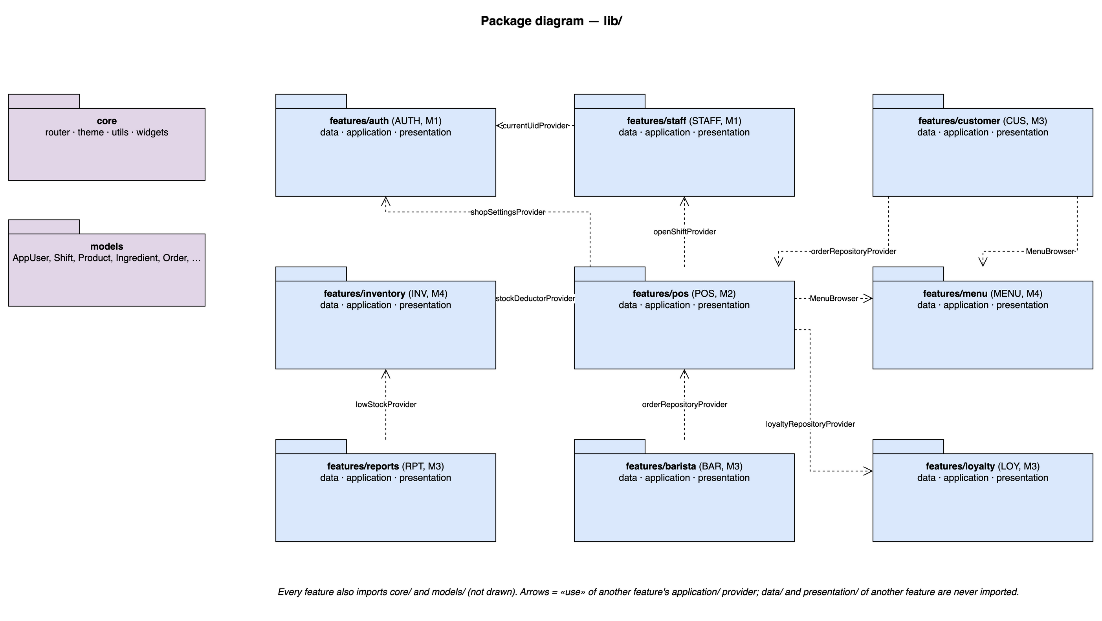
Figure 3-5: BrewBoss package diagram (lib/)
Packages Description
No | Package | Description
01 | core | App-wide infrastructure: router (GoRouter + role guard, route constants), theme (Material 3, Vietnamese locale), utils (formatVnd, date formats, TimestampConverter, validators, error mapper) and widgets (LoadingView, ErrorView, EmptyView, ConfirmDialog, OfflineBanner).
02 | models | freezed domain classes and enums of figure 3-4, shared by all features.
03 | features/auth | UC01–UC03, UC29: login, logout, password reset, profile and shop settings; currentUidProvider, currentUserProvider, shopSettingsProvider (M1).
04 | features/staff | UC04–UC06, UC44, UC45: staff accounts, shifts, cash handover; openShiftProvider (M1).
05 | features/menu | UC07–UC10: categories, products, availability, MenuBrowser widget (M4).
06 | features/inventory | UC11–UC17, UC42, UC43: ingredients, movements, stocktake, StockDeductor, lowStockProvider (M4).
07 | features/pos | UC19–UC28, UC46: table map, orders, payment, receipt; orderRepositoryProvider, tablesProvider (M2).
08 | features/barista | UC30, UC31: barista queue (M3).
09 | features/customer | UC18, UC32, UC33: table management and QR, anonymous customer ordering and tracking (M3).
10 | features/reports | UC34–UC37: dashboard, reports, order history, export (M3).
11 | features/loyalty | UC38–UC41: customers, points, vouchers; loyaltyRepositoryProvider (M3).
12 | functions (Node.js) | Cloud Functions onOrderReady and onIngredientWrite (M3, M4).

3.2.3.2 Component Diagram
Each feature folder is one component; its provided interfaces are the providers on the «use» arrows of figure 3-5. The table lists the components with the interfaces other components use.
Components Description
No | Component | Provided interfaces | Required interfaces
01 | Auth | currentUidProvider, currentUserProvider, shopSettingsProvider, auth_rules.homeRouteFor | Firebase Auth, Firestore
02 | Staff | openShiftProvider | Auth, Firestore, OrderRepository.paidOrders
03 | Menu | MenuBrowser widget, productsProvider, menu_rules.unitPrice | Firestore, Cloud Storage
04 | Inventory | stockDeductorProvider, lowStockProvider | Firestore, Menu (recipes)
05 | POS | orderRepositoryProvider, tablesProvider, order_rules | Auth, Staff, Menu, Inventory, Loyalty, VietQR
06 | Barista | — | POS (orderRepositoryProvider)
07 | Customer | — | Menu (MenuBrowser), POS (orderRepositoryProvider), Firebase anonymous auth
08 | Reports | — | POS orders, Inventory (lowStockProvider)
09 | Loyalty | loyaltyRepositoryProvider, loyalty_rules | Firestore
10 | Cloud Functions | Push notifications | Firestore triggers, FCM

3.2.4 Deployment View
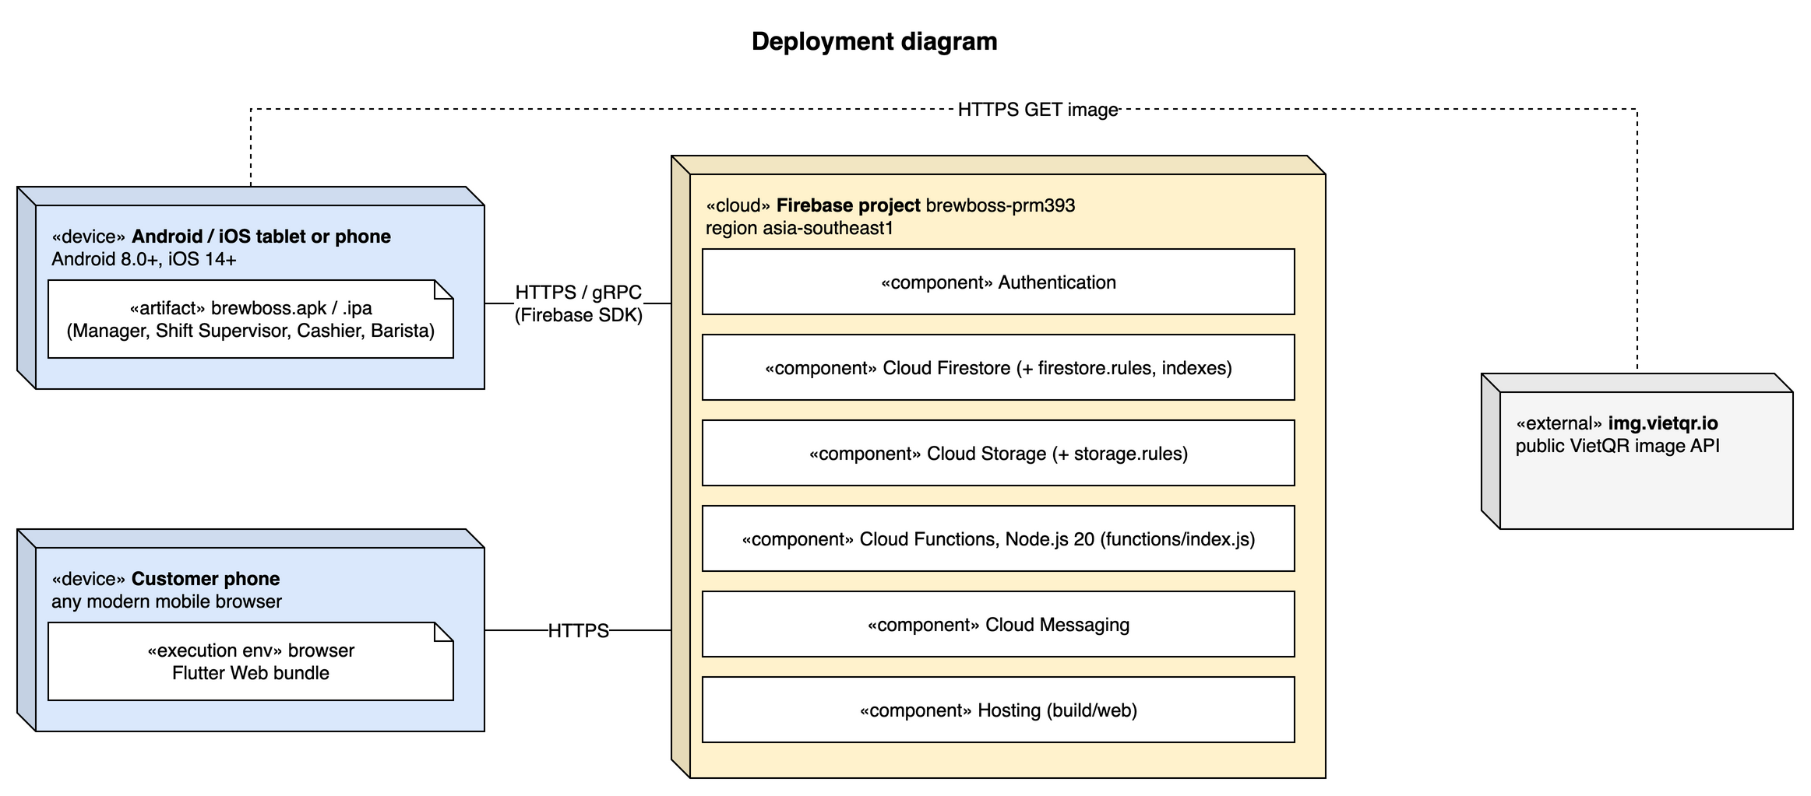
Figure 3-6: BrewBoss deployment structure
Configuration Description
No | Component / Node | Description
01 | Staff device «device» | Android 8.0+ / iOS 14+ phone or tablet running brewboss.apk / .ipa. Counter tablet: Cashier and Shift Supervisor (S13–S15). Bar tablet: Barista (S16). Manager phone (S04–S12, S19–S22). Talks to Firebase with the SDKs over HTTPS / gRPC; downloads the VietQR image over HTTPS.
02 | Customer phone «device» | Any current mobile browser executing the Flutter Web bundle served by Firebase Hosting; routes /c/:tableId and /c/:tableId/order/:id only.
03 | Firebase project «cloud» | brewboss-prm393, region asia-southeast1 (Singapore, closest to Vietnam): Authentication, Cloud Firestore with firestore.rules and firestore.indexes.json, Cloud Storage with storage.rules, Cloud Functions (Node.js 20, functions/index.js), Cloud Messaging, Hosting (build/web).
04 | img.vietqr.io «external» | Public VietQR image API; no key. Receives bank BIN, account, amount and the order shortId as transfer note.
05 | Mapping of execution units | Units 1, 2, 3, 6, 7 of 3.2.1.3 run on nodes 01 / 02; units 4 and 5 run in Cloud Functions on node 03.
06 | Build and release | flutter build apk / ipa for staff devices (sideloaded or internal testing track); flutter build web + firebase deploy --only hosting for customers; firebase deploy --only firestore,storage,functions for rules, indexes and functions.

4 Detailed Component Design

4.1 Common Design
This section gives the design shared by every feature.

4.1.1 Error Handling
• Repositories let Firebase exceptions propagate. Controllers wrap every write in AsyncValue.guard and return true / false; the screen shows the message and never crashes.
• core/utils/error_mapper.dart maps FirebaseException codes to Vietnamese messages: permission-denied → "Bạn không có quyền thực hiện thao tác này", unavailable → MSG18 "Mất kết nối", Auth wrong-password / invalid-credential → MSG01, too-many-requests → MSG02. Business rule violations raise RuleException(code) with the SRS message code.
• Validation errors are shown inline next to the field; other errors in a SnackBar; destructive actions ask for confirmation with ConfirmDialog (SRS 5.2).
• Every list and detail screen renders AsyncValue with LoadingView, ErrorView (with "Thử lại" retry calling ref.invalidate) and EmptyView.

4.1.2 Logging
• Development: debugPrint through a small log(tag, message) helper, removed from release builds by kDebugMode.
• Release: Firebase Crashlytics records uncaught errors (FlutterError.onError and PlatformDispatcher.onError) with the uid and role as custom keys.
• Business audit is not a log: who and when are stored on the documents themselves (paidBy, cancelledBy, confirmedBy, byUserId, timestamps) as required by NFR-AUD-01.

4.1.3 Messages Processing
• All user-facing strings live in lib/l10n/app_vi.arb (flutter_localizations, gen-l10n); message keys follow the SRS codes (msg01 … msg44) so testers can trace them.
• Push notifications: FCM data messages with type (orderReady / lowStock) and the target id. core/notifications.dart requests permission, registers the token after login (AUTH non-screen function #2), shows a SnackBar in the foreground and deep-links on tap: orderReady(orderId) → /pos/order/:id (S14, UC31), lowStock(ingredientId) → /manager/inventory/:id (S11, UC16); the role guard still applies.
• In-app fallback when Cloud Functions are not deployed: the table map watches openOrdersProvider for status = ready, the dashboard watches lowStockProvider.

4.1.4 UI Structure and Utility Classes
Element | Design
Routing | One GoRouter created in routerProvider. Public routes: /login, /forgot-password and the customer routes /c/** (CustomerOrderController.ensureSignedIn creates the anonymous session). Any other route without a staff session → /login; with a session → auth_rules.canOpen(role, location) else homeRouteFor(role). refreshListenable is a RouterNotifier (ChangeNotifier) that ref.listen()s currentUserProvider and calls notifyListeners(), so a deactivated or re-roled user is moved immediately.
Shells | ManagerShell (drawer with every manager function), PosShell (table map / takeaway tabs, profile), BaristaShell (full-screen queue, landscape). Responsive breakpoints: < 600 dp phone, ≥ 600 dp tablet two-pane (order editor menu + cart side by side).
Theme | Material 3, seed colour coffee brown, minimum tap target 48 × 48 dp (NFR-USE-02), barista text scale 1.3.
formatVnd(int) | NumberFormat("#,###", "vi_VN") + " ₫" → "45.000 ₫" (NFR-USE-03).
TimestampConverter | json_serializable converter Timestamp ↔ DateTime; writes use FieldValue.serverTimestamp().
validators | email, phone (10 digits, leading 0), non-negative int money, required reason.
Shared widgets | LoadingView, ErrorView, EmptyView, ConfirmDialog, ReasonDialog, MoneyField, OfflineBanner (MSG18), StatusChip.

4.1.5 Transaction Management
Every multi-document write runs in exactly one FirebaseFirestore.runTransaction (NFR-REL-01). Rules for all transactions:
• Read every document first (order, table, shift, voucher, customer, ingredients through StockDeductor.readForOrder), then validate with the pure rules, then write. Firestore aborts and retries automatically when a read document changes before commit.
• Re-check preconditions inside the transaction, never only on the screen: status = served and open shift for payment (BR-PAY-03, -04), table free for create / move (BR-ORD-03), both served for merge (BR-ORD-08).
• Timestamps use FieldValue.serverTimestamp(); audit fields are written in the same transaction.
• Transactions in the system: create staff order (counters/{yyyyMMdd} + order + table), confirm customer order (counter + order + table or open order), add items, attach loyalty customer / points, merge, move, cancel (+ waste), pay (+ stock, points, visitCount, voucher, shift cashSales / qrSales, table), stock-in, adjustment, stocktake (one per ingredient, re-reading stock), check-in (+ shiftLocks), check-out (re-reading shift totals, + shiftLocks).

4.1.6 Security
Security Rules implement the permission matrix of SRS 3.1.3. Helper functions in firestore.rules: role() = get(/users/$(request.auth.uid)).data.role, isStaff(), isManager(), atLeastSupervisor(), isActive(). Notable rules: anonymous users may create orders only with source = customer, status = awaiting, createdBy == request.auth.uid, no shortId, price-free trust (prices re-validated at confirmation) and no confirmedBy / confirmedAt, and read only orders whose createdBy is their uid or the order a mergedIntoId of theirs points to (SEC-ANON, SEC-CONFIRM); a barista may update only status, updatedAt and updatedBy and only along the barista transitions; every staff user may update only the fcmTokens field of their own users document; shift cash fields are immutable once checkOut is set (BR-STAFF-05). Stock, customer and voucher writes made by cashiers inside payment or cancellation are accepted only when the same commit moves that order to paid or cancelled (getAfter). The rules are covered by @firebase/rules-unit-testing tests on the Emulator.

4.1.7 Common Classes
Shared classes in lib/core used by every feature (layer diagram: figure 3-1, core/ package):
Class | Source file | Responsibility | Key members
routerProvider / RouterNotifier | core/router/app_router.dart | Builds the single GoRouter and refreshes it when the session or role changes | redirect(context, state), RouterNotifier.notifyListeners() on currentUserProvider change
Routes | core/router/routes.dart | Route path constants (/login, /pos, /pos/order/:id, /barista, /manager/…, /c/:tableId …) | static const String …
ErrorMapper | core/utils/error_mapper.dart | Maps FirebaseException and RuleException to Vietnamese messages (4.1.1) | String message(Object error)
RuleException | core/utils/rule_exception.dart | Business rule violation thrown by *_rules.dart and repositories; carries the SRS message code | final String code; final Map<String, Object> args
NotificationService | core/notifications.dart | FCM permission, token registration, foreground SnackBar, deep links (4.1.3) | init(), onTokenRefresh, handleTap(RemoteMessage)
Formatters / validators | core/utils/format.dart, validators.dart | formatVnd, date and time formats, phone / email / money validation | formatVnd(int), validatePhone(String?)
TimestampConverter | core/utils/timestamp_converter.dart | json_serializable converter Timestamp ↔ DateTime | fromJson, toJson
LoadingView, ErrorView, EmptyView, ConfirmDialog, ReasonDialog, MoneyField, OfflineBanner | core/widgets/ | Uniform states and dialogs of SRS 5.2 | ErrorView(onRetry), ReasonDialog → Future<String?>

4.1.8 Common Object Interactions
• Routing and role guard — SD-01 (figure in 4.2): sign-in, profile check, FCM token, then the router redirect to homeRouteFor(role).
• Write pattern — screen → controller (AsyncValue.guard, returns bool) → repository → Firestore, shown in SD-09 and SD-10.
• Transaction pattern — read everything, validate with the rules, write, commit or retry: SD-04 (payment), SD-05 (cancellation), SD-06 (merge), SD-08 (stocktake).
• Live read pattern — screen ref.watch → StreamProvider → repository snapshots → AsyncData → rebuild: SD-11.
• Notification pattern — Firestore trigger → Cloud Function → FCM → NotificationService: end of SD-02 and SD-13.

4.2 Authentication and Profile (UC01–UC03, UC29)
Feature folder lib/features/auth. It covers UC01–UC03, UC29 of the SRS.

4.2.1 Class/Component Design

4.2.1.1 Class/Component Structure
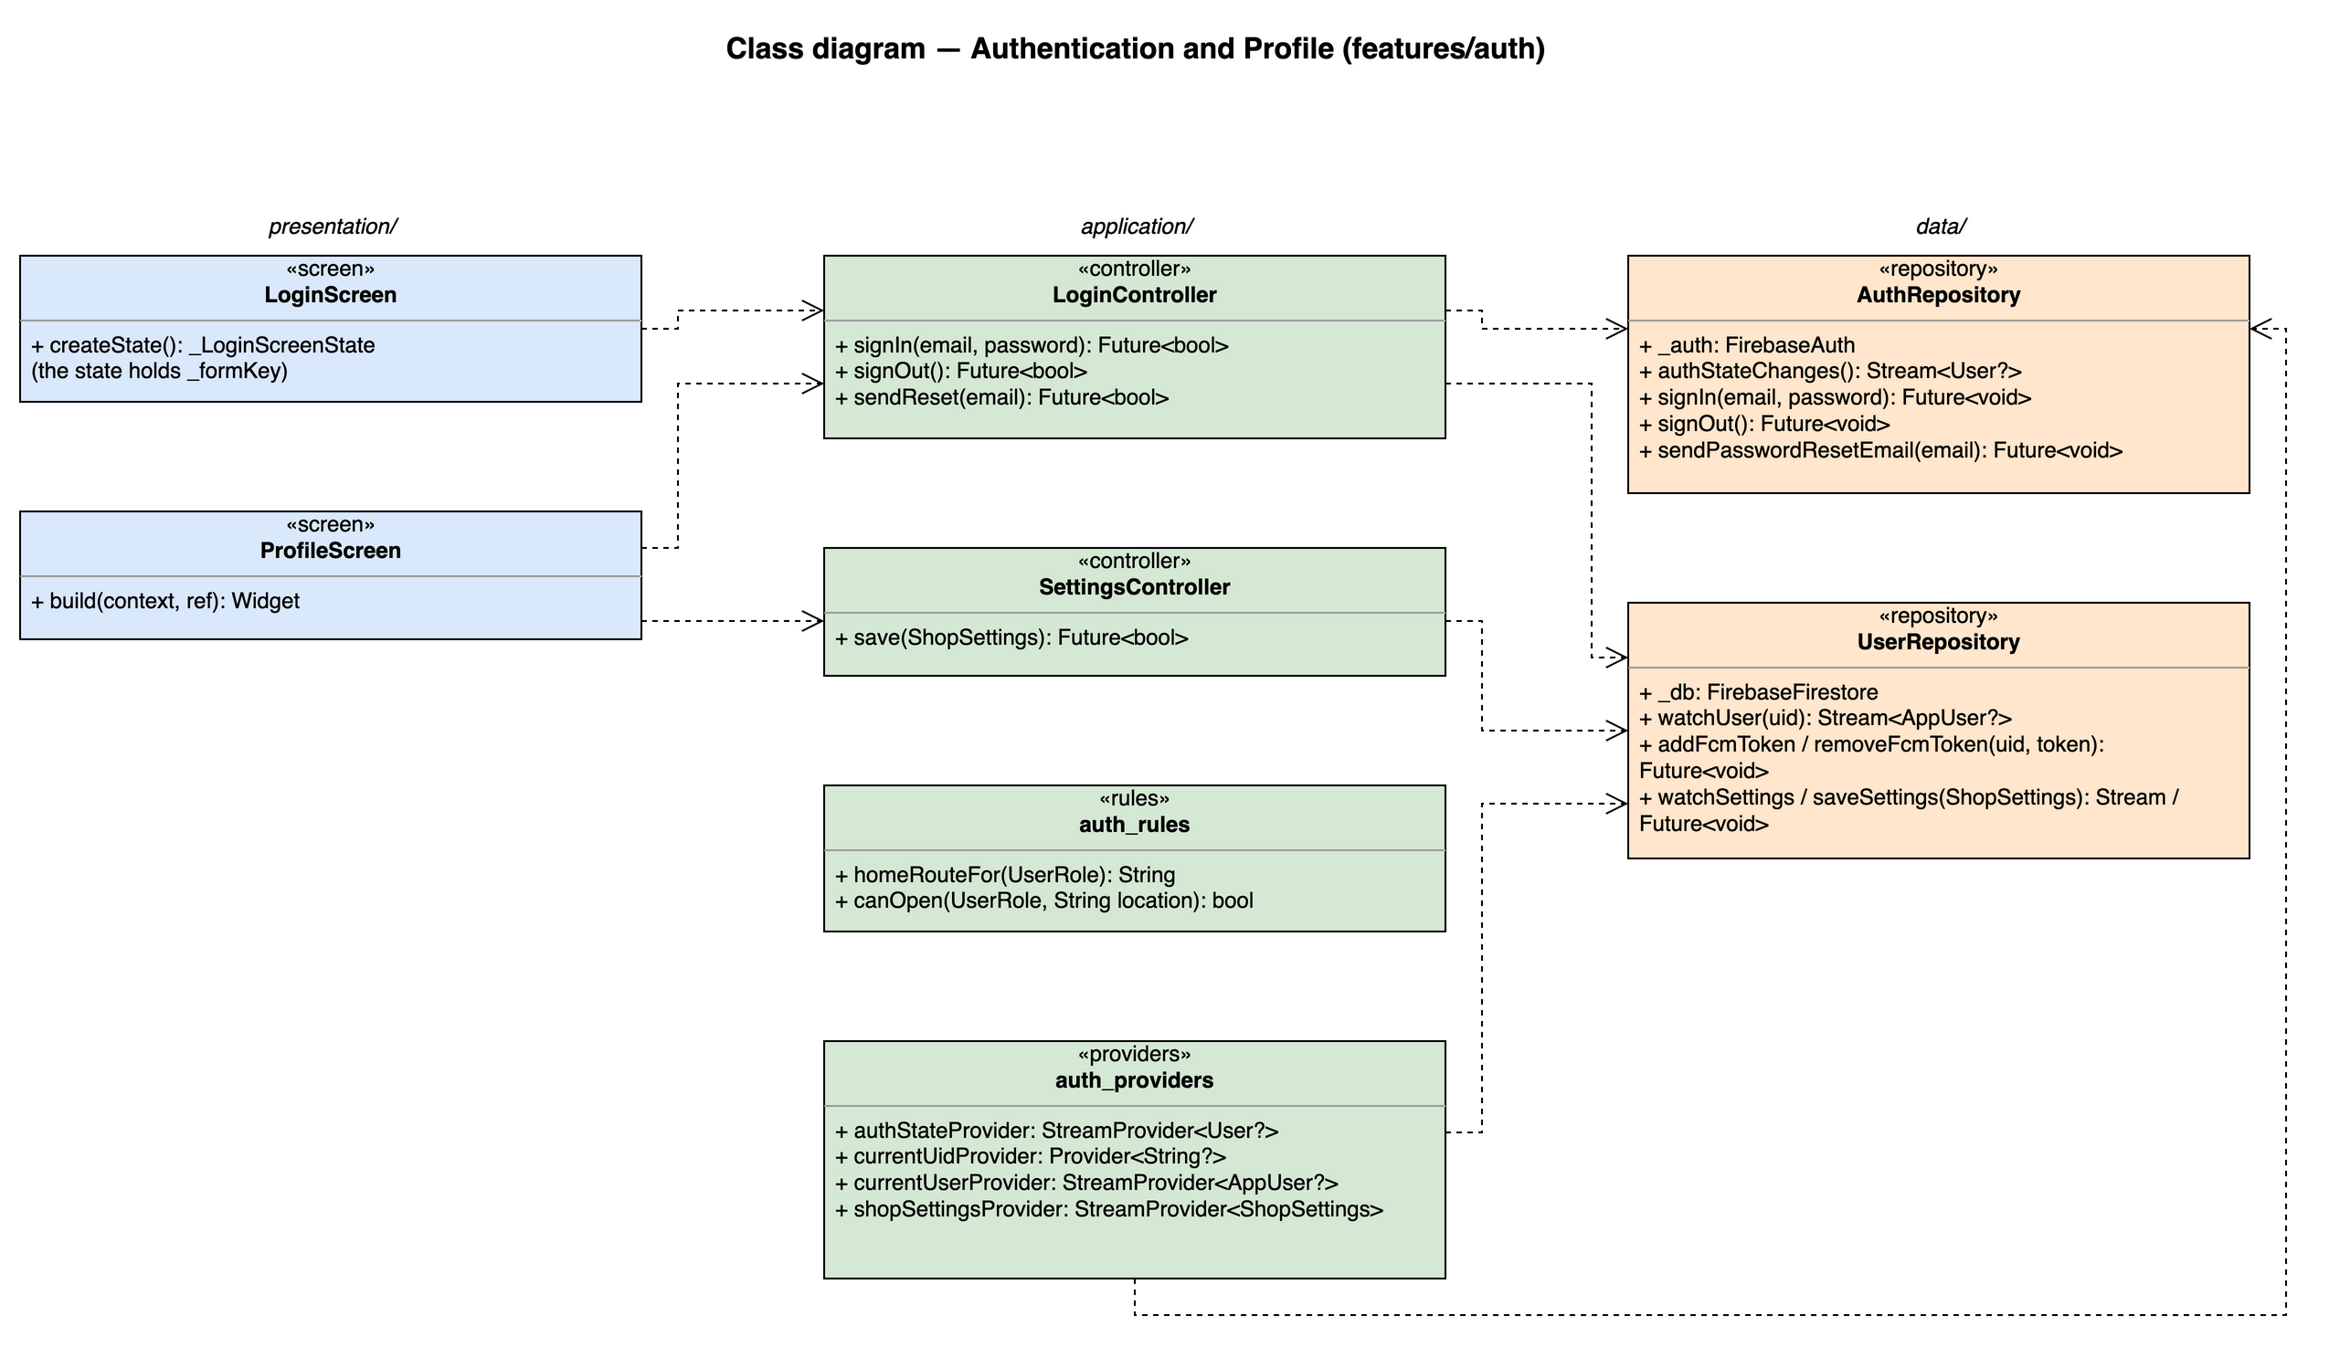
Figure 4.2-1: Class diagram for Authentication and Profile

4.2.1.2 Class/Component Description
Class | «screen» LoginScreen
Description | S02 Login. Email / password form; on success the router redirect sends the user to the role home. Also hosts the "Quên mật khẩu?" link to S03, which reuses LoginController.sendReset.
Base Class | ConsumerStatefulWidget
Constructor | const LoginScreen({super.key})
Prototype | class LoginScreen extends ConsumerStatefulWidget
Source File | lib/features/auth/presentation/login_screen.dart
Namespace | package:brewboss/features/auth/presentation
Attributes | Name | Type | Description
Attributes | _formKey | GlobalKey<FormState> | Validates email format and non-empty password
Attributes | _email, _password | TextEditingController | Field controllers, disposed in dispose()
Methods | Name | Input | Output | Description
Methods | createState | — | _LoginScreenState | Creates the ConsumerState<LoginScreen> that holds the attributes above and the private methods below; its build(BuildContext context) reads providers through the state's ref
Methods | _submit | — | Future<void> | Validates the form, calls LoginController.signIn and shows MSG01–MSG04 inline when it returns false

Class | «screen» ProfileScreen
Description | S22 Profile / settings: account info, change password, log out; shop settings section for the Manager; "Giao ca" (S06) and "Kiểm kho" (S10) entries for the Shift Supervisor.
Base Class | ConsumerWidget
Constructor | const ProfileScreen({super.key})
Prototype | class ProfileScreen extends ConsumerWidget
Source File | lib/features/auth/presentation/profile_screen.dart
Namespace | package:brewboss/features/auth/presentation
Attributes | Name | Type | Description
Attributes | ref | WidgetRef | Riverpod reference; ref.watch in build, ref.read in callbacks
Methods | Name | Input | Output | Description
Methods | build | BuildContext context, WidgetRef ref | Widget | Watches the providers listed above and renders loading / error / empty / data with AsyncValue.when
Methods | _confirmLogout | BuildContext context | Future<void> | Shows MSG05 when the user still has an open shift, then calls LoginController.signOut

Class | «controller» LoginController
Description | Write-side controller for UC01–UC03. Wraps repository calls in AsyncValue.guard and returns bool so screens only decide what to show.
Base Class | AsyncNotifier<void>
Constructor | LoginController() — created by AsyncNotifierProvider<LoginController, void>(LoginController.new)
Prototype | class LoginController extends AsyncNotifier<void>
Source File | lib/features/auth/application/login_controller.dart
Namespace | package:brewboss/features/auth/application
Attributes | Name | Type | Description
Attributes | state | AsyncValue<void> | Loading flag that disables the submit button
Methods | Name | Input | Output | Description
Methods | signIn | String email, String password | Future<bool> | AuthRepository.signIn, then reads users/{uid}; signs out again and returns false when the profile is missing (MSG04) or isActive = false (MSG03); otherwise registers the FCM token
Methods | signOut | — | Future<bool> | Removes this device FCM token, then AuthRepository.signOut (UC02)
Methods | sendReset | String email | Future<bool> | Sends the Firebase reset link; always reports MSG06 so the existence of an email is not disclosed (UC03)

Class | «controller» SettingsController
Description | Saves the single settings/shop document (UC29). Manager only; enforced again by Security Rules.
Base Class | AsyncNotifier<void>
Constructor | SettingsController() — created by AsyncNotifierProvider<SettingsController, void>(SettingsController.new)
Prototype | class SettingsController extends AsyncNotifier<void>
Source File | lib/features/auth/application/settings_controller.dart
Namespace | package:brewboss/features/auth/application
Attributes | Name | Type | Description
Attributes | state | AsyncValue<void> | Saving state
Methods | Name | Input | Output | Description
Methods | save | ShopSettings settings | Future<bool> | Validates bank account digits and positive rates, then UserRepository.saveSettings

Class | «providers» auth_providers
Description | Session state shared by every feature.
Base Class | — (top-level providers)
Constructor | —
Prototype | top-level declarations (no class)
Source File | lib/features/auth/application/auth_providers.dart
Namespace | package:brewboss/features/auth/application
Attributes | Name | Type | Description
Attributes | authStateProvider | StreamProvider<User?> | Firebase Auth state
Attributes | currentUidProvider | Provider<String?> | uid of the signed-in user
Attributes | currentUserProvider | StreamProvider<AppUser?> | Live users/{uid} profile, including role and isActive
Attributes | shopSettingsProvider | StreamProvider<ShopSettings> | Live settings/shop with the defaults of section 5.1 when missing
Methods | Name | Input | Output | Description
Methods | — | — | — | Declarations only; see Attributes

Class | «rules» auth_rules
Description | Pure routing rules used by the GoRouter redirect (BR-AUTH-ROUTE).
Base Class | — (pure functions)
Constructor | —
Prototype | top-level declarations (no class)
Source File | lib/features/auth/application/auth_rules.dart
Namespace | package:brewboss/features/auth/application
Attributes | Name | Type | Description
Attributes | — | — | No state
Methods | Name | Input | Output | Description
Methods | homeRouteFor | UserRole role | String | manager → /manager (S04); supervisor, cashier → /pos (S13); barista → /barista (S16)
Methods | canOpen | UserRole role, String location | bool | Applies the screen authorization matrix of SRS 3.1.3; false makes the router redirect to homeRouteFor(role)

Class | «repository» AuthRepository
Description | Only class that calls FirebaseAuth for staff sessions.
Base Class | —
Constructor | —
Prototype | class AuthRepository
Source File | lib/features/auth/data/auth_repository.dart
Namespace | package:brewboss/features/auth/data
Attributes | Name | Type | Description
Attributes | _auth | FirebaseAuth | Injected instance
Methods | Name | Input | Output | Description
Methods | authStateChanges | — | Stream<User?> | Session stream
Methods | signIn | String email, String password | Future<void> | signInWithEmailAndPassword; FirebaseAuthException codes are mapped to MSG01 / MSG02
Methods | signOut | — | Future<void> | Ends the session
Methods | sendPasswordResetEmail | String email | Future<void> | Reset link e-mail

Class | «repository» UserRepository
Description | Reads the users profile and the shop settings document.
Base Class | —
Constructor | —
Prototype | class UserRepository
Source File | lib/features/auth/data/user_repository.dart
Namespace | package:brewboss/features/auth/data
Attributes | Name | Type | Description
Attributes | _db | FirebaseFirestore | Firestore instance injected by the provider
Methods | Name | Input | Output | Description
Methods | watchUser | String uid | Stream<AppUser?> | users/{uid} snapshots
Methods | addFcmToken / removeFcmToken | String uid, String token | Future<void> | arrayUnion / arrayRemove on users/{uid}.fcmTokens; Security Rules let a user change only this field of their own document
Methods | watchSettings / saveSettings | ShopSettings | Stream<ShopSettings> / Future<void> | settings/shop

4.2.2 UC01–UC03 – Log in, log out, reset password

4.2.2.1 Screen Design
S01 Splash (route /). Reads the cached Firebase session and currentUserProvider, then lets the router redirect to S02 or the role home.
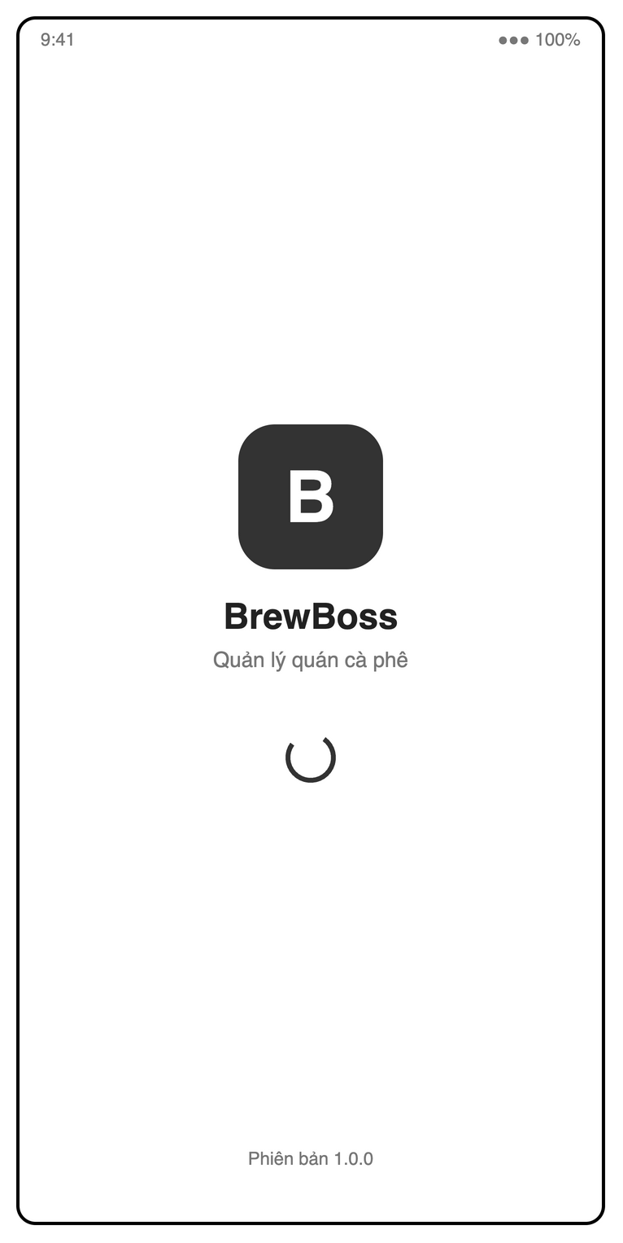
Figure 4.2-2: S01 Splash mock-up
Table 4-1: Splash Definition
No | Object Name | Type | Required | Length | Description
1 | appNameLabel | Label | Yes | NONE | Displays the app name "BrewBoss" while the saved session is checked (UC01).
2 | taglineLabel | Label | Yes | NONE | Displays "Quản lý quán cà phê".
3 | versionLabel | Label | Yes | NONE | Displays the installed version, shown as "Phiên bản 1.0.0".

4.2.2.2 Screen Design
S02 Login (route /login).
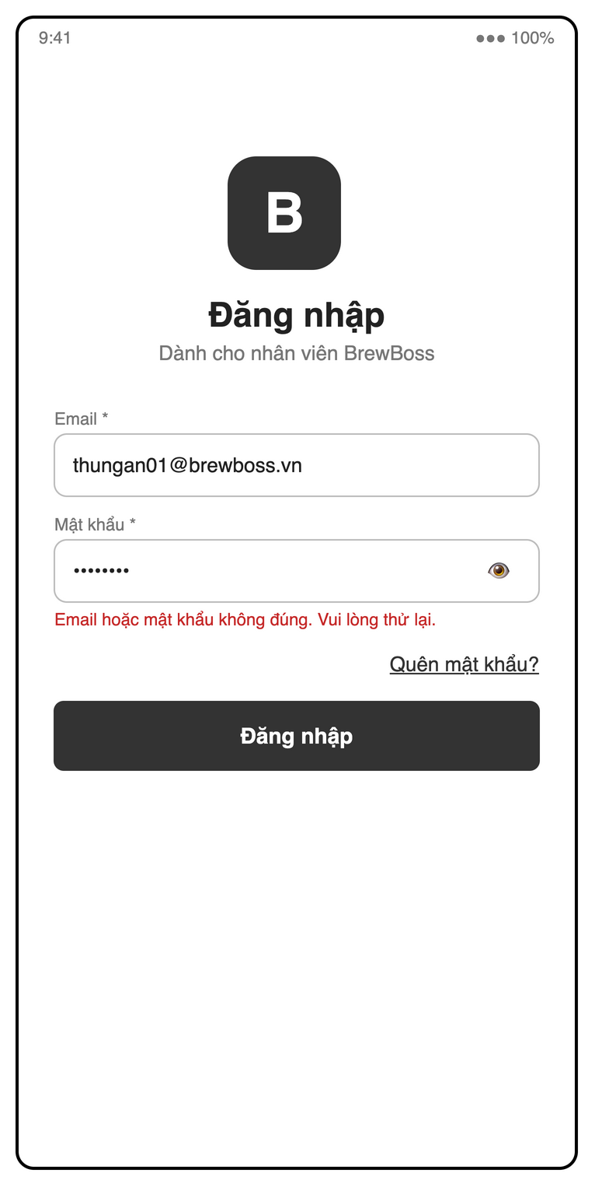
Figure 4.2-3: S02 Login mock-up
Table 4-2: Login Definition
No | Object Name | Type | Required | Length | Description
1 | titleLabel | Label | Yes | NONE | Displays "Đăng nhập".
2 | staffNoticeLabel | Label | Yes | NONE | Displays "Dành cho nhân viên BrewBoss".
3 | emailField | Text field | Yes | NONE | Accepts "Email *" with valid email syntax and inline validation (UC01).
4 | passwordField | Password field | Yes | NONE | Accepts a nonempty "Mật khẩu *" and masks its characters (UC01).
5 | passwordVisibilityButton | Icon button | Yes | NONE | The "👁" control shows or hides the password.
6 | loginErrorLabel | Label | Conditional | NONE | Shows "Email hoặc mật khẩu không đúng. Vui lòng thử lại." for invalid credentials, or the applicable account error (MSG01–MSG04).
7 | forgotPasswordLink | Link | Yes | NONE | Opens S03 through "Quên mật khẩu?".
8 | loginButton | Button | Yes | NONE | Uses "Đăng nhập" to authenticate an active account and open its role home (BR-AUTH-ROUTE).

4.2.2.3 Screen Design
S03 Forgot password (route /forgot-password). Calls LoginController.sendReset and always shows MSG06.
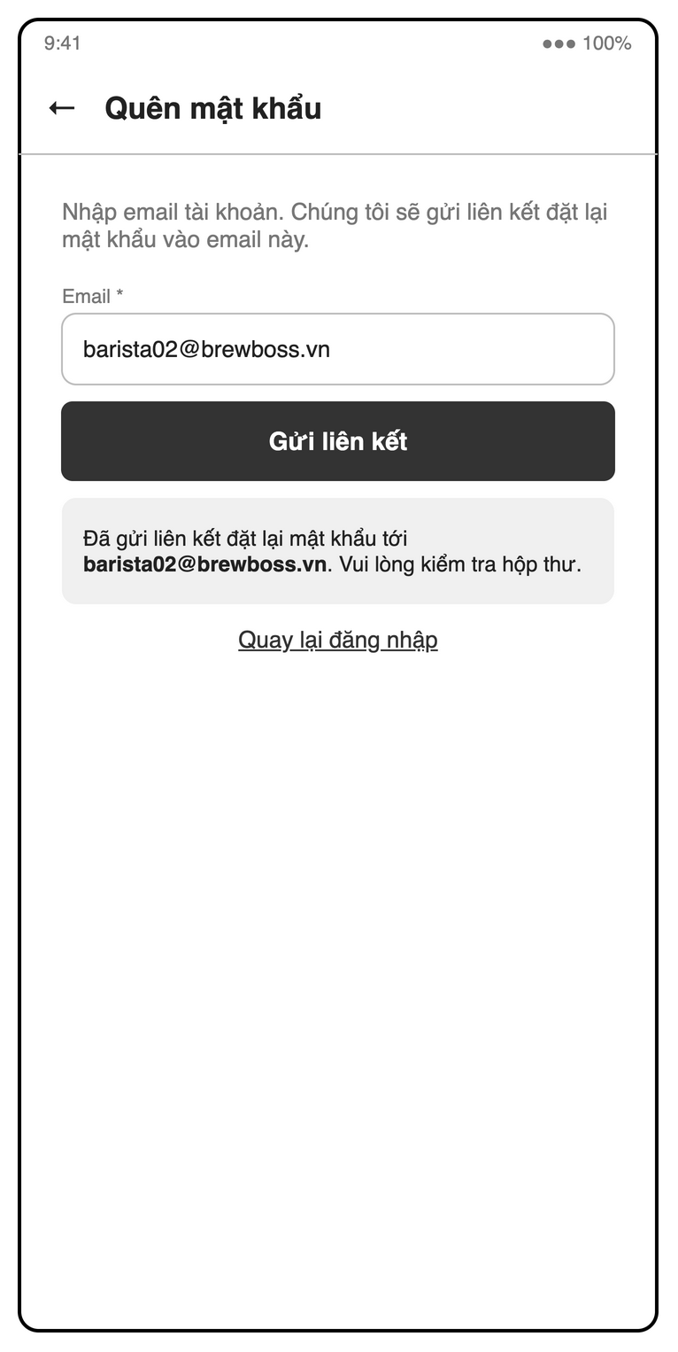
Figure 4.2-4: S03 Forgot password mock-up
Table 4-3: Forgot password Definition
No | Object Name | Type | Required | Length | Description
1 | backButton | Icon button | Yes | NONE | The "←" control returns to S02.
2 | titleLabel | Label | Yes | NONE | Displays "Quên mật khẩu".
3 | instructionsLabel | Label | Yes | NONE | Displays "Nhập email tài khoản. Chúng tôi sẽ gửi liên kết đặt lại mật khẩu vào email này.".
4 | emailField | Text field | Yes | NONE | Accepts "Email *" with valid email syntax and inline validation (UC03).
5 | sendResetLinkButton | Button | Yes | NONE | Uses "Gửi liên kết" to request a Firebase password reset email (UC03).
6 | resetResultLabel | Label | Conditional | NONE | Uses the same MSG06 response for known and unknown accounts; the mock-up reads "Đã gửi liên kết đặt lại mật khẩu tới barista02@brewboss.vn. Vui lòng kiểm tra hộp thư.".
7 | returnToLoginLink | Link | Yes | NONE | Returns to S02 through "Quay lại đăng nhập".

4.2.2.4 Object Interactions (Sequence Diagrams)
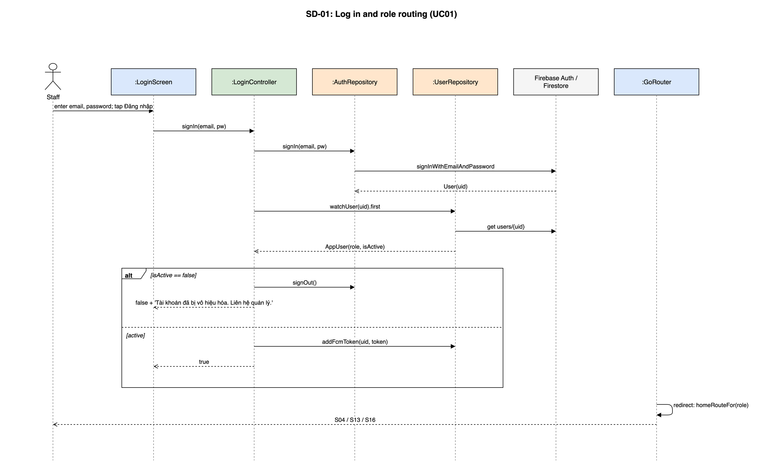
Figure 4.2-5: SD-01: Log in and role routing (UC01)

4.2.3 UC29 – Profile and shop settings

4.2.3.1 Screen Design
S22 Profile / settings (route /profile).
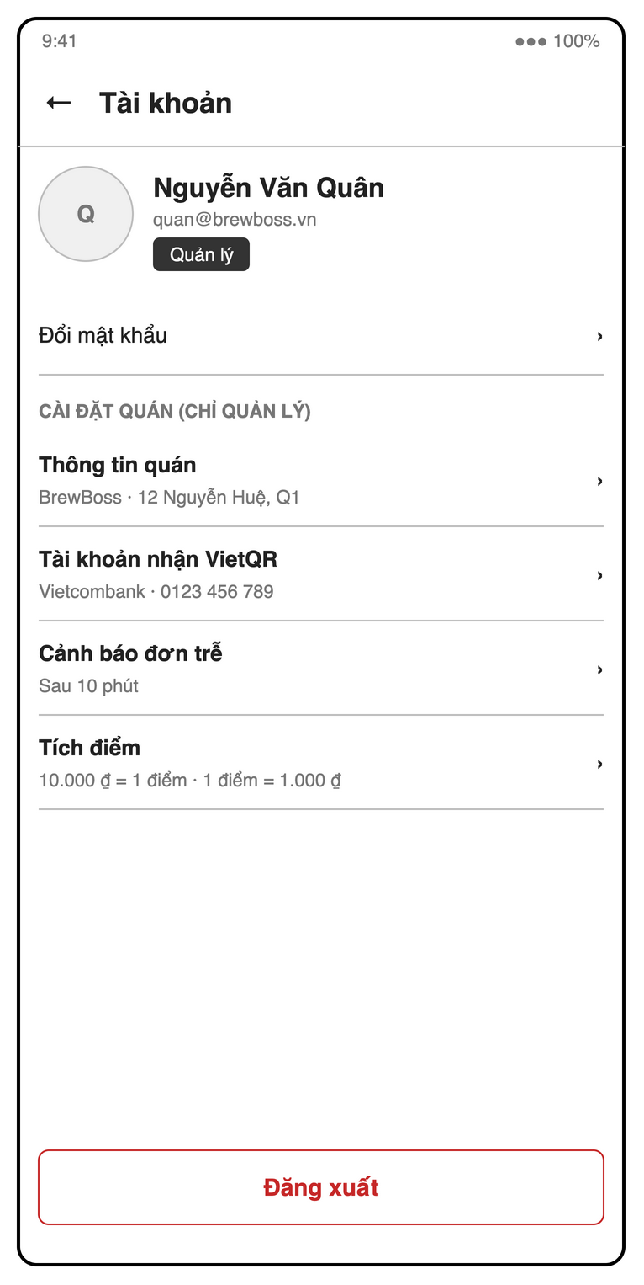
Figure 4.2-6: S22 Profile / settings mock-up
Table 4-4: Profile / settings Definition
No | Object Name | Type | Required | Length | Description
1 | backButton | Icon button | Yes | NONE | The "←" control returns from the account screen.
2 | titleLabel | Label | Yes | NONE | Displays "Tài khoản".
3 | accountCard | Card | Yes | NONE | Shows the signed-in account’s avatar, name, email and role, illustrated by "Nguyễn Văn Quân" and "Quản lý".
4 | changePasswordLink | Link | Yes | NONE | Opens password change through "Đổi mật khẩu"; credentials are handled by Firebase Auth (UC02, NFR-SEC-02).
5 | shopSettingsLabel | Label | Conditional | NONE | Displays "CÀI ĐẶT QUÁN (CHỈ QUẢN LÝ)" only for managers (UC29).
6 | shopInformationLink | Link | Conditional | NONE | The manager-only "Thông tin quán" row shows the current name and address and opens their settings.
7 | bankSettingsLink | Link | Conditional | NONE | The manager-only "Tài khoản nhận VietQR" row shows the configured bank and account and opens their settings.
8 | lateOrderSettingsLink | Link | Conditional | NONE | The manager-only "Cảnh báo đơn trễ" row shows the current threshold, illustrated by "Sau 10 phút".
9 | loyaltySettingsLink | Link | Conditional | NONE | The manager-only "Tích điểm" row shows earning and redemption rates, illustrated by "10.000 ₫ = 1 điểm · 1 điểm = 1.000 ₫".
10 | shopNameField | Text field | Conditional | NONE | Requires the shop name when managers edit "Thông tin quán" (UC29).
11 | shopAddressField | Text field | Conditional | NONE | Requires the shop address when managers edit "Thông tin quán" (UC29).
12 | bankDropdown | Dropdown | Conditional | NONE | Requires a bank selected by BIN when managers edit "Tài khoản nhận VietQR" (UC29).
13 | bankAccountNumberField | Text field | Conditional | NONE | Requires a digits-only receiving account number in manager bank settings (UC29).
14 | bankAccountNameField | Text field | Conditional | NONE | Requires the receiving account holder’s name in manager bank settings (UC29).
15 | lateOrderMinutesField | Number field | Conditional | NONE | Requires a positive integer minute threshold for "Cảnh báo đơn trễ", defaulting to 10 (UC29).
16 | earningRateField | Number field | Conditional | NONE | Requires a positive integer VND amount per earned point under "Tích điểm", defaulting to 10,000 (UC29, BR-LOY-01).
17 | redemptionRateField | Number field | Conditional | NONE | Requires a positive integer VND value per redeemed point under "Tích điểm", defaulting to 1,000 (UC29, BR-ORD-02).
18 | saveSettingsButton | Button | Conditional | NONE | The manager-only SRS action "Lưu" saves valid shop settings; invalid fields show inline errors (UC29).
19 | cashHandoverReportLink | Link | Conditional | NONE | The SRS supervisor shortcut "Giao ca" opens the authorized cash-handover tab of S06 (SRS 3.1.1).
20 | stocktakeLink | Link | Conditional | NONE | The SRS supervisor shortcut "Kiểm kho" opens stocktake in S10 (SRS 3.1.1).
21 | logoutButton | Button | Yes | NONE | Uses "Đăng xuất" to request sign-out confirmation (UC02).
22 | logoutDialog | Dialog | Conditional | NONE | Confirms "Đăng xuất" and warns "Bạn chưa check-out ca làm" when a shift is still open (UC02, MSG05).
23 | confirmLogoutButton | Button | Conditional | NONE | Confirms sign-out, clears the navigation stack and returns to S02 (UC02).
24 | cancelLogoutButton | Button | Conditional | NONE | Dismisses logout confirmation and keeps the session unchanged (UC02).
25 | checkoutAndLogoutButton | Button | Conditional | NONE | The SRS action "Check-out và đăng xuất" starts checkout before logout when a shift remains open (UC02, MSG05).
26 | logoutAnywayButton | Button | Conditional | NONE | The SRS action "Vẫn đăng xuất" permits logout despite an open shift (UC02, MSG05).

4.2.3.2 Object Interactions
ProfileScreen → SettingsController.save(settings) → UserRepository.saveSettings, which writes settings/shop and settings/public in one batch. Same screen → controller → repository → Firestore sequence as SD-09 without the image upload; log out follows SD-01 in reverse (removeFcmToken, then signOut).

4.3 Staff, Shifts and Cash Handover (UC04–UC06, UC44, UC45)
Feature folder lib/features/staff. It covers UC04–UC06, UC44, UC45 of the SRS.

4.3.1 Class/Component Design

4.3.1.1 Class/Component Structure
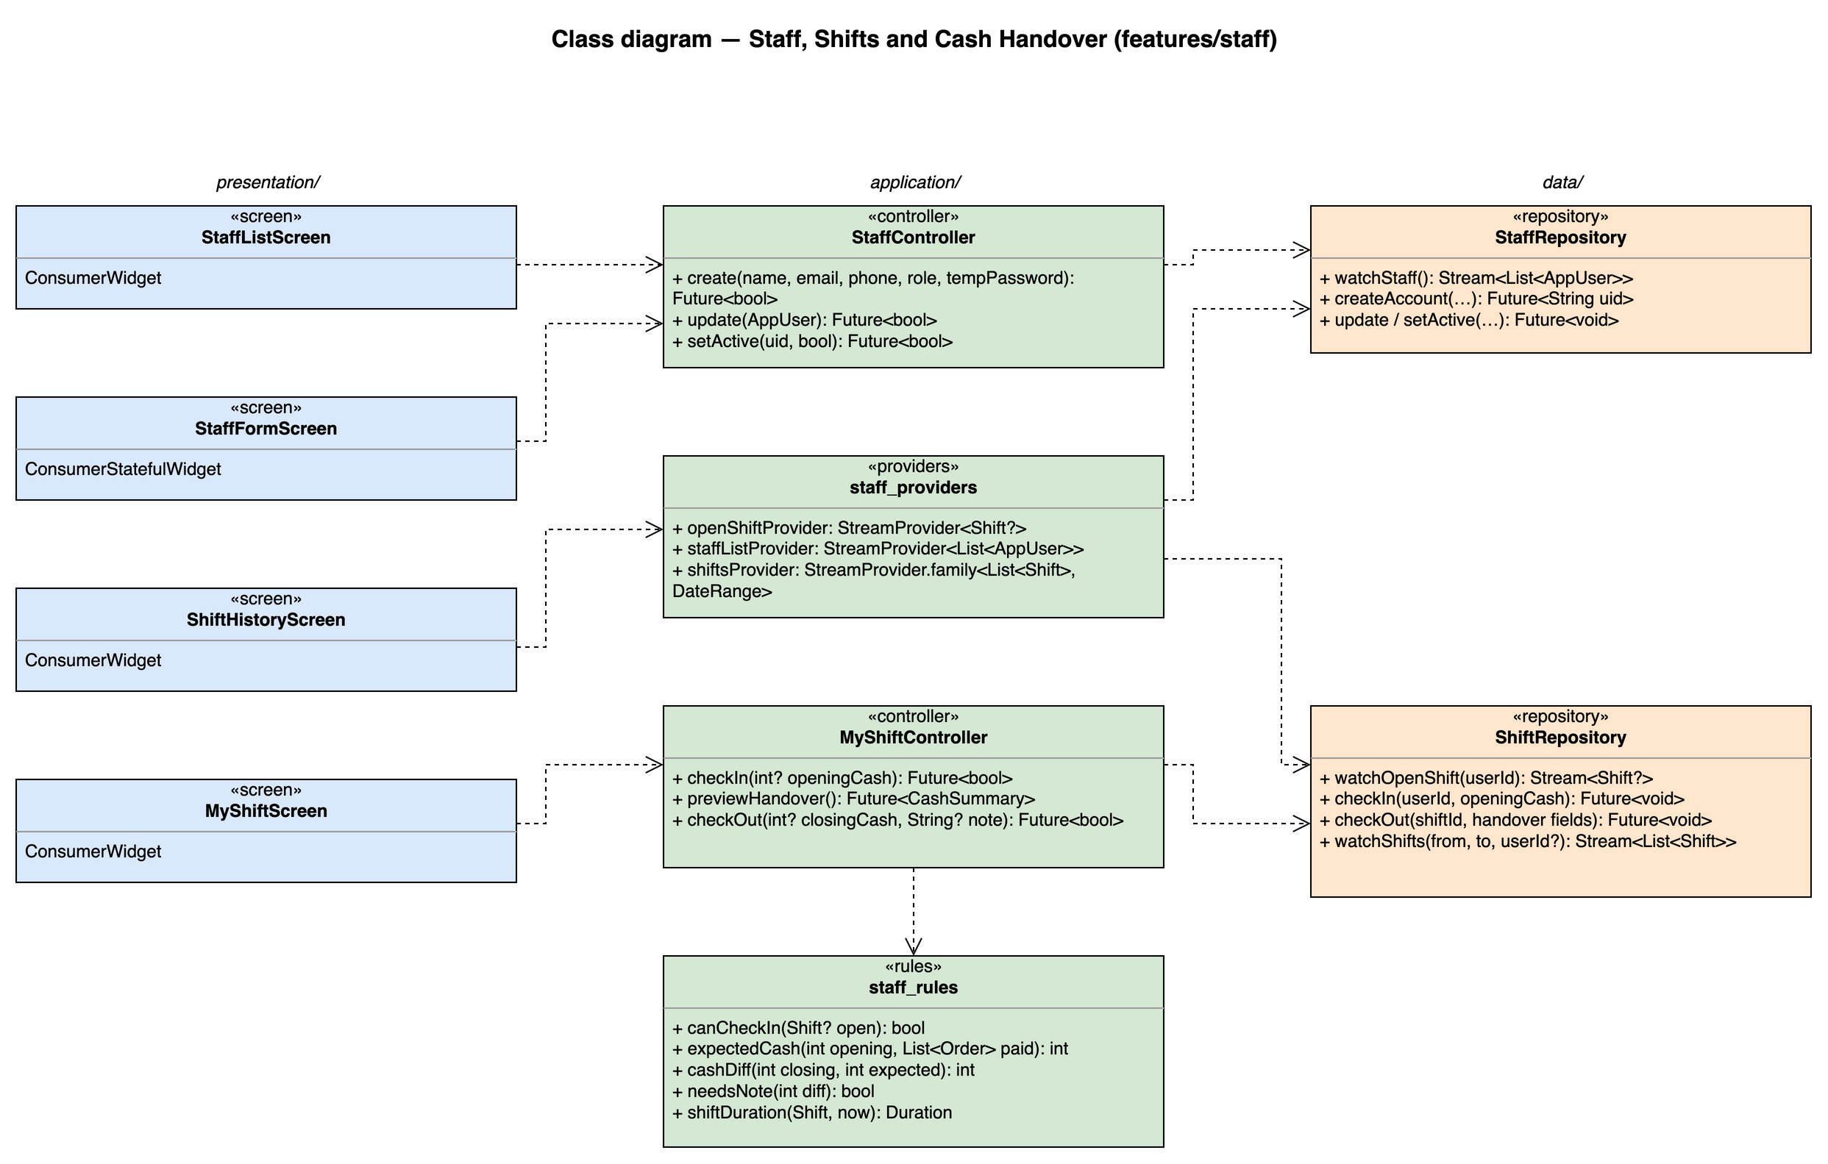
Figure 4.3-1: Class diagram for Staff, Shifts and Cash Handover

4.3.1.2 Class/Component Description
Class | «screen» StaffListScreen
Description | S05 staff list with search and role filter.
Base Class | ConsumerWidget
Constructor | const StaffListScreen({super.key})
Prototype | class StaffListScreen extends ConsumerWidget
Source File | lib/features/staff/presentation/staff_list_screen.dart
Namespace | package:brewboss/features/staff/presentation
Attributes | Name | Type | Description
Attributes | ref | WidgetRef | Riverpod reference; ref.watch in build, ref.read in callbacks
Methods | Name | Input | Output | Description
Methods | build | BuildContext context, WidgetRef ref | Widget | Watches the providers listed above and renders loading / error / empty / data with AsyncValue.when

Class | «screen» StaffFormScreen
Description | S05 create / edit form; activate or deactivate (not own account, BR-STAFF-02).
Base Class | ConsumerStatefulWidget
Constructor | const StaffFormScreen({super.key})
Prototype | class StaffFormScreen extends ConsumerStatefulWidget
Source File | lib/features/staff/presentation/staff_form_screen.dart
Namespace | package:brewboss/features/staff/presentation
Attributes | Name | Type | Description
Attributes | _formKey | GlobalKey<FormState> | Name, email, 10-digit phone, role, temporary password
Methods | Name | Input | Output | Description
Methods | createState | — | _StaffFormScreenState | Creates the ConsumerState<StaffFormScreen> that holds the attributes above and the private methods below; its build(BuildContext context) reads providers through the state's ref
Methods | _save | — | Future<void> | Calls StaffController.create or update; shows MSG07 when the email is taken

Class | «screen» MyShiftScreen
Description | S07 My shift: check-in with opening cash, running timer, check-out with cash handover (UC05, UC44).
Base Class | ConsumerWidget
Constructor | const MyShiftScreen({super.key})
Prototype | class MyShiftScreen extends ConsumerWidget
Source File | lib/features/staff/presentation/my_shift_screen.dart
Namespace | package:brewboss/features/staff/presentation
Attributes | Name | Type | Description
Attributes | ref | WidgetRef | Riverpod reference; ref.watch in build, ref.read in callbacks
Methods | Name | Input | Output | Description
Methods | build | BuildContext context, WidgetRef ref | Widget | Watches the providers listed above and renders loading / error / empty / data with AsyncValue.when
Methods | _openCheckOutSheet | — | Future<void> | Loads MyShiftController.previewHandover and shows expected cash, VietQR reference and the counted cash field

Class | «screen» ShiftHistoryScreen
Description | S06 shift history with hours per staff member (UC06, Manager) and the "Giao ca" tab (UC45, Shift Supervisor and Manager).
Base Class | ConsumerWidget
Constructor | const ShiftHistoryScreen({super.key})
Prototype | class ShiftHistoryScreen extends ConsumerWidget
Source File | lib/features/staff/presentation/shift_history_screen.dart
Namespace | package:brewboss/features/staff/presentation
Attributes | Name | Type | Description
Attributes | _range | DateRange | Selected period
Attributes | _onlyDiff | bool | Filter shifts with cashDiff ≠ 0
Methods | Name | Input | Output | Description
Methods | build | BuildContext context, WidgetRef ref | Widget | Watches the providers listed above and renders loading / error / empty / data with AsyncValue.when

Class | «controller» StaffController
Description | Staff account management (UC04).
Base Class | AsyncNotifier<void>
Constructor | StaffController() — created by AsyncNotifierProvider<StaffController, void>(StaffController.new)
Prototype | class StaffController extends AsyncNotifier<void>
Source File | lib/features/staff/application/staff_controller.dart
Namespace | package:brewboss/features/staff/application
Attributes | Name | Type | Description
Attributes | state | AsyncValue<void> | Saving state
Methods | Name | Input | Output | Description
Methods | create | name, email, phone, UserRole role, tempPassword | Future<bool> | StaffRepository.createAccount (secondary Firebase app, SD-10)
Methods | update | AppUser user | Future<bool> | Updates name, phone and role
Methods | setActive | String uid, bool active | Future<bool> | Rejects the manager's own uid (BR-STAFF-02)

Class | «controller» MyShiftController
Description | Shift check-in / check-out and cash handover (UC05, UC44).
Base Class | AsyncNotifier<void>
Constructor | MyShiftController() — created by AsyncNotifierProvider<MyShiftController, void>(MyShiftController.new)
Prototype | class MyShiftController extends AsyncNotifier<void>
Source File | lib/features/staff/application/my_shift_controller.dart
Namespace | package:brewboss/features/staff/application
Attributes | Name | Type | Description
Attributes | state | AsyncValue<void> | Saving state
Methods | Name | Input | Output | Description
Methods | checkIn | int? openingCash | Future<bool> | Requires no open shift (BR-STAFF-01) and openingCash ≥ 0 for cashier / supervisor / manager (BR-STAFF-03, MSG09)
Methods | previewHandover | — | Future<CashSummary> | Preview for the check-out sheet (SD-07): OrderRepository.paidOrders(uid, checkIn) → expectedCash = opening + Σ cashAmount, Σ qrAmount for reference (BR-STAFF-04); the stored value is recomputed at check-out
Methods | checkOut | int? closingCash, String? note | Future<bool> | Requires a note when cashDiff ≠ 0 (MSG43); ShiftRepository.checkOut recomputes expected cash from shift.cashSales inside its transaction, so a payment confirmed after the preview is included (SD-07)

Class | «providers» staff_providers
Description | Shift and staff streams; openShiftProvider is also read by PaymentController (BR-PAY-03).
Base Class | — (top-level providers)
Constructor | —
Prototype | top-level declarations (no class)
Source File | lib/features/staff/application/staff_providers.dart
Namespace | package:brewboss/features/staff/application
Attributes | Name | Type | Description
Attributes | openShiftProvider | StreamProvider<Shift?> | Open shift of the current user
Attributes | staffListProvider | StreamProvider<List<AppUser>> | All users ordered by name
Attributes | shiftsProvider | StreamProvider.family<List<Shift>, DateRange> | Shifts in a period
Methods | Name | Input | Output | Description
Methods | — | — | — | Declarations only; see Attributes

Class | «rules» staff_rules
Description | Pure shift and cash rules, unit tested.
Base Class | — (pure functions)
Constructor | —
Prototype | top-level declarations (no class)
Source File | lib/features/staff/application/staff_rules.dart
Namespace | package:brewboss/features/staff/application
Attributes | Name | Type | Description
Attributes | — | — | No state
Methods | Name | Input | Output | Description
Methods | canCheckIn | Shift? open | bool | false while a shift is open (BR-STAFF-01)
Methods | expectedCash | int opening, List<Order> paid | int | opening + Σ cashAmount (BR-STAFF-04)
Methods | cashDiff | int closing, int expected | int | closing − expected (BR-STAFF-05)
Methods | needsNote | int diff | bool | diff ≠ 0
Methods | shiftDuration | Shift s, DateTime now | Duration | checkOut ?? now − checkIn

Class | «repository» StaffRepository
Description | Creates Auth accounts through a secondary FirebaseApp so the manager stays signed in.
Base Class | —
Constructor | —
Prototype | class StaffRepository
Source File | lib/features/staff/data/staff_repository.dart
Namespace | package:brewboss/features/staff/data
Attributes | Name | Type | Description
Attributes | _db | FirebaseFirestore | Firestore instance injected by the provider
Attributes | _secondaryAuth | FirebaseAuth | Auth of the secondary app
Methods | Name | Input | Output | Description
Methods | watchStaff | — | Stream<List<AppUser>> | users collection
Methods | createAccount | name, email, phone, role, tempPassword | Future<String> | createUserWithEmailAndPassword on the secondary app, signOut there, then set users/{uid} with isActive = true
Methods | update / setActive | AppUser / uid, bool | Future<void> | users/{uid}

Class | «repository» ShiftRepository
Description | shifts collection.
Base Class | —
Constructor | —
Prototype | class ShiftRepository
Source File | lib/features/staff/data/shift_repository.dart
Namespace | package:brewboss/features/staff/data
Attributes | Name | Type | Description
Attributes | _db | FirebaseFirestore | Firestore instance injected by the provider
Methods | Name | Input | Output | Description
Methods | watchOpenShift | String userId | Stream<Shift?> | where userId, checkOut == null, limit 1
Methods | checkIn | String userId, int? openingCash | Future<void> | Transaction: requires shiftLocks/{uid} to be empty (BR-STAFF-01, safe against two devices), adds the shift with cashSales = qrSales = 0 and sets the lock
Methods | checkOut | String shiftId, int? closingCash, String? note | Future<void> | Transaction: re-reads the shift, computes expectedCash = openingCash + cashSales and cashDiff, aborts with MSG43 when the recomputed cashDiff ≠ 0 and the note is empty, otherwise sets checkOut and the handover fields and deletes shiftLocks/{uid}; Security Rules lock the cash fields afterwards
Methods | watchShifts | DateTime from, DateTime to, String? userId | Stream<List<Shift>> | Shift history query

4.3.2 UC04 – Manage staff accounts

4.3.2.1 Screen Design
S05 Staff list / detail / form (route /manager/staff).
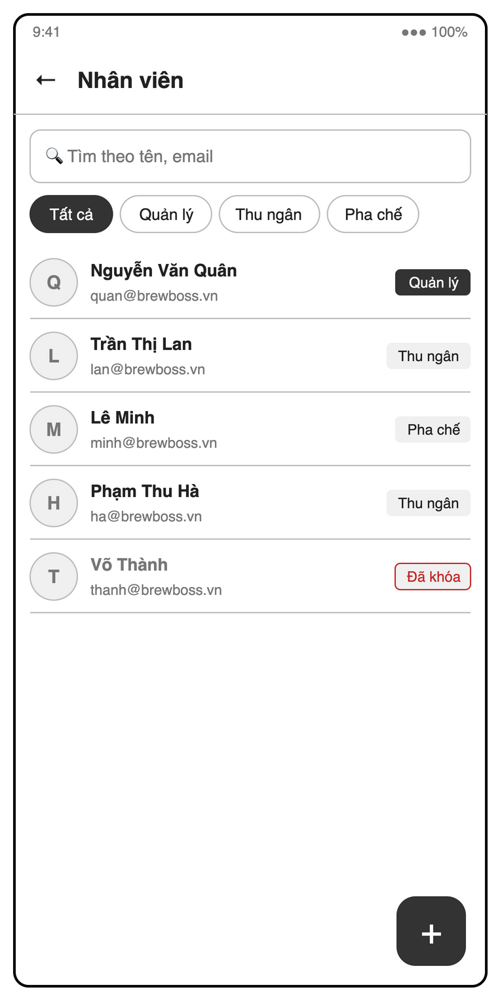
Figure 4.3-2: S05 Staff list mock-up
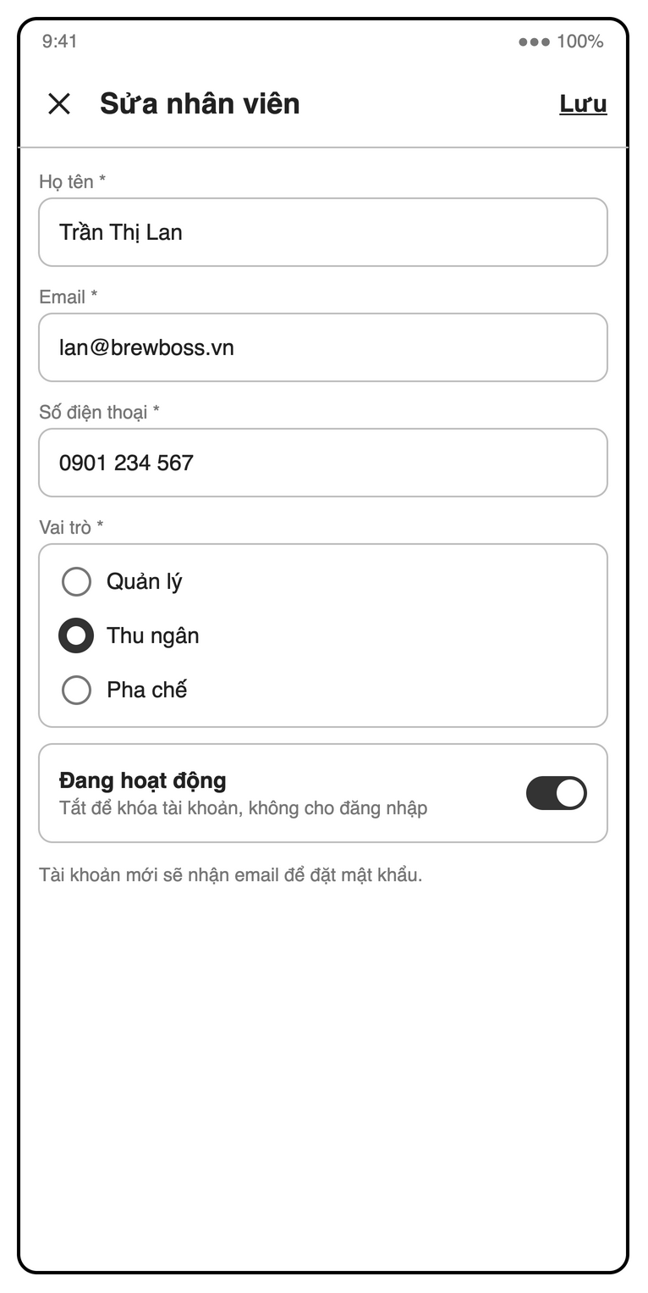
Figure 4.3-3: S05 Staff form mock-up
Table 4-5: Staff list / detail / form Definition
No | Object Name | Type | Required | Length | Description
1 | backButton | Icon button | Yes | NONE | The "←" control returns from the staff list.
2 | titleLabel | Label | Yes | NONE | Shows "Nhân viên" in the list and "Sửa nhân viên" in the edit form.
3 | staffSearchField | Search field | No | NONE | Filters staff by name or email using "Tìm theo tên, email".
4 | roleFilterChipGroup | Chip group | No | NONE | Filters by "Tất cả", "Quản lý", "Thu ngân" or "Pha chế", with supervisor also supported by SRS 2.2.
5 | staffList | List | Yes | NONE | Lists staff names, emails and roles; selecting a row opens the staff form (UC04).
6 | staffStatusBadge | Badge | Yes | NONE | Shows each staff member’s role or "Đã khóa" when inactive.
7 | addStaffButton | Icon button | Yes | NONE | The "+" control opens the new staff form.
8 | closeFormButton | Icon button | Conditional | NONE | The "✕" control discards form changes.
9 | fullNameField | Text field | Yes | NONE | Requires a nonempty "Họ tên *" (UC04).
10 | emailField | Text field | Yes | NONE | Requires a valid, unused "Email *"; read-only when editing and duplicate emails show MSG07.
11 | phoneField | Text field | Yes | 10 | Requires "Số điện thoại *" containing ten digits, displayed with spacing in the mock-up (UC04).
12 | roleRadioGroup | Radio group | Yes | NONE | Requires one "Vai trò *" from manager, supervisor, cashier or barista; self-demotion is disabled (SRS 2.2, UC04).
13 | temporaryPasswordField | Password field | Conditional | NONE | Requires the SRS field "Mật khẩu tạm" when creating an account (UC04).
14 | activeSwitch | Switch | Yes | NONE | Controls "Đang hoạt động" with the hint "Tắt để khóa tài khoản, không cho đăng nhập"; self-deactivation is disabled (BR-STAFF-02).
15 | accountSetupLabel | Label | Conditional | NONE | Displays the mock-up note "Tài khoản mới sẽ nhận email để đặt mật khẩu."; UC04 specifies a temporary password for creation.
16 | saveStaffButton | Button | Conditional | NONE | Uses "Lưu" to save valid staff details; disabled while invalid or saving (UC04, SRS 5.2).
17 | deactivateDialog | Dialog | Conditional | NONE | Confirms switching off "Đang hoạt động" before deactivating another account (BR-STAFF-02, SRS 5.2).

4.3.2.2 Object Interactions (Sequence Diagrams)
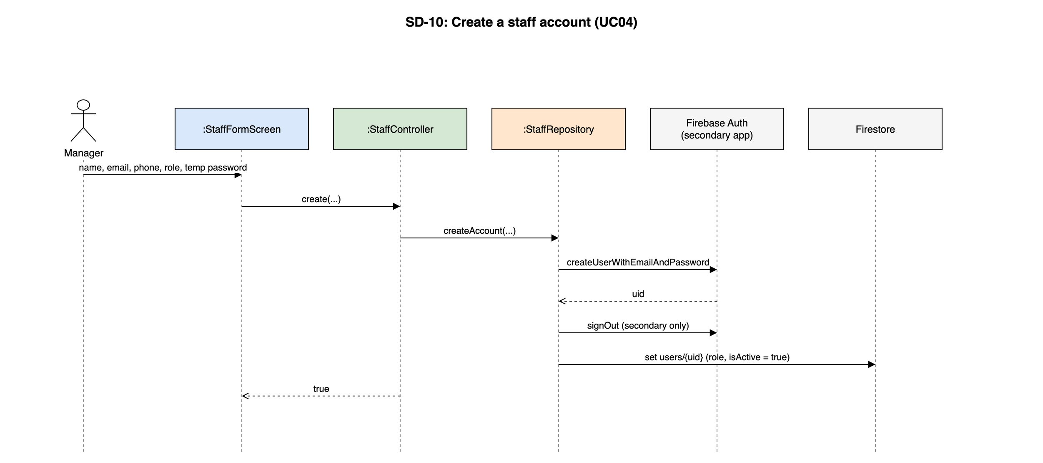
Figure 4.3-4: SD-10: Create a staff account (UC04)

4.3.3 UC05, UC44 – Check in / check out and hand over cash

4.3.3.1 Screen Design
S07 My shift (route /shift).
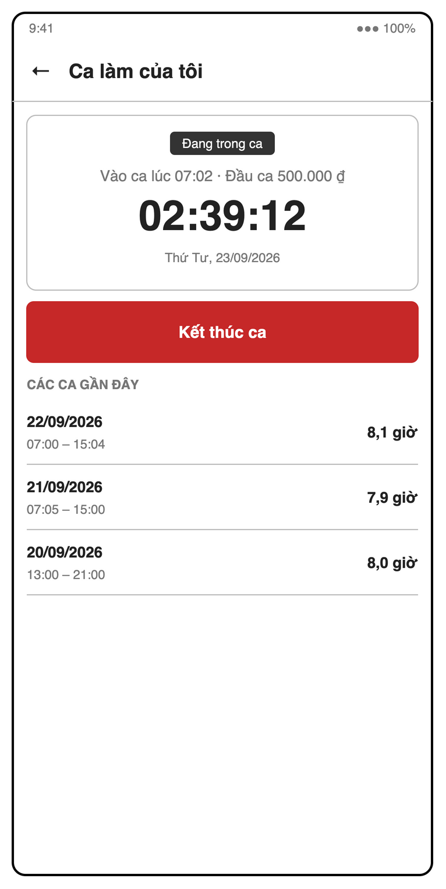
Figure 4.3-5: S07 My shift (in shift) mock-up
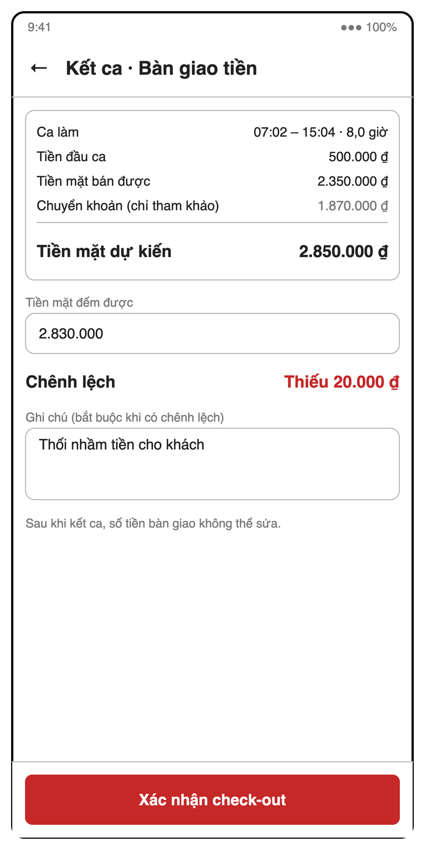
Figure 4.3-6: S07 My shift (check-out, cash handover) mock-up
Table 4-6: My shift Definition
No | Object Name | Type | Required | Length | Description
1 | backButton | Icon button | Yes | NONE | The "←" control returns from the current shift view.
2 | titleLabel | Label | Yes | NONE | Shows "Ca làm của tôi" or "Kết ca · Bàn giao tiền" for checkout.
3 | shiftStatusLabel | Label | Yes | NONE | Shows "Chưa vào ca" or "Đang trong ca" (BR-STAFF-01).
4 | checkInSummaryLabel | Label | Conditional | NONE | Shows check-in time and, for cash-handling roles, opening cash as in "Vào ca lúc 07:02 · Đầu ca 500.000 ₫" (BR-STAFF-03).
5 | shiftTimerLabel | Timer label | Yes | NONE | Shows elapsed shift time such as "02:39:12", or "--:--:--" before check-in.
6 | dateLabel | Label | Yes | NONE | Shows the current date, illustrated by "Thứ Tư, 23/09/2026".
7 | openingCashField | Number field | Conditional | NONE | Requires "Tiền đầu ca (tiền trong két)" as an integer VND amount ≥ 0 for cashiers, supervisors and managers before check-in (BR-STAFF-03, MSG09).
8 | openingCashChipGroup | Chip group | Conditional | NONE | Offers optional opening-cash presets "0", "300.000", "500.000" and "1.000.000" for cash-handling roles.
9 | openingCashHelpLabel | Label | Conditional | NONE | Displays "Đếm tiền trong két trước khi vào ca. Tài khoản Pha chế không cần nhập." (BR-STAFF-03).
10 | checkInButton | Button | Conditional | NONE | Uses "Vào ca" to create a shift only when none is open (BR-STAFF-01).
11 | endShiftButton | Button | Conditional | NONE | Uses "Kết thúc ca" to check out a barista or open cash handover for a cashier, supervisor or manager (UC05).
12 | recentShiftsList | List | Conditional | NONE | Shows "CÁC CA GẦN ĐÂY" with each shift’s date, time range and hours.
13 | handoverShiftLabel | Label | Conditional | NONE | Shows "Ca làm" with the time range and duration being closed.
14 | openingCashLabel | Label | Conditional | NONE | Shows the saved "Tiền đầu ca" during cash handover.
15 | cashSalesLabel | Label | Conditional | NONE | Shows "Tiền mặt bán được" as cash kept from orders paid by this user during the shift (BR-STAFF-04).
16 | transferSalesLabel | Label | Conditional | NONE | Shows "Chuyển khoản (chỉ tham khảo)" separately from drawer cash (BR-STAFF-04).
17 | expectedCashLabel | Label | Conditional | NONE | Shows "Tiền mặt dự kiến" as opening cash plus the shift’s cash sales (BR-STAFF-04).
18 | countedCashField | Number field | Conditional | NONE | Requires "Tiền mặt đếm được" as an integer VND amount ≥ 0 during cash handover (UC44, MSG09).
19 | cashDifferenceLabel | Label | Conditional | NONE | Shows "Chênh lệch" as counted minus expected cash, including "Thiếu 20.000 ₫" or "Khớp" (BR-STAFF-05).
20 | handoverNoteField | Text field | Conditional | NONE | The field "Ghi chú (bắt buộc khi có chênh lệch)" is mandatory for a nonzero difference and optional otherwise (BR-STAFF-05, MSG43).
21 | cashLockNoticeLabel | Label | Conditional | NONE | Displays "Sau khi kết ca, số tiền bàn giao không thể sửa." (BR-STAFF-05).
22 | confirmCheckoutButton | Button | Conditional | NONE | Uses "Xác nhận check-out" to close the shift and lock cash fields only after valid amounts and any required note (BR-STAFF-05).
23 | cancelHandoverButton | Button | Conditional | NONE | Uses the UC44 action "Hủy" to leave the shift open without saving the handover.

4.3.3.2 Object Interactions (Sequence Diagrams)
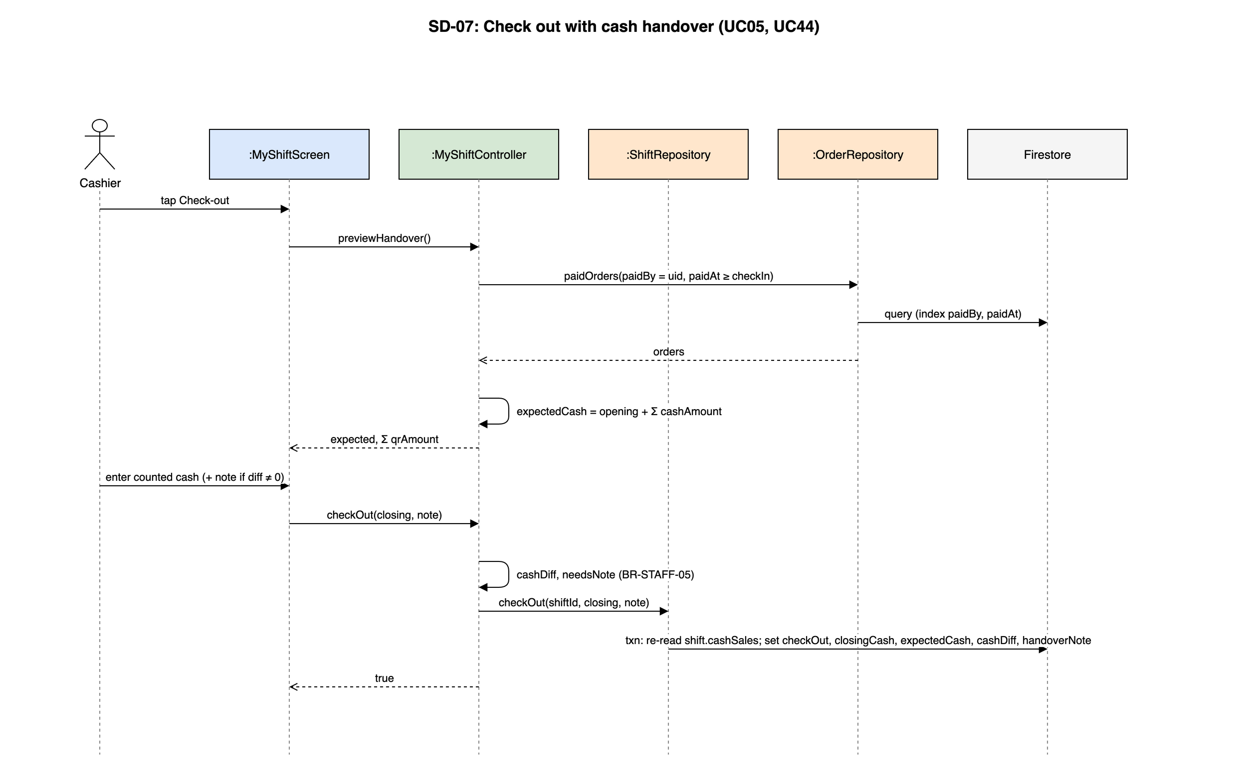
Figure 4.3-7: SD-07: Check out with cash handover (UC05, UC44)

4.3.4 UC06, UC45 – Shift history and shift cash report

4.3.4.1 Screen Design
S06 Shift history + cash handover (route /manager/shifts).
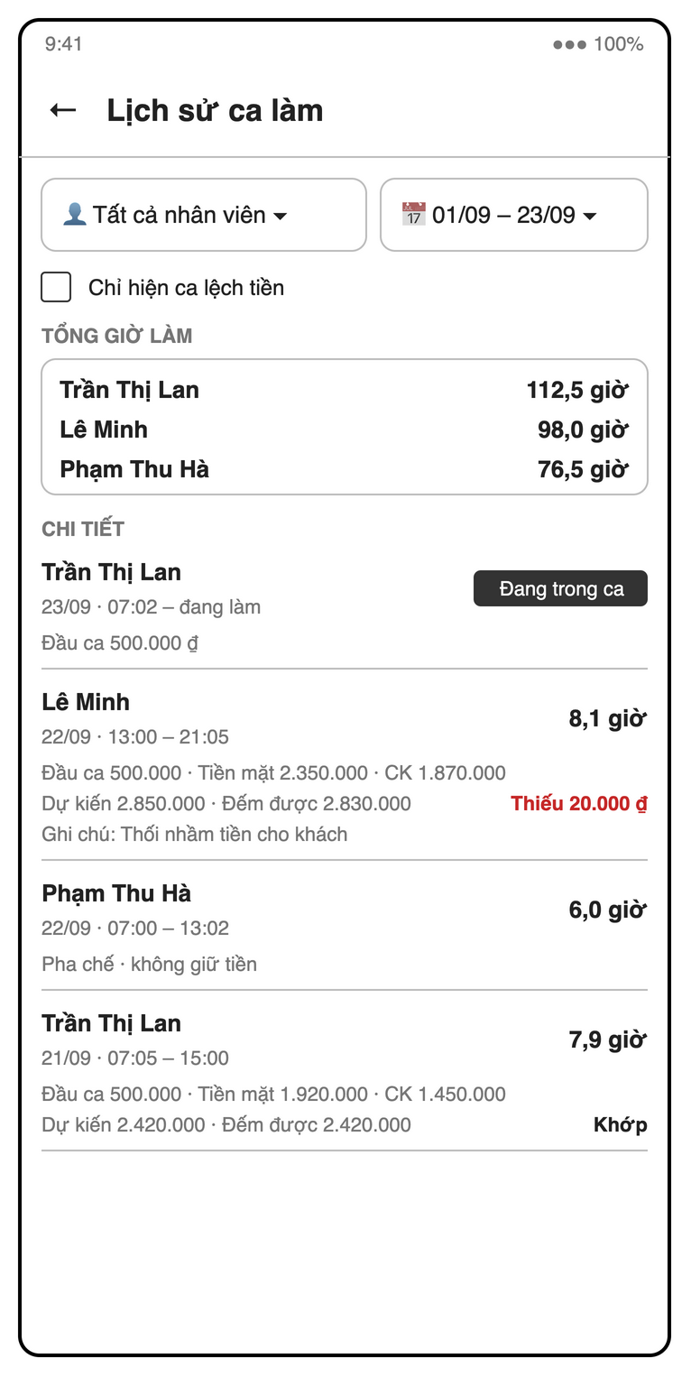
Figure 4.3-8: S06 Shift history + cash handover mock-up
Table 4-7: Shift history + cash handover Definition
No | Object Name | Type | Required | Length | Description
1 | backButton | Icon button | Yes | NONE | The "←" control returns from shift history.
2 | titleLabel | Label | Yes | NONE | Displays "Lịch sử ca làm".
3 | shiftReportTabBar | Tab bar | Yes | NONE | Provides shift history and the SRS "Giao ca" tab; supervisors may access only cash handover (UC06, UC45).
4 | staffDropdown | Dropdown | No | NONE | Selects "Tất cả nhân viên" or one staff member.
5 | periodDateRangePicker | Date range picker | Yes | NONE | Selects the report period, shown as "01/09 – 23/09", with the current week as default (UC06).
6 | differenceOnlyCheckbox | Checkbox | No | NONE | Uses "Chỉ hiện ca lệch tiền" to show nonzero cash differences, largest shortage first (UC45).
7 | totalHoursList | List | Conditional | NONE | Shows "TỔNG GIỜ LÀM" per staff member for managers, excluding open shifts (UC06).
8 | shiftList | List | Yes | NONE | Shows "CHI TIẾT" with staff, dates, time ranges and durations; open shifts show "Đang trong ca" (UC06).
9 | handoverDetailsCard | Card | Conditional | NONE | Shows opening cash, cash sales, transfer sales, expected cash, counted cash and notes; barista shifts show "Pha chế · không giữ tiền" in history and are excluded from "Giao ca" (UC45, BR-STAFF-03–BR-STAFF-05).
10 | cashDifferenceBadge | Badge | Conditional | NONE | Shows "Khớp" or a shortage such as "Thiếu 20.000 ₫" for completed cash handovers (BR-STAFF-05).
11 | periodCashTotalsCard | Card | Conditional | NONE | Shows period cash sales, VietQR sales and net cash difference in "Giao ca", excluding open shifts (UC45).
12 | emptyShiftsLabel | Label | Conditional | NONE | Shows "Không có ca làm nào" when no shifts match the filters (MSG10).

4.3.4.2 Object Interactions
Read only: ShiftHistoryScreen watches shiftsProvider(range) → ShiftRepository.watchShifts → Firestore snapshots, the same provider sequence as SD-11. The "Giao ca" tab filters cashDiff ≠ 0 in memory; hours come from staff_rules.shiftDuration.

4.4 Menu (UC07–UC10)
Feature folder lib/features/menu. It covers UC07–UC10 of the SRS.

4.4.1 Class/Component Design

4.4.1.1 Class/Component Structure
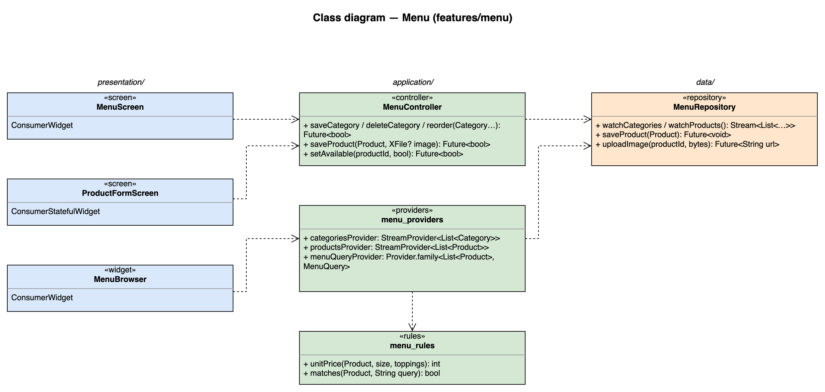
Figure 4.4-1: Class diagram for Menu

4.4.1.2 Class/Component Description
Class | «screen» MenuScreen
Description | S08 product tab (search, category filter, availability switch) and category tab (add, rename, reorder, delete). Read-only for every staff role except the availability switch.
Base Class | ConsumerWidget
Constructor | const MenuScreen({super.key})
Prototype | class MenuScreen extends ConsumerWidget
Source File | lib/features/menu/presentation/menu_screen.dart
Namespace | package:brewboss/features/menu/presentation
Attributes | Name | Type | Description
Attributes | ref | WidgetRef | Riverpod reference; ref.watch in build, ref.read in callbacks
Methods | Name | Input | Output | Description
Methods | build | BuildContext context, WidgetRef ref | Widget | Watches the providers listed above and renders loading / error / empty / data with AsyncValue.when

Class | «screen» ProductFormScreen
Description | S09 product form: name, category, image, base price, description, sizes, toppings and recipe per size (UC08, UC14).
Base Class | ConsumerStatefulWidget
Constructor | const ProductFormScreen({super.key})
Prototype | class ProductFormScreen extends ConsumerStatefulWidget
Source File | lib/features/menu/presentation/product_form_screen.dart
Namespace | package:brewboss/features/menu/presentation
Attributes | Name | Type | Description
Attributes | _draft | Product | Edited copy of the product
Attributes | _image | XFile? | Picked image, compressed before upload
Methods | Name | Input | Output | Description
Methods | createState | — | _ProductFormScreenState | Creates the ConsumerState<ProductFormScreen> that holds the attributes above and the private methods below; its build(BuildContext context) reads providers through the state's ref
Methods | _save | — | Future<void> | Validates name, basePrice ≥ 0 and at least one size, then MenuController.saveProduct (SD-09)

Class | «widget» MenuBrowser
Description | Reusable category tabs + search + product grid. Used by S14 Order editor and S17 Customer menu; opens the item options sheet (size, toppings, qty, note).
Base Class | ConsumerWidget
Constructor | const MenuBrowser({super.key})
Prototype | class MenuBrowser extends ConsumerWidget
Source File | lib/features/menu/presentation/menu_browser.dart
Namespace | package:brewboss/features/menu/presentation
Attributes | Name | Type | Description
Attributes | onPick | void Function(OrderItem) | Callback with the configured item
Attributes | showUnavailable | bool | Sold-out products are shown greyed and cannot be picked
Methods | Name | Input | Output | Description
Methods | build | BuildContext context, WidgetRef ref | Widget | Watches the providers listed above and renders loading / error / empty / data with AsyncValue.when

Class | «controller» MenuController
Description | Menu writes (UC07–UC09).
Base Class | AsyncNotifier<void>
Constructor | MenuController() — created by AsyncNotifierProvider<MenuController, void>(MenuController.new)
Prototype | class MenuController extends AsyncNotifier<void>
Source File | lib/features/menu/application/menu_controller.dart
Namespace | package:brewboss/features/menu/application
Attributes | Name | Type | Description
Attributes | state | AsyncValue<void> | Saving state
Methods | Name | Input | Output | Description
Methods | saveCategory / deleteCategory / reorder | Category… | Future<bool> | Delete is refused while the category has products (MSG11); reorder rewrites sortOrder in one batch
Methods | saveProduct | Product p, XFile? image | Future<bool> | Uploads the image first when present, then writes the product
Methods | setAvailable | String productId, bool available | Future<bool> | Toggles isAvailable (UC09)

Class | «providers» menu_providers
Description | Menu streams, cached by Firestore for offline use.
Base Class | — (top-level providers)
Constructor | —
Prototype | top-level declarations (no class)
Source File | lib/features/menu/application/menu_providers.dart
Namespace | package:brewboss/features/menu/application
Attributes | Name | Type | Description
Attributes | categoriesProvider | StreamProvider<List<Category>> | Ordered by sortOrder
Attributes | productsProvider | StreamProvider<List<Product>> | All products
Attributes | menuQueryProvider | Provider.family<List<Product>, MenuQuery> | Filtered by category and search text in memory
Methods | Name | Input | Output | Description
Methods | — | — | — | Declarations only; see Attributes

Class | «rules» menu_rules
Description | Pricing and search rules.
Base Class | — (pure functions)
Constructor | —
Prototype | top-level declarations (no class)
Source File | lib/features/menu/application/menu_rules.dart
Namespace | package:brewboss/features/menu/application
Attributes | Name | Type | Description
Attributes | — | — | No state
Methods | Name | Input | Output | Description
Methods | unitPrice | Product p, String size, List<Topping> toppings | int | basePrice + size priceDelta + Σ topping price (BR-ORD-01)
Methods | matches | Product p, String query | bool | Case- and accent-insensitive name match (MSG12 when nothing matches)

Class | «repository» MenuRepository
Description | categories, products and product images.
Base Class | —
Constructor | —
Prototype | class MenuRepository
Source File | lib/features/menu/data/menu_repository.dart
Namespace | package:brewboss/features/menu/data
Attributes | Name | Type | Description
Attributes | _db | FirebaseFirestore | Firestore instance injected by the provider
Attributes | _storage | FirebaseStorage | Product images
Methods | Name | Input | Output | Description
Methods | watchCategories / watchProducts | — | Stream<List<…>> | Collection snapshots
Methods | saveProduct | Product p | Future<void> | set products/{id}
Methods | uploadImage | String productId, Uint8List bytes | Future<String> | put products/{id}.jpg, returns the download URL

4.4.2 UC07, UC09, UC10 – Categories, availability and menu browsing

4.4.2.1 Screen Design
S08 Category & product list (route /manager/menu).
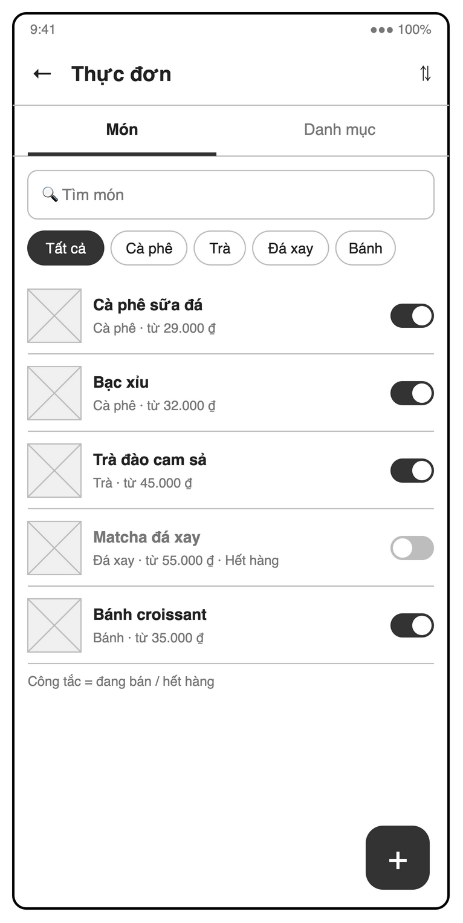
Figure 4.4-2: S08 Category & product list mock-up
Table 4-8: Category & product list Definition
No | Object Name | Type | Required | Length | Description
1 | backButton | Icon button | Yes | NONE | The "←" control returns from the menu.
2 | titleLabel | Label | Yes | NONE | Displays "Thực đơn".
3 | menuTabBar | Tab bar | Yes | NONE | Switches between "Món" and "Danh mục"; all staff may browse, while editing is manager-only (SRS 3.1.3).
4 | reorderCategoriesButton | Icon button | Conditional | NONE | The "⇅" control lets managers reorder categories by dragging (UC07).
5 | productSearchField | Search field | No | NONE | Uses "Tìm món" for case- and accent-insensitive product search (UC10, MSG12).
6 | categoryFilterChipGroup | Chip group | No | NONE | Filters products using "Tất cả", "Cà phê", "Trà", "Đá xay" and "Bánh" in category order.
7 | productList | List | Conditional | NONE | Shows product images, names, categories and starting prices such as "Cà phê · từ 29.000 ₫"; managers can open S09.
8 | soldOutBadge | Badge | Conditional | NONE | Shows "Hết hàng" on unavailable products.
9 | availabilitySwitch | Switch | Conditional | NONE | Each product switch changes availability for managers, supervisors and cashiers; baristas have read-only access (UC09).
10 | availabilityHelpLabel | Label | Conditional | NONE | Displays "Công tắc = đang bán / hết hàng" for staff allowed to change availability.
11 | addItemButton | Icon button | Conditional | NONE | The manager-only "+" control opens S09 on "Món" or the category form on "Danh mục".
12 | categoryList | List | Conditional | NONE | Shows categories on "Danh mục" for browsing and manager-only rename, reorder and delete actions (UC07).
13 | categoryNameField | Text field | Yes | NONE | Requires a nonempty, unique category name in the UC07 create or rename form.
14 | saveCategoryButton | Button | Conditional | NONE | Uses the UC07 action "Lưu" to save a valid category name.
15 | deleteCategoryButton | Button | Conditional | NONE | Offers a manager-only deletion action per category, blocked when products remain (UC07, MSG11).
16 | deleteCategoryDialog | Dialog | Conditional | NONE | Confirms category deletion and reports "Danh mục còn sản phẩm. Hãy chuyển hoặc xóa sản phẩm trước." when blocked (MSG11).
17 | emptyProductsLabel | Label | Conditional | NONE | Shows "Không tìm thấy món" when search returns no products (MSG12).

4.4.2.2 Object Interactions
Browsing follows the SD-11 provider sequence (categoriesProvider, productsProvider, menuQueryProvider). Category edits and the availability switch are single writes MenuController → MenuRepository → Firestore, as in SD-09 without the upload.

4.4.3 UC08, UC14 – Products, sizes, toppings and recipe

4.4.3.1 Screen Design
S09 Product form (route /manager/menu/:id).
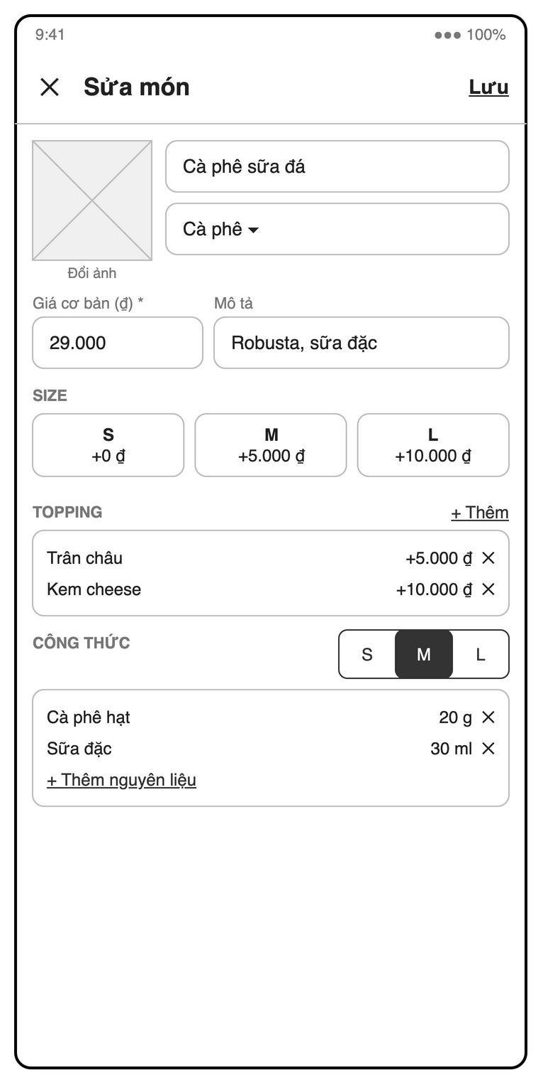
Figure 4.4-3: S09 Product form mock-up
Table 4-9: Product form Definition
No | Object Name | Type | Required | Length | Description
1 | closeButton | Icon button | Yes | NONE | The "✕" control closes the product form.
2 | titleLabel | Label | Yes | NONE | Shows "Sửa món" when editing an existing product.
3 | saveProductButton | Button | Yes | NONE | Uses "Lưu" to save valid product and recipe data; changes apply to new orders (UC08, UC14).
4 | productImage | Image | Conditional | NONE | Previews the optional product image selected with "Đổi ảnh".
5 | changeImageButton | Button | Yes | NONE | Uses "Đổi ảnh" to choose an optional camera or gallery image; saving without an image remains possible after upload failure (UC08).
6 | productNameField | Text field | Yes | NONE | Requires a nonempty product name, shown as "Cà phê sữa đá" (UC08).
7 | categoryDropdown | Dropdown | Yes | NONE | Requires an existing category, shown as "Cà phê ▾" (UC08).
8 | basePriceField | Number field | Yes | NONE | Requires "Giá cơ bản (₫) *" as a nonnegative integer VND amount (UC08).
9 | descriptionField | Text field | No | NONE | Accepts optional "Mô tả", illustrated by "Robusta, sữa đặc".
10 | sizeList | List | Yes | NONE | The "SIZE" section requires at least one size with a unique code and integer VND price delta (UC08).
11 | sizeCodeDropdown | Dropdown | Yes | NONE | Each size row selects a unique code from "S", "M" and "L" (UC08).
12 | sizePriceDeltaField | Number field | Yes | NONE | Each size row specifies the integer VND surcharge, illustrated by "+0 ₫", "+5.000 ₫" and "+10.000 ₫" (BR-ORD-01).
13 | addSizeButton | Button | Yes | NONE | Uses the SRS action "+ Thêm" in "SIZE" to add a size (UC08).
14 | toppingList | List | Yes | NONE | The optional "TOPPING" section lists names and prices; toppings have no recipe or automatic stock deduction in v1 (BR-INV-04).
15 | addToppingButton | Button | Yes | NONE | Uses "+ Thêm" in "TOPPING" to create an optional topping row.
16 | toppingNameField | Text field | Yes | NONE | Each added topping requires a name, such as "Trân châu" or "Kem cheese" (UC08).
17 | toppingPriceField | Number field | Yes | NONE | Each added topping requires an integer VND price ≥ 0, illustrated by "+5.000 ₫" (UC08).
18 | removeToppingButton | Icon button | Yes (per row) | NONE | The "✕" control removes its topping row.
19 | recipeSizeTabBar | Tab bar | Yes | NONE | Selects "S", "M" or "L" under "CÔNG THỨC" to edit that size’s recipe (UC14).
20 | recipeList | List | Yes | NONE | Lists optional ingredient quantities for the selected size, such as "Cà phê hạt" and "20 g" (UC14).
21 | recipeIngredientDropdown | Dropdown | Yes | NONE | Each recipe row selects an existing ingredient without duplicates within the size (UC14).
22 | recipeQuantityField | Number field | Yes | NONE | Each recipe row requires quantity > 0 in the ingredient’s unit, illustrated by "20 g" and "30 ml" (UC14).
23 | removeIngredientButton | Icon button | Yes (per row) | NONE | The "✕" control removes its recipe ingredient row.
24 | addIngredientButton | Button | Yes | NONE | Uses "+ Thêm nguyên liệu" to add a recipe row.
25 | copyRecipeButton | Button | Conditional | NONE | Uses the SRS action "Sao chép từ size <X>" to copy another size’s recipe for editing (UC14).
26 | missingRecipeBadge | Badge | Conditional | NONE | Warns when a size has no recipe; saving is allowed and payment deducts no stock for that size (UC14).
27 | deleteProductButton | Button | Conditional | NONE | Offers deletion of an existing product while retaining historical order snapshots (UC08).
28 | deleteProductDialog | Dialog | Conditional | NONE | Confirms product deletion before removing it (UC08, SRS 5.2).

4.4.3.2 Object Interactions (Sequence Diagrams)
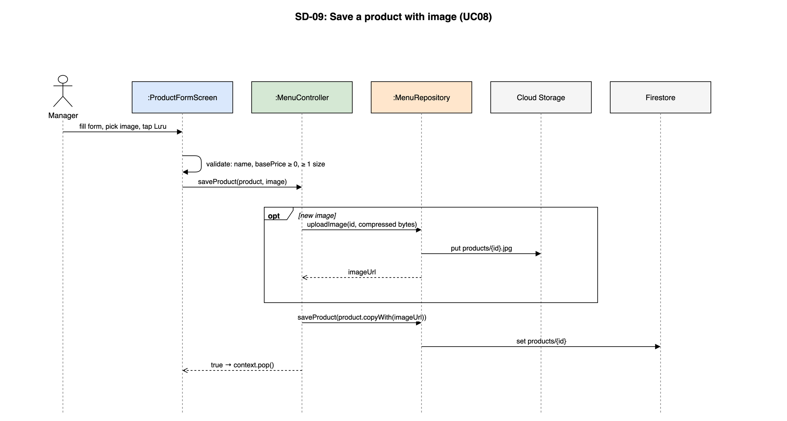
Figure 4.4-4: SD-09: Save a product with image (UC08)

4.5 Inventory (UC11–UC17, UC42, UC43)
Feature folder lib/features/inventory. It covers UC11–UC17, UC42, UC43 of the SRS.

4.5.1 Class/Component Design

4.5.1.1 Class/Component Structure
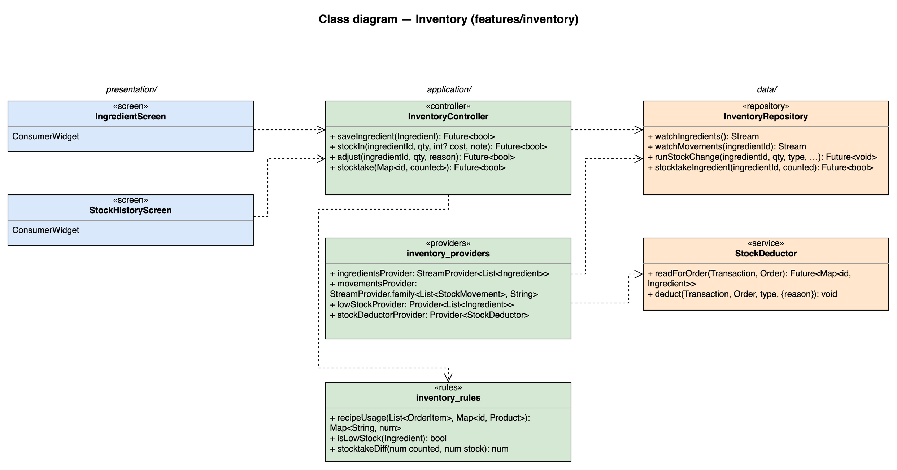
Figure 4.5-1: Class diagram for Inventory

4.5.1.2 Class/Component Description
Class | «screen» IngredientScreen
Description | S10 ingredient list with low / negative stock highlight, ingredient form and stocktake sheet (UC11, UC42).
Base Class | ConsumerWidget
Constructor | const IngredientScreen({super.key})
Prototype | class IngredientScreen extends ConsumerWidget
Source File | lib/features/inventory/presentation/ingredient_screen.dart
Namespace | package:brewboss/features/inventory/presentation
Attributes | Name | Type | Description
Attributes | _stocktake | Map<String, num> | Counted quantities entered in stocktake mode
Methods | Name | Input | Output | Description
Methods | build | BuildContext context, WidgetRef ref | Widget | Watches the providers listed above and renders loading / error / empty / data with AsyncValue.when

Class | «screen» StockHistoryScreen
Description | S11 current stock and movement history of one ingredient; stock-in and adjustment sheets (UC12, UC13, UC17).
Base Class | ConsumerWidget
Constructor | const StockHistoryScreen({super.key})
Prototype | class StockHistoryScreen extends ConsumerWidget
Source File | lib/features/inventory/presentation/stock_history_screen.dart
Namespace | package:brewboss/features/inventory/presentation
Attributes | Name | Type | Description
Attributes | ingredientId | String | Route parameter
Methods | Name | Input | Output | Description
Methods | build | BuildContext context, WidgetRef ref | Widget | Watches the providers listed above and renders loading / error / empty / data with AsyncValue.when

Class | «controller» InventoryController
Description | Inventory writes; each call is one Firestore transaction.
Base Class | AsyncNotifier<void>
Constructor | InventoryController() — created by AsyncNotifierProvider<InventoryController, void>(InventoryController.new)
Prototype | class InventoryController extends AsyncNotifier<void>
Source File | lib/features/inventory/application/inventory_controller.dart
Namespace | package:brewboss/features/inventory/application
Attributes | Name | Type | Description
Attributes | state | AsyncValue<void> | Saving state
Methods | Name | Input | Output | Description
Methods | saveIngredient | Ingredient i | Future<bool> | Unique name; delete refused while a recipe uses it (MSG13)
Methods | stockIn | String ingredientId, num qty, int? cost, String note | Future<bool> | Movement type in with total cost (UC12)
Methods | adjust | String ingredientId, num qty, String reason | Future<bool> | Reason required (MSG14); qty 0 refused (MSG15)
Methods | stocktake | Map<String, num> counted | Future<bool> | Calls InventoryRepository.stocktakeIngredient(id, counted) for each counted ingredient; returns the number adjusted (UC42, MSG41)

Class | «providers» inventory_providers
Description | Inventory streams and the shared StockDeductor.
Base Class | — (top-level providers)
Constructor | —
Prototype | top-level declarations (no class)
Source File | lib/features/inventory/application/inventory_providers.dart
Namespace | package:brewboss/features/inventory/application
Attributes | Name | Type | Description
Attributes | ingredientsProvider | StreamProvider<List<Ingredient>> | All ingredients
Attributes | movementsProvider | StreamProvider.family<List<StockMovement>, String> | Movements of one ingredient, newest first
Attributes | lowStockProvider | Provider<List<Ingredient>> | stock ≤ minStock; in-app fallback of UC16
Attributes | stockDeductorProvider | Provider<StockDeductor> | Injected into OrderRepository
Methods | Name | Input | Output | Description
Methods | — | — | — | Declarations only; see Attributes

Class | «rules» inventory_rules
Description | Pure stock rules.
Base Class | — (pure functions)
Constructor | —
Prototype | top-level declarations (no class)
Source File | lib/features/inventory/application/inventory_rules.dart
Namespace | package:brewboss/features/inventory/application
Attributes | Name | Type | Description
Attributes | — | — | No state
Methods | Name | Input | Output | Description
Methods | recipeUsage | List<OrderItem> items, Map<String, Product> products | Map<String, num> | Σ recipe qty × item qty per ingredient; toppings ignored (BR-INV-04)
Methods | isLowStock | Ingredient i | bool | stock ≤ minStock
Methods | stocktakeDiff | num counted, num stock | num | counted − stock (BR-INV-03)

Class | «service» StockDeductor
Description | Deducts stock by recipe inside a transaction owned by the caller (payment UC15, cancel waste UC43). Reads first, writes later, because Firestore transactions require all reads before writes.
Base Class | —
Constructor | —
Prototype | class StockDeductor
Source File | lib/features/inventory/data/stock_deductor.dart
Namespace | package:brewboss/features/inventory/data
Attributes | Name | Type | Description
Attributes | _db | FirebaseFirestore | Firestore instance injected by the provider
Methods | Name | Input | Output | Description
Methods | readForOrder | Transaction txn, Order order | Future<Map<String, Ingredient>> | Reads every ingredient used by the order recipes
Methods | deduct | Transaction txn, Order order, MovementType type, {String? reason} | void | stock −= usage (may go negative) and one movement per ingredient: sale on payment, adjust with the cancel reason on waste

Class | «repository» InventoryRepository
Description | ingredients and their movements sub-collection.
Base Class | —
Constructor | —
Prototype | class InventoryRepository
Source File | lib/features/inventory/data/inventory_repository.dart
Namespace | package:brewboss/features/inventory/data
Attributes | Name | Type | Description
Attributes | _db | FirebaseFirestore | Firestore instance injected by the provider
Methods | Name | Input | Output | Description
Methods | watchIngredients | — | Stream<List<Ingredient>> | Collection snapshots
Methods | watchMovements | String ingredientId | Stream<List<StockMovement>> | Sub-collection ordered by createdAt desc
Methods | runStockChange | String ingredientId, num qty, MovementType type, {int? cost, String? reason} | Future<void> | Transaction: update stock by qty and add the movement with byUserId and server timestamp
Methods | stocktakeIngredient | String ingredientId, num counted | Future<bool> | Transaction: re-reads stock, diff = counted − stock; when diff ≠ 0 sets stock = counted and adds an adjust movement "Kiểm kho" (SD-08)

4.5.2 UC11, UC42 – Ingredients and stocktake

4.5.2.1 Screen Design
S10 Ingredient list / form / stocktake (route /manager/inventory).
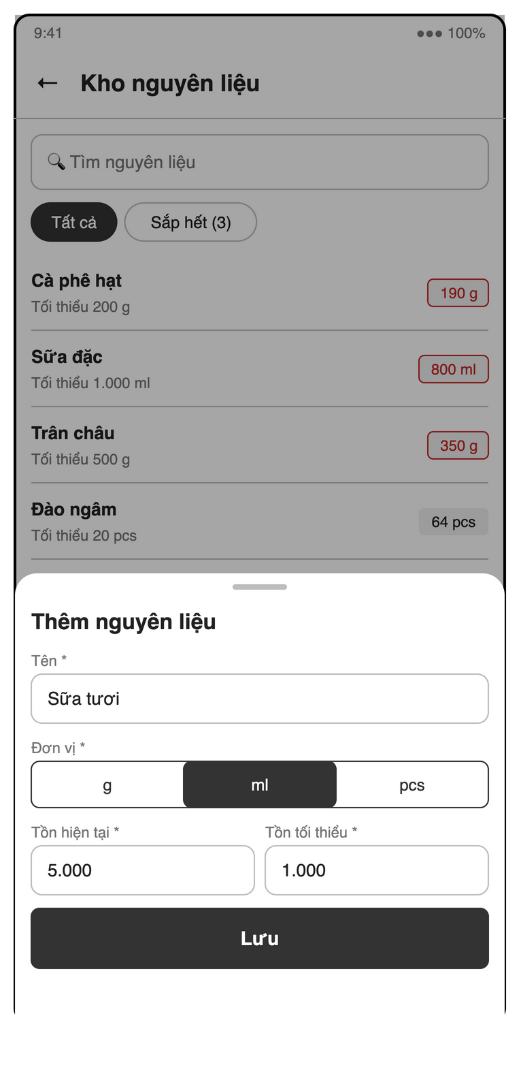
Figure 4.5-2: S10 Ingredient list / form mock-up
Table 4-10: Ingredient list / form / stocktake Definition
No | Object Name | Type | Required | Length | Description
1 | backButton | Icon button | Yes | NONE | The "←" control returns from inventory.
2 | titleLabel | Label | Yes | NONE | Displays "Kho nguyên liệu".
3 | ingredientSearchField | Search field | No | NONE | Filters ingredient names using "Tìm nguyên liệu".
4 | stockFilterChipGroup | Chip group | No | NONE | Switches between "Tất cả" and low-stock ingredients, shown as "Sắp hết (3)".
5 | ingredientList | List | Yes | NONE | Lists ingredient names, stock, units and minimums such as "Tối thiểu 200 g", highlighting stock ≤ minimum and negative stock (UC11).
6 | addIngredientButton | Button | Conditional | NONE | The manager-only "Thêm nguyên liệu" action opens the ingredient form.
7 | ingredientNameField | Text field | Yes | NONE | Requires a nonempty, unique "Tên *", illustrated by "Sữa tươi" (UC11).
8 | unitRadioGroup | Radio group | Yes | NONE | Requires one "Đơn vị *" from "g", "ml" or "pcs" (UC11).
9 | openingStockField | Number field | Conditional | NONE | Requires "Tồn hiện tại *" ≥ 0 only when creating an ingredient; positive opening stock is logged as "Tồn đầu kỳ" (UC11).
10 | minimumStockField | Number field | Yes | NONE | Requires "Tồn tối thiểu *" ≥ 0 (UC11).
11 | saveIngredientButton | Button | Conditional | NONE | The manager-only "Lưu" action saves valid ingredient details without directly editing existing stock (UC11).
12 | deleteIngredientButton | Button | Conditional | NONE | Offers manager-only deletion of an ingredient unused by recipes (UC11, MSG13).
13 | deleteIngredientDialog | Dialog | Conditional | NONE | Confirms ingredient deletion and reports recipe references when deletion is blocked (MSG13).
14 | stocktakeButton | Button | Yes | NONE | The SRS action "Kiểm kho" opens stocktake for managers and supervisors (UC42).
15 | stocktakeSheet | Bottom sheet | Conditional | NONE | The "Kiểm kho" sheet lists all ingredients for a physical count (UC42).
16 | stocktakeList | List | Conditional | NONE | Shows each ingredient and its system stock alongside the SRS "Thực tế" input (UC42).
17 | actualStockField | Number field | No | NONE | The per-ingredient "Thực tế" field accepts counts ≥ 0; blank entries leave stock unchanged (UC42, MSG42).
18 | stockDifferenceLabel | Label | Conditional | NONE | Shows counted minus system stock beside each entered count and highlights nonzero differences (BR-INV-03).
19 | saveStocktakeButton | Button | Conditional | NONE | Uses "Lưu" to record changed counts as adjustments, skipping blank entries and zero differences (BR-INV-03, MSG41, MSG15).

4.5.2.2 Object Interactions (Sequence Diagrams)
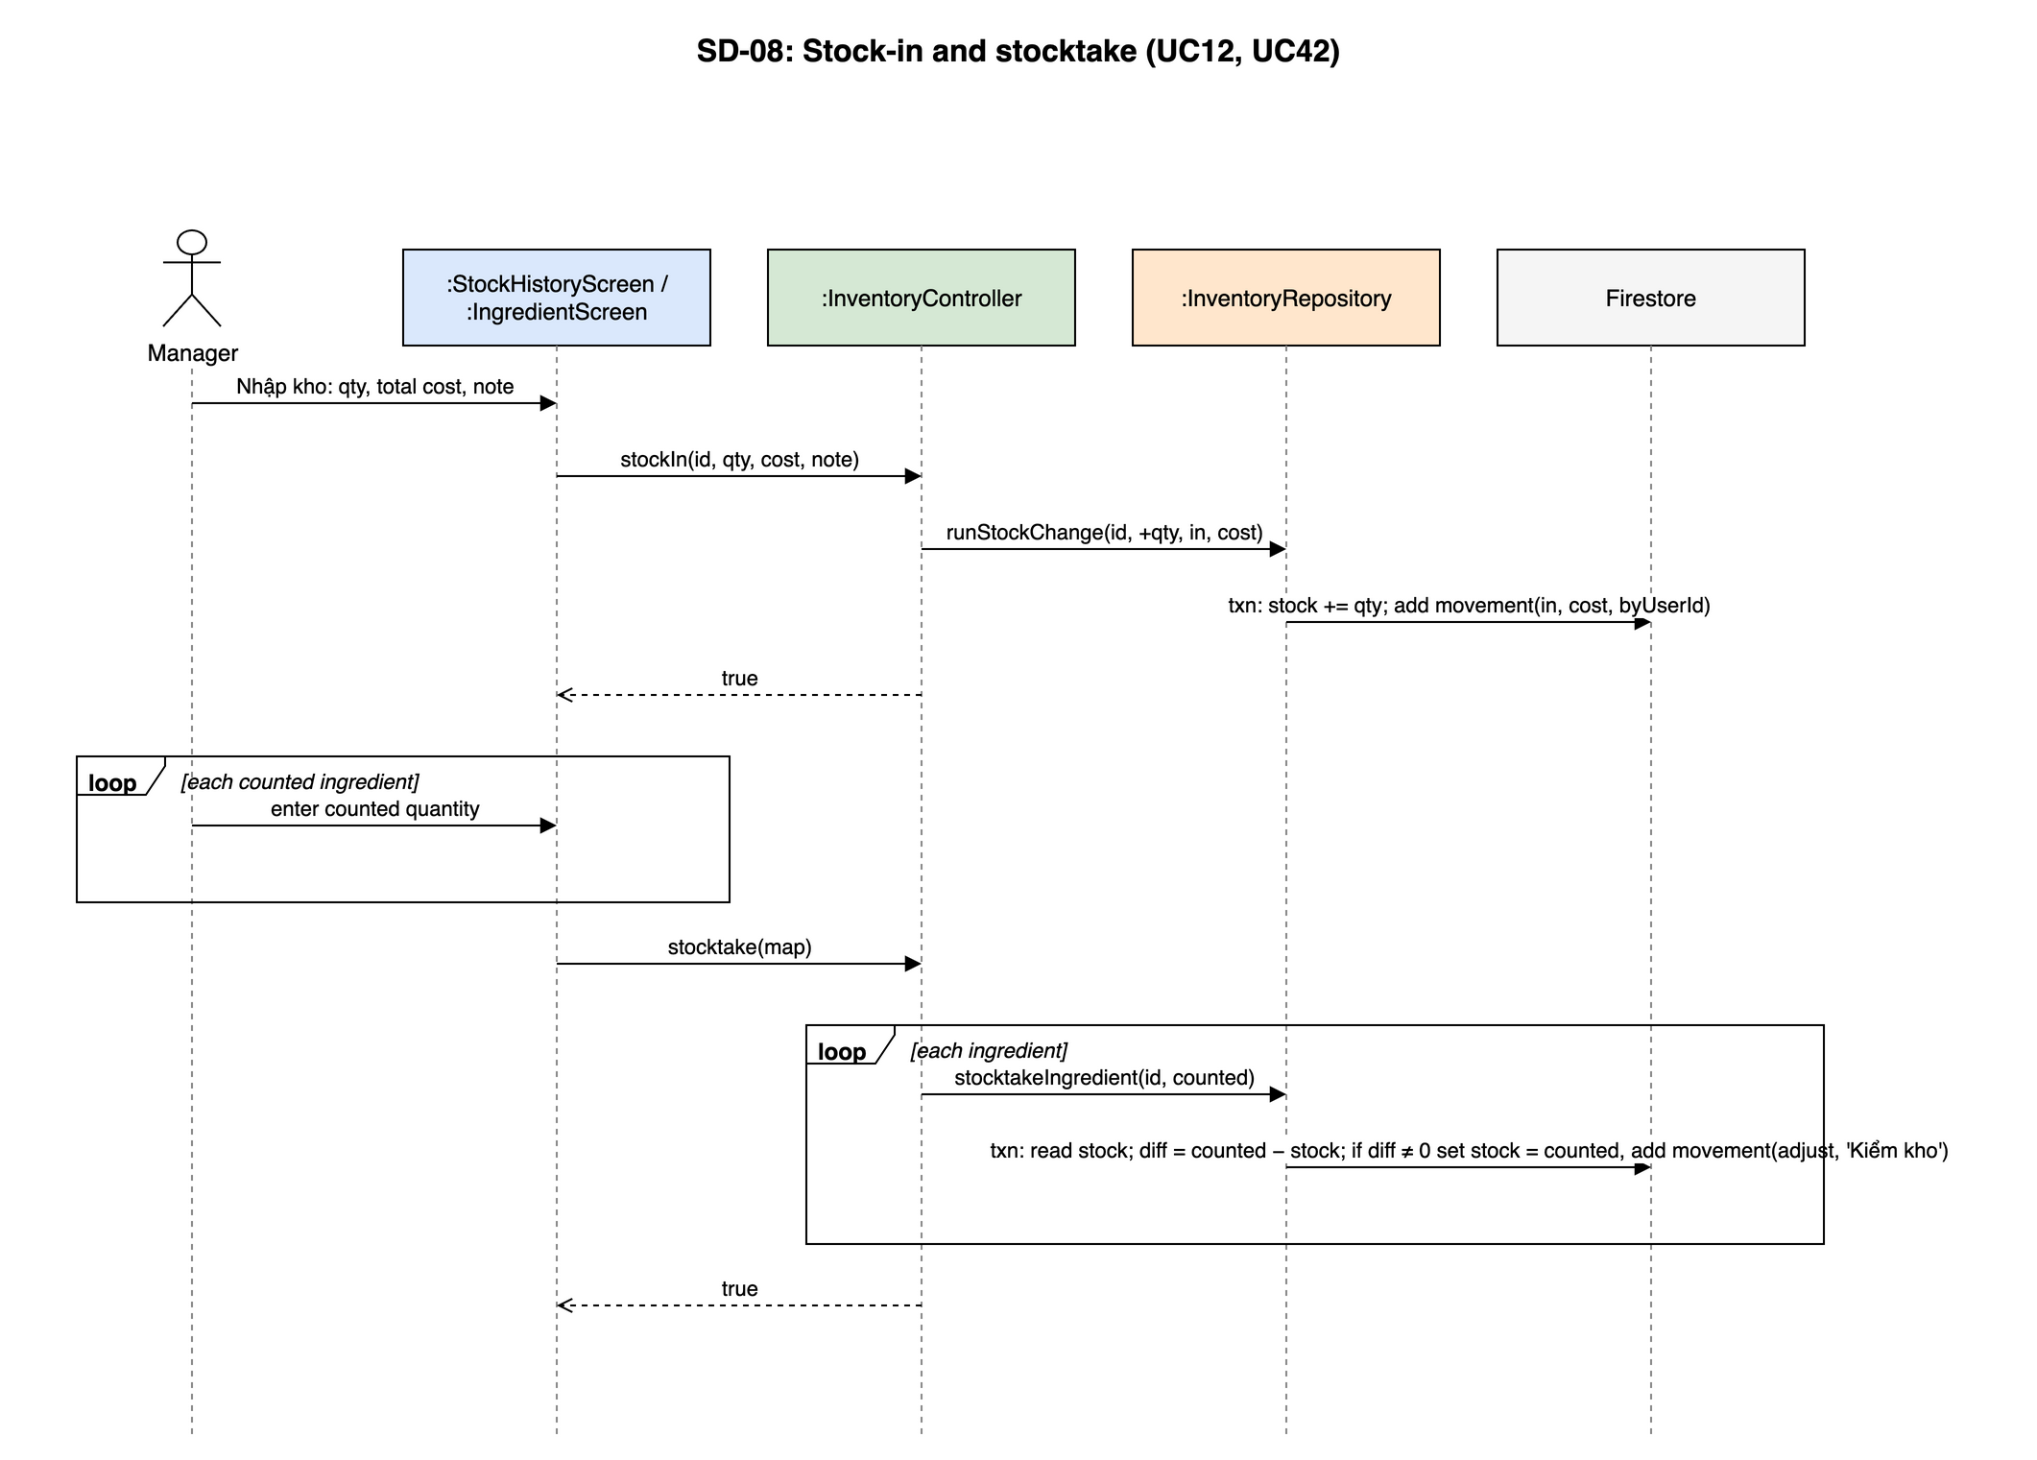
Figure 4.5-3: SD-08: Stock-in and stocktake (UC12, UC42)

4.5.3 UC12, UC13, UC17 – Stock-in, adjustment and movement history

4.5.3.1 Screen Design
S11 Stock movement history (route /manager/inventory/:id).
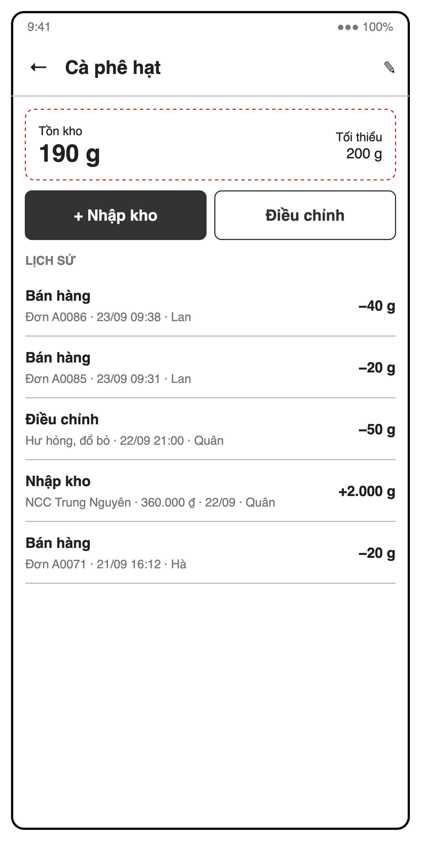
Figure 4.5-4: S11 Stock movement history mock-up
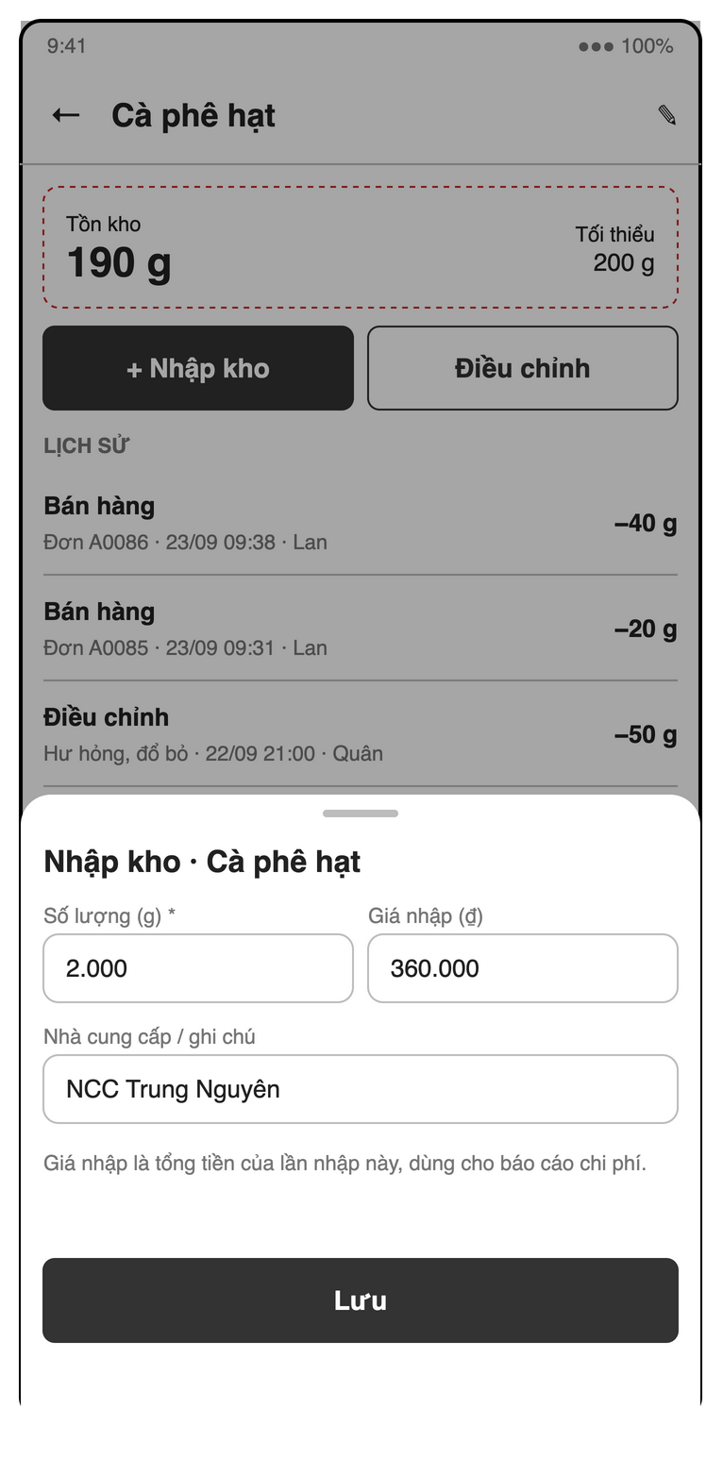
Figure 4.5-5: S11 Stock-in sheet mock-up
Table 4-11: Stock movement history Definition
No | Object Name | Type | Required | Length | Description
1 | backButton | Icon button | Yes | NONE | The "←" control returns to the ingredient list.
2 | ingredientNameLabel | Label | Yes | NONE | Displays the selected ingredient, illustrated by "Cà phê hạt".
3 | editIngredientButton | Icon button | Yes | NONE | The "✎" control opens the ingredient form for name, unit and minimum-stock edits (UC11).
4 | currentStockLabel | Label | Yes | NONE | Shows "Tồn kho" with the current quantity and unit, illustrated by "190 g".
5 | minimumStockLabel | Label | Yes | NONE | Shows "Tối thiểu" with the low-stock threshold, illustrated by "200 g".
6 | stockInButton | Button | Yes | NONE | Uses "+ Nhập kho" to open the stock-in sheet (UC12).
7 | adjustStockButton | Button | Yes | NONE | Uses "Điều chỉnh" to open the adjustment sheet (UC13).
8 | movementTypeChipGroup | Chip group | No | NONE | Filters "Nhập kho", "Bán hàng" and "Điều chỉnh" movements (UC17).
9 | movementDateRangePicker | Date range picker | No | NONE | Filters movement history by date range (UC17).
10 | movementList | List | Yes | NONE | Shows "LỊCH SỬ" with signed quantities, type, order or reason, cost, time and user; sale rows open S20 (UC17).
11 | stockInSheet | Bottom sheet | Conditional | NONE | Shows the stock-in form titled "Nhập kho · Cà phê hạt" for the selected ingredient.
12 | stockInQuantityField | Number field | Yes | NONE | Requires "Số lượng (g) *" > 0, using the selected ingredient’s unit (UC12).
13 | purchaseCostField | Number field | No | NONE | Accepts optional "Giá nhập (₫)" as the delivery’s total integer VND cost ≥ 0 (UC12).
14 | supplierNoteField | Text field | No | NONE | Accepts optional "Nhà cung cấp / ghi chú", illustrated by "NCC Trung Nguyên".
15 | costHelpLabel | Label | Conditional | NONE | Displays "Giá nhập là tổng tiền của lần nhập này, dùng cho báo cáo chi phí.".
16 | saveStockInButton | Button | Conditional | NONE | Uses "Lưu" to increase stock and log the delivery with any entered cost (UC12).
17 | adjustmentSheet | Bottom sheet | Conditional | NONE | Shows the "Điều chỉnh" form for loss or physical-count correction (UC13).
18 | adjustmentModeRadioGroup | Radio group | Yes | NONE | Requires the SRS mode "Hao hụt" or "Kiểm kê" (UC13).
19 | adjustmentQuantityField | Number field | Yes | NONE | Requires a loss quantity or actual count; loss subtracts stock and count uses actual minus current stock (UC13).
20 | adjustmentReasonField | Text field | Yes | NONE | Requires a nonempty adjustment reason; missing input shows "Vui lòng nhập lý do" (MSG14).
21 | saveAdjustmentButton | Button | Conditional | NONE | Uses "Lưu" to log the signed adjustment with its reason; zero change shows "Tồn kho không thay đổi" (MSG15).

4.5.3.2 Object Interactions
Stock-in is the first part of SD-08. An adjustment is the same sequence with type adjust and a mandatory reason. The history list follows the SD-11 provider sequence with movementsProvider(ingredientId).

4.5.4 UC15, UC16, UC43 – Stock deduction, low-stock alert and cancel waste (non-screen)
UC15 and UC43 have no screen: StockDeductor runs inside the payment transaction (SD-04) and the cancellation transaction (SD-05). UC16 is the Cloud Function onIngredientWrite shown below, with lowStockProvider as the in-app fallback on S04 and S10.

4.5.4.1 Object Interactions (Sequence Diagrams)
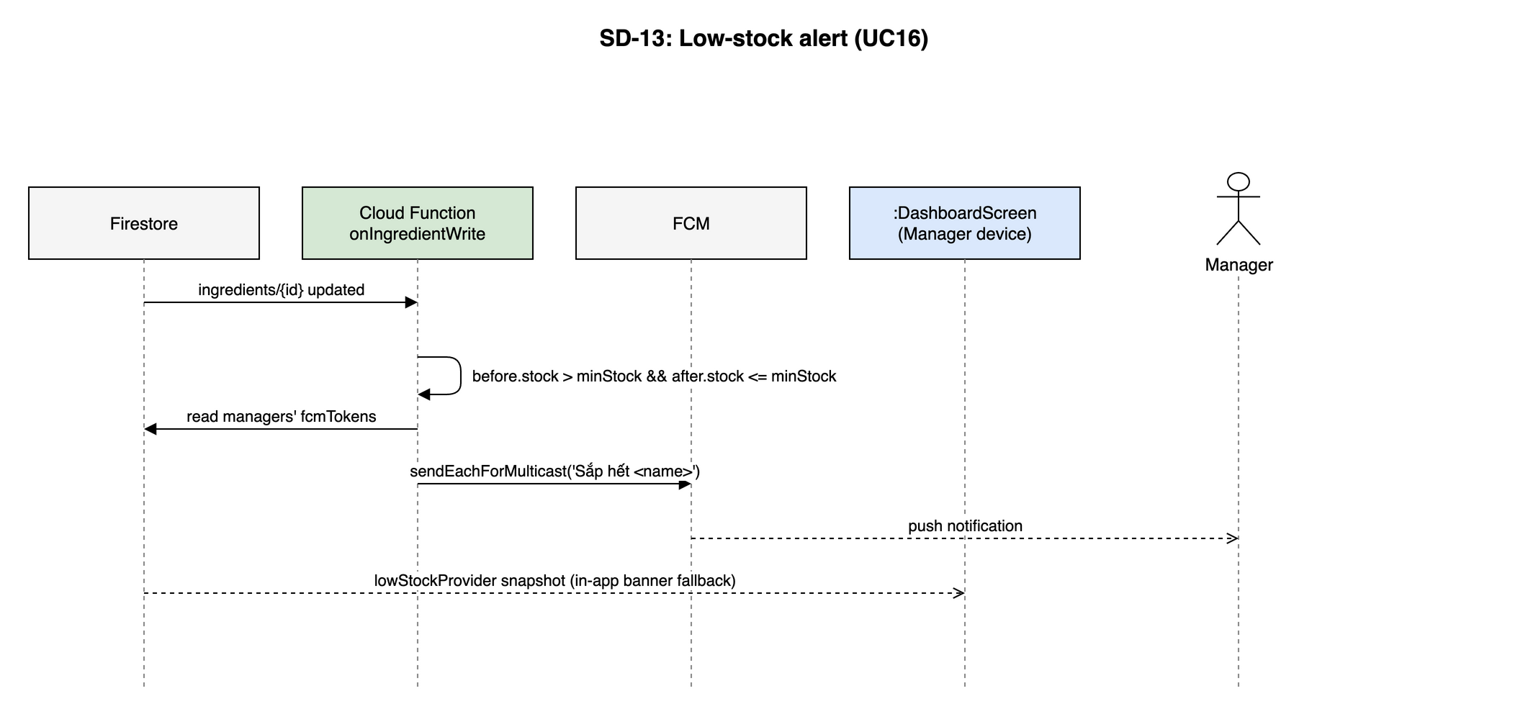
Figure 4.5-6: SD-13: Low-stock alert (UC16)

4.6 Point of Sale (UC19–UC28, UC46)
Feature folder lib/features/pos. It covers UC19–UC28, UC46 of the SRS.

4.6.1 Class/Component Design

4.6.1.1 Class/Component Structure
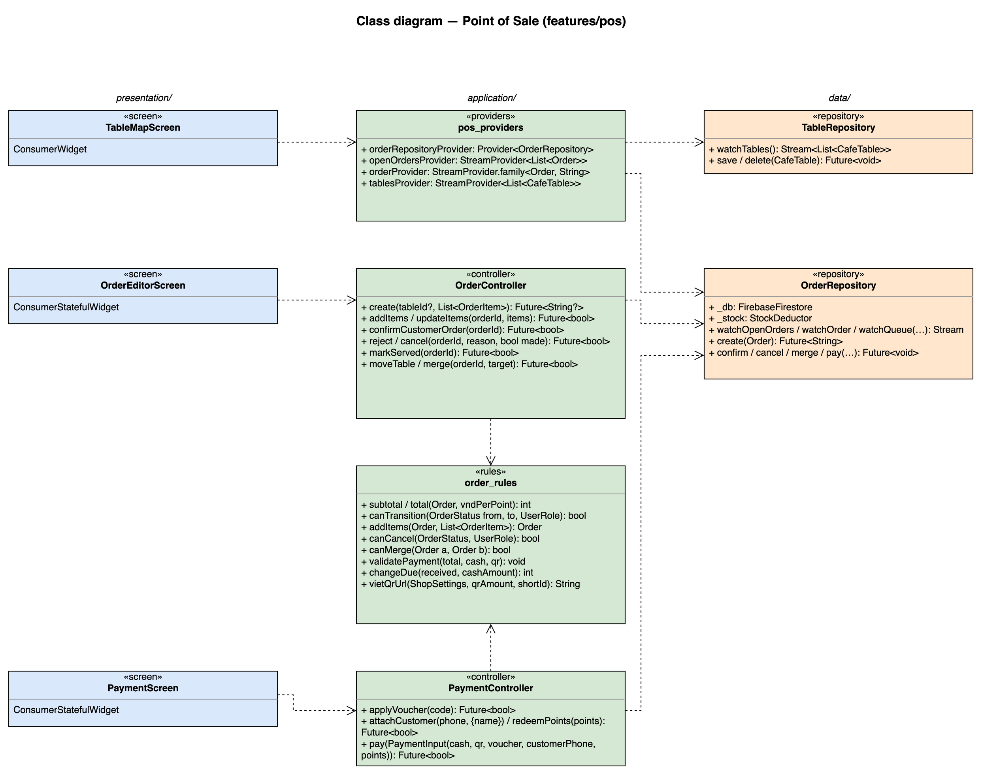
Figure 4.6-1: Class diagram for Point of Sale

4.6.1.2 Class/Component Description
Class | «screen» TableMapScreen
Description | S13 cashier home: live table status (Trống / Có khách / Chờ thanh toán), customer-order and ready badges, takeaway tab (UC19).
Base Class | ConsumerWidget
Constructor | const TableMapScreen({super.key})
Prototype | class TableMapScreen extends ConsumerWidget
Source File | lib/features/pos/presentation/table_map_screen.dart
Namespace | package:brewboss/features/pos/presentation
Attributes | Name | Type | Description
Attributes | ref | WidgetRef | Riverpod reference; ref.watch in build, ref.read in callbacks
Methods | Name | Input | Output | Description
Methods | build | BuildContext context, WidgetRef ref | Widget | Watches the providers listed above and renders loading / error / empty / data with AsyncValue.when

Class | «screen» OrderEditorScreen
Description | S14 order editor: MenuBrowser, cart, customer order confirmation, move / merge, serve and cancel actions. Buttons follow order status and role (canTransition / canCancel).
Base Class | ConsumerStatefulWidget
Constructor | const OrderEditorScreen({super.key})
Prototype | class OrderEditorScreen extends ConsumerStatefulWidget
Source File | lib/features/pos/presentation/order_editor_screen.dart
Namespace | package:brewboss/features/pos/presentation
Attributes | Name | Type | Description
Attributes | orderId | String? | null = new order
Attributes | tableId | String? | null = takeaway
Attributes | _cart | List<OrderItem> | Items not yet sent
Methods | Name | Input | Output | Description
Methods | createState | — | _OrderEditorScreenState | Creates the ConsumerState<OrderEditorScreen> that holds the attributes above and the private methods below; its build(BuildContext context) reads providers through the state's ref
Methods | _send | — | Future<void> | OrderController.create or addItems
Methods | _cancel | — | Future<void> | Reason dialog with "Đã pha" checkbox (BR-INV-02 defaults)

Class | «screen» PaymentScreen
Description | S15 payment: summary, loyalty customer (CustomerSheet), voucher, points, cash / VietQR / split and change due (UC24, UC25, UC38, UC39, UC46).
Base Class | ConsumerStatefulWidget
Constructor | const PaymentScreen({super.key})
Prototype | class PaymentScreen extends ConsumerStatefulWidget
Source File | lib/features/pos/presentation/payment_screen.dart
Namespace | package:brewboss/features/pos/presentation
Attributes | Name | Type | Description
Attributes | _cashReceived | int | Cash handed over by the customer
Attributes | _qrAmount | int | VietQR part; total for VietQR only, 0 for cash only
Methods | Name | Input | Output | Description
Methods | createState | — | _PaymentScreenState | Creates the ConsumerState<PaymentScreen> that holds the attributes above and the private methods below; its build(BuildContext context) reads providers through the state's ref
Methods | _confirm | — | Future<void> | PaymentController.pay; shows MSG26 and returns to S13

Class | «controller» OrderController
Description | All order writes except payment (UC20–UC23, UC26, UC27).
Base Class | AsyncNotifier<void>
Constructor | OrderController() — created by AsyncNotifierProvider<OrderController, void>(OrderController.new)
Prototype | class OrderController extends AsyncNotifier<void>
Source File | lib/features/pos/application/order_controller.dart
Namespace | package:brewboss/features/pos/application
Attributes | Name | Type | Description
Attributes | state | AsyncValue<void> | Saving state
Methods | Name | Input | Output | Description
Methods | create | String? tableId, List<OrderItem> items | Future<String?> | Prices by menu_rules.unitPrice; OrderRepository.create (SD-02); MSG19 when the table already has an order
Methods | addItems / updateItems | String orderId, List<OrderItem> items | Future<bool> | order_rules.addItems applies batch logic (BR-ORD-04); editing existing lines only while pending (MSG20)
Methods | confirmCustomerOrder | String orderId | Future<bool> | Re-validates prices and confirms an awaiting order (SD-03, BR-ORD-07); the shortId of a customer order is allocated here, because anonymous users cannot write the daily counter
Methods | reject / cancel | String orderId, String reason, bool made | Future<bool> | Reason required (MSG32); canCancel(status, role) else MSG33 (SD-05)
Methods | markServed | String orderId | Future<bool> | ready → served (UC23)
Methods | moveTable / merge | String orderId, String target | Future<bool> | Move to an empty table (MSG30) or merge two served orders (canMerge, MSG31, SD-06)

Class | «controller» PaymentController
Description | Payment of one order (UC25, UC46) with voucher, loyalty and points applied in the same transaction.
Base Class | AsyncNotifier<void>
Constructor | PaymentController() — created by AsyncNotifierProvider<PaymentController, void>(PaymentController.new)
Prototype | class PaymentController extends AsyncNotifier<void>
Source File | lib/features/pos/application/payment_controller.dart
Namespace | package:brewboss/features/pos/application
Attributes | Name | Type | Description
Attributes | input | PaymentInput | cash, qr, voucherCode, customerPhone, points
Methods | Name | Input | Output | Description
Methods | applyVoucher | String code | Future<bool> | loyalty_rules.voucherError → MSG22–MSG25; one voucher per order (BR-DIS-01)
Methods | attachCustomer / redeemPoints | String phone, {String? name} / int points | Future<bool> | Saves order.customerId (or clears it on detach) and order.pointsRedeemed with the recomputed total on the open order (UC38, UC39, SD-12); the balance itself changes only in the payment transaction
Methods | pay | PaymentInput input | Future<bool> | Requires an open shift (MSG28) and validatePayment (MSG27, MSG44), then OrderRepository.pay(input) (SD-04)

Class | «providers» pos_providers
Description | POS streams; orderRepositoryProvider is shared with barista, customer and staff features.
Base Class | — (top-level providers)
Constructor | —
Prototype | top-level declarations (no class)
Source File | lib/features/pos/application/pos_providers.dart
Namespace | package:brewboss/features/pos/application
Attributes | Name | Type | Description
Attributes | orderRepositoryProvider | Provider<OrderRepository> | Singleton repository with StockDeductor injected
Attributes | openOrdersProvider | StreamProvider<List<Order>> | status in awaiting…served
Attributes | orderProvider | StreamProvider.family<Order, String> | One order
Attributes | tablesProvider | StreamProvider<List<CafeTable>> | All tables
Methods | Name | Input | Output | Description
Methods | — | — | — | Declarations only; see Attributes

Class | «rules» order_rules
Description | Order state machine and money rules; the most heavily unit-tested file.
Base Class | — (pure functions)
Constructor | —
Prototype | top-level declarations (no class)
Source File | lib/features/pos/application/order_rules.dart
Namespace | package:brewboss/features/pos/application
Attributes | Name | Type | Description
Attributes | — | — | No state
Methods | Name | Input | Output | Description
Methods | subtotal / total | Order o, int vndPerPoint | int | Σ unitPrice × qty; subtotal − discount − points × vndPerPoint, min 0 (BR-ORD-02)
Methods | canTransition | OrderStatus from, OrderStatus to, UserRole role | bool | Transition table of SRS figure 2-2
Methods | addItems | Order o, List<OrderItem> items | Order | ready / served → pending with batch = max + 1; otherwise same batch (BR-ORD-04)
Methods | canCancel | OrderStatus s, UserRole role | bool | awaiting / pending: cashier and up; preparing / ready / served: supervisor or manager (BR-ORD-05)
Methods | canMerge | Order a, Order b | bool | Both served, no voucher, customer or points (BR-ORD-08)
Methods | validatePayment | int total, int cash, int qr | void | Throws unless cash + qr = total and both ≥ 0 (BR-PAY-01)
Methods | changeDue | int received, int cashAmount | int | received − cashAmount, not stored (BR-PAY-02)
Methods | vietQrUrl | ShopSettings s, int qrAmount, String shortId | String | img.vietqr.io URL of SRS 3.1.4 #8; MSG29 when no bank account

Class | «repository» OrderRepository
Description | orders and tables writes. Every multi-document change is one runTransaction (NFR-REL-01).
Base Class | —
Constructor | —
Prototype | class OrderRepository
Source File | lib/features/pos/data/order_repository.dart
Namespace | package:brewboss/features/pos/data
Attributes | Name | Type | Description
Attributes | _db | FirebaseFirestore | Firestore instance injected by the provider
Attributes | _stock | StockDeductor | Stock deduction inside payment and cancellation
Methods | Name | Input | Output | Description
Methods | watchOpenOrders / watchOrder / watchQueue | … | Stream | Live queries; watchQueue = status in (pending, preparing) ordered by createdAt
Methods | create | Order o | Future<String> | Transaction: next shortId of the day, add order (pending), table.currentOrderId
Methods | confirm / cancel / merge / pay | …, String uid | Future<void> | Transactions of SRS 3.1.4 #4–#7. confirm allocates the shortId of a customer order. pay re-checks status = served, the voucher, the customer balance and the payer's open shift, then also adds cashAmount / qrAmount to shift.cashSales / qrSales with shift.lastPaidOrderId = orderId, and stores order.shiftId
Methods | updateLoyalty | String orderId, String? customerId, int points | Future<void> | Writes customerId, pointsRedeemed and total on an open order (BR-ORD-08 then sees the attached customer)
Methods | paidOrders | String paidBy, DateTime from | Future<List<Order>> | Used by the cash handover preview (SD-07)

Class | «repository» TableRepository
Description | tables CRUD for S12 and the table map.
Base Class | —
Constructor | —
Prototype | class TableRepository
Source File | lib/features/pos/data/table_repository.dart
Namespace | package:brewboss/features/pos/data
Attributes | Name | Type | Description
Attributes | _db | FirebaseFirestore | Firestore instance injected by the provider
Methods | Name | Input | Output | Description
Methods | watchTables | — | Stream<List<CafeTable>> | Ordered by area, name
Methods | save / delete | CafeTable t | Future<void> | Delete refused while currentOrderId ≠ null (MSG17)

4.6.2 UC19 – View table map

4.6.2.1 Screen Design
S13 Table map (route /pos). Home of the Cashier and the Shift Supervisor.
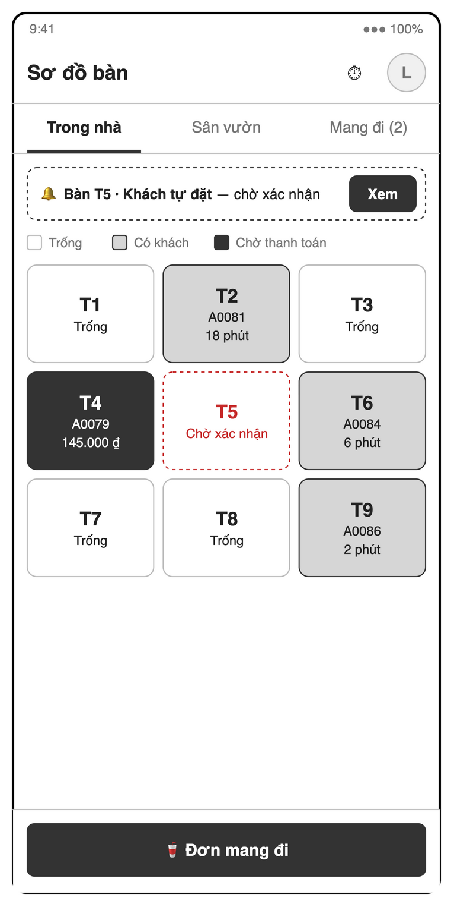
Figure 4.6-2: S13 Table map mock-up
Table 4-12: Table map Definition
No | Object Name | Type | Required | Length | Description
1 | titleLabel | Label | Yes | NONE | Displays "Sơ đồ bàn".
2 | profileButton | Icon button | Yes | NONE | The avatar shown as "L" opens S22.
3 | myShiftButton | Icon button | Yes | NONE | The "⏱" control opens S07.
4 | areaTabBar | Tab bar | Yes | NONE | Switches between areas such as "Trong nhà", "Sân vườn" and the takeaway tab "Mang đi (2)".
5 | customerOrderBanner | Banner | Conditional | NONE | Shows an awaiting request such as "Bàn T5 · Khách tự đặt — chờ xác nhận", including add-ons to occupied tables (BR-ORD-07).
6 | reviewCustomerOrderButton | Button | Conditional | NONE | Uses "Xem" to open customer-order confirmation in S14.
7 | tableStatusLegendLabel | Label | Conditional | NONE | Explains "Trống", "Có khách" and "Chờ thanh toán" on area tabs (UC19).
8 | tableGrid | Grid | Conditional | NONE | Shows live table names, order codes, elapsed times or totals; tapping opens S14 and awaiting requests do not occupy tables (BR-ORD-03).
9 | awaitingOrderBadge | Badge | Conditional | NONE | Shows "Chờ xác nhận" on tables with awaiting customer orders (BR-ORD-07).
10 | readyOrderBadge | Badge | Conditional | NONE | Marks ready orders on the table map for serving (UC19, UC23).
11 | readyOrderBanner | Banner | Conditional | NONE | Shows the in-app order-ready alert and opens its order for serving (UC31, MSG34).
12 | createTakeawayButton | Button | Yes | NONE | Uses "Đơn mang đi" or "Tạo đơn mang đi" to create an order without a table (UC19).
13 | takeawayList | List | Conditional | NONE | Shows "ĐƠN MANG ĐI ĐANG MỞ" with code, item count, total, status and elapsed time, excluding paid or cancelled orders.
14 | markDeliveredButton | Button | Conditional | NONE | The per-row "Đã giao" action marks a ready takeaway order served when handed to the customer (UC23, BR-PAY-04).
15 | payTakeawayButton | Button | Conditional | NONE | The per-row "Thanh toán" action opens S15 only for a served takeaway order (BR-PAY-04).
16 | takeawayHelpLabel | Label | Conditional | NONE | Displays "Chạm một đơn để mở Order editor (S14). Đơn đã thanh toán hoặc đã hủy không hiện ở đây.".
17 | offlineBanner | Banner | Conditional | NONE | Shows "Mất kết nối" while cached table statuses remain visible (MSG18).

4.6.2.2 Object Interactions
TableMapScreen watches tablesProvider and openOrdersProvider (SD-11 provider sequence); the awaiting and ready badges are derived from the open orders. The order-ready push that also reaches this screen is the end of SD-02.

4.6.3 UC20–UC23, UC26, UC27 – Order editor

4.6.3.1 Screen Design
S14 Order editor (route /pos/order/:id).
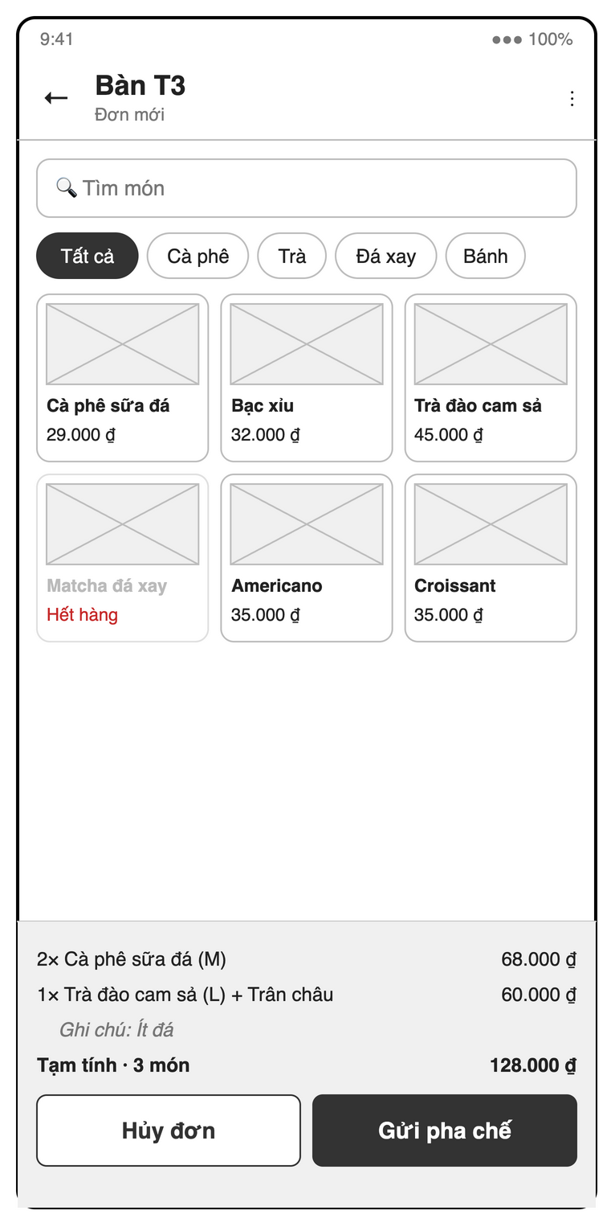
Figure 4.6-3: S14 Order editor mock-up
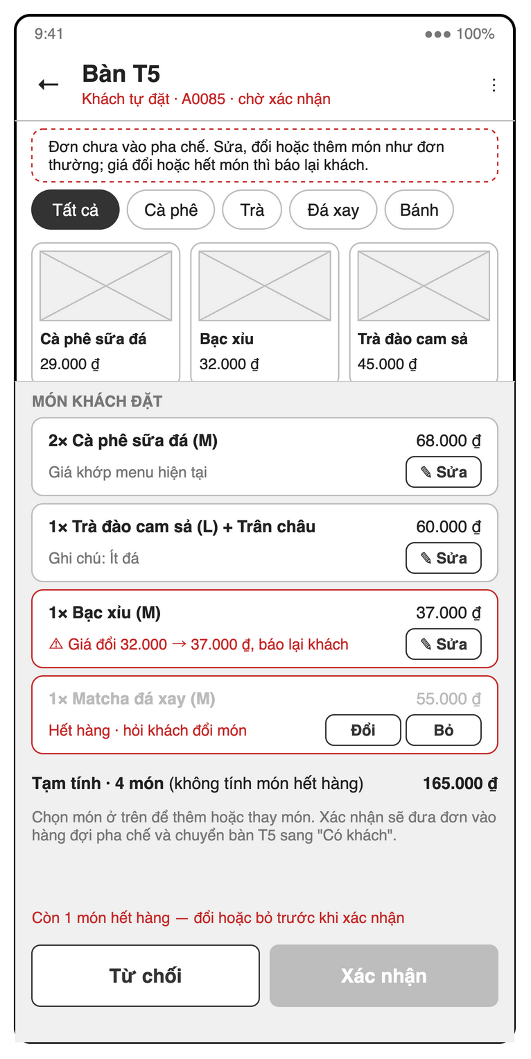
Figure 4.6-4: S14 Confirm customer order mock-up
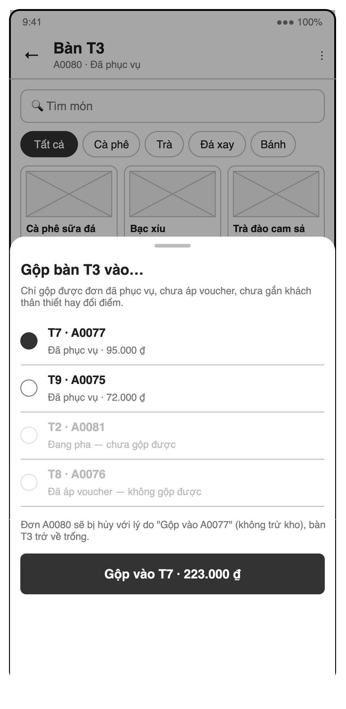
Figure 4.6-5: S14 Merge tables sheet mock-up
Table 4-13: Order editor Definition
No | Object Name | Type | Required | Length | Description
1 | backButton | Icon button | Yes | NONE | The "←" control returns from the order editor.
2 | orderHeaderLabel | Label | Yes | NONE | Shows table or takeaway, short ID and state, including "Đơn mới", "A0081 · Chờ pha (pending) · sửa được" and "Khách gọi thêm · A0086 → vào đơn A0081" (BR-ORD-06).
3 | orderActionsButton | Icon button | Yes | NONE | The "⋮" control opens order actions subject to status and role (UC20).
4 | productSearchField | Search field | No | NONE | Uses "Tìm món" for case- and accent-insensitive menu search (UC10, MSG12).
5 | categoryFilterChipGroup | Chip group | No | NONE | Filters "Tất cả", "Cà phê", "Trà", "Đá xay" and "Bánh".
6 | productGrid | Grid | Yes | NONE | Shows product names and prices; unavailable products display "Hết hàng" and cannot be added (UC20).
7 | quickAddButton | Icon button | Yes (per row) | NONE | The SRS "+" action adds one available product with its default size and no toppings (UC20).
8 | availabilitySwitch | Switch | Conditional | NONE | Long-pressing a product exposes the "Hết hàng" toggle for cashier, supervisor or manager (UC09).
9 | cartList | List | Yes | NONE | Shows quantities, sizes, toppings, notes and prices, with "MÓN KHÁCH ĐẶT" or "MÓN KHÁCH GỌI THÊM" during QR review (UC20–UC22).
10 | editItemButton | Icon button | Conditional | NONE | The per-row "✎" or "✎ Sửa" action edits draft, pending or awaiting lines; existing preparing, ready and served lines are read-only (BR-ORD-04, UC22, MSG20).
11 | removeItemButton | Button | Conditional | NONE | The per-row "Xoá" swipe action or QR-review "Bỏ" removes an editable line; removing the last saved line offers cancellation (UC21, UC22).
12 | batchStatusLabel | Label | Conditional | NONE | Shows batch headers such as "LƯỢT 1 · ĐÃ PHỤC VỤ · CHỈ ĐỌC" and "LƯỢT 2 · MỚI THÊM" (BR-ORD-04).
13 | cartHelpLabel | Label | Conditional | NONE | Shows state guidance such as "Chạm ✎ để sửa size / topping / số lượng / ghi chú · vuốt trái để xoá" or "Lượt 1 đã phục vụ nên chỉ đọc; lượt 2 gửi đi thì đơn quay về pending" (BR-ORD-04).
14 | subtotalLabel | Label | Yes | NONE | Shows item count and subtotal, such as "Tạm tính · 3 món", recalculated from current cart lines (BR-ORD-01).
15 | cancelOrderButton | Button | Conditional | NONE | Uses "Hủy đơn" with a required reason; started orders require supervisor or manager and paid or cancelled orders hide the action (BR-ORD-05, MSG33).
16 | submitOrderButton | Button | Conditional | NONE | Uses "Gửi pha chế", "Cập nhật" or "Gửi pha chế lượt 2" to save valid nonempty items, with ready or served add-ons returning to pending (BR-ORD-04).
17 | discardAddonsButton | Button | Conditional | NONE | Uses "Bỏ món thêm" to discard unsent add-on items while retaining earlier batches.
18 | markServedButton | Button | Conditional | NONE | Uses "Đã phục vụ" only for ready orders to mark delivery and enable payment (UC23, BR-PAY-04).
19 | paymentButton | Button | Conditional | NONE | Uses the SRS action "Thanh toán" to open S15 only when the order is served (BR-PAY-04).
20 | itemOptionsSheet | Bottom sheet | Conditional | NONE | Shows size, toppings, quantity and note for the selected product, illustrated by "Trà đào cam sả" (UC20).
21 | selectedProductLabel | Label | Conditional | NONE | Shows the option sheet’s product name and base price, illustrated by "Trà đào cam sả" and "45.000 ₫".
22 | sizeRadioGroup | Radio group | Yes | NONE | Requires one "SIZE", defaulting to the first size and showing deltas such as "S +0", "M +5.000" and "L +10.000" (BR-ORD-01).
23 | toppingCheckbox | Checkbox | No | NONE | Each optional "TOPPING" choice shows its name and price, such as "Trân châu" and "+5.000 ₫" (BR-ORD-01).
24 | itemNoteField | Text field | No | NONE | Accepts optional "GHI CHÚ", illustrated by "Ít đá".
25 | quantityField | Number field | Yes | NONE | Shows the quantity between "−" and "+", requiring an integer ≥ 1 with default 1 (UC20).
26 | decreaseQuantityButton | Icon button | Conditional | NONE | The "−" control decreases the item quantity without going below one (UC20).
27 | increaseQuantityButton | Icon button | Conditional | NONE | The "+" control increases the item quantity.
28 | confirmItemButton | Button | Conditional | NONE | Uses "Thêm · 60.000 ₫" to add the configured line at base price plus size and topping prices (BR-ORD-01).
29 | customerReviewInfoLabel | Label | Conditional | NONE | Explains awaiting-order review using "Đơn chưa vào pha chế." or the add-on notice "Bàn T5 đang có đơn A0081." (BR-ORD-07).
30 | priceComparisonLabel | Label | Conditional | NONE | Each reviewed line shows "Giá khớp menu hiện tại" or a warning such as "⚠ Giá đổi 32.000 → 37.000 ₫, báo lại khách" (UC22).
31 | unavailableItemLabel | Label | Conditional | NONE | Marks an unavailable customer line with "Hết hàng · hỏi khách đổi món" (UC22).
32 | replaceItemButton | Button | Conditional | NONE | The per-row "Đổi" action replaces an unavailable customer item using the menu (UC22).
33 | customerReviewWarningBanner | Banner | Conditional | NONE | Shows "Còn 1 món hết hàng — đổi hoặc bỏ trước khi xác nhận" while unavailable lines block confirmation (UC22).
34 | rejectCustomerOrderButton | Button | Conditional | NONE | Uses "Từ chối" to cancel an awaiting customer request with a required reason (BR-ORD-05, BR-ORD-07).
35 | confirmCustomerOrderButton | Button | Conditional | NONE | Uses "Xác nhận" for a free table or "Thêm vào A0081" for an occupied table after revalidation, closing the merged QR request (BR-ORD-07, MSG21).
36 | existingOrderList | List | Conditional | NONE | Shows the target order read-only under "ĐƠN ĐANG MỞ · A0081 · ĐANG PHA · CHỈ ĐỌC" during customer add-on confirmation (BR-ORD-07).
37 | addonSubtotalLabel | Label | Conditional | NONE | Shows the customer add-on count and amount, illustrated by "Món gọi thêm · 2 món" and "72.000 ₫".
38 | combinedOrderTotalLabel | Label | Conditional | NONE | Shows the projected total under "Tổng đơn A0081 sau khi thêm" (BR-ORD-07).
39 | addonImpactLabel | Label | Conditional | NONE | Explains same-batch addition while preparing and closure with reason "Gộp vào A0081"; ready or served targets receive a new batch (BR-ORD-04, BR-ORD-07).
40 | moveTableButton | Button | Conditional | NONE | The SRS "Chuyển bàn" action opens empty-table selection for an open dine-in order (UC26).
41 | mergeTableButton | Button | Conditional | NONE | The SRS "Gộp bàn" action opens merge-target selection for an open dine-in order (UC26).
42 | tableTransferSheet | Bottom sheet | Conditional | NONE | Shows move or merge targets, illustrated by "Gộp bàn T3 vào…" (UC26).
43 | mergeRuleLabel | Label | Conditional | NONE | Displays "Chỉ gộp được đơn đã phục vụ, chưa áp voucher, chưa gắn khách thân thiết hay đổi điểm." (BR-ORD-08).
44 | targetTableList | List | Yes | NONE | Requires one target in the transfer sheet; move lists empty tables and merge disables ineligible rows with reasons such as "Đang pha — chưa gộp được" (BR-ORD-03, BR-ORD-08).
45 | mergeImpactLabel | Label | Conditional | NONE | Shows source cancellation with reason "Gộp vào A0077", no stock deduction and release of the source table (BR-ORD-08).
46 | confirmMergeButton | Button | Conditional | NONE | Uses "Gộp vào T7 · 223.000 ₫" to merge only eligible served orders; conflicts show MSG30 or MSG31 (BR-ORD-08).
47 | cancelDialog | Dialog | Conditional | NONE | Confirms "Hủy đơn" with a reason and, for started orders, whether drinks were made (BR-ORD-05, BR-INV-02).
48 | cancelReasonChipGroup | Chip group | No | NONE | Offers preset cancellation reasons in the UC27 dialog as an alternative to free text.
49 | cancelReasonField | Text field | Yes | NONE | Requires a cancellation reason from a preset or free text; empty input shows "Vui lòng nhập lý do hủy" (BR-ORD-05, MSG32).
50 | drinksMadeCheckbox | Checkbox | Conditional | NONE | The SRS "Đã pha" checkbox controls waste deduction, defaulting on for ready or served and off for preparing, and hidden for awaiting or pending (BR-INV-02).
51 | confirmCancellationButton | Button | Conditional | NONE | Confirms the reason and role before cancelling, releasing the table and deducting waste only when "Đã pha" is selected (BR-ORD-05, BR-INV-02).
52 | orderFeedbackBanner | Banner | Conditional | NONE | Reports table conflicts, concurrent preparation or successful customer add-on confirmation without silently changing incompatible edits (MSG19–MSG21).

4.6.3.2 Object Interactions (Sequence Diagrams)
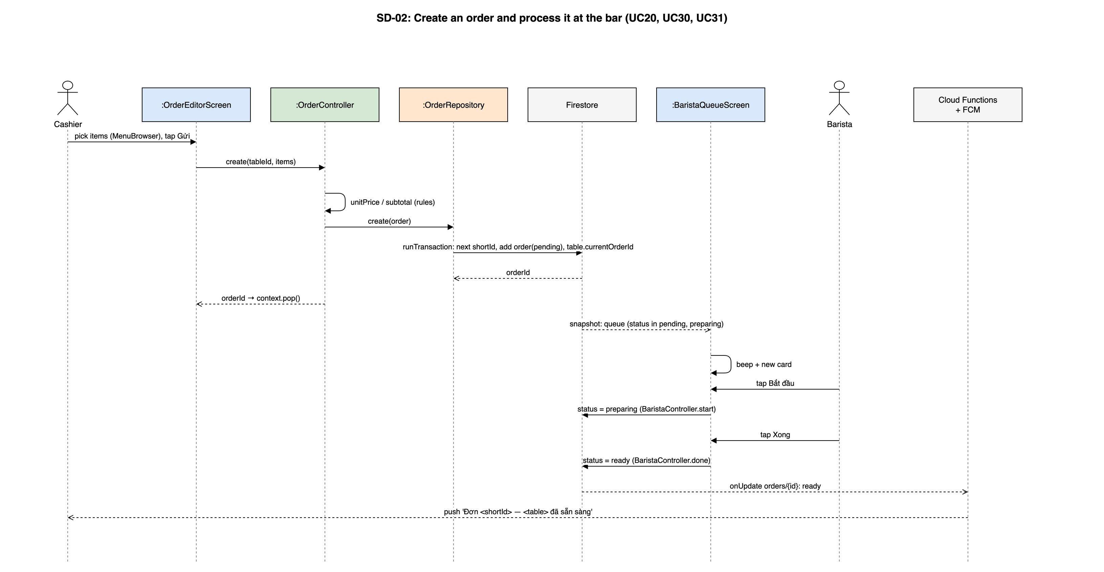
Figure 4.6-6: SD-02: Create an order and process it at the bar (UC20, UC30, UC31)
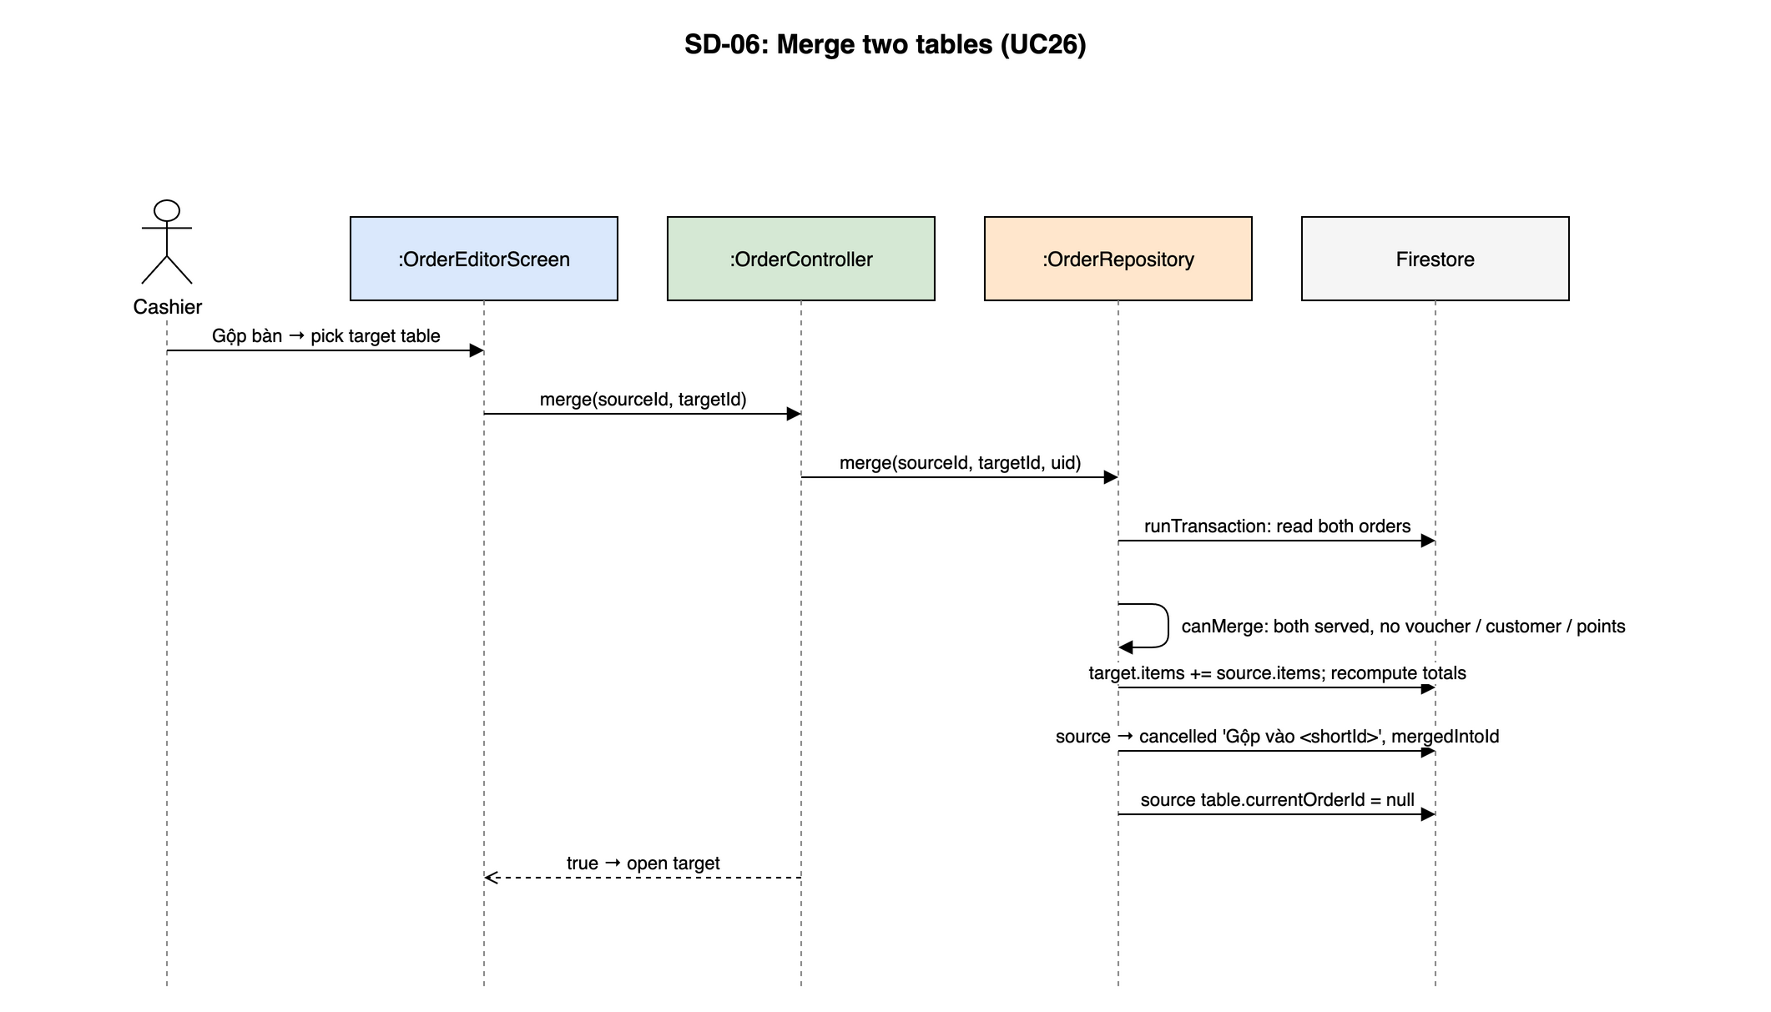
Figure 4.6-7: SD-06: Merge two tables (UC26)
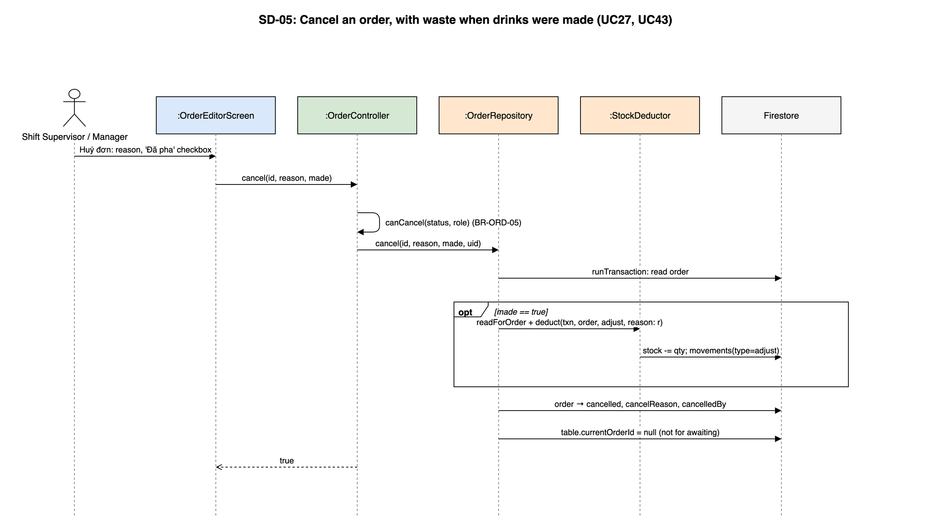
Figure 4.6-8: SD-05: Cancel an order, with waste when drinks were made (UC27, UC43)

4.6.4 UC24, UC25, UC28, UC46 – Payment and receipt

4.6.4.1 Screen Design
S15 Payment (route /pos/order/:id/pay).
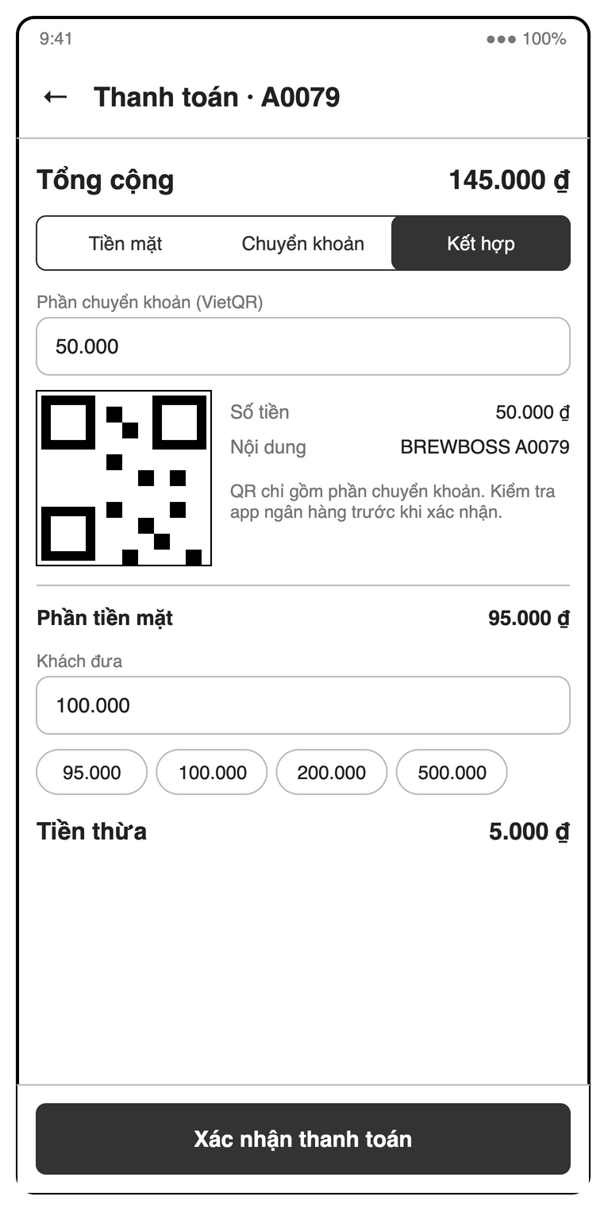
Figure 4.6-9: S15 Payment (split cash + VietQR) mock-up
Table 4-14: Payment Definition
No | Object Name | Type | Required | Length | Description
1 | backButton | Icon button | Yes | NONE | The "←" control returns from payment without confirming it.
2 | titleLabel | Label | Yes | NONE | Shows the order code in a title such as "Thanh toán · A0079".
3 | orderItemsList | List | Yes | NONE | Shows ordered quantities, names, sizes, toppings and line prices, such as "2× Cà phê sữa đá (M)".
4 | customerPhoneField | Text field | No | 10 | Accepts a loyalty phone such as "0912 345 678", normalizing spaces and +84 to ten digits starting with 0 (UC38).
5 | customerSummaryLabel | Label | Conditional | NONE | Shows the attached customer’s name, visits and balance, illustrated by "120 điểm" (UC38).
6 | newCustomerNameField | Text field | No | NONE | Accepts an optional name when the entered loyalty phone is new (UC38).
7 | createCustomerButton | Button | Conditional | NONE | Uses the SRS action "Tạo khách mới" to create a customer with zero points and visits (UC38).
8 | attachCustomerButton | Button | Conditional | NONE | Confirms attaching the customer found by phone to the order (UC38).
9 | detachCustomerButton | Icon button | Conditional | NONE | Detaches the loyalty customer and clears redeemed points before payment (UC38).
10 | voucherCodeField | Text field | No | NONE | Accepts optional "Mã voucher"; codes use A–Z and 0–9 and must be active, unexpired, available and meet the minimum subtotal (UC24, UC40).
11 | applyVoucherButton | Button | Yes | NONE | Uses "Áp dụng" to apply or replace the order’s single voucher (BR-DIS-01–BR-DIS-03, MSG22–MSG25).
12 | removeVoucherButton | Icon button | Conditional | NONE | Removes the applied voucher and resets its discount to zero (UC24).
13 | redeemPointsCheckbox | Checkbox | Conditional | NONE | The optional "Dùng 10 điểm" selection enables redemption for an attached customer (UC39).
14 | pointsToRedeemField | Number field | Conditional | NONE | Accepts optional integer points to redeem within the customer balance and payable amount (BR-LOY-02, MSG40).
15 | useMaximumPointsButton | Button | Conditional | NONE | Uses the SRS action "Dùng tối đa" to select the maximum redeemable points (UC39).
16 | subtotalLabel | Label | Yes | NONE | Shows "Tạm tính" before voucher and loyalty deductions (BR-ORD-02).
17 | voucherDiscountLabel | Label | Conditional | NONE | Shows the applied voucher and deduction, illustrated by "Voucher (GIAM10)" and "−8.000 ₫" (BR-DIS-02).
18 | pointsDiscountLabel | Label | Conditional | NONE | Shows the redeemed-points deduction, illustrated by "−10.000 ₫" (BR-ORD-02).
19 | totalLabel | Label | Yes | NONE | Shows "Tổng cộng" as subtotal minus voucher discount and redeemed-point value, with minimum zero (BR-ORD-02).
20 | paymentMethodRadioGroup | Radio group | Yes | NONE | Selects "Tiền mặt", "Chuyển khoản" or "Kết hợp"; zero-total orders skip collection and record both amounts as zero (UC25, BR-PAY-01).
21 | cashReceivedField | Number field | Conditional | NONE | Requires integer VND "Khách đưa" ≥ the cash portion in cash or split mode; insufficient cash shows MSG27 (BR-PAY-02).
22 | cashPresetChipGroup | Chip group | Conditional | NONE | Offers optional cash presets such as "145.000", "150.000", "200.000" and "500.000", adjusted to the cash portion.
23 | changeDueLabel | Label | Conditional | NONE | Shows "Tiền thừa" as cash received minus cash kept, excluding the transfer portion and without storing change (BR-PAY-02).
24 | transferAmountField | Number field | Conditional | NONE | Requires integer VND "Phần chuyển khoản (VietQR)" with 0 < transfer < total; endpoints select a single method and out-of-range values show MSG44 (UC46).
25 | cashPortionLabel | Label | Conditional | NONE | Shows "Phần tiền mặt" as total minus the transfer portion (BR-PAY-01).
26 | paymentQrImage | QR image | Conditional | NONE | Shows "VietQR" for the full amount in transfer mode or only the transfer portion in "Kết hợp" (UC25, UC46).
27 | bankNameLabel | Label | Conditional | NONE | Shows "Ngân hàng", illustrated by "Vietcombank", including when the QR image fails to load (UC25).
28 | bankAccountNumberLabel | Label | Conditional | NONE | Shows "Số tài khoản", illustrated by "0123 456 789", as transfer details and QR fallback (UC25).
29 | bankAccountNameLabel | Label | Conditional | NONE | Shows "Chủ tài khoản", illustrated by "NGUYEN VAN QUAN", as transfer details and QR fallback (UC25).
30 | qrAmountLabel | Label | Conditional | NONE | Shows "Số tiền" equal to the QR transfer amount, illustrated by "145.000 ₫" or split amount "50.000 ₫" (BR-PAY-01).
31 | transferNoteLabel | Label | Conditional | NONE | Shows "Nội dung" containing the order code, illustrated by "BREWBOSS A0079" (UC25).
32 | transferInstructionsLabel | Label | Conditional | NONE | Displays "Kiểm tra app ngân hàng, sau đó bấm xác nhận đã nhận tiền." or "QR chỉ gồm phần chuyển khoản. Kiểm tra app ngân hàng trước khi xác nhận." (UC25, UC46).
33 | confirmTransferButton | Button | Conditional | NONE | Uses "Đã nhận tiền" after a manual bank check to complete transfer-only payment or acknowledge the transfer before collecting split cash (UC25, UC46).
34 | cancelTransferButton | Button | Conditional | NONE | Uses the SRS action "Hủy" to return to method selection without recording a payment (UC25, UC46).
35 | confirmPaymentButton | Button | Conditional | NONE | Uses "Xác nhận thanh toán" for a served order and open shift, atomically saving payment, stock, points and voucher usage once collection is valid (BR-PAY-01, BR-PAY-03, BR-PAY-04).
36 | paymentFeedbackLabel | Label | Conditional | NONE | Shows "Thanh toán thành công" or the applicable cash, shift, bank or transfer error while retaining failed payments for retry (MSG26–MSG29, MSG44).
37 | openShiftLink | Link | Conditional | NONE | Opens S07 when "Bạn cần vào ca trước khi thanh toán" blocks payment (MSG28).
38 | configureBankLink | Link | Conditional | NONE | Opens S22 for managers when "Chưa cấu hình tài khoản ngân hàng" blocks QR payment (MSG29).
39 | receiptButton | Button | Conditional | NONE | The SRS action "Hóa đơn" generates a receipt only after successful payment (UC28).
40 | receiptCard | Card | Conditional | NONE | Previews receipt details including items, deductions, cash and transfer amounts; change is available only immediately after payment (UC28, BR-PAY-02).
41 | shareReceiptButton | Button | Conditional | NONE | Uses the SRS action "Chia sẻ" to open system sharing for the receipt PDF (UC28).
42 | printReceiptButton | Button | Conditional | NONE | Uses the SRS action "In" to open system printing for the receipt PDF (UC28).

4.6.4.2 Object Interactions (Sequence Diagrams)
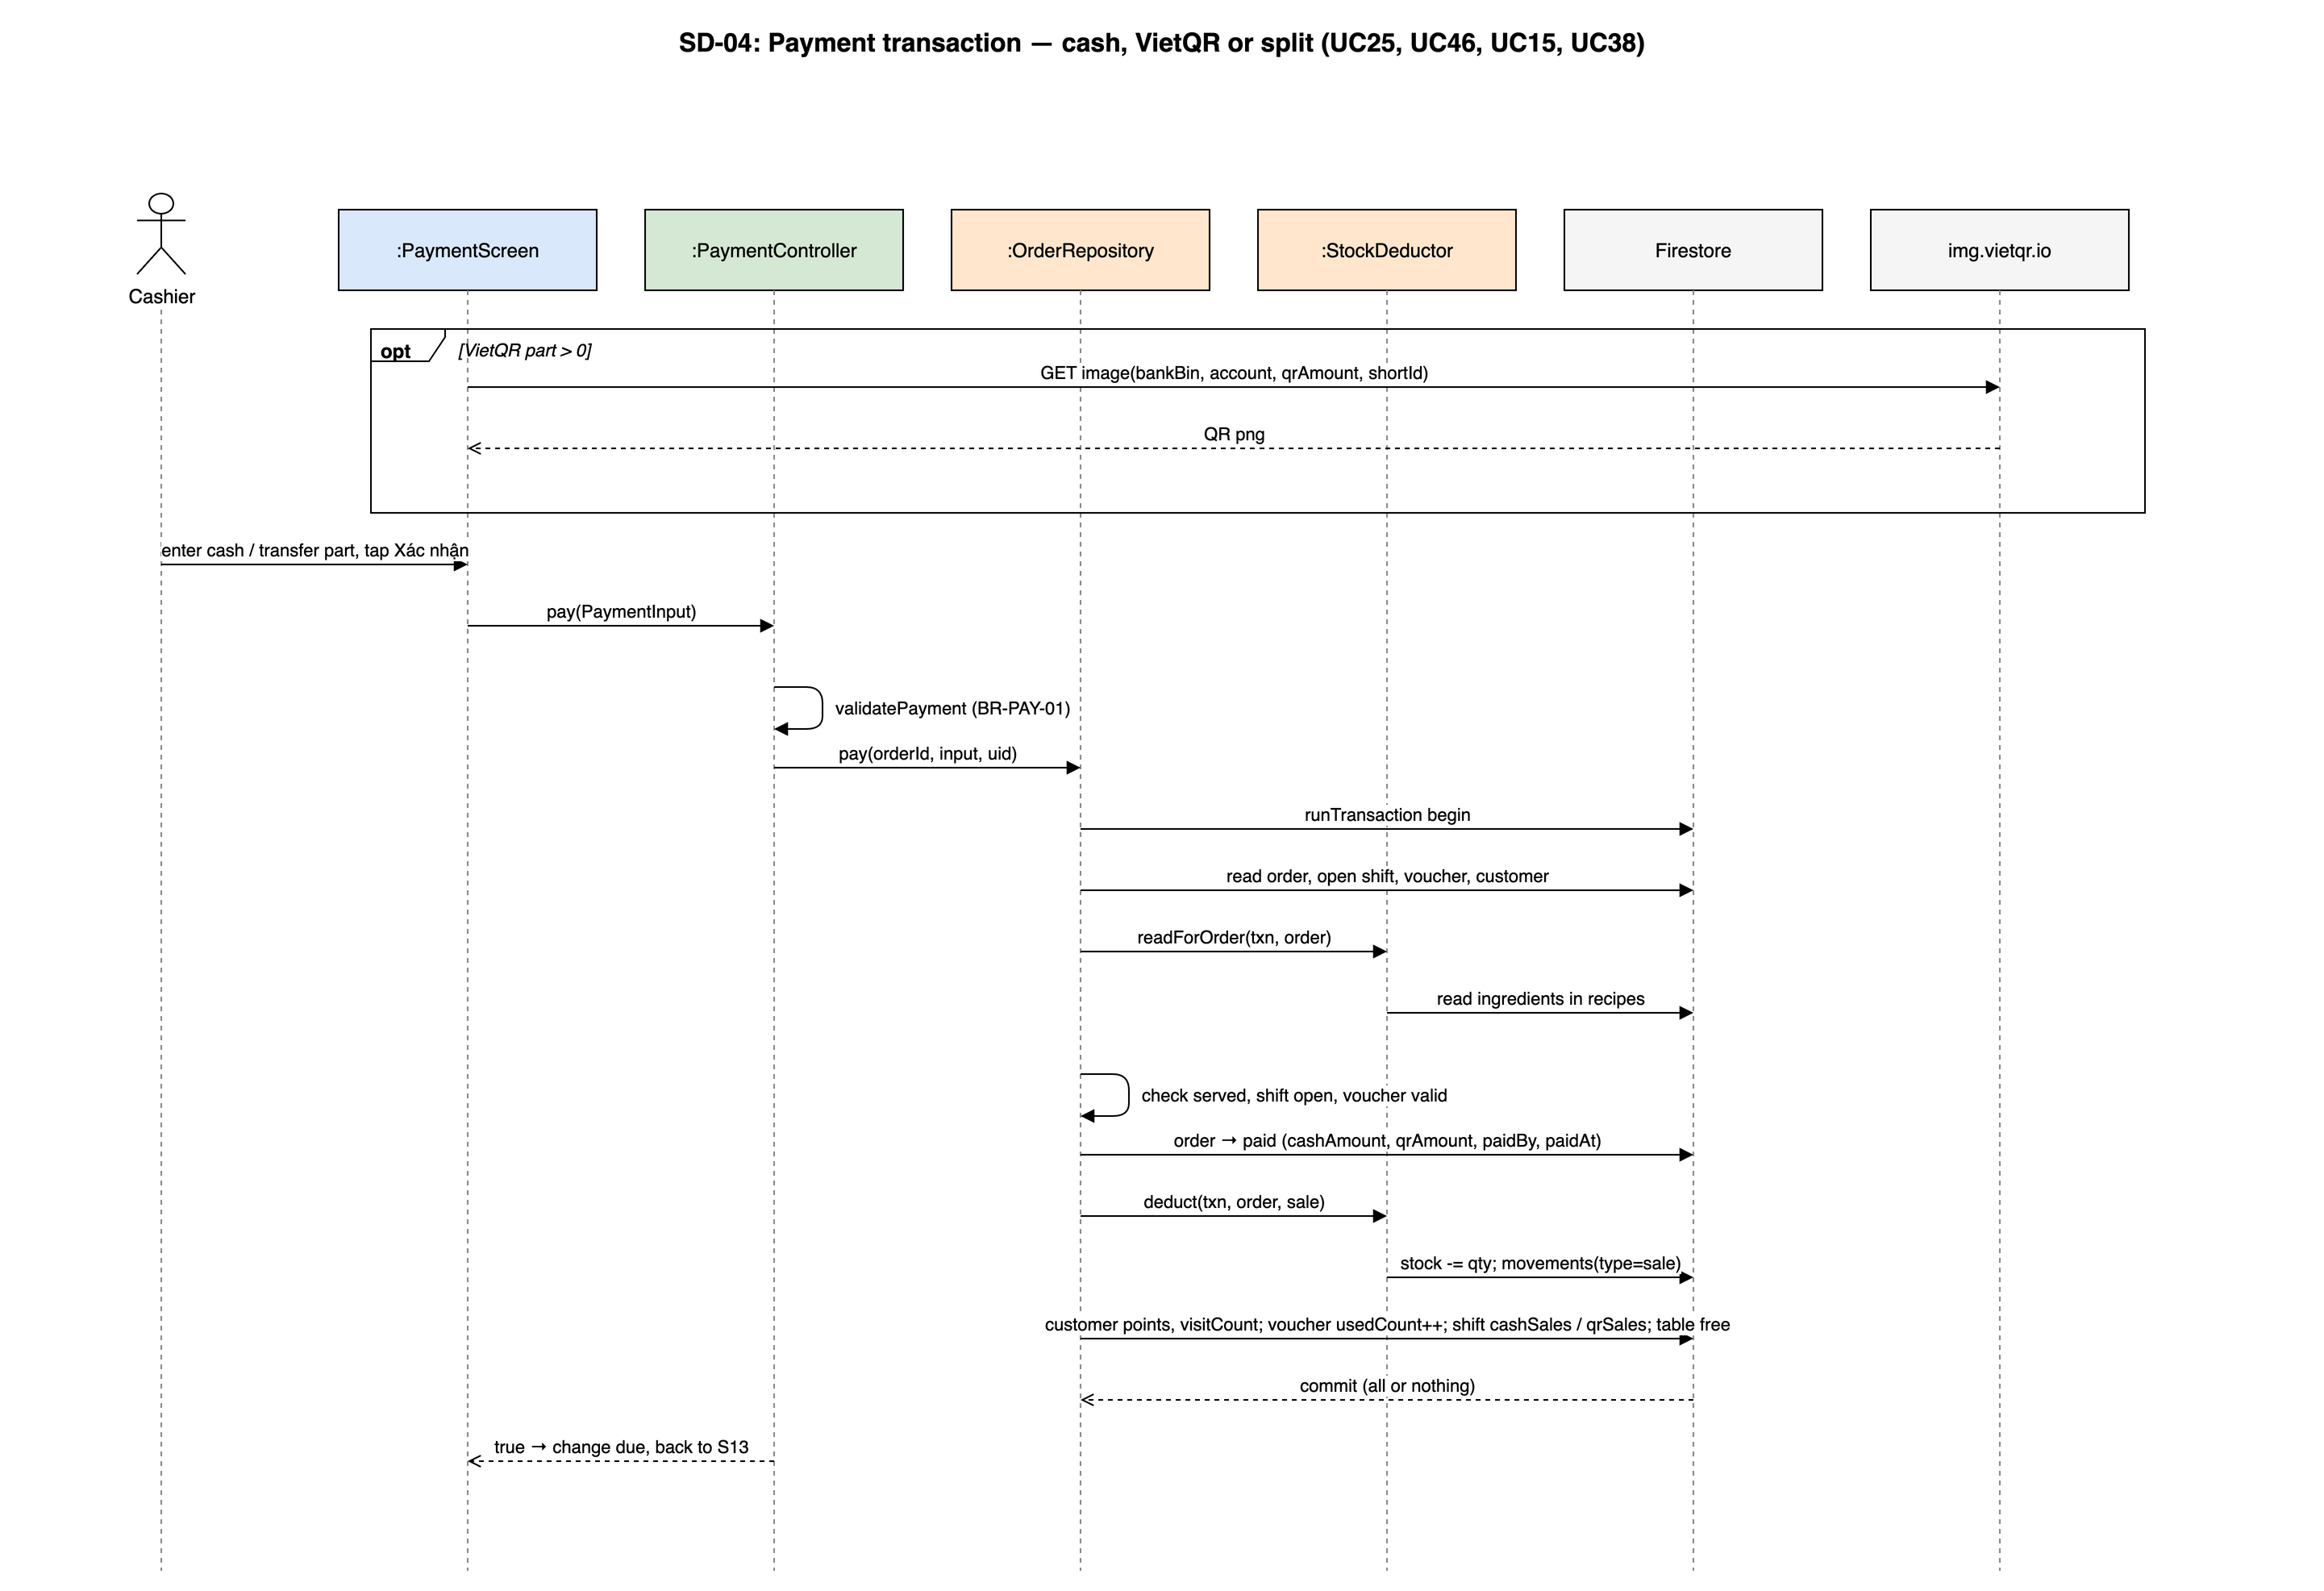
Figure 4.6-10: SD-04: Payment transaction — cash, VietQR or split (UC25, UC46, UC15, UC38)

4.7 Barista Display (UC30, UC31)
Feature folder lib/features/barista. It covers UC30, UC31 of the SRS.

4.7.1 Class/Component Design

4.7.1.1 Class/Component Structure
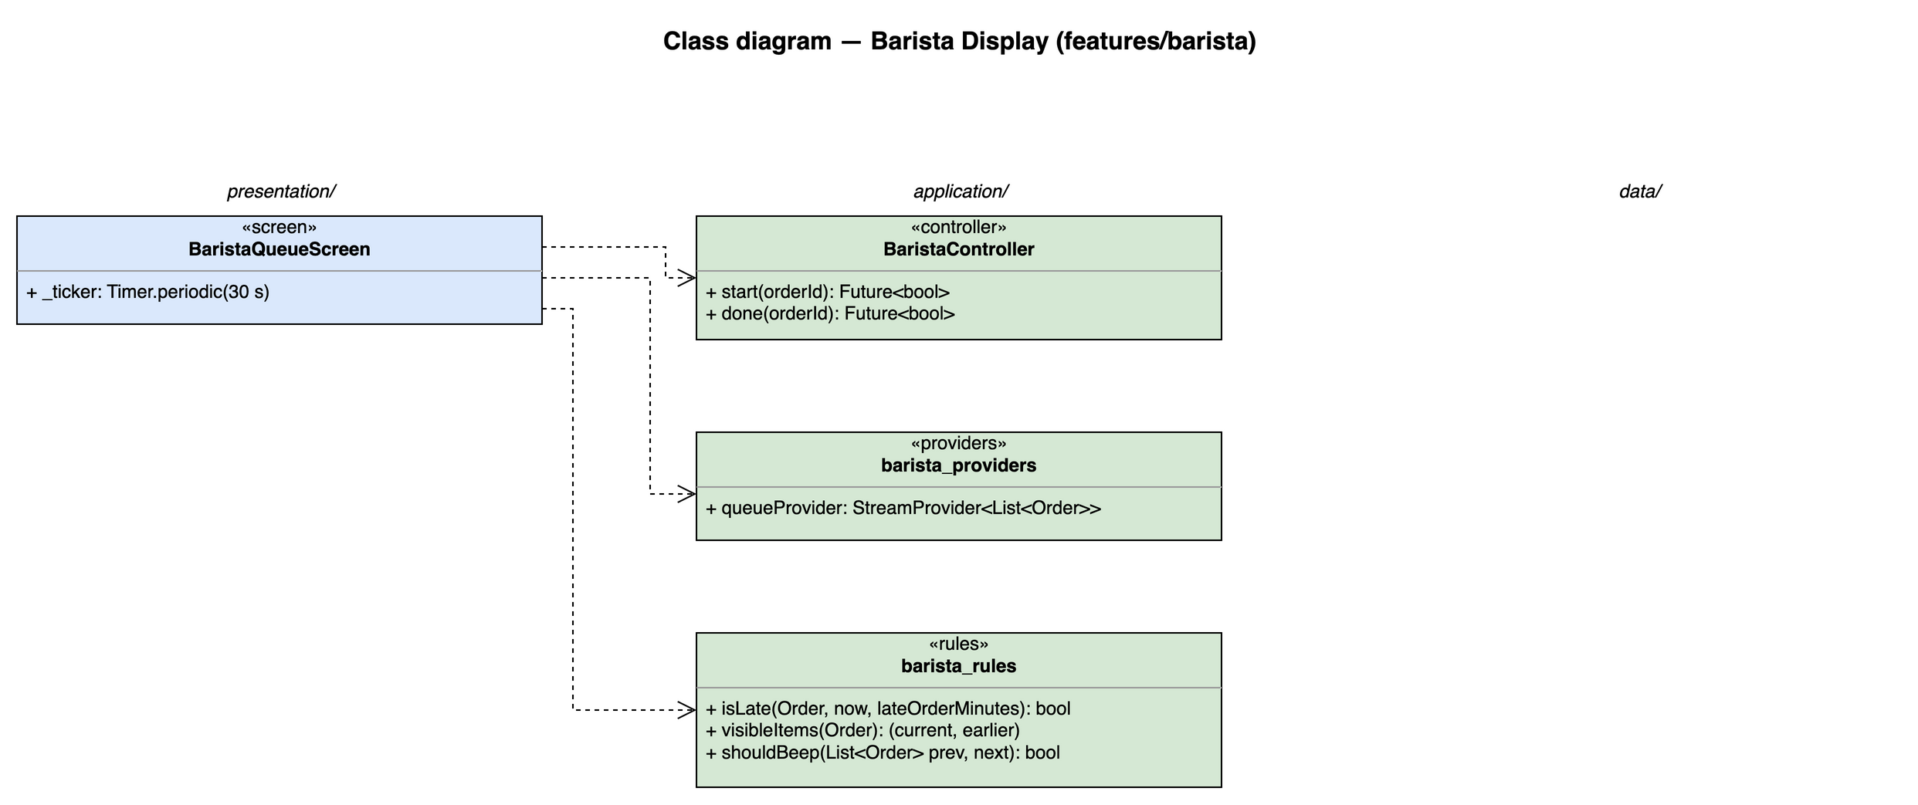
Figure 4.7-1: Class diagram for Barista Display

4.7.1.2 Class/Component Description
Class | «screen» BaristaQueueScreen
Description | S16 tablet queue of pending and preparing orders, oldest first, elapsed time and overdue warning (UC30).
Base Class | ConsumerWidget
Constructor | const BaristaQueueScreen({super.key})
Prototype | class BaristaQueueScreen extends ConsumerWidget
Source File | lib/features/barista/presentation/barista_queue_screen.dart
Namespace | package:brewboss/features/barista/presentation
Attributes | Name | Type | Description
Attributes | _ticker | Timer.periodic(30 s) | Refreshes elapsed time and the overdue colour
Attributes | _player | AudioPlayer | New-order beep
Methods | Name | Input | Output | Description
Methods | build | BuildContext context, WidgetRef ref | Widget | Watches the providers listed above and renders loading / error / empty / data with AsyncValue.when

Class | «controller» BaristaController
Description | Barista status writes; Security Rules let the barista update status only.
Base Class | AsyncNotifier<void>
Constructor | BaristaController() — created by AsyncNotifierProvider<BaristaController, void>(BaristaController.new)
Prototype | class BaristaController extends AsyncNotifier<void>
Source File | lib/features/barista/application/barista_controller.dart
Namespace | package:brewboss/features/barista/application
Attributes | Name | Type | Description
Attributes | state | AsyncValue<void> | Saving state
Methods | Name | Input | Output | Description
Methods | start | String orderId | Future<bool> | pending → preparing ("Bắt đầu"); writes status, updatedAt and updatedBy only
Methods | done | String orderId | Future<bool> | preparing → ready ("Xong"); triggers onOrderReady (UC31)

Class | «providers» barista_providers
Description | Queue stream.
Base Class | — (top-level providers)
Constructor | —
Prototype | top-level declarations (no class)
Source File | lib/features/barista/application/barista_providers.dart
Namespace | package:brewboss/features/barista/application
Attributes | Name | Type | Description
Attributes | queueProvider | StreamProvider<List<Order>> | OrderRepository.watchQueue
Methods | Name | Input | Output | Description
Methods | — | — | — | Declarations only; see Attributes

Class | «rules» barista_rules
Description | Queue display rules.
Base Class | — (pure functions)
Constructor | —
Prototype | top-level declarations (no class)
Source File | lib/features/barista/application/barista_rules.dart
Namespace | package:brewboss/features/barista/application
Attributes | Name | Type | Description
Attributes | — | — | No state
Methods | Name | Input | Output | Description
Methods | isLate | Order o, DateTime now, int lateOrderMinutes | bool | now − createdAt > lateOrderMinutes
Methods | visibleItems | Order o | (current, earlier) | Latest batch highlighted, earlier batches collapsed (BR-ORD-04)
Methods | shouldBeep | List<Order> prev, List<Order> next | bool | A new order, a new batch, or more items in the current batch of an existing order (BR-ORD-04)

4.7.2 UC30, UC31 – Process the order queue

4.7.2.1 Screen Design
S16 Barista queue (route /barista). Landscape tablet layout; also open to the Shift Supervisor and Manager.
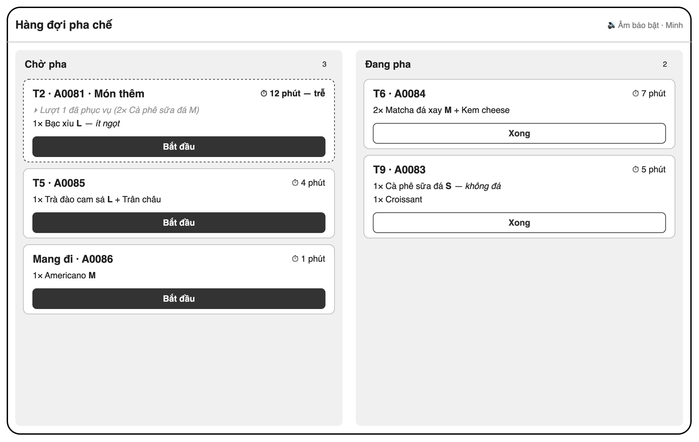
Figure 4.7-2: S16 Barista queue (tablet) mock-up
Table 4-15: Barista queue Definition
No | Object Name | Type | Required | Length | Description
1 | titleLabel | Label | Yes | NONE | Displays "Hàng đợi pha chế".
2 | soundStatusLabel | Label | Yes | NONE | Displays the sound state "Âm báo bật" and indicates alerts for new orders or current-batch additions (UC30, BR-ORD-04).
3 | profileButton | Icon button | Yes | NONE | The staff identity shown as "Minh" opens S22 from the home app bar (SRS 3.1.1).
4 | myShiftButton | Icon button | Yes | NONE | Opens S07 from the staff home app bar (SRS 3.1.1).
5 | pendingQueueList | List | Yes | NONE | The "Chờ pha" column lists pending orders oldest first and excludes awaiting requests (UC30, BR-ORD-07).
6 | preparingQueueList | List | Yes | NONE | The "Đang pha" column lists preparing orders oldest first (UC30).
7 | queueCountBadge | Badge | Yes | NONE | Shows each column’s current count, illustrated by "3" pending and "2" preparing.
8 | orderCard | Card | Yes | NONE | Shows each queued order’s table or "Mang đi", code, quantities, sizes, toppings and notes (UC30).
9 | elapsedTimerLabel | Timer label | Yes | NONE | Shows elapsed time per order, such as "⏱ 4 phút", with a warning such as "⏱ 12 phút — trễ" after the configured threshold (UC30).
10 | addonBadge | Badge | Conditional | NONE | Shows "Món thêm" for orders returned to pending with a new batch (BR-ORD-04).
11 | previousBatchesList | List | Conditional | NONE | Keeps earlier batches collapsed, illustrated by "▸ Lượt 1 đã phục vụ (2× Cà phê sữa đá M)", while the active card shows the latest batch (BR-ORD-04).
12 | startPreparationButton | Button | Yes (per row) | NONE | Each pending card uses "Bắt đầu" to move the order to preparing (UC30).
13 | finishPreparationButton | Button | Yes (per row) | NONE | Each preparing card uses "Xong" to mark ready, remove the card and notify the counter (UC30, UC31).
14 | undoCompletionButton | Button | Conditional | NONE | The SRS action "Hoàn tác" returns a completed order to preparing within five seconds (UC30).
15 | cancellationNoticeLabel | Label | Conditional | NONE | Shows the SRS notice "Đã hủy" when a cancelled order is removed from the queue (UC30).
16 | offlineBanner | Banner | Conditional | NONE | Shows "Mất kết nối" while cached cards remain visible and status taps are queued (UC30).

4.7.2.2 Object Interactions
See SD-02 (figure in 4.6): queue snapshot, beep, "Bắt đầu" (start), "Xong" (done) and the onOrderReady push to the counter.

4.8 Customer QR Ordering and Tables (UC18, UC32, UC33)
Feature folder lib/features/customer. It covers UC18, UC32, UC33 of the SRS.

4.8.1 Class/Component Design

4.8.1.1 Class/Component Structure
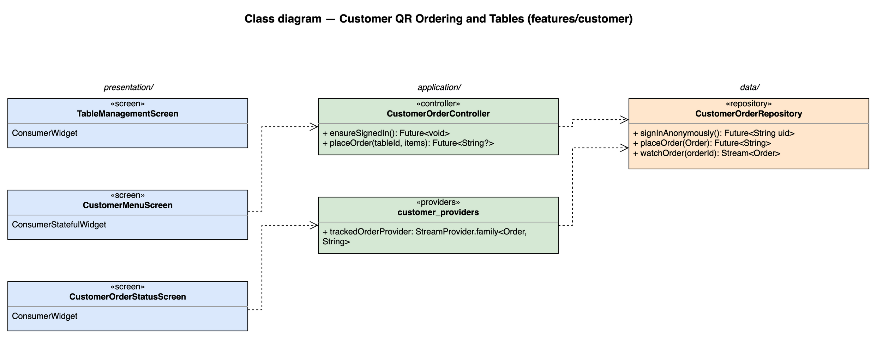
Figure 4.8-1: Class diagram for Customer QR Ordering and Tables

4.8.1.2 Class/Component Description
Class | «screen» TableManagementScreen
Description | S12 tables grouped by area, table form, QR per table and print-all through the OS share / print sheet (UC18). The QR encodes https://<hosting>/c/{tableId}.
Base Class | ConsumerWidget
Constructor | const TableManagementScreen({super.key})
Prototype | class TableManagementScreen extends ConsumerWidget
Source File | lib/features/customer/presentation/table_management_screen.dart
Namespace | package:brewboss/features/customer/presentation
Attributes | Name | Type | Description
Attributes | ref | WidgetRef | Riverpod reference; ref.watch in build, ref.read in callbacks
Methods | Name | Input | Output | Description
Methods | build | BuildContext context, WidgetRef ref | Widget | Watches the providers listed above and renders loading / error / empty / data with AsyncValue.when

Class | «screen» CustomerMenuScreen
Description | S17 anonymous menu for one table with cart and "Đặt món"; reuses MenuBrowser (UC32).
Base Class | ConsumerStatefulWidget
Constructor | const CustomerMenuScreen({super.key})
Prototype | class CustomerMenuScreen extends ConsumerStatefulWidget
Source File | lib/features/customer/presentation/customer_menu_screen.dart
Namespace | package:brewboss/features/customer/presentation
Attributes | Name | Type | Description
Attributes | tableId | String | Route parameter from the QR
Attributes | _cart | List<OrderItem> | Items to send
Methods | Name | Input | Output | Description
Methods | createState | — | _CustomerMenuScreenState | Creates the ConsumerState<CustomerMenuScreen> that holds the attributes above and the private methods below; its build(BuildContext context) reads providers through the state's ref

Class | «screen» CustomerOrderStatusScreen
Description | S18 live progress Chờ xác nhận / Đã nhận / Đang pha / Sẵn sàng; follows mergedIntoId after an add-on (UC33, MSG39).
Base Class | ConsumerWidget
Constructor | const CustomerOrderStatusScreen({super.key})
Prototype | class CustomerOrderStatusScreen extends ConsumerWidget
Source File | lib/features/customer/presentation/customer_order_status_screen.dart
Namespace | package:brewboss/features/customer/presentation
Attributes | Name | Type | Description
Attributes | orderId | String | Route parameter
Methods | Name | Input | Output | Description
Methods | build | BuildContext context, WidgetRef ref | Widget | Watches the providers listed above and renders loading / error / empty / data with AsyncValue.when

Class | «controller» CustomerOrderController
Description | Customer ordering without an account.
Base Class | AsyncNotifier<void>
Constructor | CustomerOrderController() — created by AsyncNotifierProvider<CustomerOrderController, void>(CustomerOrderController.new)
Prototype | class CustomerOrderController extends AsyncNotifier<void>
Source File | lib/features/customer/application/customer_order_controller.dart
Namespace | package:brewboss/features/customer/application
Attributes | Name | Type | Description
Attributes | state | AsyncValue<void> | Sending state
Methods | Name | Input | Output | Description
Methods | ensureSignedIn | — | Future<void> | Anonymous sign-in when no session exists
Methods | placeOrder | String tableId, List<OrderItem> items | Future<String?> | Creates source = customer, status = awaiting; MSG35 / MSG36 / MSG37 / MSG38

Class | «providers» customer_providers
Description | Customer order tracking.
Base Class | — (top-level providers)
Constructor | —
Prototype | top-level declarations (no class)
Source File | lib/features/customer/application/customer_providers.dart
Namespace | package:brewboss/features/customer/application
Attributes | Name | Type | Description
Attributes | trackedOrderProvider | StreamProvider.family<Order, String> | Own order, or the order its mergedIntoId points to
Attributes | publicShopProvider | StreamProvider<String> | Shop name from settings/public (the customer cannot read settings/shop)
Methods | Name | Input | Output | Description
Methods | — | — | — | Declarations only; see Attributes

Class | «repository» CustomerOrderRepository
Description | Writes allowed to an anonymous user by Security Rules (SEC-ANON): no price trust, no confirmedBy / confirmedAt.
Base Class | —
Constructor | —
Prototype | class CustomerOrderRepository
Source File | lib/features/customer/data/customer_order_repository.dart
Namespace | package:brewboss/features/customer/data
Attributes | Name | Type | Description
Attributes | _db | FirebaseFirestore | Firestore instance injected by the provider
Attributes | _auth | FirebaseAuth | Anonymous auth
Methods | Name | Input | Output | Description
Methods | signInAnonymously | — | Future<String> | Returns the anonymous uid
Methods | placeOrder | Order o | Future<String> | add orders with source = customer, status = awaiting, createdBy = the anonymous uid and no shortId (allocated at confirmation); prices are re-validated by the cashier (UC22)
Methods | watchOrder | String orderId | Stream<Order> | Own order snapshots (Security Rules: createdBy == request.auth.uid)
Methods | lastOrderFor | String tableId | Future<String?> | Finds the last order of this anonymous uid for the table (UC33 alternative 1a)

4.8.2 UC18 – Manage tables and print table QR codes

4.8.2.1 Screen Design
S12 Table management + QR print (route /manager/tables).
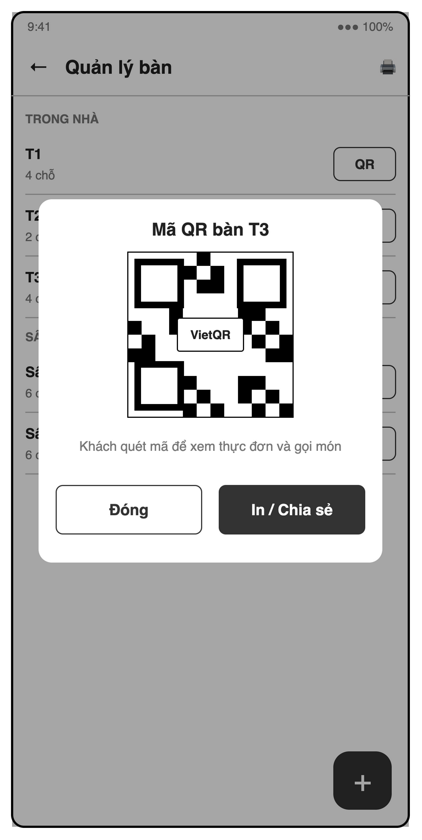
Figure 4.8-2: S12 Table management + QR print mock-up
Table 4-16: Table management + QR print Definition
No | Object Name | Type | Required | Length | Description
1 | backButton | Icon button | Yes | NONE | The "←" control returns from table management.
2 | titleLabel | Label | Yes | NONE | Displays "Quản lý bàn".
3 | printAllQrButton | Icon button | Yes | NONE | The "🖨" control prepares one page containing all table QR codes (UC18).
4 | tableList | List | Yes | NONE | Groups editable table names and capacities under areas such as "TRONG NHÀ" and "SÂN VƯỜN".
5 | showTableQrButton | Button | Yes (per row) | NONE | Uses "QR" to display the selected table’s ordering code.
6 | addTableButton | Icon button | Yes | NONE | The "+" control opens the table creation form (UC18).
7 | tableNameField | Text field | Yes | NONE | Requires a unique table name, illustrated by "T1" or "Sân vườn 1" (UC18).
8 | areaField | Text field | Yes | NONE | Requires the table’s area for grouping (UC18).
9 | capacityField | Number field | Yes | NONE | Requires an integer seat count > 0, illustrated by "4 chỗ" (UC18).
10 | saveTableButton | Button | Conditional | NONE | Uses the SRS action "Lưu" to save valid table details (UC18).
11 | deleteTableButton | Button | Conditional | NONE | Offers deletion of a table only when it has no open order (UC18, MSG17).
12 | deleteTableDialog | Dialog | Conditional | NONE | Confirms table deletion and reports "Bàn đang có đơn, không thể xóa" if the table is in use (MSG17).
13 | tableQrDialog | Dialog | Conditional | NONE | Shows the selected table’s code under a title such as "Mã QR bàn T3".
14 | tableQrImage | QR image | Conditional | NONE | Encodes the customer menu URL /c/:tableId as required by UC18, in the mock-up area marked "VietQR".
15 | qrInstructionsLabel | Label | Conditional | NONE | Displays "Khách quét mã để xem thực đơn và gọi món".
16 | closeQrButton | Button | Conditional | NONE | Uses "Đóng" to close the QR dialog.
17 | shareQrButton | Button | Conditional | NONE | Uses "In / Chia sẻ" to open system printing or sharing for the table QR (UC18).

4.8.2.2 Object Interactions
TableManagementScreen → TableRepository.save / delete (single write; delete refused while currentOrderId ≠ null, MSG17). QR codes are rendered on the device with qr_flutter and printed as a PDF through the OS print sheet; no server call.

4.8.3 UC32, UC22 – Place an order via table QR

4.8.3.1 Screen Design
S17 Customer menu (via QR) (route /c/:tableId).
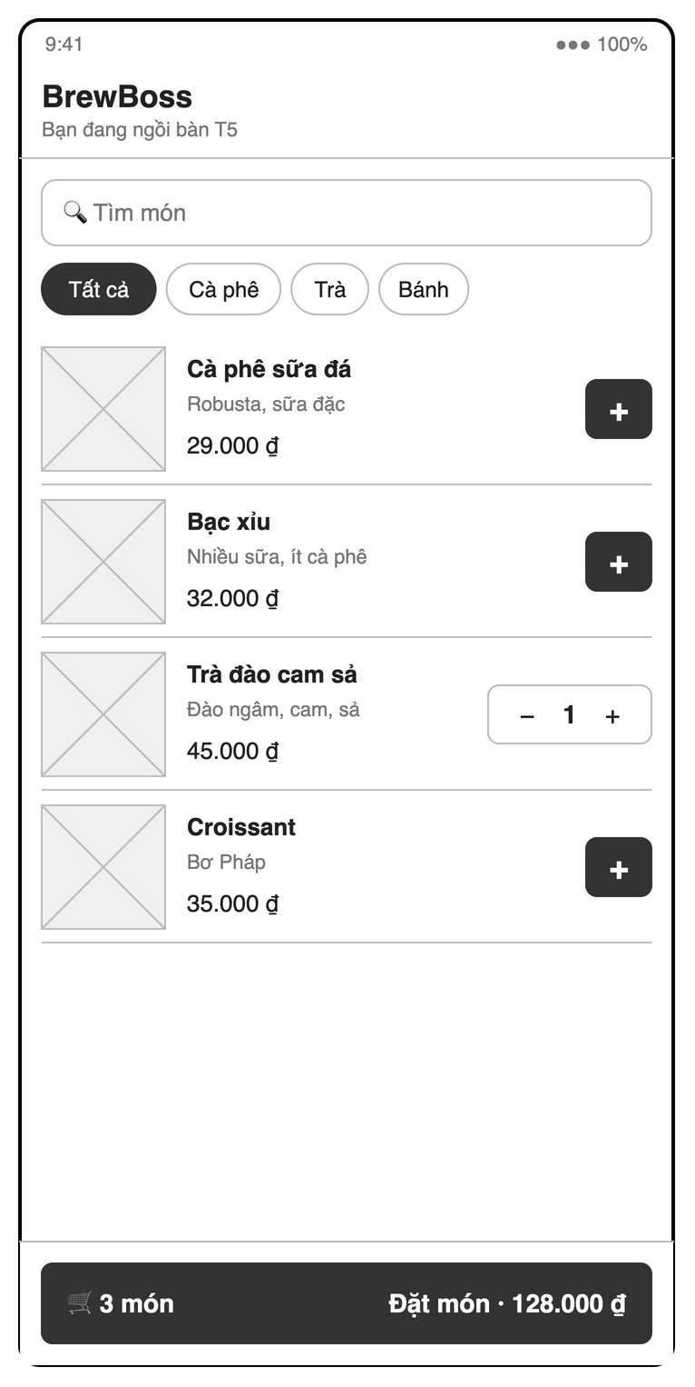
Figure 4.8-3: S17 Customer menu (via QR) mock-up
Table 4-17: Customer menu (via QR) Definition
No | Object Name | Type | Required | Length | Description
1 | shopNameLabel | Label | Yes | NONE | Shows the shop name "BrewBoss" without requiring a staff login (UC32).
2 | tableLabel | Label | Yes | NONE | Identifies the scanned table with text such as "Bạn đang ngồi bàn T5".
3 | productSearchField | Search field | No | NONE | Uses "Tìm món" for case- and accent-insensitive search of available products (UC10).
4 | categoryFilterChipGroup | Chip group | No | NONE | Filters available products using "Tất cả", "Cà phê", "Trà" and "Bánh".
5 | productList | List | Yes | NONE | Shows available product images, names, descriptions and prices, including "Cà phê sữa đá" and "Robusta, sữa đặc" (UC10).
6 | addProductButton | Icon button | Yes (per row) | NONE | The "+" control adds a product through the customer’s item-selection flow (UC32).
7 | decreaseQuantityButton | Icon button | Conditional | NONE | The per-item "−" control reduces the selected cart quantity.
8 | selectedQuantityLabel | Label | Conditional | NONE | Shows each selected product’s quantity between "−" and "+", illustrated by "1".
9 | itemOptionsSheet | Bottom sheet | Conditional | NONE | Provides the same size, topping, quantity and note controls as S14b (UC32).
10 | selectedProductLabel | Label | Conditional | NONE | Shows the selected product name and base price in the item-options sheet (UC32).
11 | sizeRadioGroup | Radio group | Yes | NONE | Requires one size, defaulting to the first, with "S +0", "M +5.000" and "L +10.000" as S14b examples (UC32, BR-ORD-01).
12 | toppingCheckbox | Checkbox | No | NONE | Offers optional toppings with prices, using the S14b choices such as "Trân châu" and "Kem cheese" (UC32).
13 | itemQuantityField | Number field | Yes | NONE | Requires an integer quantity ≥ 1 in item options, defaulting to one (UC32, S14b).
14 | itemNoteField | Text field | No | NONE | Accepts an optional item note such as "Ít đá" (UC32, S14b).
15 | confirmItemButton | Button | Conditional | NONE | Adds the configured item at its base price plus size and toppings, using the S14b action "Thêm · 60.000 ₫" (BR-ORD-01).
16 | cartButton | Button | Yes | NONE | Shows the selected item count, illustrated by "🛒 3 món", and opens the cart.
17 | cartList | List | Conditional | NONE | Shows selected items, sizes, toppings, quantities, notes and subtotal before submission (UC32).
18 | placeOrderButton | Button | Yes | NONE | Uses "Đặt món · 128.000 ₫" or "Gửi thêm món · 128.000 ₫" to send an awaiting request for cashier confirmation (BR-ORD-07).
19 | addonSentDialog | Dialog | Conditional | NONE | Shows "Đã gửi món gọi thêm" when the table has an open order and explains that staff will confirm the addition before counter payment (BR-ORD-07, MSG36).
20 | viewStatusButton | Button | Conditional | NONE | Uses "Xem trạng thái" after submission to open S18 and clear the submitted cart (UC32).
21 | orderFeedbackLabel | Label | Conditional | NONE | Shows normal submission, invalid QR or network feedback; failed submission retains the cart (MSG35, MSG37, MSG38).
22 | unavailableItemBanner | Banner | Conditional | NONE | Flags an item that became unavailable before submission and requires its removal (UC32).
23 | emptyProductsLabel | Label | Conditional | NONE | Shows "Không tìm thấy món" when no available product matches the search (MSG12).

4.8.3.2 Object Interactions (Sequence Diagrams)
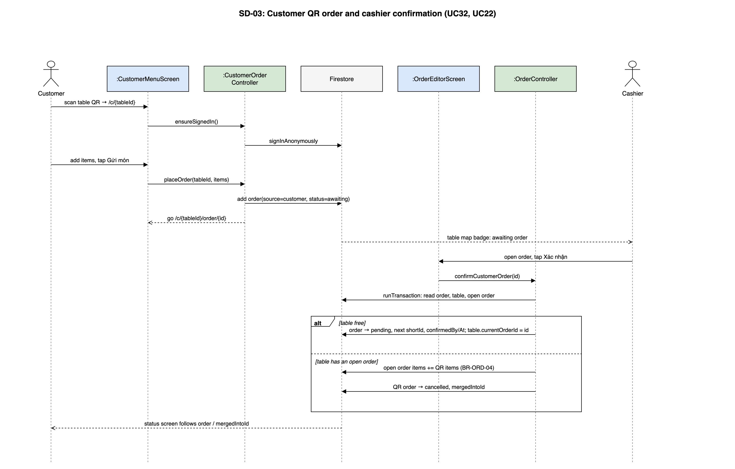
Figure 4.8-4: SD-03: Customer QR order and cashier confirmation (UC32, UC22)

4.8.4 UC33 – Track order status

4.8.4.1 Screen Design
S18 Customer order status (route /c/:tableId/order/:id).
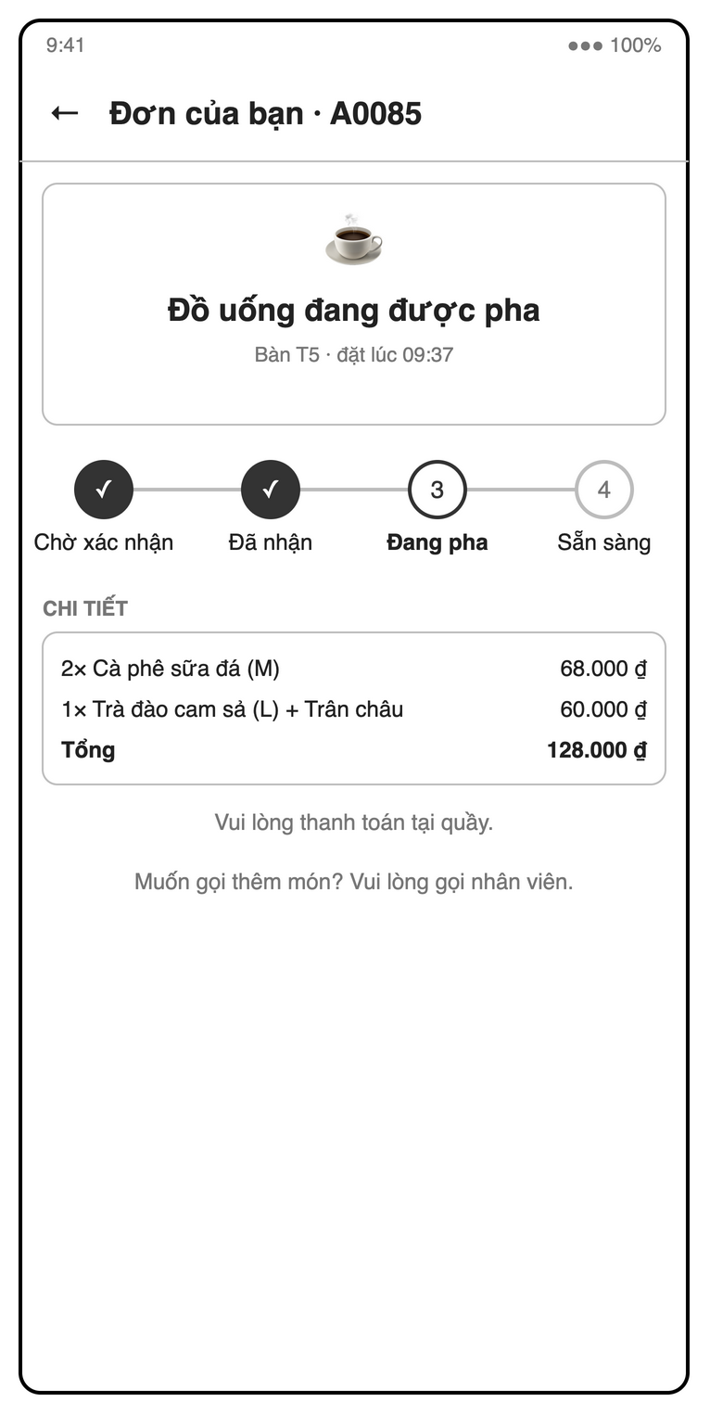
Figure 4.8-5: S18 Customer order status mock-up
Table 4-18: Customer order status Definition
No | Object Name | Type | Required | Length | Description
1 | backButton | Icon button | Yes | NONE | The "←" control returns from order tracking.
2 | orderHeaderLabel | Label | Yes | NONE | Shows the customer’s order code, illustrated by "Đơn của bạn · A0085".
3 | currentStatusLabel | Label | Yes | NONE | Shows the current progress message, illustrated by "Đồ uống đang được pha" (UC33).
4 | tableAndTimeLabel | Label | Yes | NONE | Shows table and order time, illustrated by "Bàn T5 · đặt lúc 09:37".
5 | progressList | List | Yes | NONE | Displays read-only live steps "Chờ xác nhận", "Đã nhận", "Đang pha" and "Sẵn sàng" (UC33).
6 | orderItemsList | List | Yes | NONE | Shows "CHI TIẾT" with quantities, product names, sizes, toppings and line prices.
7 | orderTotalLabel | Label | Yes | NONE | Shows "Tổng" and the order amount, illustrated by "128.000 ₫".
8 | paymentInstructionsLabel | Label | Yes | NONE | Displays "Vui lòng thanh toán tại quầy.".
9 | additionalOrderHelpLabel | Label | Yes | NONE | Displays "Muốn gọi thêm món? Vui lòng gọi nhân viên.".
10 | mergedOrderNoticeLabel | Label | Conditional | NONE | Shows "Đã thêm vào đơn <shortId>" and follows the target order after a confirmed QR add-on (BR-ORD-07, MSG21).
11 | cancelledOrderBanner | Banner | Conditional | NONE | Shows "Đơn đã bị hủy — vui lòng liên hệ nhân viên" for a cancelled order without a merge target (MSG39).

4.8.4.2 Object Interactions
See the last message of SD-03: CustomerOrderStatusScreen watches trackedOrderProvider(orderId) and switches to the mergedIntoId order after an add-on is confirmed (MSG21 / MSG39).

4.9 Reports (UC34–UC37)
Feature folder lib/features/reports. It covers UC34–UC37 of the SRS.

4.9.1 Class/Component Design

4.9.1.1 Class/Component Structure
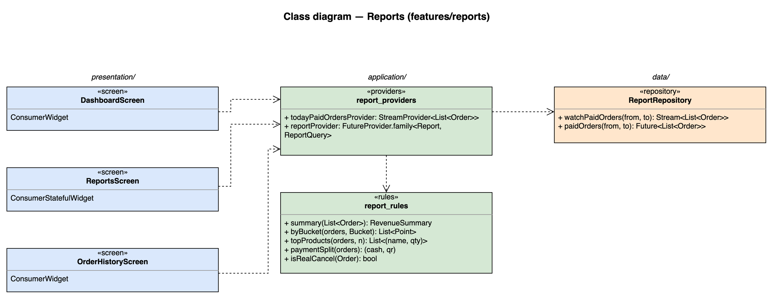
Figure 4.9-1: Class diagram for Reports

4.9.1.2 Class/Component Description
Class | «screen» DashboardScreen
Description | S04 manager home: today revenue, order count, average order value (live), shortcuts and the low-stock banner (UC34).
Base Class | ConsumerWidget
Constructor | const DashboardScreen({super.key})
Prototype | class DashboardScreen extends ConsumerWidget
Source File | lib/features/reports/presentation/dashboard_screen.dart
Namespace | package:brewboss/features/reports/presentation
Attributes | Name | Type | Description
Attributes | ref | WidgetRef | Riverpod reference; ref.watch in build, ref.read in callbacks
Methods | Name | Input | Output | Description
Methods | build | BuildContext context, WidgetRef ref | Widget | Watches the providers listed above and renders loading / error / empty / data with AsyncValue.when

Class | «screen» ReportsScreen
Description | S19 revenue chart by day / week / month, best sellers, revenue by payment method and export (UC36, UC37).
Base Class | ConsumerStatefulWidget
Constructor | const ReportsScreen({super.key})
Prototype | class ReportsScreen extends ConsumerStatefulWidget
Source File | lib/features/reports/presentation/reports_screen.dart
Namespace | package:brewboss/features/reports/presentation
Attributes | Name | Type | Description
Attributes | _query | ReportQuery | Period and bucket
Methods | Name | Input | Output | Description
Methods | createState | — | _ReportsScreenState | Creates the ConsumerState<ReportsScreen> that holds the attributes above and the private methods below; its build(BuildContext context) reads providers through the state's ref
Methods | _export | ExportFormat f | Future<void> | Builds a PDF (pdf package) or Excel (excel package) file and opens the OS share sheet

Class | «screen» OrderHistoryScreen
Description | S20 orders filtered by date, status and cashier with details and receipt (UC35, UC28).
Base Class | ConsumerWidget
Constructor | const OrderHistoryScreen({super.key})
Prototype | class OrderHistoryScreen extends ConsumerWidget
Source File | lib/features/reports/presentation/order_history_screen.dart
Namespace | package:brewboss/features/reports/presentation
Attributes | Name | Type | Description
Attributes | _filter | OrderFilter | Date, status, cashier
Methods | Name | Input | Output | Description
Methods | build | BuildContext context, WidgetRef ref | Widget | Watches the providers listed above and renders loading / error / empty / data with AsyncValue.when

Class | «providers» report_providers
Description | Report data.
Base Class | — (top-level providers)
Constructor | —
Prototype | top-level declarations (no class)
Source File | lib/features/reports/application/report_providers.dart
Namespace | package:brewboss/features/reports/application
Attributes | Name | Type | Description
Attributes | todayPaidOrdersProvider | StreamProvider<List<Order>> | watchPaidOrders(today 00:00, tomorrow 00:00); DashboardScreen applies report_rules.summary (SD-11)
Attributes | reportProvider | FutureProvider.family<Report, ReportQuery> | One-shot query for a period
Methods | Name | Input | Output | Description
Methods | — | — | — | Declarations only; see Attributes

Class | «rules» report_rules
Description | Aggregations computed on the client; only paid orders count (BR-RPT-01).
Base Class | — (pure functions)
Constructor | —
Prototype | top-level declarations (no class)
Source File | lib/features/reports/application/report_rules.dart
Namespace | package:brewboss/features/reports/application
Attributes | Name | Type | Description
Attributes | — | — | No state
Methods | Name | Input | Output | Description
Methods | summary | List<Order> orders | RevenueSummary | Revenue, count, average
Methods | byBucket | List<Order> orders, Bucket b | List<Point> | Revenue per day / week / month
Methods | topProducts | List<Order> orders, int n | List<(String, int)> | Best sellers by quantity
Methods | paymentSplit | List<Order> orders | (int cash, int qr) | Σ cashAmount, Σ qrAmount
Methods | isRealCancel | Order o | bool | false for merge / add-on closures (mergedIntoId set)

Class | «repository» ReportRepository
Description | Read-only report queries (composite index status + paidAt).
Base Class | —
Constructor | —
Prototype | class ReportRepository
Source File | lib/features/reports/data/report_repository.dart
Namespace | package:brewboss/features/reports/data
Attributes | Name | Type | Description
Attributes | _db | FirebaseFirestore | Firestore instance injected by the provider
Methods | Name | Input | Output | Description
Methods | watchPaidOrders | DateTime from, DateTime to | Stream<List<Order>> | Live query: status = paid and from ≤ paidAt < to
Methods | paidOrders | DateTime from, DateTime to | Future<List<Order>> | One-shot query for reports and export

4.9.2 UC34 – Today's revenue dashboard

4.9.2.1 Screen Design
S04 Manager home / dashboard (route /manager).
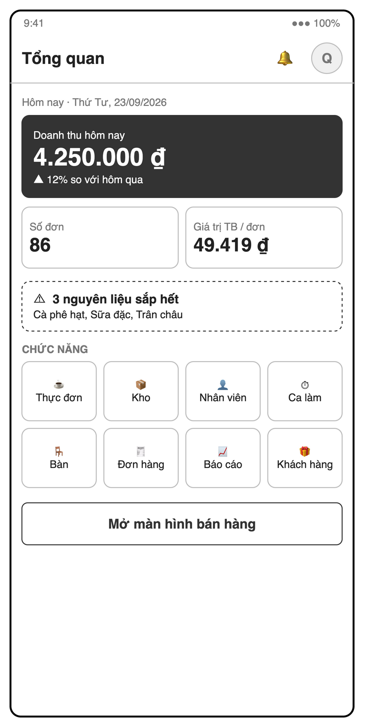
Figure 4.9-2: S04 Manager home / dashboard mock-up
Table 4-19: Manager home / dashboard Definition
No | Object Name | Type | Required | Length | Description
1 | titleLabel | Label | Yes | NONE | Displays "Tổng quan".
2 | profileButton | Icon button | Yes | NONE | The avatar shown as "Q" opens S22.
3 | notificationsButton | Icon button | Yes | NONE | The "🔔" control provides low-stock and order alerts (MSG16, MSG34).
4 | myShiftButton | Icon button | Yes | NONE | Opens S07 from the staff home app bar as required by SRS 3.1.1.
5 | todayLabel | Label | Yes | NONE | Shows the current date, illustrated by "Hôm nay · Thứ Tư, 23/09/2026".
6 | revenueCard | Card | Yes | NONE | Shows "Doanh thu hôm nay" and the comparison with yesterday using paid orders only (BR-RPT-01).
7 | orderCountCard | Card | Yes | NONE | Shows "Số đơn" as today’s paid-order count (BR-RPT-01).
8 | averageOrderValueCard | Card | Yes | NONE | Shows "Giá trị TB / đơn" as revenue divided by paid-order count, or zero when none exist (UC34).
9 | lowStockBanner | Banner | Conditional | NONE | Shows "3 nguyên liệu sắp hết" with affected ingredient names when stock is at or below minimum (UC16).
10 | openOrdersLink | Link | Yes | NONE | Displays the open-order shortcut specified by UC34.
11 | onShiftStaffLink | Link | Yes | NONE | Displays the staff-on-shift shortcut specified by UC34.
12 | functionGrid | Grid | Yes | NONE | The "CHỨC NĂNG" grid opens "Thực đơn", "Kho", "Nhân viên", "Ca làm", "Bàn", "Đơn hàng", "Báo cáo" and "Khách hàng" (S08, S10, S05, S06, S12, S20, S19, S21).
13 | openPosButton | Button | Yes | NONE | Uses "Mở màn hình bán hàng" to open S13.

4.9.2.2 Object Interactions (Sequence Diagrams)
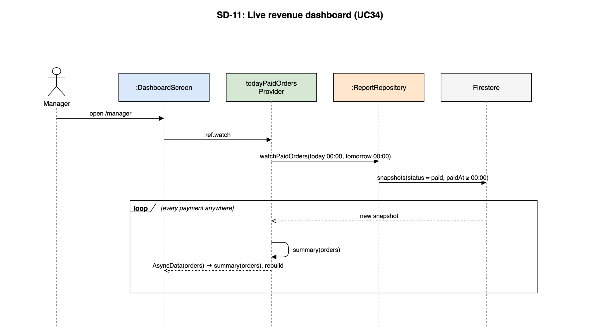
Figure 4.9-3: SD-11: Live revenue dashboard (UC34)

4.9.3 UC36, UC37 – Sales reports and export

4.9.3.1 Screen Design
S19 Reports (route /manager/reports).
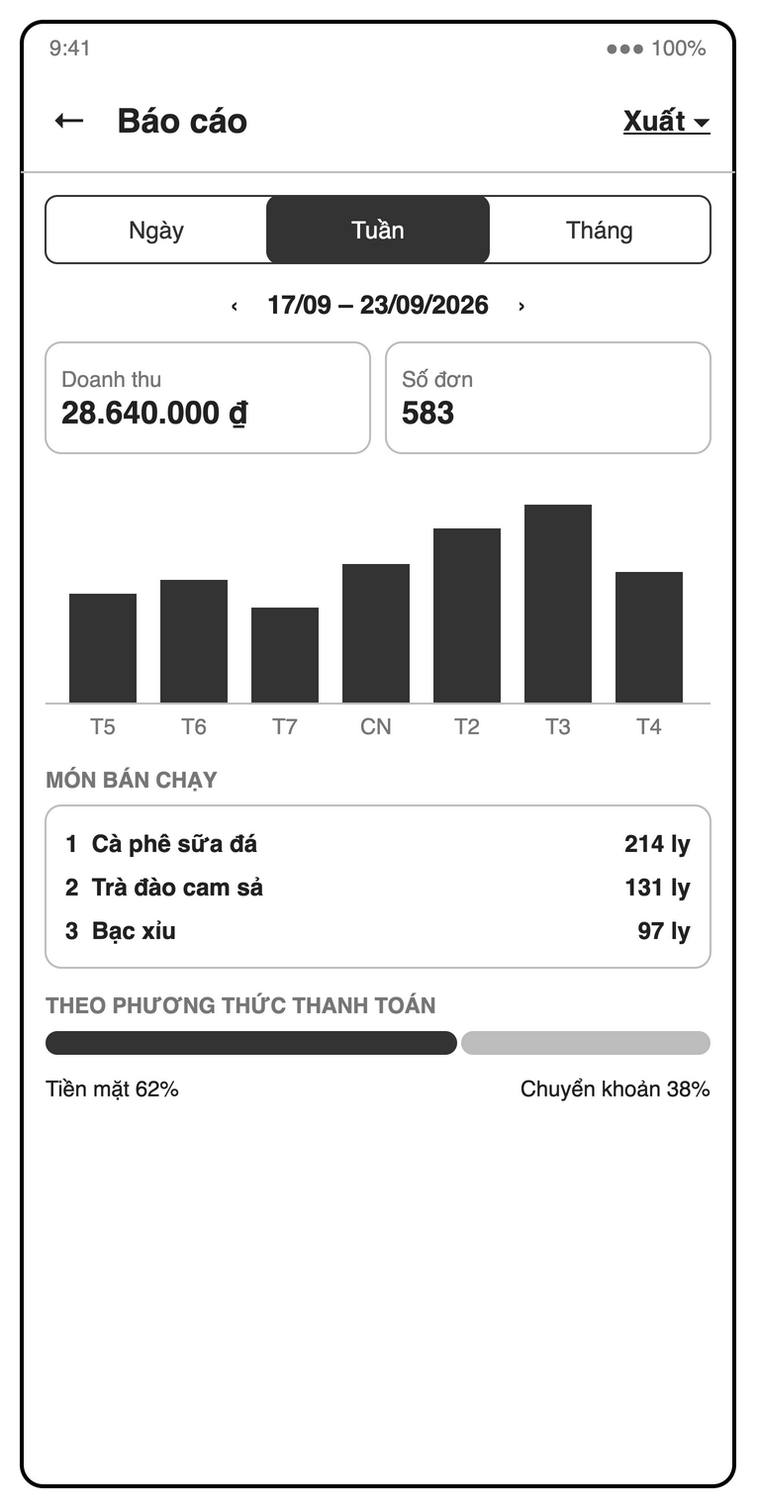
Figure 4.9-4: S19 Reports mock-up
Table 4-20: Reports Definition
No | Object Name | Type | Required | Length | Description
1 | backButton | Icon button | Yes | NONE | The "←" control returns from reports.
2 | titleLabel | Label | Yes | NONE | Displays "Báo cáo".
3 | exportDropdown | Dropdown | Yes | NONE | The "Xuất ▾" action exports the current report as PDF or Excel when data exists (UC37).
4 | groupingChipGroup | Chip group | Yes | NONE | Selects the revenue grouping "Ngày", "Tuần" or "Tháng" (UC36).
5 | periodDateRangePicker | Date range picker | Yes | NONE | Selects seven days, this month or a custom period, illustrated by "17/09 – 23/09/2026" (UC36).
6 | previousPeriodButton | Icon button | Yes | NONE | The "‹" control moves to the preceding report period.
7 | nextPeriodButton | Icon button | Yes | NONE | The "›" control moves to the following report period.
8 | revenueCard | Card | Yes | NONE | Shows "Doanh thu" as the sum of paid-order totals in the selected period (BR-RPT-01).
9 | orderCountCard | Card | Yes | NONE | Shows "Số đơn" as the paid-order count for the selected period (BR-RPT-01).
10 | revenueChart | Chart | Yes | NONE | Plots paid revenue per selected time bucket; tapping a bar opens S20 filtered to that bucket (UC36).
11 | bestSellingProductsList | List | Yes | NONE | Shows "MÓN BÁN CHẠY" ranked by quantity with revenue, defaulting to ten products (UC36).
12 | paymentMethodChart | Chart | Yes | NONE | Shows "THEO PHƯƠNG THỨC THANH TOÁN" from cashAmount and qrAmount sums, including both portions of split payments (BR-PAY-01).
13 | emptyReportLabel | Label | Conditional | NONE | Explains empty charts when the selected period contains no paid orders (UC36).

4.9.3.2 Object Interactions
ReportsScreen → reportProvider(query) → ReportRepository.paidOrders(from, to) (one-shot) → report_rules.byBucket / topProducts / paymentSplit. Export builds the PDF or Excel file on the device and opens the OS share sheet.

4.9.4 UC35 – Order history

4.9.4.1 Screen Design
S20 Order history (route /manager/orders).
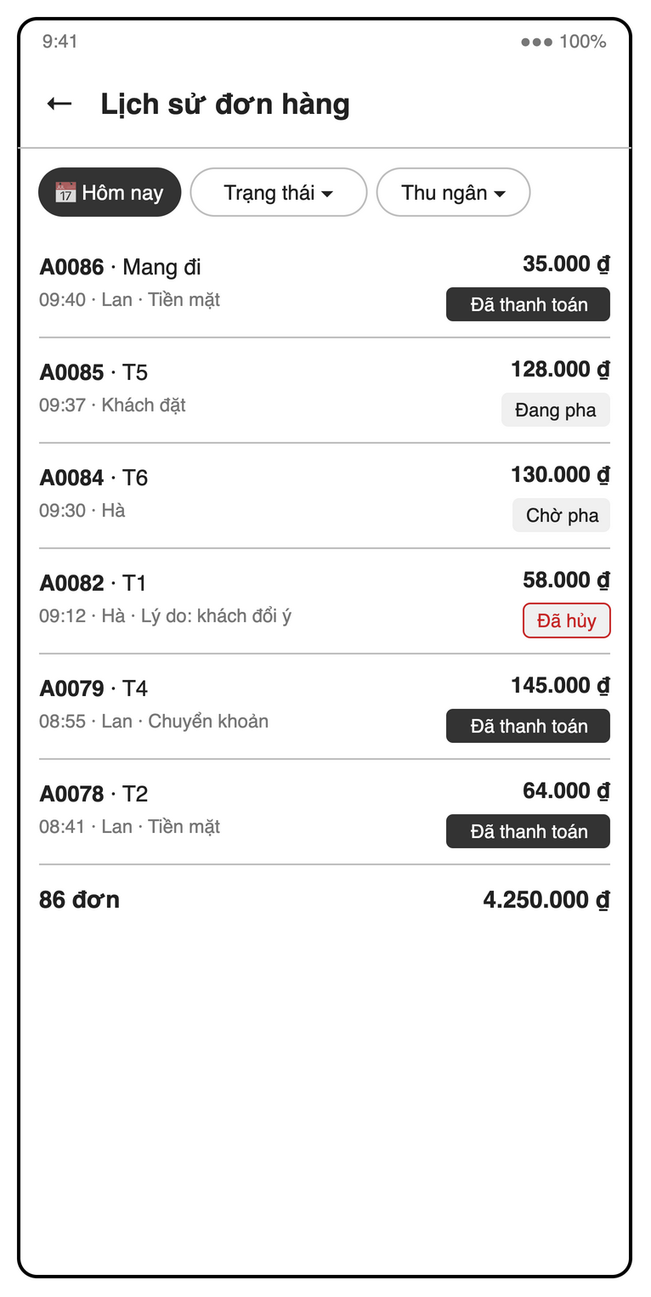
Figure 4.9-5: S20 Order history mock-up
Table 4-21: Order history Definition
No | Object Name | Type | Required | Length | Description
1 | backButton | Icon button | Yes | NONE | The "←" control returns from order history.
2 | titleLabel | Label | Yes | NONE | Displays "Lịch sử đơn hàng".
3 | periodDateRangePicker | Date range picker | No | NONE | Filters order dates and defaults to "Hôm nay" (UC35).
4 | statusDropdown | Dropdown | No | NONE | The "Trạng thái ▾" filter selects an order status.
5 | cashierDropdown | Dropdown | No | NONE | The "Thu ngân ▾" filter selects a staff member.
6 | orderList | List | Yes | NONE | Lists orders newest first with code, table or "Mang đi", time, cashier, amounts and cancellation reason where present (UC35).
7 | orderStatusBadge | Badge | Yes | NONE | Shows each row’s status, such as "Đã thanh toán", "Đang pha", "Chờ pha" or "Đã hủy".
8 | orderCountLabel | Label | Yes | NONE | Shows the filtered order count, illustrated by "86 đơn".
9 | orderTotalLabel | Label | Yes | NONE | Shows the filtered order-list total, illustrated by "4.250.000 ₫" (UC35).
10 | orderDetailCard | Card | Conditional | NONE | Shows the selected order’s items, voucher, points, cash and transfer amounts, cancellation reason and actor timestamps (UC35).
11 | receiptButton | Button | Conditional | NONE | Uses the SRS action "Hóa đơn" for a selected paid order only (UC28).
12 | receiptCard | Card | Conditional | NONE | Previews the paid order’s receipt with shop details and payment amounts, excluding historical change because it is not stored (UC28, BR-PAY-02).
13 | shareReceiptButton | Button | Conditional | NONE | Uses the SRS action "Chia sẻ" to share the receipt PDF (UC28).
14 | printReceiptButton | Button | Conditional | NONE | Uses the SRS action "In" to print the receipt PDF (UC28).
15 | emptyOrdersLabel | Label | Conditional | NONE | Displays an empty state when no orders match the filters (UC35).

4.9.4.2 Object Interactions
OrderHistoryScreen queries orders by date, status and paidBy (one-shot, paged by 50) and opens the receipt PDF as at the end of SD-04 (UC28).

4.10 Loyalty and Vouchers (UC38–UC41)
Feature folder lib/features/loyalty. It covers UC38–UC41 of the SRS.

4.10.1 Class/Component Design

4.10.1.1 Class/Component Structure
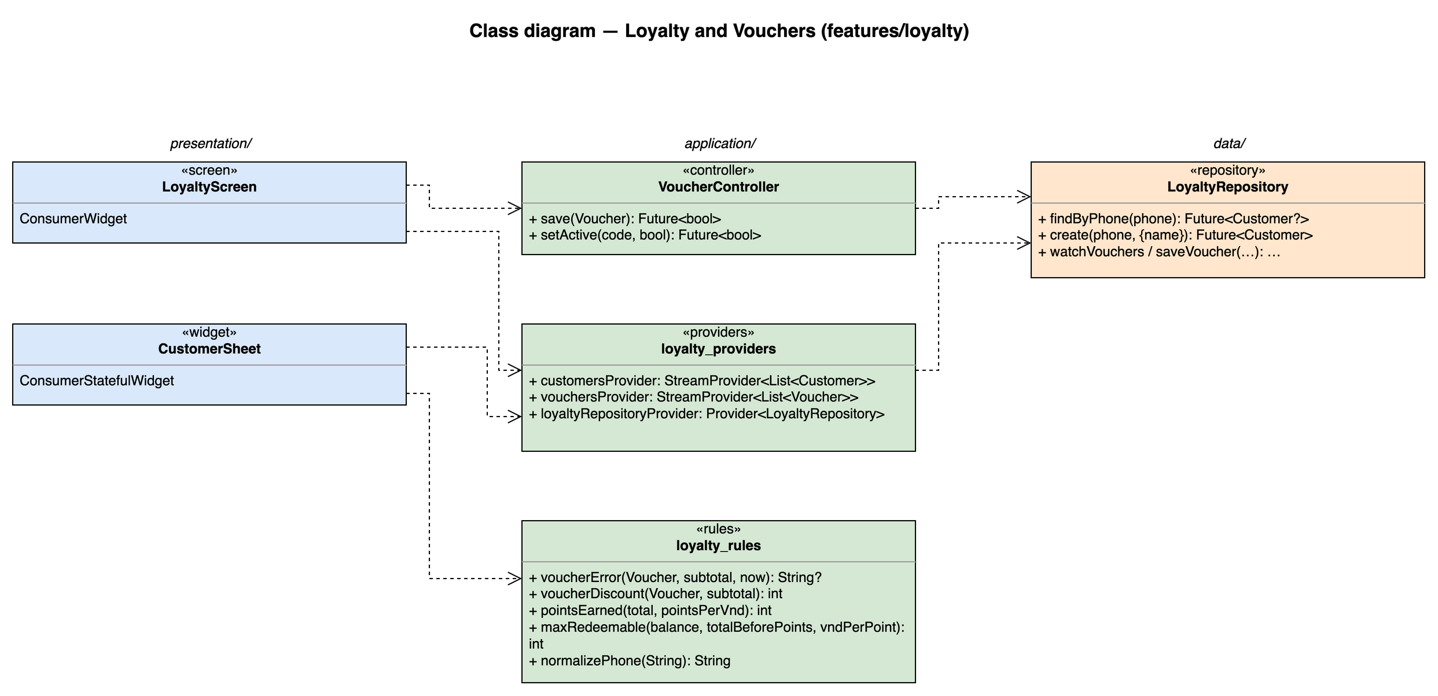
Figure 4.10-1: Class diagram for Loyalty and Vouchers

4.10.1.2 Class/Component Description
Class | «screen» LoyaltyScreen
Description | S21 customers tab (phone, name, points, visits) and vouchers tab (list and form) (UC40, UC41).
Base Class | ConsumerWidget
Constructor | const LoyaltyScreen({super.key})
Prototype | class LoyaltyScreen extends ConsumerWidget
Source File | lib/features/loyalty/presentation/loyalty_screen.dart
Namespace | package:brewboss/features/loyalty/presentation
Attributes | Name | Type | Description
Attributes | ref | WidgetRef | Riverpod reference; ref.watch in build, ref.read in callbacks
Methods | Name | Input | Output | Description
Methods | build | BuildContext context, WidgetRef ref | Widget | Watches the providers listed above and renders loading / error / empty / data with AsyncValue.when

Class | «widget» CustomerSheet
Description | Bottom sheet on S15: phone lookup or create, points to redeem (UC38, UC39, SD-12).
Base Class | ConsumerStatefulWidget
Constructor | const CustomerSheet({super.key})
Prototype | class CustomerSheet extends ConsumerStatefulWidget
Source File | lib/features/loyalty/presentation/customer_sheet.dart
Namespace | package:brewboss/features/loyalty/presentation
Attributes | Name | Type | Description
Attributes | _phone | TextEditingController | 10 digits starting with 0
Attributes | _points | int | Points to redeem
Methods | Name | Input | Output | Description
Methods | createState | — | _CustomerSheetState | Creates the ConsumerState<CustomerSheet> that holds the attributes above and the private methods below; its build(BuildContext context) reads providers through the state's ref

Class | «controller» VoucherController
Description | Voucher writes (UC40).
Base Class | AsyncNotifier<void>
Constructor | VoucherController() — created by AsyncNotifierProvider<VoucherController, void>(VoucherController.new)
Prototype | class VoucherController extends AsyncNotifier<void>
Source File | lib/features/loyalty/application/voucher_controller.dart
Namespace | package:brewboss/features/loyalty/application
Attributes | Name | Type | Description
Attributes | state | AsyncValue<void> | Saving state
Methods | Name | Input | Output | Description
Methods | save | Voucher v | Future<bool> | Code A–Z 0–9 unique; percent 1–100 or fixed > 0; usageLimit ≥ 1
Methods | setActive | String code, bool active | Future<bool> | Deactivate / reactivate

Class | «providers» loyalty_providers
Description | Loyalty streams.
Base Class | — (top-level providers)
Constructor | —
Prototype | top-level declarations (no class)
Source File | lib/features/loyalty/application/loyalty_providers.dart
Namespace | package:brewboss/features/loyalty/application
Attributes | Name | Type | Description
Attributes | customersProvider | StreamProvider<List<Customer>> | All customers
Attributes | vouchersProvider | StreamProvider<List<Voucher>> | All vouchers
Attributes | loyaltyRepositoryProvider | Provider<LoyaltyRepository> | Used by POS
Methods | Name | Input | Output | Description
Methods | — | — | — | Declarations only; see Attributes

Class | «rules» loyalty_rules
Description | Voucher and points rules.
Base Class | — (pure functions)
Constructor | —
Prototype | top-level declarations (no class)
Source File | lib/features/loyalty/application/loyalty_rules.dart
Namespace | package:brewboss/features/loyalty/application
Attributes | Name | Type | Description
Attributes | — | — | No state
Methods | Name | Input | Output | Description
Methods | voucherError | Voucher v, int subtotal, DateTime now | String? | MSG22 not found, MSG23 expired, MSG24 used up, MSG25 below minOrder; null = valid
Methods | voucherDiscount | Voucher v, int subtotal | int | percent capped by maxDiscount, or fixed (BR-DIS-02)
Methods | pointsEarned | int total, int pointsPerVnd | int | floor(total / pointsPerVnd) (BR-LOY-01)
Methods | maxRedeemable | int balance, int totalBeforePoints, int vndPerPoint | int | min(balance, totalBeforePoints ÷ vndPerPoint) (BR-LOY-02, MSG40)
Methods | normalizePhone | String raw | String | Digits only, leading 0; used as customers document id

Class | «repository» LoyaltyRepository
Description | customers and vouchers.
Base Class | —
Constructor | —
Prototype | class LoyaltyRepository
Source File | lib/features/loyalty/data/loyalty_repository.dart
Namespace | package:brewboss/features/loyalty/data
Attributes | Name | Type | Description
Attributes | _db | FirebaseFirestore | Firestore instance injected by the provider
Methods | Name | Input | Output | Description
Methods | findByPhone | String phone | Future<Customer?> | get customers/{normalizePhone(phone)}
Methods | create | String phone, {String? name} | Future<Customer> | New customer with points = 0, visitCount = 0 and the optional name (UC38)
Methods | watchVouchers / saveVoucher | Voucher | Stream / Future<void> | vouchers/{code}

4.10.2 UC40, UC41 – Customers and vouchers

4.10.2.1 Screen Design
S21 Customers & vouchers (route /manager/loyalty).
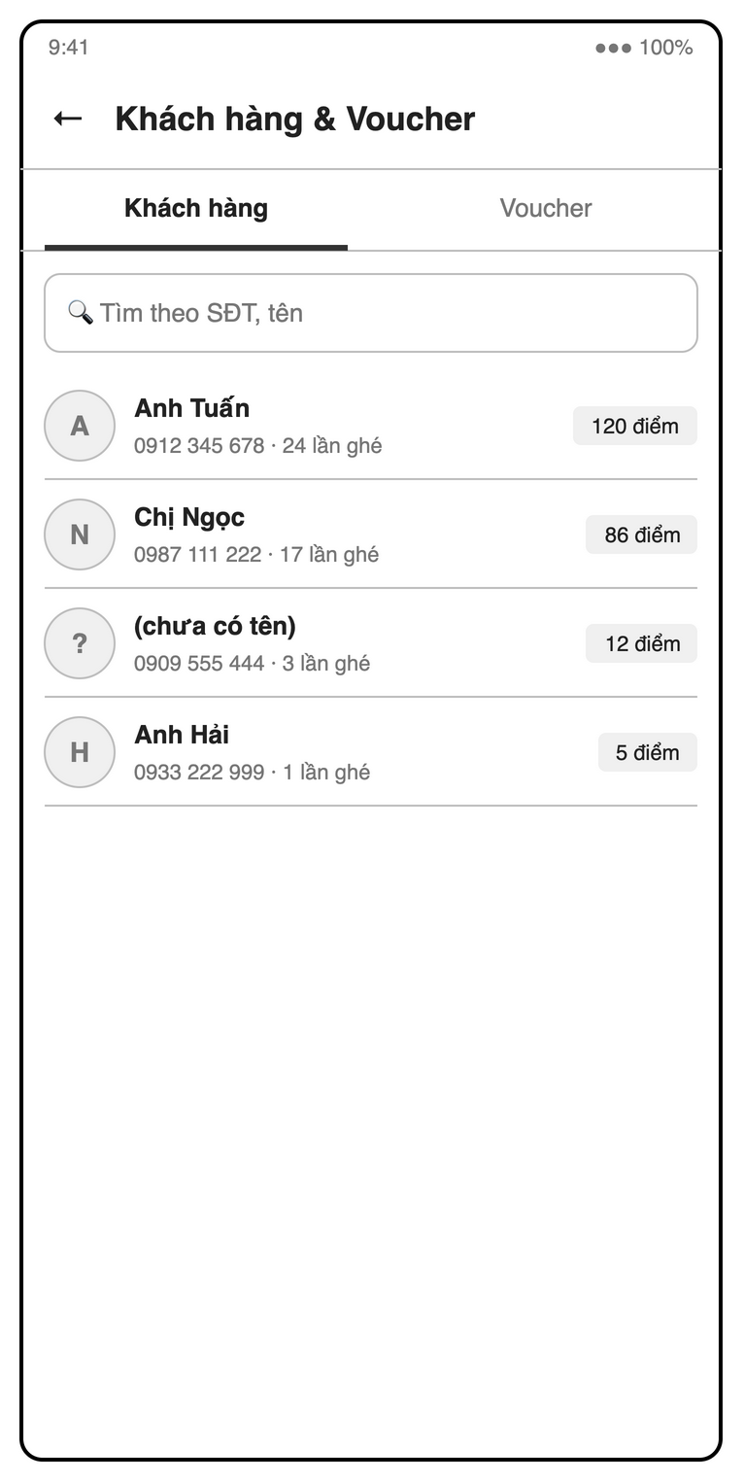
Figure 4.10-2: S21 Customers tab mock-up
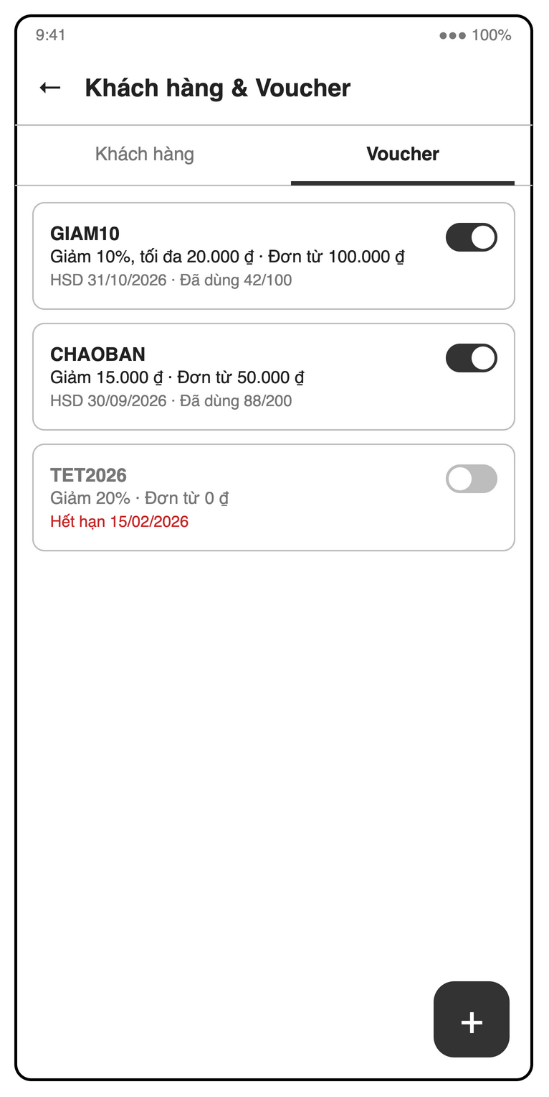
Figure 4.10-3: S21 Vouchers tab mock-up
Table 4-22: Customers & vouchers Definition
No | Object Name | Type | Required | Length | Description
1 | backButton | Icon button | Yes | NONE | The "←" control returns from customer and voucher management.
2 | titleLabel | Label | Yes | NONE | Displays "Khách hàng & Voucher".
3 | loyaltyTabBar | Tab bar | Yes | NONE | Switches between "Khách hàng" and "Voucher".
4 | customerSearchField | Search field | No | NONE | Uses "Tìm theo SĐT, tên" to filter customers by phone or name (UC41).
5 | customerSortDropdown | Dropdown | No | NONE | Sorts customers by points or visit count (UC41).
6 | customerList | List | Conditional | NONE | Shows names or "(chưa có tên)", phone numbers, visit counts and balances such as "120 điểm"; selecting a customer opens their paid orders (UC41).
7 | customerPaidOrdersList | List | Conditional | NONE | Shows paid orders for the selected customer (UC41).
8 | customerNameField | Text field | No | NONE | Allows an optional customer-name edit without requiring a name (UC41).
9 | saveCustomerNameButton | Button | Conditional | NONE | Saves the selected customer’s edited name (UC41).
10 | voucherList | List | Conditional | NONE | Shows codes such as "GIAM10", discount terms, minimum order, expiry and usage such as "Đã dùng 42/100" (UC40).
11 | voucherStatusBadge | Badge | Conditional | NONE | Shows voucher validity or exhaustion, including "Hết hạn 15/02/2026" for an expired voucher (UC40).
12 | addVoucherButton | Icon button | Conditional | NONE | The "+" control on "Voucher" opens the voucher creation form.
13 | voucherCodeField | Text field | Yes | NONE | Requires a unique code using only A–Z and 0–9, illustrated by "GIAM10"; read-only when editing (UC40).
14 | voucherTypeRadioGroup | Radio group | Yes | NONE | Requires percent or fixed discount mode (UC40).
15 | voucherValueField | Number field | Yes | NONE | Requires an integer percentage from 1–100 or an integer fixed VND amount > 0 (UC40).
16 | minimumOrderField | Number field | Yes | NONE | Requires the SRS "Đơn tối thiểu" as an integer VND amount ≥ 0 (UC40).
17 | maximumDiscountField | Number field | No | NONE | Accepts an optional integer VND cap for percentage vouchers only, illustrated by "tối đa 20.000 ₫" (BR-DIS-02).
18 | expiryDateRangePicker | Date range picker | Yes | NONE | Uses single-date selection for the SRS "Hết hạn" field and rejects a date in the past (UC40).
19 | usageLimitField | Number field | Yes | NONE | Requires the SRS "Số lượt" as an integer ≥ 1 (UC40).
20 | voucherActiveSwitch | Switch | Yes | NONE | The SRS "Đang hoạt động" control deactivates a voucher; used vouchers are never deleted (UC40).
21 | saveVoucherButton | Button | Conditional | NONE | Uses the SRS action "Lưu" to save valid voucher data; editing preserves the existing code and usage count (UC40).
22 | deactivateVoucherDialog | Dialog | Conditional | NONE | Confirms voucher deactivation before switching off "Đang hoạt động" (SRS 5.2).
23 | emptyCustomersLabel | Label | Conditional | NONE | Displays an empty state when no customer matches the search (UC41).

4.10.2.2 Object Interactions
LoyaltyScreen watches customersProvider and vouchersProvider (SD-11 provider sequence); VoucherController.save / setActive → LoyaltyRepository.saveVoucher is a single write.

4.10.3 UC38, UC39 – Attach a loyalty customer and redeem points
UC38 and UC39 run in CustomerSheet, a bottom sheet of S15 (screen definition in 4.6, S15). PaymentController.attachCustomer / redeemPoints save customerId, pointsRedeemed and the new total on the open order right away (OrderRepository.updateLoyalty); the customer balance, earned points and visitCount change only in the payment transaction (SD-04).

4.10.3.1 Object Interactions (Sequence Diagrams)
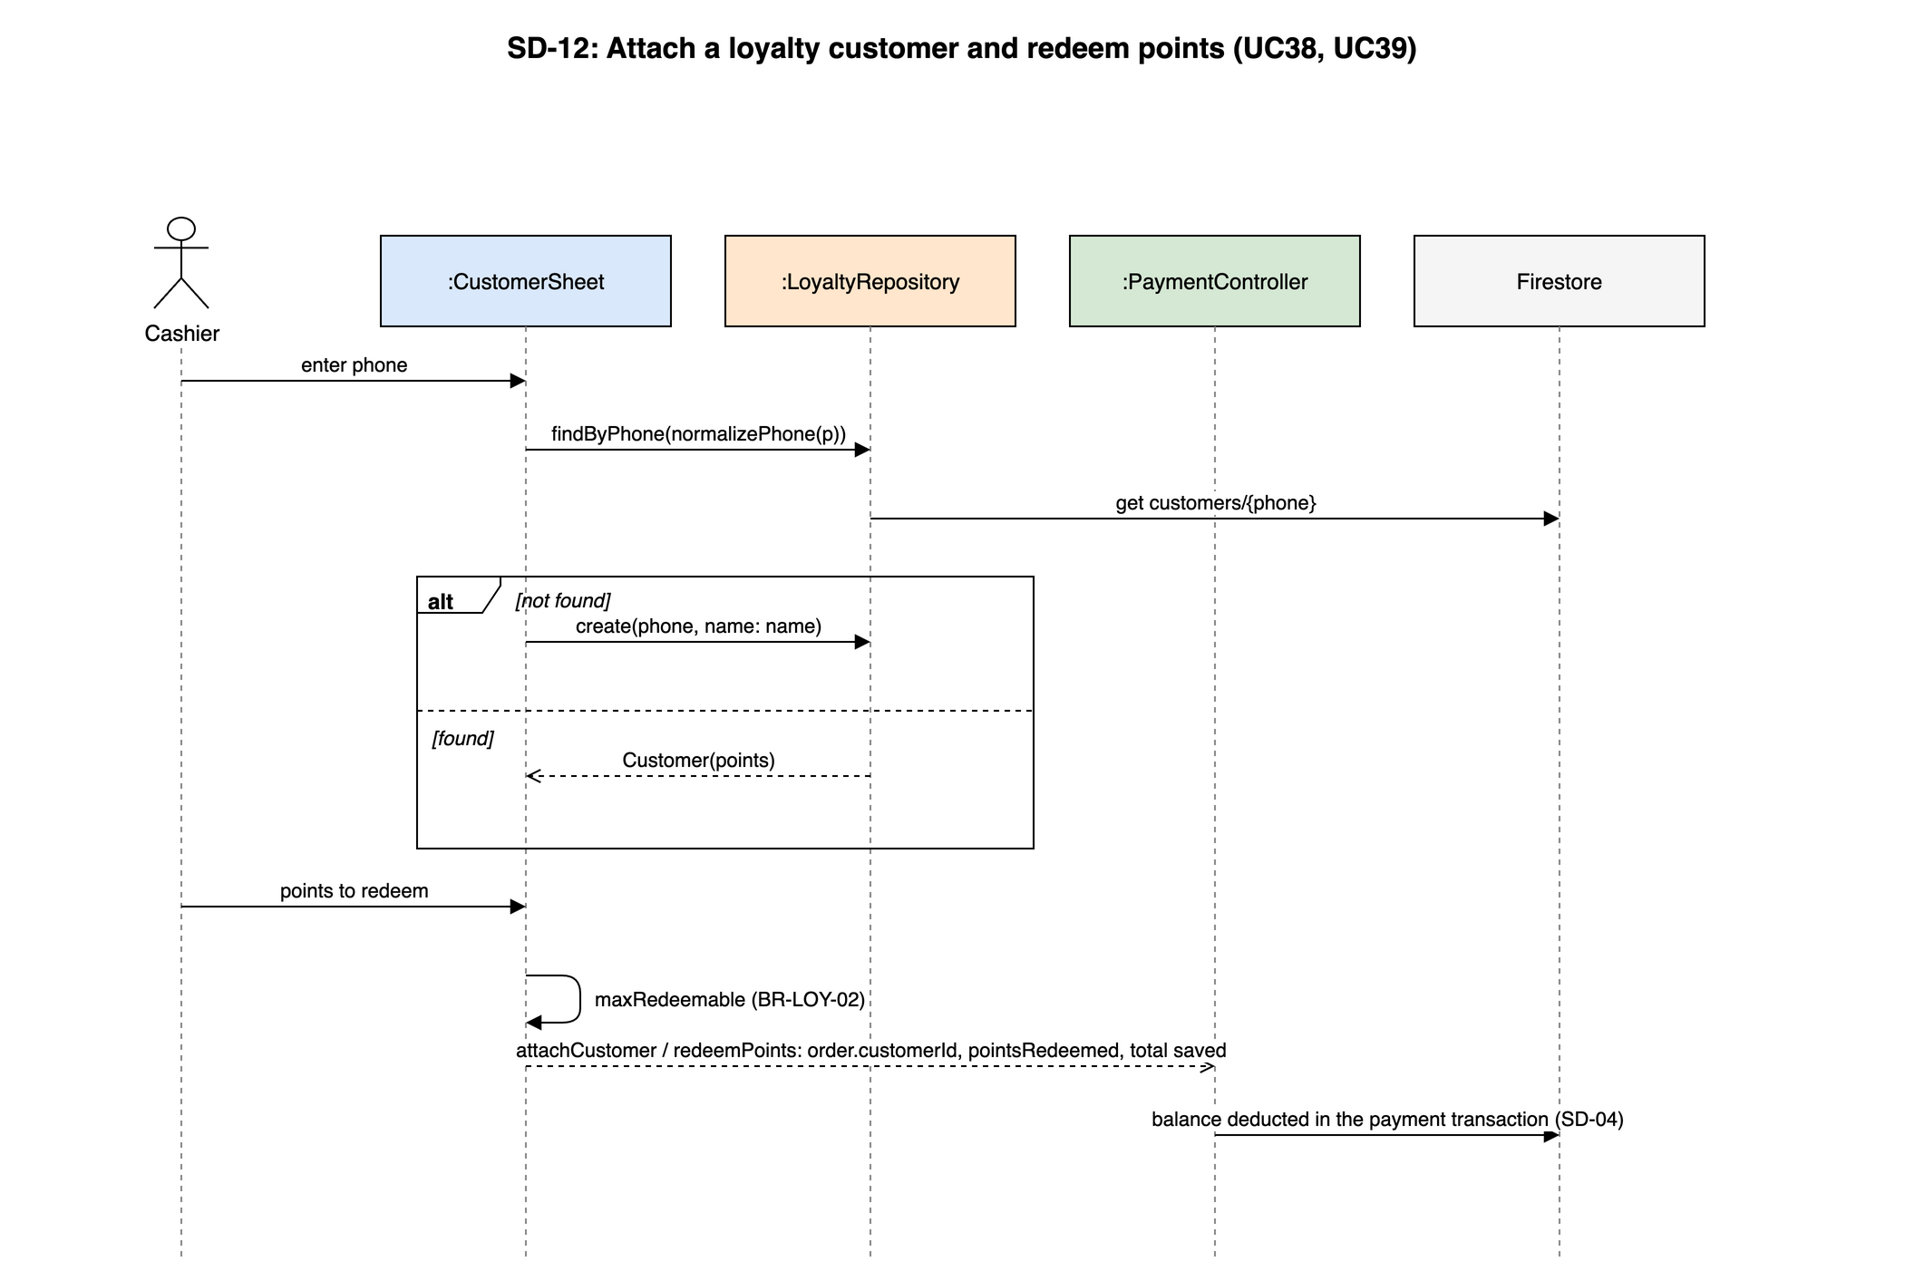
Figure 4.10-4: SD-12: Attach a loyalty customer and redeem points (UC38, UC39)

5. Database Design

5.1 Database Design
BrewBoss stores its data in Cloud Firestore (NoSQL, document model). Figure 5-1 shows the physical data model: top-level collections, the movements sub-collection and the embedded arrays / maps. Firestore has no foreign keys; "FK" in the tables below marks a document id that refers to another collection, kept consistent by the transactions of 4.1.5 and checked by Security Rules where needed. All money values are integers (VND); all timestamps are Firestore Timestamps written with serverTimestamp(); the document id is the primary key and is not stored as a field.
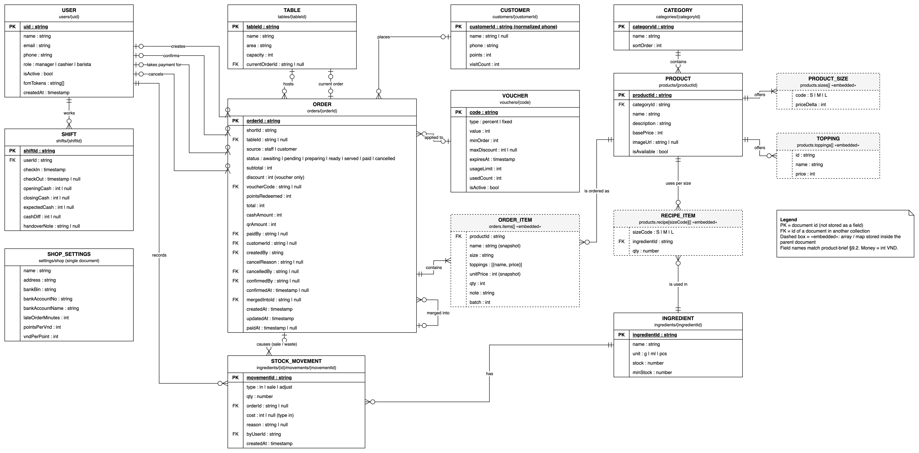
Figure 5-1: Firestore data model (physical)

a. users/{uid}
Staff accounts. Document id = Firebase Auth uid. Read by Security Rules to obtain the role.
# | Field name | Type | Size | Unique | Not Null | PK/FK | Notes
1 | uid | string | 28 | x | x | PK | Firebase Auth uid
2 | name | string | 100 |  | x |  | Full name
3 | email | string | 100 | x | x |  | Login email (unique in Firebase Auth)
4 | phone | string | 10 |  | x |  | 10 digits
5 | role | string | 10 |  | x |  | manager | supervisor | cashier | barista
6 | isActive | boolean |  |  | x |  | false = cannot log in
7 | fcmTokens | array<string> |  |  | x |  | Push tokens; arrayUnion / arrayRemove
8 | createdAt | timestamp |  |  | x |  | Server time

b. shifts/{shiftId}
One work session. Index: (userId, checkOut) to find the open shift; (checkIn) for history.
# | Field name | Type | Size | Unique | Not Null | PK/FK | Notes
1 | shiftId | string | 20 | x | x | PK | Auto-id
2 | userId | string | 28 |  | x | FK users | Staff member
3 | checkIn | timestamp |  |  | x |  | Server time
4 | checkOut | timestamp |  |  |  |  | null while open
5 | openingCash | integer |  |  |  |  | null for barista (BR-STAFF-03)
6 | closingCash | integer |  |  |  |  | Counted cash
7 | expectedCash | integer |  |  |  |  | Snapshot (BR-STAFF-04)
8 | cashDiff | integer |  |  |  |  | closing − expected
9 | cashSales | integer |  |  | x |  | Σ cashAmount of payments confirmed by this user in the shift; +cashAmount in each payment transaction
10 | qrSales | integer |  |  | x |  | Σ qrAmount, reference only
11 | lastPaidOrderId | string | 20 |  |  | FK orders | Order of the latest payment; lets Security Rules check with getAfter that this order became paid in the same commit and that the totals grew by exactly its amounts
12 | handoverNote | string | 500 |  |  |  | Required when cashDiff ≠ 0; all cash fields locked after checkOut

c. categories/{categoryId}
Menu groups.
# | Field name | Type | Size | Unique | Not Null | PK/FK | Notes
1 | categoryId | string | 20 | x | x | PK | Auto-id
2 | name | string | 50 | x | x |  | Unique (checked by the app)
3 | sortOrder | integer |  |  | x |  | Display order

d. products/{productId}
Menu items with embedded sizes, toppings and recipe per size. Index: (categoryId, name).
# | Field name | Type | Size | Unique | Not Null | PK/FK | Notes
1 | productId | string | 20 | x | x | PK | Auto-id
2 | categoryId | string | 20 |  | x | FK categories
3 | name | string | 100 |  | x
4 | description | string | 500 |  | x |  | May be empty
5 | basePrice | integer |  |  | x |  | ≥ 0
6 | imageUrl | string | 500 |  |  |  | Cloud Storage URL
7 | isAvailable | boolean |  |  | x |  | false = sold out
8 | sizes | array<map> |  |  | x |  | {code S|M|L, priceDelta}; ≥ 1
9 | toppings | array<map> |  |  | x |  | {id, name, price}; may be empty
10 | recipe | map<string, array<map>> |  |  | x |  | sizeCode → [{ingredientId (FK ingredients), qty}]

e. ingredients/{ingredientId}
Tracked raw materials.
# | Field name | Type | Size | Unique | Not Null | PK/FK | Notes
1 | ingredientId | string | 20 | x | x | PK | Auto-id
2 | name | string | 100 | x | x |  | Unique (checked by the app)
3 | unit | string | 3 |  | x |  | g | ml | pcs
4 | stock | number |  |  | x |  | May be negative
5 | minStock | number |  |  | x |  | Low-stock threshold

f. ingredients/{ingredientId}/movements/{movementId}
Append-only stock log (no update or delete in Security Rules). Index: createdAt desc.
# | Field name | Type | Size | Unique | Not Null | PK/FK | Notes
1 | movementId | string | 20 | x | x | PK | Auto-id
2 | type | string | 6 |  | x |  | in | sale | adjust
3 | qty | number |  |  | x |  | + in, − out
4 | orderId | string | 20 |  |  | FK orders | sale and cancel waste
5 | cost | integer |  |  |  |  | Total purchase cost for in
6 | reason | string | 200 |  |  |  | Required for adjust
7 | byUserId | string | 28 |  | x | FK users | Who
8 | createdAt | timestamp |  |  | x |  | When

g. tables/{tableId}
Physical tables. The auto-id is encoded in the table QR (not guessable, SEC-REMOTE).
# | Field name | Type | Size | Unique | Not Null | PK/FK | Notes
1 | tableId | string | 20 | x | x | PK | Auto-id
2 | name | string | 30 |  | x |  | e.g. "T1"
3 | area | string | 50 |  | x |  | Zone
4 | capacity | integer |  |  | x |  | > 0
5 | currentOrderId | string | 20 |  |  | FK orders | null = empty; written only in transactions

h. orders/{orderId}
Orders with embedded items. Indexes: (status, createdAt) barista queue; (status, paidAt) reports and dashboard; (paidBy, paidAt) cash handover; (tableId, status) open order lookup.
# | Field name | Type | Size | Unique | Not Null | PK/FK | Notes
1 | orderId | string | 20 | x | x | PK | Auto-id
2 | shortId | string | 5 | per day |  |  | <letter><4 digits> (BR-ORD-06); staff order: at creation; customer order: at confirmation. Design decision: SRS 3.1.6 marks it mandatory, but an anonymous user cannot be allowed to write the daily counter, so it is null while awaiting and S18 shows "Chờ xác nhận" instead of a code
3 | tableId | string | 20 |  |  | FK tables | null = takeaway
4 | source | string | 8 |  | x |  | staff | customer
5 | status | string | 9 |  | x |  | awaiting | pending | preparing | ready | served | paid | cancelled
6 | items | array<map> |  |  | x |  | {productId (FK products), name, size, toppings[{name, price}], unitPrice, qty, note, batch}
7 | subtotal | integer |  |  | x |  | Σ unitPrice × qty
8 | discount | integer |  |  | x |  | Voucher only (BR-DIS-03)
9 | voucherCode | string | 20 |  |  | FK vouchers
10 | pointsRedeemed | integer |  |  | x
11 | total | integer |  |  | x |  | BR-ORD-02, min 0
12 | cashAmount | integer |  |  | x |  | Cash kept; 0 until paid
13 | qrAmount | integer |  |  | x |  | VietQR part; 0 until paid
14 | paidBy | string | 28 |  |  | FK users
15 | shiftId | string | 20 |  |  | FK shifts | Shift of the payer (BR-PAY-03)
16 | customerId | string | 10 |  |  | FK customers
17 | createdBy | string | 28 |  | x |  | Staff uid, or the anonymous uid of the customer (ownership check)
18 | cancelReason | string | 200 |  |  |  | Required when cancelled
19 | cancelledBy | string | 28 |  |  | FK users
20 | confirmedBy | string | 28 |  |  | FK users | Staff only (SEC-CONFIRM)
21 | confirmedAt | timestamp
22 | mergedIntoId | string | 20 |  |  | FK orders | BR-ORD-07 / BR-ORD-08
23 | createdAt | timestamp |  |  | x
24 | updatedAt | timestamp |  |  | x
25 | updatedBy | string | 28 |  |  | FK users | Who made the last status change
26 | paidAt | timestamp

i. customers/{customerId}
Loyalty members; document id = normalized phone.
# | Field name | Type | Size | Unique | Not Null | PK/FK | Notes
1 | customerId | string | 10 | x | x | PK | Phone, starts with 0
2 | name | string | 100 |  |  |  | Optional
3 | phone | string | 10 | x | x |  | Same as id
4 | points | integer |  |  | x |  | Balance ≥ 0
5 | visitCount | integer |  |  | x |  | Paid orders

j. vouchers/{code}
Discount codes; document id = code.
# | Field name | Type | Size | Unique | Not Null | PK/FK | Notes
1 | code | string | 20 | x | x | PK | A–Z 0–9
2 | type | string | 7 |  | x |  | percent | fixed
3 | value | integer |  |  | x |  | 1–100 or VND > 0
4 | minOrder | integer |  |  | x |  | Minimum subtotal
5 | maxDiscount | integer |  |  |  |  | Cap for percent
6 | expiresAt | timestamp |  |  | x
7 | usageLimit | integer |  |  | x |  | ≥ 1
8 | usedCount | integer |  |  | x |  | Incremented in the payment transaction
9 | isActive | boolean |  |  | x

k. settings/shop
Single document with shop-wide settings (UC29).
# | Field name | Type | Size | Unique | Not Null | PK/FK | Notes
1 | name | string | 100 |  | x |  | Shop name
2 | address | string | 200 |  | x
3 | bankBin | string | 6 |  | x |  | VietQR bank BIN
4 | bankAccountNo | string | 20 |  | x |  | Digits only
5 | bankAccountName | string | 100 |  | x
6 | lateOrderMinutes | integer |  |  | x |  | Default 10
7 | pointsPerVnd | integer |  |  | x |  | Default 10.000
8 | vndPerPoint | integer |  |  | x |  | Default 1.000

l. settings/public
Public part of the shop settings, readable by anonymous customers (Security Rules cannot hide single fields of settings/shop). Written by SettingsController in the same batch as settings/shop.
# | Field name | Type | Size | Unique | Not Null | PK/FK | Notes
1 | name | string | 100 |  | x |  | Shop name shown on S17

m. shiftLocks/{uid}
Technical document that makes check-in safe against two devices (BR-STAFF-01): created by the check-in transaction, deleted by the check-out transaction.
# | Field name | Type | Size | Unique | Not Null | PK/FK | Notes
1 | uid | string | 28 | x | x | PK, FK users | Staff member
2 | shiftId | string | 20 |  | x | FK shifts | The open shift

n. counters/{yyyyMMdd}
Technical document for shortId allocation (BR-ORD-06): one document per day, created or incremented inside the staff create-order and the confirm-customer-order transactions; not shown to users.
# | Field name | Type | Size | Unique | Not Null | PK/FK | Notes
1 | yyyyMMdd | string | 8 | x | x | PK | Shop-local date
2 | next | integer |  |  | x |  | Next sequence number; letter = A + next ÷ 10000

Security Rules summary
Collection | Manager | Supervisor | Cashier | Barista | Customer (anonymous)
users | CRUD | read self; update own fcmTokens | read self; update own fcmTokens | read self; update own fcmTokens | —
shifts | read all; read / create / update own | read all; read / create / update own | read / create / update own | read / create / update own | —
shiftLocks | own: create at check-in, delete at check-out | own: create, delete | own: create, delete | own: create, delete | —
categories, products | CRUD | read, isAvailable | read, isAvailable | read | read
ingredients, movements | CRUD | read; adjust (stocktake); sale / adjust inside pay / cancel | read; sale / adjust only inside pay / cancel | — | —
tables | CRUD | read, currentOrderId | read, currentOrderId | read | read one
orders | CRUD | read, create, update (not paid), cancel any | read, create, update (not paid) | read; status, updatedAt, updatedBy | create awaiting, read own
customers | CRUD | read, create; points, visitCount on pay | read, create; points, visitCount on pay | — | —
vouchers | CRUD | read, usedCount on pay | read, usedCount on pay | — | —
settings/shop | CRUD | read | read | read | —
settings/public | CRUD | read | read | read | read
counters | CRUD | read, create, +1 | read, create, +1 | — | —

Note: payment and cancellation write ingredients, movements, customers, vouchers and the payer's shift totals from a cashier or supervisor device; the rules allow these writes only when the same commit updates the order to paid or cancelled (getAfter on orders/{orderId}), so a cashier cannot change stock, points or cash totals directly.

5.2 Data File Design
Files other than Firestore documents that the system reads or produces:
# | File Name | Type | Notes
1 | firestore.rules | Security Rules | Per-role access of 5.1; unit tested on the Emulator
2 | firestore.indexes.json | JSON | Composite indexes listed in 5.1 (orders, shifts, products)
3 | storage.rules | Security Rules | products/{id}.jpg: read for all, write for Manager, ≤ 2 MB, image/* only
4 | products/{productId}.jpg | JPEG in Cloud Storage | Product image, ≤ 1024 px, compressed before upload (flutter_image_compress)
5 | functions/index.js, functions/package.json | Node.js 20 source | onOrderReady, onIngredientWrite (firebase-functions v2, firebase-admin)
6 | firebase.json, .firebaserc | JSON | Hosting (build/web, SPA rewrite to index.html), emulators, deploy targets
7 | lib/firebase_options.dart | Dart (generated) | FlutterFire CLI configuration per platform
8 | lib/l10n/app_vi.arb | ARB (JSON) | Vietnamese UI strings and MSG01–MSG44
9 | pubspec.yaml | YAML | Dependencies: flutter_riverpod, go_router, freezed, json_serializable, firebase_* packages, cached_network_image, image_picker, flutter_image_compress, qr_flutter, pdf, printing, excel, share_plus, fl_chart, intl, audioplayers
10 | Receipt_<shortId>.pdf | PDF (generated) | UC28 receipt, shared through the OS share sheet; not stored
11 | BaoCao_<from>_<to>.pdf / .xlsx | PDF / Excel (generated) | UC37 report export; not stored
12 | QR_<table>.pdf | PDF (generated) | UC18 printable table QR codes (qr_flutter + pdf)

